Making sense of nonsense: pseudo-script on an Italian Renaissance maiolica dish
By Matthew Martin

At the Sotheby’s sale of the Pringsheim collection held in London on 7 and 8 June 1939, the Felton Bequest acquired for the National Gallery of Victoria, on the advice of V&A Curator Bernard Rackham, an important group of Italian Renaissance maiolica works. Among these ceramics, which now form the core of the NGV’s maiolica holdings, is a finely decorated shallow bowl with broad rim, probably from a Pesaro workshop (see below).[1] The centre of the bowl shows a naked boy bearing a shield and a sword or stick in a hilly landscape. The sides of the well are decorated in a geometric bianco sopra bianco pattern. Surrounding this, the broad rim of the bowl is decorated in a grotesque pattern featuring birds, flowers, rosettes, cornucopia, musical pipes, shields, torches, a bucranium (bull’s skull) and a sphinx with dolphins for arms. Two roundels containing deer sit on either side of the rim. Above them, incorporated into the grotesque ornament, are two panels featuring strange, script-like characters. Although they bear a strong resemblance to writing, these characters in fact belong to no known writing system. They are examples of pseudo-script: marks imitating the appearance of writing but bearing no linguistic meaning. Sometimes referred to as pseudo-Khufic, or pseudo-Arabic in literature on Italian Renaissance art for their resemblance to Arabic script, these intriguing examples of writing that is not writing are frequently encountered in paintings and on ceramics of the thirteenth to fifteenth centuries in Italy, although the phenomenon of pseudo-script can be found in European art at least as early as the tenth century.[2] In this essay I will explore the phenomenon of pseudo-script in Italian Renaissance art in general before offering some new interpretations specific to the examples present on this bowl. While pseudo-script often occurs on maiolica forms as decorative bands among other decoration, the appearance of pseudo-script on istoriato maiolica is relatively rare. I suggest that the formal characteristics of the pseudo-inscriptions on the NGV bowl, along with the framing device of the tabula ansata, suggest connections with traditions of ‘magical’ writing.
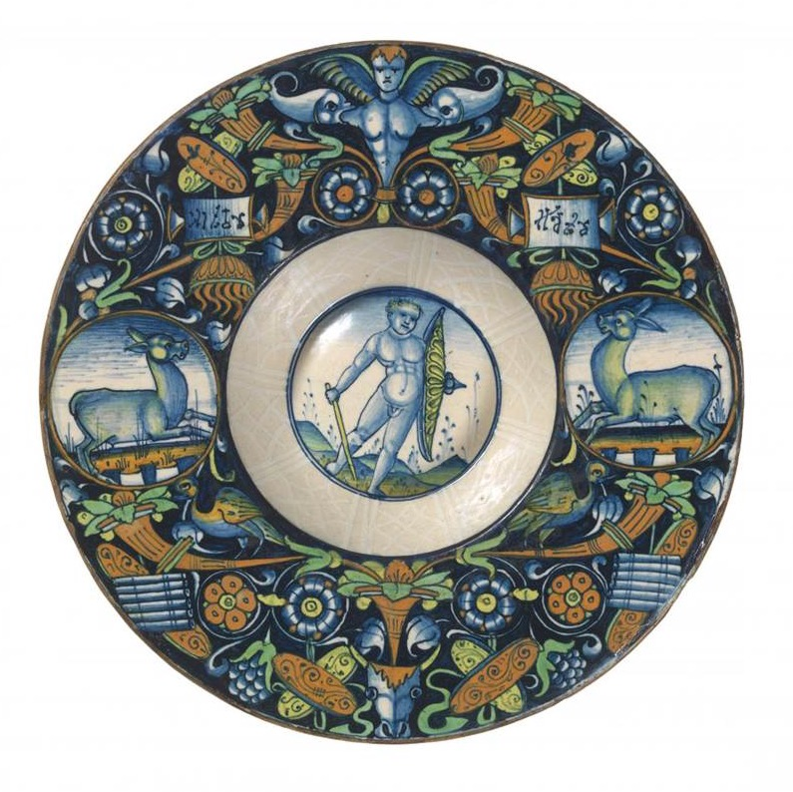
Fa104794
Italy (Pesaro)
Plate c. 1490–1500
earthenware (maiolica)
4.6 x 24.5 cm diameter
National Gallery of Victoria, Melbourne
(4675–D3)

Many of the individual motifs employed in the grotesque ornament on the NGV bowl are typical of the trophy, an iconographic device depicting objects associated with the spoils of war, which was employed to convey ideas of triumph or victory. Timothy Wilson suggests that the grotesque decoration on this bowl, and a small number of other maiolica works that may be by the same hand or workshop, are reminiscent of ornamental prints by Nicoletto da Moderna.[3] An early sixteenth-century engraving by da Moderna bears out this observation, with its depictions of shields, braziers, cornucopia and a central winged figure (see below).

EPUB002720
Italy
Nicoletto da Modena
Panel of ornament with a birdcage c. 1507
engraving on paper
Art Institute of Chicago, Chicago
Gift of Mr and Mrs Potter Palmer Jr
(1937.85)

Of particular interest is the presence of two winged figures recording inscriptions on tablets on the upper right and left of a trophy of armour and shields. The form of these tablets – known as tabula ansata, or winged tablets for the triangular ‘wings’ projecting from their short sides – mirrors the tablets bearing strange inscriptions on the NGV maiolica bowl. In the engraving, the inscriptions on the tabulae are in Latin script and include the Senatus Popolusque Romanus (SPQR) – the Senate and People of Rome, emblematic of the government of the Roman Republic. The tabula ansata was employed since the time of Imperial Rome to frame votive inscriptions.[4] The text on such a tabula was set off as possessed of importance – a dedication to a god (see below); the name of a military unit;[5] a memorial to a deceased person;[6] a blessing.[7] The tabula ansata retained such functions in the early modern period. An engraving by Daniel Hopfer of a trophy flanked by seated figures of History and Victory shows History recording the glorious deeds of the victor upon a similar tablet form (see below).

If the use of a tabula ansata draws attention to a significant text, then what is to be made of the inscriptions on the NGV maiolica bowl? Executed in pseudo-script, the text is illegible; however, the use of the tabula suggests it is important.

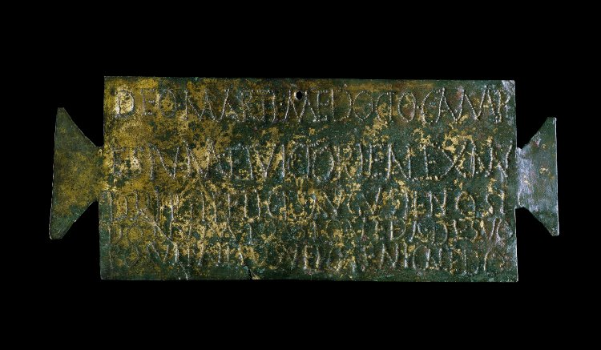
EPUB002722
Romano-British
Copper alloy plaque with punched dedication to Mars found at Colchester 222–235 CE
20.8 cm (wide)
The British Museum, London
(1892,0421.1)
© The Trustees of the British Museum

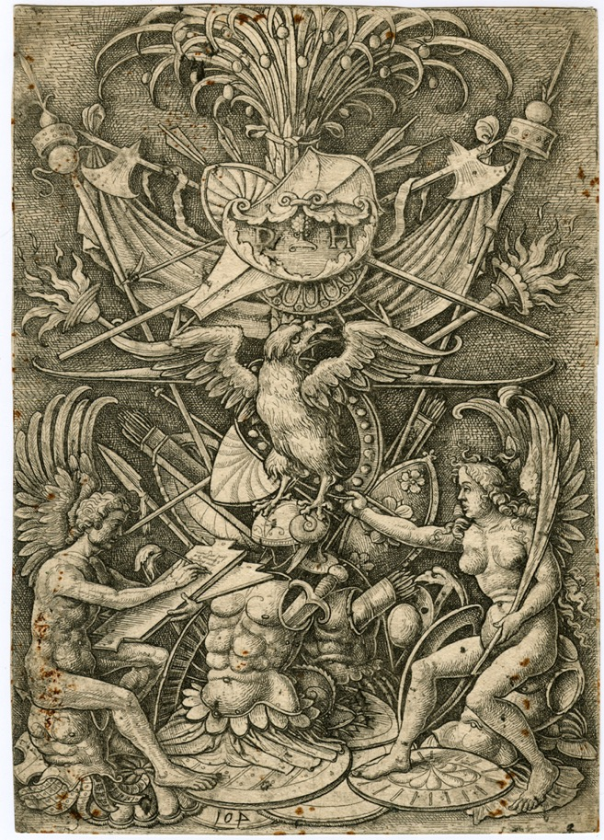
EPUB002724
Daniel Hopfer
‘A trophy of arms, History and Victory seated at lower left and right.’ Victory stretches her right arm towards Jupiter, in the form of an eagle 1505–1536
etching
22.3 cm x 15.5 cm
The British Museum, London
(1845,0809.1417)
© The Trustees of the British Museum

The meaning of pseudo-script in Italian art of the early modern period has occupied scholarship for centuries and a substantial literature on the subject has been generated.[8] Many pseudo-scripts show a carefully considered interest in the formal characteristics of writing systems associated with the eastern Mediterranean, and the production and reading of texts in those scripts. Despite the frequently encountered terms pseudo-Khufic (after the ornamental Arabic-Khufic script) and pseudo-Arabic, not all pseudo-scripts encountered in Italian art reference written Arabic; the formal characteristics of Hebrew, Greek and Mongol ’Phags Pa script are also the subject of imitation by artists.[9] It is important to bear in mind that, when artists wished, they were wholly capable of producing accurate transcriptions of inscriptions in Arabic or Hebrew. Vittore Carpaccio’s Birth of the Virgin, 1508 (Accademia Carrara, Bergamo, Italy), contains a legible Hebrew text and Andrea Mantegna produced accurate transcriptions of Hebrew in a number of his works.[10] Of course, errors may appear – distinguishing essential letter form from idiosyncrasies of a scribal ductus is not without challenge in an unfamiliar script – but even a faulty transcription will produce some areas of legibility.[11] Pseudo-script, by contrast, is entirely illegible – although numerous ingenious, but ultimately unconvincing, attempts have been made by many commentators to find sense in pseudo-inscriptions. Whatever the writing system being emulated, all pseudo-scripts function to signal the presence of a text that is not legible to the viewer, but that is presumably intelligible to others, including the figures that appear in paintings together with the pseudo-inscriptions.

In Italian art, these figures are often members of the Holy Family, saints or angels. Rosamond Mack has argued that in such instances the use of pseudo-script reminiscent of Arabic serves to contextualise these holy persons both temporally and geographically. Arabic was, Mack argues, associated with Jerusalem and the Holy Land.[12] Fourteenth- and fifteenth-century Italians recognised Arabic writing as Eastern and recognised that it had a highly honoured status in the region where Christianity was born. In an act of anachronistic reasoning, this association was extended to the early Christian era. Thus, Arabic-derived pseudo-script could evoke the Holy Land at the time of the Gospel narratives. An important element of Mack’s argument is the frequent occurrence of pseudo-script on the garments worn by holy figures in Italian paintings. Mack suggests that such pseudo-script-embellished garb was inspired by tiraz textiles, high-status fabrics ornamented with Arabic inscriptions that were often made into robes of honour worn by rulers in the Islamic world. These garments were frequently gifted by the same rulers to favoured recipients as a mark of esteem.[13] Mack argues that Italians understood the function of these prestigious textiles in their native cultural contexts and that they continued to convey such ideas in the Italian context. Depicting holy figures in such script-ornamented textiles was a means of indicating their exalted status, as well as their association with the ancient eastern Mediterranean. A similar argument explains the occurrence of pseudo-Arabic inscriptions in the halos of holy persons in early Renaissance Italian painting (see below). Mack follows the ingenious suggestion of Fred Leemhuis that these inscribed nimbuses reference inlaid brass dishes with Arabic inscriptions, interrupted at intervals by ornamental rosettes running around the circumference of the vessel, imported from Mamluk Egypt and Syria.[14] The evocation of these much-admired luxury imports from the Islamic world in depictions of holy figures again served to emphasise their revered Eastern origins.

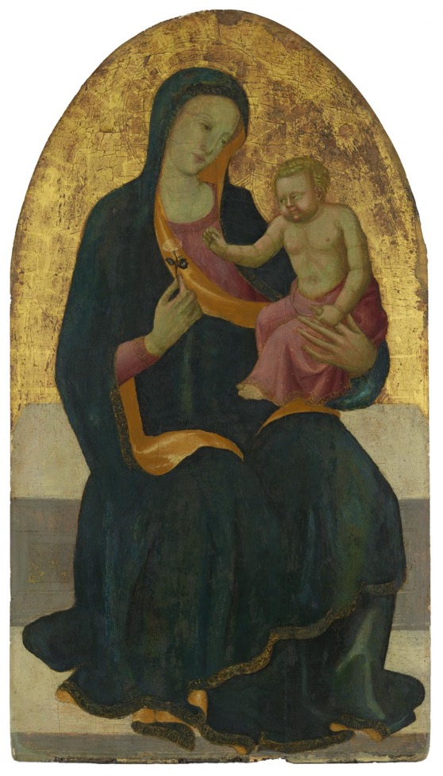
Fd103870
Giovanni Toscani
Madonna and Child early 15th century
oil, tempera and gold leaf on wood panel
121.7 x 67.3 cm
National Gallery of Victoria, Melbourne

Although widely accepted, Mack’s interpretation of pseudo-scripts in Italian painting of the fourteenth and fifteenth centuries is not without problems. First, it is founded upon an assumption that Italians of this period were ignorant of the fact that Arabic was not a major language of the Holy Land until the seventh century CE. The late thirteenth century had seen a new interest in languages and writing systems arise in Italy. Figures such as the friar Riccoldo da Monte di Croce read and spoke Arabic, expressing admiration for a language he pressed into service in his missionary work in the eastern Mediterranean, and the same period saw major translation projects undertaken resulting in works such as the Rasulid Hexaglot, a fourteenth-century lexicon of Arabic, Persian, Turkic, Greek, Armenian and Mongol, and the Codex Cumanicus, a merchant’s dictionary of Latin, Persian and Cuman, which also included Christian prayers and biblical passages rendered into Persian.[15] Educated Italians, especially clergy, were far from ignorant about the languages of the East. At the same time, the texts of scripture – familiar to the educated at the very least – made it clear that the dominant languages of the Holy Land at the time of Christ were Greek, Aramaic, Hebrew and Latin. So, the titulis crucis, discovered in the church of Santa Croce in Gerusalemme in Rome in 1492 and probably a forgery of the twelfth century, makes use of Hebrew, Greek and Latin, following the details of the inscription ordered by Pontius Pilate in the biblical text.[16] Reference to Arabic may well have evoked the idea of the Holy Land as geographical locale, but that it also consistently evoked the age of the gospel stories seems less likely. It is true that Arabic is mentioned in Acts 2:1-14 as being heard in Jerusalem at the time of Pentecost, but it is only one among a number of languages. Further, why Arabic and not Hebrew script was chosen by artists to evoke the ancient Holy Land remains without satisfactory explanation.

Another problem relates to the positioning of pseudo-inscriptions on the garments worn by holy figures in Italian paintings; they seem to bear little relationship to the appearance of ornamental inscriptions on the few surviving examples of Islamic tiraz garments.[17] The pseudo-inscriptions as they appear in paintings often occupy liminal positions – on the hems, necks and cuffs of garments. An early fifteenth-century image of the Virgin and Child by Giovanni Toscani (see above) shows pseudo-Arabic script forming bands around the edge of the Virgin’s mantle, around the cuffs of her sleeves and around the hem of the Christ Child’s robe in a manner that became conventional for many Italian representations of these textiles. Surviving historical garments, such as the Veil of St Anne preserved in the Cathedral of Apt in France – a tunic produced in Damietta, Egypt and bearing the name of the Fatimid Caliph al-Mustali (r. 1094–1101) – evidence different dispositions of woven inscriptions; in this example, in three vertical bands falling to the hem, two from the shoulders on the front and one from the central neck on the back.[18] The position of pseudo-inscriptions on painted textiles appears to reflect a compositional decision of the artist, not a reflection of any imported Islamic textiles that may have served as models. What this might mean is considered below.

A more significant issue with Mack’s interpretation of pseudo-script is that it does not account for such inscriptions on works other than paintings depicting holy personages from Christian scripture. The NGV maiolica bowl includes no depictions of Christian holy figures; indeed, the imagery employed on the bowl is overwhelmingly classical in its inspiration – grotesque ornament of a type ultimately inspired by the first-century CE fresco wall decoration of Nero’s Domus Aurea.[19] The pseudo-script does not seem here to serve as an evocation of the Holy Land in the East and the biblical past. This is not to reject outright Mack’s reading of the phenomenon of pseudo-script. Examples such as Filippino Lippi’s c. 1483 tempera on panel in the Norton Simon Museum, California, where St Apollonia from Alexandria bears pseudo-Arabic inscriptions on the hem of her mantle while, next to her, the Italian St Benedict does not, does suggest that the presence of the pseudo-inscriptions is indicating the Eastern origin of the Alexandrian saint.[20] But the combination of classicising ornament and pseudo-script on the NGV bowl indicates that the phenomenon of pseudo-inscriptions is complex and cannot be reduced to a single function. The visual representation of illegible, orientalising language appears to vary in use and register, depending on context.

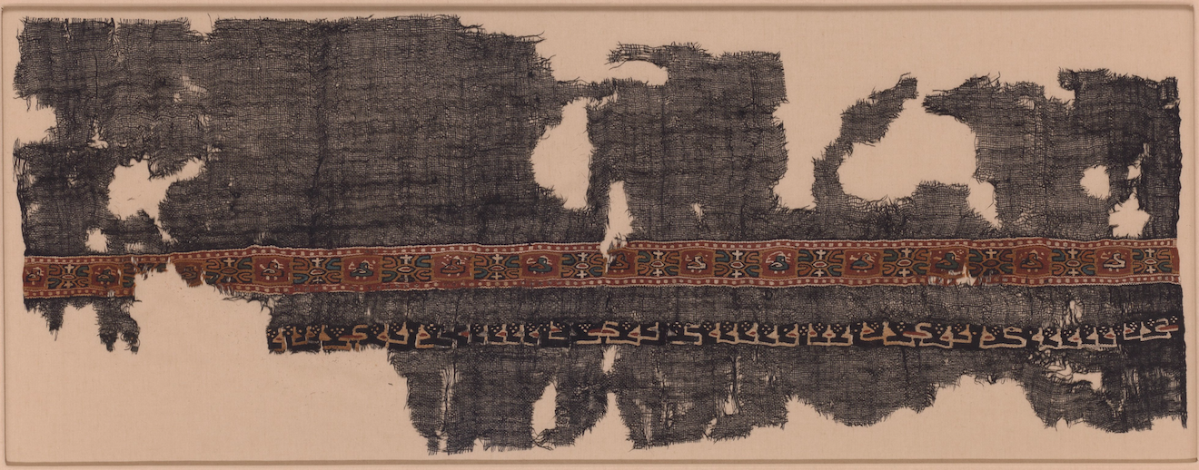
EPUB002723 [INPUT CAPTION BELOW]
Egypt, Fayum
Fragment of a shawl 9th century–10th century
wool, linen; plain weave, tapestry weave
22.2 cm x 59.7 cm
The Metropolitan Museum of Art, New York
(31.19.14)

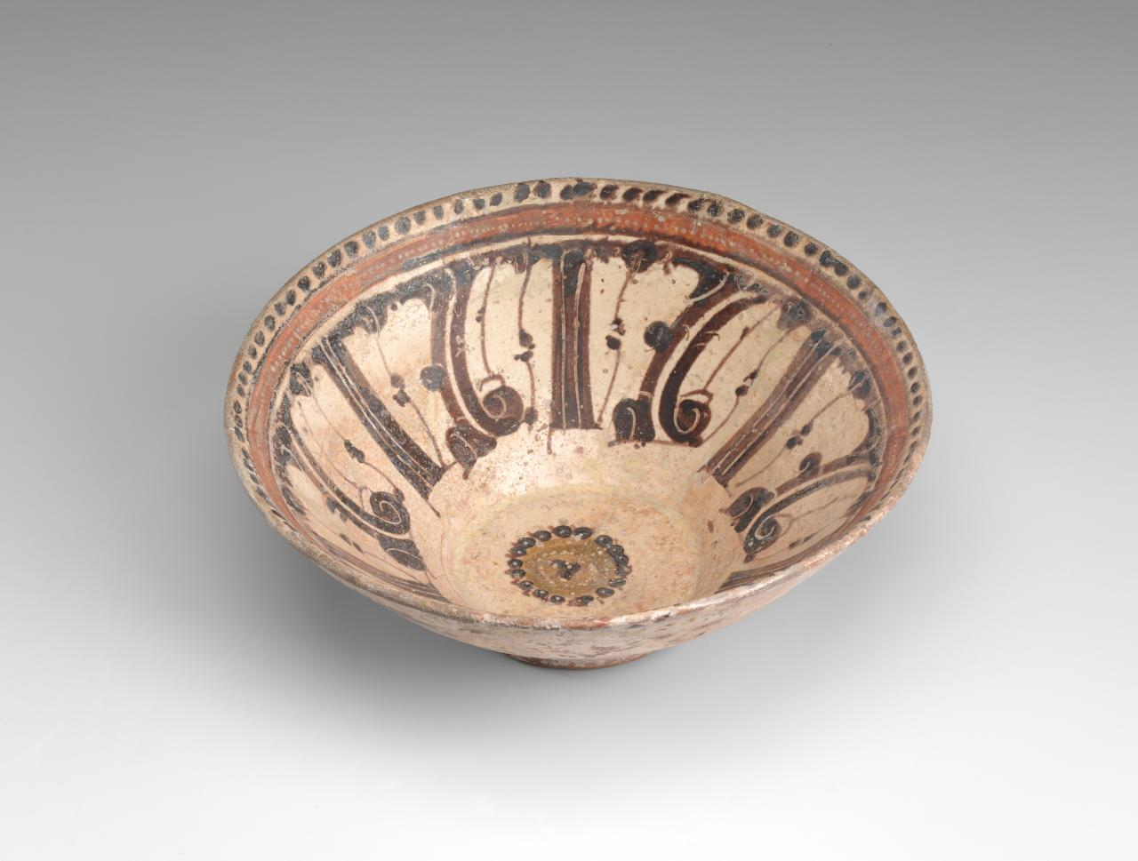
Ca101175
Persian
Bowl 9th century CE-10th century CE
earthenware
10.0 x 24.1 cm
National Gallery of Victoria, Melbourne
(1473-D5)

Calligraphic script was an important decorative device in the arts of the Islamic world and ornamental Arabic inscriptions had appeared on ceramics since the early Middle Ages. The importance of script as ornament was such that a phenomenon comparable to the pseudo-inscriptions developed, especially evident in regions where languages other than Arabic, the language of Islam, were traditionally spoken. Pseudo-Arabic inscriptions are found on textiles produced in early Islamic Egypt from the ninth century (see above).[21] A tenth-century CE bowl from Nishapur in Iran bears an ornamental Kufic inscription that is so stylised as to border on illegibility, but remains possessed of great ornamental power (see above). Similar ornamental inscriptions occur on ceramics produced in Christian Valencia in early modern Spain where lustre-glazed pottery, produced in imitation of both imported Islamic ceramics and ceramics produced in Malaga in the Muslim Kingdom of Granada, often features Kufic and pseudo-Arabic script as decoration. A plate produced in c. 1430 for the Florentine Dazzi family, probably in Manises, is decorated with a central palm tree motif surrounded by reserves with a repeating al-afiya motif – a stylised shorthand of the Arabic word for ‘health’ and ‘happiness’ (see below).[22]
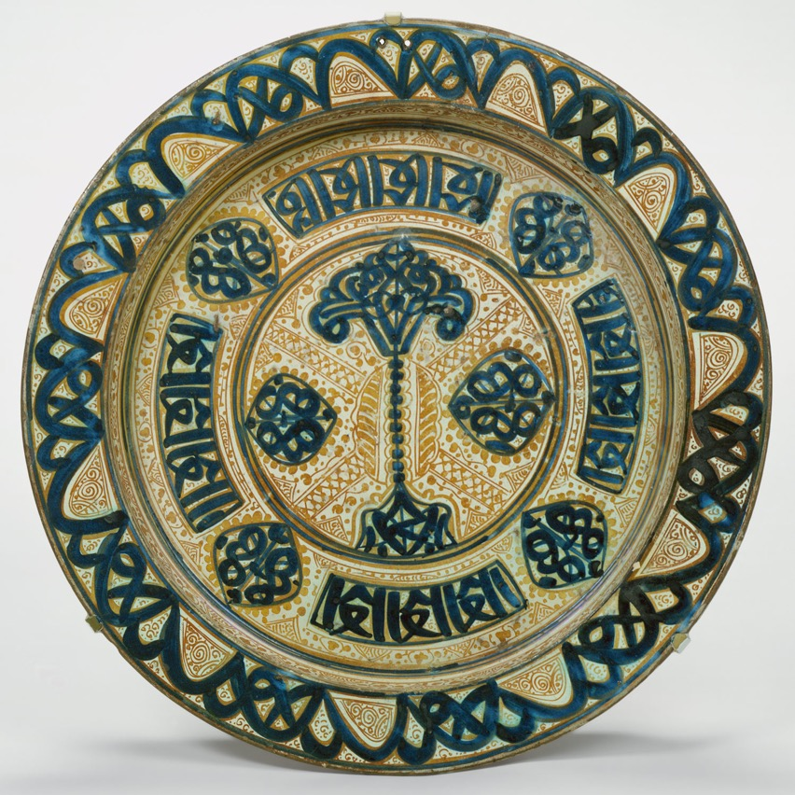
EPUB002719 [INPUT CAPTION BELOW]
Spain (Valencia)
Deep dish (brasero) c. 1430
tin-enamelled earthenware
6 cm x 45.1 cm
The Cloisters Collection, 1956
The Metropolitan Museum of Art, New York
Spanish ceramics were enormously popular among Italian elites in the fourteenth century and were an important stimulus for the development of the Italian maiolica tradition. The use of heavily stylised Arabic inscriptions and pseudo-script as ornament on these Spanish imports led to the development of pseudo-script decoration on Italian ceramics. A fifteenth-century Florentine storage jar evidences bands of abstracted geometric decoration that ultimately derive from ornamental Kufic inscriptions, just as the form of the vessel itself, the albarello, derives from a Syrian ceramic form (see below).[23] But such pseudo-Arabic decoration in fact remained relatively uncommon on Italian maiolica of the fourteenth and fifteenth centuries, especially so on istoriato wares.[24]
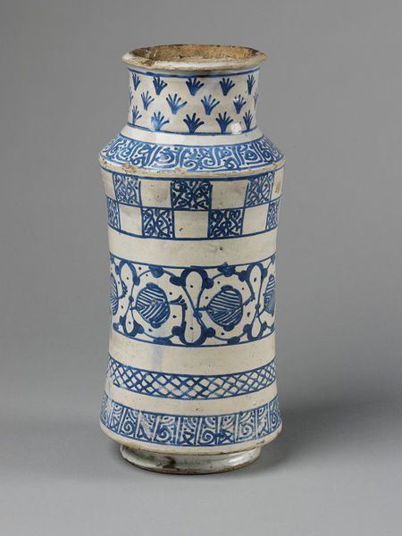
EPUB002721 [INPUT CAPTION BELOW]
Florence
Storage jar c. 1400
tin-glazed earthenware
V&A, London
(47-1907)

Of quite a different character are the pseudo-inscriptions on the NGV maiolica dish. The appearance of the inscriptions in tabulae emphasises their nature as writing, not simply abstracted ornament. It may be argued that the point of the pseudo-script on the NGV dish is to foreground the viewer’s inability to read the inscription. The markings present the formal characteristics of written text. The implication is that there is knowledge on display, but it is secret knowledge – perhaps accessible to the holy figures in paintings where pseudo-inscriptions appear, but not to the viewer. This idea of secret knowledge, of the unknowable but nevertheless significant and meaningful, deserves further exploration. The liminality of pseudo-inscriptions on textiles in Italian paintings – occurring on the borders of garments where the body emerges; on the edges of textiles employed as cloths of state; even around the entrances to tents[25] – has led to the suggestion that the inscriptions may have served some protective, talismanic function. Certainly, Islamic textiles frequently bore inscriptions that appear to have served to invoke blessing (baraka) and protection upon the wearer.[26] Apotropaic and magical significance have been attributed to pseudo-script, including pseudo-Arabic, by a number of writers.[27] Don Skemer has discussed the use of pseudo-script in late medieval textual amulets in Europe.[28] Alicia Walker has argued that pseudo-Arabic inscriptions occurring on an eleventh- to twelfth-century Byzantine enamelled glass bowl, preserved in the Treasury of San Marco in Venice, were intended to enhance the magical potency of the object and aid in its function as a divination device. Walker identifies a tradition current among twelfth-century Byzantine elites associating divination and occult knowledge with various Islamic groups deemed to be the inheritors of ancient Persian and Chaldean wisdom.[29] In this context Arabic letters became associated with magical knowledge. But as Venetia Porter demonstrates, Arabic letters, and especially the script form known as linear Kufic, was assuming growing significance in magical traditions of the Islamic world itself at the same period, a significance that continues until today.[30] The existence of the Aljamiado manuscripts collected as the Libro de dichos maravillosos, an assortment of amuletic, incantation and divinatory texts recorded in a form of Spanish written in Arabic characters by Moriscos, Spanish Muslims, suggests the continuing significance of written Arabic, including pseudo-Arabic, in folk religious contexts in Spain until the early seventeenth century.[31] The significance of Arabic writing in late medieval and early Renaissance European occult speculation is emphasised by the presence of Arabic letter forms, alongside other magical symbols, in the magic circle at the feet of the allegory of Faith in Giotto’s 1306 fresco in the Scrovegni Chapel, Padua (see below).[32]
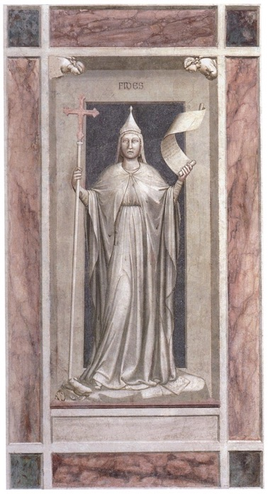

EPUB002725
Giotto
Faith 1306
fresco
detail of a manuscript from the series The Seven Virtues
Scrovegni (Arena) Chapel, Padua, Italy
Image courtesy WikiArt

But how does illegible writing, writing from which the viewer can extract no semantic sense, come to assume such significance?

In the classic stage act, the magician pronounces the word ‘abracadabra’ before pulling a white rabbit from her top hat. This ‘magic’ word is the talisman that effects the breaking of the laws of nature and conjures the furry creature out of nothing. Of course, the rabbit conjuring act is an illusion, entertaining precisely for creating the seeming of a rational, natural order upended. The stage trick invites us to momentarily suspend disbelief and contemplate a universe where human will can alter physical reality and where the agent of such power is spoken language. It is the utterance of the ‘power-ful’ word that effects change.

Speech act theory recognises the performative utterance, a spoken sentence that changes social reality.[33] When a police officer declares to a suspected criminal ‘you are under arrest’, the legal status of the detained person is transformed and their freedoms are, at least temporarily, subject to new limitations. The police officer’s words, when uttered in a specific context (that of an arrest), have effected change upon the detainee. In the pre-modern world, language was frequently held to be able to change, not only social reality, but physical reality too. This is the origin of the modern notion of ‘magic’ – the right words uttered in the appropriate ritual context could effect change in the universe. But the term ‘magic’ itself is problematic insofar as it carries negative connotations. It implies illicit use of efficacious language. The words of the Mass effecting transubstantiation of the elements of the Eucharist into the body and blood of Christ was historically an acceptable use of ritual language to achieve material transformation; the use of ritual language to curse and do harm to another was sorcery – a use of powerful words in breach of social, cultural and legal convention. With the rise to dominance of Christianity in the Mediterranean world from the fourth century onwards, the ritual use of language associated with non-Christian religion was also deemed illicit, associated with idolatry, and thus dubbed sorcery or ‘magic’.[34]

The modern stage magician’s utterance of ‘abracadabra’ is a memory of this belief in the efficacious power of language. Indeed, the word is of ancient origin. It is first attested in the late second century CE, in the De medicina praecepta of the Roman scholar and physician Quintus Serenus Sammonicus.[35] Sammonicus recommends writing the word on a piece of papyrus as part of a cure for malarial fever. Already in the second century, this was a word possessed of power. The word’s linguistic origin is disputed; it has been variously parsed as Aramaic or Hebrew (אברא כדברא), but none of these etymologies is wholly convincing.[36] Further we can be fairly certain that Sammonicus had little or no knowledge of either of these Semitic languages anyway. The word gained its mysterious power precisely because its linguistic content was indeterminate. Greek and Latin texts of ritual power from the Late Antiquity period are littered with words and names borrowed from the religious traditions and languages of the Near and Middle Easts. Names are deemed powerful words in many cultures. Pronounce someone’s name in their hearing and you immediately capture their attention. Likewise, to utter the name of a divinity or spirit was to draw their attention and invoke their power in the ritual at hand. It mattered little if one understood the name, or the language in which it was pronounced – the being invoked knew its name and responded regardless. Indeed, the use of strange-sounding names in unfamiliar languages must have heightened the sense of mystery associated with their ritual use and thus have rendered them even more powerful. This recognition of the power of unintelligible but nevertheless efficacious language was not restricted to illicit contexts. The Church Father Origen acknowledged the power of the Hebrew language, a language of which he probably had very limited, if any, real knowledge. According to the Hebrew Bible, God had created the cosmos through a speech act – ‘And God said, Let there be light’ – and so, for Origen, the very sounds of Hebrew were imbued with creative power.[37] The language was to be uttered with care, whether one understood what one was saying or not, less reality be affected.

The same power was, as Sammonicus’s use of abracadabra in a fever cure implies, also attributed to the written word. Writing imbued speech with duration beyond the act of speech itself. Ritual texts – talismans and amulets – exploited unintelligible language in written form with the advantage that their mere visual and physical presence effected the perpetual reiteration of the efficacious words. Such a tradition of efficacious but nonsensical written language can be traced in the Mediterranean world from Late Antiquity[38] through the Middle Ages[39] into the early modern period, as Giotto’s use of a magic circle replete with strange characters and pseudo-Arabic letters in the Scrovegni Chapel evidences. Such writing, above all, spoke of power. It was exclusionary in nature, as is all writing in social contexts where literacy is not universal. Where literacy is restricted to a social elite, the notion of ‘writtenness’ itself can come to be a marker of status. Imitations of the formal characteristics of written script – regardless of any meaning conveyed by the writing-like marks made – can serve to associate the (perhaps illiterate) individual with the authority derived from the prestige of writing elsewhere in the social system. But pseudo-script is universally exclusionary. The notional language it records is inaccessible to all bar, perhaps, supernatural or transmundane beings. To produce marks that are the script of an unknown language is to claim, or impute, association with a power that sits outside normal social power structures.

There exists, then, strong circumstantial evidence to consider the possibility that the appearance of pseudo-inscriptions on the NGV maiolica dish may have communicated some of these ideas about power to their viewer. Their occurrence in tabulae, emphasising their character as writing, and the currency of pseudo-inscriptions in contemporary Italian sacred art suggests as much. Pseudo-inscriptions on istoriato maiolica are, as we have noted, very unusual. How would such inscriptions have been understood by educated Italian elites using these vessels in dining contexts?[40] It is unlikely that the inscriptions possess any overtly amuletic properties – inscribed Islamic ceramics often bear wishes of health to the diner, but the sheer rarity of pseudo inscribed istoriato ceramics seems to tell against such an interpretation of the Italian examples. It is of note that decorative schemes involving grotesque ornament incorporating tabulae are not uncommon on istoriato ceramics of the fifteenth and sixteenth centuries, but where inscriptions occur on these objects, they frequently consist of dates, and the abbreviation SPQR. The association of classicising, indeed archaeological, grotesque ornament and the title of the government of the Roman Republic is perhaps unsurprising. The inclusion of dates in many of these examples, reflecting the contemporary manufacture of the ceramics, perhaps suggests an antiquity redivivus, a goal of the humanist project.[41] As Luke Syson argues, the decoration on istoriato tablewares frequently functioned as a celebration of the interests of humanist culture in the context of the villa and its associations with rustic conviviality.[42]

This makes the juxtaposition of grotesque ornament and pseudo-script even more unexpected. Do these inscriptions serve to suggest – through comparison to Rome itself and through evocation of the ‘East’– the antiquity of the Islamic Caliphate and its civilisation? The band of bianco sopra bianco ornament surrounding the well of the dish, also known as damaschino schietto (white damascene), similarly evokes Islamic decorative styles.[43] Such a reading would perhaps sit well with the bellicose image of a boy armed with sword and shield depicted in the well of the dish, standing ready to battle an empire whose power and prestige had long been perceived as a threat to Europe. Or is this too literal a reading of the pseudo-inscriptions as pseudo-Arabic? Rather than suggesting a particular cultural geography, does the pseudo-scripting instead emphasise illegibility itself and thus serve to evoke a sense of the mysterious and to function as a marker of alterity? Much that was being unearthed in early archaeological investigations must have seemed highly mysterious to humanist scholars. Inscriptional material that was fragmentary and/or difficult to decipher was encountered. The growth of interest in the fifteenth century in Egypt and the Hermetic tradition, as exemplified by the writings of Marcilio Ficino, stimulated curiosity concerning hieroglyphics. Ficino’s translation of the Corpus Hermeticum wherein he established a chronology of ancient philosophers, from Hermes Thuet through to Plato, resulted in the view that the Classical world that was the object of humanist interest was but the heir of Egypt’s ancient wisdom. Egyptian hieroglyphics, an ancient writing system whose proper decipherment escaped scholars until the nineteenth century, were construed to be sacred, divinely inspired, and an unparalleled repository of learning.[44] The currency of such ideas was encouraged by the discovery in 1419 by the Florentine traveller Christoforo Buondelmonti of a manuscript of the Hieroglyphics of Horapollo, the only treatise on hieroglyphics to survive from Classical antiquity, probably dating to around the fourth century CE. This work, in poor Greek, did much to encourage the entirely erroneous conception that hieroglyphic writing represented an ideal, Platonising and allegorical script, where the written sign was a symbolic expression of the word it represented – a true philosophical language.[45] Such speculations about the nature of hieroglyphics, as well as other aspects of the Hermetic tradition, were quickly taken up into what in modern-day terms would be referred to as esoteric philosophy, although in the Renaissance such learning was continuous with philosophy and science as it is understood today.

The idea of mysterious writing hailing from the ancient eastern Mediterranean was, thus, current in the fifteenth and sixteenth centuries among the humanist elites who were also the primary consumers of istoriato maiolica wares. This is not to suggest that the pseudo-inscriptions on the NGV dish are masquerading as hieroglyphs – the ‘hieroglyphs’ that appear in the 1499 Hypnerotomachia Poliphili of Francesco Colonna suggest that fifteenth-century imaginings about this writing system were quite literal in their pictorialness.[46] Rather I suggest that a new awareness of, and engagement with, Eastern languages and scripts, both ancient and modern, informed elite Italian views of the world. This included notions of power associated with these languages – political power and, especially in their written form, more inchoate forms of power. Pseudo-scripts evoke no particular language. Instead, they evoke here the idea of written language and the power of inaccessible knowledge. Alexander Nagel has suggested that the extreme rarity of pseudo-scripts in Italian painting after about 1520 may be attributed to a shift from viewing the biblical East as the origin of civilisation, to viewing Europe’s past firmly rooted in the Classical world.[47] The axis of the world shifts from Jerusalem to Rome.[48] The classicising grotesque ornament of the maiolica dish reflects this renewed interest in the Classical past. However, where the majority of such grotesque ornamented ceramics invoke the SPQR of ancient Rome, the NGV maiolica dish conjures an ancient past that was party to lost and hidden knowledge, knowledge that still loomed up out of the East, and to which Rome was but a beneficiary.

Matthew Martin is Lecturer in Art History and Curatorship, University of Melbourne

