Building knowledge in urban agriculture: the challenges of local food production in São Paulo and Melbourne

Luís Fernando Amato-Lourenço, PhD. Faculty of Medicine, University of São Paulo, Brazil. Researcher collaborator of the Group of Studies in Urban Agriculture - GEAU IEA/USP. @ - luisfamato@usp.br
Rafael Junqueira Buralli, M.Sc, and PhD candidate. School of Public Health, University of São Paulo, Brazil. Researcher collaborator of the Group of Studies in Urban Agriculture - GEAU IEA/USP. @ - rafael_buralli@usp.br
Guilherme Reis Ranieri, M.Sc., and PhD candidate. Faculty of Medicine, University of São Paulo, Brazil. Researcher collaborator of the Group of Studies in Urban Agriculture - GEAU IEA/USP. @ - guilherme.ranieri@usp.br
Adrian H. Hearn, PhD. Professor of Spanish and Latin American Studies, University of Melbourne. @ - a.hearn@unimelb.edu.au
Chris Williams, PhD. Lecturer in Urban Horticulture School of Ecosystem and Forest Sciences, University of Melbourne. @- chriscw@unimelb.edu.au
Thais Mauad, PhD. Professor at Faculty of Medicine, University of São Paulo, Brazil. Coordinator of the Group of Studies in Urban Agriculture - GEAU IEA/USP. @ - tmauad@usp.br

1 – Department of Pathology, School of Medicine, University of São Paulo – São Paulo, São Paulo, Brazil.
2 – Study Group on Urban Agriculture of Institute of Advanced Studies (IEA) – University of São Paulo – São Paulo, São Paulo, Brazil.
3 – School of Languages and Linguistics, University of Melbourne
4 – School of Ecosystem and Forest Sciences - University of Melbourne
5 – Departamento de Saúde Ambiental, Faculdade de Saúde Pública, Universidade de São Paulo.

Abstract

Key words: Urban Food Production; Urban Agriculture; Resilient Cities; Urban Community Gardens.

Background
Despite the progress made in recent decades on reducing global undernourishment, the Sustainable Development Goals (SDGs) released in 2015 note that ending hunger, achieving food security and sustainable agriculture, and improving nutrition are significant challenges facing a highly industrialized and urbanized world (United Nations 2015). In 2017, it was estimated that dietary risks factors caused 11 million deaths and 255 million Disability Adjusted Life Years (DALYs). High intake of sodium and low intake of whole grains and fruits were the leading risk factors globally and in many countries (Afshin et al. 2019). In Brazil, low intake of whole grains was the leading dietary risk factor for deaths and DALYs (Afshin et al. 2019). A recent Urban Health report from the UN and the WHO estimates that by 2050 more than 6.3 billion people – or 65 percent of the world’s population – will live in cities, generating an unprecedented need for sustainable production of quality food (World Health Organization & UN Habitat 2016).
As urban populations grow, the burden of poverty, food insecurity and malnutrition shift from rural to urban areas (Ruel et al. 2017). Urban environments therefore face multiple burdens: nutrition-derived growth stunting in low- and middle-income countries and increasing rates of overweight and obesity in Latin America and the Caribbean (World Health Organization & UN Habitat 2016). In their efforts to ensure sustainable urban food systems and provide public access to affordable and quality food, city governments must identify and pursue emerging opportunities (Ruel et al. 2017). This article considers the place of urban agriculture (UA) in that endeavor.
The food security, educational, and health benefits of urban agriculture are internationally recognized as an opportunity for public policy innovation (World Health Organization & UN Habitat 2016). As discussed below, the practice can reduce social, environmental and economic pressures through waste recycling, accessibility to safe and nutritious food, reduced transportation and associated emissions, employment and commercial uplift, and climate change resilience (Orsini et al. 2013). For those involved in cultivation, UA can help to reduce spending on food purchases and generate income, improve dietary health and physical activity, and promote gender-inclusive socialization (Giacché and Porto, 2015; Ruel, 2017; Orsini et al. 2013; Giacchè & Porto 2015; Ruel et al. 2017). While UA remains fragmented and incipient in many cities, its benefits are leading municipal governments worldwide to experiment with policies to support urban farmers. Below we analyze how São Paulo and Melbourne are working to overcome the related challenges.

Why São Paulo and Melbourne?
Like Brazil, Chile, and several other South American countries, Australia is highly urbanized and faces challenges in sustainably managing the growth of its cities. Some of the urban challenges faced across these regions bare similarities, but approaches to overcoming them vary considerably. Herein lie opportunities for comparative study of urban farming governance in Melbourne and São Paulo, including approaches to food systems resilience.
Australia and Brazil reflect a comparable history of food production: from indigenous subsistence farming to colonial agriculture, and subsequent reliance on transnational agribusiness to service European and more recently Chinese demand (Alejandro 1985, Hearn 2012). The expansion of commodity crops in both countries has combined with rapid urbanisation to encroach on peri-urban land, where fresh food has historically been grown for both nations’ cities. This process has stimulated greater awareness of industrial agriculture’s myriad consequences and an emerging rediscovery of urban agriculture and horticulture at the community scale, separate from traditional commercial market or subsistence gardens on the urban fringe (Carey et al. 2016, Rose and Hearn 2017, Williams and Rayner 2016). Much of the revival of community-driven urban agriculture is taking place on public land in inner cities areas. These areas face various pressures and challenges: intense competition for land; loss of subsidised council allotments and horticulture staff; decline in extension services to gardeners and growers; and contaminated air, water, and soil (McSweeney et al 2014) Below we outline recent projects in Melbourne and São Paulo, and on the basis of their achievements and setbacks, note some mutually relevant insights for strengthening their food systems.

Urban Agriculture in Melbourne
Australia has one of the highest rates of urbanisation in the world, with more than 75 percent of the population living in five cities: Sydney, Melbourne, Brisbane, Perth and Adelaide. Melbourne is projected to overtake Sydney as Australia’s most populous city by 2028, with overseas migration and university student enrolments expected to underpin population growth from five million in 2019 to eight million in 2050 (Longbottom and Knight 2018, Urban 2018). The city is world-renowned for its living standards, ranking among the first in the Economist Intelligence Unit’s index of “most livable cities” (EIU, 2018). It is located at the center of a highly productive agricultural area, with the surrounding peri-urban “foodbowl” producing around 47% of the vegetables grown in Victoria State (Carey et al., 2016).
It is estimated that over 15,000 tons of food is required each day to feed Melbourne (Sheridan et al., 2016), but the projected 2050 population will demand at least 60% more food from a diminishing area of arable land. Commercial market gardens within and around the city face constant pressure to retain their land as real estate developers identify new commercial opportunities (Brown, 2004). Among the consequences of high food demand and shrinking local supply is price inflation (Carey et al., 2016). Aiming to increase the resilience and sustainability of the city’s foodbowl while maintaining fresh food affordability, the Future Melbourne Plan has set a target for 30% of food consumed in the city to be grown within 50 km of the municipality by 2020 (City of Melbourne, 2008). While pressures mount on the traditional market garden sector, community based urban agriculture or community gardening has grown rapidly since 2005 especially in the inner and middle ring suburbs of the metropolitan Melbourne (Williams and Rayner 2016). Gardening in Australia ranks in the top five leisure activities undertaken by citizens within their households (Lawrence, 1997). The first official community garden in Melbourne was established in 1977 in Nunawading (Hering, 1995) and many other were created during this period, such as the Collingwood Children's Farm, funded in 1979 to provide disadvantaged inner city families with some semblance of experience of farm life through orchards, vegetable gardens, and access to livestock such as sheep, cows and horses (Lindsay 1992). .
Community gardens in Melbourne demonstrate two modes of land use: individually managed garden beds and communal or shared spaces, where gardeners work jointly on the same bed. Many individuals and associations use urban agriculture as part of their work, including private practice, public service, and academic research (Burton et al., 2013). Furthermore, some of the city’s urban agriculture initiatives have engaged migrants in gardening activities. The non-profit organization Cultivating Community endeavors to “engage people in activities relating to plants and food that share skills and knowledge [and to] increase their sense of community and connectedness with those around them” (Cultivating Community, 2009). In an attempt to help immigrants to settle into Melbourne and develop social connections, the project’s four community gardens—each containing between 12 and 126 plots—prioritize places for refugees. Another initiative, called “Dig In Community Garden" was established in 2002 in Port Melbourne with 58 allocated plots. The project was created after the construction of a major real estate development as an attempt to promote social cohesion in a high-density context. The gardeners are mostly middle-class, female and in their 50s (Kingleys and Townsend, 2006), demonstrating the range of urban agriculture initiatives currently flourishing in the city. In 2017, two hundred community gardens and city farms in the Victoria State were registered in the ACFCGN platform (Figure 1) (ACFCGN, 2018).
The University of Melbourne hosts two community gardens run by staff, students, ex-students and locals. The community gardens are located at the university’s Parkville Campus (MUC Garden) and at the Burnley Campus of the University (where horticulture has been taught since 1891). The main activities include the cultivation of vegetables herbs and fruit, composting, research into novel crops (including indigenous vegetables) and hosting educational events and workshops on fermenting, germinating, irrigation, etc (Williams 2016, Williams and Rayner 2016; Williams 2018).

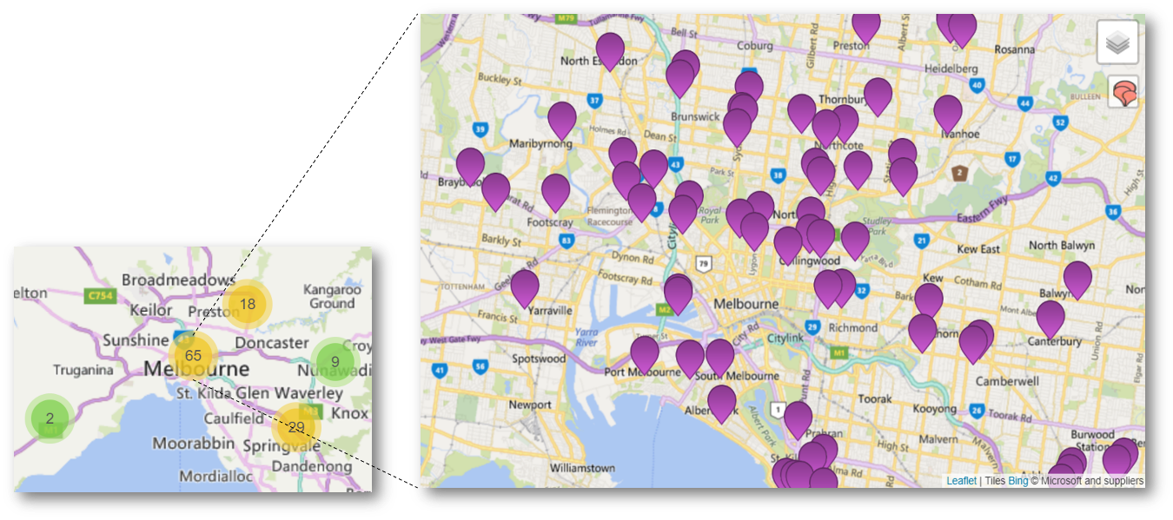
Figure 1 - City Farms and Community Gardens registered on the ACFCGN platform (ACFCGN, 2018).

Another of Melbourne’s key educational platforms for UA is the “Centre for Education and Research in Environmental Strategies” (CERES), a not-for-profit community business based on social and sustainable programs. CERES is located on 4.5 hectares adjoining the Merri Creek in East Brunswick, Melbourne. Established in 1982, it operates extensive research and education projects including permaculture training and a bush food nursery. CERES has received funding from municipal, State and Federal government programs, as well as corporate bodies and philanthropic organizations. In 2020 its international division, CERES Global, will develop a project with urban farmers in Chile.
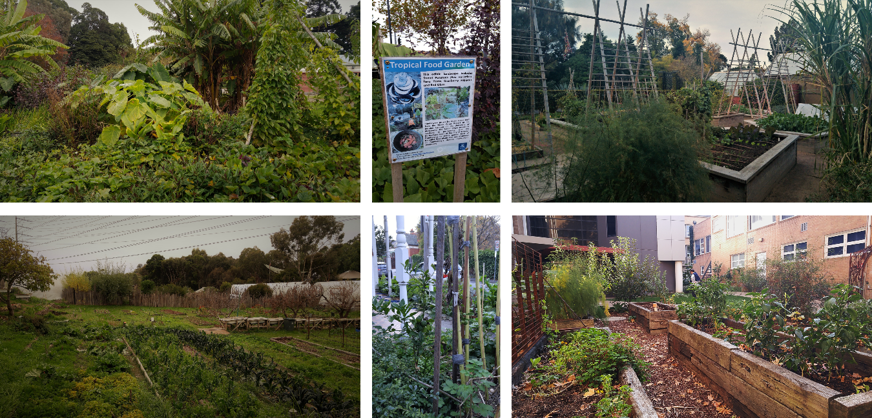

B
A
C
D
EE
F

Figure 2 – A and B: Novel Crops food garden on Burnley Campus of University of Melbourne. C: vegetable garden on Royal Botanic Gardens Victoria. D: vegetable garden on CERES – Centre for Education and Research in Environmental Strategies. E: front yard food garden in Brunswick, an inner-city suburb of Melbourne. F: Melbourne University community garden.

Metropolitan Melbourne is home to 30 municipalities or local government councils. As community interest in urban agriculture has grown various local councils have responded by allocating resources to community gardens and developing strategies. For example, the City of Yarra (which incorporates the inner city suburbs of Fitzroy, Collingwood and Richmond) was the first council in Australia to employ a dedicated Urban Agriculture Facilitator in 2012 (Williams and Rayner 2016) and has recently produced its second Urban Agriculture Strategy (City of Yarra 2019).

Meanwhile, the City of Melbourne (the local government council at the heart of metropolitan area which incorporates the Central Business District) is also engaging with community interest in growing food. The Community Garden Policy sets out the City of Melbourne’s role in managing community gardens on land it owns. This includes the City’s aims for the gardens and the resources it will invest in them, as well as its principles for their operation and how it assesses proposals for new community gardens. The policy responds to two key goals articulated in the City of Melbourne Council Plan 2013–2017: to achieve “a city for people” and an “eco-city”. The policy’s scope is limited to community gardens that operate on land that the City of Melbourne owns, and does not include gardens on privately-owned land (City of Melbourne, 2013).
In addition to the Community Garden Policy, in 2015 the City Council published “A Guide to Community Gardening in the City of Melbourne” - a companion document of policies regulating urban community gardens that provides more details about planning, operating and management (City of Melbourne, 2015). The document outlines requirements that must be addressed when developing a proposal for a community garden; the essential aspects of running a successful community garden, such as location, funding, health, safety and welfare, pests and soil contamination issues; and the criteria for formulating an Expression of Interest for a community garden on land that the City of Melbourne owns and/or manages. The document also addresses the issue of soil contamination in the city due to past industrial uses, noting the requirement that “potential community garden sites should be investigated prior to planting.” Further, the document cites certain types of inappropriate locations for community gardening purposes such heritage listed sites, roadside nature strips, public parks and gardens.

Urban Agriculture in São Paulo
The city of São Paulo, which is the capital of the state of São Paulo, is the largest and most populous city of Brazil, and one of the most inhabited cities in the world. It is the main Brazilian industrial centre and has approximately 12 million inhabitants distributed in an area of 1521.11 km² (IBGE - Instituto Brasileiro de Geografia e Estatística, 2017). The city of São Paulo has a broad contrast in the socioeconomic status within its regions, being the peripheral neighborhoods those with lower Municipal Human Development Index (MHDI), which considers longevity, income and education (Ribeiro et al. 2019). The MHDI varies between 0.689 and 0.972 (Prefeitura de São Paulo, 2017).
According to the Brazilian Institute of Geography and Statistics, in 2017, the city of São Paulo had about 550 agricultural establishments, with 441 men and 93 women working as farmers– being only 10 individuals younger than 30 years old. Only 26% of the establishments have regular public technical assistance, and 25% use pesticide for pest control. In 2017, the city of São Paulo produced 117,188 tons of banana, 11,256 tons of cassava, 70,695 tons of corn, 40,473 tons of pumpkin, 25,338 tons of beans, 16,590 tons of sugar cane, among other crops in smaller scale (IBGE - Instituto Brasileiro de Geografia e Estatística, 2017). Although the yearly food consumption per household (mean) in the South Region of Brazil is about 36.7 kg of cereals, 32.4 kg of vegetables, 11.5 kg of legumes, and 2.7 kg of leaf, only about 5-11% is produced for self-consumption, mainly in rural areas. Moreover, it was observed that as the Brazilian’s income increases, the consumption of basic food such as grains and legumes tend to decrease, and the fruit and vegetable increase (Orsini et al. 2013).
Farming has always been conducted in the city of São Paulo, and commercial agriculture started in the early 1900s in the Southern region (Parelheiros), driven by Japanese and German immigrants (Giacchè & Porto 2015). Nowadays, this region stills very important for its agricultural production, and has a large area of environmental protection of the Atlantic Forest, indigenous reserves and 2 important water reservoirs that substantially help to supply the metropolitan area, Billings and Guarapiranga (Nakamura, 2017). Although commercial urban agriculture in the city of São Paulo date back to earlies 1900’s, only more recently public policies at Federal, State and Municipal levels began to be more effectively created to encourage urban, peri-urban and sustainable agriculture.
In 1980s, the Government of São Paulo State started to stimulate urban agriculture in unused areas of public companies, such as the electrical company ELETROPAULO, the oil and gas transportation TRANSPETRO, and the water and waste management SABESP. Unfortunately, the program was later reduced due to political changes and disputes (Giacchè & Porto 2015). More than 20 years later, in 2004, the Brazilian Federal Government launched the “Program of urban and peri-urban agriculture” (Programa de de Agricultura Urbana e Periurbana). In the same period, the Municipal Government of São Paulo introduced the “Program of urban and peri-urban agriculture of the Municipality of São Paulo” (Programa de Agricultura Urbana e Periurbana no Município de São Paulo - PROAURP), through the Law n. 13.727/2004 to promote urban agriculture as a source of income and social inclusion, but changes in political strategies reduced the project to school gardens more focused on the educational role (Giacchè & Porto 2015). In 2006, the Ordinances 003/2006 and 004/2006 of the Brazilian Federal Government aimed to stimulate the development of community gardens in metropolitan areas, facilitate the transfer of federal resources to the municipalities, and implement support centers to help the purchase of agricultural equipment and inputs (Giacchè & Porto 2015).
Public policies from the federal, state and municipal levels aimed to promote urban and sustainable agriculture in the city of São Paulo. The “Sustainable Guarapiranga Program” (Programa Guarapiranga Sustentável) was launched in 2009 to protect the Guarapiranga Reservoir from environmental degradation (Giacché and Porto, 2015). This watershed, located at the city of São Paulo Green Belt (Biosphere Reserve, UNESCO) in the southern region, has the Municipal Environmental Protection Area of Capivari-Monos, and is one of the main water supply for the metropolitan region (de Brito et al. 2018). The program “Programa de Desenvolvimento Rural Sustentável - Agricultura Limpa” aimed to preserve and recover the watershed areas of the southern of the city of São Paulo.
In 2010, the Decree 51.801/2010 of the São Paulo City Hall started the “Casas de Agricultura Ecológica”, to provide technical assistance to the urban farmers, and in 2012, the Federal Government started the “National plan of agro-ecology and organic production” (Plano Nacional de Agroecologia e Produção Orgânica) to stimulate the development of urban agriculture and organic production. In 2013, the state of São Paulo started the “Program Organic São Paulo” (Programa São Paulo Orgânico) to stimulate the transition from chemical-dependent to organic farming (Giacché and Porto, 2015).
Although public policies provide the legal support, the effectiveness still very challenging and hard to implement. In 2014, in its Strategic Master Plan of the city of São Paulo, transformed 23% of the rural areas in the periphery areas of city in rural areas, to attend the farmer’s demand and stimulate urban and peri-urban agriculture. In 2015, the municipal government signed the Law 16.212/2015, which include the community gardens in the regulation of the participative management of public spaces.

In 2015, the Municipal Law 16.140/2015 determined that the food offered in municipal schools should be organic or of agroecological basis and bought from family farming. To be enrolled in the program, farmers must be organic certified or in agro-ecological transition, preferably from São Paulo. The prices paid by the municipality could be up to 30% higher than the ones bought from the conventional agriculture.
As one can see from the above exposed, legal support for UA exists in the city of São Paulo, but the implementation and continuity of the projects (that are dependent on the political orientation of the current public managers) are erroneous. For instance, Ferreira interviewed twenty organic farmers in 2015 (Ferreira, 2015). Ninety percent of them said that never received any kind of public support, be technical or financial of the local governments. Thirty-eight percent quoted the federal laws related to credit facilities for family farms as example of governmental support. It is also important to notice that the design and implementation of public policies focused on urban agriculture depend not only on the governmental actors but also on the social movements, non-governmental organizations, farmer’s cooperatives and associations (Giacché and Porto, 2015).
In São Paulo, UA practice is heterogeneous, and can be roughly understood as: 1) urban gardens with a socio-educative expression, occurring spread out throughout the city center, based on voluntary work and using agro-ecological principles; or 2) as an occupation that generate income and food to supply the local market, mostly located in the peripheral areas, in the extreme south (e.g. Parelheiros and Marsilac), and some sites in the northern (e.g. Serra da Cantareira and Perus), and eastern region of the city (e.g. São Mateus). UA in São Paulo also occurs on different scales and sites, such as power line areas (by a concession of use), school grounds, public health units, homes, or in public squares (Oliveira, 2017).
Since 2012, inspired by the urban agriculture movements worldwide, community gardens flourished in São Paulo, with peculiar characteristics. Most of them were settled in public spaces, that were underused and with inadequate maintenance by the public authorities. These gardens were occupied collectively, based on agro-ecological rules, without the division in allotments, as it occurs in Melbourne. Everyone interested can work and harvest, without rigid working hours, which limited their potential as food providers. In contrast to Melbourne, there are no municipal orientation or technical assistance to these places, which compromise greatly their existence. In most of these gardens there is limited or no access to water for irrigation or assessment of potential contamination of the soil. On the other hand, some of these gardens became poles of citizen activism, especially in themes related to environmental issues and qualification of public spaces. Nevertheless, these gardens have an important environmental educative role in the city, being associated with themes such as food and animal biodiversity in cities and accessibility to healthy and agroecological grown food.
Because of the difficulties in having access to water, good quality soil and the irregularities in working forces, most of these gardens became beds to wild edible plants (WEP). In Brazil they are known by the acronym PANC (Plantas Alimentícias Não Convencionais), while in Australia they are known as Novel Crops. These plants have recently gained an enormous popularity in Brazil (Kinup; Lorenze, 2014). PANC commonly refer to edible plants that are either ruderal, that were part of our traditional diet but were somehow forgotten or that are traditionally used by other populations but not locally (for instance, some edible Amazon plants are not used in the south of the country, like Acmella oleracea). Commonly, these novel crops are nutritious, plentiful and versatile, and can be used in many receipts to replace and complement conventional foods.
In the Brazilian community gardens, several unconventional vegetables are commonly found, such as malabar spinach (Basella alba L.), pigeon pea (Cajanus cajan), sorrel (Rumex acetosa L.), lamb's ear (Stachys byzantina K. Koch), aromatic and flowering plants; roselle (Hibiscus sabdariffa L.), Indian borage (Plectranthus amboinicus), Malvaviscus (malvaviscus arboreus Cav.), nasturtium (Tropaeolum majus L.), fruits; cambuci (campomanesia phaea), Cattley guava (Psidium cattleyanum), cassabanana (Sicana odorifera). Some of these vegetables are shown in Figure 3.
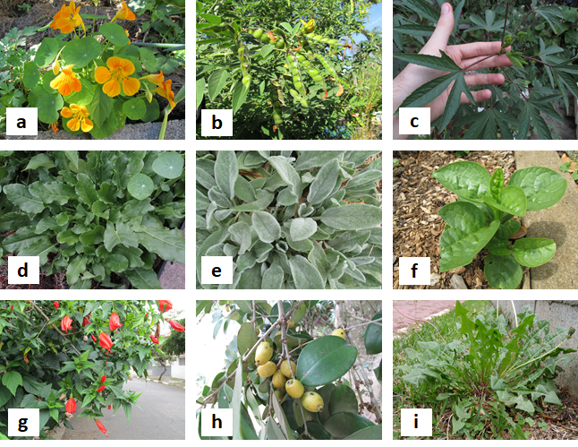
Figure 3 - Unconventional vegetables found in São Paulo’s community gardens. (a) Tropaeolum majus L, (b) pigeon pea (Cajanus cajan), (c) roselle (Hibiscus sabdariffa L.), (d) sorrel (Rumex acetosa L.), (e) Stachys byzantina K. Koch, (f) malabar spinach (Basella alba L.), (g) Malvaviscus (Malvaviscus arboreus Cav.), (h) Cattley guava (Psidium cattleyanum), (i) Dandelion (Taraxacum officinale).

Independent civil movements, like MUDA, gather people from different areas of expertise to exchange to stimulate organic agriculture in the city of São Paulo, and Hortelões Urbanos, created in 2011 as an independent Facebook based network, and which nowadays brings together about 80,000 participants from different regions of the country, promoting a strong articulation between people interested in organic food production in urban areas, whether in public or residential spaces. Initiatives like these boosted the installation and management of community gardens in public spaces in different regions of the city of São Paulo (Giacché and Porto, 2015).
It is known that fruits and vegetable consumption is determined by the availability of these foods where people live, and it tends to be less available in the peripheral lower income regions of the city (Duran, 2003). In these areas, urban gardens are source of income to small farmers, and have a potential role in increasing food security and resilience, by providing access to local production of fresh food. The project “Cidades Sem Fome” (Cities without hunger) was launched in 2004 to build community gardens in unused public and private plots of land and improve poor communities’ income. To date, it has started 25 community gardens, and employed more than a hundred people. It also has the School Gardens Project, that involves local schools and student’s parents to cultivate food and improves diet of several thousand children in 38 gardens in public schools and institutions.
Farmer’s associations and cooperatives also have an important contribution to the amount of food produced in the city of São Paulo. For instance, the “Associação de Produtores Orgânicos da Zona Leste (APO-ZL)” in the East region had more than 60 farmers registered in 2014. COOPERAPAS - Cooperativa Agroecológica dos Produtores Rurais e de Água Limpa da Região Sul de São Paulo, created in 2011, in the Southern region of the city of São Paulo, has 35 registered farmers, mostly in transition to sustainable and organic agriculture. Part of its production is marketed in non-profit stores and fairs throughout the city. In the Northern region of the city, the “Assentamento Irmã Alberta” consists in more than 40 camped families waiting for agrarian reform, and producing quality food following the principles of collective and agroecological production.
Recent effort has been put in trying to foster the distribution of the food produced in the peripheral areas of the São Paulo, especially the agroecological production, to the market, in order to improve financial sustainability of farmers (Oliveira, 2017).
Figure 4 shows the different initiatives related to urban agriculture in São Paulo.
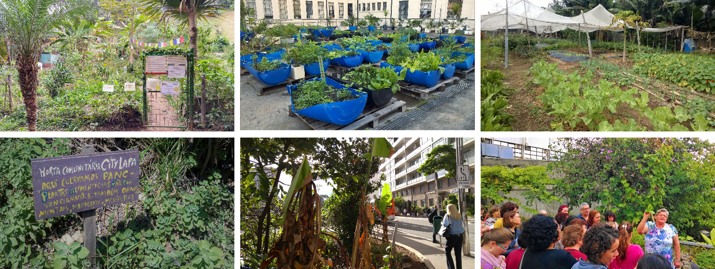

A
B
C
D
E
F

Figure 4 – A: “Horta das Corujas” Community Garden, the first occupation of public space for food cultivation. B: FMUSP community garden located at a rooftop in the Medical School of University of São Paulo. C: vegetable garden for income generation in the eastern region of São Paulo. D: “City Lapa” community garden, known for the cultivation of non-conventional species. E: “Horta dos ciclistas” located in one of the main avenues of the city. F: Educational activity promoted in the FMUSP community garden.

Conclusion
In São Paulo and Melbourne, as worldwide, UA has the potential to increase the access to healthy and affordable food. While in the city of Melbourne it is expected that 30% of food consumed is grown locally by 2020, the city of São Paulo is still mapping its production potential, and finding ways to increase local sustainable food production and distribution. UA can contribute to a more resilient local food supply due to the environmental pressures on food production. In addition, considering the severe social inequalities of São Paulo, it can represent an opportunity to build a socially inclusive urban food system.
In both cities, the access to land is an important limiting issue. Further, in São Paulo, despite many existent public policies aimed to support farmers, the implementation of these policies still very challenging and there is a lack of technical support and resources provisions. Commonly, Brazilian smallholder family farmers are socially vulnerable and rather dependent on public support to boost their production.
Community gardens are popular in both cities. In Melbourne, the city council developed guidelines to orient citizens interested in developing an urban garden, with orientations to clarify issues such as funding, maintenance, composting, water-wise practices, soil contamination, among others. In contrast, the implementation of community gardens in São Paulo is still under regulated, with lack of rules and public support of any kind, limiting these initiatives to environmental and political activism.
As Melbourne and São Paulo deal with deepening food security pressures, it is becoming more important to explore novel crops and alternative sources of protein and nutrition. In São Paulo, these novel crops production are recently increasing, and have an enormous potential to help supply nutrients demand under certain circumstances. Urban agriculture thus has an important role to play, and comparing Melbourne and São Paulo helps to clarify which policy settings and educational initiatives can help to achieve this.

Acknowledgements
This study was funded by the financial support of São Paulo Research Foundation (FAPESP) - SPRINT project 15/50081-2, project 2014/19201-9 and by Coordination and Improvement of Higher Level or Education Personnel (Capes). Rafael Buralli is funded by the Brazilian Coordination for the Improvement of Higher Education Personnel (CAPES).

References
ACFCGN, Australian City Farms & Community Gardens Network, 2018. Directory, Data & Mapping. http://directory.communitygarden.org.au/
Afshin A, Sur PJ, Fay KA, Cornaby L, Ferrara G, Salama JS, Mullany EC, Abate KH, Abbafati C, Abebe Z, et al. 2019. Health effects of dietary risks in 195 countries, 1990–2017: a systematic analysis for the Global Burden of Disease Study 2017. Lancet. 6736.
Alejandro, Carlos F. Díaz. 1985. “Argentina, Australia and Brazil Before 1929.” In Argentina, Australia and Canada Studies in Comparative Development 1870-1965, edited by D.C.M. Platt and Guido di Tella, pp.95-109. London: Palgrave Macmillan.
Baker, Judy L., 2012. Climate Change, Disaster Risk, and the Urban Poor Cities Building Resilience for a Changing World. Urban Development. Washington, DC: World Bank. Available in: <https://openknowledge.worldbank.org/handle/10986/6018> Accessed on: 12/03/2019.
Burton, P., Lyons, K., Richards, C., Amati, M., Rose, N., Desfours, L., Barclay, R., 2013. Urban food security, urban resilience and climate change (pp. 170). Gold Coast: National Climate Change Adaptation Research Facility.
Carey, R., Larsen, K., Sheridan, J. and Candy, S., 2016. Melbourne’s food future: Planning a resilient city foodbowl. Victorian Eco-Innovation Lab, The University of Melbourne.
City of Melbourne, 2008. Future Melbourne Plan. Available in: <http://www.futuremelbourne.com.au/wiki/view/FMPlan/S2G3P5LivingAndWorkingInUrbanCentres> Accessed on 25/06/2019.
City of Melbourne, 2013. Community Garden Policy. Available in: <https://www.melbourne.vic.gov.au/SiteCollectionDocuments/city_melbourne_community_garden_policy.pdf>. Accessed on 25/06/2019.
City of Melbourne, 2015. A guide to community gardening in the City of Melbourne. Available in: <https://www.melbourne.vic.gov.au/SiteCollectionDocuments/guide-community-gardening-city-of-melbourne.pdf> Accessed on 25/06/2019.
City of Yarra, 2019. Urban Agriculture Strategy 2019-2023 City of Yarra: Fitzroy
Cultivating Community, 2009. Cultivating Community Employment Information Kit. Available in: <http://www.sustainablemelbourne.com/wp-content/uploads/2009/02/cultivating-community-community-garden-team-leaderjob-description.pdf> Accessed on: 23/05/2019.
Duran, AC; Roux, AVD; Larorre, MRDO; Jaime, PC. 2013. Neighborhood socioeconomic characteristics and differences in the availability of healthy food stores and restaurants in São Paulo, Brazil. Health & Place 23 (2013) 39–47.
EIU, The Economist Intelligence Unit, 2018. The Global Liveability Index 2018: A free overview. Available in: <https://pages.eiu.com/rs/753-RIQ-438/images/The_Global_Liveability_Index_2018.pdf> Accessed on: 25/06/2019.
Ferreira, JMR. Caracterização dos agricultores orgânicos das feiras da cidade de São Paulo. Thesis presented to the Federal University of Paraná. Curitiba: 2015.
Fundação SEADE, 2017. Sistema SEADE de projeções populacionais. Available in: <http://produtos.seade.gov.br/produtos/projpop/index.php> Accessed on: 25/06/2019.
Fundação SEADE, 2019. Indicadores do Estado de São Paulo. Available in: <http://www.seade.gov.br/> Accessed on: 15/04/2019.
Giulia Giacchè; Lya Porto. Políticas públicas de agricultura urbana e periurbana: uma comparação entre os casos de São Paulo e Campinas. Informações Econômicas, SP, v. 45, n. 6, nov./dez. 2015.
Hartwig, Kari A.; Mason, Meghan. Community Gardens for Refugee and Immigrant Communities as a Means of Health Promotion. J Community Health. 2016. 41:1153–1159. DOI 10.1007/s10900-016-0195-5
Hearn, Adrian H. 2012. “What can South America and Australia learn from each other in relation to China?”, in Ariel C. Armony (ed.), Setting the Agenda: Asia and Latin America in the 21st Century, Miami: University of Miami, pp.33-38.
Hering, I., 1995. Gardens that nourish a community. Melbourne: Whitehorse Gazette.
IBGE - Instituto Brasileiro de Geografia e Estatística. 2017. Censo Agropecuário 2017. Censo Agropecuário [Internet]. [cited 2019 May 4]. Available in: <https://cidades.ibge.gov.br/brasil/sp/sao-paulo/pesquisa/24/76693> Accessed on: 22/06/2019.
Kingsley, Jonathan ‘Yotti’; Townsend, Mardie, 2006. ‘Dig In’ to Social Capital: Community Gardens as Mechanisms for Growing Urban Social Connectedness, Urban Policy and Research, 24:4, 525-537, DOI: 10.1080/08111140601035200
KINUPP, V.F.; LORENZE, H. Plantas Alimentícias não convencionais (PANC) no Brasil. Guia de identificação, aspectos nutricionais e receitas ilustradas. Instituto Plantarum de Estudos da Flora, São Paulo, 2014.
Lawrence, S.M., 1997. The congruent garden: An investigation into the role of the domestic garden in satisfying fundamental human needs. Sydney: University of New South Wales.
Lindsay, A., 1992. Riding Backwards on a Pig: a book about the Collingwood Children’s Farm. Abbotsford: Collingwood Children’s Farm Inc
Longbottom, Jessica and Ben Knight. 2018. “Melbourne's population explosion threatens to create a 'Bangkok situation.'” ABC News, 16th October. Available in: <www.abc.net.au/news/2018-10-15/melbourne-will-be-australias-biggest-city-which-party-has-policy/10358988> Accessed on: 25/06/2019.
McSweeney, P.F., Williams, C.C., Nettle, R.A., Rayner, J.P. and Brumfield, R.G., (2014) Extension approaches for horticultural innovation. In Horticulture: Plants for People and Places, Volume 3 (pp. 1117-1138). Springer Netherlands.
Nakamura, Angelica Campos, 2017. Cooperapas: agricultura e cooperativismo no extremo sul do município de São Paulo, DOI: 10.11606/D.8.2017.tde-09032017-090516
Oliveira, Lya Cynthia Porto de, 2017. Redes, ideias e ação pública na agricultura urbana : São Paulo, Montreal e Toronto. 279 p.
Prefeitura de São Paulo, 2017. A dinâmica do IDH-M e suas dimensões entre 2000 e 2010 no município de São Paulo. Available in: <https://www.prefeitura.sp.gov.br/cidade/secretarias/upload/Informes_Urbanos/29_Dimensoes_IDH-M.pdf> Accessed on: 25/06/2019.
Rose, Nick and Adrian H. Hearn. 2017. Food Systems and the Role of Local Government. Melbourne: SUSTAIN. www.circlesoffood.org/2016/04/18/food-governance-taskforce/
United Nation. Transforming our World: The 2030 Agenda for Sustainable Development. 2015. Available in: <https://sustainabledevelopment.un.org/post2015/transformingourworld> Accessed on: 25/06/2019.
United Nations, 2017. World population projected to reach 9.8 billion in 2050, and 11.2 billion in 2100. Available in: <https://www.un.org/development/desa/en/news/population/world-population-prospects-2017.html> Accessed on: 23/04/2019.
UNIVERSITY OF MELBOURNE (Australia). Southern Cities Research Centre. 2019. Available in: <https://msd.unimelb.edu.au/research/projects/completed/southern-cities-research-centre> Accessed on: 31/05/2019.
Urban, Rebecca. 2018. “Victorians’ concerns for fast-growing city.” The Australian. 5th November. Available in: <www.theaustralian.com.au/news/nation/victorians-concerns-for-fastgrowing-city/news-story/af78fd4fc04e8bd7987aff3c128858b6> Accessed on: 25/06/2019.
VICTORIA STATE GOVERMENT, 2016. Plan Melbourne. Available in: <https://www.planmelbourne.vic.gov.au/> Accessed on: 25/06/2019.
Williams, C. and Rayner, J. (2016). Bucking the trend: growing university enrolments in urban horticulture. Acta Hortic. 1126, 239-248
Williams, C. (2016) ‘Edible Landscapes and Novel Crops’. In Botanic News, Friends of the Royal Botanic Gardens Melbourne Winter Edition
Williams, C. (2018) ‘Native Vegetables Research Review and Scoping Study’ Hort Innovation Australia, Sydney

