Towards a Holistic Assessment of Circular Economy Strategies: Introducing the 9R Index and Closed-Loop Index

Abstract:
Human activities' environmental impacts can be significantly mitigated through the adoption of a circular economy approach in the production and utilisation of materials and products. To facilitate a transition to a circular economy, it is imperative to assess the degree of circularity in various scenarios. Accordingly, the measurement of circular economy strategies at the material and product level has garnered increasing interest in recent years. Consequently, a plethora of overarching guidelines and indicators have been developed, each offering distinct approaches for measuring the performance of circular economy strategies. However, despite the existing range of indicators available to measure the performance of circular economy strategies, a comprehensive set of indicators that integrates the hierarchical strategies proposed by the 10R framework and the butterfly diagram is currently lacking. As a pioneering contribution to the field, this study presents a novel set of indicators that aim to measure the effectiveness of circular economy strategies, considering the hierarchical levels established by the 10R framework. Moreover, this study employs the Analytic Hierarchy Process (AHP) fundamental scale as a means of integration to aggregate the proposed indicators, into a proposed index, named the 9R circularity index. This research study contributes to the field by offering a methodologically robust approach to comparing material flow analysis results, which streamlines the selection and comparison of appropriate circular economy strategies. The proposed approach will provide an easy-to-use data-informed tool to facilitate the transition to a circular economy and improve the environmental performance of human activities.
Keywords:
10R framework, aggregation method, material use, multiple criteria decision-making, closed-loop.

Introduction
A circular economy (CE) has been identified as one approach to reducing human activities material use and waste (Ellen MacArthur Foundation, 2012). The concept has been evolving with several definitions proposed. For the authors, the most comprehensive definition is stated by Zhai (2020), which defines CE as “an industrial system that is restorative or regenerative by intention and design. It replaces the end-of-life concept with restoration, shifts towards the use of renewable energy, eliminates the use of toxic chemicals, which impair reuse and return to the biosphere, and eliminate the waste through the superior design of materials, products, systems and business models. It operates at the micro-level (e.g., products, companies, consumers), meso-level (e.g., eco-industrial parks), macro-level (e.g., city, region, nation and beyond), with the aim to accomplish sustainable development, thus simultaneously increase environmental quality, economic prosperity and social equity, and benefit current and future generations”. This definition identifies that CE is not only about waste reduction practices, but also about reducing other environmental impacts through the use of renewable energy and regenerative products. Moreover, a definition of CE levels is key, as it can help facilitate research at each of the levels, and how they should be integrated to achieve a CE.
Within the CE definition, several frameworks have been proposed as ways to achieve its goal. For instance, the 10R framework defines ten strategies (refer to Figure 1). From the most effective to least, the 10R strategies are: refuse, rethink, reduce, reuse, repair, refurbish, remanufacture, repurpose, recycle, and recover (Potting et al., 2017). The 10R framework prioritises value retention as the CE definition intends to with the hierarchy proposition. Indeed, the most favourable strategies will incur fewer resources than the least favourable, and the initial product itself will maintain its value for longer, ideally through a closed-loop system.
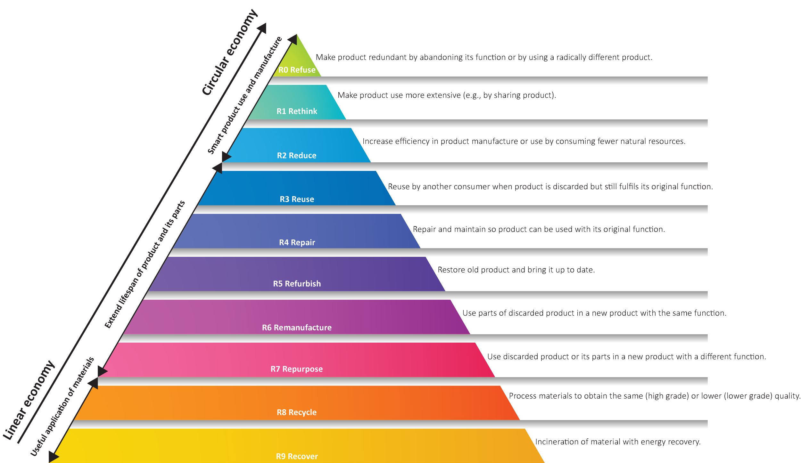

Figure 1. 10R framework. Adapted from Kirchherr et al. (2017)
Closed-loop systems are models where at the end of life, instead of landfilling or incineration, the material/product is reintegrated into the system, replacing virgin materials, and consequently, reducing its overall environmental impacts. Contrary to this, open loop systems mean that products are reintegrated to replace virgin materials for a different product. This is also considered a circular model, but the replicability of the model is reduced as in open-loop models only one cycle can be achieved. An open-loop model would have to analyse how the second product can be reintegrated into a third product, which in current practices is often landfilling or incineration.
With the clear benefit of aiming for a repeatable closed-loop scenario, some indicators have been proposed. For instance, Wiprächtiger et al. (2020) propose circularity as the summation of the mass of product retained and the mass of material recycled, divided by the total mass of material entering the system. Moreover, the material circularity indicator (MCI) has been among the most adopted CE indicators. The MCI is presented as a Microsoft Excel spreadsheet, where a single score is proposed based on reused, recycled and recycled efficiency percentages. Moreover, it considers the industry average lifespan and functional units. The MCI indicator has become very popular at the practice level. For instance, some Environmental Product Declarations (EPDs) are beginning to calculate their MCI score (Australasian EPD Programme, 2023). However, the MCI indicator does not consider the hierarchy levels of the 10R framework, hence, limiting the incentive for practitioners to increase their product value retention, as the score will not improve if they optimise their recovery strategies. The MCI score incentive approaches where the main focus is closing up the loop, even if this may incur on additional resource-intensive activities with a lower-level strategy of the 10R framework.
Hence, this study explores an approach to consider the hierarchy proposition defined within the CE definition, which can be achieved through the implementation of an index that considers the 10R framework. The main question and sub-questions that this study intends to answer are:
Main question
- How can the 10R strategies be integrated into a single-score circularity index?
Sub-questions
- Which indicators should represent each of the 10R strategies?
- Which indicators should be used to consider a closed-loop index?

Literature Review

Multi-criteria decision-making methods
When complex systems are analysed, the aggregation of information in an easily and clearly communicated way may be necessary. To do so, indicators and indices are often found in environmental assessments. Indicators are defined as “simple measures, most often quantitative that represent a state of economical, social and/or environmental development in a defined region” (Ness et al., 2007). Environmental indicators are often used when it is not feasible to measure a complete system, and approximations are needed. Environmental indicators measure a specific factor, such as energy consumption per year from steel manufacturing processes. Indicators have been proposed for CE materials and products, and play a vital role on how to measure the best alternatives when decisions are generated. Moreover, indices are a condensed description of the state of a system by aggregating several indicators or variables in a single value that represents a topic (Niemeijer, 2002). Which indicators and indices should be used for CE material and products is still under research.
To aggregate indicators into a single index, a multi-criteria decision-making (MCDM) method must be implemented. These methods define the steps required, and which weighting systems are considered to aggregate the intended indicators. Indeed, MCDM is concerned with the ranking of decision alternatives based on preference judgements made over different criteria (Deng et al., 2011). Several MCDM methods have been proposed to solve problems such as energy assessments and sustainability (Mardani et al., 2015, Reza et al., 2011, Lin et al., 2008, Lai et al., 2008, Kaklauskas et al., 2010). Among the techniques used in the last decades in construction, project safety and risk management and CE studies; the Analytic hierarchy process (AHP) was found to be the most used MCDM technique (Mardani et al., 2015, dos Santos Gonçalves and Campos, 2022). Hence, this study considers AHP as the MCDM method for the proposed indices.
The AHP technique arranges the factors that are important for a decision, in a hierarchical structure descending from an overall goal (objective) to criteria, sub-criteria, and decision alternatives in successive levels (Saaty, 1990) (refer to Figure 2). To do so, it implements the fundamental scale (refer to Table 1), where compared elements are related using a nine-point scale of comparison. In this scale, one means they are equally important; and nine, the first element has complete priority over the second. Wojnarowska et al. (2022) state that the AHP method usually follows these steps:
- Develop a hierarchy model.
- Generate pairwise comparison judgements using the fundamental scale.
- Create a comparison matrix, and calculate weighting coefficients, also known as priority vectors.
- Revise matrix consistency based on consistency ratios (CRs) and CR>0.1.
- Aggregation of group results.
- Sensitivity analysis.

Alternatives
Criteria
Objective
Scenario N

Scenario 2

Scenario 1
Criterion N
Criterion 2
Overall objective
Criterion 1

Figure 3. Hierarchy model structure Adapted from Saaty (1990)

Table 1. The AHP fundamental scale. Adapted from Saaty (1990)
Intensity of importance | Definition | Explanation
1 | Equal importance | Two activities contribute equally to the objective
3 | Moderate importance of one over another | Experience and judgment strongly favour one activity over another
5 | Essential of strong importance | Experience and judgment strongly favour one activity over another
7 | Very strong importance | An activity is strongly favoured and its dominance demonstrated in practice
9 | Extreme importance | The evidence favouring one activity over another is of the highest possible order of affirmation
2, 4, 6, 8 | Intermediate values between the two adjacent judgments | When compromise is needed

Circular economy environmental assessment
This paper continues the scoping review generated by the authors aiming to identify the currently used indicators and indices for CE materials and products. To do so, systematic combining was applied to review both academic articles and grey literature documents relating to CE in the construction industry Figure 2. In the mentioned literature review, three reviews were generated: 1) CE environmental assessment overarching guidelines (considering academic and empirical world documents), 2) CE environmental assessment case studies in the construction industry (considering academic articles), and 3) CE environmental assessment software tools (found through grey literature). As part of this article, 348 indicators were identified through all documents reviewed (Authors). Findings demonstrated that currently, no indicator considers the hierarchy level proposed by the 10R framework and the butterfly diagram. Hence, the value retention of circular scenarios is still not fully measured.
A vast majority of the indicators found are based on material flow analysis (MFA). Indeed, MFA is among the most common methodologies currently used or proposed for assessing the environmental performance of CE (Elia et al., 2017, Moriguchi, 2007, Haas et al., 2015, Harris et al., 2021). MFA is defined as “a systematic assessment of flows and stocks of materials within a system defined in space and time” (Brunner and Rechberger, 2016). MFA is based on the law of conservation matter, stating a mass balance between all inputs, stocks, and outputs of a process. Indeed, MFA consists of delimiting a system boundary, where the assessment of inputs, outputs and material flows are generated to identify how the system behaves from a mass balance point of view. Thanks to this perspective, this methodology is a very attractive approach to be used for resource management and waste management. The MCI is also based on the MFA methodology.
Moreover, the life cycle assessment (LCA) methodology has been implemented to broaden the scope of CE analysis in many studies. LCA is regulated by the ISO 14040:2006 and ISO 14044:2006 standards, which specify an iterative approach based on four phases: 1) goal and scope definition, 2) inventory analysis, 3) life cycle impact assessment, and 4) life cycle interpretation. Within the goal and scope definition, a clear identification of the intended application, audience and use is emphasised. Regarding the scope, the standard specifies 14 items that must be established including the functional unit, system boundary, assumptions and limitations. Secondly, in the life cycle inventory analysis phase, the standard guides the collection and quantification of data processes including the generation of flow diagrams which must outline all processes and a detailed description of each process to be considered. It highlights the importance of the functional unit, as this is critical to define the system boundary to be analysed and standardise results. Thirdly, in the life cycle impact assessment phase, the standard provides differentiation between other methods such as environmental impact assessment and risk assessment. The standard states that these methods can be used to gather the information, and then LCA can be done to provide an analysis based on a functional unit. Furthermore, in this section, mandatory elements are defined including the selection of impact categories, LCI classification and characterisation requirements. It also states optional activities including normalisation, grouping, weighting, and use of other methodologies such as sensitivity analysis. Lastly, in the life cycle interpretation phase, the standard defines as key components the identification of each of the other phases, evaluating the entire process by considering any significant issues, its completeness and consistency, and generating conclusions, limitations and recommendations (International Organization for Standardization, 2006). Despite the clear benefits that LCA and MFA methodologies provide, a methodology on how to integrate them for CE environmental assessment is still missing.
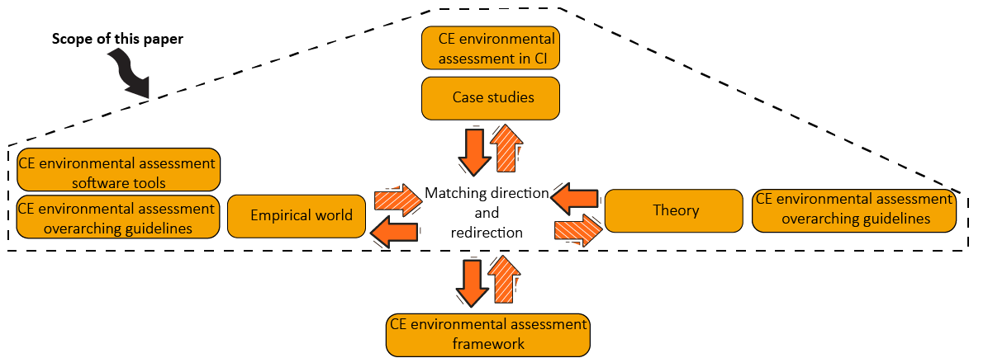
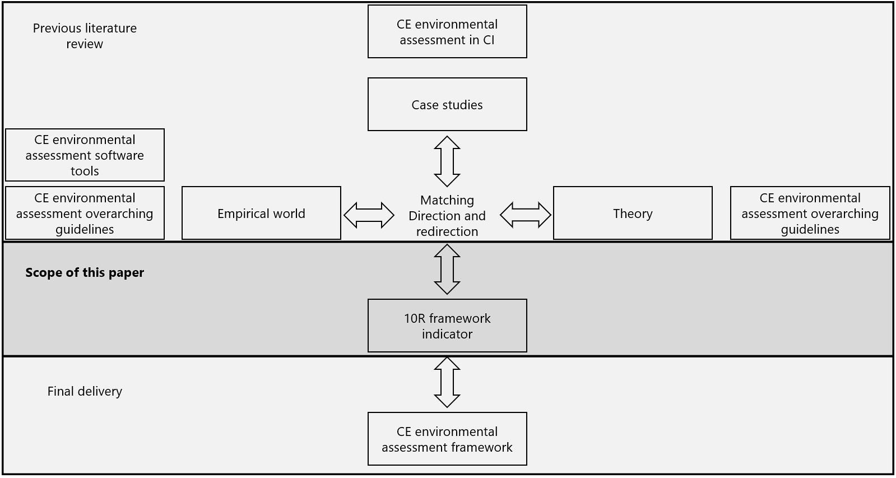

Figure 2. Systematic combining and scope of this study

Research Methodology
This study adopts a postpositivist paradigm. This paradigm accepts that knowledge grows from the gradual accumulation of findings, and theories and testing the significance of relationships (Fien, 2002). Moreover, systematic combining has been applied as the procedure for the development of the intended index, and the final framework for CE environmental assessment. Systematic combining is a procedure where empirical fieldwork, theoretical framework, and case studies analysis evolve simultaneously, and is useful for the development of new theories. In systematic combining, empirical observation and theory are matched in an iterative process to create new frameworks, which then is reviewed and improved through a case study (Dubois and Gadde, 2002). This study continues the literature review generated by the authors, and aims to propose a new index based on current indicators gaps. This index is part of the development of a new framework aiming to establish how to assess the environmental impacts of materials and products in buildings. The index is comprised of 10 indicators, which are based are based on MFA (refer to Circular economy indicators Section).

Results and Discussion
Based on MFA and LCA methodologies, the following indicators are proposed to represent the 10R framework. One point to highlight is that the refuse strategy is not considered within these indicators list. Although refuse is the best strategy stated in the 10R hierarchy, the refuse strategy itself means that all other strategies would not occur, as the material/product to analyse is no longer used, hence leaving the material outside of the scope of an MFA analysis. The indicators proposed below follow the systematic combining approach, as they are based on current indicators, including the MCI. These indicators are matched with the 10R framework, increasing the scope of the MFA to more comprehensively consider the CE definition.

Table 2. 9R indicators
Rethink | Factor for product use intensity from -1 to 1. were 0 is industry average, -1 meaning product use intensity is less than half or more, and 1 meaning product is used all possible time.
Reduce | Efficiency of product manufacture from -1 to 1. were 0 is industry average, -1 double or more of industry average materials are needed, and 1 meaning no materials are needed.
Reused | Total material reused expressed in functional unit
Repaired | Total material repaired expressed in functional unit
Refurbished | Total material refurbished expressed in functional unit
Remanufactured | Total material remanufactured expressed in functional unit
Repurposed | Total material repurposed expressed in functional unit
Recycled | Total material recycled expressed in functional unit
Recovered | Total material recovered expressed in functional unit
Landfill/fu | Total Material landfilled expressed in functional unit
Eight of these indicators use the functional unit concept, defined by ISO standards in LCAs (International Organization for Standardization, 2006). Hence, the assessment of these indicators should be based on the common units used in current practices, such as environmental product declarations. This approach aims to facilitate analysis and comparisons between products within the same category. For instance, the common functional unit for steel is kg, while for concrete is m³.
These indicators are integrated into two indices. To do so, the 10R indicators are weighted considering the AHP fundamental scale. Similarly to MCI, the higher score will represent a better product. The weighting here will prioritise one indicator over another, meaning that the higher strategy in the 10R hierarchy should be prioritised against the lowest. Given that landfilling is not considered circular, the weighting of this indicator is defined as 0. For all other 9 indicators, the hierarchy level proposed in the 10R framework is translated directly into the fundamental scale. To illustrate this, the pairwise comparison of Rethink indicators against the other indicators is stated as:
 | Reduce | Reused | Repaired | Refurbished | Remanufactured | Repurposed | Recycled | Recovered
Rethink | 2.00 | 3.00 | 4.00 | 5.00 | 6.00 | 7.00 | 8.00 | 9.00

Based on these comparisons, an AHP matrix can be generated, which is then normalised by the total in each column. The verification of matrix consistency complies with Landa max 9.428, consistency index 0.053, ratio index for 9 variables 1.45, and consistency ratio 0.037. The criteria weights to represent the 10R framework based on the AHP fundamental scale are presented in Table 2.

Table 2. Closed loop index and 9R circularity index example
 | Material: Hot rolled steel 1kg | Criteria weight % | Factors |  | Score
 | Rethink | 30.70 |  |  | 0.00 | 9R circularity index
 | Reduce | 21.82 | 0.3 |  | 6.55 | 9R circularity index
Closed loop index |  |  | Material in FU | Normalised |  | 9R circularity index
Closed loop index | Reused | 15.43 | 1 | 0.25 | 3.09 | 9R circularity index
Closed loop index | Repaired | 10.89 |  | 0.00 | 0.00 | 9R circularity index
Closed loop index | Refurbished | 7.64 |  | 0.00 | 0.00 | 9R circularity index
Closed loop index | Remanufactured | 5.33 |  | 0.00 | 0.00 | 9R circularity index
Closed loop index | Repurposed | 3.70 | 1 | 0.25 | 0.74 | 9R circularity index
Closed loop index | Recycled | 2.59 |  | 0.00 | 0.00 | 9R circularity index
Closed loop index | Recovered | 1.89 |  | 0.00 | 0.00 | 9R circularity index
Closed loop index | Landfill | 0.00 | 2 | 0.50 | 0.00 | 9R circularity index
3.827 |  | Material total in FU | 1 |  |  | 10.373
Note: FU= Functional unit
Based on the indicators and weighting system presented here, two indices are proposed. The first index is named the closed-loop index. This index aims to communicate how many materials are recirculated within the system boundary of analysis, while prioritising the 10R framework hierarchy. Hence, the index relies on integrating the following indicators: Reused, Repaired, Refurbished, Remanufactured, Repurposed, Recycled, Recovered, and Landfill. For the closed loop index, the end-user should specify the material values in functional units that are recirculating following each of the strategies. Strategies that are not been identified within the scope of the system should just be left empty. Normalisation by the total sum of the input values should be done. Then, the multiplication of the normalised values against the criteria weight should be generated, and the summation of these values is the closed loop index. The index value will range from 0 in a fully linear model where all materials end up in a landfill, and 15.43, where all materials are reused.
Similarly, the 9R circularity index will integrate the closed loop index by considering the two missing indicators: Rethink and Reduce. These indicators do not relate directly to MFA. Rather, these indicators aim to optimise the material entering the system. Hence, these indicators are more suited for companies that can play a role in increasing product use by implementing CE concepts such as the product-as-a-service model, and optimising the material use intensity in the manufacturing of their products. The 9R circularity index multiplies the factors and multiplies them against their criteria weight. The result is then added to the closed loop index to have the 9R circularity index. This index value will range from a -52.516 value where a fully linear model is occurring, with product use intensity and product manufacturing efficiency half below the industry average; and 67.948 value, when all material is reused, the product is used all possible time, and no materials are needed. 0 value will occur when there is a fully linear model, and product use intensity and product manufacturing efficiency are industry averages.
To simplify the application and understanding of these indexes, an Microsoft Excel spreadsheet is generated with all supporting data of the AHP aggregation for proposed indices creation (Authors). Similarly, to the MCI file, practitioners only need to input the values they want to assess in this file.

Conclusion and Further Research
This study presents two indices aiming to broaden the assessment of circular materials and products, by integrating current indicators including the MCI indicator with the 10R framework. To do so, 10 indicators are proposed. The proposed indicators are integrated by implementing the AHP fundamental scale, which is among the most common multi-criteria decision-making methods currently used in several areas including circularity and sustainability.
Eight of these indicators are based on MFA (Reused, Repaired, Refurbished, Remanufactured, Repurposed, Recycled, Recovered, Landfill), which are integrated to generate the closed loop index. Moreover, the scope of this index is increased considering two indicators focussed on industry average comparisons (Rethink, Reduce). Unlike the MCI score, these indices will give a higher score to products that use the top strategies recommended in the 10R framework hierarchy. Here, product manufacturers can indicate if they are prioritising a more circular model, which rewards them with a higher score if they prioritise the hierarchy level of the 10R framework. To incentivise the proposed indicators (the closed loop index, and 9R circularity index), the authors have generated a free-to-access Microsoft Excel spreadsheet (Authors). Through the implementation of these indices, it is expected that more transparency in circularity evaluation will be achieved, incentivising better practices and more user-friendly materials and product comparisons.
Future research should consider how the integration of these indexes should be done with LCA and other environmental impact categories, such as greenhouse gas emissions, energy, and water consumption.

References
AUSTRALASIAN EPD PROGRAMME. 2023. Environmental product declarations database [Online]. Available: https://epd-australasia.com/?s=MCI&post_type=epd [Accessed].
BRUNNER, P. H. & RECHBERGER, H. 2016. Handbook of Material Flow Analysis.
DENG, Y., CHAN, F. T. S., WU, Y. & WANG, D. 2011. A new linguistic MCDM method based on multiple-criterion data fusion. Expert Systems with Applications, 38, 6985-6993.
DOS SANTOS GONÇALVES, P. V. & CAMPOS, L. M. S. 2022. A systemic review for measuring circular economy with multi-criteria methods. Environmental Science and Pollution Research.
DUBOIS, A. & GADDE, L.-E. 2002. Systematic combining: an abductive approach to case research. Journal of Business Research, 55, 553-560.
ELIA, V., GNONI, M. G. & TORNESE, F. 2017. Measuring circular economy strategies through index methods: A critical analysis. Journal of Cleaner Production, 142, 2741-2751.
ELLEN MACARTHUR FOUNDATION 2012. Towards the Circular Economy: Economic and Business Rationale for an Accelerated Transition.
FIEN, J. 2002. Advancing sustainability in higher education: issues and opportunities for research. International journal of sustainability in higher education.
HAAS, W., KRAUSMANN, F., WIEDENHOFER, D. & HEINZ, M. 2015. How Circular is the Global Economy?: An Assessment of Material Flows, Waste Production, and Recycling in the European Union and the World in 2005. Journal of Industrial Ecology, 19, 765-777.
HARRIS, S., MARTIN, M. & DIENER, D. 2021. Circularity for circularity's sake? Scoping review of assessment methods for environmental performance in the circular economy. Sustainable Production and Consumption, 26, 172-186.
INTERNATIONAL ORGANIZATION FOR STANDARDIZATION 2006. ISO 14044:2006. Environmental management - life cycle assessment - Requirements and guidelines.
KAKLAUSKAS, A., ZAVADSKAS, E. K., NAIMAVICIENĖ, J., KRUTINIS, M., PLAKYS, V. & VENSKUS, D. 2010. Model for a complex analysis of intelligent built environment. Automation in construction, 19, 326-340.
KIRCHHERR, J., REIKE, D. & HEKKERT, M. 2017. Conceptualizing the circular economy: An analysis of 114 definitions. Resources, Conservation and Recycling, 127, 221-232.
LAI, Y.-T., WANG, W.-C. & WANG, H.-H. 2008. AHP-and simulation-based budget determination procedure for public building construction projects. Automation in Construction, 17, 623-632.
LIN, C.-C., WANG, W.-C. & YU, W.-D. 2008. Improving AHP for construction with an adaptive AHP approach (A3). Automation in construction, 17, 180-187.
MARDANI, A., JUSOH, A., NOR, K., KHALIFAH, Z., ZAKWAN, N. & VALIPOUR, A. 2015. Multiple criteria decision-making techniques and their applications–a review of the literature from 2000 to 2014. Economic research-Ekonomska istraživanja, 28, 516-571.
MORIGUCHI, Y. 2007. Material flow indicators to measure progress toward a sound material-cycle society. Journal of Material Cycles and Waste Management, 9, 112-120.
NESS, B., URBEL-PIIRSALU, E., ANDERBERG, S. & OLSSON, L. 2007. Categorising tools for sustainability assessment. Ecological Economics, 60, 498-508.
NIEMEIJER, D. 2002. Developing indicators for environmental policy: data-driven and theory-driven approaches examined by example. Environmental Science & Policy, 5, 91-103.
POTTING, J., HEKKERT, M., WORRELL, E. & HANEMAAIJER, A. 2017. Circular economy: measuring innovation in the product chain. Planbureau voor de Leefomgeving.
REZA, B., SADIQ, R. & HEWAGE, K. 2011. Sustainability assessment of flooring systems in the city of Tehran: An AHP-based life cycle analysis. Construction and Building Materials, 25, 2053-2066.
SAATY, T. L. 1990. The Analytic Hierarchy Process. European Journal of Operational Research, 48, 9-26.
WIPRÄCHTIGER, M., HAUPT, M., HEEREN, N., WASER, E. & HELLWEG, S. 2020. A framework for sustainable and circular system design: Development and application on thermal insulation materials. Resour. Conserv. Recycl., 154.
WOJNAROWSKA, M., ĆWIKLICKI, M. & INGRAO, C. 2022. Sustainable Products in the Circular Economy: Impact on Business and Society, Routledge.
ZHAI, J. 2020. BIM-based Building Circularity Assessment from the Early Design Stages. Eindhoven University of Technology.

