A Decade of Radical Pedagogy: Barry McNeill and Environmental Design in Tasmania, 1969-79.

Stuart King

Ceridwen Owen

Authors’ accepted manuscript, July 2018. Citation for published article: King, S., & Owen, C. (2018). A Decade of Radical Pedagogy: Barry McNeill and Environmental Design in Tasmania, 1969–79. Fabrications, 28(3), 303–330. https://doi.org/10.1080/10331867.2018.1507319

Abstract
Recent scholarship on pedagogical experimentation in the 1960s and 1970s has identified a diverse field of practices brought to bear on architectural education and their influence on architectural discourse. A new Environmental Design programme in Hobart, Tasmania, led by Barry McNeill (1937–2014) from 1969 to 1979, sits among these projects. It was the first Environmental Design programme in Australia and the most complete and radical transformation of an architecture and planning curriculum in Australia at the time, proactively embracing the educational ideals sought by student activists regionally and globally. Employing records from McNeill’s private archive and related archives alongside interviews with former staff and students, this article examines and places McNeill’s critical social approach to architectural education within the wider field of experimental architectural educational practices of the era. It explores the specific constellation of conditions that enabled McNeill’s radical transformation of curriculum in Hobart as well as its subsequent circulation and influence beyond Tasmania, highlighting the circuitous flows of ideas during the period. The article proposes McNeill’s Environmental Design programme as a space where international models from the USA, UK, and beyond were channelled, tested, contextualised, and transformed.

Introduction
Contemporary interest in pedagogical experimentation in architectural education in the 1960s and 1970s has shown the role such experiments played in the shifting of post-war architectural discourses. Much of this experimentation was radical, self-consciously seeking to destabilise disciplinary foundations while also targeting socio-political transformation. The global assemblage of cases in Beatriz Colomina’s Radical Pedagogies encompasses a diverse set of practices within architectural education across the mid to late twentieth century, extending from singular events and projects to the transformation of entire curricula and the establishment of alternative institutions. They were often short-lived and, at times, ephemeral, however, mobile professional and educational networks of the period mean that experimentation was rarely isolated. Hypothesised by Colomina’s research team as a radical architectural practice in their own right, with a nascent power that lies dormant within the “institutions that swallowed them up,” they present an opportunity to rethink the cartographies of architectural ideas and practice and future trajectories of architectural education.

Within Australia and New Zealand, recent scholarship on pedagogical experimentation in the region’s architecture schools has emerged via enquiries into the multi-faceted context of architecture’s counter cultures and their relationships to mainstream architectural discourse and practice. It has revealed the agency of students via student organisations, especially the Australasian Architecture Students’ Association (AASA), and through student protest action—an extension of global action—that challenged institutional curricula. It has also begun to map the regional field of practices brought to bear on architectural education, within specific curricula contexts ranging from experimental “live” building projects to subversive art and performance events.

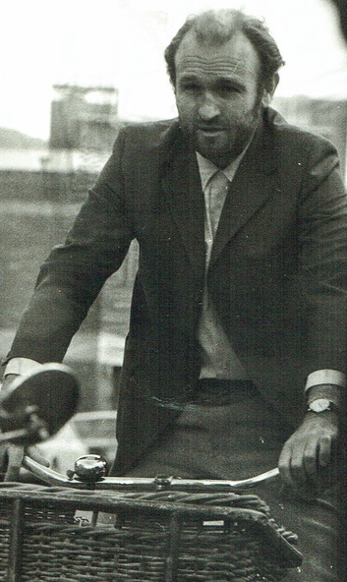
Figure 1: Barry McNeill (1937–2014), ca.1971. Photograph by Leigh Woolley.

A new architectural curriculum within an Environmental Design programme (ED) led by Barry McNeill (1937–2014) (Fig. 1) at the Hobart Technical College and, later, the Tasmanian College of Advanced Education (TCAE), from 1969 to 1979, sits among these projects. Study of it contributes to building the linkages between Australasian scholarship on radical architectural pedagogies and broader international discourse centred in North America and Europe as seen in Colomina’s Radical Pedagogies. This was the first Environmental Design programme in Australia and the most complete transformation of an architecture curriculum in Australia at the time. As such, it marks a key juncture in the importation and translation of Environmental Design education in an antipodean context. Originating in the United States in the late 1950s, Environmental Design sought new relationships among built environment disciplines and different design methodologies for emergent design problems. Central to the developing Environmental Design framework was a shift from abstract scientific systems-thinking, to situated knowledge production emphasising architecture’s connection with the social sciences.

A diversity of programmes were captured under the banner of Environmental Design in the 1960s and 1970s, a situation in itself that contributed to “unsettling” disciplinary norms. Moreover, the close coupling of interdisciplinarity and political agency in many programmes highlights the role of Environmental Design as one framework for architectural pedagogical experimentation and, by extension, its contribution to transforming architectural discourses. Indeed, Hobart ED was overlaid with radical pedagogical practices not necessarily inherent but enabled by the agency of an Environmental Design framework. For McNeill, architecture and architectural education were, above all, critical social practices, with the purpose of producing “creative, flexible, alert practitioners,” achievable by exploiting the individual differences, interests and abilities of students. Responding to student discontent with institutional course structures, the curriculum was self-directed, self-assessed and collectively governed to enable diverse outcomes. It embraced the educational opportunities of “live” community-based projects, realising the nationally-awarded Wombat One pavilion in the Hobart Botanical Gardens (1979). ED was also intrinsically interdisciplinary and its most significant directly attributable outcome, beyond its graduates, is the internationally practised “interdisciplinary earth science” permaculture, founded by Bill Mollison and David Holmgren, arising from Holmgren’s ED thesis in the mid-1970s.

McNeill’s Environmental Design programme in Hobart is known anecdotally across Australia and New Zealand. Its model of student autonomy has also been discussed by Barrie Shelton, a former academic who worked with McNeill in the programme. It has also been cited as influential, but it has not to date been critically examined in terms of its origins, operations and purported influence. This article will position McNeill’s critical social approach to architectural education within the wider field of experimental architectural educational practices of the era. It will consider the specific constellation of conditions politically, socially, and institutionally—locally and regionally—that enabled McNeill’s radical transformation of Hobart’s architecture and planning curriculum, and discuss key international connections, via the circulation of radical educators and McNeill’s own travels to North America and Europe. Those travels included visits to architecture and planning schools that were implementing Environmental Design programmes and employing new pedagogical models. Among them, and influential in the Hobart programme, were the University of Toronto and the Architectural Association, London. The subsequent circulation of McNeill’s radical pedagogical culture, through professional and student media and conference circuits, contributed to curriculum reform elsewhere and highlights the circuitous flows of ideas in architectural education during the period. One of the questions to emerge from this article is the legacy of the McNeill’s ED programme, outside of Tasmania.

The article is built around a remote institutional history, however its focus is the discourses, events and people involved in it. McNeill kept records that begin to map those connections, including personal notes, meeting minutes, course guides and unpublished conference presentations on the programme at the time of its implementation. The research employs his private archive, related archives and published material on architectural education of the period, alongside interviews with former staff and students to reconstruct the dynamics of ED in Hobart. It first examines the primary points of reference for McNeill’s model, pointing, in particular, to the role of the AASA student conferences in the mid-1960s as a conduit for the progressive ideals in education adopted by McNeill in 1969–70. The article proceeds to consider the implementation and circulation of the programme in the early 1970s, and its wider regional legacy. Finally, the article considers the programme’s demise and McNeill’s resignation in 1980, in the face of internal institutional creep and changes in the state’s higher education sector. At that point, McNeill’s anti-institutional agenda for architectural education was re-asserted in ED’s partial re-invention as the short-lived, independent Hobart Architectural Cooperative (1981–85) —another radical alternative for self-regulated, community-based education.

Conditions for Change
The radical transformation of the Hobart Technical College (HTC) programme and the rapidity of its implementation was precipitated by a series of synergistic circumstances. These include a local institutional context that requires a brief outline. An architectural draftsman's certificate course was offered at the HTC from c.1921, as an adjunct to the articled system of training. By 1932, and following the formation of the Royal Australian Institute of Architects (RAIA) and the Architects Registration Act in 1929 and 1930, respectively, a diploma course had been developed similar to courses at the Sydney and Melbourne technical colleges. Low student numbers, due to Tasmania’s small population, and the introduction of a national accreditation system in 1940, led to an alliance between the Hobart and Sydney technical colleges enabling Hobart students to gain recognition by sitting final exams in Sydney. This remained the case until the formal establishment of a Department of Architecture at the HTC in 1949 and the appointment of SWT Blythe (1905–85) as the inaugural Head of Department. At that time, Blythe implemented a Beaux Arts curriculum in which a traditionalist understanding of design was central and studies in aesthetics were privileged over engineering and construction. Blythe remained committed to this model, resisting the rise of scientific and technically-oriented curricula in architectural education elsewhere in Australia in the 1950s, to the chagrin of the local profession and national accreditation system. In 1956, the department was expanded to offer a Diploma in Town Planning.

Due to the low enrolments, the courses were without permanent staff and Blythe appointed talented former students who were practicing locally, mostly in part-time teaching roles. They included Barry McNeill, appointed as a part-time lecturer in 1966 and full-time from 1967, and when Blythe retired in 1969 McNeill succeeded him as the head of the department.

Trained at HTC, McNeill completed a Diploma of Architecture as well as a Diploma of Town and Country Planning. From 1956 to 1966 he worked for the modernist Hobart practice, Cooper & Vincent and was also actively involved with the local profession, and with the RAIA Tasmanian Chapter’s journal, Tasmanian Architect. With the shift from practice to teaching, McNeill also undertook a Bachelor of Arts in Education at the University of Tasmania, establishing a disciplinary basis in education for his lecturer position. It is unclear if McNeill was purposely appointed to succeed Blythe but the timing suggests a succession plan.

Change at the HTC corresponded with the global social justice movement and student activism in the late 1960s and 1970s. At home, environmental and historic conservation movements spurred the formation of the nascent Green party in Tasmania, while fomenting a political and cultural climate aligned with prospects of McNeill’s radical project. The opportunity then came with the transfer of the architecture and planning courses from the HTC to the proposed Tasmanian College of Advanced Education (TCAE). Prompted by a federal government inquiry into higher education in Australia and the outcomes of the Martin Report, published in 1965, the creation of a network of colleges of advanced education was proposed to complement an “elite” university system. The transfer to the TCAE was initiated in 1965 and formally endorsed by the RAIA in 1967, prior to McNeill accepting the position as Head of Department. McNeill supported the move: vocationally-oriented and open to pedagogical diversity, McNeill’s progressive pedagogical leanings were aligned to the remit of the TCAE. It is also notable that McNeill’s new Environmental Design programme was developed prior to its formal incorporation into the TCAE with the move to the new campus at Mount Nelson and administrative oversight in 1972, effectively between institutions. Thus, imperatives for curriculum reform within the discipline and profession, together with a political climate attuned to social and environmental ideals, coincided with a generational change in personnel and a context of institutional flux, with the resulting “institutional no-man’s land,” providing a unique opportunity for innovation.

Contours of Change
The only Australasian example in Colomina’s Radical Pedagogies project is a case study by Byron Kinnaird and Barnaby Bennet which articulates the agency of the Australasian Architecture Students’ Association (AASA) conferences in architectural education reform, particularly evident in the mid-1960s and early 1970s. Australia and New Zealand architectural historians have recorded their impact on local curricula following the conferences in Perth (1966), Brisbane (1967) and Auckland (1971). However it was in Hobart, which hosted the 1968 conference, that the student-led reform agenda, as developed across the conferences, was to gain its greatest traction through whole-of-curriculum reform amid the circumstances outlined above. The AASA conferences also later provided a principal venue for circulating the Hobart model.

The AASA was formed in 1948 with a mission of providing students with a forum to “exchange ideas and experiences through exhibitions and conventions” and, from 1963, it began convening national student conferences, gradually gaining strength in numbers in Adelaide (1963), Sydney (1964) and Melbourne (1965). In 1966, the conference held in Perth (in conjunction with the RAIA National Conference) was dedicated to the topic of “Education.” With an impressive guest list of international architects and educators—including Buckminster Fuller, Aldo Van Eyck, Jacob Bakema, John Voelcker and Paul Ritter—the student conference attracted approximately 450 delegates, establishing a pattern and expectation for subsequent conferences. Of further note to the evolving educational context in Australia was the involvement of Paul Ritter, at the time City Planner and Architect of Perth (1965–67) via Nottingham School of Architecture, UK (1952–64). Having advocated new approaches to architectural education for over a decade, at around the time of the conference in Perth Ritter published Educreation: Education for Creation, Growth and Change (1966), a book advocating a sociological model for education in schools of architecture, environmental design and ekistics. For Ritter, architecture should be taught in multi-disciplinary schools of Environmental Design employing student-centred approaches to learning based on principles of student self-regulation, cooperation/collaboration and therapy. Ritter gave a copy of Educreation to every registered delegate in Perth. While the success of the conference empowered the voice of students seeking reform, a new model for architectural education was also present.

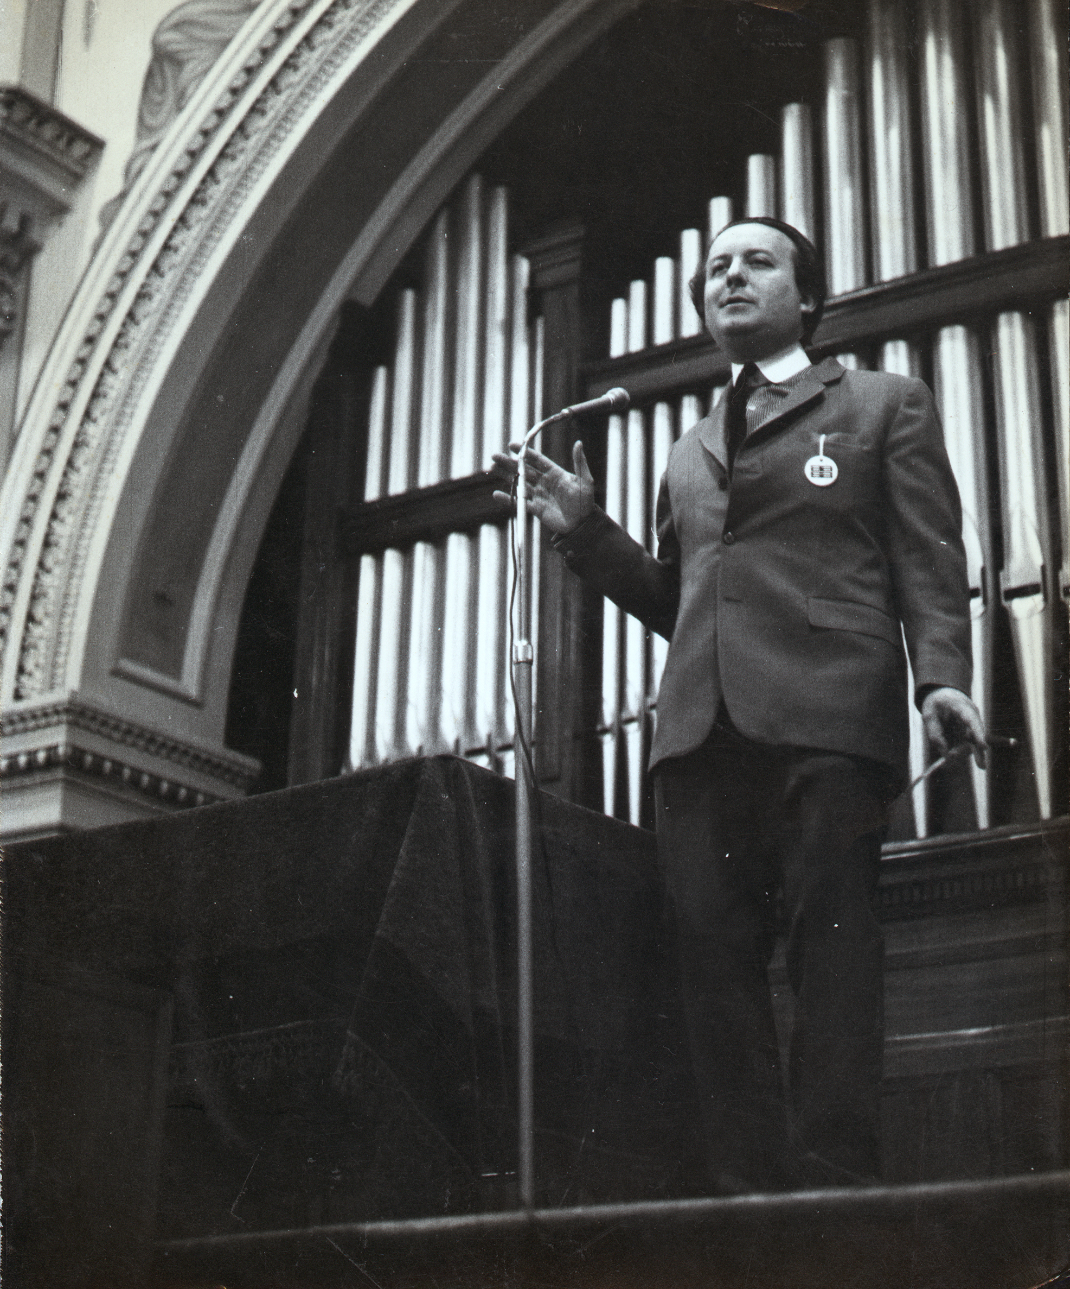
Figure 2: Cedric Price speaking at the 1968 AASA conference held in Hobart. Photographer unknown. Accession Number 0025.2014.0065, Australasian Architecture Students Association Collection, RMIT Design Archive.

In 1967, the AASA conference was convened in Brisbane where it fuelled a nascent culture of student activism seeking social and educational reform. In 1968, the conference descended on Hobart in the guise of “Creativity.” McNeill later wrote that it provided “a powerful stimulant for Tasmanian architecture” as the local profession actively questioned the hegemony of modernist orthodoxies established in architecture, planning and education. The line-up of speakers in Hobart was firmly oriented towards shifting ground within the discipline and profession, anticipating the new directions to be taken in Hobart architecture and planning curriculum. They included: the architect, educator and polemicist Cedric Price (Fig.2), from the Architectural Association in London, rallying against convention in design and language; Maurice K. Smith, New Zealand-born architect and educator at Massachusetts Institute of Technology, based at the University of Auckland in 1968, and known for his questioning of modernist forms and techniques in his teaching, and the design-build of the Maurice Smith House, Massachusetts (1963); and Joseph Esherick, a faculty member of the College of Environmental Design at the University of California Berkeley and designer (with Vernon DeMars, Donald Olsen) of the College’s brutalist Wurster Hall (built in 1964), who advocated activism and the student-centred approaches focused on real-world problems employed at Berkeley. Local speakers represented regionalist orientations prominent in Australian architecture at the time: architect Peter Johnson, recently appointed as Dean of the Faculty of Architecture at the University of Sydney and whose works were associated with the emergence of the “Sydney School” in the early 1960s; as well as Dirk Bolt and Barry McNeill who both advocated regionalist design positions through their editorial involvement in the Tasmanian Architect and their buildings, notably Bolt’s brutalist Christ College, Hobart (1960), one of the venues of the conference. Paul Ritter was again a guest speaker, further promoting the pedagogical agenda of Educreation, advocated in Hobart in terms of experiential, self-regulated and therapeutic learning.

Although smaller than Perth, the AASA considered the Hobart conference very successful in charting the “changing requirements of architectural education” alongside the case for change:

One of the most significant discoveries by students at the Convention was how torpid Architectural Education is in Australia … There is little stimulation toward sincere student involvement in Schools of Architecture in Australia – a deficiency which is obviously detrimental to both Architecture and the Profession.

Curriculum Models
Following the Hobart convention, and with the imperatives for architectural education reform at the forefront of his mind, McNeill departed Tasmania for North America and Europe on a twelve-month Churchill Fellowship (awarded in 1967), to undertake postgraduate study in urban and regional planning and politics at MIT, together with study visits to projects, agencies, and architecture and planning schools. Of particular interest to this discussion are his visits to universities and colleges that were implementing Environmental Design frameworks, as well as institutions experimenting with new pedagogical approaches. While the events in Australia outlined the contours for local architectural education reform, McNeill’s Churchill Fellowship provided models to achieve it.

Environmental Design was being adopted as a framework for architectural and planning education in North America and Europe from the late 1950s. In 1962, the American Institute of Architects established a Special Education Committee that advocated Environmental Design as a platform to redefine the parameters of the architectural profession and proposed a new two-tier education system of undergraduate degree in the liberal arts to be followed by graduate professional degrees, while institutions including the University of California Berkeley (1959) and Harvard University (1963), were creating colleges and schools of Environmental Design. A subsequent report produced in 1967, A Study of Education for Environmental Design, authored by Robert L. Geddes and Bernard P. Spring of Princeton University, and known informally as the “Princeton Report”, advocated a national framework for Environmental Design education. The report emphasised the need for new modes of professional education, proposing three goals for Environmental Design graduates: firstly, that they should be able to shape present-day practice; secondly, that they should have the capacity to adapt to rapidly changing social, economic, political, scientific, and technological settings; and, thirdly, that they should be able to look beyond present-day constraints to give direction to adaptive responses. Multi-disciplinary, team-based design methodologies and pedagogical approaches, including “live,” community-based projects, all featured among the report’s recommendations.

Records of McNeill’s Churchill Fellowship are incomplete and it is not known for certain if he visited the Environmental Design programmes at Berkeley, Harvard and Princeton but all are likely given his contacts and itinerary. However, McNeill’s Churchill Fellowhsip reports do show that in the first quarter of 1969 he visited Yale University where Charles Moore, Chair of Yale’s Department of Architecture (appointed in 1965), had recently introduced a Master of Environmental Design aimed at interdisciplinary approaches to design for “complex urban environments.” More generally, and in response to the social and professional unrest of the era, Moore was transforming Yale’s architecture curriculum. He led the redevelopment of the first year of the architectural design curriculum; encouraged students to engage with context, via the environments of New Haven; and, had established the Building Project which addressed socio-economic disadvantage through “live” community-oriented design-build projects. Also in early 1969, McNeill visited the University of Buffalo’s School of Architecture and Environmental Design, where, in 1968, the founding Dean, John P. Eberhard, was planning an Environmental Design curriculum, with a radical graduate programme in Building System Design modelled on doctoral education.

McNeill’s visits to other institutions implementing other experimental pedagogical approaches included the School of Architecture and Planning at the University of Toronto, at the time under the stewardship of the Australian-born architect, John Andrews. Andrews had been appointed as Chair of Architecture in 1967 and immediately hired Peter Prangnell to develop a new five-year curriculum for the Bachelor of Architecture. Prangnell was interested in A.S Neill’s philosophies of freedom and Ivan Illich’s ideas about self-directed education, and drew upon his experience in teaching at the Architectural Association in London and Columbia University in New York. The new Toronto curriculum was configured around “credible,” community-based “core problems” intended to structure student learning. The core problems were not traditional “studio” briefs, but rather a framework or a “forum for all historical, technical, structural and graphic practice and discussion” or a field within which students were to learn. Mandatory lecture courses were “dissolved” and specialist knowledge was introduced on a need-to-know and just-in-time basis, to foster its assimilation. Students were granted responsibility for organising their time and learning and the role of the teacher shifted from a position of “authority” to a “resource” and a “co-learner,” echoing Carl Rogers’ theory of student-centred learning. Student autonomy extended to participation in decision-making with the school and they were given a “kit of parts” to self-build their learning spaces each year—all ideas to be later translated in Hobart.

The European leg of McNeill’s Churchill Fellowship, in mid-1969, was organised around visits to planning, development and housing agencies and various new town developments in the United Kingdom, Sweden, Finland and Denmark, before returning to Australia via Athens, Tehran, Calcutta and Singapore. He also visited schools of architecture and planning, although records do not reveal which schools. However, McNeill later cited the Architectural Association in London, alongside the University of Toronto, as programmes similar to the new curriculum in Hobart, suggesting that he may have visited it. Indeed, McNeill’s later arguments for “general” versus “professional” education as the foundation for his curriculum echoes the basis of reform enacted by John Lloyd, Chairman of AA between 1967 and 1970. Immediately prior to Lloyd’s appointment at the AA, he was Dean of the Department of Architecture at the Kwame Nkrumah University of Science and Technology in Kumasi, designing the curriculum for Ghana’s first school of architecture. Addressing the context of Ghana’s social and political, economic and environmental contexts, Lloyd had begun developing an architectural pedagogy oriented towards producing “generalists” capable of synthesising solutions to complex problems. Lloyd maintained such a position at the AA, articulating the task of design as the work of synthesising integrated solutions to enrich the social milieu, and an educational policy of producing generalists in this ability applied to the physical environment. Lloyd contended that the diversity of design problems of the physical environment required a diverse and flexible curriculum responsive to student subjectivities. At the AA, this led to consolidating the second, third and fourth years into a Middle School, bracketed by an introductory foundational year and an independent final year of study. In the Middle School students effectively constructed their own curricula via self-directed, project-based learning within a system of nine units, each defined by design strategies, tactics and methods, rather that traditional briefs. Along with the alternative model of the University of Toronto, the AA provided a mechanism for individualised curricula: potentially a different curriculum for every student.

Transformation in Tasmania
When McNeill arrived back in Hobart, in August 1969, taking up the position as Head of Department, he moved swiftly to re-vision the HTC curriculum, indicating that the new model was well formulated by the time of his return. Following an “experimental year” in 1970, where the new system was “grafted” onto the old syllabus, a new ED programme was fully implemented in 1971.

The Churchill Fellowship helped McNeill to crystallise his own position on “general education” for architecture and planning, as opposed to professional training. Echoing John Lloyd’s position and programme at the AA, McNeill contended that a more expansive education was necessary to respond to the uncertain and evolving nature of the professions. Within an Environmental Design framework, this meant inter-disciplinarity, knowledge of human interactions through environmental psychology and sociology, as well as politics, law, management, and economics, and a shift in emphasis from solving to understanding problems. Following the American model, McNeill proposed a two-tier structure with a three-year general undergraduate course followed by a three-year professional post-graduate qualification. As well as supporting the objective of breadth and inter-disciplinarity in architectural education, the two-tier approach offered benefits in addressing the smaller number of students in the Tasmanian context and allowed students to keep their career options open. Post-graduate courses included Architecture, Urban Planning, Landscape Planning, and Building Operations that were “run on an inter-disciplinary basis” and admitted students with undergraduate qualifications from other fields including Arts, Science and Engineering degrees.

There was no set syllabus, but the course provided a loose framework of “study areas.” At the centre was a “problem solving core,” emphasising group learning situations in the undergraduate programme and inter-disciplinary relations in the post-graduate courses. Other areas comprised “man-environment studies,” “technology,” “communications,” “operations,” and “professional practice.” The study areas were distributed in a recommended sequence foregrounding communications and man-environment studies in the lower levels and placing an increasing focus on professional practice in the upper levels. The final semester of the undergraduate course and the final two semesters of the post-graduate course were dedicated to the production of a “substantial piece of original work” in an applied project of the student’s choice. Emphasising the synthesis of knowledge and skills gained throughout the course, the undergraduate “major study” required students to “apply the attitudes, methods and skills and knowledge that are the objectives of the first tier programme,” whereas the “professional project” required illustration of “the student’s professional capacity to undertake an exercise within the defined task roles of the specific professional qualification being sought.” With the exception of Holmgren’s permaculture project there is little information on the types and range of graduating projects undertaken by students of ED. However, a sample of projects undertaken by ED graduates interviewed for this article, included an urban conservation study of a regional town in northern Tasmania, a comparison of cross-cultural environmental values between Tasmania and China, studies of self-made and alternative housing, design aids for low-energy buildings, an un-built “live” project for a passive solar house.

At the heart of McNeill’s vision was an emphasis on motivating individuals to “understand or solve problems of intense personal significance” as opposed to teaching factual knowledge, techniques and “acceptable” solutions, and McNeill employed radical pedagogical approaches to achieve this goal. As seen at Toronto and the AA, and with reference to the educational philosophies of Carl Rogers, McNeill firmly positioned the student, rather than the curriculum, at centre stage. Students established how, where and when they would acquire knowledge and skills and were encouraged to pursue topics of personal interest. However, McNeill also diverged from the models at Toronto and the AA, which were critiqued for fragmenting their schools with individualised curricula. The start of semester at ED was like a “big research conference” with “dozens of people expressing what they wanted to learn.” Learning groups emerged, formed by students across multiple year levels aligned with topics of mutual interest, in what was described as a “laborious” process that could take hours or even days. It was an inherently cooperative model. Topics of study were wide-ranging, driven by the key emphasis on Environmental Design as “a way of understanding the world” rather than the pursuit of disciplinary knowledge. Areas of study ranged from fieldwork identifying plants to building hot water systems from scrap material, to more traditional activities such as building rudimentary shelters or spending “a couple of months making hybrid beams.” External experts were employed to complement staff expertise so that “things that mattered to you [the students] were resourced.”

As well as setting their own programme of study, students established how they would be assessed, with an emphasis on “what a student has learned from experiences gained during the semester, rather than the standard of finished work.” With the exception of graduating projects, decisions about whether to pass or fail were entirely at the student’s discretion. While not perceived as a culture within the Department, self-failure was not an uncommon practice with staff noting that students were often “hard on themselves.”

Echoing the experimental programme at Toronto, a “flat earth” administrative structure embedded students in all aspects of decision-making, from voting rights in the Department’s General Assemblies, to orientation programmes and student admission, and leading interview panels for staff appointments. (Fig. 3) Staff themselves were positioned as “academic advisors,” providing guidance and facilitating access to diverse learning opportunities. (Fig. 4) The Department’s facilities were similarly aligned with the fluidity of the programme and democratic ideology. Adopting the “kit-of-parts” approach, internal configurations could be continuously built, re-built, adapted and repurposed by staff and students armed with “meccano-like steel frame and chipboard.” A large, centrally-located board termed the “Information Exchange,” provided a platform for communication where “you could pin your hopes, aspirations, or intended projects.” (Fig. 5)

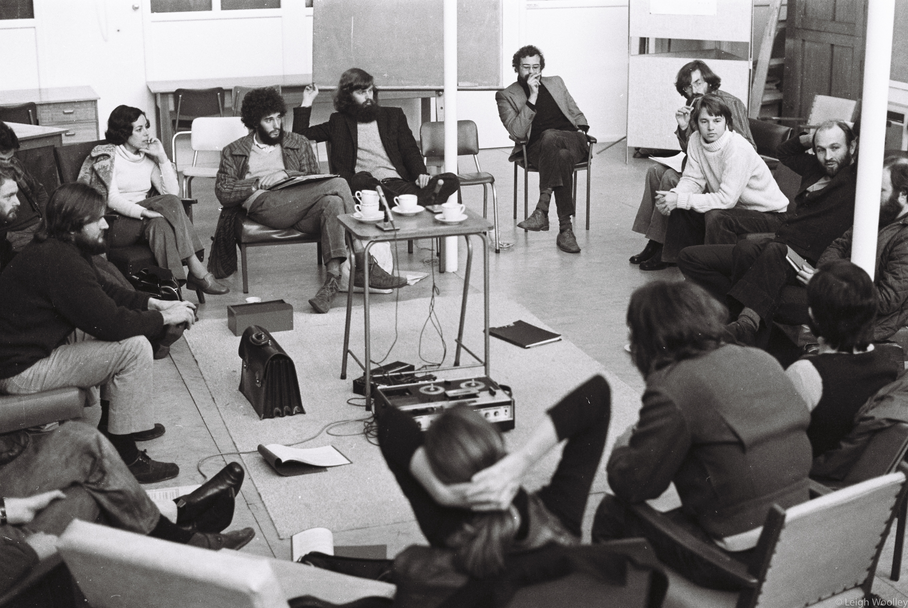
Figure 3: General Assembly meeting, Department of Environmental Design, TCAE Mount Nelson, Hobart, July 1977. Photograph by Leigh Woolley.

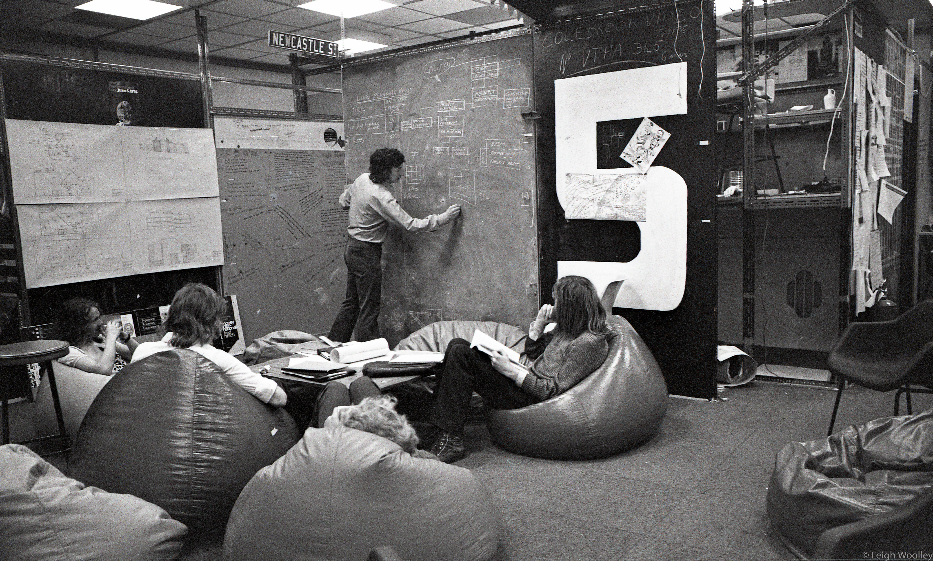
Figure 4: Staff and students at the Department of Environmental Design, TCAE, Mount Nelson, Hobart, September 1974. Photograph by Leigh Woolley.

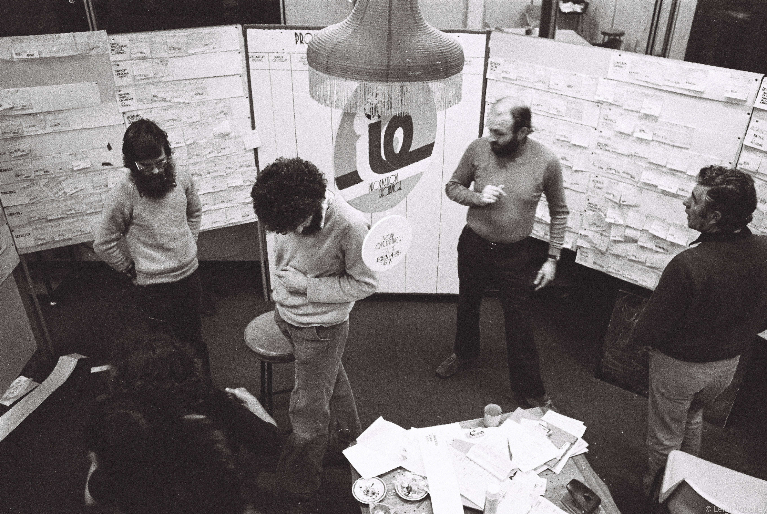
Figure 5: Information Exchange, Department of Environmental Design, TCAE, Mount Nelson, Hobart, July 1977. Left to right: Don Thompson (administration officer), Jed Stuart (student), Barry McNeill (director) and Terry Barwick (staff member). Photograph by Leigh Woolley.

Many projects were “live” community-based projects, aligned with the pedagogical framework chartered in the Princeton report. Subsequently situated under the umbrella of the Environment Design Unit (EDU), established in 1971, aims were (1) to support the community, (2) to provide real-world experience for students and (3), from a staff perspective, to bridge the gap between teaching and working roles. The EDU was to operate as a “non-profit making, consulting and research unit” with fees paid for consulting work and/or receiving grants, and members paid salaries. Surplus fees were to finance research projects, purchase equipment and pay visiting experts. Students were to participate through the “work study” component of the course and be paid “according to their level, experience, degree of participation, grant situation, etc.” An initial list of proposed projects was locally situated, encompassing environmental, architectural and policy-related endeavours. While EDU, as a unit, was described as “an idea that never flew,” the emphasis on student-driven “live” projects persisted, culminating in the most lauded and enduring example, the Wombat One Pavilion in the Hobart Botanical Gardens, 1979, led by a group of ED students in collaboration with NSW architect Richard Leplastrier. (Fig. 6)

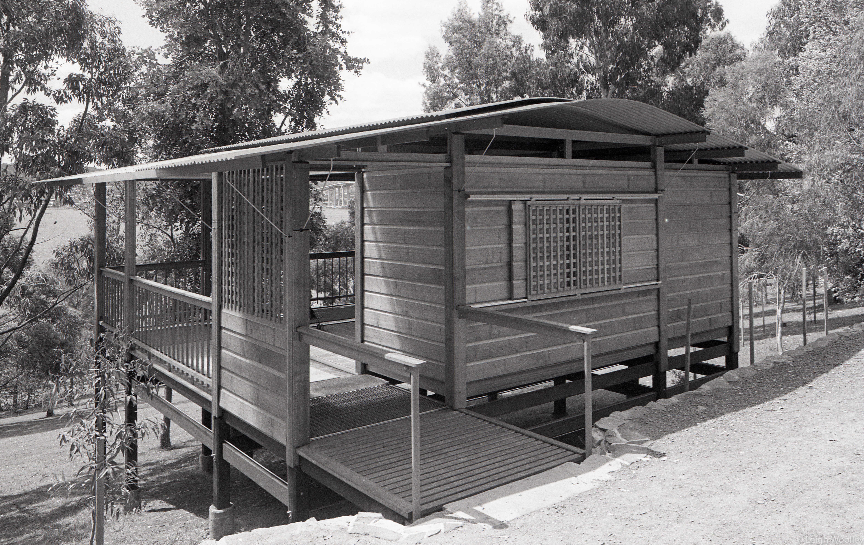
Figure 6: ‘Wombat’ late 1981, soon after construction, Botanical Gardens Hobart. Photograph by Leigh Woolley.

The “live” projects and “work study” elements of the programme enabled McNeill to address the “conservative responsibilities” of architectural schools in fulfilling both student expectations of employment, and societal expectations of the profession. Students were expected to participate in at least two semesters of work-study between the second and final year of the programme. While types of work experience were not prescribed in the undergraduate course, at post-graduate level the expectation was that work-study would be undertaken in “acceptable” areas “related to the student’s chosen field.” Both undergraduate and post-graduate courses maintained vestiges of a more orthodox approach in the final semester with graduating projects assessed by a panel, comprising the academic advisor and two external experts. Thus, “the community and its professional institutions” could “judge the competence and education standard of each student on completion of his [sic] learning programme.” In particular, the final two semesters of the professional post-graduate degree emphasised professional learning by requiring students to undertake a thesis that demonstrated their ability to “deal with a real issue and thereby prove himself [sic] to the profession and society.” The professional projects were thus positioned as an “essentially professional exercise rather than an academic study.” Nevertheless, students perceived that while they had certain “skills and advantages” following graduation, they were “not necessarily readily employable in practice.” Sustaining professional recognition for the course also required careful negotiation. Noting the complexities of navigating radical and conservative agendas, a published review of the Department, by Peter Corrigan and Bernice Murphy, “congratulated” the RAIA for its “audacity in ensuring professional recognition for the T.C.A.E. Environmental Design Department.”

Students themselves variously celebrated and struggled with the radical, unstructured and student-centred approach to learning. For some, ED represented a “green field that you didn’t imagine existed” and a “momentous” opportunity to chart your own education, yet the experience in first year could also be extremely unsettling where you were “completely at sea for weeks.” For students transferring from other institutions, ED provided an “outlet for ... frustrations” caused by “knocking our heads up against their system,” but they also recognised a loss of security and the potential to experience “mental and psychological damage” when “the onus is very much on yourself.” Others recognised how the foundational disciplinary knowledge gained in other institutions “made it easier to cope with the lack of structure in ED.”

Circulating ED
McNeill’s new vision of architectural education proved popular. Student numbers quickly grew from 60 to more than 90 within the first two years, and then 120 as the unique course attracted interest from around Australia and overseas. Staff doubled in number with new appointments broadening the disciplinary bases of the department, bringing expertise from art, ecology, environmental resources and planning, as well as building science, to support the inter-disciplinary Environmental Design philosophy. Full-time academic staff members included architects Terry Barwick, Christopher Harman, Graham Hanna and Phyllis Simons, a leading contributor to landscape architecture in Australia, Barrie Shelton, an urban designer and planner who had studied under Paul Ritter in Nottingham, Marxist planner and architect Peter Newton, American planner David Clouser, environmental engineer Graeme Watham, agricultural scientist David Horwood, and planner and biochemical engineer Jeremy Dawkins. Opportunities for exposure to diverse influences were also supported by a dedicated “special visitors” programme including politicians, personalities and influential thinkers who were “partly invited and partly invited themselves because they knew what was going on in Tasmania.” Archival records of visitors to ED are substantially incomplete, but visitors in 1971 included Paul Ritter, Amos Rapoport and Balwant Saini (senior lecturer (later professor) in architecture at the University of Queensland) and Stephen Boyden (human ecologist) followed by Bob Hawke (Labour politician and future Prime Minister of Australia), Martyn Webb (geographer), Judith O’Neill (academic and novelist), Spike Milligan (comedian), Milo Dunphy (a prominent Australian conservationist) and Graeme Gunn (newly appointed Dean of Architecture at RMIT) in 1972.

The substantive visitor programme as well as the “unusual” influx of students from across Australia and overseas is testament to the reach of the programme far beyond its remote geographic location. By 1975, Peter Corrigan (one of the first graduates of Yale’s Master of Environmental Design 1967–69), RMIT, and Bernice Murphy, TCAE, could observe in Architecture Australia that McNeill’s pedagogical experiment had “quietly permeated the field of architectural education.” In 1974, a new Environmental Design department was established at the Canberra College of Advanced Education (now University of Canberra) based on ED at the TCAE and developed in consultation with McNeill. However, the Canberra model adopted structured progression and was described by Corrigan and Murphy at the time as a “centreline of innovation in architectural education” in contrast to the “radical first breakaway at T.C.A.E.” The place in Australia that most “felt the ripples” was the Royal Melbourne Institute of Technology (RMIT) under Graeme Gunn, Dean of Architecture 1972–1982. Upon Gunn’s appointment he initiated a re-visioning of the RMIT curriculum commencing with a staff conference. In addition to the RMIT staff and student representatives, he invited Barry McNeill and Barrie Shelton—the only invitees from interstate architecture departments. Principles were established and further developed, echoing the Environmental Design frameworks of Berkeley, Yale and TCAE. Randal May, a lecturer at RMIT, and a former Hobart ED student and advocate of the programme, was influential in the development of the new course at RMIT, and TCAE elements such as the advisor system, self-assessment and an “emphasis on learning how to learn” were carried across.

ED students also contributed to the visibility of the TCAE programme through their heightened mobility. Workplace experience, external courses and travel were all embraced as a legitimate part of a student’s programme of study. “Massive road trips” to AASA student conventions and other events and festivals were a regular feature, where students “tended to be vocal” and act as “messengers” for the school.. ED students attended the AASA conference in Sunbury in 1972, where McNeill was also a keynote speaker. McNeill was also a speaker at the Sydney conference in 1977, alongside Alvin Boyarsky, Chairman of the AA. On this occasion, ED students took to the stage at McNeill’s spontaneous invitation with Boyarsky later noting their “confidence.” Two of the former ED students interviewed for this article—Leigh Woolley and Prue Slatyer—incorporated study at the AA into their ED studies.

More difficult to establish is the influence of ED within university courses via professional and personal networks of staff and students. In 1972, architecture students went on strike at the University of Auckland and University of Sydney, resulting in curriculum reform in both institutions. At the University of Sydney students negotiated with the Dean, Professor Peter Johnson, to implement an “open model”, with experiments with self-assessment and the introduction of an independent research project, all core to the curriculum in Hobart. By 1972 students at the University of Sydney would have been familiar with the Hobart ED programme via the AASA conventions, especially the Sunbury Convention. Likewise, the Dean, Peter Johnson, who had been a guest speaker at the 1968 AASA Convention in Hobart, maintained a familiarity with the TCAE, visiting in the 1970s. Whilst other Australian institutions, educators and students also looked abroad, the TCAE nonetheless provided a local translation of international currents in progressive architectural education.

Challenges to ED
Barrie Shelton described the progressive programme as “remarkable for an isolated place,” arguing that the relative lack of constraints and greater tolerances compared with larger institutions was perhaps a necessary condition for its success. Nevertheless, ED was not without its internal challenges. Critical to the success of the model was the transformation of staff attitudes from a “judgmental and authoritative stance to an accepting and democratic mode,” described by McNeill as “challenging but fulfilling.” While Shelton was attracted to ED because of McNeill’s radical educational philosophy, Terry Barwick, a practicing architect and staff member in the HTC under SWT Blythe’s leadership, was described as “largely a critic from within” who “never fully embraced the ED philosophy.” Staff profiling for the programme was also difficult to balance, with Shelton later reflecting that they gave too much weight to “professional experience” rather than “personal qualities” in staff selection and as a consequence “sailed dangerously close to the wind” of destructive conflict. McNeill was more sanguine, reflecting that “people problems ... are the essence of the school.”

Shelton’s published reflection on the trajectory of the pedagogical experiment and unpublished internal discussion papers clearly point to a perceived progression of institutional creep in the programme in the latter half of the decade. Identified issues included an increasingly structured curriculum, a “proliferation of petty regulations” in internal administrative processes and the move to more conformist facilities in the purpose-designed building on the new campus of the TCAE in 1978/9. Shelton argued that there was a shift away from the core ethos and practice of self-directed learning with “too much thinking and not enough doing” and too many projects being offered by the school which “deters students from thinking out their learning needs for themselves.” Shelton singled out the increasing emphasis on “live” community projects and their emphasis on “elements of the professional world” as problematic since they limited “free-ranging thought,” but subsequently considered “in retrospect we may have been expecting too much.”

Notwithstanding the trajectory towards more familiar institutional models, the perpetuation of aspects of McNeill’s pedagogical approach, particularly practices of self-assessment, proved too controversial for the transforming higher education context in Tasmania. Competition between the TCAE and the University of Tasmania prompted the establishment of a state and federal government committee to look into tertiary education in Tasmania, particularly in regional areas. The recommendations of the Karmel report on post-secondary education in Tasmania (1976) included a merger of the two institutions, the closure of the Mount Nelson campus and the establishment of an autonomous institution based in Launceston. The merger was contested within the academies and the community, in part, on grounds of monopolisation versus diversification of the state’s higher education sector. Rejecting the recommendations, the Council of Advanced Education established the Cosgrove committee to provide advice. Moderating the recommendations of the Karmel report, the Cosgrove committee instead proposed the retention of certain courses, including Environmental Design, Art, Music, Librarianship, Teacher Education and Legal Practice, on the Mount Nelson campus within a Hobart Centre for Advanced Education under the control of the University, with other courses absorbed into the University. McNeill was a strong advocate supporting the proposed retention of ED within the TCAE. While the TCAE’s vocational orientation provided a more tolerant climate for pedagogical diversity, the perceived “casual standards” were anathema to the more conservative University. However, political pressure to form a dedicated tertiary institution in the north, later to become the Tasmania State Institute of Technology, resulted in the ultimate relocation of the remaining TCAE courses from Hobart to Launceston in 1981.

The relocation and ideological differences about the future trajectory of education in the state prompted McNeill to resign in 1980. While parts of the course continued to be taught in Hobart, the institutional and geographic shift, together with the departure of McNeill and the appointment of a new Director, John Webster, resulted in the dismantling of McNeill’s radical student-centred approach. One ED student, who commenced in 1979, described the experience as “like a school in decline,” finally resulting in a “split” between Hobart and Launceston that “killed off” the programme.

The decade of radical pedagogical experimentation in Tasmania is characterised by a rapid rise and equally precipitous demise. Yet elements of the programme persisted in a different guise. Whilst returning to practice, McNeill continued to challenge institutionalised architectural education and, with half a dozen “disciples,” established a public forum for design and community-based architectural education, the Hobart Architectural Cooperative (1981). The prospectus for the Cooperative argued that educational institutions were, “excessively dominated by academic values related to scholarship rather than the capacity to develop ideas and make them happen.” It thus sought to offer an alternative of “learning by doing” under the guidance of “masters” of the profession. The Cooperative was also intended to be non-hierarchical; there were no staff and students, only members. It survived only until 1985, and never fulfilled its educational ambitions, instead hosting exhibitions, design conferences, seminars, and lectures, and becoming “more of a quasi-institute” and the “place to go” for the profession on Friday nights. Arguably the Cooperative’s fate was written in the cover image of its prospectus (designed by Adrian FitzGerald and Leigh Woolley) (Fig.7), which conveyed the extent to which the local architectural discourse had successfully shifted and diversified over the decade of ED. The cover of the prospectus presented a clever riff on postmodern discourse, with reference to ideas emerging from the 1980 Venice Biennale, via Tasmania’s iconic colonial-era Acanthe (a small Greek revival temple) about to dock in a projected vision of an assimilative postmodern Hobart.
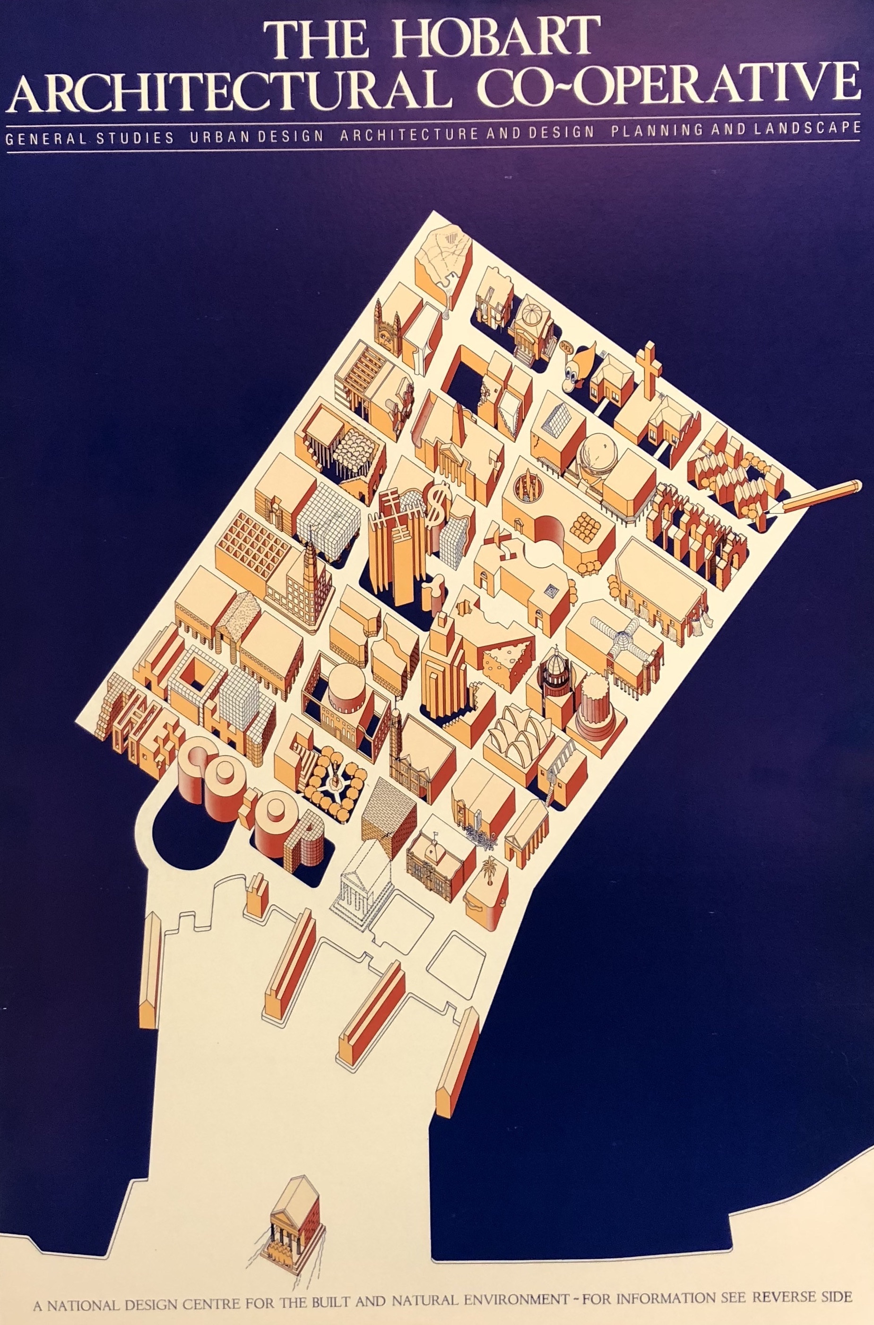
Figure 7: Hobart Architectural Cooperative poster and Prospectus (rear side). c.1981. Designed by Adrian FitzGerald and Leigh Woolley. Photograph by Leigh Woolley.

Conclusion
As the influence of ED was being felt at RMIT in Melbourne, in the mid-1970s, Corrigan and Murphy’s article on the programme asserted that its “uniqueness can’t be emphasised too strongly,” as even in the USA, a country with a “courageous” approach to education, there are “no similar architectural institutions…outside a few small, affluent, inaccessible private colleges.” While not without precedent, the extent to which McNeill was able to implement his radical vision created an internationally distinctive programme. Bracketed within a decade, ED’s success was supported by a series of synchronistic, synergistic and serendipitous conditions aligning disciplinary, social, political, and institutional imperatives for transformation together with a proponent (McNeill) and the availability of new pedagogical models within the framework of Environmental Design and other experimental approaches of the era. Its alignments revealed through its hitherto undocumented specificity are crucial to understanding its appeal and interpreting the legacy of the legend. Of key importance to scholarship is ED’s place within the international field of radical pedagogies. This paper contends that the TCAE provided a space for experimentation in a milieu of exchange, fluidity and mobility—where international models from the USA, UK and beyond could be channelled, tested, contextualised, and transformed.

McNeill is central to this carriage of ideals and models and his own travel and professional and personal connections trace webs of discourse. Alongside him and the international educators that feature, figures such as Paul Ritter and Barrie Shelton also surface, revealing the circuitous flows of ideas in architectural education in the period. Ritter appears as a constant presence amid the formulation and early implementation of McNeill’s ED programme, directly and indirectly through Barrie Shelton’s attraction to teaching in Hobart from the early 1970s and beyond ED through to the early 1990s. Educreation’s proposition of self-regulatory, cooperative and therapeutic learning is also clearly apparent in McNeill’s ED programme. Together they demonstrate a transfer of educational ideas from Nottingham, UK, to Perth and across to Hobart where the ideas were tested and professionally endorsed before they were passed through educational networks in Australasia, to Canberra, Melbourne and, possibly, Sydney and Auckland. At each step the ideas were mediated by the AASA student conventions. As a key forum for architectural education reform, the AASA student conventions presented the context and ideals that shaped ED in the late 1960s and offered a mechanism by which the contextualised experiments of ED could be disseminated to a wider audience.

Beyond ED’s direct influence and legacy in transformation of architectural programmes in Australia, this account gives shape to the spatial dynamics of architectural education in the 1960s and 1970s, identifying new nodes within international networks and highlighting regional protagonists within a largely metropolitan discourse. Australasia’s environmental design programmes, generally, and the tendrils of Hobart ED’s influence—the adoption, transformation and co-option of the pedagogical innovations within the various institutions nationally that “swallowed them up”—and their resonance in relation to contemporary architectural education also presents fertile ground for future research.

Acknowledgements
The authors would like to thank all of the interviewees who participated in the study, particularly Leigh Woolley who provided several of the photographs for this paper.

Author Biographies:
Dr Stuart King is a senior lecturer in architectural design and history at the University of Melbourne. His research is focused on the history and historiography of Australian architecture in the nineteenth and twentieth centuries. He is particularly interested in architecture in Tasmania. Stuart is also a Councillor representing interests in conservation and heritage on the Tasmanian Heritage Council.

Dr Ceridwen Owen is a senior lecturer and Program Director of Architecture & Design at the University of Tasmania. Her broad field of research interest is concerned with the relationship between sustainability and architectural theory and practice with an emphasis on inclusive design and neurodiversity. She has an interest in visual-based research methods, including photovoice and cartographic practices. Ceridwen is also a registered architect in Tasmania and a partner with Core Collective Architects.

This loose definition is consistent with the broader discourse on radical pedagogy. The introductory essay to the journal Radical Pedagogy provides an even more encompassing definition of “education and change,” including both practices “oriented towards radical social change” and those emphasising “cutting edge developments in the field of education.” Timothy McGettigan, “An Invitation to All: What is Radical Pedagogy?,” Radical Pedagogy 1, no.1 (Spring 1999), http://www.radicalpedagogy.org/radicalpedagogy/An_Invitation_to_All.html
Beatriz Colomina, Britt Eversole, Ignacio G. Galán, Evangelos Kotsioris, Anna-Maria Meister, Federica Vannucchi, et al., eds., Radical Pedagogies, http://radical-pedagogies.com/ See also: Beatriz Colomina, Esther Choi, Ignacio Gonzalez Galan and Anna-Maria Meister, “Radical Pedagogies in Architectural Education,” Architectural Review, 28 September 2012, https://www.architectural-review.com/today/radical-pedagogies-in-architectural-education/8636066.article
Colomina, Choi, Gonzalez Galan and Meister, “Radical Pedagogies in Architectural Education”
For recent work by Lee Stickells framing this inquiry, see: Lee Stickells, “‘And Everywhere Those Strange Polygonal Igloos’: Framing a History of Australian Countercultural Architecture,” in Proceedings of the Society of Architectural Historians, Australia and New Zealand: 30, Open, eds. Alexandra Brown and Andrew Leach (Gold Coast, Qld: SAHANZ, 2013), vol. 2, 555–568. See also: Lee Stickells, ed., “Way Out Down Under,”special guest issue of Fabrications: JSAHANZ 27, no.3 (2017).
Bill McKay, “Counter-Culture and its Containment: The Loose Years,” in The Auckland School: 100 Years of Architecture and Planning, eds. Julia Gatley and Lucy Treep (Auckland: University of Auckland, School of Architecture and Planning, 2017), 74–101. Kerry Francis, “Ether: An Atmosphere of Possibility,” in Proceedings of the Fourth International Conference of the European Architectural History Network, Dublin, 2016, ed. Kathleen James-Chakraborty (Dublin: School of Art History and Cultural Policy, University College Dublin, 2016), 272–284, https://eahn2016conference.files.wordpress.com/2016/06/eahn_proceedings_2016_v2a.pdf; Elizabeth Musgrave, “What’s ‘out’ …what’s ‘in’. Evolution versus Evolution: John Dalton Architect as Pamphleteer,” in Proceedings of the Society of Architectural Historians, Australia and New Zealand: 30, Open, eds. Alexandra Brown and Andrew Leach (Gold Coast, Qld: SAHANZ, 2013), vol. 2, 461–472; Glen Hill and Lee Stickells, “Pig Architecture,” Architecture Australia 101, no.2 (March 2012), https://architectureau.com/articles/pig-architecture/
Lee Stickells, “Journeys with the Autonomous House,” Fabrications: JSAHANZ 27, no.3 (2017): 352–375; Jessica Harris, “On the Buses: Mobile Architecture in Australia and the UK, 1973–75,” Architectural Histories 4, no.1 (2016): 1–14; Andrew Murray and Leonie Matthews, “Geodesic Domes and Experimental Architectural Education Practices of the 1960s,” in Proceedings of the Society of Architectural Historians, Australia and New Zealand: 32, Architecture, Institutions and Change, eds. Paul Hogben and Judith O’Callaghan (Sydney: SAHANZ, 2015), 435–445; Janina Gosseye and John Macarthur, “Angry Young Architects: Counterculture and the Critique of Modernism in Brisbane, 1967–72,“ in Proceedings of the Society of Architectural Historians, Australia and New Zealand: 31, Translation, ed. Christoph Schnoor (Auckland, New Zealand: SAHANZ and Unitec ePress; and Gold Coast, Queensland: SAHANZ, 2014), 263–275.
Joan Ockman and Avigail Sachs, “Modernism Takes Command,” in Architecture School: Three Centuries of Educating Architects in North America, eds. Joan Ockman and Rebecca Williamson (Cambridge, Mass.: MIT Press, 2012), 147.
Barry H. McNeill, “Beginnings of a School of Environmental Design,” unpublished manuscript, 4 May 1971, 6. NS4638:1:7, Tasmanian Archives and Heritage Office (TAHO).
Barrie Shelton, “A Decade of Student Autonomy in a Design School,” in Student Autonomy in Learning, ed. David Boud (London/NY: Kogan Page/Nichols Publishing, 1988), 160–85.
Leigh Woolley, “Barry McNeill” in Encyclopaedia of Australian Architecture, eds. Philip Goad and Julie Willis (Melbourne: Cambridge University Press, 2012), 447–448. Jessica Harris, Griffith Univeristy has also recently commenced research into the student-led “Information Exchange” operating within the TCAE Environemntal Design programme, yet to be published.
Barry McNeill (Architect), NG3281, Tasmanian Archives and Heritage Office (TAHO). Interviews for this research were conducted with approval and in accordance with the protocols of the Tasmania Social Sciences Human Research Ethics Committee. Approval reference, H0016954.
Richard Blythe, “Science Enthusiasts: A Threat to Beaux Arts Architectural Education in Australia in the 1950s,” Fabrications 8 (July 1997): 125. See also, Blythe, “Sydney Wallace Thomas Blythe 1905–1985,” 57. Blythe notes that SWT Blythe’s commitment to the Beaux Arts curriculum may have been a contributing factor to the withholding of RAIA accreditation, not granted until 1960.
Richard Blythe, “Sydney Wallace Thomas Blythe 1905–1985: Architect and Educator,” Masters Diss. University of Melbourne, 1998, 58. Other former students and architects appointed by Blythe to teach included: Dirk Bolt, Jim Moon, Max Vincent, Terry Barwick and Garf Haslock. Terry Barwick continued to teach under McNeill’s subsequent leadership, although not always in agreement with the new curriculum.
Woolley, “Barry McNeill”, 447.
The United Tasmania Group (UTG), purported to be first green political party in the world, was officially founded on 23 March 1972 at a meeting in the Hobart Town Hall.
Committee on the Future of Tertiary Education in Australia, Tertiary Education in Australia [Martin Report], (Canberra, Australian Capital Territory: Government Printer, 1964).
Shelton, “A Decade of Student Autonomy,” 165.
Byron Kinnaird and Barnaby Bennett “Australian and New Zealand student architecture organisations and invited speakers: Student Architecture Congresses of Australasia, Australia, New Zealand, and Papua New Guinea, 1963–1971,” in Radical Pedagogies, eds. Beatriz Colomina et al., http://radical-pedagogies.com/
Murray and Matthews, “Geodesic Domes and Experimental Architectural Education”; Gosseye and Macarthur, “Angry Young Architects”; Francis, “Ether: An Atmosphere of Possibility.”
“At last! The 1948 Show,” Ink 3, (24 May 1969). RMIT Design Archives.
Byron Kinnaird and Barnaby Bennett, “Australian and New Zealand Student Architecture Organisations and Invited Speakers, Student Architecture Congresses of Australasia, Australia, New Zealand, and Papua New Guinea, 1963–1971,” in Radical Pedagogies, eds. Beatriz Colomina et al., http://radical-pedagogies.com/search-cases/l01-student-architecture-congresses-australasia/
Paul Ritter, Educreation: Education for Creation, Growth and Change (Oxford: Pergamon Press, 1966). Ritter’s prior publications are listed in Educreation’s bibliography.
Ritter, Educreation, 195, 33–36.
Murray and Matthews, “Geodesic Domes and Experimental Architectural Education,” 438.
Gosseye and Macarthur, “Angry Young Architects”.
McNeill and Woolley, Architecture from the Edge, 85.
Speakers are listed in: Gilbert Arnold (President ASAV), “AASA Convention 1968”, unpublished report, RMIT Design Archives. Comments by Price, Esherick and Ritter, as well as student representatives, were published in “Hobart Convention 1968,” Ink 1, (2 September 1968). RMIT Design Archives.
Gilbert Arnold (President ASAV), “AASA Convention 1968”, unpublished report, RMIT Design Archives.
B. H. McNeill, “Quarterly Churchill Fellowship Report,” March 1969 & June 1969. Courtesy of the Churchill Fellows Association of Tasmania.
Ockman and Sachs, “Modernism Takes Command,” 141.
Ockman and Sachs, “Modernism Takes Command,” 146.
Robert L. Geddes and Bernard P. Spring, “A Study of Education for Environmental Design Sponsored by the American Institute of Architects,” (New Jersey: Princeton University, 1967), 53. https://files.eric.ed.gov/fulltext/ED104659.pdf
Robert A.M. Stern and Jimmy Stamp, Pedagogy and Place: 100 Years of Architecture Education at Yale, (New Haven and London: Yale University Press, 2016), 249–52.
Stern and Stamp, Pedagogy and Place, 251, 265–76.
Ockman and Sachs, “Modernism Takes Command,” 146.
Peter Prangnell, “Reflections on the U of T years,” accessed 22 January 2018, http://peterprangnell.com/reflection%3A_the_U_of_T_years_2.html
George Baird, “Winds of Change: 1 – A New Literacy,” Canadian Architect 14, no.2 (1 February 1969): 32–39.
Baird, “Winds of Change: 1 – A New Literacy,” 38.
Ray Affleck, “Winds of Change: 2 – A New Structure,” Canadian Architect 14, no.2 (1 February 1969): 40.
Affleck, “Winds of Change: 2 – A New Structure,” 40–41.
McNeill, “Beginnings of a School of Environmental Design,” 19.
Irene Sunwoo, “From the ‘Well-Laid Table’ to the ‘Market Place’: The Architectural Association Unit System,” Journal of Architectural Education, 65, no.2 (2012): 24–41 ; See also: Lukasz Stanek and Ola Uduku, “Max Bond, Niksa Ciko, Lutz Christians, Sylvia Crowe, Jane Drew, and others: School of Architecture, Town Planning and Building in Kumasi, Kwame Nkrumah University of Science and Technology, Kumasi, Ashanti Region, Ghana 1958–1972,” Radical Pedagogies, http://radical-pedagogies.com/search-cases/f01-school-of-architecture-kumasi/
John Lloyd, “Educating for Choice and Change,” Arena: The Journal of the Architectural Association 84, no.923 (June/July 1968): 2.
Anthony Wade, “The Middle School Experiment,” Arena: The Journal of the Architectural Association 84, no.923 (June/July 1968): 7.
McNeill, “Beginnings of a School of Environmental Design,” 3.
Barry H. McNeill, “General Education and Professional Training, an edited version of a paper presented at the architectural education seminar, Canberra, October 25, 1969,” unpublished manuscript, NS4638/1/7, TAHO.
McNeill, “General Education and Professional Training.”
McNeill, “Beginnings of a School of Environmental Design,” 7–8.
“TCAE Course Outline: Batchelor [sic] of Arts in Environmental Design,” April 1974, NS4633/1/11, Tasmanian Archives and Heritage Office.
Barry McNeill and Barrie Shelton, “Architectural Education in Tasmania: A Description, Questions & Replies,” manuscript, 1. NS4638/1/13, TAHO.
McNeill and Shelton, “Architectural Education in Tasmania,” 2.
“TCAE Course Outline: Batchelor [sic] of Arts in Environmental Design,” 20.
“TCAE Course Outline - Graduate Diploma of Architecture, 1975,” 8. NS4633/1/11, TAHO.
McNeill’s archive does not contain a record of major study or professional projects and library records have been lost in the transfers between multiple institutions.
Former ED students interviewed by Stuart King and Ceridwen Owen, 27–28 November 2017.
McNeill, “Beginnings of a School of Environmental Design,” 3
McNeill, “Beginnings of a School of Environmental Design,” 19.
Jim Jones interviewed by Stuart King and Ceridwen Owen, 27 November 2017.
Jim Jones interviewed by King and Owen.
Leigh Woolley interviewed by Stuart King and Ceridwen Owen, 28 November 2017.
David Travalia interviewed by Stuart King and Ceridwen Owen, 27 November 2017.
Prue Slatyer interviewed by Stuart King and Ceridwen Owen, 27 November 2017.
Barrie Shelton interviewed by Stuart King and Ceridwen Owen, 12 December 2017.
Barrie Shelton interviewed by King and Owen. Additionally, all five of the ED students that we spoke to in the study failed themselves at least once.
David Travalia interviewed by King and Owen; Paul Johnston interviewed by Stuart King and Ceridwen Owen, 28 November 2017.
Prue Slatyer interviewed by King and Owen.
Shelton, “A Decade of Student Autonomy,” 179.
Barrie Shelton interviewed by King and Owen.
“Environmental Design Unit,” 26 September, 1971. NS4633/1/4, TAHO.
“Environmental Design Unit.”
Barrie Shelton interviewed by King and Owen.
Wombat 1 was later recognised by McNeill as one of the most significant contributions of ED and is identified as the origin of community projects in the Learning-by-Making programme at the University of Tasmania today. Personal Communication, Leigh Woolley and Paul Johnston. On the University of Tasmanian’s learning by Making Programme, refer: Louise Wallace “Learning-by-Making: Design-build Studios at the School of Architecture at the University of Tasmania,” (MPhil diss., University of Tasmania, 2005); “LBM retrospective: A History of Learning by Making,” Exhibition at the Academy Gallery, University of Tasmania, 8-31 October, 2014.
McNeill, “Beginnings of a School of Environmental Design,” 2.
McNeill, “Beginnings of a School of Environmental Design,” 5.
McNeill and Shelton, “Architectural Education in Tasmania,” 5.
McNeill, “Beginnings of a School of Environmental Design,” 4.
McNeill, “Beginnings of a School of Environmental Design,” 4.
“TCAE Course outline – Graduate Diploma of Architecture, 1975,” 8.
Prue Slatyer interviewed by King and Owen.
Peter Corrigan and Bernice Murphy, “Education: Hobart,” Architecture in Australia 64, no.1 (February 1975): 63.
David Travalia interviewed by King and Owen.
Paul Johnston interviewed by King and Owen.
Jim Jones interviewed by King and Owen.
Corrigan and Murphy “Education: Hobart,” 61.
Prue Slatyer interviewed by King and Owen.
Shelton, “A Decade of Student Autonomy,” 181.
“Course outlines and guides – Department of Environmental Design (later School) 01 Jan 1974–31 Dec 1980,” NS4633/1/11, TAHO.
Andrew Saniga, Making Landscape Architecture in Australia (Sydney: UNSW Press, 2012) 91.
Barrie Shelton interviewed by King and Owen.
“Draft letter re special visitor programme,” 23 December 1971 NS4633/1/3, TAHO
“Proposed visitors,” 4 July 1972 NS4633/1/3; “Proposed visitors,” 13 June 1972. NS4633/1/3, TAHO.
Barrie Shelton interviewed by King and Owen.
Corrigan and Murphy, “Education: Hobart,” 61.
Corrigan and Murphy, “Education: Hobart,” 61.
Barrie Shelton interviewed by King and Owen.
Granville Wilson, Centenary History of Faculty of Environmental Design and Construction, Royal Melbourne Institute of Technology, (Melbourne: RMIT, Faculty of Environmental Design and Construction, [1987?]), 48.
Wilson, Centenary History of Faculty of Environmental Design and Construction, 54.
Wilson, Centenary History of Faculty of Environmental Design and Construction, 55.
Jim Jones interviewed by King and Owen.
Barrie Shelton interviewed by King and Owen.
Leigh Woolley interviewed by King and Owen.
On Sydney, refer: Glen Hill and Lee Stickells, “Pig Architecture,” Architecture Australia 101, no.2 (March 2012), https://architectureau.com/articles/pig-architecture/ On Auckland, refer: Bill McKay, “Counter-Culture and its Containment: The Loose Years,” in The Auckland School: 100 Years of Architecture and Planning, eds. Julia Gatley and Lucy Treep (Auckland: University of Auckland, School of Architecture and Planning, 2017), 74-101.
Lee Stickells, “Journeys with the Autonomous House,” 356.
Prue Slatyer interviewed by King and Owen.
Barrie Shelton interviewed by King and Owen.
McNeill, “Beginnings of a School of Environmental Design,”18.
Barrie Shelton interviewed by King and Owen.
Leigh Woolley interviewed by King and Owen.
Shelton, “A Decade of Student Autonomy,” 177.
McNeill, “Beginnings of a School of Environmental Design,”18.
Shelton, “A Decade of Student Autonomy,” 180.
Barrie Shelton, “To All Staff and Interested People,” Paper for open meeting, Teachers Centre, Domain, Hobart, 8 May 1976. Courtesy of Barrie Shelton.
Barrie Shelton, “Discussion Paper: Perspective on Projects,” 12 November 1976. Courtesy of Barrie Shelton
Shelton, “Discussion Paper: Perspective on Projects.”
Barrie Shelton interviewed by King and Owen.
Richard Davis, Open to Talent: The Centenary History of the University of Tasmania 1890-1990, (Hobart, University of Tasmania, 1990), 191.
Davis, Open to Talent, 198.
Paul Johnston interviewed by King and Owen.
Jim Jones interviewed by King and Owen.
Hobart Architectural Cooperative Prospectus, NS5014/1/4, Tasmanian Archives and Heritage Office.
Leigh Woolley interviewed by King and Owen.
Jim Jones interviewed by King and Owen.
Prue Slatyer interviewed by King and Owen.
Corrigan and Murphy, “Education: Hobart,” 63.

