A shear-thinning, self-healing, dual-cross linked hydrogel based on gelatin/vanillin/Fe³⁺/AGP-AgNPs: synthesis, antibacterial and wound-healing assessment
Chanon Talodthaisongª, Rina Patramanon^{b}, Saengrawee Thammawithan^{b}, Sarawut Lapmanee^{c}, Lamai Maikaeo^{d}, Phitchan Sricharoen^{e}, Mattaka Khongkow^{f}, Katawut Namdee^{f}, Angkana Jantimaporn^{f}, Navaphun Kayunkid^{g}, James A. Hutchison^{h}, Sirinan Kulchatª*
ªMaterials Chemistry Research Center, Department of Chemistry and Center of Excellence for Innovation in Chemistry, Faculty of Science, Khon Kaen University, Khon Kaen, 40002, Thailand.
^{b}Department of Biochemistry, Faculty of Science, Khon Kaen University, Khon Kaen, 40002, Thailand.
^{c}Department of Basic Medical Sciences, Faculty of Medicine, Siam University, Bangkok, 10160, Thailand.
^{d}Nuclear Technology Research and Development Center, Thailand Institute of Nuclear Technology (Public Organization), Nakhon Nayok, 26120, Thailand
^{e}Department of Premedical Science, Faculty of Medicine, Bangkok, Thonburi University, Thawi Watthana, Bangkok, 10170, Thailand.
^{f}National Nanotechnology Centre, National Science and Technology Development Agency, Pathumthani, 12120, Thailand.
^{g}College of Materials Innovation and Technology, King Mongkut’s Institute of Technology Ladkrabang, Ladkrabang, Bangkok 10520, Thailand
^{h}School of Chemistry and Centre of Excellence in Exciton Science, The University of Melbourne, Parkville, Victoria, 3010, Australia.
*Email: sirikul@kku.ac.th
and Proteomics Research Center for Commercial and Industrial Purposes, Khon Kaen University, Khon
Kaen, Thailand,
and Proteomics Research Center for Commercial and Industrial Purposes, Khon Kaen University, Khon
Kaen, Thailan
Abstract
A shear-thinning and self-healing hydrogel based on a gelatin biopolymer was synthesized using vanillin and Fe³⁺ as dual crosslinking agents. Rheological studies indicate the formation of a strong gel found to be injectable and exhibit rapid self-healing (within 10 minutes). The hydrogels also exhibited a high degree of swelling, suggesting potential as wound dressings since the absorption of large amounts of wound exudate, and optimum moisture levels, lead to accelerated wound healing. Andrographolide, an anti-inflammatory natural product was used to fabricate silver nanoparticles, which were characterized, and composited with the fabricated hydrogels to imbue them with anti-microbial activity. The nanoparticle/hydrogel composites exhibit activity against Escherichia coli (E. coli), Staphylococcus aureus (S. aureus), and Burkholderia pseudomallei (B. pseudomallei), the pathogen that causes melioidosis, a serious but neglected disease affecting southeast Asia and northern Australia. Finally, the nanoparticle/hydrogel composites are shown to enhance wound closure in animal models compared to the hydrogel alone, confirming that these hydrogel composites hold great potential in the biomedical field.
Keywords: Self-healing hydrogel, Andrographolide, Antibacterial, Gelatin, Vanillin, Silver nanoparticles
1. Introduction
In recent years, self-healing materials have received much attention to extend the life of materials and devices[1]. One approach, which replicates the natural self-healing process, is to include microcapsules in bulk materials that deliver healing chemicals when damage to the bulk material occurs. The success of such extrinsic self-healing approaches is limited by an inability to repair macroscopic damage (e.g. large cracks) or repeatedly heal the bulk material in the same place[2]. In contrast, intrinsically self-healing materials can repair macroscopic damage and in principle can repair damage at the same place infinitely.
Materials that employ the concept of constitutional dynamic chemistry are ideally placed as intrinsically self-healing materials[3], as they can repeatedly rebuild their chemical or physical connections under mild conditions in response to a specific external stimulus. Self-healing materials based on constitutional dynamic chemistry are typically polymers that self-heal via either non-covalent interactions or covalent bonds[4–6]. Self-healing polymers utilizing non-covalent interactions are thermodynamically stable polymers but feature high reversibility and tunability of polymerization[7]. They reconstruct networks through the dynamic formation of attractive non-covalent interactions between molecules, oligomers, or polymer chains, including hydrogen bonding, host-guest complex, metal-ligand complex, hydrophobic, π–π and ionic interactions[8,9]. The self-healing polymers utilizing covalent bonds are of more interest for their elastic response to induced mechanical stresses[10]. They undergo changes through the dynamic formation of covalent bonds, including imine bonds, boronic ester bonds, disulfide bonds, Diels–Alder reaction, and acyl hydrazone bonds.
An important application of self-healing materials is injectable delivery, as materials may need to re-configure some property, for example gelation, lost during passage through a syringe. Shear thinning hydrogels, that exhibit fluid-like flow when subjected to shear stress, are ideal for injection through a syringe. Once the shear is removed, the hydrogel returns to its gel form (a self-healing property).[11] Indeed hydrogels are particularly intriguing candidates for injectable delivery in biomedical contexts, due to their hydrophilic polymer structure which creates a biomimetic environment that can facilitate transport of physiologically relevant chemicals. Biopolymer-based self-healing hydrogels have gained increasing interest for applications of wound-dressing[12,13], antimicrobial hydrogel[14,15] and biosensors[16] due to their excellent biocompatibility and biodegradability.
Recently, there has been a surge in the popularity of self-healing hydrogel tissue adhesives owing to their ability to achieve quick hemostasis and wound closure[17]. Hydrogels provide a solution for surgical suturing without requiring time-consuming procedures or delicate skills, and without causing secondary tissue injury[18]. Hydrogels synthesized from gelatin (derived from collagen hydrolysis) are known for their excellent tissue adhesion abilities[19]. Gelatin hydrogels have been extensively used for biomedical applications due to their low cost, biodegradability, high biocompatibility, and minimal immunological reaction, all of which encourage cell adhesion and proliferation[20].
With the target of gelatin-based self-healing, injectable hydrogels, this study sought to uncover bio-compatible gelatin compounds that could function via constitutional dynamic chemistry. Vanillin (4-hydroxy-3-methoxybenzaldehyde) has been extensively used as a flavoring agent in foods, beverages, cosmetics and pharmaceuticals due to its non-toxic and pleasant aroma Vanillin has recently been found to have additional beneficial applications in the food industry because of its antioxidant, antimutagenic, antifungal, and antibacterial properties [21]. Vanillin has demonstrated antimicrobial activity in apple juice and fruit purées[22]. Importantly for this study, the aldehyde group of vanillin can form a Schiff-base bond with the amino groups of gelatin molecules, leading to dynamic reconstruction during the self-healing process[23]. Additionally, the hydroxyl group of vanillin can form hydrogen bonds with the hydroxyl or amino groups in another gelatin molecule further facilitating crosslinking. This work will demonstrate that vanillin is an effective additive for self-healing gelatin hydrogels, with ionic bonding with Fe³⁺ ions further aiding crosslinking and the construction of a reversible hydrogel network.
Finally, the hydrogel is made strongly antibacterial by incorporation of green-synthesized silver nanoparticles. The biosynthesis of silver nanoparticles (AgNPs) was achieved using Andrographolide molecule as both reducing and stabilizing agent. Andrographolide, an antiparasitic and antileishmanial agent, was extracted from Andrographis paniculata leaves[24]. The andrographolide- silver nanoparticles (AGP-AgNPs) were composited into the self-healing hydrogel, resulting in the formation of multipurpose hydrogels that are injectable, rapidly self-healing, and display antibacterial action (Scheme 1).
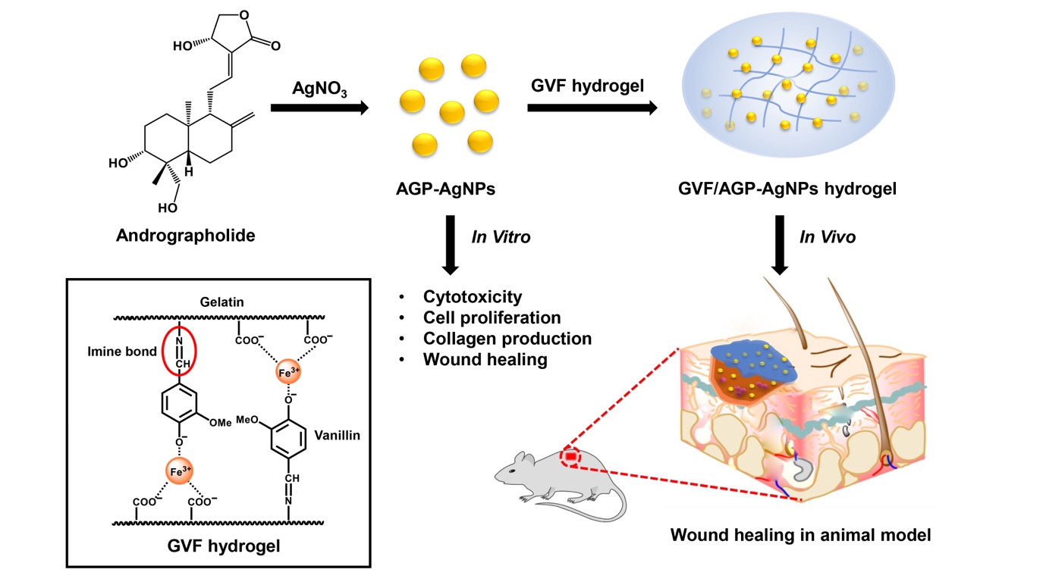
Scheme 1. Schematic of andrographolide-silver nanoparticle (AGP-AgNPs) synthesis, their incorporation into gelatin/vanillin/Fe³⁺ hydrogels, and analysis of wound healing applications of the composite materials in real animal models.
2. Experimental
2.1 Materials
Gelatin from porcine skin was purchased from Sigma-Aldrich, Germany. Vanillin was purchased from Sigma-Aldrich, France. Iron (III) chloride hexahydrate (97%) was purchased from Loba Chemie. Silver nitrate (99.9%) was purchased from POCH™. Andrographolide (9 mg/capsule) was purchased from Khaolaor. Deionized water (DI) with specific resistivity of 18.2 MΩ. cm was obtained from a RiO_{s}TM Type I Simplicity 185 (Millipore water purification system). Dimethylsulfoxide (DMSO) was purchased from Riedel-deHaën®, Germany. Antimicrobial activity assays used E.coli O157/H7, S.aureus ATCC25923, and Bp.1026b. They were obtained from the Biochemistry Laboratory, Biochemistry Department, Faculty of Science, Khon Kaen University, Thailand. 3-4,5-Dimethylthiazol-2-yl)-2,5-diphenyltetrazolium bromide was purchased from Merck Millipore Calbiochem (Massachusetts, USA). Recombinant human FGF-b (rhFGF-b) was purchased from American Type Culture Collection (ATCC, Manassas, Virginia, USA). Dulbecco’s modified Eagle’s media (DMEM), fetal bovine serum (FBS), penicillin and streptomycin (100 µg/mL) were purchased from Gibco, USA. CellTiter-Glo Luminescent cell viability assay kit and lysis buffer reagent were purchased from Promega Corporation, Wisconsin, USA. Micro-dishes were obtained from ibidi GmbH, Gräfelfing, Germany. Ascorbic acid, direct red 80 and picric acid were purchased from Sigma-Aldrich, St. Louis, MO, USA and absolute ethanol, hydrochloric acid 37% (HCl) and sodium hydroxide (NaOH) were purchased from Carlo erba. Paraformaldehyde, hematoxylin and eosin reagents were purchased from Sigma-Aldrich, St. Louis, MO, USA and slide mounting solution was purchased from Fisher Permount™ Mounting Medium, UK. The ¹H-NMR spectra were recorded using a Bruker Avance 400 MHz spectrometer (Bruker, Germany) using D₂O as a solvent.
2.2 Preparation of vanillin/Fe³⁺cross-linked gelatin hydrogels (GVF) and gelatin film (GVF film)
The dual cross-linked hydrogels were prepared via a modification of a previous report[25]. The preparation of gelatin solution involved dissolving 0.48 g of gelatin in 8 mL of DI water, stirring and heating it to 60 °C until it was completely dissolved. Subsequently, a vanillin solution of 1 mL was added to the gelatin solution, followed by the addition of 1 mL of FeCl₃.6H₂O to form gelatin/vanillin/Fe³⁺ hydrogels (GVF). The hydrogels were formed by preparing a series of Fe³⁺ crosslinking agent solutions with different final concentrations of 0, 5, 10, 15, and 20 mM (Table S1), corresponding to GVF-0, GVF-1, GVF-2, GVF-3, and GVF-4, respectively. Hydrogels with different final concentrations of vanillin were prepared by adding 0, 0.5, 1.0, 1.5, and 2.0% (w/v) of as-prepared vanillin solutions (Table S2), designated as GVF-5, GVF-6, GVF-7, GVF-8, and GVF-9, respectively. GVF-9 (GVF hydrogel) will be selected as the suitable hydrogel for further studies as described below. The prepared hydrogel was freeze dried for Solid-state UV-vis Spectra (diffuse reflectance spectra) measurement. In addition, the hydrogel was also prepared in a film form for swelling study by pouring hydrogel into a petri dish and dried in an oven at 40ºC for 24 h to prepare the GVF film which was later removed from the oven and dried at room temperature.
2.3 Synthesis of Andrographolide -stabilized silver nanoparticles (AGP-AgNPs)
The AGP-AgNPs were synthesized by a modification of a previously published method[26]. Briefly, the solution of andrographolide was prepared in 60 mL DI water using 20 capsules containing andrographolide leaf (9 mg of andrographolide/capsules) and stirred at room temperature for an hour. The solution was filtered through a microfilter to obtain a yellow solution. Silver nanoparticles were synthesized by dissolving 3 mL of the andrographolide solution in an Erlenmeyer flask containing 24 mL of DI water. Then, 3 mL of AgNO₃ (20 mM) was added to the mixture and stirred for 3 hours at room temperature. As a result of the reduction of silver salt, the color of the solution changed from colorless to red-brown, indicating the presence of silver nanoparticles. The formation of silver nanoparticles was confirmed by UV–vis spectroscopy. Based on an extinction coefficient of 31.3 × 10⁸ M⁻¹cm⁻¹ at 399.7 nm for 18 nm diameter citrate-silver nanoparticles, the concentration of andrographolide- silver nanoparticles (AGP-AgNPs) was estimated to be 0.44 nM.[27]
2.4 Synthesis of hydrogel composite containing AGP-AgNPs
To prepare AGP-AgNPs composited in GVF hydrogels, 0.48 g of gelatin powder was added to 8 mL of AGP-AgNPs solution and heated to 60 °C until completely dissolved. Then, 1 mL of 20 wt. % vanillin in ethanol was added, followed by the addition of 1 mL of 0.1 M FeCl₃.6H₂O, and the solution mixed.
2.5 Characterization of the hydrogels
The hydrogels were characterized using several analytical techniques. Attenuated Total Reflection Fourier Transform infrared (ATR-FTIR) spectra were recorded in the solid state using an ATR-FTIR spectrophotometer, and NMR spectra were obtained using D₂O as solvents. UV-Vis absorption spectra were measured using an Agilent Technologies Cary 60 UV-Vis spectrophotometer, with 1.0 cm pathlength quartz cells in the range of 200-800 nm. The thermal stability of the cross-linked hydrogels was investigated by thermogravimetric analysis (TGA, Rigaku TG-8120) under a nitrogen atmosphere with a heating rate of 10 °C/min from 25 °C to 800 °C. Solid-state UV-Vis diffuse reflectance spectra (DRS) were recorded using barium sulfate as a standard. The surface morphology of gelatin powder and freeze-dried gelatin/vanillin/Fe³⁺ hydrogels were analyzed using Scanning Electron Microscopes (Mini SEM, SEC SNE-4500M). Viscoelastic properties of the hydrogels were analyzed using a Brookfield viscometer Model RVDV-II+, and rheological properties were investigated using a parallel-plate rheometer (Physica MCR500, Germany) with a smooth stainless-steel plate of 25 mm diameter. The storage modulus (G′) and loss modulus (G″) of the hydrogels were monitored by strain amplitude (γ₀) under a strain from 0.1% to 1000% at a constant temperature (25 ºC) and frequency (1 rad s⁻¹). For angular frequency sweep experiments, G′ and G″ were measured under an angular frequency range from 0.1 to 100 Hz with a fixed strain of 0.15%. Shear thinning behavior of the hydrogels was measured as a function of shear rate from 0.1 to 1 s⁻¹ using a rotation model.
2.6 Explosive swelling measurements
The swelling behavior of the hydrogels was investigated in DI water at room temperature, wherein 0.25 g of GVF hydrogel film was submerged in 20 mL water for a specified duration, and subsequently extracted while eliminating excess water using filter paper. The gels were weighed until a constant weight was achieved. The degree of swelling was calculated using:
Swelling degree (%) = ((W_{s} – W_{o}) / W_{o}) x 100 (1)
Where W_{s} was the swollen weight of the soaked hydrogel and W_{o} was original weight of the dry hydrogel. All experiments were done in triplicate.
2.7 Proliferation of cells and collagen synthesis
The CellTiter-Glo Luminescent cell viability assay kit was used to determine the cell proliferation. In brief, cells were seeded at 2.5 × 10⁴ cells/well in 48 well-plates and incubated for 24 h. Subsequently, cells were subjected to treatment with AGP-AgNPs (0.0005, 0.001, and 0.002nM) and Vit C (50 µg/mL, indicated as a positive control) for 7 and 14 days, with the culture medium being refreshed every 2 days. After the treatment period, the culture medium was removed, and 100 µL of lysis buffer reagent (1X) was introduced into each well. Following a 10-minute incubation, 50 µL of cell lysates were mixed with CellTiter-Glo reagent for another 10 minutes. Finally, the luminescence was measured using a microplate luminometer (SpectraMax L, Molecular Devices).
The Picrosirius red staining assay was utilized as a method to detect insoluble collagen fibers. Cells were initially seeded at 2.5 × 10⁴ cells/well in 48 well-plates and incubated for 24 h. Following this, the cells were treated with AGP-AgNPs (0.0005, 0.001, and 0.002nM) and Vit C (50 µg/mL) for 7 and 14 days. After the treatment period, the culture medium was discarded, and the cells were thoroughly washed with phosphate-buffered saline (PBS) before being fixed with 4% paraformaldehyde (PFA) for 10 minutes. Upon fixation, the cells were washed with PBS twice and then stained with 0.1% direct red 80 (in saturated picric acid). After staining for 10 minutes, the dye was removed, and any excess dye was washed away by 0.01 M HCl (in 70% ethanol) twice. The stained collagen was visualized under a microscope (CKX41, Olympus, Japan), while the insoluble collagen was dissolved with 0.5 M NaOH. The content of collagen was quantified by measuring the absorbance at 540 nm using a microplate reader.
2.8 In vitro wound healing assay
The silicon culture-insert 4 well in dish 35 mm (Ibidi, Munchen, Germany) was used in wound healing assays. Cells were seeded at 3 × 10⁴ cells/well and incubated for 24 h. After incubation, the culture-insert was removed, and the cells were washed with PBS. AGP-AgNPs (0.001 and 0.002 nM) and fibroblast growth factor FGF (100 ng/ml, indicated as positive control) were added to the cells, and the culture medium was changed daily. The wound closure of migrating cells after treatment was photographed at 0, 24, and 48 h, and gap filling was investigated using the ImageJ program. Percentage gap-filling was calculated using methods from a previous study[28].
2.9 Evaluation of antibacterial activity of GVF/AGP-AgNPs hydrogel
The well diffusion method was employed to perform antimicrobial tests. Initially, a single colony was allowed to grow in Mueller Hinton Broth (MHB) at 37°C for 24 h. Subsequently, after inoculation for 3 h, the bacteria were diluted in the same media to obtain an inoculum of 1 × 10⁷ CFU/mL. The bacteria were then swabbed onto a three-dimensional MH agar plate, which was cut to generate wells of 6 mm diameter. Next, 0.05 g of GVF/AGP-AgNPs hydrogel or 20 µL of standard drug was introduced into the wells, followed by incubation at 37°C for 24 h. The positive control comprised of Gentamicin and Ceftazidime, whereas deionized water was used as the negative control. After 24 h of incubation, the inhibition zone was measured using a millimeter (mm) scale ruler.
2.10 Cell culture preparation and cell viability assay
Dulbecco's modified eagle medium (DMEM) supplemented with 10% fetal bovine serum (FBS) and 1% penicillin/streptomycin was used to cultivate human dermal fibroblast cells (ATCC, Manassas, VA, USA) in a humidified atmosphere (5% CO₂) at 37°C. To assess the impact of AGP-AgNPs on cell viability, MTT (3-(4,5-dimethylthiazol-2-yl)-2,5-diphenyltetrazolium bromide) assay was employed. For this, cells were seeded at 2 × 10⁴ cells/well in a 96-well plate and incubated for 24 h. Subsequently, cells were exposed to various concentrations of AGP-AgNPs for 24 h. After treatment, the culture medium was eliminated, and MTT (1 mg/mL) was introduced into each well. Following a 4h incubation period, the MTT solution was replaced with dimethyl sulfoxide (DMSO), and the absorbance was measured at 570 nm using a microplate reader (Synergy H1, BioTeK).
2.11 Animals and incisions made for wound study
Twelve male Wistar rats, weighing 180-200 g and aged 8 weeks, were procured from Nomura Siam International Co., Ltd., Bangkok, Thailand. The rats were kept in groups under standard animal laboratory conditions, which included a light/dark cycle (12/12 h), 21 ± 2 °C temperature, and 50-55% relative humidity. They were provided with standard rat chow (CP Co., Ltd., Bangkok, Thailand) and sterile reverse osmosis water ad libitum. The Institution's Animal Care Committee, Thammasat University, Thailand, approved all the animal procedures, which were conducted according to the Guide for the Care and Use of Laboratory Animals, National Research Council (protocol number: 01/2023). After an acclimation period of 1 week, two full-thickness skin incisions were made on the back of each isoflurane-anesthetized rat, following sterilization procedures. The skin wounds, which were 1 cm in diameter, were treated with GVF/AGP-AgNPs hydrogels or GVF gels, while the rats were given 12.5 mg/kg tramadol injection to reduce pain. The skin wounds were cleaned daily and treated with GVF/AGP-AgNPs hydrogels or GVF gels, after which they were photographed on days 3, 7, 14, and 21 post-wounding. The percentage of wound contraction was calculated using the method described previously.
2.12 Histopathology analysis
The full-thickness skin samples were collected on days 7, 14, and 21 post-wounding, for which cross-sectional specimens were obtained. The skin specimens were then fixed in 10% formaldehyde, dehydrated using graded ethanol and xylene, and subsequently embedded in paraffin. Using a Leica microtome (Microsystems, Wetzlar, Germany), the paraffin blocks were sectioned into 5 𝜇m sections, which were then stained with hematoxylin and eosin or Masson’s Trichrome (Sigma-Aldrich, St. Louis, MO, USA). The number of mononuclear leukocytes, polymorphonuclear leukocytes, and fibroblasts, as well as the degree of vascularization, were all qualitatively evaluated in three parallel sections taken from each specimen. Collagen density was measured in the wound area and compared to rat skin treated with the GVF hydrogel (non-wound control). The collagen density under the wound area was expressed as a percentage of the collagen density of the control group for each post-wounding day. The morphological evaluations were photographed by a Nikon DXM 1200 digital camera (Tokyo, Japan). The interpretation of histological slides was carried out as a blind analysis by two independent pathobiologists from the Pathology Information and Learning Center, Department of Pathobiology, Faculty of Science, Mahidol University.
2.13 Statistical analysis
Statistical analysis was performed using GraphPad Prism 7.0 (GraphPad Software, Inc., San Diego, CA). The results were expressed as mean ± standard error of the mean (SEM). The comparisons between groups were conducted using student’s-t test and/or between and within groups using one-analysis of variance (ANOVA) with post-hoc Tukey's Honest test. All statistical tests were set at a significance level α of 0.05 (P<0.05).
3. Results and Discussions
3.1 Preparation of gelatin/vanillin/Fe³⁺ hydrogels (GVF hydrogels)
A self-healing hydrogel based on gelatin was prepared using vanillin and Fe³⁺ acting as dual crosslinking agents as displayed in Scheme 1. The aldehyde group of vanillin is capable of forming Schiff-base bonds with the amino groups of gelatins, while the hydroxyl group of vanillin could form hydrogen bonding with the hydroxyl or amino groups of another gelatin molecule. The amino groups of gelatins and the hydroxyl group of vanillin also form ionic coordination with Fe³⁺, which further drives construction of a reversibly-bonded hybrid network. The Schiff-base reaction of vanillin and gelatin was confirmed by nuclear magnetic resonance (¹H-NMR) spectroscopy[29,30], with the imine bond between gelatin and vanillin showing a proton signal at 8.43 ppm (Figure S1). Additionally, ATR-FTIR spectra were used to confirm the formation of Schiff-base bonds and hydrogen bonds of hybrid linkages. Gelatin is composed of polypeptide chains consisting of different amino acids arranged in a unique order. The presence of O-H stretching vibrations was indicated by the broad peak at 3280 cm⁻¹, while the peak at 1630 cm⁻¹ was characteristic of C=O stretches, and the peaks at 1531 cm⁻¹ corresponded to N–H bending vibration (Figure S2). The formation of Schiff-base bonds between the amino group of gelatin and the aldehyde group of vanillin was confirmed by the appearance of a new peak at 1585 cm⁻¹ corresponding to the C=N stretching vibration [31,32]. However, this C=N peak of the imine bond overlapped with the peak of C=O stretches in the case of the GVF hydrogel.
UV-visible diffuse reflectance spectroscopy was used to investigate the interactions of the polymer network in the hydrogels (Figure S3a). One absorption band centered at 500 nm (blue line) was exhibited by gelatin/Fe³⁺, which could indicate the formation of a complex between the gelatin and Fe³⁺ ion. An absorption band at 440 nm (red line) was exhibited by gelatin/vanillin, may indicating the presence of an imine bond. Furthermore, the creation of the polymer network was confirmed by the characteristic peak of both vanillin and gelatin/Fe³⁺ in the GVF-9 (black line indicating as GVF hydrogel). Thermogravimetric analysis revealed that gelatin, gelatin/vanillin, and GVF hydrogel underwent decomposition in two main steps, as shown in Figure S3b. The loss of residual water in the polymers was assigned to the first region of the TGA curve at 30 °C and 100 °C. The second region from 250 °C to 400 °C of the TGA curve is attributed to the degradation of cross-linked gels. In this zone, GVF shows lower weight loss than gelatin/Fe³⁺, indicating that GVF is more stable, presumably due to higher cross-linkage density which correlates strongly with stability.

3.2 Characterizing the viscoelastic properties: Rheological measurements
Different concentrations of FeCl₃.6H₂O were used to synthesize GVF-1 to GVF-5, as described in section 2.2. Mechanical properties of the hydrogels were measured via rheology tests. The material’s elastic properties and energy storage were reflected by the storage modulus (G′) after perturbation, while the viscous properties and energy loss were reflected by the loss modulus (G″) through relaxation or dissipated heat. In a gel with a strong, covalently-linked network, the G′ modulus would be expected to be larger than the G″ modulus, indicating that the material is able to store more energy than it loses during deformation[33,34]. The rheology technique was utilized to investigate the elastic properties of all hydrogels under the strain sweep (0.1-100%) mode (Figure 1(a)). All samples demonstrated a higher storage modulus (G′) than loss modulus (G″), suggesting that the hydrogel networks were rigid and cross-linkage remained intact under large deformations.[35] It was observed that GVF-1 and GVF-2 exhibited a higher G′ compared to the other samples, suggesting that the strength of the hydrogels at those concentrations was greater than that of the other concentrations. The G′ and G″ of GVF-1 to GVF-5 were measured at a fixed strain of 0.15% in a frequency range of 0.1 to 100 Hz during the frequency sweep test. The results are presented in Figure 1b, where all samples showed a higher G′ than G″, and were stable as the frequency increased from 0.1 Hz to approximately 30 Hz, indicating that the hydrogels possessed strength and stability. However, GVF-2 (10 mM FeCl₃.6H₂O) was chosen as the most suitable concentration for the following research as it exhibited the highest stability even at frequencies up to 100 Hz.
GVF-6 to GVF-9 hydrogels were synthesized by using different concentrations of vanillin while keeping the concentration of FeCl₃.6H₂O fixed at 10 mM (Table S2). Rheology was employed to measure the viscoelastic properties of these hydrogels under strain sweep (0.1-1000%) (Figure 1c). The results indicated the formation of a strong gel with a covalently-linked network, as all samples showed G′ larger than G″. However, an inverse relationship was observed between the hardness of the GVF hydrogel and the vanillin content. This finding was further confirmed by using a Brookfield viscometer (Figure 1d). We hypothesized that the increase in vanillin content results in larger pore sizes and longer crosslink lengths, leading to the formation of softer and more stable hydrogels. In the frequency sweep test, G′ and G″ of GVF-6 to GVF-9 were measured in a range of frequencies from 0.1 to 100 Hz at a fixed strain of 0.15% (Figure 1(e)). From Figure 1(e), it is evident that the softness of the hydrogels increased with increasing vanillin content, as indicated by the increase in G″. This property is desirable for biomedical applications. GVF-8 and GVF-9 exhibited the highest softness among all samples. Therefore, GVF-8 and GVF-9 were used for investigation of shear-thinning properties (Figure 1(f)). A shear rate sweep measurement was performed under rotation mode (from 0.1 to 1 s⁻¹) to confirm the shear-thinning behavior of the gel for injectability. Both GVF-8 and GVF-9 exhibited shear-thinning properties, indicating injectability. However, the viscosity of GVF-9 as a function of shear rate was lower than that of GVF-8, indicating better injectability. Therefore, GVF-9 (GVF hydrogel) was selected as the most suitable condition for subsequent wound healing studies.
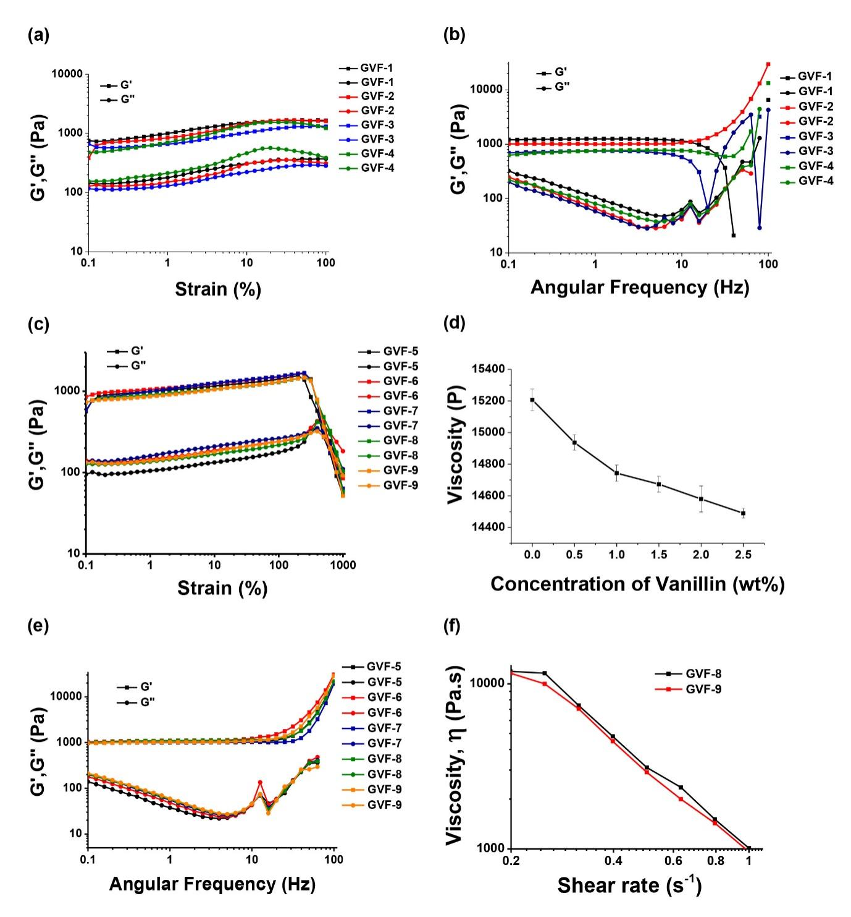
Figure 1. The storage and loss moduli of GVF hydrogels with varying concentrations of FeCl₃.6H₂O (GVF-1 to GVF-4), measured by (a) strain amplitude (structural collapse occurred above 100%) and (b) frequency sweep experiments. The storage and loss moduli of GVF hydrogels with different wt. % of vanillin were measured by (c) strain amplitude and (d) viscosity, (e) the frequency sweep experiments for GVF hydrogels with varying concentrations of vanillin (GVF-5 to GVF-9) and (f) the shear-thinning property of GVF-8 and GVF-9.
3.3 Analyzing the morphology of the GVF hydrogel and its self-healing properties
The SEM images of gelatin powder and GVF hydrogel were investigated as depicted in Figure 2(a) and (b), respectively. The surface morphology of the gelatin powder was characterized by nodules and flakes. In contrast, the GVF hydrogel exhibited a remarkable morphology, with scaly and fragmented material displaying vast gaps. This porous structure facilitates aqueous fluid diffusion within the polymeric network, thereby increasing the swelling capacity of the final hydrogel. Furthermore, the uniformly dispersed pore spaces on the surface of the GVF hydrogel indicate a homogeneous composition of the absorbent material[36]. Such a structure is a good candidate for wound-healing materials as large amounts of exudates or blood could be absorbed by the material, which also acts as a barrier to microorganisms, maintains a moist environment at the skin defect site, and exhibits good oxygen and water permeability, thereby accelerating skin regeneration.[37–39]
Reversible GVF hydrogel formation in different temperature conditions was observed as shown in Figure 2(c). It was noted that at high temperature, the hydrogel broke down to form liquids, but it quickly returned to gel-form when cooled down. The injectable nature of the hydrogel through a 1.2 mm internal diameter needle/syringe is depicted in Figure 2(d). Upon squeezing the hydrogel in the syringe, the pressure caused the cross-linkages to dissociate, causing the hydrogel to distort and "flow" like a liquid through the thin needle. The hydrogel showed fast self-healing capabilities, as the extruded hydrogel joined together to create an integrated component once more. It can be inferred that the hydrogel may be used to encapsulate cells/drugs uniformly and implant them into tissue using a minimally invasive technique.[40] Investigation of the self-healing properties of GVF hydrogel was conducted using a digital microscope, as depicted in Figure 2(e-h). Damage to the hydrogel was created by a slitting needle, as shown in Figure 2(e). GVF hydrogel subsequently exhibited excellent self-healing properties, attributed to the dual, facile crosslinking via imine bond and ionic bonds as mentioned earlier. The GVF hydrogel displayed gradual reduction in the depth of the scratch, with complete self-healing after 10 minutes as illustrated in Figure 2(h). In addition, the macroscopic test for self-healing hydrogel was also performed as shown in Figure 2(i) and Video S1 in supplementary information. The results shown that hydrogel was fully recovered/healed after damaging by the needle within 6 minutes observed by naked eyes.

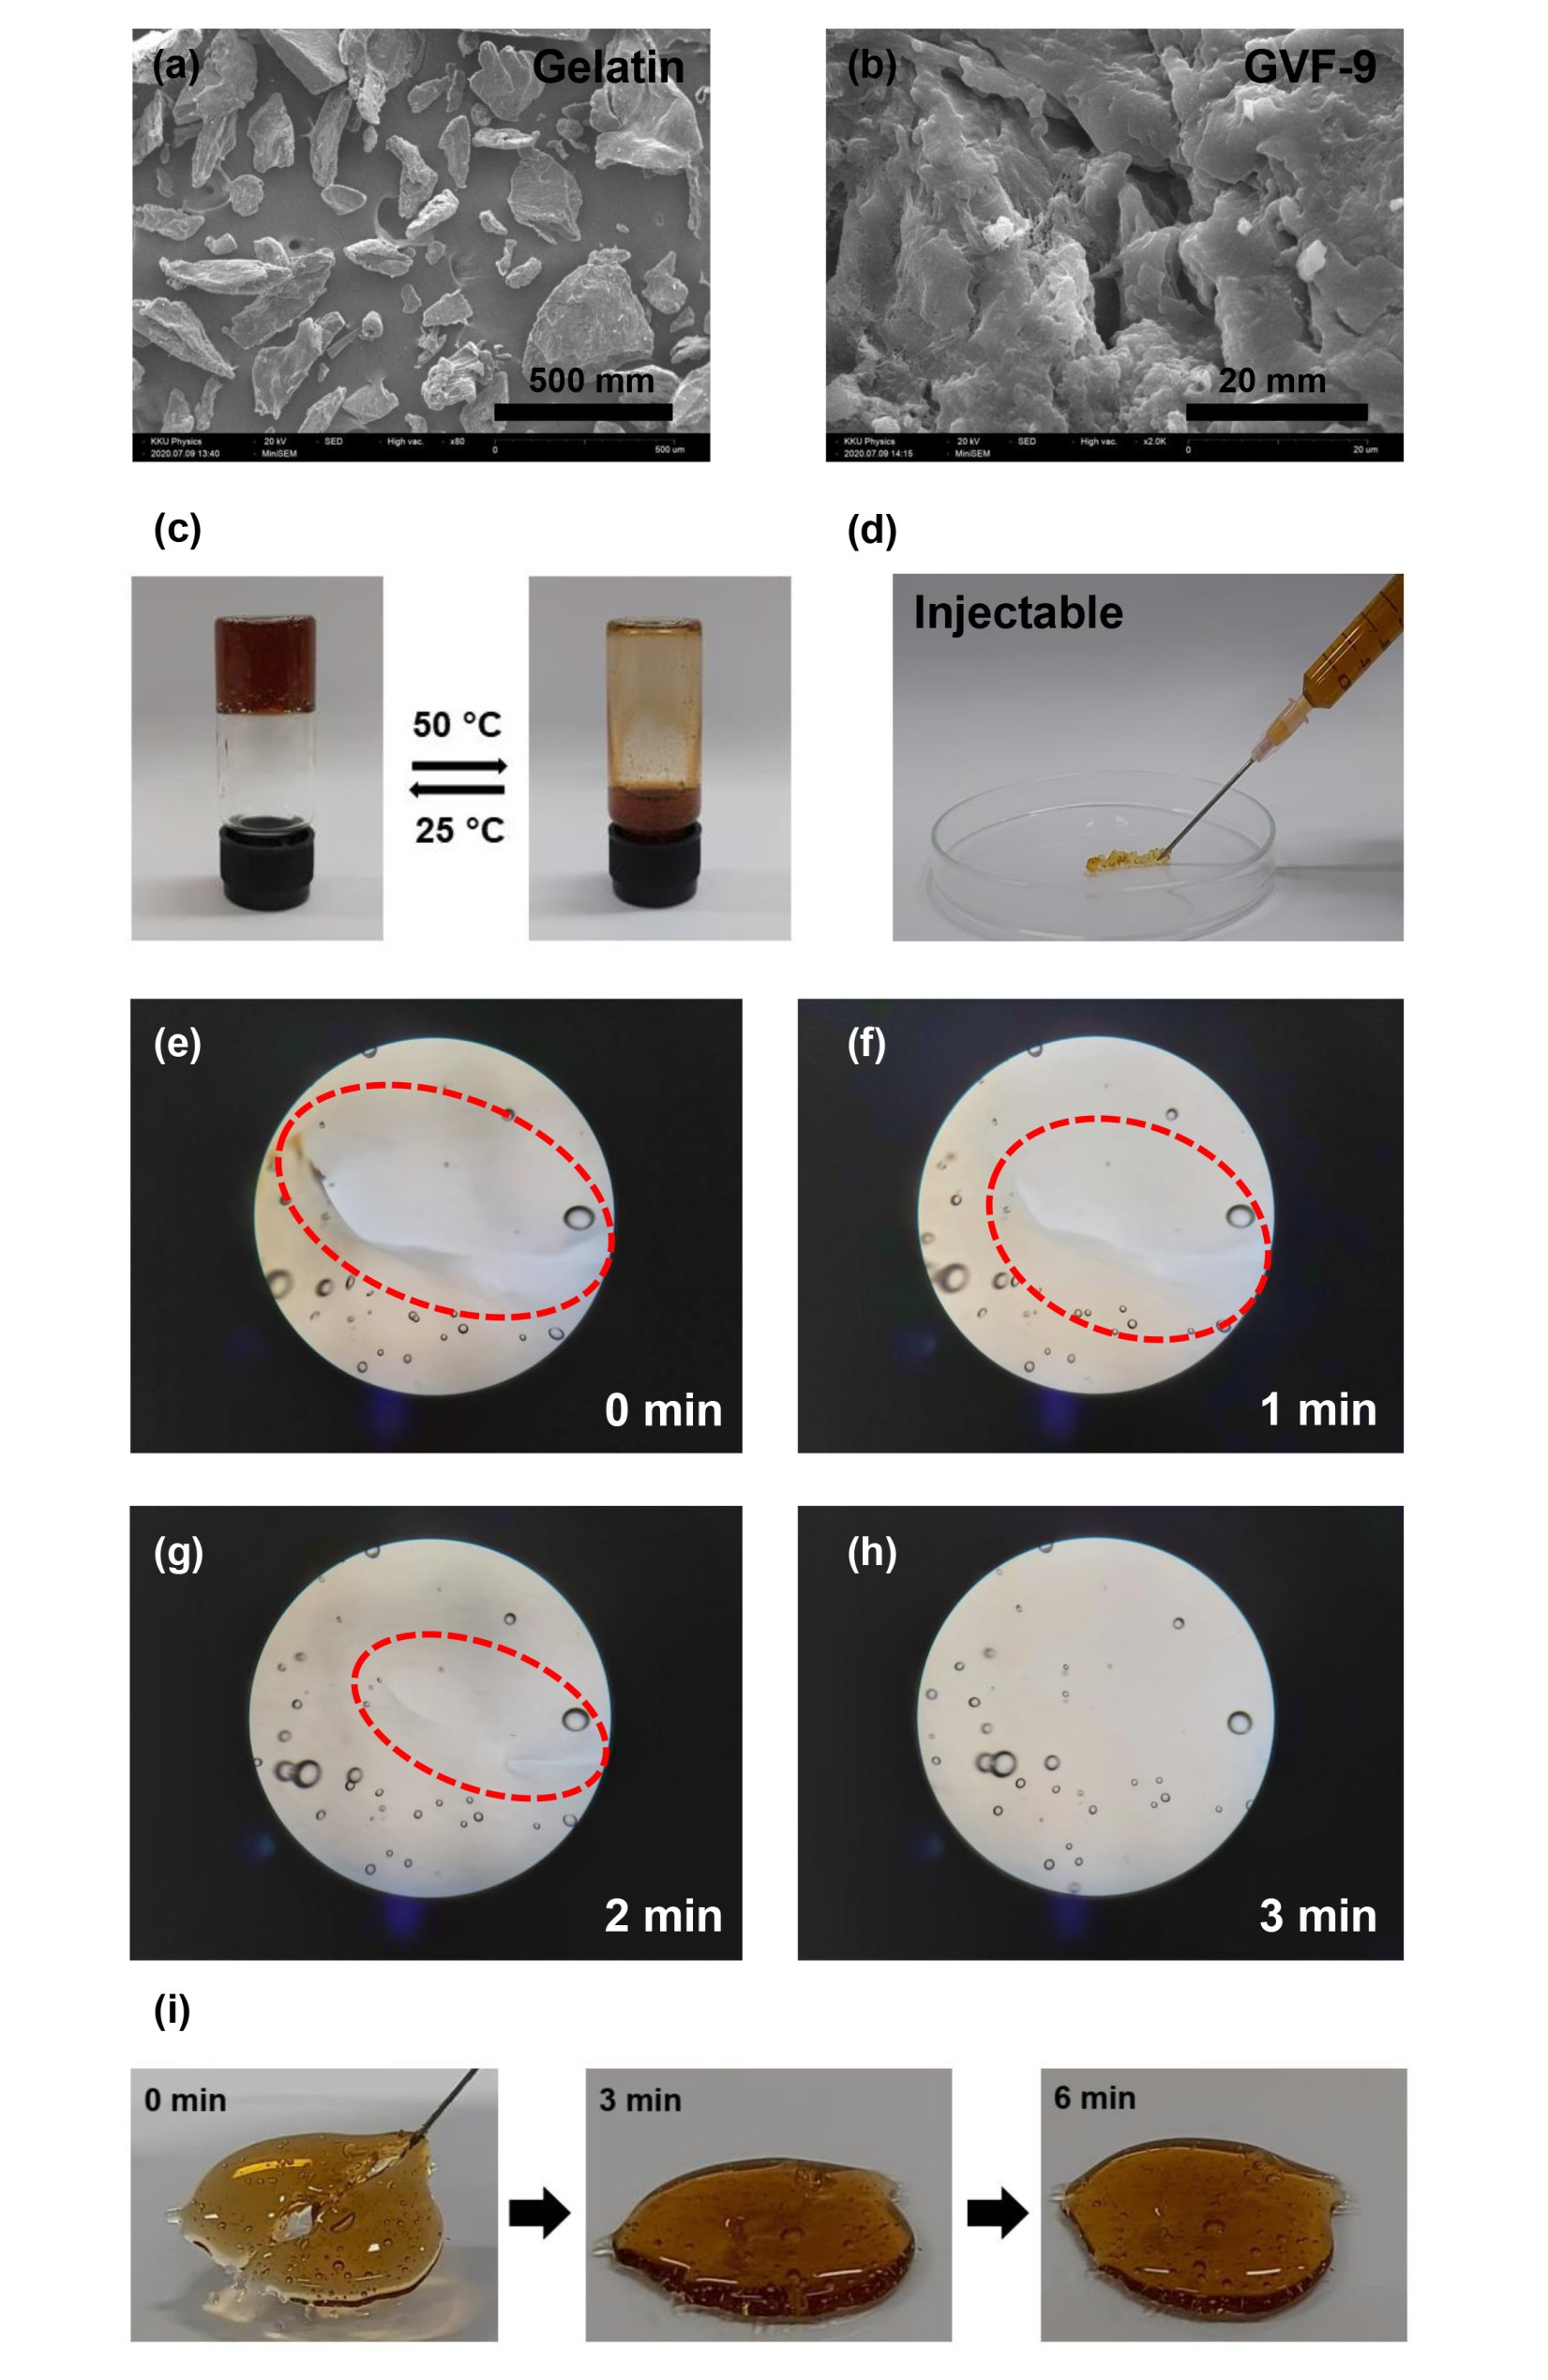
Figure 2. SEM images of (a) gelatin powder and (b) GVF hydrogel (under freeze dried process), (c) the reversible formation of GVF hydrogel in various temperature conditions, (d) the injectability of the GVF hydrogel through a 1.2 mm internal diameter needle, and (e-h) digital microscope investigation of the GVF hydrogel’s self-healing properties at various times after being slit with a needle.
3.4 Water absorption by GVF hydrogel
The hydrogels' water uptake was characterized by their swelling ratio. The swelling behavior of GVF hydrogel was studied by incubating it in DI water at room temperature for different curing times. The hydrogels exhibited an extremely high swelling degree, reaching equilibrium at 110 minutes, with a swelling degree of up to 17,000%, as illustrated in Figure S4. This exceptional moisture uptake makes GVF hydrogel an ideal candidate for maintaining a moist wound environment and absorbing significant amounts of wound exudate, both critical factors in promoting accelerated wound healing.[41,42]
3.5 Synthesis and characterization of Andrographolide-silver nanoparticles (AGP-AgNPs)
Andrographolide-silver nanoparticles (AGP-AgNPs) were synthesized by a simple routine as described in Section 2.3. AGP-AgNPs exhibited a characteristic UV-Vis spectrum at 441 nm (Figure 3(a)), resulting from localized surface plasmon resonances (LSPR). The transmission electron microscope (TEM) image of AGP-AgNPs (Figure 3(b)) showed a narrow size distribution and a spherical or pseudospherical shape with a diameter ranging from 16.85 ± 5.81 nm (n = 75) (Figure 3(c)). In any case, these results suggest the successful synthesis of stable colloidal AGP-AgNPs which may have desirable antibacterial properties when combined with the hydrogel.[43]
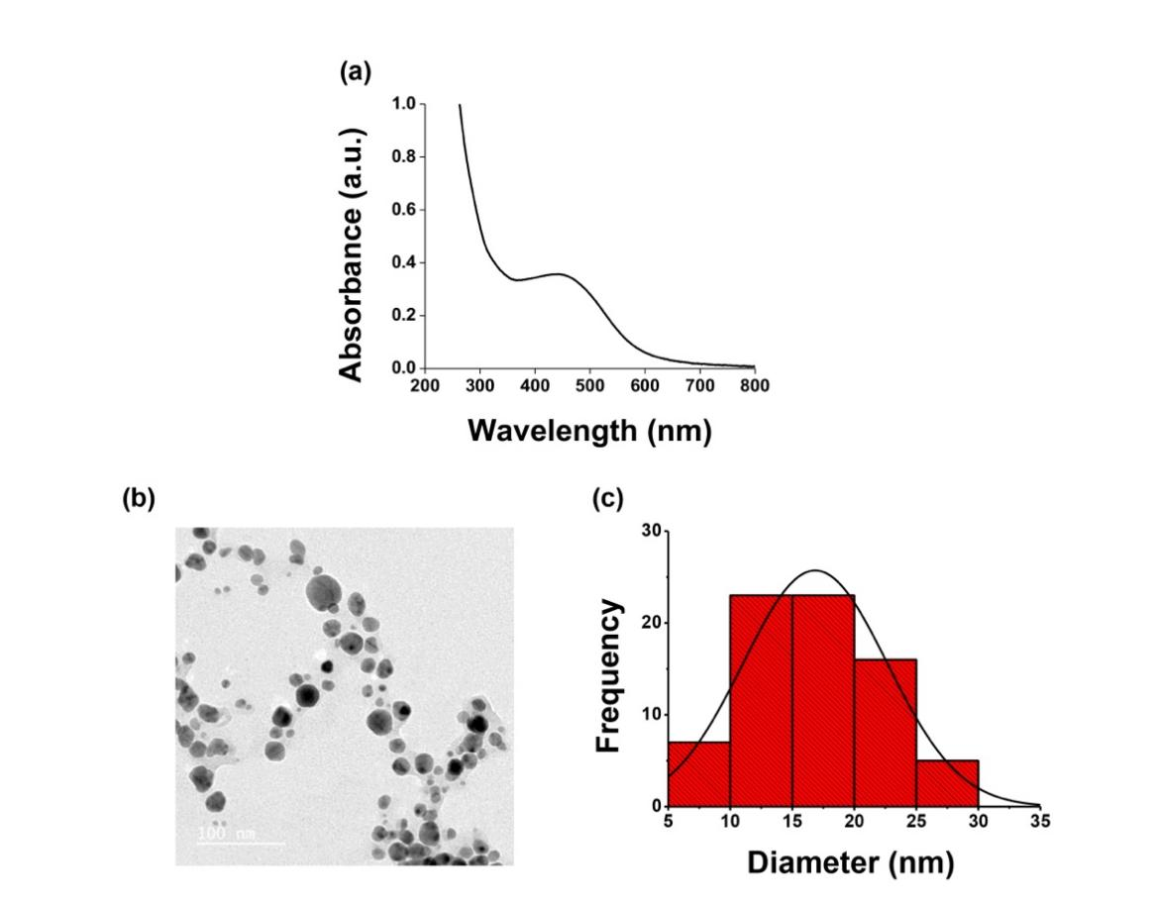
Figure 3. Characterization of Andrographolide-silver nanoparticles (AGP-AgNPs) exhibiting (a) characteristic UV-vis spectrum at 441 nm, (b) TEM image displaying a narrow size distribution with spherical and pseudospherical shape, and (c) the average diameter of AGP-AgNPs; 16.85 ± 5.81 nm (n = 75).
3.6 Cytotoxicity studies and protective effect of AGP-AgNPs towards H₂O₂-induced oxidative stress in fibroblasts
In this study, it was found that AGP-AgNPs had low cytotoxicity, with over 80% of fibroblast cells remaining viable when 0.0032 nM of AGP-AgNPs were incubated. However, cell survival decreased when concentrations of AGP-AgNPs ranging from 0.0008 nM to 0.0032 nM were used (as shown in Figure S5(a)). Therefore, AGP-AgNPs could be considered non-cytotoxic at or below a concentration of 0.0032 nM. Hydrogen peroxide (H₂O₂) is a reactive oxygen species (ROS) that causes oxidative stress. The damage induced by H₂O₂ in fibroblast cells can be assessed using MTT assay.[44] Andrographolide is a compound that has been studied for its ability to prevent oxidative stress. In previous studies, it was found that Andrographolide protected chondrocytes (a type of cartilage cell) from H₂O₂-induced injury by activating the Keap1-Nrf2-Are pathway[45]. Additionally, it was found that Andrographolide protected liver cells from H₂O₂-induced cell death by signaling through the adenosine A2a receptor and upregulating Nrf-2 transcription[46].
To investigate the protective effect of AGP-AgNPs against H₂O₂-induced oxidative stress, fibroblasts were pretreated with 0.001, 0.002, and 0.004 nM of AGP-AgNPs for 24 hours before being exposed to H₂O₂ for an additional hour. The cytotoxicity of AGP-AgNPs was first checked, as depicted in Figure S5(b). When treated with 50 and 100 μg/mL of H₂O₂, cell viability significantly decreased by approximately 25% and 40%, respectively. However, pretreatment with 0.001 and 0.002 nM of AGP-AgNPs followed by 50 μg/mL of H₂O₂ exposure significantly increased cell survival compared to H₂O₂ treatment alone. In addition, at a higher concentration of AGP-AgNPs (0.004 nM), a different trend emerges when exposed to 50 μg/mL H₂O₂. It is possible that at this concentration, AGP-AgNPs may start exhibiting cytotoxic effects themselves due to the high concentration of silver nanoparticles. This could result in a compromised antioxidant effect and a less favorable cellular outcome, as indicated in Figure S5(b). The complicated interaction between the concentration-dependent effects of AGP-AgNPs and their specific cellular response to oxidative stress is a possible reason for the observed discrepancy.
Interestingly, at 100 μg/mL H₂O₂, the best protective effect is observed at the concentration of AGP-AgNPs of 0.004 nM. This finding suggests that under a more severe oxidative stress environment, a higher concentration of AGP-AgNPs may be required to counteract the detrimental effects and maintain cellular viability. It is plausible that the antioxidant and cellular protective mechanisms induced by AGP-AgNPs become more pronounced at this higher H₂O₂ concentration, leading to the observed favorable outcome. At higher concentrations of H₂O₂ (100 μg/mL), pretreatment with AGP-AgNPs increased the viability of fibroblast cells in a dose-dependent manner. These results suggest that AGP-AgNPs could protect fibroblasts against oxidative stress induced by H₂O₂.
3.7 The effect of AGP-AgNPs on cell proliferation and collagen production in human dermal fibroblast cells
In this section, we investigate the impact of AGP-AgNPs on the proliferation of human fibroblast cells, and on the production of collagen. After being treated with 0.0005, 0.001, and 0.002 nM of AGP-AgNPs for 7 days, cell proliferation increased significantly when compared to the control group. This increase was similar to the one observed in the positive control group treated with internal control of ascorbic acid. (Figure 4(a)). Additionally, the 0.001 nM of AGP-AgNPs treatment significantly increased cell proliferation compared to the control group, while ascorbic acid notably increased cell proliferation after 14 days of incubation (Figure 4(a)). Therefore, AGP-AgNPs showed a greater potential in enhancing cell proliferation and collagen production in fibroblasts compared to the control group. In terms of total collagen, which was indicated by Picrosirius red staining (Figure 4(b)), cells treated with 0.0005, 0.001, and 0.002 nM of AGP-AgNPs and ascorbic acid showed an increase in collagen production by 2%, 11%, 18%, and 26% after 7 days compared to the control group (no AGP-AgNPs). However, after 14 days of treatment, the three tested AGP-AgNP concentrations and ascorbic acid treatment increased collagen production by 6%, 24%, 47%, and 152%, respectively, compared to the control group (Figure 4(c)). These findings suggest that exposure to AGP-AgNPs could enhance cell proliferation and collagen production in fibroblasts.
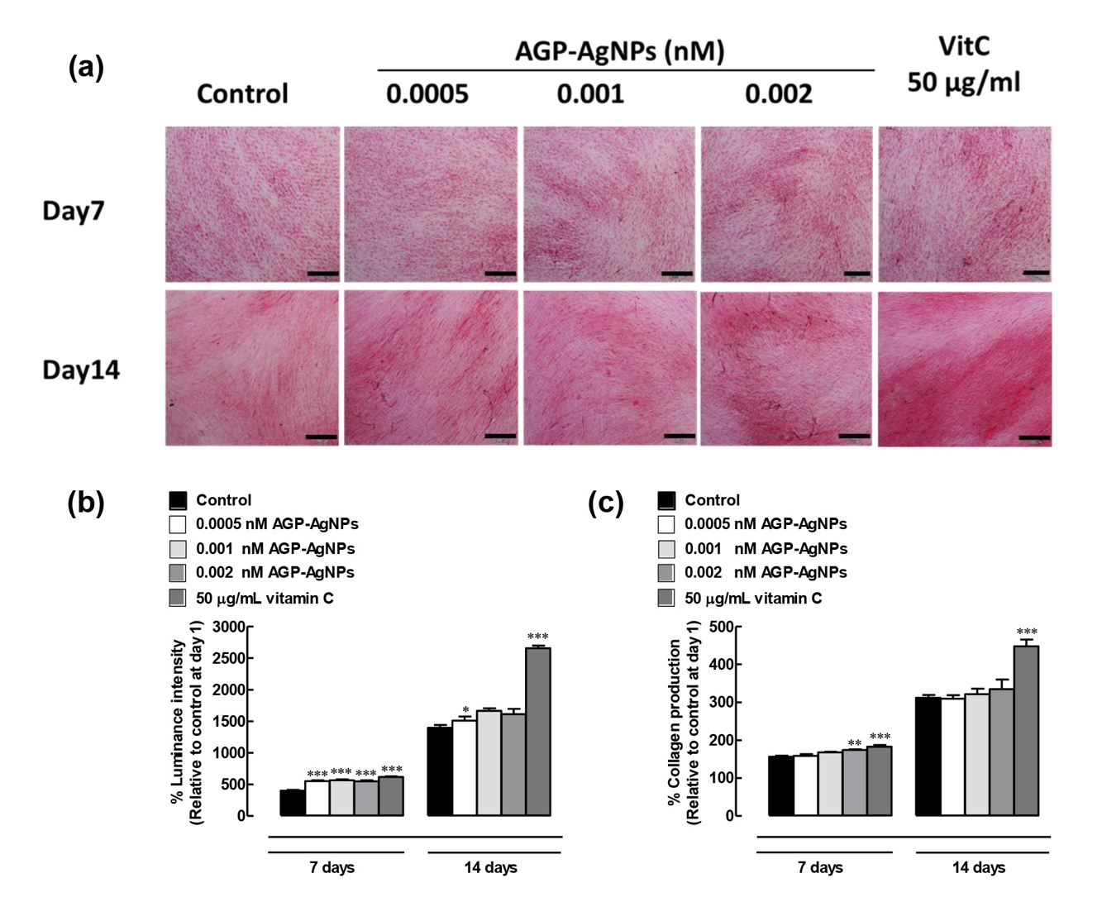
Figure 4. (a) Light transmission microscopy images of human dermal fibroblast cells which were treated with various concentrations of AGP-AgNPs (0.0005, 0.001, and 0.002 nM) and ascorbic acid (Vitamin C) at 50 μg/mL for 7 and 14 days, cell proliferation was measured and collagens were stained red with Picrosirius dye and imaged at 200 × magnification. The scale bar located in the lower right corner represents a length of 200 µm. (b) % Luminance intensity and (c) % Collagen production of previously treated human dermal fibroblast cells. The results are presented as mean ± SEM (n = 4/group). Statistical significance was calculated by comparing the treatment groups with the control group within 7 or 14 days after treatment (*P < 0.05, **P < 0.01, and ***P < 0.001).
3.8 Investigating the influence of AGP-AgNPs on in vitro wound healing
The process of wound healing typically involves three overlapping phases: hemostasis/inflammation, proliferation, and remodeling[47]. Fibroblast growth factor (FGF) plays a crucial role in in vitro wound healing. FGF stimulates the proliferation and migration of fibroblasts, which are the main cells involved in the formation of new tissue in the wound healing process by generating extra cellular matrix (ECM) and collagen structures[48,49]. Moreover, several studies have shown that Andrographolide’s antioxidant activity occurs in parallel with other wound healing drivers including regulating vascular blood flow and delaying cell necrosis[50,51]. In addition, Andrographis paniculata (A. paniculata) extracts also promoted re-epithelialization activity in wound areas in rats[51,52]. In vivo study of the effect of A. paniculata leaf extract on wound healing suggested that it enhanced rate of wound closure in rats[53].
Here, AGP-AgNPs were shown to significantly increase wound gap closure in a time-dependent manner (Figure 5(a) and (b)). Treatment with 0.001 and 0.002 nM of AGP-AgNPs and 100 ng/mL of fibroblast growth factor (FGF) for 24 hours increased cell migration by 25%, 33%, and 37% compared to the control, while 48-hour treatment promoted 60%, 82%, and 90%, respectively. Treatment with 0.001 and 0.002 nM AGP-AgNPs for 24 hours significantly increased wound gap filling (by 1.1 and 1.5 times, respectively), whereas only 0.002 nM AGP-AgNPs treatment induced significant wound gap filling (1.3 times better than untreated control) at 48 hours. Notably, the wound gap closure induced by 0.002 nM AGP-AgNPs was similar to that of the FGF positive control. These results suggest that 0.002 nM AGP-AgNPs treatment displayed wound healing properties as potent as the FGF positive control.
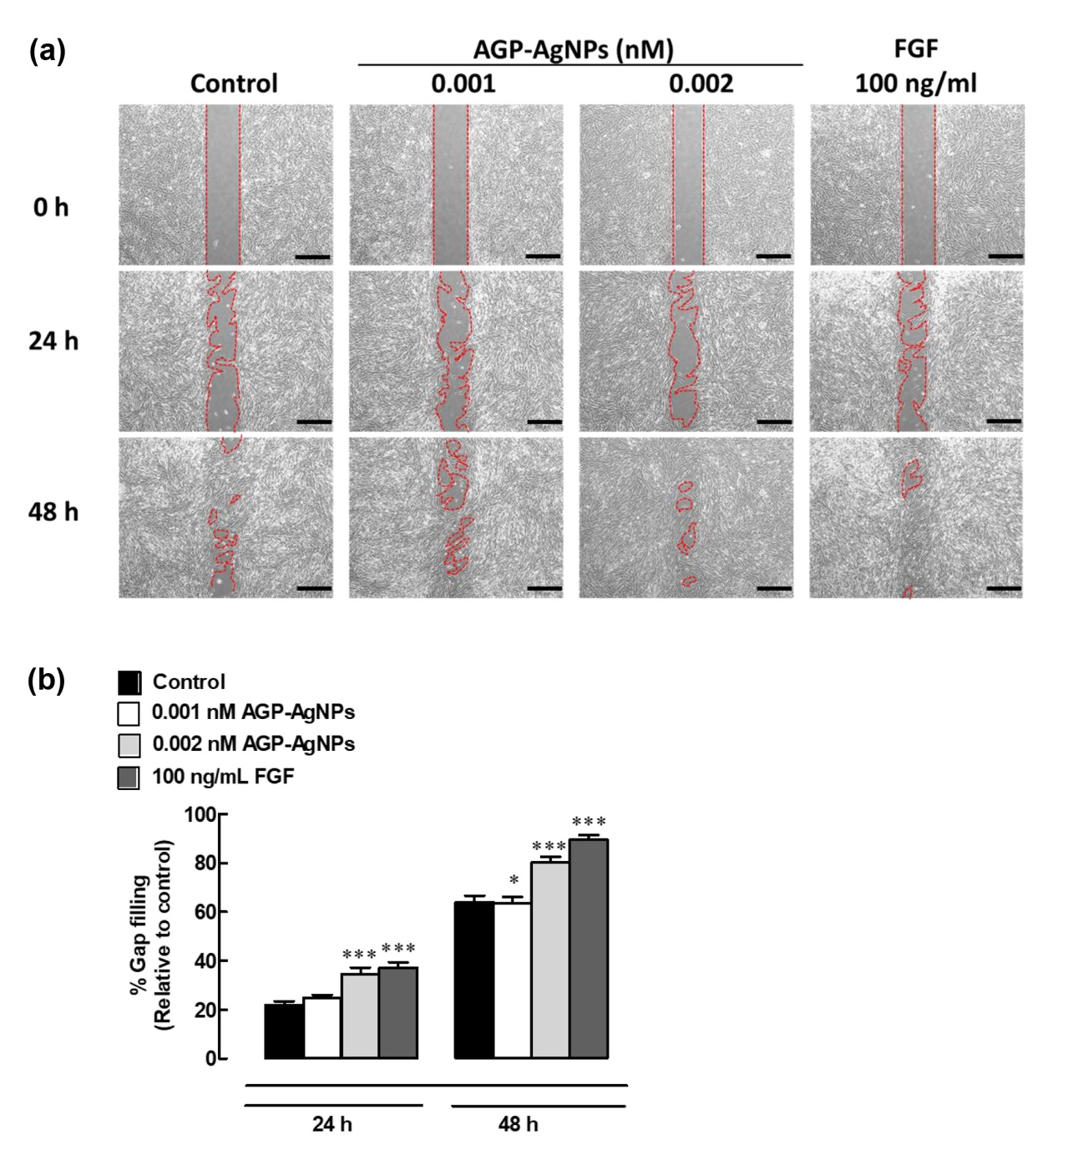
Figure 5. Effects of AGP-AgNPs on wound gap closure. (a) Human dermal fibroblast cells were treated with 0.001 and 0.002 nM of AGP-AgNPs, or 100 ng/mL of FGF as a positive control, and a scratch wound assay performed at 0, 24 and 48 h. The scale bar located in the lower right corner represents a length of 500 µm. (b) Percentage of wound gap filling relative to the original scratch width. Data were expressed as mean ± SEM (n = 4). *P < 0.05 and ***P < 0.001 compared to control within 24 h or 48 h post-treatment.
3.9 Enhanced mechanical and self-healing properties of GVF/AGP-AgNPs nanocomposite
The effect of AGP-AgNPs on the mechanical properties of GVF hydrogel was investigated next by rheological measurement. The self-healing ability of the GVF/AGP-AgNPs hydrogel composite was also examined. Under strain sweep system, storage modulus (G´) of the GVF/AGP-AgNPs hydrogels was greater than loss modulus (G″) (Figure S6(a)). It is assumed that the increased interactions between the hydrogels and AGP-AgNPs via electrostatic effects resulted in improved hydrogel stability during angular frequency sweep, as shown in Figure S6(b)[54]. Upon cutting the GVF/AGP-AgNPs hydrogel into two pieces, the divided blocks were immediately brought back into contact. After 10 minutes, the self-healed gel regained its full rheological properties, exhibiting similar strain-stiffening and strain-at-breakage as the uncut hydrogel (Figure S6(c)). All of these findings demonstrated the exceptional gelling and self-healing abilities of the double cross-linked GVF/AGP-AgNPs hydrogels.
3.10 Antibacterial activity of GVF/AGP-AgNPs hydrogels
Antimicrobial activity of GVF/AGP-AgNPs hydrogel was evaluated by diffusion test as demonstrated in Figure 6. The GVF/AGP-AgNPs hydrogel exhibited strong antimicrobial activity against both gram-positive (S. aureus) and gram-negative bacteria (E. coli), forming zones of inhibition of diameters 12.92 ± 1.66 mm and 17.00 ± 0.90 mm, respectively (Table 1). Furthermore, the antimicrobial properties of GVF/AGP-AgNPs hydrogel against B. pseudomallei were investigated. B. pseudomallei is a gram-negative bacteria endemic to tropical regions, particularly Thailand and northern Australia[55], infecting humans and animals and causing the disease melioidosis. Surprisingly, GVF/AGP-AgNPs hydrogel exhibited a strong ability to inhibit B. pseudomallei bacteria, with an inhibition zone of 13.42 ± 0.80 mm. Previous studies revealed that the nanocomposite hydrogel possesses antimicrobial properties[56,57]. In addition, these results suggest that the GVF/AGP-AgNPs hydrogels have potential as antimicrobial agents for combating this human pathogen.
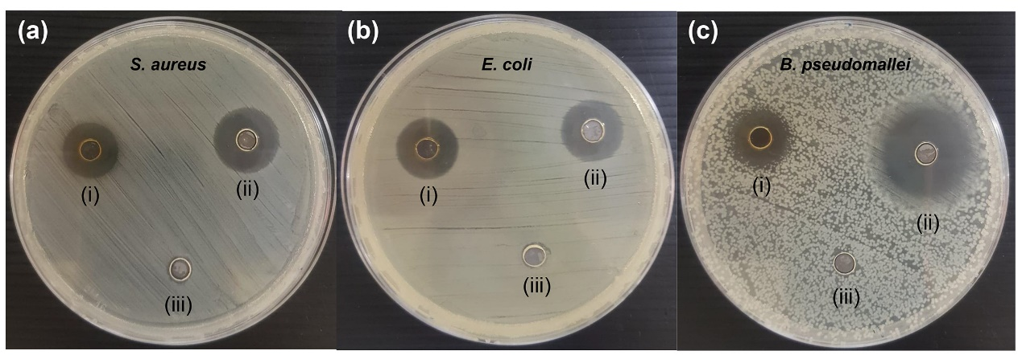

Figure 6. Antimicrobial activity of GVF/AGP-AgNPs hydrogel against (a) S. aureus ATCC25923, (b) E. coli O157/H7, and (c) B. pseudomallei 1026b in which (i) GVF/AGP-AgNPs hydrogel, (ii) 16 µg/mL gentamicin for S. aureus ATCC25923 and E. coli O157/H7, and 64 µg/mL ceftazidime for B. pseudomallei 1026b, and (iii) deionized water were used.
Table 1 Zone of inhibition in millimeters of GVF/AGP-AgNPs hydrogel and standard drugs (gentamicin and ceftazidime) against gram-negative and gram-positive bacteria.
Bacteria | Zone of inhibition (mm)
Bacteria | GVF/AGP-AgNPs | Gentamicin | Ceftazidime
S.aureus ATCC25923 | 12.92 ± 1.66 | 16.42 ± 1.01 | -
E.coli O157/H7 | 17.00 ± 0.90 | 16.42 ± 0.60 | -
B. pseudomallei 1026b | 13.42 ± 0.80 | - | 23.08 ± 0.88
Mean value ± SD, the means for triplicate samples. Inhibition zone includes diameter of well. Positive controls are 16 µg/mL gentamicin and 64 µg/mL ceftazidime.
3.11 The effect of GVF/AGP-AgNPs hydrogel on wound healing and tissue regeneration in rats
Wound healing experiments were undertaken in the presence of the GVF/AGP-AgNPs, and a GVF hydrogel control, as described in Section 2.11. Wound contraction and re-epithelialization developed continuously, as evidenced by Figure 7 and Figure S7. The GVF/AGP-AgNPs hydrogel however induced faster wound contraction than the GVF hydrogel (Figure 7(a)). The percent wound contraction was significantly higher in the GVF/AGP-AgNPs hydrogel-treated group compared to the GVF hydrogel group on both the 7th and 21st days after wounding incisions. The tissue showed an enhanced contraction of 20% and 17% on the 7th and 21st day post-treatment, respectively, for the GVF/AGP-AgNPs hydrogel as shown in Figure 7(b).
We next evaluated the percent re-epithelialization of rat skin after a wound was created, by histopathological examination, again for the GVF/AGP-AgNP and GVF hydrogel control treatment. The examination was done on day 7th, 14th, and 21st after the wound was created, and the samples were stained using Hematoxylin & Eosin. The results are shown in Figure S7(a). During the process of re-epithelialization, new epithelial cells migrate from the edges of the wound and grow over the wound bed to form a continuous layer of epithelial tissue[58]. In the H&E-stained tissue slide (as shown in Figure S7(a)), re-epithelialization can be identified by the presence of a stratified squamous epithelium covering the wound bed. The effectiveness of GVF/AGP-AgNPs hydrogel treatment on re-epithelialization can be evaluated by examining the tissue slides on day 14 and day 21 after treatment. The percentage of wound re-epithelialization was higher in the GVF/AGP-AgNPs hydrogel-treated group on days 14 and 21 after wound incisions, with 23.27% and 13.34% higher re-epithelialization observed at 7- and 21-days post-treatment, respectively, compared to the percentage of re-epithelialization in the GVF hydrogel group (as shown in Figure S7(b)). The faster wound contraction and epithelialization by the GVF/AGP-AgNPs hydrogel might be due to the stimulation of interleukin 6, transforming growth factor (TGF)-β1, epidermal growth factor (EGF), and fibroblast growth factor (FGF2) that affect the function of various inflammatory cells and fibroblasts[59]. These growth factors have been linked to the underlying mechanism of fibroblast-derived intracellular communication and the induction of rapid granulation of the proliferative phase in wound healing[59–61].
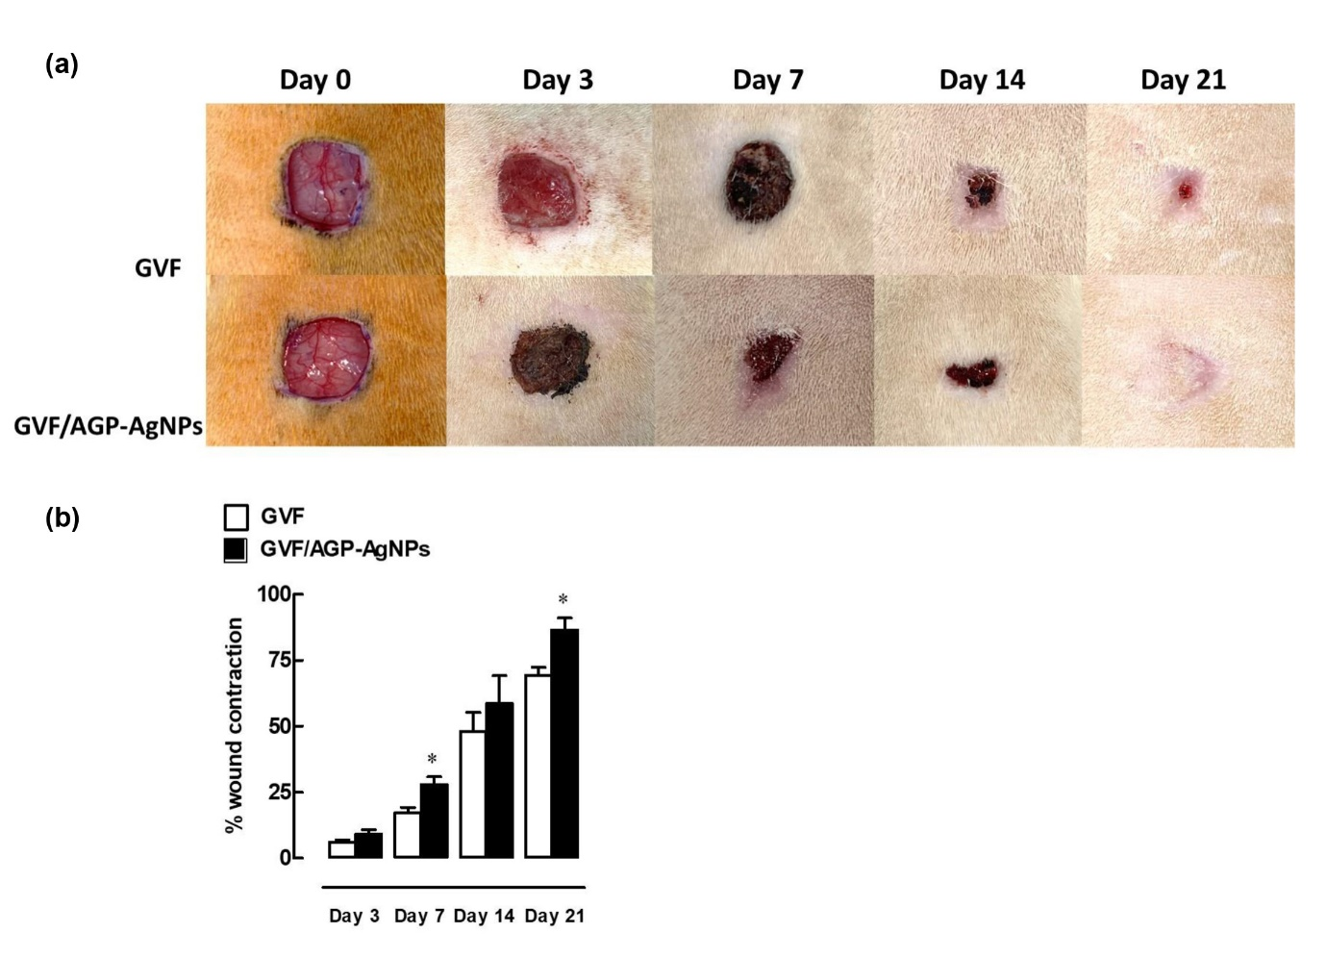
Figure 7. Effects of GVF/AGP-AgNPs on wound healing in rats. (a) Time-dependent evolution of rat skin wound closure observed after treatment with the hydrogels (GVF control, and the GVF/AGP-AgNPs hydrogel composite). (b) Percentage of wound area contraction calculated on days 3, 7, 14, and 21 post-wound incisions for treatment with GVF or GVF/AGP-AgNPs hydrogel composite. Data are expressed as mean ± SEM (n = 3/time point). *P < 0.05 compared to control on day of experiment.
Additionally, the micrographs of rat skin wounds demonstrated clear differences in cell populations between treatment with GVF/AGP-AgNPs hydrogel and the GVF gel control (Figure 8(a)). The number of mononuclear and polymorphonuclear leukocytes significantly decreased in the wound area at 14- and 21-days post-treatment with GVF/AGP-AgNPs compared to GVF, indicating a faster transition from the inflammatory phase of healing to the proliferation phase (Figure 8(b)-(c)). The number of blood vessels also increased on day 14, indicating faster wound healing by providing the necessary nutrients and oxygen to the healing tissue (Figure 8(d)). Furthermore, the number of fibroblast cells greatly increased on day 21 relative to GVF, indicating that the proliferative phase also commenced faster (Figure 8(e)).
Formation of collagen fibers was examined for the rat skin tissues treated with GVF/AGP-AgNPs, and GVF hydrogel only, by Masson’s trichrome stain as shown in Figure S8(a). Collagen is a vital protein in tissues that supports their structure and plays an essential role in wound healing. It facilitates cell migration, proliferation, and differentiation necessary for the process[62]. Masson's trichrome stain is used to quantify collagen fibers in wound healing studies by coloring them blue, while muscle fibers are colored red and cell nuclei are black or brown. The synthesis and deposition of collagen are essential for the resurfacing of a wound with new epithelium. While collagen deposition naturally decreases over the course of wound healing, the application of GVF/AGP-AgNPs hydrogels significantly increased collagen synthesis at the wound site on day 14 after surgical incision, as shown in Figure S8(b). Specifically, the hydrogels increased collagen synthesis by 76%, compared to 60% in the control group. These results suggest that GVF/AGP-AgNPs hydrogels effectively promote tissue proliferation during wound healing.
Generally, new collagen fibers and capillaries restore structure and circulation during the proliferative phase. Moreover, fibroblasts promote the production of matrix proteins, such as collagen, elastin, and proteoglycans, which lead to granulation and epithelialization[63].The findings here are consistent with those of a previous study that showed that guar gum (GG) and curcumin-stabilized silver nanoparticles (GG/Cur-AgNPs) reduced inflammation by decreasing monocytes and polymorphonuclear leukocytes, and by increasing collagen deposition and re-epithelialization during rat skin wound healing[59]. Furthermore, fibroblasts and monocytes respond to immune-related processes for tissue regeneration[64]. Our results suggest that the GVF/AGP-AgNPs hydrogel enhances the transition to the proliferative phase by recruiting monocytes, fibroblasts and collagen deposition, which subsequently facilitate epithelialization (wound healing).
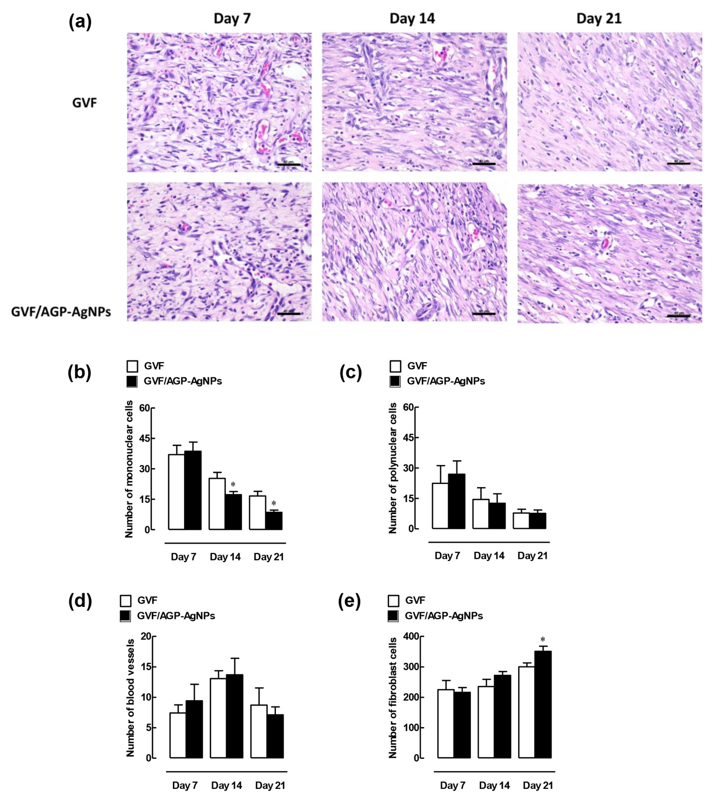
Figure 8. Histopathology of rat skin was assessed on day 7, 14, and 21 following wound incision, stained with Hematoxylin & Eosin. (a) Micrographs show sections of wound incision in rat skin treated with the hydrogels (GVF control and GVF/AGP-AgNPs). The number of (b) mononuclear leukocytes, (c) polymorphonuclear leukocytes, (d) blood vessels, and (e) fibroblasts, counted in 10 high-power fields (HPFs) at 400× magnification. The scale bar located in the lower right corner represents a length of 40 µm. The data are expressed as mean ± SEM (n = 3/time point). *P < 0.05 indicates significant difference compared to the control on the day of experiments.
4. Conclusions
This study focused on the preparation and characterization of self-healing, cross-linked gelatin/vanillin/Fe³⁺ hydrogels by spectroscopy, rheology and microscopy. The GVF-9 hydrogel (GVF hydrogel) was found to be more stable to deformation and more suitable as an injectable material. The GVF hydrogel showed a high swelling degree, indicating its ability to absorb fluid from a wound, which can lead to faster healing. In addition, Andrographolide-silver nanoparticles (AGP-AgNPs) were synthesized and their cytotoxicity and protective effect against oxidative stress in fibroblasts studied. The impact of AGP-AgNPs on the proliferation of human fibroblast cells and their production of collagen was also investigated. The results showed that a 0.002 nM AGP-AgNPs treatment had wound-healing properties as potent as the fibroblast growth factor (FGF) positive control. Furthermore, the enhanced mechanical and self-healing properties of the GVF/AGP-AgNPs nanocomposite were investigated. Moreover, GVF/AGP-AgNPs nanocomposite have shown excellent antimicrobial activity against both gram-positive and gram-negative bacteria, including against the bacterial pathogen that causes melioidosis. The effect of the GVF/AGP-AgNPs hydrogel on wound healing and tissue regeneration in rats was studied, and the functionalized GVF/AGP-AgNPs hydrogel exhibited an excellent wound healing process. In conclusion, this work shows clear potential for development of anti-microbial, self-healing, and injectable formulations for biomedical and other industrial applications. The GVF/AGP-AgNPs hydrogel is also clearly a promising candidate for enhanced wound healing and tissue regeneration.
Author’s contributions
Conceptualization, S.K. and C.T., S.L. J.A.H.; methodology, C,T., S.T., S.L., M.K., N.K.; validation, S.K., S.L.; formal analysis, S.K., C,T., S.T., S.L., M.K., N.K., R.P., A.J. J.A.H., K.N.; investigation, S.K., C,T., S.T., S.L., M.K., N.K., R.P., A.J. J.A.H., K.N.; writing–original draft preparation, S.K., C.T., S.L., M.K. and J.A.H..; writing–review and editing, visualization, supervision, project administration, S.K. All authors have read and agreed to the published version of the manuscript.
Data Availability statement
The authors confirm that the data supporting the findings of this study are available within the article and its supplementary materials. Upon reasonable request, raw data that support the findings of the study are available from the corresponding author.
Declaration of interests
We wish to confirm that there are no known conflicts of interest associated with this publication.
Acknowledgement
C.T. received the grant support from The Science Achievement Scholarship of Thailand (SAST) and Material Chemistry Research Center, Department of Chemistry, Faculty of Science, Khon Kaen University, Khon Kaen, Thailand. S.K. was also received support from the Outbound Visiting Scholar program (Khon Kaen University, 2021), Thailand Institute of Nuclear Technology (Public Organization), and the Faculty of Science, Khon Kaen University, which provided financial and laboratory support. The research was further supported by Thailand Science Research and Innovation and Siam University (grant number 01/2566 to S.L.), and the Target Development Group grant (Cosmeceuticals) P1952244 from the National Science and Technology Development Agency (NSTDA, Thailand) to M.K. and K.N. Additionally, J. A. H. was supported by the Australian Research Council (ARC) Future Fellowship (FT180100295) and the Centre of Excellence in Exciton Science (CE170100026). We would also like to thank Dr. Sayan Saengsuwan and Ubon Ratchathani University for providing viscosities and fruitful discussion.
References
[1] B. Aïssa, D. Therriault, E. Haddad, W. Jamroz, Self-healing materials systems: Overview of major approaches and recent developed technologies, Adv. Mater. Sci. Eng. 2012 (2012).
[2] J.P. Joseph, A. Singh, A. Pal, Molecular design approaches to self-healing materials from polymer and its nanocomposites, Smart Polym. Nanocomposites Energy Harvest. Self-Heal. Shape Mem. Appl. (2017) 181–218.
[3] Y. Yang, M.W. Urban, Self-healing polymeric materials, Chem. Soc. Rev. 42 (2013) 7446–7467.
[4] J.-M. Lehn, Constitutional dynamic chemistry: bridge from supramolecular chemistry to adaptive chemistry, Const. Dyn. Chem. (2012) 1–32.
[5] H. Huang, Z. Dong, X. Ren, B. Jia, G. Li, S. Zhou, X. Zhao, W. Wang, High-strength hydrogels: Fabrication, reinforcement mechanisms, and applications, Nano Res. (2023) 1–41.
[6] D. Zhao, J. Huang, Y. Zhong, K. Li, L. Zhang, J. Cai, High‐strength and high‐toughness double‐cross‐linked cellulose hydrogels: a new strategy using sequential chemical and physical cross‐linking, Adv. Funct. Mater. 26 (2016) 6279–6287.
[7] J. Chen, F. Li, Y. Luo, Y. Shi, X. Ma, M. Zhang, D.W. Boukhvalov, Z. Luo, A self-healing elastomer based on an intrinsic non-covalent cross-linking mechanism, J. Mater. Chem. A. 7 (2019) 15207–15214.
[8] Z. Wei, J.H. Yang, J. Zhou, F. Xu, M. Zrínyi, P.H. Dussault, Y. Osada, Y.M. Chen, Self-healing gels based on constitutional dynamic chemistry and their potential applications, Chem. Soc. Rev. 43 (2014) 8114–8131.
[9] B. Marco-Dufort, M.W. Tibbitt, Design of moldable hydrogels for biomedical applications using dynamic covalent boronic esters, Mater. Today Chem. 12 (2019) 16–33.
[10] S. Bian, Z. Zheng, Y. Liu, C. Ruan, H. Pan, X. Zhao, A shear-thinning adhesive hydrogel reinforced by photo-initiated crosslinking as a fit-to-shape tissue sealant, J. Mater. Chem. B. 7 (2019) 6488–6499.
[11] S. Lü, C. Gao, X. Xu, X. Bai, H. Duan, N. Gao, C. Feng, Y. Xiong, M. Liu, Injectable and self-healing carbohydrate-based hydrogel for cell encapsulation, ACS Appl. Mater. Interfaces. 7 (2015) 13029–13037.
[12] T.-C. Tseng, L. Tao, F.-Y. Hsieh, Y. Wei, I.-M. Chiu, S. Hsu, An Injectable, Self-Healing Hydrogel to Repair the Central Nervous System, Adv. Mater. Weinh. 27 (2015) 3518–3524. https://doi.org/10.1002/adma.201500762.
[13] D. Huber, G. Tegl, A. Mensah, B. Beer, M. Baumann, N. Borth, C. Sygmund, R. Ludwig, G.M. Guebitz, A dual-enzyme hydrogen peroxide generation machinery in hydrogels supports antimicrobial wound treatment, ACS Appl. Mater. Interfaces. 9 (2017) 15307–15316.
[14] C. Talodthaisong, W. Boonta, S. Thammawithan, R. Patramanon, N. Kamonsutthipaijit, J.A. Hutchison, S. Kulchat, Composite guar gum-silver nanoparticle hydrogels as self-healing, injectable, and antibacterial biomaterials, Mater. Today Commun. 24 (2020) 100992.
[15] G. Cai, J. Wang, K. Qian, J. Chen, S. Li, P.S. Lee, Extremely stretchable strain sensors based on conductive self‐healing dynamic cross‐links hydrogels for human‐motion detection, Adv. Sci. 4 (2017) 1600190.
[16] N.D. Sanandiya, S. Lee, S. Rho, H. Lee, I.S. Kim, D.S. Hwang, Tunichrome-inspired pyrogallol functionalized chitosan for tissue adhesion and hemostasis, Carbohydr. Polym. 208 (2019) 77–85.
[17] B. Jia, G. Li, E. Cao, J. Luo, X. Zhao, H. Huang, Recent progress of antibacterial hydrogels in wound dressings, Mater. Today Bio. 19 (2023) 100582. https://doi.org/10.1016/j.mtbio.2023.100582.
[18] N. Han, Z. Xu, C. Cui, Y. Li, D. Zhang, M. Xiao, C. Fan, T. Wu, J. Yang, W. Liu, A Fe 3+-crosslinked pyrogallol-tethered gelatin adhesive hydrogel with antibacterial activity for wound healing, Biomater. Sci. 8 (2020) 3164–3172.
[19] M. Yao, F. Gao, R. Xu, J. Zhang, Y. Chen, F. Guan, A dual-enzymatically cross-linked injectable gelatin hydrogel loaded with BMSC improves neurological function recovery of traumatic brain injury in rats, Biomater. Sci. 7 (2019) 4088–4098.
[20] R.M. Cava-Roda, A. Taboada-Rodríguez, M.T. Valverde-Franco, F. Marín-Iniesta, Antimicrobial activity of vanillin and mixtures with cinnamon and clove essential oils in controlling Listeria monocytogenes and Escherichia coli O157: H7 in milk, Food Bioprocess Technol. 5 (2012) 2120–2131.
[21] P. Cerrutti, S.M. ALZAMORA, S.L. VIDALES, Vanillin as an antimicrobial for producing shelf‐stable strawberry puree, J. Food Sci. 62 (1997) 608–610.
[22] D.J. Fitzgerald, M. Stratford, M.J. Gasson, A. Narbad, The potential application of vanillin in preventing yeast spoilage of soft drinks and fruit juices, J. Food Prot. 67 (2004) 391–395.
[23] C. Xu, W. Zhan, X. Tang, F. Mo, L. Fu, B. Lin, Self-healing chitosan/vanillin hydrogels based on Schiff-base bond/hydrogen bond hybrid linkages, Polym. Test. 66 (2018) 155–163.
[24] P. Roy, S. Das, T. Bera, S. Mondol, A. Mukherjee, Andrographolide nanoparticles in leishmaniasis: characterization and in vitro evaluations, Int. J. Nanomedicine. (2010) 1113–1121.
[25] N. Han, Z. Xu, C. Cui, Y. Li, D. Zhang, M. Xiao, C. Fan, T. Wu, J. Yang, W. Liu, A Fe 3+-crosslinked pyrogallol-tethered gelatin adhesive hydrogel with antibacterial activity for wound healing, Biomater. Sci. 8 (2020) 3164–3172.
[26] S. Thammawithan, C. Talodthaisong, O. Srichaiyapol, R. Patramanon, J.A. Hutchison, S. Kulchat, Andrographolide stabilized-silver nanoparticles overcome ceftazidime-resistant Burkholderia pseudomallei: study of antimicrobial activity and mode of action, Sci. Rep. 12 (2022) 10701. https://doi.org/10.1038/s41598-022-14550-x.
[27] D. Paramelle, A. Sadovoy, S. Gorelik, P. Free, J. Hobley, D.G. Fernig, A rapid method to estimate the concentration of citrate capped silver nanoparticles from UV-visible light spectra, Analyst. 139 (2014) 4855–4861. https://doi.org/10.1039/C4AN00978A.
[28] S. Bhubhanil, C. Talodthaisong, M. Khongkow, K. Namdee, P. Wongchitrat, W. Yingmema, J.A. Hutchison, S. Lapmanee, S. Kulchat, Enhanced wound healing properties of guar gum/curcumin-stabilized silver nanoparticle hydrogels, Sci. Rep. 11 (2021) 1–14.
[29] E. Pretsch, P. Bühlmann, M. Badertscher, E. Pretsch, P. Bühlmann, M. Badertscher, 1 H NMR Spectroscopy, Struct. Determ. Org. Compd. Tables Spectr. Data. (2020) 167–254.
[30] G.L. Hoatson, R.L. Vold, 2 H-NMR Spectroscopy of Solids and Liquid Crystals, Solid-State NMR III Org. Matter. (1994) 1–67.
[31] C. Xu, W. Zhan, X. Tang, F. Mo, L. Fu, B. Lin, Self-healing chitosan/vanillin hydrogels based on Schiff-base bond/hydrogen bond hybrid linkages, Polym. Test. 66 (2018) 155–163. https://doi.org/10.1016/j.polymertesting.2018.01.016.
[32] S.K. Konavarapu, K. Biradha, Luminescent Triazene-Based Covalent Organic Frameworks Functionalized with Imine and Azine: N2 and H2 Sorption and Efficient Removal of Organic Dye Pollutants, Cryst. Growth Des. 19 (2019) 362–368. https://doi.org/10.1021/acs.cgd.8b01458.
[33] Y. Guo, Y. Bao, K. Sun, C. Chang, W. Liu, Effects of covalent interactions and gel characteristics on soy protein-tannic acid conjugates prepared under alkaline conditions, Food Hydrocoll. 112 (2021) 106293. https://doi.org/10.1016/j.foodhyd.2020.106293.
[34] S.-N. Li, B. Li, Z.-R. Yu, Y. Li, K.-Y. Guo, L.-X. Gong, Y. Feng, D. Jia, yu Zhou, L. Tang, Constructing dual ionically cross-linked poly(acrylamide-co-acrylic acid) /chitosan hydrogel materials embedded with chitosan decorated halloysite nanotubes for exceptional mechanical performance, Compos. Part B Eng. 194 (2020) 108046. https://doi.org/10.1016/j.compositesb.2020.108046.
[35] X. Zhang, J. Xu, C. Lang, S. Qiao, G. An, X. Fan, L. Zhao, C. Hou, J. Liu, Enzyme-Regulated Fast Self-Healing of a Pillararene-Based Hydrogel, Biomacromolecules. 18 (2017) 1885–1892. https://doi.org/10.1021/acs.biomac.7b00321.
[36] N. Thombare, U. Jha, S. Mishra, M.Z. Siddiqui, Borax cross-linked guar gum hydrogels as potential adsorbents for water purification, Carbohydr. Polym. 168 (2017) 274–281. https://doi.org/10.1016/j.carbpol.2017.03.086.
[37] J. Qu, X. Zhao, Y. Liang, Y. Xu, P.X. Ma, B. Guo, Degradable conductive injectable hydrogels as novel antibacterial, anti-oxidant wound dressings for wound healing, Chem. Eng. J. 362 (2019) 548–560. https://doi.org/10.1016/j.cej.2019.01.028.
[38] Z. Fan, B. Liu, J. Wang, S. Zhang, Q. Lin, P. Gong, L. Ma, S. Yang, A Novel Wound Dressing Based on Ag/Graphene Polymer Hydrogel: Effectively Kill Bacteria and Accelerate Wound Healing, Adv. Funct. Mater. 24 (2014) 3933–3943. https://doi.org/10.1002/adfm.201304202.
[39] X. Zhao, B. Guo, H. Wu, Y. Liang, P.X. Ma, Injectable antibacterial conductive nanocomposite cryogels with rapid shape recovery for noncompressible hemorrhage and wound healing, Nat. Commun. 9 (2018) 2784. https://doi.org/10.1038/s41467-018-04998-9.
[40] W. Huang, Y. Wang, Y. Chen, Y. Zhao, Q. Zhang, X. Zheng, L. Chen, L. Zhang, Strong and Rapidly Self-Healing Hydrogels: Potential Hemostatic Materials, Adv. Healthc. Mater. 5 (2016) 2813–2822. https://doi.org/10.1002/adhm.201600720.
[41] Z. Xu, S. Han, Z. Gu, J. Wu, Advances and Impact of Antioxidant Hydrogel in Chronic Wound Healing, Adv. Healthc. Mater. 9 (2020) 1901502. https://doi.org/10.1002/adhm.201901502.
[42] H. Liu, C. Wang, C. Li, Y. Qin, Z. Wang, F. Yang, Z. Li, J. Wang, A functional chitosan-based hydrogel as a wound dressing and drug delivery system in the treatment of wound healing, RSC Adv. 8 (2018) 7533–7549. https://doi.org/10.1039/C7RA13510F.
[43] C. Talodthaisong, W. Boonta, S. Thammawithan, R. Patramanon, N. Kamonsutthipaijit, J.A. Hutchison, S. Kulchat, Composite guar gum-silver nanoparticle hydrogels as self-healing, injectable, and antibacterial biomaterials, Mater. Today Commun. 24 (2020) 100992. https://doi.org/10.1016/j.mtcomm.2020.100992.
[44] V. Buranasudja, C. Muangnoi, K. Sanookpan, H. Halim, B. Sritularak, P. Rojsitthisak, Eriodictyol Attenuates H2O2-Induced Oxidative Damage in Human Dermal Fibroblasts through Enhanced Capacity of Antioxidant Machinery, Nutrients. 14 (2022) 2553.
[45] B. Li, T. Jiang, H. Liu, Z. Miao, D. Fang, L. Zheng, J. Zhao, Andrographolide protects chondrocytes from oxidative stress injury by activation of the Keap1-Nrf2-Are signaling pathway, J. Cell. Physiol. 234 (2018). https://doi.org/10.1002/jcp.26769.
[46] S.P.K. Mittal, S. Khole, N. Jagadish, D. Ghosh, V. Gadgil, V. Sinkar, S.S. Ghaskadbi, Andrographolide protects liver cells from H2O2 induced cell death by upregulation of Nrf-2/HO-1 mediated via adenosine A2a receptor signalling, Biochim. Biophys. Acta BBA - Gen. Subj. 1860 (2016) 2377–2390. https://doi.org/10.1016/j.bbagen.2016.07.005.
[47] A.C. de O. Gonzalez, T.F. Costa, Z. de A. Andrade, A.R.A.P. Medrado, Wound healing-A literature review, An. Bras. Dermatol. 91 (2016) 614–620.
[48] D.M. Ornitz, N. Itoh, Fibroblast growth factors, Genome Biol. 2 (2001) 1–12.
[49] J. Li, Y. Zhang, R.S. Kirsner, Angiogenesis in wound repair: angiogenic growth factors and the extracellular matrix, Microsc. Res. Tech. 60 (2003) 107–114.
[50] E. Mussard, A. Cesaro, E. Lespessailles, B. Legrain, S. Berteina-Raboin, H. Toumi, Andrographolide, a natural antioxidant: an update, Antioxidants. 8 (2019) 571.
[51] S. Hossain, Z. Urbi, H. Karuniawati, R.B. Mohiuddin, A. Moh Qrimida, A.M.M. Allzrag, L.C. Ming, E. Pagano, R. Capasso, Andrographis paniculata (burm. F.) wall. Ex nees: an updated review of phytochemistry, antimicrobial pharmacology, and clinical safety and efficacy, Life. 11 (2021) 348.
[52] R. Jamaludin, N.M. Daud, R.S.R. Sulong, H. Yaakob, A.A. Aziz, S. Khamis, L.M. Salleh, Andrographis paniculata-loaded niosome for wound healing application: Characterisation and in vivo analyses, J. Drug Deliv. Sci. Technol. 63 (2021) 102427.
[53] F.H. Al-Bayaty, M.A. Abdulla, M.I.A. Hassan, H.M. Ali, Effect of Andrographis paniculata leaf extract on wound healing in rats, Nat. Prod. Res. 26 (2012) 423–429.
[54] M. Shin, K.H. Song, J.C. Burrell, D.K. Cullen, J.A. Burdick, Injectable and Conductive Granular Hydrogels for 3D Printing and Electroactive Tissue Support, Adv. Sci. 6 (2019) 1901229. https://doi.org/10.1002/advs.201901229.
[55] D. Limmathurotsakul, N. Golding, D.A. Dance, J.P. Messina, D.M. Pigott, C.L. Moyes, D.B. Rolim, E. Bertherat, N.P. Day, S.J. Peacock, S.I. Hay, Predicted global distribution of Burkholderia pseudomallei and burden of melioidosis, Nat. Microbiol. 1 (2016) 15008. https://doi.org/10.1038/nmicrobiol.2015.8.
[56] M.T.S. Alcântara, N. Lincopan, P.M. dos Santos, P.A. Ramirez, A.J.C. Brant, H.G. Riella, A.B. Lugão, Simultaneous hydrogel crosslinking and silver nanoparticle formation by using ionizing radiation to obtain antimicrobial hydrogels, Radiat. Phys. Chem. 169 (2020) 108777.
[57] J. Yang, Y. Chen, L. Zhao, Z. Feng, K. Peng, A. Wei, Y. Wang, Z. Tong, B. Cheng, Preparation of a chitosan/carboxymethyl chitosan/AgNPs polyelectrolyte composite physical hydrogel with self-healing ability, antibacterial properties, and good biosafety simultaneously, and its application as a wound dressing, Compos. Part B Eng. 197 (2020) 108139.
[58] I. Pastar, O. Stojadinovic, N.C. Yin, H. Ramirez, A.G. Nusbaum, A. Sawaya, S.B. Patel, L. Khalid, R.R. Isseroff, M. Tomic-Canic, Epithelialization in wound healing: a comprehensive review, Adv. Wound Care. 3 (2014) 445–464.
[59] S. Bhubhanil, C. Talodthaisong, M. Khongkow, K. Namdee, P. Wongchitrat, W. Yingmema, J.A. Hutchison, S. Lapmanee, S. Kulchat, Enhanced wound healing properties of guar gum/curcumin-stabilized silver nanoparticle hydrogels, Sci. Rep. 11 (2021) 1–14.
[60] A.G. Barschak, F.M. Stefanello, C.L. Lencina, F. De Simone, W.J. Cunico Filho, Pharmacological Application of Antiradical Compound Properties, BioMed Res. Int. 2013 (2013).
[61] H. El Gazaerly, D.M. Elbardisey, H.M. Eltokhy, D. Teaama, Effect of transforming growth factor Beta 1 on wound healing in induced diabetic rats, Int. J. Health Sci. 7 (2013) 160.
[62] T.F. Linsenmayer, Collagen, Cell Biol. Extracell. Matrix Second Ed. (1991) 7–44.
[63] R. Kenagy, Ch7 Mechanisms of Vascular Disease, University of Adelaide Press, 2011.
[64] C. Wang, C. Chu, X. Zhao, Y. Yang, C. Hu, L. Liu, J. Li, Y. Qu, Y. Man, The diameter factor of aligned membranes facilitates wound healing by promoting epithelialization in an immune way, Bioact. Mater. 11 (2022) 206–217.

