Molecular Chemistry in Cavity Strong Coupling
Kenji Hirai,†, James A. Hutchison,‡ Hiroshi Uji-i†,∆
†Division of Photonics and Optical Science, Research Institute for Electronic Science (RIES), Hokkaido University, North 20 West 10, Kita ward, Sapporo, Hokkaido, 001-0020, Japan
‡School of Chemistry and ARC Centre of Excellence in Exciton Science, The University of Melbourne, Masson Rd, Parkville, VIC 3052 Australia
∆Department of Chemistry, KU Leuven, Celestijnenlaan 200F, 3001 Heverlee Leuven, Belgium
Strong Coupling, Polariton, Optical Cavity, Rabi Splitting, Vacuum Field

ABSTRACT: The coherent exchange of energy between materials and optical fields leads to strong light-matter interactions and so-called polaritonic states with intriguing properties, halfway between light and matter. Two decades ago, research on these strong light-matter interactions, using optical cavity (vacuum) fields, remained for the most part the province of the physicist with a focus on inorganic materials requiring cryogenic temperatures and carefully fabricated, high-quality optical cavities for their study. This review explores the history and recent acceleration of interest in the application of polaritonic states to molecular properties and processes. The enormous collective oscillator strength of dense films of organic molecules, aggregates, and materials, allows cavity vacuum field strong coupling to be achieved at room temperature, even in rapidly fabricated, highly lossy metallic optical cavities. This has put polaritonic states and their associated coherent phenomena at the fingertips of laboratory chemists, materials scientists, and even biochemists, as a potentially new tool to control molecular chemistry. The exciting phenomena that have emerged suggest that polaritonic states are of genuine relevance within the molecular/material energy landscape.
Contents
1. Introduction and Historical Context
2. Principles of Strong Light-Matter Coupling
3. Practical Realization of Cavity Strong Coupling
3.1 Excitonic Strong Coupling
3.2 Vibrational Strong Coupling
4. Molecular Chemistry in Exciton Strong Coupling
4.1 Energy Transfer between Molecules
4.2 Singlet and Triplet Excited States
4.3 Polariton Transport
4.4 Polariton Lasing and Bose–Einstein Condensation
4.5 Nonlinear Optics
4.6 Photochemical Reactions
4.7 One-Dimensional Nanomaterials
4.8 Two-Dimensional Nanomaterials
5. Molecular Chemistry in Vibrational Strong Coupling
5.1 Organic Reactions
5.2 Enzymatic Reactions
5.3 Symmetry of Vibrational Modes
5.4 Theoretical Framework
5.5 Crystallization and Self-Assembly
5.6 IR Emission, Raman Scattering and Ion Conductivity
6. Concluding Remarks

1. Introduction and Historical Context
Light is of fundamental importance for the field of chemistry. On one hand, via spectroscopy, it has been an indispensable tool in the development of our understanding of atomic and molecular structure and a mainstay of modern molecular characterization techniques. On another hand, light-matter interactions that lead to chemical changes (both photochemical and photocatalytic) provide pathways to otherwise inaccessible products that have not only shaped life our planet and opened vibrant branches of modern chemistry, but also promise solutions to the most pressing challenges of our times, from carbon-neutral energy to asymmetric catalysis.
A canonical example of an indispensable light-driven chemistry is the conversion of sterols to pre-vitamin D, critical to the health of humans and higher organisms, but a reaction that has been occurring for at least 500 million years in non-vertebrate lifeforms where its function may be photoprotective.¹ The reaction is only accessible photochemically, with no known evolution of an enzyme-catalyzed thermal pathway. At the heart of this reaction is a 6-electron, electrocyclic ring-opening reaction of 1,3-cyclohexadiene (CHD) to form a linear triene, the energy landscape of which exhibits some of the classical features of a photochemical reaction (Figure 1a).² (The photochemical reaction of CHD is used as an canonical example here, but we note that this reaction has already been investigated under optical cavity strong coupling, the subject of this review.³)
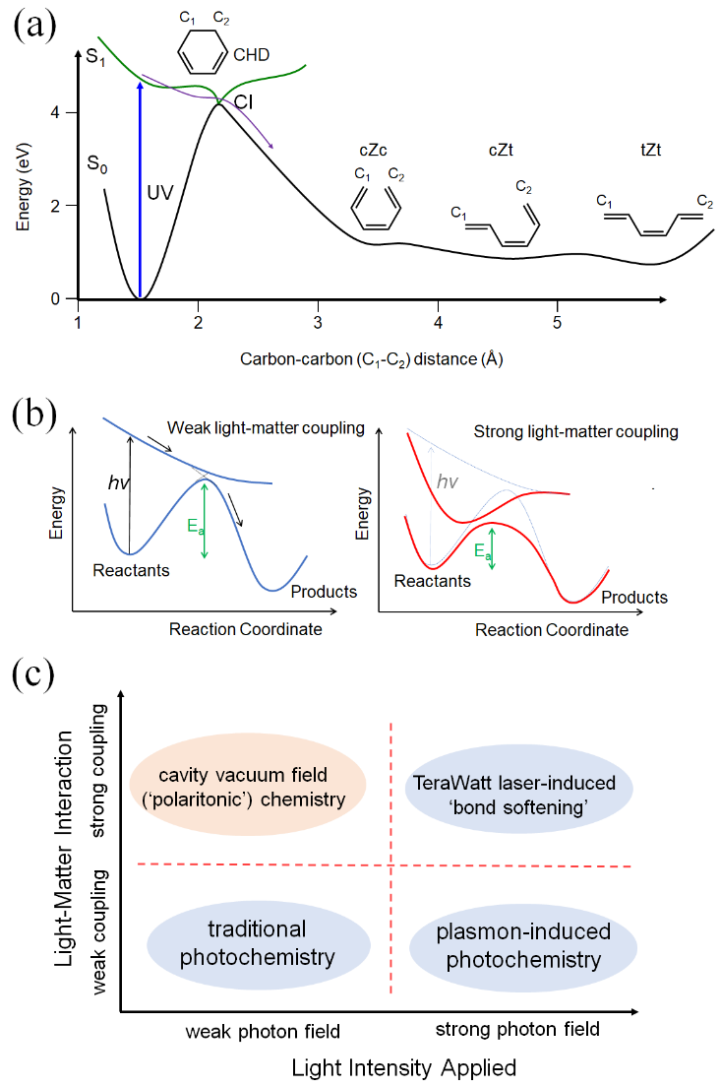
Figure 1. (a) Potential energy surface of the photoinduced ring-opening reaction at the heart of Vitamin D photosynthesis: UV photoexcitation promotes cyclohexadiene (CHD) from ground to excited state, where the thermal barrier to passage along the C₁-C₂ carbon-carbon bond stretching coordinate is vastly reduced. At the transition state, the system returns to the ground state via a conical intersection (CI), with thermal equilibration resulting in several geometric isomers of a linear triene (cZc, cZt, and tZt, structures inset, schematic illustration is reconstructed from Ref. 2); (b) Schematic of the photochemical energy landscape in (a). Left: with weak interaction between the optical field and material absorber, the photon drives transitions between states but does not alter them. Right: strong light-matter interactions alter the energy landscape, possibly modifying kinetic barriers for both ground (activation energy E_{a} indicated) and excited state chemical reaction pathways; (c) Various branches of modern photochemistry, divided by typical applied optical fields, and the strength of the light-matter interaction. The ‘strong coupling’ interaction regime results in modification of the energy levels of the system beyond their original linewidth, the ’weak coupling’ regime does not. Polaritonic chemistry fills a hither-to neglected quadrant where strong light-matter coupling is induced by interactions with negligible intensity (vacuum) fields in photonic (Fabry-Perot, plasmonic etc.) structures.
Nuclear motion along some reaction coordinate (for example stretching of a carbon-carbon bond in CHD) defines energy minima corresponding to reactant and product ground states (S₀), that may be separated by a significant thermal barrier (requiring ~4 eV activation energy to surmount in the case of CHD). Absorption of a (UV) photon however promotes the system to an excited potential energy surface (S₁), for which the energy barrier to motion along the reaction coordinate is vastly reduced, and thermally accessible. At the point where the ground and excited states cross, vibronic coupling results in the formation of conical intersections (CI) facilitating non-radiative transition back to the ground state potential surface, followed by vibrational relaxation to form the equilibrium product state (in the case of the linear triene product of the CHD ring opening, several geometric isomers are thermally accessible).
The modest spectral irradiance of ~100 W/m².nm in the ~290 nm wavelength range at midday at the Earth’s surface that drives vitamin D biosynthesis means that the interaction between light field E and the electric transition dipole µ of CHD (the scalar product E•µ) only weakly perturbs the system; transitions between energy levels are promoted but the potential energy surfaces themselves are not observably altered beyond their original linewidths. We define this as the ‘weak’ light-matter coupling regime (see Figure 1b, left side, and further on).
Synthetic organic photochemistry, from its origins to its systemization by Ciamician and Silber at the turn of the 20th century, also used sunlight as the excitation source.⁴ While today’s photochemical reactors employ narrow-wavelength-range light-emitting diode (LED) sources that can routinely provide irradiances of 10-1000 Suns,⁵ this ‘traditional’ photochemistry can still be considered to operate under relatively weak applied fields, and in a weak light-matter interaction regime, where the energy levels of the material are not altered beyond their original linewidths (see Figure 1c, bottom left quadrant). We may define other sub-fields of photochemistry however, by the varying magnitude of the applied excitation fields employed, and by the observable modification of the system’s energy levels beyond its original linewidths, due to the light-matter interaction (Figure 1c).
By the early 1980s, the enhancement of molecular photochemistry at the surface of metallic nanoparticles had been predicted and demonstrated,^{6,7} following the earlier observation by McQuillan and co-workers of enhanced Raman scattering from molecules on roughened silver electrodes.⁸ The spatial confinement of light fields via generation of localised surface plasmon resonances in metallic nanoparticles can enhance photonic intensities by up to 10¹¹ depending on the relative arrangement of the metallic nanoparticles and molecular reactants of interest. This can dramatically increase, for example, excitation rates for photochemical reactions, leading to the field of ‘plasmon-enhanced photochemistry’ (note there are other potential drivers of enhanced, or novel, photochemistry in this context, e.g. thermal effects and hot carrier generation).⁹ But except in particular conditions,^{10,11} the rapid dephasing times of ~10 fs of metallic nanoparticle plasmons, and dramatic shortening of molecular excited state lifetimes by dissipation to lossy modes at metal surfaces occur in this context. This means that, while the excitation fields are high in plasmon-induced chemistry, the light-matter interaction normally remains in the weakly-coupled regime, without observable modification to the original energy levels of the system (Figure 1c, bottom right quadrant, and discussions below).
Ideas of laser-induced chemistry were being pursued contemporaneously, exploiting both their high intensity to induce non-resonant Stark effects, and their monochromaticity to potentially target single bonds in a molecule for dissociation (targeting specific infrared molecular vibrational modes). The latter has been likened to ‘keyhole surgery’ for chemists and remains a vibrant field of photochemistry 60 years since Hall and Pimentel’s original experiments {Hall and Pimentel J. Chem. Phys.,1963, 38, 1989. Fausto et al, Chem. Soc. Rev., 2022, 51, 2853 } The former was revolutionsed in the 1990s as pulsed lasers with power densities approaching 100 TW/cm² were developed. These very high applied non-resonant optical field strengths begin to approach the inter-atomic binding potentials of molecules,^{12,13} thus distorting the potential energy surfaces beyond their original linewidths and opening up new channels for bond dissociation in a process called ‘bond softening’. Strictly speaking, avoided crossings in the potential energy surface are generated at points where undressed (unperturbed) photochemical potential energy surfaces differ in energy by one photon, in a total field of ~10¹⁵ photons, thus enhancing the light–matter coupling E_{F}•µ, where the electric field E_{F} is very large (µ is the transition dipole of a single absorber). This observable distortion of the potential energy levels of the system is a characteristic of strong light-matter coupling (Figure 1b, right side), and bond-softening represents a strong field/strong coupling approach (Figure 1c, top right quadrant).
Strong light-matter coupling and energy level distortion may also be induced, however, by playing on the other side of the light-matter coupling equation E_{F}•µ. In this regime, weak optical fields can be interacted simultaneously with a large number (N) of material absorbers, thus boosting the light matter coupling as E_{F}•√Nµ. This regime will be the focus of the current review. Experiments undertaken in the last two decades, stimulated particularly in the chemistry context by Ebbesen’s group in Strasbourg, have shown that molecular properties, including reactivity, can be modified in this way.^{3,14,15} Significant numbers of experimental and theoretical works have now emerged in this field, such that it may now claim to be filling a hither-to neglected quadrant of the photochemistry subspace (Figure 1c, top left quadrant). This low applied field/strong coupling approach has become known as ‘polaritonic chemistry’.¹⁶
Polaritonic chemistry can be realised when atoms or molecules are placed in proximity with an optical cavity (Fabry-Perot, plasmonic etc.), such that the (vacuum) optical fields coherently exchange energy with the transitions of atomic or molecular systems faster than any loss mechanism (see Section 2); this results in the strong coupling and energy level distortion beyond the original linewidth of the system discussed above (Figure 1b, right).^{14,17,18} The new energy levels are hybrid states of light and matter, also termed polaritonic states.^{19,20} Notably, achieving strong light-matter interactions with the E_{Ph} = ℏω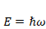 vacuum field (ω is the angular frequency of the optical field) relaxes the need for (intense) external light sources, proffering significantly milder conditions for photochemistry and reduced chance of decomposition. Thus it can be applied to a variety of molecular systems, opening up a new cross-discipline in molecular chemistry.^{16,21–24}
Strong light-matter coupling was first reported in the mid-1970s for surface waves interacting with LiF films.³⁶ Later, strong coupling was experimentally achieved in Fabry-Perot-type optical cavities (two reflective surfaces separated by ca. the wavelength of interest for coupling to the molecule dipolar transition) for the Rydberg atom,²⁵ several atoms^{26–28} and for a single atom.²⁹ By the early 1990s, the coupling of inorganic (quantum well) materials to optical cavities was reported.³⁰ The Wannier–Mott-type excitons of these inorganic materials are delocalized through the crystal lattice and thus weakly bound, requiring cryogenic temperatures for observation of strong coupling. Within a decade however, utilizing the highly localized and high binding energy Frenkel excitons of organic materials, vacuum field strong coupling at room temperature was observed (a porphyrin coordination complex in an FP cavity was employed³¹) and can now be achieved routinely.^{32–35} More recently, strong coupling was also observed between infrared cavity photons and molecular vibrational transitions.^{36,56}
Polaritonic chemistry was first demonstrated in 2012 during studies of photochemical isomerization reactions within optical cavities and via the coupling of electronic transitions.³ By 2015, these studies were extended to the vibrational energy regime and vibrational strong coupling (VSC)-modified chemistry was observed.^{37–39} Today, the effects of strong coupling on chemical reactions and various other molecular properties continue to be explored, with many exciting and surprising phenomena being uncovered.
In this review article, we highlight experimental work on cavity strong coupling applied to molecular chemistry and molecular/material properties. Although strong coupling chemistry with plasmonic systems is an exciting area that continues to grow,^{11,40,41} this review focuses on the strong coupling within Fabry-Perot optical cavities, which have been an extremely popular means of investigating cavity molecular chemistry. The review is intended to engage molecular scientists, in the language of molecular scientists, and to discuss the physics of polaritonic states intuitively wherever possible.
2. Principles of Strong Light-Matter Coupling
A microscopic picture of strong light-matter coupling begins with a molecule in an optical cavity absorbing a photon and transiting to an excited state. From there, the probability of photon emission depends on the various rates of non-radiative relaxation (intersystem crossing to triplet states, internal conversion etc.) relative to the radiative rate. The latter takes values of ~10⁸ sec⁻¹ for good chromophoric molecules in condensed phases (i.e., excited state lifetimes of the order of 10 ns in the absence of significant non-radiative relaxation pathways). In a quantum electrodynamics picture, this ‘intrinsic’ spontaneous emission rate is in fact set by dissipative interaction between the electric dipolar transition of the molecule and a continuum of electromagnetic modes in their vacuum state (the quantum state with the lowest possible energy⁴²) at the same position in space. The rate expression takes the form of Fermi’s Golden Rule and is proportional to the square of the vacuum field-matter coupling (the aforementioned E•µ) and the spectral density of vacuum field modes (the photonic density), the latter of which varies parabolically with frequency in free space.⁴³
The spectral density of these vacuum fields can be significantly altered however within an optical cavity. Standing wave conditions define spectral regions of enhanced vacuum field density compared to free space (i.e., the optical modes or resonances of the cavity) and of reduced vacuum field density compared to free space (i.e., ‘stop bands’). The interaction between the molecule and electromagnetic mode inside the optical cavity is therefore also significantly different from that in free space. As predicted by Purcell in 1946, the excited molecule’s radiative rate becomes proportional to the Quality (Q)-factor of the optical cavity, which is related to the number of rounds trips a photon of particular frequency can take in the cavity before leaking into free space.⁴⁴ Placing a molecule in an optical cavity adjusted such the cavity mode is resonant with an allowed transition of the molecule, thus enhancing the latter’s radiative rate, is an important condition for entering the strong light-matter interaction regime.
Returning to the microscopic picture of an excited molecule inside a (resonant) optical cavity, (enhanced) radiative emission results in a photon undergoing ~Q round trips in the cavity, during which time it may be reabsorbed by the emitter before escaping to free space. If the rate of emission/reabsorption (g, rate of photonic energy exchange between the molecule and the cavity) does indeed exceed the photon leakage rate and any non-radiative molecular loss rates, the strong-light matter coupling regime is achieved. This kinetic competition is often represented by three parameters (Figure 2, the cavity decay rate κ, non-resonant (‘undressed’ material) decay rate γ, and light–matter coupling exchange rate g). γ is the inverse of the lifetime of the molecular excited state (sum of the radiative and non-radiative decay rates in free space). The cavity decay rate (κ) is determined from the quality factor (Q): κ = ω/Q, where ω is the resonant mode frequency.

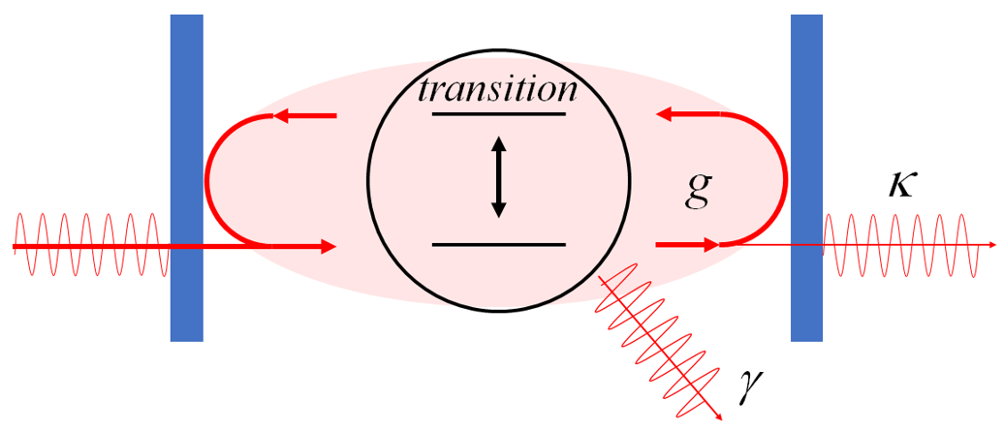
Figure 2. Schematic view of a Fabry-Perot cavity (reflective mirrors in blue) containing some material with an allowed optical transition. Illustration of the (reversible) interaction between the electromagnetic wave (red) and the absorber. κ: resonant decay rate, γ: non-resonant decay rate, g: light–matter coupling strength.
When g ≪ κ or γ, exponential decay of the molecular excited states will be observed, albeit modified by the Purcell effect, characteristic of the weak interaction regime. Conversely, when g ≫ κ and γ, temporal ringing due to exchange of the photon between the cavity and the molecule is observed, characteristic of the strong coupling regime. This temporal ringing is evidenced in the spectral domain as a splitting of the resonant molecular absorption and cavity mode transmission/reflection peaks. The magnitude of the splitting, termed the Rabi splitting (ħΩ_{R}), depends on the magnitude of the light-matter interaction ħΩ_{R} =2│E_{F}•µ│in Figure 3. In the quantum picture, the new peaks represent discrete new energy levels of the system, termed polaritonic states (upper and lower polaritons indicated as P+ and P−), that are hybrid states of photons and matter with unique properties somewhere in between each. The intriguing properties of polaritonic states have led to the discovery of unusual phenomena and generated great interest in this field.
A concept critical to polaritonic chemistry is that the spectral changes due to the polaritonic states of the coupled system may in fact represent a modified potential energy surface for a chemical reaction involving that molecule. For example, the lower polariton state (Figure 3) may now play the role of the LUMO (S₁) state in a photochemical reaction (Figures 1a,b). Furthermore, since the Rabi splitting can be as large as 100s of meV for good organic chromophores at high density in optical cavities, if they are playing a role in chemical reactions, very large changes in chemical rates and pathways could be anticipated. Such a large Rabi splitting is usually achieved by the collective coupling of a large number of molecules to a single cavity mode in an optical cavity.⁴⁵
The splitting energy is then proportional to the square root of the density of the molecules in the cavity and the quality factor (ħΩ_{R} ∝ √N/V, where N is number of molecules and V is the mode volume). This collective coupling also results in N -1 dark states (DS) being formed together with the two bright polaritonic states (Figure 3). The energy level of the N-1 dark state is the same as that of the original transition state. Some molecules in the cavity are uncoupled to the cavity mode because their transition dipole moments are orthogonal to the amplitude of the electromagnetic field, or they are located outside the cavity field. The energy level of the transition state of these uncoupled molecules is not changed. The energy levels of the N-1 dark state and uncoupled molecules are therefore the same, but these states can be distinguished. The dark states may drive interesting dynamics and phenomena in their own right, but the collective coupling is perhaps of most interest as a way to drive collective behavior in a large ensemble of absorbers. That is to say, all the material oscillators within the cavity mode volume (V ~ l³ for a Fabry-Perot cavity) are driven in phase by the interaction with the optical cavity mode, despite being separated by up to macroscopic distances. This delocalization of the polaritonic states has driven much interest in their employment for energy transfer over long distances.⁹⁵⁻⁹⁸ To reiterate an important point again, strong light-matter coupling in this context occurs between collective absorbers and the cavity vacuum field, even without an external light source being applied. This opens up the possibility of vibrational dynamics and thermal chemistry also being modified by vibrational strong coupling.^{37,38}
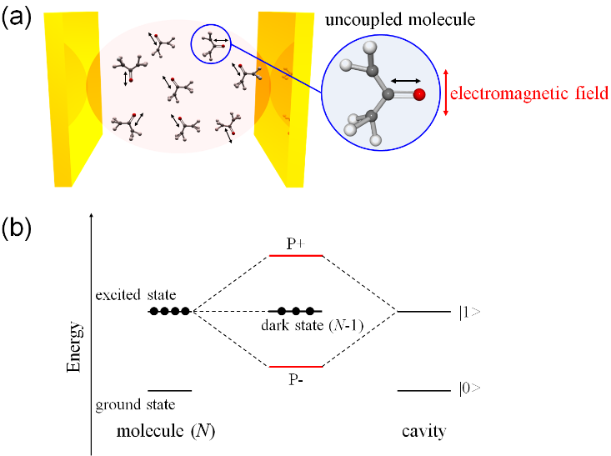
Figure 3. (a) Schematic illustration of cavity strong coupling. A number of molecules in the cavity collectively couple to a single cavity mode. The black arrows indicate the directions of transition dipole moments in each molecule. The molecule in the blue circle is an example of an uncoupled molecule, with transition dipole moment orthogonal to the cavity electromagnetic field vector. (b) Energy levels of the polaritonic states formed by the strong coupling of a molecular vibrational transition and a resonant cavity mode. The strong coupling of the molecules (N is the number of molecules) and a cavity mode generates two polaritonic states: the upper polariton (P+) and lower polariton (P−) branches and the N-1 dark states. The energy gap between P+ and P− is called the Rabi splitting.
Theoretical frameworks have been developed to describe the strong coupling system. Here, the simplest models to describe strong coupling are introduced. The Jaynes–Cummings model describes the interaction of an electromagnetic mode quantized by an optical cavity, with an atom with two energy levels.⁴⁶ When the electromagnetic mode is described by the harmonic oscillator model, the Hamiltonian of the hybridized state is described by
$H= ℏωa^{†}a+\frac{1}{2}ℏω_{0}σ_{z}+ℏg\left(aσ_{+}+a^{†}σ_{-}\right)$ (1)
where ω is the frequency of the cavity field, ω₀ is the transition frequency, a† is the field creation operator, and a is the field annihilation operator. g is the coupling strength:
g = $μ\sqrt{\frac{ℏω}{2ε_{0}V_{m}}}$ (2)
where µ is the transition dipole moment, ε₀ is the vacuum permittivity, and V_{m} is the electromagnetic mode volume. The first, second, and third terms in Eq. 1 are the Hamiltonians of the electromagnetic mode, atom, and light–matter interaction, respectively. The matrix σ₊ provides the transitions from the ground state to the excited state, σ₋ provides the inverse process, and σ_{z} expresses the energies of the states:
$σ_{+}=\left(\begin{matrix}0 & 1 \\ 0 & 0\end{matrix}\right), σ_{-}=\left(\begin{matrix}0 & 0 \\ 1 & 0\end{matrix}\right), σ_{z}=\left(\begin{matrix}1 & 0 \\ 0 & -1\end{matrix}\right)$ (3)
The eigenstates of the system are
$\left|±>_{n}=\right.\frac{1}{\sqrt{2}}\left(±\left|e, n_{ph}+\left|g, n_{ph}+\right.\right.1>\right)$ (4)
with energies
$E_{±n}=ℏω\left(n+\frac{1}{2}\right)±ℏg\sqrt{n_{ph}+1}$ (5)
where n_{ph} is the number of photons participating in strong coupling. The value of the Rabi splitting is then given by:
$Ω_{R}=2g\sqrt{n_{ph}+1}=2μ×E_{0}\sqrt{n_{ph}+1}$ (6)
where E₀ is the electromagnetic field in the cavity. Equation 2 indicates that a large value of µ (the transition dipole moment) is required for strong coupling. Additionally, V_{m} (the electromagnetic mode volume) is preferably small. Equations 5 and 6 indicate that strong coupling occurs even without photons (the value in the square root cannot be 0 even if n_{ph} = 0). This interaction in the absence of externally applied photons is the coupling of the cavity vacuum field with matter.
When many emitters are placed in an optical cavity, the system is described by the Tavis–Cummings model.⁴⁷ The system can be simplified based on the interaction of a large number of emitters (N) and a small number of photons. Under this assumption, the electromagnetic field is concentrated in the single cavity mode, providing in-phase oscillations of the transitions of all emitters and leading to formation of a collective dipole. The splitting energy is proportional to the square root of N:
${ℏΩ}_{R}=ℏΩ\sqrt{N} ∝\sqrt{\frac{N}{V_{m}}}$ (7)
Thus, the Rabi splitting energy is proportional to the square root of the concentration (N/V_{m}), as observed in experiments. We will not review the exciting recent developments of theoretical frameworks for cavity strong coupling as these have been reviewed elsewhere. The theoretical interpretations linked to the effect of VSC are discussed in Section 5.4.
3. Practical Realization of Cavity Strong Coupling
Practically speaking, strong light-molecule coupling can be achieved in a broad range of optical nano/microstructures, including plasmonic nanostructures,⁴⁰,³⁷⁻³⁹ whispering gallery cavities,^{48,49} and photonic crystals,^{50,51} and waveguide structures.⁵² Fabry-Perot (FP) cavities, comprising two parallel, reflective mirrors have been the most popular optical structure for strong coupling, however (Figure 4). The reflective surfaces are usually fabricated either from metallic films, or distributed Bragg reflectors (DBR), consisting of multiple pairs of dielectric layers of alternating refractive index material (the thickness of the layers is typically a quarter of the reflection wavelength range of interest). Each cavity mirror type has its advantages and disadvantages.
Metallic mirror cavities are relatively simple to fabricate by sputtering or evaporation, and the low penetration depth of the optical field into the mirrors (~20-30 nm) means that they strongly confine the field mode volume V, leading to enhanced Rabi splitting, as ħΩ_{R} ∝ √1/V. The drawback is that even for relatively low-loss metals in the visible and near-IR such as silver and gold, each reflection leads to strong losses and Q factors are limited to 10-100. Since optical mode peak widths are inversely proportional to the Q factor, metallic cavity modes are relatively broad (10s of nm widths in the visible spectrum), which can limit the visibility of small Rabi splittings. Nevertheless, metal-deposited mirrors have been used in a variety of applications in excitonic and vibrational strong coupling. Semi-metals such as Ge can also be used as the mirror for mid-infrared regions,⁵³ which is useful for electrochemistry due to its high work function.
On the other hand, DBR mirrors are relatively difficult to fabricate as they may require 10s to 100s of layers to be deposited, and due to penetration and multiple scattering of the field in the DBR stack, mode volumes cannot be confined to ~100 nm as it can with metallic mirrors, which reduces relatively the Rabi splitting. However, due to the use of low loss dielectric materials, DBR cavities can routinely have very high Q factors of 100s-10000s, and very narrow peak widths which make smaller Rabi splittings resolvable. The long coherence times of the light-matter interactions in these cavities are used to realize polariton lasing and the Bose–Einstein condensation (see Section 4.4).
On the molecular side, functional molecules can be deposited on one mirror via sublimation or direct crystal growth. Another popular technique is to dope molecules into a polymer matrix that is spin-coated onto the mirror to form a smooth film. In either case, the thickness of the deposited film determines the mirror separation, and thus the cavity mode wavelength can be conveniently adjusted to resonance with the targeted molecular transition by tuning this thickness (e.g., changing the speed of the spin-coating, or the concentration of the cast polymer/chromophore solution). The top mirror for completing the cavity is often deposited directly on top of the molecule/polymer film, though care must be taken when sputtering or evaporating metals that they do not damage the organic layer. In this case ‘sticky’ metal mirrors can be separately prepared and placed parallel to the first mirror.¹³
Liquid phase molecular systems are convenient to use in vibrational strong coupling measurements, for which cavity mirror separations are of the order of several microns at least, though electronic strong coupling of liquid samples is also possible.⁵⁴ For infrared (IR) FP cavities, ~10 nm metallic films can be used due to the even shorter optical field penetration depth at IR frequencies, and are deposited on IR transparent substrates. The metallic mirrors are often then covered by an inert layer, such as resins, organic polymers, or silicon dioxide, to avoid any effect of direct contact between the molecules and metal surfaces. The mirrors are arranged such that they are parallel and face each other, with polymer films (e.g., Mylar or Kapton) employed as spacers between mirrors. In this case the thickness of the spacer film approximately determines the mirror separation and thus the resonant wavelength of the FP cavity, with tuning achieved simply by compressing the spacer.
he spectroscopic characteristics of the molecules also determines their suitability for use in strong coupling experiments. Since the coupling scales with µ√N, molecules with strongly allowed absorptions, and which can be packed at high density without undergoing deleterious aggregation-induced spectral changes are most suited. The latter condition is one of the most challenging for strong light-molecule coupling experiments. Narrow/sharp absorption bands are also preferred to aid the visibility of Rabi splitting (in tandem with spectrally high-Q cavity modes as discussed above). The absorption bands of polaritonic states are generally sharp even if the original molecular absorbance is broad.^{55–57} The reduction in inhomogeneous broadening is attributed to motional narrowing due to the extended wavefunction of the polariton.⁵⁸
It should be noted that not all the molecules in the FP cavity are coupled with the same magnitude to the optical cavity, this is because they are usually deposited with random orientations, or sample random orientations over time in the case of liquid samples. The optical field is parallel to the mirror plane in an FP cavity, so molecules with transition dipole directed parallel to the mirrors can couple maximally, while if directed perpendicular to the mirror plane, they will couple not at all. Furthermore, the cavity optical modes are not uniform in space within the cavity (see Figure 3), with anti-nodes of maximum amplitude and nodes where the electric field intensity is zero.^{59,60} The leads to further heterogeneity of coupling magnitude for molecules spread throughout a cavity and the presence of uncoupled molecular states that can interact with the coupled polaritonic bright and dark states.
Angle-resolved spectroscopy is a convenient way to characterize light-molecule strong coupling. Optical cavity modes in Fabry-Perot cavities feature strong angular (momentum) dispersion, blue-shifting as angle of observation moves away from perpendicular to the mirror plane (defined as 0° in Figure 4). Polaritonic states also display angular dispersion, but of lesser extent as they are photons mixed with non-dispersive material transitions.
A typical result for an angle-resolved transmission experiment on a Fabry-Perot cavity containing molecules under strong light-matter coupling is shown in Figure 4. In the absence of an absorber the cavity mode energy increases parabolically with increasing incident probe angle (short-dashed line). Where this mode approaches a material absorption however (horizontal long-dashed line) hybridization and polariton state formation results in an avoided crossing. The Rabi splitting is defined as the minimum approach of the new polaritonic state branches, P+ (solid upper line) and P− (solid lower line), which occurs exactly at resonance (0° in Figure 4). At higher incident angles (i.e., when the photonic energy is tuned away from the material absorption energy), P+ and P− become more photon-like and molecule-like, respectively. Once again, the visibility of this spectral splitting at resonance, beyond the spectral widths of the optical and material absorbers separately, indicates the occurrence of strong light-matter coupling.

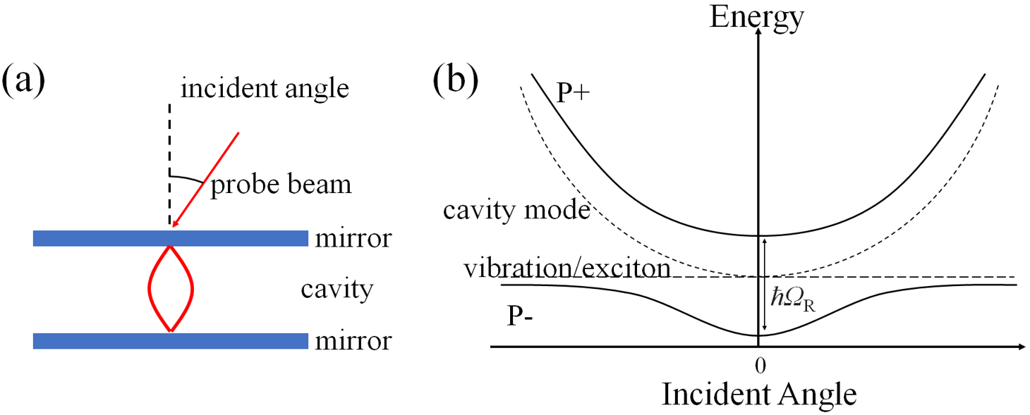

Figure 4. (a) Schematic illustration of angle-resolved spectroscopy of a FP cavity. (b) Energy-momentum (energy vs. angle) dispersion of transmission through an FP cavity, normal incidence relative to the mirror plane is defined as 0°. The dashed parabolic and horizontal lines indicate the dispersive optical mode and the molecular transition energy, respectively. The black solid lines indicate the upper (P+) and lower (P−) polariton branches. The energy gap between P+ and P− at normal incidence (resonance) corresponds to the Rabi splitting (ħΩ_{R}).
3.1 Excitonic Strong Coupling

Early investigations of strong coupling in optical cavities focused on exciton–photon interactions in inorganic materials.^{30,61} For example, the formation of polaritonic states was observed when GaAs was placed in a microcavity.³⁰ As mentioned earlier, because of the weak binding energy of Wannier–Mott excitons in these inorganic materials, strong coupling was realized only at cryogenic temperatures. However, because of the large transition dipole moments and binding energies of Frenkel excitons, the strong coupling of organic molecules can be explored at room temperature. Cavity strong coupling was observed for organic–inorganic hybrid molecules, i.e., coordination complexes (e.g., tetra-(2,6-t-butyl)phenol-porphyrin zinc) located in a microcavity at room temperature.³¹ Later, cavity strong coupling was investigated using molecular J-aggregates^{62–66}, organic dyes,⁶⁷ organic crystals⁶⁸ porphyrin coordination complexes,⁶⁹ and organic semiconducting polymers⁷⁰ placed in the FP cavities (Figure 5). More recently, cavity strong coupling has been extended to organic functional materials such as carbon nanotubes,⁷¹ chromosomes⁷² and biological proteins.⁷³ The emission properties also change under cavity strong coupling. Enhanced emission from the lower polaritonic branch⁷⁴ and an enlarged Stokes shift⁷⁵ have been observed following formation of polaritonic states.
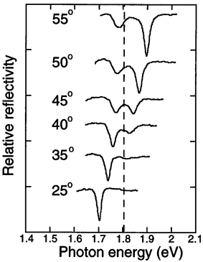
Figure 5. Reflection spectra of (2,2’-dimethyl-8-phenyl5,6,5’,6’-dibenzothiacarbocyanine chloride in a FP cavity. The incident angle of the probe beam is varied from 25° to 55°. The cavity modes are far from resonance at 25° and 35°, and on-resonance at 40°, 45°, 50° and 55°. The dashed line indicates exciton absorption of 2,2’-dimethyl-8-phenyl5,6,5’,6’-dibenzothiacarbocyanine chloride. Reproduced with permission from Ref. 62. Copyright 1999 the American Physical Society.
The relaxation dynamics of exciton-polaritons is a rich area of research, with both the population of polaritonic states following pumping of incoherent excitations in the system, and decay of polaritons, the subject of much study.²⁴ Vibronic transitions play a central role in the interplay between coupled and polaritonic states, including overcoming ‘bottlenecks’ due to requirement of changes in both energy and momentum in radiative transitions between these two systems, and in non-radiative transitions that can dominate for organic molecular exciton–polariton systems due to the presence of dark and uncoupled state continua mentioned earlier. In the latter case, the upper polariton decays non-radiatively to the dark states much faster than the similar decay from dark states to the lower polariton.²⁴ Thus, the dark states act as a reservoir and an energy sink, and radiative relaxation to the ground state can occur from here or the lower polariton branch.
Pump-probe spectroscopy can also be used to reveal the dynamics of coupled/uncoupled state transitions, and relaxations from, for example, the lower polaritonic branch. Assuming that photon loss is the fastest decay pathway in the system, the lifetime of a lower polariton is expected to be twice that of the photon in the cavity, because the energy exchange rates in both directions between the cavity and excited state are assumed to be equal. However, the lifetime of the lower polariton branch has been shown to be longer than expected in some circumstances.⁷⁶ The prolonged lifetime of the lower polariton can be explained by the ‘drip feeding’ of the lower polariton by the reservoir of uncoupled and dark polaritonic states. Additionally, transitions from polaritonic states to different-order cavity modes have been observed by pump-probe spectroscopy.⁷⁷
3.2 Vibrational Strong Coupling

Strong coupling has been observed not only for electronic transitions but also for vibrational transitions. In this case the polaritonic states are formed when the optical cavity mode is resonant with a vibrational transition. Vibrational strong coupling (VSC) was experimentally observed for the carbonyl stretching vibration of poly(vinyl acetate), strongly coupled to an IR FP cavity vacuum field (Figure 6), and for the same vibration in poly(methylmethacrylate).^{36,57} The vacuum Rabi splitting derived from the VSC of the carbonyl stretching vibration was observed by IR spectroscopy. VSC has since been observed in a variety of functional molecules and materials, such as in solid-state organic polymers, organometallic compounds, and liquid solutions containing organic molecules,^{57,78,79} proteins,⁸⁰ organometallic compounds,^{81–83} liquid crystals⁸⁴, and the solvent molecules themselves.^{85,86} VSC has been achieved using a range of vibrational modes, usually with strongly allowed IR absorptions, including carbonyl, azide, and cyano groups, carbon-carbon double bonds, and hydroxyl groups. The strong coupling of α-lactose was also realized at terahertz frequencies.⁸⁷ As mentioned earlier, the ~microns separation of mirrors for cavities for VSC makes the use of solutions convenient, which in turn has allowed diffusive, bimolecular chemistry to be studied, a crucial inspiration and means for applying VSC towards modifying thermal chemistry.^{39,88}
Similar to the case of excitonic strong coupling, transient spectroscopy is essential for analyzing the dynamics of vibro-polaritonic states. Transient absorption spectroscopy was used to investigate the excited state of a vibro-polaritons of W(CO)₆ in hexane, with VSC of the carbonyl stretch.^{89–91} Pump-probe spectroscopy indicated that the upper polariton relaxes much faster than the lower polariton and uncoupled reservoir states. This tendency was the same as that observed for the exciton-polaritons (Section 3.1). In the first few picoseconds after excitation, Rabi oscillation-coherent energy transfer between the polariton branches was also observed.

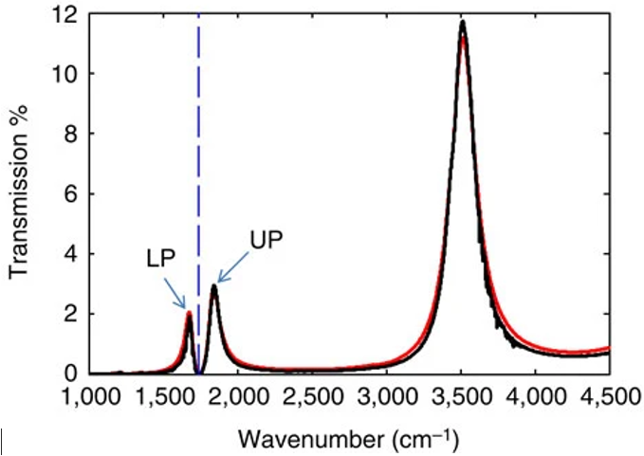
Figure 6. IR transmission spectrum of a Fabry-Perot cavity filled with poly(vinyl acetate), with thickness of 1.9 microns, such that a bare cavity mode lies near 1740 cm⁻¹, resonant with the C=O stretching vibrational mode of the polymer (dashed vertical line). The formation of upper (UP) and lower (LP) polaritons due to vibrational strong coupling are evident in the normal incidence experimental (solid black curve) and theoretical (red curve) spectra. Reproduced with permission from Ref. 36. Copyright 2015 Springer Nature.

Further studies on the dynamics of the vibro-polaritonic states of W(CO)₆ were realized through the application of two-dimensional (2D) IR spectroscopy (Figure 7).^{89–93} As mentioned earlier, for N molecules in the cavity mode volume, and besides the two bright polaritonic modes of the molecule-cavity coupled system, there are N-1 dark modes, as well as uncoupled molecular states that are either outside the field mode volume, or their transition dipole moment is orthogonal to the optical field polarization. The latter states are not observable via normal IR transmission spectra or their signatures cannot be easily disentangled from those of the bright polaritonic modes. The application of 2D IR spectroscopy allows the visualization of these dark/uncoupled states in isolation from the bright vibro-polaritonic states. The 2D spectra showed that the dark states and bright polaritons dynamics were interdependent. When one mode (dark states) was excited, the optical response of the bright vibro-polaritons was influenced, and vice versa.
Recently, vibrational energy transfer among molecules via vibro-polaritonic states was experimentally observed.⁹⁴ The vibrational energy of W(CO)₆ was rapidly transferred to W(¹³CO)₆ under VSC but did not occur without VSC. The enhancement of vibrational energy transfer under VSC was also supported by theoretical simulations of CO₂ molecules.⁹⁵ The molecular dynamics simulation of collectively coupled CO₂ suggested that the vibrational energy transfer among strongly coupled molecules was enhanced under VSC. Since enhanced vibrational energy transfer is considered to be a possible mechanism for modified chemistry under VSC (see further on),⁹⁶ transient spectroscopy of VSC systems is emerging as an essential tool.³⁷ Furthermore, as already observed for electronic strong coupling, dark and uncoupled populations cannot be ignored in the behavior of vibrationally strongly-coupled systems.

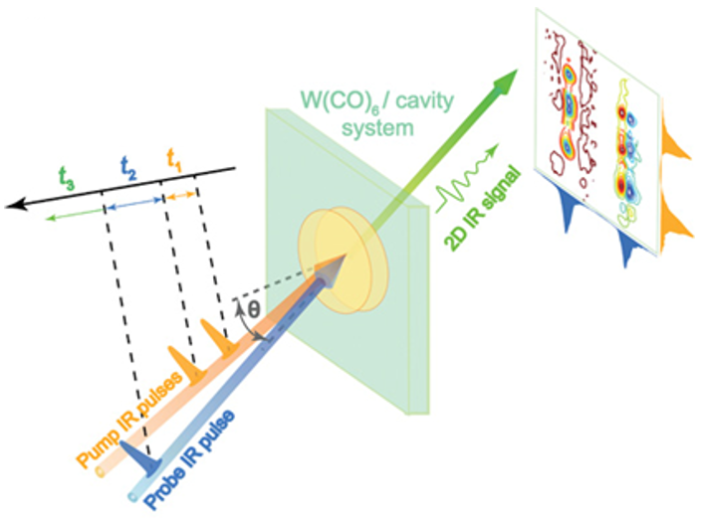

Figure 7. (a) Schematic illustrations of vibrational polariton 2D IR spectroscopy setup. Pump and probe IR incident beams are symmetric with respect to the surface normal with the same tilting angle (θ). Spectra of the pump and probe pulses are shown as 2D IR spectra on their respective axes, showing the interactions of two states. Reproduced with permission from Ref. 91. Copyright 2019 American Association for the Advancement of Science.
4. Molecular Chemistry in Exciton Strong Coupling
4.1 Energy Transfer between Molecules

When molecular electronic transitions are strongly coupled to the cavity modes, the energy of both absorption and emission are shifted due to polariton state formation. Furthermore, the polaritonic states are delocalized over distances far beyond characteristic distances for Förster-type resonance energy transfer (FRET, <10 nm). This opens possibilities for enhancing energy transfer between molecules.
The strong coupling of FRET donor and acceptor molecules to a single optical cavity mode has been a fertile pathway towards this enhancement. Polariton-enhanced energy transfer in this context was demonstrated in 2014 by Lidzey and co-workers, using a mixed layer of J-aggregated molecular dyes (the cyanines NK-2707 and TDBC) in a FP cavity.⁹⁷ The excitations of NK-2707 and TDBC were simultaneously coupled to the same cavity mode, resulting in three polaritonic states: upper, middle, and lower branches, each with varying contributions from each component state. The middle branch polariton contains relatively similar contributions from the TDBC and NK-2707 J-aggregates and was a prominent feature in fluorescence excitation spectra, suggested that it is an important state for mediating energy transfer between the two systems.
In 2017, polariton-enhanced energy transfer was demonstrated between another pair of J-aggregated cyanine dyes (TDBC and BRK), this time however with the donor and acceptor dyes separated by up to 70 nm, well beyond the characteristic FRET distance (Figure 8).⁹⁸ Polariton-enhanced energy transfer was in fact shown to be insensitive to distance in this configuration, instead being dependent on the degree of hybridization between the aggregates and the optical cavity mode. Later, polariton-enhanced energy transfer between TDBC and NK-2707 was demonstrated across a 2-micron spacer.⁹⁹ The energy transfer was independent of the distance if the strong coupling was maintained. Polariton-assisted energy transfer between two types of boron-dipyrromethene (BODIPY) core dyes has also been investigated, both in mixed layers and separated by a spacer. While energy transfer was shown to occur in both configurations, it was more efficient in the mixed layer.¹⁰⁰

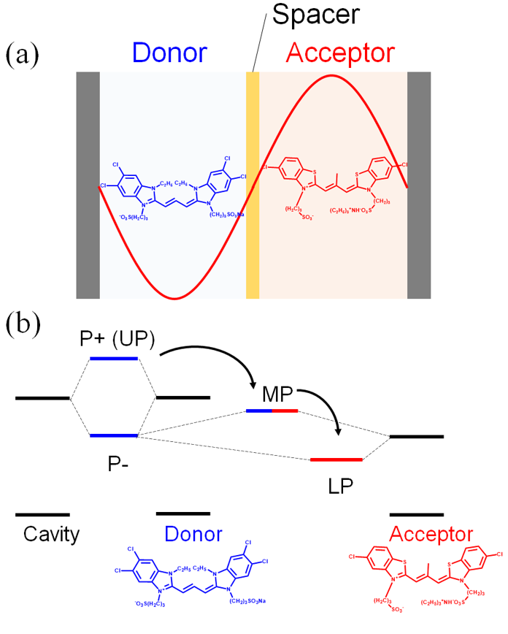
Figure 8. (a) Schematic illustration of long-range energy transfer via strong coupling to an FP cavity mode. The FRET donor (TDBC) and acceptor (BRK) pair are embedded in polymer films separated by a spacer layer. Spacer thickness can be varied but the energy transfer occurs with similar efficiency as long as mutual strong coupling to an FP cavity mode is maintained. (b) Energy diagram showing strong coupling of the FP cavity mode to the J-aggregate transitions, generating cascading polaritonic states: the upper (UP), middle (MP), and lower (LP) states with relative contributions from donor or acceptor indicated by blue and red lines. P+ and P- are the putative upper and lower polariton branches that would be present if only the donor was present and strongly coupled to the photonic mode.
Polariton-enhanced energy transfer has also been demonstrated to enhance light harvesting in (planar) heterojunction device architectures. 2,6-diphenylanthracene (2,6-DPA) as a donor and perylene-3,4,9,10-tetracarboxylic dianhydride (PTCDA) as an acceptor were separately layered and placed in the FP cavity composed of parallel silver mirrors. Coupling the organic dyes to the same cavity mode was shown to double the efficiency of energy transferred to the heterojunction interface. These results suggest applications of cavity strong coupling to light-harvesting systems.¹⁰¹
The mechanism of polariton-assisted energy transfer has been investigated by ultrafast 2D white-light spectroscopy.¹⁰² (6,5)- and (7,5)-carbon nanotubes (CNTs) have different bandgaps, and they thus act as a donor and an acceptor, respectively. (6,5)- and (7,5)-CNTs were layered by a polymer spacer and placed in a FP cavity to realize strong coupling. Under strong coupling, 2D spectroscopy captured the cross peak between the UP and LP states, indicating long-range energy transfer. The intermolecular coupling of the CNTs generates manifold states near the UP and LP states. When the UP and LP states are not well separated from the manifold states, the photon content is redistributed over many states within the manifold states. The photon then enters the manifold states from the UP state, creating delayed emergence of the cross peak in 2D spectroscopy, corresponding to long-range energy transfer from the (6,5)-CNTs to the (7,5)-CNTs.

4.2 Singlet and Triplet Excited States

Shifts in energy levels due to the formation of polaritonic states has also been shown to modulate the photophysical dynamics between triplet and singlet excited states, such as reverse intersystem crossing (RISC),¹⁰³ singlet fission^{104–106} and photon up-conversion triplet-triplet annihilation.¹⁰⁷ RISC is the transition from the triplet state to the singlet state of a molecule, that while uphill in energy, can be achieved via available thermal energy if the singlet-triplet energy gap is small enough (i.e., not greater than a few kT). RISC can improve the radiative efficiency of organic light-emitting diodes (OLED) as the spin statistics of exciton formation from injected free carriers favor the formation of non-radiative triplet states. Conversion of these triplets to radiative singlets by RISC is often slow despite many efforts to design organic chromophores with reduced singlet-triplet energy gaps. Erythrosin B is a representative molecule that exhibits emission through RISC. When Erythrosin B was placed in an FP cavity and its excited state was coupled to the cavity mode, enhanced RISC was observed.¹⁰³ Assuming that the newly generated lower polariton (singlet) state becomes the new LUMO of the system, the singlet-triplet energy for the system was reduced, resulting in the enhanced RISC rate (Figure 9).

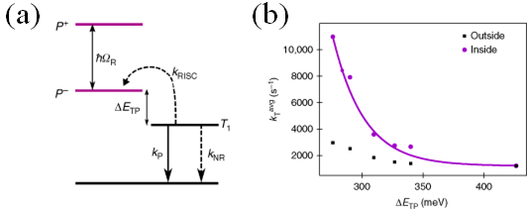
Figure 9. (a) Energy diagram indicating the kinetics of the triplet-state depopulation pathways inside a cavity. k_{P}, k_{NR}, and k_{RISC} indicate the rates of phosphorescence, non-radiative decay, and reverse intersystem crossing, respectively. ΔE_{TP} is the energy difference between T₁ and P⁻ (lower polaritonic state). (b) The average total rate constant of the triplet state (k_{T}^{avg}) depopulation as a function of ΔE_{TP}. When Erythrosin B is not in the strong coupling regime, the rate of triplet decay is equivalent to a bare film including Erythrosin B. However, when Erythrosin B is in the strong coupling regime, the phosphorescence decay was four times faster inside the cavity as compared to outside. The change in k_{T} is attributed to a reduced triplet-polaritonic state energy gap. Reproduced with permission from Ref. 103. Copyright 2018 Springer Nature.

Singlet fission (SF) is a phenomenon in which a singlet exciton splits into two triplet excitons of half the original exciton energy.¹⁰⁸ SF is expected to boost the efficiency of solar cells if a high energy exciton splits into two lower energy triplets that are still above the (typically silicon) bandgap and can be harvested by the solar cell. Amorphous rubrene is a well-known molecule that exhibits SF. A rubrene film was placed in an FP cavity, with the singlet exciton strongly-coupled to the cavity mode.¹⁰⁴ The SF rate was found to decrease due to polaritonic state formation in this case (Figure 10). The SF rate in the polaritonic state was interpreted based on three factors: electronic coupling between singlet and triplet states, overlap of the vibrational wavefunctions, and the energy gap between triplet states and lower polaritonic states. The formation of polaritonic states was found to induce a reduction in the S₁-T₁ electronic coupling, and to the overlap of the vibrational wavefunctions, resulting in the decreased SF rate.

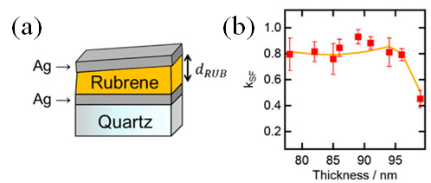
Figure 10. (a) Schematic illustration of a rubrene film in a FP cavity. The thickness of the rubrene film (d_{RUB}) is continuously changed by using a wedged cavity configuration. (b) The experimental (red squares) and simulated thickness dependence of the singlet fission rate (k_{SF}) in a FP cavity normalized by that in the rubrene film without cavity. k_{SF} decreases under strong coupling regime (lower than 1.0). Reproduced with permission from Ref. 104. Copyright 2019 American Institute of Physics publishing.

Thermally activated delayed fluorescence (TADF) is fluorescence caused by RISC in which the lowest triplet excited state (T₁) is thermally activated to the singlet excited state (S₁). Because of the high luminescence quantum yields of TDAF, TDAF molecules are expected to be promising materials for OLEDs. The kinetics of RISC under strong coupling have been investigated using 1,3,5-tris(4-(diphenylamino)phenyl)-2,4,6-tricyanobenzene (3DPA3CN), a molecule showing TADF.¹⁰⁹ 3DPA3CN exhibits TADF because of the small energy gap between S₁ and T₁ (~0.1 eV). To reduce aggregation-induced quenching, 2,2′,2′′-(1,3,5-benzinetriyl)-tris(1-phenyl-1-H-benzimidazole) (TPBi) was co-deposited with 3DPA3CN. 3DPA3CN and TPBi were placed in a FP cavity consisting of Ag reflective mirrors, forming strong coupling states. Because of the strong coupling of the S₁ state with a cavity mode, the polaritonic states formed. Because of the energy splitting, the LP state was energetically lower than the T₁ state. Although acceleration of RISC might be expected because of the inverted energy states of S₁ and T₁, the observed kinetics of RISC was unchanged. This was because the RISC rate was still slow owing to the large difference between the densities of the dark T₁ state and LP state, leading to an unchanged RISC rate. However, there is the possibility that the delayed fluorescence yield is enhanced by strong coupling. This can occur in cases in which the equilibrium between S₁ and T₁ is much faster than the fluorescence from S₁, such as in singlet fission or organometallic complexes.
A mechanistic study of TADF molecules under strong coupling has been performed.¹¹⁰ DABNA, which shows TADF, was placed in a FP cavity to achieve strong coupling. Because of the strong coupling of the S₁ state, the LP state was energetically lower than the T₁ state, meaning energy inversion of the LP and T₁ states. The RISC rate under strong coupling was evaluated by changing the temperature, providing an Arrhenius plot that gave the energy barriers. The Arrhenius plot suggested barrier-free conversion between the triplet and LP states. When the contribution of matter to the polaritonic state was low, the triplet state and LP state were disconnected.
The effect of strong coupling on triplet excitons was further investigated.¹⁰⁵ Triplet-triplet annihilation (TTA) is the spin-allowed conversion of two triplets into a single exciton.^{111,112} One well-known example of TTA is the photon up-conversion of 9,10-diphenylanthracene (9,10-DPA) and platinum(II) octaethylporphine (PtOEP). A polymer film containing a mixture of DPA and PtOEP was placed between the Ag reflecting mirrors, acting as an FP cavity. The singlet exciton was coupled to the cavity mode to form polaritonic states. Under strong coupling, the emission always originates from the lower polariton branch, regardless of whether the coupled 9,10-diphenylanthracene or the uncoupled Pt-porphyrin is excited. Interestingly, longer-lived emission was observed under strong coupling (Figure 11). Longer-lived emissions were also observed in the cases of strong coupling of diketopyrrolopyrrolethiophene (DPPT) and 5,12-bis(triisopropylsilylethynyl)tetracene (TIPS-tetracene). The photodynamics of DPPT include intersystem crossing from singlet to triplet excitons and the regeneration of singlet excitons via TTA. Likewise, the photodynamics of TIPS-tetracene involves the singlet fission from singlet to two triplet excitons and TTA. Longer-lived emissions were observed for the delayed emissions of DPPT and TIPS-tetracene. In the early stage, DPPT and TIPS-tetracene emitted from directly excited singlet states, but delayed emission was attributed to TTA. This indicates that longer-lived emissions are attributed to the modulation of the photodynamics related to TTA. The reason for the longer lifetime of the emissions from the lower branch is still under discussion. The singlet excited states of DPA, DPPT, and TIPS-tetracene are coupled to the cavity mode; however, the formation of polaritonic states influences other processes that can interact with the singlet excited state.

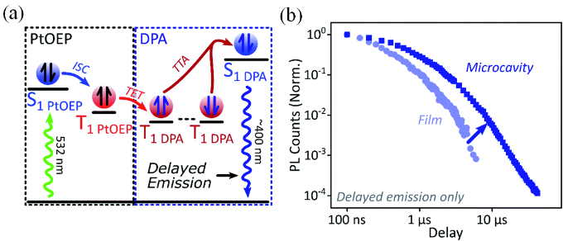
Figure 11. (a) Schematic illustration of photon up-conversion of the diphenylanthracene (DPA)/platinum(II) octaethylporphine (PtOEP) system. ISC: intersystem crossing, TET: triplet energy transfer, TTA: triplet–triplet annihilation. (b) Decay kinetics of DPA film emission, and of exciton-polariton emission in an optical cavity, following excitation of PtOEP. The emission lifetime is enhanced under strong coupling. Reproduced with permission from Ref. 105. Copyright 2020 the Royal Society of Chemistry.
4.3 Polariton Transport
The Frenkel excitons of organic materials are localized, resulting in short-range exciton transport, normally by incoherent hopping via FRET. The formation of polaritons by strong exciton coupling, with their aforementioned extended wavefunctions, opens up new possibilities for enhanced exciton diffusion. J-aggregated cyanine dye (TDBC) films placed in FP cavities have indeed be shown to exhibit long-range exciton diffusion, over several microns (Figure 12).¹¹³ This is attributed to the delocalization of polaritonic wavefunctions over the cavity mode volume. The strong coupling between excitons and photons also improves the migration of excitons and charge carriers in organic materials.^{114,115}

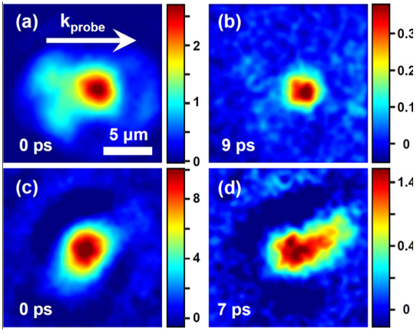
Figure 12. Spatial distribution of excitons in a film of bare molecules (a) at zero time delay (b) and at a delay of τ = 9 ps between the pump and probe pulses. (c–d) Polariton distribution measured in the cavity sample for transverse magnetic polarization (c) at zero time delay and (d) after 7 ps of evolution, showing the expansion of the polaritonic state in space. The polariton expands in the horizontal direction (direction of probe beam momentum), reaching a width of 6 μm after 7 ps. Reproduced with permission from Ref. 113. Copyright 2013 American Chemical Society.

The dynamics of polariton migration have been investigated using femtosecond transient absorption spectroscopy, which can visualize the motion of a polariton in a FP microcavity.¹¹⁶ Under cavity strong coupling of the fluorophore BODIPY, the velocity of a polariton was shown to be proportional to the Q factor of the microcavity. The Q-factor-dependent velocity can be interpreted based on the delocalization and coherence of the dark states. In a FP cavity, some molecules are strongly-coupled, while others are not due to molecular disorder. The FP cavity with a high Q factor provides the energetically narrow cavity mode, which selectively couples to a narrower population of the molecular absorber. The resulting N-1 dark states possess a smaller energetic distribution. The resulting smaller manifold of N-1 dark states therefore features increased delocalization and coherence. The more delocalized and coherent dark states permit a rapid channel of population exchange with diffusing bright polariton states, resulting in long-range transport in which the velocity depends on the Q factor.

4.4 Polariton Lasing and Bose–Einstein Condensation
Bose–Einstein condensation (BEC) is a phenomenon where de Broglie wavelength of many bosonic particles overlap, allowing the system to relax into a single coherent quantum state. This was theoretically predicted in 1925¹¹⁷ and later experimentally demonstrated by using Rb and Na gas.^{118,119} As the temperature decreases, de Broglie wavelength (λ_{dB} = √2πℏ²/mk_{b}T, m is the effective particle mass, k_{B} is the Boltzmann constant and T is the temperature) becomes longer, to be compatible with the mean distance between particles. The BEC of Rb and Na was observed from a few micrometers to hundreds of nanometers. Exciton-polaritons are bosonic composite quasi-particles with effective mass 10⁻⁴ to 10⁻⁵ times smaller than that of a bare electron. Because of the low effective mass, BEC can occur at elevated or even room temperature.¹²⁰ It should be noted that the polariton condensation process is not the same as conventional BEC. The polariton BEC occurs under non-equilibrium conditions,^{121–123} whereas equilibrium conditions are essential for a conventional BEC. The polariton has a finite lifetime because of the leakage of photons through the mirrors, such that the polariton system is in a non-equilibrium state (Figure 13a).

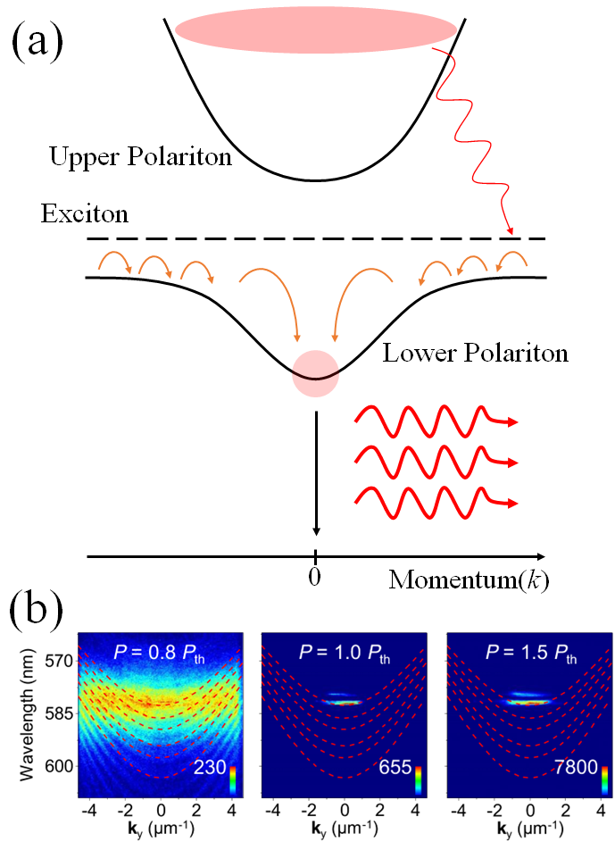

Figure 13. (a) Energy-momentum dispersion of exciton-polariton branches following strong coupling of some absorber to an FP cavity, with red arrows outlining the polariton condensation process. The excitons are initially excited by a pump laser to a higher energy level, which cool to the lowest energy bottleneck region. Excitons in the bottleneck region then scatter into the condensate state (zero momentum (k) state of the lower polariton branch). (b) Experimental dispersion curves of polariton condensate formation. Dashed curves are the fitted polariton dispersion. Below the threshold for condensation, the polaritons are broadly distributed in energy. Above the threshold, polaritons condense in the k = 0 ground state. Reproduced with permission from Ref. 146. Copyright 2021 Springer Nature.
Polariton condensation was initially investigated in inorganic semiconductor materials.^{124–127} The polariton BEC was first demonstrated using a CdTe/CdMgTe microcavity.¹²⁴ An intriguing application of polariton condensation is the polariton laser, where condensation to the ground polaritonic states generates laser-like coherent emission.¹²⁸ The threshold for polariton lasing is significantly lower than that of semiconductor photon lasing.^{129–132} Condensation to the polariton ground state was observed at 19 K. Later, intriguing quantum phenomena accompanied by polariton condensation, such as polariton lasing,^{133–137} superfluidity,^{138,139} and vortex formation,¹⁴⁰ were realized. Polariton condensation in inorganic materials occurs at temperatures lower than 100 K because of the weak binding energy of Wannier–Mott excitons, although polariton condensation at room temperature was realized in ZnO^{141–143} and GaN^{144,145} with high-quality microcavities.
Organic materials are suitable for forming coherent quantum states at room temperature because of the aforementioned strong binding energy of the Frenkel excitons.¹⁴⁶ Organic polariton lasing was first demonstrated in single crystals of anthracene placed in a cavity composed of two DBR mirrors. At room temperature, the lasing threshold was lower than the lowest threshold for conventional photonic lasing.¹⁴⁷ Later, organic polariton BEC was realized at room temperature in methyl-substituted ladder-type poly(p-phenylene) polymers placed between two DBR mirrors.¹⁴⁸ To date, room-temperature organic polariton condensation^{149–153} and many promising applications based on related quantum phenomena, including polariton lasing¹⁵⁴ and superfluidity¹⁵⁵ have been achieved. A wide variety of organic materials have been investigated as active materials for polariton condensation and its related applications, such as organic polymers,^{156,157} fluorescent proteins,^{158,159} organic dyes,^{160–163} and organic-inorganic hybrid semiconductors (Figure 13b).¹⁶⁴ Most studies on polariton condensation have been performed in FP cavities composed of two parallel metallic mirrors. However, the organic crystal itself can act as an optical cavity via reflections at the crystalline interfaces (see also Conclusions section for further discussion). Formation of exciton polaritons has been observed in an organic single crystal of N,N′-bis(2,6-diisopropyl phenol)−3,4,9,10-perylenetetracarboxylic diimide, despite the low Q factor.¹⁵² BEC condensation of a polariton was observed in a single organic crystal of this material.
4.5 Nonlinear Optics
Polaritonic states have been shown to modulate non-linear optical susceptibilities and the generation of higher harmonics. For example, a nanofiber porphyrin aggregate outside an FP cavity showed second-harmonic generation (SHG) signals around the intense Soret absorption band (420 nm) under excitation with an 840 nm laser.¹⁶⁵ The porphyrin nanofibers were then placed in an FP cavity to form polaritonic states, coupling the second cavity mode to the Soret band transition. The first cavity mode then matched the 840 nm pump laser and served to enhance this excitation. By changing the pump excitation wavelength from 740 to 980 nm, the efficiency of SHG as a function of wavelength could be measured in both conditions (Figure 14). While the SHG signal followed the shape of the Soret band outside the cavity, characteristic of resonance-enhanced SHG, bimodal SHG signals were observed in the cavity, peaking at ca. 390 and 460 nm, corresponding to the upper and lower polariton wavelengths, respectively. The SHG signal from the lower polariton was much stronger than that from the upper polariton, and two orders of magnitude stronger than for outside the cavity.
Tunable third-harmonic generation (THG) signals were also demonstrated by the cavity strong coupling of polymethine dye.¹⁶⁶ THG signals were observed upon the excitation of the lower polariton. The excitation wavelength was varied from 1250 nm to 1950 nm by changing the incident angle of the pump laser. The change in the excitation wavelength enables modulation of the emission wavelength of the THG. The enhancement coefficient of the THG signals is 108 times stronger than that of the polymethine dye outside the FP cavity.
The electroabsorption of squaraine under strong coupling has been investigated to determine the effect of strong coupling on the nonlinear optical response.¹⁶⁷ The electroabsorption corresponds to the imaginary part of [χ⁽³⁾(ω,0,0)]. Squaraine dispersed in a wide-gap host matrix was placed in FP cavities, and the electroreflectance was analyzed by varying the coupling strength. Classical transfer matrix modeling captured the shape of the spectrum for a low concentration of squaraine, but it failed for a high concentration of squaraine. In particular, the LP states for a high concentration of squaraine could not be captured by transfer matrix modeling. This is attributed to the interaction between the LP and aggregate states. The results indicated that electroabsorption can be manipulated by strong coupling of organic molecules.

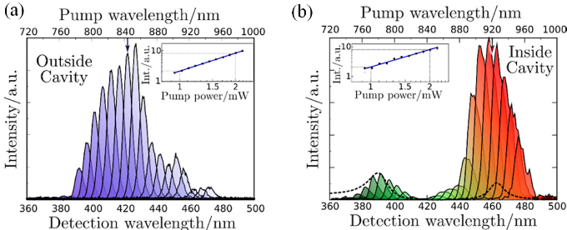
Figure 14. Second-harmonic generation (SHG) spectra measured at different pump wavelengths for a c-Porphyrin fiber outside (a) and inside (b) the cavity. The maximum SHG intensity was at 390 nm and 460 nm inside the cavity, indicating the SHG signals from polaritonic states. The SHG signal from lower polaritonic state (460nm) is more than 5 times stronger than that from upper polaritonic state (390nm). Reproduced with permission from Ref. 165. Copyright 2016 American Chemical Society.
4.6 Photochemical Reactions
Spiropyran is a representative photochromic molecule. Spiropyran absorbs UV light and is converted to green-absorbing merocyanine. Conversely, merocyanine converts back to spiropyran when it absorbs visible light. Spiropyran dispersed in a PMMA film has been placed in a FP cavity consisting of parallel Ag mirrors.¹⁶⁸ By optimizing the thickness of the film, the cavity mode was adjusted to the green-light region, which can couple to merocyanine. Under UV irradiation, spiropyran in the cavity was converted to merocyanine that strongly coupled to the cavity mode, forming a very large Rabi splitting (an absolute record at the time, with the >700 meV splitting pushing the system into the collective ‘ultra-strong coupling’ regime where the Rabi splitting is a significant fraction (>10%) of the undressed material transition energy). In contrast, merocyanine in the cavity could be converted back to spiropyran under visible-light irradiation, resulting in the disappearance of strong coupling. In this way this study also demonstrated all-optical control on strong light-matter coupling, and was inspiration for the first studies of photochemical reaction kinetics in optical cavities (Figure 15).
The modification of chemical reactions under strong light-matter coupling was first observed by coupling electronic transitions to cavities, and for the study of photochemical reactions. The first example was the ring-opening photoisomerization of a spiropyran to a merocyanine.¹⁶⁹

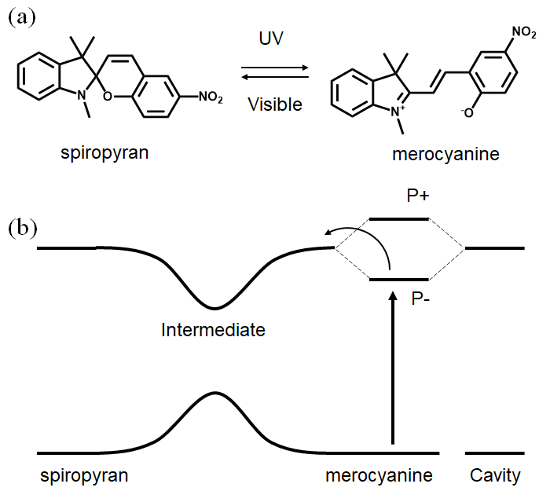
Figure 15. (a) Reaction scheme of photochemical isomerization of spiropyran and merocyanine. (b) Energy diagram of spiropyran and merocyanine under strong coupling. The excited state of merocyanine was strongly coupled to the cavity mode, forming polaritonic states (P+ and P–). An energy barrier was formed from P– to the intermediate state (I). Because of the increased energy barrier, the photochemical isomerization from merocyanine to spiropyran slows down.

The rate of the photoisomerization was followed inside and outside the cavity, for optical cavities with an optical mode resonant with the merocyanine absorption at 565 nm, or a non-resonant case. The photoisomerization rate in the non-resonant cavity was identical to that observed outside the cavity. However, for the resonant cavity, transformation from spiropyran to merocyanine became slower as the system progressively became more strongly coupled to the merocyanine absorption. This change in rate was attributed to the lower polaritonic state becoming the effective LUMO of the merocyanine half of the photochromic system. This lowering of the merocyanine excited state energy would introduce a thermal barrier to reaction along the excited state potential energy surface, and relatively enhance direct relaxation to the ground state, leading to an overall change in rates and final yield of merocyanine formation in the photostationary state. Femtosecond-resolution transient absorption spectroscopy in the same study indeed showed that the lower polariton transition associated with the merocyanine at ~650 nm was short-lived relative to the merocyanine outside the cavity.
In addition to cavity strong coupling, the work function of merocyanine under strong coupling has been investigated.¹⁷⁰ Spiropyran/merocyanine dispersed in a PMMA film was placed on a plasmonic hole array to achieve strong coupling of merocyanine. Kelvin probe microscopy revealed surface potential changes under strong coupling, suggesting that formation of polaritonic states indeed affects the electronic energy levels. In other words, the strong coupling influences the redox process of the corresponding molecules.
Photoisomerization of norbornadiene/quadricyclane has also been investigated under strong coupling.¹⁷¹ Norbornadiene absorbs light and is converted to quadricyclane. Conversely, quadricyclane is converted to norbornadiene by heating. Norbornadiene/quadricyclane was dispersed in a polystyrene film and placed in a FP cavity composed of parallel Al mirrors. Under the strong coupling of norbornadiene, two polaritonic states, UP and LP branches, were generated. By excitation to the UP state, the quantum yield did not change compared with that of bare norbornadiene. However, when excited to the LP state, the quantum yield was lower than that of bare norbornadiene, and was found to depend on the detuning of the cavity mode from the material transition. Detuning of the cavity mode changes the relative molecular and photonic contributions to the LP state, with more photonic states having shorter lifetime. The photoisomerization yield was more strongly changed for the resonant case than for the ‘blue-detuned’ case, the latter of which has strong molecular contribution to the polariton and a more ‘molecular’ lifetime which is essentially that of the reservoir of polaritonic dark states (especially in the case of disorder). Thus, the photochemical modification depends on competition between radiative decay and decay into the molecule-like reservoir for the LP. Once again, lowering the energy of the LP state can generate an additional energy barrier for the photoisomerization process from the LP state. Interestingly, the thermal back conversion from quadricyclane to norbornadiene was unchanged, probably because thermal back conversion occurs along the ground state which is not strongly perturbed by the cavity interaction (this was also observed for the merocyanine thermal reversion reaction¹⁶⁹).
Photoisomerization under strong coupling was also theoretically investigated for azobenzenes.^{172,173} Under a strong coupling regime, a polaritonic conical intersection was predicted to emerge, altering the photoisomerization kinetics. Particularly when a large number of molecules collectively couple to a cavity mode, the single excitation is distributed over the hybrid system of many molecules and the cavity mode, suppressing the photochemical reaction.¹⁷³ The suppression of the photochemical reaction is more pronounced when many molecules are coupled to the cavity mode. These experimental and theoretical works suggest that the energy landscape of photochemical reactions is indeed altered by the strong light-matter coupling and the introduction polaritonic states.
4.7 One-Dimensional Nanomaterials
Carbon nanotubes were originally discovered in deposits on the cathode of carbon arcs.¹⁷⁴ The first carbon nanotubes discovered were multi-walled carbon nanotubes, which consisted of several concentrically-stacked tubes of different diameters. Single-walled carbon nanotubes (SWCNTs) were successfully synthesized later.¹⁷⁵ SWCNTs are promising materials for optoelectronics because of their charge carrier mobilities and diameter-dependent near-infrared photoluminescence.¹⁷⁶
Exciton-polaritons were observed to form from SWCNTs embedded in a polymer matrix in an FP cavity.⁷¹ Rabi splitting of over 110 meV was observed as a result of the large oscillator strength and sharp excitonic transitions of the SWCNTs. The near-infrared photoluminescence of SWCNT under strong coupling was observed only from the lower polariton branch.⁷¹ Later, the exciton-polariton emission of SWCNTs was controlled by electrical pumping in an FP cavity integrated with a field-effect transistor.¹⁷⁷ The luminescence from SWCNTs under strong coupling was always observed from the LP either by optical excitation or electrical pumping. The coupling strengths of the SWCNT exciton and cavity modes were modulated by the addition of electrons or holes, leading to a change in the emission efficiency and a shift in the emission wavelength. The controllable strong coupling of positive trions in SWCNTs was realized by hole-doping of SWCNTs with the application of voltage (Figure 16).¹⁷⁸
More recently, one-dimensionally aligned SWCNTs were placed in an FP cavity.¹⁷⁹ The large Rabi splitting (329 meV) was observed only when the polarization of the probe light was parallel to the aligned SWCNTs, implying that the alignment of the transition dipole of SWCNTs maximized the light-matter interaction.

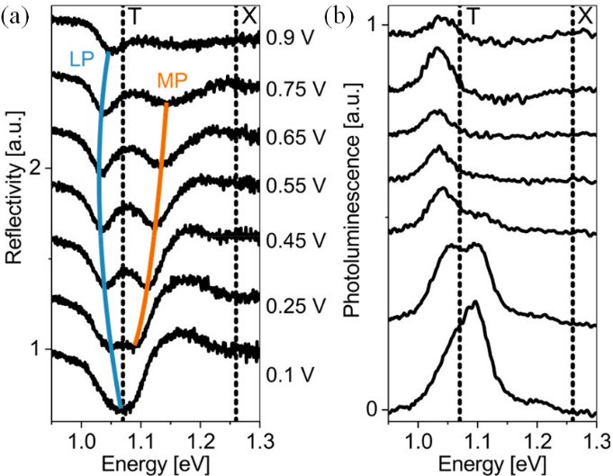
Figure 16. (a) Reflection and (b) photoluminescence spectra of SWCNTs in an FP cavity, for different applied voltages from 0.9 V (top, strongly hole-doped) to 0.1 V (bottom, barely hole-doped). LP and MP indicate lower and middle branch polaritons splitting around the positive trion (T) energy, respectively. At applied potentials of 0.25 V and above, trion population increases above the threshold for visibility of the LP/MP splitting, both in reflectance and emission (though the majority of emission eventuates from the LP). At 0.1 V applied, only a single reflectance/emission band is observed at the trion energy. Reproduced with permission from Ref. 178. Copyright 2018 American Chemical Society.
4.8 Two-Dimensional Nanomaterials
2D transition metal dichalcogenides (TMDs), which are Van der Waals layered materials composed of a transition metal (M = Mo, W) and chalcogen (X = S, Se, Te), are promising ultrathin optoelectronic materials.^{180–183} Depending on the combination of elements in the TMDs, and various layered heterostructures thereof, these materials can be semiconductors, metals, and even superconductors, with strong potential for integration into optoelectronic devices.
The cavity strong coupling of 2D TMDs was demonstrated in MoS₂¹⁸⁴, MoSe₂/hexagonal boron nitride¹⁸⁵, WS₂^{186,187} and MoSe₂¹⁸⁸ placed in the FP cavities.¹⁸⁹ The earlier experiments focused on few/monolayer MoS₂/MoSe₂ and were performed with DBR cavities at cryogenic temperatures due to the relatively broad excitonic absorptions in these materials. Later it was shown that the spectrally sharper and higher oscillator strength WS₂ excitonic transition allowed strong coupling to be achieved for a monolayer at room temperature and using metallic cavities (both Fabry-Perot and plasmonic).¹⁸⁷ More recently the modulation of polaritonic states of WS₂ has been demonstrated by applying electric fields in FP cavities.¹⁹⁰ The electric field drove n-doping of the WS₂, leading to control of emission intensity from the negative trion. More recently again, enhanced electron mobility owing to strong coupling was observed in an FP cavity (Figure 17).¹⁹¹

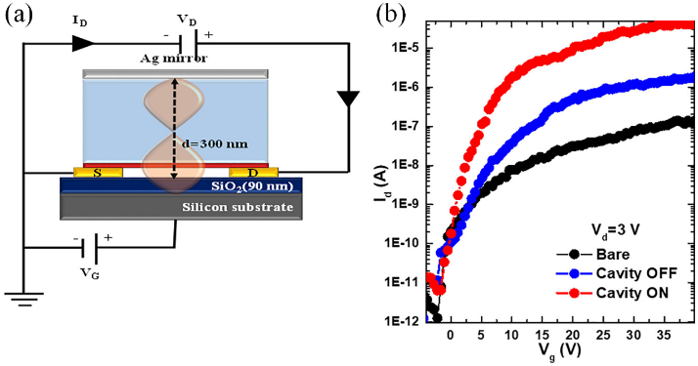
Figure 17. (a) Schematic illustration of a three-terminal field effect transistor (FET) configuration of 6-layered WS₂ coupled to the cavity mode. (b) The mobility of WS₂ strongly coupled to cavity mode (red) is higher than that of WS₂ detuned from cavity mode (blue). The mobility of the bare WS₂ flake (black) is low because of a high Schottky contact barrier and the presence of an SiO₂ layer. Reproduced with permission from Ref. 191. Copyright 2021 American Chemical Society.
Because of their quasi-hexagonal lattice structure lacking inversion symmetry and strong spin-orbit coupling, 2D TMDs can feature two energy-degenerate but oppositely spin-polarized electronic states at so-called Valleys of the conduction band in momentum space, that can be selectively accessed by circularly polarized excitation (Figure 18a-b). The resulting spin-momentum locked excitons can allow a higher density of information to be encoded in signals, triggering interest in 2D TMDs as ‘valleytronics’ materials.^{192,193} However, inter-Valley scattering during thermalization can wash out Valley selectivity away from cryogenic temperatures, limiting practical applications.
Cavity strong coupling of 2D TMDs presents a potential solution to this challenge, in part because mixing the (spin-momentum locked) excitonic states with light enhances their radiative character, such that they might emit circularly polarized light faster than inter-valley scattering can occur at room temperature. The preservation of spin-valley locking in the strong coupling regime at room temperature has indeed been demonstrated in FP cavities by several groups since 2017.^{194–197}
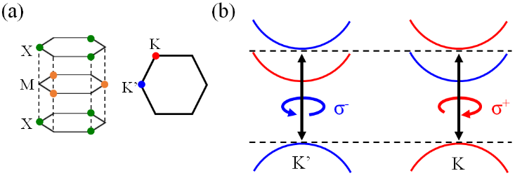
Figure 18. (a) Illustration of the quasi-hexagonal lattice structure of 2D TMDs; M: metal, X: chalcogen. Spin-polarized excitons are formed in different valleys in the momentum space: K and K’ valleys at the edges of the Brillouin zone. (b) Illustration of the valley-dependent optical selection rules. In the K (K’) valley, the optical transitions couple to σ+ (σ−) polarized light.
5. Molecular Chemistry in Vibrational Strong Coupling
5.1 Organic Reactions
The strong coupling of molecular vibrational normal modes (VSC) of functional groups to infrared cavity photons has been shown to accelerate or decelerate a range of chemical reactions.^{37,88,198,199} The effect of VSC on chemical reactions was first observed in the deprotection reaction of a silyl group from an alkynyl silane (entry 1 in Table 1, Figure 19).³⁹ The deprotection of the silyl group is initiated by the nucleophilic substitution reaction of 1-phenyl-2-trimethylsilylacetylene with tetra-n-butylammonium fluoride (TBAF). In this reaction, a fluoride ion attacks the silicon atom of 1-phenyl-2-trimethylsilylacetylene and the Si–C bond dissociates. Placing the reaction solution in an FP cavity allowed VSC of the Si–C vibration in 1-phenyl-2-trimethylsilylacetylene to be achieved. Under VSC of the Si–C vibrational mode, the reaction rate decreased by a factor of 5.5. The suppression of the deprotection reaction of alkynyl silane was applied to site-selective reactions (entry 2 in Table 1).²⁰⁰ The site-selective reaction was investigated using tert-butyldimethyl{[4-(trimethylsilyl)but-3-yn-1-yl]oxy}silane, which has two types of silyl bonds, i.e., Si–C and Si–O. Both of these bonds can react with TBAF. Cleavage of the Si–C bond gives (but-3-yn-1-yloxy)(tert-butyl)dimethylsilane (1) and cleavage of the Si–O bond gives 4-(trimethylsilyl)but-3-yn-1-ol (2). Under VSC, the cleavage of Si–C bond was suppressed, and the formation ratio of 2 increased.
The effect of VSC has also been observed in other organic reactions. Prins cyclization is a synthetic reaction that produces cyclic compounds. In Prins cyclization, the hydroxyl group of a homoallyl alcohol attacks the carbonyl carbon, initiating the cyclization reaction. Under VSC of the C=O stretching vibration, the reaction rate of Prins cyclization decreased (entry 3 in Table 1).²⁰¹ The modulation of Prins cyclization by VSC was also applied to site-selective reactions. 4-acetylbenzaldehyde has aldehyde and ketone groups, both of which can undergo Prins cyclization (entry 4 in Table 1).²⁰² As the aldehyde group is more reactive, the ratio of the reacted aldehyde groups to reacted carbonyl groups (aldehyde + ketone) was 60% without VSC. Under VSC of the ketone group, the reaction of ketone was suppressed, leading to an increase in the ratio of reacted aldehyde groups to 88%. Acceleration of reactions under VSC has also been reported, although alkynyl silane deprotection and Prins cyclization were suppressed under VSC. The hydrolysis reaction of cyanate ions is accelerated under VSC of the OH stretch of water molecules (entry 5 in Table 1).²⁰³
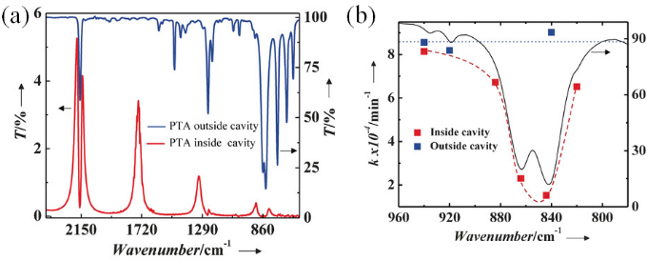
Figure 19. (a) IR transmission spectrum of an FP cavity after injection of 1-phenyl-2-trimethylsilylacetylene (PTA) (red). IR transmission spectrum of PTA (blue). The vacuum Rabi splitting is observed around 850 cm⁻¹ in transmission. (b) IR transmission spectrum of Si−C modes of PTA. The reaction rate as a function of the cavity tuning for reactions inside (red squares) and outside (blue squares) the cavity. The reaction rate decreases when the cavity mode is tuned to the absorption maximum of Si-C modes. Reproduced with permission from Ref. 178. Copyright 2016 Wiley-VCH.
As discussed in Section 2 and 3 above, usually very large numbers of molecules are collectively coupled to the cavity vacuum field mode via highly allowed vibrational absorptions to sustain strong light-matter interactions at room temperature and in relatively lossy metallic FP cavities. Thus, early work on VSC as outlined above often involved pure polymers or pure liquids coupled to the cavity. It is much more difficult to realize VSC for the vibrations of a solute in a relatively dilute solvent, despite the great relevance of such solutions for chemistry.
In this context, cooperative VSC was explored, in which several types of molecules with the same vibrational energy cooperatively couple to the cavity mode. In particular, when the reactants and solvent molecules possess the same vibrational energy, the cooperative VSC state is realized even at low reactant concentrations because large quantities of solvent molecules cooperatively boost the coupling. Such a cooperative VSC effect was reported for the solvolysis of p-nitrophenyl acetate (PNPA). When the carbonyl stretch of PNPA (reactant) and ethyl acetate (solvent) were in a cooperative VSC state, the solvolysis reaction was accelerated (entry 6 in Table 1).²⁰⁴
The effect of cooperative VSC was also investigated for the reaction of p-nitrophenyl benzoate (and its derivatives) in isopropyl acetate. The cooperative VSC state was achieved by coupling the carbonyl stretch of the p-nitrophenyl benzoate derivative (reactant) and isopropyl acetate (solvent) to the cavity mode. The reaction rates of the p-nitrophenyl benzoate derivatives increased under cooperative VSC, but did not follow the Hammett relation. That is, the reaction rate could not be explained by the substituent constant, which depends on electron-withdrawing and electron-donating properties. The observed mismatch with the Hammett relation was attributed to the influence of VSC on both intra- and intermolecular interactions (entry 7 in Table 1).²⁰⁵
More recently, cooperative VSC was taken further for the modulation of the alcoholysis of phenyl isocyanate with cyclohexanol. The NCO stretch of phenyl isocyanate and the carbonyl stretch of cyclohexyl carbanilate are strong absorptions for which VSC can be applied. Additionally, the CH modes of tetrahydrofuran (THF), cyclohexanol, and cyclohexyl carbanilate are strong absorptions; thus, the collective VSC can be investigated. The effects of (cooperative) VSC of these vibrational modes were investigated. The reaction rate was found to decrease by a factor of 5 for cavities tuned to the NCO stretch, and also to be reduced by half for cavities tuned to the carbonyl stretch and CH modes. (entry 8 in Table 1).²⁰⁶
5.2 Enzymatic Reactions
VSC has also been applied to enzymatic reactions. Pepsin is a stomach enzyme that digests proteins in ingested food. When the OH stretching modes of pepsin and water molecules are in a cooperative VSC state, the reaction rate of peptide hydrolysis decelerates (entry 9 in Table 1).²⁰⁷ As the active site of pepsin contains OH groups, it is possible that the activity of pepsin is altered by the VSC of OH stretching mode. A VSC effect has also been observed in the enzymatic reaction of α-chymotrypsin, a pancreatic enzyme that digests proteins (entry 10 in Table 1).²⁰⁸ The rate of ester hydrolysis by α-chymotrypsin enhances when the OH stretching mode of water (solvent) and OH and NH stretching modes of α-chymotrypsin are in a cooperative VSC state. The rate-limiting step in ester hydrolysis is proton transfer, suggesting that VSC of OH and NH stretching modes improves proton dissociation.
5.3 Symmetry of Vibrational Modes
The symmetry of vibrational modes has been shown to influence the effect of VSC. For instance, the equilibrium constant of the charge-transfer (CT) complex between 1,3,5-trimethylbenzene and iodine changed under VSC, thus affecting the Gibbs free energy (ΔG°).²⁰⁹ The molecular vibrations were classified into two symmetry types: A' (aliphatic C–H stretch and –CH₃ bend) and E' (aromatic C–H stretch and ring C=C stretch). ΔG° increased under VSC of the vibrations with symmetry A', whereas, it decreased under VSC of the vibrations with symmetry E' (entry 11 in Table 1). This trend suggests that the symmetry of the vibrational modes affects the activation and deactivation of reactions under VSC.
In fact, the stereoselectivity of the organic reaction changes under VSC, depending on the symmetry of the vibrational modes. Different stereoselectivities were observed for the ring-opening reactions of cyclobutene derivatives under the VSC of the C=O stretching and C–H vibrations. For cyclobutene-cis-3,4-dimethylcarboxylate, the conrotatory ring-opening reaction was promoted, and cis-trans, trans-trans-butadiene derivatives were formed under the VSC of the C=O stretching vibration.²¹⁰ In contrast, trans-butadiene derivatives were formed under the VSC of the C–H vibration (entry 12 in Table 1). The different stereoselectivities were interpreted based on the difference in vibrational symmetry.
5.4 Theoretical Frameworks
The mechanistic explanation for the effect of VSC on chemical reactions is not yet fully understood. To address this issue, theoretical frameworks have been proposed to account for the effect of VSC on chemistry.^{211,212} The development of theories has focused on simulation of the acceleration or deceleration of chemical reactions. These opposite effects on the reaction rate have been shown to occur for VSC depending on the reaction type and mechanism. Other important challenges include the explanation of the resonance effect, and the dependence on the number of molecules coupled to a cavity mode (N), of VSC. In experiments, VSC-induced changes in the reaction rate are maximized under resonant conditions in which the cavity mode is tuned to the absorption maximum of the vibrational mode. The VSC effect also depends on N but in a non-trivial way (i.e. not linearly proportional to ħΩ_{R} and therefore N^{0.5}).²¹³
Indeed the observed activation barrier changed non-linearly with the Rabi splitting, and the changes in the reaction enthalpies and entropies were much greater than the VSC-induced shifts in vibrational absorption.²¹³ Therefore the perhaps naïve/intuitive notion that the shifts in vibrational absorption energy due to polariton formation might lead to direct or proportional changes to the thermal activation energy immediately needed to be evaluated. Simulations of cavity-modified reaction rates were initially simulated based on the transition state theory.^{214–216} For instance, the one-dimensional Shin–Metiu model has been used for the simulation.²¹⁷ The model is composed of three atoms and one electron. The two atoms are fixed, and the interactions among one electron, two fixed atoms, and one movable atom are considered. This model can capture the change in the reaction kinetics, but no resonant effect is observed. The N dependence is also only duplicated when all of the molecules are oriented and coupled to the cavity mode.
The cavity-modified Marcus–Levich–Jortner model has also been proposed,²¹⁸ which relies on electron transfer from a donor to an acceptor across the potential energy surface. This model predicts that electron transfer to the LP state, shifted downward in energy by the Rabi splitting, results in a change of the reaction kinetics. This mechanism can explain both the resonance and the N-dependence effects of VSC. Because this theory postulates an excited electronic potential energy surface with nonadiabatic coupling to the ground-state potential energy surface, the simulated result could be applicable to reactions including charge transfer.
The transmission coefficient (κ) is normally assumed to be 1 in transition state theory. The condition under which κ is at a minimum has been derived from Grote–Hynes theory.^{219,220} Reduction of κ slows down the reaction rate.^{221–223} In this context, phenomenologically, the resonant cavity mode could cause trapping of the molecule near the transition state to slow down the reaction rate. This model can describe the resonant effect, but the frequency range does not completely match the experimental results.
Based on quantum electrodynamical density functional theory, the decrease in the reaction rate of F⁻ attacking Si has been simulated.^{39,224} Under the resonant condition, the reaction trajectory is trapped in the local minimum of the intermediate state longer than under non-resonant conditions. Trapping in the intermediate state is explained by an effect where the resonant cavity mode induces energy transfer between the vibrational modes of Si–C and the F–Si–C–C chain.
Another interpretation of the role of the optical cavity has been proposed based on a classical model applied to the dissociation reaction of triatomic molecules.⁹⁶ For the bent triatomic molecule, the two outer atoms were bound by anharmonic Morse potentials to the center atom coupled to a harmonic bending mode. The optical cavity absorbed the energy from the resonant molecules without rapidly returning the energy to the molecules. This behavior of the optical cavity interferes with the intramolecular vibrational energy redistribution, resulting in deceleration of a dissociation reaction. The resonant effect was clearly predicted in this case.
Vibrational dissipation via dark states has recently been proposed as a mechanism for VSC-modified chemistry.²²⁵ The model was based on electron transfer from a reactant potential energy surface with zero vibrational excitations to a product potential energy surface with a single vibrational excitation. The reaction rate can be determined by the competition between the forward rate from the reactant to the product, the backward rate from the product to the reactant, and the thermalization rate from the product potential energy surface with one vibrational excitation. When N molecules are disordered in the cavity, the dark state is localized on several molecules rather than on all of the molecules. Under the localization of the dark state, the forward rate slightly decreases, the backward rate is unchanged, and the thermalization rate greatly increases, leading to an increase in the reaction rate.
An increased thermalization under strong coupling has also been predicted by molecular dynamics simulations.⁹⁵ Simulations based on first-principle calculations mostly account for a single molecule coupled to a cavity mode, but molecular dynamics simulations capture the collective effect of many molecules. The model was built based on a large number of CO₂ molecules at room temperature with a small fraction of hot CO₂ molecules. The LP state can be transiently excited and facilitates intermolecular vibrational energy transfer, resulting in acceleration of vibrational energy relaxation of the hot molecules.
More recently, an ab initio method was introduced to the theoretical description of cavity-modified reactions.²²⁶ The system was based on methyl chloride reacting with an ammonia molecule to produce methylamine and hydrogen chloride. The simulations suggested that both the C–Cl and C–N bonds are not fully formed nor broken. With increasing coupling strength, the electronic structure is modified because of the interaction with the photon field. The formation energy of the intermediate complex increases, suggesting a decrease of the chemical reactivity. However, the simulated cavity-induced electronic effects are not sufficiently large to justify the experimental results.
As summarized above, theoretical modelling has played an important role, together with experimental studies, in deepening understanding of VSC-modified chemistry. Some of these theoretical approaches capture the experimental observation that thermochemical reaction kinetics change under VSC. The resonance effect and N dependence have also been successfully simulated, but with departures from the experimental cases, such as the frequency range and activation energy magnitude. The field awaits further development of theoretical frameworks that can fully account for the observed effects of VSC on chemistry to date, and for further experimental VSC chemistry examples to test theories against.

Table 1. Chemical reactions modulated by vibrational strong coupling
entry | reaction | vibration | effect
organic reactions
1 | 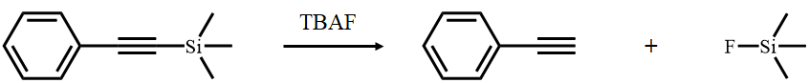 | Si–C stretch | deactivated
2 | 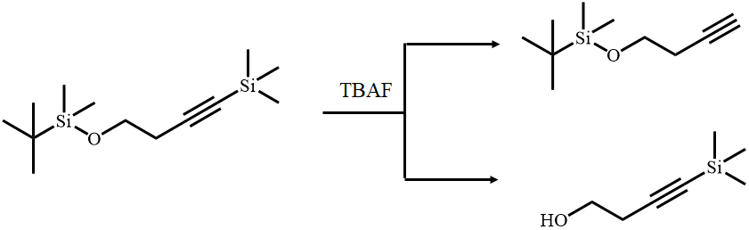 | Si–CH₃ stretch  Si–C stretch  Si–O stretch | site-selective
3 | 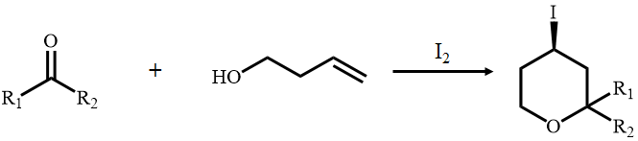 | C=O stretch | deactivated
4 | 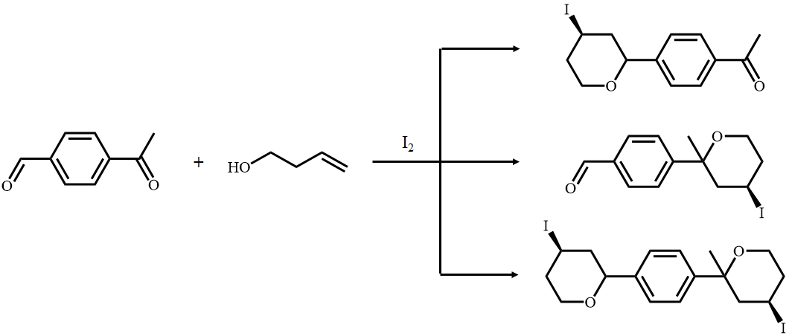 | C=O stretch | site-selective
5 | 2H₂O + OCN⁻ → CO₃²⁻ + NH₄⁺  2D₂O + OCN⁻ → CO₃²⁻ + ND₄⁺  2H₂O + NH₃BH₃ → NH₄⁺ + BO₂⁻ + 3H₂ | O–H stretch  O–D stretch | activated
organic reactions under cooperative vibrational strong coupling
6 | 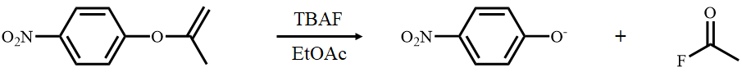 | C=O stretch | activated
7 | 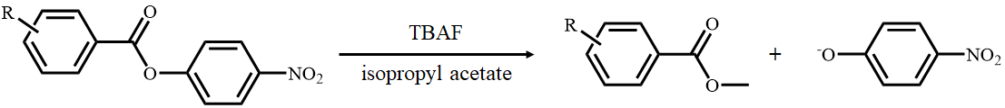 | C=O stretch | activated
8 | 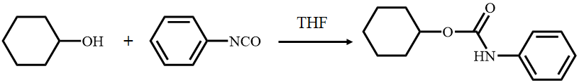 | NCO stretch  C=O stretch  C-H vibration | deactivated
enzymatic reactions
9 | R₁NHCOR₂ → R₁NH₃⁺ + R₂COOH | O–H stretch | deactivated
10 | 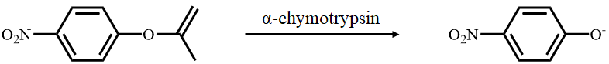 | O–H stretch  N–H stretch | activated
symmetry of vibration modes
11 | 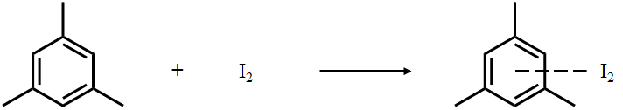 | C=C stretch  C–H stretch | change of K_{eq}
12 | 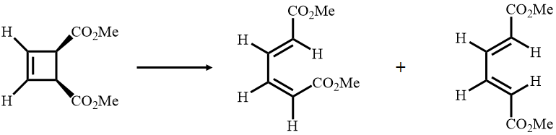 | C=O stretch  CH₃ bend | stereoselective

5.5 Crystallization and Self-Assembly
VSC can be applied to modulate not only organic and enzymatic reactions but also self-assembly. The self-assembly of metal ions and organic ligands gives extended framework structures, called metal-organic frameworks (MOFs) or porous coordination polymers.^{227,228} MOFs have attracted attention due to their functional properties such as gas adsorption, gas separation, heterogeneous catalysis, and chemical sensing. In solution, the same combination of metal ions and organic ligands sometimes yield MOFs with different crystal structures, causing heterogeneity in their porous properties, which may compromise their performance. In general, the selectivity of the crystal structure depends on the energy landscape of the dissolved components, which is influenced by solvation. For instance, the self-assembly of zinc nitrate and 2-methylimidazole in an aqueous solution produces two types of MOFs, ZIF-8²²⁹ and ZIF-L.²³⁰ Under VSC of the OH stretching mode of water as the solvent, ZIF-8 was selectively obtained (Figure 20).²³¹ This result suggests that the self-assembly process can be influenced by the VSC of solvent molecules (entry 1 in Table 2). Control experiments outside FP cavities however show that ZIF-8 is selectively obtained in alcoholic solutions over aqueous solutions. The dipole strength of the OH group in an alcohol is weaker than that in water, meaning that the cavity-induced effect on the solvent during crystallization may be to reduce the dipolar strength of the solvent functional group targeted for VSC. Theory suggests that electrons interacting with the cavity field become more localized, reducing electronic dipoles.{ref?} The predicted electronic effects are not large enough to explain effects on chemical reactions (i.e. bond formation and cleavage), but they could be in the range to influence weaker intermolecular interactions.
The VSC effect on self-assembly has also been observed in polymers. Poly(para-phenylenethynylene) (PPE) in o-dichlorobenzene (dcb) spontaneously assembles into fiber-like aggregates that undergo gelation due to CH–π interactions. However, when a solution of PPE was placed in an FP cavity and the aromatic ring C=C stretching vibrations of PPE and dcb were strongly coupled to the cavity mode, flake-like structures were obtained (entry 2 in Table 2). This result suggests that VSC can affect the van der Waals forces between the polymer and solvent.²³² The self-assembly of simple organic molecules under VSC has also been reported. The self-assembly of 1,3-bis(phenylethynyl)benzene produces flake-like assemblies because of π–π interactions. In contrast, spherical assemblies were formed under the VSC of the C–C stretching mode of the aromatic rings (entry 3 in Table 2). This change in the self-assembly structures of 1,3-bis(phenylethynyl)benzene is likely attributable to the modulation of the π–π interactions under VSC.²³³ Interestingly, the VSC of the C=C stretching vibration of 1,4-bis(phenylethynyl)benzene did not influence the packing structures, which suggests that molecular symmetry is a key factor for VSC-modulated phenomena.

Figure 20. Scanning electron microscopy images of ZIF crystals formed (a) in free solution (no optical cavity) and (b) inside an FP cavity. In (a), larger, cuboctahedral-shaped ZIF-8 crystals and smaller, crosshair-star-shaped ZIF-L crystals are present. In (b), ZIF-8 is present, but no ZIF-L is observed.
5.6 IR Emission, Raman Scattering and Ion Conductivity
The influence of VSC on spectroscopic phenomena has also been reported. Polaritonic IR emission was demonstrated using VSC states. The carbonyl stretching vibration in polymethyl methacrylate (PMMA) is strongly coupled to the cavity mode to form vibro-polaritonic states, that is, the upper and lower branches. At 100 ⁰C, a strong emission from the lower vibro-polaritonic branch was observed, indicating IR emission from the vibro-polaritonic state.²³⁴
The enhancement of Raman scattering has been demonstrated under VSC. Poly(vinyl acetate), (PVAc), was placed in an FP cavity to realize VSC of the carbonyl stretch at 1740 cm⁻¹. The upper and lower vibro-polaritonic states were observed at 1842 cm⁻¹ and 1681 cm⁻¹, respectively. Raman signals appeared at 1966 cm⁻¹ and 1600 cm⁻¹, which were not observed without VSC, suggesting the contribution of VSC to the emergence of additional Raman signals. The intensities of the new Raman signals were two to three orders of magnitude higher than the uncoupled C=O band intensity. ²³⁵
VSC was also recently shown to influence the proton conductivity of aqueous solutions. The hydroxyl stretching vibration of the water molecules was coupled to the FP cavity mode to induce VSC. The proton conductivity of the aqueous solution and its dielectric constants were changed under VSC.²³⁶ In an aqueous solution of potassium chloride, the proton conductivity was enhanced several times, whereas in an aqueous solutions of perchloric acid, the proton conductivity was enhanced by more than one order of magnitude. The observed increase in the proton conductivity strongly depends on the coupling strength of the cavity mode.

Table 2. Crystallization and self-assembly modulated by vibrational strong coupling
entry | reaction | vibration
1 | 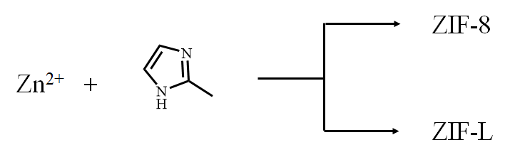 | O–H stretch
2 | 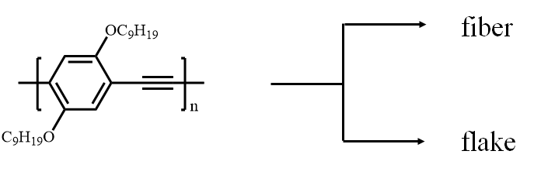 | C=C stretch
3 | 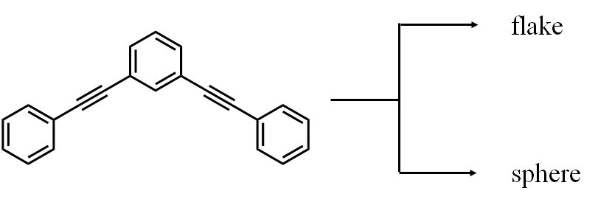 | C=C stretch

6. Concluding Remarks
Clearly, light-molecule strong coupling in Fabry-Perot-type optical cavities offers enormously diverse and attractive opportunities to modulate (photo)chemical and (photo)physical properties of molecules and materials. That relatively simply fabricated metallic Fabry-Perot cavities can feature coherent interactions with densely absorbing molecular films at room temperature has been a key driver in the explosion of interest in this area in the last two decades. Laboratory (bio)chemists with access to a metal sputterer and a spin-coater can rapidly produce such cavities and thus apply the full range of chemical systems at their disposal, investigating the effect of introducing polaritonic states case by case.
Over the last decade, the diversity of molecules used in Polaritonic Chemistry has greatly increased. While the field initially focused on inorganic semiconductors, now various molecules (e.g., coordination compounds, discrete organic molecules, organic polymers, proteins, nanocarbons, and MOFs) have been tested, each bringing their own rich diversity of properties and behaviours that can lead to new phenomena in the field. Recently, cavity-free strong coupling was also reported.²³⁷ Due to the large difference in refractive index between some crystalline materials and their surroundings, efficient optical reflections can occur at the crystal facets. The crystal itself therefore acts as the optical cavity and allows strong coupling if the physical size of the crystal, and the material absorptions within the crystal, are appropriate. This mirror-free strong coupling extends the diversity of materials and contexts within which polaritonic effects can be exploited.
Major research outcomes have included new or modulated chemistry and self-assembly/crystallization that could have industrial relevance, more efficient molecular charge and energy transfer that could lead to more efficient light harvesting, and much more. Central to the understanding of many of these phenomena is the concept that polaritonic states are genuine quantum states within the molecular/material energy landscape (albeit with different lifetimes due to their half-photonic nature, and different capacity to transfer energy due to their dramatically larger spatial extent). Theorists have made enormously valuable contributions to understanding how these states can interact with (un)coupled molecular states to date, though much understanding and consolidation of experimental results still await the field.
This is particularly the case for vibrational strong coupling-induced chemistry. The chemical reactions themselves are complicated to model, even without VSC, requiring treatment of numerous intermolecular and molecular interactions in various orientations. In addition, a single reaction can have several possible reaction pathways to attain the product. The field will no doubt develop exciting new theoretical frameworks in the coming years.
Further developments in spectroscopy will also deepen the understanding of polaritonic state dynamics. The challenges of performing transient absorption spectroscopy of organic polaritonic systems, where significant reflections occur, compared to conventional molecular solution spectroscopy where only transmission dominates, has been highlighted {ref 76, Schwartz ChemPhysChem}. Transient signatures associated with polaritonic transitions were also shown to decay over times much longer than expected from theory {76 again}. However, it has recently been found that transient absorption/reflectance spectroscopy includes an untargeted effect that elongates the lifetime of the polariton because of the stop-band edge and sidebands of the Bragg reflector.²³⁸ The benefits of 2D coherent multi-dimensional spectroscopy for untangling coherent couplings not revealed by linear spectroscopy was mentioned earlier in this review. While such experiments are not easily accessible, requiring 4-wave mixing of ultrafast pulses, it is surely one of the brightest areas of potential for uncovering new experimental phenomena in Polaritonic Chemistry.
Can one envision a future where Polaritonic Chemistry might make real contributions to chemical industry? Perhaps fortuitously, the rise of Polaritonic Chemistry, with its requirement for nano/microfluidic cavities, has coincided with the rise of flow or continuous processing over batch processing in the chemical industry {I would like to reference this if we are allowed to https://www.chemistryworld.com/features/the-flow-revolution/2500496.article}. The benefits in terms of sustainability, safety, and reaction/mixing control for flow chemistry may all be directly applicable to polaritonic chemistry, particularly for microfluidic devices used for vibrational strong coupling.
Another area of obvious potential high impact is optoelectronics research, which may leverage intriguing polaritonic phenomena such as long-range energy transfer and low-threshold lasing, subject to compatibility with specific optoelectronic devices. All-polariton transistors are just one example of advances in this direction, initially functioning only at cryogenic temperature,²³⁹ they have now been demonstrated to work at room temperature.²⁴⁰ Electrical pumping is a priority in this area, while the narrow bandwidth and angle-dependent emission imposed by polaritonic cavities can be advantageous for certain applications, as demonstrated recently for polaritonic organic light emitting diodes (POLEDS).{Nat Photonics 2023, Mischiok et al, https://doi.org/10.1038/s41566-023-01164-6}
The rapid development in the field of Polaritonic Chemistry over the last decade can be attributed in part to the influx of contributing scientists from a variety of fields. We hope that this review will motivate molecular chemists, materials scientists, physicists, and even biochemists to (further) engage with this field, which remains full of opportunities and challenges.
AUTHOR INFORMATION
Kenji Hirai - Division of Photonics and Optical Science, Re-search Institute for Electronic Science (RIES), Hokkaido University, North 20 West 10, Kita ward, Sapporo, Hokkaido, 001-0020, Japan. hirai@es.hokudai.ac.jp
James A. Hutchison – School of Chemistry, The University of Melbourne, Masson Rd, Parkville VIC 3052, Australia.
Hiroshi Uji-i - Division of Photonics and Optical Science, Re-search Institute for Electronic Science (RIES), Hokkaido University, North 20 West 10, Kita ward, Sapporo, Hokkaido, 001-0020, Japan.
Author Contributions
The manuscript was written through contributions of all authors.
Notes
The authors declare no competing financial interest.
Biographies
Kenji Hirai received his Ph.D. degree from Kyoto University in 2013. He was a postdoctoral research fellow at the University of Michigan. In 2014, he became a specially-appointed assistant professor at Hokkaido University, where he has been an associate professor since 2017. From 2018 to 2022, he was also a researcher in the Precursory Research for Embryonic Science and Technology (PRESTO) program of Japan Science and Technology Agency (JST). His current research interests are nanomaterials and light-matter interaction.
James Andell Hutchison is a senior lecturer at the School of Chemistry, the University of Melbourne, working on optical sensing and 2D materials. Previously he was Chargé de Recherche with the CNRS in Strasbourg, France, working on plasmonics and light-molecule strong coupling. He studied single-molecule imaging in a post-doc at KU Leuven, Belgium. He received his PhD at the University of Melbourne (2006) with a research focus on photosynthetic mimicry.
Hiroshi Uji-i received his PhD at Department of Chemistry, Tohoku University in 2002. He was a postdoctoral research fellow at KU Leuven, Belgium. He was a research professor at KU Leuven and now a professor at Hokkaido University, Japan. His current interests are high-resolution microscopy and plasmonics.
ABBREVIATIONS
CHD 1,3-cyclohexadiene
UV ultraviolet
CI conical intersection
LED light emitting diode
VSC vibrational strong coupling
FP Fabry-Perot
DBR distributed Bragg reflection
DS dark state
P+ upper polariton
P- lower polariton
UP upper polariton
LP lower polariton
4TBPPZn tetra-(2,6-t-butyl)phenol-porphyrin zinc
IR infrared
2D two-dimensional
MP middle polariton
FRET Forster resonance energy transfer
MP middle polariton
BODIPY boron-dipyrromethene
2,6-DPA 2,6-diphenylanthracene
PTCDA perylene-3,4,9,10-tetracarboxylic dianhydride
CNT carbon nanotube
RICS reverse intersystem crossing
OLED organic light emitting diode
SF singlet fission
TDAF thermally activated delayed fluorescence
3DPA3CN 1,3,5-tris(4-(diphenylamino)phenyl)-2,4,6-tricyanobenzene
TPBi 2,2′,2′′-(1,3,5-benzinetriyl)-tris(1-phenyl-1-H-benzimidazole)
TTA Triplet-triplet annihilation
9,10-DPA 9,10-diphenylanthracene
PtOEP platinum(II) octaethylporphine
DPPT diketopyrrolopyrrolethiophene
TIPS-tetracene 5,12-bis(triisopropylsilylethynyl)tetracene
BEC Bose-Einstein condensation
SHG second-harmonic generation
THG third-harmonic generation
SWCNTs single-walled carbon nanotubes
TMDs transition metal dichalcogenide
TBAF tetra-n-butylammonium fluoride
PNPA p-nitrophenyl acetate
THF tetrahydrofuran
CT charge-transfer
MOF metal-organic framework
PPE poly(para-phenylenethynylene)
DCB o-dichlorobenzene
PMMA polymethyl methacrylate
PVAc polyvinyl acetate

REFERENCES
(1) Wacker, M.; Holick, M. F. Sunlight and Vitamin D: A Global Perspective for Health. Dermatoendocrinol. 2013, 5, 51–108.
(2) Wolf, T. J. A.; Sanchez, D. M.; Yang, J.; Parrish, R. M.; Nunes, J. P. F.; Centurion, M.; Coffee, R.; Cryan, J. P.; Gühr, M.; Hegazy, K.; Kirrander, A.; Li, R. K.; Ruddock, J.; Shen, X.; Vecchione, T.; Weathersby, S. P.; Weber, P. M.; Wilkin, K.; Yong, H.; Zheng, Q.; Wang, X. J.; Minitti, M. P.; Martínez, T. J. The Photochemical Ring-Opening of 1,3-Cyclohexadiene Imaged by Ultrafast Electron Diffraction. Nat. Chem. 2019, 11, 504–509.
(3) Hutchison, J. A.; Schwartz, T.; Genet, C.; Devaux, E.; Ebbesen, T. W. Modifying Chemical Landscapes by Coupling to Vacuum Fields. Angew. Chem. Int. Ed. 2012, 51, 1592–1596.
(4) Roth, H. D. The Beginnings of Organic Photochemistry. Angew. Chem. Int. Ed. 1989, 28, 1193–1207.
(5) Buglioni, L.; Raymenants, F.; Slattery, A.; Zondag, S. D. A.; Noël, T. Technological Innovations in Photochemistry for Organic Synthesis: Flow Chemistry, High-Throughput Experimentation, Scale-up, and Photoelectrochemistry. Chem. Rev. 2022, 122, 2752–2906.
(6) Nitzan, A.; Brus, L. E. Theoretical Model for Enhanced Photochemistry on Rough Surfaces. J. Chem. Phys. 1981, 75, 2205–2214.
(7) Goncher, G. M.; Parsons, C. A.; Harris, C. B. Enhanced Photochemistry on Metal Surfaces. J. Chem. Phys. 1984, 5858, 80–82.
(8) Wang, W.; Wang, W.; Liu, L.; Xu, L.; Kuang, H.; Zhu, J.; Xu, C. Raman Spectra of Pyridine Adsorbed at a Silver Electrode. Chem. Phys. Lett. 1974, 26, 163–166.
(9) Tatsuma, T.; Nishi, H.; Ishida, T. Plasmon-Induced Charge Separation: Chemistry and Wide Applications. Chem. Sci. 2017, 8, 3325–3337.
(10) Munkhbat, B.; Wersäll, M.; Baranov, D. G.; Antosiewicz, T. J.; Shegai, T. Suppression of Photo-Oxidation of Organic Chromophores by Strong Coupling to Plasmonic Nanoantennas. Sci. Adv. 2018, 4, eaas9552.
(11) Shi, X.; Ueno, K.; Oshikiri, T.; Sun, Q.; Sasaki, K.; Misawa, H. Enhanced Water Splitting under Modal Strong Coupling Conditions. Nat. Nanotechnol. 2018, 13, 953–958.
(12) Bucksbaum, P. H.; Zavriyev, A.; Muller, H. G.; Schumacher, D. W. Softening of the H2+ Molecular Bond in Intense Laser Fields. Phys. Rev. Lett. 1990, 64, 1883–1886.
(13) Kanya, R.; Morimoto, Y.; Yamanouchi, K. Observation of Laser-Assisted Electron-Atom Scattering in Femtosecond Intense Laser Fields. Phys. Rev. Lett. 2010, 105, 8–11.
(14) Ebbesen, T. W. Hybrid Light-Matter States in a Molecular and Material Science Perspective. Acc. Chem. Res. 2016, 49, 2403–2412.
(15) Kowalewski, M.; Bennett, K.; Mukamel, S. Cavity Femtochemistry: Manipulating Nonadiabatic Dynamics at Avoided Crossings. J. Phys. Chem. Lett. 2016, 7, 2050–2054.
(16) Dovzhenko, D. S.; Ryabchuk, S. V.; Rakovich, Y. P.; Nabiev, I. R. Light-Matter Interaction in the Strong Coupling Regime: Configurations, Conditions, and Applications. Nanoscale 2018, 10, 3589–3605.
(17) Ruggenthaler, M.; Tancogne-Dejean, N.; Flick, J.; Appel, H.; Rubio, A. From a Quantum-Electrodynamical Light–Matter Description to Novel Spectroscopies. Nat. Rev. Chem. 2018, 2, 0118.
(18) Herrera, F.; Owrutsky, J. Molecular Polaritons for Controlling Chemistry with Quantum Optics. J. Chem. Phys. 2020, 152.
(19) Ciuti, C.; Bastard, G.; Carusotto, I. Quantum Vacuum Properties of the Intersubband Cavity Polariton Field. Phys. Rev. B - Condens. Matter Mater. Phys. 2005, 72, 115303.
(20) Galego, J.; Garcia-Vidal, F. J.; Feist, J. Cavity-Induced Modifications of Molecular Structure in the Strong-Coupling Regime. Phys. Rev. X 2015, 5, 041022.
(21) Hertzog, M.; Wang, M.; Mony, J.; Börjesson, K. Strong Light-Matter Interactions: A New Direction within Chemistry. Chem. Soc. Rev. 2019, 48, 937–961.
(22) Garcia-Vidal, F. J.; Ciuti, C.; Ebbesen, T. W. Manipulating Matter by Strong Coupling to Vacuum Fields. Science 2021, 373, ebad0336.
(23) Flick, J.; Rivera, N.; Narang, P. Strong Light-Matter Coupling in Quantum Chemistry and Quantum Photonics. Nanophotonics 2018, 7, 1479–1501.
(24) Ribeiro, R. F.; Martínez-Martínez, L. A.; Du, M.; Campos-Gonzalez-Angulo, J.; Yuen-Zhou, J. Polariton Chemistry: Controlling Molecular Dynamics with Optical Cavities. Chem. Sci. 2018, 9, 6325–6339.
(25) Rempe, G.; Walther, H.; Klein, N. Observation of Quantum Collapse and Revival in a One-Atom Maser. Phys. Rev. Lett. 1987, 58, 353–356.
(26) Raizen, M. G.; Thompson, R. J.; Brecha, R. J.; Kimble, H. J.; Carmichael, H. J. Normal-Mode Splitting and Linewidth Averaging for Two-State Atoms in an Optical Cavity. Phys. Rev. Lett. 1989, 63, 240–243.
(27) Zhu, Y.; Gauthier, D. J.; Morin, S. E.; Wu, Q.; Carmichael, H. J.; Mossberg, T. W. Vacuum Rabi Splitting as a Feature of Linear-Dispersion Theory: Analysis and Experimental Observations. Phys. Rev. Lett. 1990, 64, 2499–2502.
(28) Rempe, G.; Thompson, R. J.; Brecha, R. J.; Lee, W. D.; Kimble, H. J. Optical Bistability and Photon Statistics in Cavity Quantum Electrodynamics. Phys. Rev. Lett. 1991, 67, 1727–1730.
(29) R. J. Thompson, G. Rempe, and H. J. K. Observation of Normal-Mode Splitting for an Atom in an Optical Cavity. Phys. Rev. Lett. 1992, 68, 1132–1135.
(30) Weisbuch, C.; Nishioka, M.; Ishikawa, A.; Arakawa, Y. Observation of the Coupled Exciton-Photon Mode Splitting in a Semiconductor Quantum Microcavity. Phys. Rev. Lett. 1992, 69, 3314–3317.
(31) Lidzey, D. G.; Bradley, D. D. C.; Skolnick, M. S.; Virgili, T.; Walker, S.; Whittaker, D. M. Strong Exciton-Photon Coupling in an Organic Semiconductor Microcavity. Nature 1998, 395, 53–55.
(32) Agranovich, V. M.; La Rocca, G. C. Electronic Excitations in Organic Microcavities with Strong Light-Matter Coupling. Solid State Commun. 2005, 135, 544–553.
(33) Tischler, J. R.; Scott Bradley, M.; Zhang, Q.; Atay, T.; Nurmikko, A.; Bulović, V. Solid State Cavity QED: Strong Coupling in Organic Thin Films. Org. Electron. 2007, 8, 94–113.
(34) Holmes, R. J.; Forrest, S. R. Strong Exciton-Photon Coupling in Organic Materials. Org. Electron. 2007, 8, 77–93.
(35) Feist, J.; Galego, J.; Garcia-Vidal, F. J. Polaritonic Chemistry with Organic Molecules. ACS Photonics 2018, 5, 205–216.
(36) Shalabney, A.; George, J.; Hutchison, J.; Pupillo, G.; Genet, C.; Ebbesen, T. W. Coherent Coupling of Molecular Resonators with a Microcavity Mode. Nat. Commun. 2015, 6, 5981.
(37) Nagarajan, K.; Thomas, A.; Ebbesen, T. W. Chemistry under Vibrational Strong Coupling. J. Am. Chem. Soc. 2021, 143, 16877–16889.
(38) Herrera, F.; Spano, F. C. Theory of Nanoscale Organic Cavities: The Essential Role of Vibration-Photon Dressed States. ACS Photonics 2018, 5, 65–79.
(39) Thomas, A.; George, J.; Shalabney, A.; Dryzhakov, M.; Varma, S. J.; Moran, J.; Chervy, T.; Zhong, X.; Devaux, E.; Genet, C.; Hutchison, J. A.; Ebbesen, T. W. Ground-State Chemical Reactivity under Vibrational Coupling to the Vacuum Electromagnetic Field. Angew. Chem. Int. Ed. 2016, 55, 11462–11466.
(40) Halas, N. J.; Lal, S.; Chang, W. S.; Link, S.; Nordlander, P. Plasmons in Strongly Coupled Metallic Nanostructures. Chem. Rev. 2011, 111, 3913–3961.
(41) Rokitski, R.; Tetz, K. A.; Fainman, Y. Propagation of Femtosecond Surface Plasmon Polariton Pulses on the Surface of a Nanostructured Metallic Film: Space-Time Complex Amplitude Characterization. Phys. Rev. Lett. 2005, 95, 177401.
(42) Dirac, P. A. M. The Quantum Theory of the Emission and Absorption of Radiation. Sci. Glob. Secur. 1927, 114, 243–265.
(43) Kleppner, D. Inhibited Spontaneous Emission. Phys. Rev. Lett. 1981, 47, 233–236.
(44) Purcell, E. M. Proceedings of the 2010 Annual Meeting of the Society for the Study of Ingestive Behavior (SSIB), July 13-17, 2010, Pittsburgh, Pennsylvania. Phys. Rev. 1946, 69, 681.
(45) Herrera, F.; Spano, F. C. Cavity-Controlled Chemistry in Molecular Ensembles. Phys. Rev. Lett. 2016, 116, 238301.
(46) E.T.Jaynes, F. W. C. Comparison of Quantum and Semiclassical Radiation Theories with Application to the Beam Maser. Proc. IEEE 1963, 51, 89–109.
(47) Michael Tavis, F. W. C. Exact Solution for an N-Molecule—Radiation-Field Hamiltonian. Phys. Rev. 1968, 170, 379–384.
(48) Yang, S.; Wang, Y.; Sun, H. D. Advances and Prospects for Whispering Gallery Mode Microcavities. Adv. Opt. Mater. 2015, 3, 1136–1162.
(49) Farr, W. G.; Goryachev, M.; Creedon, D. L.; Tobar, M. E. Strong Coupling between Whispering Gallery Modes and Chromium Ions in Ruby. Phys. Rev. B - Condens. Matter Mater. Phys. 2014, 90, 054409.
(50) Vučković, J.; Lončar, M.; Mabuchi, H.; Scherer, A. Design of Photonic Crystal Microcavities for Cavity QED. Phys. Rev. E 2002, 65, 016608.
(51) Jiang, J. H.; John, S. Photonic Crystal Architecture for Room-Temperature Equilibrium Bose-Einstein Condensation of Exciton Polaritons. Phys. Rev. X 2014, 4, 031025.
(52) Ciers, J.; Roch, J. G.; Carlin, J. F.; Jacopin, G.; Butté, R.; Grandjean, N. Propagating Polaritons in III-Nitride Slab Waveguides. Phys. Rev. Appl. 2017, 7, 034019.
(53) Yitzhari, R.; Kapon, O.; Tischler, Y. R. Vibrational Strong Light-Matter Coupling in an Open Microcavity Based on Reflective Germanium Coatings. J. Phys. Chem. A 2022, 126, 1282–1288.
(54) Bahsoun, H.; Chervy, T.; Thomas, A.; Börjesson, K.; Hertzog, M.; George, J.; Devaux, E.; Genet, C.; Hutchison, J. A.; Ebbesen, T. W. Electronic Light-Matter Strong Coupling in Nanofluidic Fabry-Pérot Cavities. ACS Photonics 2018, 5, 225–232.
(55) Houdré, R.; Stanley, R. P.; Ilegems, M. Vacuum-Field Rabi Splitting in the Presence of Inhomogeneous Broadening: Resolution of a Homogeneous Linewidth in an Inhomogeneously Broadened System. Phys. Rev. A - At. Mol. Opt. Phys. 1996, 53, 2711–2715.
(56) Li, T. E.; Subotnik, J. E.; Nitzan, A. Cavity Molecular Dynamics Simulations of Liquid Water under Vibrational Ultrastrong Coupling. Proc. Natl. Acad. Sci. U. S. A. 2020, 117, 18324–18331.
(57) Long, J. P.; Simpkins, B. S. Coherent Coupling between a Molecular Vibration and Fabry-Perot Optical Cavity to Give Hybridized States in the Strong Coupling Limit. ACS Photonics 2015, 2, 130–136.
(58) Wurdack, M.; Estrecho, E.; Todd, S.; Yun, T.; Pieczarka, M.; Earl, S. K.; Davis, J. A.; Schneider, C.; Truscott, A. G.; Ostrovskaya, E. A. Motional Narrowing, Ballistic Transport, and Trapping of Room-Temperature Exciton Polaritons in an Atomically-Thin Semiconductor. Nat. Commun. 2021, 12, 5366.
(59) Wang, S.; Chervy, T.; George, J.; Hutchison, J. A.; Genet, C.; Ebbesen, T. W. Quantum Yield of Polariton Emission from Hybrid Light-Matter States. J. Phys. Chem. Lett. 2014, 5, 1433–1439.
(60) Ahn, W.; Vurgaftman, I.; Dunkelberger, A. D.; Owrutsky, J. C.; Simpkins, B. S. Vibrational Strong Coupling Controlled by Spatial Distribution of Molecules within the Optical Cavity. ACS Photonics 2018, 5, 158–166.
(61) Houdré, R.; Stanley, R. P.; Oesterle, U.; Ilegems, M.; Weisbuch, C. Room-Temperature Cavity Polaritons in a Semiconductor Microcavity. Phys. Rev. B 1994, 49, 16761–16764.
(62) Lidzey, D. G.; Bradley, D. D. C.; Virgili, T.; Armitage, A.; Skolnick, M. S.; Walker, S. Room Temperature Polariton Emission from Strongly Coupled Organic Semiconductor Microcavities. Phys. Rev. Lett. 1999, 82, 3316–3319.
(63) Schouwink, P.; Berlepsch, H. V.; Dähne, L.; Mahrt, R. F. Observation of Strong Exciton-Photon Coupling in an Organic Microcavity. Chem. Phys. Lett. 2001, 344, 352–356.
(64) Lidzey, D. G.; Fox, A. M.; Rahn, M. D.; Skolnick, M. S.; Agranovich, V. M.; Walker, S. Experimental Study of Light Emission from Strongly Coupled Organic Semiconductor Microcavities Following Nonresonant Laser Excitation. Phys. Rev. B 2002, 65, 195312.
(65) Agranovich, V. M.; Litinskaia, M.; Lidzey, D. G. Cavity Polaritons in Microcavities Containing Disordered Organic Semiconductors. Phys. Rev. B 2003, 67, 085311.
(66) Tischler, J. R.; Bradley, M. S.; Bulović, V.; Song, J. H.; Nurmikko, A. Strong Coupling in a Microcavity LED. Phys. Rev. Lett. 2005, 95, 036401.
(67) Holmes, R. J.; Forrest, S. R. Strong Exciton-Photon Coupling and Exciton Hybridization in a Thermally Evaporated Polycrystalline Film of an Organic Small Molecule. Phys. Rev. Lett. 2004, 93, 186404.
(68) Kéna-Cohen, S.; Davanço, M.; Forrest, S. R. Strong Exciton-Photon Coupling in an Organic Single Crystal Microcavity. Phys. Rev. Lett. 2008, 101, 116401.
(69) Kéna-Cohen, S.; Forrest, S. R. Green Polariton Photoluminescence Using the Red-Emitting Phosphor PtOEP. Phys. Rev. B 2007, 76, 075202.
(70) Tropf, L.; Dietrich, C. P.; Herbst, S.; Kanibolotsky, A. L.; Skabara, P. J.; Würthner, F.; Samuel, I. D. W.; Gather, M. C.; Höfling, S. Influence of Optical Material Properties on Strong Coupling in Organic Semiconductor Based Microcavities. Appl. Phys. Lett. 2017, 110, 153302.
(71) Graf, A.; Tropf, L.; Zakharko, Y.; Zaumseil, J.; Gather, M. C. Near-Infrared Exciton-Polaritons in Strongly Coupled Single-Walled Carbon Nanotube Microcavities. Nat. Commun. 2016, 7, 13078.
(72) Coles, D. M.; Yang, Y.; Wang, Y.; Grant, R. T.; Taylor, R. A.; Saikin, S. K.; Aspuru-Guzik, A.; Lidzey, D. G.; Tang, J. K. H.; Smith, J. M. Strong Coupling between Chlorosomes of Photosynthetic Bacteria and a Confined Optical Cavity Mode. Nat. Commun. 2014, 5, 6561.
(73) Dietrich, C. P.; Steude, A.; Schubert, M.; Ohmer, J.; Fischer, U.; Höfling, S.; Gather, M. C. Strong Coupling in Fully Tunable Microcavities Filled with Biologically Produced Fluorescent Proteins. Adv. Opt. Mater. 2017, 5, 1600659.
(74) Ballarini, D.; De Giorgi, M.; Gambino, S.; Lerario, G.; Mazzeo, M.; Genco, A.; Accorsi, G.; Giansante, C.; Colella, S.; D’Agostino, S.; Cazzato, P.; Sanvitto, D.; Gigli, G. Polariton-Induced Enhanced Emission from an Organic Dye under the Strong Coupling Regime. Adv. Opt. Mater. 2014, 2, 1076–1081.
(75) Tanyi, E. K.; Thuman, H.; Brown, N.; Koutsares, S.; Podolskiy, V. A.; Noginov, M. A. Control of the Stokes Shift with Strong Coupling. Adv. Opt. Mater. 2017, 5, 1600941.
(76) Schwartz, T.; Hutchison, J. A.; Léonard, J.; Genet, C.; Haacke, S.; Ebbesen, T. W. Polariton Dynamics under Strong Light-Molecule Coupling. ChemPhysChem 2013, 14, 125–131.
(77) Delpo, C. A.; Kudisch, B.; Park, K. H.; Khan, S. U. Z.; Fassioli, F.; Fausti, D.; Rand, B. P.; Scholes, G. D. Polariton Transitions in Femtosecond Transient Absorption Studies of Ultrastrong Light-Molecule Coupling. J. Phys. Chem. Lett. 2020, 11, 2667–2674.
(78) Simpkins, B. S.; Fears, K. P.; Dressick, W. J.; Spann, B. T.; Dunkelberger, A. D.; Owrutsky, J. C. Spanning Strong to Weak Normal Mode Coupling between Vibrational and Fabry-Pérot Cavity Modes through Tuning of Vibrational Absorption Strength. ACS Photonics 2015, 2, 1460–1467.
(79) Muallem, M.; Palatnik, A.; Nessim, G. D.; Tischler, Y. R. Strong Light-Matter Coupling and Hybridization of Molecular Vibrations in a Low-Loss Infrared Microcavity. J. Phys. Chem. Lett. 2016, 7, 2002–2008.
(80) Vergauwe, R. M. A.; George, J.; Chervy, T.; Hutchison, J. A.; Shalabney, A.; Torbeev, V. Y.; Ebbesen, T. W. Quantum Strong Coupling with Protein Vibrational Modes. J. Phys. Chem. Lett. 2016, 7, 4159–4164.
(81) George, J.; Chervy, T.; Shalabney, A.; Devaux, E.; Hiura, H.; Genet, C.; Ebbesen, T. W. Multiple Rabi Splittings under Ultrastrong Vibrational Coupling. Phys. Rev. Lett. 2016, 117, 153601.
(82) Crum, V. F.; Casey, S. R.; Sparks, J. R. Photon-Mediated Hybridization of Molecular Vibrational States. Phys. Chem. Chem. Phys. 2018, 20, 850–857.
(83) Imran, I.; Nicolai, G. E.; Stavinski, N. D.; Sparks, J. R. Tuning Vibrational Strong Coupling with Co-Resonators. ACS Photonics 2019, 6, 2405–2412.
(84) Hertzog, M.; Rudquist, P.; Hutchison, J. A.; George, J.; Ebbesen, T. W.; Börjesson, K. Voltage-Controlled Switching of Strong Light–Matter Interactions Using Liquid Crystals. Chem. - A Eur. J. 2017, 23, 18166–18170.
(85) Hiura, H.; Shalabney, A.; George, J. Vibrational Ultra Strong Coupling of Water and Ice. ChemRxiv Sep 14, 2019, 10.26434/chemrxiv.9808508.v1.
(86) Fukushima, T.; Yoshimitsu, S.; Murakoshi, K. Vibrational Coupling of Water from Weak to Ultrastrong Coupling Regime via Cavity Mode Tuning. J. Phys. Chem. C 2021, 125, 25832–25840.
(87) Damari, R.; Weinberg, O.; Krotkov, D.; Demina, N.; Akulov, K.; Golombek, A.; Schwartz, T.; Fleischer, S. Strong Coupling of Collective Intermolecular Vibrations in Organic Materials at Terahertz Frequencies. Nat. Commun. 2019, 10, 3248.
(88) Hirai, K.; Hutchison, J. A.; Uji-i, H. Recent Progress in Vibropolaritonic Chemistry. Chempluschem 2020, 85, 1981–1988.
(89) Dunkelberger, A. D.; Spann, B. T.; Fears, K. P.; Simpkins, B. S.; Owrutsky, J. C. Modified Relaxation Dynamics and Coherent Energy Exchange in Coupled Vibration-Cavity Polaritons. Nat. Commun. 2016, 7, 13504.
(90) Xiang, B.; Ribeiro, R. F.; Dunkelberger, A. D.; Wang, J.; Li, Y.; Simpkins, B. S.; Owrutsky, J. C.; Yuen-Zhou, J.; Xiong, W. Two-Dimensional Infrared Spectroscopy of Vibrational Polaritons. Proc. Natl. Acad. Sci. U. S. A. 2018, 115, 4845–4850.
(91) Xiang, B.; Ribeiro, R. F.; Li, Y.; Dunkelberger, A. D.; Simpkins, B. B.; Yuen-Zhou, J.; Xiong, W. Manipulating Optical Nonlinearities of Molecular Polaritons by Delocalization. Sci. Adv. 2019, 5, 5196.
(92) Xiang, B.; Ribeiro, R. F.; Chen, L.; Wang, J.; Du, M.; Yuen-Zhou, J.; Xiong, W. State-Selective Polariton to Dark State Relaxation Dynamics. J. Phys. Chem. A 2019, 123, 5918–5927.
(93) Yang, Z.; Xiang, B.; Xiong, W. Controlling Quantum Pathways in Molecular Vibrational Polaritons. ACS Photonics 2020, 7, 919–924.
(94) Xiang, B.; Ribeiro, R. F.; Du, M.; Chen, L.; Yang, Z.; Wang, J.; Yuen-Zhou, J.; Xiong, W. Intermolecular Vibrational Energy Transfer Enabled by Microcavity Strong Light–Matter Coupling. Science 2020, 368, 665–667.
(95) Li, T. E.; Nitzan, A.; Subotnik, J. E. Collective Vibrational Strong Coupling Effects on Molecular Vibrational Relaxation and Energy Transfer: Numerical Insights via Cavity Molecular Dynamics Simulations. Angew. Chem. Int. Ed. 2021, 60, 15533–15540.
(96) Wang, D. S.; Neuman, T.; Yelin, S. F.; Flick, J. Cavity-Modified Unimolecular Dissociation Reactions via Intramolecular Vibrational Energy Redistribution. J. Phys. Chem. Lett. 2022, 13, 3317–3324.
(97) Coles, D. M.; Somaschi, N.; Michetti, P.; Clark, C.; Lagoudakis, P. G.; Savvidis, P. G.; Lidzey, D. G. Polariton-Mediated Energy Transfer between Organic Dyes in a Strongly Coupled Optical Microcavity. Nat. Mater. 2014, 13, 712–719.
(98) Zhong, X.; Chervy, T.; Zhang, L.; Thomas, A.; George, J.; Genet, C.; Hutchison, J. A.; Ebbesen, T. W. Energy Transfer between Spatially Separated Entangled Molecules. Angew. Chem. Int. Ed. 2017, 56, 9034–9038.
(99) Georgiou, K.; Jayaprakash, R.; Othonos, A.; Lidzey, D. G. Ultralong-Range Polariton-Assisted Energy Transfer in Organic Microcavities. Angew. Chem. Int. Ed. 2021, 60, 16661–16667.
(100) Georgiou, K.; Michetti, P.; Gai, L.; Cavazzini, M.; Shen, Z.; Lidzey, D. G. Control over Energy Transfer between Fluorescent BODIPY Dyes in a Strongly Coupled Microcavity. ACS Photonics 2018, 5, 258–266.
(101) Wang, M.; Hertzog, M.; Börjesson, K. Polariton-Assisted Excitation Energy Channeling in Organic Heterojunctions. Nat. Commun. 2021, 12, 1874.
(102) Son, M.; Armstrong, Z. T.; Allen, R. T.; Dhavamani, A.; Arnold, M. S.; Zanni, M. T. Energy Cascades in Donor-Acceptor Exciton-Polaritons Observed by Ultrafast Two-Dimensional White-Light Spectroscopy. Nat. Commun. 2022, 13, 7305.
(103) Stranius, K.; Hertzog, M.; Börjesson, K. Selective Manipulation of Electronically Excited States through Strong Light-Matter Interactions. Nat. Commun. 2018, 9, 2273.
(104) Takahashi, S.; Watanabe, K.; Matsumoto, Y. Singlet Fission of Amorphous Rubrene Modulated by Polariton Formation. J. Chem. Phys. 2019, 151, 074703.
(105) Polak, D.; Jayaprakash, R.; Lyons, T. P.; Martínez-Martínez, L.; Leventis, A.; Fallon, K. J.; Coulthard, H.; Bossanyi, D. G.; Georgiou, K.; Petty, A. J.; Anthony, J.; Bronstein, H.; Yuen-Zhou, J.; Tartakovskii, A. I.; Clark, J.; Musser, A. J. Manipulating Molecules with Strong Coupling: Harvesting Triplet Excitons in Organic Exciton Microcavities. Chem. Sci. 2020, 11, 343–354.
(106) Liu, B.; Menon, V. M.; Sfeir, M. Y. The Role of Long-Lived Excitons in the Dynamics of Strongly Coupled Molecular Polaritons. ACS Photonics 2020, 7, 2292–2301.
(107) Agranovich, V.; Benisty, H.; Weisbuch, C. Organic and Inorganic Quantum Wells in a Microcavity: Frenkel-Wannier-Mott Excitons Hybridization and Energy Transformation. Solid State Commun. 1997, 102, 631–636.
(108) Millicent B. Smith, and J. M. Singlet Fission. Chem. Rev. 2010, 110, 6891–6936.
(109) Eizner, E.; Martínez-Martínez, L. A.; Yuen-Zhou, J.; Kéna-Cohen, S. Inverting Singlet and Triplet Excited States Using Strong Light-Matter Coupling. Sci. Adv. 2019, 5, eaax4482.
(110) Yu, Y.; Mallick, S.; Wang, M.; Börjesson, K. Barrier-Free Reverse-Intersystem Crossing in Organic Molecules by Strong Light-Matter Coupling. Nat. Commun. 2021, 12, 3255.
(111) Yong, C. K.; Musser, A. J.; Bayliss, S. L.; Lukman, S.; Tamura, H.; Bubnova, O.; Hallani, R. K.; Meneau, A.; Resel, R.; Maruyama, M.; Hotta, S.; Herz, L. M.; Beljonne, D.; Anthony, J. E.; Clark, J.; Sirringhaus, H. The Entangled Triplet Pair State in Acene and Heteroacene Materials. Nat. Commun. 2017, 8, 15953.
(112) Musser, A. J.; Clark, J. Triplet-Pair States in Organic Semiconductors. Annu. Rev. Phys. Chem. 2019, 70, 323–351.
(113) Rozenman, G. G.; Akulov, K.; Golombek, A.; Schwartz, T. Long-Range Transport of Organic Exciton-Polaritons Revealed by Ultrafast Microscopy. ACS Photonics 2018, 5, 105–110.
(114) Schachenmayer, J.; Genes, C.; Tignone, E.; Pupillo, G. Cavity-Enhanced Transport of Excitons. Phys. Rev. Lett. 2015, 114, 196403.
(115) Feist, J.; Garcia-Vidal, F. J. Extraordinary Exciton Conductance Induced by Strong Coupling. Phys. Rev. Lett. 2015, 114, 196402.
(116) Pandya, R.; Ashoka, A.; Georgiou, K.; Sung, J.; Jayaprakash, R.; Renken, S.; Gai, L.; Shen, Z.; Rao, A.; Musser, A. J. Tuning the Coherent Propagation of Organic Exciton-Polaritons through Dark State Delocalization. Adv. Sci. 2022, 9, 2105569.
(117) Einstein, A. Quantentheorie Des Einatomigen Idealen Gases. Sitzungsber. Preuss. Akad. Wiss., Phys. Math. Kl. 1925, p 237.
(118) Anderson, M. H.; Ensher, J. R.; Matthews, M. R.; Wieman, C. E.; Cornell, E. A. Observation of Bose-Einstein Condensation in a Dilute Atomic Vapor. Science 1995, 269, 198–201.
(119) Davis, K. B.; Mewes, M.-O.; Andrews, M. R.; Druten, N. J. van; Durfee, D. S.; Kurn, D. M.; Ketterle, W. Bose-Einstein Condensation in a Gas of Sodium Atoms. Phys. Rev. Lett. 1995, 75, 3969.
(120) Deng, H.; Haug, H.; Yamamoto, Y. Exciton-Polariton Bose-Einstein Condensation. Rev. Mod. Phys. 2010, 82, 1489–1537.
(121) Byrnes, T.; Kim, N. Y.; Yamamoto, Y. Exciton-Polariton Condensates. Nat. Phys. 2014, 10, 803–813.
(122) Butov, L. V.; Kavokin, A. V. The Behaviour of Exciton-Polaritons. Nat. Photonics 2012, 6, 2.
(123) Keeling, J.; Kéna-Cohen, S. Bose-Einstein Condensation of Exciton-Polaritons in Organic Microcavities. Annu. Rev. Phys. Chem. 2020, 71, 435–459.
(124) Kasprzak, J.; Richard, M.; Kundermann, S.; Baas, A.; Jeambrun, P.; Keeling, J. M. J.; Marchetti, F. M.; Szymánska, M. H.; André, R.; Staehli, J. L.; Savona, V.; Littlewood, P. B.; Deveaud, B.; Dang, L. S. Bose-Einstein Condensation of Exciton Polaritons. Nature 2006, 443, 409–414.
(125) R. Balili, V. H.; D. Snoke, L. Pfeiffer, K. W. Bose-Einstein Condensation of Microcavity Polaritons in a Trap. Science 2007, 316, 1007–1010.
(126) Love, A. P. D.; Krizhanovskii, D. N.; Whittaker, D. M.; Bouchekioua, R.; Sanvitto, D.; Al Rizeiqi, S. A.; Bradley, R.; Skolnick, M. S.; Eastham, P. R.; André, R.; Dang, L. S. Intrinsic Decoherence Mechanisms in the Microcavity Polariton Condensate. Phys. Rev. Lett. 2008, 101, 067404.
(127) Jiang, Z.; Ren, A.; Yan, Y.; Yao, J.; Zhao, Y. S. Exciton-Polaritons and Their Bose–Einstein Condensates in Organic Semiconductor Microcavities. Adv. Mater. 2022, 34, 2106095.
(128) Butov, L. V. A Polariton Laser. Nature 2007, 447, 540–541.
(129) Deng, H.; Weihs, G.; Snoke, D.; Bloch, J.; Yamamoto, Y. Polariton Lasing vs. Photon Lasing in a Semiconductor Microcavity. Proc. Natl. Acad. Sci. U. S. A. 2003, 100, 15318–15323.
(130) Christmann, G.; Butt́, R.; Feltin, E.; Carlin, J. F.; Grandjean, N. Room Temperature Polariton Lasing in a GaNAlGaN Multiple Quantum Well Microcavity. Appl. Phys. Lett. 2008, 93, 051102.
(131) Kim, S.; Zhang, B.; Wang, Z.; Fischer, J.; Brodbeck, S.; Kamp, M.; Schneider, C.; Höfling, S.; Deng, H. Coherent Polariton Laser. Phys. Rev. X 2016, 6, 011026.
(132) Ishii, T.; Miyata, K.; Mamada, M.; Bencheikh, F.; Mathevet, F.; Onda, K.; Kéna-Cohen, S.; Adachi, C. Low-Threshold Exciton-Polariton Condensation via Fast Polariton Relaxation in Organic Microcavities. Adv. Opt. Mater. 2022, 10, 2102304.
(133) Bhattacharya, P.; Xiao, B.; Das, A.; Bhowmick, S.; Heo, J. Solid State Electrically Injected Exciton-Polariton Laser. Phys. Rev. Lett. 2013, 110, 206403.
(134) Schneider, C.; Rahimi-Iman, A.; Kim, N. Y.; Fischer, J.; Savenko, I. G.; Amthor, M.; Lermer, M.; Wolf, A.; Worschech, L.; Kulakovskii, V. D.; Shelykh, I. A.; Kamp, M.; Reitzenstein, S.; Forchel, A.; Yamamoto, Y.; Höfling, S. An Electrically Pumped Polariton Laser. Nature 2013, 497, 348–352.
(135) Su, R.; Diederichs, C.; Wang, J.; Liew, T. C. H.; Zhao, J.; Liu, S.; Xu, W.; Chen, Z.; Xiong, Q. Room-Temperature Polariton Lasing in All-Inorganic Perovskite Nanoplatelets. Nano Lett. 2017, 17, 3982–3988.
(136) Wang, J.; Da, P.; Zhang, Z.; Luo, S.; Liao, L.; Sun, Z.; Shen, X.; Wu, S.; Zheng, G.; Chen, Z. Lasing from Lead Halide Perovskite Semiconductor Microcavity System. Nanoscale 2018, 10, 10371–10376.
(137) Zhang, L.; Hu, J.; Wu, J.; Su, R.; Chen, Z.; Xiong, Q.; Deng, H. Recent Developments on Polariton Lasers. Prog. Quantum Electron. 2022, 83, 100399.
(138) Amo, A.; Sanvitto, D.; Laussy, F. P.; Ballarini, D.; Valle, E. Del; Martin, M. D.; Lemaître, A.; Bloch, J.; Krizhanovskii, D. N.; Skolnick, M. S.; Tejedor, C.; Viña, L. Collective Fluid Dynamics of a Polariton Condensate in a Semiconductor Microcavity. Nature 2009, 457, 291–295.
(139) Amo, A.; Lefrère, J.; Pigeon, S.; Adrados, C.; Ciuti, C.; Carusotto, I.; Houdré, R.; Giacobino, E.; Bramati, A. Superfluidity of Polaritons in Semiconductor Microcavities. Nat. Phys. 2009, 5, 805–810.
(140) Lagoudakis, K. G.; Ostatnický, T.; Kavokin, A. V.; Rubo, Y. G.; André, R.; Deveaud-Plédran, B. Observation of Half-Quantum Vortices in an Exciton-Polariton Condensate. Science 2009, 326, 974–976.
(141) Guillet, T.; Mexis, M.; Levrat, J.; Rossbach, G.; Brimont, C.; Bretagnon, T.; Gil, B.; Butté, R.; Grandjean, N.; Orosz, L.; Réveret, F.; Leymarie, J.; Ziga-Pérez, J.; Leroux, M.; Semond, F.; Bouchoule, S. Polariton Lasing in a Hybrid Bulk ZnO Microcavity. Appl. Phys. Lett. 2011, 99, 161104.
(142) Xie, W.; Dong, H.; Zhang, S.; Sun, L.; Zhou, W.; Ling, Y.; Lu, J.; Shen, X.; Chen, Z. Room-Temperature Polariton Parametric Scattering Driven by a One-Dimensional Polariton Condensate. Phys. Rev. Lett. 2012, 108, 166401.
(143) Lu, T.-C.; Lai, Y.-Y.; Lan, Y.-P.; Huang, S.-W.; Chen, J.-R.; Wu, Y.-C.; Hsieh, W.-F.; Deng, H. Room Temperature Polariton Lasing vs Photon Lasing in a ZnO-Based Hybrid Microcavity. Opt. Express 2012, 20, 5530.
(144) Christopoulos, S.; Von Högersthal, G. B. H.; Grundy, A. J. D.; Lagoudakis, P. G.; Kavokin, A. V.; Baumberg, J. J.; Christmann, G.; Butté, R.; Feltin, E.; Carlin, J. F.; Grandjean, N. Room-Temperature Polariton Lasing in Semiconductor Microcavities. Phys. Rev. Lett. 2007, 98, 126405.
(145) Baumberg, J. J.; Kavokin, A. V.; Christopoulos, S.; Grundy, A. J. D.; Butté, R.; Christmann, G.; Solnyshkov, D. D.; Malpuech, G.; Von Högersthal, G. B. H.; Feltin, E.; Carlin, J. F.; Grandjean, N. Spontaneous Polarization Buildup in a Room-Temperature Polariton Laser. Phys. Rev. Lett. 2008, 101, 136409.
(146) Bittner, E. R.; Silva, C. Estimating the Conditions for Polariton Condensation in Organic Thin-Film Microcavities. J. Chem. Phys. 2012, 136, 034510.
(147) Kéna-Cohen, S.; Forrest, S. R. Room-Temperature Polariton Lasing in an Organic Single-Crystal Microcavity. Nat. Photonics 2010, 4, 371–375.
(148) Johannes D. Plumhof, Thilo Stöferle, Lijian Mai, U. S. and R. F. M. Room-Temperature Bose–Einstein Condensation of Cavity Exciton–Polaritons in a Polymer. Nat. Mater. 2014, 13, 247–252.
(149) Daskalakis, K. S.; Maier, S. A.; Kéna-Cohen, S. Spatial Coherence and Stability in a Disordered Organic Polariton Condensate. Phys. Rev. Lett. 2015, 115, 035301.
(150) Bobrovska, N.; Matuszewski, M.; Daskalakis, K. S.; Maier, S. A.; Kéna-Cohen, S. Dynamical Instability of a Nonequilibrium Exciton-Polariton Condensate. ACS Photonics 2018, 5, 111–118.
(151) Ren, J.; Liao, Q.; Huang, H.; Li, Y.; Gao, T.; Ma, X.; Schumacher, S.; Yao, J.; Bai, S.; Fu, H. Efficient Bosonic Condensation of Exciton Polaritons in an H-Aggregate Organic Single-Crystal Microcavity. Nano Lett. 2020, 20, 7550–7557.
(152) Tang, J.; Zhang, J.; Lv, Y.; Wang, H.; Xu, F. F.; Zhang, C.; Sun, L.; Yao, J.; Zhao, Y. S. Room Temperature Exciton–Polariton Bose–Einstein Condensation in Organic Single-Crystal Microribbon Cavities. Nat. Commun. 2021, 12, 3265.
(153) Grant, R. T.; Michetti, P.; Musser, A. J.; Gregoire, P.; Virgili, T.; Vella, E.; Cavazzini, M.; Georgiou, K.; Galeotti, F.; Clark, C.; Clark, J.; Silva, C.; Lidzey, D. G. Efficient Radiative Pumping of Polaritons in a Strongly Coupled Microcavity by a Fluorescent Molecular Dye. Adv. Opt. Mater. 2016, 4, 1615–1623.
(154) Arnardottir, K. B.; Moilanen, A. J.; Strashko, A.; Törmä, P.; Keeling, J. Multimode Organic Polariton Lasing. Phys. Rev. Lett. 2020, 125, 233603.
(155) Daskalakis, K. S.; Maier, S. A.; Murray, R.; Kéna-Cohen, S. Nonlinear Interactions in an Organic Polariton Condensate. Nat. Mater. 2014, 13, 271–278.
(156) Wei, M.; Rajendran, S. K.; Ohadi, H.; Tropf, L.; Gather, M. C.; Turnbull, G. A.; Samuel, I. D. W. Low-Threshold Polariton Lasing in a Highly Disordered Conjugated Polymer. Optica 2019, 6, 1124.
(157) Kang, J. W.; Song, B.; Liu, W.; Park, S. J.; Agarwal, R.; Cho, C. H. Room Temperature Polariton Lasing in Quantum Heterostructure Nanocavities. Sci. Adv. 2019, 5, eaau9338.
(158) Dietrich, C. P.; Steude, A.; Tropf, L.; Schubert, M.; Kronenberg, N. M.; Ostermann, K.; Höfling, S.; Gather, M. C. An Exciton-Polariton Laser Based on Biologically Produced Fluorescent Protein. Sci. Adv. 2016, 2, e1600666.
(159) Betzold, S.; Dusel, M.; Kyriienko, O.; Dietrich, C. P.; Klembt, S.; Ohmer, J.; Fischer, U.; Shelykh, I. A.; Schneider, C.; Höfling, S. Coherence and Interaction in Confined Room-Temperature Polariton Condensates with Frenkel Excitons. ACS Photonics 2020, 7, 384–392.
(160) Cookson, T.; Georgiou, K.; Zasedatelev, A.; Grant, R. T.; Virgili, T.; Cavazzini, M.; Galeotti, F.; Clark, C.; Berloff, N. G.; Lidzey, D. G.; Lagoudakis, P. G. A Yellow Polariton Condensate in a Dye Filled Microcavity. Adv. Opt. Mater. 2017, 5, 1700203.
(161) Sannikov, D.; Yagafarov, T.; Georgiou, K.; Zasedatelev, A.; Baranikov, A.; Gai, L.; Shen, Z.; Lidzey, D.; Lagoudakis, P. Room Temperature Broadband Polariton Lasing from a Dye-Filled Microcavity. Adv. Opt. Mater. 2019, 7, 1900163.
(162) Putintsev, A.; Zasedatelev, A.; McGhee, K. E.; Cookson, T.; Georgiou, K.; Sannikov, D.; Lidzey, D. G.; Lagoudakis, P. G. Nano-Second Exciton-Polariton Lasing in Organic Microcavities. Appl. Phys. Lett. 2020, 117, 123302.
(163) Sabatini, R. P.; Maasoumi, F.; Prasad, S. K. K.; Zhang, B.; Clark, C.; Schmidt, T. W.; Wong, W. W. H.; Lakhwani, G. Organic Polariton Lasing with Molecularly Isolated Perylene Diimides. Appl. Phys. Lett. 2020, 117, 041103.
(164) Paschos, G. G.; Somaschi, N.; Tsintzos, S. I.; Coles, D.; Bricks, J. L.; Hatzopoulos, Z.; Lidzey, D. G.; Lagoudakis, P. G.; Savvidis, P. G. Hybrid Organic-Inorganic Polariton Laser. Sci. Rep. 2017, 7, 11377.
(165) Chervy, T.; Xu, J.; Duan, Y.; Wang, C.; Mager, L.; Frerejean, M.; Münninghoff, J. A. W.; Tinnemans, P.; Hutchison, J. A.; Genet, C.; Rowan, A. E.; Rasing, T.; Ebbesen, T. W. High-Efficiency Second-Harmonic Generation from Hybrid Light-Matter States. Nano Lett. 2016, 16, 7352–7356.
(166) Barachati, F.; Simon, J.; Getmanenko, Y. A.; Barlow, S.; Marder, S. R.; Kéna-Cohen, S. Tunable Third-Harmonic Generation from Polaritons in the Ultrastrong Coupling Regime. ACS Photonics 2018, 5, 119–125.
(167) Cheng, C. Y.; Krainova, N.; Brigeman, A. N.; Khanna, A.; Shedge, S.; Isborn, C.; Yuen-Zhou, J.; Giebink, N. C. Molecular Polariton Electroabsorption. Nat. Commun. 2022, 13, 7937.
(168) Schwartz, T.; Hutchison, J. A.; Genet, C.; Ebbesen, T. W. Reversible Switching of Ultrastrong Light-Molecule Coupling. Phys. Rev. Lett. 2011, 106, 196405.
(169) Hutchison, J. A.; Schwartz, T.; Genet, C.; Devaux, E.; Ebbesen, T. W. Modifying Chemical Landscapes by Coupling to Vacuum Fields. Angew. Chem. Int. Ed. 2012, 51, 1592–1596.
(170) Hutchison, J. A.; Liscio, A.; Schwartz, T.; Canaguier-Durand, A.; Genet, C.; Palermo, V.; Samorì, P.; Ebbesen, T. W. Tuning the Work-Function via Strong Coupling. Adv. Mater. 2013, 25, 2481–2485.
(171) Mony, J.; Climent, C.; Petersen, A. U.; Moth-Poulsen, K.; Feist, J.; Börjesson, K. Photoisomerization Efficiency of a Solar Thermal Fuel in the Strong Coupling Regime. Adv. Funct. Mater. 2021, 31, 2010737.
(172) Fregoni, J.; Granucci, G.; Coccia, E.; Persico, M.; Corni, S. Manipulating Azobenzene Photoisomerization through Strong Light–Molecule Coupling. Nat. Commun. 2018, 9, 4688.
(173) Galego, J.; Garcia-Vidal, F. J.; Feist, J. Suppressing Photochemical Reactions with Quantized Light Fields. Nat. Commun. 2016, 7, 13841.
(174) Iijima, S. Helical Microtubules of Graphitic Carbon. Nature 1991, 354, 56–58.
(175) Sumio Iijima, T. I. Single-Shell Carbon Nanotubes of 1-Nm Diameter. Nature 1993, 363, 603–605.
(176) Yeung, C. S.; Tian, W. Q.; Liu, L. V.; Wang, Y. A. Chemistry of Single-Walled Carbon Nanotubes. J. Comput. Theor. Nanosci. 2009, 6, 1213–1235.
(177) Graf, A.; Held, M.; Zakharko, Y.; Tropf, L.; Gather, M. C.; Zaumseil, J. Electrical Pumping and Tuning of Exciton-Polaritons in Carbon Nanotube Microcavities. Nat. Mater. 2017, 16, 911–917.
(178) Möhl, C.; Graf, A.; Berger, F. J.; Lüttgens, J.; Zakharko, Y.; Lumsargis, V.; Gather, M. C.; Zaumseil, J. Trion-Polariton Formation in Single-Walled Carbon Nanotube Microcavities. ACS Photonics 2018, 5, 2074–2080.
(179) Gao, W.; Li, X.; Bamba, M.; Kono, J. Continuous Transition between Weak and Ultrastrong Coupling through Exceptional Points in Carbon Nanotube Microcavity Exciton-Polaritons. Nat. Photonics 2018, 12, 362–367.
(180) Splendiani, A.; Sun, L.; Zhang, Y.; Li, T.; Kim, J.; Chim, C. Y.; Galli, G.; Wang, F. Emerging Photoluminescence in Monolayer MoS2. Nano Lett. 2010, 10, 1271–1275.
(181) Mak, K. F.; Lee, C.; Hone, J.; Shan, J.; Heinz, T. F. Atomically Thin MoS2: A New Direct-Gap Semiconductor. Phys. Rev. Lett. 2010, 105, 136805.
(182) Wang, Q. H.; Kalantar-Zadeh, K.; Kis, A.; Coleman, J. N.; Strano, M. S. Electronics and Optoelectronics of Two-Dimensional Transition Metal Dichalcogenides. Nat. Nanotechnol. 2012, 7, 699–712.
(183) Xu, X.; Yao, W.; Xiao, D.; Heinz, T. F. Spin and Pseudospins in Layered Transition Metal Dichalcogenides. Nat. Phys. 2014, 10, 343–350.
(184) Liu, X.; Galfsky, T.; Sun, Z.; Xia, F.; Lin, E. C.; Lee, Y. H.; Kéna-Cohen, S.; Menon, V. M. Strong Light-Matter Coupling in Two-Dimensional Atomic Crystals. Nat. Photonics 2015, 9, 30–34.
(185) Dufferwiel, S.; Schwarz, S.; Withers, F.; Trichet, A. A. P.; Li, F.; Sich, M.; Del Pozo-Zamudio, O.; Clark, C.; Nalitov, A.; Solnyshkov, D. D.; Malpuech, G.; Novoselov, K. S.; Smith, J. M.; Skolnick, M. S.; Krizhanovskii, D. N.; Tartakovskii, A. I. Exciton-Polaritons in van Der Waals Heterostructures Embedded in Tunable Microcavities. Nat. Commun. 2015, 6, 8579.
(186) Flatten, L. C.; He, Z.; Coles, D. M.; Trichet, A. A. P.; Powell, A. W.; Taylor, R. A.; Warner, J. H.; Smith, J. M. Room-Temperature Exciton-Polaritons with Two-Dimensional WS 2. Sci. Rep. 2016, 6, 33134.
(187) Wang, S.; Li, S.; Chervy, T.; Shalabney, A.; Azzini, S.; Orgiu, E.; Hutchison, J. A.; Genet, C.; Samorì, P.; Ebbesen, T. W. Coherent Coupling of WS2 Monolayers with Metallic Photonic Nanostructures at Room Temperature. Nano Lett. 2016, 16, 4368–4374.
(188) Dhara, S.; Chakraborty, C.; Goodfellow, K. M.; Qiu, L.; O’Loughlin, T. A.; Wicks, G. W.; Bhattacharjee, S.; Vamivakas, A. N. Anomalous Dispersion of Microcavity Trion-Polaritons. Nat. Phys. 2018, 14, 130–133.
(189) Basov, D. N.; Fogler, M. M.; García De Abajo, F. J. Polaritons in van Der Waals Materials. Science 2016, 354, 195.
(190) Chakraborty, B.; Gu, J.; Sun, Z.; Khatoniar, M.; Bushati, R.; Boehmke, A. L.; Koots, R.; Menon, V. M. Control of Strong Light-Matter Interaction in Monolayer WS2 through Electric Field Gating. Nano Lett. 2018, 18, 6455–6460.
(191) Bhatt, P.; Kaur, K.; George, J. Enhanced Charge Transport in Two-Dimensional Materials through Light-Matter Strong Coupling. ACS Nano 2021, 15, 13616–13622.
(192) Zeng, H.; Dai, J.; Yao, W.; Xiao, D.; Cui, X. Valley Polarization in MoS 2 Monolayers by Optical Pumping. Nat. Nanotechnol. 2012, 7, 490–493.
(193) Mak, K. F.; He, K.; Shan, J.; Heinz, T. F. Control of Valley Polarization in Monolayer MoS2 by Optical Helicity. Nat. Nanotechnol. 2012, 7, 494–498.
(194) Chen, Y. J.; Cain, J. D.; Stanev, T. K.; Dravid, V. P.; Stern, N. P. Valley-Polarized Exciton-Polaritons in a Monolayer Semiconductor. Nat. Photonics 2017, 11, 431–435.
(195) Dufferwiel, S.; Lyons, T. P.; Solnyshkov, D. D.; Trichet, A. A. P.; Withers, F.; Schwarz, S.; Malpuech, G.; Smith, J. M.; Novoselov, K. S.; Skolnick, M. S.; Krizhanovskii, D. N.; Tartakovskii, A. I. Valley-Addressable Polaritons in Atomically Thin Semiconductors. Nat. Photonics 2017, 11, 497–501.
(196) Sun, Z.; Gu, J.; Ghazaryan, A.; Shotan, Z.; Considine, C. R.; Dollar, M.; Chakraborty, B.; Liu, X.; Ghaemi, P.; Kéna-Cohen, S.; Menon, V. M. Optical Control of Roomerature Valley Polaritons. Nat. Photonics 2017, 11, 491–496.
(197) Qiu, L.; Chakraborty, C.; Dhara, S.; Vamivakas, A. N. Room-Temperature Valley Coherence in a Polaritonic System. Nat. Commun. 2019, 10, 1513.
(198) Dunkelberger, A. D.; Simpkins, B. S.; Vurgaftman, I.; Owrutsky, J. C. Vibration-Cavity Polariton Chemistry and Dynamics. Annu. Rev. Phys. Chem. 2022, 73, 429–451.
(199) Li, T. E.; Cui, B.; Subotnik, J. E.; Nitzan, A. Molecular Polaritonics: Chemical Dynamics under Strong Light-Matter Coupling. Annu. Rev. Phys. Chem. 2022, 73, 43–71.
(200) Thomas, A.; Lethuillier-Karl, L.; Nagarajan, K.; Vergauwe, R. M. A.; George, J.; Chervy, T.; Shalabney, A.; Devaux, E.; Genet, C.; Moran, J.; Ebbesen, T. W. Tilting a Ground-State Reactivity Landscape by Vibrational Strong Coupling. Science 2019, 363, 615–619.
(201) Hirai, K.; Takeda, R.; Hutchison, J. A.; Uji-i, H. Modulation of Prins Cyclization by Vibrational Strong Coupling. Angew. Chem. Int. Ed. 2020, 59, 5332–5335.
(202) Hirai, K.; Ishikawa, H.; Takahashi, Y.; Hutchison, J. A.; Uji-i, H. Autotuning of Vibrational Strong Coupling for Site‐Selective Reactions. Chem. – A Eur. J. 2022, 28, e202201260.
(203) Hiura, H.; Shalabney, A.; George, J. Vacuum-Field Catalysis: Accelerated Reactions by Vibrational Ultra Strong Coupling. ChemRxiv May 26, 2021, 10.26434/chemrxiv.7234721.v5.
(204) Lather, J.; Bhatt, P.; Thomas, A.; Ebbesen, T. W.; George, J. Cavity Catalysis by Co-Operative Vibrational Strong Coupling of Reactant and Solvent Molecules. Angew. Chem. Int. Ed. 2019, 58, 10635–11063.
(205) Lather, J.; Thabassum, A. N. K.; Singh, J.; George, J. Cavity Catalysis: Modifying Linear Free-Energy Relationship under Cooperative Vibrational Strong Coupling. Chem. Sci. 2022, 13, 195–202.
(206) Wonmi Ahn, Felipe Herrera, B. S. S. Modification of Urethane Addition Reaction via Vibrational Strong Coupling. ChemRxiv Apr 05, 2022, 10.26434/chemrxiv-2022-wb6vs.
(207) Vergauwe, R. M. A.; Thomas, A.; Nagarajan, K.; Shalabney, A.; George, J.; Chervy, T.; Seidel, M.; Devaux, E.; Torbeev, V.; Ebbesen, T. W. Modification of Enzyme Activity by Vibrational Strong Coupling of Water. Angew. Chem. Int. Ed. 2019, 58, 15324–15328.
(208) Lather, J.; George, J. Improving Enzyme Catalytic Efficiency by Co-Operative Vibrational Strong Coupling of Water. J. Phys. Chem. Lett. 2021, 12, 379–384.
(209) Pang, Y.; Thomas, A.; Nagarajan, K.; Vergauwe, R.; Joseph, K.; Patrahau, B.; Wang, K.; Genet, C.; Ebbesen, T. W. On the Role of Symmetry in Vibrational Strong Coupling - The Case of Charge Transfer Complexation -. Angew. Chem. Int. Ed. 2020, 59, 10436–10440.
(210) Sau, A.; Nagarajan, K.; Patrahau, B.; Lethuillier‐Karl, L.; Vergauwe, R. M. A.; Thomas, A.; Moran, J.; Genet, C.; Ebbesen, T. W. Modifying Woodward–Hoffmann Stereoselectivity Under Vibrational Strong Coupling. Angew. Chem. Int. Ed. 2021, 60, 5712–5717.
(211) Wang, D. S.; Yelin, S. F. A Roadmap Toward the Theory of Vibrational Polariton Chemistry. ACS Photonics 2021, 8, 2818–2826.
(212) Fregoni, J.; Garcia-Vidal, F. J.; Feist, J. Theoretical Challenges in Polaritonic Chemistry. ACS Photonics 2022, 9, 1096–1107.
(213) Thomas, A.; Jayachandran, A.; Lethuillier-Karl, L.; Vergauwe, R. M. A.; Nagarajan, K.; Devaux, E.; Genet, C.; Moran, J.; Ebbesen, T. W. Ground State Chemistry under Vibrational Strong Coupling: Dependence of Thermodynamic Parameters on the Rabi Splitting Energy. Nanophotonics 2020, 9, 249–255.
(214) Zhdanov, V. P. Vacuum Field in a Cavity, Light-Mediated Vibrational Coupling, and Chemical Reactivity. Chem. Phys. 2020, 535, 110767.
(215) Li, T. E.; Nitzan, A.; Subotnik, J. E. On the Origin of Ground-State Vacuum-Field Catalysis: Equilibrium Consideration. J. Chem. Phys. 2020, 152, 234107.
(216) Campos-Gonzalez-Angulo, J. A.; Yuen-Zhou, J. Polaritonic Normal Modes in Transition State Theory. J. Chem. Phys. 2020, 152, 161101.
(217) Galego, J.; Climent, C.; Garcia-Vidal, F. J.; Feist, J. Cavity Casimir-Polder Forces and Their Effects in Ground-State Chemical Reactivity. Phys. Rev. X 2019, 9, 021057.
(218) Campos-Gonzalez-Angulo, J. A.; Ribeiro, R. F.; Yuen-Zhou, J. Resonant Catalysis of Thermally Activated Chemical Reactions with Vibrational Polaritons. Nat. Commun. 2019, 10, 4685.
(219) Hänggi, P.; Talkner, P.; Borkovec, M. Reaction-Rate Theory: Fifty Years after Kramers. Rev. Mod. Phys. 1990, 62, 251–341.
(220) Grote, R. F.; Hynes, J. T. The Stable States Picture of Chemical Reactions. II. Rate Constants for Condensed and Gas Phase Reaction Models. J. Chem. Phys. 1980, 73, 2715–2732.
(221) Li, X.; Mandal, A.; Huo, P. Cavity Frequency-Dependent Theory for Vibrational Polariton Chemistry. Nat. Commun. 2021, 12, 1315.
(222) Li, X.; Mandal, A.; Huo, P. Theory of Mode-Selective Chemistry through Polaritonic Vibrational Strong Coupling. J. Phys. Chem. Lett. 2021, 12, 6974–6982.
(223) Mandal, A.; Li, X.; Huo, P. Theory of Vibrational Polariton Chemistry in the Collective Coupling Regime. J. Chem. Phys. 2022, 156, 014101.
(224) Schäfer, C.; Flick, J.; Ronca, E.; Narang, P.; Rubio, A. Shining Light on the Microscopic Resonant Mechanism Responsible for Cavity-Mediated Chemical Reactivity. Nat. Commun. 2022, 13, 7817.
(225) Du, M.; Yuen-Zhou, J. Catalysis by Dark States in Vibropolaritonic Chemistry. Phys. Rev. Lett. 2022, 128, 96001.
(226) Riso, R. R.; Haugland, T. S.; Ronca, E.; Koch, H. Molecular Orbital Theory in Cavity QED Environments. Nat. Commun. 2022, 13, 1368.
(227) Kitagawa, S.; Kitaura, R.; Noro, S. I. Functional Porous Coordination Polymers. Angew. Chem. Int. Ed. 2004, 43, 2334–2375.
(228) Eddaoudi, M.; Eddaoudi, M.; Kim, J.; Rosi, N.; Yaghi, O. M. Systematic Design of Pore Size and Functionality in Isoreticular MOFs. 2012, 469, 32–34.
(229) Hayashi, H.; Côté, A. P.; Furukawa, H.; O’Keeffe, M.; Yaghi, O. M. Zeolite A Imidazolate Frameworks. Nat. Mater. 2007, 6, 501–506.
(230) Lo, Y.; Lam, C. H.; Chang, C. W.; Yang, A. C.; Kang, D. Y. Polymorphism/Pseudopolymorphism of Metal-Organic Frameworks Composed of Zinc(II) and 2-Methylimidazole: Synthesis, Stability, and Application in Gas Storage. RSC Adv. 2016, 6, 89148–89156.
(231) Hirai, K.; Ishikawa, H.; Chervy, T.; Hutchison, J. A.; Uji-i, H. Selective Crystallization via Vibrational Strong Coupling. Chem. Sci. 2021, 12, 11986–11994.
(232) Joseph, K.; Kushida, S.; Smarsly, E.; Ihiawakrim, D.; Thomas, A.; Paravicini-Bagliani, G. L.; Nagarajan, K.; Vergauwe, R.; Devaux, E.; Ersen, O.; Bunz, U. H. F.; Ebbesen, T. W. Supramolecular Assembly of Conjugated Polymers under Vibrational Strong Coupling. Angew. Chem. Int. Ed. 2021, 19665–19670.
(233) Sandeep, K.; Joseph, K.; Gautier, J.; Nagarajan, K.; Sujith, M.; Thomas, K. G.; Ebbesen, T. W. Manipulating the Self-Assembly of Phenyleneethynylenes under Vibrational Strong Coupling. J. Phys. Chem. Lett. 2022, 1209–1214.
(234) Chervy, T.; Thomas, A.; Akiki, E.; Vergauwe, R. M. A.; Shalabney, A.; George, J.; Devaux, E.; Hutchison, J. A.; Genet, C.; Ebbesen, T. W. Vibro-Polaritonic IR Emission in the Strong Coupling Regime. ACS Photonics 2018, 5, 217–224.
(235) Shalabney, A.; George, J.; Hiura, H.; Hutchison, J. A.; Genet, C.; Hellwig, P.; Ebbesen, T. W. Enhanced Raman Scattering from Vibro-Polariton Hybrid States. Angew. Chem. Int. Ed. 2015, 54, 7971–7975.
(236) Fukushima, T.; Yoshimitsu, S.; Murakoshi, K. Inherent Promotion of Ionic Conductivity via Collective Vibrational Strong Coupling of Water with the Vacuum Electromagnetic Field. J. Am. Chem. Soc. 2022, 144, 12177–12183.
(237) Pandya, R.; Chen, R. Y. S.; Gu, Q.; Sung, J.; Schnedermann, C.; Ojambati, O. S.; Chikkaraddy, R.; Gorman, J.; Jacucci, G.; Onelli, O. D.; Willhammar, T.; Johnstone, D. N.; Collins, S. M.; Midgley, P. A.; Auras, F.; Baikie, T.; Jayaprakash, R.; Mathevet, F.; Soucek, R.; Du, M.; Alvertis, A. M.; Ashoka, A.; Vignolini, S.; Lidzey, D. G.; Baumberg, J. J.; Friend, R. H.; Barisien, T.; Legrand, L.; Chin, A. W.; Yuen-Zhou, J.; Saikin, S. K.; Kukura, P.; Musser, A. J.; Rao, A. Microcavity-like Exciton-Polaritons Can Be the Primary Photoexcitation in Bare Organic Semiconductors. Nat. Commun. 2021, 12, 6519.
(238) Renken, S.; Pandya, R.; Georgiou, K.; Jayaprakash, R.; Gai, L.; Shen, Z.; Lidzey, D. G.; Rao, A.; Musser, A. J. Untargeted Effects in Organic Exciton-Polariton Transient Spectroscopy: A Cautionary Tale. J. Chem. Phys. 2021, 155, 154701.
(239) Zasedatelev, A. V.; Baranikov, A. V.; Urbonas, D.; Scafirimuto, F.; Scherf, U.; Stöferle, T.; Mahrt, R. F.; Lagoudakis, P. G. A Room-Temperature Organic Polariton Transistor. Nat. Photonics 2019, 13, 378–383.
(240) Ballarini, D.; De Giorgi, M.; Cancellieri, E.; Houdré, R.; Giacobino, E.; Cingolani, R.; Bramati, A.; Gigli, G.; Sanvitto, D. All-Optical Polariton Transistor. Nat. Commun. 2013, 4, 1778.

