Response of the rat optic nerve to acute intraocular & intracranial pressure changes
Da Zhao, Zheng He, Anna Van Koeverden, Algis J. Vingrys, Vickie H.Y. Wong, Jeremiah, K.H. Lin, Christine T.O. Nguyen, Bang V. Bui
Affiliation: Department of Optometry and Vision Sciences, University of Melbourne, Parkville, Victoria, Australia
Correspondence:
Associate Professor Bang V Bui
Department of Optometry and Vision Sciences
University of Melbourne, Parkville, 3010, Victoria, Australia.
Tel: +61 3 8344 7006
Fax: +61 3 9035 9905
Email: bvb@unimelb.edu.au
Grant support: Research Collaboration Grant 501098, University of Melbourne (CTON, BVB, ZH, AJV). National Health and Medical Research Council (NHMRC) Grants 1046203 (BVB, AJV), Melbourne Neuroscience Institute Fellowship (CTON).

Introduction
Glaucoma is a neurodegenerative disease, characterized by the progressive death of retinal ganglion cells. Elevated intraocular pressure (IOP) is known to be an important risk factor for glaucoma, however it is not the only force acting on the optic nerve. Intracranial pressure (ICP) also exerts an effect on the optic nerve head; effectively opposing the force applied by IOP. Indeed, this balance of forces creates a pressure gradient (or the trans-laminar pressure gradient) across the optic nerve head [1]. Increasingly it is thought that the pressure difference between IOP and ICP, the trans-laminar pressure (TLP), may be critical for the integrity of the retina and optic nerve [2] and thus ICP may be an important risk factor for glaucoma [2-6].

Morgan and colleagues [7] used scanning laser ophthalmoscopy to study the deformation of the optic nerve head surface in canine eyes. They found that posterior and anterior displacement of the optic nerve surface could be produced by increasing IOP and ICP, respectively [7]. Thus acute changes in trans-laminar pressure have measureable effects on structure of the optic nerve. Whether such structural changes will occur in species whose optic nerve lack a substantive lamina cribrosa, such as the rat, is not known. Importantly, whether these structural changes lead to deficits in retinal and ganglion cell function has yet to be studied.

In this study we employ spectral domain optical coherence tomography (OCT) to quantify the response of the rat optic nerve to changes a wide range of IOP and ICP levels. We assess the effect optic nerve pressure difference on surface deformation as well as retinal thickness. We relate these changes to the full field electroretinogram measured to determine the relationship between optic nerve structure and function. By studying the rat optic nerve we hope to show that, this species, which has become a widely used model of IOP-related injury, may also have utility for studies of ICP modification [8].

Methodology
All experimental procedures were in compliance with the National Health and Medical Research Council Australian Code of Practice for the care and use of animals for scientific purposes. Prior to commencement, animal ethics approval was obtained from the Howard Florey Institute Animal Experimentation Ethics Committee (13-044-UM).

As described in detail in our study [8] we employ adult male Long-Evans rats (n = 5 – 9 each group). All experiments were conducted under anaesthesia induced using ketamine and xylazine (60:5 mg/kg). Body temperature was maintained at 37.5 ± 0.5°C, pupils were dilated prior to imaging.

Optic nerve pressure gradient manipulation

Intraocular pressure control: IOP control was achieved by vitreous chamber cannulation using a 27G needle [9], which was connected to a saline reservoir. IOP level was increased from 10 to 90 mmHg in steps of 10 mmHg each lasting 3 minutes. Each animal underwent the IOP step protocol twice at two randomly chosen ICP levels (0, 5, 15, 25 or 30 mmHg). Each IOP/ICP run was separated by 21 minutes. OCT and ERG measurements were conducted in two parallel cohorts of animals (n = 6 – 7, OCT; n = 5 – 9, ERG). OCT or ERG assessment was conducted at each IOP step.

Intracranial Pressure (ICP) control: Intracranial pressure was manipulated via a custom made dual-cannula placed into the lateral ventricle on the side ipsilateral to the eye cannula. The needle was inserted to a depth of 3.5 mm at co-ordinates of 1.5 mm caudal to bregma and 2 mm lateral to midline.

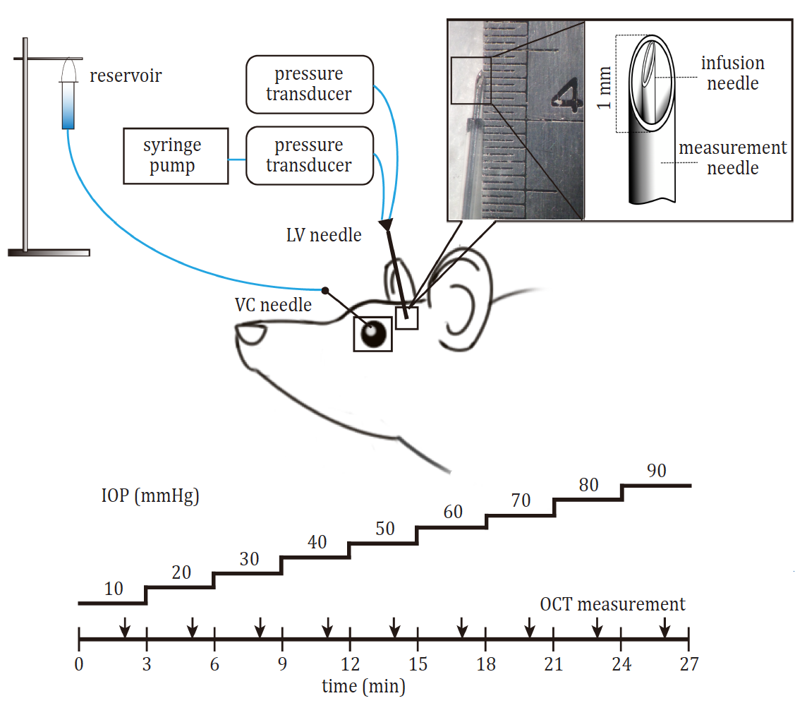
Figure 1. Modifying intracranial pressure and intraocular pressure. A: a cannula is placed into the vitreous chamber. This is connected to a saline reservoir to allow IOP to be controlled, in this case from 10 to 90 mmHg in steps of 10 mmHg. A double lumen needle is inserted into the lateral ventricle. In inner lumen is connected to a syringe pump for intracranial pressure control. The outer lumen is connected to a pressure transducer for ICP monitoring. Once ICP had stabilized (0, 5, 15, 25, 30 mmHg) optical coherence tomography (OCT) or electroretinograms (ERG) were measured at each IOP level [8].

Outcome measures
Functional assessment using the electroretinogram: Retinal function was assessed using the full-field electroretinogram (ERG). As described previously [10], custom-made silver-chloride active and reference electrodes were placed on the central cornea and sclera (ring shaped), respectively. Dim light levels were used to probe inner retinal function. For electroretinogram (ERG) recordings, rats were dark-adapted overnight (12 hours). All preparation was undertaken only with light from a dim red light emitting diode to maintain retinal sensitivity for scotopic threshold response (STR) measurements [10].

Structural assessment using optical coherence tomography: Spectral domain Optical coherence tomography (OCT) was utilized to investigate the deformation of the optic nerve head (ONH) and thickness changes in the retina (Image-Guided 830 nm OCT, Phoenix Research Laboratories, Pleasanton, CA, USA). A line scan through the optic nerve was measured and analysed for anterior surface position at 200 µm from the centre of the optic nerve. Retinal thickness is the perpendicular distance Bruch’s membrane to the anterior surface of the retina. RNFL thickness was also measured at various from the centre of the optic nerve.

Results
Structural changes in response to IOP and ICP modification
Figure 2 shows that with increasing IOP elevation for a fixed ICP level of 5 mmHg, there is progressively more deformation of the anterior retinal surface.

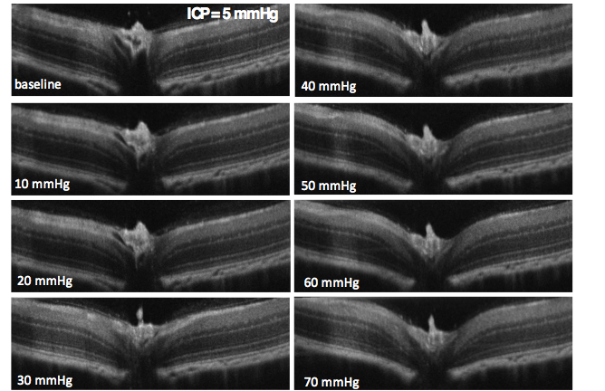
Figure 2: Tissue deformation at the rodent optic nerve head at various levels of IOP levels from 10 to 70 mmHg. Intracranial pressure was marinated at 5 mmHg through the IOP procedure [8].

Figure 3 shows that in comparison to an ICP of 5 mmHg, when ICP is raised to 25 mmHg there is less IOP-induced tissue deformation of the rat optic nerve. This is summarized in Figure 4, where for a fixed IOP level of 70 mmHg the effect of ICP modification becomes readily apparent. In particular, when ICP is higher there is less surface deformation (15, 25 and 30 mmHg), whereas when ICP is lower (-5 mmHg) we observed more surface deformation. Similarly, Figure 5 shows that higher ICP attenuates retinal compressions caused by IOP elevation, whereas low ICP exacerbates the retinal compression.

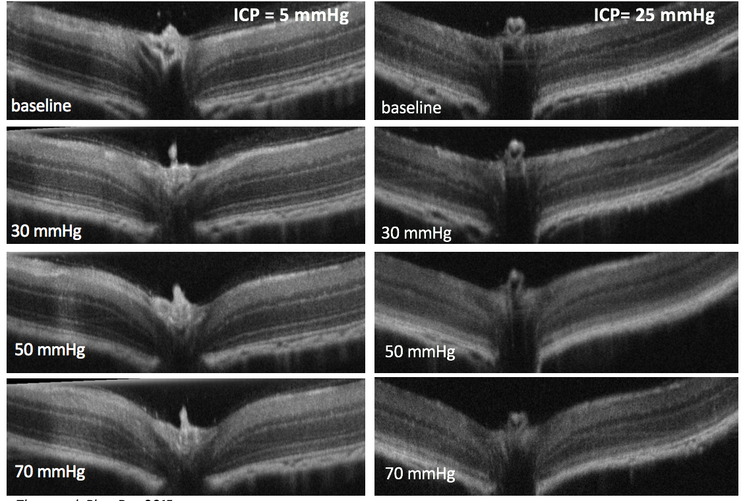
Figure 3: Effect of ICP on the response of the rat optic nerve to IOP elevation. At selected IOP levels, it is clear that when ICP is raised there is less deformation of the anterior surface of the optic nerve [8].

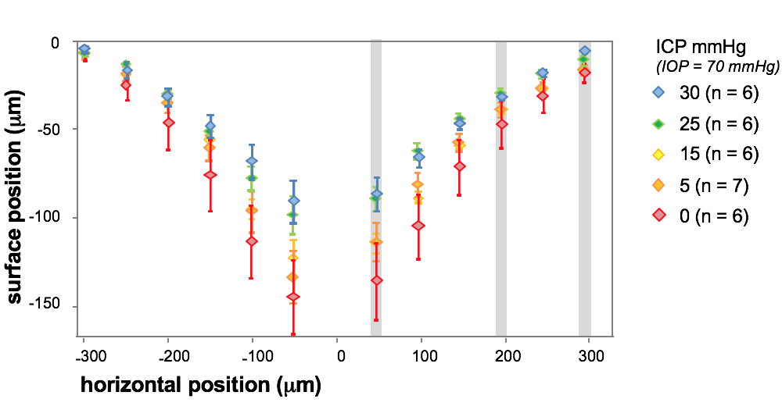

Figure 4: Summary of effect of IOP elevation (70 mmHg) on the anterior retina surface at a range of ICP levels. Relative retinal surface position (±SEM) measured at a range of locations on either side of the optic nerve. Deformation is greater nearer the centre of the optic nerve. Deformation seen with IOP elevation is increased at lower (ICP) and reduced at higher ICP [8].
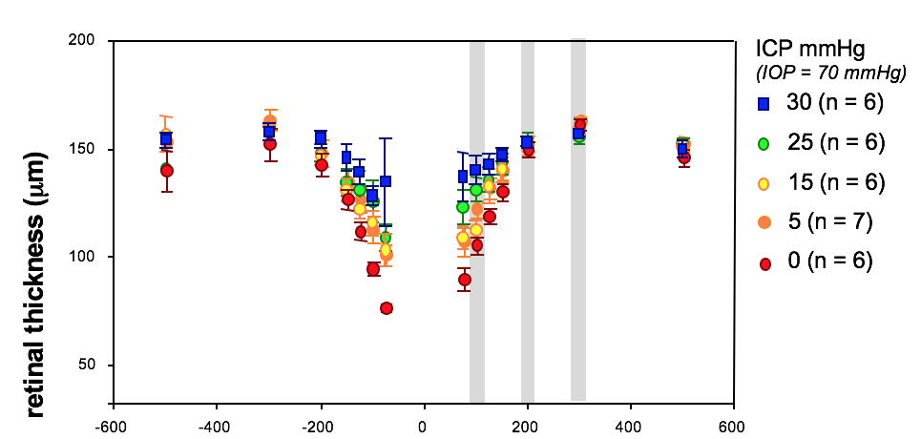

Figure 5: Summary of effect of IOP elevation (70 mmHg) on retinal thickness at a range of ICP levels. Retinal thickness (±SEM) measured at a range of locations on either side of the optic nerve. Retinal compression is greater nearer the centre of the optic nerve. Retinal compression seen with IOP elevation is increased at lower (ICP) and reduced at higher ICP [8].

Functional changes in response to IOP and ICP modification

Figures 6 and 7 clearly demonstrate that there is a functional =correlate of the structural changes shown in the preceding figures. In particular, it is clear that in response to IOP elevation retinal function gradually declines. At an IOP of 70 mmHg the ERG is less than half of its original size. This is the case for animals with ICP of 5 mmHg. In comparison, when ICP is elevated to 25 mmHg, retinal function is less affected by IOP elevation. In contrast, when ICP is lowered to 0 mmHg there is increased function susceptibility to IOP elevation. These outcomes are summarized in Figure 7.

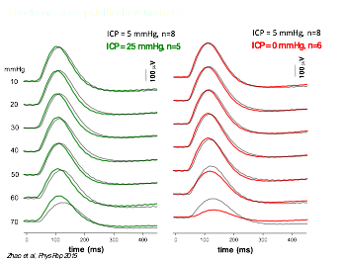

Figure 6: Functional susceptibility to IOP elevation is influenced by the ICP level. ERG responses are measured at each IOP level in animals with normal (black traces), high (green traces) or low (red traces) intracranial pressure [8].

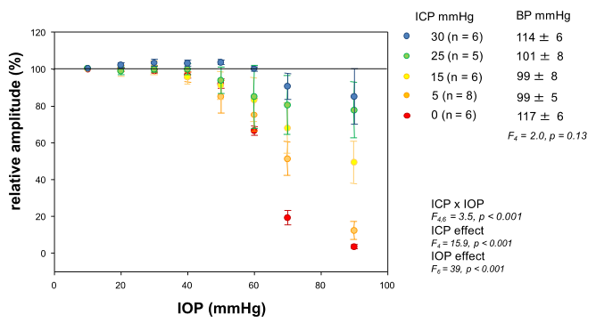

Figure 7: Functional susceptibility to IOP elevation is influenced by the ICP level. ERG amplitude are expressed relative to baseline at 10 mmHg (%). Group averaged (±SEM) data for a range of ICP levels [8].

Discussion

The above data show that the rat optic nerve shows robust responses to both IOP and ICP modification. This response was measurable in terms of structural (deformation and compression) and for the first time we show that there is a clear functional correlate.

We show that when ICP is high the optic nerve tissue shows less IOP induced deformation and compression, which correlate with reduced functional susceptibility. The converse is true when ICP is low. There were more structural changes and greater functional susceptibility to IOP elevation.

Few studies have investigated the effect that both ICP and IOP modification have on optic nerve tissues. Morgan et al [7] assessed the effect of acute pressure manipulation on the canine optic nerve, and concluded that that the optic nerve pressure gradient was the major determinant of optic nerve head surface position. In fact the authors suggested that intracranial pressure might have slightly greater effect than IOP on modifying optic nerve structure. This is in accordance with the current findings in the rats. Both our study and that of Morgan et al [7] are qualitatively in agreement with Yang et al [11]. This study showed that 12 months of chronic ICP lowering in non-human primates lead to posterior deformation of the optic nerve head and peripapillary retina. These laboratory studies provide evidence that ICP is an important determinant of optic nerve health.

Evidence is mounting in favour of ICP as a risk factor glaucoma development. A number of studies have reported that ICP is lower in glaucoma patients, which results in higher translaminar pressure gradients [12-16]. Models such as these may help us better understand how high pressure gradient might lead to ganglion cell injury in glaucoma.

Summary
- The influence that ICP has on the optic nerve, and how this might influence the risk of glaucoma is an area of interest.
- We show for the first time that acute ICP and IOP modification affect both structure and function of the retina and optic nerve head.
- Although the rat optic nerve lacks a well-developed connective tissue lamina cribrosa, these data suggest that rats are a good model, as IOP, ICP and blood pressure can all be monitored and controlled during imaging for electroretinography assessment.

Future directions
- Relating retinal function with blood flow and optic nerve structure will move us toward a better understanding of vascular and biomechanical determinates of retinal health.
- Studies in older animals can help us understand ageing influences the response of the optic nerve to pressure gradient modification
- Development of a rodent model of chronic ICP modification can help us better understand longer term adaptive changes in the optic nerve head

References

1. Morgan WH, et al. 1998. The correlation between cerebrospinal fluid pressure and retrolaminar tissue pressure, Invest Ophthalmol Vis Sci, 39:1419.
2. Berdahl JP, and Allingham RR. 2010. Intracranial pressure and glaucoma, Curr Opin Ophthalmol, 21:106.
3. Jonas JB, et al. 2013. Intracranial pressure and glaucoma, J Glaucoma, 22 Suppl 5:S13.
4. Pasquale LR. 2008. Low intracranial pressure: a tipping point in our understanding of primary open-angle glaucoma?, Ophthalmology, 115:761.
5. Siaudvytyte L, et al. 2015. Update in intracranial pressure evaluation methods and translaminar pressure gradient role in glaucoma, Acta Ophthalmol, 93:9.
6. Wostyn P, et al. 2011. Are intracranial pressure fluctuations important in glaucoma?, Med Hypotheses, 77:598.
7. Morgan WH, et al. 2002. Optic disc movement with variations in intraocular and cerebrospinal fluid pressure, Invest Ophthalmol Vis Sci, 43:3236.
8. Zhao D, et al. 2015. The effect of intraocular and intracranial pressure on retinal structure and function in rats, Physiological reports, 3.
9. He Z, et al. 2012. Blood pressure modifies retinal susceptibility to intraocular pressure elevation, PLoS One, 7:e31104.
10. Bui BV, and Fortune B. 2004. Ganglion cell contributions to the rat full-field electroretinogram, J Physiol, 555:153.
11. Yang D, et al. 2014. Optic neuropathy induced by experimentally reduced cerebrospinal fluid pressure in monkeys, Invest Ophthalmol Vis Sci, 55:3067.
12. Berdahl JP, et al. 2008. Cerebrospinal fluid pressure is decreased in primary open-angle glaucoma, Ophthalmology, 115:763.
13. Ren R, et al. 2010. Cerebrospinal fluid pressure in glaucoma: a prospective study, Ophthalmology, 117:259.
14. Wang N, et al. 2012. Orbital cerebrospinal fluid space in glaucoma: the Beijing intracranial and intraocular pressure (iCOP) study, Ophthalmology, 119:2065.
15. Ren R, et al. 2011. Cerebrospinal fluid pressure in ocular hypertension, Acta Ophthalmol, 89:e142.
16. Ren R, et al. 2011. Trans-lamina cribrosa pressure difference correlated with neuroretinal rim area in glaucoma, Graefes Arch Clin Exp Ophthalmol, 249:1057.

