IJMS-D-14-00152 Manuscript submitted to Prof. V.M. Bierbaum Special Issue
Guest Editors: Profs Mary Rodgers and Peter Armentrout
Handling Editor: Prof. Michael Bowers
REVISED Version: 8 July 2014

Formation of Sugar Radical Cations from Collision-induced Dissociation of Non-Covalent Complexes with S-Nitroso Thiyl Radical Precursors. ^{ξ,ψ}

Sandra Osburn,^{a,b} Spencer J. Williams, ª and Richard A. J. O’Hair* ^{a,b}

(a) School of Chemistry and Bio21 Molecular Science and Biotechnology Institute, The University of Melbourne, Victoria 3010, Australia.
(b) ARC Centre of Excellence for Free Radical Chemistry and Biotechnology, The University of Melbourne, Victoria 3010, Australia.

* Correspondence and PROOFS to: Professor Richard O’Hair:
Fax: +613 9347-5180; Tel: +61 3 8344-2452; E-mail: rohair@unimelb.edu.au

ψ Dedicated to Prof. Ronnie Bierbaum on the occasion of her 65th Birthday and in recognition of her important contributions to gas phase ion chemistry and service to the American Society of Mass Spectrometry.

ξ Part 81 of the series “Gas-Phase Ion Chemistry of Biomolecules”

ABSTRACT:
A 'bio-inspired' method has been developed for generating sugar radical cations by multistage mass spectrometry (MS⁴) experiments involving collision-induced dissociation (CID) of protonated non-covalent complexes between a sugar and an S-nitrosylated thiol amine, [H₃NXSNO+M]⁺ (where X = (CH₂)₂; (CH₂)₃; (CH₂)₄; CH(CO₂H)CH₂ and CH(CO₂CH₃)CH₂). In the first stage of CID (MS²), homolysis of the S-NO bond unleashes a thiyl radical to give the non-covalent radical cation, [H₃NXS•+M]⁺. It was found that complexes containing S-nitroso cysteamine (X = (CH₂)₂) produced the most abundant radical cations for monosaccharides, while for larger sugars the most abundant radical cations were generated from the S-nitroso derivatives of 3-amino-1-propanethiol (X = (CH₂)₃) and 4-amino-1-butanethiol (X = (CH₂)₄). CID (MS³) of the radical cation complex resulted in the dissociation of the non-covalent complex to generate the sugar radical cation [M•]⁺. Deuterium labelling studies reveal that this process involves abstraction of a hydrogen atom from a C-H bond of the sugar coupled with proton transfer to the sugar. The fragmentation reactions of the radical cation, [M•]⁺, were studied by another stage of CID (MS⁴). In this work the scope of the method was established, particularly for the S-NO bond homolysis (MS²) and [M•]⁺ formation (MS³) steps. Twenty six different sugars were examined and radical cations could be generated for polysaccharides of varying lengths, as well as for the methyl pyranosides of a range of monosaccharides.

Running Title: Sugar Radical Cations from Non-Covalent Thiyl Radical Complexes
Keywords: non-covalent complex; S-nitrosocysteine; saccharides; collision-induced dissociation.

1. Introduction:

Since the pioneering work of Finan et al on the electron ionization (EI) of monosaccharides and small oligosaccharides [1,2], there have been numerous reports on the use of mass spectrometry to analyse sugars [3]. Electrospray ionization (ESI) and matrix assisted laser desorption ionization (MALDI) are now commonly used to generate even electron ions, which can then be subjected to CID to generate sequence ions (Scheme 1 shows the accepted sequence ion nomenclature [4]). In contrast, the use of gas phase radical ion chemistry to direct the fragmentation of sugars has lagged behind. Exceptions include the use of: electron capture dissociation (ECD) and electron transfer dissociation (ETD), which result in radical-directed cleavages in oligosaccharides [5]; formation of radical ions by electron detachment dissociation (EDD) and the related negative electron transfer dissociation (NETD) method [6] or photo-activated electron detachment [7]; use of Siu’s method [8] to form radical anions by dissociation of a ternary metal complex containing the carbohydrate [9]; and extension of Beachamp’s free radical initiated peptide sequencing (FRIPS) method [10] to oligosaccharides [11].

Scheme 1

Here we report a new “bio-inspired” approach to generating radical cations of sugars in the gas phase. Nature exploits radical chemistry by certain enzymes to transform carbohydrate-based substrates [12]. A well-studied example involves the transformation of the sugar of RNA to DNA by the cysteinyl radical within ribonucleotide reductases. A key step in the overall transformation involves intermolecular H atom abstraction (HAT) from 1 to give radical 2 (Scheme 2) [12].
Scheme 2

The fact that the reaction shown in Scheme 2 proceeds within a non-covalent complex inspires a MS approach that utilizes a charged non-covalent complex between a sugar and a radical to generate a charged sugar radical. The rational design of such a non-covalent complex requires: (i) ready transfer to the gas phase of a charged non-covalent complex containing a sugar and a radical precursor; (ii) formation of the radical cation non-covalent complex by unleashing the radical site from the precursor in preference to dissociation of the non-covalent complex; and (iii) transfer of the radical and charge sites to the sugar upon dissociation of the radical cation non-covalent complex.

Regarding requirement (i), there are numerous reports that demonstrate that ESI readily affords non-covalent complexes of sugars, particularly those involving ammonium ions, [M + RNH₃]⁺ [13]. Requirement (ii) can be met by a consideration of bond dissociation energies to unleash radical sites [14] versus binding energies of non-covalent complexes [15]. An ideal radical precursor is S-nitrosocysteine, since it has a weak S-NO bond (BDE ∼ 113 kJ mol⁻¹) [16]. Indeed we have been able to cleanly generate thiyl radicals of cysteine (eq. 1, where X = CH(CO₂H)CH₂), its derivatives and peptides to study their gas phase structure and fundamental bimolecular and unimolecular reactivity [17]. Aside from the example of ribonucleotide reductase discussed earlier (Scheme 2), there is evidence in the solution phase literature that shows requirement (iii) can be met, since thiyl radicals have been shown to abstract hydrogen atoms from carbohydrates [18].

[H₃NXSNO]⁺ → [H₃NXS]^{•+} + NO• (eq. 1)

Recently we have shown that all three requirements can indeed be met [19]. As a “proof of concept”, the non-covalent complex between protonated S-nitrosocysteine and 18-crown-6 (18-C-6) was formed by ESI and shown to fragment via NO• loss to produce the radical cation non-covalent complex (eq. 2). The subsequent CID spectrum of [CysS + H + (18-C-6)]^{•+} shows losses from the cysteine as well as from the crown ether ring, suggesting that intramolecular HAT can occur within the non-covalent complex.

[CysSNO + H + (18-C-6)]⁺ → [CysS + H + (18-C-6)]^{•+} + NO• (eq. 2)

Here we explore the use of Siu’s method (eq. 3) [8] and protonated S-nitrosothioamine non-covalent complexes for forming radical cations of sugars. The sugars and S-nitrosothioamines studied are shown in Scheme 3.

[Cu(tpy)(M)]²⁺ → [M]^{•+} + [Cu(tpy)]⁺ (eq. 3)

Scheme 3

2. Materials and Methods
2.1 Materials
Cysteine, cysteine O-methyl ester, cysteamine, 3-amino-1-propanethiol, and tert-butyl nitrite were purchased from Sigma Aldrich Chemical Co. and used as received. 4-Amino-1-butanethiol was synthesized by Otava Chemical Co. (Ontario, CA). The sugars: methyl α-D-glucopyranoside, methyl β-D-glucopyranoside, D-glucose, methyl α-D-galactopyranoside, methyl β-D-galactopyranoside, D-galactose, methyl α-D-mannopyranoside, methyl β-D-mannopyranoside, D-mannose, D-mannitol, phenyl β-D-glucopyranoside, 4-hydroxyphenyl β-D-glucopyranoside, myo-inositol, L-arabinose, D-ribose, D-xylose, methyl β-cellobioside, cellobiose, trehalose, lactose, sucrose, maltotriose, maltotetrose, maltopentose, maltohexose, and maltoheptose were purchased from Sigma Aldrich Chemical Co. and Carbosynth Ltd. (Compton, UK) and used as received.

The [Cu(tpy)(M)]²⁺ complexes were formed by mixing the copper salt (2,2’:6’,2”-terpyridine)copper(II) nitrate monohydrate ([Cu(II)(tpy)(NO₃)₂].H₂O) [8b] with the sugar of interest (M) in a 1:1 ratio in 50/50 methanol/water with 1% acetic acid. The solution was then diluted to 50 µM.

The S-nitroso derivatives were generated by allowing a 1.5:1 mixture of tert-butyl nitrite and a 1 mM solution of the thiol (in 1:1 methanol:water with 1% acetic acid) to react for 10 minutes at room temperature. The reaction mixture was then diluted 100-fold using 50/50 methanol:water with 1% acetic acid.

2.2 Mass spectrometry
Complexes containing the sugar non-covalently bound to the S-nitroso derivative were made by mixing 2 equivalents of the sugar with 1 equivalent of the S-nitroso derivative in 1:1 methanol:water with 1% acetic acid to give a final concentration of 1 µM.

Electrospray ionization (ESI) mass spectra were collected using a Thermo Scientific LTQ-FT-ICR hybrid mass spectrometer (Bremen, Germany), consisting of a linear ion trap coupled to a 7T FT-ICR mass spectrometer. Analyte solutions were injected onto the ion trap mass spectrometer using a syringe pump with a flow rate of 5.0 µL min⁻¹. The instrument settings were optimized for maximum [H₃NXSNO+M]⁺ signal intensity by using the auto-tune routine within the Tune program. The spray needle voltage, nitrogen sheath gas flow rate, and the capillary temperature were maintained at +5 kV, 5 arbitrary units, and 200 ºC, respectively. Helium gas was used as the collision gas for CID experiments.

CID studies were performed by mass selecting the precursor ion and subjecting it to collisional activation. The normalized collision energy (RCE), which sets the amplitude of the RF energy applied to the end-cap electrodes, was set between 16 and 18% (arbitrary units) depending on the complex. The activation Q was set at 0.25 for the monosaccharides, for the other sugars the Q value was varied to observe the lower mass S-nitroso derivatives. The activation time was set at 30 ms.

3. Results and discussion
3.1 Formation of the radical cations using Siu’s method.
A wide range of radical cations of peptides have been generated via Siu’s method [8], which involves CID of copper(II) ternary metal complexes, [Cu(L)(M)]²⁺ (where L = an auxillary ligand and M is the peptide) [8]. Since radical cation formation is not restricted to residues with aromatic side chains [8], we were interested in examining whether this method could be applied to generate sugar radical cations. ESI/MS of a 1:1 mixture of the [Cu(II)(tpy)(NO₃)₂].H₂O salt and a sugar, M, generates the non-covalent complex, [Cu(tpy)(M)]²⁺ (data not shown). For simple glycosides such as methyl α-D-glucopyranoside, CID of [Cu(tpy)(M)]²⁺ (245 m/z) fails to form the radical cation, which instead undergoes loss of MeOH to give [Cu(tpy)(M-MeOH)]²⁺ (Figure 1a, 229 m/z). As tyrosine-containing peptides readily generate radical cations using Siu's method [8], we also examined the CID spectrum of the copper(II) ternary complex of 4-hydroxyphenyl β-D-glucopyranoside (Figure 1B). Indeed, the radical cation, [M•]⁺, can be formed according to eq. 3, but it is a minor product as it undergoes fragmentation to form an ion at 110 m/z , which corresponds to the radical cation of hydroquinone. Given these limitations, we abandoned this method as a way of generating radical cations of sugars and turned our attention to the use of the [H₃NXSNO+M]⁺ non-covalent complexes.

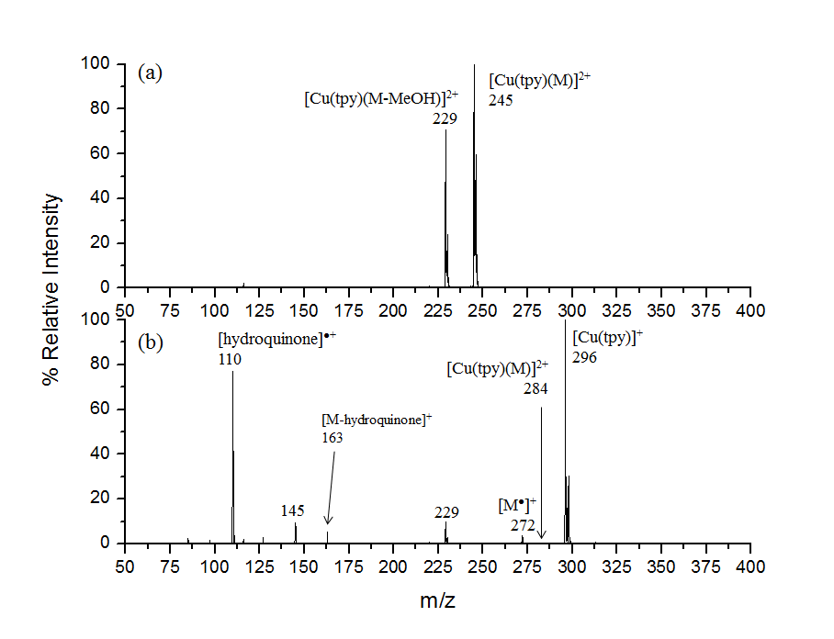
Figure 1: CID mass spectra of the [Cu(tpy)(M)]²⁺ complexes, where M is: (a) methyl α-D-glucopyranoside (245 m/z) and (b) 4-hydroxyphenyl β-D-glucopyranoside (284 m/z). The spectra were collected using an LTQ-FT-ICR hybrid mass spectrometer. The RCE value was 16%. Note that the Cu containing ions in the spectra contain both ⁶³Cu and ⁶⁵Cu isotopes due to the 1.5 m/z mass selection of the precursor ions.

3.2 Formation of radical cations via non-covalent complexes
ESI/MS of 1 µM solutions of a mixture of 2:1 sugar:S-nitroso derivative resulted in the formation of abundant [H₃NXSNO+M]⁺ non-covalent complexes, consistent with previous literature reports on the formation of ammonium ion complexes of sugars [13]. A range of other ions were observed in the ESI/MS including the protonated monomers [H₃NXSNO]⁺ and [M + H]⁺ (data not shown).

Sugar radical cations can indeed be formed from the [H₃NXSNO+M]⁺ non-covalent complexes in a set of multistage mass spectrometry experiments, as shown for the example of methyl α-D-galactopyranoside (Figure 2). In the first stage of CID (MS²; Figure 2a) the nitrosylated complex ([H₃NXSNO+M]⁺; 301 m/z) dissociated to form the radical cation of the complex ([H₃NXS•+M]⁺; 271 m/z) as well as the protonated nitrosylated thiol derivative ([H₃NXSNO]⁺; 107 m/z). The radical cation of the thiol derivative was also observed ([H₃NXS•]⁺; 77 m/z).

The second stage of CID (MS³; Figure 2b) involved the dissociation of the radical cation of the non-covalent complex ([H₃NXS•+M]⁺; 271 m/z), which successfully produced the radical cation of the sugar ([M•]⁺; 194 m/z). This ion fragments to lose HO• (177 m/z), H₂O (176 m/z), or 2 molecules of H₂O (158 m/z). The way the radical cation is formed will dictate the site(s) of the radical and charge. To address the mechanism of radical cation formation, we carried out a key deuterium labelling experiment in which all of the labile hydrogens of the non-covalent complex were exchanged for deuterium. In the second stage of CID (MS³), the peak corresponding to the radical cation of the sugar (194 m/z) shifted five mass units to 199 m/z (Figure 2c). This shows that formation of the sugar radical cation involves abstraction of a hydrogen from one of the C-H bonds of the sugar coupled with D⁺ transfer. Thus the radical is located on a carbon atom and the charge is located on an oxygen. This is consistent with the lower bond dissociation energy of the C-H versus O-H bonds in sugars [11], and the fact that the only sites for protonation in sugars are the O atoms [20]. Thus the type of radical cation formed in our method is distinct to the canonical structures of radical cations of sugars formed via EI/MS [2].

The final stage of CID (MS⁴; Figure 2c) involved dissociation of the radical cation of the sugar ([M•]⁺; 194 m/z), which led to the loss of 1 and 2 water molecules (176 and 158 m/z, respectively). The peaks at 102, 103, and 104 m/z involve fragmentation of the sugar ring.
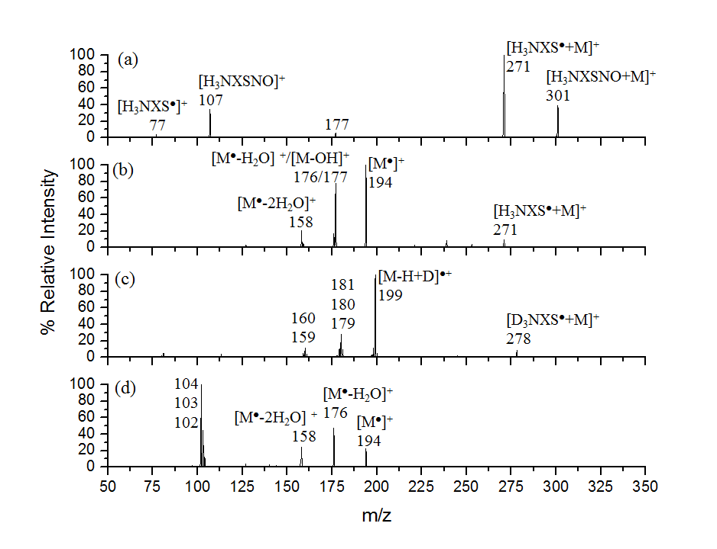
Figure 2: Formation of the radical cation of methyl α-D-galactopyranoside: (a) CID mass spectrum (MS²) of the methyl α-D-galactopyranoside:Eth-NO complex (301 m/z); (b) CID mass spectrum (MS³) of the radical cation of the methyl α-D-galactopyranoside:Eth complex (271 m/z); (c) CID mass spectrum (MS³) of the radical cation of the methyl α-D-galactopyranoside:Eth complex in which all the labile protons have been exchanged in D₂O (278 m/z); and (d) CID mass spectrum (MS⁴) of the radical cation of methyl α-D-galactopyranoside (194 m/z). Spectra were collected using an LTQ-FT-ICR hybrid mass spectrometer. The RCE value was 16%.

3.2.1 Step 1: CID of [H₃NXSNO+M]⁺
Since all of the protonated S-nitrosothiolamines, [H₃NXSNO]⁺, readily generate thiyl radicals via the exclusive loss of NO (eq. 1), we have examined the positive ion ESI/MS of a mixture of a sugar, M, and an S-nitrosothiolamine for all combinations of sugars and S-nitrosothiolamines shown in Scheme 3. Of the 130 combinations, all of the non-covalent complexes could be formed with sufficient intensity to allow them to be mass selected and subjected to CID. However, the non-covalent complexes for the larger sugars (maltopentose, maltohexose, and maltoheptose) had lower ion intensities. Both the type of S-nitrosothiolamine and sugar can influence the fragmentation reactions observed (Figure 3) for the non-covalent complex, [H₃NXSNO+M]⁺, which can be classified into four fragmentation pathways: the desired bond homolysis reaction (eq. 4); dissociation of the complex to form the protonated S-nitrosothiolamines (eq. 5); dissociation of the complex in conjunction with bond homolysis to form the protonated amino thiyl radical (eq. 6); and dissociation of the complex with proton transfer to form the protonated sugar (eq. 7). Figure 3 shows selected examples, while Table 1 lists the percentage yields of the various fragmentation channels for the MS/MS data collected for all the non-covalent complexes studied.

[H₃NXSNO+M]⁺ → [H₃NXS•+M]⁺ + NO• (eq. 4)
→ [H₃NXSNO]⁺ + M (eq. 5)
→ [H₃NXS•]⁺ + M + NO• (eq. 6)
→ [MH]⁺ + H₂NXSNO (eq. 7)

For a given monosaccharide, the yield of the desired bond homolysis channel can be significantly influenced by the choice of S-nitrosothiolamine. For example, for the complexes containing methyl α-D-galactopyranoside, a greater yield of bond homolysis is observed for S-nitrosocysteamine ([H₃NXS•+M]⁺; 271 m/z; Figure 3a) than for the S-nitrosothiolamine derived from 3-amino-1-propanethiol ([H₃NXS•+M]⁺; 285 m/z; Figure 3b). An examination of Table 1 reveals that in the case of the monosaccharides, use of the S-nitroso derivative of cysteamine generally gives the highest yield of bond homolysis. Also noteworthy is a lack of formation of the protonated sugar (eq. 7).

For larger sugars, these trends no longer hold. In the case of lactose, a smaller yield of bond homolysis is observed for S-nitrosocysteamine ([H₃NXS•+M]⁺; 419 m/z; Figure 3c) than for the S-nitrosothiolamine derived from 3-amino-1-propanethiol ([H₃NXS•+M]⁺; 433 m/z; Figure 3d), suggesting that the longer alkylene linker promotes bond homolysis, perhaps by changing the types and the strength of hydrogen bonding within the complex. An examination of Table 1, however, reveals that there are no specific trends for how bond homolysis is influenced by linker length for larger sugars. Formation of the protonated sugar (eq. 7) becomes a significant channel for larger sugars, which likely reflects a higher proton affinity for larger sugars. It should be noted that for the largest sugars (maltopentose, maltohexose, and maltoheptose) very little of the radical cation of the complex is formed regardless of the thiolamine used, suggesting that this method of generating the radical cation is less effective for the larger sugars, at least in terms of the thiolamines studied here. Nonetheless, sufficient yields of the radical cation (eq. 4) were formed for many sugars, allowing examination of their subsequent fragmentation reactions.
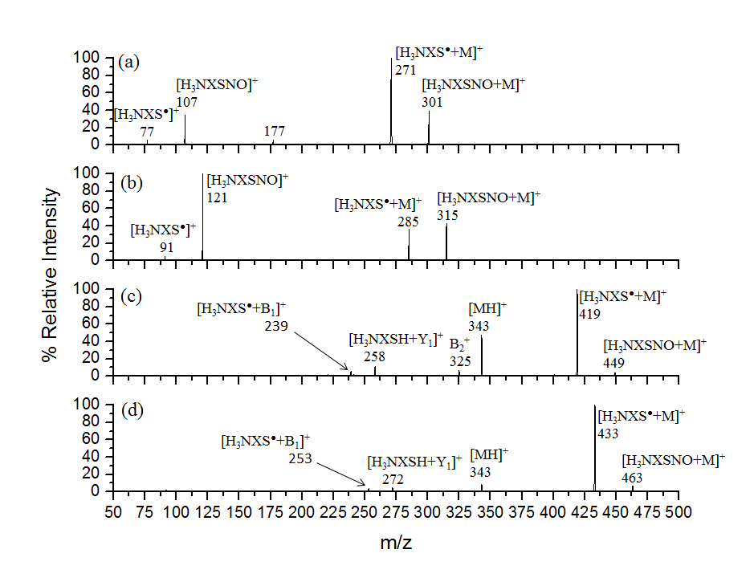Figure 3: CID mass spectra (MS²) comparison of radical cation formation of the methyl α-D-galactopyranoside complexed with (a) Eth-NO and (b) Prop-NO. CID mass spectra (MS²) comparison of radical cation formation of lactose complexed with (c) Eth-NO and (d) Prop-NO. The spectra were collected using an LTQ-FT-ICR hybrid mass spectrometer. The RCE value was 16%.

Table 1: Summary of MS² experiments involving CID of [H₃NXSNO+M]⁺. The channels reported include formation of the radical cation of the non-covalent complex via NO loss (eq. 4), loss of the sugar (eq. 5) and bond cleavage reactions.^{(a)}
Sugar | Charge & Radical Carrier | % Radical Cation Complex | % H₃NXSNO⁺ | % H₃NXS^{●+} | % Sugar⁺ | % Other
methyl α-D- galactopyranoside | Cys  CysOMe  Eth  Prop  But | 42.0  17.9  75.9  31.2  8.3 | 40.3  61.2  19.0  65.9  80.0 | 13.1  20.9  3.4  2.9  11.7 | 0  0  0  0  0 | 4.6  0  1.7  0  0
methyl β-D- galactopyranoside | Cys  CysOMe  Eth  Prop  But | 57.1  33.9  80.3  41.4  19.3 | 22.9  44.4  8.3  55.7  70.2 | 8.4  16.5  1.6  2.8  10.5 | 0  0  0  0  0 | 11.6  5.2  9.8  0  0
D-galactose | Cys  CysOMe  Eth  Prop  But | 38.9  21.6  76.8  26.8  9.3 | 43.9  70.4  21.5  54.4  82.5 | 17.2  8.0  1.7  18.8  8.2 | 0  0  0  0  0 | 0  0  0  0  0
methyl α-D- mannopyranoside | Cys  CysOMe  Eth  Prop  But | 36.6  17.4  75.7  54.6  19.2 | 31.1  30.9  13.3  43.1  64.7 | 11.1  18.5  1.0  2.3  16.0 | 0  0  0  0  0 | 9.8  4.8  10.0  0  0
methyl β-D- mannopyranoside | Cys  CysOMe  Eth  Prop  But | 81.1  53.9  93.1  72.1  20.6 | 10.7  30.0  3.7  26.6  72.4 | 3.6  11.5  0  1.3  7.0 | 0  0  0  0  0 | 4.6  4.6  3.2  0  0
D-mannose | Cys  CysOMe  Eth  Prop  But | 38.8  14.1  74.6  22.5  9.8 | 43.1  77.8  23.1  57.5  84.0 | 18.1  8.1  2.3  20.0  6.2 | 0  0  0  0  0 | 0  0  0  0  0
methyl α-D- glucopyranoside | Cys  CysOMe  Eth  Prop  But | 23.6  7.6  57.0  15.1  3.5 | 58.7  69.7  34.5  81.4  75.3 | 17.7  22.7  6.0  3.5  11.1 | 0  0  0  0  2.6 | 0  0  2.5  0  7.5
methyl β-D-glucopyranoside | Cys  CysOMe  Eth  Prop  But | 15.7  4.6  49.9  8.1  0.6 | 65.1  72.0  39.0  88.5  84.8 | 19.2  23.4  3.4  3.4  14.5 | 0  0  0  0  0 | 0  0  7.0  0  0
D-glucose | Cys  CysOMe  Eth  Prop  But | 11.6  4.0  42.3  5.2  0 | 65.1  86.1  54.4  71.4  48.5 | 23.3  9.9  3.4  23.4  1.0 | 0  0  0  0  0 | 0  0  0  0  50.5

Table 1 continued:
Sugar | Charge & Radical Carrier | % Radical Cation Complex | % H₃NXSNO⁺ | % H₃NXS^{●+} | % Sugar⁺ | % Other
D-Mannitol | Cys  CysOMe  Eth  Prop  But | 2.5  2.8  53.5  21.6  1.2 | 41.1  80.2  19.9  71.8  93.6 | 6.4  8.3  2.0  6.6  5.2 | 14.7  0  2.7  0  0 | 35.3  8.6  21.9  0  0
phenyl β-D- glucopyranoside | Cys  CysOMe  Eth  Prop  But | 3.9  1.8  20.9  15.5  2.8 | 53.6  67.2  31.1  66.5  64.9 | 11.5  20.8  1.8  5.9  14.6 | 0  0  0  0  0 | 31.0  10.2  46.2  12.1  17.7
4-hydroxyphenyl β-D-glucopyranoside | Cys  CysOMe  Eth  Prop  But | 29.2  7.3  38.5  31.7  4.7 | 52.3  57.1  0  54.9  77.3 | 1.3  14.7  0  5.2  18.0 | 0  0  0  0  0 | 17.2  20.9  61.5  8.2  0
Myo-inositol | Cys  CysOMe  Eth  Prop  But | 3.7  1.2  18.4  2.3  0.9 | 74.4  77.3  75.0  68.6  87.4 | 21.9  21.5  6.6  13.5  9.3 | 0  0  0  0  0 | 0  0  0  15.6  2.4
L-arabinose | Cys  CysOMe  Eth  Prop  But | 2.9  4.3  6.5  2.4  0 | 77.7  87.8  87.2  76.1  92.5 | 19.4  1.9  6.3  21.5  7.5 | 0  0  0  0  0 | 0  0  0  0  0
D-ribose | Cys  CysOMe  Eth  Prop  But | 5.6  2.5  17.5  2.0  2.5 | 75.5  95.1  75.6  75.8  96.5 | 18.9  2.4  6.9  22.2  1.0 | 0  0  0  0  0 | 0  0  0  0  0
D-xylose | Cys  CysOMe  Eth  Prop  But | 2.2  14.4  7.4  2.1  3.7 | 79.7  74.4  86.1  76.3  91.7 | 18.1  11.2  6.5  21.6  4.6 | 0  0  0  0  0 | 0  0  0  0  0
methyl β- cellobioside | Cys  CysOMe  Eth  Prop  But | 41.2  51.6  66.5  87.2  87.8 | 0  1.9  0  2.0  3.9 | 0  0  0  0.8  1.5 | 6.1  0  4.6  0  0 | 52.7  46.5  28.9  10.0  6.8
cellobiose | Cys  CysOMe  Eth  Prop  But | 37.1  68.7  77.7  85.0  93.8 | 1.1  7.0  3.9  3.8  6.2 | 1.3  2.0  4.5  2.2  0 | 2.0  0  0  0  0 | 58.5  22.3  16.9  9.0  0
Table 1 continued:
Sugar | Charge & Radical Carrier | % Radical Cation Complex | % H₃NXSNO⁺ | % H₃NXS^{●+} | % Sugar⁺ | % Other
trehalose | Cys  CysOMe  Eth  Prop  But | 38.2  50.3  34.1  79.2  57.7 | 5.6  16.8  0.4  15.7  14.9 | 0  2.1  0  5.0  20.5 | 0  0  0  0  0 | 56.2  30.8  65.5  0  6.9
lactose | Cys  CysOMe  Eth  Prop  But | 10.9  60.9  60.5  86.1  94.2 | 0  0  0  0.3  0.4 | 0  0  0  0.4  0.8 | 61.1  31.0  26.8  6.7  4.6 | 28.0  8.1  12.7  6.5  0
sucrose | Cys  CysOMe  Eth  Prop  But | 35.3  71.9  85.9  85.5  90.3 | 4.7  8.5  0.3  3.3  4.3 | 0  0  0  1.3  0 | 12.4  2.5  0  0  0 | 47.6  17.1  13.8  9.9  5.4
maltotriose | Cys  CysOMe  Eth  Prop  But | 66.2  43.0  82.7  97.2  79.8 | 0  0  0  0  4.6 | 0  0  0  0  0.5 | 4.1  0  0  2.8  0 | 29.7  57.0  17.3  0  15.1
maltotetrose | Cys  CysOMe  Eth  Prop  But | 3.9  0  24.1  77.8  73.7 | 0  0  0  0  0 | 0  0  0  0  0 | 56.4  81.1  57.0  7.8  2.2 | 39.7  18.9  18.9  14.4  24.1
maltopentose | Cys  CysOMe  Eth  Prop  But | 5.5  8.8  0  0  0 | 0  0  0  0  0 | 0  0  0  0  0 | 27.0  20.8  92.2  82.7  64.0 | 67.5  70.4  7.8  17.3  36.0
maltohexose | Cys  CysOMe  Eth  Prop  But | 12.5  5.6  0  0  0 | 0  0  0  0  0 | 0  0  0  0  0 | 12.6  23.6  91.0  53.8  63.7 | 74.9  70.8  9.0  46.2  36.3
maltoheptose | Cys  CysOMe  Eth  Prop  But | 11.5  3.2  0  0  0 | 0  0  0  0  0 | 0  0  0  0  0 | 12.5  10.7  87.3  75.9  0 | 76.0  86.1  12.7  24.1  100.0
(a) The final column lists the sum of all remaining fragmentation pathways, which can include the formation of sugar sequence ions for the larger sugars (e.g. Figure 3C).

3.2.2 Step 2: CID of [H₃NXS•+M]⁺
Many of the radical cation complexes, [H₃NXS•+M]⁺, were formed in sufficient yield to examine their CID spectra in MS³ experiments and the percentage yields of the various fragmentation channels are given in Table 2. Here we focus our discussion on four representative examples, which illustrate how both the nature of the sugar and the thiyl radical can influence the gas phase chemistry of the radical cation complex (Figure 4). The types of fragmentation reactions that were observed include: the desired coupled intermolecular proton and HAT reactions to give the radical cation of the sugar (eq. 8); dissociation of the complex to form the protonated amino thiyl radical (eq. 9); dissociation of the complex with intermolecular HAT to form the protonated thiolamines and the sugar radical (eq. 10); small molecule losses from the complex, and ions that appear to arise from fragmentation of the sugar radical cation. Dissociation via proton transfer (eq. 11) to the sugar was not observed.

[H₃NXS•+M]⁺ → [M•]⁺ + H₂NXSH (eq. 8)
→ [H₃NXS•]⁺ + M (eq. 9)
→ [H₃NXSH]⁺ + [M-H]• (eq. 10)
→ [M+H] ⁺ + H₂NXS• (eq. 11)

The data in Figure 4a shows that for the complex between methyl α-D-galactopyranoside and cysteamine thiyl radical, dissociation is dominated by formation of the radical cation of the sugar ([M•]⁺, eq. 8, 194 m/z). In contrast, solely changing the complex to that with the thiyl radical of 3-amino-1-propanethiol (Figure 4b) leads to formation of the radical cation ([H₃NXS•]⁺, eq. 9, 91 m/z) and the protonated thiolamine ([H₃NXSH]⁺, eq. 10, 92 m/z). This same trend is observed with larger sugars, as illustrated for lactose, where the dominant formation of the radical cation of the sugar ([M•]⁺, eq. 8, 342 m/z) occurs with cysteamine (Figure 4c) instead of with 3-amino-1-propanethiol (Figure 4d), although there is still a high abundance of the radical cation of the sugar present with 3-amino-1-propanethiol. It is worth noting the presence of several sequence ions in the spectra for lactose (Figures 4c and 4d).

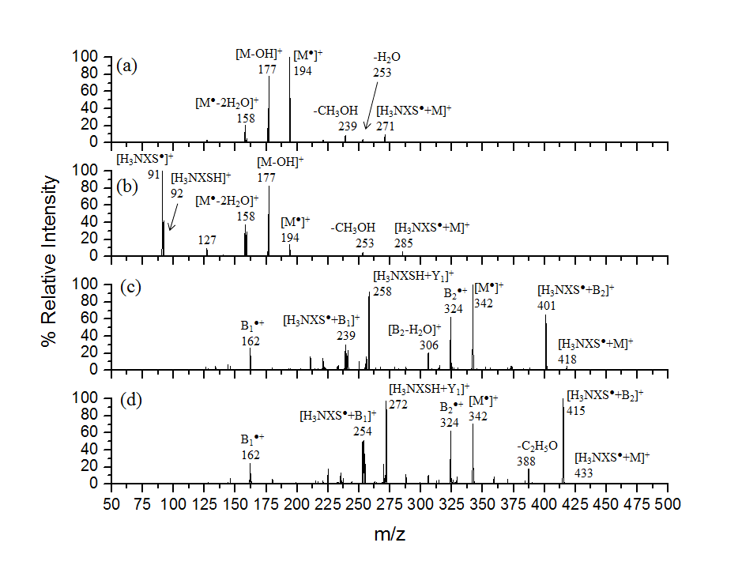
Figure 4: Formation of the radical cation of the sugars via CID of the radical cation of the non-covalent complex (MS³). CID mass spectra of the radical cation of methyl α-D-galactopyranoside complexed with (a) cysteamine ([H₃NXS•+M]⁺; 271 m/z) and (b) 3-amino-1-propanethiol ([H₃NXS•+M]⁺; 285 m/z). CID mass spectra of the radical cation of lactose complexed with (c) cysteamine ([H₃NXS•+M]⁺; 418 m/z) and (d) 3-amino-1-propanethiol ([H₃NXS•+M]⁺; 433 m/z). The spectra were collected using an LTQ-FT-ICR hybrid mass spectrometer. The RCE value was 16%.

Table 2 lists the CID spectra of the radical cation complexes, [H₃NXS•+M]⁺. An examination of this table reveals a similar trend in the role of the linker size, X, to that observed in the CID of [H₃NXSNO+M]⁺ (Table 1). Thus a higher yield of the desired channel of [M•]⁺ formation (eq. 9) occurs for the smaller linker sizes. A possible explanation based upon the labelling studies (Figure 2c), which highlight that radical cation formation involves H atom abstraction followed by proton transfer, is that as the linker size increases, the proton affinity of H₂NXSH is likely to increase (based on the proton affinities of related amine alcohols and diamines [21]), making proton transfer from H₃NXSH⁺ to the sugar radical, [M-H]•, less likely. Finally, the fact that methyl mannopyranosides produce less of the radical cation than methyl galactopyranosides and methyl glucopyranosides highlights that the structure of the sugar also plays a role in the yield of [M•]⁺ produced.

Table 2: Summary of competition between [M●]⁺ formation, M loss, [M-H]● and other bond cleavage reactions from the dissociation of the radical cation of the complex.
Sugar | Charge and Radical Carrier | % [M●]⁺ | % M Loss | % [M-H]● Loss | % Other ^{(a)}
methyl α-D-galactopyranoside | Cys  CysOMe  Eth  Prop  But | 53.3  53.1  57.9  4.6  1.0 | 0.9  2.0  6.1  21.2  18.1 | 5.1  14.2  12.4  10.4  61.9 | 40.7  30.7  23.6  63.8  19.0
methyl β-D-galactopyranoside | Cys  CysOMe  Eth  Prop  But | 57.3  52.6  54.2  2.7  2.1 | 0.4  2.0  7.3  20.1  24.4 | 5.7  14.6  17.8  9.2  55.9 | 36.6  30.8  20.7  68.0  17.6
D-galactose | Cys  CysOMe  Eth  Prop  But | 8.3  1.2  2.7  0.5  0 | 49.3  15.2  18.5  57.7  79.7 | 13.3  26.3  11.2  41.8  20.3 | 29.1  57.3  67.6  0  0
methyl α-D-mannopyranoside | Cys  CysOMe  Eth  Prop  But | 8.0  13.9  12.2  15.9  5.7 | 0.6  5.7  4.3  21.1  10.2 | 13.3  26.3  11.2  41.8  20.3 | 29.1  57.3  67.6  0  0
methyl β-D-mannopyranoside | Cys  CysOMe  Eth  Prop  But | 27.1  17.1  38.9  9.9  1.4 | 0.5  3.9  4.2  23.2  17.2 | 9.8  12.6  7.3  15.4  59.6 | 62.6  66.4  49.6  51.5  21.8
D-mannose | Cys  CysOMe  Eth  Prop  But | 2.5  1.9  6.3  0.7  0 | 23.1  16.2  14.2  58.6  82.4 | 37.7  30.3  15.6  38.8  17.6 | 56.7  51.6  63.9  1.9  0
methyl α-D-glucopyranoside | Cys  CysOMe  Eth  Prop  But | 58.4  54.6  50.4  12.6  2.9 | 0.5  3.1  0  24.3  17.8 | 4.9  18.7  2.1  17.9  64.4 | 36.2  23.6  47.5  45.2  14.9
methyl β-D-glucopyranoside | Cys  CysOMe  Eth  Prop  But | 50.6  52.2  58.0  17.5  2.8 | 0.5  3.2  0.9  19.2  21.7 | 6.7  15.8  4.6  21.9  59.9 | 42.2  28.8  36.5  41.4  15.6
D-glucose | Cys  CysOMe  Eth  Prop  But | 8.8  2.6  4.0  0.8  0 | 17.4  4.7  46.6  55.4  96.1 | 53.6  12.9  31.5  40.9  3.9 | 24.2  79.8  17.9  2.9  0

Table 2 Continued:
Sugar | Charge and Radical Carrier | % [M●]⁺ | % M Loss | % [M-H]● | % Other ^{(a)}
D-Mannitol | Cys  CysOMe  Eth  Prop  But | 12.5  37.5  0.9  0  0 | 0  5.7  0.7  10.8  0.4 | 25.0  5.7  10.3  59.8  60.2 | 62.5  51.1  88.1  29.4  35.8
Phenyl β-D-glucopyranoside | Cys  CysOMe  Eth  Prop  But ^{(b)} | 15.1  23.4  14.1  5.1  ---- | 0  12.5  0.4  2.3  ---- | 21.0  32.7  4.0  57.6  ---- | 63.9  31.4  81.5  34.8  ----
4-hydroxyphenyl β-D-glucopyranoside | Cys  CysOMe  Eth  Prop  But | 65.9  41.2  21.2  67.0  12.6 | 0  2.9  0  3.0  0.5 | 2.3  23.5  0  27.8  40.4 | 31.8  32.4  78.8  2.7  46.5
Myo-inositol | Cys  CysOMe  Eth  Prop  But | 12.9  4.0  0.4  0  0 | 6.0  12.9  22.1  20.1  9.7 | 23.0  25.7  39.3  1.6  57.3 | 58.1  57.4  38.2  78.3  33.0
L-arabinose | Cys  CysOMe  Eth  Prop  But ^{(b)} | 0  0.2  0  0.1  ---- | 17.7  16.5  17.3  40.9  ---- | 57.6  67.2  63.6  15.2  ---- | 24.7  16.1  19.1  43.8  ----
D-ribose | Cys  CysOMe  Eth  Prop  But ^{(b)} | 1.3  0.7  0  0  ---- | 8.6  12.2  14.2  61.5  ---- | 15.1  34.7  29.1  15.7  ---- | 75.0  52.4  56.7  22.8  ----
D-xylose | Cys  CysOMe  Eth  Prop  But ^{(b)} | 0  0.1  0  0.2  ---- | 18.7  10.2  17.7  52.0  ---- | 55.1  30.1  26.8  19.8  ---- | 26.2  59.6  55.5  28.0  ----
methyl β-D-cellobioside | Cys  CysOMe  Eth  Prop  But | 81.6  62.8  59.2  4.5  5.6 | 0.6  0.3  0  12.0  8.5 | 0.3  3.1  0  20.0  49.7 | 17.5  33.8  40.8  55.5  36.2
Cellobiose | Cys  CysOMe  Eth  Prop  But | 55.5  15.3  41.1  8.5  1.0 | 0  0.4  0  2.0  3.4 | 0  12.8  0  8.0  29.5 | 44.5  71.5  58.9  81.5  66.1

Table 2 Continued:
Sugar | Charge and Radical Carrier | % [M●]⁺ | % M Loss | % [M-H]● Loss | % Other ^{(a)}
Trehalose | Cys  CysOMe  Eth  Prop  But | 8.6  9.8  2.4  1.2  0 | 0  0.1  0.7  3.6  8.9 | 0  4.3  1.5  30.8  41.8 | 91.4  85.9  95.4  64.4  49.3
Lactose | Cys  CysOMe  Eth  Prop  But | 39.3  34.8  29.0  26.7  10.3 | 0  0.8  0.6  4.3  8.7 | 0  6.7  2.0  13.7  42.5 | 60.7  57.7  68.4  55.3  38.5
Sucrose | Cys  CysOMe  Eth  Prop  But | 15.6  12.3  3.9  0  0.7 | 1.7  3.6  0  5.6  4.2 | 12.2  19.4  0  20.8  39.7 | 70.5  64.7  96.1  73.6  55.4
Maltotriose | Cys ^{(b)}  CysOMe ^{(b)}  Eth  Prop  But ^{(b)} | ----  ----  14.8  18.8  ---- | ----  ----  0  0  ---- | ----  ----  1.2  1.4  ---- | ----  ----  84.0  79.8  ----
Maltotetrose | Cys ^{(b)}  CysOMe ^{(b)}  Eth  Prop  But ^{(b)} | ----  ----  2.9  4.1  ---- | ----  ----  0  0  ---- | ----  ----  0  0  ---- | ----  ----  97.1  95.9  ----
Maltopentose | Cys ^{(b)}  CysOMe ^{(b)}  Eth ^{(b)}  Prop ^{(b)}  But ^{(b)} | ----  ----  ----  ----  ---- | ----  ----  ----  ----  ---- | ----  ----  ----  ----  ---- | ----  ----  ----  ----  ----
Maltohexose | Cys ^{(b)}  CysOMe ^{(b)}  Eth ^{(b)}  Prop ^{(b)}  But ^{(b)} | ----  ----  ----  ----  ---- | ----  ----  ----  ----  ---- | ----  ----  ----  ----  ---- | ----  ----  ----  ----  ----
Maltoheptose | Cys ^{(b)}  CysOMe ^{(b)}  Eth ^{(b)}  Prop ^{(b)}  But ^{(b)} | ----  ----  ----  ----  ---- | ----  ----  ----  ----  ---- | ----  ----  ----  ----  ---- | ----  ----  ----  ----  ----
(a) The final column lists the sum of all remaining fragmentation pathways, which include sequential losses of H₂O and include the formation of sugar sequence ions for the larger sugars.
(b) [H₃NXS•+M]⁺ was not formed in the MS² experiment (Table 1) or its signal was too weak to carry out CID experiments.

3.4 Comparison of the CID spectra of [M+H]⁺ and [M•]⁺ of methyl β-cellobioside.

We have also examined the CID spectra of several of the radical cations of sugars in a series of MS⁴ experiments (data not shown), but these are not reported here since a challenge for the larger sugars is to distinguish between products arising with the charge retained at the reducing end versus those in which the charge is retained at the non-reducing end. Therefore we have only compared the fragmentation reactions of the [M•]⁺ of methyl β-cellobioside to that of [M+H]⁺, in which the presence of the methyl glycoside allows distinction of the two individual sugar residues. The data in Figure 5 reveals that the major ion observed for dissociation of the radical cation ([M•]⁺; 356 m/z; Figure 5a) is the sequence ion [Y₁-H]^{•+}, 194 m/z, where the C-O bond of the non-reducing end of the sugar is cleaved and the reducing end retains the charge and radical. A small peak corresponding to loss of water is also observed at 338 m/z. By comparison protonated methyl β-cellobioside dissociates to form the [Y₁]⁺ (195 m/z; Figure 5b) and the [B₁]⁺ (163 m/z; Figure 5b) ions, which involves heterolytic fragmentation of the same bond, but with the non-reducing end of the sugar retaining the charge. The dominant peak in this spectrum is the [B₂]⁺ (325 m/z), which is formed by the loss of methanol from the anomeric carbon of the reducing end of the sugar. While it is too early to establish whether the radical cations of sugars formed via our method will prove useful in sugar structure determination, the preliminary results shown in Figure 5 are promising since they show that CID of [M+H]⁺ and [M•]⁺ provides complementary information.
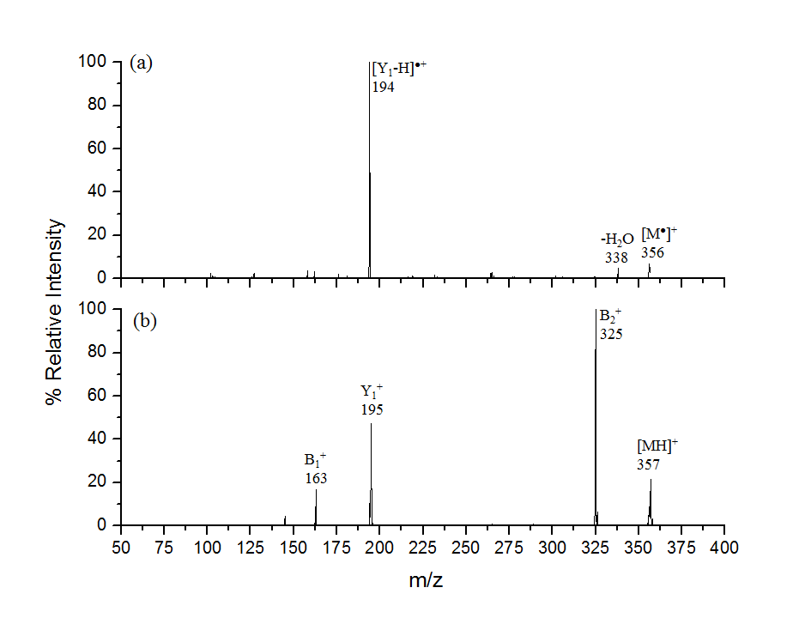
Figure 5: Comparison of the CID of the radical cation of the sugar and the protonated sugar for methyl β-cellobioside. CID mass spectrum of the (a) radical cation of methyl β-cellobioside ([M•]⁺; 356 m/z), MS⁴. CID mass spectrum of the (b) protonated methyl β-cellobioside cation ([M+H]⁺; 357 m/z), MS². The spectra were collected using an LTQ-FT-ICR hybrid mass spectrometer. The RCE value was 16%.

4. Conclusions

A new method has been developed for generating radical cations of sugars in the gas phase. The scope of this technique was explored by examining non-covalent complexes between sugars ranging from monosaccharides through to heptasaccharides and various S-nitrosylated thiolamines (Scheme 3). It is clear that no single S-nitrosothiolamine is ideal to form both the non-covalent radical cation complex, [H₃NXS•+M]⁺ (eq. 4) as well as the sugar radical cation, [M•]⁺ (eq. 8) and optimization needs to be performed to identify the best candidate for individual sugars. For the simple thiolamines, the linker length appears to play a role in both reactions as highlighted for the monosaccharide methyl α-D-galactopyranoside (compare Figures 3a and 3b, and 4a and 4b). The CID spectra of the [M•]⁺ of the disaccharide methyl β-cellobioside suggest that radical cleavage reactions are operative, but further work will be required to understand mechanistic aspects of the formation and subsequent fragmentation reactions of these sugar radical cations. Future studies will use isotope labelling and DFT calculations to examine the formation and fragmentation reactions of the radical cation of methyl α-glucopyranoside.

Acknowledgements:
RAJO thanks the Australian Research Council (ARC) for financial support via the ARC Centre of Excellence in Free Radical Chemistry and Biotechnology. SJW is an ARC Future Fellow and thanks the ARC for financial support.

References:
[1] (a) P. A. Finan, R. I. Reed, W. Snedden, Application of the mass spectrometer to carbohydrate chemistry, Chem. Ind. (1958) 1172; (b) P. A. Finan, R. I. Reed, Application of the Mass Spectrometer to Polysaccharide Chemistry, Nature, 184 (1959) 1866.
[2] For a review of the earlier EI/MS literature: H. Budzikiewicz, C. Djerassi and D. H. Williams, Structure Elucidation of Natural Products by Mass Spectrometry, Volume 2: Steroids, Terpenoids, Sugars, and Miscellaneous Classes, Holden-Day, San Francisco, 1964, Chapter 27, pp 203-240.
[3] (a) D. J. Harvey, Analysis of carbohydrates and glycoconjugates by matrix-assisted laser desorption/ionization mass spectrometry: An update for 2007–2008, Mass Spectrom. Rev., 31 (2012) 183–311; (b) M. J. Kailemia, L. R. Ruhaak, C. B. Lebrilla, I. J. Amster, Oligosaccharide Analysis by Mass Spectrometry: A Review of Recent Developments, Anal. Chem., 86 (2014) 196–212.
[4] B. Domon, C. E. Costello, A systematic nomenclature for carbohydrate fragmentations in FAB-MS/MS spectra of glycoconjugates, Glycoconj. J., 5 (1988) 397-409.
[5] (a) C. Zhao, B. Xie, S.Y. Chan, C.E. Costello, P.B. O’Connor, Collisionally activated dissociation and electron capture dissociation provide complementary structural information for branched permethylated oligosaccharides, J. Am. Soc. Mass Spectrom., 19 (2008) 138–150; (b) L. Han, C. E. Costello, Electron Transfer Dissociation of Milk Oligosaccharides, J. Am. Soc. Mass Spectrom. 22 (2011) 997– 1013.
[6] (a) J. J. Wolff, L. Chi, R. J. Linhardt, I. J. Amster, Distinguishing Glucuronic from Iduronic Acid in Glycosaminoglycan Tetrasaccharides by Using Electron Detachment Dissociation, Anal. Chem. 79 (2007) 2015– 2022; (b) J. J. Wolff, F. E. Leach, T. N. Laremore, D. A. Kaplan, M. L. Easterling, R. J. Linhardt, I. J. Amster, Negative Electron Transfer Dissociation of Glycosaminoglycans, Anal. Chem. 82 (2010) 3460– 3466; (c) J. T. Adamson, K. Håkansson, Electron Detachment Dissociation of Neutral and Sialylated Oligosaccharides, J. Am. Soc. Mass Spectrom. 18 (2007) 2162– 2172; (d) J. R. Kornacki, J. T. Adamson, K. Håkansson, Electron Detachment Dissociation of Underivatized Chloride-Adducted Oligosaccharides, J. Am. Soc. Mass Spectrom. 23 (2012) 2031– 2042.
[7] (a) B. J. Ko, J. S. Brodbelt, 193 nm Ultraviolet Photodissociation of Deprotonated Sialylated Oligosaccharides, Anal. Chem. 83 (2011) 8192– 8200; (b) A. Racaud, R. Antoine, L. Joly, N. Mesplet, P. Dugourd, J. Lemoine, Wavelength-tunable ultraviolet photodissociation (UVPD) of heparin-derived disaccharides in a linear ion trap, J. Am. Soc. Mass Spectrom., 20 (2009) 1645–1651; (c) Q. Enjalbert, C. Brunet, A. Vernier, A.-R. Allouche, R. Antoine, P. Dugourd, J. Lemoine, A. Giuliani, L. Nahon, Vacuum Ultraviolet Action Spectroscopy of Polysaccharides, J. Am. Soc. Mass Spectrom., 24 (2013) 1271-1279; (d) A. Racaud, R. Antoine, P. Dugourd, J. Lemoine, Photoinduced Dissociation of Heparin-​Derived Oligosaccharides Controlled by Charge Location J. Am. Soc. Mass Spectrom., 21 (2010) 2077-2084; (d) D. Ropartz, J. Lemoine, A. Giuliani, Y. Bittebiere, Q. Enjalbert, R. Antoine, P. Dugourd, M.-C. Ralet, H. Rogniaux, Deciphering the structure of isomeric oligosaccharides in a complex mixture by tandem mass spectrometry: Photon activation with vacuum ultra-​violet brings unique information and enables definitive structure assignment, Anal. Chim. Acta, 807 (2014) 84-95
[8] (a) I.K. Chu, C.F. Rodriquez, C.-T. Lau, A.C. Hopkinson, K.W.M. Siu, Molecular Radical Cations of Oligopeptides, J. Phys. Chem. B, 104 (2000) 3393 –3397; (b) C.K. Barlow, S. Wee, W. D. McFadyen, R. A. J. O’Hair, Designing Copper(II) Ternary Complexes to Generate Radical Cations of Peptides in the Gas Phase: Role of the Auxiliary Ligand, Dalton Trans., (2004) 3199-3204; (c) C.K. Barlow, R. A. J. O'Hair, W. D. McFadyen, The Formation of Cationic Peptide Radicals by Gas Phase Redox Reactions with Trivalent, Chromium, Manganese, Iron and Cobalt Complexes, J. Am. Chem. Soc., 127 (2005) 6109-6115; (d) K.W.M. Siu, A.C. Hopkinson, “Peptide Radical Cations", in Principles of Mass Spectrometry Applied to Biomolecules, ed. J. Laskin and C. Lifshitz, Wiley Interscience, 2006, Chapter 9; (e) I.K. Chu, J. Laskin, Formation of peptide radical ions through dissociative electron transfer in ternary metal-ligand-peptide complexes, Eur. Mass Spectrom., 17 (2011) 543-556; (f) Wee, S.; O'Hair, R. A. J.*; McFadyen, W.D., "Side Chain Radical Losses from Radical Cations Allows Distinction of Leucine and Isoleucine Residues in the Isomeric Peptides Gly-XXX-Arg.", Rapid Commun. Mass Spectrom., 2002, 16, 884-890.
[9] L. Feketeová, C.K. Barlow, T. Benton, S.J. Rochfort, R. A. J. O’Hair, The formation and fragmentation of flavonoid radical anions, Int. J. Mass Spectrom., 301 (2011) 174 – 183.
[10] R. Hodyss, H.A. Cox, J.L. Beauchamp, Bioconjugates for tunable peptide fragmentation: free radical initiated peptide sequencing (FRIPS). J Am Chem Soc. 127 (2005), 12436-12437.
[11] J. Gao, D.A. Thomas, C.H. Ho Sohn, J. L. Beauchamp, Biomimetic Reagents for the Selective Free Radical and Acid–Base Chemistry of Glycans: Application to Glycan Structure Determination by Mass Spectrometry, J. Am. Chem. Soc., 135 (2013) 10684–10692.
[12] (a) W. Buckel, B. T. Golding. Encyclopedia of Radicals in Chemistry, Biology and Materials, (Eds: C. Chatgilialoglu, A. Studer). Wiley, Chichester, 2012, Vol. 3, pp. 1501-1546; (b) G. M. Sandala, D. M. Smith, L. Radom. Encyclopedia of Radicals in Chemistry, Biology and Materials, (Eds: C. Chatgilialoglu, A. Studer). Wiley, Chichester, 2012, Vol. 3, pp. 1547-1576; (c) J. Stubbe. Ribonucleotide Reductases: Amazing and Confusing. J. Bio. Chem. 265 (1990) 5329; (d) S.S. Mao, T.P. Holler, G.X. Yu, J.M. Bollinger Jr., S. Booker, M.I. Johnston, J. Stubbe, A Model for the Role of Multiple Cysteine Residues Involved in Ribonucleotide Reduction: Amazing and Still confusing. Biochem. 31 (1992) 9733.
[13] (a) G. Giorgi, M. Speranza, Stereoselective noncovalent interactions of monosaccharides with hydrazine, Int. J. Mass Spectrom. 249–250 (2006) 112–119; (b) K.E. Gregory, A. Ostrinskaya, R.R. Kunz, Reagent assessment for detection of ammonium ion-molecule complexes, Rapid Commun Mass Spectrom., 27 (2013) 2797-2806.
[14] (a) S. J. Blanksby, G. B. Ellison, Bond Dissociation Energies of Organic Molecules, Acc. Chem. Res., 36 (2003) 255–263; (b) D. F. McMillen, D. M. Golden. Hydrocarbon Bond Dissociation Energies. Annu. Rev. Phys. Chem., 33 (1982) 493; (c) Y.-R, Luo, Handbook of bond dissociation energies in organic compounds. CRC Press, Boca Raton, 2003.
[15] M. Meot-Ner (Mautner), Update 1 of: Strong Ionic Hydrogen Bonds, Chem. Rev., 112 (2012) PR22.
[16] J.-M. Lü, J. M. Wittbrodt, K. Wang, Z. Wen, H. B. Schlegel, P. G. Wang, J.-P. Cheng. NO Affinities of S-Nitrosothiols: A Direct Experimental and Computational Investigation of RS-NO Bond Dissociation Energies. J. Am. Chem. Soc., 123 (2001) 2903.
[17] (a) V. Ryzhov, A. K. Y. Lam, R. A. J. O’Hair. Gas-Phase Fragmentation of Long-Lived Cysteine Radical Cations Formed via NO Loss from Protonated S-Nitrosocysteine, J. Am. Soc. Mass Spectrom., 20 (2009) 985; (b) A. Lam, V. Ryzhov, R. A. J. O’Hair. Mobile Protons versus Mobile Radicals: Gas Phase Unimolecular Chemistry of Radical Cations of Cysteine Containing Peptides. J. Am. Soc. Mass Spectrom., 21 (2010) 1296; (c) S. Osburn, J.D. Steill, J. Oomens, R.A.J. O’Hair, M.J. Van Stipdonk, V. Ryzhov. Structure and Reactivity of the Cysteine Methyl Ester Radical Cation, Chem. Eur. J., 17 (2011) 873; (d) S. Osburn, G. Berden, J. Oomens, R.A.J. O’Hair, V. Ryzhov. Structure and Reactivity of the N-Acetyl-Cysteine Radical Cation and Anion: Does Radical Migration Occur? J. Am. Soc. Mass Spectrom., 22 (2011) 1794; (e) S. Osburn, T. Burgie, G. Berden, J. Oomens, R.A.J. O’Hair, V. Ryzhov. Structure and Reactivity of Homocysteine Radical Cation in the Gas Phase Studied by Ion-Molecule Reactions and Infrared Multiple Photon Dissociation, J. Phys. Chem. A, 117 (2012) 1144; (f) S. Osburn, G. Berden, J. Oomens, R.A.J. O’Hair, V. Ryzhov. S-to-αC Radical Migration in the Radical Cation of Gly-Cys and Cys-Gly, J. Am. Soc. Mass Spectrom., 23 (2012) 1019; (g) S. Osburn, G. Berden, J. Oomens, K. Gulyuz, N.C. Polfer, R.A.J. O’Hair, V. Ryzhov. Structure and Reactivity of the Glutathione Radical Cation: Radical Rearrangement from the Cysteine Sulfur to the Glutamic Acid α-Carbon Atom, ChemPlusChem, 78 (2013) 970.
[18] (a) M.J. Robins, G.J. Ewing, Biomimetic Modeling of the First Substrate Reaction at the Active Site of Ribonucleotide Reductases. Abstraction of H3‘ by a Thiyl Free Radical, J. Am. Chem. Soc., 121 (1999) 5823–5824; (b) D. Pogockia, C. Schöneich, Thiyl radicals abstract hydrogen atoms from carbohydrates: reactivity and selectivity, Free Rad. Biol. Med., 31 (2001) 98–107; (c) S.F. Wnuk, J. A. K. Penjarla, T. Dang, A.M. Mebel, T. Nauser, C. Schöneich, Modeling of the ribonucleotide reductases substrate reaction. Hydrogen atom abstraction by a thiyl free radical and detection of the ribosyl-based carbon radical by pulse radiolysis, Collect. Czech. Chem. Commun., 76 (2011) 1223-1238.
[19] S. Osburn, R. A. J. O’Hair, Unleashing radical sites in non-covalent complexes: The case of the protonated S-nitrosocysteine/18-crown-6 complex, Rapid Commun. Mass Spectrom., 27 (2013) 2783.
[20] (a) K. A. Jebber, K. Zhang, C. J. Cassady, A. Chung-Phillips, Ab Initio and Experimental Studies on the Protonation of Glucose in the Gas Phase, J. Am. Chem. Soc., 118 (1996), 10515-10524; (b) S. Rudić, H.-B. Xie, R. B. Gerber, J.P. Simons, Protonated sugars: Vibrational spectroscopy and conformational structure of protonated O-methyl α-D-galactopyranoside, Mol. Phys., 110 (2012) 1609-1615.
[21] G. Bouchoux, J. Y. Salpin, Gas-phase basicities of polyfunctional molecules. Part 2: Saturated basic sites., Mass Spectrom. Rev. 31 (2012) 353-390.

