Plasmonic Gold Nanoparticles Decorated Ultrathin SnO₂ Nanosheets for Broadband Photodetection
Nitu Syed^{1,3,§}*, Gus O. Bonin^{2§}, Chung Kim Nguyen³, Mei Xian Low³, Jiajun Meng¹, Ali Zavabeti^{3,4}, Billy James Murdoch⁵, Anthony S. R. Chesman⁶, Shifan Wang⁷, Pallavi Punj¹, Kibret A. Messalea³, Sumeet Walia³, James Bullock⁷, Kenneth B. Crozier^{1,7}, Daniel E. Gómez², Ann Roberts¹*
¹ School of Physics, ARC Centre of Excellence for Transformative Meta-Optical Systems, The University of Melbourne, VIC 3010, Australia
²School of Science, RMIT University, Melbourne, VIC 3001, Australia
³School of Engineering, RMIT University, Melbourne, VIC 3001, Australia
⁴Department of Chemical Engineering, The University of Melbourne, Parkville, VIC 3010, Australia
⁵RMIT Microscopy and Microanalysis Facility, College of Science, Engineering & Health, RMIT University, Melbourne, VIC 3001, Australia
⁶CSIRO Manufacturing, Clayton, VIC 3169, Australia
⁷Department of Electrical and Electronic Engineering, The University of Melbourne, VIC 3010, Australia

Email: ann.roberts@unimelb.edu.au, nitu.syed@unimelb.edu.au
Keywords: Liquid metal; tin oxide; gold nanoparticles; hot electrons; COMSOL simulation

Abstract
Two-dimensional (2D) transparent semiconducting oxides have attracted considerable attention in multifunctional electronic and optoelectronic devices owing to their exciting physical properties and excellent stability. However, due to their wide bandgap, absorption in the visible region is very limited. Here, we show enhanced light−matter interactions by integrating plasmonic gold nanoparticles onto ultrathin 2D SnO₂ nanosheets, leading to higher optical absorption in the visible spectra. In this work, a vacuum-free liquid metal printing technique is used to deposit large-area ~1.9 nm thick SnO₂ nanosheets, which were then decorated with gold nanoparticles utilizing an electrostatic self-assembly technique. The enhancement of the electric field due to localized surface plasmon resonance and the migration of plasmon-induced hot electrons at the Au−SnO₂ interface is verified utilizing COMSOL simulations. Moreover, experimental observations of fabricated photodetectors based on Au−SnO₂ hybrid structure demonstrate a broadband spectral response ranging from ultraviolet to visible wavelengths. In particular, we observe an improved room temperature photoresponsivity of ∼950 mA W⁻¹ and a 17-fold enhancement in photocurrent at 400 nm wavelength as compared to bare SnO₂. This work provides a viable route to tune the optical properties of wide bandgap 2D functional oxides, making them attractive for large-area nanoscale broadband photodetectors and optoelectronic devices.

Introduction
Two-dimensional (2D) materials have been intensively investigated for their intriguing optoelectronic properties, originating from their atomic-scale thickness and morphology.^{1, 2} Recently, various 2D metal oxides have established themselves as promising building blocks for various optoelectronic applications, specifically in the photodetection domain.³ However, most of these ultrathin metal oxides absorb only a limited fraction of incident light due to their nano-scale thickness, hindering applications in efficient light-driven devices, particularly in the visible spectra.⁴ Hence, effectively increasing the light-matter coupling without compromising other beneficial aspects of these 2D structures has become a crucial issue.⁴

Till now, several surface modification approaches have been reported to improve the performance and efficiency of various nano optoelectronic devices.^{4, 5,6} Among various strategies to enhance the light–matter interaction, integrating various plasmonic nanostructures onto the 2D surface has drawn considerable interest as a means to improve the photoresponsivity.^{7, 8} These hybrid nanostructures demonstrate unique optical characteristics originating from the combination of plasmonic optical effects and unique physicochemical properties of the ultrathin nanomaterials. More importantly, plasmonic electrical effects, including enhanced photogeneration rate, formation of highly localized electromagnetic (EM) fields, efficient charge transfer and plasmon-induced hot electrons, play a significant role in augmenting performance in hybrid photoelectric devices.^{9,10, 11} To date, the integration of plasmonic metal structures with nanomaterials has focused primarily on monolayer and few layer van der Waals stacked 2D layered materials such as graphene, boron nitride (hBN) and transition metal dichalcogenides (TMDs). These van der Waal structures have widely been investigated for various applications including optical sensors, photocatalysis, photodetectors with improved responsivity, and enhanced photocurrents.¹²⁻¹⁸ However, the incorporation of noble metal nanoparticles on visibly transparent non-layered semiconducting oxides (TSOs) has hardly been reported. Such hybrid systems could potentially overcome problems associated with weak light absorption in TSOs and have a substantial impact on widespread application in photonic devices.³

Tin dioxide (SnO₂) is a technologically important n-type, transparent semiconducting oxide.¹⁹⁻²¹ However, SnO₂ faces limitations in the photodetection capability, as its wide bandgap permits operation only within the ultra-violet (UV) spectra. Recently, liquid metal printing has attracted significant attention, offering a vacuum-free route to deposit ultrathin (<5 nm thickness) transparent semiconducting oxides.²²⁻²⁶ The printing technique relies on the Cabrera-Mott oxidation of metals resulting in the formation of a thin, flat, and self-passivating oxide skin across the metal surface^{27, 28} which can readily be transferred to target substrates with minimal imperfections.^{22, 23, 28}
In this work, a vacuum free liquid metal printing technique is utilized to harvest ~1.9 nm thick SnO₂ nanosheets from the surface of molten tin. The printing technique facilitates the deposition of SnO₂ with lateral dimension of over 1cm². Next this large area 2D SnO₂ were decorated with plasmonic gold nanoparticles (AuNP) utilizing a scalable electrostatic self-assembly technique. Next, photodetectors are fabricated with SnO₂ nanosheets decorated with AuNP which show photoresponse over a broad spectral range from the UV to visible. A noteworthy improvement in photocurrent up to ~1500% with a maximum responsivity of 950 mA W⁻¹ is observed in the visible wavelength (400 nm). This can be attributed to the surface plasmon resonance of the gold nanoparticles which leads to the enhancement of large local field in Au-SnO₂ interface enabling significant absorption of electromagnetic waves. Excitation of localized surface plasmons in AuNP further promotes the migration of hot electrons into the semiconducting SnO₂ improving the photodetector’s overall performance. As such, we demonstrate the realization broadband UV and visible light photodetection platform utilizing a low-cost and scalable fabrication route. Moreover, this study will enable the production of next-generation nano optoelectronic devices including plasmonic gas sensors, photosensors and photocatalysis.

Results and discussions
The deposition of 2D tin dioxide (SnO₂) nanosheets was performed by exploiting a liquid metal-based van der Waals exfoliation technique (Supporting Fig. S1a) in an ambient atmosphere.^{28, 29} This printing process utilizes the spontaneous growth and subsequent exfoliation of the 2D tin oxide skin grown on a droplet of liquid tin (see Experimental section). In this experiment, tin metal was heated to 280 °C on a hot plate, and the 2D tin oxide was exfoliated immediately from the freshly preconditioned²⁹ molten tin onto suitable substrates (e.g. quartz or SiO₂/Si). The touch printing technique enables the deposition of continuous nanosheets across a large lateral plane exceeding 1 cm² area (Supporting Fig. S1) and results in highly reproducible tin oxide nanosheets with an average thickness of ~1.9 nm (Supporting Fig. S2a). It has, however, been reported that the liquid metal-derived SnO_{x} consists of both tin monoxide (SnO) and tin dioxide (SnO₂) under ambient conditions.^{29, 30,31} Hence, the 2D SnO_{x} nanosheets were subjected to post-thermal annealing at 450°C for 15 min in ambient air to promote the formation of the SnO₂ phase³², a process which is validated via various characterization methods (Supporting Fig. S2).

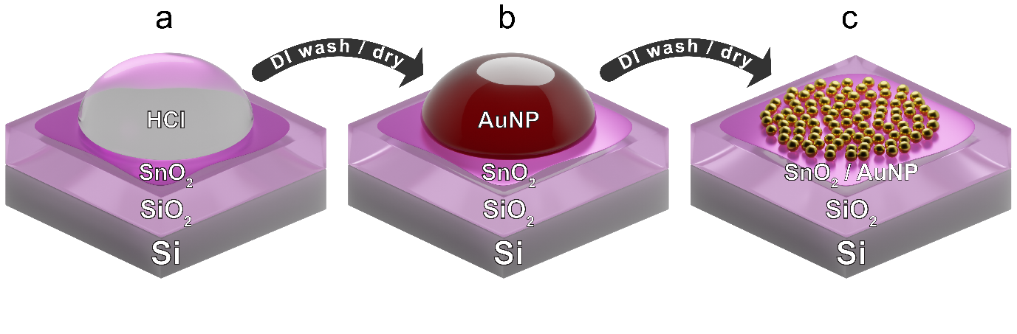

Figure 1. Step-by-step procedure for the electrostatic self-assembly of gold nanoparticles with the a) modification of tin dioxide surface charge from exposure to dilute hydrochloric acid (HCl), b) substrate exposure to a concentrated nanoparticle dispersion and c) resulting self-assembled monolayer of gold nanoparticles after washing and drying.

Next an efficient surface modification approach was introduced to incorporate plasmonic nanoparticles on the SnO₂ film. A four-step electrostatic self-assembly technique³³ (Fig. 1a-c) was used to prepare a gold nanoparticle (AuNP) decorated SnO₂ film (Au-SnO₂). During the self-assembly process, the deposited SnO₂ film first undergoes acidic pre-treatment using dilute HCl to clean and hydrogenate its surface, effectively inducing a uniform positive surface charge (Fig. 1a). Next, the electrostatic stability of concentrated colloidal Au nanoparticles is manipulated through the addition of NaOH, where an increase in pH deprotonates and increases the negative charge of the citrate ligands on the surface of the nanoparticles, and the increased ionic concentration reduces their Debye shielding length. After washing the acid solution from the substrate surface, the colloidal gold / NaOH mixture is then drop cast onto the SnO₂ surface and left undisturbed for 3 hours (Fig. 1b) before finally washing and drying the substrate surface, leaving a closely packed monolayer of gold nanoparticles (Fig. 1c).
During the exposure of the SnO₂ to the nanoparticle solution, the self-assembly of citrate-capped Au nanoparticles is driven by an interplay between two electrostatic interactions: i) the electrostatic attraction between the negatively charged gold particles and the positively charged SnO₂ surface, which drives the Au monolayer formation, and ii) the interparticle repulsion of like-charged gold particles in solution, which prevents nanoparticle aggregation on the substrate surface, preventing AuNP multilayer formation. By fine-tuning the interplay of the nanoparticle−substrate attraction and interparticle stability (proportional to the concentration of NaOH in the Au nanoparticle solution), electrostatic self-assembly of the nanoparticles was achieved.
This self-assembly strategy was easily scaled to an area of several square millimeters (mm²) as evidenced by optical microscopy (Fig. 2a) which shows large-area 2D SnO₂ films (deposited on SiO₂/Si substrates) covered with AuNP. The optical micrograph further confirmed that the nanosheet retained its original morphology with self-assembled AuNP, while the color contrast had changed from light blue (Supporting Fig. S1a) to a green hue in the presence of AuNP. The darkfield image indicated the distribution of the homogeneous nanoparticles over the SnO₂ film, where their capacity to scatter light results in a brightly colored surface image (Supporting Fig. S3). The as-synthesized oxide surfaces were found to be very compatible with the electrostatic self-assembly process. The corresponding high magnification SEM images of the Au-SnO₂ (Supporting Fig. S4a) reveal that mostly ellipsoid shaped gold nanoparticles are randomly distributed on the surface of the SnO₂. The statistical analysis of over more than two hundred nanoparticles (shown in Fig. 2c and Supporting Fig. S4a) are indicative of an approximately monodisperse distribution of particle dimensions with an average diameter of 71 ± 10 nm and 49 ± 5 nm along the long and short dimensions, respectively. The average thickness of the nanoparticles was measured to be ~ 40 ± 5 nm with ~15% surface coverage. The electrostatic self-assembly process is adopted from previous literature³³ which demonstrated the ability of the nanoparticles to absorb light is largely impacted by its surface coverage. Higher absorption is obtained when nanoparticle surface coverage remained below 50%.³³ Hence, during self-assembly, we aimed to introduce as many nanoparticles as possible to contribute to plasmonic absorption, where close interparticle spacing introduces further near-field enhancements and, consequently significantly stronger absorption.^{34, 35} However, if the nanoparticles are too closely spaced and form aggregates, this can significantly hinder absorption³³ and provide pathways for sensing structures to short circuit. On the other hand, very low concentration of nanoparticles would not contribute enough to enhance the optical absorbance of the Au-SnO₂.
Fig. 2d shows the topography image of the Au-SnO₂ obtained using AFM which clearly confirms the presence of AuNP on SnO₂. The morphological structure of the hybrid nanostructured Au-SnO₂ sample was further analyzed by transmission electron microscopy (TEM). Fig. 2e depicts the TEM image of Au-SnO₂ and shows the presence of Au on SnO₂. The high-resolution TEM (HR-TEM) (insets of Fig. 2e) of the lattice fringes taken from the SnO₂ film and AuNP clearly show the 0.27 nm (101) plane of SnO₂³⁶ and the 0.24 nm (111) plane of AuNP.³⁷ The AFM and TEM both confirm the uniformity of the SnO₂, and the self-assembled AuNP did not change or damage the morphology of the nanosheets.

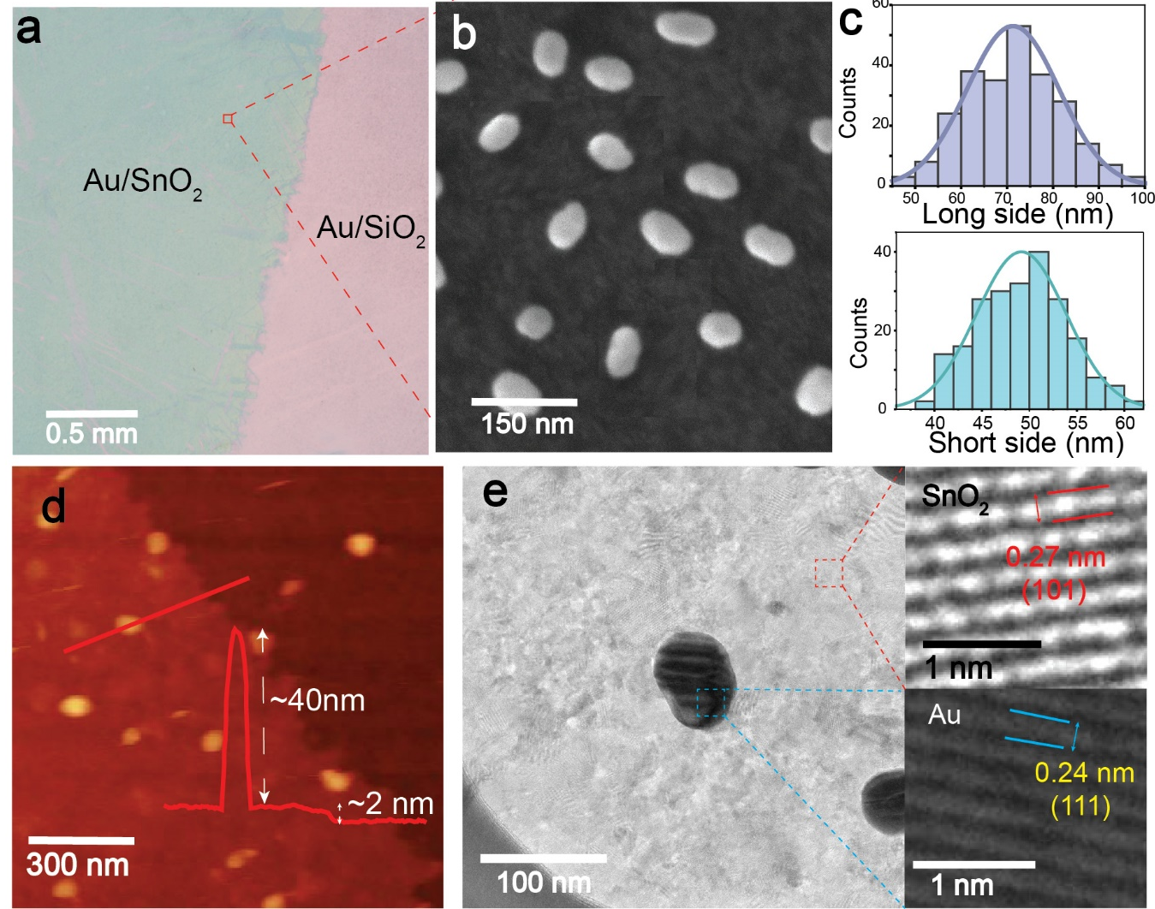

Figure 2. Characterizations of AuNP on the SnO₂ surface. a) Optical bright-field image of 2D SnO₂ film decorated with AuNP prepared on 300 nm SiO₂/Si substrate. b) SEM image of the hybrid Au-SnO₂ film. c) The diameter distributions of the AuNP. d) AFM showing the presence of AuNP on top of SnO₂ film with the corresponding step height profile of the film and gold nanoparticles. e) TEM image of Au-SnO₂. The top and bottom insets show the lattice fringes taken from the SnO₂ film and AuNP, respectively.

The elemental composition and nature of chemical bonding in Au-SnO₂ hybrids have been explored using X-ray photoelectron spectroscopy (XPS), which reveals the presence of Sn 3d, Au 4f, and O 1s spectral peaks. Fig. 3a shows the XPS spectrum of the Sn 3d energy state, revealing two symmetrical peaks located at 487.01 and 495.5 eV, consistent with the Sn 3d_{5/2} and Sn 3d_{3/2} states, respectively. Further, the peak-to-peak separation between Sn 3d_{5/2} and Sn 3d_{3/2} is 8.49 eV, which can be attributed to the Sn⁴⁺ state of SnO₂ consistent with earlier reports.³⁸ Fig. 3b shows the O 1s spectrum, which contains peaks associated with various oxygen species for the Au-SnO₂ structure. The peak at ~531.1 eV relates to oxygen bound to Sn⁴⁺ in SnO₂,³⁸ while the peak at ~532.4 eV is related to the oxide layer on the Si/SiO₂ substrate. The spectrum of Au 4f (Fig. 3c) of the Au-SnO₂ film can be deconvoluted into two peaks located at 83.8 eV and 87.50 eV, which correspond to Au 4f_{7/2} and Au 4f_{5/2}, respectively. The energy positions of the Au 4f peaks demonstrate that the Au coupled with the tin oxide film is in the metallic state with spin-orbit splitting energy of 3.7 eV.³⁹

The optical properties of the SnO₂ and Au-SnO₂ were explored using UV-Vis-NIR absorption spectroscopy (Fig. 3d). Both of the samples showed a high absorption peak in the UV region, which can be attributed to the band edge absorption of SnO₂ consistent with previous literature.¹⁹ However, there is an additional absorption feature in the range of 300-400 nm, attributed to indirect transitions involving defect energy bands associated with gap states generally observed in non-stoichiometric SnO₂.⁴⁰ The SnO₂ exhibits negligible absorption at wavelengths >400 nm. While the absorption spectrum of the Au-SnO₂ displays an enhanced absorption in the visible spectrum, in the range of ~480–580 nm with a maximum absorption at ~530 nm, attributed to the excitation of localized surface-plasmon resonance (SPR) of the gold nanoparticles. The absorbance spectrum of self-assembled gold nanoparticles is provided in Supporting Fig. S5 showing high baseline level of absorption leading to an upward shift of the total absorbance of Au-SnO₂ hybrid system. The Au-SnO₂ has an asymmetric absorption resonance due to nanoparticle size dispersity, and their slight oval shape resulting from their synthesis.^{41,42} The appearance of the additional absorption feature in Au-SnO₂ at longer wavelengths (>650 nm) could potentially be attributed to the presence of inter-plasmon coupling effects from the aggregation of gold nanoparticles.⁴³ The oscillations of the conduction electrons in adjacent gold nanoparticles often generate an extra red-shifted absorbance associated with the number of aggregated nanoparticles and the position of their longitudinal SPR modes.⁴³

An energy band diagram for the synthesized SnO₂ before decoration with AuNP is proposed based on UV-vis spectroscopy, VB XPS and photoemission spectroscopy in air (PESA) analysis (Supporting Fig. S6-S7). PESA revealed that the work function (ϕ_{M}) of the gold nanoparticles is approximately 4.7 eV which matches well with previous report.⁴⁴ The Fermi level of 2D SnO₂ was measured to be 4.94 eV, consistent with literature.⁴⁵ The VBXPS and UV-Vis were next used to determine the energy band diagram of the 2D SnO₂. VBXPS indicates the difference of valence band maximum (E_{VBM}) and Fermi level which is found to be ~3.3 eV resulting in the location of valence band edge at E_{VBM} = -8.24 eV with respect to the vacuum (Fig. S6c). Based on the measured direct optical bandgap of E_{g} ≈ 3.9 eV (Supporting Fig. S6d) for the SnO₂, we expect the conduction band minimum (E_{CBM}) to be situated at E_{CBM} = -4.34 eV.

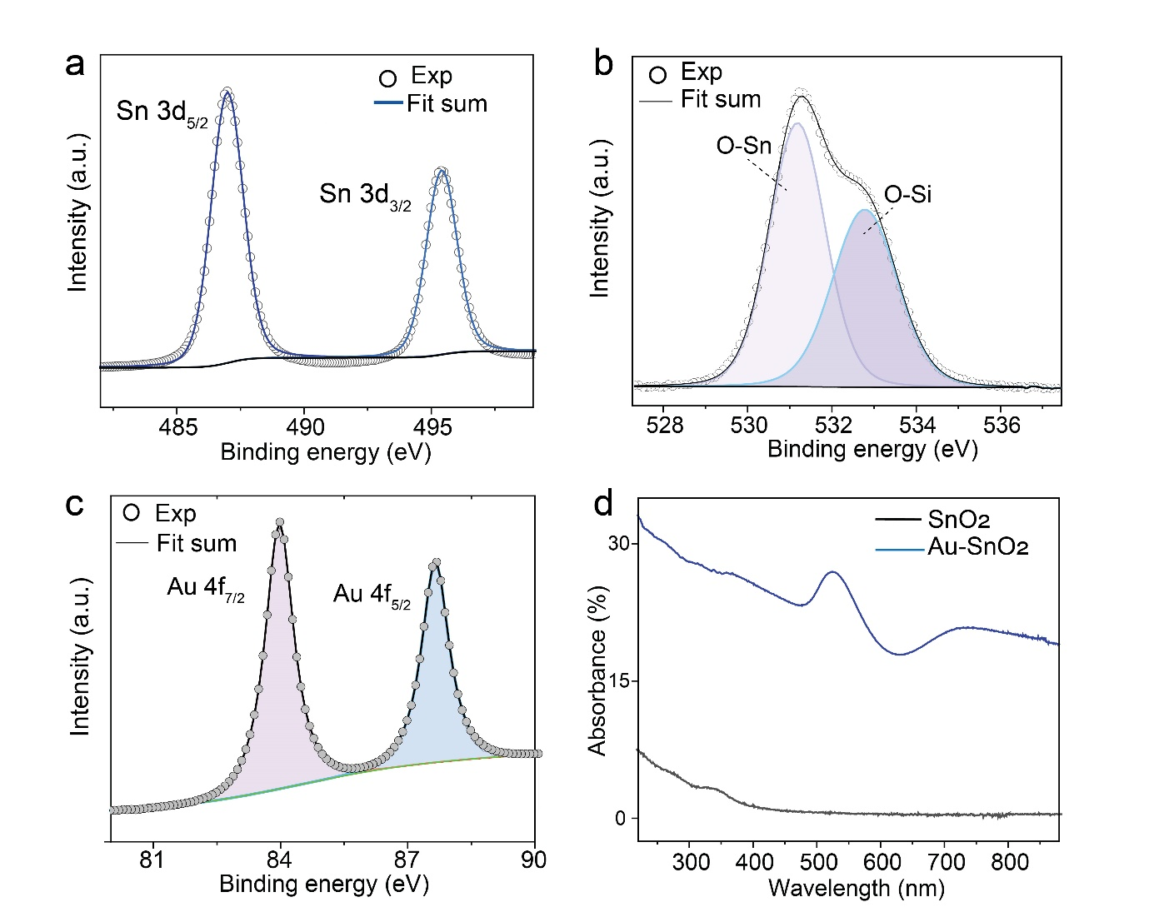
Figure 3. XPS spectra for the Au-SnO₂ hybrid structure for a) Sn 3d, b) O 1s and c) Au 3f core level. d) UV-vis spectra of the SnO₂ nanosheets and Au-SnO₂ where absorbance of SnO₂ nanosheets was acquired using UV-vis Cary spectrophotometer (black line). While an integrating sphere was used to obtain the absorbance of Au-SnO₂ (blue line) where reflection (R) and transmission (T) of light were considered, and the optical absorption (A) for Au-SnO₂ was subsequently calculated as: A = 1 – (R+T).

To further understand this enhanced absorption mechanism in the Au-SnO₂ structure, numerical simulations were obtained through the full-wave, finite element method solution of Maxwell equations, as implemented in COMSOL Multiphysics (simulation details in the Experimental section).³³ Here, the light−matter interactions are investigated for ellipsoid shaped Au nanoparticles (70 nm diameter with 40 nm thickness) on an atomically flat layer of SnO₂ (with thickness of 2 nm, consistent with the AFM and SEM images). In order to investigate the spatial distributions of energy and hot electrons in the structure, we simulate the distributions of normalized electric field (Fig. 4a), absorbed power (Fig. 4b) and hot electron generation rate (Fig. 4c) in one periodic unit of the structure. The plots were obtained at free-space wavelengths close to resonance (530 nm) and off-resonance (285 nm and 700 nm). Numerical calculations show strong enhancement in absorption in visible wavelength for the Au-SnO₂ system with plasmon resonance peak at ~530 nm (Supporting Fig. S8). The corresponding simulated absorption spectra is in broad agreement with the experimental measurements as shown in Fig. 3d. The simulations indicate strong confinement of the electric field in the vicinity of Au-SnO₂ interface at 530 nm, indicating the presence of surface plasmon resonance. These near-field excitations close to the Au-SnO₂ interface are capable of enhancing the charge carrier excitations and yielding a high photon-to-electron conversion efficiency. A considerable amount of power dissipation was observed in the gold nanoparticles at 285 nm and 530 nm, which would correspond to absorption inside the gold nanoparticle (Fig. 4b). The hot spots of the power dissipation are pushed down toward the Au−SnO₂ interface at the resonance wavelength which signifies that the light is trapped in close proximity of the gold nanoparticles. Moreover, Fig 4c shows highly confined hot spots at the plasmon resonance wavelength indicating hot electrons are generated in the vicinity of the semiconductor-metal interface. The stronger field intensity signifies a higher rate of plasmon induced hot carrier formation. ^{42, 46} This hot electron generation rate G($\vec{r}$, $ω$) is calculated by ⁴⁷
$$G(\vec{r},ω)=\frac{ε_{i}{\left|\vec{E}\left(\vec{r},ω\right)\right|}^{2}}{2ℏ},$$
where $ε_{i}$ is the imaginary part of the permittivity of Au, ω is the angular frequency of incident light, $\left|\vec{E}\left(\vec{r},ω\right)\right|$ is the electrical field density at the position $\vec{r}$ and $ℏ$ is the reduced Planck constant.

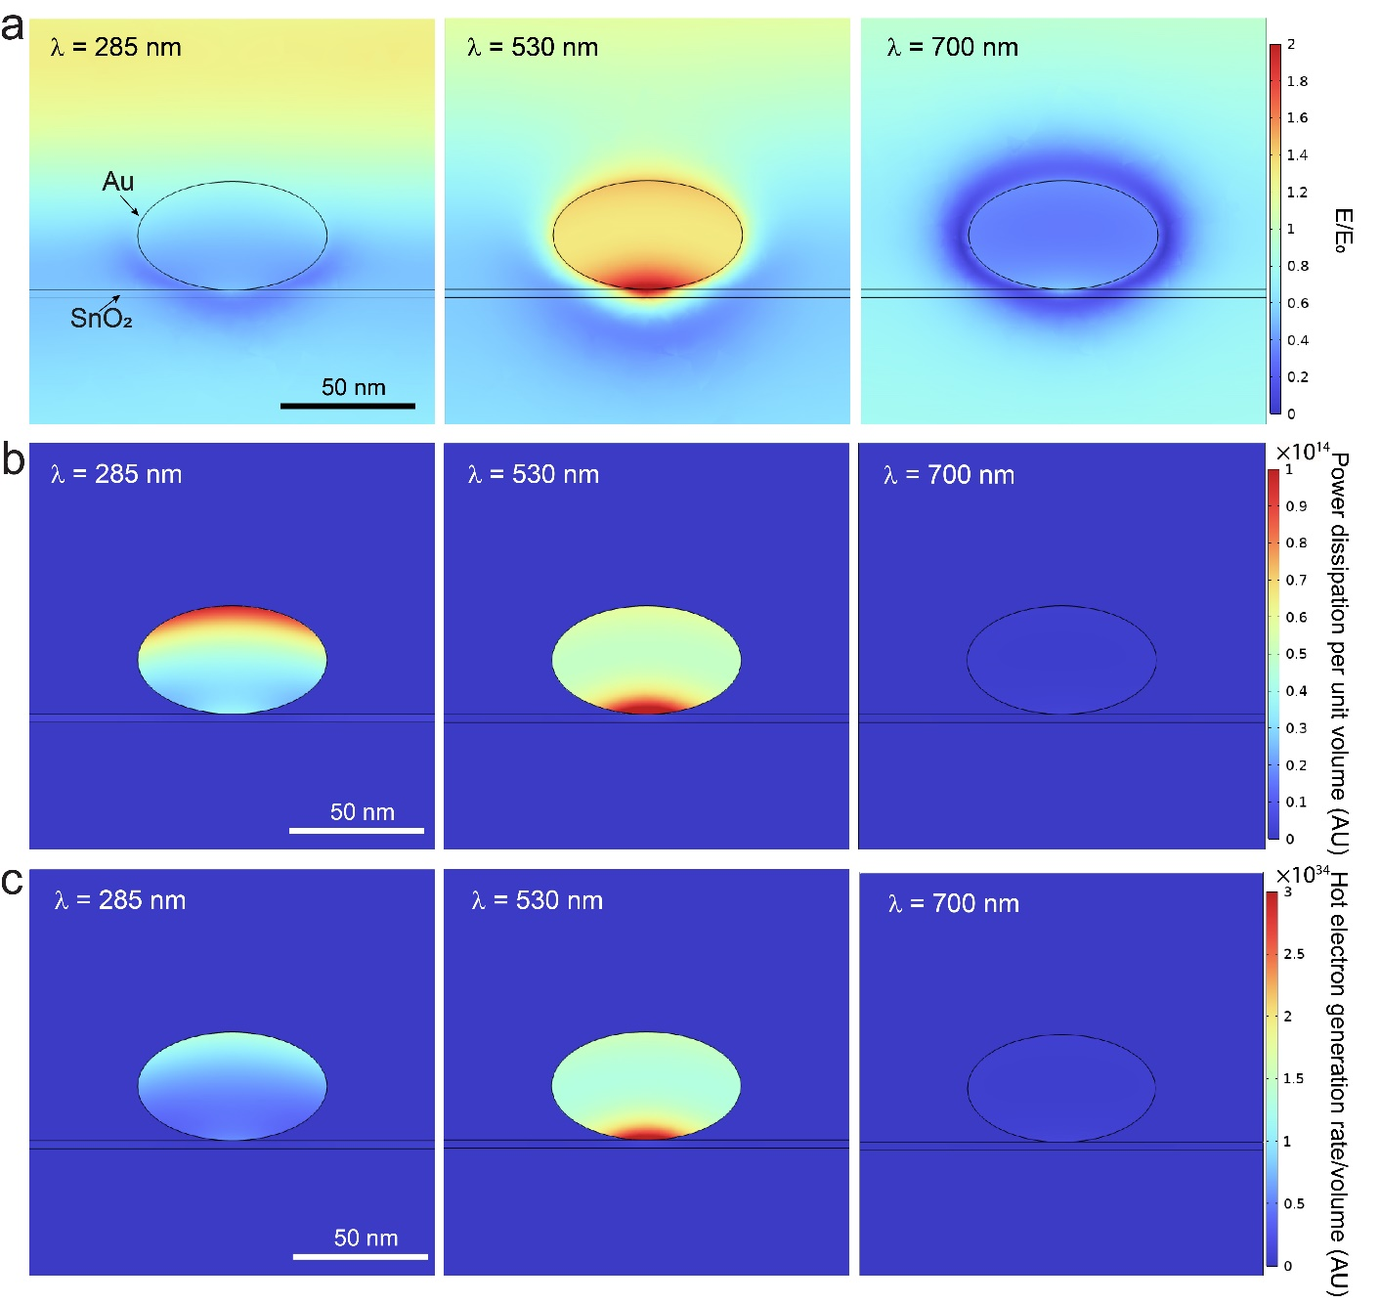
Figure 4. COMSOL simulations to demonstrate the enhanced light-matter interaction in Au-SnO₂. a-c) Cross-sections showing the magnitude of the electric field, power dissipation density and hot electron generation rate in the Au-SnO₂-SiO₂ system at different wavelengths on- (530 nm) and off- (285 nm and 700 nm) resonance.

To confirm the effect of SPR on the enhancement of the photodetector performance, photodetectors utilizing 2D SnO₂ were fabricated with and without gold nanoparticles. The device consists of interdigitated electrodes as shown in Supporting Fig. S9a. Firstly, the photo responses of the SnO₂ photodetectors without and with AuNP are characterized using UV light emitting diode (LED) sources of 285 nm. The I–V characteristics under dark and UV illumination are depicted in Supporting Fig. S9b. The Au-SnO₂ photodetector showed a 5-fold enhancement in the photocurrent at 285 nm wavelength with an enhanced photoresponsivity of 1.6×10³ A W⁻¹ (Fig. 5b). The photoresponse at 285 nm wavelength as a function of illumination power intensity have been presented in Fig. S9c. The origin of higher UV photoresponse of Au-SnO₂ device in comparison to bare SnO₂ possibly emerge from the inter-band transition of gold d-band electrons in the UV spectra.^{48, 49} The d-band electrons of gold nanoparticles are excited to the conduction band upon UV excitation, which migrate to SnO₂ layer due to the existence of electric field at the metal-semiconductor interface, leading to higher photoconductivity. While in bare SnO₂, the photoresponsivity in UV region is ascribed to the band edge absorption and hence much lower than the Au-SnO₂ heterostructure. In addition, there is a possibility that the photogenerated holes in the SnO₂ are trapped by the AuNP, which inhibit the electron-hole recombination resulting in a greater number of free charge carriers and eventually improves the photocurrent in the UV region.⁵⁰
Next the visible photoresponse of the fabricated photodetectors were evaluated by a laser-driven white light source ranging from 400-700 nm (the schematic of the visible light photodetection setup is provided in the Supporting Fig. S10). All measurements were taken at room temperature with an applied voltage bias of 0.5 V. The power density of each visible light wavelength is provided in Supporting Tables S1 and S2. The time-dependent photocurrent (I_{ph}–t) characteristics for the Au-SnO₂ at different visible wavelengths has been demonstrated in Fig 5c. For the SnO₂ device, photocurrents at visible wavelengths are insignificant compared to the UV response, which is expected due to the wide bandgap of the as-grown SnO₂ films. The SnO₂ based photodetector shows a $I_{ph}$ of ~4.6 μA at 400 nm excitation. Small photocurrent in bare SnO₂ nanosheets beyond the UV range is consistent with the trap states associated with defect levels,⁴⁰ which can play a significant role in the excitonic generation and recombination events that occur in a photodetector. However, the photocurrent in bare 2D SnO₂ device dramatically decreases beyond 500 nm with $I_{ph}$ falling to near zero at longer wavelengths (Supporting Table S1) due to prohibition of the absorption of photons.
In contrast, an evident improvement in photocurrent under the visible-light excitation of ~400-600 nm is observed for Au-SnO₂ (Fig 4c and Supporting Table S2). Here, a maximum photo-current of ~75.5 μA was obtained at ~400 nm, which is nearly 15 times higher than that of the pristine SnO₂ film with all operating conditions being identical. The percentage enhancement of photocurrents for different visible wavelengths in Au-SnO₂ in comparison to bare SnO₂ is provided in Supporting Table S3. The responsivity (R), an important parameter for evaluating the sensitivity of the detector, was determined by measuring the ratio of the photocurrent to the intensity of the light source at a certain wavelengths, R =$\frac{I_{ph}}{P×A}$ where P being the power density of the light source and A is the active area illuminated to light.⁵¹ Further to the improved photocurrent, decorating the SnO₂ film with AuNP improved the responsivity in comparison to pristine SnO₂ (Fig. 5d). The maximum responsivity of Au-SnO₂ photodetector is calculated ~950 mA W⁻¹, whereas that of the bare SnO₂ device is ~61 mA W⁻¹ at 400 nm. The multiple on-off cycle of the Au-SnO₂ photodetectors for red (625 nm), green (550 nm) and blue (450 nm) light is shown in Fig. 5e. The device exhibits stable and repeatable switching characteristics under visible light irradiation indicating the recovery of the initial states after different visible-light illuminations were turned off. The detailed figures of merit (FoM) for all three parameters of responsivity (R), detectivity (D*), external quantum efficiency (EQE) including the rise and fall times for different visible wavelengths are provided in Supporting Table S2.
Supporting Table S4 shows a performance comparison of the Au-SnO₂ photodetector fabricated in this work and the previously reported photodetectors decorated with plasmonic nanoparticles. However, the results are not directly comparable as the fabricated photodetectors have different sizes, dimensions, structures, and contact electrodes, but significant enhancement to the photocurrents of the plasmonic nanoparticle decorated devices is observed. Here, it is important to note that the detection performance of the device reported in this study is not the highest. However, this is the first time where ultrathin, wide-bandgap semiconducting 2D metal oxide decorated with plasmonic metal nanoparticles has been used for broadband UV-visible photodetection with suitability for large-scale fabrication. Further experimental analysis to investigate the impact of different nanoparticle concentrations on the performance of Au-SnO₂ photodetector should be considered in future work.
The enhancement of the UV photodetection and the extension of spectral sensitivity to visible-light photodetection can originate from one or more of the following processes: (1) generation of excitons in the SnO₂ by a two-photon process; (2) photoexcitation of filled mid-gap trap states correlated with SnO₂ defects; (3) augmentation of the local optical field in the vicinity of AuNP, where the localized surface plasmon resonance enhances the light absorption of the SnO₂ layer underneath, and lastly (4) the charge transfer between the gold nanoparticles and SnO₂ due to hot electron generation.¹⁷ However, the negligible photocurrents produced by visible light illumination of SnO₂ devoid of AuNP indicate that the formation of photoexcited electron hole pairs associated with the first two processes cannot be a major contributor. Hence, the improved photocurrents for Au-SnO₂ are associated with surface plasmon excitation of AuNP which is further accompanied by the injection of plasmonic hot electrons.⁴⁶
The localized surface plasmon of the gold leads to the collective oscillation of conduction electrons in metal nanoparticles. Light is trapped inside the AuNP due to this oscillation, leading to a stronger local electric field at Au-SnO₂ interface effectively improving the light absorption of SnO₂.¹⁵ However, surface plasmon has finite lifetime and the nonradiative decay can lead to the formation of an hot electron–hole pair in the metal where the hot electrons behave as free particles.^{42, 47, 52} To obtain a better understanding of the generation and transport processes of hot electrons in Au-SnO₂ interface, a detailed band diagram is shown in Fig. 5f. The work function of AuNP and SnO₂ were found to be ~4.7 eV and ~4.94 eV, respectively, leading to a conduction band of SnO₂ bending downward at the interface.⁵³ Given the nanoparticle’s Fermi level is higher than that of the bare SnO₂ (E_{f-SnO} < E_{f-AuNP}), electrons will flow from the nanoparticles into the SnO₂ until the Fermi levels of metal and semiconductor are aligned.⁵⁴ This flow of charge causes the Fermi level of the SnO₂ to increase toward that of the gold nanoparticles, supported by the PESA measurements of Au-SnO₂ (pink dotted line, Fig. 5f). Gold exhibit large optical absorption in visible spectra (~530nm) due to the excitation of localized surface plasmons and hence electrons in the SP band of the AuNP can be excited using visible light.⁵⁵ When the Au-SnO₂ device is illuminated, photons are absorbed by the gold nanoparticles and plasmon induced hot carriers are generated.⁵² Excited electrons transport to the empty states in the metal’s conduction band, leaving behind the same number of holes under the Fermi level (hot holes).^{56, 57} Hot electrons with an energy exceeding the barrier height can migrate across the Au-SnO₂ heterojunction and diffuse in the active semiconducting channel of SnO₂ film.⁴ Whereas the holes generated in the d-shell, have a large effective mass and smaller kinetic energy with a very short mean free path.^{56, 57} In addition, the hot holes encounter a large valence band offset lowering the emission probability in the Au-SnO₂ junction.⁵⁸ Hence, the hot holes generated inside the metal have a very slim chance of contributing to the photocurrent in the n-type semiconductor. The presence of enhanced electric field at plasmon resonance and hot electron generation at the vicinity of the Au-SnO₂ at resonance wavelength is further validated by the COMSOL simulation (Fig 4a-c). While at the off-resonance condition, insignificant absorbance of photons by AuNP results in a negligible photocurrent enhancement.

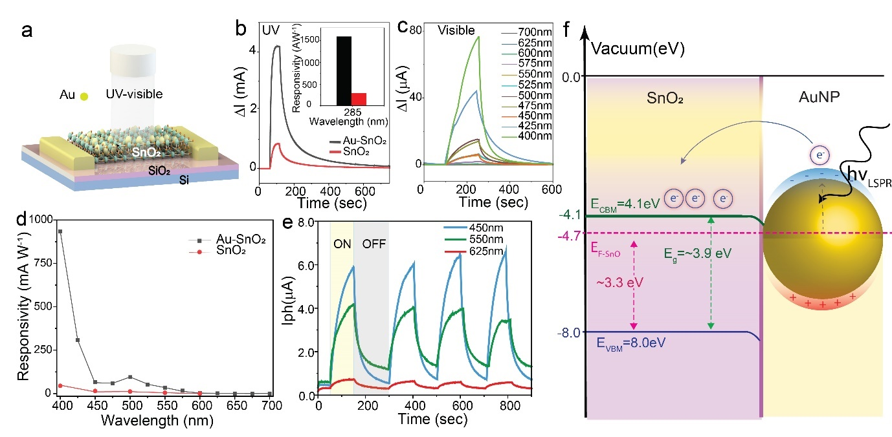
Figure 5. Photodetection performance of Au-SnO₂. (a) The schematic structure of the photodetector device. (b) Photocurrent obtained at UV wavelength of 285 nm. (c) Photocurrent obtained at different visible wavelengths. (d) Responsivity obtained at different visible wavelengths for SnO₂ and Au-SnO₂. (e) Multiple on/off photocurrent cycles of the photodetector measured at red (625 nm), green (550 nm) and blue (450 nm) wavelengths operated at V_{ds}=0.5V. (f) Hot electron injection into the 2D SnO₂ film from gold nanoparticles. Self-assembled gold nanoparticles are illuminated by appropriate low-energy visible light to excite their local surface plasmon resonance. Hot electrons are dissociated from the gold nanoparticle and harvested by the SnO₂ when excited by surface plasmon resonance wavelengths.

Conclusion
In summary, we demonstrated the successful incorporation of gold nanoparticles onto liquid-metal-derived, wide bandgap 2D tin dioxide nanosheets, enhancing their photodetection capability into the UV-visible spectra. Colloidal gold nanoparticles were arranged on a ~2 nm thick SnO₂ nanosheet via electrostatic self-assembly process offering great potential for depositing plasmonic nanoparticles over several square millimeters (mm²). The dispersed gold nanoparticles were clearly observed and characterized by electron microscopy, with spectroscopic data further supporting the presence of their local surface plasmon resonance. Photodetectors fabricated utilizing the Au-SnO₂ hybrid structure demonstrated superior photoresponsivity of up to ~950 mA W⁻¹ along with a 17-fold enhancement in photocurrents in the visible wavelength (400 nm) compared to that found in bare SnO₂. The enhancement of local field due to surface plasmon resonance enabled significant absorption of electromagnetic waves at the Au-SnO₂ interface. Furthermore, plasmonic hot carrier generation and the migration of hot electrons to the adjacent semiconducting SnO₂ supplemented the performance of the photodetectors. Theoretical simulations based on COMSOL Multiphysics further validated the presence of intense electromagnetic hot spots at the Au-SnO₂ interface at resonance wavelength. As such, by exploiting the plasmonic properties of metal nanoparticles, light absorption within the ultrathin metal oxides can be tuned and improved. Moreover, this work offers a straightforward method to develop emerging nanoscale photodetectors and optoelectronic devices for broadband applications.

4 Experimental Section
4.1 Materials
Elemental tin (99.9%) was purchased from Roto Metal. All materials were obtained from Sigma-Aldrich and used as received. 300 nm SiO₂/ Si wafers were purchased from D&X Co., Ltd.
4.2 Synthesis of 2D tin oxide nanosheets
Ultrathin tin oxide sheets were obtained by utilizing a van der Waals touch printing technique following previous reports.²⁹ Prior to synthesis, 300 nm SiO₂/Si substrates were cleaned sequentially with acetone, propanol, and Milli-Q water, followed by blow drying with compressed air. The synthesis was performed under ambient conditions. Bulk tin metal was placed on a hot plate and melted at 280 °C. In order to remove any pre-existing oxide layer and to expose a pristine metal surface, the liquid tin was preconditioned²⁹ prior to the van der Waals touch printing. Preconditioning of the liquid tin was performed by squeezing the liquid tin droplet between two glass slides to separate pre-existing surface oxides. Next, the freshly formed interfacial oxide layer was exfoliated from the liquid tin by touching the surface with a suitable substrate (e.g., SiO₂/Si). The synthesis was conducted under the ambient atmosphere. The same method can also be applied to synthesize the material on quartz substrates. Thermally and mechanically robust Si₃N₄ TEM (Ted Pella, 21587-10) membranes were used to develop TEM samples that were prepared by directly printing the tin oxide sheet onto the TEM membrane.²⁹ Prior to device fabrication, the obtained materials were annealed at 450° C for 15 minutes in ambient air.
Synthesis of citrate-capped gold nanoparticles: Citrate-capped Au nanoparticles were synthesized via a previously reported method.⁴¹ 254 µL of a 0.05 M HAuCl₄ precursor solution was added to 50 mL of MQ water in a conical flask and this solution was brought to a boil. Trisodium citrate dihydrate dissolved in 2 mL of MQ water was introduced to induce growth; 2.58$×$10⁻⁴ M of citrate in the final solution gave nanoparticles roughly 70 nm in diameter. The solution was left to boil for 3–5 minutes, yielding a transparent red solution. Nanoparticle solutions were concentrated through precipitation via centrifugation (5000 rpm for 5 minutes), where supernatant volume is reduced by a factor of 15× before the nanoparticle precipitate is redispersed, i.e. 1.5 mL of nanoparticle solution is concentrated into 0.1 mL.

Electrostatic Self-Assembly: SnO₂ was first deposited onto SiO₂(300nm)/Si, followed by immersion in a dilute (0.024 M) solution of aqueous HCl overnight. Prior to electrostatic self-assembly, the nanoparticle solution was cleaned twice via centrifugation at 5000 rpm for 3 minutes to remove excess citrate. With nanoparticles precipitated at the end of each centrifugation cycle, the supernatant was removed and replaced with MilliQ water. The solution for electrostatic self-assembly was prepared by adding 15 µL of 0.1 M NaOH to 400 µL of the Au nanoparticle solution.
Once the NaOH was introduced to the nanoparticle solution, the substrate was removed from the HCl solution, rinsed with DI, and dried under a nitrogen stream. The self-assembly solution was then dropcasted onto the substrate surface with a pipette. The substrate was left covered and undisturbed for 3 hours, then rinsed with DI water and dried under a stream of nitrogen.
4.3 Characterization of 2D tin oxide nanosheets
XPS was conducted using a Thermo Scientific K-alpha XPS spectrometer equipped with a monochromatic Al K_{α} source (hν = ~1486.6 eV). CasaXPS software was used to analyze and process all XPS data. A Leica DM2500 optical microscope was utilized to obtain optical images. The thickness of the 2D nanosheet and surface morphology were obtained using a Bruker Dimension Icon AFM operating under ScanAsyst-air mode. TEM images were taken using a JEOL JEM-2100F TEM operating at an acceleration voltage of 200 kV equipped with a Gatan OneView camera. All TEM and HRTEM data were analyzed using Gatan Microscopy suite software. UV-vis measurements were acquired for pristine 2D SnO₂ nanosheets prepared on quartz with a Cary 60 UV-vis spectrophotometer.
Optical absorbance measurements of Au-SnO₂ and gold nanoparticles were carried out using the integrating sphere attachment for the Agilent Cary 3000 UV-VIS spectrophotometer. These measurements were used to measure both the reflection (R) and transmission (T) of light, which enabled the simultaneous collection of scattered and specular components of both the transmission and reflection of light. By conservation of energy, the optical absorption (A) was subsequently calculated as: A = 1 – (R+T). Raman spectra of the annealed SnO₂ were collected using a Horiba Scientific LabRAM HR evolution Raman spectrometer equipped with a 532 nm laser source and 1800 mm⁻¹ grating. Three periods of accumulation, each with a duration of 60 s, were utilized to scan each of the deposited samples. SEM images were taken from a Nova Nano SEM with an accelerating voltage of 5 kV. PESA Riken Keiki AC-2 was utilized to study the band structure of different samples at a power of 500 nW.
4.4 Device fabrication and measurement
Interdigital electrodes (IDEs) were fabricated on 300 nm SiO₂/Si substrates with 9 pairs of electrodes on a single substrate and a 10 μm gap between each couple of electrodes. The overall active area of the detector was ~88000 μm². 300 nm thick SiO₂/Si substrates were cleaned sequentially with acetone, propanol, and Milli-Q water, followed by blow-drying with compressed air. The ultrathin SnO₂-based photodetectors were fabricated via a photolithography process. First, AZ 5214E photoresist was spin coated onto 2D tin oxide sheets deposited on 300 nm thick SiO₂/Si substrates. The wafers were then soft baked on a hot plate at 95 ºC for 90 seconds. The IDEs were patterned by employing a Maskless Aligner - Heidelberg MLA150. The samples were then developed in AZ-726 MIF developer after laser writing. An e-beam evaporator (PVD75 - Kurt J. Lesker) was then employed to deposit Cr/Au (10/100 nm) electrodes, followed by a lift-off process utilising acetone to remove the photoresist residue. For the fabrication of the Au-SnO₂ photodetector, a AuNP layer was self-assembled once the IDE devices were fabricated.
UV and Visible photoresponsivity characterization:
All device performance measurements were carried out at ambient conditions. LED sources (Thorlabs Inc.) were used to determine the UV photocurrent of the devices at 285 and 365 nm wavelengths. The illumination intensity was 3 mW.cm⁻² and the bias voltage was fixed at 0.5 V. A commercial UV power meter (Newport Corporation) aided in incident power calibration. Photoresponsivity R (AW⁻¹) for UV wavelength was extracted from the photodetector performance using the equations below:⁵⁹⁻⁶¹
$R$= $\frac{I_{ph}}{P*A}$ (1)
where I_{ph}, P, and A, are the change in photocurrent at incident illumination, power density, effective area subjected to illumination, and dark current, respectively. Here I_{ph}=I_{light}-I_{dark}
I_{light} = photocurrent after incident illumination and I_{dark} =dark current.
External quantum efficiency (EQE) is defined as charge carriers detected in the external circuit per incident photon and can be obtained using the following equation:^{59, 62}
EQE = $\frac{hcR}{eλ}$ (2)
where h is the Planck’s constant, c represents light speed, and e is the electron charge. R and λ are the photoresponsivity and the wavelength, respectively.
The rise time (T_{rise}) and fall time (T_{fall}) are calculated as the time for the photocurrent to increase from 10% to 90% and decrease from 90% to 10% during the on/off cycle of light illumination.^{63, 64}
A laser-driven white light source (400-1000 nm) coupled to a monochromator was used for Vis-responsivity characterization. A Xenon lamp coupled to a monochromator (Cornerstone 260i, Newport) was used to characterize the responsivity in the visible range (400-700 nm). The illumination power for each visible wavelength is provided in Supporting Table S2 and the bias voltage was fixed at 0.5 V. A visible objective (λ = 400-1000 nm, magnification 10×) is used to focus the light onto the device. The photodetectors are biased (500 mV) using a transimpedance amplifier (TIA, SRS 570), with the dark current offset to zero. The illumination power density at the focal plane is measured through a pinhole aperture (500 µm), using a power meter equipped with calibrated Si (430-750 nm; Thorlabs, S121C) and Ge (750 -1500 nm; Thorlabs, S122C) photodiodes.
Optical modelling
To gain insight into the interaction of light with this sample, the Finite Element Method as implemented in COMSOL Multiphysics 6.1 with the Wave Optics module was used to model a periodic array of spherical gold nanoparticles (70 nm diameter and 40 nm thickness) on a 3 nm thick layer of SnO₂ on a glass substrate (refractive index assumed to be fixed at 1.5). The optical constants of gold were taken from Johnson and Christy.⁶⁵ The periodicity of the structure was taken to be 100 nm and periodic boundary conditions were used on the sides to emulate an infinite device. Port boundary conditions were used at the upper and lower surfaces of the modelled region to monitor reflectance, transmittance and absorptance, and eliminate back reflections.

AUTHOR INFORMATION
Corresponding Author
* E-mail: nitu.syed@unimelb.edu.au, ann.roberts@unimelb.edu.au

ASSOCIATED CONTENT
Supporting Information. The Supporting Information is available free of charge at https://pubs.acs.org and contains: synthesis of tin oxide nanosheets, characterizations of gold nanoparticles (AuNP); experimental setup for the photodetector at different visible wavelengths; photodetection performance of tin oxide with and without AuNP; overview of studies on Au-SnO₂ and other modifying methods reported earlier.
Author Contributions
§N.S. and G.O.B. contributed equally
Acknowledgements
The authors would like to thank the RMIT Microscopy and Microanalysis Facility (RMMF) and the Micro Nano Research Facility (MNRF). N. S. recognizes the support of a McKenzie Postdoctoral Fellowship from the University of Melbourne. A.R and K. C. acknowledges the support of the Australian Research Council (ARC) Centre of Excellence for Transformative Meta-Optical Systems (TMOS, CE200100010).

References

1. Wang, J.; Han, J.; Chen, X.; Wang, X., Design strategies for two‐dimensional material photodetectors to enhance device performance. InfoMat 2019, 1 (1), 33-53.
2. Baugher, B. W.; Churchill, H. O.; Yang, Y.; Jarillo-Herrero, P., Optoelectronic devices based on electrically tunable p–n diodes in a monolayer dichalcogenide. Nat. Nanotechnol. 2014, 9 (4), 262-267.
3. Koppens, F.; Mueller, T.; Avouris, P.; Ferrari, A.; Vitiello, M.; Polini, M., Photodetectors based on graphene, other two-dimensional materials and hybrid systems. Nat. Nanotechnol. 2014, 9 (10), 780-793.
4. Li, X.; Zhu, J.; Wei, B., Hybrid nanostructures of metal/two-dimensional nanomaterials for plasmon-enhanced applications. Chem. Soc. Rev. 2016, 45 (11), 3145-3187.
5. Shin, S. W.; Lee, K.-H.; Park, J.-S.; Kang, S. J.; interfaces, Highly transparent, visible-light photodetector based on oxide semiconductors and quantum dots. ACS Appl. Mater. 2015, 7 (35), 19666-19671.
6. Tao, L.; Chen, Z.; Li, Z.; Wang, J.; Xu, X.; Xu, J. B., Enhancing light‐matter interaction in 2D materials by optical micro/nano architectures for high‐performance optoelectronic devices. InfoMat 2021, 3 (1), 36-60.
7. Schuller, J. A.; Barnard, E. S.; Cai, W.; Jun, Y. C.; White, J. S.; Brongersma, M. L., Plasmonics for extreme light concentration and manipulation. Nat. Mater. 2010, 9 (3), 193-204.
8. Yan, S.; Zhu, X.; Dong, J.; Ding, Y.; Xiao, S., 2D materials integrated with metallic nanostructures: fundamentals and optoelectronic applications. Nanophotonics 2020, 9 (7), 1877-1900.
9. Clavero, C., Plasmon-induced hot-electron generation at nanoparticle/metal-oxide interfaces for photovoltaic and photocatalytic devices. Nat. Photonics 2014, 8 (2), 95-103.
10. Luong, D. H.; Lee, H. S.; Ghimire, G.; Lee, J.; Kim, H.; Yun, S. J.; An, G. H.; Lee, Y. H., Enhanced light–matter interactions in self-assembled plasmonic nanoparticles on 2D semiconductors. Small 2018, 14 (47), 1802949.
11. Sriram, P.; Manikandan, A.; Chuang, F.-C.; Chueh, Y.-L., Hybridizing plasmonic materials with 2D-transition metal dichalcogenides toward functional applications. Small 2020, 16 (15), 1904271.
12. Liu, Y.; Cheng, R.; Liao, L.; Zhou, H.; Bai, J.; Liu, G.; Liu, L.; Huang, Y.; Duan, X., Plasmon resonance enhanced multicolour photodetection by graphene. Nat. Commun. 2011, 2 (1), 579.
13. Jing, W.; Ding, N.; Li, L.; Jiang, F.; Xiong, X.; Liu, N.; Zhai, T.; Gao, Y., Ag nanoparticles modified large area monolayer MoS₂ phototransistors with high responsivity. Opt. Express 2017, 25 (13), 14565-14574.
14. Khan, R.; Uthirakumar, P.; Kim, T. H.; Lee, I.-H., Enhanced photocurrent performance of partially decorated Au nanoparticles on ZnO nanorods based UV photodetector. Mater. Res. Bull. 2019, 115, 176-181.
15. Wu, Z. Q.; Yang, J. L.; Manjunath, N. K.; Zhang, Y. J.; Feng, S. R.; Lu, Y. H.; Wu, J. H.; Zhao, W. W.; Qiu, C. Y.; Li, J. F.; Lin, S. S., Gap‐Mode Surface‐Plasmon‐Enhanced Photoluminescence and Photoresponse of MoS₂. Adv. Mater. 2018, 30 (27), e1706527.
16. Han, Z.; Ren, L.; Cui, Z.; Chen, C.; Pan, H.; Chen, J., Ag/ZnO flower heterostructures as a visible-light driven photocatalyst via surface plasmon resonance. Appl. Catal. B: Environ. 2012, 126, 298-305.
17. Lin, J.; Li, H.; Zhang, H.; Chen, W., Plasmonic enhancement of photocurrent in MoS₂ field-effect-transistor. Appl. Phys. Lett. 2013, 102 (20), 203109.
18. Mukherjee, S.; Chowdhury, R. K.; Karmakar, D.; Wan, M.; Jacob, C.; Das, S.; Ray, S. K., Plasmon triggered, enhanced light–matter interactions in Au–MoS₂ coupled system with superior photosensitivity. J. Phys. Chem. C 2021, 125 (20), 11023-11034.
19. Baco, S.; Chik, A.; Yassin, F. M., Study on optical properties of tin oxide thin film at different annealing temperature. J. Sci. 2012, 4 (1).
20. Karmaoui, M.; Jorge, A. B.; McMillan, P. F.; Aliev, A. E.; Pullar, R. C.; Labrincha, J. o. A. n.; Tobaldi, D. M., One-step synthesis, structure, and band gap properties of SnO₂ nanoparticles made by a low temperature nonaqueous sol–gel technique. ACS Omega 2018, 3 (10), 13227-13238.
21. Batzill, M.; Diebold, U., The surface and materials science of tin oxide. Prog. Surf. Sci. 2005, 79 (2-4), 47-154.
22. Aukarasereenont, P.; Goff, A.; Nguyen, C. K.; McConville, C. F.; Elbourne, A.; Zavabeti, A.; Daeneke, T., Liquid metals: an ideal platform for the synthesis of two-dimensional materials. Chem. Soc. Rev. 2022, 51 (4), 1253-1276.
23. Zhao, S.; Zhang, J.; Fu, L., Liquid metals: a novel possibility of fabricating 2D metal oxides. Adv. Mater. 2021, 33 (9), 2005544.
24. Xie, H.; Li, Z.; Cheng, L.; Haidry, A. A.; Tao, J.; Xu, Y.; Xu, K.; Ou, J. Z., Recent advances in the fabrication of 2D metal oxides. iScience 2022, 25 (1), 103598.
25. Tang, Y.; Huang, C.-H.; Nomura, K., Vacuum-free liquid-metal-printed 2D indium–tin oxide thin-film transistor for oxide inverters. ACS Nano 2022.
26. Huang, C.-H.; Tang, Y.; Yang, T.-Y.; Chueh, Y.-L.; Nomura, K., Atomically thin tin monoxide-based p-channel thin-film transistor and a low-power complementary inverter. ACS Appl. Mater. Interfaces 2021, 13 (44), 52783-52792.
27. Cabrera, N.; Mott, N. F., Theory of the oxidation of metals. Rep. Prog. Phys. 1949, 12 (1), 163-184.
28. Zavabeti, A.; Ou, J. Z.; Carey, B. J.; Syed, N.; Orrell-Trigg, R.; Mayes, E. L. H.; Xu, C.; Kavehei, O.; O’Mullane, A. P.; Kaner, R. B.; Kalantar-zadeh, K.; Daeneke, T., A liquid metal reaction environment for the room-temperature synthesis of atomically thin metal oxides. Science 2017, 358 (6361), 332-335.
29. Daeneke, T.; Atkin, P.; Orrell-Trigg, R.; Zavabeti, A.; Ahmed, T.; Walia, S.; Liu, M.; Tachibana, Y.; Javaid, M.; Greentree, A. D.; Russo, S. P.; Kaner, R. B.; Kalantar-Zadeh, K., Wafer-Scale Synthesis of Semiconducting SnO Monolayers from Interfacial Oxide Layers of Metallic Liquid Tin. ACS Nano 2017, 11 (11), 10974-10983.
30. Atkin, P.; Orrell-Trigg, R.; Zavabeti, A.; Mahmood, N.; Field, M. R.; Daeneke, T.; Cole, I. S.; Kalantar-Zadeh, K., Evolution of 2D Tin Oxides on the Surface of Molten Tin. Chem. Commun. 2018, 54 (17), 2102-2105.
31. Syed, N.; Nguyen, C. K.; Zavabeti, A.; Low, M. X.; Wei, X.; Krishnamurthi, V.; Irfan, M.; Lee, W. S.; Duong, N. M.; Nguyen, A. T., Vacuum-free liquid-metal-printed 2D semiconducting tin dioxide: the effect of annealing. ACS Appl. Electron. Mater. 2024, 01842.
32. Nguyen, C. K.; Taylor, P. D.; Zavabeti, A.; Alluhaybi, H.; Almalki, S.; Guo, X.; Irfan, M.; Kobaisi, M. A.; Ippolito, S. J.; Spencer, M. J. S.; Balendhran, S.; Roberts, A.; Daeneke, T.; Crozier, K. B.; Sabri, Y.; Syed, N., Instant-in-air liquid metal printed ultrathin tin oxide for high-performance ammonia sensors. 2309342.
33. Bonin, G. O.; Barrow, S. J.; Connell, T. U.; Roberts, A.; Chesman, A. S.; Gómez, D. E., Self-assembly of plasmonic near-perfect absorbers of light: The effect of particle size. J. Phys. Chem. Lett. 2020, 11 (19), 8378-8385.
34. Lloyd, J. A.; Ng, S. H.; Liu, A. C. Y.; Zhu, Y.; Chao, W.; Coenen, T.; Etheridge, J.; Gómez, D. E.; Bach, U., Plasmonic Nanolenses: Electrostatic Self-Assembly of Hierarchical Nanoparticle Trimers and Their Response to Optical and Electron Beam Stimuli. ACS Nano 2017, 11 (2), 1604-1612.
35. Syubaev, S. A.; Zhizhchenko, A. Y.; Pavlov, D. V.; Gurbatov, S. O.; Pustovalov, E. V.; Porfirev, A. P.; Khonina, S. N.; Kulinich, S. A.; Rayappan, J. B. B.; Kudryashov, S. I.; Kuchmizhak, A. A., Plasmonic Nanolenses Produced by Cylindrical Vector Beam Printing for Sensing Applications. Sci. Rep. 2019, 9 (1), 19750.
36. Fang, X.; Yan, J.; Hu, L.; Liu, H.; Lee, P. S., Thin SnO₂ nanowires with uniform diameter as excellent field emitters: a stability of more than 2400 minutes. Adv. Funct. Mater.
2012, 22 (8), 1613-1622.
37. Melendez, L. V.; Barrow, S. J.; Liu, A.; Connell, T. U.; Gómez, D. E., Breaking plasmonic symmetry through the asymmetric growth of gold nanorods. Optica 2020, 7 (12), 1666-1672.
38. Kwoka, M.; Ottaviano, L.; Passacantando, M.; Santucci, S.; Czempik, G.; Szuber, J., XPS study of the surface chemistry of L-CVD SnO₂ thin films after oxidation. Thin Solid Films
2005, 490 (1), 36-42.
39. Movahed, S. K.; Fakharian, M.; Dabiri, M.; Bazgir, A., Gold nanoparticle decorated reduced graphene oxide sheets with high catalytic activity for Ullmann homocoupling. RSC Adv. 2014, 4 (10), 5243-5247.
40. Rakhshani, A. E.; Makdisi, Y.; Ramazaniyan, H. A., Electronic and optical properties of fluorine-doped tin oxide films. J. Appl. Phys. 1998, 83 (2), 1049-1057.
41. Kimling, J.; Maier, M.; Okenve, B.; Kotaidis, V.; Ballot, H.; Plech, A., Turkevich method for gold nanoparticle synthesis revisited. J. Phys. Chem. B 2006, 110 (32), 15700-15707.
42. Ratchford, D. C.; Dunkelberger, A. D.; Vurgaftman, I.; Owrutsky, J. C.; Pehrsson, P. E., Quantification of efficient plasmonic hot-electron injection in gold nanoparticle–TiO₂ films. Nano Lett. 2017, 17 (10), 6047-6055.
43. Yang, Y.; Matsubara, S.; Nogami, M.; Shi, J., Controlling the aggregation behavior of gold nanoparticles. Mater. Sci. Eng. B. 2007, 140 (3), 172-176.
44. Anderson, P. A., Work function of gold. Phys. Rev. 1959, 115 (3), 553.
45. Islam, M.; Hakim, M., Electron affinity and work function of polycrystalline SnO₂ thin film. J. Mater. Sci. Lett. 1986, 5 (1), 63-65.
46. Xiao, H.; Lo, S.-C.; Tai, Y.-H.; Clark, J. K.; Ho, Y.-L.; Deng, C.-Z.; Wei, P.-K.; Delaunay, J.-J., Hot electron photodetection with spectral selectivity in the C-band using a silicon channel-separated gold grating structure. Nano Ex. 2020, 1 (1), 010015.
47. Chalabi, H.; Schoen, D.; Brongersma, M. L., Hot-electron photodetection with a plasmonic nanostripe antenna. Nano Lett. 2014, 14 (3), 1374-1380.
48. Balamurugan, B.; Maruyama, T., Evidence of an enhanced interband absorption in Au nanoparticles: size-dependent electronic structure and optical properties. Appl. Phys. Lett. 2005, 87 (14).
49. Xie, X. N.; Zhong, Y. L.; Dhoni, M. S.; Xie, Y.; Loh, K. P.; Sow, C. H.; Ji, W.; Wee, A. T. S., UV-visible-near infrared photoabsorption and photodetection using close-packed metallic gold nanoparticle network. J. Appl. Phys. Lett. 2010, 107 (5).
50. Gogurla, N.; Sinha, A. K.; Santra, S.; Manna, S.; Ray, S. K., Multifunctional Au-ZnO plasmonic nanostructures for enhanced UV photodetector and room temperature NO sensing devices. Sci. Rep. 2014, 4 (1), 6483.
51. Liu, K.; Sakurai, M.; Liao, M.; Aono, M., Giant improvement of the performance of ZnO nanowire photodetectors by Au nanoparticles. J. Phys. Chem. C 2010, 114 (46), 19835-19839.
52. Manjavacas, A.; Liu, J. G.; Kulkarni, V.; Nordlander, P., Plasmon-Induced Hot Carriers in Metallic Nanoparticles. ACS Nano 2014, 8 (8), 7630-7638.
53. Li, F.; Gao, X.; Wang, R.; Zhang, T.; Lu, G., Study on TiO₂-SnO₂ core-shell heterostructure nanofibers with different work function and its application in gas sensor. Sens. Actuators B Chem. 2017, 248, 812-819.
54. Zhang, Z.; Yates Jr, J. T., Band bending in semiconductors: chemical and physical consequences at surfaces and interfaces. Chem. Rev. 2012, 112 (10), 5520-5551.
55. Hartland, G. V.; Besteiro, L. V.; Johns, P.; Govorov, A. O., What’s so hot about electrons in metal nanoparticles? ACS Energy Lett. 2017, 2 (7), 1641-1653.
56. Khurgin, J. B., Fundamental limits of hot carrier injection from metal in nanoplasmonics. Nanophotonics 2020, 9 (2), 453-471.
57. Ahlawat, M.; Mittal, D.; Govind Rao, V., Plasmon-induced hot-hole generation and extraction at nano-heterointerfaces for photocatalysis. Commun. Mater. 2021, 2 (1), 114.
58. Sun, Q.; Zhang, C.; Shao, W.; Li, X., Photodetection by hot electrons or hot holes: a comparable study on physics and performances. ACS Omega 2019, 4 (3), 6020-6027.
59. Nguyen, C. K.; Low, M. X.; Zavabeti, A.; Murdoch, B. J.; Guo, X.; Aukarasereenont, P.; Mazumder, A.; Dubey, A.; Jannat, A.; Rahman, M. A.; Chiang, K.; Truong, V. K.; Bao, L.; McConville, C. F.; Walia, S.; Daeneke, T.; Syed, N., Atomically Thin Antimony-Doped Indium Oxide Nanosheets for Optoelectronics. Adv. Opt. Mater. 2022, (n/a), 2200925.
60. Low, M. X.; Tawfik, S. A.; Russo, S. P.; Sriram, S.; Bhaskaran, M.; Walia, S., Strain modulation of optoelectronic properties in nanolayered black phosphorus: implications for strain-engineered 2D material systems. ACS Appl. Nano Mater. 2022.
61. Kaur, D.; Kumar, M., A strategic review on gallium oxide based deep-ultraviolet photodetectors: recent progress and future prospects. Adv. Opt. Mater. 2021, 9 (9), 2002160.
62. Krishnamurthi, V.; Khan, H.; Ahmed, T.; Zavabeti, A.; Tawfik, S. A.; Jain, S. K.; Spencer, M. J. S.; Balendhran, S.; Crozier, K. B.; Li, Z.; Fu, L.; Mohiuddin, M.; Low, M. X.; Shabbir, B.; Boes, A.; Mitchell, A.; McConville, C. F.; Li, Y.; Kalantar-Zadeh, K.; Mahmood, N.; Walia, S., Liquid-Metal Synthesized Ultrathin SnS Layers for High-Performance Broadband Photodetectors. Adv. Mater. 2020, 32 (45), 2004247.
63. Nguyen, C. K.; Low, M. X.; Zavabeti, A.; Jannat, A.; Murdoch, B. J.; Della Gaspera, E.; Orrell-Trigg, R.; Walia, S.; Elbourne, A.; Truong, V. K.; McConville, C. F.; Syed, N.; Daeneke, T., Ultrathin oxysulfide semiconductors from liquid metal: a wet chemical approach. J. Mater. Chem. C 2021, 9 (35), 11815-11826.
64. Qiu, Q.; Huang, Z., Photodetectors of 2D Materials from Ultraviolet to Terahertz Waves. Adv. Mater. 2021, 33 (15), 2008126.
65. Johnson, P. B.; Christy, R.-W., Optical constants of the noble metals. Phys. Rev. B 1972, 6 (12), 4370.

Graphic for manuscript(TOC)
