Cite as: Bacalja, A. (2018). What Videogames have to Teach Us (Still) about Subject English. English in Australia, 53(3), 51-63.
What videogames have to teach us (still) about subject English
Alex Bacalja
(University of Melbourne)

Abstract:
This paper reports on a participatory action research project which used videogames as the central texts of play and study in a middle-years English classroom in Australia. Ongoing questions about the nature of subject English have often focussed on the discipline’s ability to accommodate twenty-first century literacies. Videogames, like increasingly popular and digital forms of texts, are often praised for their ability to engage students (Gee, 2003), yet less is understood about the pedagogies necessary to enable the rigorous study of these texts in classroom contexts. The study found while that existing conceptual and pedagogic models of subject English can be adopted and adapted to suit the unique affordances of this text type, issues associated with play and interactivity complicate the use of videogames in the classroom. This work offers a new contribution to the evolving field of study associated with games as text (Beavis, Dezuanni, & O'Mara, 2017). The study has implications for those seeking to engage more closely with students’ textual worlds but unsure how to negotiate videogames’ intrinsic textual features.
Words: 6000 (without reference list)
7508 (including reference list)

Introduction
It has been over fifteen years since Bill Green tackled the challenges that the growth of literacy had presented for the theorisation and practice of subject English (Green, 2002). Through his discussion of the many tensions and reactions to changes facing the discipline, Green posed a number of provocations that, given the rapid rise in digitally-mediated communication technologies, are as relevant today as they were at the turn of the century. Green asked:
- Will English survive the transition to the twenty-first century?
- Will it maintain or renew its traditional centrality in the school curriculum?
- How is it adapting to the circumstances it now finds itself in, and evolving accordingly? Is it? (p. 25)
These questions are linked to English’s “complicated presence” (2004, p. 291), which has not untangled itself in recent years.
The research project reported below represents on way to answer some of these questions by presenting the findings of a research project which bridged the nexus between twenty-first century digital texts and traditional orientations to English. It responds to those who have variously invited: engagement with new perspectives (Boomer, 1988, p. 25); a reimagining and remaking the subject (Durrant & Beavis, 2001; Green, 2001); attention to the “substance and method of producing histories of English” (Patterson, 2002, p. 45); reassembling the field (Luke, 2004); and affirming the possibilities of English as a project for the future (Doecke, Howie, & Sawyer, 2006). Curriculum always involves conflicting interests, incorporating regressions from the past and possibilities for the future (Young, 1998), and the suggestion that English should change to incorporate texts not traditionally the focus of study offers one response to those posing questions about the future of the subject.
While the received tradition of English teaching, in a post-WW2/post-Dartmouth world, was understood as attentive to learners and to student voices and texts (Green, 2004, p. 296) this is no longer possible. We teach now in more constrained times. It is true that the latter half of the twentieth century was a time when the subject was increasingly sensitive to students, a view that correlates closely with a ‘Personal Growth’ philosophy of English. However, if this were still the prevailing philosophy, we would have long ago accepted texts into the English classroom which are today at the centre of students’ out-of-school literacy lives, namely videogames.
The most recent edition of the annual Digital Australia report (Brand, Todhunter, & Jervis, 2017), a gaming-related yearly survey of 1200 Australia households and 3400 individuals of all ages, revealed that ninety-seven percent of Australian households with children have a device for playing videogames, and ninety percent of 5-14 year olds and eighty-two percent of 15-24 year olds played games. Average daily gameplay was about the same for the youngest and older Australians, reaching 70 minutes a day for 5-14 year old females and about 110 minutes for their male counterparts (p. 16). The pervasiveness of videogames in the survey-respondents’ lives was evident in data showing that eighty-two percent of parents restrict access to videogames as a punishment but, contrarily, seventy-six percent use videogames as a reward.
Despite the growing body of research establishing the centrality of videogames in the lives of young people, this has not filtered into curriculum documents. The term ‘videogames’ is absent from Australian national curriculum documents for English (ACARA, 2018). Furthermore, an analysis of the Senior English and Literature text lists from across Australia reveals that videogames have never been included as a text which teachers can elect to teach to their students. The gap between students’ home and school literacies remains, despite a growing body of literature establishing the value of closing such a gap.

Videogames, learning and literacy
One of the most common arguments in favour of videogames as learning tools focuses on their ability to facilitate constructivist learning environments and new ways of thinking about schooling (Carr, Schott, Burn, & Buckingham, 2004; Gee, 2003; Squire, 2003). Gee’s influential work What videogames have to teach us about learning and literacy (2003) sought to use videogames as a means of building schooling on better principles of learning, outlining thirty-six ‘Learning Principles’ found in good videogames which combine to scaffold gamers through hard, long and challenging experiences.Numerous edited collections have been compiled to bring together the findings of research investigating videogame-based learning (Hawisher & Selfe, 2007; Hayes & Duncan, 2012; Khine, 2011; Salen, 2008; Steinkuehler, Squire, & Barab, 2012). What this body of research reveals is that the combined effect of narrative, action, stories, immersion, agency, and transformation, produces an environment which encouraged active learning, and subsequent engagement and success.
Definitions of videogame literacies, or game/gaming literacies, are in their infancy. Burn (2007), in an attempt to capture what videogame literacy ‘looks like’, describes six characteristics of game literacy, saying:
- It draws on cultural experiences of games
- It requires access to technological tools and the ability to use them
- It requires an operational literacy
- It requires and develops an understanding of key concepts important to game-texts
- The process is multimodal and multiliterate
- A wider notion of game-literacy in order to include peripheral literacies (pp. 65-66)
For Salen (2007), gaming literacies emerge from a gaming attitude, a stance or attitude adopted and tied directly to play. Gaming literacies are not simply about how games work, as in their design, but also how they support “a performative and often transgressive learning stance based in play” (p. 307). Definitions have also come to emphasise two different priorities, games as design and games as social and cultural products. Beavis (2014) brings these two foci together in a model for critical games literacy based on the belief that videogames-as-text differ to other texts and forms of popular culture. The model consists of two interlaced layers; games as action and games as text, and brings together aspects of how these texts exist as the active creation of new texts, but also in terms of how narrative positions players in the real world.
However, these definitions have not been without challenge. Pelletier (2005a) points to the difficulty of positioning games within existing literacy frameworks due to the issue of semiotic systems and the extent to which games can be ‘read’ and ‘written’. As a result of questions about what reading and writing involve, Pelletier argues that a collapsing of the differences between them has occurred. Other authors have pointed out the problem with the ludic, or play, element of videogames, namely that the difficulty of a game literacy is that it must also account for the playable aspect of videogames, which will likely require new and distinctive pedagogic methods (Buckingham, 2006; Buckingham & Burn, 2007). Squire’s (2008) focus on the social dimensions of gameplay highlights the way that different gaming communities construct gaming very differently, and as a result, this will impact upon the systems of ‘reading’ or framing of gameplay that emerges.
Additionally, a range of work has sought to understand highly realistic gameworlds in terms of how they: construct a sense of place which enhances emotional connection to certain locations (Ryan, 2009), enlist narrative story lines and interactive rules that support a dynamic unity of person and transformative play (Barab, Gresalfi, & Ingram-Goble, 2010), and contribute to designed narrative-centered learning environments (Spires, 2015). As a result of many of these influences, research has also begun to focus on the nexus between videogames and the English classroom.

Creating space for videogames in English
A brief look at some of the ways that videogames as text in the English classroom has come to be conceptualised and practised is evident in English in Australia. This conversation began in 1998 when Catherine Beavis reported on the controversy ensuing after she delivered a lecture advocating, amongst other things, for computer games to be studied, like other popular culture texts, alongside more traditional texts in the English curriculum (Beavis, 1998). In more recent years, the journal has published a body of work seeking to understand what place these texts have in the English classroom and how teachers might work to support learning. Moon’s (2008) interest in the English experiences of disengaged boys suggested that a turn towards the technical styles, systematic instruction, and contrived personas, characteristic of videogames, might be one way to engage those boys who hold English in low esteem. Beavis (2008) and Russell and Beavis (2012) studied changes in curricula towards a recognition of the multimodal, to demonstrate how videogames could be used to compliment the study of more traditional texts. Beavis et al.’s (2015) report on case-studies from five secondary schools found that ‘turning around’ to the affordances of digital games, in terms of ‘action’ and ‘text’, facilitated English classrooms more relevant to students’ lifeworlds. Finally, Marcon and Faulkner’s (2016) incorporation of the game Minecraft into the classroom bridged students’ outside- and inside-school literacy practices, while Lowien’s (2016) work explored the linguistic and visual semiotic depictions of value positions in the videogame Watch Dogs, drawing connections between SFL theory, the Australian Curriculum English, and videogames as texts for study.
Outside of Australia, there have also been few efforts to incorporate videogames into English curricula. Pelletier (2005b) describes a case study working with 12 and 13 year olds in a media and subject English unit which concluded that literacy was a competence which could, and indeed should, be developed and evaluated multimodally, and not just in print form. Buckingham and Burn (Buckingham & Burn, 2007; Burn, 2007) used a school-based intervention aimed at developing game-authoring software to show how students could be introduced into the metalanguage of game design and narrative and then use this knowledge to construct new representational systems. Simpson and Clem (2008) used commercially available videogames to test the efficacy of game-anchored learning and concluded that students quickly established the ‘experts’ in the group who helped to create a collaborative learning environment. A number of studies have reported the benefits of using simulation based instruction to facilitate learning with English as an Additional Language students (Glover-Adams, 2009; Ranalli, 2008; Suh, Kimt, & Kim, 2010). McNeice, Smith and Robison (2012) designed a games-unit that allowed students to develop their critical literacy skills within a context personally relevant to them, while Ostenson’s work (2013) engaged reluctant readers through a focus on archetypal heroes and narratives in videogames. Finally, Burn and Durran (2013) and Burn, Bryer and Coles (2016) work researching how students worked multimodally to transform literature (Macbeth and Beowulf) into computer games concluded that students can be supported to creatively mediate classical literature and videogames in the English classroom.
To return to Green’s provocations, this body of work confirms that English is in a state of transition. Yet, despite the abundance of work exploring the impact of the digital on English teaching and learning (Beavis, 1999, 2010; Green, 2001; Love, 1998; Sefton-Green & Nixon, 2003; Snyder, 1997), many New Media texts are still largely absent from English classrooms despite their enormous popularity in popular culture.

Research Design
This paper reports findings from a participatory action research project in the qualitative tradition. The study, a response to the lack of research which positions videogames as texts for study within paradigms of subject-English, was designed to capture the dispositions of eight students involved in a five-week intervention playing and studying videogames in a subject English classroom, and the pedagogical practices of one teacher, guided by the research questions below, to analyse and understand the complex social reality in the classroom. A participatory action research design allowed me, in the roles of teacher-researcher, to examine their own practices in order to develop new ideas for practice and praxis, new ways of doing things, and new kinds of relationships between those involved (Kemmis, 2010, p. 420).
The research was guided by three research questions:
- What are the pedagogical issues associated with working with videogames in subject English classrooms?
- What are the intrinsic practices associated with videogames which will impact on the study of these texts in subject English?
- How does the projective identity capacity of videogames, both inside and outside of subject English, affect learning and teaching with these texts?
These questions sought to expand on existing work linking the home-literacy practices of students to curriculum demands (Apperley & Walsh, 2012; Beavis, 2014; Buckingham & Burn, 2007), establishing the pedagogical possibilities for playing and studying videogames, as well as the unique textual characteristics of these texts. This became an opportunity to test whether the affordances so often cited by those investigating the relationship between learning and videogames (Gee, 2003; Salen, 2008; Squire, 2003; Squire & Jenkins, 2004) remain active when the context of play shifts to a focus on the study of such texts within educational contexts.
The context of the study was a Year Ten classroom in a co-educational secondary school in the outer Northern-suburbs of Melbourne. A five-week intervention was delivered during the participants’ scheduled English classes. The preference for a small group of middle-years’ students, eight participants between 15 and 16 years of age, allowed the researcher to pursue a detailed and deep understanding of the experiences of these participants, the smaller group size allowing for closer interaction between the researcher and the students. Given the prevalence of videogames amongst Australian youth (Brand et al., 2017), this age-group were identified as ideal participants because of the increasing independence they were likely to have experienced in terms of gameplaying in contexts absent of adult supervision. When combined with the emphasis on selecting students who self-identified as gamers, it was assumed that this would facilitate the playing and studying of videogames without the need to spend time learning basic functional skills, such as operating a controller.
The core component of the intervention involved the teacher-researcher working with the study’s participants in a teaching space completing activities associated with videogame play and study. A range of playing and learning activities were conducted utilising the videogame console known as the Xbox 360, produced by Microsoft. Figure 1 provides a summary of the activities that took place during each topic of the intervention. Six games were incorporated into the study, each used to achieve different learning and teaching goals. Selection was determined so as to meet a number of objectives. The games needed to have a combination of strong narrative and play components, and they needed to include a mix of single and multiplayer formats. Adhering to classifications restrictions proved a significant obstacle, limiting selection to games rated by the national media classification board as suitable to audiences age 15 and under, largely eliminating most popular and large-production games from selection.
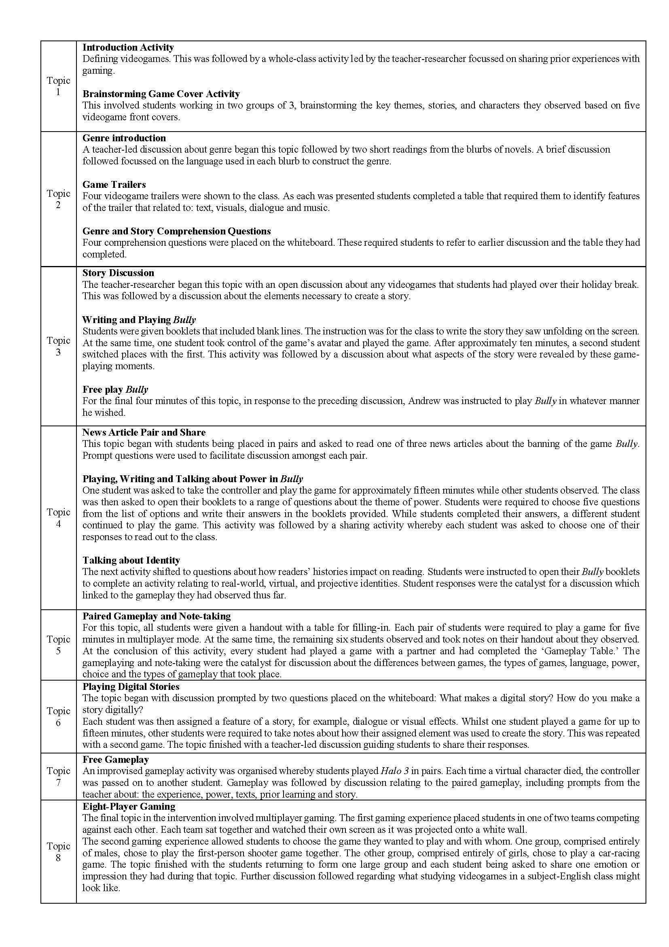In order to maximise the opportunity to form understandings in response to the research questions, data relating to individual interviews (before and after the intervention), audio-recordings of all classroom interactions and student work-samples were collected. Data analysis was conducted through a thematic analysis approach (Boyatzis, 1998). All data was inputted into data analysis software, NVivo, (QSR International, 2010), and manual-coded according to themes. Themes were generated for coding according to the theory and literature, and as a result of engaging with the data as it was collected.
What follows presents findings from the intervention related to pedagogical approaches to teaching videogames as text. It describes teaching activities from the intervention, as well as the responses from students. While data related to critical literacy have been explored elsewhere (Author withheld, 2018), themes of multimodality, gaming capital, play and interactivity, and their implications for classroom learning and teaching, are discussed here.

Understanding multimodal storytelling
One focus of the intervention was to support students to understand how stories are realised multimodally. During the first lesson of the intervention, students completed a game-cover activity which involved working in groups of three to deconstruct the front covers of six videogames. Each game-cover was printed in colour on A3 paper with space provided for students to write notes. Students were instructed by the teacher-researcher to use each game’s cover to hypothesise what they thought the cover revealed about the characters, themes, and stories within each game. Figure 2 and Figure 3 show the work of two groups.
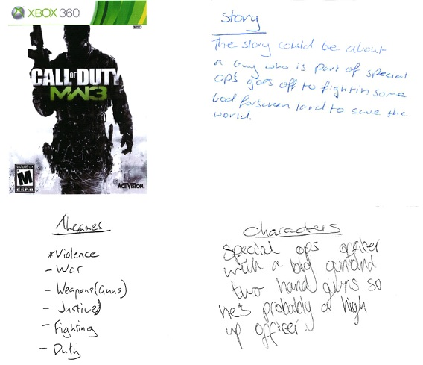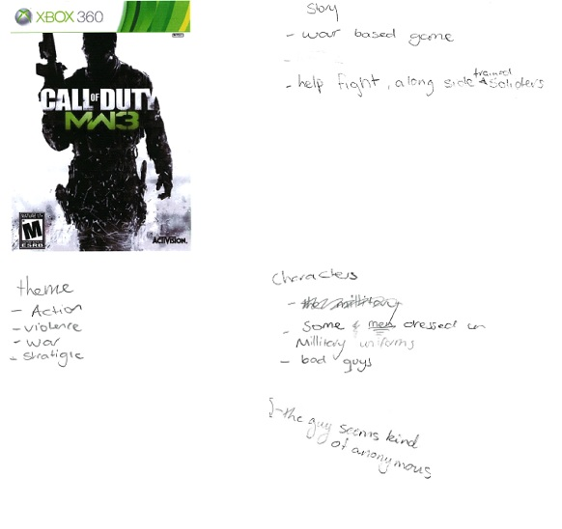These two posters revealed that a learning scaffold, in the form of a game-cover, supported by three prompts (themes, characters, story) were sufficient to guide students’ reading so that they could identify various visual elements and use these to generate ideas. This preliminary activity was just the first of numerous activities that moved towards pedagogies targeted at skills associated with new literacies (Unsworth, 2008).
One way students showed their multimodal reading capacity was through differentiating between visual elements serving different purposes. For example, both game posters refer to the highly popular game Call of Duty: Modern Warfare 3, likely to have been played by many of the participants. In their poster, Brad, Cam and Harley, made a connection between the presence of “guns” and the themes of “war” and “violence”. Likewise, the presentation of the protagonist in dark shades and with no facial features led Kate, Rachel and Alicia to conclude that the character “seems kind of anonymous”. Student notations were evidence of reading multimodal images, with minimal teacher intervention, in a way that identified and grouped visuals, before abstracting these groupings for association with story elements.
Another intervention activity required students to identify how moving images could support the realisation of narrative. This was evident in the multiple modalities which students referred to when deconstructing gameplay, including cinematic cut-scenes. A gameplay narrative activity, whereby individual students took turns using the controller to play each game’s introductory scenes, was designed to reveal how stories are created multimodally. Students were required to complete a table that captured how visuals, dialogue, music and texts functioned to create the story unfolding on the screen. Figure 4 shows the collated student responses to the roles played by visuals to create the story of one of the games, Fable II.
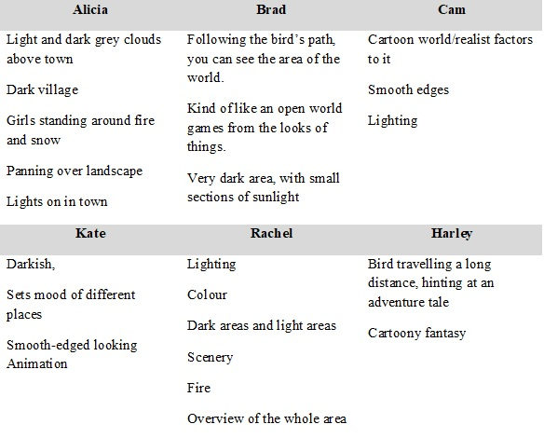All six students described the role played by light and dark imagery to create the setting. Kate moved beyond simply identifying visual features, explaining the function of light and dark motifs in stating, it “sets the mood of different places”. Several students also used visual representations to position observed gameplay within particular genres of narrative, including Harley’s comment that the presence of a bird was “hinting at an adventure tale” and Brad’s comment that the bird’s flight path allowed the gamer to “See the area of the world”, and then classifying the setting by linking it to a particular genre of videogame “kind of like an open-world game.” These comments captured how students could identify and analyse how modes beyond the printed word contributed to the creation of stories and worlds seemingly of another place and time that appear real, and encourage exploration in order to further unravel the narrative (Mott, Callaway, Zettlemoyer, Lee, & Lester, 1999).

Connecting with students’ gaming capital
Classroom activities also aimed to connect with the textual world of students. In the tradition of personal growth approaches to English (Britton, 1970; Dixon, 1975), one aim of this work was to value student experience and encourage learning about self and the world through developing relations to texts and context. An early activity in the intervention included a teacher-led discussion whereby each of the students present were asked to share their prior experiences with videogames, and to describe their favourite game. The intention was for this activity to encourage reflection on prior gaming activity and to create the learning environment as a shared experience. The data showed that students possessed various degrees of gaming capital, a form of cultural capital which when activated in the right context produces social profit (Bourdieu, 1986). Described by Consalvo (2007) as knowledge about games, the gaming industry, and other players, it enables interactions with games and facilitates learning and playing.. A brief insight into each students’ gaming capital can be seen in the following comments:
Cam: I've probably spent, yeah probably ten years, maybe a bit less, maybe nine years playing videogames. I’ve played all sorts of game over the years. I'm into a lot of fantasy [games] like those ones with main stories. [My favorite is] probably a game called Rune Factory. It’s on the DS.
Brad: Yeah, I played a lot of videogames. I'm influenced by my step dad who it’s a rare thing for him not to visit JB Hi-Fi and bring home a game of some sort. So I, yeah, I played lots and lots of games because he is a step dad he plays lots of, I don’t know. He plays lots of shooter games so I play lots of those too. I do enjoy the Halo series as well as the Call of Duty and things.
Harley: I played games just a lot. Just every night probably. My favorite is probably World of Warcraft.
Kate: I used to play games more than I do. I used to play The Sims all the time. Like, all the time. I don’t know, my brother plays a lot of games so I just borrow them. I like Batman: Arkham Asylum.
Rachel: I don’t really play games. [After prodding from the teacher-researcher, Rachel elaborated on her initial response]
I don’t know. They are very fun. Like, some of my friends play them and they really like them. They seem really fun.
Alicia: Mine is probably just playing with my little brother on the Wii game mainly and we can play Mario Cart a lot but other than that, not much experience with videogames.

The data revealed a contrast between those with extensive exposure to videogames, such as Cam, and those who play rarely, such as Rachel. The references to time spent playing games showed how some students had experienced far more opportunities to develop their gaming capital, which would be observed later in the study as a factor impacting on the ways students responded during learning activities. Harley’s claim of playing videogames every night, like Kate’s assertion that she had been an avid gamer in the past, combined with other contributions made by these two students throughout the intervention, were indicative of two teenagers who had accumulated ways of talking and acting with videogames that have become embodied in the form of dispositions of the mind and body (Bourdieu, 1986, p. 47) and could be called upon for distinction during activities that valued this type of knowledge and experience.
Student talk during the game-cover activity described earlier showed how students could mobilise gaming capital to complete learning activities. As they deconstructed the game posters, students were recorded saying:
Cam: Yeah. I haven’t played it [Fable] much but I’ve seen my brother play it quite a lot. He’s into the series. He’s got [game] 1, 2, and 3.
Harley: Bully. Oh, Bully’s a grouse game. I used to play it all the time.
Cam: That flaming lady.
Brad: It’s like the lady in Dragon Age.
Cam: Hey we got Civilization. That’s a good game, that’s pretty cool.
Cam: Have you played that game? It’s very weird.
Brad: I played the Age of Empires. That’s pretty close.
Cam: Yeah but this one is turn based, I don’t really like it. It is turn based.
Brad: That’s all right there will be like tactics.
Cam: It’s a bit of turn-based and real-time strategy.
Brad: Did you ever play Final Fantasy Grim Attack?
Cam: No.
Brad: That’s the same thing.
Students are making connections between the demands of the task at hand and knowledge they possessed about other games from the same genre. This is evidence of intertextual reasoning (Kristeva, 1980, 1986), as student references to a number of games created relationships between them and informed the meanings and discourse imposed on the original text. For example, when Brad makes connections between the games Age of Empires, Final Fantasy Grim Attack and Civilization he is using his knowledge of the characteristics of one game genre to inform his, and his peers, initial perceptions of the games which were the focus of the activity.
The way in which students used their gaming capital was similar to findings from other practice-based research incorporating videogames in subject English. Ostenson’s (2013) study of storytelling in the high school classroom involved a study of archetypal heroes across many genres of stories in collaboration with a study of narrative in videogames. He found that this pedagogical approach empowered and supported reluctant readers by allowing them to bring more of their culture into the classroom. The intervention explored in this paper similarly empowered students to draw on their knowledge of videogames to participate in deep and engaging conversations about the unique strengths and weaknesses of storytelling in videogames, thus improving their self-efficacy. The interaction between Cam, Harley and Brad is evidence of gaming capital informing textual comprehension as a result of the application of a pedagogy that begins with students.

Play
The games at the centre of the intervention were not prescribed for at-home play, necessitating gameplay in the classroom to realise their story elements. What was revealed was the challenge between the mobilisation of play for the purpose of navigating the goals of the game and play in the service of learning and teaching goals associated with the intervention. This became evident when students were asked to describe the experience of play following an eight-player gaming session, when students played games of their choosing in two teams of four students.
Student feedback is presented in Figure 5 below, in terms of student talk which captured the interactions between players, and talk which focussed on successful or unsuccessful play.
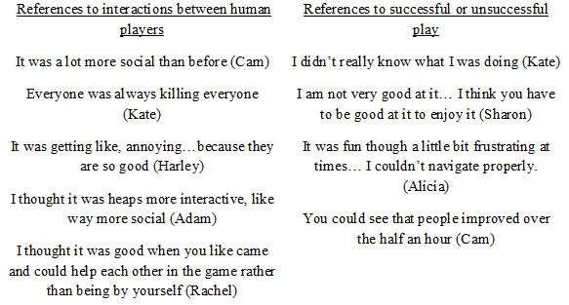Figure 5: Student comments about ‘learning to play’
Students reported positive and negative effects of social and multiplayer gameplay on how they learnt to play the game, with the range captured by the support Rachel felt she received from her team mates who could “help each other in the game,” and on the opposite end of the spectrum, Harley reporting on an obstacle to learning to play as a result of some players’ greater gaming ability, “It was getting like, annoying…because they are so good.” Similarly, student comments relating to successful or unsuccessful play demonstrated that some students found learning to play challenging, “I didn’t really know what I was doing” (Kate), while others observed a noticeable improvement in the quality of play after a period of time, “You could see that people improved over the half an hour” (Cam).
Student comments, captured by references to social gameplay and the challenges of play are examples of play when it is conceived in terms of ‘learning to play’, as opposed to ‘playing to learn’ (Arnseth, 2006). Arnseth (2006), interrogating the distinction between playing to learn and learning to play, has argued that when playing to learn the emphasis is on learning some content or skill which should be the end result of game playing. As such, knowledge and skills are treated as effects or outcomes. Conversely, learning to play puts the emphasis on the activity of playing. The student comments in Figure 5 show that the introduction of gameplay into English contexts may produce the circumstances for students to focus their talk on play-based goals, rather than subject English focussed goals.
Learning environments which incorporate gameplay need to be carefully planned so that play as an activity which can support text comprehension is realised, but also recognising that time will need to be allocated so that learning to play is supported, in the same way that most English classrooms allocate time to read the set novel or view the set film. The risk here is that students who lack basic gaming skills will be more likely to focus their attention on learning to play, minimising the benefits which can arise from playing to learn.

Interactivity
Complex processes of meaning-making between reader and writer are further complicated in the videogame English classroom when we consider that any game requires input from a user before its story can be fully realised. In the tradition of Rosenblatt (1938) and Eagleton’s (1983) work on the transaction between reader and writer, questions about a game creator’s intention are further complicated by processes of interactivity. When students played videogames during the intervention, they engaged with the game designers to co-construct the story on the screen. This activity typifies interactivity, a partnership between the reader and the text in the production of meaning.
Ryan’s (2001) theory of interactivity distinguishes between interactivity which is figurative, where there is collaboration between the reader and the text in the production of meaning, and interactivity which is literal, meaning “textual mechanisms that allow the reader to affect the ‘text’ of the text as a visible display of signs, and to control the dynamics of its unfolding” (p. 17). In practical terms, textual practices that involve a student reading a novel represent figurative interactivity as the student’s reading of the text necessitates collaboration with the author’s work. Textual practices which invite a gamer to use a controller to direct an avatar represent literal interactivity as the gamer’s actions affect the actual text, as evidenced by visuals on the screen. For interactivity to be literal the text must undergo physical changes during the reading/making process. This distinction is evident in two types of text activity from the intervention.
During a gameplay comprehension activity, one student played the game Bully, an open-world sandbox game where the player takes control of Jimmy Hopkins, a rebellious student at the fictional Bullworth Academy, while the rest of the class wrote down what they saw happening on the screen. This learning activity produced both literal and figurative interactivity.
The first form of interactivity related to students making sense of what they saw on the television screen, itself an image projected from the videogame console. During this activity, Brad used the controller to direct the virtual character around the gameworld, completing several introductory game activities and familiarising himself with the virtual setting. The other students were directed to watch the screen and make notes in their workbooks describing what they saw unfolding. All students were involved in ‘reading’ the images, sounds, colour and events depicted on the screen, a form of figurative interactivity similar to meaning-making during film-viewing, or as it occurs when a reader engages with a novel and constructs meaning from the words on the page.
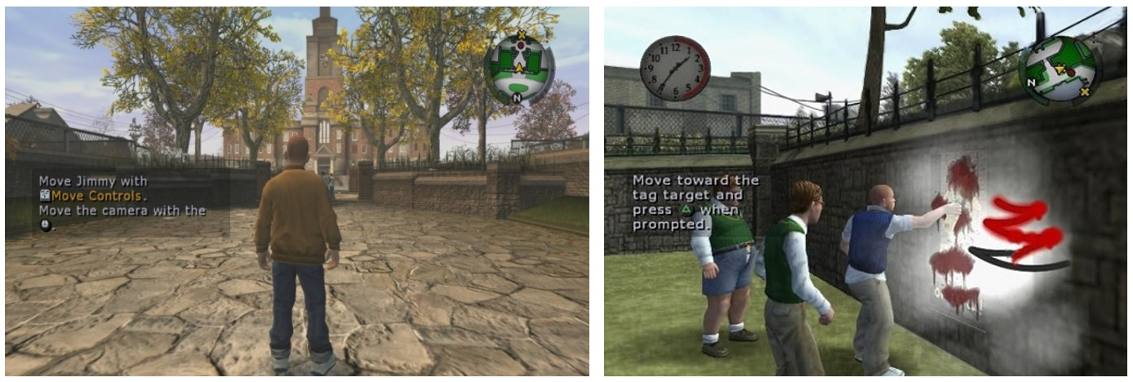Figure 6: Interactivity in the Bully gameworld
The second form of textual practice analysed, intrinsic to the playing of videogame, was more literal in nature and refers specifically to Brad’s actions controlling the virtual character. Figure 6 captures typical gameplay from the game Bully. It shows how the game allowed Brad to perform two types of activity. The screenshot on the left shows how Brad could roam around the gameworld, a fictional boarding school called Bullworth Academy, and the town in which it was situated. The screenshot on the right depicts how Brad could approach and respond to other virtual characters, choosing to complete quests and challenges. Both of these types of textual practice involved literal interactivity, where the text must undergo physical changes during the reading/making process. It is worth noting that this is a process distinctive from the reading or viewing taking place when engaging with novels or films. The game provided, and required, Brad to take control of a textual mechanism, the virtual character, which was accessible through a handheld controller and allowed his decisions to form the ‘text’ of the text (Ryan, 2001, p. 17). While all students figuratively interacted with the text, only Brad literally interacted, evidenced by the virtual world incorporating and responding to each and every command he issued. Physical changes in the text were realised through the changing visual landscape, a response to Brad’s decisions about where to go, and also through dialogue with other virtual characters, a response to Brad’s decisions regarding whom to engage with.
Textual study in subject English has often been characterised by attempts to uncover and understand the work and the author’s intended message through attention to the text (J. Thomson, 2004). This approach to textual understanding would be insufficient for dealing with videogame literacies which pose the complex challenge of unpacking game action to distinguish the meanings and intentions of the enmeshed relationship between game designer and game player.

Conclusions
Returning to Green’s three provocations about how English will service the rise of digitally-mediated communications in the twenty-first century, we can see how the inclusion of digital texts for play and study in the English classroom will impact on how teachers and students negotiate teaching and learning. Findings from the study show that while videogames share many features with other texts traditionally studied in English, there are distinct videogame practices. The interactive and immersive component of videogame practice impacts their realisation. Similarly, the socially-mediated performance of these texts, in terms of gameplay collaboration, are at odds with the often-solitary way that print-based texts are enacted. When combined with the highly multimodal nature of videogames, we are left with a text that demands new ways of conceptualising textual study in subject English.
New media texts which play such an important part in young people’s lives and are symbolic of broader technological shifts are redefining what matters in subject English. The integration of new technologies need not be a threat to the subject, but in fact, can enhance the great work that English teachers are already doing with text, and suggest some new ways forward.
Adult anxiety about the ‘newness’ of videogames, and their capacity to engage absolutely, is not sufficient justification for ignoring these texts and their associated practices. With change comes anxiety, and a disparity between teacher identities and new forms of text has the capacity to produce considerable angst. Salen’s (2008) argument about change is apt. She says that despite our desire to change the way that learning and thinking occurs in classrooms, we are limited by old tensions which pit the real against the virtual, the in-school against the out-of-school, the formal and the informal. The concerns about videogame mirror these same tensions. At a time when questions of student-engagement continue to be asked and attention focussed on those students disengaged from schooling (Gallup, 2015; S. Thomson, De Bortoli, & Buckley, 2013), playing with virtual characters, in digital worlds, and inviting students to become a part of the narrative construction and enactment is a positive outcome for students that will be impacted by each teacher’s ability to reconcile their professional identity within a version of subject English that is changing.

References
ACARA. (2018). The Australian Curriculum. http://www.australiancurriculum.edu.au/: ACARA.
Apperley, T., & Walsh, C. (2012). What digital games and literacy have in common: a heuristic for understanding pupils' gaming literacy. Literacy, 46(3), 115-122.
Arnseth, H. C. (2006). Learning to Play or Playing to Learn - A Critical Account of the Models of Communication Informing Educational Research on Computer Gameplay. Game Studies, 6(1).
Barab, S. A., Gresalfi, M., & Ingram-Goble, A. (2010). Transformational Play: Using Games to Position Person, Content, and Context. Educational researcher, 39(7), 525-536.
Beavis, C. (1998). Pressing (the right?) buttons: literacy and technology, crisis and continuity. English in Australia, 123, 42-51.
Beavis, C. (1999). Literacy, English, and Computer Games. (Text Adaptation).
Beavis, C. (2008). Paying Attention to Texts: Literacy Culture and Curriculum. English in Australia, 43(1), 23-31.
Beavis, C. (2010). English in the Digital Age: Making English Digital. English in Australia, 45(2), 21-30.
Beavis, C. (2014). Games as Text, Games as Action: Video games in the english classroom. Journal of Adolescent & Adult Literacy, 57(6), 433-439.
Beavis, C., Dezuanni, M., & O'Mara, J. (Eds.). (2017). Serious play: Literacy, learning and digital games. New York: Routledge.
Beavis, C., Walsh, C., Bradford, C., O'Mara, J., Apperley, T., & Gutierrez, A. (2015). 'Turning around' to the affordances of digital games: English curriculum and students' lifeworlds. English in Australia, 50(2), 30.
Boomer, G. (1988). The English Teacher, Research and Change. In B. Green & G. Boomer (Eds.), Metaphors and meanings: essays on English teaching (pp. 15-30). Victoria: AATE.
Bourdieu, P. (1986). The Forms of Capital. In J. G. Richardson (Ed.), Handbook of Theory and Research for the Sociology of Education (pp. 242-258). New York: Greenwood.
Boyatzis, R. E. (1998). Transforming qualitative information : thematic analysis and code development. Thousand Oaks, CA: Sage Publications.
Brand, J., Todhunter, S., & Jervis, J. (2017). Digital Australia 2018. Retrieved from Eveleigh, NSW:
Britton, J. (1970). Language and Learning. London: Allen Lane The Penguin Press.
Buckingham, D. (2006). Defining digital literacy - What do young people need to know about digital media? Nordic Journal of Digital Literacy, 4, 263-277. Retrieved from
Buckingham, D., & Burn, A. (2007). Game literacy in theory and practice. Journal of Educational Multimedia and Hypermedia, 16(3), 323.
Burn, A. (2007). 'Writing'computer games: game literacy and new-old narratives. L1 Educational Studies in Language and Literature, 7(4), 45-67.
Burn, A., Bryer, T., & Coles, J. (2016). Playing Beowulf: Bringing Literature, Drama, Media and Computing together for the new curriculum. Teaching English, 69(12), 63-69.
Burn, A., & Durran, J. (2013). Playing Shakespeare: Macbeth - Narrative, Drama, Game. Teaching English(1), 33-34.
Carr, D., Schott, G., Burn, A., & Buckingham, D. (2004). Doing Game Studies: A multi-method approach to the study of textuality, interactivity and narrative space. Media International Australia, 110(March), 19-30.
Consalvo, M. (2007). Cheating : gaining advantage in videogames. Cambridge, Mass.: MIT Press.
Dixon, J. (1975). Growth through English : set in the perspective of the seventies. London: Oxford University Press for the National Association for the Teaching of English.
Doecke, B., Howie, M., & Sawyer, W. (Eds.). (2006). Only connect-: English teaching, schooling and community. Kent Town: Wakefield Press in association with the Australian Association for the Teaching of English.
Durrant, C., & Beavis, C. (2001). A P(ICT)ure is Worth... In C. Beavis & C. Durrant (Eds.), P(ICT)ures of English : teachers, learners and technology (pp. 1-10). Kent Town, S. Aust.: Wakefield Press.
Eagleton, T. (1983). Literary Theory: An Introduction. Oxford: Blackwell.
Gallup. (2015). 2015 Gallup Student Poll Report - Australia and New Zealand. Retrieved from http://www.gallupstudentpoll.com.au/184571/2015-gallup-student-poll-report-australia-new-zealand.aspx
Gee, J. P. (2003). What video games have to teach us about learning and literacy. New York: Palgrave Macmillan.
Glover-Adams, M. (2009). Engaging 21st-Century Adolescents: Video Games in the Reading Classroom. English Journal, 98(6), 56-59.
Green, B. (2001). English teaching,‘Literacy’and the post-age: on compos (IT) ing and other new times metaphors. P (ICT) ures of English: English Teaching, Literacy and New Technologies, Wakefield Press (AATE), 2001, 249-271.
Green, B. (2002). A Literacy Project of Our Own. English in Australia, 134(July), 25-32.
Green, B. (2004). Curriculum, ‘English’and Cultural Studies; or, changing the scene of English teaching? Changing English, 11(2), 291-305.
Hawisher, G. E., & Selfe, C. L. (2007). Gaming Lives in the Twenty-First Century.
Hayes, E. R., & Duncan, S. C. (Eds.). (2012). Learning in Videogame Affinity Spaces. New York: Peter Lang Publishing.
Kemmis, S. (2010). What is to be done? The place of action research. Educational action research, 18(4), 417-427.
Khine, M. S. (2011). Learning to play: exploring the future of education with video games (Vol. 53): Peter Lang.
Kristeva, J. (1980). Desire in language : a semiotic approach to literature and art (T. Gora, A. Jardine, & L. S. Roudiez, Trans. L. S. Roudiez Ed.). New York: Columbia University.
Kristeva, J. (1986). The Kristeva Reader (T. Moi Ed.). New York: Columbia Univeristy Press.
Love, K. (1998). Old cyborgs, young cyborgs (and those in between). English in Australia, 63-75.
Lowien, N. (2016). The semiotic construction of values in the videogame Watch Dogs. English in Australia (0155-2147), 51(2).
Luke, A. (2004). At Last: The Trouble with English. Research in the Teaching of English, 39(1), 85-95.
Marcon, N., & Faulkner, J. (2016). Exploring minecraft as a pedagogy to motivate girls' literacy practices in the secondary English classroom. English in Australia, 51(1), 63.
McNeice, L., Smith, A., & Robison, T. (2012). Computer games, archetypes and the quest narrative: Computer games as texts in the English classroom. In C. Beavis, J. O'Mara, & L. McNeice (Eds.), Digital Games: literacy in action (pp. 24-32). Kent Town: Wakefield Press.
Moon, B. (2008). Things to do in Duskwood when you're Dead: English Lessons from World of Warcraft. English in Australia, 43(1), 47-56.
Mott, B. W., Callaway, C. B., Zettlemoyer, L. S., Lee, S. Y., & Lester, J. C. (1999). Towards narrative-centered learning environments. Paper presented at the Proceedings of the 1999 AAAI fall symposium on narrative intelligence.
Ostenson, J. (2013). Exploring the Boundaries of Narrative: Video Games in the English Classroom. English Journal, 102(6), 71-78.
Patterson, A. (2002). Installing English at the hub of Early twentieth century school curricular. History of Education Review, 31(2), 45-58.
Pelletier, C. (2005a). Studying games in school: a framework for media education.
Pelletier, C. (2005b). The uses of literacy in studying computer games: Comparing students' oral and visual representations of games. English Teaching, 4(1), 40.
QSR International. (2010). NVivo.
Ranalli, J. (2008). Learning English with the Sims: exploiting authentic computer simulation games for L2 learning. Computer Assisted Language Learning, 21(5), 441-455.
Rosenblatt, L. M. (1938). Literature as exploration. New York: Noble and Noble Publishers Inc.
Russell, J., & Beavis, C. (2012). English Revisited: Sucker Punch, Moffatt, Avatars and Forensic Evidence. English in Australia, 47(2), 27-35.
Ryan, M.-L. (2001). Narrative as virtual reality: Immersion and interactivity in literature and electronic media: Johns Hopkins University Press.
Ryan, M.-L. (2009). From narrative games to playable stories: Toward a poetics of interactive narrative. Storyworlds: A Journal of Narrative Studies, 1(1), 43-59.
Salen, K. (2007). Gaming literacies: A game design study in action. Journal of Educational Multimedia and Hypermedia, 16(3), 301-322.
Salen, K. (2008). The ecology of games: Connecting youth, games, and learning: MIT Press.
Sefton-Green, J., & Nixon, H. (2003). Can 'English' Cope? The Challenge of Popular Culture, Digital Technologies, and Curriculum Change. In B. Doecke, D. Homer, & H. Nixon (Eds.), English Teachers at Work: Narratives, Counter Narratives and Arguments (pp. 242-254). Kent Town, South Australia: Australian Association for the Teaching of English.
Simpson, E., & Clem, F. A. (2008). Video Games in the Middle School Classroom. Middle School Journal, 39(4), 4-11.
Snyder, I. (1997). Page to screen : taking literacy into the electronic era. St. Leonards, N.S.W.: Allen & Unwin.
Spires, H. A. (2015). Digital Game-Based Learning. Journal of Adolescent & Adult Literacy, 59(2), 125-130. doi:10.1002/jaal.424
Squire, K. (2003). Video Games in Education. Retrieved from http://citeseerx.ist.psu.edu/viewdoc/download?doi=10.1.1.100.8500&rep=rep1&type=pdf
Squire, K. (2008). Video-Game Literacy. In J. Coiro, M. Knobel, C. Lankshear, & D. J. Leu (Eds.), Handbook of Research on New Literacies (pp. 635-669). New York: Lawrence Erlbaum Associates.
Squire, K., & Jenkins, H. (2004). Harnessing the Power of Games in Education. InSight, 3(1), 5-33.
Steinkuehler, C., Squire, K., & Barab, S. (2012). Games, learning, and society: Learning and meaning in the digital age: Cambridge University Press.
Suh, S., Kimt, S. W., & Kim, S. J. (2010). Effectiveness of MMORPG-based instruction in elementary English education in Korea. Journal of Computer Assisted Learning, 26, 370-378.
Thomson, J. (2004). Literature Practices. In W. Sawyer & E. Gold (Eds.), Reviewing English in the 21st Century (pp. 290-291). Melbourne: Phoenix Education.
Thomson, S., De Bortoli, L., & Buckley, S. (2013). PISA 2012: How Australia measures up.
Unsworth, L. (Ed.) (2008). New literacies and the English curriculum : multimodal perspectives. London; New York: Conituum.
Young, M. (1998). The Curriculum of the Future: from the'new sociology of education'to a critical theory of learning. Londond: Falmer Press.

Bully, Dungeon Siege 3, Fable 2, Forza Motorsport 4, Marvel Ultimate Alliance 2, and Halo 3.

