Incorporating whey protein aggregates produced with heat and ultrasound treatment into rennet gels and model non-fat cheese systems
Charitha J. Gamlath^{1,2,3}, Thomas S. H. Leong^{1,2,3}, Muthupandian Ashokkumar^{2,3}, Gregory J. O. Martin^{1,3*}

¹Department of Chemical Engineering, The University of Melbourne, Parkville, Victoria 3010, Australia.
²School of Chemistry, The University of Melbourne, Parkville, Victoria 3010, Australia.
³The ARC Dairy Innovation Hub, The University of Melbourne, Parkville, Victoria 3010, Australia.
*Corresponding author: gjmartin@unimelb.edu.au

Abstract:
Whey proteins (WP) are expulsed from cheese coagulation during syneresis. Incorporating denatured WP aggregates into cheese gels has been previously proposed to increase cheese yield. However, the effects of WP aggregate properties on gelation kinetics and protein retention are not yet fully understood. The effects size and hydrophobicity differences in WP aggregates produced by heat and ultrasound were investigated in relation to the kinetics of rennet gelation and protein retention in model non-fat cheddar cheeses. Rheological measurements showed that sufficiently large aggregates of denatured WP could avoid impairment of rennet gelation caused by native WP, irrespective of changes in the soluble calcium concentration or the surface hydrophobicity of the aggregates. WP aggregates formed by combined heat and ultrasound treatment were more hydrophobic than the larger heat-treated aggregates and better retained in cheese. However, expulsion of sufficiently large aggregates conferred an openness to the cheese microstructure, which could improve the texture of low-fat cheese.

Key words
Low-fat cheese, Rennet gelation, Ultrasound, Whey proteins, Denaturation

Graphical Abstract

1. Introduction
Rennet gelation converts liquid milk into a coagulum during the production of many types of cheeses (Guinee & Wilkinson, 1992). Milk in its natural form is a stable colloidal suspension comprised of emulsified fat, minerals, proteins (casein and whey proteins) and lactose. Casein is present in milk as large colloidal aggregates (50-200 nm) known as casein micelles, which consist of a hydrophobic core rich in αs₁, αs₂ and β-caseins covered by a hydrophilic κ-casein-rich ‘hairy’ layer that provides electrostatic and steric stability (Jenness, 1999; Walstra, 1999). During rennet gelation, the chymosin enzyme present in rennet (a secretion from the calf intestine) cleaves the κ-casein hairy layer, which destabilizes the casein micelle, facilitating aggregation and subsequent gel formation through hydrophobic interactions (Fox, Guinee, Cogan, & McSweeney, 2017; Vasbinder, Rollema, & De Kruif, 2003). Contrastingly, the globular whey proteins, which are small (5-10 nm) (Fox, Guinee, Cogan, & McSweeney, 2000; Rüegg, Moor, & Blanc, 1977) compared to cleaved casein micelles, drain out from the gel structure. This process, known as “syneresis”, results in the loss of approximately 20% of the total protein in milk during cheese making (Hinrichs, 2001). Fat globules are larger (~0.1-15 µm in diameter) and are mostly retained in the coagulum, providing cheese its distinctive creaminess (Logan et al., 2015).
Previous attempts to incorporate whey proteins with the aim of producing high-protein cheeses (Baldwin et al., 1986; Banks & Muir, 1985; Brown & Ernstrom, 1982; Chamberland, Benoit, et al., 2019; Chamberland, Mercier-Bouchard, et al., 2019; Hinrichs, 2001; Ismail, Ammar, & El‐Metwally, 2011; Lo & Bastian, 1998; Mead & Roupas, 2001; Punidadas, Feirtag, & Tung, 1999; Stankey et al., 2017) used two approaches: (i) ultrafiltration to increase the protein concentration in the cheese milk and (ii) heat denaturation of whey proteins to facilitate casein-whey protein or whey protein-whey protein crosslinking. The use of concentrated native proteins (both casein and whey proteins concentrated by ultrafiltration) in cheese milk has been researched extensively, with varying increases in cheese yields and protein retention having been reported for different proteins and concentrations and types of cheese (Mistry & Maubois, 2017). Recently, Chamberland, Benoit, et al. (2019) and Chamberland, Mercier-Bouchard, et al. (2019) reported increased cheese yields and protein recovery (Chamberland, Benoit, et al., 2019; Chamberland, Mercier-Bouchard, et al., 2019) when cheese milks were formulated with ultrafiltration retentates, as compared to whole milk or traditionally standardised cheese milk. The increased protein retention was attributed to the formation of a stronger protein matrix (Chamberland, Mercier-Bouchard, et al., 2019).
At elevated temperatures (>65 ºC), whey proteins denature and can then form intermolecular disulphide bridges between free thiol groups present in some of the casein and whey proteins (e.g. α-lactalbumin, β-lactoglobulin and κ-casein) (Monahan, German, & Kinsella, 1995; Vasbinder, Alting, & de Kruif, 2003). The application of heat to denature and attach whey proteins to micellar κ-casein has been used to increase the yields of yoghurt and cream cheese, which are made by acid gelation (Kethireddipalli, Hill, & Dalgleish, 2010; Lucey, Tamehena, Singh, & Munro, 1998). However, this approach impairs rennet gelation, by coating the casein micelles with denatured whey proteins (Singh & Waungana, 2001; Vasbinder, Rollema, et al., 2003). Further, while an increase in the moisture content of cheddar cheese made from heat-treated milk has been recorded (Lo & Bastian, 1998), there was no increase in whey protein retention.
Alternatively, heat denaturation of casein-depleted whey protein streams can form whey protein aggregates while avoiding whey protein-casein interactions. Banks and Muir (1985) attempted to incorporate such heat-treated and acid-precipitated whey concentrate (produced by heating 0.9% w/w whey protein streams at 95 ºC for 20 minutes and precipitating at pH 6 to achieve final protein and fat contents of 6.6% w/w and 4.5% w/w, respectively) into cheese. Although the cheese yield increased by 9%, the increase was mainly attributed to the retention of fat-protein complexes, rather than incorporation of whey proteins alone (Banks & Muir, 1985). In another study, Baldwin et al. (1986) attempted to incorporate partially denatured (~78-80%, with no reported aggregation) whey proteins, produced from the heat treatment (70 ºC for 15 minutes) of whey protein concentrates, into cheddar cheese. Although they reported a 3.4% increase in the total nitrogen content in cheese, the final cheese yield was not significantly improved due to fat loss resulting from a weaker gel matrix. In a similar study, Brown and Ernstrom (1982), incorporated heat-denatured whey protein (75 ºC for 30 min) into cheese milk. Although the cheese yield increased by 4%, the protein content was not affected. Similar increases in overall cheese yields are reported for mozzarella cheese made by incorporating acidified denatured whey proteins (Punidadas et al., 1999), however with no quantification of protein retention.
Earlier studies to incorporate denatured whey proteins into cheese mostly investigated changes in the sensory attributes and the composition of cheeses (Banks & Muir, 1985; Brown & Ernstrom, 1982; Punidadas et al., 1999) rather than attempting to optimise whey protein aggregate properties to increase whey protein retention. Further, the observed increases in cheese yields were largely followed by increases in moisture (Banks & Muir, 1985; Brown & Ernstrom, 1982; Punidadas et al., 1999), fat (Banks & Muir, 1985) and/or casein content (Banks & Muir, 1985) in cheese, rather than whey protein retention. This may be due to the production of whey protein aggregates that were too small to be retained within the cheese matrix. Although aggregate size was not reported, these studies used dilute whey protein streams (Banks & Muir, 1985; Brown & Ernstrom, 1982; Punidadas et al., 1999), and/or mild heat treatments (Brown & Ernstrom, 1982), which typically result in relatively small aggregates after heat treatment (Roefs & De Kruif, 1994).
The advent of membrane technology has enabled the production of concentrated whey protein streams and powders, that upon heat treatment, can produce larger whey protein aggregates, which can then be disintegrated into so-called microparticulates (~1 µm) using high-pressure homogenisation (Suárez, Fernández, Balbarie, Iglesias, & Riera, 2016). The effect of incorporating microparticulated whey protein in cheese as a fat replacer has been of increasing interesting in the past decade. However, the extent of whey protein aggregate retention is still under debate. For example, Sturaro, De Marchi, Zorzi, and Cassandro (2015) found` that increasing the whey protein-to-fat ratio decreased the yield of low-fat Caciotta cheese. Contrastingly, Stankey et al. (2017) and Perreault, Rémillard, et al. (2017) reported that incorporation of microparticulated whey protein in low fat cheddar cheeses and semi hard cheeses could increase cheese yield, however much of this was an increased moisture content resulting from the enhanced water binding capacity of the denatured whey proteins. Similar increases in moisture content have also been reported for whey incorporated into Caciotta cheese (Di Cagno et al., 2014).
Regardless of the effect on yield, it has been shown that incorporation of microparticulated whey proteins can improve the texture of otherwise firm low-fat cheese curds (Schenkel, Samudrala, & Hinrichs, 2013; Stankey et al., 2017). Schenkel et al. (2013) hypothesised that the presence of inert whey protein particulates in the casein network could lead to fewer casein crosslinks and therefore an improved (softer) texture. However, both Schenkel et al. (2013) and Stankey et al. (2017) reported that the protein retention in the cheeses was not significantly improved. Another similar study by McMahon, Alleyne, Fife, and Oberg (1996) concluded that the whey protein microparticulates used as a fat replacer were too small (0.5-1 µm) to create large enough gaps in the casein structure of mozzarella cheese.
With increased interest in incorporating whey protein particulates in cheese matrices to alter their composition and texture, studies have aimed at understanding the effect of denatured whey protein aggregates on the kinetics of rennet gelation and establishing mechanisms behind the observed textural changes. Perreault, Morin, Pouliot, and Britten (2017) et al. recently reported that both sedimentable (~8 µm) and soluble protein fractions in denatured whey protein concentrates can negatively impact the rate of rennet gelation. A complementary study by Giroux, Lanouette, and Britten (2015) proposed that denatured whey proteins participate in hydrophobic interactions with casein micelles and impair rennet gelation. However, the relative effect of native whey proteins and denatured whey protein aggregates of different sizes on rennet gelation kinetics and cheese microstructure is yet to be investigated.
Ultrasound (US) processing can be used to alter the functional properties of protein suspensions (Ashokkumar et al., 2009; Gordon & Pilosof, 2010; Leong et al., 2018). When ultrasound (sound with a frequency > 20 kHz) is applied to a liquid, minuscule air bubbles in the medium can expand and then collapse violently during acoustic rarefaction and compression cycles. Particularly during low-frequency high-power sonication, strong physical forces such as shear, shock waves and microjets form as a result of acoustic cavitation, which can cause particles in suspension to collide at sufficient force to result in disintegration (Mason, Cobley, Graves, & Morgan, 2011). Therefore, low-frequency high-power ultrasound can effectively be used to reduce the size of large whey protein aggregates at processing times as short as 5 seconds (Ashokkumar et al., 2009; Gordon & Pilosof, 2010; Leong et al., 2018). This offers a means of controlling the size of whey protein aggregates when formulating cheese milks, by reducing larger heat-induced aggregates to the desired size range. High-pressure homogenisation can also be used to alter the size of whey protein aggregates. This method typically requires a prior mechanical stirring step to improve the flowability of viscous, non-Newtonian streams of concentrated heat-denatured whey proteins (Suárez et al., 2016). In contrast, US-assisted whey protein size reduction has the advantage of being able to be applied directly to such streams.
The effect of aggregate properties on the initial rennet gelation, aggregate, and the mechanism behind cheese microstructural changes are of interest in the context of optimising this technology. Therefore, in this study, denatured whey protein aggregates of different sizes were produced using heat treatment followed by ultrasound, and the effect of aggregate size on rennet gelation kinetics investigated. In addition, the retention of whey protein aggregates incorporated into model non-fat cheeses (prepared using a cheddar cheese making protocol), was quantified and investigated in relation to observed microstructural changes.

2. Materials and Methods
2.1 Milk protein concentrate powders
Two types of milk protein concentrates powders were used as the source of whey protein: a membrane-filtered whey protein (MFWP) and a commercially available whey protein concentrate (WPC) from cheese whey (“Select whey protein concentrate” purchased from Professional Whey, Erina, Australia). Pasteurised skim milk (“Pauls Skinny Milk”, produced by Lactalis Australia, South Brisbane, Australia) was used as the casein source.
MFWP was produced using a previously reported method (Gamlath, Leong, Ashokkumar, & Martin, 2018). The protein composition of the skim milk as well as MFWP and WPC powders was determined (in at least duplicates) as described in section 2.2. The MFWP was 75.2 ± 0.9% w/w whey protein and 1.1 ± 0.9% w/w casein (total protein content of 76.3 ± 0.5% w/w), WPC was 68.1 ± 1.4% w/w whey protein and 4.9 ± 1.4% w/w casein (total protein content of 73.0 ± 0.1% w/w), and the skim milk was 2.67 ± 0.03 % w/w casein and 0.56 ± 0.05% w/w whey protein (total protein content of 3.23 ± 0.05% w/w). Unless otherwise specified, WPC and MFWP were dissolved in distilled and deionised water, at respective powder concentrations of 10% w/w and 20% w/w. The solutions were stirred for 2 hours at room temperature before each experiment.
2.2 Protein quantification
Protein analysis of WPC, MFWP, skim milk, curds and whey was performed based on the Dumas combustion method using a LECO Trumac CNS analyser (LECO Corporation, St Joseph, Michigan, USA) using a method that complies with the ISO 1489 standard. Samples of milk (~ 2 mL), milk protein powder (~ 0.1 g), cheese curds (~ 0.2 g), or whey (~ 2 mL) were accurately weighed onto a ceramic boat and oven dried overnight (104 °C). The boats were then loaded into the LECO analyser and combusted at a temperature of 1100 °C within the furnace. Protein values were determined from the measured nitrogen % using a conversion factor of 6.38 (Mariotti, Tomé, & Mirand, 2008).
Protein retention in curds was calculated using the following equation:
$$Protein retention= \frac{Protein content of curd in \%\frac{w}{w} ×Mass of curd }{Protein content of cheese milk in \%\frac{w}{w} ×Mass of cheese milk}×100$$
Casein and whey protein fractions of skim milk, MFWP and WPC were determined using a previously reported method (Shahani & Sommer, 1951) with a few modifications. For non-casein nitrogen determination, 20 mL of milk or 10% w/w whey protein solutions were mixed with 10 mL of distilled and deionised water. The samples were heated to 40 °C in a water bath and acidified with 1 mL of 10% w/w hydrochloric acid. Water was added to make a total volume of 40 mL and the sample was cooled to room temperature. The pH of the sample was adjusted to 4.6-4.7 using 1 M hydrochloric acid or 1 M sodium hydroxide solutions. The precipitated casein was removed by centrifugation (839 g for 10 min) followed by filtration through 0.22 µm syringe filters. Approximately 2 mL of filtrate was loaded into a nickel-lined ceramic boat and oven dried overnight (104°C) before non-casein nitrogen was determined using the LECO analyser.
For non-protein nitrogen determination, 10 mL of milk or 10% w/w whey protein solution were mixed with 10 mL of 30% w/v trichloroacetic acid. Precipitated proteins were removed by centrifugation (839 g for 10 min) followed by filtration through a 0.22 µm syringe filter. Approximately 2 mL of filtrate was loaded into a nickel-lined ceramic boat and dried overnight (104 °C) before non-casein nitrogen determination using the LECO analyser. The casein nitrogen content was determined by subtracting the non-casein nitrogen content from the total nitrogen content of the sample. The difference between the non-casein nitrogen content and the non-protein nitrogen content was used as the whey nitrogen content of the sample. Protein values were then determined by multiplying the measured or calculated nitrogen percentages by a conversion factor of 6.38 (Mariotti, Tomé, & Mirand, 2008).
2.3 Fat quantification
The fat content of MFWP, WPC and the centrifuged WPC dispersion were measured according to the Bligh and Dyer method (Manirakiza, Covaci, & Schepens, 2001). 10 g of 10% w/w MFWP, 10% w/w WPC or centrifuged (at 3,842 g for 20 min) 10% w/w WPC were added to a falcon tube along with 10 mL chloroform and 20 mL of methanol. The sample was shaken vigorously for 2 min and another 10 mL of chloroform was added. The sample was then centrifuged at 3,842 g for 10 min and the bottom chloroform-rich layer was separated using a Pasteur pipette. 20 mL of a 10% v/v methanol in chloroform mix was used for the secondary extraction. Pooled chloroform extracts were dried overnight at 64 °C and the residual dry mass was measured for fat quantification. WPC powder had a measured fat content of 5.28 ± 0.25 % w/w. The fat content of MFWP powder was <0.1% w/w. Centrifuged 10% w/w WPC solutions had a fat content of 0.188 ± 0.032% w/w, which translated to a 1.88 ± 0.32% w/w fraction of nano-sized fat droplets in the WPC powder.
2.4 Heat and ultrasound treatment
Whey protein solutions used in rennet gelation trials and cheese trials were treated in different sample volumes. For rennet gelation trials, 25 mL of WPC (10% w/w) or MFWP (20% w/w) solutions were heated in a water bath at 85 ºC for 15 min and then immediately cooled by immersing in an ice bath. WPC systems used for cheese trials were heated for 15 min in batches of 50 mL, placed in a water bath at 95 ºC. All milk protein systems had similar temperature vs. time profiles (Fig. S1 in supplementary data) during heating. The heated solutions were then sonicated in batches of 25 mL, at 20 kHz frequency and 50% amplitude for 1 min using an 11 mm horn (Model 102C (CE), Branson Ultrasonics, St. Louis, Missouri, USA). The power delivered was 33 W as determined by calorimetry.
2.5 Particle size measurement
The size of particles in freshly prepared 10% w/w reconstituted samples MFWP and WPC was measured by dynamic light scattering using a Malvern Zetasizer Nano ZS (Malvern Panalytical Ltd, Malvern, UK) at 25 °C. The MFWP and WPC solutions were diluted 1000 and 500 times respectively, with deionized and distilled water before analysis. The ‘milk protein size analysis’ setting was used (particle refractive index: 1.45, particle absorption 0.001, viscosity of water 0.8872 cP, refractive index of water 1.33, measurement angle: 173° backscatter). The WPC solution was also centrifuged at 3,842 x g for 20 min, and the top and middle layers of the supernatant measured.
The volume mean diameter of the whey protein aggregates in the heated and sonicated MFWP (20% w/w) and WPC (10% w/w) solutions was measured using a Malvern Mastersizer 2000 with a Hydro EV accessory (Malvern Panalytical Ltd, Malvern, UK). Distilled water was used as the diluent. A particle refractive index of 1.45 and an absorption of 0.001 were used for the measurement.
2.6 Rheological measurements during rennet gelation
Two sets of four milk systems were prepared by mixing MFWP (20% w/w) or WPC (10% w/w) with skim milk diluted using distilled and deionised water. The first set contained skim milk diluted with distilled and deionized water (DS), diluted skim milk with untreated MFWP (DS MFWP), diluted skim milk with heat-treated MFWP (DS HT MFWP) and diluted skim milk with heated and sonicated MFWP (DS HT US MFWP). All systems, excluding DS, consisted of a 1:1 casein-to-whey protein ratio while the casein concentration was constant at 2.1% w/w for all four systems. The second set contained four similar systems prepared with skim milk diluted with distilled and deionized water (DS), diluted skim milk with untreated WPC (DS WPC), diluted skim milk with heat-treated WPC (DS HT WPC) and diluted skim milk with heated and sonicated WPC (DS HT US WPC). All systems excluding DS, consisted of a 0.9:1 casein-to-whey protein ratio with a constant casein concentration of 2.0 % w/w. However, the DS system in the second set, had a casein concentration of 1.9% w/w. Samples (20 mL) of each milk system were equilibrated at 31 °C in a water bath for 1 hour and renneted with 0.2 mL of 3.5 IMCU/mL rennet solution (prepared from 200 IMCU/mL Chymax Plus FPC, Cheeselinks, Lara, Australia, batch numbers 3233770 & 3241446). The change in the storage modulus (G’) as a function of time was measured using an AR-G2 rheometer (TA Instruments, New Castle, Delaware, USA) with a controlled shear strain of 2.5% at 1 Hz using a concentric cylinder (996284) tool at 31 °C for 1 hr. The G’ at t = 0 was normalised to -0.02 Pa in all measurements.
2.7 Soluble calcium
Each whey protein dispersion was ultracentrifuged at 100,000 g using a Beckman Coulter ultracentrifuge (Optima L-100 XP fitted with a 70 Ti rotor) for 1 hr at 4 °C. The separated supernatant was filtered through 0.45 µm syringe filters. 1.2 mL of 100% w/v Trichloro acetic acid (BDH AnalR, Dubai, UAE) was added per 0.5 mL sample and diluted to 10 mL with deionised and filtered water. The samples were then centrifuged at 839 g for 5 min using a Thermofisher Hereus Megafuge 8 benchtop centrifuge fitted with a HIGHConic III fixed angle rotor. 0.3 mL of the filtered (using 0.45 µm syringe filters) supernatant was diluted with 4.7 mL of deionised and filtered water and the soluble calcium was measured with an inductive coupled plasma (ICP) optical emission spectrometer, Varian 720-ES with SPS 3 auto sampler (Varian Inc., Palo Alto, California, USA), wavelength: 315.887 nm, power: 1 kW, plasma flow: 15 L/min, auxiliary flow: 1.5 L/min, nebuliser flow: 0.75 L/min, pump rate: 15 rpm.
2.8 Surface hydrophobicity
Protein surface hydrophobicity was determined using a 1-anilinonaphthalene-8-sulfonate (ANS) fluorometric assay (Alizadeh-Pasdar & Li-Chan, 2000). A stock solution of 8 × 10⁻³ M ANS (Sigma Aldrich, St Louis, Missouri, USA) was prepared in 0.1 M, pH 7.4 phosphate buffer and stored in darkness at room temperature. Whey protein solutions were diluted in phosphate buffer to at least three concentrations between 0.001-0.025% w/w. 20 µL of ANS solution was added to 4 mL of protein solution, wrapped in aluminium foil and vortexed for 15 min. The relative fluorescence intensity (normalised to the maximum measurable intensity of the equipment) of each sample and the dilution blanks was measured using excitation and emission wavelengths of 390 (slit width 5 mm) and 470 nm (slit width 5 mm).
In order to measure the effect of fat content on the surface hydrophobicity of whey protein systems three 10% w/w WPC solutions were prepared by mixing untreated 10% w/w WPC solution (with 0.528% w/w fat) and a centrifuged 10% w/w WPC solution (containing 0.188% w/w fat) to reach final fat contents of 0.528% w/w, 0.400% w/w and 0.250% w/w. A 10% w/w MFWP system containing 0.260% w/w fat was also prepared by adding anhydrous milk fat to 15mL of 10% WPC solution and sonicating at 7.4W for 3s. Diluted samples from each system were used for the surface hydrophobicity measurement.
Relative fluorescence intensity in response to protein concentration was determined by linear regression and used as an index for surface hydrophobicity. Absolute surface hydrophobicity values showed significant variability between batches of measurements carried out with different freshly prepared buffers. However consistent trends were observed between heat and heat-plus-ultrasound treatments. For consistency, hydrophobicity values measured using the same buffer are presented throughout the manuscript.
2.9 Model cooked rennet gel and cheese systems
Cheese milks were formulated by blending 10% w/w WPC solutions (treated or otherwise) and distilled and deionised water into skim milk to achieve a total protein concentration of 3.66% w/w and a casein:whey protein ratio of 1.9:1. Diluted skim milk (with distilled and deionised water) with a matching casein concentration was used as a control fat-free cheese milk. Cooked rennet gels were made from 100 g batches of these milks using a cheddar cheesemaking protocol adapted from Ong, Dagastine, Kentish, and Gras (2012) and Ong, Dagastine, Kentish, and Gras (2013). Cheese milk was transferred 120 mL sterilized containers and warmed to 31 °C in a water bath. Mesophilic starter culture (Cheeselinks, Lara, Australia) containing a mix of Lactococcus lactis subsp. lactis and Lactococcus lactis subsp. cremoris was added at a concentration of 4 ×10 ⁻³ % w/w. Milk was ripened until a pH drop of 0.1 units was achieved. Rennet (200 IMCU/mL, Chymax Plus FPC, Cheeselinks, Lara, Australia, batch number 3241446) was added to reach a final concentration of 10⁻² % v/w. Gelation was allowed to proceed for 1.5 hours at 33 °C until a firm gel was formed, and the coagulum was cut into ~1 cm cubes. Cooking was done by shaking the mixture in an orbital shaker (60 rpm) at room temperature for 1 hour. Whey was then drained by straining for 40 minutes and the cooked curd and whey was stored separately overnight at 4 °C until compositional analysis.
Model cheeses were produced using 10 kg of cheese milk with similar composition to those used for rennet gel trials. After cutting the coagulum, cooking was done by stirring the mixture manually (at approximately 30-60 rpm) while increasing the temperature from 33 °C to 38 °C over ~ 45 min. The mixture was further cooked at 38 °C until the pH reached ~ 6.1 and the whey was then drained. Cheddaring of the cooked curd was performed until a pH of 5.5 was reached. The cheddared curd was then cut into ~5 cm pieces, mixed with salt at 2.5% weight of the curd mass, packed into a mould lined with a cheese cloth and pressed overnight at an applied mass of 129 g/cm² cheese. Sweet whey from draining and cheddaring were pooled together and stored at 4 °C prior to compositional analysis. Pressed cheeses were vacuum packed and stored at 4 °C until further analysis.
2.10 Sodium dodecyl sulphate polyacrylamide-gel electrophoresis (SDS-PAGE)
SDS-PAGE was carried out using Bio-Rad (Bio-Rad Technologies, Gladesville, Australia) pre-cast 4-20% Criterion TGX 18 well gel cassettes in a Bio-Rad Criterion cell. Tris/glycine/SDS running buffer (Bio-Rad) was prepared on the day of running by diluting the buffer solution 10 times with distilled and deionised water. Whey samples were diluted to 15% v/v in deionised water and combined with Laemmli buffer (Bio-Rad) (with 5% v/v mercaptoethanol (Sigma Aldrich, St Louis, Missouri, USA) at a volume ratio of 1:1. Samples were heated at 90 °C for 5 min to denature the proteins, and subsequently cooled to room temperature. Gel lanes were loaded with 20 µL of sample alongside an ‘All blue’ protein standard (Bio-Rad) and run for 43 min at 200 V. Gels were then removed from the cassettes, washed with distilled and deionised water, stained with Coomassie Biosafe stain for 60 min under gentle mixing, and de-stained under gentle mixing with distilled and deionised water for 60 min. Stained gels were then loaded into a Bio-Safe Gel-Doc unit (Bio-Rad) for imaging.
2.11 Confocal laser scanning microscopy
Microstructural analysis of cheese and rennet gels, was performed by confocal microscopy. For rennet gels, skim milk and WPC were stained separately. 30 µL of fluorescein sodium salt (Sigma Aldrich, Missouri, USA) (0.1% w/v in pH 8 distilled water) and 10 µL of Fast green (Sigma Aldrich, St Louis, Missouri, USA) (0.2 % w/v in distilled and deionised water) were added to 100 mL of skim milk and 50 mL of WPC solution, respectively. While Fast green participates in ionic interactions with basic amino acid residues in proteins (Tas, Ploeg, Mitchell, & Cohn, 1980), fluorescein interacts with tryptophan residues (Barbero et al., 2009). Since proteins in skim milk and WPC have both basic and tryptophan residues, unbound stains in skim milk and WPC solutions could result in cross staining once the milk systems were formulated. Therefore, to remove unbound Fast green and fluorescein, stained skim milk and WPC solutions were transferred to dialysis tubes (7 kDa and 10 kDa, respectively), and dialysed for 2 days against unstained skim milk and WPC solutions, that were replaced with fresh material every 24 hours. Milk systems were formulated using stained skim milk and WPC to match the casein and whey protein concentrations used in the cheese trials, and rennetted accordingly. Rennetted milk samples were immediately transferred into a concave well in a microscope slide (BRAND®, 76x26 mm, concavity 15-18 mm and depth of 0.6 – 0.8 mm) and covered with a cover slip. The microscope slides were incubated at 31 °C for 1 hour then removed and stored at room temperature until analysis.
For cheese samples, slices (~5 mm x 5 mm x 1 mm slices) were stained with 2 drops each of Fast green (0.2 % w/v in distilled and deionised water) and Nile red (0.1% w/v in ethanol) dyes and placed on a glass slide. Dyes were absorbed for ~ 3 min, excess dye was wiped off, and a cover slip applied (Leong et al., 2018).
A Leica SP5 confocal microscope (Leica Microsystems, Wetzlar, Germany) was used to image the gels with the laser lines set at 486 and 633 nm for excitation. The fluorescence emission was captured through a 60X oil immersion lens using 2 photo multiplier tubes set at 500-600 nm (Nile red and fluorescein emission) and 655-755 nm (Fast green emission). The percentage of saturated pixels in the images was adjusted to 0.3% for uniformity.
2.12 Statistical analysis
For cheese compositional analysis, results from duplicate or triplicate measurements were analysed with Minitab 17 (Minitab LLC, State College, Pennsylvania, USA) using a one-way ANOVA (with a 95% confidence interval), followed by a Tukey’s pairwise comparison.

3. Results and Discussion
3.1 Effect of aggregated microfiltered whey proteins on rennet gelation
In a previous study, native whey proteins were found to impair the rate of rennet gelation, and this effect was attributed in part to their small size (~ 5 nm) (Gamlath et al., 2018). Therefore, to study the effect of incorporating differently sized heat denatured whey protein aggregates on the kinetics of rennet gelation, denatured whey protein aggregates of two size ranges were first produced using heat treatment alone (HT) and heat treatment followed by sonication (HT US). To investigate the mechanism of rennet gelation in the presence of native and aggregated whey proteins, MFWP was used initially as the source of whey protein as it is produced with minimal processing and has low casein and fat content. Particle size measurements confirmed that prior to heat treatment, MFWP contained only native whey proteins, with a single peak at 5-7 nm (Figure 1a) that corresponds to globular native whey proteins (Laiho, Ercili-Cura, Forssell, Myllärinen, & Partanen, 2015; Rosa, Sala, Van Vliet, & Van De Velde, 2006). Upon heat treatment, denatured whey protein particulates with a broad size distribution between 60-600 µm were formed. However, upon sonication, the majority of the microparticles were disintegrated to smaller particles between 0.01 µm - 2 µm in size (Figure 1b). Heat-induced aggregation of whey proteins (Mulvihill & Donovan, 1987) and the ability of low-frequency high-power US to break apart whey protein aggregates, is well-known (Wang & Wang, 2004). The results presented here are consistent with this knowledge.

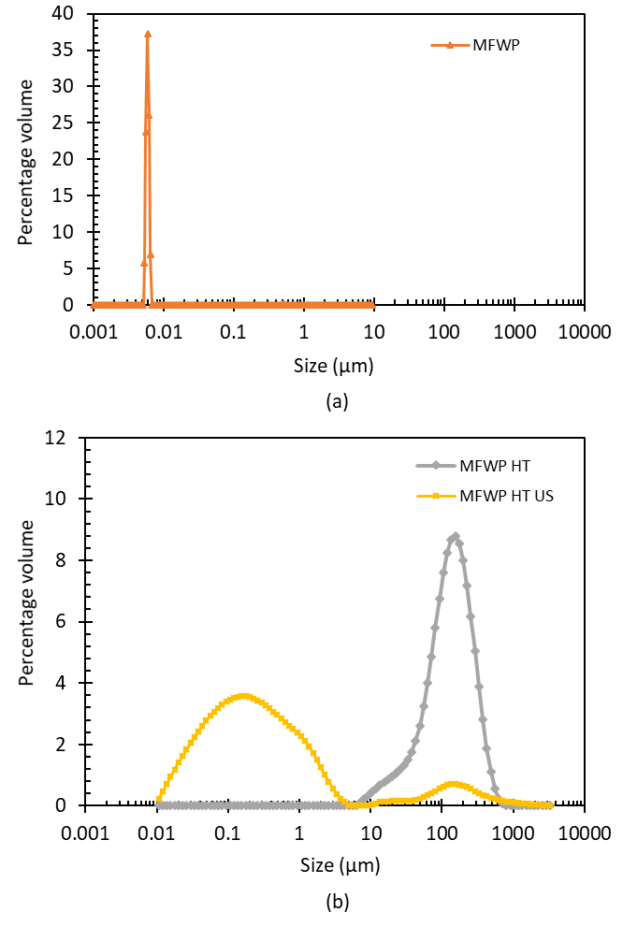
Figure 1: Particle size distribution of (a) untreated microfiltered whey protein (MFWP) () as measured by dynamic light scattering (Malvern Zetasizer). Particle size distributions of (b) heat-treated MFWP () and heat-treated and sonicated MFWP () measured by laser diffraction (Malvern Mastersizer). Two particle sizing methods were used to accurately measure across the wide particle size range (~ 5 nm to ~600 µm).
Next, milk systems were prepared for rennet gelation by mixing the treated whey protein solutions with diluted skim milk. The rennet gelation kinetics of four milk systems containing (i) diluted skim milk (DS), (ii) diluted skim milk with untreated/native MFWP (DS MFWP), (iii) diluted skim milk with heated MFWP (DS HT MFWP), and (iv) diluted skim milk with heated then sonicated MFWP (DS HT US MFWP) were analysed using oscillatory rheology. Figure 2 illustrates the change in the storage modulus (G’) of each milk system (at 31 °C) with time after rennet addition. The rapid increase in G’ indicates the onset of gelation which is characteristic of a gelling system under kinetic control (Meza-Nieto, Vallejo-Cordoba, González-Córdova, Félix, & Goycoolea, 2007). Gelation was fastest for diluted skim milk alone, and slowest when native MFWP was added to diluted skim milk (Figure 2). With MFWP, the rate of gelation was higher when the whey proteins were in the form of large heat-denatured aggregates than when the denatured whey protein aggregate size was reduced by sonication. However, the gelation rate of the DS HT US MFWP was still faster than that of the DS MFWP system.

Figure 2: Kinetics of rennet gelation of milk systems made with diluted skim milk only ( ), diluted skim milk with untreated/native MFWP (), diluted skim milk with heated MFWP () and diluted skim milk with heated then sonicated MFWP (). The error bars represent the standard deviation of measurements of duplicate samples.
The impaired gelation with added native MFWP agrees with our previous study in which native whey protein was shown to impair rennet gelation (Gamlath et al., 2018). The present results demonstrate that incorporating larger whey protein aggregates produced using heat denaturation can greatly reduce the impairment. It was hypothesised that the improved rate of gelation could be due to the larger whey protein aggregates no longer being able to occupy the spaces created in the cleaved casein micelle and therefore are not able to provide a steric barrier to the aggregation of renneted casein micelles. In addition, a reduction in the surface hydrophobicity of whey protein aggregates as the size increases could reduce interactions between cleaved casein micelles and whey protein aggregates during gelation. It is also possible that changes in the soluble calcium in the medium as a result of heat and US treatment could influence the gelation rate. The soluble calcium of untreated MFWP (Table 1) was similar (at a 95% CI) to its total calcium content of 888 ± 16 ppm, indicating that negligible amounts of calcium were bound to proteins in the MFWP. When subjected to heat and US treatments the soluble calcium content in MFWP remained essentially unchanged. As the soluble calcium concentration was the same for the MFWP, HT MFWP and HT US MFWP systems, this should not be an explanatory factor in the observed differences in gelation kinetics.
Table 1: Soluble calcium and surface hydrophobicity of differently treated MFWP systems.
Whey protein system | Soluble calcium (ppm) | Surface hydrophobicity index
MFWP | 883 ± 5ª | 755±3ª
MFWP HT | 882 ± 8 ª | 3623±172^{b}
MFWP HT US | 863 ± 17 ª | 4782±25^{c}
* The standard deviation of measurements of at least duplicates samples prepared from the same treatment tube are denoted alongside the mean value. Although the absolute surface hydrophilicity values varied between separate trials done on different days with freshly prepared buffer, an increasing trend with HT and HT US treatments was consistency observed.
** Significantly different values (p < 0.05) within a column are denoted using superscript letters.
The hydrophobicity of MFWP increased with heat treatment followed by a further increase after sonication (Table 1). Thermal denaturation of whey proteins is known to expose hydrophobic domains that are otherwise buried within the native globular structure (Giroux et al., 2015). Such hydrophobic regions interact to form larger whey protein aggregates which are later disintegrated by cavitation induced shear forces of US. Disintegrated aggregates have more exposed hydrophobic residues that are otherwise buried within larger aggregates.
A complementary study by Giroux et al. (2015) also reported improved rennet gelation when whey proteins were denatured at varying concentrations (5% w/w – 20% w/w) to form small aggregates with an average size ranging between 41 nm to 299 nm. In their experiments, the larger aggregates (299 nm) were found to be less hydrophobic than the smaller aggregates (41 nm). In contrast to the current study, in which the smaller aggregates were made by fragmenting large aggregates, the small and large aggregates in the study by Giroux et al. (2015) were made by heat denaturation at varying concentrations of protein. Their study concluded that the smaller, more hydrophobic aggregates could better interact with the hydrophobic renneted casein micelles than the less hydrophobic larger aggregates, and more severely impair casein network formation. Contrastingly, Perreault, Morin, et al. (2017) reported that the less hydrophobic soluble protein fraction of denatured whey protein concentrates impaired rennet gelation more severely than the more hydrophobic sedimentable fraction, which had larger aggregates (~8 µm). Nonetheless, in our study, aggregate hydrophobicity cannot be directly correlated to either the size of the whey protein aggregates or to the rate of gelation. Native MFWP had the smallest particle size (5-7 nm) and the lowest hydrophobicity (755 ± 3). The HT MFWP had the largest particles (60-600 µm) and a higher hydrophobicity index of 3623 ± 172. The HT US MFWP with intermediate sized particles (0.01 µm - 2 µm) had the highest hydrophobicity index of 4782 ± 25). Therefore, irrespective of the hydrophobicity, it appears that the size of the whey protein/aggregate is the key factor in determining its effect on rennet gelation. While small (5-7 nm) native whey proteins can occupy the spaces created on renneted casein micelles (which is ~50-200 nm in diameter), larger heat-denatured aggregates (60-600 µm) and heat-denatured and sonicated aggregates (0.1-2 µm) are too large to be able to do so.
3.2 Effect of aggregates made from whey protein concentrate powder on rennet gelation
While MFWP was used here to understand the mechanism behind the effect of aggregating whey protein on rennet gelation, whey protein concentrates produced from cheese whey are more widely produced and of more industrial relevance. To investigate the effect of replacing MFWP with WPC on the kinetics of rennet gelation, cheese milks (with a casein:whey protein ratio of 0.9:1) were formulated by incorporating fat suspensions into diluted skim milk. Four milk systems with diluted skim milk (DS), diluted skim milk with untreated WPC (DS WPC), diluted skim milk with heat-treated WPC (DS HT WPC) and diluted skim milk with heat-treated and sonicated WPC (DS HT US WPC) were analysed.
The particle size distributions of treated WPC samples were first determined (Figure 3a). Compared to the untreated MFWP solution that had a single peak at 5-7 nm, two peaks were observed in the untreated WPC solution at 50-90 nm and 150-450 nm. After centrifuging the WPC solution, the fat-rich top layer had a peak at 65-400 nm reflecting the presence of homogenised fat (Thiebaud, Dumay, Picart, Guiraud, & Cheftel, 2003). The protein-rich middle layer had two peaks at 30-60 nm and 80-300 nm. The peak at 30-60 nm could possibly correspond to small whey proteins aggregates (Giroux et al., 2015), while the peak at 80-300 nm corresponds to both submicron-sized fat globules (Michalski, Michel, & Geneste, 2002) that comprised 1.88 ± 0.33 % w/w of the powder, and relatively large whey protein aggregates and/or casein micelles (Glantz et al., 2010). Similar to MFWP, upon heat treatment, denatured whey protein particulates were formed in the 10% w/w WPC solutions, as indicated in the particle size distribution (major peak between 4-250 µm). After sonication the majority of these particles were disintegrated into smaller particles <6 µm, with only a small amount of larger aggregates remaining (Figure 3b).
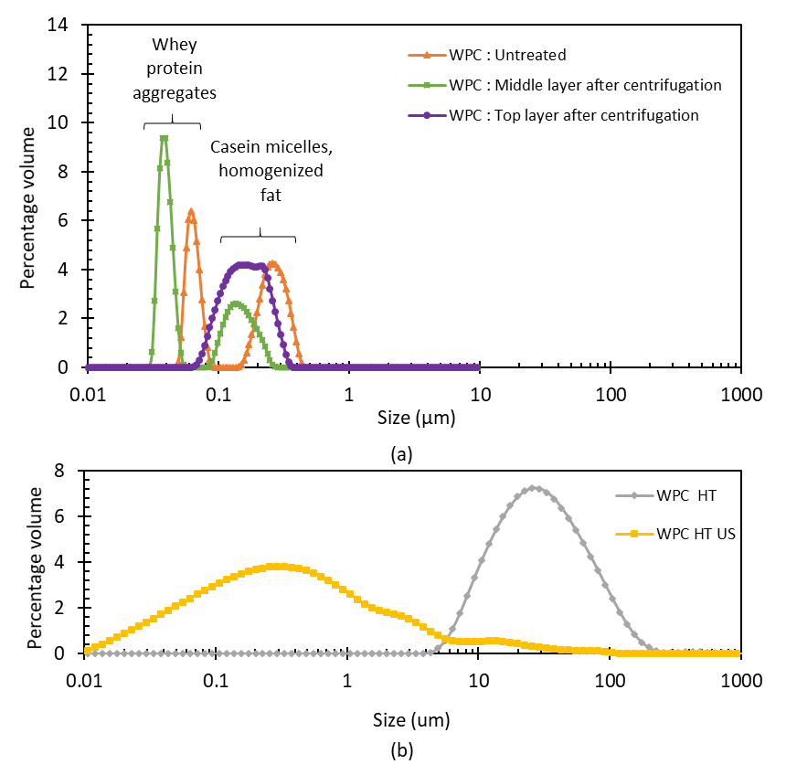
Figure 3: Particle size distributions of (a) untreated WPC (), the middle layer of centrifuged WPC () and the top layer of centrifuged WPC ( ) as measured by dynamic light scattering (Malvern Zetasizer). Particle size distributions of (b) heat-treated WPC () and heat-treated and sonicated WPC () measured by laser diffraction (Malvern Mastersizer). Two particle sizing methods were used to accurately measure across a wide particle size range (~30 nm to ~900 µm).
The trends in gelation kinetics with respect to whey protein aggregate size for the DS WPC, DS HT WPC and DS HT US WPC systems (Figure 4) was similar to that of the comparable systems made from MFWP (Figure 2). Again, improved gelation compared to the untreated WPC occurred after heat treatment (DS HT WPC). The gelation rate reverted to that of the untreated WPC when the WPC aggregate size was reduced using ultrasound (DS HT US WPC). This is consistent with proposed mechanism that increasing the size of the whey proteins by heat-induced aggregation prevents the whey proteins from associating with, and thereby impairing, the gelation of the renneted casein micelles. The storage moduli in all WPC systems were less than those in the equivalent MFWP system. This could be explained by the lower overall casein concentration in the WPC systems. Also, in contrast to the native MFWP that impaired the rennet gelation of diluted skim milk, the addition of untreated WPC improved the rate of rennet gelation. The improved gelation could be due to the slightly higher casein concentration in the WPC samples (2.0% w/w) compared to the DS (1.9 % w/w), which was due to the presence of casein in the WPC (4.9 ± 1.4% w/w) that was negligible in the MFWP. The presence of casein micelles is reflected in the size distribution data as a peak between 80-300 nm (Figure 3a).

Figure 4: Kinetics of rennet gelation of milk systems made with diluted skim milk only (), diluted skim milk with untreated WPC (), diluted skim milk with heated WPC () and diluted skim milk with heated then sonicated WPC (). The error bars represent the standard deviation of measurements of duplicate samples.
As with the MFWP systems, the hydrophobicity of the WPC systems increased with heat-treatment and further increased with subsequent ultrasound (Table 2). The relatively higher surface hydrophobicity of the untreated WPC compared to the untreated MFWP could be due to the presence of aggregates (with more exposed hydrophobic sites), as indicated in the size distribution data and residual fat in the commercial WPC, which contained 5.28% w/w fat, compared to <0.1% w/w in the MFWP powder. To investigate whether the fat in the commercial WPC could fully account for the increase in hydrophobicity, a separate experiment was carried comparing 10% WPC solutions prepared with different fat contents ranging between 0.250% w/w and 0.528% w/w to a 10% w/w MFWP system containing 0.260% w/w anhydrous milk fat (Figure S2). At a similar level of fat (~0.25%) the MFWP system showed a significantly lower surface hydrophobicity than the WPC system, confirming that the increase in surface hydrophobicity in WPC is primarily due to the presence of denatured whey protein aggregates. Distinct to the WPC, heat treatment of the WPC was found to significantly reduce the soluble calcium content (Table 2). This can be attributed to the presence of casein in the WPC, as it is known that soluble calcium shifts to colloidal calcium associated with casein micelles upon heating (Zhang & Aoki, 1996). Sonication did not cause further changes in the calcium equilibrium. As equal amounts of whey protein dispersions were added to the DS WPC, DS HT WPC and DS HT US WPC milk systems, the lower soluble calcium in the HT WPC and HT US WPC systems would translate to a lower soluble calcium content in the DS HT WPC and DS HT US WPC milk systems compared to that of the DS WPC system. Although a reduction in soluble calcium should impair the rate of rennet gelation (Martin, Williams, & Dunstan, 2010), the opposite was observed in this study. This further confirms that the size of the whey proteins/aggregates is key in determining the rate of rennet gelation irrespective of the changes in the soluble calcium.
Table 2: Soluble calcium and surface hydrophobicity of differently treated WPC systems.
Whey protein system | Soluble calcium (ppm) | Surface hydrophobicity index
WPC | 318 ± 1ª | 3090 ± 100ª
WPC HT | 231 ± 3 ^{b} | 8891 ± 473^{b}
WPC HT US | 233 ± 2 ^{b} | 14590 ± 223^{c}
* The standard deviation of measurements of at least duplicates samples prepared from the same treatment tube are denoted alongside the mean value. Although the absolute surface hydrophilicity values varied between separate trials done on different days with freshly prepared buffer, an increasing trend with HT and HT US treatments was consistency observed.
** Significantly different values (p < 0.05) within a column are denoted using superscript letters.
3.3 Incorporation of whey protein aggregates into rennet gels
To complement the gelation kinetics study, insights into how whey proteins are incorporated into the gel matrix could be gained through confocal imaging of the gel microstructure. Despite the observed differences in the gelation rates and gel strengths of the differently treated WPC systems, the microstructure images (Figure 5) show entrapment of the whey proteins within the casein gel matrix of all the sample. However, the microstructure of the samples appeared to differ. In the gels with untreated WPC, the whey proteins were present as relatively small clusters spread evenly throughout the casein matrix. Whereas in the system with heated-treated WPC, the whey proteins existed as larger, separated clusters, while in the heated and sonicated system the clusters were smaller yet interconnected. Presumably, smaller more dispersed aggregate clusters should be more effective than larger more localised aggregates at reducing the number of casein-casein crosslinks by acting as an inert barrier inside the casein matrix. The higher number of casein-casein cross links that can form with larger aggregates could be the reason for the higher final gel strengths observed in the DS HT WPC system, compared to the DS WPC and DS HT US WPC systems (Figure 4).
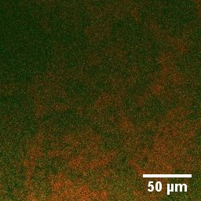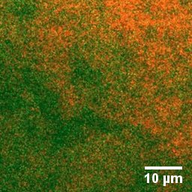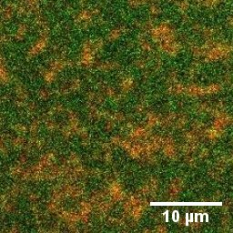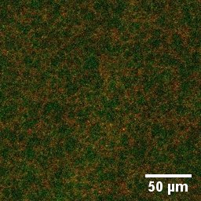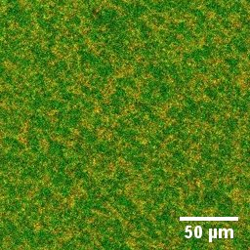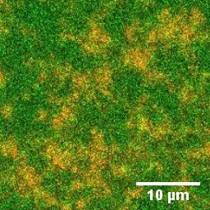
DS HT US WPC
DS HT WPC
DS WPC
Figure 5: Microstructural images of rennet gels made from skim milk with added untreated (left), heat-treated (middle) and heated then sonicated (right) WPC. Skim milk and WPC were stained in green and red respectively. The yellow areas representing the overlay of green and red, are representative of whey protein clusters (red) in the casein matrix (green). The images in the top and bottom rows are of different magnifications.

Although whey proteins are well incorporated into the initial gel matrix (Figure 5), their retention in the cheese despite multiple post-gelation processing steps such as cutting, cooking, cheddaring and pressing will depend on how strongly whey proteins are entrapped and bound within the casein matrix. Both aggregate size and surface hydrophobicity could be determining factor in whey protein retention. For example, inert fat droplets (droplets that are not coated in casein micelles and therefore do not interact with the casein matrix) are better retained in cheeses when they are similar in size to the pores created in the gel matrix (Logan et al., 2015). Although an increased hydrophobicity of whey protein aggregates (with heat and US treatments) did not appear to affect the rate of casein micelle aggregation during rennet gelation, it could nonetheless result in stronger interactions between the casein matrix and whey protein aggregates that could help retain them within the casein gel structure during post-coagulation processing. Therefore, to assess whether the size or hydrophobicity of the whey protein aggregates influence their retention in the rennet gel matrix, the protein retention in cooked rennet gel systems made with DS, DS WPC, DS HT WPC and DS HT US WPC systems was measured (Table 3).
Table 3: Compositional analysis and protein retention in rennet gel curds and whey made from diluted skim milk (DS), diluted skim milk with untreated whey protein concentrate (DS WPC), diluted skim milk with heat-treated WPC (DS HT WPC) and diluted skim milk with heat-treated and sonicated WPC (DS HT US WPC).
Cheese milk system | Moisture content in cooked curd  (% w/w) | Total solids in drained whey (% w/w) | Protein content in cooked curd (% w/w) | Protein content in drained whey (% w/w) | Mass of cooked curd (g) | Protein retention in cooked curd (% of input protein) | Protein loss in drained whey (% of input protein) | Ratio of total protein in cooked curd: casein content in cheese milk
DS | 83.5±0.3ª | 5.57±0.22ª | 10.6±0.4ª | 0.58±0.38ª | 22.7±0.1 ª | 83.5±3.1ª | 15.6±0.9 | 1.07±0.04ª
DS WPC | 83.8±1.2 ª | 6.82±0.12^{b} | 10.2±0.3 ª | 1.47±0.13 ^{b} | 25.1 | 69.7±1.9^{b} | 29.6±1.8 ^{b} | 1.12±0.3 ^{a b}
DS HT WPC | 83.3±0.7 ª | 6.77±0.14^{b} | 11.5±0.8 ª | 1.35±0.10 ^{b} | 23.6±2.1ª | 73.3±1.7^{b} | 30.0±3.4 ^{b} | 1.18±0.03 ^{b}
DS HT US WPC | 83.6±0.2 ª | 6.41±0.01^{b} | 11.0±0.1 ª | 1.11±0.06 ^{c} | 26.8±0.0ª | 81.0±0.6ª | 22.2±1.2^{c} | 1.30±0.01 ^{c}
* The standard deviation of replicate measurements of duplicate milk systems are denoted alongside the mean value except for the DS WPC system, for which the cooked curds were formed once and replicate samples were measured.
** Significantly different values (p < 0.05) within a column are denoted using superscript letters.

In conventional cheese making, most of the casein is retained in the curd as part of the cheese matrix, whereas almost all the whey protein is lost into the whey. To account for the higher concentration of whey protein in the cheese milks with added WPC, a comparison was made on the basis of the protein retention in the cheese per gram of casein in the cheese milk. The ratio of total protein to casein (hence whey protein retention) was similar for the DS (1.07 ± 0.04) and DS WPC (1.12 ± 0.03) systems, indicating that the majority of whey protein/aggregates in the WPC were sufficiently small (Figure 3: 30-60 nm peak of the protein-rich middle layer) to escape the gel to a similar extent to the native whey protein in the skim milk. The larger aggregates (Figure 3: 80-300 nm peak of the protein rich middle layer) were not sufficiently abundant to significantly influence protein retention. The similarity in whey protein retention despite the high surface hydrophobicity of WPC (2347 ± 7) compared to that of native whey protein (487 ± 19) of the WPC indicates that hydrophobicity was not a major factor in the retention of small whey protein aggregates. The protein-to-casein ratio was higher for the heat-treated WPC system (1.18 ± 0.03) and higher again for the WPC that had been heated then ultrasound treated (1.30 ± 0.01), which was also reflected by 5.2% and 16.2% increases in protein retention, compared to the system with untreated WPC. The increased retention of the heat-treated WPC can be attributed to the increased size of the aggregates. The further increase in retention of the heated and ultrasound-treated WPC, which had somewhat smaller but more hydrophobic aggregates than the heat-treated WPC, suggests hydrophobicity can increase the retention of sufficiently large whey protein aggregates. While the majority of the whey proteins are expulsed during the cutting and cheddaring stage of cheese making, these results suggest that sufficiently large and hydrophobic whey protein aggregates can associate strongly enough with renneted casein micelles to facilitate retention inside the coagulum. Somewhat relatedly, Perreault, Rémillard, et al. (2017) reported that protein retention in semi-hard cheese (20-24% fat) was higher when the sedimentable fraction of denatured whey protein concentrates was added than when the soluble fraction was used. Ismail et al. (2011) reported an increase in the overall cheese yield when denatured whey protein aggregates were incorporated during mozzarella cheese making from buffalo milk containing fat <2%. However, this appears to be the first time an increase in whey protein retention has been reported for cheese milk containing negligible fat.
3.4 Retention of whey protein aggregates in model fat-free cheese
Cheddar cheese making involves post-cooking steps such as salting and pressing that can lead to further expulsion of loosely bound proteins from the cheese matrix. Therefore, model cheeses were made from 10 kg batches of the different WPC cheese milk systems to investigate whether the whey protein aggregates retained in the curds could be maintained through the post-cooking process.
As with the curds, compositional analysis of the cheeses showed an increase in protein retention with heat and heat-coupled US treatment (Table 4). The increase in protein retention is likely due to an increase in the retention of whey protein. SDS-PAGE analysis of the sweet whey was performed that provided further evidence of whey protein retention in the DS HT US WPC cheese (Figure 6). Analysis of the cheese was not possible due to the difficulty of melting and solubilising the fat-free cheeses, even after EDTA addition. The intensities of α-lactalbumin, β-lactoglobulin and serum albumin bands of the sweet whey from the DS HT US WPC cheese were low compared to those from the DS WPC and DS HT WPC cheeses, suggesting that more whey protein was retained in the DS HT US WPC cheese (Figure 6). It should be noted that the low intensity of the whey protein bands in the DS sweet whey is due to the low initial whey protein concentration in the cheese milk, translating to a relatively low whey protein loss. Together the composition and SDS-PAGE data indicate that more whey protein was incorporated in cheese when both the aggregate size and the surface hydrophobicity of the whey proteins were increased by heat or heat coupled with ultrasound. While there was an increase in whey protein retention with increased size and hydrophobicity for the WPC augmented systems, the protein retention in the WPC-enriched cheeses was significantly lower than in the DS cheese, suggesting that the majority of the added whey proteins were still released during syneresis.
Table 4: Compositional analysis of model cheeses.
Cheese type | Total solids in sweet whey (% w/w) | Moisture content in pressed curd (% w/w) | Total protein in sweet whey (% w/w) | Protein content in pressed curd (% w/w) | Protein retention in pressed curd (% of input protein) | Ratio of total protein in cheese: casein content in cheese milk
DS | 5.73±0.01ª | 54.3±0.3ª | 0.79±0.03ª | 40.78±0.24ª | 85.8±0.5ª | 1.11±0.01 ^{ab}
DS WPC | 6.31±0.02^{b} | 53.2±0.3ª | 1.30±0.00^{b} | 40.89±0.27ª | 68.3±0.4^{b} | 1.10±0.01 ª
DS HT WPC | 6.73±0.02^{c} | 58.6±0.5^{b} | 1.18±0.05^{c} | 36.34±0.04^{b} | 70.7±0.1^{c} | 1.14±0.00 ^{ab}
DS HT US WPC | 6.36±0.02^{b} | 61.1±1.2^{c} | 1.06±0.01^{d} | 33.82±1.00^{c} | 72.7±2.1^{c} | 1.17±0.03 ^{b}
*The standard deviation of the measurements of duplicate or triplicate samples are denoted alongside the mean value.
**Significantly different values (p < 0.05) within a column are denoted using superscript letters.
***Note that the total weight of curds and sweet whey used for protein retention and loss calculations were measured once.

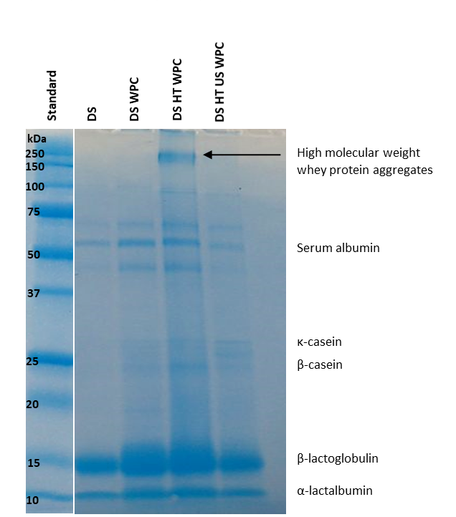
Figure 6: SDS-PAGE gel of sweet whey samples from cheeses made from diluted skim milk (DS), diluted skim milk with untreated whey protein concentrate (DS WPC), diluted skim milk with heat-treated WPC (DS HT WPC) and diluted skim milk with heat-treated and sonicated WPC (DS HT US WPC).
In traditionally made cheddar cheeses, fat globules trapped inside the protein matrix acts as a cheese structure breaker providing an ‘openness’ to its microstructure (Lobato-Calleros et al., 2007). Therefore, a common problem associated with low-fat cheese is the rigidity caused by a strongly interlinked protein structure. Due to the very low fat content (<0.02% w/w) in the milk formulation used in these experiments, the DS cheese (Figure 7a top two rows) and DS WPC cheese (Figure 7b top two rows) had a hard and gummy texture. However, despite the low-fat content, cheese made with incorporation of heated (Figure 7c top two rows) or heated and sonicated (Figure 7d top two rows) WPC were softer and closer to regular cheddar cheese in appearance.
Confocal microscopy was used to investigate the role of the incorporated whey protein aggregates on the cheese microstructure (Figure 7, bottom rows). Cheese made from diluted skim milk and diluted skim milk with added untreated WPC showed a smoother more compact cheese protein structure (represented in green) with small pore (represented in black) (Figure 7a bottom two rows). This is a more compact microstructures than is typical of cheese made from full cream milk (with ~3.4% fat) (Lobato-Calleros et al., 2007). With the addition of heat-treated WPC the microstructure was interrupted with larger pores and cracks (Figure 7c bottom two rows), and with heat-treated then sonicated WPC the structure was more granular (Figures 7d bottom two rows). Due to the very low fat content in the cheese milk (<0.02% w/w), there were no distinguishable areas of Nile red-stained fat (represented in red). While the protein analysis indicated retention of whey protein in the DS HT WPC and DS HT US WPC cheeses, the majority of the whey protein was still lost during syneresis. It is possible that the expulsion of the differently sized whey proteins or whey protein aggregates during syneresis along with changes in moisture content contributed to changes in the cheese microstructure.
Denatured whey protein has a high moisture binding capacity than native whey proteins, as is known to increase the moisture content in cheese, thereby conveying a softer texture via hydration of the protein matrix (Stankey et al., 2017). It has been reported that at moisture contents up to 50% w/w, the moisture in acid gel cheese remains almost entirely bound to the protein matrix as water of hydration (Hennelly, Dunne, O’Sullivan, & O’Riordan, 2005). Above 54% w/w moisture content, finely distributed water can coalesce to form free water in the protein matrix. Although such ‘limiting’ moisture contents have not been reported for rennetted cheese, dark ‘pores’ or serum pockets can be observed in the DS HT WPC (moisture content = 58.6%) and DS HT US WPC (moisture content = 61.1% w/w) cheese microstructure, which could possibly have been formed by the coalescence of free water.
In addition to the presence of pores, the DS HT WPC and DS HT US WPC cheeses had a granular or ‘flaky’ protein microstructure. This granular structure could result from the disturbance to the casein matrix caused by the expulsion of differently sized whey protein aggregates from the gel. Incorporating smaller, untreated whey proteins resulted in the smaller irregularities of the DS WPC cheese, while the expulsion of larger heat-treated whey aggregates caused larger irregularities responsible for the flaky microstructure. Meanwhile the expulsion of medium sized aggregates produced with heat treatment and sonication provided a more granular microstructure.
The present results suggest that during rennet gelation, incorporating heat-denatured (Figure 8c) and US-treated whey protein aggregates (Figure 8d) can reduce the impairment of rennet gelation caused by native whey proteins (Figure 8h). At the same whey protein concentration, incorporating larger aggregates that are less numerous results in less steric hindrance compared to smaller aggregates that are more numerous, leading to faster rennet gelation (Figure 8 i, j). During subsequent gelation large whey protein aggregates can become incorporated into the casein matrix, which is enhanced by their higher surface hydrophobicity (Figure 8 l, m) compared to native whey proteins. During post-gelation processing of the curd, the majority of the whey protein is released from the casein matrix, however some hydrophobic aggregates can be retained due to hydrophobic interactions with the renneted casein. The expulsion of whey sufficiently large protein aggregates (that were loosely bound to the casein gel) during cooking provides an “openness” and irregularity to the microstructure and reduce the rigidity of the casein matrix in low-fat cheese (Figure 8 o, p).

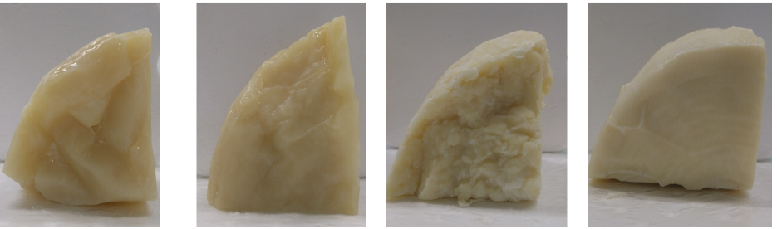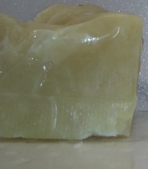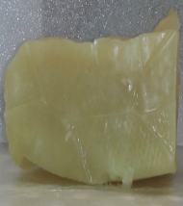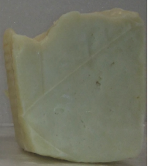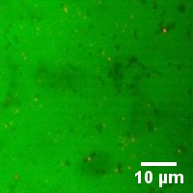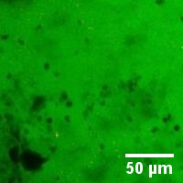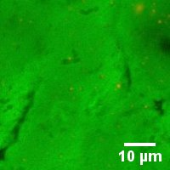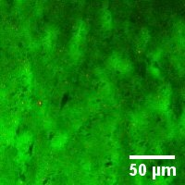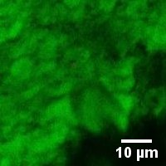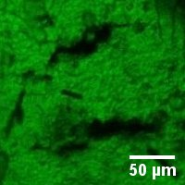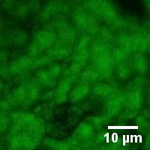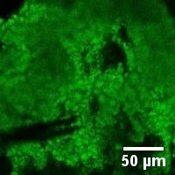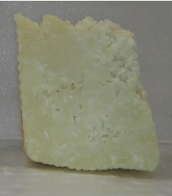
(a)
(b)
(c)
(d)
Figure 7: Visual appearance of the surface (top row) and interior (second row), and the microstructure (bottom two rows) of model cheeses made with (a) DS, (b) DS WPC, (c) DS HT WPC and (d) DS HT US WPC. Black areas in the microstructural images represent pores in the cheese while green areas represent the protein matrix.
Figure 8: Proposed mechanism for the effect of whey protein aggregates on the rate of rennet gelation and the protein retention in cheese. Upon heat treatment, native whey proteins () (a) unfold (b) and expose their buried hydrophobic residues (). Subsequently, denatured whey proteins aggregate due to hydrophobic interactions (c). Acoustic shear disintegrates large whey aggregates into smaller particles with more exposed hydrophobic residues (d). When whey proteins are added to a system containing casein micelles ( ) and rennet ( ) (e), (f), (g), native whey proteins occupy the spaces created on the micelle surface from the cleavage κ-casein impairing the enzyme hydrolysis process. They further provide a steric barrier to interactions between cleaved micelles ( ), reducing the rate of gelation (h). Sufficiently large heat-treated or heat- and ultrasound-treated whey protein aggregates are unable to interact with cleaved casein micelles, or obstruct aggregation and allows a stronger coagulum to be formed (i), (j). More hydrophobic aggregates can interact ( ) with the casein matrix more (l), (m) compared to native whey proteins (k), and are therefore less likely to be expulsed during whey syneresis. The majority of the smaller native whey proteins escape the coagulum (n) during syneresis. The expulsion of larger whey protein aggregates facilitates a more granular cheese structure with irregularities (o), (p).
4. Conclusions
This study demonstrated that sufficiently large whey protein aggregates, formed using heat or heat-plus-ultrasound treatment on whey protein streams, could avoid impairment of rennet gelation caused by native whey protein in whey protein-rich cheese milks with a consistent casein concentration. Further, these treatments could improve whey protein retention when incorporated into cheese production from whey protein- rich cheese milks. Irrespective of changes in the soluble calcium in the systems, larger aggregates can reduce the steric barrier created by native whey proteins and smaller whey protein aggregates. Further, more hydrophobic aggregates can interact with the casein matrix, which reduces the expulsion of whey protein during syneresis. However, the expulsion of larger whey protein aggregates facilitates a more open cheese microstructure and mitigates the increased hardness that is observed in low fat cheeses. This study demonstrated the potential of using heat and ultrasound treatment to increase the retention of whey protein and improve the texture of low-fat cheese.

Acknowledgements
Authors are grateful for the support received from Ms. Masooma Munir during cheese trials and for Biological Optical Microscopy Platform (BOMP), The University of Melbourne for the support provided for using the Confocal Laser Scanning Microscope. This research was supported under Australian Research Council’s Industrial Transformation Research Program (ITRP) funding scheme (project number IH120100005). The ARC Dairy Innovation Hub is a collaboration between The University of Melbourne, The University of Queensland and Dairy Innovation Australia Ltd.

Declaration of interest
None

References

Alizadeh-Pasdar, N., & Li-Chan, E. C. (2000). Comparison of protein surface hydrophobicity measured at various pH values using three different fluorescent probes. Journal of Agricultural and Food Chemistry, 48(2), 328-334. doi:https://doi.org/10.1021/jf990393p
Ashokkumar, M., Lee, J., Zisu, B., Bhaskarcharya, R., Palmer, M., & Kentish, S. (2009). Hot topic: Sonication increases the heat stability of whey proteins. Journal of Dairy Science, 92(11), 5353-5356. doi:https://doi.org/10.3168/jds.2009-2561
Baldwin, K. A., Baer, R., Parsons, J., Seas, S., Spurgeon, K., & Torrey, G. (1986). Evaluation of yield and quality of cheddar cheese manufactured frommilk with added whey protein concentrate. Journal of Dairy Science, 69(10), 2543-2550. doi:https://doi.org/10.3168/jds.s0022-0302(86)80699-3
Banks, J. M., & Muir, D. (1985). Effect of incorporation of denatured whey protein on the yield and quality of Cheddar cheese. International Journal of Dairy Technology, 38(1), 27-32. doi:https://doi.org/10.1111/j.1471-0307.1985.tb00536.x
Barbero, N., Barni, E., Barolo, C., Quagliotto, P., Viscardi, G., Napione, L., Pavan, S., & Bussolino, F. (2009). A study of the interaction between fluorescein sodium salt and bovine serum albumin by steady-state fluorescence. Dyes and pigments, 80(3), 307-313.
Brown, R. J., & Ernstrom, C. A. (1982). Incorporation of ultrafiltration concentratedwhey solids into cheddar cheese for increased yield. Journal of Dairy Science, 65(12), 2391-2395. doi:https://doi.org/10.3168/jds.s0022-0302(82)82514-9
Chamberland, J., Benoit, S., Harel-Oger, M., Pouliot, Y., Jeantet, R., & Garric, G. (2019). Comparing economic and environmental performance of three industrial cheesemaking processes through a predictive analysis. Journal of Cleaner Production, 239, 118046. doi:https://doi.org/10.1016/j.jclepro.2019.118046
Chamberland, J., Mercier-Bouchard, D., Dussault-Chouinard, I., Benoit, S., Doyen, A., Britten, M., & Pouliot, Y. (2019). On the Use of Ultrafiltration or Microfiltration Polymeric Spiral-Wound Membranes for Cheesemilk Standardization: Impact on Process Efficiency. Foods, 8(6), 198. doi:https://doi.org/10.3390/foods8060198
Di Cagno, R., De Pasquale, I., De Angelis, M., Buchin, S., Rizzello, C., & Gobbetti, M. (2014). Use of microparticulated whey protein concentrate, exopolysaccharide-producing Streptococcus thermophilus, and adjunct cultures for making low-fat Italian Caciotta-type cheese. Journal of Dairy Science, 97(1), 72-84. doi:https://doi.org/10.3168/jds.2013-7078
Fox, P. F., Guinee, T. P., Cogan, T. M., & McSweeney, P. L. (2000). Fundamentals of cheese science. Gaithersburg: Aspen Publishers.
Fox, P. F., Guinee, T. P., Cogan, T. M., & McSweeney, P. L. (2017). Enzymatic coagulation of milk. In Fundamentals of cheese science (pp. 185-229). Boston: Springer.
Gamlath, C. J., Leong, T. S., Ashokkumar, M., & Martin, G. J. (2018). The inhibitory roles of native whey protein on the rennet gelation of bovine milk. Food chemistry, 244, 36-43. doi:https://doi.org/10.1016/j.foodchem.2017.10.029
Giroux, H. J., Lanouette, G., & Britten, M. (2015). Effect of whey protein aggregates of various sizes on the formation and properties of rennet-induced milk gels. Food Hydrocolloids, 45, 272-278. doi:https://doi.org/10.1016/j.foodhyd.2014.12.004
Glantz, M., Devold, T., Vegarud, G., Månsson, H. L., Stålhammar, H., & Paulsson, M. (2010). Importance of casein micelle size and milk composition for milk gelation. Journal of Dairy Science, 93(4), 1444-1451. doi:https://doi.org/10.3168/jds.2009-2856
Gordon, L., & Pilosof, A. M. (2010). Application of high-intensity ultrasounds to control the size of whey proteins particles. Food Biophysics, 5(3), 203-210. doi:https://doi.org/10.1007/s11483-010-9161-4
Guinee, T. P., & Wilkinson, M. (1992). Rennet coagulation and coagulants in cheese manufacture. International Journal of Dairy Technology, 45(4), 94-104. doi:https://doi.org/10.1111/j.1471-0307.1992.tb01791.x
Hennelly, P. J., Dunne, P. G., O’Sullivan, M., & O’Riordan, D. (2005). Increasing the moisture content of imitation cheese: effects on texture, rheology and microstructure. European Food Research and Technology, 220(3-4), 415-420.
Hinrichs, J. (2001). Incorporation of whey proteins in cheese. International Dairy Journal, 11(4), 495-503. doi:https://doi.org/10.1016/s0958-6946(01)00071-1
Ismail, M., Ammar, E. T., & El‐Metwally, R. (2011). Improvement of low fat mozzarella cheese properties using denatured whey protein. International Journal of Dairy Technology, 64(2), 207-217. doi:https://doi.org/10.1111/j.1471-0307.2010.00654.x
Jenness, R. (1999). Composition of Milk. In N. P. Wong (Ed.), Fundamentals of Dairy Chemistry (pp. 1-38). Gaithersburg, Maryland: Aspen Publishers, Inc.
Kethireddipalli, P., Hill, A. R., & Dalgleish, D. G. (2010). Protein interactions in heat-treated milk and effect on rennet coagulation. International Dairy Journal, 20(12), 838-843. doi:https://doi.org/10.1016/j.idairyj.2010.06.003
Laiho, S., Ercili-Cura, D., Forssell, P., Myllärinen, P., & Partanen, R. (2015). The effect of dynamic heat treatments of native whey protein concentrate on its dispersion characteristics. International Dairy Journal, 49, 139-147. doi:https://doi.org/10.1016/j.idairyj.2015.05.002
Leong, T. S., Walter, V., Gamlath, C. J., Yang, M., Martin, G. J., & Ashokkumar, M. (2018). Functionalised dairy streams: Tailoring protein functionality using sonication and heating. Ultrasonics Sonochemistry, 48(1), 499-508. doi:https://doi.org/10.1016/j.ultsonch.2018.07.010
Lo, C., & Bastian, E. (1998). Incorporation of native and denatured whey proteins into cheese curd for manufacture of reduced fat, Havarti-type cheese. Journal of Dairy Science, 81(1), 16-24. doi:https://doi.org/10.3168/jds.s0022-0302(98)75545-6
Lobato-Calleros, C., Reyes-Hernández, J., Beristain, C., Hornelas-Uribe, Y., Sanchez-Garcia, J., & Vernon-Carter, E. (2007). Microstructure and texture of white fresh cheese made with canola oil and whey protein concentrate in partial or total replacement of milk fat. Food research international, 40(4), 529-537. doi:https://doi.org/10.1016/j.foodres.2006.10.011
Logan, A., Leis, A., Day, L., Øiseth, S. K., Puvanenthiran, A., & Augustin, M. A. (2015). Rennet gelation properties of milk: influence of natural variation in milk fat globule size and casein micelle size. International Dairy Journal, 46, 71-77. doi:https://doi.org/10.1016/j.idairyj.2014.08.005
Lucey, J. A., Tamehena, M., Singh, H., & Munro, P. A. (1998). Effect of interactions between denatured whey proteins and casein micelles on the formation and rheological properties of acid skim milk gels. Journal of Dairy Research, 65(4), 555-567. doi:https://doi.org/10.1017/s0022029998003057
Manirakiza, P., Covaci, A., & Schepens, P. (2001). Comparative study on total lipid determination using Soxhlet, Roese-Gottlieb, Bligh & Dyer, and modified Bligh & Dyer extraction methods. Journal of food composition and analysis, 14(1), 93-100.
Mariotti, F., Tomé, D., & Mirand, P. P. (2008). Converting nitrogen into protein—beyond 6.25 and Jones' factors. Critical reviews in food science and nutrition, 48(2), 177-184. doi:https://doi.org/10.1080/10408390701279749
Martin, G. J., Williams, R. P., & Dunstan, D. E. (2010). Effect of manufacture and reconstitution of milk protein concentrate powder on the size and rennet gelation behaviour of casein micelles. International Dairy Journal, 20(2), 128-131. doi:https://doi.org/10.1016/j.idairyj.2009.08.007
Mason, T., Cobley, A., Graves, J., & Morgan, D. (2011). New evidence for the inverse dependence of mechanical and chemical effects on the frequency of ultrasound. Ultrasonics Sonochemistry, 18(1), 226-230. doi:https://doi.org/10.1016/j.ultsonch.2010.05.008
McMahon, D. J., Alleyne, M., Fife, R., & Oberg, C. (1996). Use of fat replacers in low fat Mozzarella cheese. Journal of Dairy Science, 79(11), 1911-1921. doi:https://doi.org/10.3168/jds.s0022-0302(96)76560-8
Mead, D., & Roupas, P. (2001). Effect of incorporation of denatured whey proteins on chemical composition and functionality of pizza cheese. Australian Journal of Dairy Technology, 56(1), 19.
Meza-Nieto, M. A., Vallejo-Cordoba, B., González-Córdova, A. F., Félix, L., & Goycoolea, F. M. (2007). Effect of β-lactoglobulin A and B whey protein variants on the rennet-induced gelation of skim milk gels in a model reconstituted skim milk system. Journal of Dairy Science, 90(2), 582–593. doi:https://doi.org/10.3168/jds.s0022-0302(07)71541-2
Michalski, M.-C., Michel, F., & Geneste, C. (2002). Appearance of submicronic particles in the milk fat globule size distribution upon mechanical treatments. Le Lait, 82(2), 193-208.
Mistry, V. V., & Maubois, J.-L. (2017). Application of membrane separation technology to cheese production. In Cheese (pp. 677-697): Elsevier.
Monahan, F. J., German, J. B., & Kinsella, J. E. (1995). Effect of pH and temperature on protein unfolding and thiol/disulfide interchange reactions during heat-induced gelation of whey proteins. Journal of Agricultural and Food Chemistry, 43(1), 46-52. doi:https://doi.org/10.1021/jf00049a010
Mulvihill, D., & Donovan, M. (1987). Whey proteins and their thermal denaturation-a review. Irish Journal of Food Science and Technology, 11(1), 43-75.
Ong, L., Dagastine, R. R., Kentish, S. E., & Gras, S. L. (2012). The effect of pH at renneting on the microstructure, composition and texture of Cheddar cheese. Food research international, 48(1), 119-130. doi:https://doi.org/10.1016/j.foodres.2012.02.020
Ong, L., Dagastine, R. R., Kentish, S. E., & Gras, S. L. (2013). The effect of calcium chloride addition on the microstructure and composition of Cheddar cheese. International Dairy Journal, 33(2), 135-141. doi:https://doi.org/10.1016/j.idairyj.2013.03.002
Perreault, V., Morin, P., Pouliot, Y., & Britten, M. (2017). Effect of denatured whey protein concentrate and its fractions on rennet-induced milk gels. International Dairy Journal, 64, 48-55. doi:https://doi.org/10.1016/j.idairyj.2016.09.005
Perreault, V., Rémillard, N., Chabot, D., Morin, P., Pouliot, Y., & Britten, M. (2017). Effect of denatured whey protein concentrate and its fractions on cheese composition and rheological properties. Journal of Dairy Science, 100(7), 5139-5152. doi:https://doi.org/10.3168/jds.2016-12473
Punidadas, P., Feirtag, J., & Tung, M. (1999). Incorporating whey proteins into mozzarella cheese. International Journal of Dairy Technology, 52(2), 51-55. doi:https://doi.org/10.1111/j.1471-0307.1999.tb02070.x
Roefs, S. P., & De Kruif, K. G. (1994). A model for the denaturation and aggregation of β‐lactoglobulin. European Journal of Biochemistry, 226(3), 883-889. doi:https://doi.org/10.1111/j.1432-1033.1994.00883.x
Rosa, P., Sala, G., Van Vliet, T., & Van De Velde, F. (2006). Cold gelation of whey protein emulsions. Journal of Texture Studies, 37(5), 516-537. doi:https://doi.org/10.1111/j.1745-4603.2006.00066.x
Rüegg, M., Moor, U., & Blanc, B. (1977). A calorimetric study of the thermal denaturation of whey proteins in simulated milk ultrafiltrate. Journal of Dairy Research, 44(3), 509-520. doi:https://doi.org/10.1017/s002202990002046x
Schenkel, P., Samudrala, R., & Hinrichs, J. (2013). The effect of adding whey protein particles as inert filler on thermophysical properties of fat‐reduced semihard cheese type Gouda. International Journal of Dairy Technology, 66(2), 220-230. doi:https://doi.org/10.1111/1471-0307.12036
Shahani, K., & Sommer, H. (1951). The protein and non-protein nitrogen fractions in milk. I. Methods of analysis. Journal of Dairy Science, 34(10), 1003-1009.
Singh, H., & Waungana, A. (2001). Influence of heat treatment of milk on cheesemaking properties. International Dairy Journal, 11(4-7), 543-551. doi:https://doi.org/10.1016/s0958-6946(01)00085-1
Stankey, J. A., Lu, Y., Abdalla, A., Govindasamy‐Lucey, S., Jaeggi, J. J., Ø Mikkelsen, B., Pedersen, K. T., & Andersen, C. B. (2017). Low‐fat Cheddar cheese made using microparticulated whey proteins: Effect on yield and cheese quality. International Journal of Dairy Technology, 70(4), 481-491. doi:https://doi.org/10.1111/1471-0307.12413
Sturaro, A., De Marchi, M., Zorzi, E., & Cassandro, M. (2015). Effect of microparticulated whey protein concentration and protein-to-fat ratio on Caciotta cheese yield and composition. International Dairy Journal, 48, 46-52. doi:https://doi.org/10.1016/j.idairyj.2015.02.003
Suárez, A., Fernández, L., Balbarie, P., Iglesias, J. R., & Riera, F. A. (2016). Predicting the properties of the whey protein microparticles produced by heat and mechanical treatments. European Food Research and Technology, 242(8), 1211-1220.
Tas, J., Ploeg, M. v. d., Mitchell, J., & Cohn, N. (1980). Protein staining methods in quantitative cytochemistry. Journal of microscopy, 119(3), 295-311.
Thiebaud, M., Dumay, E., Picart, L., Guiraud, J., & Cheftel, J. (2003). High-pressure homogenisation of raw bovine milk. Effects on fat globule size distribution and microbial inactivation. International Dairy Journal, 13(6), 427-439. doi:https://doi.org/10.1016/s0958-6946(03)00051-7
Vasbinder, A., Alting, A. C., & de Kruif, K. G. (2003). Quantification of heat-induced casein–whey protein interactions in milk and its relation to gelation kinetics. Colloids and Surfaces B: Biointerfaces, 31(1-4), 115-123. doi:ttps://doi.org/10.1016/s0927-7765(03)00048-1
Vasbinder, A., Rollema, H., & De Kruif, C. (2003). Impaired rennetability of heated milk; study of enzymatic hydrolysis and gelation kinetics. Journal of Dairy Science, 86(5), 1548-1555. doi:https://doi.org/10.3168/jds.s0022-0302(03)73740-0
Walstra, P. (1999). Casein sub-micelles: do they exist? International Dairy Journal, 9(3), 189-192. doi:https://doi.org/10.1016/s0958-6946(99)00059-x
Wang, L., & Wang, Y. J. (2004). Application of high‐intensity ultrasound and surfactants in rice starch isolation. Cereal chemistry, 81(1), 140-144. doi:https://doi.org/10.1094/cchem.2004.81.1.140
Zhang, Z. P., & Aoki, T. (1996). Behaviour of calcium and phosphate in bovine casein micelles. International Dairy Journal, 6(8-9), 769-780. doi:https://doi.org/10.1016/0958-6946(96)00006-4

Supplementary data

Figure S1: Temperature vs. time profiles of 25 mL 10% w/w WPC (), 50 mL 10% w/w WPC (), and 25 mL 20% MFWP () samples subjected to heating.

Figure S2: Surface hydrophobicity indices of 10% w/w WPC () and MFWP () systems with varying fat contents.

