Interfacial rheology of fluid-fluid interfaces at the micro to nanoscale with AFM

Matthew Dominic Biviano
ORCID Identifier – 0000-0001-5101-2771

Submitted in total fulfilment of the requirements of the degree of Doctor of Philosophy

September 2019

Department of Chemical Engineering

The University of Melbourne

Abstract
This thesis introduces and benchmarks 2 novel AFM based techniques to characterise the interfacial rheology of polymeric fluid-fluid interfaces. We develop and benchmark a time-dependent extension of capsule compression to model oscillatory indentations, determining the interfacial rheology of capsules from thin shells to thick shells. This is first tested and benchmarked using the food-based emulsifier β-lactoglobulin at the MCT-Oil interface. This system is then crosslinked and the behavioural changes in the capsule oscillatory rheology, bicone shear rheology and pendant drop dilational rheology are tested.

This investigation has shown that there is a significant frequency dependent response of β-lactoglobulin capsules to an oscillatory indentation in both the native and the crosslinked state. We also show that there is a large indentation depth dependence on the time dependent dwell behaviour. When comparing these behaviours to the bicone shear rheology and pendant drop dilational rheology, the magnitude of the moduli at similar frequencies differs strongly between all techniques. Comparatively, the tan(δ) between the bicone and capsule measurements exhibits similar magnitudes for both the native and crosslinked cases.

An extension of the capsule technique was made to include thicker interfaces, where the thickness of the interface is more than 5% of the overall capsule radius. This model was tested with the food hydrocolloid chitosan, which in acetate buffer concentrations above 0.3M makes particulates and becomes surface active, forming a thick film at the interface. We determine the properties of this film by assessing the film mechanically and visually. To mechanically characterise the film, we utilize bicone interfacial shear rheology, and both linear and oscillatory capsule compression. The film exhibits characteristic particle like behaviours and rapidly heals when broken in shear. Similar self-healing characteristics are then observed in the linear capsule compression, and the oscillatory capsule compression shows similar moduli and behaviour to that observed by the bicone. The visual characterisation was done with in-situ aqueous imaging and dry Langmuir-Blodgett imaging of a transferred film, where a thick, continuous, particulate film is observed.

We continue to push the lengthscale of interfacial rheology by developing a novel method of observing the interfacial rheology at a fluid/fluid interface. This method consists of placing a cantilever tip at the interface between two fluids, laterally translating the tip and observing the torsional force on the cantilever. This force can then be transformed into an interfacial viscosity with the knowledge of the diameter of the tip at the interface. We apply this technique to two types of interfaces, linear polymeric interfaces and a globular protein interface. At the air/water interface, we test the linear polymers PEO and PSS, where we observe that shorter chain length PSS shows a reduction in the interfacial viscosity. β-lactoglobulin is observed over time at the decane/water interface, where the interfacial viscosity increases over time, and non-linear strain dependent behaviour is observed.

Declaration

This is to certify that:
- The thesis comprises only my original work towards the PhD except where indicated in the Preface,
- Due acknowledgement has been made in the text to all other material used,
- The thesis is fewer than 100 000 words in length, exclusive of tables, maps, bibliographies and appendices.

Matthew Dominic Biviano

Preface
All work presented in this thesis has been completed in the duration of my enrolment at the University of Melbourne. Capsule models for chapters 4 and 5 have been developed by Joe Berry, and bicone experiments have been completed with the help of Lukas Böni and Peter Fischer. All material at the date of submission is unpublished, with the goal of publishing. I acknowledge the ARC, the Robert Bage Memorial scholarship, The University of Melbourne and Particulate Fluids Processing Centre for financial support during my PhD.

Acknowledgements
This PhD has been a hell of journey and been one of the most stressful and fruitful times of my life to date. With the patience and care from my supervisors, groupmates, friends, family and wife I’ve made it this far, but I’m here writing my acknowledgments, and I’m rather sad to see it end.
Starting chronologically and certainly most importantly, thank you Ray Dagastine for taking me on as PhD student after leaving my potential prospects at Monash and in the job market to come to UniMelb. The freedom, opportunities, direction and careful wisdom, both in life and science that you’ve provided has frankly been awesome. You’ve set a very high bar for me wherever I go next. A special mention to Joe Berry for effectively being my second supervisor. Your support, thoughts, expertise and friendship has gotten me through many difficult projects. Your support with coding and math (which is still the devil) has made a lot of my work possible. In the same vein, thank you Srinivas Mettu for all the guidance and teachings especially at the beginning of my PhD. Thank you for fielding all my questions, giving me a hand with countless experiments throughout the years and walking me through the industrial side of my PhD. Most of all, to those who supervised me at UniMelb, thank you for trusting me with my overzealous ideas and supporting me in making many of them a reality.
I've been very lucky to go to some amazing places and work with some fantastic people during my PhD. By far the largest external contribution to my PhD was working with Peter Fischer's lab for 4 months in ETH Zurich. The trip was more fun and interesting than I expected or hoped for. Thank you Peter for your gentle guidance over the last 3 years and always making me feel welcome in Zürich. A large thanks must go to Lukas, who decided to follow me back to Melbourne for a cold winter, and cultivated my love of boardgames by introducing me to Agricola. I never knew what a hagfish or a rheometer was before arriving at your door, let alone that they had something in common.
During my first year I spent many hours working the lab with Snow and Matilda, where we spent hours and hours cracking hundreds of capsules together and chatting. Thanks for your patience with me just starting my PhD, we learnt a lot together.
To some of the hardest working folk I know, Gyeongwon and JJ. Thank you for a great collaboration, you always had fantastic questions to ask, and always had time for my questions and curiosity about your projects.
Another thanks to Lisa and Mark for inviting me to the cold and windy Cork for a short stay with you at Teagasc, which I still struggle to pronounce. I very much appreciated the visit, from seeing a new corner of a very foreign land to seeing a very different approach to AFM and imaging.
Coming back home, I happen to meet a young PhD named Tom from the office next door. After a coffee and a number of good ideas we became friends and started a scientific partnership that has pushed the understanding and knowledge of our works. Thank you for your time, knowledge and patience over the years. I hope that we continue to work together into the future.
To my fellow PhD students, past and present, groupmates, temporary groupmates, you’ve made my time during my PhD. The group has waxed and waned over time, but a thanks to the ones I started with in Christine, Chris, Emily, Alisa, our new arrivals, Avinash, Tanwee, and Dinesh, and visitors Yuqi and Ellen. From all our conferences and travels together, to supporting eachother’s ideas for experiments and theories, I've had a great time hanging out with you all individually and as a group.
I have also been very fortunate to make some friends that have made conferences, lunches, coffees, dinners and trips to the pub much more enjoyable. You have made life far more fun and interesting over the last few years. A very special mention to Ross and Alicia for trading experimental failures and troubles, and Becca for helping me keep 7eleven open with regular $1 coffees.
To my poor parents Ewa and Dominic, for putting up with me over these long years I thank you. Thank you for your support on this endeavour, and giving me the skills to be a scientist.
To the most influential person in my life, my now wife, Marie. Who 2 months into my degree I visit in Copenhagen for Christmas to meet her family, only after dating her for 2 weeks. Who would know that we’d be married only 3 short years later. Thanks for all the time, energy, and care that you've taken with me over these 4 years.

Table of contents

Abstract i
Declaration iii
Preface iv
Acknowledgements v
Table of contents vii
List of figures x
Chapter 1 – Thesis overview 1
1.1 Colloidal interactions and stability of emulsions 2
1.2 Objectives and outcomes 2
1.3 Chapter summaries 3
Chapter 2 – Literature review 6
2.1 Colloidal Interactions and Stability of Emulsions 7
2.2 Interfacial Characterisation and Behaviour 7
2.2.1 Interfacial Tension 7
2.2.2 Curved Interfaces 7
2.2.3 Contact angle 8
2.2.4 Adsorption of surfactant species to the interface 9
2.2.3 Interfacial Rheology 11
2.3.1 Interfacial Dilational Behaviour 12
2.3.2 Interfacial Shear behaviour 14
2.4 Capsule Compression 16
2.4.1 Capsule Definition and Use 16
2.4.2 Capsule Compression 17
2.5 Atomic Force Microscopy 19
2.5.1 AFM introduction 19
2.5.2 AFM rheology 19
2.5.3 DLVO Surface Forces 21
2.5.4 Non-DLVO surface Forces 21
2.5.5 Cantilever Calibration 23
2.5.6 Calculation of invOLS 25
Chapter 3 – Materials and methods 27
3.1 Materials 28
3.1.1 𝛽-lactoglobulin 28
3.1.2 Chitosan 28
3.1.3 Effect of Crosslinking and Crosslinkers 28
3.2 Methods 29
3.2.1 Glassware Cleaning 29
3.2.2 Atomic Force Microscope 29
3.2.3 Laser Doppler Vibrometer or LDV 32
3.2.4 Colloidal Probe Cantilever Preparation 33
3.2.5 AFM imaging 33
3.2.6 Capsule Preparation 33
3.2.7 Capsule Indentation Measurements 34
3.2.8 pH adjustments of solutions 34
3.2.9 Cleaning of Oils 35
3.2.10 Interfacial tension measurements: Pendant Drop 35
3.2.11 Dilational Interfacial Rheology 36
3.2.12 Shear Interfacial Rheology 37
3.2.13 Dynamic Light scattering 38
3.2.14 Infrared Spectroscopy 38
Chapter 4 – Viscoelastic characterisation of emulsion drops via microcapsule compression and dilational and shear interfacial rheology 40
4.1 Introduction 41
4.2 Materials and methods 42
4.2.1 Materials 42
4.2.2 Bicone Interfacial Shear Setup 42
4.2.3 Interfacial Tension 42
4.2.4 Interfacial Dilational Rheology 43
4.2.5 Capsule Preparation 43
4.2.6 AFM methodology 43
4.2.7 AFM Oscillatory Capsule Compression Analysis 44
4.3 Results and Discussion 45
4.3.1 Bicone Interfacial Shear rheology 45
4.3.2 Pendant Drop Interfacial Dilational Rheology 47
4.3.3 Oscillatory AFM indentation 49
4.3.4 Validity of AFM oscillatory experiments 51
4.3.5 Comparing behaviour across methods 53
4.4 Conclusions 53
Chapter 5 – Interfacial properties of chitosan in interfacial shear and capsule compression 55
5.1 Introduction 56
5.2 Materials and Methods 57
5.2.1 Materials 57
5.2.2 Preparation of the Aqueous solutions and cleaning glassware 57
5.2.3 Interfacial Tension 57
5.2.4 Bicone Interfacial Shear Rheometry 58
5.2.5 In-situ Atomic Force Microscopy Images 58
5.2.6 Langmuir-Blodgett Trough Transfer 58
5.2.7 Capsule Compression Experiments 58
5.2.8 Dynamic Light Scattering and Zeta Potential Measurements 59
5.3 Results and Discussion 59
5.3.1 AFM Imaging Characterisation 59
5.3.2 Dynamic Interfacial Tension Properties 61
5.3.3 Interfacial Shear Properties 62
5.3.4 Shear Self-Healing Behaviour 63
5.3.5 Oscillatory Indentation Analysis 65
5.4 Conclusion 67
Chapter 6 – Nano-shear rheometer, bridging the nano- to mesoscale response of interfacial films 69
6.1 Introduction 70
6.2 Methods 70
6.3 Results and Discussion 73
6.4 Conclusion 76
Chapter 7 – Summary and conclusions 77
References 81
Appendices 101
9.1 Supplemental information for chapter 4 101
9.2 Supplemental information for chapter 5 – Interfacial properties of chitosan in interfacial shear and capsule compression 104
9.2.1 Details of AFM fluid cell assembly. 104
9.2.2 Supplementary information 4 – Oscillatory fitting procedure for Capsule Indentation 106
9.3 Supplemental information for chapter 6 – Nano-shear rheometer, bridging the nano- to mesoscale response of interfacial films 109
9.3.1 Materials and Methods 109

List of figures
Figure 2.1 Example of the contact angle: Drop and surface, and particle at a fluid interface 8
Figure 2.2 – Example of Wilhelmy Plate and Du Nuöy ring 10
Figure 2.3. Example of bicone interfacial rheometer 15
Figure 2.4. Diagram of the compression of an oil cored capsule 17
Figure 2.4. A pictographic example of a cantilever and the torsional and normal bending modes 23
Figure 3.1. A simple diagram of an AFM 29
Figure 3.2. Power Spectrum data example from laser doppler vibrometer 31
Figure 3.3. LDV measurement example 32
Figure 3.4. Pendant Drop setup 35
Figure 3.5. Diagram of a bicone interfacial rheometer at the oil/water interface. 37
Figure 4.1. Behaviour of the β-lactoglobulin film before, during and after crosslinking. 45
Figure 4.2. Frequency response of pendant drop dilational interfacial rheology of crosslinking β-lactoglobulin 48
Figure 4.3. Examples of AFM oscillatory indentation experiments on β-lactoglobulin microcapsules 49
Figure 4.4. Frequency response of β-lactoglobulin capsules, native and crosslinked at various indentation depths 50
Figure 4.6. Comparison of the tan(δ) behaviour across the AFM and bicone measurements in this work. 52
Figure 5.1. AFM images of Chitosan at the air-water and oil-water interface, with the diameter of chitosan particles as a function of pH. 60
Figure 5.2. The interfacial tension of chitosan 61
Figure 5.3. Bicone interfacial rheology of chitosan at the oil-water interface: Amplitude sweep and time sweep. 62
Figure 5.4. Self healing behaviour of chitosan in the bicone interfacial shear rheometer. 64
Figure 5.5. Example and results of an AFM oscillatory indentation analysis 65
Figure 5.6 – Self Healing Capsule Dynamics 66
Figure 6.1. Description of the AFM setup and an example of a force response to a lateral translation. 71
Figure 6.2. Interfacial viscosity of linear polymers vs molecular weight, and a table of attempted systems. 73
Figure 6.3. Results from the translation of a nano-rod through 𝛽-lactoglobulin at an oil-water interface. 74
Figure S4.1: Comparison of different crosslinking times on the self-healing behaviour of the β-lactoglobulin films. 102
Figure S4.2: The fit of the Lukassen and Van Dan Temple (LVDT) model to the pendant drop stress relaxation experiment. 102
Figure S5.1 AFM image of air-water transferred chitosan film scratch test. 104
Figure S5.2 500x500nm AFM height and phase image of chitosan at the air/water interface. 105
Figure S5.3 400x400nm height and phase image of chitosan at oil/water interface. 105
Figure S5.4 Graphical representation of oil droplet immobilisation technique. 105
Figure S6.1 – Schematic of the pinned interface setup and the interface generation technique 109
Figure S6.2 – Example of capillary force measurement – Successful and Unsuccessful. 113
Figure S6.3 – Example of a PSS 350kDa force curve. The change in deflection voltage as a function of the X sensor is plotted. 113
Figure S6.4 - Fitting the log transformed viscosity vs velocity data to observe and quantify the power law decay. 114
Figure S6.5 Translational force as a function of tip velocity for β-Lactoglobulin and PSS 30kDa 114

Chapter 1 – Thesis overview

1.1 Colloidal interactions and stability of emulsions
Fluid/fluid interfaces are ubiquitous in the world around us, and are common to almost all chemical industries, from food processing¹ to medicine² and chemical processing^{3, 4}. Emulsions are generated when fluid/fluid interfaces are perturbed and one fluid becomes dispersed in the other⁵. The colloidal behaviour determines whether these emulsions generated will be stable over time or coalesce together and separate back into distinct phases. The droplets will interact due to the buoyancy and Brownian motion, causing interactions to occur through the bulk phase where a thin film develops between two droplets. The stability of this film governs whether the emulsion droplet collision will result in a coalescence event or the droplets remaining intact, influencing the stability of the emulsion system to phase separation. It has been observed that the stability of emulsions is highly dependent on the characteristics of the bulk solution and the characteristics of the material at the interface. The main controlling factors are the size, thus curvature of the droplets, their interfacial tension and interfacial deformation, the interplay of the repulsive and attractive forces between the droplets and the rheological behaviour of the material at the interface⁶.

Over the last ten to fifteen years, advances in our ability to measure the interactions between drops has significantly advanced our understanding of the interplay of many of the above factors, notably through novel methods using atomic force microscopy (AFM)⁷. For drops with length scales relevant to emulsions, there is a reasonable understanding of how the interplay between of range of colloidal forces⁸ , the interfacial tension, interfacial or drop deformation and hydrodynamic drainage behaviour control the stability of a thin film between a drop pair^{8,9}. In this advanced framework of measurements and modelling in AFM studies by groups in Australia¹⁰, Canada⁹, the USA¹¹, the UK¹² and Germany¹³, the role of interfacial rheology in drop interactions has been far less studied, yet in the larger context of emulsion, known to affect emulsion behaviour¹⁴. To address this gap in our understanding, in this thesis we develop and apply novel characterisation techniques to understand the rheological behaviour of these interfaces over various length scales.

1.2 Objectives and outcomes
The overall theme of this thesis is to develop and determine the interfacial rheology on the micro to nanoscale with AFM. AFM is a highly sensitive force sensor which allows for the accurate positioning and force observation of a tip with controllable geometry. In this thesis we develop and benchmark the use of AFM as a sensitive method to determine the interfacial rheological behaviour of food-based emulsifiers. The first method we will develop, and benchmark is the indentation of emulsion droplets with food-based polymers in a time dependent manner to determine the rheological properties of the interfacial films. This will be compared to the macroscopic response of the identical interface at the macroscale in both dilational and shear flow fields. The second method developed is the use of a cantilever as a lateral force sensor. We place a rod into an interface and laterally oscillate the probe, observing the resistance to the movement of the probe. These methods observe both the micro and nanoscale response to deformation of an interface and can be performed on a scale that closely resembles that of interfaces in industrial contexts.

We build on the pioneering work by Fery in using AFM to character microcapsules^{15, 16} . In this thesis, we develop a time dependent capsule compression technique that is used to analyse the compression of emulsion droplets coated with the well-studied model food protein β-lactoglobulin in the native and crosslinked states. To compare the behaviours observed in the time dependent capsule compression we compare the behaviour observed in capsule compression to well the established techniques of pendant drop dilational rheology and bicone interfacial shear rheology. To determine the time dependent rheology of capsules we expand the current leading theory¹⁷ on capsule compression to include a time dependence on the measured modulus. This also allows for the extraction of a storage and loss modulus from the application of oscillatory indentation on the particles.

While exploring the behaviour of β-lactoglobulin, other food-based systems were explored and it was found that chitosan in high acetate buffer concentration solutions exhibit strong interfacial rheological behaviour and self-healing characteristics in interfacial shear rheology that were not observed in literature¹⁸. We further explored the colloidal, rheological and interfacial properties of the interfacial chitosan film, with a variety of techniques. To characterise the colloidal properties of the film, light scattering was done to determine the size of the chitosan aggregates. To corroborate these sizes, imaging of chitosan films both transferred to mica and in-situ on a droplet of oil was done to determine the surface morphology of the chitosan films. The rheological properties were then explored over 2 length scales with interfacial shear rheology and oscillatory indentation of micron sized oil droplets with AFM. The initial work on oscillatory capsule compression is extended here to include capsules with thicker material at the shell wall, all the way up to solid particles.

For the final chapter, we continue the theme of pushing the boundaries of interfacial rheology by further reducing the length scale of the observation. We place a tip into the interface of a droplet or bubble and laterally move the tip in an interface with structure present. The resistance to movement of the tip can be calculated and the interfacial viscosity can be determined. We observe the viscosities of two different types of interfaces. First, using sharp tips at the air/water interfaces we explored the interfacial viscosity of monodisperse long chain polymers of polystyrene sulphonate and polyethylene oxide. Second, using a cylindrical nano-rod attached to the tip of a cantilever¹⁹, we probe the time dependent behaviour of 𝛽-lactoglobulin at the decane/water interface. Using an adapted analysis model from literature²⁰ the interfacial viscosity as a function of polymer chain length or time was determined. In addition, at some conditions a non-linear response of the interface was observed as a function of both strain and strain rate.

1.3 Chapter summaries
Chapter 2 – Literature review
This chapter contextualises the work in this thesis, exploring the force response behaviour of interfaces. We discuss the recent literature and relevant characteristics of fluid-fluid interfaces, how material at interfaces behave, and the various methods of determining the mechanical behaviours of material at interfaces. We then cover the recent literature relevant to capsule compression and interfacial microrheology.

Chapter 3 – Materials and Methods
This chapter discusses the materials used and the details of various techniques used to determine the interfacial rheology, as well as the background details around the AFM methods that are used. This chapter covers the background and applications of the techniques utilized in the consequent chapters.

Chapter 4 - Comparison of the viscoelastic characterisation of emulsion drops via microcapsule compression to dilational and shear interfacial rheology
This chapter compares macroscale dilational and shear rheological techniques with the novel oscillatory capsule compression technique and model developed in this work. We explore the interfacial rheological behaviour of native β-lactoglobulin, and the effect of adding a crosslinker to the aqueous phase over time.

Chapter 5 - Interfacial properties of chitosan in interfacial shear and capsule compression
In this work we explore the structure of salt-aggregated chitosan at the MCT oil/water interface. We probe the interfacial rheology of the chitosan film with interfacial shear rheology and oscillatory capsule compression. We also observe self-healing capsule behaviour and extend the model introduced in chapter 4. These observations are then related to surface imaging of the film both in situ and transferred to mica.

Chapter 6 - Nano-shear rheometer, bridging the nano- to mesoscale response of interfacial films
Here we introduce and explore a new technique where an AFM tip is laterally oscillated while inserted into an interface and the viscosity of the interface is then calculated from the drag on the tip. We show the use of this technique on linear polymers and similarly to chapter 4 on an aging β-lactoglobulin film.

Chapter 7 – Summary and Conclusions
We summarise the material in the thesis and highlight the main conclusions found in this thesis.

All three of the chapters in this thesis are in the process of publication. In addition, over the course of this work, particularly in the study of microcapsules has led to a number of publications in related areas to this thesis. This includes:
1. S. Tan, S. Mettu, M.D. Biviano, M.F. Zhou, B. Babgi, J. White, R.R. Dagastine, M. Ashokkumar, Ultrasonic synthesis of stable oil filled microcapsules using thiolated chitosan and their characterization by AFM and numerical simulations, Soft Matter 12(34) (2016) 7212-7222.
2. Q.Y. Ye, M. Biviano, S. Mettu, M.F. Zhou, R. Dagastine, M. Ashokkumar, Modification of pea protein isolate for ultrasonic encapsulation of functional liquids, Rsc Advances 6(108) (2016) 106130-106140.
3. L.J. Boni, A. Sanchez-Ferrer, M. Widmer, M.D. Biviano, R. Mezzenga, E.J. Windhab, R.R. Dagastine, P. Fischer, Structure and Nanomechanics of Dry and Hydrated Intermediate Filament Films and Fibers Produced from Hagfish Slime Fibers, Acs Applied Materials & Interfaces 10(47) (2018) 40460-40473.
4. G. Yun, Q.A. Besford, S.T. Johnston, J.J. Richardson, S.J. Pan, M. Biviano, F. Caruso, Self-Assembly of Nano- to Macroscopic Metal-Phenolic Materials, Chemistry of Materials 30(16) (2018) 5750-5758.
5. T. Moore, M. Biviano, K.A. Mumford, R.R. Dagastine, G.W. Stevens, P.A. Webley, Solvent Impregnated Polymers for Carbon Capture, Industrial & Engineering Chemistry Research 58(16) (2019) 6626-6634.
6. G. Yun, J.J. Richardson, M. Biviano, F. Caruso, Tuning the Mechanical Behaviour of Metal-Phenolic Networks through Building Block Composition, Acs Applied Materials & Interfaces 11(6) (2019) 6404-6410.

The above studies are not directly related to the studies embodied in this thesis but did allow for the refinement of experimental expertise to achieve the more novel methods contained in the thesis.

Both chapters 4 and 5 were done in collaboration with Peter Fischer at ETH, Zurich. The bicone interfacial rheology work was primarily completed in Prof. Fischer’s laboratory during a study abroad research exchange with ETH.

Chapter 2 – Literature review

2.1 Colloidal Interactions and Stability of Emulsions
Fluid/fluid interfaces are ubiquitous in the world around us, and are common to almost all chemical industries, from food processing¹ to medicine² and chemical processing^{3, 4}. Emulsions are where fluid/fluid interfaces are perturbed and one fluid forms an enclave around the other⁵. The colloidal behaviour determines whether these emulsions generated will be stable over time or coalesce together and separate back into distinct phases. The droplets will interact due to the buoyancy and Brownian motion, causing interactions to occur through the bulk phase where a thin film develops between two droplets. The stability of this film governs whether the emulsion droplet collision will result in a coalescence event or the droplets remaining intact, influencing the stability of the emulsion system to phase separation. It has been observed that the stability of emulsions is highly dependent on the characteristics of the bulk solution and the characteristics of the material at the interface. The main controlling factors are the size, thus curvature of the droplets, their interfacial tension, the repulsive forces between the droplets and the rheological behaviour of the material at the interface⁶. In this thesis we will develop and apply novel characterisation techniques to understand the rheological behaviour of these interfaces over various lengthscales.

2.2 Interfacial Characterisation and Behaviour

2.2.1 Interfacial Tension
Interfacial tension is the result of the energy required to maintain interfacial area between two immiscible fluids. The interfacial tension of two fluids in contact is an important quantity when considering the stability and generation of interfaces. If we consider the molecules at the interface of a drop to have a different energetic condition compared to the molecules at the bulk, if there is energy required to transport a molecule from the bulk to the interface, such that:
δE = 𝛾. δA Eq.1
Where 𝛾 is the interfacial tension and the change in the surface area, ẟA, is proportional to a change in the energy of the system. If 𝛾 is negative the system will mix, and if positive, the system will attempt to minimise the surface area. If we imagine that the surface area of the droplet is a square with the length x and width l, keeping l constant, a change in energy will be δE = Fδx, proportional to the work done. Where the change in area δA = lδx, putting this into the equation above:

Fδx = 𝛾.l.δx Eq.2
𝛾 = F/l Eq.3

Where we recover the proportionality constant behaving as a tension, a force over a length, or the proportionality of change in energy as the change in surface area. It should be mentioned that these energies are typically denoted as Gibbs free energies that have a small entropic consideration, as entropy is also modified on the change in area. For simplicity, we have not considered it here²¹.

2.2.2 Curved Interfaces
When a curved interface is produced, such as a droplet of oil in water, the interfacial tension between the two fluids continues to apply a force to the droplet, but this force is applied to the internal area of the droplet, and imposes an additional pressure to the droplet. This pressure difference is known as the Laplace pressure, and can be calculated from the following relationship:
$ΔP =γ(\frac{1}{r_{1}}+\frac{1}{r_{2}})$ Eq.4

Where ΔP is the differential pressure across the interface, γ is the interfacial tension and r₁ and r₂ are the principle radii of curvature. This equation simplifies to $ΔP =\frac{2γ}{r_{1}}$ for a spherical droplet, where this has large implications for the stability of soluble components in solution. Smaller droplets will have higher internal pressures, leading to their dissolution and the growth of larger drops which exhibit lower pressures. This phenomenon is referred to as Oswald ripening, and is observed in many fields, from the growth of ice crystals in ice cream²² to a reduction in emulsion stability²³.
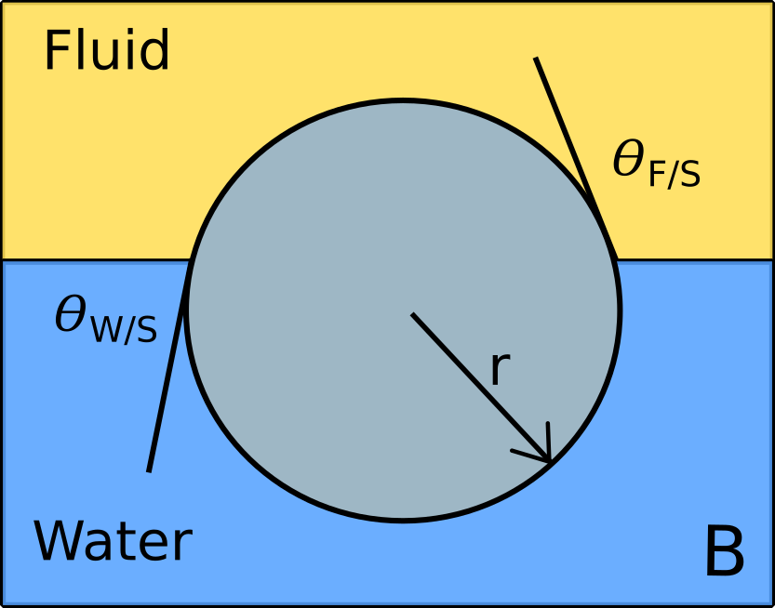
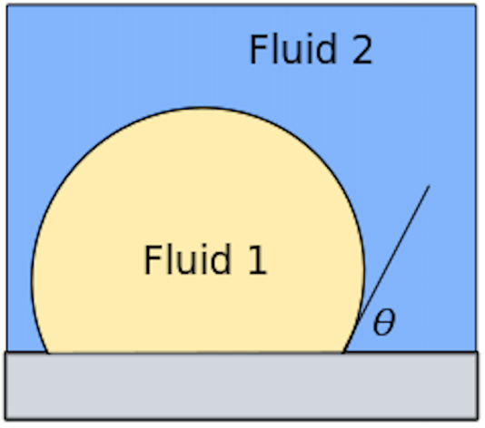
A

Figure 2.1 Example of the contact angle: Drop and surface, and particle at a fluid interface
A Contact angle between two fluids on a substrate, where the angle is 𝛳. B Equilibrium contact angle of a particle at a water/fluid interface.

2.2.3 Contact angle
When a droplet of a fluid is brought into contact with a solid wet by another fluid, a 3 phase contact line is generated at the point of contact of the droplet with the solid as seen in figure 2.1. This contact angle is dependent on the interfacial energy of the interactions between the solid/fluid 1, solid/fluid 2 and fluid 1/fluid 2. For oil-bubble/water/solid systems explored in this thesis, we observe the behaviour of static fluids, where the solid interface is wetted by water and then wetted by oil or air. The energy of wetting can be described by the following relationship, known as the Dupre equation:

$-ΔG/A = γ_{FS}-γ_{FW}-γ_{SW}$ Eq.5

Where the change in Gibbs free energy per area (G/A) is a function of the change in surface energy of the fluid/water (FW), solid/water (SW) and fluid/solid (FS) areas that occur when the solid is close to the fluid/water interface. Thus, if we apply an oil droplet or bubble to a flat solid interface, a contact angle (𝛳) will arise at the contact point between the 3 phases as per Young’s equation:
$\frac{|γ_{SW}-γ_{SF}|}{γ_{FW}}=cos(θ)$ Eq.6
The contact angle is typically observed by placing a droplet of the substance onto a substrate and observing the droplet’s contact angle with the substrate. This static method can be modified to observe advancing and receding contact lines by the addition of a needle which can either add or remove liquid from the droplet to understand the adhesion and removal behaviour of droplets from surfaces. The condition for this experiment is that the surface is flat and smooth, as curved and angled planes will have different contact angles depending on the direction of gravity. Furthermore, rough surfaces will cause contact line pinning, which can highly bias the measurement, and must be considered.
When considering the materials used in these experiments, commonly the external fluid is either air or water, and the droplet fluid is either water, air or oil²¹. The solids used in these experiments are typically categorised as either high or low energy surfaces, where a high energy surfaces is clean glass, polystyrene or mica, and a low energy surface may be polydimethylsiloxane (PDMS) or polytetrafluoroethylene (PTFE). Commonly, high surface energy surfaces will produce either very highly wetting contact angles (~0º) or highly repelling contact angles (~120º), depending on the hydrophobic/hydrophilic characteristic of the liquid, and low energy substrates will have more similar contact angles for most liquids.
In the context of particles or highly curved interfaces such as observed in Pickering emulsions, an equilibrium of wetting position between the two phases will occur, as observed in figure 2.1B. At this position, assuming the surface is smooth and isotropic, the energy of the equilibrium position compared to being wet by one of the adjacent bulk fluids is²¹:

$ΔG = -γ_{FW}πr^{2}(1-|cos(θ)|)^{2}$ Eq.7

Where r is the radius of the particle and a diagram of this can be seen in figure 3. This wetting will occur provided |cos(𝛳)| < 1, which from Young’s equation (Eq. 6) suggests that there must be a net reduction in overall energy for a particle to adsorb at an interface. Thus, as the radii becoming larger, and the contact angles are closer to 90º, adsorption becomes more energetically favourable.

2.2.4 Adsorption of surfactant species to the interface
Commonly, surface active materials in one of the fluids will diffuse to the interface and adsorb. When these materials straddle the interface, they thermodynamically lower the energy of the interfacial system, thereby reducing interfacial energy. As per Eq. 1, if the area is kept constant and there is a reduction in the energy of the system, there must be a reduction in the proportionality constant 𝛾, which we defined as the interfacial tension²⁴.

Typically a surfactant is a substance that contains both hydrophobic groups (e.g. -C_{x}H_{x}, -C_{x}F_{x}, etc), and hydrophilic groups (e.g. -SO₄, -CO₃,-OH, -SH, etc), where the surfactant will go to the interface and tend to reside there, giving rise to an excess surfactant concentration that will reduce the interfacial tension. This is due to the hydrophobic group and hydrophilic groups being solvated better by one or the other fluids, but as the molecule is still together, they tend to reside at the interface between these two phases. This higher solvency at the interface creates a drive for the adsorption of the surfactant species to the interface, commonly referred to as the chemical potential. As the surfactant is diffusing from the bulk to the interface, the timescale associated with the adsorption of material to the interface is dependent on the size of the surfactant, the viscosity of the solution, and the concentration of the surfactant, where this process been modelled extensively^{25, 26}. Adsorption from the bulk is always balanced by the energy of solvation of the surfactant molecules, i.e. the concentrations or conditions at which the surfactants form micelles or other aggregated phases and the packing behaviour of surfactants at the surface. The modification of the solution or surfactant by varying the amount of hydrophobic or hydrophilic groups, temperature or pressure will have a strong effect on the kinetics and the final interfacial tension of systems with surfactants. An early example of this effect known as Traube’s rule²⁷ whereby the increase in CH₂ groups in the tail group of a surfactant, is observed to reduce the quantity of the surfactant needed to reduce the interfacial tension of an air/water interface by a factor of 3.

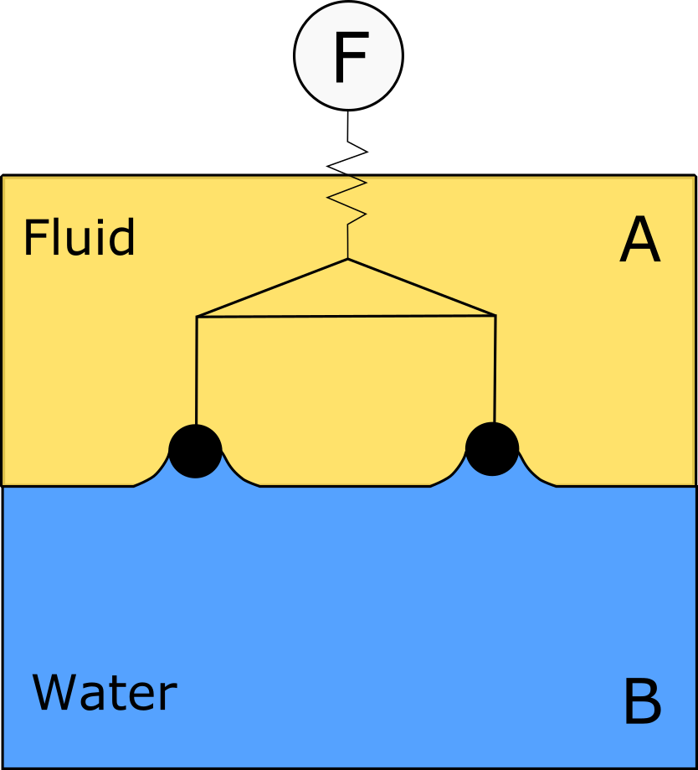
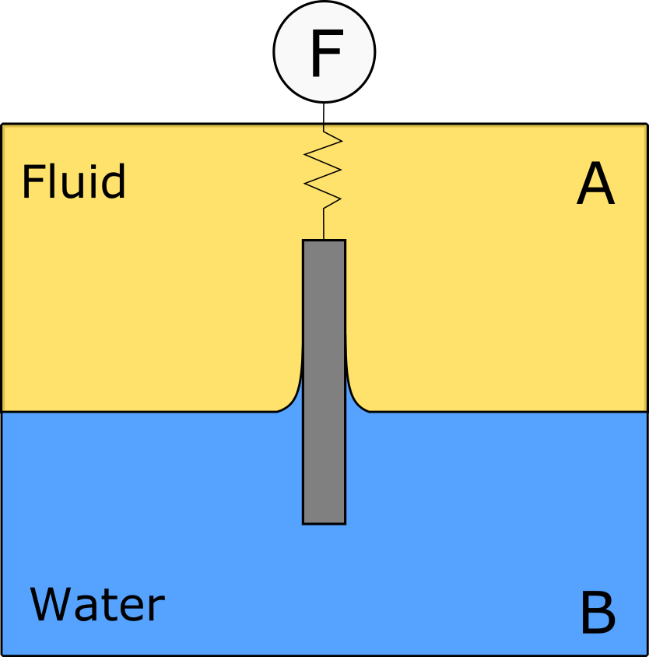
When complex surfactants are used such as lipids²⁸, polymers²⁹⁻³¹ or particles³²⁻³⁴ more complex adsorption dynamics from the bulk occur. The excess concentration of these types of surfactants at the interface will result in the interactions between these interfacial species, where these interactions lead to significant changes in the behaviour of the interfaces when deformation is applied.

Figure 2.2 – Example of Wilhelmy Plate and Du Nuöy ring
Left, the schematic of a Wilhelmy plate and on the right is an example of a Du Nuöy ring. Both these examples are cross sections of the centre of the device.

The interfacial tension of fluid-fluid interfaces can be determined by either observing the capillary force applied by an interface to a force balance, or directly by observing the balance of the capillary pressure with either direct pressure or buoyancy. In this work we focus on interfacial tension measuring techniques that can be applied to complex interfaces, and thus must allow for measurement over time at an interface with a stable surface area. Typically, the capillary force can be observed by the placement of a Wilhelmy plate or Du Nuöy ring at the interface^{24, 35} as seen in Figure 2.2, and observing the change in force at the force transducer. These delicate setups are commonly used on Langmuir-Blodgett troughs, where interfacial area is controlled by the use of moving barriers which compresses the interfacial material³⁶. Other common methods of observing the interfacial tension are to measure the tension indirectly by applying external forces to the interface and observing the shape or dimensions of the interface. Two common methods that observe these forces are capillary tensiometers³⁷ and pendant drop tensiometers^{38, 39}.

In the case of polymers, biologically derived polymers are ubiquitous in the food industry, with proteins⁴⁰ and polysaccharides⁴¹ being the most common. Many proteins which have hydrophilic and hydrophobic moieties will concentrate at the interface and reduce the interfacial tension. Typically, when proteins absorb to the interface they exhibit many different adsorption phases^{32, 42}, consisting of the proteins diffusing from the bulk to the interface, adsorbing to the interface, changing their structure^{43, 44}, then spreading. The dominant two methods of studying proteins at interfaces are the Langmuir-Blodgett trough equipped with a Wilhelmy plate and the pendant drop technique. Due to the high volume of solution and large surface area, Langmuir-Blodgett troughs are generally used for spread films at air/water interfaces⁴⁵. Smaller volume techniques such as pendant drop are used for absorbed films on oil/water and air/water interfaces, and can be easily sealed allowing for measurements for 10s of hours^{32, 46, 47}. Comparatively, polysaccharides have a much more complex set of behaviours due to the wider variety of polysaccharides⁴¹, and have not been explored in similar detail compared to proteins due to less surface active behaviour, with a few exceptions such as hydrophobically modified starch⁴⁸, and gum arabic⁴⁹, and chitosan⁵⁰ which can have similar interfacial tension behaviour to proteins.
Proteins typically reduce the interfacial tension initially rapidly and reach a steady state value in minutes to hours⁵¹, and are highly sensitive to the conditions present such as bulk concentration^{32,42,52}, pH⁵³, ionic strength, temperature^{30, 54, 55}. Strongly pH dependent behaviour is common to many proteins around the isoelectric point, such as that with 𝛽-lactoglobulin⁵³ and Bovine Serum Albumin (BSA)⁵⁶, which is thought to be due to the reduction in electrostatic repulsion between the proteins, causing higher packing densities and lower the interfacial tension with faster adsorption, as closer packed proteins can form multilayered structures⁵⁷. Temperature has a similar effect, reducing the timescale of adsorption, and lowering the final interfacial tension⁵⁵. It should also be noted that it has been observed that the interfacial tension of the proteins continues to drop over time, even after it has reached an apparent plateau^{42, 52, 55}, which is thought to be a result of the chain rearrangement and bond formation between the protein molecules. These are mostly physical bonds as although sulphide links^{58, 59} are observed in many of these proteins, studies suggest there is no reshuffling of chemical bonds due to denaturation⁶⁰.

2.2.3 Interfacial Rheology
Interfacial rheology is the study of the response of the layers at the interface between two phases to mechanical deformation. The force response of the interface is typically described in the classical mechanical terms of elasticity and viscosity in two dimensions as opposed to three dimensions as found in traditional bulk rheology⁶¹⁻⁶⁴. As per bulk rheology, to simplify the analysis of the behaviour at the interface, the applied deformation is typically done in shear or dilation. Determining the shear and dilational response independently gives insight into the characteristics of the interfacial system in applications, such as emulsion or foam generation and stability^{30, 65-67}.
When mechanical deformation occurs to a rheologically complex interface, two separate processes are occurring, a change in the interfacial or surface tension and a change in the extra surface stress. The general expression for surface stress σ_{s} can be described in a tensoral form as follows⁶³:
$$σ_{s}=σ\left(Γ,T\right)I_{s}+τ$$
Where σ(Γ,T) is the interfacial or surface tension which only relies on the interfacial concentration (Γ) and temperature (T). The tensoral variables are, I_{s} the surface unit tensor and τ the surface extra stress tensor. This approach separates the state variable of interfacial tension and the extra stresses which include both isotropic and deviatoric stresses on the interface. As the interfacial tension can be determined from an equation of state, this allows the isotropic and deviatoric extra stresses to be calculated by constitutive relationships.
Additionally, we will define the 2D shear and compressional moduli, G_{s} and K_{s} as the material properties of interfacially bound material in shear and compression. These are analogous to the 3D bulk shear and compressional moduli that precede them.

2.3.1 Interfacial Dilational Behaviour
It is common to many industrial processes that new interfacial area is created in systems where there are surface active materials already present at the interface. When new surface area is created on an interface with material already present, initially the new surface area will have the same surface tension or surface energy as the interface without surface active material, which will be higher than the interface with material present. In the case of interfaces without significant 2D shear or compressional moduli, the measured interfacial tension as defined by Gibbs is the summation of the interfacial energy of the material at the interface over the area it is present, and thus will be higher at the instant of the interfacial area increase. A dilational event will be done within a timescale with a small area change, in which either a step change or an oscillation in the surface area is applied. The processes of either adsorption to the interface or reorganisation and diffusion of the interfacial material at the interface may occur within the timescale of the applied strain, modifying the observed interfacial tension. This rearrangement or adsorption process is described as complex interfacial viscoelasticity, and described with the following set of equations⁶⁸:
$ΔA = A(t) -A_{0}$ $α= ΔA/A_{0}$ $Δγ =γ(t) -γ_{0}$
$Δγ=K_{0}α-η\frac{dα}{dt}$ Eq.8
Where A(t) and 𝛾(t) are the instantaneous area and interfacial tension respectively, A₀ and 𝛾₀ are the initial area and interfacial tension prior to perturbation, where K₀ and 𝜂 are the dilatational Gibbs elasticity and viscosity respectively. For an applied area change we can determine the moduli as a function of frequency. We can transform the applied time quantities to a frequency space whereby all frequency dependent functions can be superimposed to represent a single quantity thus⁶⁸:
$K(t)=\frac{Δγ}{α}$ Eq.9
${K(ω)}^{*}=K'(ω) +iK"(ω)$ Eq.10
Where K* is the complex surface dilatational modulus at a frequency of 𝜔. When transformed to the frequency domain with the application of a Fourier transformation, the real part is the storage modulus and the imaginary part is the loss modulus. This is distinct from the 2D compressional modulus K_{s}, which pertains to a material property as opposed to this quantity which describes surfactant absorption/desorption or interfacial rearrangement process.
To apply this to experimental data, we can either observe the interfacial tension behaviour for a step area perturbation to the system or an oscillatory area perturbation. For a step area change we can calculate the K’ and K” from the following integral:
$K'(ω) = K_{inf}+ω\int_{0}^{t}{(K(t)-K_{inf}).sin(ωt).dt}$ Eq.11
$K'(ω) =ω\int_{0}^{t}{(K(t)-K_{inf}).cos(ωt).dt}$ Eq.12
Where 𝜔 is the particular frequency of interest, K_{inf} is the limiting K value, the value of K the experiment asymptotes to infinite time (t→∞). When these area perturbations are applied in a sinusoidal manner at varying frequencies, the solution to the above equation for this applied strain gives the result:
$$K' = |K^{*}|sin(θ)$$
$K' = |K^{*}|cos(θ)$ $Eq.10$

Where 𝛳 is the phase lag between the applied area change and the interfacial tension. We apply these techniques in the context of pendant drop tensiometry, where a sessile drop is generated at the end of a capillary and allowed to equilibrate with the solution over time, and then perturbed by either a step or oscillatory variation in the volume and thus surface area of the droplet.
For perturbations below 1Hz, classically, dilational interfacial rheology was performed on a Langmuir-Blodgett trough⁶⁹, where material would be either spread from isopropanol or chloroform or allowed to adsorb onto the surface from the bulk, and the surface area of the trough would be increased in dilation or reduced in compression. The tension is observed with a sensitive force balance attached to a Wilhelmy plate in the trough as seen in Figure 2.2. Typically, air/water troughs are used as oil/water troughs are difficult to use due to the large volume of oil required and are not common in literature^{68, 70}. Due to the large volumes of liquid required, and sensitivity of the instrument and typically requiring an isolated flow hood to operate, more practical approaches have been developed to observe interfacial rheology such as the capillary pressure tensiometer^{37, 71}, pendant drop tensiometer⁷². Both these techniques utilize significantly lower volumes of liquid (1-10mL), allow for interfacial rheology of oil and gaseous systems, but cannot be used for spread monolayers. Furthermore, for frequencies above 1-2Hz, the only method of determining the interfacial rheology is by the application of capillary waves at the surface of a Langmuir-Blodgett trough, which investigate a range of frequencies spanning 1-4kHz⁷³.
The techniques described have been used successfully to determine the complex dilational moduli, but in more complex systems such as the proteins explored in this thesis, 2D compressional^{45, 74} and shear moduli^{47, 75, 76} are present which complicate the measurement of the complex dilational moduli. To measure the compressional moduli, the capillary rheometer^{37,77}, Langmuir troughs⁷⁸, the circular Langmuir trough^{79,80}, Stress Fitting Elastometry^{79, 81} and Capsule Wrinkling analysis⁸² have been used. These methods vary highly in their approach to determining the compressional modulus, and have been covered extensively in the excellent review by Jaensson and Vermant⁶³.
These techniques have been used for many systems such as those discussed in the section “Adsorption of surfactant species to the interface”, where the dilational behaviour of polymers, and especially proteins at the oil/water and air/water interfaces has been a topic of interest for many decades^{32, 40, 47, 51, 83, 84}. There are generally 2 categories of proteins, globular and flexible proteins, which both have varying sets of behaviours due to their behaviour at the interface. In the case of globular protein films, such as those explored in this thesis, it has been found that these films are stable to washing out the protein from the bulk⁴⁷, have significant pH dependent effects^{53, 85} and form the highest moduli films at their isoelectric point^{53, 85} , and their rheological behaviours are not strongly dependent on the bulk concentration above a threshold concentration^{32, 85}. The rheology of these films tends to be relatively frequency independent behaviour at high frequencies with a large scale relaxation at low frequencies^{47, 76}, where the amplitude is relatively linear at low amplitude⁸⁶. Most of these characteristics are thought to be due to the high degree of packing and denaturation at the interface, producing a denatured protein gel at the interface^{30, 31, 87}. It should be noted that the interfacial rheology discussed here is for adsorbed as opposed to spread films of protein, where aging effects can begin to occur, forming an interconnected film. It has been observed previously⁴⁵, that these same globular proteins can behave as soft disks at the interface if not aged. Flexible proteins tend to behave more like polymeric surfactants such as pluronic²⁹ or PVA⁸⁸ which reduce the interfacial tension, do not show strong interfacial layers at the interface, and can be washed out⁴⁷.
Other polymers such as polysaccharides have generally not been assessed for their interfacial rheology due to their low interfacial tension change, with the exception of gum arabic, hydrophobically modified starch⁸⁹ and chitosan⁹⁰. These substances can range from having primarily viscous interfacial rheology such as in the case of hydrophobically modified starch, or strongly elastic interfacial rheology, as per chitosan or gum arabic.

2.3.2 Interfacial Shear behaviour
Interfacial shear rheology is the observation of the force required to deform to an interfacially bound film in shear. To observe the stress-strain relationship for interfaces, objects are typically placed at the interface, a stress is applied to the interface and the response is observed or measured. Due to the bulk bound nature of an interface, significant drag may be present due to the presence of the bulk phases adjacent to the interface. To reduce the subphase contribution many experimental techniques and geometries have been developed to accurately observe the rheology of the interface while minimising the drag from the bulk.
The original shear viscometers were designed to determine steady state viscosities of films by either causing and observing flow through a channel by changing surface pressures across a channel^{91, 92} or by observing the movement of particles trapped in a film being dragged by a moving subphase⁹³⁻⁹⁵. These indirect methods have been used to determine interfacial viscosities to ~10⁻⁸ Pa.m.s⁹⁶, but cannot be used to determine the viscoelastic properties of films. To determine the viscoelastic moduli, it is key to introduce an oscillating force or displacement, which was originally achieved by the application of oscillatory motions to the bulk fluid and the observation of the motion of particles at the interface^{97, 98}.
An alternative to applying stress to the interface via the subphase or by inducing flow via interfacial pressure gradients is to utilize magnetism to drive the motion of rods and particles at the interface. This was originally implemented by Brooks et al⁹⁹ with the use of mm long magnetised rods. These are controlled by varying the current to Helmholtz coils placed around a Langmuir trough. This induces a controllable linear magnetic field, applying a force to the magnetised rods, where their movements can be tracked via light microscopy. This has been significantly improved by the use of microbuttons^{100, 101}, which have a purely shear flow field compared to the mixed flow generated by rods, and an improvement of moduli sensitivity from ~10⁻⁶ to ~10⁻⁹ Pa.m.s^{102, 103}.
If the use of a Langmuir-Pockels trough is not desired or needed while maintaining high sensitivity, it is common to use geometries that can be tested in a small cup with low volumes (50-100mL), with a defined interfacial area. To achieve this, originally a biconical bob held in place by a torsional wire in the centre of a cup was used. The bob rotates due to the motion of the cup around it, and the motions of the bob can be observed, and the torque observed with the knowledge of the radius of the disk and the torsional spring constant of the wire. This was originally implemented by Langmuir¹⁰⁴, where it was improved on by Brown et al¹⁰⁵ with the use of a circular knife edge suspended at the interface by a torsional wire. The determination of the interfacial viscosity from the observed torque in a bicone or disk geometry at was first solved by Slattery and Oh¹⁰⁶ for high Bo flow, and recently solved for low Bo flow by Erni et al¹⁰⁷. Although the torsional wire method is highly sensitive to interfacial viscosity¹⁰⁸, direct applications of torque and deformation have become common, replacing the torsional wire with stress and strain controlled rheometers as the technological advancement in force transducers has occured⁷⁰. This has also given rise to the use of delicate geometries such as the double wall ring¹⁰⁹, which is observed to be sensitive to interfacial viscosities of 10⁻⁶ Pa.m.s compared to 10⁻⁴ Pa.m.s for the bicone geometry.
When using these geometries, the types of material at these interfaces most commonly explored are synthetic polymers¹¹⁰, proteins³², lipids¹¹¹, and particulate films¹¹². Commonly, these can be spread at the interface or self-absorbed from the bulk, depending on the solubility of the material in the bulk phases, the cost of the material, and the desired interface. There is a significant difference in behaviour between the two methods of adsorption to the interface, but due to the nature of the application of this work in food, we will be using the self-absorption for our experiments.
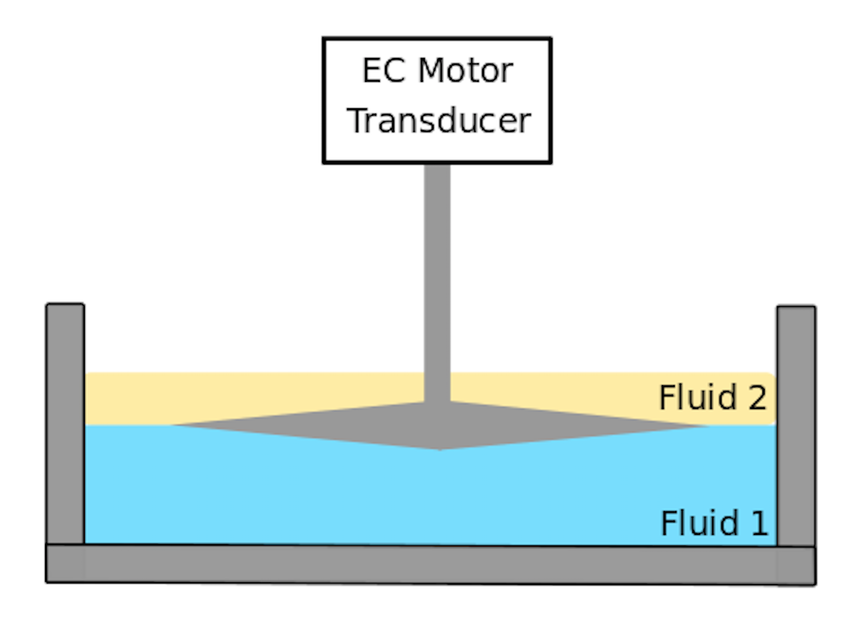
Figure 2.3. Example of bicone interfacial rheometer
The setup of the bicone, where the denser fluid 1 is found at the base of the cup, and the lighter fluid 2 is present above the bicone and fluid 1. The bicone is pinned at the interface between the two fluids. The motor applies the deformation and the transducer determines the torque applied.
In this thesis we will be focusing on the bicone attachment for the determination of interfacial shear rheology. The setup for the system can be observed in figure 2.3, where the biconical bob is observed pinned at the interface between two fluids, and attached to the driving motor and force transducer. In the case of applying deformation to the interface, there is drag present from the contact of the upper fluid and lower fluid upon the movement of the bicone. Typically, the ratio of the subphase drag to the interfacial drag is calculated by the Boussinesq number:

$Bo =\frac{|η_{int}|}{(η_{1}+η_{2})R_{1}}$ Eq.13

Where 𝜂_{int} is the interfacial viscosity, and 𝜂₁ and 𝜂₂ are the viscosities of the outer solutions, and R₁ is the radius of the bicone. For highly viscous interfacial films, where the Boussinesq number is much higher than 1 (Bo >> 1), the shear flow can be simplified to a two-dimensional Couette flow, where the interfacial film is effectively decoupled from the flow of the bulk phases. In this case, we can calculate the interfacial viscosity of the film by the following relationship from Erni et al¹⁰⁷:
$|η_{int}|=\frac{M-\frac{8}{3}{R_{2}}^{3}(η_{1}+η_{2})Ω}{4π{R_{2}}^{2}Ω}$ Eq.14

Where 𝛺 is the angular velocity of the bicone and R₂ is the radius of the cup. For situations where the Bo is closer to 1, a more detailed analysis of the flow field and calculation of the interfacial viscosity can be found in Erni et al¹⁰⁷. In the experiments conducted in this thesis, we use the bicone in oscillatory mode, where a harmonic oscillation of amplitude strain γ is applied to the surface and a resultant torque τ is measured, where there is a phase offset 𝛳 between the applied and measured signal¹¹³:
$γ(t) = γ_{A}sin(ωt)$
$τ(t) = τ_{A}sin(ωt)$ Eq.15
where
${G^{*}}_{i} = \frac{τ_{A}}{γ_{A}}$ Eq.16
Where γ_{A} and τ_{A} are the strain and torque amplitudes respectively and G*_{i} is the complex interfacial shear modulus. This can be decomposed into the storage and loss modulus via the following relationships:

$G'_{i}=|{G^{*}}_{i}|cos(θ)$
$G{''}_{i}=|{G^{*}}_{i}|sin(θ)$ $Eq.15$

2.4 Capsule Compression

2.4.1 Capsule Definition and Use
Capsules are a ubiquitous method of encapsulating various environmentally sensitive solids, liquids or gases, to allow for stability or to provide functionality within certain environmental requirements. Commonly encapsulated substances can include fragrances¹¹⁴, drugs¹¹⁵, nutrients¹¹⁶ and gases¹¹⁷, where these capsules are currently in use and applied to a vast number of industries including food¹¹⁸, agriculture¹¹⁹, pharmaceutical^{120, 121}, and textiles¹²².

Encapsulation can be done with a number of methods where the methods differ depending on the application. Common methods of producing capsules include spray drying¹²³, emulsion or core templating¹²⁴ and fluidised bed coating¹²⁵, where in all methods a shell is formed which provides stability and functionality to the encapsulated material.

To maintain the themes explored in this thesis, we will be analysing the behaviour of droplets coated with a thin gel material, where we are concerned with the mechanical behaviours of these gel coated drops to understand how they behave under applied deformation as seen in figure 2.4. The deformation behaviour of the capsules is a method to determine the behaviours of the capsule and the properties of the gel film on the capsule.

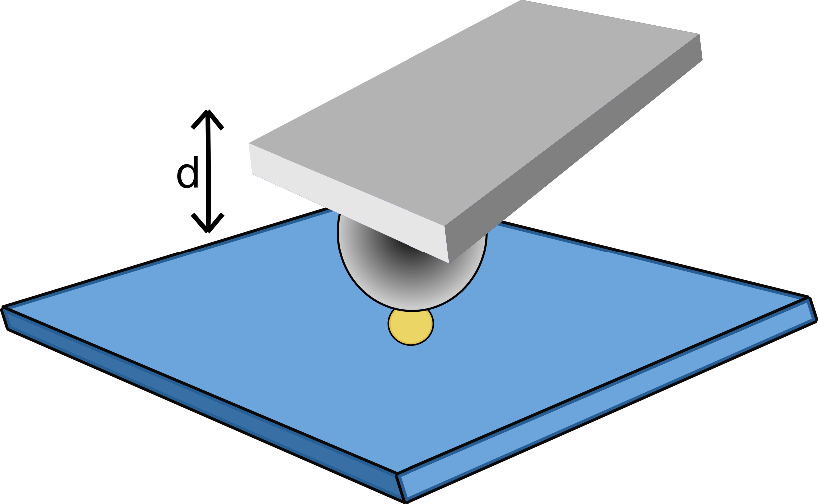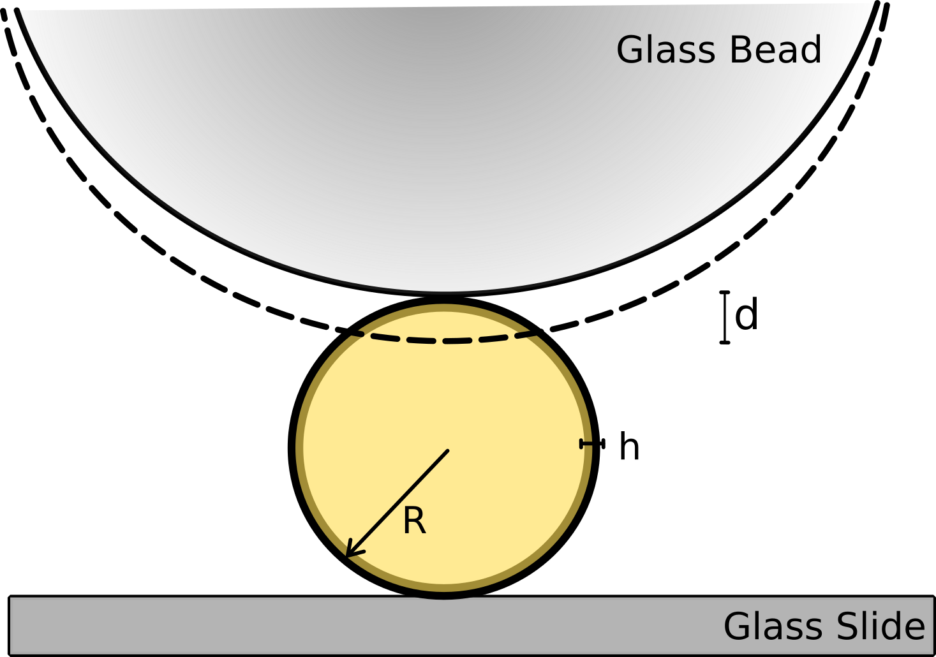
Figure 2.4. Diagram of the compression of an oil cored capsule
Diagram of compression of an oil cored capsule via AFM with a colloidal probe attached cantilever, where the capsules of radius R and thickness h are indented with a probe much larger than the capsule radius.

2.4.2 Capsule Compression
Many different approaches have been taken to determine the behaviour of the materials on capsules, where the applied deformation field depends strongly on the size and strength of the capsule being tested. Typically, when observing capsule behaviour, it is desired to understand the properties of the shell material, which often controls the behaviour of the capsule. To determine shell properties, deformation is applied to single capsules, where the force required to deform is observed. To deform micron sized, soft capsules 5 methods are common, where in the ascending order of sensitivity: Optical/magnetic tweezers, micropipette aspiration, shear flow¹²⁶, compression via AFM and compression via micromanipulation or nanoindentation. Optical or magnetic tweezers is a technique where dielectric^{127, 128} or magnetic¹²⁹ particles are attached to cells, and a field is used to apply deformation to those objects. Furthermore, with optical tweezers it is also possible to directly deform cells¹³⁰. This has been developed and tested successfully with cells, and theorized to be possible with bubbles¹³¹, but has not been done with capsules to date. Micropipette aspiration is where negative pressure is applied to either rupture or pull the capsule into the pipette. This technique was originally used for use with cells and microbeads¹³² , and was extended to test capsules, where primarily the bending stiffness of the capsule is tested. This technique though suffers from significant optical limitations, thus reducing the observable capsule size. Furthermore, the measurement is suited for softer capsules¹³³, and does not work well with stiff capsules¹³⁴. The technique has recently been extended to observe the buckling of particle laden drops, which have shown to be very similar to capsules^{135, 136}. Shear flow experiments have been conducted in a rheometer¹³⁷ or classical shear band^{138, 139} and 4 rolling mill¹⁴⁰ Taylor’s apparatus, where a flow is generated over droplets, and the deformation is observed optically. These techniques have successfully used for large droplets up to 1mm, and have recently been extended to microdroplets in microfluidic experiments¹⁴¹⁻¹⁴³. These techniques can be very sensitive to capsule deformation, and has been used to observe and quantify time dependent effects^{138, 144}, but require viscous fluids to operate, and are often limited to large capsules. Capsule compression techniques such as AFM¹⁶ and micromanipulation¹⁴⁵⁻¹⁴⁷ appear to have the largest dynamic range in terms of particle size, from 0.1µm¹⁴⁸ to centimetres, with a tuneable force sensitivity from pN to N. Additionally, extensive modelling of capsule membrane behaviour in compression is present in literature for many capsule behaviours including elastic^{17, 149-151} bending in compression have been explored. To date though there has been little exploration of time dependent effects in compression which are highly relevant to the application of capsules in use, as most forces occur over varying timescales. A thorough review of these techniques can be found by Neubauer et al¹⁵². In the case of the capsules that are used in this thesis, we will focus on the experiments and modelling of capsules deformed via AFM capsule compression.

In AFM capsule compression, the capsule is adhered to a glass plate and a cantilevered paddle of silicon nitride or silicon with either a sharp tip, colloidal sphere or a bare flat end is used to compress the capsule. The bending response of the cantilever is observed via the angular deflection of a laser position on the back of the cantilever, where this deflection has been calibrated to translate into a force. Extent of capsule indentation (𝛿) is commonly determined by the movement of the cantilever base take the bending of the cantilever, although reflection interference contrast microscopy¹⁵ or confocal microscopy¹³⁶ have been used to reconstruct capsule deformation. The AFM method is a flexible technique which is sensitive to forces from pN to μN, able to indent particle sizes ranging from 100nm to 100μm, and in most fluid mediums with minimal preparation.
A qualitative description of capsule compression in AFM is presented in Figure 2.4, whereas summarised by Fery and Weinkamer¹⁶ there are many modes of deformations that capsules can exhibit when compressed. A capsule may flex, bend or buckle to depending on the nature of the capsule shell, geometry of the indenter and extent of deformation. Typically, experiments are designed to assess these modes individually. When using spherical or flat indenters, the small indentation extension of Reissner’s¹⁵ and Hertz’s model further developed by Berry et al¹⁷ is applicable, and for higher deformations above $\sqrt{\frac{hR}{4π}}$¹⁵³, Lulevich’s theory¹⁴⁹ describing membrane stretching and bending may be used. If point loads are used, then buckling theory can apply, but without direct observations of the buckling, this is difficult to use and more applicable to shear flow experiments¹⁶. In this thesis we consider capsules at the small indentation threshold using spherical indenters. To summarize this approach, capsules with a film of thickness h, where a spherical indenter significantly larger than the capsule is used to indent the capsules, we can use the small deformation region where 𝛿<h to characterise Young’s modulus of the capsule shell material. The model employed most widely is the Reissner model^{154, 155}, which has recently been corrected and extended by Berry et al¹⁷ to accommodate a range shell thicknesses from h/R→0 to h/R=1. This model is summarised by the following relation:
$\frac{F\sqrt{(3(1-v^{2}}}{(h/R)^{3}4R^{2}}=Eβ(\frac{Cδ}{h})^{α}$ Eq.17

Where F is the applied force, v is the Poisson’s ratio, E is the film’s Young’s modulus and C, 𝛼 and 𝛽 are determined from numerical simulations as a function of capsule shell to radius ratio. This model can accurately describe the mechanics of the capsule shell, but the time dependence of this indentation has not been reported or discussed in the literature, and has large implications on the stability of emulsion interfaces to Oswaldt ripening and coalescence¹⁵⁶⁻¹⁵⁸ as well as stability to external mechanical and chemical stimuli. It has been observed that many polymer gels at the micron scale show significant visco¹⁵⁹⁻¹⁶² and poroelasticity^{163, 164}, and the methods in these works are typically applying either constant force or deformation and observing relaxation, or applying sinusoidal oscillations on the materials. We expect that there is a significant relaxation timescale that will occur with capsule shell materials, but there are no experimental observations or models to describe them, as long timescales are difficult to probe with AFM, and the characteristic timescales of polymer relaxation is very rapid compared to large scale experiments¹⁶⁵.
Recently there has been a focus on the viscoelastic mechanics of capsules in shear, where the viscoelastic response of capsules has been observed previously in microfluidic shear by Gires¹⁴⁴ and Diaz^{166, 167}, and in the spinning drop apparatus and shear rheoscope¹⁶⁸ following the modelling of Barthes Biesel^{126, 169, 170}. The behaviours of these capsules are observed in strong shear forces which require highly viscous non-aqueous solutions, commonly high concentrations of glycerol in water, strongly limits the systems that can be observed.

2.5 Atomic Force Microscopy

2.5.1 AFM introduction
Originally, atomic force microscopes or AFMs were developed by Binnig, Quate and Gerber in 1986¹⁷¹ in conjunction with IBM, where this system was the integration of the then new scanning tunnelling microscope and stylus profilometry. The basic design of an AFM is comprised of a laser reflected off the back of a cantilevered beam, and then brought into contact with a surface via the application of voltage to a piezoelectric stack. When in contact with the surface, this cantilevered beam bends proportionally to the distance it is bent and changes the reflected angle of the laser on the back of the cantilever, acting as an optical lever. This beam is observed by a photodetector made of 4 quadrants, where a change in the relative voltages within this photodetector array provides the signal to the user. When scanning a sample, the deflection voltage will change as the tip is rastered over a topographical feature, where if a control loop is implemented to maintain a constant deflection voltage, the piezo stack will change its height to maintain this constant voltage. The recording of these changing signals as a function of the tip position is the method by which images of the surface are recorded. A common modification to this technique is to oscillate the cantilever at its primary resonant frequency with a piezo element, where the photodetectors will observe a deflection voltage amplitude and frequency due to this oscillation¹⁷². When the oscillating tip is brought into contact with the surface, this will dampen the oscillations of the tip, and reduce the oscillatory amplitude voltage strongly depending on the force of the contact with the surface. Thus, providing a similar signal to the contact mode described above, but allows the measurement of more delicate samples due to significantly less lateral forces between the tip and the surface in contact. The change in oscillation frequency can also be used as a sensitive measurement of height, but requires very sharp resonant peaks or Q values, and thus are impractical for applications in this thesis. For further reading, Giessibl¹⁷³ provides an excellent review of the progression and sensitivity of AFM measurements.
The use of AFM as a force sensing apparatus is evident in the operation, where the linear change in observed deflection voltage is proportional to the force applied. In the application of imaging, it is desirable to have sharp tips on the end of cantilevers to improve resolution, but in the quantitative observation of forces, these tips would require quantification by SEM or reverse imaging¹⁷⁴, appropriately sized to measure forces with high sensitivity, or have consistent enough surface chemistry¹⁷⁵ to be useful in the probing of interaction forces at nanoscopic distance resolutions required for the quantification of many weak forces.
To improve these behaviours, a micron sized bead can be glued to the end of the cantilever to increase the interacting area of the cantilever^{176, 177}. This addition of a particle was initially used to quantify the DLVO forces between silica plates and silica particles at various NaCl concentrations, but has become more ubiquitous now to be used in the determination of interaction forces between surfaces^{178, 179} and indentation properties of solids¹⁸⁰.

2.5.2 AFM rheology
When forces are applied to any material, they are always accompanied by a force rate, where if the material is compliant at that applied force, the material will deform. Typically, these quantities are described as stress and strain, where both are a function of the area that the forces are applied to. When applying these forces to materials it is important to control either the strain or stress as a function of time to determine if there is a dependence on this variable. As an example, when applying force in aqueous solutions, the velocity of the indenter is typically reduced to 500nm/s or below, where the hydrodynamic drag and pressure from flow between the substrate and the indenter is typically negligible¹⁷⁶. There are 3 main ways that the time dependence of an application of force can be controlled: by varying the velocity of movement, applying a constant strain or stress, commonly called a “Dwell” measurement, or applying a sinusoidally oscillating strain or stress to a substrate. Dwell can be separated into two separate cases, one with a constant force or a creep and one with a constant deformation or indentation known rheologically as a stress relaxation¹⁸¹. All these applications of force have controlled timescales to their application, and have been modelled by traditional rheological approaches for many geometries of materials such as flat gels and spherical particles, as well as extended into interfacial rheology to describe interfacial rheological behaviour⁸⁷.

When observing time dependent phenomena in polymeric gels, as explored by this thesis, there are various forces that are present in the indentation of a polymer gel in aqueous solutions. Indentation is most commonly done using cantilevers with spheres attached to the tip¹⁸². These provide a surface with an easily modelled geometry and evenly distribute the applied pressure to reduce sample degradation.
When in contact with an object that possesses some poro- or visco-elasticity, and if the contact time with that object is within the timescale of the response, there will be a time dependent behaviour of the indentation. Poroelasticity is the drainage of liquid from a porous solid, and viscoelasticity is the intrinsic liquid-like dissipation of energy over time within a solid. The behaviour of the poroelasticity can be useful in characterising the effective pore size of a material and directly determines diffusion times¹⁶³. The viscoelastic behaviour of a material and the timescales indicate how the polymers behave within the gel and is important to the function and use of the gel. As both mechanisms are present in hydrogels, determining those characteristics gives an indication of the gels properties and functions, where these characteristics have large implications for separation processes¹⁸³ and cell growth^{184, 185} and differentiation media^{186, 187}. Although the viscoelastic behaviour of a gel has been observed via means of linear indentation¹⁸⁸, tip oscillation¹⁶² and dwell measurements¹⁸⁹, due to the difficulty of measuring of poroelastic behaviour, only dwells have been used^{163, 190}. These two behaviours are observed and characterised in the same way when compared with linear and oscillatory behaviour but differ strongly in their dwell behaviour. Typically, in a dwell of visco- or poroelastic gels, the dwell can be fit with an exponential decay function F=Ae^{-τt}, where the τ will increase as the indentation increases in the case of a poroelastic substrate, but for a viscoelastic one, τ will be constant. If these behaviours are present in an object, there will be a significant hysteresis between the approach and retract of the force curve applied, and occasionally adhesion in highly viscous films¹⁹¹.
As the focus of this thesis is on the development of AFM based rheological techniques a brief background on the application to surface forces is required in the interpretation of all phenomena observed in this thesis. The forces discussed here are colloidal forces in aqueous solution, where a more thorough discussion about surface forces, their application and behaviours can be found by Israelachvilli¹⁹² and Capella, Kappl, and Butt¹⁸⁰.

2.5.3 DLVO Surface Forces
DLVO forces, named after Derjaguin, Landau, Verway and Overbeek, are the most ubiquitous colloidal forces that are observed in indentation, where these forces are the addition of electrostatic and Van der Waals interactions. Electrical double layer forces are commonly observed as a strong attraction or repulsion, which depend strongly on the density of charges on the surface, the indenter and substrate geometry, the distance between the indenter and the substrate and the ionic strength of the solution¹⁹². The origin of the force is the interaction between two electrically charged planes, which was first noted by Helmholtz¹⁹³. Poisson-Boltzmann theory included the effect of ions which will be present in the solution, forming a diffuse ion charge layer at the charged surface, where the electrostatic attraction of the ions at the interface are balanced by their Brownian motion. When the charged interfaces get closer, the ion layers will begin to interact and overlap causing an increase in the osmotic pressure of the ions, causing either an attractive or repulsive interaction depending on the charge of the surface and the electrostatic boundary condition at the surface. The length of the diffuse region is inversely proportional to the ion concentration in the bulk, causing a higher ion concentration at the charged interface, reducing the length of the interaction. The observed force therefore increases with increased interaction area, decreases with distance from the adjacent interface, and increases with higher surface charge and lower ion concentration. If these forces are attractive, there may be an adhesion on the retraction of the cantilever¹⁹⁴. In setups designed to observe such interactions, the force can be observed 10-20nm from the substrate, where the force increases exponentially the closer the probe is to the surface. This is very important to indentation as it can cause significant difficulty when attempting to determine a contact point, where adhesion can make the analysis difficult as the contact area of the tip is unclear.

In DLVO force models the electrical double layer force is described in combination with the Vander Waals forces¹⁹⁵, which are the summation of dipole-dipole, dipole-induced dipole and induced dipole-induced dipole interactions between two substrates over an interacting dielectric medium. The origin of these forces can be described by the interaction of gases or liquids, where the dipoles of a molecule cause the orientation shift of another dipole in the solution. The induced dipoles can also occur due to the fluctuation of electrons within the molecule, causing their alignment or shift, and a dipole being induced causing an interaction with other induced or permanent dipoles^{192, 193}. As we wish to use this effect to characterise the interaction between surfaces and over long distances and not simple molecules, the interaction energies can be calculated with Lifshitz theory¹⁹⁶, which is able to quantify this force in the form of a separation dependent Hamaker function, calculated from the dielectric spectra of the materials. The Vander Waals force is therefore highly dependent on the surfaces and the medium that those surfaces interact between. These are typically very short range forces, where the force decays as a function of the inverse square to cubic as a function of distance from the surface for flat half-spaces¹⁹². Due to the surface perturbation when indenting soft materials, Vander Waals interactions between the tip and material are common, and have led to the development of various models including the JKR and DMT models to account for the interaction¹⁹¹.

2.5.4 Non-DLVO surface Forces
A common non-DLVO force in indentation of polymer gels is the brush or steric force, which originates from overlap of the polymer chains extending out into the solution from the surface of the material. In the case of surface grafted chains in a good solvent, when compressed, these polymers entropically aim to restore their fully hydrated behaviour and generate a repulsive pressure between the two surfaces when their hydration volume is reduced, provided there is no plastic deformation or chain rearrangement. This force is complex and shows many different behaviours, where for dense brushes on a flat interface being indented by a spherical indenter force decays rapidly as a function¹⁹⁷ of F∝(𝛿^{-5/4} - 𝛿^{7/4}), and shows identical approach and retraction behaviour. Commonly though, as one pulls away from the surface, polymers bound to the material surface may adhere to the indenter. As we retract these polymers are stretched, requiring force to stretch the polymer chains and then to desorb the chains from the indenter. These are typically low force interactions (10-100pN) but possess a characteristic shape. Due to the high amount of polymers in food based systems, especially proteins which adsorb strongly on surfaces^{58, 198}, and drops¹⁹⁹ where steric forces have been measured. These phenomena are well described quantitatively and phenomenologically in the article by Friedsam et al²⁰⁰ and the aforementioned review by Butt et al¹⁸⁰.

When there is a sufficient concentration of particles or polymer in the solution, a phenomenon known as a depletion force may occur when two surfaces come closer together. The lengthscale of this force is the 2-3 diameters of the particle or polymer in the solution. As the separation between the surfaces gets smaller, the number of particles or polymers become excluded from the gap between the surfaces, resulting in an osmotic pressure difference with the bulk concentration. The osmotic pressure difference leads to an attraction between the surfaces. If the particles or polymers have a solution structures, this excluded volume effect can become oscillatory, leading to force maxima and minima. This force applies both to the approach and retract, where a weak adhesion will be present due to the first peak of this oscillatory force. These forces have been observed in rigid systems between solid surfaces in AFM^{201, 202}, surface force apparatus (SFA)²⁰³, and total internal reflection microscopy^{204, 205} (TIRM) measurements, but also in soft systems between bubbles^{206, 207} and drops²⁰⁸. This has also been observed to occur with polymers in food systems, with emulsion stability being affected by the presence of hydrocolloids and proteins^{41, 209}.
When indenting systems where there is a second fluid phase present such as with bubbles or droplets, the second fluid may wet the cantilever, causing a capillary bridge to form between the cantilever and the second fluid. These capillary forces cause a large “jump to contact” which manifests as a sudden drop in force either close to contact. This is then accompanied by a strong adhesion which is strongly dependent on the area wetted by the other fluid. The origin of this force is the preferential wetting of the solid compared to the fluid/fluid interface, which then pulls on the tip as the capillary force attempts to reduce the surface area of the fluid/fluid interface. This force classically arose between two surfaces close to each other in the presence of a condensing vapour²¹⁰, and has been shown to be present at fluid-fluid interfaces²¹¹. This force has been characterised for many types of particles and interfaces²¹², where it has been observed that the contact angle of the particle surface at that interface and the roughness of the particle appear to have the largest effect on the wetting forces observed^{213, 214}. This force behaviours are highly relevant when observing the interactions between solids and fluid/fluid interfaces and is a useful indicator whether the tip is penetrating the other fluid phase.

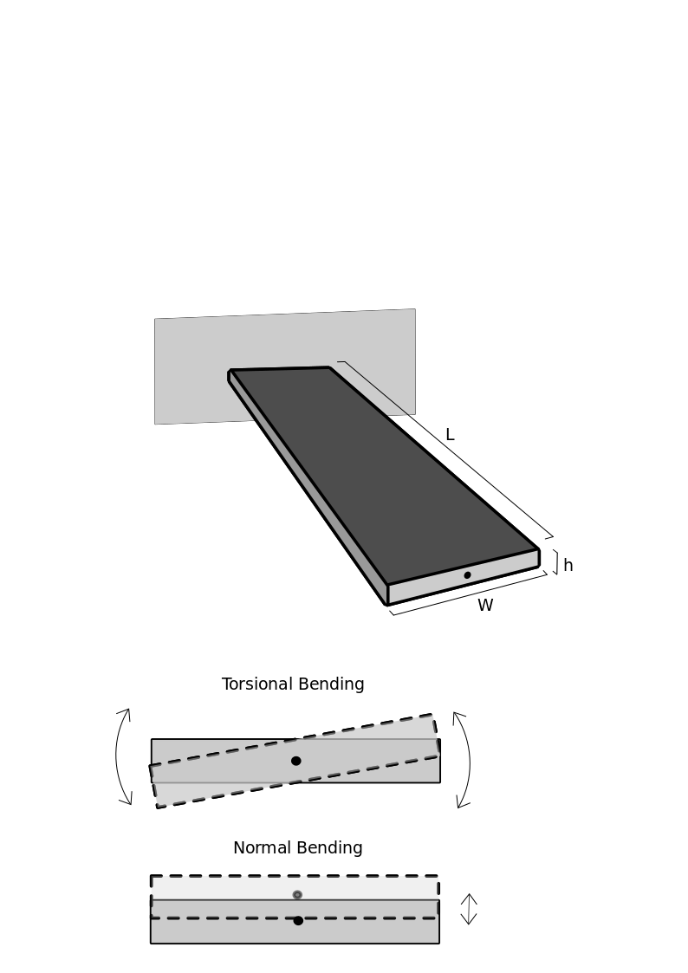
Figure 2.4. A pictographic example of a cantilever and the torsional and normal bending modes
On the left a pictographic example of a cantilever, highlighting the dimensions of the cantilever and common configuration of an AFM cantilever. On the right are the modes of bending of a cantilever, either in torsion or normal directions. These are also the directions that force can be measured when applied.

2.5.5 Cantilever Calibration
Cantilever calibration is required to determine the force per distance of deflection of a cantilever when applying forces with an atomic force microscope. A cantilever typically has 2 modes in which force can be applied, either in the normal direction or in the torsional direction as per Figure 2.4, where there are a number of ways that cantilevers can be calibrated. The simplest model to describe the behaviour of AFM cantilevers, we can consider the geometry of the cantilevers used and classical Euler-Bernoulli beam theory. In the use case of cantilevers for applications of force, we apply movements far below their primary resonant frequency (>>10kHz) and as such can consider the forces applied to be static. For the case of a cantilevered beam fixed at one end as described by Figure 2.4, the force required to deflect a beam a certain distance (d) is:
$d= \frac{4Fl^{3}}{Ewt^{3}}$
$k=\frac{F}{d}=\frac{Ewt^{3}}{4l^{3}}$ Eq.18

This method can also be used to determine the torsional spring constant via the following relationship:
$k_{tors}=\frac{Gwt^{3}}{3L}$ Eq.19

To determine an estimate for the spring constant the dimensions of the cantilever (l,w,t) and the Young’s modulus (E), where the Young’s modulus and thickness of a cantilever can vary slightly from cantilever to cantilever and strongly affect the value of the spring constant. As such, various methods of determining the spring constant have been developed, which infer the spring constant from the frequency dependent behaviour of the cantilever. The most common methods used are the thermal method²¹⁵, Sader method²¹⁶ and Cleveland method²¹⁷. The thermal method relies on the application of equipartition theorem to the free thermal oscillations of the cantilever, the Sader method relies on analysing the viscous damping effect on the thermal spectrum of the cantilever, and the Cleveland method observes the fundamental frequency change with the addition of a known mass to the end of a cantilever, and relates this to the spring constant of the cantilever. For the ease of use and practicality with the cantilevers used in all studies, the thermal method has been employed for all spring constant measurements in this thesis.

The thermal method relies on the use of the equipartition theorem which states that the energy in a system in equilibrium with its environment will possess the intrinsic thermal energy of that environment, and thus we can equate it to the energy held by a spring or cantilever. As the energy that is held in the system is always half potential and half kinetic, we find the following relationship:
$\frac{1}{2}k_{b}T = \frac{1}{2}k〈z^{2}〉^{ }$ Eq.20

Where〈z²〉is the mean squared displacement of the cantilever tip, k_{b} is the Boltzmann constant, and T is the absolute temperature in Kelvin. To use this model, a correction must be applied to account for non-idealities of the AFM cantilevers compared to the simple harmonic oscillator that is assumed by Eq. 20. Typically, is model is presented as such for calibrating a cantilever in an AFM^{215, 218-220}:
$k_{nor}= \frac{χ_{nor}k_{b}T}{γ^{2}〈z^{2}〉^{ }}$ Eq.21

Where χ_{nor} is the flexural mode correction to correct for the use of a single vibrational mode on a real cantilever, and numerically found to be 0.971. γ is the optical lever angle correction factor, which in an AFM is typically 1.09 and corrects for the cantilever having a fixed end, and is not a freely vibrating beam, and the change in angle of the reflection angle due to this bending, where the physical change in height is required. When utilizing a laser doppler vibrometer (LDV), which measures height variations directly, γ is very close to one, and thus treated as one. When utilizing an LDV for measurements of spectra, the baseline must be corrected in the displacement spectrum prior to transforming the spectrum to the power spectrum to prevent significant overestimation of the spring constant^{220, 221}.

To determine the mean squared displacement of the thermal oscillations of a cantilever, the thermally driven height or angle fluctuations of a cantilever are observed as a function of time, where a Fourier transformation is applied to the dataset to determine the change in angle or height as a function of frequency. The primary oscillation frequency is used due to the high signal to noise ratio of the peak compared to subsequent harmonic frequencies. Typically, these spectra are then corrected by the subtraction of the background oscillations, and then converted to the power spectrum (m²/Hz) (PSD) as a function of frequency (f) where a simple harmonic oscillator model is fit to the data^{222, 223}:
$PSD =A_{white}+\frac{{Q^{2}A}_{DC}{f_{R}}^{4}}{Q^{2}(f^{2}-{f_{R}}^{2})^{2}+f^{2}{f_{R}}^{2}}$ Eq.22

Where B is a fitting constant, Q is the quality factor, f_{R} is the primary resonant frequency, and A_{white} is the white noise background. The area below this function corrected for white noise can then be integrated to give the mean squared displacement, and thus the spring constant:
$〈z^{2}〉^{ }=\int_{-∞}^{∞}{PSD.df}= \frac{π}{2}f_{R}Q{A_{DC}}^{2}$ Eq.23
$k=\frac{2k_{b}Tχ}{πf_{R}Q{A_{DC}}^{2}}$ Eq.24

This same fitting technique can be used for the primary torsional mode of the cantilever, where the equipartition theorem also holds true^{221, 224}. The torsional mode though is no longer a force per meter (N/m), but a torque applied (N/rad). Due to the inability to use an AFM to calibrate the torsional mode of cantilevers in this thesis due to the requirement of contact being required to calibrate the inVOLS not being possible due to tip fragility, and the torsional Sader method being less widely used than the torsional thermal method for calibration of the torsional mode in cantilevers only the LDV method will be described in detail. For further reading Labuda et al²²⁴ and Sader et al²²⁵ show the application of the Sader method. The torsional spring constant can be calculated from the following relationship:
$k_{tors}=\frac{χ_{tor}k_{B}T}{〈z^{2}〉^{ }}r^{2}$ Eq.25

Where r is the distance from the centre of the cantilever that the height was taken from and χ_{tor} is 0.811. The determination of the mean squared displacement is the same as above. A slight modification to this equation can be done to simplify the calculation of the torsional spring constant by means of 2 measurements done on the same cantilever, but with a known distance (d) between the two measurement points along the short axis of the cantilever:
$k_{tors}=\frac{χ_{tor}k_{B}T}{(〈z_{1}{〉+}^{ }〈z_{2}{〉)^{2}}^{ }}d^{2}$ Eq.26
Furthermore, if the placement of the laser cannot be done at the same length of the cantilever where the tip is present, a length correction must be made for the difference in the torsional spring constant measured, as a measurement closer to the base of the cantilever will give higher torsional spring constant values, thus:
$k_{torsCorr}=k_{torsMeas}(\frac{L_{t}-ΔL}{L_{t}})$ Eq.27

Where k_{torsCorr} is the corrected torsional spring constant, k_{torsMeas} is the torsional spring constant measured at a certain distance ΔL from the tip length L_{t}. To utilize these cantilevers, we must convert these values of torsional spring constants to lateral spring constants at the application of force from the cantilever for a distance applied. To do this, we must know the height of the cantilever from the centre of the cantilever to the point of contact with the object probed h_{tip}, typically taken from scanning electron microscopy (SEM) or light microscopy. To relate the torsional spring constant to the lateral one, the following relation is used:
$k_{lat}=\frac{k_{tors}}{{h_{tip}}^{2}}$ Eq.28

2.5.6 Calculation of invOLS
When using a cantilever in an AFM for force measurements, the movement of the cantilever will induce a voltage change. This is known as the inverse light optical sensitivity or invOLS, where this is typically reported as nm/V. This is typically calibrated in 2 ways: either by coming into contact with a solid surface and observing the change in voltage for a certain displacement, or by using the thermal method, one can back calculate the invOLS if the spring constant is known. Both these techniques are implemented in the software provided by Asylum Research to determine the invOLS for a normal invOLS. This is done by fitting a simple harmonic oscillator model as above, but to the voltage power (A_{V}, V²/Hz) spectrum instead of the displacement spectrum (A_{DC}, m²/Hz). This can then be used to calculate the invOLS either for the normal²²⁶ movement or the torsional one^{227, 228}:

$invOLS_{N} = \sqrt{\frac{2k_{B}T}{πk_{norm}f_{R}A_{V}Q}}$ Eq.29

$invOLS_{Tors} = \sqrt{\frac{2k_{B}T}{πk_{tors}f_{R}A_{V}Q}}$ Eq.30

For the use of normal force with LDV calibrated cantilevers, it should be mentioned that a correction due to the tilt of the cantilever (α) requires to be done²²³, which is as follows:

$k_{normCorr} =k_{norm}.cos^{2}(α)$ Eq.31

Chapter 3 – Materials and methods

3.1 Materials

3.1.1 𝛽-lactoglobulin
𝛽-lactoglobulin is a globular protein derived from various mammalian milks, but primarily derived from cows or sheep’s milk²²⁹, where in research it is commonly used as a model globular protein due to its abundance and low cost. The protein comes in two variants, A and B differing by 2 amino acids. Both are made up of 162 amino acid residues and possesses a molecular weight of 18.4kDa where 15% of the protein is folded into 𝛼-helicies, and 50% is folded into 𝛽-sheets and has 2 disulphide links within in structure and one free cysteine residue²³⁰. The protein forms dimers in solution above pH 2 or at temperatures below 30ºC, and shows an isoelectric point at pH 5⁵³, exhibits a pH dependent interfacial tension and both dilational⁵³ and shear rheology^{32, 76} at the air/water²³¹ and oil/water²³² interface.

The tertiary structures within 𝛽-lactoglobulin are observed to have significant hydrophobic residues, which rearrange 𝛽-lactoglobulin when it is at a hydrophobic boundary such as the air or oil/water interface. This drives adsorption to the interface, and irreversibly changes the structure of the protein⁵⁶ allowing it to interact strongly with the adjacent protein molecules, forming an interfacial gel^{107, 231}. 𝛽-lactoglobulin was purchased from Sigma Aldrich (>90% PAGE) and used as supplied.

3.1.2 Chitosan
Chitosan is a cationic polysaccharide produced from the degradation of chitin derived from crustacean shells²³³ or fungal sources²³⁴. Chitosan is comprised of 𝛽(1→4) bonded N-acetyl-D-glucosamine with a low proportion (<20%) of N-acetyl-D-glucosamine randomly dispersed along the linear backbone. Chitosan is a highly pH sensitive polymer, where below pH 6.5 it is soluble in water, and above it is insoluble. Chitosan exhibits useful antibacterial and antifungal behaviour, while possessing high biodegradability, and biocompatibility in mammals²³⁵. Due to this, it has been found used in the agriculture, medical textile and food industries²³⁶.
Chitosan is commonly characterised by the metrics of degree of acetylation and molecular weight, where in the case of our experiments are tested by infrared spectrometry²³⁷ and viscometry²³⁸. Chitosan of nominal molecular weight 30K was purchased from Sigma Aldrich, St. Gallen, and used as supplied.

3.1.3 Effect of Crosslinking and Crosslinkers
Crosslinking of polymeric gels is a common process which modifies the mechanical behaviour of polymeric materials, increasing the elastic modulus and reducing the viscous behaviour of the material²³⁹. This is typically implemented by the increasing the content of ionic, covalent or physical bonds between the chains²⁴⁰. Crosslinkers are highly dependent on the material being crosslinked, and in the case of proteins due to the prevalence of amine groups²⁴¹, it is common to use aldehydes which rapidly react with the amine groups in acidic environments to form imines²⁴². Glutaraldehyde is a hydrophilic, short carbon chain aliphatic dialdehyde, with the aldehydes at opposite ends of the molecule, allowing it to link up 2 parts of the chain. It has commonly been used in literature to crosslink both 𝛽-lactoglobulin²⁴³ and chitosan²⁴⁴. Glutaraldehyde (25%wt aqueous solution) is purchased from Sigma Aldrich, St. Gallen, for Bicone Interfacial Rheometry, and for all other experiments was purchased from Thermofisher.

3.2 Methods

3.2.1 Glassware Cleaning
Glassware was cleaned using a 3-step process of soaking with surfactant, then with an acid and then a base. The surfactant solution is a labware detergent (AJAX, Thermofisher, Australia) diluted at 1:9 with Milli-Q water, the acid solution is 78%wt Nitric acid (AR grade, Thermofisher, Australia), diluted to 10%wt in Milli-Q water, and the base solution is 10%wt sodium hydroxide pellets (AR grade, Chem-Supply Australia) added to Milli-Q water. Each soaking step was done for a minimum of an hour rinses of copious amounts of Milli-Q water after each step. Once the process is complete, the glassware should be completely wetted by the rinse water. If not, the glassware is soaked for a subsequent hour in the base solution and checked again. A similar procedure is used for PTFE, although without the base wash or hydrophilicity test, which is not applicable to PTFE.

3.2.2 Atomic Force Microscope
The atomic force microscope or AFM is a tool with a plethora of uses, but was originally designed to image surfaces¹⁷¹. The device works by the measurement of the change in angle of a focused light beam positioned on the back of a reflective cantilever. When the cantilever comes into contact with a substrate, the beam bends changing the angle of the reflected laser onto a four quadrant photodiode detector which registers the bending as a difference in voltage between the top half and bottom half of the detector, as seen in Figure 3.1. When the stage or the tip is translated in the X or Y plane, the tip will bend in response to changes in topography resulting in changes in the angle of the laser and a variation in the photodiode detector voltage. If a control loop is implemented to maintain a constant voltage of the photodiode detector by moving the distance between the tip and the stage, a three dimensional map of the topography can be determined as the tip is raster scanned across the surface.
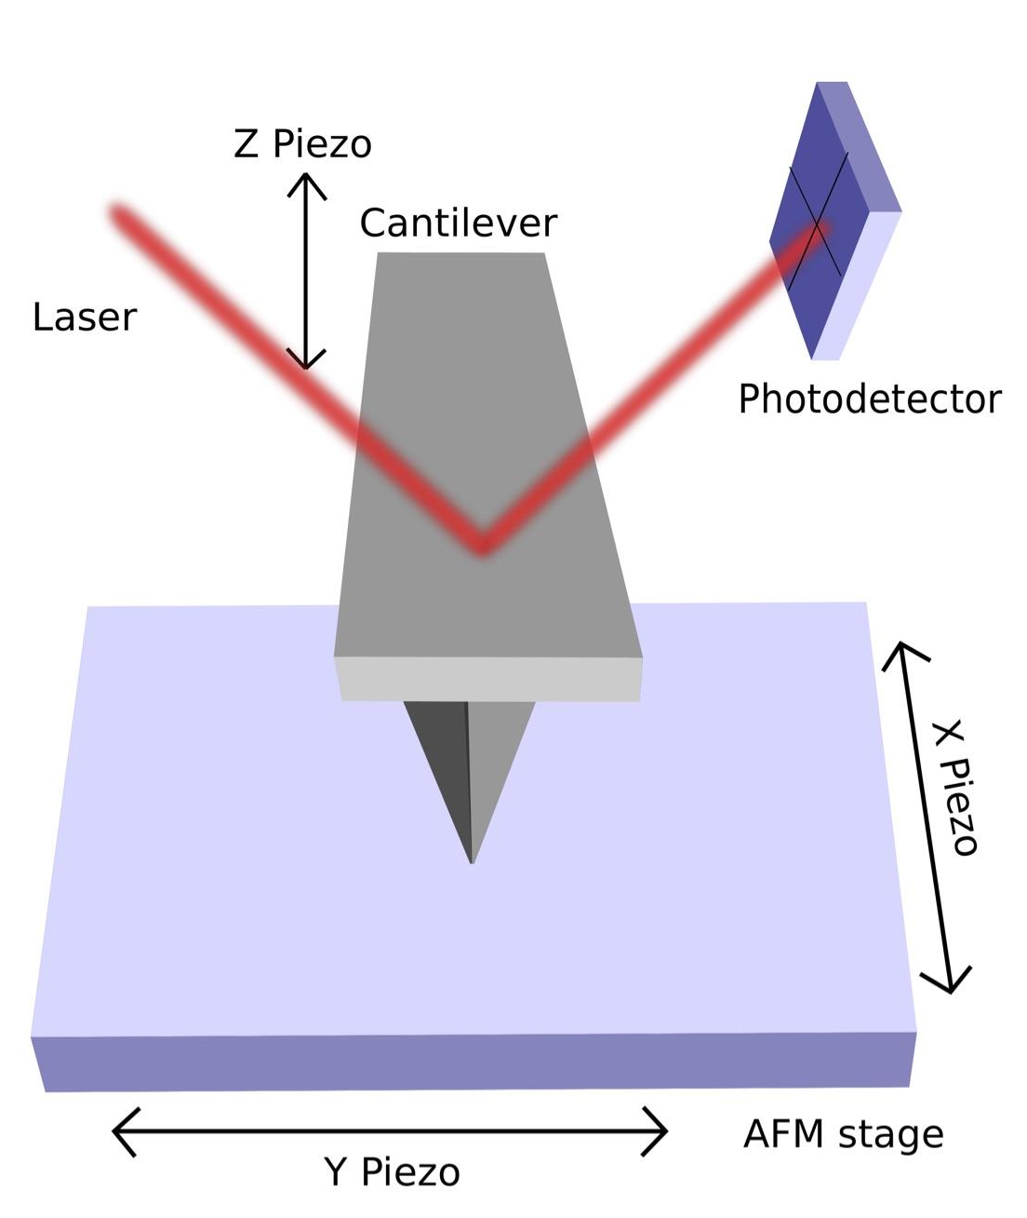
Figure 3.1. A simple diagram of an AFM
Showing the design as used by Asylum Research AFM systems, where the X, Y and Z piezo assemblies are independent of each other. This setup allows the actuation of the Z while the AFM stage rasters across the sample.

Alternately, if the x and y piezo stages are kept stationary and the tip is translated in the z direction towards the surface bringing the tip in contact with the surface and then continues to cause the cantilever to bend, leading to a change in voltage across the photodiode detector. A voltage-distance curve can be plotted, where the deflected voltage is proportional to the force applied by the cantilever. If the cantilever possesses a spring constant greater than that of the substrate, the substrate can deform. If this force is insufficient to deform the substrate, the deflection of the cantilever will correspond to movement of the z piezo stage, which is a means of calibrating the deflection sensitivity of the cantilever. This is the inverse optical lever sensitivity or inVOLS, and typically in the units of nm/V. To determine the inVOLS, the slope of the deflection voltage vs Z piezo is taken when the cantilever is in contact. This measurement is often repeated a minimum of three times for the same tip-sample combination to reduce error. There are other ways to measure the inVOLS which have been covered in “Cantilever Calibration” in chapter 2.
If the substrate is deformed or indented, then to determine the deformation of a substrate or the force a cantilever is applying over a distance, we must account for the bending of the cantilever when describing the distance travelled by the cantilever tip. The tip-sample separation or substrate deformation is not measured directly in an AFM measurement. Instead the movement translation of the Z piezo stage at the base of the cantilever (Z Piezo, Z) and the bending of the tip (Deflection, D) are measured independently with time. To calculate the tip-sample separation, or substrate deformation, we use the following definition or distance balance for the AFM:
$ΔS=ΔZ-ΔD$ Eq.32
As alluded to above, once the tip is in contact with the surface, i.e., if the substrate deforms, then only the indentation will be measured. Prior to the tip-surface contact, this relation can be used to describe either the case where no substrate deformation occurs, i.e., or the case where both changes and tip-surface separation and substrate deformation may occur. The second case is more complicated and often requires a model for interpretation, for example the interaction between a drop or a bubble and a particle attached to the end of the cantilever.
The deflection of the cantilever can also be transformed into a force by the knowledge of the spring constant (N/m), and the knowledge of the orientation of the cantilever. Typically, this requires a calibration step, often done on the AFM instrument itself. The most common method and industry standard, used in thesis, is done by observing the thermally driven amplitude (V) as a function of frequency of the cantilever in air. The theory behind the calibration can be found in chapter 2 “Cantilever Calibration”. We utilize the primary resonant frequency peak of the cantilever, usually the lowest frequency of the cantilever as it typically shows the highest amplitude as observed in Figure 3.2. We routinely use the AFM software to acquire these data, but the data in Figure 3.2 was acquire using a laser doppler vibrometer (LDV), discussed in the next section.
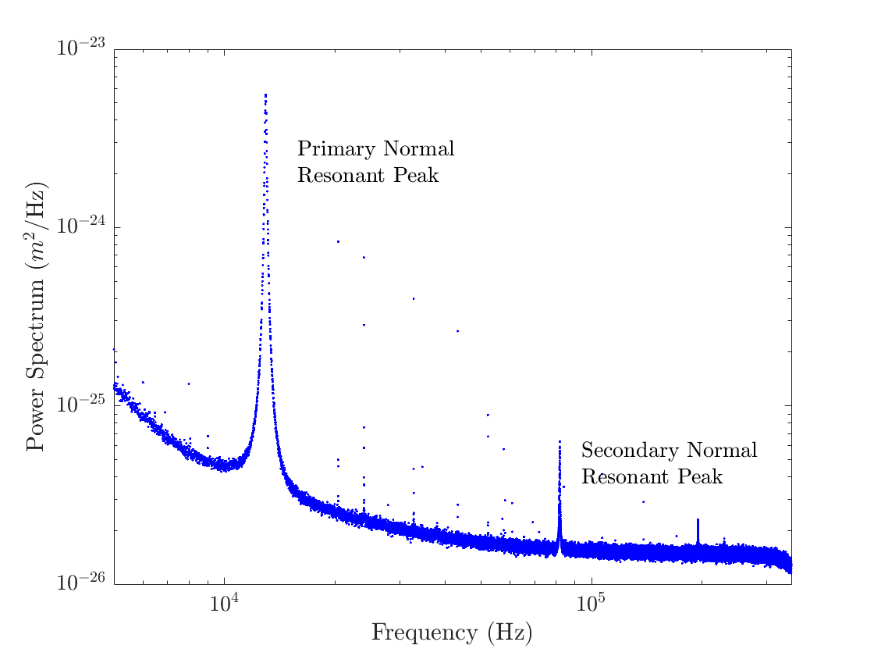
Figure 3.2. Power Spectrum data example from laser doppler vibrometer
An example of a power spectrum of a thermally driven cantilever in a laser doppler vibrometer, showing the behaviour of a typical rectangular cantilever.

For most cantilevers with a primary resonant frequency above 10kHz in air, a simple damped harmonic oscillator model is used to fit this peak. This model is used to integrate the area of the peak, which can then be used to determine the mean squared displacement of the peak. This allows the use of the equipartition theorem to determine the spring constant of the cantilever as follows:
$k_{nor}= \frac{χ_{nor}k_{b}T}{γ^{2}〈z^{2}〉^{ }}$ Eq. 21

$PSD =A_{white}+\frac{{Q^{2}A}_{DC}{f_{R}}^{4}}{Q^{2}(f^{2}-{f_{R}}^{2})^{2}+f^{2}{f_{R}}^{2}}$ Eq. 22

$k=\frac{2k_{b}Tχ_{nor}}{πf_{R}Q{A_{DC}}^{2}}$ Eq. 24

Eq. 21 is the expression for the equipartition theorem for an AFM cantilever, where k_{nor} is the normal spring constant, 𝜒_{nor} is the flexural mode correction at 0.971, k_{B} is the Boltzmann constant, T is the temperature in Kelvin, 𝛾 is the optical lever correction factor which is 1.09 for rectangular and 1.10 for triangular cantilevers. Eq. 22 is the equation fitted to the voltage power spectrum (V²/Hz), PSD, where f is the frequency, f_{R} is the resonant frequency, Q is the Q factor, and A_{DC} is the amplitude factor. These methods can also be used to determine the spring constant in an LDV, which give the displacement (m) as a function of frequency. For LDV measurements 𝛾 is 1, and the spectrum used is the power spectrum (m²/Hz), where the spectrum must be first corrected by a reference spectrum in displacement before converting to the power spectrum.
Other methods of cantilever calibration are discussed in chapter 2 “Cantilever Calibration”.

3.2.3 Laser Doppler Vibrometer or LDV
A Laser Doppler Vibrometer determines the change in the position of an object to the resolution of 10’s of picometers as a function of time. This is done by interferometry using 2 beams of light, where one is reflected off a sample and another is used as a reference beam where it has a slight change in its wavelength with the use of a Bragg cell. As the sample moves, it doppler shifts the reflected light slightly which shifts the wavelength of light. When the reflected light is recombined with the reference beam of light of a known shift, this leads to intensity peaks in the measured light or “beating” due to the interference. The frequency of the doppler shift can be determined from the spacing of these beats, from which the velocity profile can be determined as a function of time and moved to the frequency space. An example of this spectrum can be found in Figure 3.2.

The instrument used was a Polytec MSA-400 (Waldbronn, Germany), where only cantilevers with sufficient reflectivity (silver or gold coated) were used and were measured directly in the gel pack box. In all experiments, single spot spectrums were taken using a 50X objective, where a reference sample is taken at the base of the cantilever to subtract the background signal²²², and the sample was levelled with respect to the incident light. Depending on the reflectivity of the sample and the height and width of the peak, the number of runs and resolution was tailored to ensure a high signal to noise ratio for the desired peak. To determine the primary normal frequency of the cantilevers, a spectrum was taken at the lower frequency range between 2kHz and 30kHz, for the Contact-G (f_{R}~14kHz, BudgetSensors, Bulgaria), where the laser is placed adjacent to the tip to avoid length adjustment²²¹.
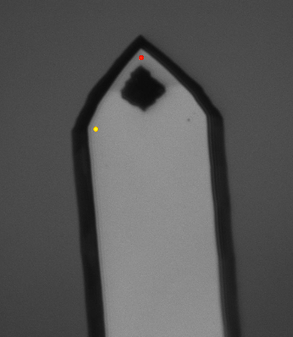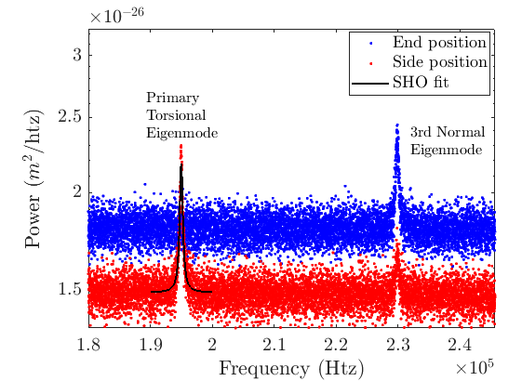
Figure 3.3. LDV measurement example
Example of an LDV measurement on a BudgetSensors Contact-G tip. The left is the microscope image of the cantilever tip with the two points, the end and side position. The right image is an example of the power spectrum of the tip, where the Simple Harmonic Oscillator is fit to the primary torsional mode of the thermal spectrum of the tip.

For measurements of the lateral spring constant via determination of the resonant peaks corresponding to lateral motion of the cantilever, the cantilever response is measured by placing the laser in the centre of the cantilever past the tip, and comparing these spectra to ones taken beside the cantilever tip. For the Contact-G cantilevers tested, the torsional primary frequency was measured to be between 190 and 220kHz. To calculate the lateral spring constant, the laser position distance from the centre must be known, thus an image of the cantilever and laser position is taken by the software where the pixel positions of the laser positions are known, as observed in Figure 3.3. From the image and SEM analysis of the cantilever dimensions, a distance from the centre of the cantilever can be calculated. Newer methods of achieving this can be found by Labuda et al²²⁴ and discussed in the Chapter 2 “Cantilever Calibration”.

3.2.4 Colloidal Probe Cantilever Preparation
When determining the force behaviour of capsules and substrates in this thesis, cantilevers with particles attached to the ends were used. All force measurements were done with triangular MLCT cantilevers (Brucker, CA, USA), where these cantilevers have a glass bead (10-20um diameter) attached to the tip of the cantilever, which allows for a distributed load on the substrate. These cantilevers have 5 cantilevers on one side, and have a range of lengths and force constants, where cantilevers C, D, E and F, with nominal spring constant values of 0.01,0.03, 0.1 and 0.3, respectively, are used in this thesis. The particles were attached to the cantilevers by micromanipulation of the cantilevers using in an Asylum MFP-3D (Asylum Research, CA, USA). A 30 minute two part epoxy (Araldite Super Strength, Selleys) was spread onto a microscope slide with a 22G syringe cannula, and the cantilever tip dipped into the glue. This glue coated cantilevers were then positioned over the top of a glass bead, deposited on a microscope slide via evaporation of a solution of glass beads. The solution of glass beads is created by adding 0.1mg to 1mL of deionized water, and sonicating it for 20 mins, and then placing a large droplet (2cm diameter) onto the glass, allowing the larger particles to settle for 10 minutes, and then slowly evaporating the water away on a hot plate set to 50ºC. Once the particles are attached to the cantilevers, they are allowed to dry for at least 24 hours and are UV-ozone cleaned for 20 minutes prior to use.
Cantilevers are typically calibrated for their force constant after this by use of the “Thermal Method”^{215, 245}, as described above.

3.2.5 AFM imaging
AFM imaging in this thesis was exclusively done on an Asylum Cypher S or ES (Asylum Research, CA, USA). The cantilevers used for aqueous imaging are BL-AC40s (Olympus, purchased from Asylum Research, CA, USA), which are short (38um long) and soft (0.1N/m), with a gold reflective coating. Imaging using these cantilevers is done with blue drive, which is a photothermal excitation method where a pulsed 405nm laser is used to thermally expand the base of the cantilever periodically to generate tip oscillations^{246, 247}. These oscillations are only located at the cantilever itself, thus improving the imaging stability.
For imaging in air, Tap300 cantilevers (BudgetSensors, Sofia, Bulgaria) are used which possess a high force constant (~40N/m) and have been used coated with 5nm of chromium and 20nm of gold or used with bare silicon as dictated by the application. These are driven with a piezo drive at the base of the cantilever holder.

3.2.6 Capsule Preparation
Capsules were dispersed in an aqueous medium, where the capsules were typically made or received as a highly concentrated aqueous dispersion. The substrate for all capsule compressions is a glass round (Asylum Research, CA, USA), placed in a PEEK holder (Asylum Research), which is held to the stage by neodymium magnets. These glass slides are initially cleaned by the glass cleaning procedure (see “Glassware Cleaning”) and UV-Ozone cleaned for 20 minutes (BioForce ProCleaner, Holgate Scientific Australia). If a negatively charged substrate is desired, the substrate is used directly after cleaning. If a positively charged substrate is desired, the substrate is soaked in a low concentration (0.01% w/v) solution of Poly-L-Lysine and rinsing in Milli-Q prior to capsule attachment. To attach capsules of lower density than water to the slides, the bulk solution for the experiments is added to a small PTFE cap (~1mL), slightly overfilling it, where a small amount of the concentrated capsule dispersion is added. The prepared glass slide is then added over the top and allowed to sit for a minimum of 1-2 hours to allow for capsule adhesion. Once the incubation time is complete, the slide is rapidly removed from the small cap, where it is then secured into the PEEK AFM holder, and filled with the experimental solution, liberating any capsules not fully adhered to the substrate. The experimental solution is then replaced several times until unbound capsules are not observed with light microscopy. For capsules with a density greater than the aqueous medium, the capsules are allowed to settle onto the glass, incubating for 1-2 hours to ensure adherence to the glass. It is important to allow for the capsules to incubate for an extended period of time and substrate adhesion to be optimal to ensure no capsule movement during indentation.

3.2.7 Capsule Indentation Measurements
All force measurements are performed on an Asylum MFP-3D AFM, where the cantilevers and sample are placed in the AFM, carefully ensuring that the AFM head is sealed from the aqueous solution with a silicone or Viton skirt. Prior to the measurements, the laser is aligned and placed on the back of the cantilever in air and then lowered into the solution. The laser is realigned after passing through the interface and the deflection set to 0V, where the AFM is then allowed to thermally equilibrate for 10-20 minutes. Once the deflection voltage is observed to be constant for 1 min or longer, the tip can then be brought into contact with the glass round by using the “Engage” function and lowering the head until the Z piezo voltage can be held at 70V, ensuring that no capsules or debris are present below the indenter. Once in contact, the inVOLS may be taken by applying a force curve with the glass substrate, not the capsule, with the voltage trigger of 1V at a velocity below 1um/s. The slope of the line after contact, as observed by an increase in deflection, is the inVOLS. This is typically done in triplicate to ensure certainty of the inVOLS. The indenter is then moved away from the surface, and engaged above a capsule, ensuring that the centre of the indenter is placed directly above the capsule using the inverted light microscopy.
Once in contact, the application of force can be controlled in by varying indentation velocity, depth of indentation, maximum force applied and application of non-linear movements of the cantilever. These parameters have been explored extensively in this thesis in the case of capsules.

3.2.8 pH adjustments of solutions
The pH of solutions is required throughout this thesis and is done with a pH meter (Hanna Instruments, HI 255, RI, USA), which is calibrated each day of use over the solution range of 4, 7 and 10 (pH calibration buffer, ProSciTech, Australia). Typically, the solutions used are acidic acetate buffers which are mixed stoichiometrically with the amount of sodium hydroxide required to mostly neutralized the added acid, and finely adjusted with the use of a 1% sodium hydroxide solution in Milli-Q water. When adding the sodium hydroxide, the solution is stirred and allowed to come to equilibrium prior to further addition of base.

3.2.9 Cleaning of Oils
To ensure the correct surface activity of the oils used in this thesis, many have been filtered. This is done by the use of a packed Florisil (mesh 60-100, Sigma Aldrich, Australia) column, where a cleaned glass chromatography column (2cm diameter, 20cm long) with a sintered frit at the base is packed with Florisil to a height of 5-10cm, and tapped until air is no longer observed to be removed from the bed. The oil is then added from the top, allowed to filter through the packed bed and collected in a cleaned glass vial for use. We have observed that the oils maintain constant surface activity for up to 2 weeks, as measured by interfacial tensiometry, when sealed and kept in the dark.

3.2.10 Interfacial tension measurements: Pendant Drop
To determine the interfacial tension of an oil/water interface, a method that is commonly used for complex interfaces is the pendant drop method. This method works by generating a droplet or bubble on the end of a J shaped capillary which is pinned to the end of a capillary and observing the shape of the drop. The buoyancy force acting on the droplet from the density difference between the drop or bubble is balanced by the interfacial tension of the system. Thus, with prior knowledge of the densities of the bulk and droplet phases, the curvature profile of the droplet can be used to determine its interfacial tension. In this thesis, this is done with an OCA 20 (Dataphysics, Stuttgart, Germany) using the internal software or by using the software from Berry et al¹⁷ which processes the images taken from a CCD camera a Flea3 (FLIR, OR, USA) or by using a different tensiometer, an Attension Theta (Biolin Scientific, Gothenburg, Sweden). In this work, only lighter than water oils are used, therefore an oil droplet is generated from a J shaped needle, where this needle is immersed in a solution of interest placed in a clean quartz cuvette 20x20x30mm with clear, flat sides as per Figure 3.4 below. This droplet is observed by a camera and connected to a computer to record and fit a droplet shape to the observed droplet profile.
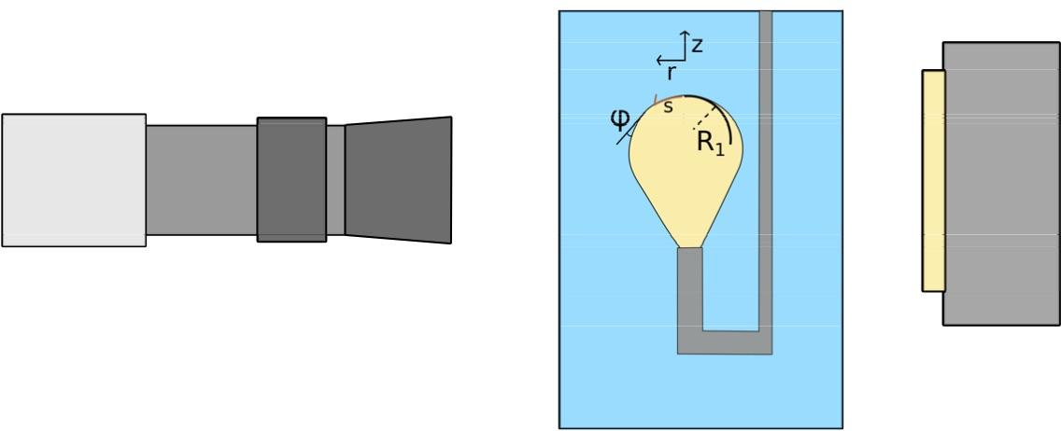
Figure 3.4. Pendant Drop setup
An example of a pendant drop setup, where a sessile droplet or bubble is observed by a camera. This camera is then sent to a computer for the droplet profiles to be calculated.

This technique is based on the balance of the Young-Laplace equation with the hydrostatic pressure surrounding the drop at equilibrium. The Laplace pressure difference at the interface of a curved surface can be described by Eq33:

$γ(\frac{1}{R_{1}}+\frac{1}{R_{2}}) = ΔP_{0}-Δ⍴gh$ Eq.33

Where 𝛾 is the interfacial tension, R₁ and R₂ are the principle radii of curvature, ΔP₀ is the change in pressure across the interface referenced to height at the apex of the droplet, Δ⍴ is the difference in density between the phases, g is the gravitational constant, and h height is the depth of the liquid. Thus, the Δ⍴gh term is the hydrostatic pressure acting on the droplet at any depth.
To calculate the interfacial tension, the shape of the droplet must be quantified for the interfacial tension around the droplet¹⁷. To solve this, we can translate the Young-Laplace equation into cylindrical coordinates, r and z, where together with the tangent angle φ as per Figure 3.4:

$$\frac{dϕ}{ds}=2-Bo.z-\frac{sin(ϕ)}{r}$$
$$\frac{dr}{ds}=cos(ϕ)$$
$\frac{dz}{ds}=sin(ϕ)$ Eq.34

Where Bo is the Bond number which is defined in the following equation:
$Bo = \frac{Δ⍴g{R_{o}}^{2}}{γ}$ Eq.35
Where these equations take advantage of the cylindrical symmetry of the pendant drop and allow for a unique solution to the Young-Laplace equation for the varying curvature of a pendant drop. For further reading, an excellent recent review of interfacial tensiometry with perspectives on interfacial rheology can be found by Jaensson and Vermant⁶³.

3.2.11 Dilational Interfacial Rheology
When using pendant drop, it is possible to change the surface area of the droplet during the measurement when done slowly enough to maintain equilibrium. The change in interfacial tension can be used to determine the dilational interfacial rheology of the interface. Typically, this is done either by rapidly changing the droplet area and observing the change in interfacial tension over time, or by oscillating the droplet volume slightly, and observing the change in interfacial tension as the droplet is oscillating. For more detailed descriptions of these processes, refer to Chapter 2 “Dilational Interfacial Rheology”. Both these methods have been done primarily using the Attension Theta with a piezo oscillating volume attachment. For a sinusoidal oscillation in the area the following functions can be fit to the oscillating area (A) and interfacial tensions (𝛾) as a function of time, with the practical limitation of the technique up to 0.2Hz²⁴⁸:

$A(t) = A_{0}+ΔAsin(ωt)$
$γ(t) = γ_{0}+Δγsin(ωt+θ)$ Eq.36

Where A₀ and 𝛾₀ are the area and interfacial tension offsets, ΔA and Δ𝛾 are the area and interfacial tension amplitudes, 𝜔 is the frequency of the oscillation, and 𝜃 is the phase offset between the applied area signal to the interfacial tension. To determine the maximum limit of the applied amplitude, an amplitude sweep should be done⁷⁶. These fitted quantities are used to determine the storage (K’) and loss (K’’) moduli of the interface by the following relations:
$K' = \frac{Δγ}{ΔA/A_{o}}cos(θ)$
$K'' = \frac{Δγ}{ΔA/A_{o}}sin(θ)$ Eq.37

To determine the interfacial moduli of a step change in surface area (ΔA), the following relationship can be used to determine the storage and loss moduli over a frequency range of 10⁻¹ to 10⁻⁶ Hz, where the droplet is allowed to re-equilibrate over 5 hours of observation:
$K(t)=\frac{Δγ}{ΔA/A_{o}}$
$$K'(ω) = K_{inf}+ω\int_{0}^{t_{max}}{(K(t)-K_{inf}).sin(ωt).dt}$$
$K''(ω) =ω\int_{0}^{t_{max}}{(K(t)-K_{inf}).cos(ωt).dt}$ Eq.38
Where this integration is done discretely over a set of 𝜔, typically 3 per decade, and over the range of t from 10s after the perturbation to the end of the observation time, where K_{inf} is the final value of K at the end of the set.

3.2.12 Shear Interfacial Rheology
Interfacial shear rheology is where an oscillating or constant shear deformation is applied to an interface, and the torque required to deform the interface is observed. This can be done directly in a stress or strain controlled rheometer using either a bicone¹⁰⁷ or double walled ring¹⁰⁹ attachment, which has been pinned to an interface and to the side(s) of a circular cup. In this work, we exclusively use a bicone attachment on an Anton Paar MCR-502 or MCR-702 (Graz, Austria). The mathematical background for the use of the bicone rheometer can be found in chapter 2, “Shear Interfacial Rheology”. The setup of the bicone shown in Figure 3.5 below.
Figure 3.5. Diagram of a bicone interfacial rheometer at the oil/water interface.
The setup of the bicone, where the denser fluid 1 is found at the base of the cup, and the lighter fluid 2 is present above the bicone and fluid 1. The bicone is pinned at the interface between the two fluids. The motor applies the deformation and the transducer determines the torque applied.
In using the bicone configuration, the stainless steel cup and bicone is first cleaned the with Milli-Q water, ethanol and isopropanol, and rinsed with Milli-Q water and dried with clean compressed air or nitrogen. Once clean, the bicone and cup are secured in to the rheometer, and the aqueous solution is added into the cup up to the mark indicated by the toolset. The bicone is held in the upper toolset and lowered into the aqueous phase until a drop in the force is measured by the upper toolset, indicating contact to the aqueous solution. The height of the liquid can then be calculated as a differential to the height from the contact point depending on the angle and width of the bicone, where newer software with the MCR-702 completes this action in an automated fashion. Once lowered into the solution to the point of the solution appears flat on the pinned to the edge of the bicone. Then the oil can then be added to create an oil layer above the aqueous layer. The oil is added from the centre of the bicone and allowed to flow over the bicone to cover the air/water interface, until the layer height desired is attained, typically around ~1cm. The bicone testing begins soon after the oil layer fully coats the water.
To test the interfaces presented in this thesis, 3 separate tests are done to the interfaces. Initially to observe the aging of the interface, a time sweep of a minimum of 15 hours at a constant strain of 1% and frequency of 1 rad/s is used. To test the frequency dependence of the systems tested, a frequency sweep between 0.1 rad/s to 10 rad/s at a constant strain of 0.5%, where 10 rad/s is the upper limit of the frequency sweep due to inertial noise. To observe the strain behaviour of the film, a strain sweep between 0.1 to 150% strain is done. Typically, within these limits the film reaches its breaking strain and a crossover point where the magnitude of the storage modulus drops below the loss modulus. In all strain tests, 30 mins was waited before the films were retested for their strain sweep behaviour.

3.2.13 Dynamic Light scattering
Dynamic light scattering is a technique used to determine the sizes of particles in a solution, where the size of the particles can range from 5 nm to 10,000 nm. A dynamic light scattering device contains a laser which is passed through a solution with suspended particles. The scattered light is observed as a speckle pattern recorded from a position slightly offset from the laser beam path either in reflectance or transmittance. Each pixel in the speckle pattern corresponds to the scattering of a single particle in a single position. The particle diffusion in the solution causes the speckles to vary from bright to dark in a blinking fashion, where the time taken for the blink will be proportional to the average Brownian velocity of the particles. The time vs intensity behaviour of the speckle pattern can be quantified by the analysing the blinking time as an autocorrelation function. This autocorrelation function can then have various algorithms fitted to it to determine the average particle size in the solution. For all solutions tested in this thesis, a Malvern ZetaSizer Nano ZS (Malvern, UK), where solutions at low concentrations are used (0.0005% wt particles) to ensure reproducible results. As particles much smaller than the wavelength of light are being tested, Rayleigh’s approximation applies which is independent of the refractive index of the particles.

3.2.14 Infrared Spectroscopy
Infrared spectroscopy is a technique where a spectrum of infrared light typically between 500 and 3500cm⁻¹ is transmitted through a sample, and the amount of light absorbed is quantified. The light absorbed in this spectrum is highly dependent on the composition of the sample, where different functional groups present in the sample will absorb light at certain frequencies within the infrared spectrum proportionally to the quantity of those groups, and the absorption characteristics of that absorber. We utilize infrared spectroscopy to determine the quantity of acetylation of crystallized chitosan, where we utilize a Bruker LUMOS FTIR microscope, using the FTIR crystal mated to the top of the chitosan crystal. The chitosan was dried in a sealed container with dried silica gel particles for 24hrs prior to testing in the FTIR.

Chapter 4 – Viscoelastic characterisation of emulsion drops via microcapsule compression and dilational and shear interfacial rheology

Abstract
Interfacial rheology provides insight into mechanical properties of adsorption layers on liquid-liquid interfaces, which mediates the stability of emulsion droplets. In this work we present a novel approach to determining the interfacial rheological behaviour of microcapsules made with a liquid core. We introduce a time dependent model to determine the storage and loss moduli of a capsule shell in small oscillatory deformations. Using oscillatory indentation with atomic force microscopy (AFM), the viscoelastic response of β-lactoglobulin on an oil/water interface in the native and crosslinked state was investigated and compared to macroscale experiments comprising dilational pendant drop rheology, and bicone interfacial shear rheology (ISR). Our model revealed that oscillatory AFM on protein coated droplets provides similar tan(δ) results to ISR but the values of the viscoelastic moduli G’ and G’’ differ orders of magnitude to the calculated interfacial moduli of either shear or dilational techniques. The AFM method differs from macroscopic methods with a different flow field and low deformation compared to dilational and shear techniques. This technique can be used to probe the interfacial behaviour at the scale of an emulsion droplet, opening up the possibility of testing the interfacial behaviour of coatings with complex histories and extremely small volumes.

4.1 Introduction
Encapsulation of materials in microcapsules ensures stability of the core material until the appropriate conditions for release via a range of external stimuli including mechanical breakage or changes in environment (e.g. pH, temperature or ionic strength) leading to degradation of the shell material. This technique is used in many industries from food products¹¹⁴, textiles¹²², pharmaceuticals²⁴⁹ and fragrances²⁵⁰. For systems where the viscosity of the bulk and encapsulated phases are low, the breakdown of the shell can be controlled by its rheological behaviour²⁵¹.

Microcapsules can be fabricated using emulsion and particle templating²⁵² which provide a high degree of control over the capsule properties. There has been many efforts to characterise these particles in terms of their mechanical behaviour to determine their stability and function in relevant environments. To date, the mechanical behaviour of capsule shells is mainly characterised by determining their Young’s modulus¹⁵², non-linear compression behaviour²⁵³ and internal release behaviour²⁵⁴.

A common approach used to determine the behaviour of microcapsule shells is via micromechanical compression using atomic force microscopy (AFM)²⁵⁵. The technique was pioneered by Dubreuil et al¹⁵over a decade ago. Recently, the compression analysis of soft materials has been refined for both soft particles²⁵⁶ and thin shelled capsules¹⁷, prompting further investigation into the time dependent mechanical behaviour of capsule shells via micromechanical compression. Significant work has been done by Barthes-Biesel et al and others over many years in the observation and analysis of the time dependent mechanical behaviour of capsules in extensional flow regimes within microfluidic devices^{138, 144, 166, 167, 257-259} where the capsule radius is typically 50-200 microns. However, there has been little time-dependent analysis of capsules undergoing compression, particularly for capsules in the 10s of microns to sub-micron range size range.

Depending on the shell properties, the interfacial rheological response is likely to be important to microcapsule compression behaviour^{149, 260}. Yet, the difficulty in measuring the dynamic microcapsule shell response directly has led to the creation of surrogate systems that mimic the adsorption layer in other geometries, often at larger length scales. Many techniques have been developed to measure the interfacial rheology of liquid-liquid interfaces⁷⁰, where the deformation forces are typically applied either in shear on planar films^{99, 107, 109, 250, 261} or in capillary-based drop dilational rheology systems^{37, 47, 71, 74, 262}. Bicone and pendant drop interfacial rheology have been used to observe the rheological behaviour of interfacial films^{263, 264} in conjunction with capsule compression to probe Young’s modulus²⁶³. AFM film compression also has been used to determine the viscoelastic behaviour of thin layers typically used in capsules¹⁶⁵. Yet to our knowledge, there exists no combination of experimental methods and analysis framework to quantify the viscoelastic properties of microcapsule shells in their native geometry under compression.

In this work, we have chosen a well-defined protein adsorption layer which can be used to compare the viscoelastic response of the oil core micro-capsules measured via AFM to a range of interfacial rheological methods at the same oil-water interface. This study builds on the existing interfacial rheological studies^{32, 76, 165, 265-267} of β-lactoglobulin. β-lactoglobulin is a globular milk protein that has been shown to lower the interfacial tension of both air/water and oil/water interfaces, and also shown to exhibit viscoelastic behaviour at either interface³². To further probe β-lactoglobulin behaviour, the known β-lactoglobulin crosslinker glutaraldehyde^{268, 269} is added in order to modify the rheological behaviour. There have been many studies of systems to observe the change in material behaviour between non-crosslinked and crosslinked interfacial polymer films using either AFM with particles and polymers^{135, 270} or interfacial rheology with milk proteins^{269, 271}. In this work, by reproducing the same adsorbed layer across multiple measurement geometries and comparing the rheological behaviour may lead to new insights into the relevance of interfacial rheology to microcapsule strength and behaviour.

4.2 Materials and methods

4.2.1 Materials
The materials used include β-lactoglobulin, 25% glutaraldehyde solution, glacial acetic acid and sodium hydroxide pellets from Sigma Aldrich, St. Gallen, Switzerland for bicone experiments. For capsule and pendant drop experiments, sodium hydroxide from Chem-Supply, and glacial acetic acid from Fluka Chemicals was used. Delios.V(MCT oil) is purchased from BASF. All materials were used in their purchased form. The aqueous phase emulsifier β-lactoglobulin was added to a 0.45M acetate buffer at pH 5, and used in a concentration of .001% wt for all experiments. The β-lactoglobulin was allowed to dissolve for 3 hours prior to use in any experiments.

4.2.2 Bicone Interfacial Shear Setup

A rotational rheometer (Anton Paar, Physica MCR-501) was used with a bicone tool (bicone radius = 35.05 mm, cup radius = 45 mm). The aqueous phase was added to the cup and the bicone is then lowered onto the bare interface to the point of contact with the aqueous phase where the edge of the bicone is pinning the interface. The oil is added over the bicone. The bicone was then sinusoidally oscillated, and the resulting torques processed to determine the interfacial elastic and loss moduli¹⁰⁷. For the determination of viscosities of both phases, an Ubbelohde viscometer was used. All interfacial shear measurements were done in triplicate to ensure reproducibility. To crosslink the interface, 2mL of unstabilised 10 %w/w glutaraldehyde-in-oil emulsion was added to the oil layer. This layer increased the thickness of the oil layer by less than a millimetre, negligibly impacting the calculation of the interfacial adsorption layer moduli. Once added, the droplets are not present at the oil/water interface after 10 minutes of their addition, as they have been incorporated into the aqueous solution.
All measurements were done at 22ºC and amplitude sweeps were performed at 1 rad/s. To observe the build-up of the interfacial adsorption layer, time sweeps were performed for 10 - 15 hours at constant amplitude of 0.5 %, where these amplitude and frequency selections were found to be within the linear viscoelastic region. Once the crosslinker was added, the layers were observed for a further 3 to 24 hours. To characterise the interfacial network properties, amplitude sweeps were performed by logarithmically ramping the oscillation amplitude from 0.1 to 150 %.

4.2.3 Interfacial Tension
Dynamic interfacial tension pendant drop tensiometry was used to determine the purity of buffered solutions and oils. All measurements were performed on a homebuilt tensiometer, where a pendant drop is generated on the end of a suspended syringe with a needle in a cuvette and observed over time (Flea3, FLIR, Richmond, Canada). The interfacial tension is determined via OpenDrop¹⁷ from images collected from these experiments. Typical precision in these experiments is within 1 mN/m, and the interfacial tension between the buffer and oil is tested prior by observing a value of 27 mN/m for an hour. All measurements were done with a 0.8 mm diameter stainless steel hook shape needle, where MCT oil is the drop phase, and protein solution is the continuous phase.

4.2.4 Interfacial Dilational Rheology
The setup for the dilational rheology is similar in design to the interfacial tension but done on an Attension Theta (Biolin Scientific). Initially the oil droplet is produced at the end of a hook needle and the protein adsorption layer is allowed to build on the interface for 15 hours. The interfacial dilational storage K’ and loss K” moduli of the MCT oil-buffer interface were determined by either a step change or an oscillating change in the interfacial area of a pendant drop. Oscillatory moduli were determined using the Attension software.
Dilational amplitude and frequency sweeps were performed to characterise the complex moduli of the interfacial adsorption layers explored here. The frequency sweep was performed at 0.01 to 1 Hz with a deformation of 1.3 %. Lag time of 20 minutes was used between measurements to ensure that the drop had come to equilibrium between perturbations.
To probe slower frequencies the approach from Freer et al⁴⁷ is used, where a step area expansion of 2% is applied to an aged pendant drop, and the change in interfacial tension is observed over the following 2 hours. More details on the analysis can be found in the Supplementary Information.

4.2.5 Capsule Preparation
To immobilize the emulsion particles for AFM experiments, first emulsion droplets are produced by the vigorous shaking of 10 mL test tubes with 2 mL of buffer and 0.1 mL of oil until a significant fraction of the observed droplets are below 10 μm. Pre-dissolved β-lactoglobulin is added to the emulsion and allowed to adsorb for 15 hours without further agitation. A 10 μL aliquot of the concentrated creamed emulsion is added to a small amount of fresh buffered β-lactoglobulin solution in an overfilled 10 mL test tube. A glass round which has been soaked for an hour in lab detergent, 10% nitric acid solution and ozone cleaned for 20 minutes is placed over the top. The capsules are allowed to float to the glass round for a minimum of 12 hours at 4°C to allow for capsule adhesion to the glass round. To crosslink the native protein capsules, glutaraldehyde is added to the AFM fluid cell 24 hours prior to the compression of the capsules, where the glutaraldehyde concentration is 0.1 %wt in the buffer solution.

4.2.6 AFM methodology
All mechanical AFM capsule testing was done on an Asylum Research MFP-3D (Santa Barbara, CA, USA) using Bruker MLCT cantilevers (Cantilevers “D” and “E”, nominal spring constant values of 0.06 and 0.13 N/m) with silica beads from 15 – 30 μm diameter attached with optically clear 2 part epoxy (Super Strength, Selleys Australia) using an MFP-3D with an inverted microscope. All cantilever spring constants are calibrated with the Thermal method²¹⁵ and ranged in value from 0.08 to 0.15 N/m. Prior to all indentation experiments, the normal deflection sensitivity of the cantilever was measured by recording the deflection of the probe while in contact with the glass surface. The capsules chosen for compression in this experiment varied from 3 to 20 μm in diameter.

All normal force curves were done at velocities below 2um/s to avoid hydrodynamic effects. All measurements were done in closed loop mode, where the indentation depth was always the controlled variable to compensate for the deflection of the cantilever over dwells and oscillations. The sample rate used for these experiments was 5kHz.
Based on the standard dwell function in an AFM force curve, a new method was developed by adding a controlled small amplitude oscillation after the initial indentation to probe the microcapsule behaviour response to oscillatory mechanical perturbation. In a dwell function, the spherical probe first approaches the capsule at a rate similar to a typical force curve prior to reaching to a target indentation depth. The cantilever is then held at the target indentation depth for a set time, often several seconds, and then the cantilever is retracted at the same rate as the approach. Typical indentation depths (Δ) of 10, 50 or 150nm and an approach/retract velocity of 500 nm/s were used. The applied indentation is held for 1 s, and then an additional small oscillatory amplitude is then added to the z-piezo drive for a desired time. The amplitude and period of the oscillation are carefully controlled to allow for a minimum of 5 full oscillations. Thermal drift is always a concern in long time AFM measurements where only observed drift in the average deflection was significantly smaller than the oscillation amplitude was acceptable. For these data, this often restricted measurements to less than 20 s. The frequencies used ranged between 0.5 – 20 Hz and the indentation amplitudes varied between 2 and 10 nm. The maximum velocity of the cantilever while oscillating was limited to the product of 2π the oscillation frequency and the amplitude, nominally 502 nm/s for this study. Control measurements at large separations where there was no observed force response from capsule compression (approximately a 100 μm) were used to confirm the bulk hydrodynamic drag on the cantilever was negligible.

4.2.7 AFM Oscillatory Capsule Compression Analysis
To quantify the viscoelastic behaviour of a capsule undergoing oscillatory compression with a colloidal probe, we modify the approach of Mahaffy et al. ¹⁵⁹. We consider small amplitude oscillation indentations $δ_{c}'$ relative to a mean indentation depth $δ_{0,c}$:
$Δ_{c}=CΔ_{AFM}=Δ_{0,c}-Δ_{c}'$ Equation 1
The subscript c refers to the corrected indentation, which is related to the measured indentation $δ_{AFM}$ by a correction factor C that accounts for the effect of the substrate on the measurement¹⁷. For a capsule with shell thickness $h≪R$, where $R$ is the radius of the capsule, the correction factor $C=0.5$.
For mean indentation depths $δ_{0,c}≲h$ the mean force on the probe is given by Reissner’s theory:
$F_{0}=\frac{4Eh^{2}Δ_{0,C} }{R \sqrt{3(1-v^{2})} }$ as per Berry et al
This is then translated into a shear modulus using Hooke’s law:

$F_{0}=\frac{8G_{0}h^{2}Δ_{0,c}}{\sqrt{3}R}{\left(\frac{1+v}{1-v}\right)}^{1/2}$ Equation 2
where $G_{0}$ is the zero frequency shear modulus, and $v$ is the Poisson’s ratio, which is assumed to be 0.4²⁷².
The effect of the small amplitude oscillations on the measured force can be quantified using the first two terms of a Taylor’s series expansion of $F$ about the average indentation depth, yielding
$F≈F_{0}+ Δ_{c}'\frac{8G^{*}h^{2}}{\sqrt{3}R}{\left(\frac{1+v}{1-v}\right)}^{1/2}$ Equation 3
Solving for the shear modulus G* gives
$G^{*}= \frac{\sqrt{3}R}{8h^{2}}{\left(\frac{1-v}{1+v}\right)}^{1/2}\left(\frac{F-F_{0}}{Δ-Δ_{0,c}}\right)$ Equation 4
This can be transformed to the frequency domain upon application of the correspondence principle:
$G^{*}(ω)= \frac{\sqrt{3}R}{8h^{2}}{\left(\frac{1-v}{1+v}\right)}^{1/2}\frac{F_{amp}(ω)}{δ_{amp}(ω)}$ Equation 5

Where using a Fourier analysis, the complex behaviour of the adsorption layer can be calculated from the phase shift (ϕ) between the applied indentation and the observed force. The resulting sinusoidal functions (see SI) are fit to the applied indentation and the observed force.

4.3 Results and Discussion

4.3.1 Bicone Interfacial Shear rheology

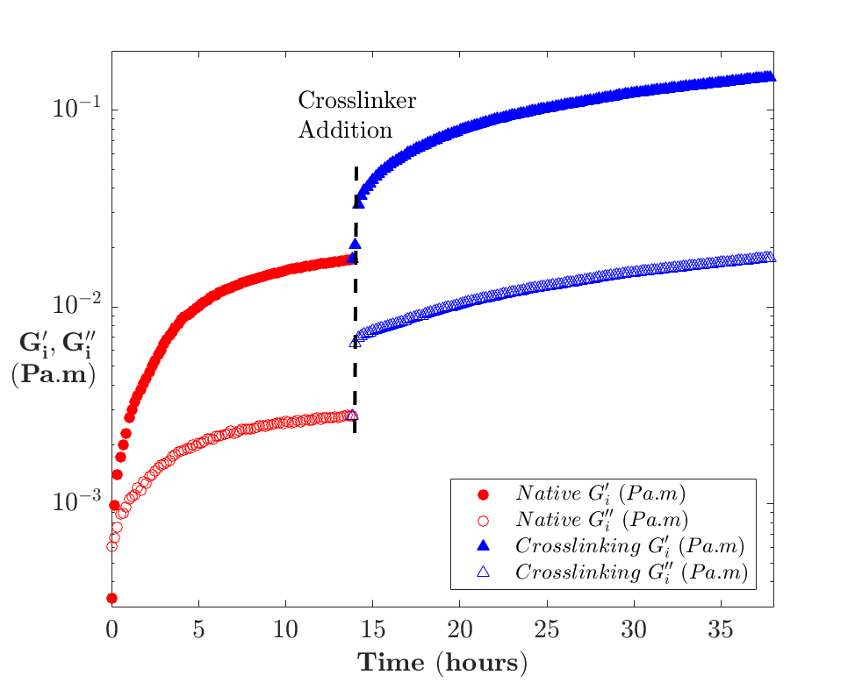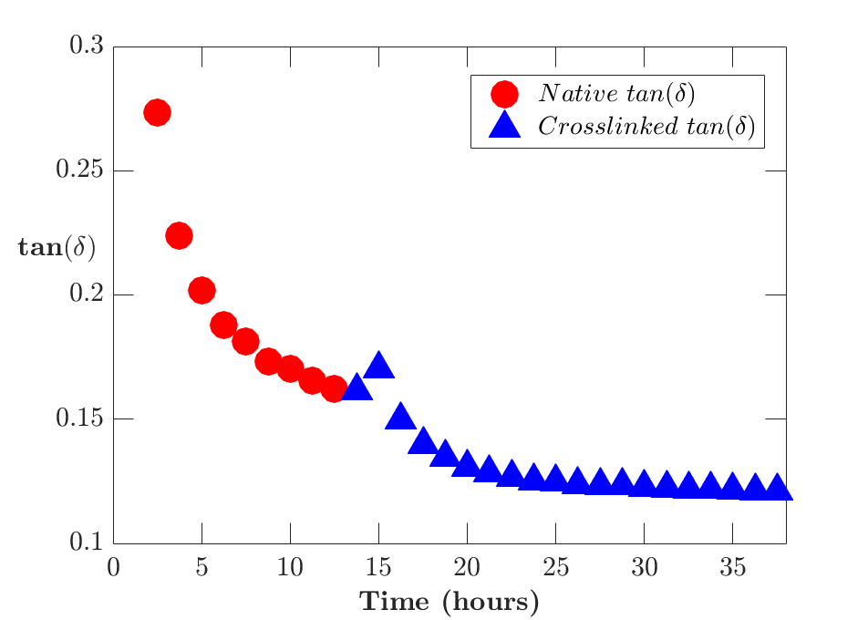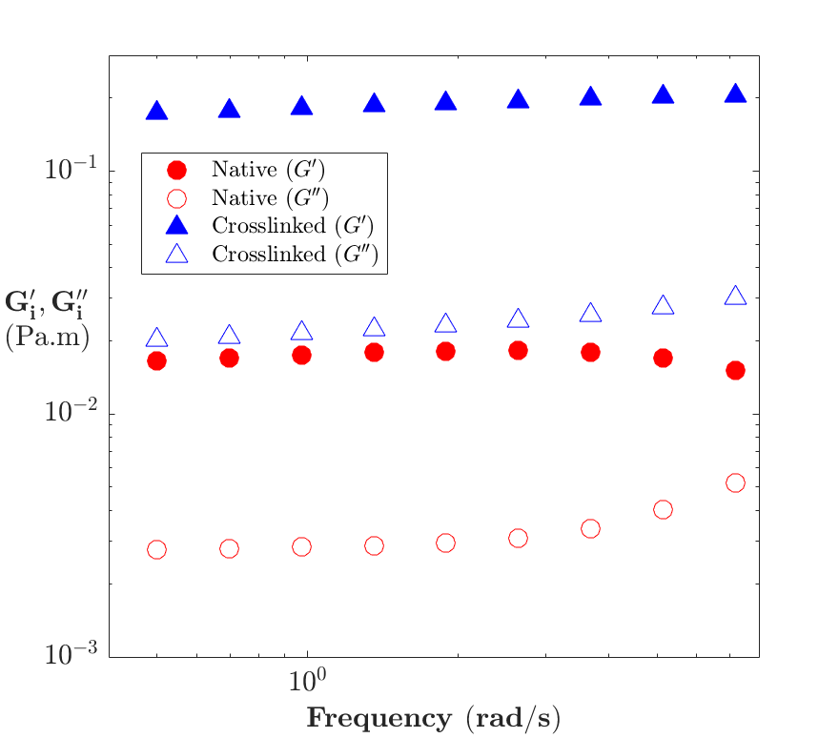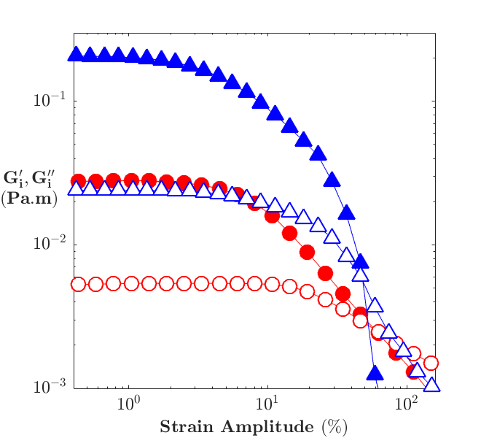
C
D
A
B
Figure 4.1. Behaviour of the β-lactoglobulin film before, during and after crosslinking.
Bicone shear interfacial rheology: Behaviour of the β-lactoglobulin adsorption layer before, during and after crosslinking. A Time sweep of the β-lactoglobulin adsorption layer. Crosslinking at ~15hrs, where red indicates the native adsorption layer and blue for the crosslinked layer. B The tan(δ) changes with time and crosslinking. C The frequency sweep of the native and crosslinked layers at 24 hours of crosslinking. D Amplitude strain sweeps of the native β-lactoglobulin adsorption layer after 15 hours and crosslinked layer after 24hrs of crosslinking.

The viscoelastic adsorption layer building behaviour of β-lactoglobulin was probed using a bicone interfacial shear system, where the layer is allowed to adsorb to the interface, and subsequently crosslinked by the addition of glutaraldehyde after ~15 hours of adsorption, as seen in Figure 4.1A. From t = 0 the protein layer storage and loss moduli grow exponentially in the first 5 hours, after which the film moduli grow linearly. The adsorption layer is allowed to continually increase in both moduli for a further 10 hours before crosslinking. The $tan(δ)$ ($G_{i}^{''}/G_{i}^{'}$) seen in Figure 4.1B initially begins at 0.3 and exponentially drops to 0.17 after 15 hours. These behaviours are consistent with previous studies of β-lactoglobulin at water/oil interfaces^{76, 231}. With the addition of glutaraldehyde to crosslink the layer, the storage and loss moduli increase, and the tan(δ) decreases further over the consecutive 20 hours. There is a slight increase in the tan(δ) initially when the adsorption layer is crosslinked due to the initial rapid rise of the loss modulus after crosslinking. The storage modulus then gradually increases after crosslinking begins, and the adsorption layer continues to become more elastically dominated over time. Early studies with the use of transglutaminase to crosslink β-lactoglobulin and other milk proteins²⁷³⁻²⁷⁵ at the oil/water interface have observed a similar rise in the interfacial moduli of crosslinked protein at interfaces.
Prior to the addition of the crosslinker and 5 hours after the addition, frequency and amplitude sweeps were taken to characterise the effects of crosslinking on the adsorption layer behaviour. The frequency sweeps seen in Figure 4.1C show no frequency dependent behaviour changes in the native or crosslinked layers, which is consistent with an interfacial gel, which β-lactoglobulin and other globular proteins have been observed to behave as in previous studies^{76, 87, 231}. There is a slight increase in the high frequency behaviour of the native film, but this is likely to be an artefact due to instrumental inertia, and has been observed in previous studies^{107, 266}.
The amplitude sweep, shown in Figure 4.1D, of the native adsorption layer exhibits a linear viscoelastic response region below 3.3% strain, where it transitions to a strain thinning regime until the crossover point at 60% where the layer is “broken” and the viscous modulus dominates. In contrast for the crosslinked film, the linear region ends at 1.5% strain and behaves in a strain thinning manner until a break at a similar strain. Prior to breaking, the adsorption layer exhibits similar yielding behaviour to the native layer. When observing the intermediate crosslinking time of 5 hours (Figure S4.1B), we observe that there is a sharp transition to breakage, instead of the smooth transitions observed in the native and 24 hours crosslinked layer. The difference in the behaviour indicates that at 5hrs the layer is not fully crosslinked.

The recovery of the native, partially crosslinked (5 hrs) and crosslinked layers were probed via second amplitude sweep is performed 30 mins after the first amplitude sweep (Figure S4.1). The native layer maintains a similar crossover strain and effectively a complete recovery of the layer whereas after 5 hours of crosslinking there is a significant decrease in the crossover strain, and a small reduction in the moduli, indicating a partial recovery of the layer. This is contrasted strongly with the adsorption layer in the 24 hours crosslinked case which after the initial amplitude sweep shows a significant reduction in moduli, crossover amplitude, and linear region, indicating that the layer has not recovered. These results suggest that the adsorption later loses the polymeric mobility required to heal the film as the film is crosslinked.

4.3.2 Pendant Drop Interfacial Dilational Rheology
Figure 4.2 shows the change in the storage, $K^{'}$, and loss modulus,${ K}^{''}$, over the frequency range from the step strain measurement at the low frequencies and the oscillatory strain at the higher frequencies. In the high frequency experiments, the response to the applied oscillation appears to be constant over the frequency range tested with little change in behaviour or magnitude observed after crosslinking. We speculate that this is due to a lack of any high frequency behaviour other than a Gibb’s modulus, similar to observations for lysozyme⁸⁷, ovalbumin, BSA and β-lactoglobulin⁴⁶ at the oil/water interface. This suggests there is the generation of new interface, but no relaxation processes are occurring in this timescale to stabilize the new interface^{276, 277}.
The longer timescales accessed in stress relaxations measurements in Figure 4.2 show significant change in the frequency dependent behaviour as crosslinking occurs. Initially, the native adsorption layer shows significant relaxation, as observed by the reduction of the elastic modulus, $K^{'}$, at low frequencies. As the adsorption layer is crosslinked, the reduction in the $K^{'}$ at low frequencies decreases, where after 24 hours of crosslinking no change in the $K^{'}$ is observed across the frequency range. Additionally, the oscillatory data shows a slightly higher value for the $K^{'}$ at higher frequencies due to the difference in area dilation between the stress relaxation and oscillatory pendant drop measurements, 1.3% area dilation to 2%, respectively. A negative correlation of amplitude to elastic modulus has also been observed previously with β-lactoglobulin at oil/water interfaces⁷⁶.
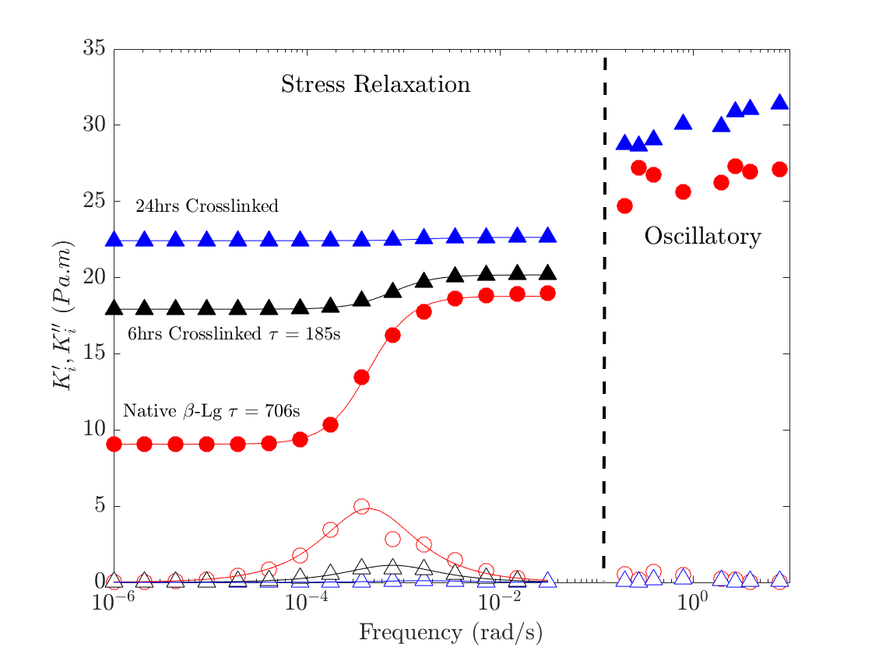
Figure 4.2. Frequency response of pendant drop dilational interfacial rheology of crosslinking β-lactoglobulin
The storage modulus, $K^{'}$- solid markers, and the loss modulus, $K^{''}$- hollow markers, behaviour of a dilational step stress relaxation and oscillatory behaviour of a pendant oil drop in a solution of β-lactoglobulin after 15 hours of aging, or the crosslinking for 6 or 24 hours after 15 hours of film aging. All solid lines drawn are the fits to a single mode general linear viscoelastic model. The area amplitude change of the step and oscillatory dilational rheology was set at 2 % for stress relaxation and 1.3 % for the oscillatory experiments.

Similarly to Freer et al⁸⁷ a single frequency relaxation GLVE model⁶³ for insoluble monolayers of macromolecules has been fit to the step strain dilational frequency sweep, shown as the solid lines in Figure 4.2. The GLVE model fits well to the data, where the Lucassen and van dan Temple (LVDT) model⁶⁹ showed significant deviations (Figure S4.2, SI). These data are similar to other studies done on globular protein films^{75, 76, 87}, which also showed good agreement with the GLVE model. . This suggests that there is no exchange of material between the adsorption layer and the bulk after 15 hours of drop aging before and after crosslinking. We observe a reduction in the relaxation time for the elastic and storage moduli in Figure 4.2 after crosslinking, indicating that the crosslinking reduces the relaxation time required for the adsorption layer to rearrange in response to the area change.
The reduced timescale due to crosslinking also corresponds to a significant reduction in the magnitude of the loss modulus and relaxation at larger frequencies. This relaxation is thought to be due to the rearrangement and polymeric relaxation of the film, which crosslinking reduces^{181, 278}. This corresponds to an increase in the $K^{'}$ at low frequencies as the crosslinking time increases, until the $K^{'}$ is identical to that observed at higher frequencies, as observed at 24 hours. After 32 hours of crosslinking, step or oscillatory perturbations do not produce drop profiles that could be analysed without significant error^{39, 279}. This leads to the conclusion, that the interfacial tension increase due to area change in crosslinked droplets is due to the Gibbs modulus.

Comparing these results to others in literature, the timescales, behaviours and moduli magnitudes of the native β-lactoglobulin interface are similar to those observed by others ²³². The dilational crosslinked behaviour of β-lactoglobulin has been explored using transglutaminase²⁷³, but significantly different behaviour was observed including lower dilational moduli and conversely a longer timescale of relaxation for the crosslinked protein. The dilational behaviour of glutaraldehyde crosslinked β-lactoglobulin at the MCT oil interface was also investigated by Romoscanu et al²⁶⁹. In this study little aging of the film was done and significant expansions of a crosslinked pendant droplet lead to the observation of significantly lower dilational moduli. Thus, the significant differences in experimental setup make it difficult to compare results.

Additionally, as pointed out by Jaensson and Vermant⁶³ and explored by Pepicelli et al⁷⁹, this measurement is not sufficient to determine the compressional surface modulus (K_{s}) of the film, and as such further experiments to characterise the interface by stress fitting elastometry²⁸⁰, capillary pressure tensiometry⁷⁴ or planar trough⁷⁹⁻⁸¹ must be done.

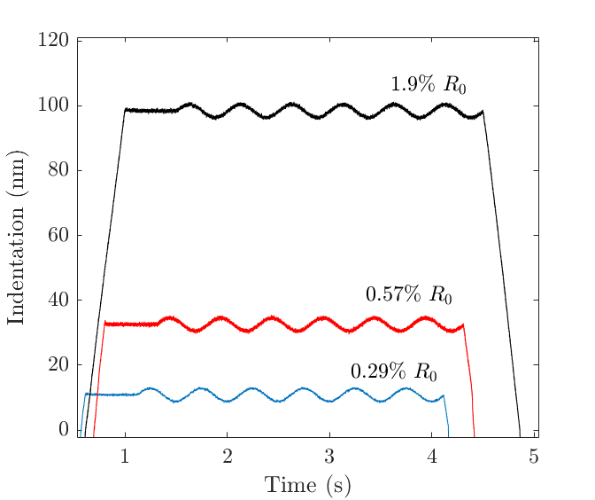
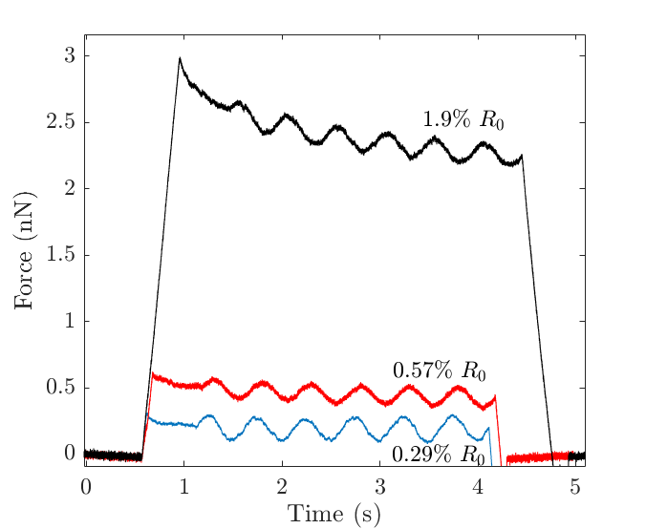
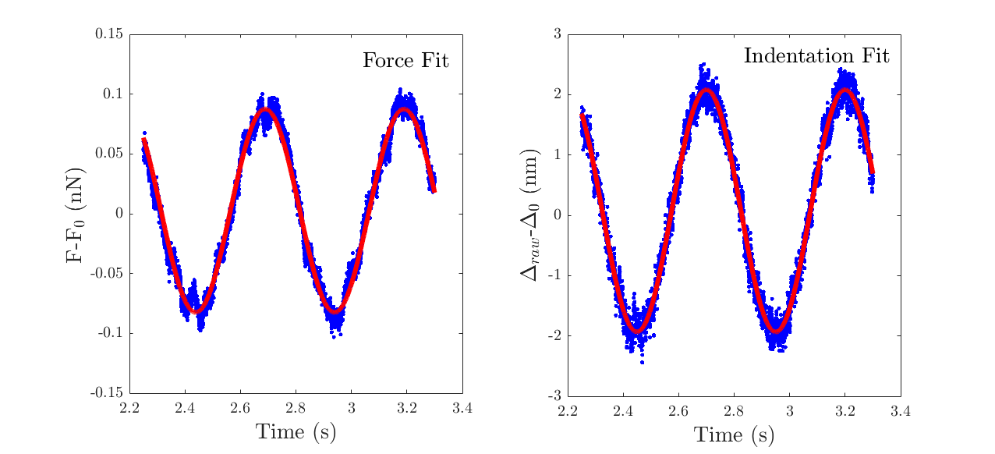
A
B
C
D
Figure 4.3. Examples of AFM oscillatory indentation experiments on β-lactoglobulin microcapsules
We observe the indentation and force behaviour of the β-lactoglobulin microcapsules when oscillations are applied to the capsules at three different indentation depths 0.29, 0.57 and 1.9 % of the particle radius, A The indentation applied to the capsule as a function of time is shown. B The force response of the capsule to the applied indentation and oscillatory indention is shown as a function of time. C A sinusoidal function is fitted to the applied indentation oscillation versus time data. D A separate sinusoidal function is fit to force response in the oscillatory response portion of the force versus time data.

4.3.3 Oscillatory AFM indentation
The oscillatory indentation of the microcapsule was applied after the initial indentation of the microcapsules in the approach section of the force curve. For a range of strains, as shown in Figure 4.3A and 4.3B, the AFM force curve is a dynamic measurement where the indentation and the force response can be plotted parametrically in time. The initial indentation is held for 0.5 to 1 s to allow for the viscous relaxation of the microcapsules and then an additional oscillatory motion is applied to the cantilever. The tip is oscillated at 0.5 – 40 Hz at amplitude of 2 – 10 nm, resulting in a maximum oscillation velocity between 4 to 320 nm/s. The oscillatory indentation and force data as a function of time are fit to a sine function to quantify the amplitude of the oscillations and phase shift and calculate the storage and loss moduli, see the SI for details.

As seen in Figure 4.3C and D, both the force and the indentation are well described by the sinusoidal fit. It is also common to observe a non-linear section in the force response from the relaxation of the initial indentation for the deepest indentation, as seen in Figure 4.3B. In this instance, the fit is restricted to portion of the force curve that does not show this effect from the initial response. The origin of the relaxation observed in Figure 4.3B we attribute to the volume conserved stretching of the polymer film, which will cause the rapid relaxation of the polymer film. In these curves a longer time may be required for the curves to reach equilibrium, thus thermal drift can play a role.

The small indentation regime of the capsules was tested at 24 hours after crosslinking, and all experiments showed no significant changes in the microcapsule indentation behaviour, as observed in Figure 4.3B. In addition, the amplitude force response from the oscillatory applied indentation amplitude showed a linear dependence with increasing amplitude below 5 nm. For amplitudes greater than this, the force response can exhibit a non-linear dependence with indentation and the force response no longer appears sinusoidal in nature (see Figure S4.3). Indentations below 2 nm of amplitude were attempted, but the force signals were difficult to distinguish from the background or thermal noise of the cantilever.
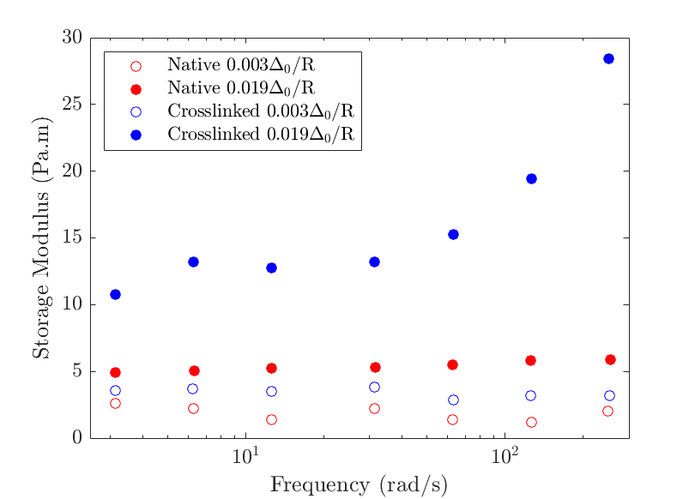
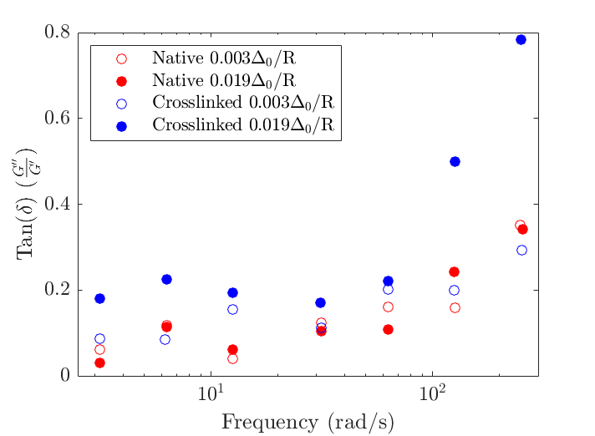
A
B

Figure 4.4. Frequency response of β-lactoglobulin capsules, native and crosslinked at various indentation depths
Results of the AFM oscillatory rheology, demonstrating the change in modulus from a representative native β-lactoglobulin microcapsule to a representative crosslinked microcapsule, where the radii are equivalent. The storage modulus (G’) (A) and the tan(δ) (B) as a function of frequency, for both a native and crosslinked microcapsule at a small, open circle, and large indentation depth, solid circles.

When analysing the oscillating indentation moduli, we find that the both the native and crosslinked storage moduli of the capsules are linear across the tested frequency range and have very similar moduli at low indentation depths. We observe a doubling of the interfacial storage modulus at low indentations due to crosslinking for 24hrs as shown by the open circles in Figure 4.4A. This was shown to be independent of the range of capsule radii studied, see Figure S4.3A. At high initial indentation depths, the storage modulus of crosslinked capsules increases by an order of magnitude compared to the lower indentation behaviour as shown by the solid circles in Figure 4.4A. We expect this is due to the droplet acquiring strain stiffening behaviour from the crosslinking¹⁸¹.

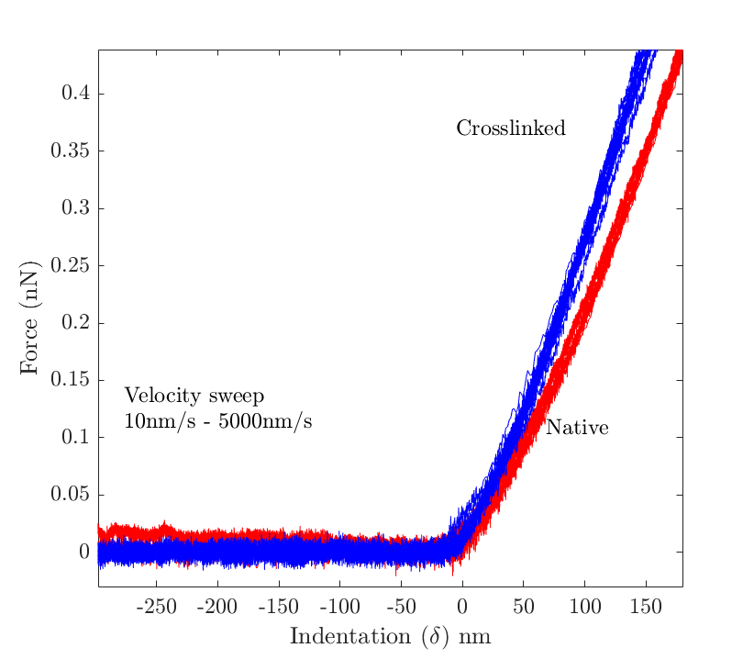
The native and crosslinked tan(δ) behaviours are similar to each other in magnitude and behaviour at similar frequencies. At low frequencies, the native and crosslinked tan(δ) behaviour are similar and linear. For both native adsorption layers and the smaller indentation crosslinked layer there seems to be a transition to an increasing tan(δ) at 60 rad/s, indicating that the layers are exhibiting significantly higher loss characteristics. This may be in part due to the frequency approaching the glass transition of the interfacial film, which has been observed in colloidal glasses^{75,76} and polymer gels⁷⁷. The observed maximum tan(δ) for crosslinked layer at the deepest indentation depth was observed to reach a range of 0.45 to 0.8. As we observe strain stiffening and force relaxation in these force curves (Figure 4.3B) we expect that the oscillation will also probe the same large relaxation response observed in the higher indentation behaviours.
Figure 4.5 – Validation of AFM oscillatory experiments
Qualifying the validity of the oscillatory indentation data by exhibiting the variability and limits of the indentation response. This shows variation in the observed force curves as a function of velocity for both the crosslinked and native capsules.

4.3.4 Validity of AFM oscillatory experiments
The indentation of capsules has been discussed at length in literature^{15, 16, 152, 281} and analysed through the lens of shell theory extensively. The main limitations in the use of the Reissner regime presented here are: non-linear effects, bending, buckling and volume conserved stretching. These effects modify the compression behaviour of the capsules, causing the erroneous estimation of the Young’s modulus from the indentation experiments. Bending and buckling occur when the microcapsule is under compression and highly dependent on the thickness and material properties of the capsule shell. Volume conserved stretching occurs when the capsule indentations is sufficient to cause stretching due to the constant volume constraint of an oil droplet. To ensure the linearity of the capsule response, the initial indentation was limited to indentation of 0.6% Δ/R. Exceeding this strain results in significant force relaxation upon dwelling as shown in Figure 4.3B for force versus time. In addition, higher strains also result in a change in the magnitude of the force response for both native and crosslinked microcapsules, as seen in Figure 4.5A and S4.3, where the storage modulus increases significantly, most likely due to volume conserved stretching.
Bending and buckling are well observed phenomena in capsule indentation behaviour^{15, 152, 282} and typically occur once a transition indentation is reached. In the case of a large spherical indenter compressing a significantly smaller capsule, buckling is not likely as it is more common in systems where the radius of the indenter is significantly smaller than that of the capsule¹⁵. The bending energy is dependent on the thickness and radius of the capsule as per the analysis of Fery et al¹⁶, $\frac{E_{stretch}}{E_{bend}}={\left(\frac{R}{h}\right)}^{2}$, where the ratio of stretching to bending is dependent on the shell thickness and capsule radius. For thin shells with micron radii, the energy associated with bending will be insignificant compared to the stretching behaviour. In the experiments shown here stretching contributes less than 10% to the overall force where details are included in the SI.
The observed tan(δ) can be highly variable and was observed to reach a range of 0.45 to 0.8 at the highest frequencies tested. It has been observed that higher tip oscillation frequencies are more sensitive to viscous forces from the bulk fluid due to higher tip velocities^{160, 162, 283}, which result in a higher tan(δ) when probing polymer gels. We have oscillated the tip in the free solution >100μm from the surface across all frequencies used and observed no force on any cantilever used, thus negating any possible body force on the cantilever being present in the measurement. We have also tested the velocity range in linear indentation between 50nm/s and 5μm/s as in Figure 4.5 and found no change in the slope across this velocity range. The maximum velocity that is achieved in this experiment is 502nm/s during the oscillation which is significantly lower than the velocities required to observe drag on a cantilever near a deformable interface for significantly larger tips and droplets^{8, 284, 285}.
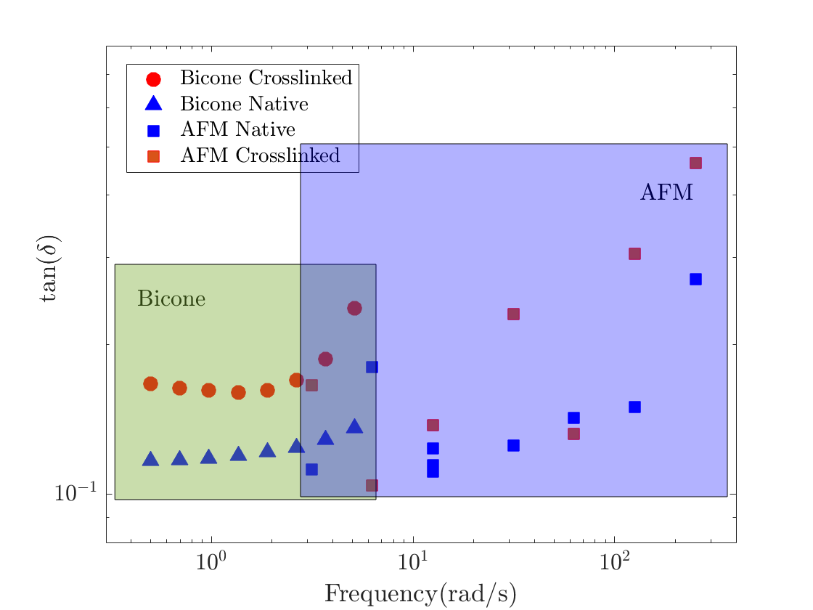
Figure 4.6. Comparison of the tan(δ) behaviour across the AFM and bicone measurements in this work.

4.3.5 Comparing behaviour across methods
We find that that although the shear moduli are an order of magnitude different between the bicone shear and AFM measurements, there is a strong similarity in the tan(δ) observed between the two techniques as seen in Figure 4.6. The AFM data also shows that although there is a clear difference between the crosslinked and native moduli, they do not show the order of magnitude change observed in the bicone measurements. It is common that different forms of interfacial rheology show different behaviours and moduli, which is not surprising given the different flow fields and modes of interfacial deformation^{286, 287}. The interfacial shear rheology is tested in controlled kinematic conditions to only produce a shear strain field, whereas the capsule compression induces a complex strain field on the interface. Another origin of the discrepancy in AFM is likely the difficulty in measuring an accurate layer thickness with these thin films as the Berry approach has a dependence of ~ h³, causing the estimate to be highly sensitive to errors in film thickness. In the AFM measurements a <0.1% strain is used as per the calculations from Tan et al¹³⁶, compared to the 1% strain applied in shear. Capsule indentation may find strong similarities to bicone interfacial rheology when strained further as we observe a significant change in the moduli observed between the native and crosslinked capsules at high initial indentations Δ₀, as observed in figure 4.4.

The storage and loss moduli measured with dilational pendant drop rheology are not compared here as this technique does not measure the 2D compressional or shear modulus, but provides complimentary information regarding the timescales of interfacial rearrangement. The storage and loss moduli indicate that in the rapid timescale of the other experiments, further relaxation processes are not occurring. This is seen clearly in Figure 4.2, as the oscillatory pendant drop measurements show orders of magnitude lower loss moduli in the same timescales accessed by bicone and AFM measurements.

The addition of glutaraldehyde to crosslink the film shows several effects on the interfacial rheology of the protein films. In the shear rheology, we observe a significant increase in the storage and loss moduli, a shortening of the linear viscoelastic region in the amplitude behaviour, and a lower crossover strain. Crosslinking produces a stiffer, more brittle film when applying amplitude sweeps in shear, similarly to the behaviour of transglutaminase or heated β-lactoglobulin gels^{271, 288}. In these experiments, frequency dependent behaviour is not observed in any interfacial gels. When applying dilational strain by increasing surface area and measuring the change in interfacial tension with a pendant drop, there is no longer a significant loss moduli at any frequency, as once crosslinked there is no mechanism for polymeric relaxation of the interfacial film. This is corroborated by the bicone shear rheology, which shows that healing behaviour is strongly affected by the crosslinking of the protein film at the interface.

4.4 Conclusions
This study introduces the use of oscillatory indentation with AFM to characterise the response of β-lactoglobulin on an oil/water interface in the native and crosslinked state using an oscillatory extension of the theory of Berry et al¹⁷. The β-lactoglobulin microcapsules exhibit a frequency independent response to small compressions for both the native and crosslinked films, where hydrodynamic effects become relevant at higher frequencies. Additionally, we observe a doubling of the modulus going from native to crosslinked droplets. To compare, the pendant drop interfacial dilational and bicone shear rheology behaviour of β-lactoglobulin on an oil/water interface was tested, where we explored the various effects of crosslinking on the rheological behaviour of the film over time. We find that in shear, the film modulus increases by an order of magnitude with crosslinking but shows similar yield behaviour and gel like behaviour in the frequency sweep. Conversely, using pendant drop dilational rheology a plateau at the Gibb’s modulus at high frequencies was observed in both native and crosslinked films, but at lower frequencies, the large relaxation due to polymeric rearrangement in native films was no longer observed due to the reduced mobility of the protein at the interface. The oscillatory capsule indentation showed a similar tan(δ) to bicone shear rheology, but the calculated interfacial moduli was significantly higher than found with shear. We attribute the large difference in the modulus, to the flow fields and lengthscale in the capsule compression technique being significantly different compared to bicone interfacial shear, as well as the difficulty in measuring the thickness of the interface which is required to determine the moduli in the case of capsule measurements.

Chapter 5 – Interfacial properties of chitosan in interfacial shear and capsule compression

Abstract
The time dependent behaviour of surface-active adsorption layers at the oil-water interface can dictate emulsion behaviour at both the micro- and macro-scale. In addition, self-healing behaviour of the adsorption layer may benefit emulsion stability subject to large deformation under processing or during final application. We explore the behaviour of chitosan, a known hydrophilic emulsifier, which forms nanoparticle aggregates when the concentration of acetate buffer exceeds 0.3M. We observe the adsorption layer building and strain dependent behaviour of the chitosan at the MCT oil/water interface. We compare this to the behaviour of identical chitosan layers coated on oil droplets via AFM colloidal probe compression in both linear and oscillatory compression. In both interfacial shear rheometry and the capsule compression, a thick, elastic layer with strong time dependent recovery behaviour is observed after large strains are applied suggesting the layer has some self-healing capabilities. In oscillatory compression the elastic moduli of the capsules show little frequency dependence.

5.1 Introduction
Recovery of films after degradation is the goal of many engineered materials, where a number of approaches have been taken to design material systems that are self-healing after breakdown²⁸⁹. A potential use of recovery in films is the coating of capsules, because capsules are commonly designed to be robust to repetitive applied stress but break when the correct stimuli is applied¹²⁴. The mechanical properties of capsules is commonly tested in compression¹⁵² or flow²⁵⁹, but these films may be also formed at planar interfaces where the dilational and shear rheological behaviour of the film⁷⁰ can be more easily quantified. These larger interface methods are sensitive to the film behaviour in different flow fields, and can give insight into the recovery and possible self-healing characteristics. Capsule compression can induce complex stresses in the film¹⁵², so multiple tools to characterise film recovery can be advantageous.
Chitosan is a common biopolymer produced from the chemical and mechanical degradation of crustacean shells through the random hydrolysis of acetyl groups attached to the primary amine on the linear 𝛽 (1→4) bonded D-glucosamine backbone, where a positively charged polysaccharide is produced²⁹⁰. Due to the presence of the primary amine, the pKa of chitosan is 6.5. Below this pH chitosan behaves as a cationic polyelectrolyte and above it is insoluble. Due to the abundance, low cost, high biocompatibility, high biodegradation, and low toxicity of chitosan²⁹¹ it has found use in various industries such as in food products²⁹², pharmaceutical²⁹³ and biomedical applications²⁹⁴.
The positively charged chitosan polymer has been shown to strongly interact with negatively charged species in solution, such as proteins²⁹⁵, small molecular weight surfactants²⁹⁶, dispersed solids²⁹⁷ and salts²⁹⁸. The addition of these species can lead to self-assembled complexes that exhibit new functionality such as drug holding capacity²⁹³, rheological properties²⁹⁹ or interfacial behaviour³⁰⁰. In addition, Skorik et al.^{301, 302} recently have shown that chitosan may also form colloidally stable aggregated particles that self-assemble in 0.3 M sodium chloride and sodium acetate solutions, creating stable nanoparticles between 10 – 30 nm in diameter. These nanoparticles solutions exhibit increased hydrophobicity in pyrene fluorescence studies³⁰³, suggesting that these nanoparticles may have promising interfacial properties.
Previous studies have shown chitosan to be an adequate stabilizer of oil/water emulsions^{297, 304-306}. Interfacial tension (IFT) studies have shown that chitosan has a low surface activity at the air/water interface in acetate buffer with little added electrolyte^{307, 308}. Below 0.3 M of sodium chloride or sodium acetate in aqueous solution^{301, 309}, low concentrations of chitosan reduces the interfacial tension slightly, with a strong decrease in IFT requiring high concentrations (> 0.5 %wt) of chitosan³¹⁰. T Studies observing the surface tension of chitosan above 0.3 M of sodium acetate show a dramatic increase in the interfacial activity of chitosan, where the surface tension decreased significantly (P ~ 30 mN/m)^{90, 311}. Furthermore, when adsorbed chitosan films formed at the air/water interface were studied using dilational rheology a significant increase in the dilational moduli was observed with the addition of 0.3 M of sodium acetate. In the investigation of the shear interfacial rheological properties of chitosan, Romero et al¹⁸ probed the rheology of a spread chitosan film at the air/water interface containing 10mM phosphoric acid. A strongly viscoelastic, albeit weak interface was observed.
In our previous work with capsules we have explored the elastic properties of capsules^{255, 312, 313}, where little work has been done to characterise viscoelastic capsule behaviour in the context of compression³¹⁴, with most characterization undertaken by observing the shape of capsules in flow conditions within microfluidic channels^{144, 166-168}. Typically, capsule shells are made from materials that break and cannot reform where capsule films may be improved with the use of self-healing films³¹⁵. More common is the use of capsules in the context of self-healing polymer networks^{316, 317}, where material fracture causes some capsules to break and subsequently heal the overall matrix. a
The objective of this work is to probe the interfacial behaviour of chitosan solutions with 0.5M sodium acetate at the medium chain triglyceride/water interface with pendant drop tensiometry, interfacial shear rheology and capsule compression via atomic force microscopy (AFM). In addition, to visualise the interface, we use in-situ AFM imaging of the oil/water interface and transfer Langmuir-Blodgett films of the air/water interface to observe the surface morphology of the chitosan adsorption layer. The dispersion stability of the chitosan nanoparticle is also explored over a pH and ionic strength range using dynamic light scattering.

5.2 Materials and Methods

5.2.1 Materials
Low molecular weight (nominal molar mass of 30 kDa) chitosan, glacial acetic acid and sodium hydroxide pellets were purchased from Sigma Aldrich (St. Gallen, Switzerland) for interfacial shear experiments. For pendant drop and capsule compression experiments, sodium hydroxide (Chem-Supply, Australia), glacial acetic acid (Fluka Chemicals, Chem-Supply, Australia), 78 % Nitric acid (Sigma Aldrich, Australia) and Labware Detergent Concentrate (AJAX, ThermoFisher, Australia) were used. The Medium Chain Triglyceride (MCT) oil was purchased from BASF chemicals under the name Delios V. All materials were used in their purchased form, except where the MCT oil, which was filtered through a packed Florisil (100–200 mesh, Sigma Aldrich, Australia) column. Post-treatment the interfacial tension of MCT oil against Milli-Q (18.2MΩ resistivity, Merck Millipore, Australia) increased to a constant value. The average molecular weight of the chitosan, and viscosity of the oil and sub phase were determined via a capillary viscometer as per Brugnerotto et al²³⁸ . Determination of the acetylation degree was done via infrared spectroscopy and found to be 21.5 % acetylated, and the viscometry measurement indicates the average molecular weight of the chitosan is 30 kDa and likely to be polydisperse due to the origin of the material.

5.2.2 Preparation of the Aqueous solutions and cleaning glassware
To prepare buffer or chitosan solution, glacial acetic acid was diluted with Milli-Q water to create a 0.5 M aqueous solution of acetic acid. The chitosan was added and dissolved over 24 hours to produce a chitosan solution that is then pH corrected with 10 % sodium hydroxide until the desired pH is reached. For all interfacial tension, rheology and AFM experiments pH 4 was used with a chitosan concentration of 0.05 %wt. For buffer solutions, the chitosan was omitted, and the acetic acid solution is neutralized to the desired pH. All glassware and glass rounds were washed by soaking in AJAX detergent for 1 hour, 10 % nitric acid solution for 1 hour, and 10 %wt sodium hydroxide solution for one hour. This is then checked for hydrophilicity by observing the wetting behaviour of Milli-Q water, and held in the sodium hydroxide for a further hour if required.

5.2.3 Interfacial Tension
Pendant drop tensiometry was used to obtain the interfacial tension of buffer, oil and chitosan solutions. Measurements were performed on a DataPhysics OCA20 (Stuttgart, Germany), where oil droplets were grown and suspended from the tip of a hook shaped syringe. Measurements were done with a 0.7 mm syringe submerged in a 30x30x50 mm quartz glass cuvette filled with the desired aqueous solution. To reduce evaporation and airborne contamination for all measurements the cuvette was covered after the syringe is lowered into the cuvette.

5.2.4 Bicone Interfacial Shear Rheometry
All interfacial rheology measurements were performed using a shear rheometer (Physica MCR 501, Anton Paar, Austria) with a bicone tool (bicone radius = 35.05 mm, cup radius = 45 mm)¹⁰⁷. The aqueous fluid was first added to the cup, the bicone then lowered into the solution, and positioned at the interface. MCT oil was then gently added over the top of the bicone to cover the water interface, to a thickness of 1 mm above. For time sweep measurements the bicone was oscillated at 1 rad/s with an amplitude strain of 1%. Amplitude sweep measurements were done after 15 hours of measuring, and utilized a constant frequency of 0.1 rad/s.

5.2.5 In-situ Atomic Force Microscopy Images
All in-situ images were acquired with an Asylum Cypher ES in AC mode driven via BlueDrive. The cantilevers (Olympus AC40) were ozone treated for 20 mins, the tip side sputter coated with 5nm of chromium, and 20nm of gold, and then soaked in ethanol containing 10 mM (11-Mercaptoundecyl)-N,N,N-trimethylammonium bromide for 60 mins. These cantilevers were then rinsed twice each with ethanol and milli-Q water prior to use. An oil/water interface was created by immobilizing oil in a PTFE capillary glued to the centre of a glass slide and covering it with aqueous solution. This required a two-step process where the small capillary is slightly over-filled with oil and a larger capillary was placed over the top and filled with aqueous solution, creating a stable pinned oil/water interface protruding from the smaller capillary. The glass slide was then covered with solution sufficient to cover the small capillary, and the larger capillary is removed. A droplet of the solution was placed on the cantilever and the AFM head was brought into contact with the solution. The details and steps for this procedure as well as a schematic of the process can be found in the Supplementary Information.

5.2.6 Langmuir-Blodgett Trough Transfer
Langmuir-Blodgett film transfers were done by filling a 60 mm diameter glass petri dish cleaned as above and filled half-way with the 0.05 % chitosan solution. The petri dish was covered using the petri dish lid for 24 hours to allow the film to build. To transfer the interface to mica, the mica was freshly cleaved, then lowered and retracted into the solution at 60 degrees to the interface at 1cm/min as per Mackie et al^{318, 319}. Once the solution dewetted from the mica, it was quickly added to an ethanol bath and allowed to soak for 5 mins. The sample was then allowed to dry in a laminar flow hood for 10 mins. To determine the thickness of the film, the film is scratched with the freshly cut end of solder wire to allow for a soft contact and minimal scratching of the mica below. The mica is then mounted on a metal puck (Ted Pella, USA), and placed in the Asylum Cypher ES, where AC mode is used to image the samples with Tap300-G cantilevers (BudgetSensors, Sofia, Bulgaria). As note, many types of surfaces were attempted (glass, mica and silicon wafer) at the oil/water interface, but none were successful in transferring the chitosan film to the solid substrate. These were attempted from both the aqueous and oil phases.

5.2.7 Capsule Compression Experiments
Capsules were generated using an emulsion as a template. The emulsion was generated in a 1 mL Eppendorf tube with 50 μL of oil in 0.5 mL of buffer solution by shaking until the emulsion droplet size range of 2 - 20 μm was obtained, checked via light microscopy. Once the desired emulsion size was reached, the emulsion was transferred to a small glass vial with a PTFE lid where 0.5 mL of 0.1 % chitosan in buffer was added, and the mixture was allowed to incubate for 12 hours prior to adhesion to the glass rounds for AFM indentation. The capsules were adhered to the glass round by adding the emulsion solution to a 0.5 mL PTFE lid, where it was overfilled and the clean glass round was placed on the top, and allowed to incubate for a further for 2 hours. The glass round and PTFE lid were then flipped over and secured into a fluid cell. The PTFE lid was removed and further 0.05 % chitosan solution was added to flush any excess unbound capsules. After this, the sample was allowed to equilibrate for a further 12 hours to ensure capsule stability during experiments.
Capsule compression experiments were completed in an Asylum MFP-3D (Asylum Research, Santa Barbara, USA). A silica bead (15 μm diameter) was attached to a MLCT-010 tipless cantilevers (Bruker, USA) using epoxy (Super Strength Araldite, Selleys) via micromanipulation with the AFM. The epoxy was allowed to cure for 24 hours prior to use. The cantilever was calibrated via the thermal method³²⁰. The inverse optical light sensitivity (inVOLS) was measured prior to each experiment from the slope of the deflection voltage compared to the piezo motion when the tip was in contact with the glass substrate. To ensure linearity across experimental force range, the voltage change for a certain piezo motion was tested over 2V. The approach and retract rate were varied from 100 to 5 μm/s and did not exhibit any dependence on velocity, therefore a velocity of 1 μm/s was used. Oscillatory indentation was conducted as per Biviano et al³¹⁴. Briefly, first an initial load and the resulting indentation are applied to the immobilised capsule using the approach portion of a typical force curve ramp, but the applied load is maintained using the dwell function of the AFM. During the dwell portion of the force curve, a small amplitude oscillation is applied via the piezo drive and the force response is recorded. The phase lag between the piezo drive and the force response is determined by fitting the oscillatory drive and force response as a function of time. The initial indentation depth for the force curve was chosen from the linear response to the capsule indentation, typically at 80 nm, which was observed to be in the centre of the linear force response regime for most capsules between 3 and 8 μm in diameter. The ratio of the shell thickness to capsule radius is h/R ~ 0.1. To account for the thickness shell and the deformation at both contact points with the probe and the substrate, a rescaling of the indentation is required to account for the asymmetric deformation of the capsule. This analysis follows the framework developed by Berry et al¹⁷ and the analysis for oscillatory capsule compression from Biviano et al³¹⁴. For further details of the analysis refer to the Supplemental Information. The range of oscillation frequencies was tested between 1 and 40 Hz, and the amplitude of oscillation was tested at 2 and 5 nm, where the 5 nm frequency sweep provided a better signal to noise ratio.

5.2.8 Dynamic Light Scattering and Zeta Potential Measurements
All dynamic light scattering and zeta potential experiments utilized a Malvern ZetaSizer Nano (Malvern Panalytical, UK), and were performed at 25ºC. The optimum chitosan concentration used for the dynamic light scattering was determined to be 0.005 %wt from successive dilutions with buffer of the 0.05 % solution, where the scattering exhibited consistent peak widths and positions without evidence of multiple reflections.

5.3 Results and Discussion

5.3.1 AFM Imaging Characterisation
The transferred films (Figure 1A) showed domains of strand like structures of chitosan on the air/water film, where the strands appear to be a thin 5 – 10 nm layer atop a flat adsorbed layer, with particles embedded in the strands. These particles are relatively monodisperse with a diameter of 20 – 30 nm. An image of a smaller region (500 nm x 500 nm) shows the details of the structure between the particles with line or undulation like structures from adsorbed chitosan with a smaller height profile (see the height and phase image in Figure S1). The chitosan forms a 125 - 140 nm thick adsorbed layer measured via the scratch method (see Figure S2 for the AFM image). There is significant variation in the layer thickness measured within samples from 40nm to 150nm. We assume the thinner areas are due to stretching, therefore we assume thicker areas are a better measure of the dry thickness. Due to the difficulty of transferring the adsorbed layer from the oil/water interface means that a direct thickness estimate is not possible, and in subsequent analysis we assume that it is the same thickness as measured at the air/water interface.
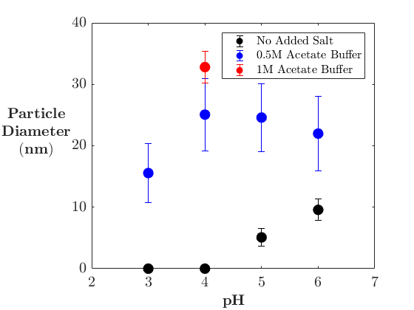
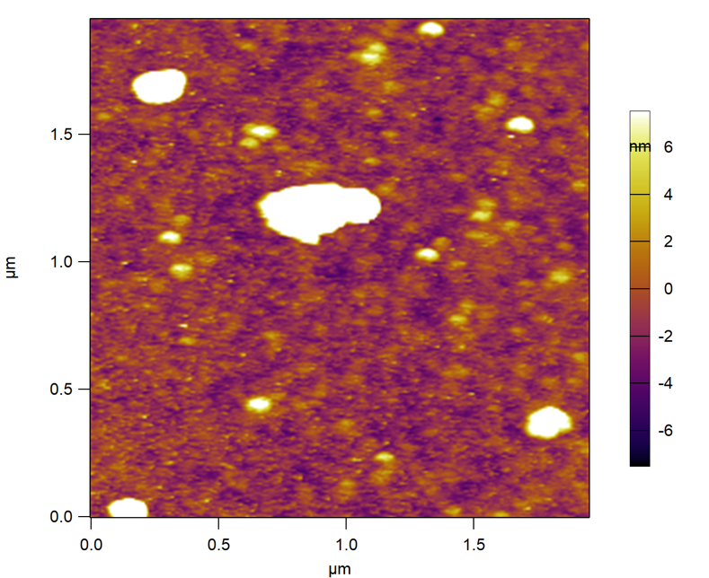
A
Air Side
Aqueous Side
This work
B
C
C
Figure 5.1. AFM images of Chitosan at the air-water and oil-water interface, with the diameter of chitosan particles as a function of pH.
A Representative AFM image of the chitosan air/water interface, where the Langmuir-Blodgett film was transferred to mica after 24 hours of adsorption. Similar structures are observed after 3 to 24 hours of adsorption. B Representative AFM image of a chitosan layer imaged from the aqueous side in-situ after 5 hours of adsorption. No change in the morphology of the images was observed after 3 hours. C The effect of pH and buffer concentration on chitosan average particle diameter measured by dynamic light scattering.

The in-situ imaging at the oil/water interface (Figure 1B) shows a flat adsorbed layer with large particles present. The imaging of the oil/water layer from the aqueous side does not show any considerable structuring compared to the Langmuir-Blodgett film transfer in Figure 1A. Smaller images of the adsorbed layer show that the flat areas are comprised of smaller particles that pack closely (Figure S3). The oil/water interface imaging shows an adsorbed layer of aggregated particles 50 – 100 nm in diameter interspersed around large non-spherical aggregates. The larger non-spherical aggregates appear to be a feature of the layer as no large particles were observed in light scattering experiments, which showed a monodisperse 20 – 30 nm diameter particle (see Figure 1C) and a small population of doublets also observed by Skorik et al.^{301, 302}. All particles observed are stationary and do not move while imaging as observed by others³²¹, indicating that they are well adhered or incorporated into the layer. The observation of particles at both the aqueous and non-aqueous side of the adsorption layer, and a thickness indicate a that densely packed particulates form multiple layers at the interface.
The dynamic light scattering shows that in solutions of 0.5 M sodium acetate chitosan forms stable 20 - 30 nm particles from pH 6 to pH 3, whereas smaller 15 nm particles are formed at pH 2 (Figure 1C). Further to this, without the addition of the salt there does not appear to be any particles formed below pH 5. Previous studies with lower salt concentrations³⁰⁵ and unreported pH conditions^{302, 322, 323} in sodium chloride and sodium acetate have shown similar sized particles, where chain length and deacetylation degree strongly affect the particle size of the chitosan. In our experiments, increasing the concentration to 1 M of sodium acetate did not impact formation of the chitosan particles, in contrast to previous studies where the addition of sodium chloride was shown previously to produce smaller chitosan particles than sodium acetate^{301, 302}.

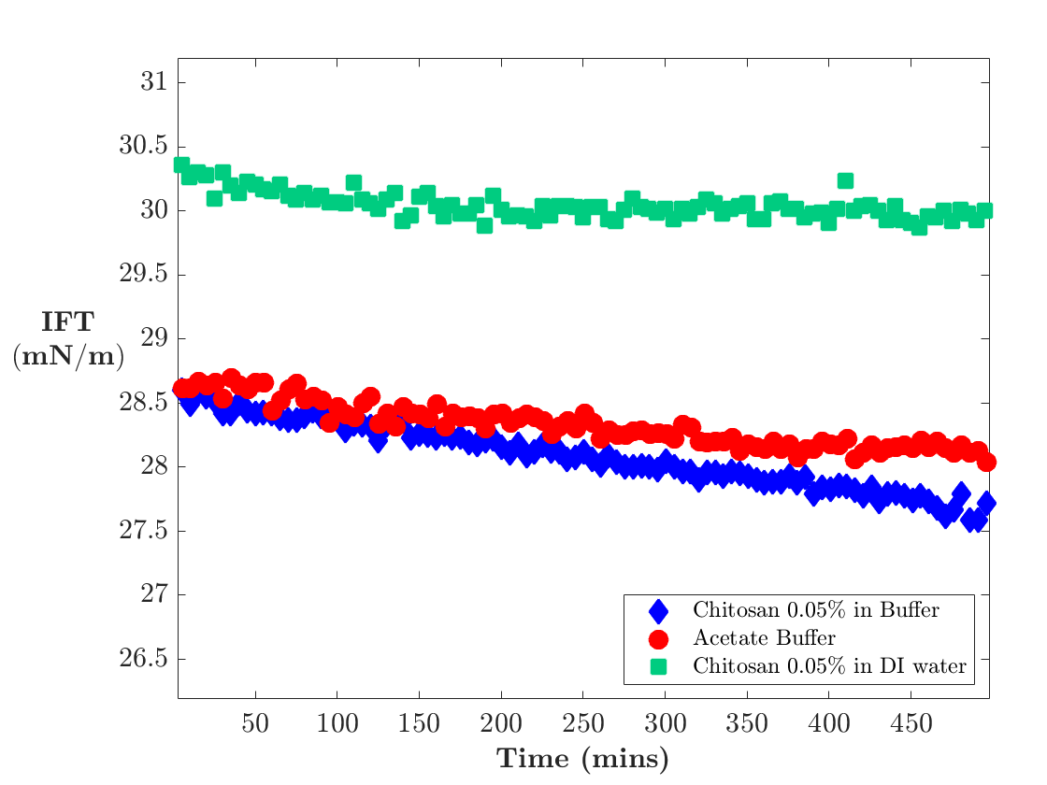

Figure 5.2. The interfacial tension of chitosan
The interfacial tension of the chitosan and buffer solutions at the oil water interface over 8 hours. The interfacial tension of MCT oil against Milli-Q water is 30 ± 2 mN/m.

5.3.2 Dynamic Interfacial Tension Properties
The interfacial tension of MCT oil against Milli-Q was found to be 30 ± 2 mN/m. Chitosan solutions in the absence of added buffer or salt not show a significant change in the interfacial tension, as shown in Figure 2. As a control measurement, the reduction in the interfacial tension due to the acetate buffer in the absence of chitosan is also shown Figure 2. The solution with chitosan and buffer shows a small decrease in interfacial tension compared to the control measurement. This strongly contrasts with the behaviour at the air/water interface reported earlier, where a significant decrease in the surface tension (~ 30 mN/m) is observed for a 0.3 M sodium acetate solution⁹⁰. Smaller changes in interfacial tensions have been reported for increasingly polar oil/water interfaces stabilized by the protein 𝛽-lactoglobulin⁴⁶, which may be considered a soft particle at the interface²³². The lack of chitosan surface activity in the absence of buffer is consistent with previous oil/water interface studies^{301, 309}. The decrease of interfacial tension of chitosan in the buffer solution in comparison to the buffer only solution suggests that the chitosan is surface active. What is more difficult to determine from these data alone is if the chitosan is competing with the buffer for the interface. The formation of nanoparticles observed in the films imaged with the AFM in concert with these data would suggest that buffer increases the hydrophobicity of the chitosan sufficiently to adsorb to the oil/water interface and reduce the interfacial tension. This appears to be the determining condition to drive wetting of particles at the interface^{77, 324-327}, despite some systems not lowering the overall interfacial tension significantly(± 2 mN/m)^{325, 328}.

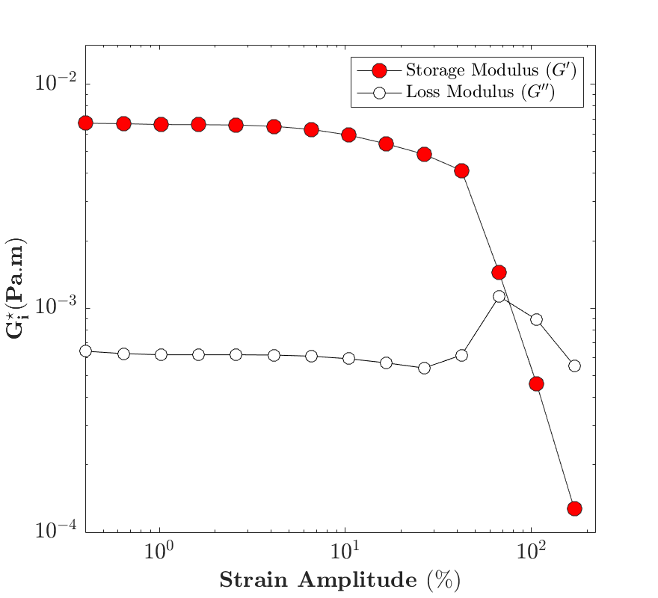
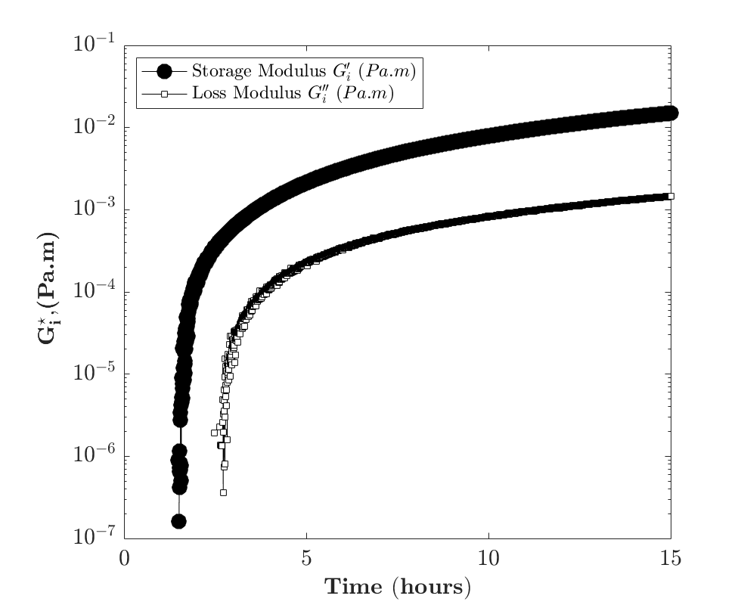
A
B

Figure 5.3. Bicone interfacial rheology of chitosan at the oil-water interface: Amplitude sweep and time sweep.
A Shows the interfacial shear rheology of the film in the bicone interfacial rheometer at a constant strain of 1 % and 1 rad/s as a function of time, showing the change in the interfacial moduli of the adsorption layer. B Example of an amplitude strain sweep of the chitosan taken 15 hours after the elastic modulus is observed in the bicone interfacial shear rheometer.

5.3.3 Interfacial Shear Properties
The interfacial rheometer was used to was used to determine the mechanical properties of the adsorption layer over 15 hours (Figure 3A). A shear strain amplitude sweeps was then taken at 15 hours with a set of amplitude strains from 0.1 to 150 % (Figure 3B). The interfacial shear response shows the building of a predominantly elastic interfacial layer over 15 hours. As seen in Figure 3A, there is no signal from the adsorption layer initially, however after 1 - 5 hours the layer becomes mechanically viable and moduli of the layer grow linearly for 15 hours and increase to ~ 10⁻² Pa m. This adsorption layer behaviour resembles the formation of particulate films from bulk adsorption to the interface, where there is a significant lag between the observation of interfacial moduli above the noise threshold of the measurement with a gradual rise of the layer modulus over time^{297, 329-332}.
The shear strain amplitude sweep measured the moduli of the layer from 0.1 to 150 % strain, enabling identification of the linear viscoelastic region and crossover point where the layer became predominantly liquid-like (Figure 3B). The strain sweep shows a long linear region up to 10 % strain and a significant change in the slopes of the elastic and loss moduli at 35 % strain where the storage modulus drops and the loss modulus increases. Subsequently, the elastic modulus falls below the loss modulus at 60% strain. The behaviour at crossover is similar to the shear rheology of soft glassy particulate suspensions³³³ and particulate films¹¹². However the wide linear region at strains < 10 % is not commonly observed in particulate systems and stands in contrast to the characteristically short (< 1% strain), linear regions of particle films in the literature, both for self-absorbed films and films spread at interfaces^{324, 328, 330, 334}. Additionally, in all these systems, the increase in the loss modulus as the film approaches crossover is commonly observed for particulate films ^{324, 328, 330, 334}.
The significant increase in the width of the linear viscoelastic region of for the chitosan adsorption layer indicates a behaviour that is not observed in typical particulate films. In the work by Christopher et al.^{335, 336}, Reynaert et al.³³⁷, and Zang et al.^{324, 338} with hard spheres, a significant increase in the moduli and a lengthening of the linear viscoelastic region is observed with an increase in the interparticle forces and packing density, but the film still remains relatively brittle within the linear viscoelastic region (maximum reported strain of 1 %). Comparing the behaviour of hard particles to soft particles by Cicuta et al.⁴⁵ suggests that soft spheres such as 𝛽-lactoglobulin may exhibit similar behaviour up to close packing, but will deviate significantly when dense packing (φ > 1) is reached. 𝛽-lactoglobulin has been shown to have similar film moduli (~ 10⁻² Pa m) and long linear viscoelastic regions in shear²³¹. Although the abrupt change in slope in elastic and storage modulus prior to crossover in this work is not seen in 𝛽-lactoglobulin crossover behaviour, which has a more gradual change in moduli, attributed to the rearrangement and interaction of the proteins at the interface^{32, 40}. It is clear that there is significant interparticle interactions from the chitosan aggregation observed in the imaging study (see Figure 1), and the interfacial shear behaviours are similar to that of typical particulate interfaces. The method of film preparation may be important as well. In this work, the adsorption layer was prepared via diffusion from the subphase in comparison to study by Romero et al.¹⁸ where a chitosan film spread at the air/water interface showed a 10-fold drop in storage and loss moduli. The strain sweep showed a short linear region (< 1 %) where crossover is observed at 5 % strain.

5.3.4 Shear Self-Healing Behaviour
The interfacial rheometer was used to was used to determine the mechanical properties of the adsorption layer over 15 hours (Figure 3A). A shear strain amplitude sweeps was then taken at 15 hours with a set of amplitude strains from 0.1 to 150 % (Figure 3B). The interfacial shear response shows the building of a predominantly elastic interfacial layer over 15 hours. As seen in Figure 3A, there is no signal from the adsorption layer initially, however after 1 - 5 hours the layer becomes mechanically viable and moduli of the layer grow linearly for 15 hours and increase to ~ 10⁻² Pa m. This adsorption layer behaviour resembles the formation of particulate films from bulk adsorption to the interface, where there is a significant lag between the observation of interfacial moduli above the noise threshold of the measurement with a gradual rise of the layer modulus over time^{297, 329-332}.
The shear strain amplitude sweep measured the moduli of the layer from 0.1 to 150 % strain, enabling identification of the linear viscoelastic region and crossover point where the layer became predominantly liquid-like (Figure 3B). The strain sweep shows a long linear region up to 10 % strain and a significant change in the slopes of the elastic and loss moduli at 35 % strain where the storage modulus drops and the loss modulus increases. Subsequently, the elastic modulus falls below the loss modulus at 60% strain. The behaviour at crossover is similar to the shear rheology of soft glassy particulate suspensions³³³ and particulate films¹¹². However the wide linear region at strains < 10 % is not commonly observed in particulate systems and stands in contrast to the characteristically short (< 1% strain), linear regions of particle films in the literature, both for self-absorbed films and films spread at interfaces^{324, 328, 330, 334}. Additionally, in all these systems, the increase in the loss modulus as the film approaches crossover is commonly observed for particulate films ^{324, 328, 330, 334}.
The significant increase in the width of the linear viscoelastic region of for the chitosan adsorption layer indicates a behaviour that is not observed in typical particulate films. In the work by Christopher et al.^{335, 336}, Reynaert et al.³³⁷, and Zang et al.^{324, 338} with hard spheres, a significant increase in the moduli and a lengthening of the linear viscoelastic region is observed with an increase in the interparticle forces and packing density, but the film still remains relatively brittle within the linear viscoelastic region (maximum reported strain of 1 %). Comparing the behaviour of hard particles to soft particles by Cicuta et al.⁴⁵ suggests that soft spheres such as 𝛽-lactoglobulin may exhibit similar behaviour up to close packing, but will deviate significantly when dense packing (φ > 1) is reached. 𝛽-lactoglobulin has been shown to have similar film moduli (~ 10⁻² Pa m) and long linear viscoelastic regions in shear²³¹. Although the abrupt change in slope in elastic and storage modulus prior to crossover in this work is not seen in 𝛽-lactoglobulin crossover behaviour, which has a more gradual change in moduli, attributed to the rearrangement and interaction of the proteins at the interface^{32, 40}. It is clear that there is significant interparticle interactions from the chitosan aggregation observed in the imaging study (see Figure 1), and the interfacial shear behaviours are similar to that of typical particulate interfaces. The method of film preparation may be important as well. In this work, the adsorption layer was prepared via diffusion from the subphase in comparison to study by Romero et al.¹⁸ where a chitosan film spread at the air/water interface showed a 10-fold drop in storage and loss moduli. The strain sweep showed a short linear region (< 1 %) where crossover is observed at 5 % strain.
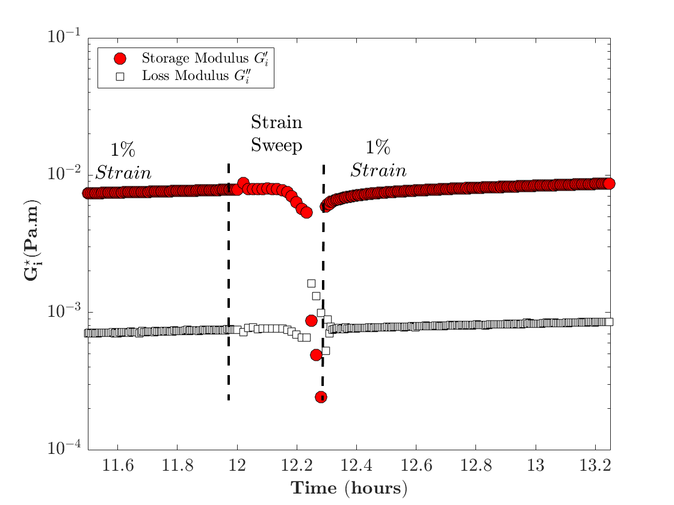
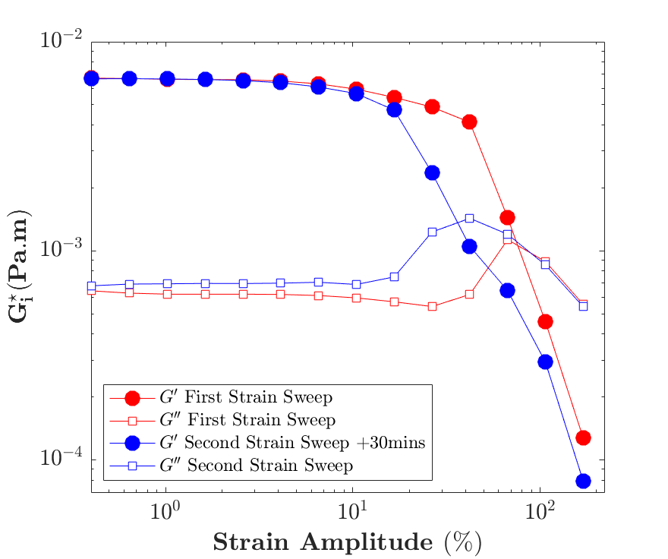
A
B

Figure 5.4. Self healing behaviour of chitosan in the bicone interfacial shear rheometer.
A The time dependent behaviour of the healing interface, where the time sweep observes a strain sweep, and then transitions back to 1% strain and 1 rad/s. B The strain sweep behaviour between the first and second strain sweeps applied to the same film consecutively, where there has been a 30 min waiting period between sweeps.

After 15 hours of the layer adsorption with a 1 % strain to observe adsorption layer moduli, an amplitude sweep caused a translation in the rheological behaviour from solid-like to liquid-like, breaking the adsorption layer as observed (Figure 4A). Once the layer is broken, the applied amplitude returns to 1 % strain and the layer returns to the identical moduli prior to the amplitude sweep within 10 mins of the transition. The layer recovery was indicative of a self-healing behaviour that has been commented on in other particulate films^{324, 325, 330} and has been demonstrated before in nanoclay particles³³² and silica particle³²⁴ systems.
After 30 mins of layer observation a second amplitude sweep was done to further probe the strain dependent behaviour of the layer as shown Figure 4B. In the second amplitude sweep the layer maintains a long linear elastic region up to 10 % strain, but the layer rapidly reaches crossover at 20 % strain compared to 60 % strain in the first sweep. In both sweeps we observe a significant rise in the loss modulus and sharp drop in the elastic modulus prior to the crossover point. Self-healing behaviours have not been well examined for shear forces applied to films. Although, hysteresis effects have been explored extensively in dilational experiments using Langmuir-Blodgett troughs³³⁹, where hysteresis is commonly observed in predominantly elastic films and in particulate films¹¹². We speculate the nature of the self-assembled chitosan nanoparticles in the layer provides the capability for the layer to reform after breakage.

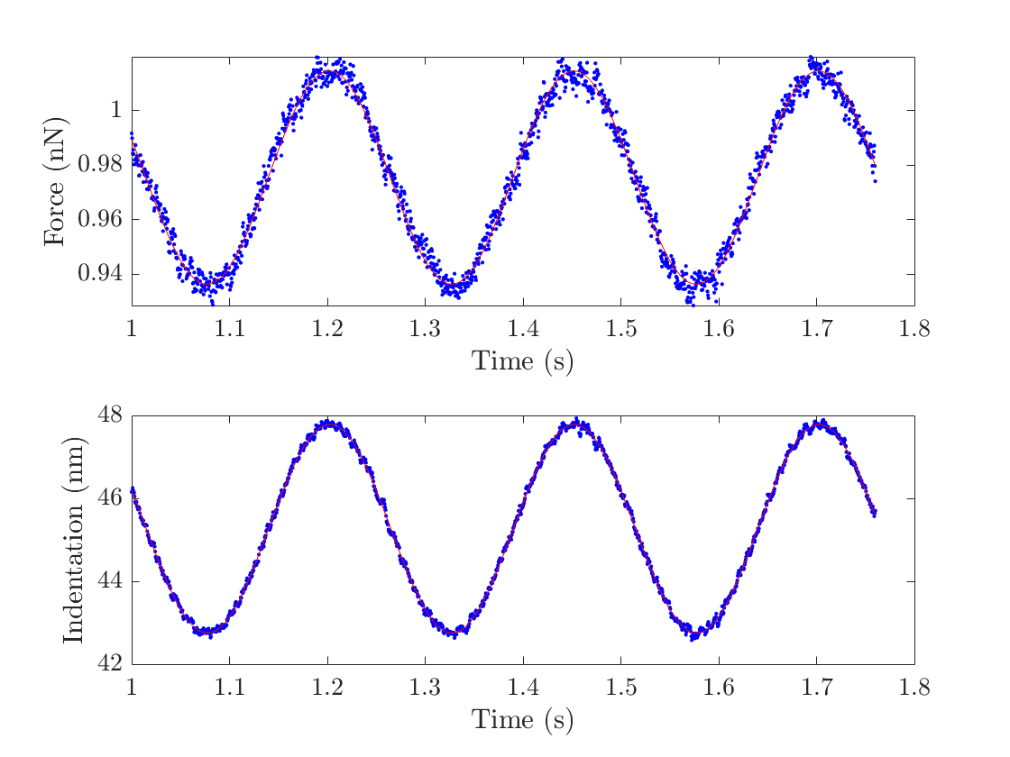
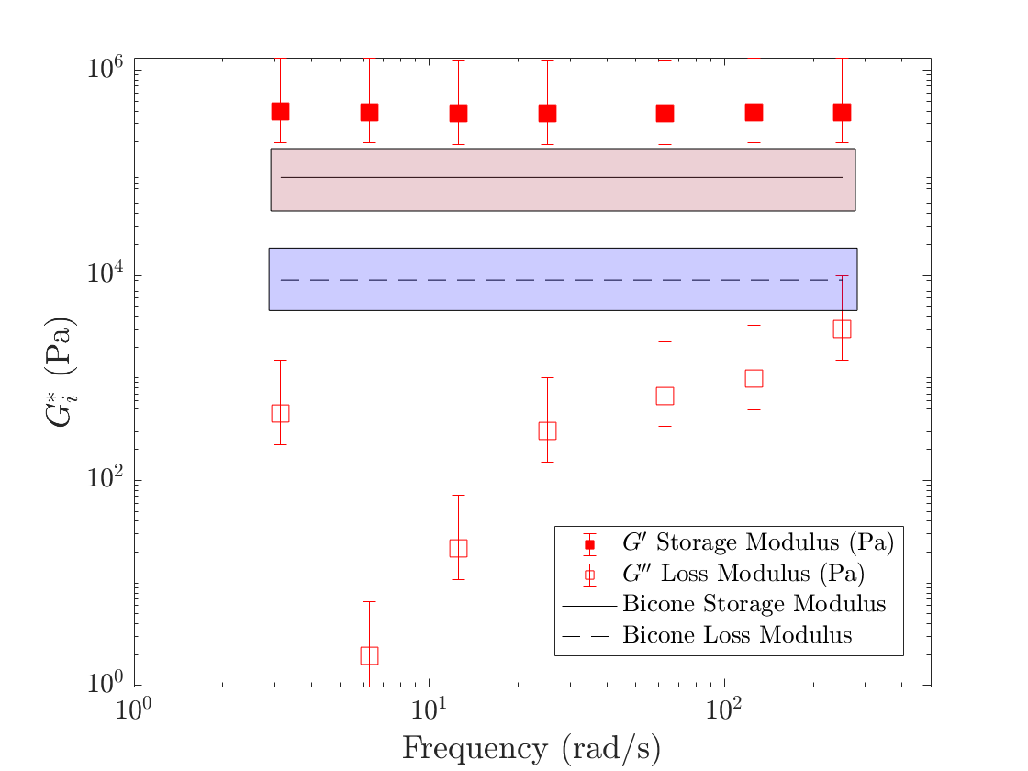
A
B
Figure 5.5. Example and results of an AFM oscillatory indentation analysis
A An example of the applied indention (top panel) and the force response (bottom panel) of an oscillatory region of an AFM force curve on a chitosan microcapsule, already under an applied constant load using the dwell function of the AFM. The red line is the fit to a sine wave. B AFM oscillatory frequency sweep results, for storage and loss moduli (filled and open squares) where the red and blue boxes are the range of moduli values observed in the bicone interfacial rheology experiments. Error bars are calculated from the variation in the thickness estimate from 80nm to 150nm.

5.3.5 Oscillatory Indentation Analysis
To further probe the rheological behaviour of the adsorption layer, oscillatory indentation was performed on the capsules in a similar fashion to the work of Biviano et al³¹⁴. The approach differs in that the analysis accounts for the deformation of a thick capsule shell, not a thin capsule in the Reissner limit used in our previous work. An example of oscillatory indentation via the piezo drive and force response of a chitosan capsule are shown in Figure 5A. The viscoelasticity of the capsule interface has been determined over the frequency of 1 to 40 Hz (Figure 5B). At low frequencies (1 Hz) the chitosan behaves elastically with a loss modulus 5 orders of magnitude lower than the elastic modulus. As the frequency increases, the elastic modulus is observed to be close to constant, whereas the loss modulus increases by 2 orders of magnitude. The storage moduli are similar in magnitude when one accounts for the propagation of the error based on the layer thickness determined range from the AFM imaging measurements. It is important to note that these two measurements differ in that the bicone is a constant interfacial area measurement in a well constrained shear flow field and the capsule measurement utilizes a complex deformation field and a small area expansion. The ages of the interface also differ where the longer adsorption time of the chitosan capsule may contribute to the higher modulus. In contrast, the bicone loss modulus in a similar frequency range exhibits significantly higher values compared to the AFM data. It is important to note that the instrument sensitivity of the bicone may be limited due to the soft interface as the Boussinesq number is significantly higher in the bicone geometry.

A
B
C
D
Glass
Buffer
Top View
Oil
Figure 5.6 – Self Healing Capsule Dynamics
A Schematic of the AFM capsule compression experiment was conducted. B An example showing the different behaviour between force curves of a capsule which show a discontinuity, indicating a fracture in the capsule, compared to a force curve without a fracture. C An observation of consecutive indentations on the discontinuity behaviour of an individual capsule. D Effect of increasing applied force (circles), as a sequence, on the prevalence of the discontinuity, adhesion and the measured Young’s Modulus (squares) of the capsule layer.

5.3.6 Capsule Indentation, Rupture and Recovery
The linear indentation of the chitosan capsules using colloidal probe AFM shows similar behaviours to those observed in other hydrated polymer based capsule systems^{152, 340} (Figure 6A & B). Initially there is a either a response from surface forces or compression of any soft polymer brush layer at the contact point, which transitions to a linear elastic region and then a non-linear deformation region. Using multiple force curves for 8 capsules the Young’s modulus was found to be 460 ± 50 kPa, in line with the observations for oscillatory AFM. When the applied load and indentation are restricted to the linear elastic region without breakage, force curves were repeatable with little or no adhesion or hysteresis between the approach and retract curves, for example, the blue curve in Figure 6B. In addition, for a sequence of force curves on a single capsule shown in Figure 6C, the response in the lower force region prior to capsule breakage maintains a similar at varying loads prior to the point of rupture of the shell.

When compressing the capsules past the initial linear regime (<100 nm), a discontinuity is observed, as shown in Figure 6B, where the red curve shows a sudden drop at 200 nm after contact. We attribute this discontinuity to shell rupturing as there is also significant adhesion and hysteresis in the retract portion of the force curve. The adhesion may be the result of a the broken chitosan film adhering to the silica indenter. The chitosan coating is expected to be slightly hydrophobic³⁰³ leading to the possibility that the presence of the oil may also contribute the adhesion. The adhesion with the probe particle would suggest the breakage may occur in the region local to the indenter, but one cannot rule out fracture in other regions of the shell as well.

Subsequent force curves on a ruptured capsule exhibit the discontinuity at lower indentation depths and forces as seen in Figure 6C. This behaviour suggests the part of the shell that has ruptured becomes weaker with additional breakages. Similar to the bicone interfacial rheology results in Figure 4, if we allow time between large perturbations to the layer, we observe a recovery in the response behaviour. Unlike the decrease in rupture force in Figure 6C, when a recovery time is introduced, the rupture force, or discontinuity, returns to its initial maximum value as shown in Figure 6D where the maximum force is recorded for a sequence of force curves. After the discontinuity is observed, noted on the figure, a recovery time of 10 minutes leads to the rupture force returning to its initial maximum value. The Youngs modulus extracted from the low force region of the force curves, also plotted in Figure 6D, does not change indicating the shell materials properties remain constant even when the capsule ruptures. This recovery or self-healing behaviour is consistent between capsules, although the short recovery time only occurs in capsules for one to two cycles where recovery for further compression cycles require much longer times (> 1 hour). Comparing the behaviour of other particulate films in capsule indentation such as clay capsules by Tan et al.³⁴⁰ or free and crosslinked Pickering emulsions using nanoparticles by Ferri et al.¹³⁵, recovery or healing is not commonly observed.

5.4 Conclusion
We have explored the behaviour of chitosan at the interface, where chitosan is a known hydrophilic emulsifier which forms particles when concentrations of acetate buffer exceed 0.3 M. We have observed strain dependent rheological behaviour of chitosan adsorption layers at the MCT/Oil interface on oil droplets via linear and oscillatory AFM colloidal probe compression and with bicone shear interfacial rheology. AFM also is used to observe the interfacial structures and thickness of the film with the use of in-situ interfacial imaging and Langmuir-Blodgett transfers. Imaging at the interface shows a layer of densely packed particles, with sizes similar to or larger than that observed in dynamic light scattering in the bulk. The measurements indicate that salt aggregated chitosan particles at the interface produces a thick, elastic layer with particulate behaviour in shear. Additionally, when observing the layer in shear and with capsule compression a time dependent recovery suggesting a self-healing behaviour is present after high strains are applied to the layers in both geometries. This is the first strong evidence of the self-healing at microscale fluid-fluid interfaces, closely connecting the phenomena observed at the macroscale fluid interface to the microscale.

Chapter 6 – Nano-shear rheometer, bridging the nano- to mesoscale response of interfacial films

Abstract
We present a novel technique to characterise the translational drag of an interfacially bound AFM tip at the air/water and decane/water interfaces. We apply lateral movement of both rods and sharp tips inserted into the interface and observe the lateral deflection of the AFM tip as a function of the applied lateral velocity. The technique has been benchmarked on the polymeric interfaces with charged sodium polystyrene sulphonate and neutral polyethylene oxide, as well as a protein interface of β-lactoglobulin. For the synthetic polymers, we observed a dependence of translational resistance on the molecular weight of polystyrene sulphonate at the interface. The β-lactoglobulin was observed to exhibit strong time and strain dependent behaviour. The protein film increased in viscosity over time until no further signal was observed when the probe approached the interface. In all measurements of the viscosity of the protein interface, significantly higher viscosities are measured at longer translational lengths. The estimated viscosity observed in these experiments are of similar magnitude to those observed by other macroscale experiments. This novel technique corroborates many of the observed moduli and behaviours of other larger scale techniques, but also queries the interaction of solids with interfacially bound material at the nanoscale.

6.1 Introduction
The stability and behaviour of emulsion and foam is strongly influenced by the interfacial rheology of the gas-liquid or liquid-liquid interface. Their interfacial rheology has been explored on macroscopic length scales with including shear^{99, 101, 107, 109} and dilation^{63, 68} and more complex approaches with droplets such as ribbon shear measurements on protein capsules^{138, 139} and shear measurements on polymeric coatings²⁵¹. When exploring the active rheology of interfaces at the millimetre to micron scale, careful miniaturization of dilational and shear experiments have led to microcapillary interfacial rheometers in dilational modes^{37, 71} and magnetic microrods^{341, 342} or buttons¹⁰⁰ in shear. Often, these methods suffer from the constraints of light microscopy, and thus are size limited to length scales of microns.

Passive Brownian diffusion tracking of spherical particles dispersed at an interface with optical microscopy or confocal microscopy has allowed for particle probe diameters down to 40nm³⁴³. As observed by Lee et al³⁴¹ comparing the active force measurements to particle diffusion measurements in protein interfacial layers, the magnitude of the moduli can differ by several orders of magnitude. The flow fields associated with Brownian motion and a well-defined applied shear do not always describe the complex effects observed when solids translate through interfaces. Thus particles^{344, 345} and larger millimetre disks^{346, 347} or disks 10s of micrometres in diameter¹⁰¹ have been placed at interfaces and translated to observe these effects. These have shown a rich set of behaviour for interfacial layers of polymers, proteins or membranes of lipids^{100, 341, 342, 346, 348}, but are difficult to perform due to optical and magnetic limits, as well as strong limitations when used with capillary induced motion³⁴⁵.

One approach is to use atomic force microscopy (AFM) to directly place micro- or nanoscale probes in the interfaces with nanometre precision in their translation. By taking advantage of nanofabrication or micromanipulation methods, as well as control over surface chemistry and roughness, objects have been placed at surfactant free^{19, 344, 349, 350} or more complex^{349, 351, 352} interfaces reliably with nano and microrods^{341, 353, 354} and microbuttons^{100, 101}. For complex, time dependent microrheological behaviour, globular proteins at the interface have been explored with diffusing particle and active rheology^{341, 342, 348, 354}. In this work we explore the response of films to translating nanometre scale probes located at the fluid-fluid interface. We utilize the well-developed force sensing approach of AFM to determine the translational interfacial drag of both a rod and a sharp cantilever tip at the air/water and decane/water interface. We measure the drag at the air/water interface in solutions with the linear polymers sodium polystyrene sulphonate (PSS), average molecular weights of 30kDa and 350kDa, polyethylene oxide (PEO), average molecular weights of 200kDa, and 1,000kDa, and the time dependent drag of β-lactoglobulin at the decane/water interface at transitional strains from 1 to 10 microns and two orders of magnitude in strain rate.

6.2 Methods
An MFP-3D (Asylum Research, CA, USA) AFM was used for the decane/water interface and Cypher-ES (Asylum Research, CA, USA) was used for the air/water interface measurements. The Nauga Needle HAR-NP CM-13 was used for the β-lactoglobulin measurements at the decane/water interface. These cantilevers have a 3-6𝜇m long, 100-200nm diameter Ag₂Ga rod grown from the cantilevers as shown in Figure 1C. The Olympus Biolever mini with a 7𝜇m height tip and a <10nm diameter oxide sharpened tip was used for linear polymer films measurements at the air/water interface due to their lower lateral spring constant and higher sensitivity compared to the Nauga Needle cantilevers. All cantilever dimensions were measured via SEM (FlexSEM 1000, Hitachi) imaging. The Biolevers were hydrophobised using octadecyltrichlorosilane (Sigma Aldrich, NSW, Australia) where further details of the cantilevers and modification can be found in the SI. Both normal and torsional spring constants were determined with the use of a laser doppler vibrometer or LDV (MSA-400, Polytec, Waldbronn, Germany) using an approach based on the work by Gates and Pratt²²². Further details and typical values are reported in the SI.
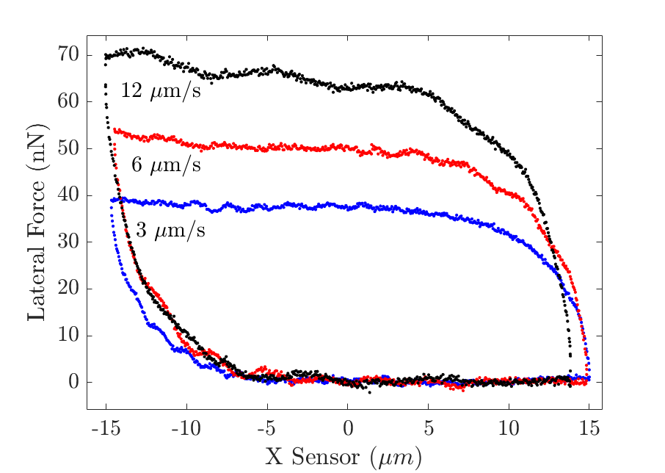
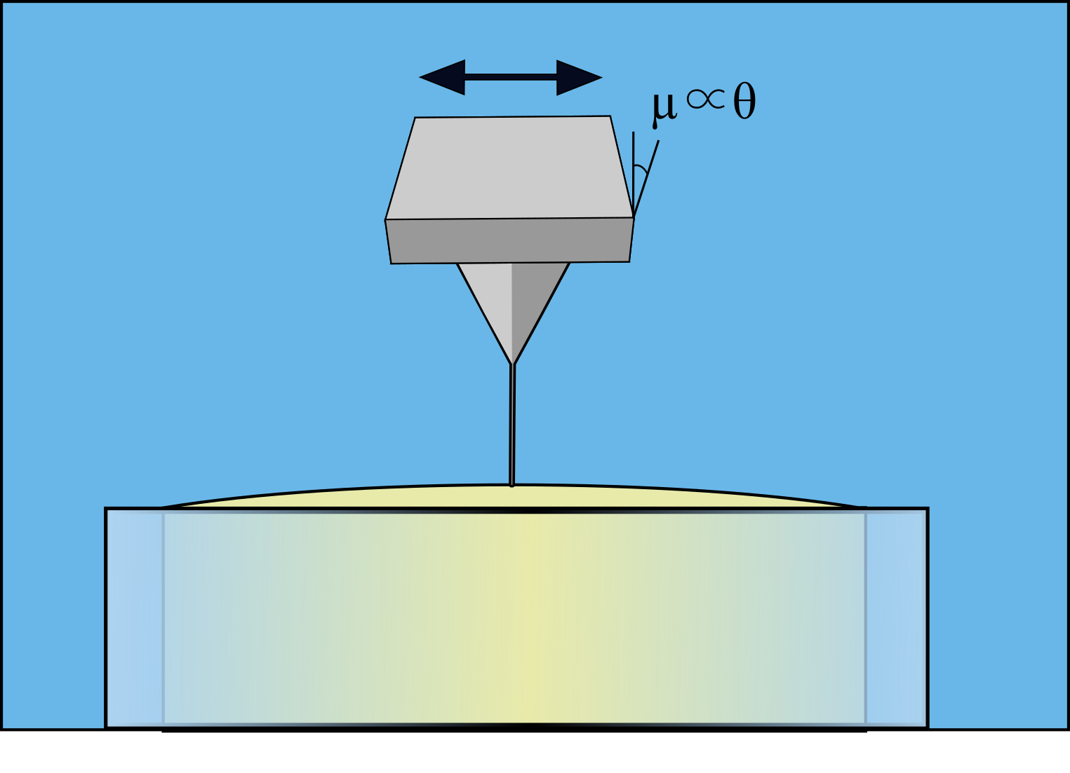
A
B
C

Figure 6.1. Description of the AFM setup and an example of a force response to a lateral translation.
A A schematic of the translation of the nano-rod tip penetrating through an oil water interface pinned. The interface is pinned at the edge of PTFE tubing, where the change in the torsional angle of the cantilever is proportional to the interfacial viscosity. B The AFM lateral voltage signal from the torsional of the AFM cantilever versus the single x-axis translation of the AFM piezo stage for a nano-rod at the decane/water interface in the presence of a β-lactoglobulin film. The increase in the hysteresis in the voltage-translation loop is due to the increase in the x-axis translation speed from 3 to 12 μm/s. (C) A SEM image of an AFM cantilever with an Ag₂Ga nanorod (diameter of 311 nm) protruding from the tip.
As described in Figure 1 either an air/water or decane/water interface was pinned at the edge of an immobilized ~1mm length PTFE tube with an inner diameter of between 0.5 and 1mm in either an aqueous solution or decane. The PTFE tube is left empty to form an air-water interface or filled with water to form an oil-water interface. An aqueous solution or decane is added using a secondary removable 8mm ID glass tube to form the surrounding environment for loading into the AFM fluid cell. Further details are given in the SI.

Utilizing the AFM integrated optics, the tip is centred in close proximity to the droplet or bubble interface. A force curve in the normal direction is acquired to locate the interface as well as probe the retraction behaviour between the cantilever probe and the interface. The nano-rod cantilevers have a fixed radius measured independently via SEM, but the contact radius must be determined for the Biolever cantilevers. Thus, the retraction portion of the force curve is used to determine the equilibrium wetting radius on the tip using the independently measured equilibrium interfacial tensions (PEO and PSS systems are 63mN/m^{355, 356} and 72mN/m^{206, 357, 358}, respectively) and the previous methods for measuring the interfacial tension of a drop or bubbles with an AFM³⁴⁹. Once the normal force curve was acquired, what is referred to as a friction loop in the Asylum Research software suite was used. A constant force setpoint of <1nN is maintained over the force loop, where the lateral voltage change as a constant velocity is recorded as the piezo is translated in a single direction (x-axis) perpendicular to the tip for a predefined distance as shown in Figure 1B. The lateral voltage difference of the four-quadrant photodiode detector is recorded as a function of the piezo translation as shown in Figure 1D. Both the length of the x-axis translation and the tip velocity can be varied independently. The inverse lever sensitivities and cantilever spring constants were used to calculate normal and torsional forces. Further details of the operation of the AFM and calibration of the drag on the cantilever from the bulk can be found in the SI. The translational resistance force of the lateral movement is calculated by determining the difference between the positive and negative velocity directions and dividing these observations by 2, assuming the force response is constant in both directions. The resultant voltage differences are then multiplied by the force calibration constant 𝛾 (N/V), the product of the inVOLS and spring constant, to determine the resultant force and used to calculate the interfacial viscosity. For the first 10-20 shear sweeps measurements, There does not appear to be any degradation of the film or systematic change in the observed friction loops for the first 10-20 shear sweep measurements. For measurements over longer times, in the case of the 𝛽-lactoglobulin film, the shear appears to affect the film response, thus the tip is moved between test times.

The lateral diffusion of objects in interfaces was originally discussed by Saffman and Delbrück³⁵⁹ in their seminal work on particle diffusion in viscous interfaces. These methods were refined for highly viscous interfaces with no boundaries, either on the interface or above or below the interface by Hughes et al.³⁶⁰, Stone and Ajdari³⁶¹, and Fisher et al²⁰. Fisher et al²⁰ has characterised the effect of a rod protruding from the interface, and the resistance of this rod as it translates through the interface. This work also corrects for the for Marangoni forces and assumes a viscous membrane at the interface. As the maximum rod length (l) to diameter (a) is ~50 for this work, the solution to the interfacial viscosity is close to the solution for spheres translating through interfaces at high Boussinesq numbers, where the Boussinesq number is defined as $Bo=\frac{η_{s}}{{(η}_{B1}+η_{B2}).r}$. η_{s} is the surface viscosity, r is the characteristic length of the system, which in this case is the radius of the rod and η_{B} are the viscosity of the two adjacent phases, η_{B1} being the phase where the rod predominantly resides. This quantity is utilized to determine the interfacial viscosity from a rod translating through an interface as per Fisher et al.:

$\frac{F_{D}}{\left(η_{B1}+η_{B2}\right)rU}=\frac{4πBo}{\ln\left(Bo\right)-γ}+\frac{2πη_{B1}}{\left({(η}_{B1}+η_{B2}\right)\ln\left(\frac{l}{2r}\right)}\left(\frac{l}{r.Bo}+8\frac{\ln\left(\frac{l}{Bo.r}\right)+γ-e^{\frac{l}{Bo.r}}Ei\left(-\frac{l}{Bo.r}\right)}{\ln\left(Bo\right)-γ}\right)$ Eq. 1

where U is the velocity of the rod, l is the length of the rod, 𝛾 is Euler’s constant at ~0.5771, and Ei is the exponential integral function. This was solved with MATLAB utilizing a root finding algorithm to determine the Bo, which the viscosity can be calculated from. As the liquids used are Newtonian in the solutions at the concentrations used^{356, 362}, a value of 1 mPa.s is used for aqueous phase, and 0.84 mPa.s for decane³⁶³. For the analysis of the sharp tip data, the solution for high Bo translations of an infinitely thin disk of known radius, translating over an infinite subphase are used, as per Hughes et al³⁶⁰, utilizing the nomenclature from the formula from Fisher et al:

$F= \frac{4πrU}{Bo\left(\ln\left(\frac{2}{Bo}\right)-γ+{\left(\frac{4}{π}\right)}^{\frac{1}{2}}Bo-\frac{1}{2}Bo^{2}\ln\left(\frac{2}{Bo}\right)\right)}$ Eq. 2

For further information the interfacial models used in Eq. 1 and 2 above, refer to the supplementary information.
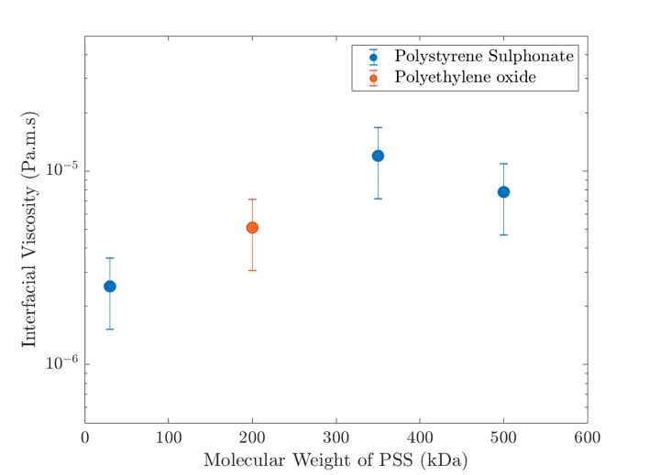
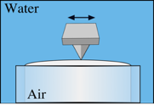
Interfacial Stabilizer | Capillary force | Trans. Resistance
None
SDS (Below CMC)
SDS (Above CMC) |  | -
Pluronic F108 |  | -
𝛽-lactoglobulin (Air/water) |  | -
𝛽-lactoglobulin (Decane/water)
Poly Ethylene Oxide
Polystyrene Sulphonate

Figure 6.2. Interfacial viscosity of linear polymers vs molecular weight, and a table of attempted systems.
A The effect of molecular weight on the observed interfacial viscosity of a weakly adsorbing polystyrene sulphonate and polyethylene oxide at the air/water interface; the measurement schematic shown in the upper left inset. The viscosity of 350kDa and 500kDa PSS as a function of the applied velocity is shown in the lower right inset. The concentration of polymer in solution is 0.2mg/L. B Table of attempted systems at the air/water interface, and the criteria to assess their viability.

6.3 Results and Discussion
We have observed that for most systems to exhibit translational resistance the capillary force must be measured in the normal direction, as observed in figure 1B. We determine the presence of a capillary force behaviour where a jump-in and strong retraction force is observed in the normal AFM force curve³⁴⁹ as the tip approaches and retracts from the interface. Examples of the measured capillary force can be found in SI (Fig S2). We tested various systems for the presence of capillary forces and summarise the systems tested in figure 2B. We attempted to probe sodium dodecylsulphate at the air/water interface. At concentrations below the CMC capillary forces are present but no translational resistance was observed, as consistent with the observations of Zell et al¹⁰³. Above the CMC, no capillary forces or translational resistance are measured, as consistent with the limitations observed by Uddin et al³⁴⁹ where the nanorod was unable to penetrate the interface. Two strongly adsorbing polymers, Pluronic F108 and 𝛽-lactoglobulin, were also tested at the air/water interface, but neither capillary forces or translational resistance were observed. The lack of tip penetration in these systems is attributed to the steric layer^{364, 365} associated with the polymer adsorption, preventing the of wetting of the tip. The weaker adsorbing polymers, PSS and PEO, were found to exhibit both capillary forces and translational resistance at the air/water interface. PEO is known to have microrheological³⁴³ and translational³⁴⁶ viscosities at the interface and PSS has been observed in foamability tests, ellipsometry³⁶⁶, interfacial tension^{366, 367}, AFM force measurements²⁰⁷ and neutron reflectivity experiments³⁵⁷ to absorb to the air/water interface, but the interfacial viscosity has not been reported.

We report the interfacial viscosity for PSS at the air/water interface at three molecular weights, 30kDa and 350kDa and 500 kDa, which is shown in Figure 2. The viscosity increases by an order of magnitude when comparing the shorter chain length of 30kDa to both longer chain lengths, 350kDa and 500kDa. This behaviour may be due to the significantly thinner layer formed with shorter chains or the accompanied by an increase in interfacial concentration of the polymer as the chain length increases, both observed in neutron reflectivity measurements³⁵⁷. The viscosity at 500kDa is similar compared to the 350kDa sample, although this sample is polydisperse compared to the 350kDa and 30kDa polymers, which may explain why the 500kDa polymer did not show a significantly larger surface viscosity compared than the 350kDa case. The observed viscosity for 200kDa PEO shown in Figure 2 exhibits an interfacial viscosity of approximately ~5𝜇Pa.m.s, which is similar to that observed for 400kDa PEO observed at larger lengthscales³⁴⁶. We observe here that the PSS and PEO layers have similar interfacial viscosities in line with similar layer thicknesses around 1-2nm for similar length polymers and adsorbed amounts around ~0.6 mg/m² as determined by both neutron reflectivity^{355, 357, 368} and ellipsometry³⁶⁶.

The interfacial viscosity does not show a strong dependence on tip velocity or translation length over the velocity range from 6 to 30𝜇m/s (inset, Figure 2a) where the velocities and translation in this study are smaller by at least an order of magnitude compared to the earlier PEO study³⁴⁶. The interfacial drag for these polymers is close to the noise threshold for the setup, as seen in figure S3. Despite this, PSS and PEO exhibit reliable interfacial shear behaviour at the air-water interface. Additionally, 1MDa PEO was repeatedly tested at the same monomer concentrations as above. A capillary force was observed in the normal force curve indicating the probe penetrated the interface, but and no lateral signal was observed. We speculate that this may be due to the longer length scale of heterogeneity on the surface due to the longer chains. The solution based radius of gyration for PEO is estimated to be 40nm³⁶⁹, where the typical estimated diameter found for the Biolever tips is ~10-20 nm. It has been observed previously in passive and active interfacial microrheology that when the surface heterogeneities are similar in size to the probe, lower interfacial viscosities are observed³⁷⁰. As this experiment is close to the sensitivity of the setup, it is possible, that a reduction in the surface viscosity resulted in a force response too weak to be observed.
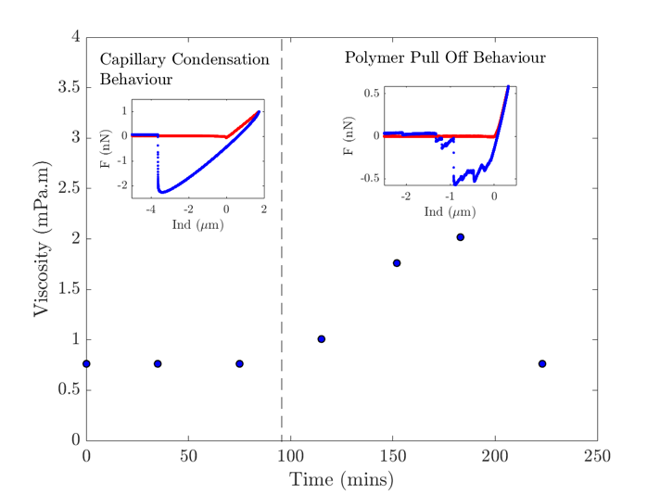
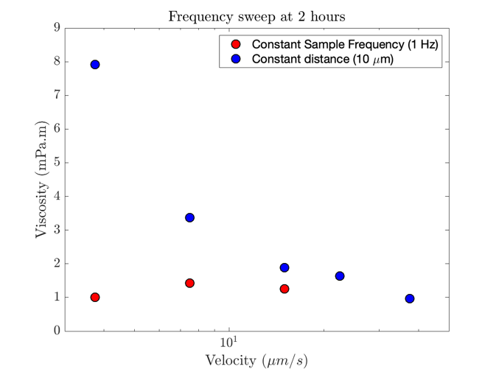
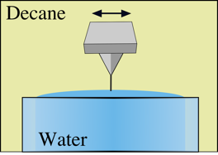
Figure 6.3. Results from the translation of a nano-rod through 𝛽-lactoglobulin at an oil-water interface.
A
B
A The interfacial viscosity of 𝛽-lactoglobulin as a function of time at the decane/water interface at a velocity of 3𝜇m/s translated back and forth over a distance of 1.5𝜇m. The insets are examples of normal force curves take in the area denoted by the dashed line. B The interfacial viscosity as a function of velocity. The blue data was acquired at a constant distance where the velocity was changed. The red data was taken at a constant sample rate of 1hz, where the distance and velocity were changed. The distances for the red data are 3, 6 and 12 𝜇m, in order of increasing velocity and the constant distance for the blue data was 12 𝜇m. The inset is a schematic of the measurement.
𝛽-lactoglobulin at the oil/water interface was also found to show both capillary forces in normal translation and a high lateral translational resistance when the tip is inserted from the decane side as schematically shown in the inset to figure 3B. To probe the film formation behaviour, we observe the interfacial viscosity of 𝛽-lactoglobulin as a function of time as seen in figure 3A, where a 1µm movement at 1hz was used. This smaller distance and slower tip velocity showed less resistance and none of the more complex behaviour exhibited with either larger translations and velocities as shown in Figure 3B. Thus these measurements will likely behave similarly to a viscous, incompressible interface, and may be modelled by the solution from Fischer et al²⁰.

The initial and maximum viscosities observed in Figure 3A at 1μm/s are similar to that of the interfacial moduli in bicone measurements^{32, 76, 231} where analogously the oil is added to an already exposed proteinaceous aqueous phase. The timescales of viscosity growth differ between the two measurements where the bicone shows a gradual growth and the growth in the AFM measurements is delayed where after 75 minutes the viscosity increases to ~10¹ mPa.m.s over the next 75 minutes. This growth point also coincides with a change in the pull off behaviour discussed later. In contrast to the bicone measurements, the interfacial viscosity continues to grow, but at approximately ~200mins the viscosity returns to the viscosity prior to 100mins. At this point, the rod is still wet by the interface, but the longest translation that can be used is 1.5𝜇m where the extent of the AFM scanner movement can be used in previous measurements. Longer translations result in no measurable torsion on the cantilever. We can infer that the film is beginning to reject the tip and additional translation distance provides the energy required to exit the interface. The times where the AFM behaviour changes are observed are similar to passive microrheology experiments of 𝛽-lactoglobulin protein layers. At similar times, colloidal particles at the interface experiments cease to translate in the protein layer^{341, 348} at ~100 mins, coinciding with an increase in the interfacial modulus in our experiments.

Unlike more macroscopic interfacial rheological measurements or even micro-rheology measurements, the use of the AFM allows for access to additional information on the polymer behaviour at the interface via the force curves normal to the interface. In the observations prior to the increases in viscosity, i.e. in the first 75 minutes of Figure 3A, the normal force curves exhibit capillary force behaviours typical to the formation of a contact line at an exposed interface to the edge of a rod^{349, 371}, (see left inset to Figure 3A). As the viscosity begins to increase, the retraction portion of the force curve changes (See right inset to Figure 3A), characterised by jagged peaks in the retraction. This behaviour is typical of the presence of polymers adhering to the rod while attached to the interface, resulting in extension of the polymer at the oil/water interface³⁷¹. The evolution of the force curve behaviour indicates an increase in polymeric material, 𝛽-lactoglobulin this instance, at the interface. Considering the force curve behaviour and the increasing viscosity this suggests that polymer-polymer interactions are increasing as the hydrophobic groups on the proteins localise to the interface as part of the structural rearrangement of 𝛽-lactoglobulin^{43, 44, 372, 373}. The structural rearrangement in the film or an increase in 𝛽-lactoglobulin adsorption over time is consistent with the reduction of translation distance that results in measured torsional resistance after 200mins, where the tip is almost fully rejected from the interface. Unlike the pluronic steric coatings on the interface where there is full rejection of the tip from the interface, attractive interactions between the rod and protein layer are observed in the retraction force curve. These results motivate more exploration of the behaviour of globular proteins at the interface over time.

To explore non-linearities in the protein’s response to deformation, both the translation velocity and translation length were systematically tested for a 𝛽-lactoglobulin film with an age of ~120 mins, shown in figure 3B. When the translation length was held constant at 10µm, a significant decrease in interfacial viscosity is observed with an increase in velocity over the range from 3 to 30µm/s. Most surprisingly, at the slowest velocity with the 10µm translation length has an order of magnitude higher viscosity than the same measurement velocity carried out at translation length of 1.5µm. This trend carries through for all three velocity points taken over 1.5, 3 and 6µm translations, where the smaller translational length has the lower viscosity at the same velocity. Further, as the velocity increases and the translation lengths become closer, i.e. the viscosity begins to approach the lower viscosity. The reduction in viscosity as a function of velocity over the constant length data was fit by a power law decay in the viscosity is observed 𝜂 ∝ 𝜔^{-0.7±0.1} (see figure S4 for example), where the decay is consistent over the experimental timepoints. The origin of this behaviour is still unknown, but is likely due to the non-linear rheology of globular protein interfaces^{342, 354}. We do not observe this behaviour in the linear polymer film (figure S5) and is only a feature of the protein film. We speculate that the non-linear behaviour of the film is due to the interconnectivity of the 𝛽-lactoglobulin film which has been observed to have domains, similarly to phospholipid monolayers¹⁰⁰. It is observed³⁴¹ that when microparticles are spread at the interface and used as tracers during an active microrod experiment, the tracers are observed to move in a radius 2-3 times the radius of the ~30𝜇m rod when the rod is rotated by 90º. The drag on the interface causes the elastically connected regions with embedded particles to translate compared to the probe particles outside this region which have little movement. This domain effect, coupled with the shear and dilational regimes that occur with translating probe measurements³⁷⁴ will require further modelling to fully understand the origin of the increased drag on the tip at different translation lengths.

6.4 Conclusion
In conclusion, we have developed a technique to apply and measure the translational drag of a tip inserted into the air/water or decane/water interface and transform this drag into an interfacial viscosity. We apply lateral movement of both rods and sharp tips inserted into the interface and observe the lateral deflection of the AFM tip as a function of the applied lateral velocity and translational length. We have applied this technique to polymeric interfaces of sodium polystyrene sulphonate, polyethylene oxide and 𝛽-lactoglobulin. With the linear polymers we have observed a dependence of translational resistance on the molecular weight of polystyrene sulphonate at the interface. The interfacial viscosity of 𝛽-lactoglobulin was observed over a function of time to monitor film building effects. The protein film viscosity was initially stable, with an increasing viscosity after 75 minutes, after which the film became sensitive to the translation length would not show interfacial force resistance above 1.5𝜇m of translation. Unlike previous interfacial rheology measurements, we were also able to AFM force curves to probe the same interfaces in-situ to gain more insight into the development of the 𝛽-lactoglobulin and possible rearrangement of the protein with time. We also observe non-linear effects of the 𝛽-lactoglobulin at the interface, where all measurements of the viscosity are significantly higher when measured over longer translational lengths.

Chapter 7 – Summary and conclusions

The overall theme of this thesis is to develop and determine the interfacial rheology on the micro to nanoscale with AFM. AFM is a highly sensitive force sensor which allows for the accurate positioning and force observation of a tip with controllable geometry. In this thesis we develop and benchmark the use of AFM as a sensitive method to determine the interfacial rheological behaviour of food-based emulsifiers. The first method we will develop, and benchmark is the indentation of emulsion droplets with food-based polymers in a time dependent manner to determine the rheological properties of the interfacial films. This will be compared to the macroscopic response of the identical interface at the macroscale in both dilational and shear flow fields. The second method developed is the use of a cantilever as a lateral force sensor. We place a rod into an interface and laterally oscillate the probe, observing the resistance to the movement of the probe. These methods observe both the micro and nanoscale response to deformation of an interface and can be performed on a scale that closely resembles that of interfaces in industrial contexts.

We first developed the time-dependent capsule compression model³⁴³ from the leading theory in capsule compression¹⁷, which allows for the analysis of oscillatory indentation of thin walled capsules. The oscillatory indentation of capsules was first benchmarked at the MCT-oil interface with aged β-lactoglobulin, both native and crosslinked with glutaraldehyde. This interface was created as a capsule and also within a bicone interfacial shear rheometer, and a pendant drop dilational rheometer. The same conditions were used to determine the behaviour of the β-lactoglobulin interface at various stages of crosslinking. We observe across both the native and crosslinked β-lactoglobulin capsules, the frequency dependent behaviour is similar, the elastic modulus is constant, and the loss modulus increases as a function of frequency. A significant indentation depth dependence on the dwell behaviour of β-lactoglobulin capsules is present in both crosslinked and native systems, where a force relaxation is present above a threshold indentation, which may interfere with oscillatory experiments.

We then compare the 3 techniques and observe 3 different effects from crosslinking. The capsules are tested both in the native and crosslinked states, and show a slight increase in the magnitude of the elastic modulus and similar tan(δ) behaviour. The bicone behaviour changes dramatically as the crosslinking occurs, where an order of magnitude increase in the shear moduli occurs. The bicone also reveals that after crosslinking the film can no longer self-heal. Between the techniques though, the magnitudes of the moduli vary highly, but the tan(δ) behaviour between the bicone and oscillatory capsule compression is similar at the same frequencies. The pendant drop dilational behaviour shows that crosslinking progressively reduces the observed loss modulus of the film at low frequencies, indicating that the rearrangement of the adsorbed layer is strongly reduced by crosslinking. We observe that the behaviour of microcapsules in oscillatory compression may vary significantly from the results of the macroscopic techniques typically used to characterise interfacial behaviour.

The second system to utilize the time-dependent capsule compression is the hydrocolloid chitosan, which was recently determined to self-aggregate into partially hydrophobic particulates in acetate solutions above 0.3M. We further explored the nature of these particulates and determined their film forming ability and characteristics at the MCT-Oil interface. To determine the size and stability of these particles, we employ dynamic light scattering, which showed that these particles are stable from pH 3 to 6, and at concentrations from 0.3-1M of acetate. These particles were then imaged both with a novel in-situ imaging technique, where the oil/water interface is imaged from the aqueous side, and with the deposition of air/water Langmuir-Blodgett films to mica, where the thickness of the film is determined. The images show a thick, continuous particulate film on both the aqueous and air-side of the film.

Mechanically, the films were characterised both with bicone shear rheology and with linear and oscillatory capsule compression. The bicone shear rheology showed characteristic behaviour of a particulate interface in both the building of the film, and the amplitude sweep. The film also showed significant self-healing behaviours, where the films would heal almost identically back to the original moduli and amplitude sweep behaviour within 30 mins. The oscillatory capsule compression showed similar moduli to that observed in the bicone, but with significantly lower loss moduli compared to the bicone experiments. In linear compression, we observe the self-healing dynamics of capsules in compression. We observe that similar healing times are observed for capsules as for films, and that identical film moduli are observed for the film during and after the ‘breaking’ process.

The final AFM technique developed is the observation of translational resistance of an AFM probe to lateral translation. This technique comprises of either a sharp tip or a nano-rod bound to a cantilever being inserted into a fluid/fluid interface and then laterally translated. This translation causes the torsional bending of the cantilever due to the resistance of the interface. This torsion is monitored by the AFM and can be transformed into a force. With the knowledge of the pinned radius of the tip or rod at the interface, the interfacial shear can be determined as per Fischer et al²⁰ .

With this novel technique, we have characterised 2 interfaces: a polymeric interface of polystyrene sulphonate or polyethylene oxide, and a globular protein, β-lactoglobulin. The polymeric interfaces are tested at an air/water interface with a sharp tip, where we observe that the layers behave as Newtonian fluids at the interface, as observed previously³⁴³. We observe that there is an increase in viscosity as chain length increases. We then tested β-lactoglobulin at the decane/water interface with a Ag₂Ga rod attached to the tip. The time dependent behaviour of the film growth at the interface is probed, and the growth of the film modulus is observed. At 120 minutes, the film no longer allows for the penetration of the rod and the viscosity at shear lengths above 1𝜇m no longer show any drag when in contact with the film. We also observe that there are significant strain dependent behaviours with β-lactoglobulin at the interface, where longer length translations at the same velocity exhibit significantly higher drag.

Interfacial rheology is critical for emulsions stability. Yet it is challenging to study the time response of well-defined films, and often requires the use of millimetre scale on flat and curved films, which bear little resemblance to the films on emulsion droplets used in practice. The AFM methods developed here are able to probe the time dependent rheological response of the interface of micron scale drops with a defined geometry. This technique may access behaviours with a strong context to industrial systems that were previously impossible to probe. We can compare the macroscopic traditional methods, which connect the behaviour of large-scale film measurements to the microcapsule or emulsion scale behaviour. The magnitude increase of the moduli when the β-lactoglobulin system is crosslinked tested by AFM is small, where the bicone rheometer showed an order of magnitude increase. These two phenomena are quite different and may reflect more about the differences in scale and application of force in interfacial deformation. Other behaviours are quite universal across methods or length scale. For example, the chitosan films show self-healing behaviour in both AFM and bicone measurements. For the nano-rod measurements, we again see differences in the non-linear viscosity behaviour of the β-lactoglobulin system compared to active and passive microrheology measurements. Ultimately, this work and new AFM methods have opened a window to the importance considering how one probes interfacial rheology on length scales between 1 to 3 orders of magnitude smaller than existing interfacial rheological methods. This work now positions the field to ask how these new insights can help interpret emulsion behaviour on drops with a significant interfacial rheological response.

References
1. Kirchsteiger-Meier, E.; Baumgartner, T., Global Food Legislation. Wiley-VCH Verlag GmbH & Co. KGaA: Weinheim, Germany, 2014.
2. Nielloud, F.; Marti-Mestres, G., Pharmaceutical Emulsions and Suspensions. Drugs and the Pharmaceutical Sciences 2000.
3. Scott, K.; Hughes, R., Industrial Membrane Separation Technology. Springer Science & Business Media: 2012; p 305.
4. Perry, R. H.; Green, D. W., Perry’s chemical engineers’ handbook. Mc Graw 2015.
5. Bibette, J.; Leal-Calderon, F.; Schmitt, V.; Poulin, P., Emulsion Science: Basic Principles. An Overview. Springer: 2003; p 142.
6. Ivanov, I. B.; Kralchevsky, P. A., Stability of emulsions under equilibrium and dynamic conditions. Colloids Surf. A Physicochem. Eng. Asp. 1997, 128, (1), 155-175.
7. Dagastine, R. R.; Manica, R.; Carnie, S. L.; C, C. D. Y.; Stevens, G. W.; Grieser, F., Dynamic Forces Between Two Deformable Oil Droplets in Water. Science 2006, 313, (5784), 210-213.
8. Lockie, H. J.; Manica, R.; Stevens, G. W.; Grieser, F.; Chan, D. Y. C.; Dagastine, R. R., Precision AFM measurements of dynamic interactions between deformable drops in aqueous surfactant and surfactant-free solutions. Langmuir 2011, 27, (6), 2676-2685.
9. Xie, L.; Shi, C.; Cui, X.; Zeng, H., Surface Forces and Interaction Mechanisms of Emulsion Drops and Gas Bubbles in Complex Fluids. Langmuir 2017, 33, (16), 3911-3925.
10. Dagastine, R. R.; Manica, R.; Carnie, S. L.; Chan, D. Y. C.; Stevens, G. W.; Grieser, F., Dynamic forces between two deformable oil droplets in water. Science 2006, 313, (5784), 210-213.
11. Liu, J.; Xu, Z.; Masliyah, J., Interaction forces in bitumen extraction from oil sands. J. Colloid Interface Sci. 2005, 287, (2), 507-520.
12. Gunning, A. P.; Mackie, A. R.; Wilde, P. J.; Morris, V. J., Atomic force microscopy of emulsion droplets: probing droplet- droplet interactions. Langmuir 2004, 20, (1), 116-122.
13. Snyder, B. A.; Aston, D. E.; Berg, J. C., Particle- drop interactions examined with an atomic force microscope. Langmuir 1997, 13, (3), 590-593.
14. Berg, J. C., An Introduction to Interfaces & Colloids: The Bridge to Nanoscience. World Scientific: 2010; p 785.
15. Dubreuil, F.; Elsner, N.; Fery, A., Elastic properties of polyelectrolyte capsules studied by atomic-force microscopy and RICM. Eur. Phys. J. E Soft Matter 2003, 12, (2), 215-221.
16. Fery, A.; Weinkamer, R., Mechanical properties of micro- and nanocapsules: Single-capsule measurements. Polymer 2007, 48, (25), 7221-7235.
17. Berry, J. D.; Mettu, S.; Dagastine, R. R., Precise measurements of capsule mechanical properties using indentation. Soft Matter 2017, 13, (10), 1943-1947.
18. Romero, A.; Verwijlen, T.; Guerrero, A.; Vermant, J., Interfacial properties of crayfish protein isolate/chitosan mixed films. Food Hydrocoll. 2013, 32, (2), 395-401.
19. Yazdanpanah, M. M.; Hosseini, M.; Pabba, S.; Berry, S. M.; Dobrokhotov, V. V.; Safir, A.; Keynton, R. S.; Cohn, R. W., Micro-wilhelmy and related liquid property measurements using constant-diameter nanoneedle-tipped atomic force microscope probes. Langmuir 2008, 24, (23), 13753-13764.
20. Fischer, T. H. M.; Dhar, P.; Heinig, P., The viscous drag of spheres and filaments moving in membranes or monolayers. J. Fluid Mech. 2006, 558, 451-475.
21. Hunter, R. J., Introduction to Modern Colloid Science. Oxford University Press: 1993; p 338.
22. Hartel, R. W., Mechanisms and kinetics of recrystallization in ice cream. In The Properties of Water in Foods ISOPOW 6, Reid, D. S., Ed. Springer US: Boston, MA, 1998; pp 287-319.
23. Taylor, P., Ostwald ripening in emulsions. Adv. Colloid Interface Sci. 1998, 75, (2), 107-163.
24. Dukhin, S. S.; Kretzschmar, G.; Miller, R., Dynamics of Adsorption at Liquid Interfaces: Theory, Experiment, Application. Elsevier: 1995; p 600.
25. Eastoe, J.; Dalton, J. S., Dynamic surface tension and adsorption mechanisms of surfactants at the air–water interface. Adv. Colloid Interface Sci. 2000, 85, (2), 103-144.
26. Miller, R.; Kretzschmar, G., Adsorption Kinetics of Surfactants at Fluid interfaces. Advances in Colloid and Interface Science 1991, 97-121.
27. Traube, J., Ueber die Capillaritätsconstanten organischer Stoffe in wässerigen Lösungen. Justus Liebigs Ann. Chem. 1891, 265, (1), 27-55.
28. Birdi, K. S., Self-Assembly Monolayer Structures of Lipids and Macromolecules at Interfaces. Springer Science & Business Media: 2006; p 387.
29. Ramírez, P.; Stocco, A.; Muñoz, J.; Miller, R., Interfacial rheology and conformations of triblock copolymers adsorbed onto the water–oil interface. J. Colloid Interface Sci. 2012, 378, (1), 135-143.
30. Bos, M. A.; van Vliet, T., Interfacial rheological properties of adsorbed protein layers and surfactants: a review. Adv. Colloid Interface Sci. 2001, 91, (3), 437-471.
31. Murray, B. S., Interfacial rheology of food emulsifiers and proteins. Curr. Opin. Colloid Interface Sci. 2002, 7, (5), 426-431.
32. Mitropoulos, V.; Mütze, A.; Fischer, P., Mechanical properties of protein adsorption layers at the air/water and oil/water interface: a comparison in light of the thermodynamical stability of proteins. Adv. Colloid Interface Sci. 2014, 206, 195-206.
33. Binks, B. P., Colloidal particles at liquid interfaces. Phys. Chem. Chem. Phys. 2007, 9, (48), 6298-6299.
34. Binks, B. P., Particles as surfactants—similarities and differences. Curr. Opin. Colloid Interface Sci. 2002, 7, (1), 21-41.
35. du Noüy, P. L., An interfacial tensiometer for universal use. J. Gen. Physiol. 1925, 7, (5), 625-631.
36. Roberts, G., Langmuir-Blodgett Films. Springer Science & Business Media: 2013; p 425.
37. Alvarez, N. J.; Walker, L. M.; Anna, S. L., A microtensiometer to probe the effect of radius of curvature on surfactant transport to a spherical interface. Langmuir 2010, 26, (16), 13310-13319.
38. Stauffer, C. E., The Measurement of Surface Tension by the Pendant Drop Technique. J. Phys. Chem. 1965, 69, (6), 1933-1938.
39. Berry, J. D.; Neeson, M. J.; Dagastine, R. R.; Chan, D. Y. C.; Tabor, R. F., Measurement of surface and interfacial tension using pendant drop tensiometry. J. Colloid Interface Sci. 2015, 454, 226-237.
40. Mezzenga, R.; Fischer, P., The self-assembly, aggregation and phase transitions of food protein systems in one, two and three dimensions. Rep. Prog. Phys. 2013, 76, (4), 046601.
41. Dickinson, E., Hydrocolloids as emulsifiers and emulsion stabilizers. Food Hydrocolloids 2009, 23, (6), 1473-1482.
42. Beverung, C. J.; Radke, C. J.; Blanch, H. W., Protein adsorption at the oil/water interface: characterization of adsorption kinetics by dynamic interfacial tension measurements. Biophys. Chem. 1999, 81, (1), 59-80.
43. Day, L.; Zhai, J.; Xu, M.; Jones, N. C.; Hoffmann, S. V.; Wooster, T. J., Conformational changes of globular proteins adsorbed at oil-in-water emulsion interfaces examined by Synchrotron Radiation Circular Dichroism. Food Hydrocoll. 2014, 34, 78-87.
44. Zhai, J.; Wooster, T. J.; Hoffmann, S. V.; Lee, T.-H.; Augustin, M. A.; Aguilar, M.-I., Structural Rearrangement of β-Lactoglobulin at Different Oil–Water Interfaces and Its Effect on Emulsion Stability. Langmuir 2011, 27, (15), 9227-9236.
45. Cicuta, P.; Stancik, E. J.; Fuller, G. G., Shearing or compressing a soft glass in 2D: time-concentration superposition. Phys. Rev. Lett. 2003, 90, (23), 236101.
46. Benjamins, J.; Lyklema, J.; Lucassen-Reynders, E. H., Compression/expansion rheology of oil/water interfaces with adsorbed proteins. Comparison with the air/water surface. Langmuir 2006, 22, (14), 6181-6188.
47. Freer, E. M.; Yim, K. S.; Fuller, G. G.; Radke, C. J., Shear and dilatational relaxation mechanisms of globular and flexible proteins at the hexadecane/water interface. Langmuir 2004, 20, (23), 10159-10167.
48. Prochaska, K.; Kedziora, P.; Le Thanh, J.; Lewandowicz, G., Surface activity of commercial food grade modified starches. Colloids Surf. B Biointerfaces 2007, 60, (2), 187-194.
49. Bouyer, E.; Mekhloufi, G.; Le Potier, I.; de Kerdaniel, T. d. F.; Grossiord, J.-L.; Rosilio, V.; Agnely, F., Stabilization mechanism of oil-in-water emulsions by β-lactoglobulin and gum arabic. J. Colloid Interface Sci. 2011, 354, (2), 467-477.
50. Babak, V. G.; Desbrières, J.; Tikhonov, V. E., Dynamic surface tension and dilational viscoelasticity of adsorption layers of a hydrophobically modified chitosan. Colloids Surf. A Physicochem. Eng. Asp. 2005, 255, (1), 119-130.
51. Joos, P., Approach for an equation of state for adsorbed protein surfaces. Biochim. Biophys. Acta 1975, 375, (1), 1-9.
52. Miller, R.; Krägel, J.; Wüstneck, R.; Wilde, P. J.; Li, J. B.; Fainerman, V. B.; Loglio, G.; Neumann, A. W., Adsorption kinetics and rheological properties of food proteins at air/water and oil/water interfaces. Food / Nahrung 1998, 42, (03‐04), 225-228.
53. Engelhardt, K.; Lexis, M.; Gochev, G.; Konnerth, C.; Miller, R.; Willenbacher, N.; Peukert, W.; Braunschweig, B., pH Effects on the Molecular Structure of β-Lactoglobulin Modified Air–Water Interfaces and Its Impact on Foam Rheology. Langmuir 2013, 29, (37), 11646-11655.
54. Dickinson, E., Adsorbed protein layers at fluid interfaces: interactions, structure and surface rheology. Colloids Surf. B Biointerfaces 1999, 15, (2), 161-176.
55. Chen, P.; Prokop, R. M.; Susnar, S. S.; Neumann, A. W., Interfacial tensions of protein solutions using axisymmetric drop shape analysis. In Studies in Interface Science, Möbius, D.; Miller, R., Eds. Elsevier: 1998; Vol. 7, pp 303-339.
56. Lu, J. R.; Su, T. J.; Thomas, R. K., Structural Conformation of Bovine Serum Albumin Layers at the Air–Water Interface Studied by Neutron Reflection. J. Colloid Interface Sci. 1999, 213, (2), 426-437.
57. Malcolm, A. S.; Dexter, A. F.; Middelberg, A. P. J., Mechanical Properties of Interfacial Films Formed by Lysozyme Self-Assembly at the Air- Water Interface. Langmuir 2006, 22, (21), 8897-8905.
58. Dickinson, E.; Matsumura, Y., Time-dependent polymerization of β-lactoglobulin through disulphide bonds at the oil-water interface in emulsions. Int. J. Biol. Macromol. 1991, 13, (1), 26-30.
59. Monahan, F. J.; McClements, D. J.; German, J. B., Disulfide-mediated polymerization of whey proteins in whey protein isolate-stabilized emulsions. Adv. Exp. Med. Biol. 1997, 415, 127-136.
60. Wierenga, P. A.; Kosters, H.; Egmond, M. R.; Voragen, A. G. J.; de Jongh, H. H. J., Importance of physical vs. chemical interactions in surface shear rheology. Adv. Colloid Interface Sci. 2006, 119, (2-3), 131-139.
61. Krägel, J.; Derkatch, S. R.; Miller, R., Interfacial shear rheology of protein-surfactant layers. Adv. Colloid Interface Sci. 2008, 144, (1-2), 38-53.
62. Miller, R.; Wüstneck, R.; Krägel, J.; Kretzschmar, G., Dilational and shear rheology of adsorption layers at liquid interfaces. Colloids Surf. A Physicochem. Eng. Asp. 1996, 111, (1), 75-118.
63. Jaensson, N.; Vermant, J., Tensiometry and rheology of complex interfaces. Curr. Opin. Colloid Interface Sci. 2018, 37, 136-150.
64. Fuller, G. G.; Vermant, J., Complex Fluid-Fluid Interfaces: Rheology and Structure. Annual Review of Chemical and Biomolecular Engineering 2012, 3, (1), 519-543.
65. Erni, P., Deformation modes of complex fluid interfaces. Soft Matter 2011, 7, (17), 7586-7600.
66. Wierenga, P. A.; Gruppen, H., New views on foams from protein solutions. Curr. Opin. Colloid Interface Sci. 2010, 15, (5), 365-373.
67. Langevin, D., Influence of interfacial rheology on foam and emulsion properties. Adv. Colloid Interface Sci. 2000, 88, (1-2), 209-222.
68. Ravera, F.; Ferrari, M.; Santini, E.; Liggieri, L., Influence of surface processes on the dilational visco-elasticity of surfactant solutions. Adv. Colloid Interface Sci. 2005, 117, (1-3), 75-100.
69. Lucassen, J.; Van Den Tempel, M., Dynamic measurements of dilational properties of a liquid interface. Chem. Eng. Sci. 1972, 27, (6), 1283-1291.
70. Miller, R.; Ferri, J. K.; Javadi, A.; Krägel, J.; Mucic, N.; Wüstneck, R., Rheology of interfacial layers. Colloid and Polymer Science 2010, 288, (9), 937-950.
71. Alvarez, N. J.; Anna, S. L.; Saigal, T.; Tilton, R. D.; Walker, L. M., Interfacial Dynamics and Rheology of Polymer-Grafted Nanoparticles at Air–Water and Xylene–Water Interfaces. Langmuir 2012, 28, (21), 8052-8063.
72. Faour, G.; Grimaldi, M.; Richou, J.; Bois, A., Real-Time Pendant Drop Tensiometer Using Image Processing with Interfacial Area and Interfacial Tension Control Capabilities. J. Colloid Interface Sci. 1996, 181, (2), 385-392.
73. Noskov, B. A., Dilational surface rheology of polymer and polymer/surfactant solutions. Curr. Opin. Colloid Interface Sci. 2010, 15, (4), 229-236.
74. Kirby, S. M.; Zhang, X.; Russo, P. S.; Anna, S. L.; Walker, L. M., Formation of a Rigid Hydrophobin Film and Disruption by an Anionic Surfactant at an Air/Water Interface. Langmuir 2016, 32, (22), 5542-5551.
75. Pereira, L. G. C.; Cascão Pereira, L. G.; Théodoly, O.; Blanch, H. W.; Radke, C. J., Dilatational Rheology of BSA Conformers at the Air/Water Interface. Langmuir 2003, 19, (6), 2349-2356.
76. Rühs, P. A.; Affolter, C.; Windhab, E. J.; Fischer, P., Shear and dilatational linear and nonlinear subphase controlled interfacial rheology of β-lactoglobulin fibrils and their derivatives. J. Rheol. 2013, 57, (3), 1003-1022.
77. Kotula, A. P.; Anna, S. L., Probing timescales for colloidal particle adsorption using slug bubbles in rectangular microchannels. Soft Matter 2012, 8, (41), 10759.
78. Petkov, J. T.; Gurkov, T. D.; Campbell, B. E.; Borwankar, R. P., Dilatational and Shear Elasticity of Gel-like Protein Layers on Air/Water Interface. Langmuir 2000, 16, 3703-3711.
79. Pepicelli, M.; Jaensson, N.; Tregouet, B.; Schroyen, A.; Alicke, T.; Tervoort, T. A.; Monteux, C.; Vermant, J., Surface viscoelasticity in model polymer multilayers: From planar interfaces to rising bubbles. Journal of Rheology 2019, 63, (815).
80. Pepicelli, M.; Verwijlen, T.; Tervoort, T. A.; Vermant, J., Characterization and modelling of Langmuir interfaces with finite elasticity. Soft Matter 2017, 13, (35), 5977-5990.
81. Verwijlen, T.; Imperiali, L.; Vermant, J., Separating viscoelastic and compressibility contributions in pressure-area isotherm measurements. Advances in Colloid and Interface Science 2014, (206), 428-436.
82. Hegemann, J.; Knoche, S.; Egger, S.; Kott, M.; Demand, S.; Unverfehrt, A.; Rehage, H.; Kierfeld, J., Pendant capsule elastometry. J. Colloid Interface Sci. 2018, 513, 549-565.
83. Lucassen-Reynders, E. H.; Benjamins, J.; Fainerman, V. B., Dilational rheology of protein films adsorbed at fluid interfaces. Curr. Opin. Colloid Interface Sci. 2010, 15, (4), 264-270.
84. Benjamins, J.; Lucassen-Reynders, E. H., Surface dilational rheology of proteins adsorbed at air/water and oil/water interfaces. Proteins at Liquid Interfaces 1998, 341-384.
85. Won, J. Y.; Gochev, G. G.; Ulaganathan, V.; Krägel, J.; Aksenenko, E. V.; Fainerman, V. B.; Miller, R., Dilational visco-elasticity of BLG adsorption layers at the solution/tetradecane interface--Effect of pH and ionic strength. Colloids Surf. A Physicochem. Eng. Asp. 2017, 521, 204-210.
86. Rühs, P. A.; Scheuble, N.; Windhab, E. J.; Fischer, P., Protein adsorption and interfacial rheology interfering in dilatational experiment. Eur. Phys. J. Spec. Top. 2013, 222, (1), 47-60.
87. Freer, E. M.; Yim, K. S.; Fuller, G. G.; Radke, C. J., Interfacial Rheology of Globular and Flexible Proteins at the Hexadecane/Water Interface: Comparison of Shear and Dilatation Deformation. J. Phys. Chem. B 2004, 108, (12), 3835-3844.
88. Morioka, T.; Kawaguchi, M., Surface Dilatational Moduli of Poly(vinyl acetate) (PVAc) and PVAc-Poly(n-hexyl isocyanate) (PHIC) Blend Films at the Air–Water Interface. Langmuir 2011, 27, (14), 8672-8677.
89. Erni, P.; Windhab, E. J.; Gunde, R.; Graber, M.; Pfister, B.; Parker, A.; Fischer, P., Interfacial Rheology of Surface-Active Biopolymers: Acacia senegal Gum versus Hydrophobically Modifed Starch. Biomacromolecules 2007, 8, (11), 3458-3466.
90. Babak, V. G.; Auzely, R.; Rinaudo, M., Effect of electrolyte concentration on the dynamic surface tension and dilational viscoelasticity of adsorption layers of chitosan and dodecyl chitosan. J. Phys. Chem. B 2007, 111, (32), 9519-9529.
91. Nutting, G. C.; Harkins, W. D., Pressure--Area Relations of Fatty Acid and Alcohol Monolayers. J. Am. Chem. Soc. 1939, 61, (5), 1180-1187.
92. Sacchetti, M.; Yu, H.; Zografi, G., A canal surface viscometer for the in‐plane steady shear viscosity of monolayers at the air/water interface. Review of Scientific Instruments 1993, 64, (7), 1941-1946.
93. Davies, J. T.; Mayers, G. R. A., Studies on the interfacial viscosities of monolayers. Trans. Faraday Soc. 1960, 56, (0), 691-696.
94. Mannheimer, R. J.; Schechter, R. S., An improved apparatus and analysis for surface rheological measurements. J. Colloid Interface Sci. 1970, 32, (2), 195-211.
95. Goodrich, F. C.; Allen, L. H.; Poskanzer, A., A new surface viscometer of high sensitivity. I. Theory. J. Colloid Interface Sci. 1975, 52, (2), 201-212.
96. Sato, N.; Ito, S.; Yamamoto, M., Molecular Weight Dependence of Shear Viscosity of a Polymer Monolayer: Evidence for the Lack of Chain Entanglement in the Two-Dimensional Plane. Macromolecules 1998, 31, (8), 2673-2675.
97. Prieditis, J.; Amundson, N. R.; Flumerfelt, R. W., Interfacial viscoelastic response to oscillatory shear deformations. J. Colloid Interface Sci. 1987, 119, (2), 303-314.
98. Krieg, R. D.; Son, J. E.; Flumerfelt, R. W., A new method for surface shear viscosity measurements: Decay of surface motions at a rotated gas—liquid interface. J. Colloid Interface Sci. 1981, 79, (1), 14-20.
99. Brooks, C. F.; Fuller, G. G.; Frank, C. W.; Robertson, C. R., An interfacial stress rheometer to study rheological transitions in monolayers at the air- water interface. Langmuir 1999, 15, (7), 2450-2459.
100. Choi, S. Q.; Steltenkamp, S.; Zasadzinski, J. A.; Squires, T. M., Active microrheology and simultaneous visualization of sheared phospholipid monolayers. Nat. Commun. 2011, 2, 312.
101. Zell, Z. A.; Mansard, V.; Wright, J.; Kim, K.; Choi, S. Q.; Squires, T. M., Linear and nonlinear microrheometry of small samples and interfaces using microfabricated probes. J. Rheol. 2016, 60, (1), 141-159.
102. Reynaert, S.; Brooks, C. F.; Moldenaers, P.; Vermant, J.; Fuller, G. G., Analysis of the magnetic rod interfacial stress rheometer. Journal of Rheology 2008, 52, (1), 261-285.
103. Zell, Z. A.; Nowbahar, A.; Mansard, V.; Leal, L. G.; Deshmukh, S. S.; Mecca, J. M.; Tucker, C. J.; Squires, T. M., Surface shear inviscidity of soluble surfactants. Proc. Natl. Acad. Sci. U. S. A. 2014, 111, (10), 3677-3682.
104. Langmuir, I., Two-dimensional gases, liquids and solids. Science 1936, 84, (2183), 379-383.
105. Brown, A. G.; Thuman, W. C.; McBain, J. W., The surface viscosity of detergent solutions as a factor in foam stability. Journal of Colloid Science 1953, 8, (5), 491-507.
106. Soo-Gun, O. H.; Slattery, J. C., Disk and biconical interfacial viscometers. J. Colloid Interface Sci. 1978, 67, (3), 516-525.
107. Erni, P.; Fischer, P.; Windhab, E. J.; Kusnezov, V.; Stettin, H.; Läuger, J., Stress- and strain-controlled measurements of interfacial shear viscosity and viscoelasticity at liquid/liquid and gas/liquid interfaces. Rev. Sci. Instrum. 2003, 74, (11), 4916-4924.
108. Maestro, A.; Ortega, F.; Monroy, F.; Krägel, J.; Miller, R., Molecular weight dependence of the shear rheology of poly(methyl methacrylate) Langmuir films: a comparison between two different rheometry techniques. Langmuir 2009, 25, (13), 7393-7400.
109. Vandebril, S.; Franck, A.; Fuller, G. G.; Moldenaers, P.; Vermant, J., A double wall-ring geometry for interfacial shear rheometry. Rheol. Acta 2010, 49, (2), 131-144.
110. Langevin, D.; Monroy, F., Interfacial rheology of polyelectrolytes and polymer monolayers at the air–water interface. Curr. Opin. Colloid Interface Sci. 2010, 15, (4), 283-293.
111. Langevin, D., Surface shear rheology of monolayers at the surface of water. Adv. Colloid Interface Sci. 2014, 207, 121-130.
112. Mendoza, A. J.; Guzmán, E.; Martínez-Pedrero, F.; Ritacco, H.; Rubio, R. G.; Ortega, F.; Starov, V. M.; Miller, R., Particle laden fluid interfaces: dynamics and interfacial rheology. Adv. Colloid Interface Sci. 2014, 206, 303-319.
113. Derkach, S. R.; Krägel, J.; Miller, R., Methods of measuring rheological properties of interfacial layers (Experimental methods of 2D rheology). Colloid J. 2009, 71, (1), 1-17.
114. Madene, A.; Jacquot, M.; Scher, J.; others, Flavour encapsulation and controlled release–a review. International journal of 2006.
115. Allen, T. M.; Cullis, P. R., Drug delivery systems: entering the mainstream. Science 2004, 303, (5665), 1818-1822.
116. Zuidam, N. J.; Nedovic, V., Encapsulation Technologies for Active Food Ingredients and Food Processing. Springer Science & Business Media: 2009; p 400.
117. Cosgrove, D., Ultrasound contrast agents: an overview. Eur. J. Radiol. 2006, 60, (3), 324-330.
118. Nedovic, V.; Kalusevic, A.; Manojlovic, V.; Levic, S.; Bugarski, B., An overview of encapsulation technologies for food applications. Procedia Food Science 2011, 1, 1806-1815.
119. de Oliveira, J. L.; Campos, E. V. R.; Bakshi, M.; Abhilash, P. C.; Fraceto, L. F., Application of nanotechnology for the encapsulation of botanical insecticides for sustainable agriculture: prospects and promises. Biotechnol. Adv. 2014, 32, (8), 1550-1561.
120. Bysell, H.; Månsson, R.; Hansson, P.; Malmsten, M., Microgels and microcapsules in peptide and protein drug delivery. Adv. Drug Deliv. Rev. 2011, 63, (13), 1172-1185.
121. Koker, S. D.; De Koker, S.; Hoogenboom, R.; De Geest, B. G., ChemInform Abstract: Polymeric Multilayer Capsules for Drug Delivery. ChemInform 2012, 43, (27), no-no.
122. Nelson, G., Microencapsulation in textile finishing. Rev. Prog. Color. Relat. Top. 2001, 31, (1), 57-64.
123. I Ré, M., Microencapsulation by spray drying. Drying Technol. 1998, 16, (6), 1195-1236.
124. Esser-Kahn, A. P.; Odom, S. A.; Sottos, N. R.; White, S. R.; Moore, J. S., Triggered Release from Polymer Capsules. Macromolecules 2011, 44, (14), 5539-5553.
125. Teunou, E.; Poncelet, D., Batch and continuous fluid bed coating--review and state of the art. J. Food Eng. 2002, 53, (4), 325-340.
126. Barthès-Biesel, D., Modeling the motion of capsules in flow. Curr. Opin. Colloid Interface Sci. 2011, 16, (1), 3-12.
127. Svoboda, K.; Block, S. M., Biological applications of optical forces. Annu. Rev. Biophys. Biomol. Struct. 1994, 23, 247-285.
128. Neuman, K. C.; Nagy, A., Single-molecule force spectroscopy: optical tweezers, magnetic tweezers and atomic force microscopy. Nat. Methods 2008, 5, (6), 491-505.
129. Bausch, A. R.; Möller, W.; Sackmann, E., Measurement of local viscoelasticity and forces in living cells by magnetic tweezers. Biophys. J. 1999, 76, (1 Pt 1), 573-579.
130. Guck, J.; Ananthakrishnan, R.; Mahmood, H.; Moon, T. J.; Cunningham, C. C.; Käs, J., The optical stretcher: a novel laser tool to micromanipulate cells. Biophys. J. 2001, 81, (2), 767-784.
131. Skelton, S. E.; Sergides, M.; Memoli, G.; Maragó, O. M.; Jones, P. H., Trapping and deformation of microbubbles in a dual-beam fibre-optic trap. J. Opt. 2012, 14, (7), 075706.
132. Mitchison, J. M.; Swann, M. M., The mechanical properties of the cell surface. J. Exp. Biol. 1954.
133. Rawicz, W.; Olbrich, K. C.; McIntosh, T.; Needham, D.; Evans, E., Effect of chain length and unsaturation on elasticity of lipid bilayers. Biophys. J. 2000, 79, (1), 328-339.
134. Dieluweit, S.; Csiszár, A.; Rubner, W.; Fleischhauer, J.; Houben, S.; Merkel, R., Mechanical properties of bare and protein-coated giant unilamellar phospholipid vesicles. A comparative study of micropipet aspiration and atomic force microscopy. Langmuir 2010, 26, (13), 11041-11049.
135. Ferri, J. K.; Carl, P.; Gorevski, N.; Russell, T. P.; Wang, Q.; Böker, A.; Fery, A., Separating membrane and surface tension contributions in Pickering droplet deformation. Soft Matter 2008, 4, (11), 2259-2266.
136. Tan, S.-Y.; Tabor, R. F.; Ong, L.; Stevens, G. W.; Dagastine, R. R., Nano-mechanical properties of clay-armoured emulsion droplets. Soft Matter 2012, 8, (11), 3112-3121.
137. Walter, A.; Rehage, H.; Leonhard, H., Shear induced deformation of microcapsules: shape oscillations and membrane folding. Colloids Surf. A Physicochem. Eng. Asp. 2001, 183-185, 123-132.
138. Erni, P.; Fischer, P.; Windhab, E. J., Deformation of single emulsion drops covered with a viscoelastic adsorbed protein layer in simple shear flow. Appl. Phys. Lett. 2005, 87, (24), 244104.
139. Erni, P.; Windhab, E. J.; Fischer, P., Emulsion Drops with Complex Interfaces: Globular Versus Flexible Proteins. Macromol. Mater. Eng. 2011, 296, (3-4), 249-262.
140. Chang, K. S.; Olbricht, W. L., Experimental studies of the deformation of a synthetic capsule in extensional flow. J. Fluid Mech. 1993, 250, 587-608.
141. Gubspun, J.; Gires, P.-Y.; Loubens, C. d.; Barthès-Biesel, D.; Deschamps, J.; Georgelin, M.; Leonetti, M.; Leclerc, E.; Edwards-Lévy, F.; Salsac, A.-V., Characterization of the mechanical properties of cross-linked serum albumin microcapsules: effect of size and protein concentration. Colloid Polym. Sci. 2016, 294, (8), 1381-1389.
142. Lefebvre, Y.; Leclerc, E.; Barthès-Biesel, D.; Walter, J.; Edwards-Lévy, F., Flow of artificial microcapsules in microfluidic channels: A method for determining the elastic properties of the membrane. Phys. Fluids 2008, 20, (12), 123102.
143. de Loubens, C.; Deschamps, J.; Georgelin, M.; Charrier, A.; Edwards-Levy, F.; Leonetti, M., Mechanical characterization of cross-linked serum albumin microcapsules. Soft Matter 2014, 10, (25), 4561-4568.
144. Gires, P.-Y.; Barthès-Biesel, D.; Leclerc, E.; Salsac, A.-V., Transient behavior and relaxation of microcapsules with a cross-linked human serum albumin membrane. J. Mech. Behav. Biomed. Mater. 2016, 58, 2-10.
145. Cole, K. S., Surface forces of the arbacia egg. J. Cell. Comp. Physiol. 1932, 1, (1), 1-9.
146. Zhang, Z.; Saunders, R.; Thomas, C. R., Mechanical strength of single microcapsules determined by a novel micromanipulation technique. J. Microencapsul. 1999, 16, (1), 117-124.
147. Hu, J.; Chen, H.-Q.; Zhang, Z., Mechanical properties of melamine formaldehyde microcapsules for self-healing materials. Materials Chemistry and Physics 2009, 118, (1), 63-70.
148. Tan, S.; Sherman, R. L., Jr.; Ford, W. T., Nanoscale compression of polymer microspheres by atomic force microscopy. Langmuir 2004, 20, (17), 7015-7020.
149. Lulevich, V. V.; Andrienko, D.; Vinogradova, O. I., Elasticity of polyelectrolyte multilayer microcapsules. J. Chem. Phys. 2004, 120, (8), 3822-3826.
150. Taber, L. A., Large deflection of a fluid-filled spherical shell under a point load. J. Appl. Mech. 1982, 49, (1), 121-128.
151. Pozrikidis, C., Modeling and Simulation of Capsules and Biological Cells. 2003.
152. Neubauer, M. P.; Poehlmann, M.; Fery, A., Microcapsule mechanics: from stability to function. Adv. Colloid Interface Sci. 2014, 207, 65-80.
153. Fery, A.; Dubreuil, F.; Möhwald, H., Mechanics of artificial microcapsules. New J. Phys. 2004, 6, (1), 18.
154. Reissner, E., Stresses and small displacements of shallow spherical shells. II. J. Math. Phys. 1946, 25, (1-4), 279-300.
155. Reissner, E., Stresses and Small Displacements of Shallow Spherical Shells. I. Journal of Mathematics and Physics 1946, 25, (1-4), 80-85.
156. Herranz, B.; Alvarez, M. D.; Ridout, M. J.; Wilde, P. J., Influence of interfacial mechanisms on the rheology of creaming emulsions. Int. J. Food Prop. 2018, 21, (1), 1322-1331.
157. Meinders, M. B. J.; van Vliet, T., The role of interfacial rheological properties on Ostwald ripening in emulsions. Adv. Colloid Interface Sci. 2004, 108-109, 119-126.
158. Erni, P.; Jerri, H. A.; Wong, K.; Parker, A., Interfacial viscoelasticity controls buckling, wrinkling and arrest in emulsion drops undergoing mass transfer. Soft Matter 2012, 8, (26), 6958-6967.
159. Mahaffy, R. E.; Shih, C. K.; MacKintosh, F. C.; Käs, J., Scanning probe-based frequency-dependent microrheology of polymer gels and biological cells. Phys. Rev. Lett. 2000, 85, (4), 880-883.
160. Abidine, Y.; Laurent, V. M.; Michel, R.; Duperray, A.; Palade, L. I.; Verdier, C., Physical properties of polyacrylamide gels probed by AFM and rheology. EPL 2015, 109, (3), 38003.
161. Yango, A.; Schäpe, J.; Rianna, C.; Doschke, H.; Radmacher, M., Measuring the viscoelastic creep of soft samples by step response AFM. Soft Matter 2016, 12, (40), 8297-8306.
162. Nalam, P. C.; Gosvami, N. N.; Caporizzo, M. A.; Composto, R. J.; Carpick, R. W., Nano-rheology of hydrogels using direct drive force modulation atomic force microscopy. Soft Matter 2015, 11, (41), 8165-8178.
163. Hu, Y.; Chen, X.; Whitesides, G. M.; Vlassak, J. J.; Suo, Z., Indentation of polydimethylsiloxane submerged in organic solvents. Journal of Materials Research 2011, 26, (6), 785-795.
164. Chan, E. P.; Hu, Y.; Johnson, P. M.; Suo, Z.; Stafford, C. M., Spherical indentation testing of poroelastic relaxations in thin hydrogel layers. Soft Matter 2012, 8, (5), 1492-1498.
165. Francius, G.; Hemmerle, J.; Ball, V.; Lavalle, P.; Picart, C.; Voegel, J.-C.; Schaaf, P.; Senger, B., Stiffening of soft polyelectrolyte architectures by multilayer capping evidenced by viscoelastic analysis of AFM indentation measurements. J. Phys. Chem. C 2007, 111, (23), 8299-8306.
166. Diaz, A.; Pelekasis, N.; Barthès-Biesel, D., Transient response of a capsule subjected to varying flow conditions: Effect of internal fluid viscosity and membrane elasticity. Phys. Fluids 2000, 12, (5), 948-957.
167. Diaz, A.; Barthès-Biesel, D.; Pelekasis, N., Effect of membrane viscosity on the dynamic response of an axisymmetric capsule. Phys. Fluids 2001, 13, (12), 3835-3838.
168. Koleva, I.; Rehage, H., A comparison of different experimental methods for investigating the mechanical properties of plane polysiloxane membranes and capsule walls. Soft Matter 2012, 8, (29), 7672-7682.
169. Barthès-Biesel, D.; Rallison, J. M., The time-dependent deformation of a capsule freely suspended in a linear shear flow. J. Fluid Mech. 1981, 113, 251-267.
170. Pieper, G.; Rehage, H.; Barthès-Biesel, D., Deformation of a Capsule in a Spinning Drop Apparatus. J. Colloid Interface Sci. 1998, 202, (2), 293-300.
171. Binnig, G.; Quate, C. F.; Gerber, C., Atomic force microscope. Phys. Rev. Lett. 1986, 56, (9), 930-933.
172. Martin, Y.; Williams, C. C.; Wickramasinghe, H. K., Atomic force microscope–force mapping and profiling on a sub 100‐Å scale. Journal of Applied Physics 1987, 61, (10), 4723-4729.
173. Giessibl, F. J., AFM's path to atomic resolution. Materials Today 2005, 8, (5), 32-41.
174. Neto, C.; Craig, V. S. J., Colloid Probe Characterization: Radius and Roughness Determination. Langmuir 2001, 17, (7), 2097-2099.
175. Senden, T. J.; Drummond, C. J., Surface chemistry and tip-sample interactions in atomic force microscopy. Colloids and Surfaces A: Physicochemical and Engineering Aspects 1995, 94, (1), 29-51.
176. Ducker, W. A.; Senden, T. J.; Pashley, R. M., Direct measurement of colloidal forces using an atomic force microscope. Nature 1991, 353, (6341), 239-241.
177. Ducker, W. A.; Senden, T. J.; Pashley, R. M., Measurement of forces in liquids using a force microscope. Langmuir 1992, 8, (7), 1831-1836.
178. Senden, T. J., Force microscopy and surface interactions. Current Opinion in Colloid & Interface Science 2001, 6, (2), 95-101.
179. Bonaccurso, E.; Kappl, M.; Butt, H., Thin liquid films studied by atomic force microscopy. Current Opinion in Colloid & Interface Science 2008, 13, (3), 107-119.
180. Butt, H.-J.; Cappella, B.; Kappl, M., Force measurements with the atomic force microscope: Technique, interpretation and applications. Surface Science Reports 2005, 59, (1-6), 1-152.
181. Larson, R. G., The structure and rheology of complex fluids. Oxford university press New York: 1999; Vol. 150.
182. Qian, L.; Zhao, H., Nanoindentation of Soft Biological Materials. Micromachines (Basel) 2018, 9, (12).
183. Schägger, H.; von Jagow, G., Tricine-sodium dodecyl sulfate-polyacrylamide gel electrophoresis for the separation of proteins in the range from 1 to 100 kDa. Anal. Biochem. 1987, 166, (2), 368-379.
184. Wells, R. G., The role of matrix stiffness in regulating cell behavior. Hepatology 2008, 47, (4), 1394-1400.
185. Engler, A. J.; Sen, S.; Sweeney, H. L.; Discher, D. E., Matrix elasticity directs stem cell lineage specification. Cell 2006, 126, (4), 677-689.
186. Leipzig, N. D.; Shoichet, M. S., The effect of substrate stiffness on adult neural stem cell behavior. Biomaterials 2009, 30, (36), 6867-6878.
187. Levy-Mishali, M.; Zoldan, J.; Levenberg, S., Effect of scaffold stiffness on myoblast differentiation. Tissue Eng. Part A 2009, 15, (4), 935-944.
188. Gillies, G.; Prestidge, C. A.; Attard, P., An AFM Study of the Deformation and Nanorheology of Cross-Linked PDMS Droplets. Langmuir 2002, 18, (5), 1674-1679.
189. Attard, P., Measurement and interpretation of elastic and viscoelastic properties with the atomic force microscope. Journal of Physics: Condensed Matter 2007, 19, (47), 473201.
190. Kalcioglu, Z. I.; Ilke Kalcioglu, Z.; Mahmoodian, R.; Hu, Y.; Suo, Z.; Van Vliet, K. J., From macro- to microscale poroelastic characterization of polymeric hydrogels via indentation. Soft Matter 2012, 8, (12), 3393.
191. Barthel, E., Adhesive elastic contacts: JKR and more. J. Phys. D Appl. Phys. 2008, 41, (16), 163001.
192. Israelachvili, J. N., Intermolecular and Surface Forces. Academic Press: 2015; p 710.
193. Butt, H.-J.; Graf, K.; Kappl, M., Physics and Chemistry of Interfaces. John Wiley & Sons: 2013; p 495.
194. Larson, I.; Drummond, C. J.; Chan, D. Y. C.; others, Direct force measurements between dissimilar metal oxides. The Journal of Physical 1995.
195. Cappella, B.; Dietler, G., Force-distance curves by atomic force microscopy. Surf. Sci. Rep. 1999, 34, (1), 1-104.
196. Lifshitz, E. M.; Hamermesh, M.; Others, The theory of molecular attractive forces between solids. In Perspectives in Theoretical Physics, Elsevier: 1992; pp 329-349.
197. Gennes, P. G. d.; de Gennes, P. G., Polymers at an interface; a simplified view. Advances in Colloid and Interface Science 1987, 27, (3-4), 189-209.
198. Wahlgren, M.; Arnebrant, T., Adsorption of β-Lactoglobulin onto silica, methylated silica, and polysulfone. J. Colloid Interface Sci. 1990, 136, (1), 259-265.
199. Dagastine, R. R.; Chau, T. T.; Chan, D. Y. C.; Stevens, G. W.; Grieser, F., Static and Hydrodynamic Interaction Forces between Pluronic Stabilized Emulsion Droplets Measured Using Afm. In The 2006 Annual Meeting, 2006.
200. Friedsam, C.; Seitz, M.; Gaub, H. E., Investigation of polyelectrolyte desorption by single molecule force spectroscopy. Journal of Physics: Condensed Matter 2004, 16, (26), S2369-S2382.
201. Üzüm, C.; Christau, S.; von Klitzing, R., Structuring of Polyelectrolyte (NaPSS) Solutions in Bulk and under Confinement as a Function of Concentration and Molecular Weight. Macromolecules 2011, 44, (19), 7782-7791.
202. Biggs, S., Direct measurement of the depletion interaction in binary solutions of polyelectrolytes. Phys. Chem. Chem. Phys. 2010, 12, (16), 4172-4177.
203. Horn, R. G.; Israelachvili, J. N., Direct measurement of structural forces between two surfaces in a nonpolar liquid. J. Chem. Phys. 1981, 75, (3), 1400-1411.
204. Biggs, S.; Dagastine, R. R.; Prieve, D. C., Oscillatory Packing and Depletion of Polyelectrolyte Molecules at an Oxide- Water Interface. J. Phys. Chem. B 2002, 106, (44), 11557-11564.
205. Sharma, A.; Tan, S. N.; Walz, J. Y., Effect of Nonadsorbing Polyelectrolytes on Colloidal Interactions in Aqueous Mixtures. J. Colloid Interface Sci. 1997, 191, (1), 236-246.
206. Browne, C.; Tabor, R. F.; Grieser, F.; Dagastine, R. R., Direct AFM force measurements between air bubbles in aqueous polydisperse sodium poly(styrene sulfonate) solutions: effect of collision speed, polyelectrolyte concentration and molar mass. J. Colloid Interface Sci. 2015, 449, 236-245.
207. Browne, C.; Tabor, R. F.; Grieser, F.; Dagastine, R. R., Direct AFM force measurements between air bubbles in aqueous monodisperse sodium poly(styrene sulfonate) solutions. J. Colloid Interface Sci. 2015, 451, 69-77.
208. Jamieson, E. J.; Fewkes, C. J.; Berry, J. D.; Dagastine, R. R., Forces between oil drops in polymer-surfactant systems: Linking direct force measurements to microfluidic observations. J. Colloid Interface Sci. 2019, 544, 130-143.
209. Jang, W.; Nikolov, A.; Wasan, D. T., Effect of Depletion Force on the Stability of Food Emulsions. J. Dispersion Sci. Technol. 2005, 25, (6), 817-821.
210. Butt, H.-J.; Kappl, M., Normal capillary forces. Adv. Colloid Interface Sci. 2009, 146, (1-2), 48-60.
211. Biggs, S.; Cain, R. G.; Dagastine, R. R.; Page, N. W., Direct measurements of the adhesion between a glass particle and a glass surface in a humid atmosphere. Journal of Adhesion Science and Technology 2002, 16, (7), 869-885.
212. Gillies, G.; Kappl, M.; Butt, H.-J., Direct measurements of particle–bubble interactions. Advances in Colloid and Interface Science 2005, 114-115, 165-172.
213. Zanini, M.; Isa, L., Particle contact angles at fluid interfaces: pushing the boundary beyond hard uniform spherical colloids. J. Phys. Condens. Matter 2016, 28, (31), 313002.
214. Zanini, M.; Lesov, I.; Marini, E.; Hsu, C.-P.; Marschelke, C.; Synytska, A.; Anachkov, S. E.; Isa, L., Detachment of Rough Colloids from Liquid–Liquid Interfaces. Langmuir 2018, 34, (16), 4861-4873.
215. Hutter, J. L.; Bechhoefer, J., Calibration of atomic‐force microscope tips. Rev. Sci. Instrum. 1993, 64, (7), 1868-1873.
216. Sader, J. E., Frequency response of cantilever beams immersed in viscous fluids with applications to the atomic force microscope. J. Appl. Phys. 1998, 84, (1), 64-76.
217. Cleveland, J. P.; Manne, S.; Bocek, D.; Hansma, P. K., A nondestructive method for determining the spring constant of cantilevers for scanning force microscopy. Rev. Sci. Instrum. 1993, 64, (2), 403-405.
218. Proksch, R.; Schäffer, T. E.; Cleveland, J. P.; Callahan, R. C.; Viani, M. B., Finite optical spot size and position corrections in thermal spring constant calibration. Nanotechnology 2004, 15, (9), 1344-1350.
219. Butt, H. J.; Jaschke, M., Calculation of thermal noise in atomic force microscopy. Nanotechnology 1995, 6, (1), 1-7.
220. Su, C.; Fischl, R.; Shi, J.; Belikov, S., Quantitative measurement of cantilever spring constant using heterodyne interferometer. J. Nanosci. Nanotechnol. 2009, 9, (2), 736-740.
221. Gates, R. S.; Pratt, J. R., Accurate and precise calibration of AFM cantilever spring constants using laser Doppler vibrometry. Nanotechnology 2012, 23, (37), 375702.
222. Sader, J. E.; Sanelli, J. A.; Adamson, B. D.; Monty, J. P.; Wei, X.; Crawford, S. A.; Friend, J. R.; Marusic, I.; Mulvaney, P.; Bieske, E. J., Spring constant calibration of atomic force microscope cantilevers of arbitrary shape. Rev. Sci. Instrum. 2012, 83, (10), 103705.
223. Schillers, H.; Rianna, C.; Schäpe, J.; Luque, T.; Doschke, H.; Wälte, M.; Uriarte, J. J.; Campillo, N.; Michanetzis, G. P. A.; Bobrowska, J.; Dumitru, A.; Herruzo, E. T.; Bovio, S.; Parot, P.; Galluzzi, M.; Podestà, A.; Puricelli, L.; Scheuring, S.; Missirlis, Y.; Garcia, R.; Odorico, M.; Teulon, J.-M.; Lafont, F.; Lekka, M.; Rico, F.; Rigato, A.; Pellequer, J.-L.; Oberleithner, H.; Navajas, D.; Radmacher, M., Standardized Nanomechanical Atomic Force Microscopy Procedure (SNAP) for Measuring Soft and Biological Samples. Sci. Rep. 2017, 7, (1), 5117.
224. Labuda, A.; Cao, C.; Walsh, T.; Meinhold, J.; Proksch, R.; Sun, Y.; Filleter, T., Static and dynamic calibration of torsional spring constants of cantilevers. Rev. Sci. Instrum. 2018, 89, (9), 093701.
225. Green, C. P.; Lioe, H.; Cleveland, J. P.; Proksch, R.; Mulvaney, P.; Sader, J. E., Normal and torsional spring constants of atomic force microscope cantilevers. Rev. Sci. Instrum. 2004, 75, (6), 1988-1996.
226. Higgins, M. J.; Proksch, R.; Sader, J. E.; Polcik, M.; Mc Endoo, S.; Cleveland, J. P.; Jarvis, S. P., Noninvasive determination of optical lever sensitivity in atomic force microscopy. Review of Scientific Instruments 2006, 77, (1), 013701.
227. Wagner, K.; Cheng, P.; Vezenov, D., Noncontact method for calibration of lateral forces in scanning force microscopy. Langmuir 2011, 27, (8), 4635-4644.
228. Mullin, N.; Hobbs, J. K., A non-contact, thermal noise based method for the calibration of lateral deflection sensitivity in atomic force microscopy. Rev. Sci. Instrum. 2014, 85, (11), 113703.
229. McSweeney, P. L. H.; Fox, P. F., Advanced Dairy Chemistry: Volume 1A: Proteins: Basic Aspects, 4th Edition. Springer: 2013; p 548.
230. Kontopidis, G.; Holt, C.; Sawyer, L., Invited review: beta-lactoglobulin: binding properties, structure, and function. J. Dairy Sci. 2004, 87, (4), 785-796.
231. Jung, J.-M.; Gunes, D. Z.; Mezzenga, R., Interfacial activity and interfacial shear rheology of native β-lactoglobulin monomers and their heat-induced fibers. Langmuir 2010, 26, (19), 15366-15375.
232. Bergfreund, J.; Bertsch, P.; Kuster, S.; Fischer, P., Effect of Oil Hydrophobicity on the Adsorption and Rheology of β-Lactoglobulin at Oil–Water Interfaces. Langmuir 2018, 34, (16), 4929-4936.
233. Younes, I.; Rinaudo, M., Chitin and chitosan preparation from marine sources. Structure, properties and applications. Mar. Drugs 2015, 13, (3), 1133-1174.
234. No, H. K.; Meyers, S. P., Preparation and Characterization of Chitin and Chitosan—A Review. J. Aquat. Food Prod. Technol. 1995, 4, (2), 27-52.
235. Rinaudo, M., Chitin and chitosan: Properties and applications. Prog. Polym. Sci. 2006, 31, (7), 603-632.
236. Hamed, I.; Özogul, F.; Regenstein, J. M., Industrial applications of crustacean by-products (chitin, chitosan, and chitooligosaccharides): A review. Trends Food Sci. Technol. 2016, 48, 40-50.
237. Brugnerotto, J.; Lizardi, J.; Goycoolea, F. M.; Argüelles-Monal, W.; Desbrières, J.; Rinaudo, M., An infrared investigation in relation with chitin and chitosan characterization. Polymer 2001, 42, (8), 3569-3580.
238. Brugnerotto, J.; Desbrières, J.; Roberts, G.; Rinaudo, M., Characterization of chitosan by steric exclusion chromatography. Polymer 2001, 42, (25), 09921-09927.
239. Urayama, K.; Kawamura, T.; Kohjiya, S., Structure–mechanical property correlations of model siloxane elastomers with controlled network topology. Polymer 2009, 50, (2), 347-356.
240. Kavanagh, G. M.; Ross-Murphy, S. B., Rheological characterisation of polymer gels. Prog. Polym. Sci. 1998, 23, (3), 533-562.
241. Gerrard, J. A., Protein–protein crosslinking in food: methods, consequences, applications. Trends Food Sci. Technol. 2002, 13, (12), 391-399.
242. McMurry, J., Organic Chemistry. Cengage Learning: 2011; p 1262.
243. Teng, Z.; Xu, R.; Wang, Q., Beta-lactoglobulin-based encapsulating systems as emerging bioavailability enhancers for nutraceuticals: a review. RSC Adv. 2015, 5, (44), 35138-35154.
244. Ravi Kumar, M. N. V., A review of chitin and chitosan applications. React. Funct. Polym. 2000, 46, (1), 1-27.
245. Butt, H. J.; Jaschke, M., Calculation of thermal noise in atomic force microscopy. Nanotechnology 1995, 6, (1), 1.
246. Ratcliff, G. C.; Erie, D. A.; Superfine, R., Photothermal modulation for oscillating mode atomic force microscopy in solution. Applied Physics Letters 1998, 72, (15), 1911-1913.
247. Labuda, A.; Cleveland, J.; Geisse, N. A.; Kocun, M.; Ohler, B.; Proksch, R.; Viani, M. B.; Walters, D., Photothermal excitation for improved cantilever drive performance in tapping mode atomic force microscopy. Microscopy and Analysis28 2014, 3, S21-S25.
248. Leser, M. E.; Acquistapace, S.; Cagna, A.; Makievski, A. V.; Miller, R., Limits of oscillation frequencies in drop and bubble shape tensiometry. Colloids Surf. A Physicochem. Eng. Asp. 2005, 261, (1), 25-28.
249. Becker, A. L.; Johnston, A. P. R.; Caruso, F., Layer‐by‐layer‐assembled capsules and films for therapeutic delivery. Small 2010.
250. Dardelle, G.; Jacquemond, M.; Erni, P., Delivery Systems for Low Molecular Weight Payloads: Core/Shell Capsules with Composite Coacervate/Polyurea Membranes. Adv. Mater. 2017, 29, (23).
251. Fischer, P.; Erni, P., Emulsion drops in external flow fields—the role of liquid interfaces. Curr. Opin. Colloid Interface Sci. 2007, 12, (4-5), 196-205.
252. Wang, Y.; Angelatos, A. S.; Caruso, F., Template Synthesis of Nanostructured Materials via Layer-by-Layer Assembly†. Chemistry of Materials 2008, 20, (3), 848-858.
253. Bonilla, M. R.; Stokes, J. R.; Gidley, M. J.; Yakubov, G. E., Interpreting atomic force microscopy nanoindentation of hierarchical biological materials using multi-regime analysis. Soft Matter 2015, 11, (7), 1281-1292.
254. Fernandes, P. A. L.; Delcea, M.; Skirtach, A. G.; Möhwald, H.; Fery, A., Quantification of release from microcapsules upon mechanical deformation with AFM. Soft Matter 2010, 6, (9), 1879-1883.
255. Tan, S.; Mettu, S.; Biviano, M. D.; Zhou, M.; Babgi, B.; White, J.; Dagastine, R. R.; Ashokkumar, M., Ultrasonic synthesis of stable oil filled microcapsules using thiolated chitosan and their characterization by AFM and numerical simulations. Soft Matter 2016, 12, (34), 7212-7222.
256. Glaubitz, M.; Medvedev, N.; Pussak, D.; Hartmann, L.; Schmidt, S.; Helm, C. A.; Delcea, M., A novel contact model for AFM indentation experiments on soft spherical cell-like particles. Soft Matter 2014, 10, (35), 6732-6732.
257. Mercadé-Prieto, R.; Allen, R.; York, D.; Preece, J. A.; Goodwin, T. E.; Zhang, Z., Determination of the shell permeability of microcapsules with a core of oil-based active ingredient. J. Microencapsul. 2012, 29, (5), 463-474.
258. Barthès-Biesel, D.; Rallison, J. M., The time-dependent deformation of a capsule freely suspended in a linear shear flow. Journal of Fluid Mechanics 1981, 113, (-1), 251.
259. Barthès-Biesel, D., Modeling the motion of capsules in flow. Current Opinion in Colloid & Interface Science 2011, 16, (1), 3-12.
260. Mettu, S.; Zhou, M.; Tardy, B. L.; Ashokkumar, M.; Dagastine, R. R., Temperature dependent mechanical properties of air, oil and water filled microcapsules studied by atomic force microscopy. Polymer 2016, 102, 333-341.
261. Kim, K.; Choi, S. Q.; Zasadzinski, J. A.; Squires, T. M., Interfacial microrheology of DPPC monolayers at the air–water interface. Soft Matter 2011, 7, (17), 7782-7789.
262. Lunkenheimer, K.; Kretzschmar, G., Neuere Ergebnisse der Untersuchung der Elastizität von löslichen Adsorptionsschichten nach der Methode der pulsierenden Blase. Zeitschrift für Physikalische Chemie 1975, 256O, (1).
263. Jerri, H. A.; Jacquemond, M.; Hansen, C.; Ouali, L.; Erni, P., “Suction Caps”: Designing Anisotropic Core/Shell Microcapsules with Controlled Membrane Mechanics and Substrate Affinity. Advanced Functional Materials 2016, 26, (34), 6224-6237.
264. Ferri, J. K.; Dong, W.-F.; Miller, R.; Möhwald, H., Elastic Moduli of Asymmetric Ultrathin Free-Standing Polyelectrolyte Nanocomposites. Macromolecules 2006, 39, (4), 1532-1537.
265. Whitby, C. P.; Fischer, F. E.; Fornasiero, D.; Ralston, J., Shear-induced coalescence of oil-in-water Pickering emulsions. J. Colloid Interface Sci. 2011, 361, (1), 170-177.
266. Erni, P.; Fischer, P.; Windhab, E. J., Sorbitan tristearate layers at the air/water interface studied by shear and dilatational interfacial rheology. Langmuir 2005, 21, (23), 10555-10563.
267. Dickinson, E.; Hong, S.-T., Interfacial and Stability Properties of Emulsions: Influence of Protein Heat Treatment and Emulsifiers. Food Macromolecules and Colloids, 269-274.
268. Murphy, R. W.; Farkas, B. E.; Jones, O. G., Effect of crosslinking on the physical and chemical properties of β-lactoglobulin (Blg) microgels. J. Colloid Interface Sci. 2017, 505, 736-744.
269. Romoscanu, A. I.; Mezzenga, R., Cross Linking and Rheological Characterization of Adsorbed Protein Layers at the Oil−Water Interface. Langmuir 2005, 21, (21), 9689-9697.
270. Elsner, N.; Kozlovskaya, V.; Sukhishvili, S. A.; Fery, A., pH-Triggered softening of crosslinked hydrogen-bonded capsules. Soft Matter 2006, 2, (11), 966.
271. Murray, B. S., Interfacial Dilatational Properties of Milk Proteins Cross-Linked by Transglutaminase. Journal of Agricultural and Food Chemistry 1998, 46, (3), 884-890.
272. Dimitriadis, E. K.; Horkay, F.; Maresca, J.; Kachar, B.; Chadwick, R. S., Determination of elastic moduli of thin layers of soft material using the atomic force microscope. Biophys. J. 2002, 82, (5), 2798-2810.
273. Færgemand, M.; Murray, B. S.; Dickinson, E., Cross-Linking of Milk Proteins with Transglutaminase at the Oil−Water Interface. Journal of Agricultural and Food Chemistry 1997, 45, (7), 2514-2519.
274. Færgemand, M.; Murray, B. S.; Dickinson, E.; Qvist, K. B., Cross-linking of adsorbed casein films with transglutaminase. International Dairy Journal 1999, 9, (3-6), 343-346.
275. Ridout, M. J.; Paananen, A.; Mamode, A.; Linder, M. B.; Wilde, P. J., Interaction of transglutaminase with adsorbed and spread films of β-casein and к-casein. Colloids and Surfaces B: Biointerfaces 2015, 128, 254-260.
276. Lucassen-Reynders, E. H.; Fainerman, V. B.; Miller, R., Surface Dilational Modulus or Gibbs' Elasticity of Protein Adsorption Layers. The Journal of Physical Chemistry B 2004, 108, (26), 9173-9176.
277. Lucassen-Reynders, E. H.; Benjamins, J.; Fainerman, V. B., Dilational rheology of protein films adsorbed at fluid interfaces. Current Opinion in Colloid & Interface Science 2010, 15, (4), 264-270.
278. McKenna, G. B.; Gaylord, R. J., Relaxation of crosslinked networks: theoretical models and apparent power law behaviour. Polymer 1988, 29, (11), 2027-2032.
279. Nagel, M.; Tervoort, T. A.; Vermant, J., From drop-shape analysis to stress-fitting elastometry. Adv. Colloid Interface Sci. 2017, 247, 33-51.
280. Nagel, M.; Tervoort, T. A.; Vermant, J., From drop-shape analysis to stress-fitting elastometry. Advances in Colloid and Interface Science 2017, 247, (May), 33-51.
281. Vinogradova, O. I., Mechanical properties of polyelectrolyte multilayer microcapsules. J. Phys. Condens. Matter 2004, 16, (32), R1105.
282. Knoche, S.; Kierfeld, J., Buckling of spherical capsules. Phys. Rev. E Stat. Nonlin. Soft Matter Phys. 2011, 84, (4 Pt 2), 046608.
283. Alcaraz, J.; Buscemi, L.; Grabulosa, M.; Trepat, X.; Fabry, B.; Farré, R.; Navajas, D., Microrheology of human lung epithelial cells measured by atomic force microscopy. Biophys. J. 2003, 84, (3), 2071-2079.
284. Dagastine, R. R.; Webber, G. B.; Manica, R.; Stevens, G. W.; Grieser, F.; Chan, D. Y. C., Viscosity effects on hydrodynamic drainage force measurements involving deformable bodies. Langmuir 2010, 26, (14), 11921-11927.
285. Webber, G. B.; Manica, R.; Edwards, S. A.; Carnie, S. L.; Stevens, G. W.; Grieser, F.; Dagastine, R. R.; Chan, Dynamic Forces between a Moving Particle and a Deformable Drop. J. Phys. Chem. C 2008, 112, (2), 567-574.
286. Miller, R.; Ferri, J. K.; Krägel, J.; Javadi, A.; Mucic, N.; Wustneck, R., Rheology of interfacial layers. Current Opinion in Colloid and Interface Science 2014, 19, (6), 514-519.
287. Alcaraz, J.; Buscemi, L.; Grabulosa, M.; Trepat, X.; Fabry, B.; Navajas, D.; Farre, R., Microrheology of Human Lung Epithelial Cells Measured by Atomic Force Microscopy. Biophysical Journal 2003, 84, 2071-2079.
288. Færgemand, M.; Murray, B. S.; Dickinson, E., Cross-Linking of Milk Proteins with Transglutaminase at the Oil-Water Interface. Journal of Agricultural and Food Chemistry 1997, 45, 2514-2519.
289. Wu, D. Y.; Meure, S.; Solomon, D., Self-healing polymeric materials: A review of recent developments. Progress in Polymer Science 2008, 33, (5), 479-522.
290. Rinaudo, M., Chitin and Chitosan — Properties and Applications. ChemInform 2007, 38, (27).
291. Dash, M.; Chiellini, F.; Ottenbrite, R. M.; Chiellini, E., Chitosan—A versatile semi-synthetic polymer in biomedical applications. Progress in Polymer Science 2011, 36, (8), 981-1014.
292. Shahidi, F.; Arachchi, J. K. V.; Jeon, Y.-J., Food applications of chitin and chitosans. Trends in Food Science & Technology 1999, 10, (2), 37-51.
293. Kumar, M. N. V. R.; Ravi, M. N.; Muzzarelli, R. A. A.; Muzzarelli, C.; Sashiwa, H.; Domb, A. J., Chitosan Chemistry and Pharmaceutical Perspectives. ChemInform 2005, 36, (11).
294. Kean, T.; Thanou, M., Chapter 10. Chitin and Chitosan: Sources, Production and Medical Applications. Polymer Chemistry Series, 292-318.
295. Huang, Y.; Onyeri, S.; Siewe, M.; Moshfeghian, A.; Madihally, S. V., In vitro characterization of chitosan–gelatin scaffolds for tissue engineering. Biomaterials 2005, 26, (36), 7616-7627.
296. Thongngam, M.; McClements, D. J., Characterization of interactions between chitosan and an anionic surfactant. J. Agric. Food Chem. 2004, 52, (4), 987-991.
297. Alison, L.; Rühs, P. A.; Tervoort, E.; Teleki, A.; Zanini, M.; Isa, L.; Studart, A. R., Pickering and Network Stabilization of Biocompatible Emulsions Using Chitosan-Modified Silica Nanoparticles. Langmuir 2016, 32, (50), 13446-13457.
298. Lehoux, J.; Dupuis, G., Recovery of chitosan from aqueous acidic solutions by salting-out: Part 1. Use of inorganic salts☆. Carbohydrate Polymers 2007, 68, (2), 295-304.
299. Dupuis, G.; Lehoux, J., Recovery of chitosan from aqueous acidic solutions by salting-out. Part 2: Use of salts of organic acids☆. Carbohydrate Polymers 2007, 68, (2), 287-294.
300. Berger, J.; Reist, M.; Mayer, J. M.; Felt, O.; Peppas, N. A.; Gurny, R., Structure and interactions in covalently and ionically crosslinked chitosan hydrogels for biomedical applications. Eur. J. Pharm. Biopharm. 2004, 57, (1), 19-34.
301. Skorik, Y. A.; Petrova, V. A.; Okatova, O. V.; Strelina, I. A.; Gasilova, E. R., Characterization of Clusters and Unimers in Associating Solutions of Chitosan by Dynamic and Static Light Scattering. Macromolecular Chemistry and Physics 2016, 217, (14), 1636-1644.
302. Korchagina, E. V.; Philippova, O. E., Ion-Specific Self-Assembly of Hydrophobically Modified Polycation of Natural Origin. Macromolecules 2015, 48, (23), 8622-8628.
303. Amiji, M. M., Pyrene fluorescence study of chitosan self-association in aqueous solution. Carbohydrate Polymers 1995, 26, (3), 211-213.
304. Schulz, P. C.; Rodríguez, M. S.; Del Blanco, L. F.; Pistonesi, M.; Agulló, E., Emulsification properties of chitosan. Colloid & Polymer Science 1998, 276, (12), 1159-1165.
305. Wang, X.-Y.; Heuzey, M.-C., Chitosan-Based Conventional and Pickering Emulsions with Long-Term Stability. Langmuir 2016, 32, (4), 929-936.
306. Li, X.; Xia, W., Effects of concentration, degree of deacetylation and molecular weight on emulsifying properties of chitosan. Int. J. Biol. Macromol. 2011, 48, (5), 768-772.
307. Pepić, I.; Filipović-Grčić, J.; Jalšenjak, I., Interactions in a nonionic surfactant and chitosan mixtures. Colloids Surf. A Physicochem. Eng. Asp. 2008, 327, (1), 95-102.
308. Nilsen-Nygaard, J.; Strand, S. P.; Vårum, K. M.; Draget, K. I.; Nordgård, C. T., Chitosan: Gels and Interfacial Properties. Polymers 2015, 7, (3), 552-579.
309. Rinaudo, M.; Milas, M.; Le Dung, P., Characterization of chitosan. Influence of ionic strength and degree of acetylation on chain expansion. Int. J. Biol. Macromol. 1993, 15, (5), 281-285.
310. Mai-ngam, K., Comblike poly(ethylene oxide)/hydrophobic C6 branched chitosan surfactant polymers as anti-infection surface modifying agents. Colloids Surf. B Biointerfaces 2006, 49, (2), 117-125.
311. Calero, N.; Muñoz, J.; Ramírez, P.; Guerrero, A., Flow behaviour, linear viscoelasticity and surface properties of chitosan aqueous solutions. Food Hydrocoll. 2010, 24, (6), 659-666.
312. Mettu, S.; Ye, Q.; Zhou, M.; Dagastine, R.; Ashokkumar, M., Ultrasonically synthesized organic liquid-filled chitosan microcapsules: part 2: characterization using AFM (atomic force microscopy) and combined AFM–confocal laser scanning fluorescence microscopy. Soft Matter 2018, 14, (16), 3192-3201.
313. Ye, Q.; Biviano, M.; Mettu, S.; Zhou, M.; Dagastine, R.; Ashokkumar, M., Modification of pea protein isolate for ultrasonic encapsulation of functional liquids. RSC Adv. 2016, 6, (108), 106130-106140.
314. Biviano, M. D.; Böni, L.; Berry, J. D.; Fischer, P.; Dagastine, R., Viscoelastic characterisation of emulsion drops via AFM microcapsule compression and dilational and interfacial shear rheology. In Preparation 2020.
315. Hager, M. D.; Greil, P.; Leyens, C.; van der Zwaag, S.; Schubert, U. S., Self-healing materials. Adv. Mater. 2010, 22, (47), 5424-5430.
316. Hia, I. L.; Lam, W. H.; Chai, S.-P.; Chan, E.-S.; Pasbakhsh, P., Surface modified alginate multicore microcapsules and their application in self-healing epoxy coatings for metallic protection. Mater. Chem. Phys. 2018, 215, 69-80.
317. Schneider, A.; Richert, L.; Francius, G.; Voegel, J.-C.; Picart, C., Elasticity, biodegradability and cell adhesive properties of chitosan/hyaluronan multilayer films. Biomed. Mater. 2007, 2, (1), S45-51.
318. Mackie, A. R.; Gunning, A. P.; Wilde, P. J.; Morris, V. J., Orogenic Displacement of Protein from the Oil/Water Interface. Langmuir 2000, 16, (5), 2242-2247.
319. Mackie, A. R.; Gunning, A. P.; Wilde, P. J.; Morris, V. J., Orogenic Displacement of Protein from the Air/Water Interface by Competitive Adsorption. J. Colloid Interface Sci. 1999, 210, (1), 157-166.
320. Hutter, J. L.; Bechhoefer, J., Calibration of atomic‐force microscope tips. Review of Scientific Instruments 1993, 64, (7), 1868-1873.
321. Costa, L.; Li‐Destri, G.; Pontoni, D.; others, Liquid–Liquid Interfacial Imaging Using Atomic Force Microscopy. Adv. Mater. 2017.
322. Skorik, Y. A.; Petrova, V. A.; Okatova, O. V.; Strelina, I. A.; Gasilova, E. R., Characterization of Clusters and Unimers in Associating Solutions of Chitosan by Dynamic and Static Light Scattering. Macromol. Chem. Phys. 2016, 217, (14), 1636-1644.
323. Philippova, O. E.; Volkov, E. V.; Sitnikova, N. L.; Khokhlov, A. R.; Desbrieres, J.; Rinaudo, M., Two types of hydrophobic aggregates in aqueous solutions of chitosan and its hydrophobic derivative. Biomacromolecules 2001, 2, (2), 483-490.
324. Zang, D. Y.; Rio, E.; Delon, G.; Langevin, D.; Wei, B.; Binks, B. P., Influence of the contact angle of silica nanoparticles at the air–water interface on the mechanical properties of the layers composed of these particles. Mol. Phys. 2011, 109, (7-10), 1057-1066.
325. Safouane, M.; Langevin, D.; Binks, B. P., Effect of particle hydrophobicity on the properties of silica particle layers at the air-water interface. Langmuir 2007, 23, (23), 11546-11553.
326. Hunter, T. N.; Wanless, E. J.; Jameson, G. J.; Pugh, R. J., Non-ionic surfactant interactions with hydrophobic nanoparticles: Impact on foam stability. Colloids and Surfaces A: Physicochemical and Engineering Aspects 2009, 347, (1-3), 81-89.
327. Manga, M. S.; Hunter, T. N.; Cayre, O. J.; York, D. W.; Reichert, M. D.; Anna, S. L.; Walker, L. M.; Williams, R. A.; Biggs, S. R., Measurements of Submicron Particle Adsorption and Particle Film Elasticity at Oil-Water Interfaces. Langmuir 2016, 32, (17), 4125-4133.
328. Brugger, B.; Vermant, J.; Richtering, W., Interfacial layers of stimuli-responsive poly-(N-isopropylacrylamide-co-methacrylicacid) (PNIPAM-co-MAA) microgels characterized by interfacial rheology and compression isotherms. Phys. Chem. Chem. Phys. 2010, 12, (43), 14573-14578.
329. Scheuble, N.; Geue, T.; Windhab, E. J.; Fischer, P., Tailored interfacial rheology for gastric stable adsorption layers. Biomacromolecules 2014, 15, (8), 3139-3145.
330. Krishnaswamy, R.; Majumdar, S.; Ganapathy, R.; Agarwal, V. V.; Sood, A. K.; Rao, C. N. R., Interfacial rheology of an ultrathin nanocrystalline film formed at the liquid/liquid interface. Langmuir 2007, 23, (6), 3084-3087.
331. Bertsch, P.; Diener, M.; Adamcik, J.; Scheuble, N.; Geue, T.; Mezzenga, R.; Fischer, P., Adsorption and Interfacial Layer Structure of Unmodified Nanocrystalline Cellulose at Air/Water Interfaces. Langmuir 2018, 34, (50), 15195-15202.
332. Kim, J. K.; Rühs, P. A.; Fischer, P.; Hong, J. S., Interfacial localization of nanoclay particles in oil-in-water emulsions and its reflection in interfacial moduli. Rheologica Acta 2013, 52, (4), 327-335.
333. Joshi, Y. M., Dynamics of colloidal glasses and gels. Annu. Rev. Chem. Biomol. Eng. 2014, 5, 181-202.
334. Van Hooghten, R.; Blair, V. E.; Vananroye, A.; Schofield, A. B.; Vermant, J.; Thijssen, J. H. J., Interfacial Rheology of Sterically Stabilized Colloids at Liquid Interfaces and Its Effect on the Stability of Pickering Emulsions. Langmuir 2017, 33, (17), 4107-4118.
335. Rahman, S. E.; Laal-Dehghani, N.; Barman, S.; Christopher, G. F., Modifying interfacial interparticle forces to alter microstructure and viscoelasticity of densely packed particle laden interfaces. J. Colloid Interface Sci. 2019, 536, 30-41.
336. Barman, S.; Christopher, G. F., Role of capillarity and microstructure on interfacial viscoelasticity of particle laden interfaces. Journal of Rheology 2016, 60, (1), 35-45.
337. Reynaert, S.; Moldenaers, P.; Vermant, J., Interfacial rheology of stable and weakly aggregated two-dimensional suspensions. Phys. Chem. Chem. Phys. 2007, 9, (48), 6463-6475.
338. Zang, D. Y.; Rio, E.; Langevin, D.; Wei, B.; Binks, B. P., Viscoelastic properties of silica nanoparticle monolayers at the air-water interface. Eur. Phys. J. E Soft Matter 2010, 31, (2), 125-134.
339. Hann, R. A., Molecular Structure and Monolayer Properties. Langmuir-Blodgett Films 1990, 17-92.
340. Tan, S.-Y.; Tabor, R. F.; Ong, L.; Stevens, G. W.; Dagastine, R. R., Nano-mechanical properties of clay-armoured emulsion droplets. Soft Matter 2012, 8, (11), 3112.
341. Lee, M. H.; Reich, D. H.; Stebe, K. J.; Leheny, R. L., Combined passive and active microrheology study of protein-layer formation at an air- water interface. Langmuir 2009, 26, (4), 2650-2658.
342. Allan, D. B.; Firester, D. M.; Allard, V. P.; Reich, D. H.; Stebe, K. J.; Leheny, R. L., Linear and nonlinear microrheology of lysozyme layers forming at the air–water interface. Soft Matter 2014, 10, (36), 7051-7060.
343. Song, Y.; Dai, L. L., Two-particle interfacial microrheology at polymer- polymer interfaces. Langmuir 2010, 26, (16), 13044-13047.
344. Petkov, J. T.; Denkov, N. D.; Danov, K. D.; Velev, O. D.; Aust, R.; Durst, F., Measurement of the Drag Coefficient of Spherical Particles Attached to Fluid Interfaces. Journal of Colloid and Interface Science 1995, 172, (1), 147-154.
345. Petkov, J. T.; Danov, K. D.; Denkov, N. D.; Aust, R.; Durst, F., Precise Method for Measuring the Shear Surface Viscosity of Surfactant Monolayers. Langmuir 1996, 12, (11), 2650-2653.
346. Barentin, C.; Muller, P.; Ybert, C.; Joanny, J. F.; di Meglio, J. M., Shear viscosity of polymer and surfactant monolayers. Eur. Phys. J. E Soft Matter 2000, 2, (2), 153-159.
347. Barentin, C.; Ybert, C.; Di Meglio, J.-M.; Joanny, J.-F., Surface shear viscosity of Gibbs and Langmuir monolayers. J. Fluid Mech. 1999, 397, 331-349.
348. Lee, M. H.; Cardinali, S. P.; Reich, D. H.; Stebe, K. J.; Leheny, R. L., Brownian dynamics of colloidal probes during protein-layer formation at an oil–water interface. Soft Matter 2011, 7, (17), 7635-7642.
349. Uddin, M. H.; Tan, S. Y.; Dagastine, R. R., Novel characterization of microdrops and microbubbles in emulsions and foams using atomic force microscopy. Langmuir 2011, 27, (6), 2536-2544.
350. Johnson, D. J.; Miles, N. J.; Hilal, N., Quantification of particle–bubble interactions using atomic force microscopy: A review. Adv. Colloid Interface Sci. 2006, 127, (2), 67-81.
351. McGuiggan, P. M.; Wallace, J. S., Maximum Force Technique for the Measurement of the Surface Tension of a Small Droplet by AFM. J. Adhes. 2006, 82, (10), 997-1011.
352. Gillies, G.; Büscher, K.; Preuss, M.; Kappl, M.; Butt, H.-J.; Graf, K., Contact angles and wetting behaviour of single micron-sized particles. J. Phys. Condens. Matter 2005, 17, (9), S445.
353. Dhar, P.; Fischer, T. M.; Wang, Y.; Mallouk, T. E.; Paxton, W. F.; Sen, A., Autonomously moving nanorods at a viscous interface. Nano Lett. 2006, 6, (1), 66-72.
354. Dhar, P.; Cao, Y.; Fischer, T. M.; Zasadzinski, J. A., Active interfacial shear microrheology of aging protein films. Phys. Rev. Lett. 2010, 104, (1), 016001.
355. Lu, J. R.; Su, T. J.; Thomas, R. K.; Penfold, J.; Richards, R. W., The determination of segment density profiles of polyethylene oxide layers adsorbed at the air-water interface. Polymer 1996, 37, (1), 109-114.
356. Kim, M. W., Surface activity and property of polyethyleneoxide (PEO) in water. Colloids Surf. A Physicochem. Eng. Asp. 1997, 128, (1), 145-154.
357. Yim, H.; Kent, M.; Matheson, A.; Ivkov, R.; Satija, S.; Majewski, J.; Smith, G. S., Adsorption of Poly(styrenesulfonate) to the Air Surface of Water by Neutron Reflectivity. Macromolecules 2000, 33, (16), 6126-6133.
358. Caminati, G.; Gabrielli, G., Polystyrene sulfonate adsorption at water—graphon and water—air interfaces. Colloids Surf. A Physicochem. Eng. Asp. 1993, 70, (1), 1-14.
359. Saffman, P. G.; Delbrück, M., Brownian motion in biological membranes. Proc. Natl. Acad. Sci. U. S. A. 1975, 72, (8), 3111-3113.
360. Hughes, B. D.; Pailthorpe, B. A.; White, L. R., The translational and rotational drag on a cylinder moving in a membrane. J. Fluid Mech. 1981, 110, 349-372.
361. Stone, H. A.; Ajdari, A., Hydrodynamics of particles embedded in a flat surfactant layer overlying a subphase of finite depth. J. Fluid Mech. 1998, 369, 151-173.
362. Boris, D. C.; Colby, R. H., Rheology of Sulfonated Polystyrene Solutions. Macromolecules 1998, 31, (17), 5746-5755.
363. Aminabhavi, T. M.; Patil, V. B.; Aralaguppi, M. I.; Phayde, H. T. S., Density, Viscosity, and Refractive Index of the Binary Mixtures of Cyclohexane with Hexane, Heptane, Octane, Nonane, and Decane at (298.15, 303.15, and 308.15) K. J. Chem. Eng. Data 1996, 41, (3), 521-525.
364. Svitova, T. F.; Wetherbee, M. J.; Radke, C. J., Dynamics of surfactant sorption at the air/water interface: continuous-flow tensiometry. J. Colloid Interface Sci. 2003, 261, (1), 170-179.
365. Manor, O.; Chau, T. T.; Stevens, G. W.; Chan, D. Y. C.; Grieser, F.; Dagastine, R. R., Polymeric stabilized emulsions: steric effects and deformation in soft systems. Langmuir 2012, 28, (10), 4599-4604.
366. Schulze-Zachau, F.; Bachmann, S.; Braunschweig, B., Effects of Ca2+ Ion Condensation on the Molecular Structure of Polystyrene Sulfonate at Air–Water Interfaces. Langmuir 2018, 34, (39), 11714-11722.
367. Klitzing, R. v.; Espert, A.; Asnacios, A.; Hellweg, T.; Colin, A.; Langevin, D., Forces in foam films containing polyelectrolyte and surfactant. Colloids Surf. A Physicochem. Eng. Asp. 1999, 149, (1), 131-140.
368. Rennie, A. R.; Crawford, R. J.; Lee, E. M.; Thomas, R. K.; Crowley, T. L.; Roberts, S.; Qureshi, M. S.; Richards, R. W., Adsorption of poly(ethylene oxide) at the air-solution interface studied by neutron reflection. Macromolecules 1989, 22, (8), 3466-3475.
369. Devanand, K.; Selser, J. C., Asymptotic behavior and long-range interactions in aqueous solutions of poly(ethylene oxide). Macromolecules 1991, 24, (22), 5943-5947.
370. Ortega, F.; Ritacco, H.; Rubio, R. G., Interfacial microrheology: Particle tracking and related techniques. Curr. Opin. Colloid Interface Sci. 2010, 15, (4), 237-245.
371. Butt, H.-J.; Cappella, B.; Kappl, M., Force measurements with the atomic force microscope: Technique, interpretation and applications. Surf. Sci. Rep. 2005, 59, (1), 1-152.
372. Scheuble, N.; Lussi, M.; Geue, T.; Carrière, F.; Fischer, P., Blocking Gastric Lipase Adsorption and Displacement Processes with Viscoelastic Biopolymer Adsorption Layers. Biomacromolecules 2016, 17, (10), 3328-3337.
373. Sakuno, M. M.; Matsumoto, S.; Kawai, S.; Taihei, K.; Matsumura, Y., Adsorption and Structural Change of $\beta$-Lactoglobulin at the Diacylglycerol- Water Interface. Langmuir 2008, 24, (20), 11483-11488.
374. Manikantan, H.; Squires, T. M., Irreversible particle motion in surfactant-laden interfaces due to pressure-dependent surface viscosity. Proc. Math. Phys. Eng. Sci. 2017, 473, (2205), 20170346.
375. Ohler, B., Cantilever spring constant calibration using laser Doppler vibrometry. Rev. Sci. Instrum. 2007, 78, (6), 063701.
376. Green, C. P.; Sader, J. E., Torsional frequency response of cantilever beams immersed in viscous fluids with applications to the atomic force microscope. J. Appl. Phys. 2002, 92, (10), 6262-6274.
377. Yates, B.; Labuda, A.; Lysy, M., Robust and Efficient Parametric Spectral Estimation in Atomic Force Microscopy. arXiv [stat.AP] 2017.

Appendices

9.1 Supplemental information for chapter 4

Step Area Expansion Analysis
The dilational relaxation modulus can be calculated as function of time from the change in surface tension due to this step change can be modelled by a derivation of Gibbs equation:
$K\left(t\right)= \frac{∆γ(t)}{∆A/A_{0}}$ Equation S1
The dilational relaxation modulus K(t) can be transformed from the time to the frequency domain by a Fourier transform, which was computed as per the equations 7 and 8⁵¹ in MATLAB (Mathworks, NJ, USA).
$K^{'}\left(ω\right)=K_{∞}+ω\int_{0}^{∞}{\left[K\left(t\right)-K_{∞}\right]\sin\left(ωt\right)dt}$ Equation S2
$K^{''}\left(ω\right)=ω\int_{0}^{∞}{\left[K\left(t\right)-K_{∞}\right]\cos\left(ωt\right)dt}$ Equation S3
Where
$K^{*}\left(ω\right)=K^{'}\left(ω\right)+{iK}^{''}\left(ω\right)$ Equation S4
To model the stress relaxation behaviour, the general linear viscoelastic equation was used⁵¹. The GLVE model used to analyse the dilational modulus utilizing a single mode is used. The variables in equations 10 and 11 are defined as: $K_{M}$ which is the high frequency limiting modulus as the frequency approaches zero, $τ_{M}$ is the characteristic timescale of relaxation, and $K_{∞}$ is the low frequency limiting modulus.
$K'=K_{∞}+K_{M}\frac{τ_{M}^{2}ω^{2}}{1+ τ_{M}^{2}ω^{2}}$ Equation S5
$K" = K_{M} \frac{τ_{M}ω}{1+ τ_{M}^{2}ω^{2}}$ Equation S6
AFM Force fitting equations
Equations used to fit to the oscillatory indentation of capsules
$δ=δ_{amp}sin⁡(ωt)$ Equation S7
$F=F_{amp}sin⁡(ωt+φ)$ Equation S8
$G^{*}\left(ω\right)=G^{'}\left(ω\right)+iG''(ω)$ Equation S9
$G^{'}\left(ω\right)=G^{*}.cos⁡(φ)$ Equation S10
$G^{''}\left(ω\right)=G^{*}.sin(φ)$ Equation S11
where $G^{'}$ is the storage modulus and $G^{''}$is the loss modulus.
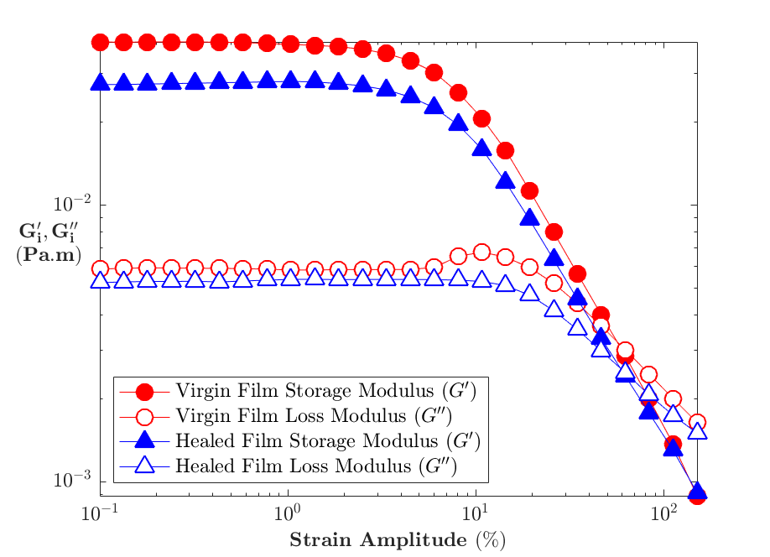
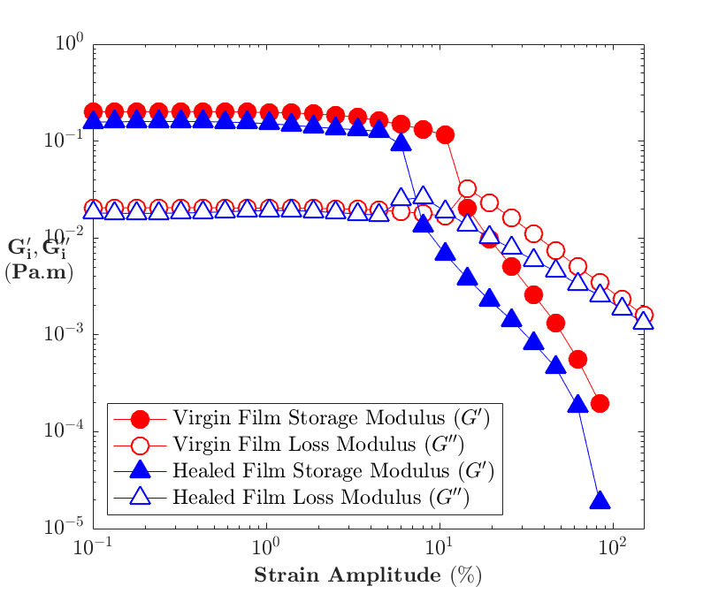
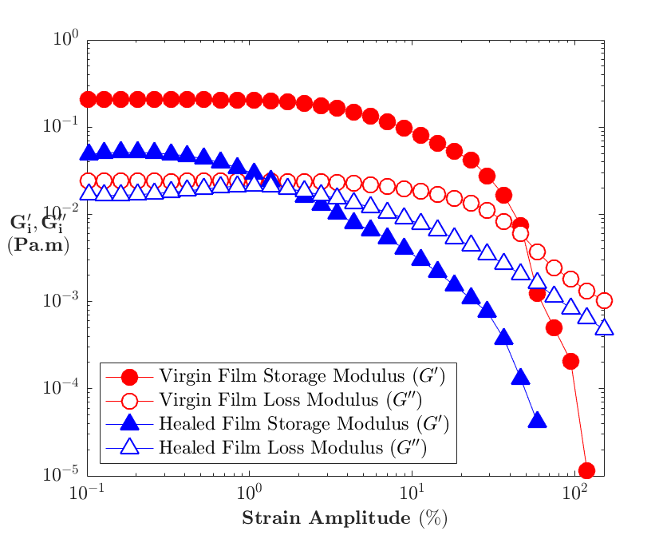
A
B
C

Figure S4.1: Comparison of different crosslinking times on the self-healing behaviour of the β-lactoglobulin films.
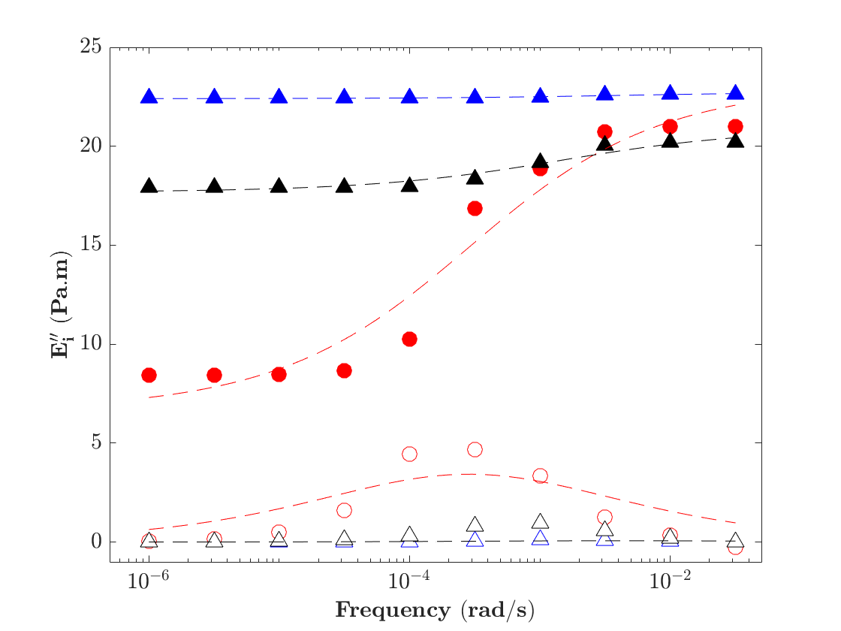
The comparison of different crosslinking times on the self-healing behaviour of the films as observed by the application of successive amplitude sweep to the film, the first amplitude sweep observed in red, and one taken after 30 mins of the film healing. The 3 different sweeps observed are of the native film prior to crosslinking (A), after 5 hrs of crosslinking (B) and after 24hrs of crosslinking (C).

Figure S4.2: The fit of the Lukassen and Van Dan Temple (LVDT) model to the pendant drop stress relaxation experiment.
There can be significant errors seen in the amplitude dependent behaviour of the capsules. This error was most significant with the misalignment of the cantilever and capsule, as seen in the data above. It was also prevalent in capsules with significant damage from the deposition process. All data from these capsules was discarded.

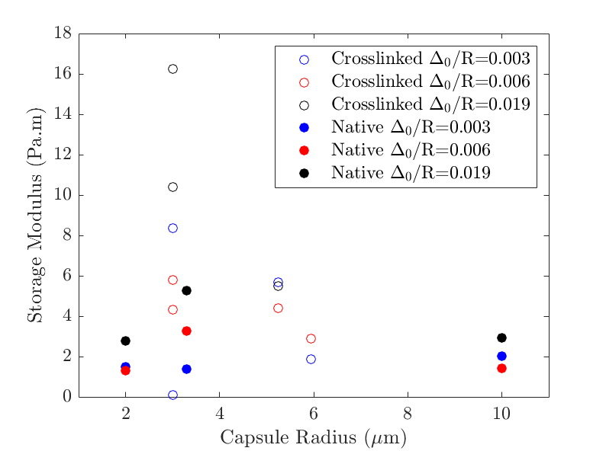
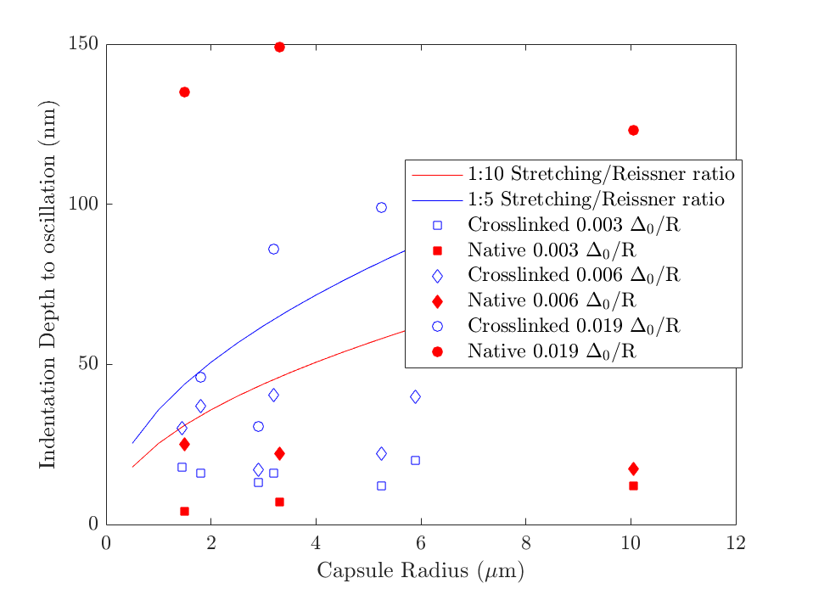
A
B
Figure S4.3 – Qualifying the validity of the oscillator indentation data by exhibiting the variability and limits of the indentation response. A is the comparative storage moduli (G’) of all capsule oscillations in this study and their measured storage moduli as a function of capsule radius and indentation depth. B plots the indentation depth vs capsule radius, and quantifies the potential stretching force to Reissner force ratio at these indentation depths.

As shown in Figure S3B, the line with an indentation depth of 10 % of the force may be from stretching compared to the Reissner regime capsule compression is plotted. This shows that for the majority of oscillation experiments under an indentation of 0.6% Δ₀/R, the capsules will be dominated by the thin shell compression mechanics in Reissner’s force and not volume conserved stretching.

9.2 Supplemental information for chapter 5 – Interfacial properties of chitosan in interfacial shear and capsule compression

9.2.1 Details of AFM fluid cell assembly.
To create a flat interface for imaging, a 1mm length of 0.5mm ID PTFE tubing (Cole Palmer, USA) was washed with ethanol and water and then attached via UV curable glue (Locktite 349, Henkel, Australia) onto the centre of a 1 cm x 1 cm cut microscope glass slide (Fischer Scientific, Australia) which was cleaned as above after roughing the centre. To form the interface, a small droplet of oil is added to the PTFE tubing and a larger cleaned round glass capillary of ID 8mm is placed over the top of the glued tubing. Chitosan solution is rapidly added to the capillary which forms the oil/water interface and excess oil is deposited onto the capillary. If the oil volume is not correct, a drawn glass capillary with a tip diameter less than 100μm attached to a syringe is used to correct the oil volume while the meniscus is visible through the larger round glass capillary. Once the oil is flat on the surface of the tubing, the large round glass capillary is removed, and solution is added if required. To begin the measurement, the interface is found initially, and imaging begins in a small area of 200x200nm at a slow rate of 1Hz to find the interface. A graphical explanation can be found in the supplementary information, Fig S4.

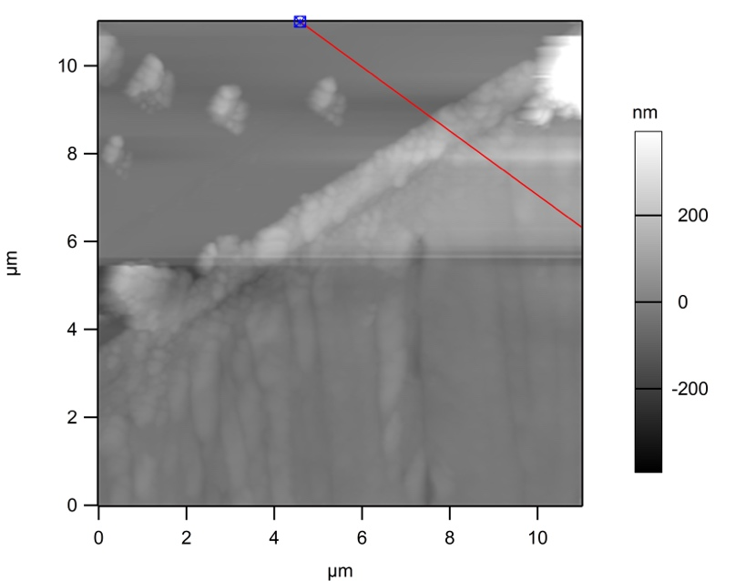
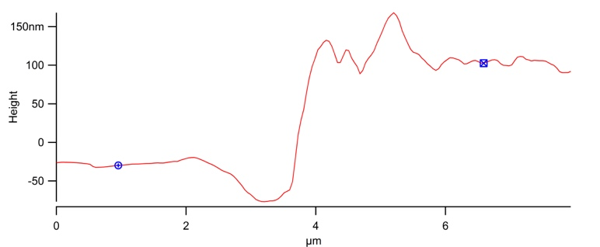

Figure S5.1 AFM image of air-water transferred chitosan film scratch test.
The image of the scratch of the trough transfer of the Air-water chitosan film, where the film has been transferred to mica. As seen in the cutline, the difference between the top layer and the base layer is 125-130nm.
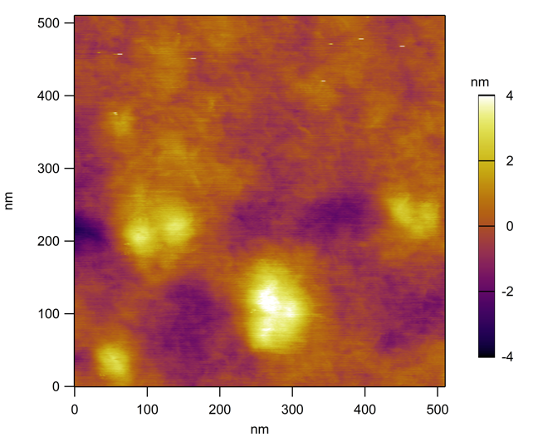
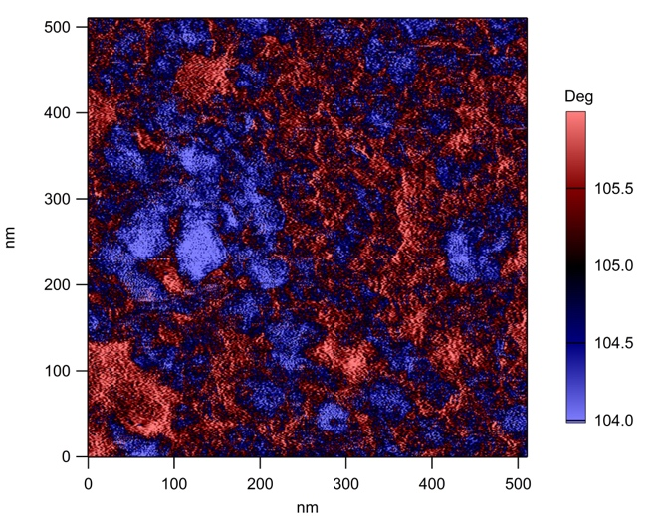
Figure S5.2 500x500nm AFM height and phase image of chitosan at the air/water interface.
The smaller image of the trough transfer showing both the height and the phase image. The height shows particles at the film surface, but in the base areas there is a clear differentiation between a particulate phase (blue) and an overlying phase (red).
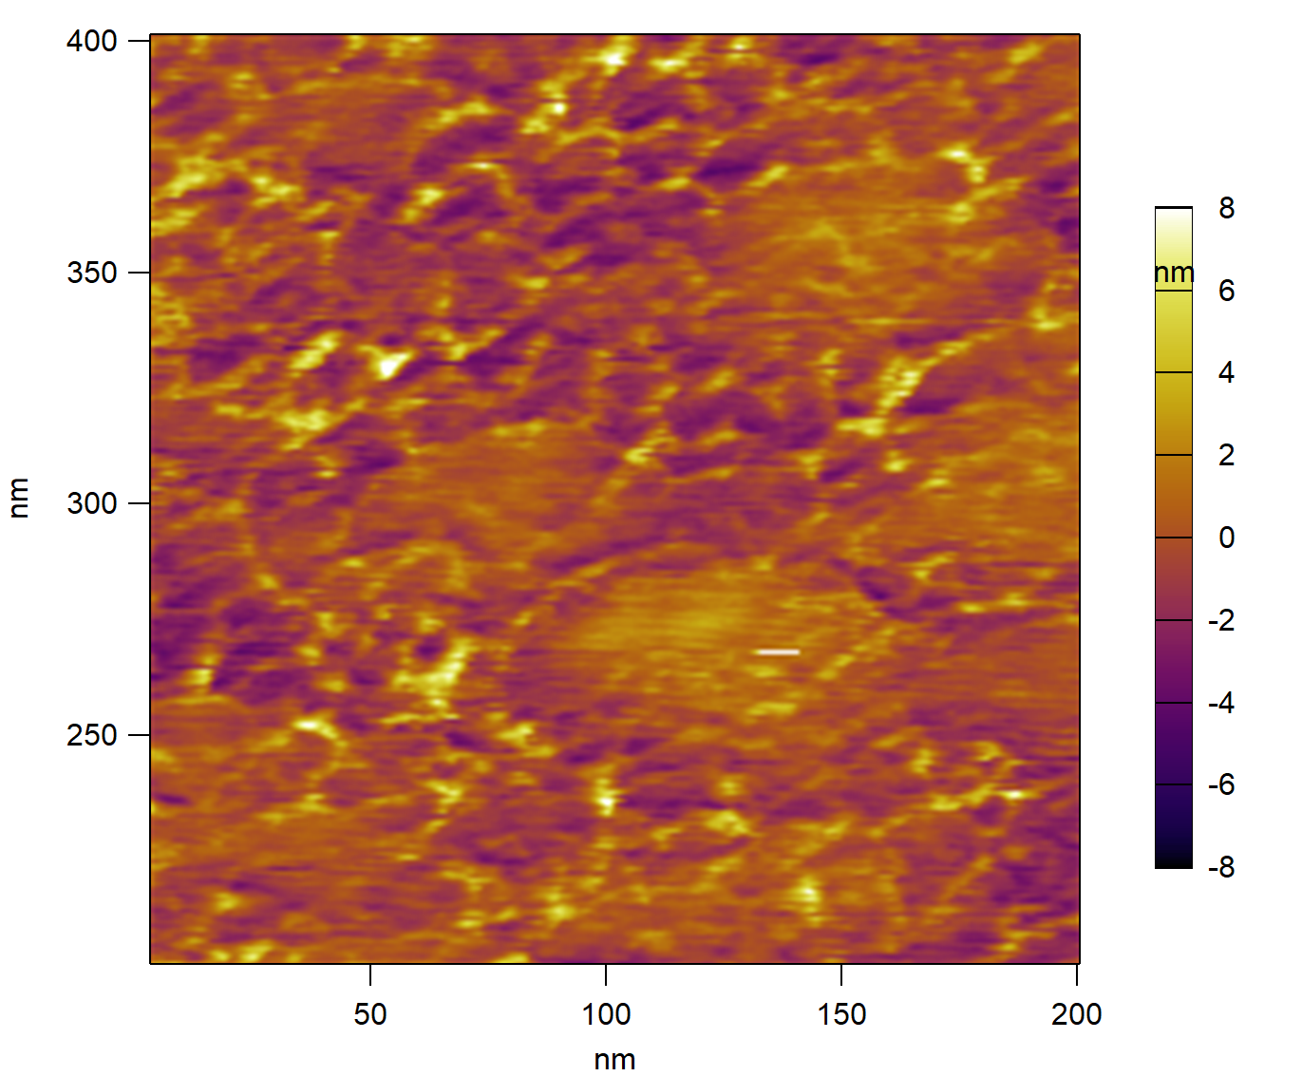
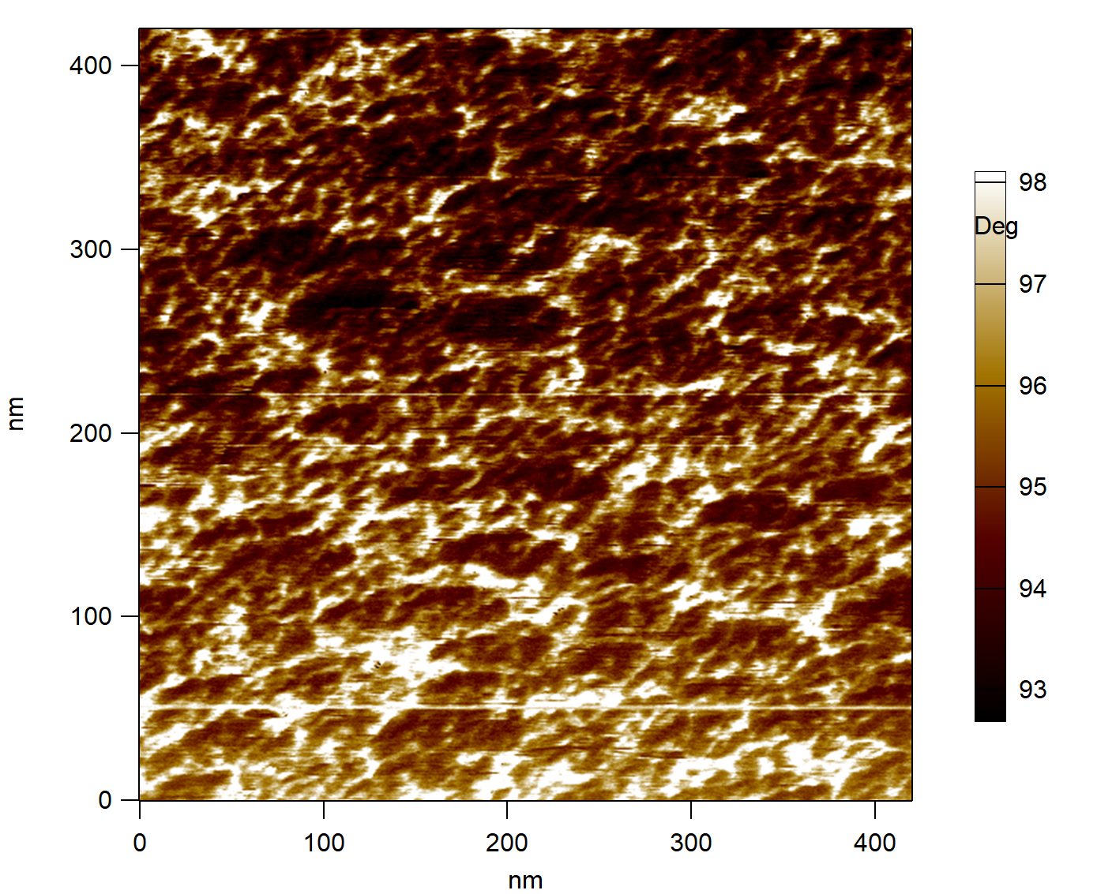

Figure S5.3 400x400nm height and phase image of chitosan at oil/water interface.
This is the 400x400nm height and phase image of the chitosan film from the aqueous side, after 5 hours of film building. This shows the presence of large particles at the film-water interface, and the outline of 10-20nm particles in the phase trace.

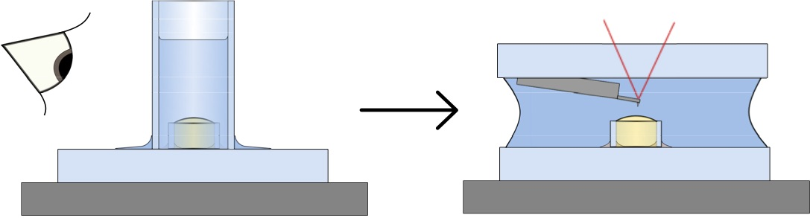
Figure S5.4 Graphical representation of oil droplet immobilisation technique.
A graphical representation of the method used to generate a flat oil/water interface in the aqueous solution used for in-situ imaging.

9.2.2 Supplementary information 4 – Oscillatory fitting procedure for Capsule Indentation
To quantify the viscoelastic behaviour of a capsule undergoing oscillatory compression with a colloidal probe, we modify the approach of Mahaffy et al. (2011). We consider small amplitude oscillation indentations $δ_{c}'$ relative to a mean indentation depth $δ_{0,c}$:
$$δ_{c}=Cδ_{AFM}=δ_{0,c}-δ_{c}'$$
The subscript c refers to the corrected indentation, which is related to the measured indentation $δ_{AFM}$ by a correction factor C that accounts for the effect of the substrate on the measurement (Berry et al., 2017). For a capsule with shell thickness $h≪R$, where $R$ is the radius of the capsule, the correction factor $C=0.5$.
For mean indentation depths $δ_{0,c}≲h$ the mean force on the probe is given by Reissner’s theory:
$$F_{0}=\frac{8G_{0}h^{2}δ_{0,c}}{\sqrt{3}R}{\left(\frac{1+v}{1-v}\right)}^{1/2},$$
where $G_{0}$ is the zero frequency shear modulus, and $v$ is the Poisson’s ratio (assumed to be ?).
The effect of the small amplitude oscillations on the measured force can be quantified using the first two terms of a Taylor’s series expansion of $F$ about the average indentation depth, yielding
$$F≈F_{0}+ δ_{c}'\frac{8G^{*}h^{2}}{\sqrt{3}R}{\left(\frac{1+v}{1-v}\right)}^{1/2}$$
Solving for the shear modulus G* gives
$$G^{*}= \frac{\sqrt{3}R}{8h^{2}}{\left(\frac{1-v}{1+v}\right)}^{1/2}\left(\frac{F-F_{0}}{δ-δ_{0,c}}\right)$$
This can be transformed to the frequency domain upon application of the correspondence principle:
$$G^{*}(ω)= \frac{\sqrt{3}R}{8h^{2}}{\left(\frac{1-v}{1+v}\right)}^{1/2}\frac{F(ω)}{δ(ω)}$$

$$F_{\text{drag}}=iωαδ_{c}'$$

Hertz:
$$F_{0}=\frac{{8G_{0}{δ_{0,c}}^{3/2}\overline{R}}^{1/2}}{3\left(1-v^{2}\right)}$$
$$F≈F_{0}+ δ_{c}'\frac{{4G^{*}{δ_{0,c}}^{1/2}\overline{R}}^{1/2}}{1-v}$$
$$\frac{F-F_{0}}{δ-δ_{0,c}}=\frac{{4G^{*}{δ_{0,c}}^{1/2}\overline{R}}^{1/2}}{1-v}$$
$$G^{*}= \frac{1-v}{{4{δ_{0,c}}^{1/2}\overline{R}}^{1/2}}\left(\frac{F-F_{0}}{δ-δ_{0,c}}\right)$$
$$G^{*}(ω)= \frac{1-v}{{4{δ_{0,c}}^{1/2}\overline{R}}^{1/2}}\frac{F(ω)}{δ(ω)}$$

Reissner:
$$F_{0}=\frac{8G_{0}(1+v)h^{2}δ_{0,c}}{R\sqrt{3\left(1-v^{2}\right)}}$$
$$F_{0}=\frac{8G_{0}h^{2}δ_{0,c}}{\sqrt{3}R}{\left(\frac{1+v}{1-v}\right)}^{1/2}$$
$$F≈F_{0}+ δ_{c}'\frac{8G^{*}h^{2}}{\sqrt{3}R}{\left(\frac{1+v}{1-v}\right)}^{1/2}$$
$$\frac{F-F_{0}}{δ-δ_{0,c}}=\frac{8G^{*}h^{2}}{\sqrt{3}R}{\left(\frac{1+v}{1-v}\right)}^{1/2}$$
$$G^{*}= \frac{\sqrt{3}R}{8h^{2}}{\left(\frac{1-v}{1+v}\right)}^{1/2}\left(\frac{F-F_{0}}{δ-δ_{0,c}}\right)$$
$$G^{*}(ω)= \frac{\sqrt{3}R}{8h^{2}}{\left(\frac{1-v}{1+v}\right)}^{1/2}\frac{F(ω)}{δ(ω)}$$
Berry:
$$F_{0}=\frac{8βG_{0}h^{3-α}{δ_{0,c}}^{α}}{\sqrt{3}R}{\left(\frac{1+v}{1-v}\right)}^{1/2}$$
$$F≈F_{0}+ δ_{c}'\frac{8αβG^{*}h^{3-α}{δ_{0,c}}^{α-1}}{\sqrt{3}R}{\left(\frac{1+v}{1-v}\right)}^{1/2}$$
$$\frac{F-F_{0}}{δ-δ_{0,c}}=\frac{8αβG^{*}h^{3-α}{δ_{0,c}}^{α-1}}{\sqrt{3}R}{\left(\frac{1+v}{1-v}\right)}^{1/2}$$
$$G^{*}= \frac{\sqrt{3}R}{8αβh^{3-α}{δ_{0,c}}^{α-1}}{\left(\frac{1-v}{1+v}\right)}^{1/2}\left(\frac{F-F_{0}}{δ-δ_{0,c}}\right)$$
$$G^{*}(ω)= \frac{\sqrt{3}R}{8αβh^{3-α}{δ_{0,c}}^{α-1}}{\left(\frac{1-v}{1+v}\right)}^{1/2}\frac{F(ω)}{δ(ω)}$$

When fitting the behaviour of the oscillatory capsule indentation, we follow the routine set out by Biviano et al, and modify it with the addition of rescaling of the indentation by the following relationship from Berry et al:
$$\frac{F \sqrt{3\left(1-v^{2}\right)}}{G(1+v){\left(\frac{h}{R}\right)}^{3}8R^{2}}=β{\left(\frac{Cδ_{afm}}{h}\right)}^{α}$$
$$F=β{\left(\frac{δ_{C}}{h}\right)}^{α}{\left(\frac{h}{R}\right)}^{3}\frac{8{G(1+v)R}^{2}}{\sqrt{3\left(1-v^{2}\right)}}$$
$$\frac{F-F_{0}}{δ-δ_{0}}=\frac{{8αβG(1+v)h}^{3-α}}{R\sqrt{3\left(1-v^{2}\right)}}{δ_{0}}^{α-1}$$

Reissner ($α=1, β=1$):
$$\frac{F-F_{0}}{δ-δ_{0}}=\frac{8G(1+v)h^{2}}{R\sqrt{3\left(1-v^{2}\right)}}$$

Hertz:
$$\frac{F-F_{0}}{δ-δ_{0}}=\frac{{4G(1+v)δ^{3/2}R}^{1/2}}{\left(1-v^{2}\right)}{δ_{0}}^{0.5}$$
Where the left hand side must be calculated and used as the input for indentation, as in Biviano et al, α and β were 1, and here they have non unity values, and must be calculated from Berry et al. The oscillations of the rescaled indentation and force can then be fitted for sinusoidal functions where:
$$G^{*}\left(ω\right)=G^{'}\left(ω\right)+iG''(ω)$$
$$G^{'}\left(ω\right)=G^{*}.cos⁡(ϕ)$$
$$G^{''}\left(ω\right)=G^{*}.sin(ϕ)$$
$$G^{*}(ω)=\frac{R }{4h^{3}}\frac{\sqrt{3\left(1-v^{2}\right)}}{1+v}\frac{F\left(ω\right)}{δ^{*}\left(ω\right)}$$

Where R is the capsule radius, h is the thickness of the shell, v is the Poisson’s ratio, G is the bulk shear modulus of the capsule film, E is the Young’s Modulus of the film, F(ω) is the amplitude of the force, δ*(ω) is the amplitude of the rescaled indentation, and φ is the phase lag between the rescaled indentation and the force. The rescaled indentation and force are fitted from the indentation and force response of the AFM indentation.

Abidine, Y., Laurent, V., Michel, R., Duperray, A., Iulian, L., Verdier, C. (2015). Physical properties of polyacrylamide gels probed by AFM and rheology. Europhysics Letters, 109.
Alcaraz, J., Buscemi, L., Colchero, J., & Baro, A. (2002). Correction of Microrheological Measurements of Soft Samples with Atomic Force Microscopy for the Hydrodynamic Drag on the Cantilever. Langmuir, 18, 716–721. https://doi.org/10.1021/la0110850
Alcaraz, J., Buscemi, L., Grabulosa, M., Trepat, X., Fabry, B., Navajas, D., & Farre, R. (2003). Microrheology of Human Lung Epithelial Cells Measured by Atomic Force Microscopy. Biophysical Journal, 84(March), 2071–2079. https://doi.org/10.1016/S0006-3495(03)75014-0
Mahaffy, R. E., Shih, C. K., Mackintosh, F. C., & Käs, J. (2000). Scanning Probe-Based Frequency-Dependent Microrheology of Polymer Gels and Biological Cells. Physical Review Letters, 85(4).

9.3 Supplemental information for chapter 6 – Nano-shear rheometer, bridging the nano- to mesoscale response of interfacial films

9.3.1 Materials and Methods
Materials
Poly-ethylene oxide (PEO) average molecular weight 200kDa, and 1,000kDa, Polystyrene Sulphonate 30kDa and 370kDa (monodisperse, with PDI 1.1 or better), Decane (ReagentPlus, >99%), Florisil (100-200 mesh) and Octadecyltrichlorosilane (99%) were purchased from Sigma Aldrich, Australia. Water used is Milli-Q (Millipore-Merck, Australia). Sodium Chloride (AR grade), Sodium Hydroxide (AR grade) was purchased from Chem-Supply Australia. Nitric acid 68% (AR grade), Cyclohexane (AR grade) and AJAX labware detergent were purchased from Thermofisher Australia. 𝛽-Lactoglobulin (90% PAGE) was purchased from Sigma Aldrich, St. Gallen, Switzerland. All materials are used as provided, where the Decane was purified prior to use by the eluted twice through a 10cm packed column of Florisil, and the interfacial tension checked against Milli-Q water for a stable interfacial tension of 50±2mN/m. Sodium dodecylsulphate was purchased from Sigma Aldrich Australia (99%, SDS Page) and recrystallized in ethanol (AR grade, Thermofisher Australia) prior to use.
Solution Preparation
All polymer solutions are made with Milli-Q water, where the PEO, PSS and 𝛽-Lactoglobulin are dissolved 24hrs prior to use. The PEO and PSS are dissolved at 0.2mg/L and the 𝛽-Lactoglobulin is dissolved at 0.1mg/mL into Milli-Q water.
Figure S6.1 – Schematic of the pinned interface setup and the interface generation technique

Pinned interface setup
The setup is summarized in figure S1, where a small volume of oil is held in a ~1mm length PTFE tube with an inner diameter of between 0.5 and 1mm, which is adhered to a glass slide either for mounting on a stainless steel puck or into an MFP-3D fluid cell. To manufacture these devices, for the puck mounted setup, 1mm thick glass microscopy slides (Thermofisher, Australia) are cut into 10x10mm squares, and the MFP-3D round glass slides are used as purchased. The centres of these glass slides are roughened slightly with round diamond tipped drill bits, and then soaked first in 10% AJAX labware detergent diluted with Milli-Q water for an hour, then 10% Nitric Acid solution with Milli-Q for 1hr, and then left overnight in 10% sodium hydroxide solution with Milli-Q, where between solutions, the glass pieces are washed with copious amounts of Milli-Q water. Once soaked, the glass is then dried under nitrogen flow prior to the attachment of the PTFE tubing. A 1mm length of 0.5 – 1mm ID PTFE tubing (John Morris, Australia) is carefully cut square with a scalpel, and washed with isopropanol, ethanol and water. A small amount of optically clear UV curable resin (Loctite 349, Henkel Australia) was smeared into the roughened area and spread with a disposable stainless steel cannula. The washed PTFE tube is then placed into the glue with tweezers and placed in a chamber with ~380nm fluorescent UV lamps for 1hr. The glass slides are then either attached to a puck or placed in the MFP-3D fluid cell. To ensure cleanliness the fluid cell and heads of the AFM, both are disassembled and cleaned with isopropanol, ethanol and water prior to use. The glass slides are made immediately before use, and discarded after the experiment.

Interface Generation
To generate the droplets or bubbles used, the pinned droplet setup is is placed in the AFM. All liquid handling is done by cleaned pasteur pipettes. For the PEO/PSS experiments, the PTFE tube is left empty and a 2cm long 8mm ID glass tube is then placed over the top of the PTFE tube and the aqueous solution is pipetted into the glass tube. To create the interface for the 𝛽-lactoglobulin experiments, an aqueous solution of 𝛽-lactoglobulin is added to the PTFE tube, slightly overfilling the tube. A 2cm long 8mm ID glass tube is then placed over the top, and decane is added to the top of the glass tube. Once the interfaces have been generated, a small LED torch is shone behind the sample to check for the meniscus of the droplet or bubble is flat. If not, a pipette is used to remove the air or water from the PTFE tube. Additional fluid is then added to the setup to ensure a stable experiment, and the 8mm ID glass tube is removed slowly from the bulk fluid. Before bringing the AFM head into the solution, a droplet of the bulk fluid is added on top of the cantilever.

AFM Setup
The AFMs used in this work were an MFP-3D, and a Cypher-ES (Asylum Research, CA, USA). The MFP-3D is used for the 𝛽-lactoglobulin experiments, and the Cypher-ES is used for all other experiments. The cantilevers used for the 𝛽-lactoglobulin experiments, with varying surface pressure, are Nauga Needle HAR-NP CM-13, which are 450x50x2𝜇m probes with a nominal spring constant of 0.2N/m, that have 3-6𝜇m long, 100-200nm diameter Ag₂Ga rods grown from the ~15mm height tip, as seen in figure x. For higher sensitivity measurements of interfaces with constant surface pressure, Biolever mini cantilevers (Olympus, Asylum Research Probe store, CA, USA) have been used, which have nominal dimensions of 38x16x0.2𝜇m with a 7𝜇m height tip, and a <10nm diameter oxide sharpened tip. These both have been individually dimensionally characterised by the use of SEM (FlexSEM 1000, Hitachi). Prior to use, the Biolevers are hydrophobised by first rinsing in ethanol, then Milli-Q water each for 5 minutes, placed in a UV-Ozone chamber (Procleaner, Bioforce, Holgate Scientific, Australia) for 10 mins, and directly soaked in a 1% solution of octadecyltrichlorosilane (Sigma Aldrich, NSW, Australia) in cyclohexane for 15 mins. The cantilevers are then washed in cyclohexane, ethanol and water, and are used immediately after functionalisation.

The spring constants were determined with the use of a laser doppler vibrometer or LDV (MSA-400, Polytec, Waldbronn, Germany), which measures the thermal motion of the cantilever tips as a function of frequency by utilizing the interferometric change of the frequency of light due to a doppler shift³⁷⁵. The thermal method pioneered by Hutter and Bechhoefer, was used to determine the torsional spring constant based on the adaption by Gates and Pratt using an LDV approach.^{215, 221}. The displacement spectrum was observed from 5kHz to 350kHz at 1 point per 8Hz with a 50x objective, and the spectrum was taken over 10s to reduce thermal drift²²². The primary lateral peak was determined by comparing the thermal spectrum of the centre of the cantilever and the edge of the cantilever and finding the additional peak that arises from the spectrum taken on the edge^{221, 225, 376}. The thermally driven amplitude is determined by integrating the displacement power spectrum vs over the peak by fitting a simple harmonic oscillator function with a white noise term³⁷⁷ which can be used to determine the torsional spring constant.

$$k_{θ}=\frac{k_{B}Tχ}{{{(A}_{RMS1 }+A_{RMS2})}^{2} }Δd^{2}$$

Where k_{B} is the Boltzmann constant, T is the temperature in Kelvin, 𝜒 is the mode shape correction factor and is equal to 0.811 and the Δd is the distance between two points on the same horizontal axis across the cantilever²²⁴. The distances were calibrated by the use of a known distance within the LDV, and then the laser positions were calibrated from those positions. Typical values of the torsional spring constant were 5e-11 N.m/rad for the Biolever mini cantilevers and 1e-8 N.m/rad for the HAR-NP cantilevers. For the HAR-NP cantilevers normal spring constants are also determined from the LDV measurements by analysing the primary frequency of the cantilevers as determined by the first largest peak after the 1/f noise. The amplitude of these peaks is determined by fitting the power spectrum vs Hz utilizing the modified MATLAB function of Yates et al³⁷⁷ with an additional peak finding algorithm to automate the peak fitting. Biolevers, are calibrated with the Sader method for both normal²¹⁶ and lateral³⁷⁶ modes. Normal spring constants ranged from 0.08 to 0.2 N/m for the Biolevers and 0.15-0.4 for the HAR-NP cantilevers. LDV measured spring constants are checked against the Sader method for normal²¹⁶ and lateral³⁷⁶ cantilevers for cross comparison, utilizing the online calibration applet, and found to be within 1% of the LDV measured values.

The normal and lateral inverse optical lever sensitivity, required to convert the AFM voltage signals, was determined using the measured respective spring constants and calculating the sensitivity from the thermal spectra of the cantilever in water according to the methods outlined in^{226, 228}. From a simple harmonic oscillator fit for the primary resonant torsional peak, the inVOLS can be calculated^{226, 228}:

$$γ=h\sqrt{\frac{2k_{B}Tk_{θ}}{πf_{0}P_{DC}Q}}$$

Where g is in units of N/V, h is the total height of the tip, f₀ is the resonant frequency, P_{DC} is the DC power variable, and Q is the Q factor. To note, ensure the P_{DC} must be corrected for the estimated inVOLS to ensure a correct voltage is used. Due to the small indentations depths used in these experiments compared to the length of the tips we have assumed that h is the length of the measured tip length. The same procedure can be applied to the primary resonant peak in the normal thermal spectra with the following relationship²²⁶.

$$γ=\sqrt{\frac{2k_{B}Tk_{N}}{πf_{0}P_{DC}Q}}$$

AFM protocol
Once calibrated, the tip is lowered into the droplet or bubble with a 0.1V differential trigger, utilizing the 4x bottom objective to ensure that the tip is placed in the centre of the droplet or bubble, or offset slightly to ensure the tip is contacting the interface. Once the cantilever has reached the interface, a force curve is taken and a jump to contact and a dewetting adhesion are checked for as per figure S2. Caution has been taken when approaching the interface as the curved surface may contact the body of the cantilever prior to the tip, producing non-linear lateral force behaviour.

To determine the lateral shear behaviour, an appropriate normal force is determined from the normal force curves and utilized for the lateral shear. The retraction force is also used to determine the equilibrium wetting radius on the tip³⁴⁹, where the equilibrium interfacial tensions of the PEO and PSS systems are 63mN/m^{355, 356} and 72mN/m^{206, 357, 358} respectively. When running lateral shear experiments, low forces <1nN are used to ensure a consistent wetting behaviour. Furthermore, the position of the tip is kept close to the centre of the bubble or droplet where the height variation is the least, to reduce any non-linear effects over the lateral force curve. Within the Asylum Research software suite, the friction loop is used, where a force setpoint is maintained over the force loop, similarly to a contact mode imaging experiment. This records the lateral voltage change as a constant velocity is used, where the velocity direction is changed when the predefined distance has been moved, generating a triangular waveform, as the distance moved is then reversed to come back to the original position. It should be noted, that all experiments are done with an integral gain (IG) of 15 or above for all experiments. There is a strong increase in the observed viscosity which plateaus out with increased IG if this is not done as seen in Supplementary Information Figure 1. Additionally, scan frequencies (number of scans per second) of 1hz or less are used. For comparison with the polymeric systems, a sinusoidal waveform is tested also, but no difference in the behaviour of the force was observed. The resultant force of the lateral movement is calculated by determining the difference between the positive and negative velocity directions, and dividing these observations by 2 assuming the viscosity is constant in both directions. Over 10-20 shear sweeps, there does not appear to be any degradation of the film for the systems tested. In the case of the 𝛽-lactoglobulin film though, the shear appears to affect the film formation over time, and as such the tip is moved between testing times. The resultant voltage differences are then multiplied by 𝛾 to determine the resultant force and used to calculate the interfacial viscosity.

To determine the drag on the cantilever from the subphases, the friction loop is also done far above the interface (>100𝜇m) in the same solutions with the same velocities and distances. In all experiments, there was no change in the voltage signal, and thus no drag on the cantilever was observed. Identical measurements of the interfacial viscosity were done at the interface of clean bubbles, and no signal is observed. It should be mentioned that these systems are highly sensitive to contamination, which can skew the datasets by orders of magnitude, thus high degrees of cleanliness of the equipment and setup are required.
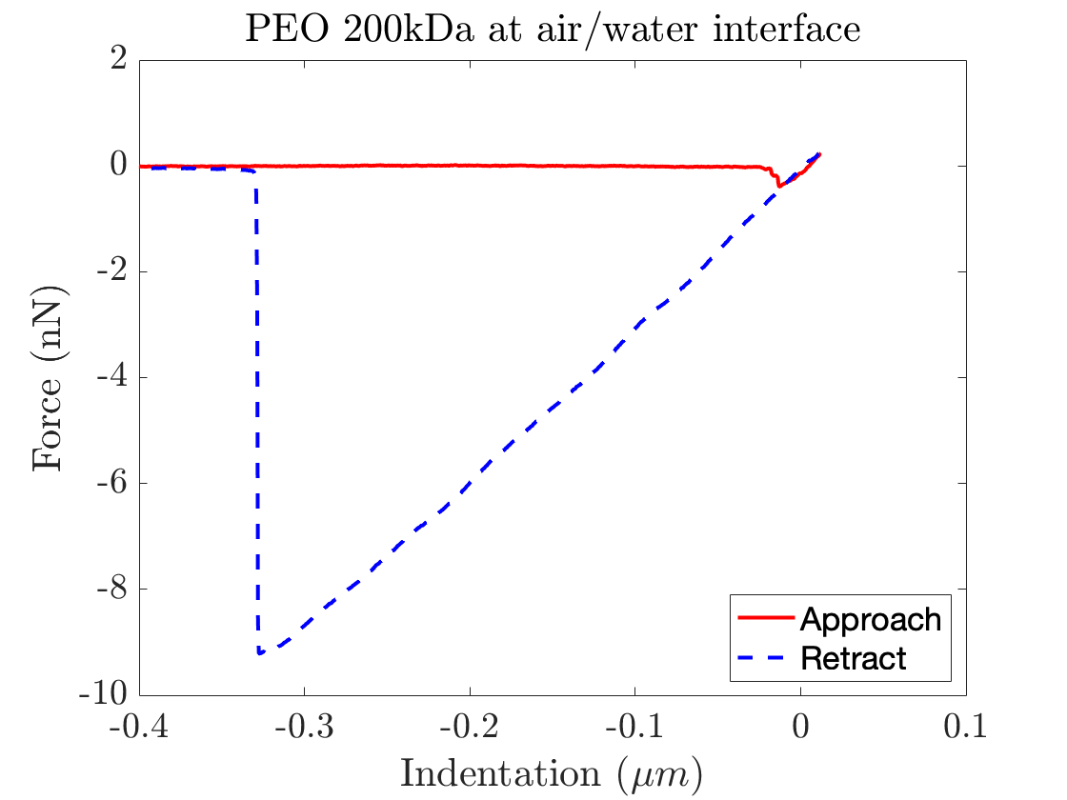
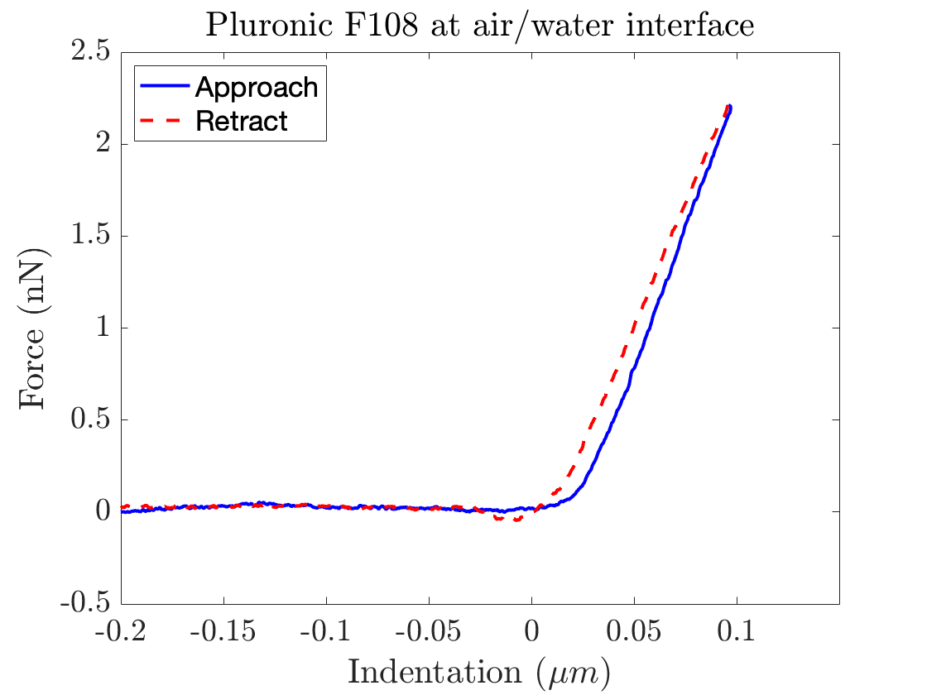

Figure S6.2 – Example of capillary force measurement – Successful and Unsuccessful.
Capillary force curve example from normal AFM force curves. Left: An example of a successful capillary force measurement of 200kDa PEO at the air/water interface. The curve shows a slight dip prior to the constant compliance region after indentation = 0 and a large adhesion on retract. Right: An example of an unsuccessful capillary force measurement of Pluronic F108 at the air-water interface. Where there is no dip prior to contact after indentation = 0, and no adhesion observed.

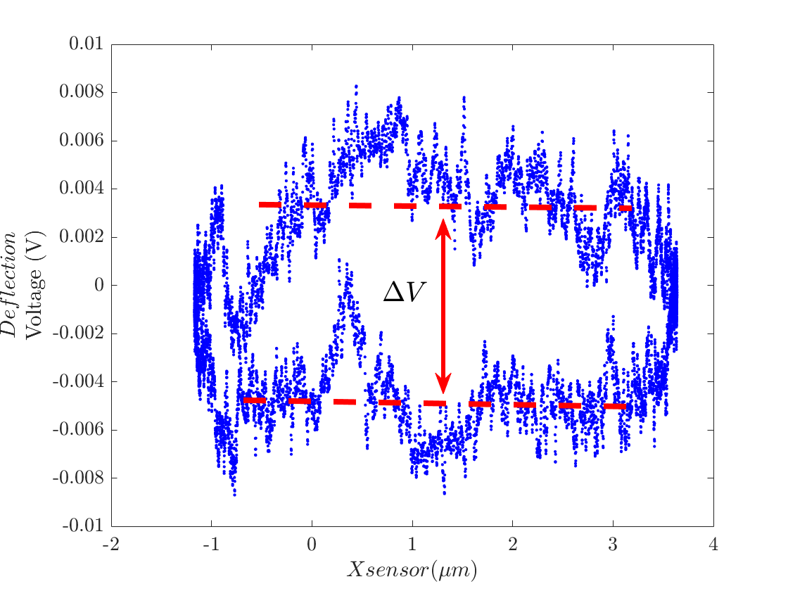

Figure S6.3 – Example of a PSS 350kDa force curve. The change in deflection voltage as a function of the X sensor is plotted.

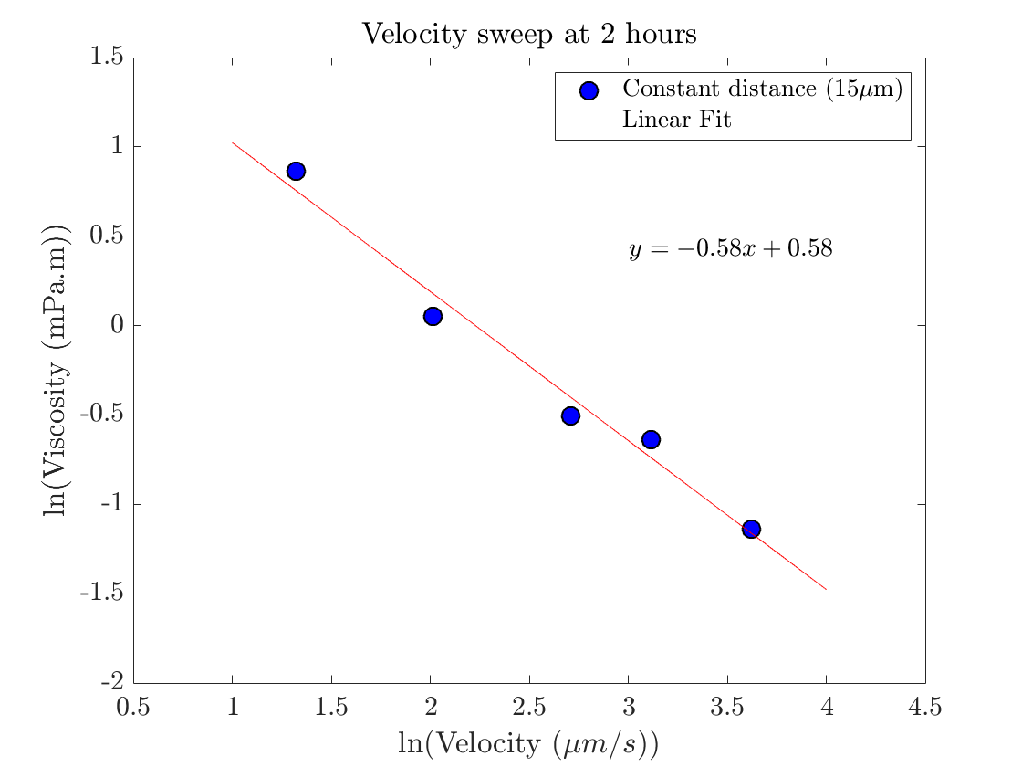
Figure S6.4 - Fitting the log transformed viscosity vs velocity data to observe and quantify the power law decay.

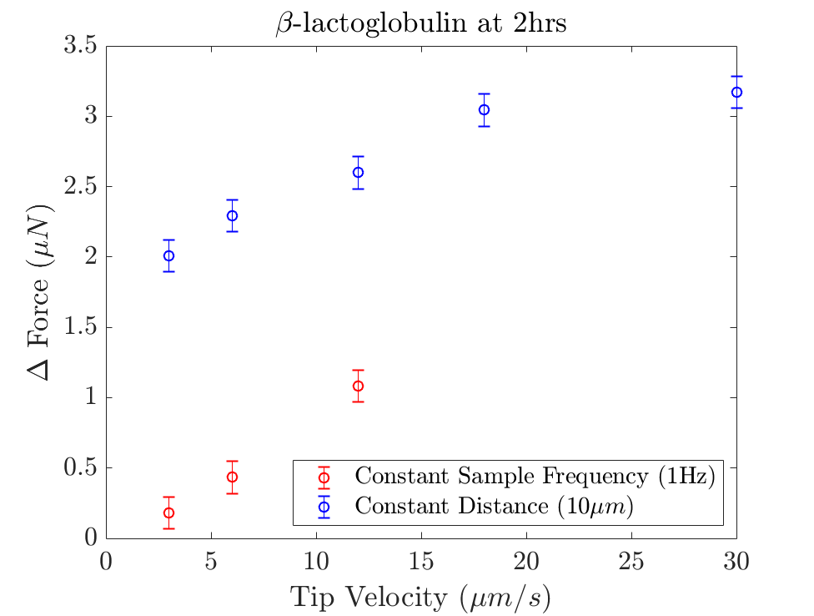
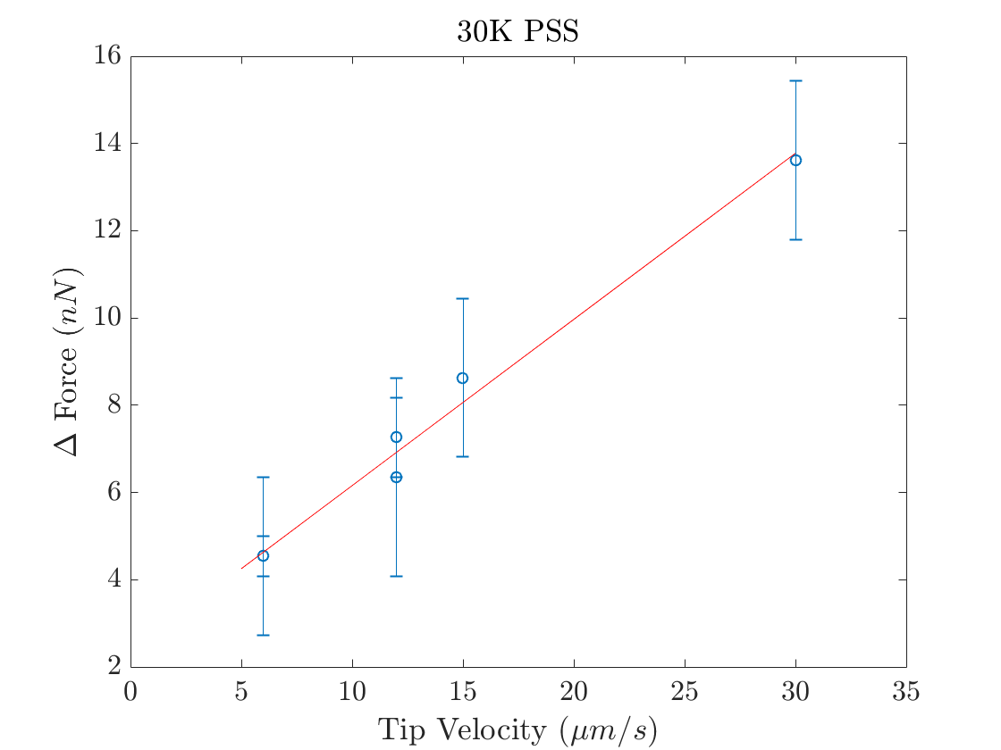

Figure S6.5 Translational force as a function of tip velocity for β-Lactoglobulin and PSS 30kDa
Left: The translational force as a function of velocity for β-Lactoglobulin after 2hrs of film building. The constant sample frequency and constant distance data are separated to highlight the different behaviours at different frequencies. Right: The translational force as a function of velocity for 30kDa PSS. The data consists of many various sample frequencies from 0.2Hz to 2Hz over various distances from 2μm to 5μm. The line is fitted to the data, and shows a highly linear fit to the viscosity, indicating Newtonian behaviour of the PSS film.

