Multi-scale influences on rainfall in Northeast Australia

Thi Lan Dao,ª Claire L. Vincent ,ª Todd. P. Laneª
ª School of Geography, Earth and Atmospheric Sciences and ARC Centre of Excellence for Climate Extremes, The University of Melbourne, Melbourne, Victoria, Australia

Corresponding author: Thi Lan Dao, thiland@student.unimelb.edu.au

ABSTRACT
This study examines the multi-scale modulation of mean and extreme rainfall in Northeast (NE) Australia under different background modes of variability, which is a new aspect given the high-resolution and long-term observational datasets. Daily rainfall probability is significantly modified by the Madden Julian Oscillation (MJO), and its influence varies with the seasons and is associated with atmospheric circulation anomalies. Rainfall generally decreases during El Niño and increases during La Niña years; however, there is a notable spatial nuance to the El Niño Southern Oscillation (ENSO)-associated extreme rainfall, with some locations showing the opposite precipitation response to the typical ENSO-rainfall relationship. Despite more precipitation overall in La Niña years, the mean and extreme precipitation responses to the MJO appear to be stronger and more often statistically significant during El Niño compared to La Niña periods. The impact of ENSO on the MJO-rainfall relationship is stronger than the variation of the MJO itself with ENSO, and likely reflects a change in the MJO-modulation of rain-bearing atmospheric processes. During El Niño periods, diurnal rainfall amplitude is generally stronger in the central and southern subtropical parts of the study area than during La Niña periods, while the opposite tendency occurs in the northern tropical part. The diurnal cycle of both mean and extreme precipitation is amplified during suppressed convection phases compared to enhanced convection phases of the MJO. In general, the peak time of diurnal cycle does not change with MJO regimes, but there are some notable differences in rainfall propagation between enhanced and suppressed MJO phases.

SIGNIFICANCE STATEMENT
This study presents a new perspective on the relationship between precipitation in Northeast (NE) Australia and two important climate modes, the Madden Julian Oscillation (MJO) and the El Niño Southern Oscillation (ENSO). Rainfall in NE Australia is strongly influenced by the MJO, the ENSO and their interaction, suggesting that climate models need to capture both individual climate modes and their interactions for reliable rainfall projections. These findings have societal climate risk implications, as NE Australia is an area prone to catastrophic flooding due to extreme rainfall.
1. Introduction
Northeast (NE) Australia is an important agricultural region, with approximately 95% of Australia’s sugarcane being grown along coastal areas of Queensland (Smith et al., 2014). This area and the surrounding Gulf Country region are often exposed to extreme rainfall events such as the 2010-2011 Queensland floods (King et al., 2013a), the 2019 Townsville flood (Cowan et al., 2019), and the 2022 Eastern Australia floods (Goodwin, 2022). Rainfall in NE Australia mainly occurs during extended summer months (November-April) and its variability is associated with several large-scale climate modes. Although there has been extensive work examining the effect of individual climate modes on rainfall in the region, there has been limited research on understanding the way these drivers interact to influence rainfall. The El Niño-Southern Oscillation (ENSO), characterized by above-normal sea surface temperatures (SST) in the equatorial Pacific during El Niño events and vice versa during La Niña events, is the most prominent mode of interannual climate variability on Earth with notable influences worldwide (McPhaden et al., 2006; Guilyardi et al., 2009). El Niño and La Niña events tend to create unfavorable and favorable conditions for precipitation to occur during winter, spring and summer over NE Australia, respectively (McBride and Nicholls 1983; Lough 1991). In addition, a La Niña event has stronger impacts on the intensity and duration of precipitation compared to an El Niño event (Power et al., 2006, King et al., 2013a). Previous studies also suggested that the influence of ENSO on rainfall in Queensland, NE Australia depends on both the amplitude and zonal location of ENSO events (Murphy and Ribbe, 2004; Wang and Hendon, 2007). Wu and Leonard (2019) found a significant effect of ENSO on the dependence between extreme precipitation and storm surges in coastal Australia, and this relationship is driven by unequally weighted mechanisms due to the interaction between large-scale climate modes and local forcings. The Madden-Julian Oscillation (MJO) (Madden and Julian 1971,1972), characterized by a planetary-scale eastward propagation of atmospheric winds and convection with a period of about 30-60 days, is the dominant driver modulating rainfall in northern Australia on intraseasonal time scales (Wheeler & McBride, 2012). Over NE Australia, rainfall probability tends to be enhanced when the MJO tropical convection develops over the eastern Maritime Continent, and reduced when the MJO convection occurs in the western Indian Ocean and Africa (Wheeler et al., 2009). Da Silva and Matthews (2021) found a stronger effect of the MJO on extreme precipitation than on mean rainfall over the Maritime Continent. In addition, Marshall et al., (2021) also suggested that the MJO has influences on extreme precipitation at weekly timescales in Australia.
The interactions between ENSO and the MJO, which may affect the rainfall associated with each climate mode, have been highlighted in previous studies. The spatiotemporal propagation of MJO is significantly modulated by different ENSO states, and this is explained by the dynamical wave feedback and moisture-convection feedback (Wei and Ren 2019). Using simulated data, Fonseca et al. (2019) also suggested that the amplitude of MJO events during boreal summer is strengthened in canonical El Niño years (SST warming in the eastern equatorial Pacific Ocean) and reduced in La Niña years, while the influence of ENSO Modoki (SST warming in the central equatorial Pacific Ocean) depends on MJO phases. In addition to the MJO-ENSO interaction, its impact on precipitation has also been discussed in several regions. For example, precipitation anomalies during ENSO events can be enhanced or weakened when they co-occur with the MJO (Shimizu and Ambrizzi 2016). Hoell et al. (2014) found that the MJO regulates the intensity of tropical Pacific rainfall as well as the midlatitude teleconnections during ENSO years. The MJO-associated convection has been shown to modulate the effect of ENSO on extreme rainfall events over northern South America (Shimizu et al., 2017). During weak to moderate El Niño (La Niña) events, the MJO’s effect on the diurnal rainfall amplitude in Maritime Continent is increased (reduced), with a small impact on the phase of diurnal cycle. (Fonseca et al., 2019). Arcodia et al. (2020) found significant contributions of constructive and destructive interference between MJO and ENSO signals to extreme precipitation in North America. Vashisht and Zaitchik (2022) also pointed out a stronger response of rainfall in East Africa to MJO during El Niño periods compared to neutral and La Niña periods.
Using data from 43 stations, Ghelani et al. (2017) investigated the joint modulation of daily mean rainfall in tropical Australia by the MJO and ENSO. They found that the MJO-rainfall relationship over tropical Australia is stronger and more statistically significant in El Niño than in La Niña years. The authors further used statistical arguments to demonstrate that the impact of ENSO on MJO-precipitation connection is not just due to changes in the frequency and amplitude of the MJO with ENSO state, and therefore must relate to changes in the statistics of the precipitation under different combinations of MJO phases and ENSO states. Cowan et al. (2023) examined the combined effect of the MJO and ENSO on weekly precipitation probabilities across Australia using gridded data. They pointed out that in summer, the reduced rainfall signal associated with suppressed convection phases of the MJO in northern Australia during El Niño years is stronger than during La Niña or neutral ENSO years. These studies suggest that to improve predictions and climate-scale projections of mean and extreme precipitation events, it is essential to understand the joint modulation of local rainfall by large-scale modes of variability.
Many studies of the tropics show that there is a strong diurnal precipitation cycle with peaks over land (ocean) in the late afternoon or evening (early morning) and that the MJO plays a crucial role in regulating the diurnal cycle (e.g., Kikuchi and Wang, 2008; Rauniyar and Walsh 2011; Peatman et al., 2014; Vincent and Lane 2016). Over the Maritime Continent, rainfall is enhanced on the islands before the enhanced convection phases of the MJO reach the Maritime Continent and is suppressed when the MJO resides on the Maritime Continent (Birch et al., 2016; Ling et al; 2019; Qian 2020). Using a simulation with the Weather Research and Forecasting (WRF) model, Vincent and Lane (2017) further pointed out that there are two peaks in the diurnal cycle of precipitation over the Maritime Continent and the diurnal rainfall asymmetry is highly related to moisture availability rather than kinetic forcing. Rauniyar and Walsh (2011) investigated the influence of the MJO on characteristics of the diurnal cycle of precipitation over the Maritime Continent and northern Australia. Their results suggest that the average daily precipitation rate as well as the diurnal cycle of precipitation in northern Australia is modulated by the MJO. The diurnal cycle of precipitation over the Maritime Continent and northern Australia is also modulated by ENSO states (Rauniyar and Walsh, 2013). While previous studies have discussed the interaction between the diurnal cycle of rainfall and large-scale drivers, most of them focused on the Maritime Continent region. The diurnal timing of extreme rainfall and its interaction with climate modes in NE Australia are not well understood.
NE Australia has complex topography with the Great Dividing Range (GDR) acting as a marked separation between the eastern (coastal) and western (inland) parts of the region (Fig.1). The GDR produces orographic precipitation enhancement and affects the propagation direction of fronts and other weather systems, leading to the different precipitation pattern between two sides of the mountains with wetter conditions in the east (Theobald et al., 2015; Pepler et al., 2020, Twomey and Kiem, 2021). There have been a number of studies investigating the impact of the MJO and ENSO on Australia rainfall, but how these modes and their interaction affect precipitation extremes in NE Australia remains unclear. Moreover, the interactions of climate modes are overlaid with local variability caused by topography, coastal processes and convection, making this region a challenge for extreme rainfall prediction. Therefore, there is a clear need for a better understanding of the nature of regional precipitation in Queensland using high-resolution datasets. Most previous studies have focused on the relationship of rainfall and large-scale modes over larger areas such as the whole of Australia (Wheeler et al., 2009; Marshall et al., 2021; Cowan et al., 2023) or tropical Australia (Ghelani et al., 2017), which may limit them to providing detailed discussion of individual subregions. For those above reasons, this study specifically focuses on examining the modulation of mean and extreme rainfall in NE Australia under different background modes of variability to explore how the combined influence of these modes can impact the rainfall. The remainder of this paper is organized as follows. Data are described in section 2, and the methodologies for calculation of the daily rainfall probability and statistical significance tests are presented in section 3. Section 4 examines the impacts of climate modes on daily and sub-daily rainfall in NE Australia. Discussions and conclusions are presented in sections 5 and 6.
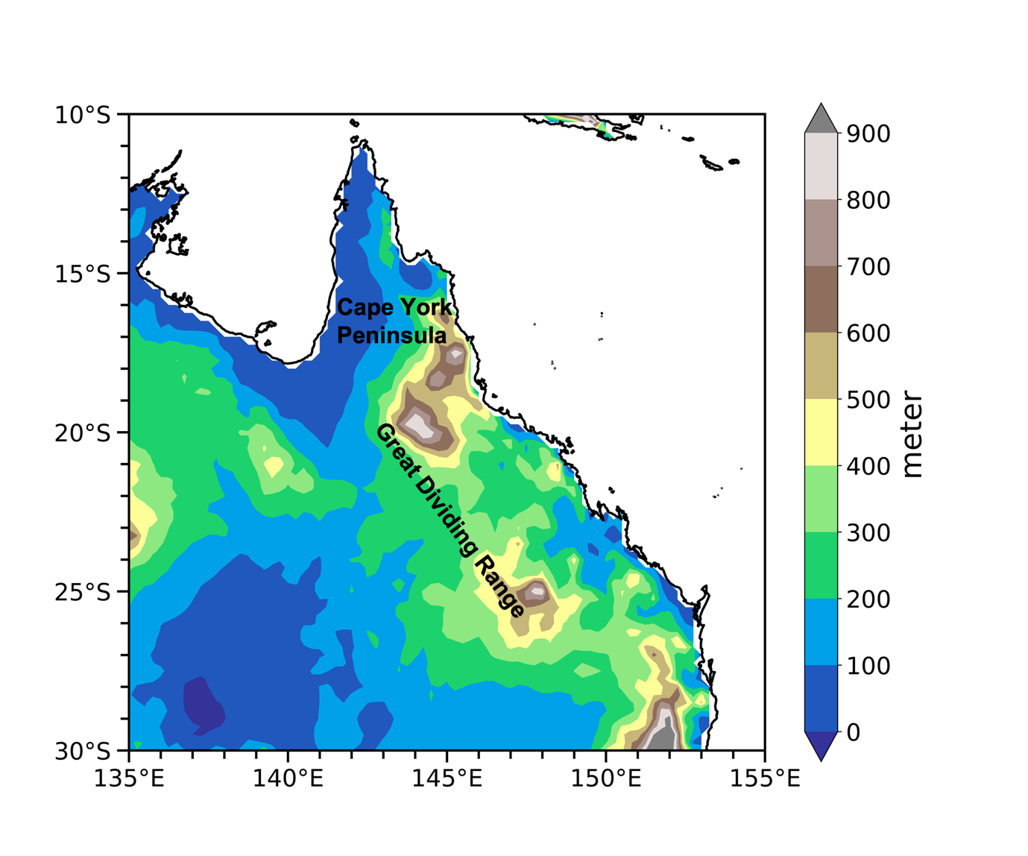
Fig. 1. Topographic map of study area. The locations mentioned in the study are shown in black font.
2. Data
a. Precipitation and wind data
Daily rainfall is obtained from the Australia Water Availability Project (AGCD) version 1 dataset, which is the Bureau of Meteorology’s official dataset for climate analyses. The AGCD dataset provides rainfall at daily and monthly timescales on a horizontal resolution of 0.05° x 0.05° (Jones et al., 2009). The dataset has been used extensively for investigating rainfall in Australia (King et al., 2013a; Black and Lane, 2015; Ghelani et al., 2017 and Dey et al., 2021) and can represent some extreme rainfall characteristics (King et al., 2013b).
The Tropical Rainfall Measuring Mission (TRMM) combined satellite 3-hourly gridded precipitation product 3B42 (Huffman et al., 2007, Tropical Rainfall Measuring Mission 2011) is used to examine the diurnal cycle of mean and extreme rainfall. The dataset has 3-hourly temporal resolution with a global horizontal resolution of 0.25° x 0.25°, covering from 50°S to 50°N latitude and from 1998 to 2019.
The 850hPa wind is obtained from the European Center for Medium-Range Weather Forecast ERA5 reanalysis data at 0.25°x0.25° spatial resolution for the period 1959-2022.
b. MJO index
Two indices, namely the Real-time Multivariate MJO (RMM; Wheeler and Hendon, 2004) and Index Historical Reconstruction (IHR; Oliver and Thompson, 2012) are used to define the MJO amplitude and phase. We use two indices to classify MJO phases as none of the available indices fully cover our study period (1959-2022). The RMM index is constructed using a pair of multivariate empirical orthogonal functions (EOFs) of equatorially averaged upper-and lower-level zonal winds and outgoing longwave radiation. The IHR index, a daily reconstruction of the RMM index from 1905 to 2015, is calculated from Twentieth-Century Reanalysis version 3 surface pressure (Compo et al., 2011). With a longer period compared to the RMM index, the IHR index is a better option for examining the joint modulation of precipitation by large-scale modes of variability which require long data records. This study uses the IHR index for the period 1959-2015, and RMM index for the rest of our study period (2016-2022). Note that the impacts of the MJO on rainfall in NE Australia during wet seasons (DJF; MAM) for the period 1974-2015 are similar between two indices. The entire cycle of the MJO is classified into eight phases namely phase 1 to 8 (Wheeler and Hendon, 2004). Phase 1 is defined when the MJO tropical convection develops over the western Indian Ocean and Africa. Phases 2 and 3 are over Indian Ocean, phases 4 and 5 are over the Maritime Continent, phases 6 and 7 are over the western Pacific, and phase 8 is over the Pacific Ocean. Only MJO events with an amplitude greater than or equal to one are chosen for composite analyses. With this criterion, each MJO phase has about 400 - 500 days to composite in each season for our study period (1959-2022). The exact number of days in each MJO phase is shown at the top right of the corresponding Figures.
c. ENSO index
Following Pui et al. (2012) and Ghelani et al. (2017), the Troup Southern Oscillation Index (SOI), calculated as the standardized anomaly of pressure difference between Tahiti and Darwin, is used to examine the influence of ENSO on precipitation in NE Australia. SOI is found to have the highest correlation with Australia’s rainfall relative to other ENSO indices (Risbey et al., 2009). In addition, the SOI, which forms the basis of SOI-based probabilistic precipitation forecasting (Stone et al., 1996), is one of the most dependable predictors aiding agricultural decision-making (Cowan et al., 2023). The monthly SOI values are smoothed with a 3-month running mean to obtain better correspondence with other ENSO indices (Slemr et al., 2016; Ghelani et al., 2017) and then converted to daily values using the smoothed monthly index for all the days of that month. To maximize the sample size for extreme precipitation analysis, following Cowan et al. (2023), the La Niña and El Niño phases are identified when the daily SOI value is ≥ 4 and ≤ -4, respectively. El Niño and La Niña events are listed in Table S1 in supplementary material.
3. Method
There are two different time periods used in this study. The first period is 1959-2022 for examining the impact of climate modes on daily rainfall. We specifically focus on the rainy season, from November to April, when examining the joint modulation of precipitation by the MJO and ENSO for additional data, especially for extreme precipitation. The second period is 1998-2018 for the diurnal rainfall analysis using satellite data.
This study firstly examines the impact of individual climate modes (e.g., MJO, ENSO) on NE Australia rainfall in different seasons. Some work on this has been done before (e.g., Risbey et al., 2009; Wheeler et al., 2009; Marshall et al., 2021, Cowan et al., 2023); however, most previous studies used lower resolution data, shorter time periods or focused on different timescales (e.g., weekly timescales). In addition, the independent influences of ENSO and MJO on extreme rainfall in NE Australia have not been well discussed. Using high-resolution data, this study focuses on the impact of MJO and ENSO on both mean and extremes rainfall at daily and sub-daily timescales, and on how these impacts are modulated by local forcings in NE Australia. We then investigate how the interaction of MJO and ENSO affects daily rainfall during the wet season (November to April). Multiple rainfall metrics using different percentile-defined thresholds are examined to give a comprehensive picture of how mean and extreme rainfall in Queensland are modulated by climate modes and their combinations.
The probability of daily rainfall exceeding a predefined rainfall threshold (e.g., the upper tercile) conditioned on MJO phase is defined as the number of days with precipitation greater than the threshold value divided by the total number of days for a specific MJO phase. Following previous studies (Wheeler et al., 2009, Ghelani et al., 2017; Pourasghar et al., 2019), the conditional likelihood is then calculated as the probability itself divided by the baseline probability. The value of one indicates that the probability of rain is unchanged from the baseline probability, while ratio values greater than one indicate an increase in precipitation probability, and less than one indicate a decrease. A baseline probability is defined as the actual probability of exceeding the threshold value regardless of MJO phase (Ghelani et al., 2017; Pourasghar et al., 2019). This means that in some areas where the upper tercile threshold of daily precipitation is equal to 0, the actual probability is smaller than 33%. To include the impact of ENSO, we perform the analysis above but limit it to days occurring during El Niño or La Niña periods.
Following Wheeler et al. (2009), statistical significance for MJO-related precipitation composites is evaluated using the Monte Carlo method, whereby we simulate 1000 randomizations of the MJO phase vector. Each iteration consists of a random shift of the MJO phase vector against the rainfall time series in 7-day steps and a recalculation of the precipitation probability as above. The allowed shifts in the method vary between 50 days and total length minus 50 days, and a confidence interval is built from these 1000 iterations. This method maintains the statistical characteristics of the MJO including its serial correlation and the different number of days in each MJO phase. This test assesses whether precipitation probabilities associated with MJO phases, are larger or smaller than that expected from random weather variations.
A double-significance test is also performed to test if the modulation of MJO-rainfall connection during a given ENSO state comes from the variation in precipitation response to the MJO during the ENSO state, or variation in the MJO itself because of its statistical connection with ENSO (Ghelani et al., 2017, Pourasghar et al., 2019). The first test, like the one described above (irrespective of ENSO period), evaluates whether rainfall probabilities are statistically significant compared to random climate variations. In the second test, we limit the simulated Monte Carlo phases vectors to only values from active ENSO period. This allows the variation of MJO phases distribution with ENSO to be considered implicitly. By considering only MJO phase values associated with one ENSO state, the MJO-ENSO statistical connection is preserved as part of the second Monte Carlo significant test. Thus, any significant results are outside the influence of this relationship. If the results satisfy both significant tests, they cannot arise because of the MJO-ENSO statistical relationship only and reflect the actual change in the MJO-precipitation relationship. The significance of the wind composite is evaluated using a local t-test that involves calculating the effective sample size and considering the lag 1 autocorrelation of the seasonal wind anomalies (Wheeler et al., 2009, Cowan et al., 2023).
For the influences of ENSO on daily precipitation, the statistical significance of rainfall and wind patterns is judged based on the Student’s t-test at a 90% confidence interval. All statistical significance tests are calculated and evaluated separately at each grid point. It should be noted that to consider the spatial dependence between grid point series, the significance of the individual grid-point test is then often evaluated through a False Discovery Rate method (Wilks, 2011; Short et al., 2019). However, since our results below indicate a lot of fine-scale variation that is obviously aligned with topographic features, we decided to present the statistical results at each grid point, with the caveat that around 5 in every 100 grid points may show a significant result by chance, and that in some cases these areas of chance significance may be clustered in space. However, we note that the large areas of significance shown in the results are unlikely to occur by chance.
4. Results
a. Influences of the MJO on rainfall in NE Australia
We first investigate the influence of the MJO on mean and extreme precipitation in NE Australia in different seasons (Figs 2-3). These results can be interpreted as the relative increase or decrease in the probability of rainfall exceeding the chosen thresholds (Fig. S1 in supplementary material). For the summer (DJF; Fig 2), the rainfall composite shows a marked difference between northern and southern Queensland, and a noticeable difference between inland and coastal areas. Daily rainfall probability in northern Queensland increases significantly during phases 5-7 associated with the occurrence of low-level westerly wind anomalies over the north of NE Australia, and decreases during phases 1-3 associated with the easterly wind anomalies. The greatest enhancement of precipitation likelihood occurs in phase 6 with a rainfall ratio above 1.4, and the largest suppression of rainfall probability appears in phase 1 with a ratio around 0.6. That is, the probability of receiving daily rainfall above the upper tercile threshold in northern Queensland varies from less than 20% (0.6 x 33%) in phase 1 to above 46% (1.4 x 33%) in phase 6. By analyzing composite 850-hPa wind (not shown), we further found that the anomalous westerlies in the north of study domain during phases 5-7 of the MJO result from a reversal of the wind direction to a mean westerly flow rather than indicating a weakening of the easterly trade winds during these phases. For southern Queensland, the enhanced rainfall signals associated with northeasterly wind anomalies are evident during phases 3 and 4 of the MJO, and the reduced rainfall signals along with anomalous southeasterlies occur during phases 6 and 7. The decreased precipitation associated with anomalous southwesterlies occurs over the entire region during phase 8, with a rainfall ratio of about 0.7.
Generally, the impact of the MJO on extreme precipitation is similar to that on mean rainfall with a strong north-south contrast in rainfall pattern during summer. Over northern Queensland, the extreme rainfall probability is significantly increased during phases 5-7, and decreased during phases 8, 1, 2 and 3. The ratio of rainfall probability increases by 1.4-1.6 times during phase 5-7 of the MJO, indicating that the chance of receiving rainfall above the upper decile (90th percentile) threshold is around 14-16% during these phases. In contrast, the rainfall likelihood ratio is about 0.5-0.7, which means that the probability of rainfall exceeding the upper decile values is only around 5-7% during phases 8, 1, 2, and 3. For southern Queensland, daily extreme rainfall probability is enhanced to 15 % (1.5 x10%) during phases 3 and 4, and reduced to 6% (0.6 x10%) during phases 6, 7, 8, and 1. The MJO-associated precipitation patterns for the 90th and 95th percentiles are similar but the 95th percentile precipitation pattern is less robust due to the smaller sample size of extreme events (not shown).
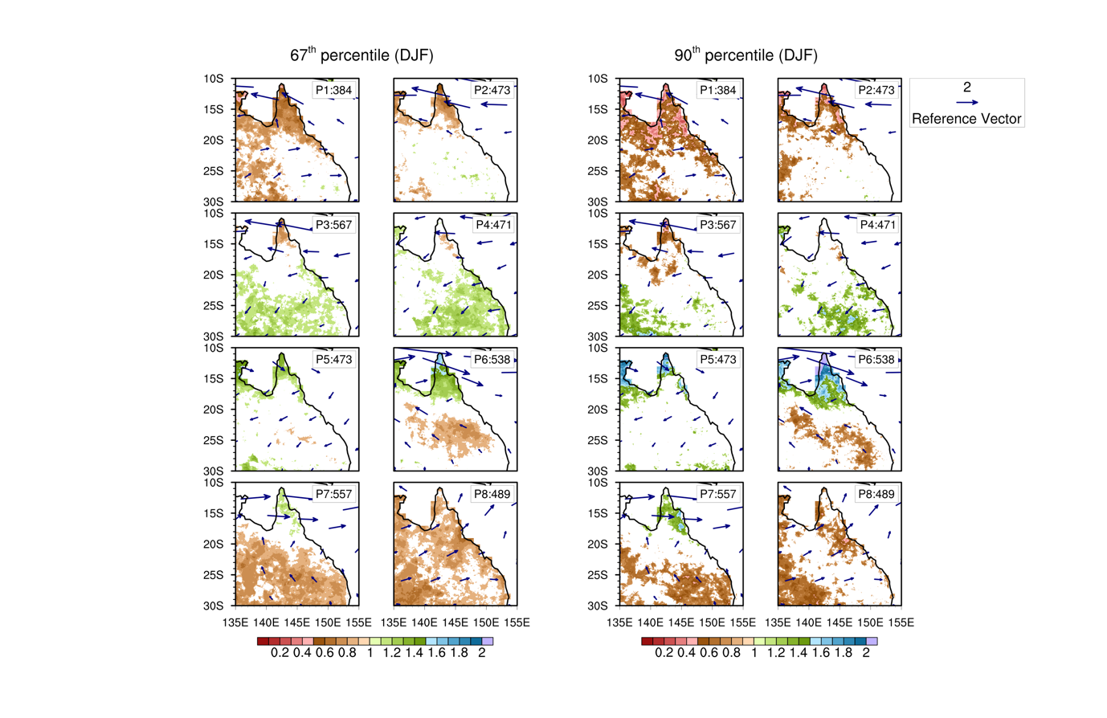
Fig. 2. Composites of daily rainfall probabilities (shading) exceeding the upper tercile (67th percentile) and the 90th percentile, expressed as a ratio to the climatological probability, and 850-hPa wind anomalies (vectors, m s⁻¹) during the summer (DJF) from 1959-2022 in eight different MJO phases (P1 to P8). Only statistically significant results at the 10% level are shown. Number of days for the corresponding MJO phase is indicated in top right of each panel.
The influence of the MJO on daily rainfall probability is observed to change in various seasons. For the autumn (MAM; Fig.3), rainfall likelihood significantly increases in phases 4-6 and decreases in phases 8, 1 and 2 across the whole NE Australia. Enhanced rainfall signals occur in conjunction with northerly anomalies in phase 4, and westerly anomalies in phases 5 and 6. In contrast, suppressed precipitation probabilities are associated with anomalous southerlies in phase 8, and anomalous easterlies in phases 1 and 2. There is a difference in the spatial distribution of precipitation patterns related to the MJO phases between summer and autumn. While the impact of MJO on precipitation in NE Australia exhibits a strong north-south gradient in summer, it shows less spatial variation in autumn. This may be related to the difference in the climatological winds between summer and autumn with more uniform wind anomaly patterns associated with MJO phases in autumn. The modulation of extreme precipitation by the MJO is also evident in autumn, with increased rainfall signals during phases 4-6 and decreased rainfall signals during phases 8, 1 and 2. For example, over the Cape York region, the likelihood of rainfall exceeding the upper decile threshold varies from 4-5% during phases 1-2 to above 18% during phase 6 of the MJO.
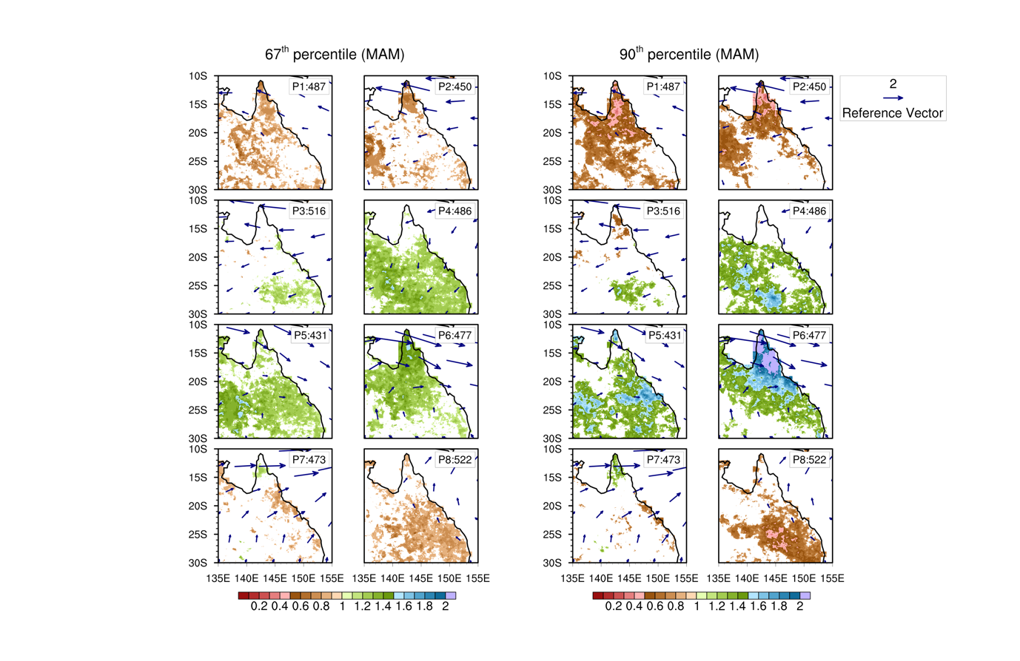
Fig. 3. Same as in Fig.2, but for the autumn (MAM)
These above results indicate that the MJO exerts a significant impact on mean rainfall over NE Australia, consistent with previous studies (Wheeler et al., 2009; Cowan et al., 2023). It should be noted that Wheeler et al. (2009) used data on a 1° grid, while this study is on a 0.05° grid, but our results are still consistent with their findings in both seasons (DJF; MAM). However, we also identify some differences in the probability of rainfall exceeding upper tercile thresholds compared to those of Wheeler et al. (2009). For example, we find weaker and less significant increased rainfall signals over Cape York during phase 5 of the MJO in autumn. These slight differences could be due to the use of different timescales (daily versus weekly scale), a different study period (64 years versus 30 years), the use of datasets with different spatial resolutions (0.05° grid versus 1° grid), and the use of different MJO indices. Focusing on a small area with high resolution data allows this study to better identify the variations of rainfall on small spatial scales. For example, this study shows a noticeable difference in the spatial distribution of precipitation with MJO over coastal, inland and elevated topography areas, which was not previously highlighted. In addition to mean rainfall, the MJO also has significant influences on extreme rainfall in NE Australia. The patterns of mean and extreme rainfall probability are relatively similar. The probability of extreme rainfall above upper decile threshold increases to 14-16% during enhanced convection phases (e.g., phases 5 and 6) and decreases to only 5-7% during suppressed convection phases (e.g., phases 1 and 2) of the MJO. This level of extreme rainfall modulation by the MJO may affect the risk of flooding in the region. The above analyses are mainly focused on wet seasons (DJF; MAM). The modulation of rainfall by the MJO in winter and spring is less pronounced and is not discussed in this study.
b. Influences of ENSO on rainfall in NE Australia
Figures 4-7 show the impacts of ENSO on rainfall over NE Australia for four different seasons. In summer (DJF, Fig.4), rainfall anomalies are modulated by ENSO and this modulation exhibits substantial geographical variation. During El Niño (Fig. 4a), significantly lower precipitation only appears in some sub-regions of Queensland. For example, the strongly suppressed rainfall signals associated with anomalous southeasterlies occur in a small area of northeastern Queensland (15°S-23°S, 140°E-150°E). In contrast, during La Niña periods, NE Australia typically experiences wetter conditions with positive rainfall anomalies of approximately 3mm/day (Fig. 4c). The enhanced rainfall signals during La Niña are associated with easterly anomalies over the subtropical south and northwesterly anomalies over the tropical north of Queensland. The extreme rainfall pattern related to ENSO shows a spatial complexity with some locations showing the opposite response to ENSO (Figs. 4b and d). Similar to mean rainfall, extreme precipitation is enhanced in southern Queensland, associated with easterly anomalies during La Niña years. In contrast, extreme rainfall is significantly decreased over the Cape York, in conjunction with anomalous northwesterlies during La Niña.
NE Australia generally experiences dry conditions during El Niño, and wet conditions during La Niña years in autumn (MAM; Fig 5). However, the composite rainfall signals also show a large variation with geographical location, especially for extreme rainfall. During El Niño periods (Fig. 5a), the significantly decreased precipitation signals along with anomalous southeasterlies are evident in northern Queensland. In contrast, during La Niña years (Fig. 5c), the increased rainfall in northern Queensland is mainly associated with strong northwesterly anomalies. The spatial complexity of ENSO-related precipitation is more evident in extreme precipitation patterns. Despite the overall decrease in extreme rainfall during El Niño years, there are still signs of increased rainfall in some sub-regions of Queensland (Fig. 5b). Precipitation is generally suppressed during El Niño and enhanced during La Niña in winter (JJA, Fig.6) and spring (SON, Fig.7). In winter, the anomalous easterlies dominate most of NE Australia during El Niño years, and the westerly anomalies occur during La Niña years. The composite of rainfall signal and low-level wind anomalies are relatively uniform across the entire study area in spring, suggesting that the effects of ENSO on spring precipitation are less influenced by local forcing such as the orientation of topography. These results are consistent with previous research findings that precipitation in NE Australia is typically suppressed during El Niño and enhanced during La Niña periods (e.g., McBride and Nicholls 1983; Lough 1991; Murphy and Ribbe 2004). However, there is a notable spatial nuance to this result, with some locations showing the opposite response to ENSO, especially for extreme rainfall events. In summer, for example, although extreme precipitation is generally increased during La Niña years, the Cape York region shows opposite signals.
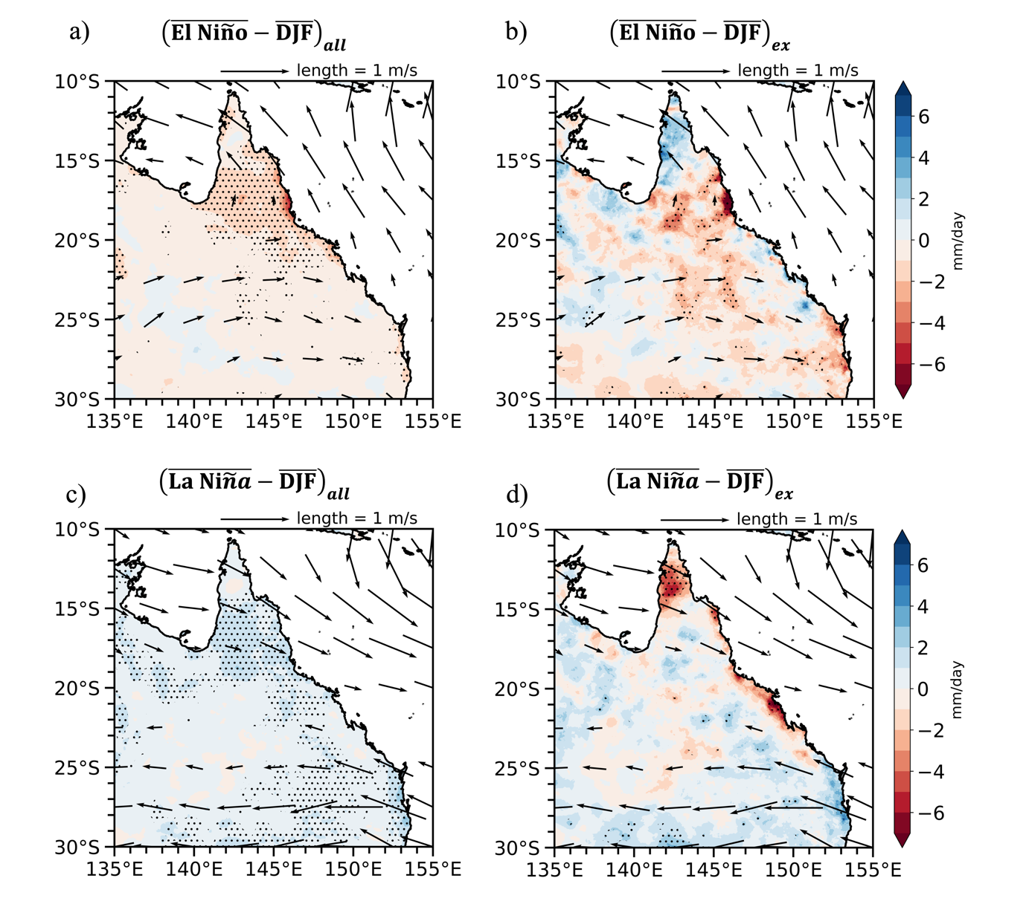
Fig. 4. Anomalies of mean rainfall (a,c) and 90th percentile rainfall (b,d) (shading, mm/day), and 850hPa wind (vectors, m/s) for two different ENSO states during summer season (DJF) from 1959-2022. Dots indicate where rainfall anomalies are statistically significant at the 10% levels. Only statistically significant wind anomalies at the 10% level are shown.

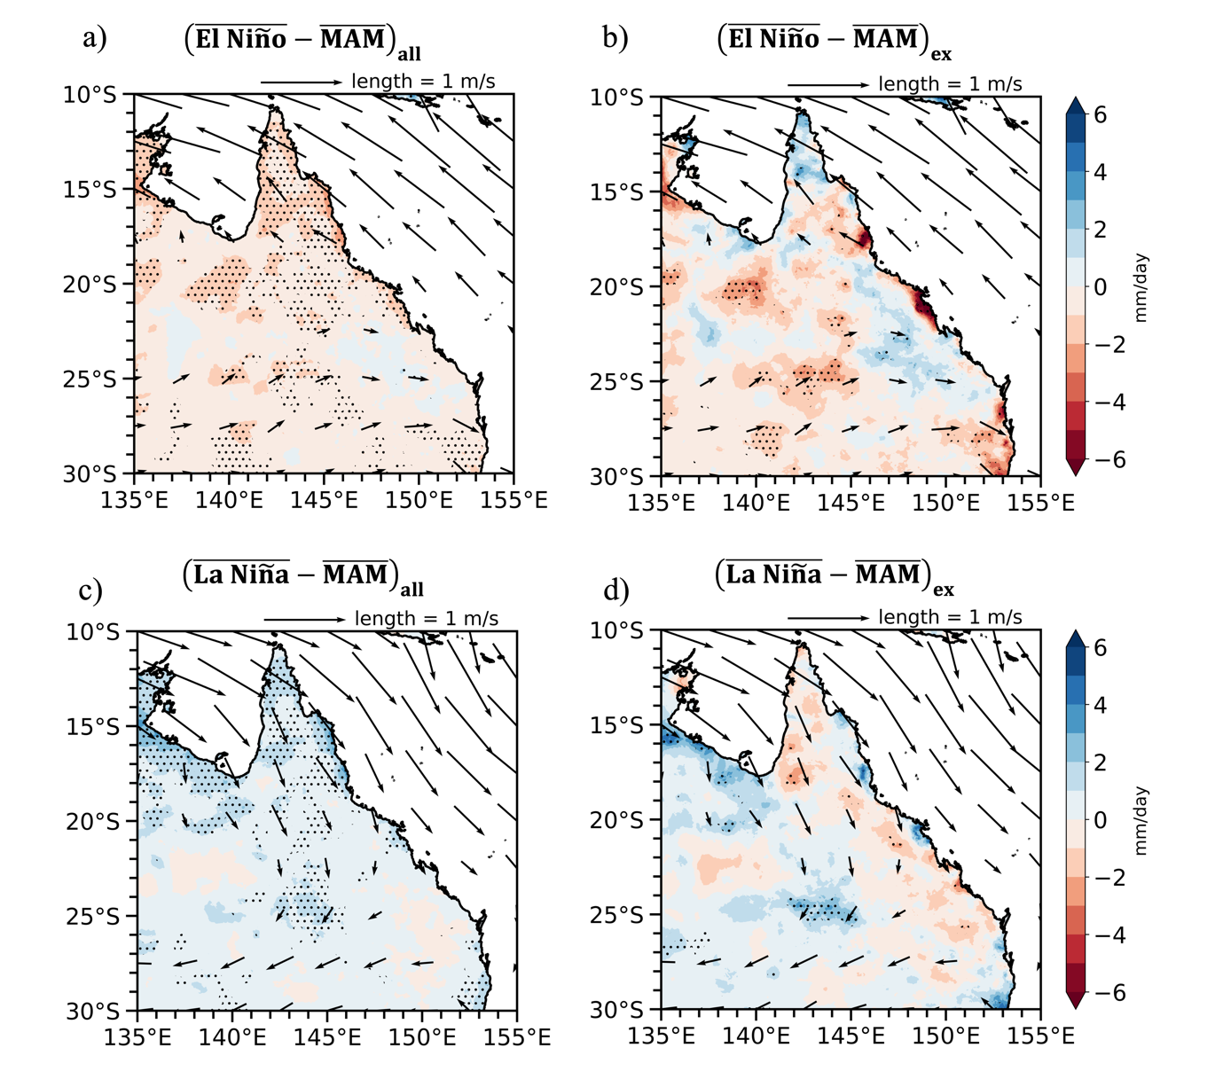
Fig. 5. Same as in Fig.4, but for autumn (MAM)
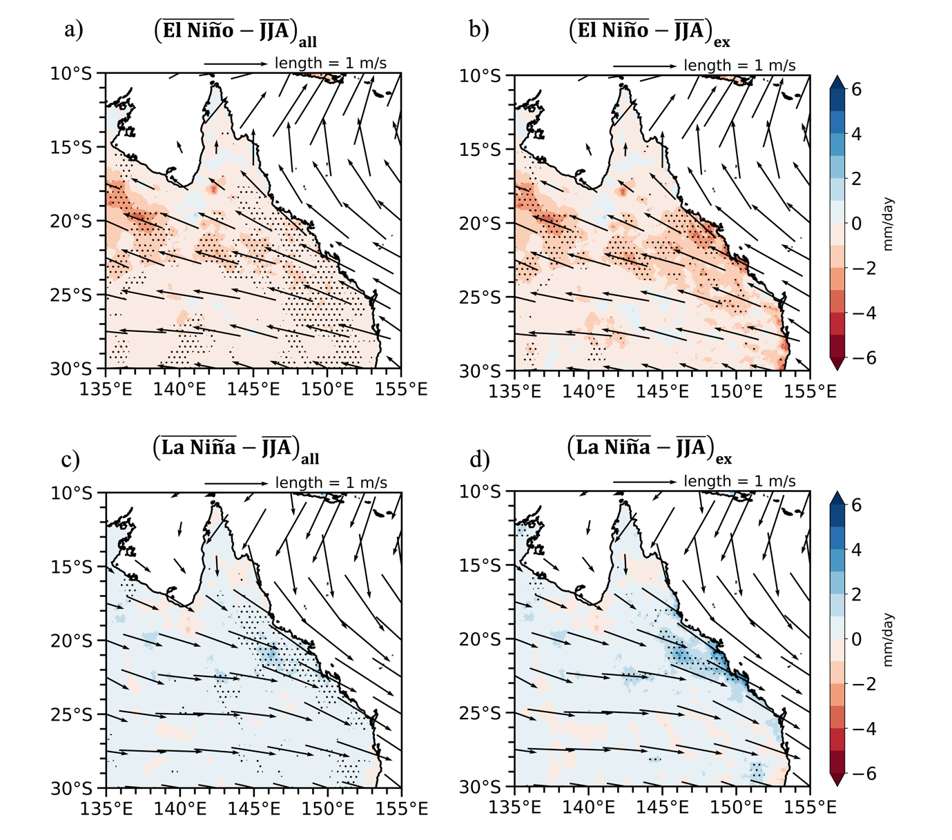
Fig. 6. Same as in Fig.4, but for winter (JJA)
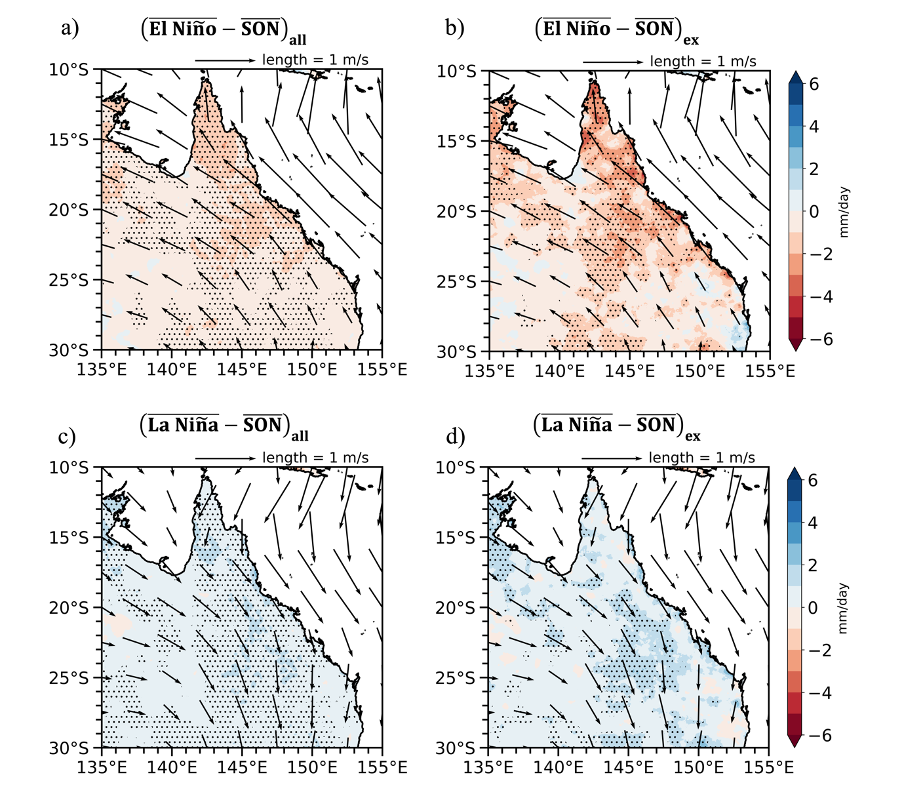
Fig. 7. Same as in Fig.4, but for spring (SON)
c. Joint impact of ENSO and MJO on rainfall in NE Australia
This section examines the combined influence of the MJO and ENSO on daily rainfall in NE Australia during the wet season (November to April) from November 1959 to April 2022. Figures 8 and 9 compare the probability of mean rainfall (67th percentile) and extreme rainfall (90th percentile) with MJO phases under different background ENSO conditions, respectively. It is noted that the probability of rainfall exceeding the 67th or 90th percentile threshold in NE Australia is higher during La Niña compared to El Niño years (Figs. S2 and S3 in supplementary material), where the percentiles are defined using all time periods, irrespective of ENSO phases. Here, we examine rainfall probabilities relative to the 67th or 90th percentile threshold of a given ENSO phase. This approach helps elucidate the scale interaction, but also has a practical basis: under background drier El Niño conditions, the stakeholder impact of enhanced rainfall caused by the MJO may be highly significant for water sensitive applications, while under background wetter La Niña conditions, the impact of enhanced rainfall could be critical for hydrological systems that may already be saturated.
During El Niño, the probabilities of upper tercile precipitation are significantly enhanced in phases 4-6 and suppressed in phases 8, 1 and 2 of MJO. The enhanced precipitation likelihood ratios are around 1.4 in phase 4 in southeastern Queensland, while in phase 5, the ratios are approximately 1.3-1.4 along the coast. The most significant enhancement, with a daily rainfall probability rate of around 1.6, occurs in northern Queensland in phase 6. The rainfall probability ratio reduces to 0.5 in western region in phase 8 and continues to decrease and shift to northern Queensland in phases 1 and 2. The decreased precipitation probabilities are most significant in phases 1 and 2 when many grid points satisfy the double significance test. A large area satisfying the significance test also suggests that the statistically significant results are not caused by chance. During the transition phases of the MJO (phases 3 and 7), there is a contrasting pattern of rainfall probability between northern and southern Queensland. For example, during phase 3, the northern region experiences drier conditions while wetter conditions occur in the southeastern region.
During La Niña, by comparison, the amplitude of precipitation responses to the MJO tends to weaken. The ratios of both increased and decreased rainfall probabilities are around 1.2 -1.4 and 0.6 -0.8, respectively (between 20-40% difference from climatology). Wetter conditions are expected in phases 5 and 6 of MJO, which is generally true for both ENSO phases. However, during La Niña, there is an overall weakening in the daily rainfall probability response to the MJO. During both El Niño and La Niña years, enhanced precipitation signals are associated with westerly anomalies during phase 6, while suppressed rainfall signals are linked with easterly anomalies during phases 1 and 2 over Cape York. However, the intensity of low-level wind anomalies associated with the MJO is stronger during El Niño than during La Niña periods for these MJO phases.
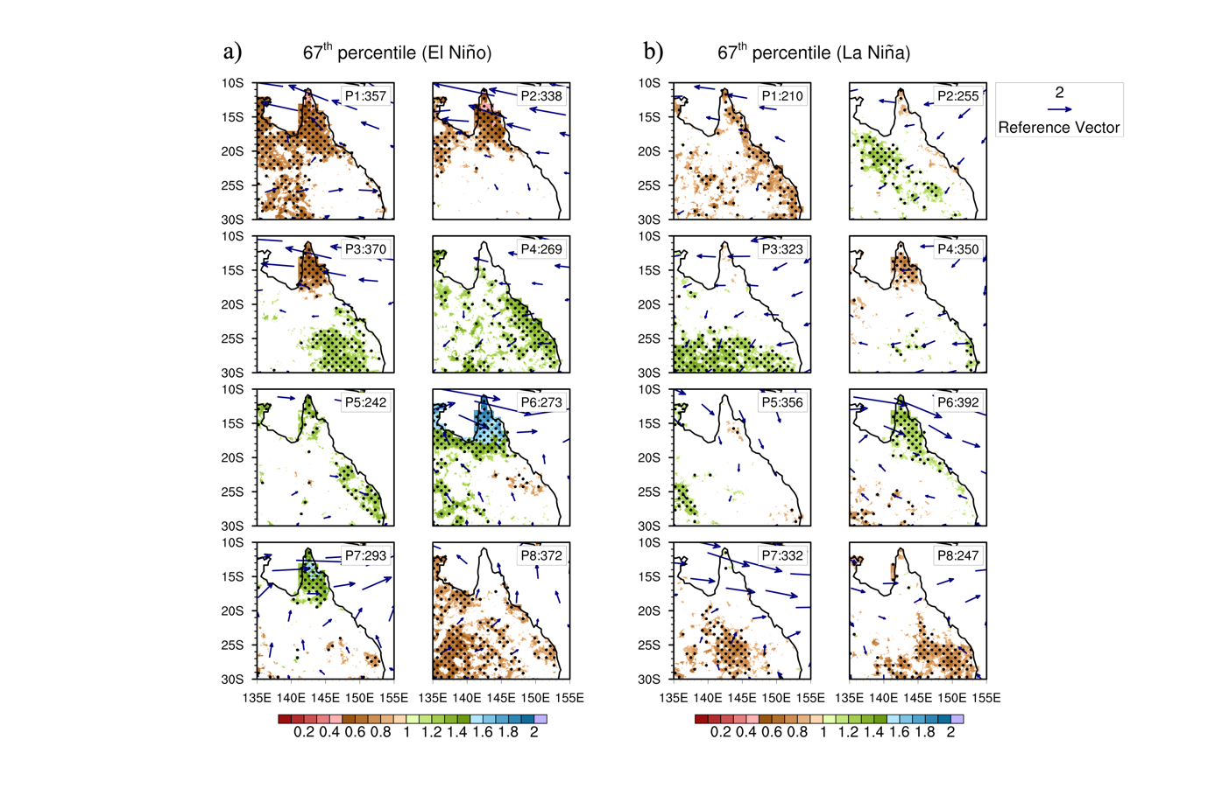
Fig. 8. MJO composites of daily precipitation probability above the upper tercile threshold for (a) El Niño, and (b) La Niña periods in NE Australia during the rainy season (November-April) from 1959 to 2022. Only statistically significant rainfall results at the 10% level over the analysis period regardless of ENSO states are shown. Black dots show additionally significant results when restricted to ENSO state only. Only statistically significant wind anomalies at the 10% level are shown. Fig. 8a and 8b show ratio relative to the probability of upper tercile rainfall across all El Niño, La Niña days, respectively.
The response of extreme rainfall to MJO under different ENSO states is illustrated in Fig.9. During El Niño, there is a significant enhancement of rainfall in northern Queensland during phases 6 and 7, with a probability ratio up to 2. This corresponds to a 100% increase in extreme rainfall probability compared to all days in El Niño years. In contrast, precipitation is significantly suppressed during phases 1 and 2, with a rate around 0.4, indicating a 60% reduction in the probability of extreme rainfall relative to entire El Niño periods. The influence of the MJO on extreme precipitation during La Niña years is weaker and less significant compared to that during El Niño years. During La Niña years, the ratios of increased and decreased rainfall probabilities are approximately 1.4-1.5 and 0.6, respectively. This indicates a less than 50% difference in the probability of extreme rainfall compared to all days during La Niña periods. By examining the difference between the largest and smallest likelihood of rainfall across all MJO phases (Fig. S4 in supplementary material), we further find that the influence of the MJO on rainfall during El Niño periods is about 2 times stronger than during La Niña periods. The largest difference is observed in northern Queensland.
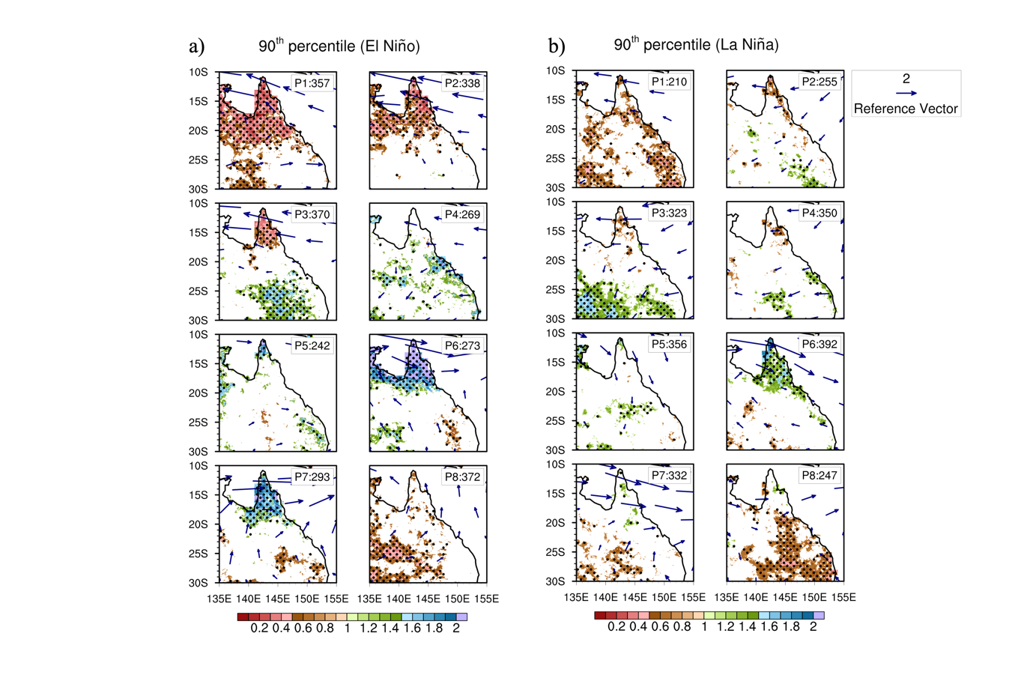
Fig. 9. Same as in Fig.8, but for the upper decile (the 90th percentile) of daily rainfall
The aforementioned results clearly demonstrate that NE Australia’s wet season rainfall is modified by ENSO, MJO and their interactions. The precipitation response to the MJO appears to be stronger and more significant during El Niño years compared to La Niña years. A double significance test is performed to test whether the change in the MJO-precipitation relationship with ENSO phases is attributable to changes in the MJO itself or changes in the precipitation response to the MJO. Many grid points satisfy the double significance test indicating that the variation of the MJO-associated rainfall pattern with ENSO phases does not come solely from the variation of the MJO itself, consistent with Ghelani et al. (2017) and Cowan et al. (2023). Instead, it reflects the actual change in the response of precipitation to the MJO with ENSO phases from a statistical perspective. The physical processes behind this difference are likely have a combination of dynamical and thermodynamical explanations and require further investigation. The above findings are generally in agreement with Ghelani et al. (2017) who investigated the joint modulation of the MJO and ENSO on daily mean rainfall during the wet season across tropical Australia. Unlike that study, however; we use station-based gridded rainfall data (AGCD) instead of station data to provide a more comprehensive picture of spatiotemporal variability of precipitation in NE Australia. In addition, this study also analyses the joint impact of MJO and ENSO on extreme precipitation events that have not been examined in previous studies.
d. Diurnal cycle of rainfall in NE Australia and its modulation by the MJO and ENSO
Following Rauniyar and Walsh (2011), the Normalized Relative Amplitude (NRA) of the precipitation diurnal cycle, defined as the ratio of the difference between 00-11 and 12-23 Local Time (LT) precipitation to the climatological average precipitation, is utilized to examine the variations of rainfall diurnal cycle associated with MJO and ENSO. The climatological average precipitation is calculated for the entire period (20 DJF seasons from 1998 to 2018). In this section, the MJO phases are classified into the enhanced convection phase (phases 4-7) and the suppressed convection phase (phase 8, 1, 2, 3). Figure 10 shows the spatial distribution of the NRA derived from TRMM data for total precipitation (Fig.10a), two MJO regimes, namely the enhanced convection phase (Fig. 10b) and the suppressed convection phase (Fig. 10c), and two ENSO phases, La Niña (Fig. 10d) and El Niño (Fig. 10e). In general, more rainfall occurs in the evening over NE Australia except for a small area (25°S-30°S, 135°E-137°E) where Kati Thanda-Lake Eyre is located. The NRA map shows a marked geographical variation with larger values in coastal areas compared to inland areas. For example, the NRA values above 0.5 in coastal regions are likely due to land-sea breeze circulations, while just below 0.2 in inland regions. The amplitude of the diurnal precipitation cycle is larger during the suppressed MJO phase, while it is closer to climatological values during the enhanced MJO phase. The diurnal rainfall signal during El Niño years is stronger than that in La Niña years in the central western Queensland (south of 20°S). This is in contrast to northern Queensland (north of 20°S), where the diurnal amplitude of precipitation during La Niña periods is larger compared to El Niño periods. Since the impact of the MJO on precipitation diurnal cycles is more pronounced than that of ENSO, in the following analyses, we specifically focus on examining the interaction of the MJO and the diurnal cycle of rainfall in NE Australia.
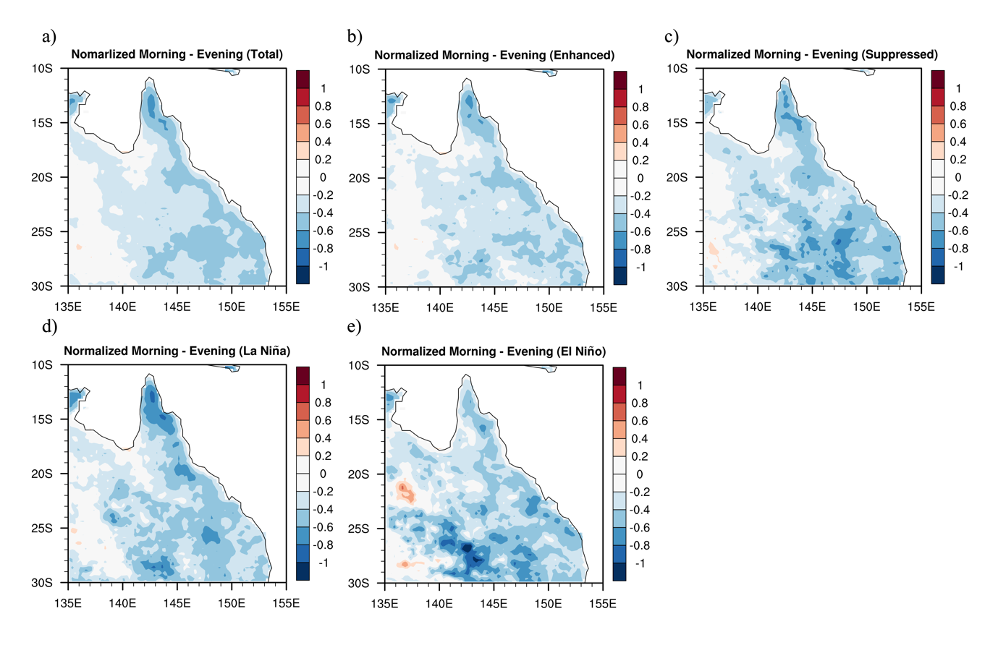
Fig. 10. The spatial distribution of NRA derived from TRMM satellite data for (a) all days, (b) enhanced rainfall phase of MJO, (c) suppressed rainfall phase of MJO, (d) La Niña, and (e) El Niño in NE Australia for summer season (DJF) from 1998 to 2018.
To quantify the regional variations in the diurnal characteristics of rainfall, an EOF analysis was performed for the diurnal cycle of total precipitation during the enhanced and suppressed convection phases of MJO (Fig. 11). The EOF analysis is conducted using TRMM 3B42 annual climatological diurnal precipitation for 20 austral summers from 1998 to 2018 over NE Australia (10° - 30°S, 135 - 155 °E). For climatological rainfall (Fig.11a), EOF1 and EOF2 together account for more than 90% of the total variance and the corresponding principal components (PC1 and PC2) show a marked diurnal cycle. The EOF1 which explains 72.4% of total variance indicates a clear contrast between the ocean and land, while EOF2, accounting for 18.7% of total variance, shows a variation in the diurnal cycle of precipitation with respect to geographical location and topographic orientation. Tropical Australia and coastal areas have stronger diurnal signals with larger values of both EOF1 and EOF2, while subtropical and inland regions show a very weak signal. Peak rainfall occurs in the early afternoon over Cape York Peninsula and northeast Arnhem Land (positive signs in both EOFs), and in the evening over areas further south (positive EOF1 and negative EOF2), suggesting an inland propagation of precipitation. This may be associated with the local forcing during the afternoon (PC2) and the non-local forcing from propagating systems in the evening (PC1), particularly where there is convergence from the two sides of Cape York. Over the ocean, maximum precipitation begins over coastal areas in the early morning (negative values in both EOFs) and then propagates offshore.
During the enhanced and suppressed convection phases of the MJO (Figs.11b and c) the first two EOFs together explain more than 85% of the total variance and the PC1 time series exhibits a typical feature of diurnal precipitation with a peak over land in the afternoon, and over ocean in the morning. In general, the occurrence time of maximum precipitation does not change with the MJO phases; however, there are some notable differences in rainfall propagation between enhanced and suppressed MJO phases. Over the Cape York Peninsula, the onshore propagation of precipitation moves further south during the suppressed convection phase of MJO. In contrast, near the Top End, inland precipitation moves further south during the enhanced convection phases of MJO. These results are consistent with previous studies indicating that precipitation peaks in the afternoon as a result of a sea-breeze convergence mechanism and that the diurnal rainfall cycle is larger in suppressed convection phases than in enhanced convection phases of MJO (e.g., Rauniyar and Walsh 2011; Peatman et al., 2014; Vincent and Lane 2016). However, these studies mainly focused on the Maritime Continent and the detailed features of rainfall diurnal cycle in NE Australia have not been addressed. In addition, our findings also suggest that the diurnal rainfall signals are not only pronounced in the deep tropics but are also observed in subtropical NE Australia.
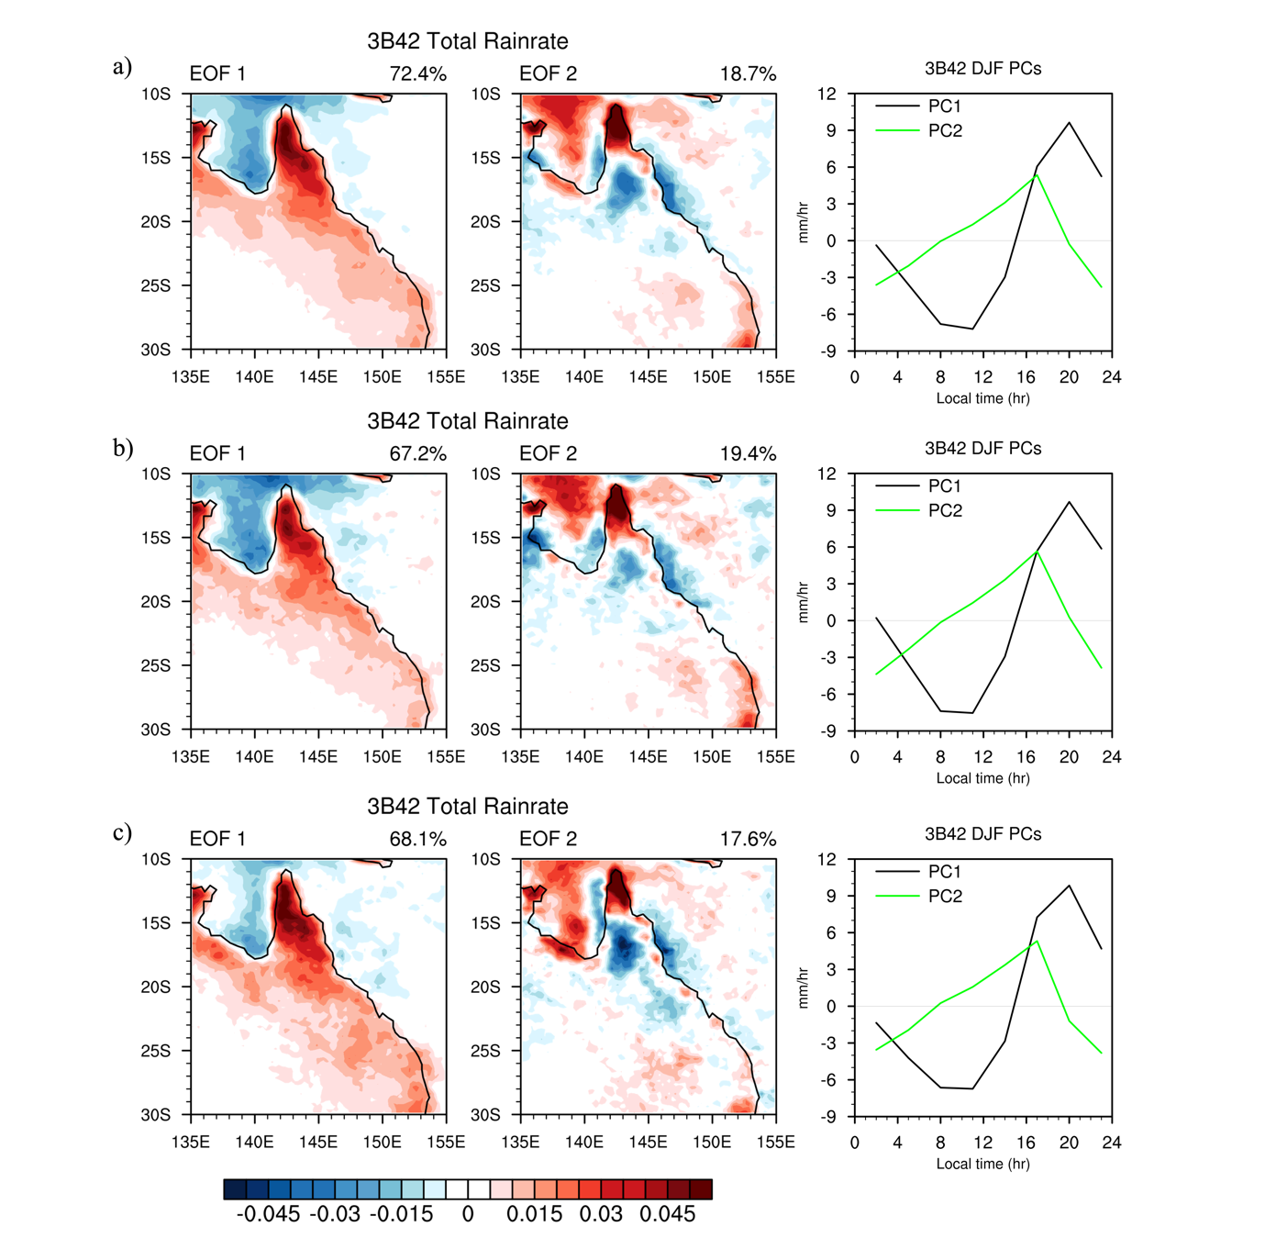
Fig. 11. EOF analysis of the diurnal precipitation cycle for climate average (a), the enhanced convection phases (b) and suppressed convection phases (c) of the MJO in NE Australia during summer season (DJF) from 1998 to 2018
To examine the diurnal cycle of extreme rainfall over NE Australia, we binned extreme rainfall events into daily 3-hour intervals. The 95th percentile of all summer hourly precipitation time series for the period 1998-2018 is defined as the extreme precipitation threshold. The frequency distribution of extreme rainfall events for the two respective MJO categories is illustrated in Fig.12. In both suppressed and enhanced MJO regimes, extreme precipitation most often occurs over NE Australia in late afternoon (16.00-18.00 LT) and early evening (19.00-21.00 LT) with more than 50% of extreme rainfall events occurring during these two-time periods. In contrast, the frequency of extreme rainfall is minimal in the early morning with less than 10% of extreme events occurring. The late-afternoon maxima extreme rainfall occurrence can be explained by the daily adjusted surface solar radiative heating that affects the atmospheric static destabilization and mesoscale circulation generation. In coastal regions, this may be reinforced by local circulations associated with the land sea breeze circulation. The amplitude of the diurnal cycle of extreme precipitation is about 50% larger in the suppressed convection phase of MJO than in the enhanced convection phase. The larger amplitude during suppressed MJO phases compared to enhanced phases is also evident when we consider separately the onset, peak and last time of extreme rainfall events (Fig. S5 in supplementary material).
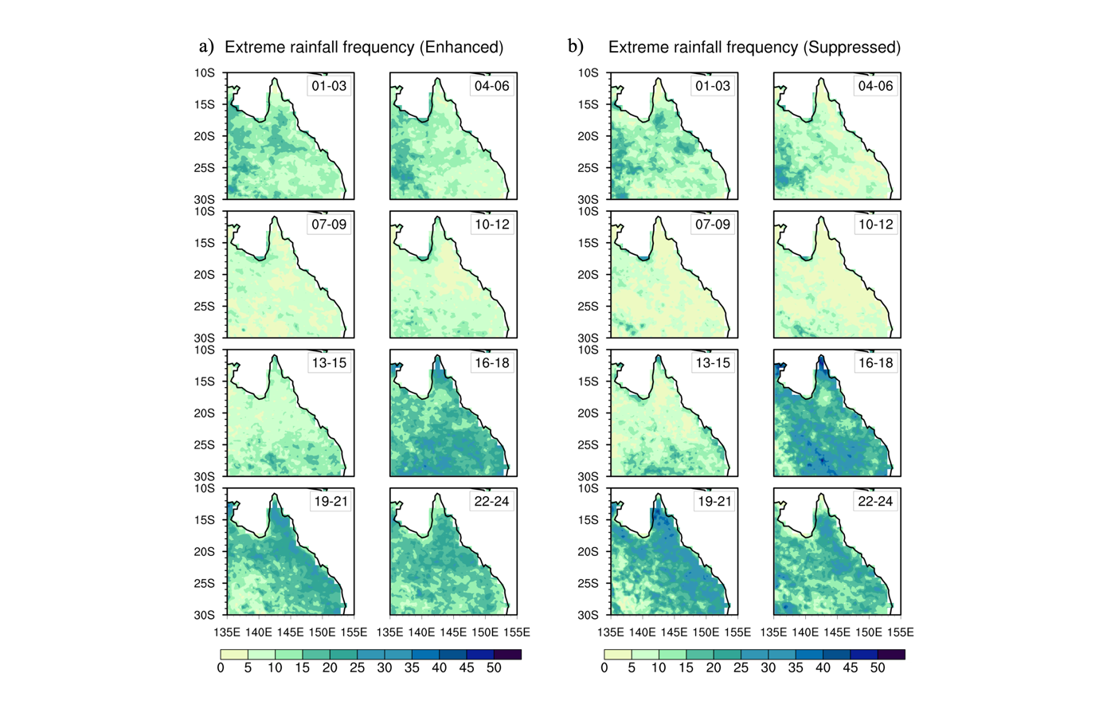
Fig. 12. The spatial distribution of extreme rainfall frequency (unit: %) during different hours for enhanced (a) and suppressed (b) MJO phases in NE Australia during summer from 1998 to 2018. The frequency of extreme rainfall is calculated as the number of extreme events in each 3-hour interval divided by the total number of extreme events.
5. Discussion
There have been a number of studies examining the impact of large-scale climate modes on rainfall in NE Australia, but very few have focused on the interaction of these modes on extreme precipitation events. In addition, the independent influences of climate modes on daily and sub-daily mean and extreme rainfall over NE Australia have not been well understood. Building upon previous studies and leveraging the longer time series of the currently available high-resolution datasets, this research presents a comprehensive study on the multi-scale modulations of mean and extreme precipitation in NE Australia under different background modes of variability. This is important and essential for quantifying the impact of model errors on various scales, and for mapping large-scale climate projections to local impacts. The key results are listed below:
- Daily mean and extreme rainfall probabilities in NE Australia are significantly modulated by the MJO and its influence exhibits a marked geographical variation. The probability of experiencing rainfall above the upper decile threshold (90th percentile) varies from 5-7% during suppressed convection phases to 14-16% during enhanced convection phases of the MJO in summer and autumn.
- Precipitation in NE Australia is typically decreased during El Niño and increased during La Niña periods. However, there are spatial nuances to ENSO-related extreme rainfall over NE Australia with some locations showing the opposite precipitation response to ENSO. This fine-scale variation is critical when expressing climate-change impacts on rainfall at local-scale, city-scale or even farm-scale and indicates the importance of process-based downscaling at these scales.
- The influence of the MJO on daily extreme rainfall is about 2 times stronger in El Niño than in La Niña years. By utilizing a double significance test, we further find that the influence of ENSO on the MJO-rainfall connection cannot be solely attributed to the variation of the MJO itself. Rather, it reflects an actual change in the response of precipitation to the MJO with ENSO phases.
- The amplitude of the rainfall diurnal cycle in NE Australia is modulated by the MJO and ENSO. The EOF analysis of the precipitation diurnal cycle shows that the peak time of rainfall does not change with the MJO phase, but there are some obvious differences in rainfall propagation in NE Australia between enhanced and suppressed MJO phases.
- The amplitude of the diurnal cycle of extreme precipitation is 50% larger in the suppressed convection phases compared to the enhanced convection phases of the MJO.
Our key findings on the combined influence of the MJO and ENSO on mean rainfall are consistent with previous studies (Ghelani et al., 2017; and Cowan et al., 2023) and also strengthen their conclusions. Note that our results show a weaker and less significant modulation of daily rainfall by the MJO during phases 3 and 5 in La Niña periods compared to the results of Ghelani et al. (2017). This difference may have resulted from the use of different datasets and different periods between two studies. It is noted that the AGCD rainfall dataset used in our study is derived from the interpolation of rain gauge data, and its accuracy may be limited in areas with low station density. With a relatively low station density in the western Queensland (Evans et al., 2020), the impact of climate modes on rainfall over this region should be interpreted with a caveat that some of the significant results may be affected by issues with AGCD data. However, using the gridded rainfall data allows us to provide more comprehensive picture of spatiotemporal variability of daily precipitation in NE Australia, which is crucial for model evaluation.
To our knowledge, the joint modulation of MJO and ENSO on extreme rainfall in Australia has not been examined in previous studies. This study shows that the influence of the MJO on mean and extreme rainfall tends to be greater and more significant during El Niño compared to La Niña years. One possible reason responsible for this difference is changes in the strength of the Walker circulation. According to Ghelani et al. (2017), the weakening of Walker circulation during El Niño years allows the MJO to modulate atmospheric conditions and precipitation more strongly. Conversely, the enhanced Walker circulation during La Niña years seems to weaken the influence of the MJO on large-scale environmental variables, leading to a decrease in the observed rainfall variability. It should be noted that different ENSO types associated with distinct spatial patterns of SST anomalies may exert different effects on the MJO-precipitation connection. However, this study does not consider ENSO diversity and its effects on the relationship between MJO and precipitation in NE Australia. Since 1950, there has been a notable decline in rainfall during the rainy season over NE Australia (Cai et al., 2010, 2014). This long-term trend could potentially impact our results of the influences of the MJO, ENSO and their interaction on rainfall during the wet season from 1959 to 2022.
6. Conclusions
By using high-resolution datasets, this study provides a comprehensive picture of how climate modes affect the daily and sub-daily mean and extreme rainfall in NE Australia that has not been well addressed in previous studies. We found that NE Australia’s rainfall variability associated with MJO, ENSO and their interactions exhibits a marked geographical variation. There are topographic/coastal aspects to the combined rainfall response that will not be captured in coarse resolution datasets. In addition, there are likely dynamic, thermodynamic and mesoscale aspects to the interaction. We do not know how the interactions might be altered under a climate change modification to each of these aspects. In the future, more numerical modelling studies are required to understand the physical mechanisms driving these interactions.
Our analyses also identify that rainfall in NE Australia exhibits a distinct diurnal cycle, and that the diurnal cycle of rainfall is modulated by the MJO and ENSO. While most previous studies focus on the diurnal variation of precipitation over the deep tropics, our findings suggest that results from the deep tropics extend over subtropical NE Australia. This could have implications for examining subtropical precipitation variability and improving our understanding of the scale interactions of diurnal convection and climate modes. In addition, to our knowledge, this study provides the first examination of the diurnal variation of extreme rainfall and its modulation by the MJO in NE Australia. These preliminary results motivate further studies to understand the characteristics of the sub-daily heavy rainfall events and their subseasonal variability in the tropics and subtropics.
Finally, this study has found that daily rainfall in NE Australia is strongly modulated by the MJO, ENSO and their interactions. This suggests that climate models need to represent both independent climate modes (e.g., MJO, ENSO, and likely other modes as well, depending on location) and their interactions for reliable rainfall projections. It is noted that the spatial resolution of current climate models may be too coarse to capture the spatial nuances of rainfall pattern associated with the MJO, ENSO and its interaction in NE Australia, which is evident by the fine-scale variations around coastal areas that would fit entirely within a single global climate model grid box. This is the first known study to examine the joint modulation of intraseasonal extreme precipitation by the MJO and ENSO in NE Australia, an area prone to flooding due to extreme rainfall, using observational data. These findings have potential implications for climate and agricultural risk management.

Acknowledgments.
This work was funded by the Melbourne Research Scholarship, the Rowden White Scholarship and the Australian Research Council (ARC) Centre of Excellence for Climate Extremes (CE170100023). Analysis was performed using the National Computing Infrastructure (NCI) National Facility. We would like to thank Yi Huang and Hoa Quynh Nguyen Dao for their valuable comments during manuscript revision process. We also thank the three reviewers for their critical comments and helpful suggestions to improve the quality of this study.

Data Availability Statement.
The AGCD daily precipitation data was from the Australia Bureau of Meteorology (https://doi.org/10.4227/166/5a8647d1c23e0, accessed on 1 October 2021). The TRMM satellite 3-hourly precipitation 3B42 data was from the Goddard Earth Sciences Data and Information Services Center (https://disc.gsfc.nasa.gov/datasets/TRMM_3B42_7/summary, accessed on 10 December 2021). The ERA5 reanalysis data was from Copernicus Climate Change Service Climate Data Store (https://cds.climate.copernicus.eu/cdsapp#!/dataset/reanalysis-era5-pressure-levels, accessed on 1 June 2022 ). The RMM, IHR and SOI indices were downloaded from the Australia Bureau of Meteorology (http://www.bom.gov.au/climate/mjo, https://ecjoliver.weebly.com/mjo-reconstruction.html, http://www.bom.gov.au/climate/enso/soi/ ). The codes can be made available by the corresponding author upon reasonable request.

REFERENCES
Arcodia, M. C., B. P. Kirtman, and L. S. P. Siqueira, 2020: How MJO teleconnections and ENSO interference impacts U.S. precipitation. J. Climate, 33, 4621–4640, https://doi.org/10.1175/JCLI-D-19-0448.1.
Birch, C., S. Webster, S. Peatman, D. Parker, A. Matthews, Y. Li, and M. Hassim, 2016: Scale interactions between the MJO and the western Maritime Continent. J. Climate, 29, 2471-2492, https://doi.org/10.1175/JCLI-D-15-0557.1.
Black, M. T., and T. P. Lane, 2015: An improved diagnostic for summertime rainfall along the eastern seaboard of Australia. Int. J. Climatol., 35, 4480-4492, https://doi.org/10.1002/joc.4300.
Cai, W., P. van Rensch, T. Cowan, and A. Sullivan, 2010: Asymmetry in ENSO teleconnection with regional rainfall, its multidecadal variability, and impact. J. Climate, 23, 4944–4955, https://doi.org/10.1175/2010JCLI3501.1.
Cai, W., A. Purich, T. Cowan, P. van Rensch, and E. Weller, 2014: Did Climate Change-Induced Rainfall Trends Contribute to the Australian Millennium Drought? J. Climate, 27, 3145-3168, https://www.jstor.org/stable/26193409.
Compo, G. P., and Coauthors, 2011: The twentieth century reanalysis project. Quart. J. Roy. Meteor. Soc., 137, 1-28, https://doi.org/10.1002/qj.776.
Cowan, T., and Coauthor, 2019: Forecasting the extreme rainfall, low temperatures, and strong winds associated with the northern Queensland floods of February 2019. Wea. Climate Extremes, 26, 100232, https://doi.org/10.1016/j.wace.2019.100232.
Cowan, T., M. C. Wheeler, and A. G. Marshall, 2023: The Combined Influence of the Madden-Julian Oscillation and El Nino-Southern Oscillation on Australia Rainfall. J. Climate, 313-334, https://doi.org/10.1175/JCLI-D-22-0357.1.
Da Silva, N. A., and A. J. Matthews, 2021: Impact of the Madden-Julian Oscillation on extreme precipitation over western Maritime Continent and Southeast Asia. Quart. J. Roy. Meteor. Soc., 147(739), 3434-3453, http://dx.doi.org/10.13039/100010897.
Dey, R., M. Bador, L. V. Alexander, and S. C. Lewis, 2021: The drivers of extreme rainfall event timing in Australia. Int. J. Climatol., 41, 6654-6673, https://doi.org/10.1002/joc.7218.
Evans, A., D. Jones, R. Smalley, S. Lellyett, 2020: An enhanced gridded rainfall analysis scheme for Australia, Bureau Research Report No. 041.
Fonseca, R., T. Y. Koh, C. K. Teo, 2019: Multi-scale interactions in a high-resolution tropical-belt experiment and observations. Climate Dyn., 52, 3503–3532, https://doi.org/10.1007/s00382-018-4332-y
Ghelani, R. P., E. C. Oliver, N. J. Holbrook, M. C. Wheeler, and P. J. Klotzbach, 2017: Joint Modulation of Intraseasonal Rainfall in Tropical Australia by the Madden‐Julian Oscillation and El Niño‐Southern Oscillation. Geophys. Res. Lett., 44, 10,754-710,761, https://doi.org/10.1002/2017GL075452.
Goodwin, I. D, 2022: The Weather behind the Eastern Australian floods-the storm cluster from 23rd February to 2nd April. Risk frontiers, Briefing Note 464.
Guilyardi, E., A. Wittenberg, A. Fedorov, M. Collins, C. Wang, A. Capotondi, G. J. van Oldenborgh, and T. Stockdale, 2009: Understanding El Niño in ocean–atmosphere general circulation models: progress and challenges. Bull. Amer. Meteor. Soc., 90, 325–40, https://doi.org/10.1175/2008BAMS2387.1.
Hoell, A., M. Barlow, M. C. Wheeler, and C. Funk, 2014: Disruptions of El Niño-Southern Oscillation Teleconnections by the Madden-Julian Oscillation, Geophys. Res. Lett., 41, 998- 1004, https://doi.org/10.1002/2013GL058648.
Huffman, G. J., and Coauthors, 2007: The TRMM Multisatellite Precipitation Analysis (TMPA): Quasi-global multiyear, combined-sensor precipitation estimates at fine scales. J. Hydrometeor., 8, 38-55, https://doi.org/10.1175/JHM560.1.
Jones, D. A., W. Wang, and R. Fawcett, 2009: High-quality spatial climate data-sets for Australia. Aust. Meteorol. Oceanogr. J., 58, 233, https://doi.org/10.22499/2.5804.003
Kikuchi, K., and B. Wang, 2008: Diurnal precipitation regimes in the global tropics. J. Climate, 21, 2680-2696, https://doi.org/10.1175/2007JCLI2051.1.
King, A. D., L. V. Alexander, and M. G. Donat, 2013a: Asymmetry in the response of eastern Australia extreme rainfall to low‐frequency Pacific variability. Geophys. Res. Lett., 40, 2271-2277, https://doi.org/10.1002/grl.50427.
King, A. D., L. V. Alexander, and M. G. Donat, 2013b: The efficacy of using gridded data to examine extreme rainfall characteristics: a case study for Australia. Int. J. Climatol., 33, 2376-2387, https://doi.org/10.1002/joc.3588.
Ling, J., C. Zhang, R. Joyce, P. p. Xie, and G. Chen, 2019: Possible role of the diurnal cycle in land convection in the barrier effect on the MJO by the Maritime Continent. Geophys. Res. Lett., 46, 3001-3011, https://doi.org/10.1029/2019GL081962.
Lough, J. M., 1991: Rainfall variations in Queensland, Australia: 1891–1986. Int. J. Climatol., 11, 745-768, https://doi.org/10.1002/joc.3370110704.
Madden, R.A., and P.R. Julian, 1971: Detection of a 40–50 day oscillation in the zonal wind in the tropical Pacific. J. Atmos. Sci., 28(5), 702–708, https://doi.org/10.1175/1520-0469(1971)028<0702:DOADOI>2.0.CO;2.
Madden, R.A., and P. R. Julian, 1972: Description of global-scale circulation cells in the tropics with a 40–50 day period. J. Atmos. Sci., 29(6), 1109–1123, https://doi.org/10.1175/1520-0469(1972)029<1109:DOGSCC>2.0.CO;2.
Marshall, A. G., H. H. Hendon, and D. Hudson, 2021: Influence of the Madden-Julian Oscillation on multiweek prediction of Australian rainfall extremes using the ACCESS-S1 prediction system. J. South. Hemisphere Earth Syst. Sci., 71, 159-180, https://doi.org/ 10.1007/s00382-018-4272-6
McBride, J. L., and N. Nicholls, 1983: Seasonal relationships between Australian rainfall and the Southern Oscillation. Mon. Wea. Rev., 111, 1998-2004, https://doi.org/10.1175/1520-0493(1983)111<1998:SRBARA>2.0.CO;2.
McPhaden M. J., S. E. Zebiak, and M. H. Glantz, 2006: ENSO as an integrating concept in earth science. Science 314, 1740–5, https://doi.org/10.1126/science.1132588.
Murphy, B. F., and J. Ribbe, 2004: Variability of southeastern Queensland rainfall and climate indices. Int. J. Climatol., 24, 703-721, https://doi.org/10.1002/joc.1018.
Oliver, E. C., and K. R. Thompson, 2012: A reconstruction of Madden Julian Oscillation variability from 1905 to 2008. J. Climate, 25, 1996-2019, https://doi.org/10.1175/JCLI-D-11-00154.1.
Peatman, S. C., A. J. Matthews, and D. P. Stevens, 2014: Propagation of the Madden–Julian Oscillation through the Maritime Continent and scale interaction with the diurnal cycle of precipitation. Quart. J. Roy. Meteor. Soc., 140, 814-748, https://doi.org/10.1002/qj.2161.
Pepler, A. S., A. J. Dowdy, P. van Rensch, I. Rudeva, J. L. Catto, and P. Hope, 2020: The contributions of fronts, lows and thunderstorms to southern Australian rainfall. Climate Dyn., 55, 1489-1505, https://doi.org/ 10.1007/s00382-020-05338-8
Pourasghar, F., E. C. Oliver, and N. J. Holbrook, 2019: Modulation of wet‐season rainfall over Iran by the Madden–Julian Oscillation, Indian Ocean Dipole and El Niño–Southern Oscillation. Int. J. Climatol.,39, 4029-4040, https://doi.org/10.1002/joc.6057.
Power, S., M. Haylock, R. Colman, and X. Wang, 2006: The predictability of interdecadal changes in ENSO activity and ENSO teleconnections. J. Climate, 19, 4755-4771, https://doi.org/10.1175/JCLI3868.1.
Pui, A., A. Sharma, A. Santoso, and S. Westra, 2012: Impact of the El Niño-southern oscillation, Indian ocean dipole, and southern annular mode on daily and subdaily rainfall characteristics in east Australia. Mon. Wea. Rev., 140, 1665-1682, https://doi.org/10.1175/MWR-D-11-00238.1.
Qian, J. H., 2020: Mechanisms for the dipolar patterns of rainfall variability over large islands in the Maritime Continent associated with the Madden–Julian oscillation. J. Atmos. Sci., 77, 2257-2278, https://doi.org/10.1175/JAS-D-19-0091.1.
Rauniyar, S. P., and K. J. Walsh, 2011: Scale interaction of the diurnal cycle of rainfall over the Maritime Continent and Australia: Influence of the MJO. J. Climate, 24, 325-348, https://doi.org/10.1175/2010JCLI3673.1.
Rauniyar, S. P., and K. J. E. Walsh, 2013: Influence of ENSO on the Diurnal Cycle of Rainfall over the Maritime Continent and Australia. J. Climate, 26, 1304-1321, https://doi.org/10.1175/JCLI-D-12-00124.1.
Risbey, J. S., M. J. Pook, P. C. McIntosh, M. C. Wheeler, and H. H. Hendon, 2009: On the remote drivers of rainfall variability in Australia. Mon. Wea. Rev., 137, 3233-3253, https://doi.org/10.1175/2009MWR2861.1.
Shimizu, M. H., and T. Ambrizzi, 2016: MJO influence on ENSO effects in precipitation and temperature over South America. Theor. Appl. Climatol., 124, 291-301, https://doi.org/ 10.1007/s00704-015-1421-2
Shimizu, M. H., T. Ambrizzi, and B. Liebmann, 2017: Extreme precipitation events and their relationship with ENSO and MJO phases over northern South America. Int. J. Climatol., 37(6), 2977-2989, https://doi.org/10.1002/joc.4893.
Short, E., C. L. Vincent, T. P. Lane, 2019: Diurnal Cycle of Surface Winds in the Maritime Continent Observed through Satellite Scatterometry. Mon. Wea. Rev., 2023-2044, https://doi.org/10.1175/MWR-D-18-0433.1.
Slemr, F., C. A. Brenninkmeijer, A. Rauthe-Schöch, A. Weigelt, R. Ebinghaus, E. G. Brunke, L. Martin, T. G. Spain, and S. O'Doherty 2016: El Niño-Southern Oscillation influence on tropospheric mercury concentrations. Geophys. Res. Lett., 43, 1766–1771, https://doi.org/10.1002/2016GL067949.
Smith, M., M. J. Poggio, M. Thompson, and A. Collier, 2014: The Economics of Pesticide Management Practices on Sugarcane Farms: Final Synthesis Report. Department of Agriculture, Fisheries and Forestry (DAFF), Queensland.
Stone, R. C., G. L. Hammer, and T. Marcussen, 1996: Prediction of global rainfall probabilities using phases of the Southern Oscillation Index. Nature, 384, 252-255, https://doi.org/10.1038/384252a0
Theobald, A., H. McGowan, J. Speirs, and N. Callow, 2015: A synoptic classification of inflow-generating precipitation in the Snowy Mountains, Australia. J. Appl. Meteorol.Climatol., 54, 1713-1732, https://doi.org/10.1175/JAMC-D-14-0278.1.
Tropical Rainfall Measuring Mission, 2011: TRMM_3B42: TRMM (TMPA) rainfall estimate L3 3 hour 0.25 degree x 0.25 degree V7. NASA GSFC.
Twomey, C. R., and A. S. Kiem, 2021: Australian rainfall variability—Why is the eastern seaboard of Australia different to the rest of Australia and also internally inhomogeneous. Int. J. Climatol., 41, 5051-5071, https://doi.org/10.1002/joc.7116.
Vashisht, A., and B. Zaitchik, 2022: Modulation of East African boreal fall rainfall: combined effects of the Madden Julian Oscillation (MJO) and El Niño Southern Oscillation (ENSO). J. Climate, 2019-2034, https://doi.org/10.1175/JCLI-D-21-0583.1.
Vincent, C. L., and T. P. Lane, 2016: Evolution of the diurnal precipitation cycle with the passage of a Madden–Julian oscillation event through the Maritime Continent. Mon. Wea. Rev., 144, 1983-2005, https://doi.org/10.1175/MWR-D-15-0326.1.
Vincent, C. L., and T. P. Lane, 2017: A 10-Year Austral Summer Climatology of Observed and Modeled Intraseasonal, Mesoscale, and Diurnal Variations over the Maritime Continent. J. Climate, 30, 3807-3828, https://doi.org/10.1175/JCLI-D-16-0688.1.
Wang, G., and H. H. Hendon, 2007: Sensitivity of Australian rainfall to inter–El Niño variations. J. Climate, 20, 4211-4226, https://doi.org/10.1175/JCLI4228.1.
Wheeler, M, C., and H. H. Hendon, 2004: An all-season real-time multivariate MJO index: Development of an index for monitoring and prediction. Mon. Wea. Rev., 132 (8), 1917-1932., https://doi.org/10.1175/1520-0493(2004)132<1917:AARMMI>2.0.CO;2.
Wheeler, M. C., H. H. Hendon, S. Cleland, H. Meinke, and A. Donald, 2009: Impacts of the Madden–Julian Oscillation on Australian Rainfall and Circulation. J. Climate, 22, 1482-1498, https://doi.org/10.1175/2008JCLI2595.1.
Wheeler, M. C., and J. L. McBride, 2012: Australian monsoon, In W. K. M. Lau, & D. E. Waliser (Eds). Intraseasonal variability in the atmosphere-ocean climate system (2nd ed., pp 147-198). Berlin: Springer, https://doi.org/10.1007/978-3-642-13914-7_5.
Wei, Y., and H. Ren, 2019: Modulation of ENSO on fast and slow MJO modes during boreal winter. J. Climate, 32, 7483–7506, https://doi.org/10.1175/JCLI-D-19-0013.1.
Wilks, D. S, 2011: Statistical Methods in the Atmospheric Sciences. 3rd ed. Int. Geophys. Ser., 100, 704.
Wu, W., and M. Leonard, 2019: Impact of ENSO on dependence between extreme rainfall and storm surge. Environ. Res. Lett., 14, 124043, https://doi.org/10.1088/1748-9326/ab59c2.

The Bureau of Meteorology defines the northern wet season as October to April

