Chapter xxxxx
DIURNALLY-FORCED CONVECTION IN THE AUSTRALIAN MONSOON

Todd P. Lane^{1,4}, Claire L. Vincent^{1,4}, Martin Jucker^{2,4}, Martin Bergemann^{1,4} and Sugata Narsey^{3,4}
- School of Earth Sciences, The University of Melbourne, Australia
- Climate Change Research Centre, University of New South Wales, Australia
- School of Earth, Atmosphere and Environment, Monash University, Australia
- ARC Centre of Excellence for Climate Extremes
email: tplane@unimelb.edu.au

The Australian monsoon features diverse multiscalar interactions that manifest as a variety of convective cloud features and modes of organization. Darwin is arguably the best studied and understood region affected by the Australian monsoon, being the focus of numerous international field programs and observational deployments. The monsoon near Darwin is affected considerably by intraseasonal variability, with five distinct regimes that have recently been identified through objective clustering methods. These regimes differ in the direction of the low-level wind, total column moisture, the latitudinal extent of the monsoon trough, the cloud cover, and the diurnal cycle of wind and precipitation. Two of these regimes are closely linked to the traditional categories of ‘active monsoon’ and ‘break’ periods. The break periods near Darwin feature intense diurnally-forced organized convective systems that are localised and often initiated or organized by coastal processes such as the sea / land breeze system. In contrast, the active periods have more widespread cloud cover and a weaker diurnal cycle of wind and precipitation.
In this chapter we present a summary of recent work that has examined diurnally-forced convection near Darwin, and its variation with monsoon regime. We present examples using radar observations, satellite precipitation estimates, and high-resolution modelling. We also summarise some of the challenges in realistically simulating convection in the region using high-resolution models.

The Australian Monsoon and its regimes
The tropical northern regions of Australia can be categorized into two distinct periods: the wet season (~October to ~April) and the dry season. During the wet season more than 90% of the rainfall occurs, leading to marked differences between the two periods of the year and the meteorological impact on the community, agriculture, and tourism. The climate of Darwin is broadly characterized by these two distinct periods and the behavior of convection in the Darwin wet season has been the focus of many studies and field experiments. Examples include the Australian Monsoon Experiment (AMEX; Holland et al. 1986), the Maritime Continent Thunderstorm Experiment (MCTEX; Keenan et al. 2000), and the Tropical Warm Pool – International Cloud Experiment (TWP-ICE; May et al. 2008). Although many instruments have been deployed at Darwin (both temporary and long-term installations), a key platform is the Gunn Point C-band polarimetric radar (C-POL; Keenan et al. 1998), which has been used for many studies of convection and rainfall processes in the region. See Fig. 1 for its location. Darwin’s coastal location, complex coastline, and the nearby Tiwi Islands make it an ideal location to study monsoonal convection and its multiscale variability.
The Darwin wet season experiences significant intraseasonal variability that manifests as a range of distinct regimes. Much of this variability is thought to be the result of midlatitude influences (e.g., Hung and Yanai 2004, Davidson et al. 2007, Berry and Reeder 2016, Narsey et al. 2017). Figure 2 presents an analysis of the mean wet season, and an example season (the 2005/2006 season) to illustrate the rainfall variability, which is closely linked to the monsoonal regimes. These regimes include the traditional descriptions of the monsoon build-up period and following monsoon onset there are active monsoon and break periods. Each of these terms have been defined in a range of ways, but a commonly used method to distinguish active and break periods based on the zonal winds at Darwin is found in Drosdowsky (1996). This method defines the active monsoon (sometimes referred to as a monsoon ‘burst’, e.g., Troup 1961) as when the mean zonal wind from the surface to 500-hPa is westerly, and the mean zonal wind between 300 and 100 hPa is easterly. The monsoon period is defined by the onset (the first burst) and the retreat (the last burst), with intermediate periods (of at least three days) that do not satisfy the active monsoon criteria defined as break periods.
More recently, Pope et al. (2009) performed a cluster analysis on wind and thermodynamic radiosonde profiles from Darwin to create objective definitions of the intraseasonal regimes of the Darwin wet season. The study identified five regimes, now often referred to as the ‘Pope regimes’, with distinct wind and moisture profiles: Dry Easterly (DE), Deep Westerly (DW), Easterly (E), Shallow Westerly (SW), and Moist Easterly (ME). Of these regimes there is close correspondence between the DW regime and wind-based definitions of the active monsoon, and also close correspondence between the ME regime and wind-based definitions of the break. The SW regime has features similar to the DW regime, though with less moisture. The SW regime is consistent with previous discussions of the ‘suppressed monsoon’ (e.g., May et al. 2008), which can feature a more active monsoon trough over the eastern part of Australia. The DE regime is a dry trade wind dominated flow, occurring mostly before monsoon onset and after monsoon retreat. The E regime is more moist, corresponding to the ‘build-up’. Of all five regimes, the ME and DW regimes are the moistest, as is demonstrated by Fig. 2c of Kumar et al. (2013).
Examples of the qualitative differences between the Darwin rainfall patterns during active (DW) and break (ME) periods of the Australian monsoon are shown in Fig. 3, alongside a two-month average of the daily rainfall. The differences in the meteorological conditions can be summarized as follows: active monsoon periods feature a monsoon trough encroaching to the south of Darwin, low-level westerly winds, large-scale forcing that leads to widespread clouds and convection and the greatest area-averaged rainfall of any of the other wet season regimes. In contrast, the break periods feature low-level easterly winds, suppressed large-scale forcing that leads to more localized and intense convection, especially over land. Break periods possess some similarities to monsoon build-up regimes, which also contain intense locally forced convection over land, albeit in a drier environment. Of interest, the strong ‘Hector’ thunderstorms that form over the Tiwi Islands (e.g., Keenan et al. 1990) are prevalent in the build-up (E regime) and break (ME) regimes of the wet season.
Drosdowsky’s (1996) analysis identified the mean length of active monsoon periods to be about two weeks, with a mean return period of about a month. In both estimates the standard deviation was approximately two weeks, suggesting significant variability in length and recurrence interval. Some of this variability, and monsoon onset, can be linked to the Madden Julian Oscillation (MJO; see Wheeler and McBride 2011 for a detailed discussion). For example, Pope et al. (2009) showed that the ME (break) regime showed a slight increase in its occurrence during phases 3-4 of the MJO, as measured by the Wheeler and Hendon (2004) index.
Pope et al. (2009) showed that the ME regime (break) actually has the highest probability of occurrence (40-50%) of all the regimes between December and March, followed by the SW regime and then the DW regime. Though if the two westerly regimes (DW and SW) were combined together they would form the most frequent regime. This analysis is updated for the period 1957 to 2017 in Fig. 4.
Kajikawa et al. (2010) created an Australian monsoon index, defined as the spatial average (over the area 5°S – 15 °S, 110°E – 130°E) of the 850-hPa zonal wind. This index allows assessment of the monsoon onset, intraseasonal, interannual and interdecadal variability of the Australian monsoon, over a broader region than just Darwin. Using this index, Kajikawa et al. (2010) found that the monsoon onset had noteworthy interannual variability, but the monsoon retreat did not as it was more closely linked to the annual cycle. Moreover, they showed that early monsoon onset was related to a strong monsoon season, and vice versa.

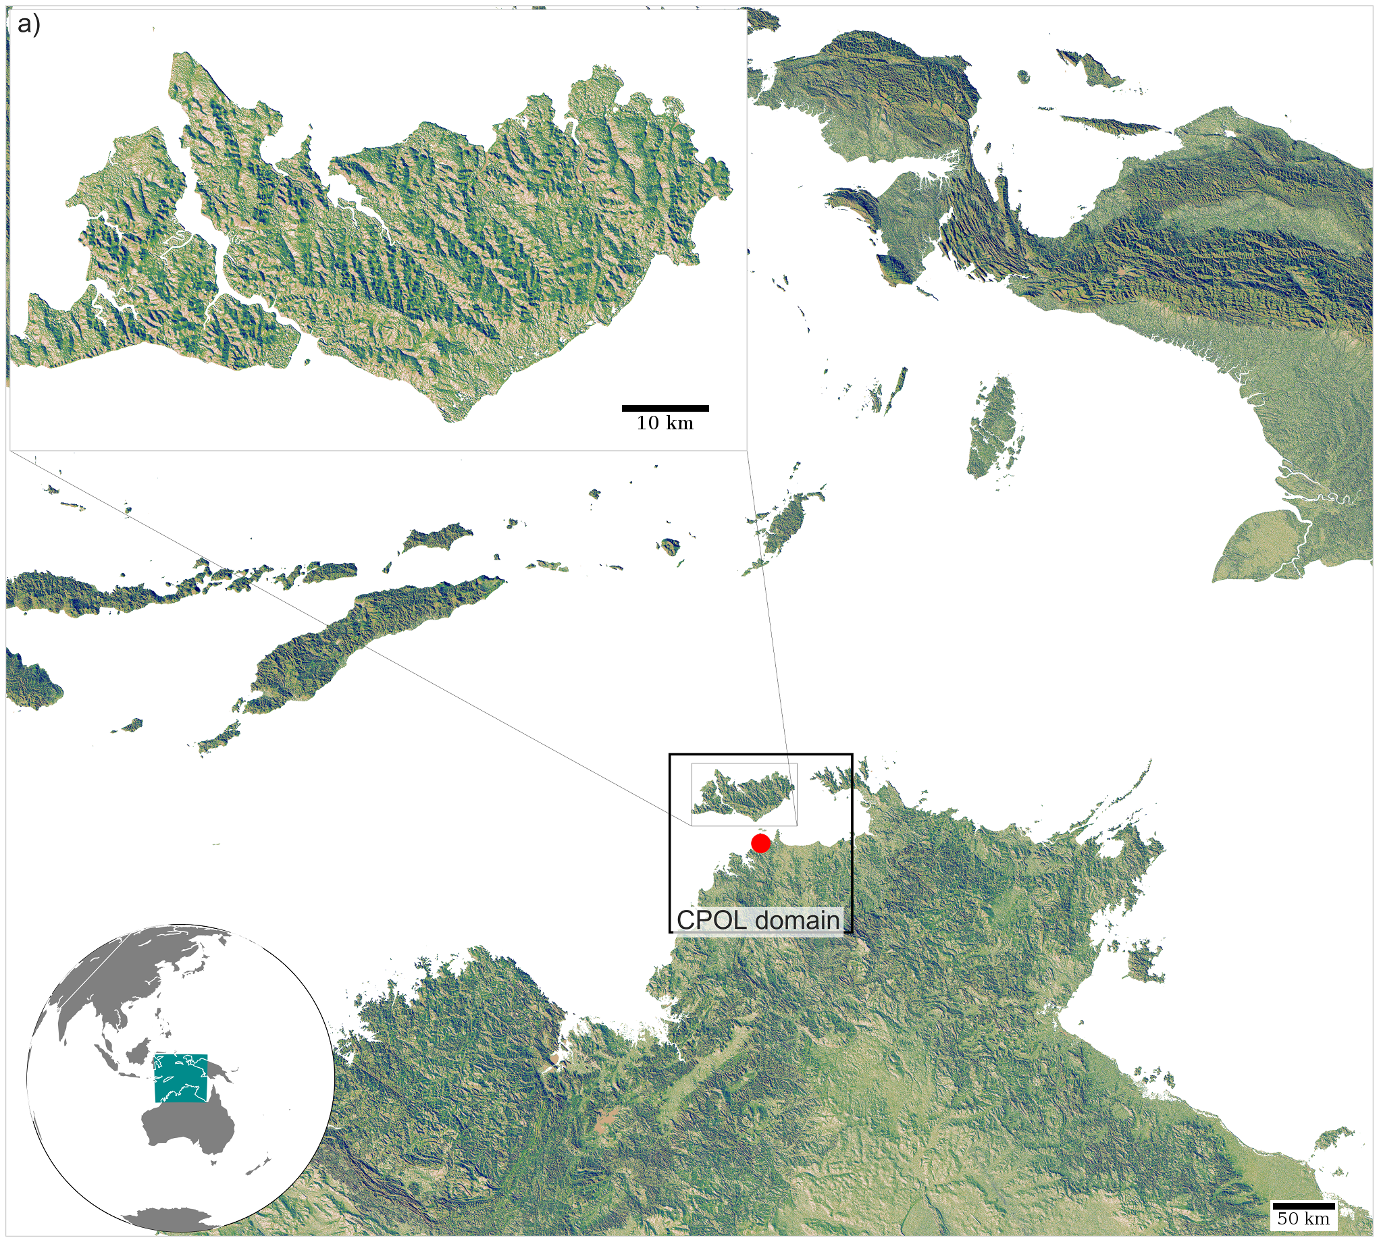

Fig. 1 Region of interest. The maps show Northern Australia and surrounding islands, with the red dot the location of the CPOL Darwin radar and its observational domain denoted by the black square. The inset shows the Tiwi Islands (Bathurst Island to the west and Melville Island to the east).

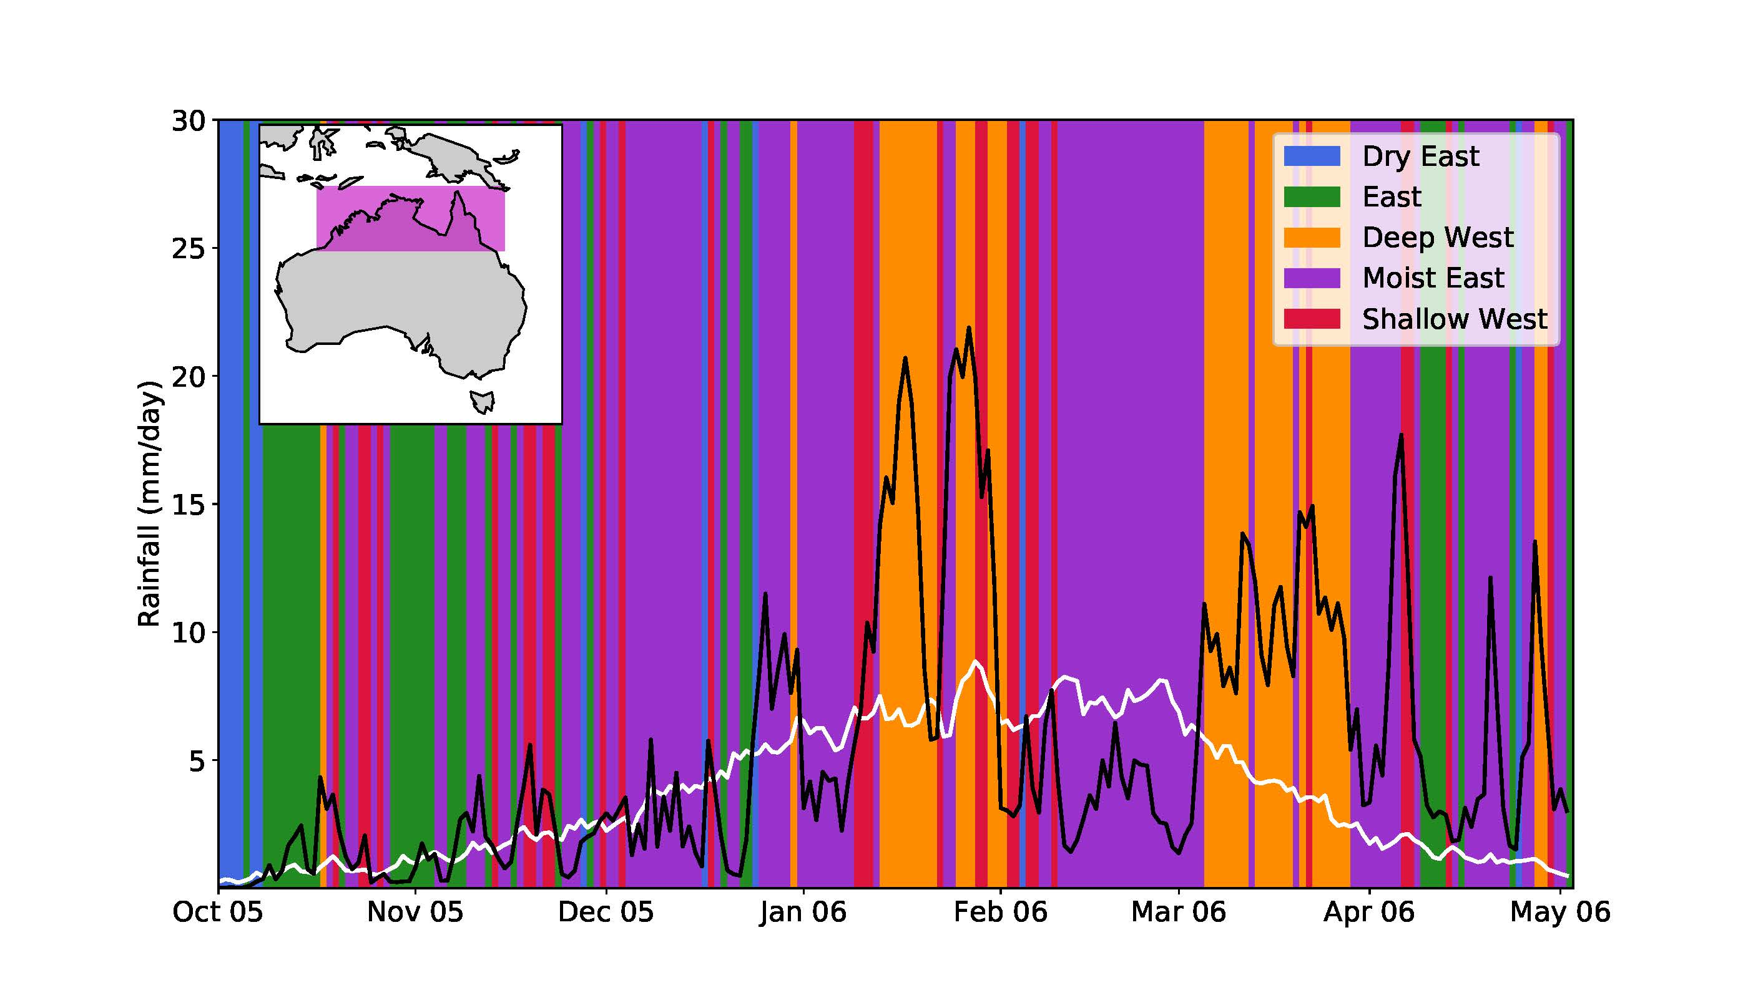

Fig. 2 Rainfall during the Australian monsoon, averaged over the region shown in the inset map. Solid white line is the average rainfall from 1979 to 2010. The solid black line is the rainfall for the 2005/2006 season. Colored shading represents the Pope regime categories (discussed in the text) for the 2005/2006 season. Rainfall is from the Australian Water Availability Project (AWAP, Jones et al. 2009) dataset.

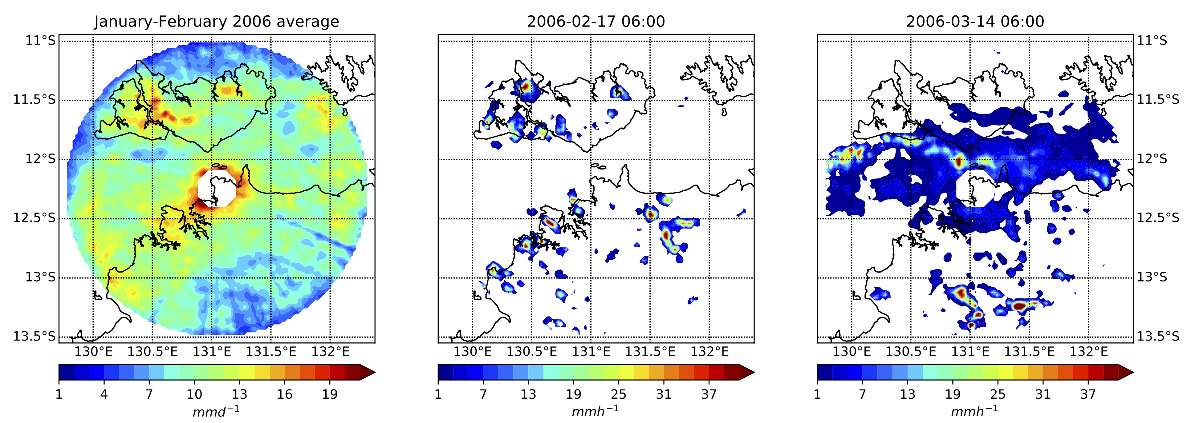

Fig. 3 Radar-derived rainfall from the Gunn Point polarimetric radar (CPOL). Left is the average daily rainfall from January to February 2006. The centre and right images are examples of instantaneous rain rate from the break (ME regime) at 0600 UTC 17 February 2006 (centre) and the active monsoon (DW regime) at 0600 UTC 14 March 2006 (right). The coast is shown as a solid line and the nominal 150 km range of the radar is evident in the left image. Note the different colour scales between the average rainfall image and the instantaneous images.

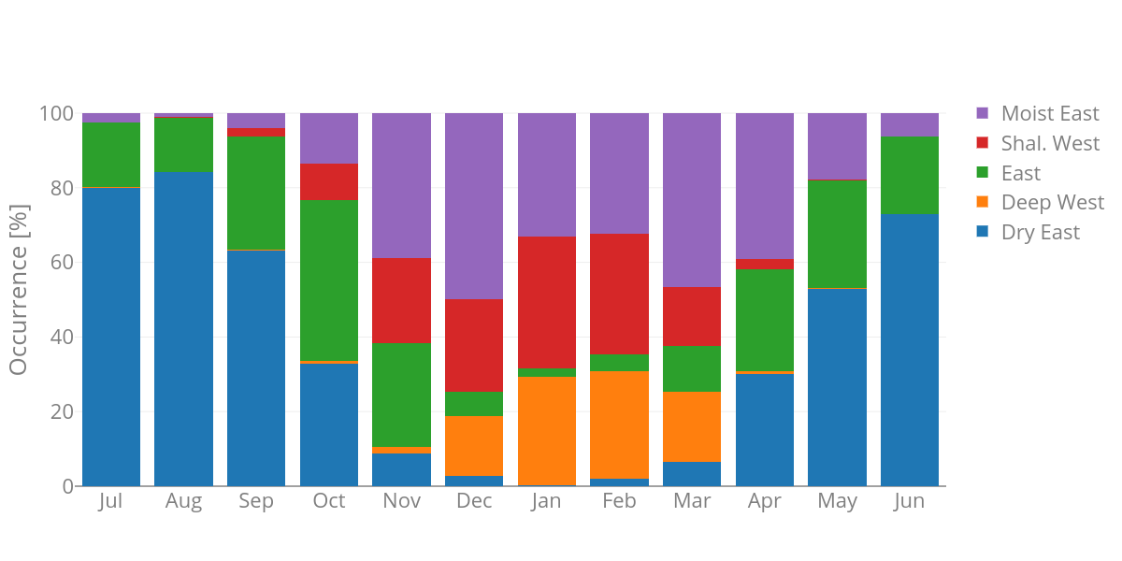
Fig. 4 Frequency of occurrence of the Pope regime categories by month for 1957-2017.

Diurnally-forced convection
The regimes of the monsoon are particularly relevant when considering the occurrence of localised storms, which often occur as part of the diurnally-forced convective initiation that is dominant in the break. Examples of Darwin rainfall for an active and break period are shown in Fig. 5. Figure 5b illustrates a well-defined diurnal cycle with peak rainfall activity in the late afternoon / early evening on most days, as well as a secondary peak in the early morning on some days. In contrast, even though there is a diurnal signal in rainfall in the active monsoon (Fig. 5a), with afternoon rainfall regularly occurring, the timing of the daily peaks in rainfall is variable and more closely related to large-scale forcing than pure diurnal forcing. Moreover, although the area-averaged rain rate is larger in the active monsoon, the localized and intense nature of the break convection can lead to more intense local rain rates, which is consistent with Fig. 3, and the localized break storms often deepen to penetrate the tropical tropopause layer and lower stratosphere (e.g., Hassim et al. 2014).
In terms of the intensity of extreme rainfall, Pope et al. (2009, their Fig. 5) demonstrated that the largest 24-h rainfall accumulations at the Darwin Airport gauge occur in the ME regime, followed by the SW and then the DW regimes. However, for 24-h accumulations less than 200 mm, the DW regime has by far the largest frequency of occurrence. Of these three regimes, Kumar et al. (2013, their Fig. 4) identified that the SW regime has the deepest convective cells, followed by the ME and then DW regimes. Both the SW and ME regimes have notable lightning activity.
To examine the variation of the diurnal cycle with monsoon regime, composite diurnal cycles for the five Pope regimes are shown in Fig. 6 for the 2014/2015 wet season for two satellite-derived rainfall products: CMORPH (Climate Prediction Center, 2011) and TRMM 3B42 (Huffman et al., 2007; Goddard Space Flight Center, 1998). These cycles are separated into rainfall over land and sea, which captures the mean diurnal cycles over the land/sea areas but loses information about the intensity of localized rainfall events. As can be seen in Fig. 6, all regimes (except the DE regime) have a notable diurnal cycle over land. In the SW and DW regimes this cycle is superimposed on substantial daily background rainfall (consistent with the variable timing in daily maxima seen in Fig. 5a); in these regimes the sea points have a similar background rainfall with only a small diurnal cycle. For the E and ME regimes over land the diurnal peaks occur after a near-zero rainfall over land in the early morning; similarly, over the sea there is minimal rainfall with the exception of the early morning peak. The DE regime has little rainfall.
It is worth noting that Fig. 6 also highlights the differences in rainfall derived from the two satellite precipitation products. Not only are there differences in rainfall totals, but also differences in the timing of the diurnal cycle. Some of these uncertainties are alleviated by using radar and gauge data. Yet, the rainfall uncertainties over Darwin (and elsewhere in the Maritime Continent) pose significant difficulties for model evaluation in the region.
During the break (ME) and build-up periods (E) the dominant forcing of convection is associated with topographic effects and coastal processes. The afternoon peak of convective activity occurs predominantly over land (e.g., Fig. 3, centre panel) and can be linked to ascent from surface heating, sea-breeze initiation, and convergence of sea breezes over the narrow peninsulas and the Tiwi Islands. For example, the regularly occurring Hector storms are formed by converging sea breezes (e.g., Carbone et al. 2000). The early morning peak in rainfall (seen in Fig. 6 and on a few days in Fig. 5b) normally occurs offshore and can be related to land breeze circulations and offshore convergence associated with complex coastlines (e.g., Wapler and Lane 2012). These processes governing offshore rainfall near the coast work in concert with radiative effects that enhance nocturnal rainfall over the oceans (e.g., Gray and Jacobson 1973, Ranfall et al. 1991). Yet, consistent with Vincent and Lane (2016), density currents and gravity waves are likely the dominant mechanisms near coasts.
During the westerly monsoon regimes (DW and SW) the background forcing associated with the monsoon trough leads to substantial daily mean rainfall, albeit with a strong diurnal cycle superimposed upon it by land-based convection. The amplitude of the diurnal cycle during these regimes does not appear suppressed, as might be expected from the mean cloudiness during those periods.

Fig. 5 Rain rate derived from the Gunn Point polarimetric radar, averaged over the range of the radar identified in Fig. 3. Each panel shows four days representative of (a) the active monsoon (DW) and (b) the break (ME). The abscissa is in local time starting 1 Jan 2006, and (a) and (b) have different scales on the ordinate. Adapted from Wapler et al. (2010)

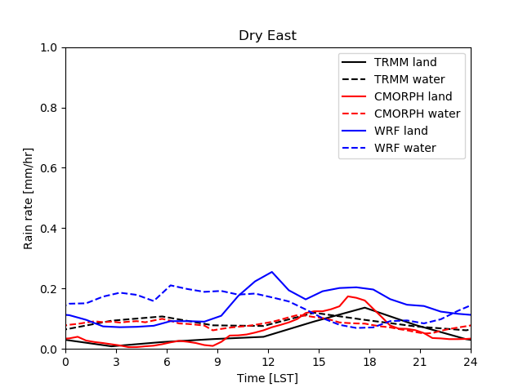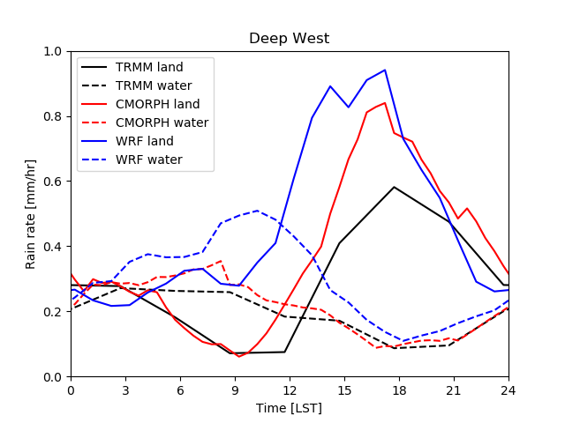
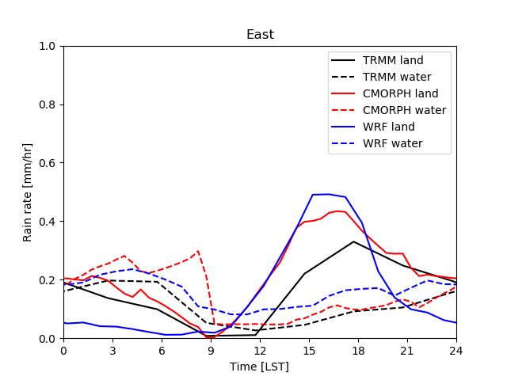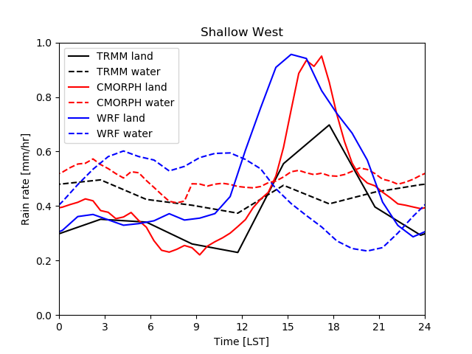
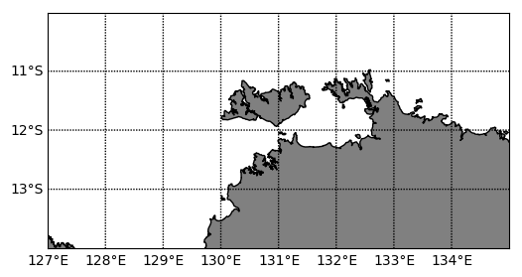
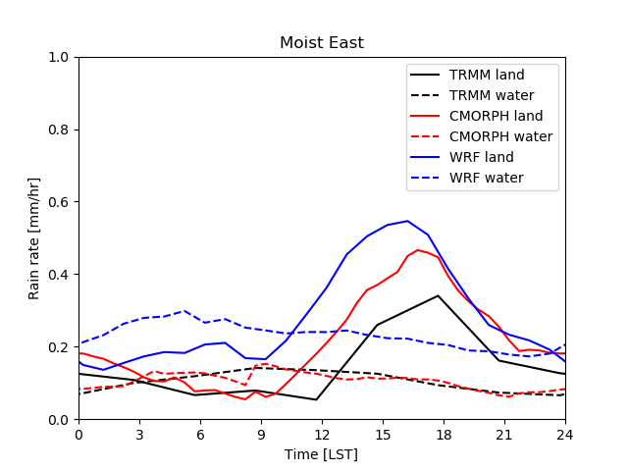

Fig. 6 Composite diurnal cycles of hourly rainfall (mm/hr) separated into the five monsoon regimes. Rain is calculated over land points (solid) and sea points (dashed) for the area shown in the bottom right panel. Lines correspond to rainfall derived from WRF simulations (at 4 km grid spacing), TRMM, and CMORPH for November 2014 to April 2015.

It is clear that many of the processes that determine the diurnal cycle of intense convection near Darwin, especially during the break periods, are similar to those that occur elsewhere in the Maritime Continent (MC), especially during suppressed periods of the MJO. For example, Vincent and Lane (2017) examined aspects of the diurnal cycle of rainfall and convection over the entire MC and documented similar behavior to Darwin, with afternoon peaks in convective activity over land, which then transition to offshore maxima in the early morning. However, the offshore signal is stronger in other parts of the Maritime Continent than Darwin. Bergemann et al. (2015) analyzed satellite rainfall observations and identified that a significant proportion of coastal rainfall in the MC is aligned with coastlines, further highlighting the importance of coastal processes. In agreement with the comments above, although the proportion of coastally-aligned rainfall over land during the day near Darwin is similar to the other islands in the MC, the offshore coastally-aligned rainfall is weaker than the large MC islands. Presumably these geographic differences are related to the height of topography over the large MC islands compared to the relatively flat terrain near Darwin, with both katabatic flows and the sea / land breeze circulation contributing to the coupling between land and oceanic convection.
Recent work by Brown et al. (2017) has examined the sea / land breeze system near Darwin using scatterometer wind measurements. This work demonstrated that the Darwin region does have very well-defined sea and land breezes and the scatterometer measurements documented that the sea / land breeze extends a few hundreds of kilometres offshore. This offshore extent and intensity of the sea / land breeze wind perturbations are modulated considerably by the phase of the monsoon. Stronger wind perturbations extend farther offshore during the break compared to the active periods. These differences are related to the reduced cloud cover during break periods, leading to stronger coastal circulations that ultimately initiate intense and localized convection.

Convection-permitting modelling
A number of studies have examined convection processes over Darwin using cloud-resolving and/or convection-permitting models. Wapler et al. (2010) evaluated the performance of convection-permitting models during parts of TWP-ICE. They found that the models compared better to observations during break periods when localized forcing is dominant. During active regimes of the monsoon the regional convection-permitting models are reliant on the accuracy of large-scale forcing. Consequently, during active periods the models had more difficulty reproducing the spatial and temporal characteristics of the convection. Caine et al. (2013) studied the simulated convective cell characteristics (in a 1.25-km resolution model) during a break period and compared those characteristics to objects identified from radar data. Their study identified a number of significant biases in convective cell depth and size. The positive bias in cell depth is likely a consequence of simulated convective updrafts that are too intense, owing to an ineffective treatment of entrainment at convection-permitting resolutions. Some aspects of these biases were alleviated with higher resolution (420-m horizontal grid spacing).
Other convection-permitting model errors, identified by simulations over Darwin and elsewhere in the MC (e.g., Vincent and Lane 2017), are that the rainfall over land is too intense and occurs a few hours too early. These biases may be linked to the inability of convection-permitting models to properly resolve shallow convection, which also limits their ability to realistically represent the transition from shallow to deep convection. Inadequacies in cloud microphysics are also important sources of systematic errors. Of interest, comparisons between models and satellite observations made by Brown et al. (2017) suggest that the sea / land breeze can be well represented by convection-permitting models, adding further confidence in the explanations above.
As an example of the variations in model performance with regime of the Australian monsoon, Fig. 6 also shows composite simulated rainfall diurnal cycles. These data are from a model simulation of the 2014/2015 wet season using the Weather Research and Forecasting model (WRF, Skamarock et al. 2008) with 4-km horizontal grid spacing – the full details of the simulation are described in Brown et al. (2017). Consistent with the discussion above, in the E, ME and DW regimes the convection-permitting WRF simulation produces a rainfall peak that is too large. For this example, in the SW regime the model produces a rainfall peak that has some agreement with the CMORPH estimates. The simulations for the DW, SW, and ME regimes are all a few hours too early in the timing of their convective development over land (with agreement for the E regime). These results are consistent with the inability of convection-permitting models to properly simulate the transition from shallow to deep convection in a realistic manner, which can lead to deep convection occurring too early.

Summary

This chapter has summarized some recent work that has characterized the behavior of the Australian monsoon, its regimes, and the occurrence of diurnally-forced convection in those regimes. The traditional categories of ‘active monsoon’ and ‘break’ have been expanded upon with the creation of the ‘Pope regimes’ that, among other things, introduce the distinct shallow westerly regime, which has been also referred to as a ‘suppressed monsoon’ in the past.
Of interest, with the exception of the Dry East (pre- and post-monsoon trade wind) regime, all of the regimes feature a distinct diurnal cycle near Darwin, especially over the land. Yet, the most intense rainfall and deepest convection occur during the Moist East (ME) and Shallow West (SW) regimes. The ME (break) regime has received considerable attention in the past, but the SW regime has received far less attention.
Convection-permitting models are now commonly used for prediction and process studies over the region of the Australian monsoon and broader Maritime Continent. These models have notable systematic biases in the timing and intensity of convection and further efforts to improve them, through both improved physical processes and model resolution, are required.

Acknowledgment
This work was supported by the Australian Research Council’s Centres of Excellence Program (CE170100023). Simulations were conducted using resources from the National Computational Infrastructure (NCI) facility in Canberra. The authors thank Valentin Louf (Bureau of Meteorology) for supplying the radar data and Alain Protat (Bureau of Meteorology) for supplying the Pope regimes data.

References
Bergemann, M., C. Jakob, and T.P. Lane, 2015: Global detection and analysis of coastline associated rainfall using objective pattern recognition techniques. J. Climate, 28, 7225-7236.
Berry, G. J. and Reeder, M. J. (2016). The dynamics of Australian monsoon bursts. J. Atmos. Sci., 73, 55-59.
Brown, A.L., C.L. Vincent et al., 2017: Scatterometer estimates of the tropical sea breeze circulation near Darwin, with comparison to regional models. Quart. J. Roy. Meteor. Soc. in press.
Caine, S., T.P. Lane et al., 2013: Statistical assessment of tropical convection-permitting model simulations using a cell-tracking algorithm. Mon. Wea. Rev., 141, 557-581.
Carbone, R.E., J.W. Wilson et al., 2000: Tropical Island Convection in the Absence of Significant Topography. Part I: Life Cycle of Diurnally Forced Convection. Mon. Wea. Rev., 128, 3459–3480.
Climate Prediction Center, 2011: NOAA CPC morphing technique (CMORPH) global precipitation analyses 30 minute estimates at 8 km resolution. [Available online at http://ftp.cpc.ncep.noaa.gov/precip/CMORPH_V1.0/RAW/8km-30min/.]
Davidson, N. E., Tory, K. J., Reeder, M. J., and Drosdowsky, W. L. (2007). Extratropical-tropical interaction during onset of the Australian monsoon: Reanalysis diagnostics and idealized dry simulations. Journal of the Atmospheric Sciences, 64, 3475-3498.
Drosdowsky, W., 1996: Variability of the Australian Summer Monsoon at Darwin: 1957–1992. J. Climate, 9, 85–96.
Goddard Space Flight Center, 1998: TRMM (Tropical Rainfall Measurement Mission) project merged HQ-infrared precipitation estimate (3B42), version 7. [Available online at ftp://trmmopen.gsfc.nasa.gov/pub/merged/3B42RT/]
Gray, W.M., and R.W. Jacobson, 1977: Diurnal variation of deep cumulus convection. Mon. Wea. Rev., 105, 1171–1188.
Hassim, M.E.E., T.P. Lane, and P.T. May, 2014: Ground-based observations of overshooting convection during the Tropical Warm Pool-International Cloud Experiment. J. Geophys. Res. Atmos., 119, 880-905.
Holland, G.J., J.L. McBride et al., 1986: The BMRC Australian Monsoon Experiment: AMEX. Bull. Amer. Meteor. Soc., 67, 1466–1472.
Huffman, G. J., Bolvin, D. T., Nelkin, E. J., Wolff, D. B., Adler, R. F., Gu, G., Nelkin, E. J., Bowman, K. P., Hong, Y., Stocker, E. F. and Wolff, D. B., 2007: The TRMM Multisatellite Precipitation Analysis (TMPA): Quasi-global, multiyear, combined-sensor precipitation estimates at fine scales. J. Hydrometeor., 8, 38–55.
Hung, C.-W. and Yanai, M. (2004). Factors contributing to the onset of the Australian summer monsoon. Quart. J. Roy. Meteor. Soc., 130, 739-758.
Jones, D.A., W.Wang, and R. Fawcett, 2009: High-quality spatial climate datasets for Australia. Aust. Meteor. Oceanogr. J., 58, 233–248.
Kajikawa, Y., B. Wang, and J. Yang, 2010: A multi-time scale Australian monsoon index. Int. J. Climatology, 30, 1114-1120.
Keenan, T. D., B.R. Morton, X. S. Zhang, and K. Nyguen, 1990: Some characteristics of thunderstorms over Bathurst and Melville Islands near Darwin, Australia. Quart. J. Roy. Meteor. Soc., 116, 1153-1172.
Keenan, T., K. Glasson et al., 1998: The BMRC/NCAR C-Band Polarimetric (C-POL) Radar System. J. Atmos. Oceanic Technol., 15, 871–886
Keenan, T., P. May et al., 2000: The Maritime Continent Thunderstorm Experiment (MCTEX): Overview and Some Results. Bull. Amer. Meteor. Soc., 81, 2433–2455.
Kumar, V.V., A. Protat, C. Jakob, G. Penide, S. Kumar, and L. Davies, 2013: On the effects of large-scale environment and surface types on convective cloud characteristics over Darwin, Australia. Mon. Wea. Rev., 141, 1358-1374.
May, P.T., J.H. Mather et al., 2008: The Tropical Warm Pool International Cloud Experiment. Bull. Amer. Meteor. Soc., 89, 629–645
Narsey, S., M.J. Reeder, D. Ackerley, and C. Jakob, 2017: A Midlatitude Influence on Australian Monsoon Bursts. J. Climate, 30, 5377–5393
Pope, M., C. Jakob, and M.J. Reeder, 2009: Regimes of the North Australian Wet Season. J. Climate, 22, 6699–6715.
Randall, D.A., Harshvardhan, and D.A. Dazlich, 1991: Diurnal Variability of the Hydrologic Cycle in a General Circulation Model. J. Atmos. Sci., 48, 40–62.
Skamarock, W. C., and Coauthors, 2008: A description of the Advanced Research WRF version 3. NCAR Tech. Note NCAR/TN-475+STR, 113 pp.
Troup, A.J., 1961: Variations in upper tropospheric flow associated with the onset of the Australian summer monsoon. Indian J. Meteor. Geophys., 12, 217–230.
Vincent, C.L., and T.P. Lane, 2016: Evolution of the diurnal precipitation cycle with the passage of a Madden-Julian Oscillation event through the Maritime Continent. Mon. Wea. Rev., 144, 1983-2005.
Vincent, C.L., and T.P. Lane, 2017: A 10-year Austral summer climatology of observed and modeled intraseasonal, mesoscale and diurnal variations over the Maritime Continent. J. Climate, 30, 3807-3828.
Wapler, K., T.P. Lane et al., 2010: Cloud-system-resolving model simulations of tropical cloud systems observed during the Tropical Warm Pool-International Cloud Experiment. Mon. Wea. Rev., 138, 55-73.
Wapler, K., and T.P. Lane, 2012: A case of offshore convective initiation by interacting land breezes near Darwin, Australia. Meteor. Atmos. Phys., 115, 123-137.
Wheeler, M.C., and H.H. Hendon, 2004: An All-Season Real-Time Multivariate MJO Index: Development of an Index for Monitoring and Prediction. Mon. Wea. Rev., 132, 1917–1932.
Wheeler, M.C., and J.L. McBride, 2011: Australasian Monsoon (Ch. 5), in Lau, W.K.M and D. E. Waliser (Editors), Intraseasonal Variability in the Atmosphere–Ocean Climate System 2nd Ed. Springer-Verlag.

