Identification of key messages for a national suicide prevention media campaign
Dr Angela Nicholas
ORCID: 0000-0003-1979-7278
Submitted in total fulfilment of the requirements of the degree of Doctor of Philosophy
August 2020
Faculty of Medicine, Dentistry and Health Sciences
The University of Melbourne

Abstract
The suicide rate in Australia has increased over recent years, indicating a need for novel suicide prevention interventions. A large proportion of people at risk of suicide do not seek professional help, but rather express their suicidal thoughts to close friends and family members. However, expressions of suicidal thoughts to family and friends can be indirect and ambiguous, and consequently can be missed or misunderstand, leading to dismissive response and missed opportunities for suicide prevention. A suicide prevention media campaign aimed at family members and friends may be one useful population-level suicide prevention strategy to encourage greater recognition of suicide risk and appropriate helping actions in response to suicidal communications. Current evidence for what messages would be acceptable and appropriate for inclusion in such as campaign, however, is limited.
The research described in this thesis was undertaken to develop suicide prevention messages to include in an Australian suicide prevention campaign aimed at family and friends of adults at risk of suicide. To understand what messages would be most important to include, five studies were undertaken and are described in this thesis. Study 1 was an expert consensus study involving suicide prevention professionals and people with lived experience of suicide risk. This study established which suicide prevention actions these experts believe are the most important to encourage in a suicide prevention campaign aimed at family and friends. Study 2 was an online survey study involving people with lived experience of suicide risk that aimed to assess the most and least helpful actions taken by others in response to their suicidal communications. Studies 3 to 5 used data from a nationally representative telephone survey conducted with Australian adults. Study 3 examined Australian adults’ confidence and intentions to help a person close to them at risk of suicide. Study 4 examined helping actions given and received in response to suicidal communications. Study 5 assessed the relationships between beliefs in suicide ‘myths’ and helping intentions and actions.
Overall, the findings from these studies show that Australian adults are confident and willing to assist a person close to them at risk of suicide. They intend to undertake, and indeed do undertake, a number of appropriate helping actions toward people close to them who are at risk of suicide. These appropriate actions include listening and talking to the person at risk and encouraging them to seek professional help. However, Australian adults also largely fail to ask important risk assessment questions, and commonly undertake actions that do not conform to best practice in suicide prevention. Such non-recommended actions include telling the person at risk ‘what they have going for them’ and telling them that their suicide would hurt their family and friends. A substantial minority of Australian adults also believe in suicide myths, including those related to encouraging suicidal thoughts by talking about suicide. The combined results of these studies have been utilised to make recommendations regarding the most useful messages to include in an Australian suicide prevention campaign aimed at family members and friends at people at risk of suicide.

Declaration
This is to certify that

(i) the thesis comprises only my original work towards the PhD except where
indicated in the Preface;

(ii) due acknowledgement has been made in the text to all other material used;

(iii) the thesis is fewer than 100 000 words in length, exclusive of tables, maps, bibliographies and appendices.

__________________________________________________
Dr Angela Nicholas (DHealthPsyc (Research), BPsyc (Hons))

Preface
Chapters 4 to 8 of this thesis comprise five articles that have been published or accepted for publication in peer-reviewed journals throughout the course of my PhD candidature. All of these are multi-author papers for which I am the first authour. Their publications status is as follows.
Study 1 (included as Chapter 4) has been published in Crisis.
Nicholas A, Rossetto A, Jorm A, Pirkis J, Reavley N. (2018) Importance of messages for a suicide prevention media campaign: An expert consensus study. Crisis, 39(6), 438-450.

Study 2 (included as Chapter 5) has been accepted for publication in the Journal of Mental Health.
Nicholas A, Pirkis J, Reavley N. What responses do people at risk of suicide find most helpful and unhelpful from professionals and non-professionals? Journal of Mental Health, In Press, 31 July 2020

Study 3 (included as Chapter 6) has been published in Suicide and Life-Threatening Behavior.
Nicholas A. Pirkis J, Rosetto A, Jorm A, Spittal MJ, Reavley N. (2019) Confidence and intentions to help a person at risk of suicide: A nationally representative telephone survey. Suicide and Life-Threatening Behavior, Epub ahead of print, July 2019.

Study 4 (included as Chapter 7) has been published in Social Science and Medicine: Population Health.
Nicholas A, Pirkis J, Jorm A, Spittal MJ, Reavley N. (2019) Helping actions given and received in response to suicide risk: Findings from an Australian national survey. SSM – Population Health, 9. 100483.
Study 5 (included as Chapter 8) has been published in BMC Psychiatry.
Nicholas A, Niederkrotenthaler T, Reavley N, Pirkis J, Jorm A, Spittal MJ. (2020) Belief in suicide prevention myths and its effect on helping: A nationally representative survey of Australian adults. BMC Psychiatry, 20 (303)
All of these papers are original works. Funding for this research was provided by Beyond Blue. The funding was gained through a competitive tender process. The application for the funding, and therefore, the overall research design was undertaken by my supervisors and colleagues, Professor Jane Pirkis, Professor Anthony Jorm and Associate Professor Nicola Reavley. Dr Alyssia Rossetto and Associate Professor Matthew Spittal also contributed significantly to the undertaking of these five studies. Herein, I refer to these five researchers as my ‘research team’. Guided by this team, I made a significant contribution to the development, conduct, analysis and reporting for each of the studies, and I describe this contribution to each study here.
In Study 1, I was largely responsible for developing the questionnaire used to conduct the consensus study, recruitment of participants, overseeing data collection, data analysis and reporting, and preparing the manuscript for publication. I conducted these activities with advice and guidance from my research team. The research methods and the items included in the questionnaire are based on previous work by Professor Anthony Jorm and his colleagues.
In Study 2, I was largely responsible for developing the questionnaire used to conduct the online survey study, recruitment of participants, overseeing data collection, data analysis and reporting, and preparing the manuscript for publication. Associate Professor Nicola Reavley and I each undertook analysis (coding) of the qualitative data. Therefore, we undertook development of the coding framework in consultation and compared coding outcomes. I conducted all other activities with advice and guidance from Associate Professor Nicola Reavley and Professor Jane Pirkis, who are the co-authors of this paper.
Studies 3 to 5 made use of the same dataset gathered through a nationally representative telephone survey. I was responsible for the research involved in developing many of the items to include in the survey. I worked closely with Roy Morgan Research Ltd to develop the final form of the survey, with valuable input from Associate Professor Nicola Reavley, to use as a computer-assisted telephone survey. I also participated in the briefing of their interviewers and the first day of pilot-testing of the survey carried out at their call centre and answered questions about the survey as required. I was responsible for the data analysis reported in the papers included as Chapters 6 to 8. This analysis was conducted with support from Associate Professor Matthew J Spittal, a statistician. I was also the primary author responsible for preparation of the manuscripts. In Study 5, I also collaborated with Associate Professor Thomas Niederkrotenthaler from the Medical University of Vienna, Austria. Associate Professor Niederkrotenthaler provided valuable input into the initial development of the article and provided feedback on several drafts prior to submission.

Acknowledgements
This research was funded by Beyond Blue.
Throughout my candidature, I was supported by a PhD scholarship from the National Health and Medical Research Council of Australia and an Ian Scott Mental Health PhD scholarship from Australian Rotary Health.
I am very grateful for the guidance and encouragement I have received from my principal supervisor Associate Professor Nicola Reavley, and my co-supervisors Professor Jane Pirkis and Associate Professor Matthew Spittal. I have also been very lucky to receive much advice and support from Professor Anthony Jorm, who is a member of my advisory group. I also want to thank Professor Lisa Gibbs, Chair of my advisory group, who has been warm, supportive and positive throughout my candidature.
My thanks also to Dr Alyssia Rossetto, who worked in partnership with me on several aspects of the research program. Thank you for your efficiency, smile and warm hugs.
I am also grateful to Associate Professor Thomas Niederkrotenthaler for his collaboration, and to him and his team for warmly hosting me at the University of Vienna.
I was also very glad to have made two visits to the University of Bristol and want to thank Professor David Gunnell for his advice on being an academic researcher and on life in general. I am also grateful to his team for their hospitality during those visits.
I was also made very welcome at University College Cork. Thank you to Professor Ella Arensman and her team for their collaboration, cake and travel advice.
Thank you, finally, to my colleagues and fellow PhD candidates at the Centre for Mental Health. It is a great place to work and study, and I share laughs every day.

Table of Contents
Chapter 1 Introduction 1
1.1 Setting the context 1
1.2 Structure of this thesis 2
Chapter 2 Background 3
2.1 Suicide in Australia 3
2.2 Suicide prevention and suicide prevention media campaigns 4
2.3 Exposure to suicide 7
2.4 Challenges to identifying suicide risk 9
2.5 Consequences of positive and negative reactions to suicidal communications 12
2.6 Helpful and unhelpful behaviours following suicidal communications 14
2.7 Knowledge and attitudes as a precursor to helping behaviours 15
2.8 Australians’ current helping intentions and behaviours towards a person at risk of suicide 20
2.9 Interventions aimed at improving helping actions toward people at risk of suicide 22
2.10 Summary 25
Chapter 3 Conceptual and Methodological Overview 28
3.1 Conceptual overview 28
3.1 Methodological overview 35
Chapter 4 Study 1. Importance of messages for a suicide prevention media campaign: An expert consensus study 2
4.1 Abstract 2
4.2 Background 3
4.3 Method 4
4.4 Results 11
4.5 Discussion 20
4.6 References 26
Chapter 5 Study 2. What responses do people at risk of suicide find most helpful and unhelpful from professionals and non-professionals 28
5.1 Abstract 28
5.2 Background 29
5.3 Method 31
5.4 Results 34
5.5 Discussion 43
5.6 References 49
Chapter 6 Study 3. Confidence and intentions to help a person at risk of suicide 52
6.1 Abstract 52
6.2 Background 54
6.3 Methods 56
6.4 Results 60
6.5 Discussion 67
6.6 References 71
Chapter 7 Study 4. Helping actions given and received in response to suicide risk: Findings from an Australian national survey 75
7.1 Abstract 75
7.2 Background 76
7.3 Method 77
7.4 Results 80
7.5 Discussion 93
7.6 References 98
Chapter 8 Study 5. Belief in suicide prevention myths and its effect on helping: A nationally representative survey of Australian adults 101
8.1 Abstract 101
8.2 Background 103
8.3 Methods 104
8.4 Results 109
8.5 Discussion 119
8.6 References 125
Chapter 9 Discussion 129
9.1 Overview of study findings related to the research questions 129
9.2 Recommendations for messages to include in an Australian suicide prevention campaign aimed at family members and friends 140
9.3 Implications for suicide prevention 141
9.4 Implications for Beyond Blue: development of the #YouCanTalk campaign 143
9.5 Future research 144
9.6 Summary 146
References 148

Table of Tables
Table 1. Ratings by each expert panel of items included in our consensus study 35
Table 2. Items for the consensus study questionnaire 49
Table 3. Demographics of participants: Gender, role and experience with suicide risk 56
Table 4. Job titles for relevant professional or volunteer roles 57
Table 5. Messages rated by 80% or more of both panels as ‘high’ or ‘very high’ priority 58
Table 6. 15 top-rated messages from each panel in descending order of rated priority 59
Table 7. Core messages appearing in the top 15 statements rated by each panel 61
Table 8. Respondents’ history of suicidal thoughts and suicide attempts 78
Table 9. Suicide communications and helping responses 80
Table 10. Frequency of specific types of helping actions 82
Table 11. Most helpful and unhelpful strategies from professionals (n = 39, n = 17) and non-professionals (n = 39, n = 59) 83
Table 12. Sociodemographic and exposure characteristics of the population 102
Table 13. Confidence to assist the person in the vignette by vignette, percent (95% CI) 103
Table 14. Logistic regression analysis predicting likelihood of helping intentions 106
Table 15. Sociodemographic and exposure characteristics of population who knew someone in distress in the last 12 months and who did and did not offer them support 122
Table 16. Logistic regression using sociodemographic and exposure characteristics to predict likelihood of having offered assistance to a family member or close friend like the person in the vignette 123
Table 17. Results of Logistic regression analysis using sociodemographic and exposure characteristics to predict whether respondents carried out specified actions 125
Table 18. Results of Logistic regression analysis using sociodemographic and exposure characteristics to predict whether respondents carried out suicide-specified actions when the person in distress had been thinking about suicide 128
Table 19. Descriptive statistics for sociodemographic and exposure characteristics 149
Table 20. Percentage frequencies of those who did and did not agree with the suicide prevention myths 150
Table 21. Multiple logistic regression analysis using sociodemographic and exposure characteristics to predict endorsement of myths 152
Table 22. Linear regression analyses of the associations between belief in suicide myths and helping intentions, and between belief in suicide myths and helping behaviors, adjusted for sociodemographic characteristics 156

Table of Figures
Figure 1. Coding of qualitative data using an Excel spreadsheet 31
Figure 2. Responses received from lived-experience participants throughout data collection 54
Figure 3. Responses received from professional participants throughout data collection 55
Figure 4. Progression through history of suicidal thoughts and attempts questions 77
Figure 5. Percentage of the population likely or very likely to carry out specified helping actions 104
Figure 6. Flow of respondents through questions relating to supporting someone experiencing distress similar to the person in the vignette 121
Figure 7. Flow of respondents through questions relating to receiving help for suicidal thoughts 130
Figure 8. Percentage (95% CI) of population who had experienced suicidal thoughts in the last 12 months who received 15 specified types of helping action from a non-professional 131
Figure 9. Sociodemographic and exposure variables predicting beliefs in suicide myths (↓ = lower odds, ↑ higher odds) 154
Figure 10. Significant relationships between belief in suicide prevention ‘myths’ and helping intentions and behaviors (↓ = lower odds, ↑ higher odds) 157

Table of Appendices
Appendix A. Consensus study questionnaire 210
Appendix B. Study 2 qualitative data coding framework 229
Appendix C. Study 1 ethics approval letter 235
Appendix D. Study 2 ethics approval letter 236
Appendix E. Study 2 online survey 237
Appendix F. Studies 3, 4 and 5 ethics approval letter 258
Appendix G. Study 3, 4 and 5 national telephone survey 259
Appendix H. Screenshots from the #YouCanTalk campaign 278

Introduction

Setting the context
In 2018, suicide was the 14th leading cause of death of Australians, and the leading cause of death for those aged 15 to 44 (Australian Bureau of Statistics, 2019). One major challenge for suicide prevention is that a large proportion of those who attempt suicide do not access health or mental health care in the period leading up to their suicide attempt (Hunt et al., 2009; Isometsä, 2001; Sveticic, Milner, & De Leo, 2012). This lack of formal help-seeking for suicidal thoughts and intentions hampers intervention efforts. However, a substantial proportion of people experiencing suicidal thoughts do attempt to communicate their distress to loved ones (Paraschakis, Michopoulos, Christodoulou, Koutsaftis, & Douzenis, 2015; SANE Australia and University of New England, 2015; Wasserman et al., 2008; Wolk-Wasserman, 1986). This communication offers opportunities for provision of informal help from family and friends, and for encouragement of professional help-seeking.
In 2016, Beyond Blue, an Australian not-for-profit organisation that aims to provide information and support for those affected by depression, anxiety and suicide, commissioned our research team from the Centre for Mental Health, Melbourne School of Population and Global Health at the University of Melbourne to conduct the research program that formed the basis of this PhD research.
The aim of this research was to identify what evidence-informed and socially acceptable advice could be given to the Australian general public to increase the likelihood that they will ask about and support someone who may be at risk of suicide to stay safe and get the help they need. The outcomes of this research have been used by Beyond Blue to develop a national social media-based suicide prevention campaign, #YouCanTalk. (https://www.lifeinmindaustralia.com.au/youcantalk). Led by Beyond Blue, this campaign has brought together ten major not-for-profit Australian mental health organisations to promote suicide prevention messages and resources for family and friends of people at risk of suicide to foster their confidence to assist the person at risk, and to encourage them to undertake appropriate helping behaviours and encourage professional help. This campaign is aimed at adults (aged 18 and over); therefore, adults were the focus of this research.
This PhD extends the original work conducted for Beyond Blue to inform the #YouCanTalk campaign in order to make a unique contribution to the academic literature regarding informal helping for people at risk of suicide.

Structure of this thesis
This thesis comprises ten chapters. Following on from this introductory chapter, Chapter 2 provides an overview of the existing literature regarding informal helping toward people at risk of suicide. Chapter 3 describes the overarching theoretical and conceptual framework underpinning this research. This chapter also provides additional details about the methods used in the five studies. Length restrictions mean this information couldn’t be included in the original publications. Chapters 4 to 8 are papers published, or accepted for publication, in peer-reviewed journals. These papers represent the empirical work undertaken for this thesis. Chapter 4 (Study1) details an expert consensus study in which suicide prevention experts, including clinical and research professionals, and those with lived experience of suicide risk, including those at risk and carers of those at risk, rated a series of suicide prevention statements for their importance for inclusion in a suicide prevention media campaign aimed at family and friends of people at risk of suicide. Chapter 5 (Study 2) describes an online survey of respondents who had their own experiences of suicide risk. These respondents provided information on communication of their suicide risk to others, actions undertaken by those most helpful to them when they were at risk, and actions undertaken that were most unhelpful. Chapters 6 to 8 report on different components of a nationally representative telephone survey of Australian adults regarding their confidence, attitudes, intentions and actions to help a person close to them at risk of suicide. Chapter 6 (Study 3) reports on the study of those survey components relating to helping confidence and intentions to help a person at risk of suicide; Chapter 7 (Study 4), to helping actions given and received; and Chapter 8 (Study 5), to belief in suicide prevention myths (attitudes) and the relationship of these beliefs to helping intentions and behaviours. Chapter 9 is an overall Discussion that synthesises the findings of the five studies in the context of the international literature and theoretical frameworks outlined in Chapter 2, outlines the implications of the study findings, and proposes directions for future research.

Background
The empirical studies described in this thesis were conducted in order to develop messages for a suicide prevention media campaign aimed at increasing the likelihood that family and friends of people at risk of suicide will identify when their loved one is at risk, and then intervene appropriately. Before developing the methods for these studies and the resulting suicide prevention messages, it was imperative to gain an understanding of the existing Australian and international literature on a range of suicide prevention topics. Understanding the literature related to the effectiveness of suicide prevention campaigns informed a determination of whether a suicide prevention media campaign has the potential to be an effective suicide prevention intervention and identified those components essential to include in an effective campaign. The literature regarding exposure of community members to suicide and communication of suicide risk provided important information on whether family and friends of those at risk of suicide are an appropriate target audience for such a campaign. Therefore, this Background section begins with a summary of the evidence for suicide prevention campaigns and of the frequency of suicidal communications to family and friends.
The remainder of the Background summarises the literature related to types of communication of suicide risk, helping behaviours in response to those communications and their effects on the person at risk, attitudes that may mediate helping intentions and behaviours in response to communication of risk, and existing suicide prevention education interventions aimed at family and friends. Summarising this evidence allows identification of existing key messages that might be translated directly into a family and friends-focused suicide prevention media campaign; allows the design of research that enhances, rather than replicates, the existing evidence base; and provides examples of existing methods that can be capitalised and improved upon in the current research. Herein, the term ‘at risk of suicide’ refers to anyone experiencing suicidal thoughts, ranging from those experiencing suicidal thoughts but who have no plan for suicide, to those who have made a suicide attempt.

Suicide in Australia
The Australian standardised death rate by suicide in 2018 was 12.1 deaths per 100 000 people. Despite some fluctuations, since 2009 there has been an overall steady increase in this suicide rate (Australian Bureau of Statistics, 2019). This increasing trend suggests a need for novel interventions in suicide prevention in Australia, particularly in the context of a declining global suicide rate (currently 10.5 per 100 000) (World Health Organisation, 2016).

Suicide prevention and suicide prevention media campaigns
Suicide prevention interventions are generally classified as belonging on a continuum comprising ‘universal’, ‘selective’ and ‘indicated’ interventions (Silverman & Maris, 1995). Universal interventions are those targeted at whole populations that aim to promote protective factors for suicide prevention and reduce risk factors for suicide (World Health Organisation, 2012). Examples of universal interventions include restricting access to means of suicide, such as placement of physical barriers to jumping at suicide ‘hotspots’ like bridges and cliffs; promotion of responsible media reporting of suicide; and national suicide prevention programs (World Health Organisation, 2012). Selective interventions are those aimed at population subgroups identified as being at greater risk of suicide (Institute of Medicine Committee on Pathophysiology and Prevention of Adolescent and Adult Suicide, 2002); for example, ‘gatekeeper’ training for those people most likely to identify suicide risk among particular subgroups (e.g., teachers, managers, coaches, first responders), and screening programs for groups with indicators of suicide risk (e.g., on presentation to a general practitioner for mental health difficulties). Indicated interventions are those that provide support to people identified as being at high risk of suicide, such as those who have made a suicide attempt (Silverman & Maris, 1995). Such interventions could include counselling with a psychologist or treatment using antidepressants.
One increasingly popular universal intervention is the suicide prevention media campaign (Zalsman et al., 2016). These campaigns are central to many national suicide prevention programs and often promote key suicide prevention messages to the general population. Such campaigns commonly aim to raise awareness in the community regarding suicide ‘warning signs’ and risk factors, and appropriate ways to help someone at risk; to reduce stigma regarding suicide and to encourage help-seeking for those at risk; each with the ultimate aim of reducing deaths by suicide (Ftanou et al., 2017; Pirkis, Rossetto, Nicholas, Robinson, & Reavley, 2019).
Suicide prevention campaigns frequently comprise a combination of media approaches, including radio- and video-based ‘public service announcements’, commonly played on television, in cinemas or online; and newer media approaches, such as social media (Ftanou et al., 2017). Public service announcements are a type of advertising aimed at ‘serving community interests’ through promotion of certain programs, activities and services (Dessart, 2013).
Although a reduction in suicides is the central aim of all suicide prevention interventions, suicide is a relatively low frequency event and suicide reduction following a media campaign is difficult to assess in the short term. Furthermore, attribution of a reduction in suicides to a single suicide prevention media campaign is difficult, given the range of simultaneous influences on those at risk. With these difficulties in mind, evaluations of the efficacy of suicide prevention media campaigns tend to focus on changes in more immediate outcomes, such as in knowledge, awareness and attitudes related to suicide, and help-seeking intentions and help-seeking behaviours undertaken by those at risk following exposure to the campaign (Dumesnil & Verger, 2009; Niederkrotenthaler, Reidenberg, Till, & Gould, 2014; Pirkis et al., 2019; Torok, Calear, Shand, & Christensen, 2017). Dominant behaviour change theories (e.g., the Theory of Planned Behaviour) posit that changes in knowledge, awareness and attitudes are essential precursors to behavioural change (Ajzen, 1991, 2011). Therefore, suicide prevention media campaigns may work to reduce suicidal behaviour by producing positive change in these psychological precedents. The Theory of Planned Behaviour in relation to the effects of media campaigns is discussed further in Section 3.1.
Over recent decades, there have been several systematic and narrative reviews that have attempted to assess the efficacy of suicide prevention media campaigns (du Roscoät & Beck, 2013; Dumesnil & Verger, 2009; Mann et al., 2005; Niederkrotenthaler et al., 2014; Pirkis et al., 2019; Torok et al., 2017). In some of these reviews, media campaigns were part of a broader public education campaign (e.g., also including suicide prevention week public ‘events’ and education workshops) and the specific effects of the media component on the outcomes of interest could not be assessed (du Roscoät & Beck, 2013; Mann et al., 2005; Zalsman et al., 2016). In regard to the evidence for efficacy of public education campaigns more broadly, the authors of these reviews concluded that more evidence is needed (du Roscoät & Beck, 2013; Mann et al., 2005; Zalsman et al., 2016).
There are, however, a number of narrative and systematic reviews that have focused purely on summarising the evidence of the effects of suicide prevention media campaigns on a range of suicide prevention outcomes (Dumesnil & Verger, 2009; Niederkrotenthaler et al., 2014; Pirkis et al., 2019; Torok et al., 2017). These reviews show that evidence for the effectiveness of suicide prevention media campaigns is variable. Specifically, evidence for their effects on promoting help-seeking is mixed and the evidence for their effects on reducing suicides is very limited (Dumesnil & Verger, 2009; Niederkrotenthaler et al., 2014; Pirkis et al., 2019; Torok et al., 2017). Nonetheless, examples of media campaigns that produce significant and meaningful increases in help-seeking (Bossarte et al., 2014; Jenner, Jenner, Matthews-Sterling, Butts, & Williams, 2010; Oliver et al., 2008), and significant reductions in suicides (Matsubayashi, Ueda, & Sawada, 2014; Mishara & Martin, 2012) have indeed been implemented. There is more consistent evidence, however, that these media campaigns can improve knowledge, awareness and attitudes related to suicide, with some exceptions (Dumesnil & Verger, 2009; Pirkis et al., 2019; Torok et al., 2017). Assessment of the long-term effects of these campaigns is relatively rare, and again, findings regarding maintenance of positive effects vary between studies (Torok et al., 2017).
Proposed reasons for these variable findings regarding the efficacy of suicide prevention campaigns include heterogeneity in message content, how information is delivered, duration of the campaign and degree of repetition of exposure to suicide prevention messages; variability in audience characteristics that make the suicide prevention messages more or less effective; and penetration in the target population (Dumesnil & Verger, 2009; Niederkrotenthaler et al., 2014; Pirkis et al., 2019; Torok et al., 2017). In trying to understand the necessary mechanisms that increase the efficacy of media campaigns, Torok et al. (2017) conducted a review of media campaigns in which they attempted to identify patterns in the delivery mechanisms of effective and ineffective campaigns. (Torok et al.) concluded that those campaigns of longer duration, that achieved the highest level of exposure of the audience to the suicide prevention messages, and which engaged the community in an active way, as opposed to passive exposure to suicide prevention messages, were more likely to be effective. However, the authors also concluded that more evaluations of high quality are needed to establish a stronger evidence base.
In summary, it is clear the evidence base for suicide prevention campaigns is still developing. However, despite inconsistencies across study outcomes, there are some promising findings that media campaigns can have positive effects on suicide-related outcomes. A suicide prevention media campaign may therefore be a useful intervention for promotion of suicide prevention messages to family and friends of people at risk of suicide, given adequate duration, exposure and community engagement.

Exposure to suicide
Suicide prevention messages aimed at improving helping behaviour in response to suicide risk in the general population can only be effective if people believe that they will be placed in the situation where they are required to respond to suicide risk. A survey of exposure to suicide among Australians showed that 89% had been exposed to at least one suicide attempt of someone they knew and 80% had been exposed to both a suicide attempt and a suicide death (Maple et al., 2016). Close to half of these were family members, and almost one third of these survey respondents reported they were ‘very close’ to the person who had attempted suicide. However, the convenience sample used for that survey is likely to provide an overestimate of exposure, as the topic of the survey is more likely to attract those exposed to suicide. The nationally representative random digit dial telephone survey undertaken for the research outlined in this thesis also assessed exposure to suicide (not reported elsewhere in this thesis). Results of the survey show that 58% of respondents had been exposed to a suicide death, and almost one third reported a close relationship with the person who had died (Maple, Sanford, Pirkis, Reavley, & Nicholas, 2019). This estimate of lifetime exposure to suicide is similar to that found in a study conducted in the United States that also used a nationally representative sample (Feigelman, Cerel, McIntosh, Brent, & Gutin, 2018). In this study, lifetime exposure to suicide was 51%. These estimates exceeding half of the population are far higher, however, than those reported in a meta-analysis of pooled exposure data from seven countries, which indicated a lifetime exposure of 21% (Andriessen, Rahman, Draper, Dudley, & Mitchell, 2017). Notably, the samples used in the studies reviewed in this meta-analysis were not always representative of the population from which they were drawn, and this rate of lifetime exposure, therefore, may not provide an accurate population estimate. Furthermore, as the authors of this meta-analysis note, the wording of questions used to ask about suicide exposure vary across studies, and it is not clear what effect this may have on responses and may account for this much lower estimate of suicide exposure (Andriessen et al., 2017). Given that results from both a nationally representative Australian (Maple et al., 2019) and US study (Feigelman et al., 2018) indicate that exposure to suicide among the population is more than 50%, targeting family and friends in a suicide prevention media campaign can be undertaken in the knowledge that the likelihood of knowing someone who attempts, or dies by, suicide is relatively high, and that suicide prevention messages may therefore be salient to a majority of the general population.

Suicidal communications to family and friends
In addition to the likelihood of members of the general population knowing someone who will make a suicide attempt, there is also research evidence indicating that a large proportion of those who attempt or die by suicide communicate their suicidal thoughts or intentions to family and friends prior to a suicide attempt. Expressing suicidal thoughts to family and friends is as common, or possibly more common, than seeking professional help for such thoughts (Barnes, Ikeda, & Kresnow, 2001; Draper, Krysinska, Snowdon, & De Leo, 2017a; Isometsä, 2001; Pompili et al., 2016). Australian studies have estimated that less than half of people who die by suicide are in contact with mental health or health services prior to their death (Kavalidou, McPhedran, & De Leo, 2015; Sveticic et al., 2012). International studies have produced similar estimates (Barnes et al., 2001; Cukrowicz, Duberstein, Vannoy, Lin, & Unutzer, 2014; Encrenaz et al., 2012; Hunt et al., 2009; Isometsä, 2001). The international body of literature regarding adults’ suicidal communications to family and friends (i.e., expression of suicidal thoughts or intentions) is also relatively consistent, and estimates that between one third and one half of people who attempt or die by suicide will have suicidal communications with family or friends prior to their suicidal act (Barnes et al., 2001; Isometsä, 2001; Paraschakis et al., 2015; Pompili et al., 2016; Wasserman et al., 2008; Wolk-Wasserman, 1986). A 2016 meta-analysis of data from 14 601 suicide deaths reported in 36 studies showed that approximately half of people who had died by suicide communicated suicidal thoughts to another person, but this communication was more commonly to family members (next-of-kin = 43%) than to professionals (healthcare professionals = 29%) (Pompili et al., 2016). Isometsa’s earlier (2001) review of psychological autopsy studies included three studies of communications of suicidal intent. This review indicated that about one third to one half of those who had died by suicide communicated their suicidal intent to family members in the months prior to their death and a similar number to professionals. Isometsa notes that these are not ‘necessarily the same subjects’ (p.383), indicating that some people may prefer confiding in family over professionals, and vice versa. Other individual studies have similarly estimated that one third to one half of people with suicidal thoughts communicate those thoughts to family and friends (Barnes et al., 2001; Latakienė et al., 2015; Paraschakis et al., 2015; Wasserman et al., 2008; Wolk-Wasserman, 1986).
One exception to this general consensus regarding communication of suicidal thoughts to family and friends is an Australian qualitative study (SANE Australia and University of New England, 2015). Thirty-one participants who had at least one lifetime suicide attempt were interviewed about their suicide attempt. Two-thirds of these participants had not undertaken any suicide communication prior to their suicide attempt, stating that they had feared rejection and negative reactions, believed they were beyond help, did not know how to communicate their thoughts and feelings, or did not want to worry other people. More than half of these participants, however, also stated that support from family and friends had assisted recovery. The majority of these participants had attempted suicide multiple times and may differ from those included in other studies, though these data are not available in all other studies for comparison; this sampling bias limits generalisability to others at risk of suicide.
In summary, while the evidence is somewhat mixed, on balance it appears that a large proportion of people with suicidal thoughts do communicate in some way with close family or friends about their distress. Therefore, equipping family and friends with improved knowledge and skills to offer support to the person at risk of suicide allows enhanced opportunities for suicide prevention beyond identification and assistance provided by health and mental health professionals. With this in mind, the general population (family and friends) seem a useful target audience for a suicide prevention media campaign.

Challenges to identifying suicide risk
Although suicidal communication to family and friends is relatively common, these communications are sometimes indirect and ambiguous; consequently, they can be easily misunderstood or dismissed (Owen et al., 2012; Owens et al., 2011). Wasserman (2001) used a classification system to categorise different types of suicidal communications into direct and indirect verbal and non-verbal communications (Box 1).
Indirect suicidal communications, in particular, can be ambiguous and missed as signs of suicide risk. This is especially problematic for identification of suicide risk, as evidence suggests that indirect suicidal communications are more common than direct suicidal communications (Latakienė et al., 2015; Owen et al., 2012; Shand et al., 2015; Wasserman et al., 2008; Wolk-Wasserman, 1986).
Box 1. Types of suicidal communications
 | Verbal Communications | Non-Verbal Communications
Direct | Direct expression of suicidal intent. Also statements such as, ‘everything is hopeless’ or ‘ending it all is the only right thing’. Can be expressed in arguments and accusations toward loved ones that they are to blame. | Acts such as attaining means of suicide, such as stockpiling medications or obtaining a weapon.
Indirect | Statements like, ‘I can’t go on like this’, ‘perhaps we won’t see each other again’. | Acts such as preparing for death or ‘putting affairs in order’, such as writing a will, giving away belongings. Also making strong attempts to contact loved ones or seeking solitude and isolation.
Adapted from Wasserman (2001, p. 32).
In an Australian survey of 251 men who had attempted suicide in the last 6 to 18 months, participants endorsed those signs that others might have noticed that indicated they were ‘down’ or suicidal. These were predominantly indirect nonverbal communications such as ‘shutting myself away’ (84%), while less than half had undertaken direct verbal suicidal communication, as indicated by the item, ‘told one or more people how I was feeling’ (43%) (Shand et al., 2015, p. 4). A qualitative study involving interviews with family and friends of 14 people who had died by suicide in the United Kingdom also found indirect suicidal communications to be common (Owen et al., 2012). Three cases reported indirect communications related specifically to suicidal intent (e.g., ‘This year I am not going to be here anymore’) and nine to indirect communications relating to suicidal thoughts and feelings (e.g., ‘I can’t do this anymore’). Conversely, five of the 14 cases reported direct verbal suicidal communications of suicidal intent (e.g., ‘I am going to hang myself’), and six of direct communication of suicidal thoughts or feelings (e.g., ‘I’ve had feelings… like I just wish I wouldn’t wake up’). Latakienė et al. (2015), similarly found that of the 21 participants who had been admitted to a hospital for a suicide attempt, eight had suicidal communications prior to the attempt, and five of these were indirect verbal communications.
Despite significant cultural differences, Wasserman et al. (2008) reported similar findings from a Vietnamese study with 19 young people (aged 15 to 24) who had attempted suicide. In that study, just three of the participants used direct verbal communications, seven used indirect verbal communications, and ten used non-verbal communications such as ‘deviant behaviour and weakening or rupturing ties with their families’ (p.50). In an American interview study of 40 patients who had attempted suicide and their therapists and significant others, Wolk-Wasserman (1986) identified that ‘one feature shared by all patients… was the incidence of protracted indirect verbal communication’ (p. 495). Only a minority also used direct verbal communication. Only in retrospect, during the interviews, did significant others recognise that the behavioural changes and relationship difficulties they had experienced with the suicidal person were in fact expressing suicidal intent. This study highlights the difficulties that loved ones may face in understanding indirect communications as expressions of suicide risk.
Recognition of suicide risk is an obvious precursor to family and friends being able to appropriately intervene to assisting to reduce ongoing risk. However, communication of suicidal thoughts to family and friends is more likely to be indirect than direct. Therefore, family and friends must be able to recognise those indirect suicide communications, including those that are nonverbal, in order to intervene to reduce suicide risk. Therefore, research assessing how well community members are currently able to identify suicide risk that is expressed indirectly is timely, and suicide prevention messages that promote knowledge of indirect suicide communications are also likely to be a pertinent inclusion in a family and friends-focused suicide prevention media campaign.

Consequences of positive and negative reactions to suicidal communications
Communication of suicidal thoughts to family and friends, and the subsequent recognition of these as indicating suicide risk, offer opportunities for interrupting suicidal thinking, planning and attempts, to support the person at risk to seek professional help, and to reduce feelings of isolation and ‘burdensomeness’ (Joiner, 2005) that frequently accompany suicidal thoughts (Owen et al., 2012; Player et al., 2015). In addition, the reactions of family and friends to suicidal communication also have important effects on future mental health and future suicidal communications. These reactions may be positive or negative.

The Interpersonal Theory of Suicide
The Interpersonal Theory of Suicide (ITS) (Joiner, 2005; Van Orden et al., 2010) provides a framework for understanding how the responses of family and friends to suicide communications can act to decrease or increase suicide risk. An understanding of these mechanisms can provide important information about the types of helping behaviours that should be promoted and discouraged in a suicide prevention campaign.
In short, the ITS proposes that ‘suicidal desire’ arises when a person experiences both ‘thwarted belongingness’ and ‘perceived burdensomeness’. Suicidal acts arise when the person experiences hopelessness that these two states will ever change, and when they acquire ‘capability for suicide’. Thwarted belongingness occurs when a person is unable to meet their fundamental human need ‘to belong’; that is, when they are socially isolated or lack social connectedness. Perceived burdensomeness describes the feeling that one is a burden to those around them. Capability for suicide refers to the increased capacity over time of a person to overcome their innate fear or harm and death in order to carry out a suicidal act (Van Orden et al., 2010).
Though not without its critics (e.g., Hjelmeland & Loa Knizek, 2020), the ITS is arguably the current predominant theory of suicide. There has been a great deal of research that has tested components of the theory and the ability of the model to predict suicidal thoughts in a variety of samples. Illustrating the volume of research relating to the ITS, a 2017 meta-analysis of research relating to the ITS included data from 122 samples (Chu et al., 2017). The results of this meta-analysis led the authors to conclude that ‘thwarted belongingness and perceived burdensomeness were significant correlates of suicide ideation severity’ (Chu et al., 2017 p.1313) and that these constructs in addition to capability for suicide were associated with previous suicide attempts. They note, however that ‘effect sizes for these relationships were weak-to-moderate’ and there has been a lack of investigation of whether the TPB can predict suicide deaths (p. 1313).
Since thwarted belongingness and perceived burdensomeness are interpersonal constructs, the reaction of family and friends to suicide communications have the potential to increase feelings of connection and worth, thereby increasing feelings of belongingness, reducing feelings of burdensomeness, and consequently reducing suicide risk. There is some research evidence (summarised in the following section) that indicates that positive reactions to suicide communications can indeed have these positive effects.

The importance of reactions to suicide communications
Fulginiti, Pahwa, Frey, Rice, and Brekke (2016) assessed past and intended suicidal communications among 30 adults with severe mental illness. Those people in the participants’ social network who had been the recipients of suicidal communications in the past were 26 times more likely to be disclosed to in the future. Also, very few people in the social network were recipients of suicidal communications (median, 1-2 people), and these were likely to be those closest to the person at risk. These findings emphasise the need for appropriate responses to communications of suicidal risk in order to encourage future communications. The opportunities to respond to suicidal communications are also likely to be limited, since few members of the social network are sought out as recipients of such communications. Negative reactions from these recipients could increase the likelihood of future non-communication, either to that person or to others.
Frey and Fulginiti (2017) studied data from 74 survivors of a suicide attempt and found that receiving more positive family reactions to the suicide attempt were associated with lower thwarted belongingness and perceived burdensomeness. The quality of the family reaction also had a mediating effect on the relationship between disclosure and thwarted belongingness and perceived burdensomeness; although disclosure itself is probably not enough to reduce these precursors for suicidal ideation, which can only be reduced if family reactions are positive. Theoretically, this reduction in precursors to suicidal intention should therefore reduce subsequent suicidal intent, though this was not tested by Frey and Fulginiti.
One study by this same lead author did find a relationship between positive family reactions to suicidal communications and less severe depression symptoms (Frey, Hans, & Cerel, 2016). This study involved 74 adult suicide attempt survivors, 89% of whom had disclosed past suicidal behaviour to a friend or family member. Echoing the findings of Frey and Fulginiti (2017), disclosure alone was not predictive of depression symptoms severity, as quality of the family reaction mediated this relationship. Reduced symptom severity was only predicted by positive family reactions. In contrast, the small (N = 21) qualitative study of Latakienė et al. (2015) illustrates the deleterious effects of negative reactions from family members to suicidal communications, which participants reported were ‘impelling to commit suicide’ (p. ‘130), as they increased loneliness and helplessness.
Collectively, these study findings show that positive reactions of family and friends to suicidal communications can promote future disclosure, allowing further opportunities for suicide prevention (Fulginiti et al., 2016); reduce thwarted belongingness and burdensomeness (Frey & Fulginiti, 2017), which are precursors to suicidal thoughts and intentions; and reduce depression symptoms (Frey et al., 2016). Therefore, it is imperative that family and friends provide positive and appropriate responses to suicidal communications in order to reduce current and future suicide risk. The importance of promoting these behaviours within a suicide prevention media campaign is therefore illustrated. With few exceptions, however, these studies report little detail about what behaviours actually constitute ‘positive’ and ‘negative’ responses to suicide risk, or in simpler terms, what people at risk find helpful and unhelpful from family and friends in response to suicidal communications.

Helpful and unhelpful behaviours following suicidal communications
There is limited literature on the actions that people at risk of suicide view as helpful. This is a significant gap that needs to be addressed in future suicide prevention research. Shand et al’s (2015) study of Australian men showed that the following actions were helpful in interrupting a suicide attempt: having family and friends be concerned and follow up with them, spend additional time with them, provide them with hope, make them feel valued and talk to them. In order to re-develop the Australian Mental Health First Aid Guidelines for Suicidal Ideation and Behaviour (Mental Health First Aid Australia, 2014), Ross, Kelly, and Jorm (2014) conducted a Delphi study involving a panel of 35 consumer advocates who had experienced their own suicide risk or a suicide attempt. This panel, and a panel of suicide prevention professionals, rated 436 statements for their importance to include in the Guidelines. The statements described ‘helping actions a member of the public could take, and information they should have, to help someone who is experiencing suicidal thoughts’ (p. 241). Although Ross et al. did not report the consumer advocates’ responses separately, these were highly correlated with those of the professionals. Responses showed the importance of connecting directly with the person at risk, talking and providing support, and connecting them with professional support. Ross et al. also noted that these interactions helped to promote a sense of belongingness.
Studies of the responses from family and friends that people who have experienced suicide risk find unhelpful are similarly rare. The interview study of Latakienė et al. (2015) identified ‘indifference, disbelief in the seriousness of intent… and not engaging in helping’ (p. 130) as unhelpful reactions that worsened the suicidal thoughts of the person at risk. Following analysis of 300 interviews with patients admitted to hospital for a suicide attempt and their significant others, Wolk-Wasserman (1986) characterised the negative responses of significant others to suicidal communications as ‘silence and increased tension in the relationship’, ‘ambivalence’ and ‘aggressiveness’ (p. 496).
As discussed in section 2.4, some unhelpful responses to suicidal communications can arise from their ambiguous nature (Owen et al., 2012; Owens et al., 2011) resulting in inadvertent ‘missing’ of suicide risk. However, poor knowledge and attitudes relating to suicide prevention have also been implicated as precursors to poor helping intentions and behaviours in response to suicide risk.

Knowledge and attitudes as a precursor to helping behaviours
Knowledge and attitudes to suicide and suicide prevention are operationalised and measured in various ways in the helping literature. The two terms ‘knowledge’ and’ attitudes’ are sometimes used interchangeably in the literature. Some studies measure knowledge and attitudes as a person’s beliefs regarding the effectiveness of specific helping behaviours, such as talking to the individual, asking questions about suicide, and suggesting they see a mental health professional (Aldrich, 2017; Kuhlman, Walch, Bauer, & Glenn, 2017) or the risk of carrying out specific behaviours, such as ‘asking about suicide could make someone start thinking about it’ (Cwik et al., 2016; Domino, 1996). Others examine people’s perceptions of their role in suicide prevention, including the utility of intervention, such as ‘once a person has made up their mind to kill themselves, no one can stop them’ (Renberg & Jacobsson, 2003); or their responsibility to intervene: ‘if a person wants to kill themselves it is their business and we should not interfere’ (Renberg & Jacobsson, 2003). Still others examine beliefs regarding the predictability of suicide, and therefore the presence of opportunities to intervene: ‘suicide happens without warning or any sign’ (Marzano, Smith, Long, Kisby, & Hawton, 2016; Nakayma & Amagasa, 2004; Renberg & Jacobsson, 2003); or toward specific suicidal behaviours: ‘those who talk about suicide don’t really do it’ (Hjelmeland & Knizek, 2004; Till, Wild, Arendt, Scherr, & Niederkrotenthaler, 2018),
Discussion of knowledge and attitudes in the helping literature often groups these attitudes under the construct of suicide ‘myths’; that is, beliefs about suicide and suicide prevention that persist in the general population despite evidence that they are untrue (Domino, 1990). There is evidence from a number of countries that many suicide myths persist. Commonly, these include the belief that talking about suicide might encourage it (Cwik et al., 2016; Hjelmeland & Knizek, 2004; Renberg & Jacobsson, 2003); that those who talk about suicide don’t make a suicide attempt (Hjelmeland & Knizek, 2004; Till et al., 2018); that there are no warning signs before an attempt (Arendt, Scherr, Niederkrotenthaler, Krallman, & Till, 2018; Marzano et al., 2016; Renberg & Jacobsson, 2003); and that suicide can’t be prevented if a person has made up their mind to die (Baber & Bean, 2009; Hjelmeland & Knizek, 2004; Renberg & Jacobsson, 2003). There has been no recent investigation of beliefs in suicide myths in the Australian population, and therefore it is currently unclear whether there are some specific beliefs that need to be addressed in Australian suicide prevention interventions.
Evidence for the effects of attitudes on helping behaviour toward a person at risk of suicide has come from studies using the Theory of Planned Behaviour as a way of predicting helping behaviour toward people at risk of suicide (Aldrich, 2017; Kuhlman et al., 2017) and from examinations of the effects on helping intentions of ‘debunking’ of suicide myths or education that aims to improve suicide prevention knowledge (Arendt et al., 2018; Litteken & Sale, 2018; Strunk, King, Vidourek, & Sorter, 2014).

The Theory of Planned Behaviour and suicide prevention
The Theory of Planned Behaviour (TPB) proposes that behaviour can in part be predicted by attitudes toward that behaviour (attitudes), whether one believes they have control over performing that behaviour (perceived behavioural control), and ‘subjective norms’ or the ‘perceived social pressure to perform or not perform the behavior’ (Ajzen, 1991, p. 188). These is turn form a person’s intention to carry out the behaviour, and intentions, in turn and in part, predict behaviour, which is also affected by ‘behavioural control’ at the time of needed action. The TPB has been used to predict a range of health behaviours (e.g., dietary behaviour, condom use, sun protective behaviours), though the model’s predictive strength varies greatly according to the type of behaviour for which behaviour change is sought (Andrew et al., 2016; Li, Figg, & Schuez, 2019; McEachan, Conner, Taylor, & Lawton, 2011; Starfelt Sutton & White, 2016).
There have been few studies that have directly assessed the ability of the TPB to predict helping behaviour toward someone at risk of suicide; however, those that have done so have demonstrated that TPB variables predicted between 37 and 57% of variance in intentions ratings (Aldrich, 2015; Capp, Deane, & Lambert, 2001; Deane et al., 2006; Kuhlman et al., 2017; Muehlenkamp & Hagan, 2019b), in line with variance predicted in other studied behaviours. However, there is substantial variation in the findings from these studies regarding the relationships between the TPB variables and helping intentions and behaviours.
In a study of 420 college students, Muehlenkamp and Hagan (2019a) found that while subjective norms were associated with intent to ask a person about suicidal thoughts, attitudes were associated with intent to refer the person for help. In addition to testing the TPB variables, they also assessed the effect of perceived severity of suicide risk. Perceived risk was shown to interact with perceived behavioural control to predict intent to ask about suicidal thoughts and to refer for help. This demonstrates that when there is high perceived suicide risk, the desire to intervene to assist a person at risk can ‘override’ even low perceived behavioural control in predicting their intent to take action.
A study by Kuhlman et al. (2017) is one of the few to assess helping behaviour in addition to helping intentions. These authors used the TPB to examine the effects of a suicide prevention gatekeeper training program at a college campus (N = 385) on intentions to ask a person who may be at risk if they are thinking about suicide, whether they had asked this question of someone at risk at follow-up, and whether they had consequently referred them for mental health treatment. They found ‘partial’ support for the TPB in that intentions and behavioural control were associated with the gatekeeper behaviours, and perceived behavioural control was associated with intentions. However, attitudes and subjective norms were not associated with intentions. Kuhlman et al. also quantitatively measured the presence of five possible situational barriers (e.g., privacy, unfamiliarity with the person) at the time the gatekeeper became aware of the suicide risk. Situational barriers predicted referral behaviour, though not questioning about suicide risk, and had a negative association with perceived behavioural control (self-efficacy).
Analysing the results of an online questionnaire designed to test the utility of the TPB in predicting suicide prevention intentions (N = 367), Aldrich (2015) similarly found that there was no association between attitudes and intentions, but that perceived behavioural control was an important predictor of intentions. However, in this study, subjective norms were also a strong predictor of intentions, in contrast with the findings of Kuhlman et al. (2017).
Showing contrasting findings again, Capp et al. (2001), in a study suicide prevention gatekeeper training for an Australian Aboriginal community, showed that attitudes and behavioural control (barriers) were predictors of helping intentions, while subjective norms were not. In a two-year follow-up study, intentions and confidence to help (perceived behavioural control) were predictive of having carried out helping actions toward a person at risk of suicide. The predictive value of other TPB variables were not examined quantitatively, though qualitative analysis of barriers to helping showed the importance of these in moderating a person’s ability to offer help (behavioural control) (Deane et al., 2006).
These mixed findings for the utility of the TPB for predicting helping intentions and actions toward a person at risk of suicide suggest that the strength of the model may vary with the type of intentions and behaviours it is being used to predict, and the type of attitudes that are measured. In addition, situational variables that arise can affect whether helping intentions are carried out (Deane et al., 2006; Kuhlman et al., 2017).
Despite these inconsistencies, there is overall support for the TPB in predicting suicide prevention helping intentions and behaviours. Therefore, modifying population attitudes, subjective norms, and confidence to undertake suicide prevention helping behaviours through a suicide prevention media campaign could in turn lead to increased intentions to help, and consequently, to increased helping behaviour. Studies of the TPB also suggest that suicide prevention messages communicated in a suicide prevention campaign may vary in their effectiveness to change behaviour depending on individual factors inherent in people exposed to the campaign. Therefore, understanding how population subgroups vary on their pre-existing attitudes, confidence and intentions to help a person at risk of suicide could assist in developing messages targeted at different groups. Situational barriers to carrying out helping intentions that arise in unique individual circumstances cannot be overcome at a population level; however, a suicide prevention media campaign could communicate how helpers can overcome common situational barriers in order to intervene.

‘Debunking’ suicide myths
Tests of the TPB in predicting suicide prevention helping intentions and behaviours illustrates how improving attitudes to suicide can improve helping intentions. The TPB can be applied to suicide prevention interventions by correcting belief in suicide myths and assessing whether this results in positive changes in suicide prevention helping intentions and/or behaviours. There was just one study identified that directly tested this relationship. In a randomised controlled trial, Arendt et al. (2018) targeted the two suicide myths, ‘Those who talk about suicide will not actually do it’ and ‘Talking about suicide encourages suicidal behaviour'. They presented participants in the intervention arm with an article in which the protagonist planned his suicide but changed his mind before making a suicide attempt. He then called a crisis line and was glad he decided not to end his life. The article challenged the first myth by stating that the research shows that most people who attempt suicide communicate their plan to others, offering a chance for intervention. The second myth was challenged by including expert opinion stating that addressing suicidal thoughts with the person at risk is helpful. Results of the trial showed that reading this information altered the participants’ knowledge relating to the two suicide myths and consequently increased positive intentions to carry out suicide prevention helping behaviours. No such studies were identified that assessed effects on helping behaviour, and such studies are needed to assess whether and which helping behaviours can be improved by reducing beliefs in suicide myths.
Results of some evaluations of suicide prevention gatekeeper training have tested whether providing information aimed at debunking suicide myths can be effective, and whether these trainings improve helping intentions or behaviours. Although these studies show that gatekeeper training can both reduce belief in suicide myths and increase helping intentions, they have not directly tested the link between these two constructs (Litteken & Sale, 2018; Strunk et al., 2014).
In summary, there is some research evidence suggesting that attitudes to suicide do indeed play a role in predicting helping intentions (Aldrich, 2017; Arendt et al., 2018; Kuhlman et al., 2017; Litteken & Sale, 2018; Strunk et al., 2014), though the evidence for the effect of attitudes on helping behaviours is very limited (Kuhlman et al., 2017). While by no means intended as a test of this theory, a number of studies in this thesis are based on the TPB. The TPB provides a useful framework for designing a suicide prevention media campaign to improve suicide prevention intentions and behaviours. Such a campaign could do so by improving knowledge, attitudes and confidence related to suicide prevention in order to produce helping intentions and behavioural change.

Australians’ current helping intentions and behaviours towards a person at risk of suicide
To understand which helping behaviours need to be encouraged and discouraged in a suicide prevention media campaign aimed at family and friends, it is essential to understand which helping behaviours are currently being undertaken. Suicide prevention messages can then be aimed at increasing those recommended behaviours rarely undertaken and discouraging non-recommended behaviours frequently undertaken.
Since 2003, there have been two population-based surveys (with three resulting papers cited here) (Jorm, Blewitt, Griffiths, Kitchener, & Parslow, 2005b; Rossetto, Jorm, & Reavley, 2014a; Rossetto, Jorm, & Reavley, 2014b), and one large-scale follow-up survey study (Rossetto, Jorm, & Reavley, 2016) of Australian’s helping intentions, or helping intentions and behaviours, toward a person at risk of suicide. In each of these surveys, respondents were exposed to a vignette in which a person (John/Jenny) is experiencing symptoms of depression and suicidal thoughts. The depression symptoms include sadness, fatigue, insomnia, loss of appetite and weight, problems making decisions and loss of occupational functioning. Suicidal thoughts were described in a direct manner, stating ‘John/Jenny feels he/she will never be happy again and believes his/her family would be better off without him/her. John/Jenny has been so desperate, he/she has been thinking of ways to end his/her life’(e.g., Rossetto et al., 2014b, p. 3). To assess helping intentions, respondents were asked to respond to the open-ended question, ‘Imagine John/Jenny is someone you have known for a long time and care about. You want to help him/her. What would you do?’ (e.g., Rossetto et al., 2014b, p. 3). The responses were coded for type and quality according to common specified criteria (Jorm et al., 2005b; Rossetto et al., 2014a; Rossetto et al., 2016; Rossetto et al., 2014b). In those surveys assessing real-life helping behaviours toward a person at risk of suicide, respondents were asked if they knew someone experiencing difficulties like those of John/Jenny and what, if anything, they had done to help. Responses to this question were also coded for type and quality (Rossetto et al., 2014a; Rossetto et al., 2016; Rossetto et al., 2014b).
The first of these surveys was conducted in 2003-2004 as a household survey. In this study, participants were exposed to one of four types of vignettes: depression, depression with suicidal thoughts, early schizophrenia and chronic schizophrenia. Just under 1,000 people were presented with the depression with suicidal thoughts vignette and asked about their intentions to help that person (Jorm et al., 2005b). The second was the 2011 National Survey of Mental Health Literacy and Stigma, in which 1008 people received the suicidal thoughts vignette and were asked about their intentions to help that person and their real-life helping behaviours toward a family member or friend (Kitchener & Jorm, 2002; Rossetto et al., 2014a; Rossetto et al., 2014b). The third study involved an online survey with six-month follow-up. In this study, 820 Australian adults provided responses regarding their helping intentions toward the person in the vignette and their real-life helping behaviours, as well as their ability to recognise John/Jenny as being at risk of suicide, and their confidence to help such a person (Rossetto et al., 2016). These responses were provided both at baseline and follow-up.
Despite the several years between the 2003-2004 and 2011 surveys, the findings regarding Australian adults’ helping intentions toward a person at risk of suicide are consistent (Jorm et al., 2005b; Rossetto et al., 2014b). Australians’ helping intentions primarily involve listening and talking to the person and offering them support, as well as encouraging professional help-seeking, though a substantial minority do not intend to undertake these behaviours (Jorm et al., 2005b; Rossetto et al., 2014b). Notably, only a small proportion intended to ask about suicidal thoughts. In relation to past helping behaviour in reaction to a person at risk of suicide, the findings are similar (Rossetto et al., 2016; Rossetto et al., 2014b). Indeed, Rossetto et al. (2016) found that past helping intentions were a significant predictor of future helping behaviours in response to suicide risk, along with confidence to help and past helping behaviours. In the latter study (Rossetto et al., 2016), Australian adults were predominantly able to identify a person presented in a vignette as experiencing depression and suicidal thoughts, and on average, were ‘moderately’ confident to help such a person.
These Australian studies have also examined those sociodemographic characteristics of Australian adults that are predictive of helping intentions and behaviours. In Rossetto et al’s (2016) study, speaking a language other than English at home was associated with lower quality helping behaviours. In the studies of Rossetto et al. (2014a) and Jorm et al. (2005b), being male was associated with lower quality helping intentions and behaviours toward a person at risk of suicide, while in the study of Rossetto et al. (2014a), being aged 30 to 59 was associated with higher quality intentions and behaviours (while being aged 18 to 20 and 60+ were not).
The vignettes presented to participants in these studies directly communicate to participants that John/Jenny ‘has been thinking of ways to end his/her life’. These study findings illustrate that in response to this direct expression of suicide risk, many Australians intend to undertake, and indeed are undertaking, some helpful actions toward people at risk of suicide and are moderately confident in doing so. However, there is a substantial proportion of the population who do not intend to undertake these helpful actions, and relatively few take direct actions to assess suicide risk. Therefore, there is scope for improving the confidence, intentions and actions of Australians toward people close to them at risk of suicide.

Interventions aimed at improving helping actions toward people at risk of suicide
Elements of existing interventions aimed at improving helping behaviours toward people at risk of suicide may be directly applicable and transferable to a family and friends-focused suicide prevention campaign. One of the most common types of such interventions is suicide prevention gatekeeper training. Suicide prevention gatekeeper training aims to imbue community members with the ‘knowledge, skills, and strategies to help these individuals to better recognize and inquire about risk for suicide and intervene appropriately’ (Holmes, Clacy, Hermens, & Lagopoulos, 2019) . The definition of ‘gatekeepers’ varies, but generally, they are seen as people in the community who are well-placed to recognise when a person is at risk of suicide and to provide support and referral (Yonemoto, Kawashima, Endo, & Yamada, 2019). Gatekeeper training is often aimed at adolescent peers in high schools (Cusimano & Sameem, 2011; Katz et al., 2013; Klimes-Dougan, Klingbeil, & Meller, 2013; Robinson et al., 2013; Wilcox & Wyman, 2016); college or university peer ‘advisors’ (Cimini et al., 2014; Pasco, Wallack, Sartin, & Dayton, 2012; Tompkins & Witt, 2009); and adult gatekeepers such as educators, first responders, clergy and coaches (Bean & Baber, 2011; Yonemoto et al., 2019). While these programs are typically group-based programs of between 50 minutes and four hours’ duration (Cigularov, Chen, Thurber, & Stallones, 2008; Wyman et al., 2010), it is useful to assess the effectiveness of these programs and their key messages to identify whether these may be transferable to a suicide prevention media campaign. While gatekeeper training aimed at adolescents is well studied in the literature (Robinson et al., 2013), the focus here is on studies aimed at adults, including young adults, since the proposed suicide prevention campaign was designed to target adults aged 18 and over.
Adult-focused suicide prevention gatekeeper training programs typically include training regarding the warning signs of suicide risk; how to support the person at risk, including through active listening and questioning regarding suicidal thoughts and plans; and regarding referral to locally based services (Cimini et al., 2014; Pasco et al., 2012; Tompkins & Witt, 2009). They also emphasise that suicidal thoughts are not a ‘normal’ reaction to stress and that all expressions of suicidal thoughts must be taken seriously. Some programs also include discussion of potential barriers to intervention with the person at risk (Cimini et al., 2014).
A recent meta-analysis of data from 11 studies examining the effects of suicide prevention gatekeeper training for college campuses showed that from pre- to post-training there was a large effect for increasing knowledge relating to suicide and to improving self-efficacy to address suicide risk, and a moderate effect for changing skills to address suicide risk (Wolitzky-Taylor, LeBeau, Perez, Gong-Guy, & Fong, 2019). This meta-analysis did not examine whether these effects were maintained in the longer term.
A recent systematic review of the longer term effects of gatekeeper training (Holmes et al., 2019) included 27 studies evaluating gatekeeper training programs with follow-up periods ranging from one to 24 months. They found sustained positive effects of suicide prevention gatekeeper training on knowledge, self-efficacy for addressing suicide risk, intentions to undertake gatekeeping behaviours and on gatekeeper behaviours. There was no sustained effect of training on attitudes toward suicide. However, the effects of training were generally weak to moderate, and relatively few studies assessed effects on intentions and behaviours. Holmes et al. (2019) also noted that while there was moderate support for the effects of gatekeeper training on increasing referrals and use of referral pathways to professional help, there was only weak support for effects on other gatekeeping behaviours. These differences indicate that effects of training are not uniform for helping actions. Furthermore, they highlight the likely importance of a number of contextual factors that may moderate the effects of suicide prevention gatekeeper training. These factors include baseline knowledge and attitudes, motivation to participate in training, and barriers to making referrals (e.g., beliefs in suicide myths). To date, the effects of such contextual factors are not well understood.
Attempting to examine the outcomes of evaluations of suicide prevention gatekeeper training with higher quality study designs, the review of Yonemoto et al. (2019) included only randomised controlled trials (n = 10) and intervention studies with prospective or quasi-experimental designs (n = 6). These authors concluded that ‘the effects of gatekeeper training remain unclear’ (p. 513) and that while gatekeeper training programs ‘have some positive effects... the supportive evidence is limited’ (p. 513). They noted poor study design and reporting as significant problems in the literature.
On balance, this body of research suggests that suicide prevention gatekeeper training, which involves teaching community members about identifying and responding to suicide risk, can have some positive and sustained effects. In particular, there is evidence for positive effects on knowledge and self-efficacy regarding suicide prevention and less evidence that there are some positive effects on helping intentions and behaviours. Therefore, transferring some key messages that are communicated through these programs to a suicide prevention media campaign aimed at improving the suicide prevention actions of family and friends could have some utility. Indeed, some key messages from suicide prevention gatekeeper training programs were tested in a study included in this thesis. The method for how selection of these messages occurred is detailed in Section 3.1.1.2.2. These findings also highlight the importance of considering how individual factors, such as baseline beliefs regarding suicide prevention, might impact on the effectiveness of the program in producing desired behaviour change.

Summary
The Australian suicide rate has been increasing over the last decade (Australian Bureau of Statistics, 2019), indicating a need for further development of effective approaches to suicide prevention. Suicide prevention media campaigns, often consisting of a community service announcement (played on radio, television, online and/or in cinema) and social media components, are a relatively common form of universal intervention for suicide prevention (Ftanou et al., 2017). There is some evidence for the effectiveness of these campaigns in improving knowledge, awareness, and attitudes to suicide, though evidence for their effects on suicide is limited (Dumesnil & Verger, 2009; Pirkis et al., 2019). While these campaigns are most commonly aimed at encouraging help-seeking for those at risk of suicide, some aim to improve helping intentions and behaviours of family and friends toward those at risk (Dumesnil & Verger, 2009; Pirkis et al., 2019).
It is very common for Australian adults to know a person who has attempted or died by suicide (Maple et al., 2016), and a substantial proportion of these will have expressed their intentions to family or friends prior to their suicide attempt (e.g., Isometsä, 2001; Pompili et al., 2016). Therefore, it is essential that Australian adults are able to identify when those close to them are at risk of suicide and to intervene appropriately. A suicide prevention media campaign aimed at family and friends of people at risk of suicide may be an effective way of improving helping behaviours following communication of suicide risk at a population level.
Although suicidal communications from those at risk toward family and friends are relatively common, these communications are frequently indirect and expressed in ways that are difficult to interpret as expressions of suicide risk (Owen et al., 2012; Owens et al., 2011). This lack of identification of suicide risk can lead to inadvertent dismissal of these communications or failure to respond in an appropriate way (Owen et al., 2012; Owens et al., 2011). This suggests that suicide prevention messages aimed at family and friends must include information on understanding indirect communications of suicide risk. However, evidence for how well community members can interpret the indirect suicide communications of suicide risk is limited.
Poor knowledge and attitudes to suicide prevention, or beliefs in ‘suicide myths’ may also relate to failures to identify suicide risk and poor helping intentions and behaviours toward those at risk of suicide (Arendt et al., 2018; Schurtz, Cerel, & Rodgers, 2010; Strunk et al., 2014). Therefore, negative attitudes to suicide prevention may need to be targeted in a family and friends-focused suicide prevention campaign, but little is currently known about the attitudes of Australians toward suicide and suicide prevention.
Helpful responses to suicidal communications can promote future suicidal communications, allowing family and friends further opportunities to intervene to reduce suicide risk. Helpful responses to suicidal communications can also result in improved feelings of belongingness and reduced depression symptoms. Conversely, unhelpful responses can have the opposite effects (Frey & Fulginiti, 2017; Frey et al., 2016; Fulginiti et al., 2016), possibly promoting further suicidal intentions (Latakienė et al., 2015). There is, however, little empirical research regarding the most helpful responses from the perspective of those at risk, and therefore it is not clear what helping behaviours should be promoted in a family and friends-focused suicide prevention campaign.
Australian research has shown that Australians are able to identify suicide risk when communicated directly, are moderately confident to help a person close to them at risk of suicide, and commonly intend, and carry out, some common helpful behaviours toward people at risk of suicide, though few carry out any form or risk assessment (Jorm et al., 2005b; Rossetto et al., 2014a; Rossetto et al., 2016; Rossetto et al., 2014b). Therefore, there is potential for improvement of Australians’ helping actions toward those close to them at risk of suicide, and positive helping responses could be promoted at a population level through a suicide prevention media campaign.
Currently, suicide prevention gatekeeper training is a common strategy for attempting to improve the helping actions of community members toward people at risk of suicide. There is some evidence for positive and sustained effects of these programs, though better evidence for their effects on helping behaviour is needed. Notwithstanding, transfer of messages from such programs into a family and friends-focused suicide prevention campaign may be beneficial.

Conceptual and Methodological Overview

Conceptual overview

Building the evidence base for a family and friends-focused suicide prevention campaign
There is currently no evidence regarding which messages are most important to promote to the general, untrained adult population in a suicide prevention campaign in order to promote appropriate helping. As stated by Dumesnil and Verger (2009) in their review of the effects of depression and suicide prevention media campaigns, few suicide prevention campaigns are based on:
preliminary "diagnostic" surveys intended to pinpoint the epidemiologic, environmental, social, and cultural context in which the program was to be introduced. Such surveys are essential for determining… what is needed by various population subgroups, for designing the programs (objectives, target populations, methods, and means), and for collecting data for pre-post comparisons.’ (p. 1210).
This studies described in this thesis were unique in that they were designed to build an up-to-date Australian evidence base for the development of targeted suicide prevention messages to include in a suicide prevention campaign targeted at family and friends of a person at risk. Suicide prevention campaigns are rarely based on the knowledge of the community (be it at the local or national level) to which they will be targeted, but rather on the broader literature. This research used novel methods to make a unique contribution to the suicide prevention literature and provides a precedent for how an evidence base can be developed to ensure that suicide prevention campaigns are targeted to the needs of the community, increasing the likelihood of them bringing about behavioural change. It also forms a baseline for measuring the effects of a subsequent suicide prevention campaign. Furthermore, as demonstrated by the background literature (Chapter 2), there is limited literature internationally on identification of suicide risk by family and friends of the person at risk, and the behaviours of those family and friends once risk is determined. Therefore, in addition to building the evidence base for an Australian family and friends-focused suicide prevention campaign, the empirical studies in this thesis make important contributions to the broader literature.

Establishing priorities for best practice helping actions
Although clinical guidelines and the Mental Health First Aid guidelines for suicide prevention (Mental Health First Aid Australia, 2014) can be used as a base for developing suicide prevention messages aimed at family members and friends of those at risk of suicide, these guidelines are too detailed and require a substantial time commitment to be taught. Therefore, all actions they outline cannot be promoted directly in a suicide prevention media campaign. The first two studies in this thesis were designed to help prioritise the most important information that family and friends of people at risk of suicide need to know in order to provide appropriate support to those at risk of suicide. These studies assessed expert opinions regarding best practice from those with lived experience of suicide risk (direct risk or as a carer) and suicide prevention professionals. Therefore, the results of these studies assist in creating a ‘shortlist’ of best practice actions and knowledge that family members and friends of people at risk of suicide need to know in order to provide the most appropriate support in response to suicidal communications.
This best practice shortlist, in itself, makes an important contribution to the literature, but also provides a baseline with which to compare current helping practice among family and friends of those at risk of suicide. Identifying gaps between best practice and current practice allows the development of targeted suicide prevention messages aimed at promoting best practice helping actions not currently being undertaken.

Comparing best practice with current practice
In order to best understand current practice in suicide prevention toward family and friends, it is useful to ‘triangulate’ data on current practice by gaining multiple perspectives. As such, the studies described in this thesis were designed to collect data related to suicide prevention helping actions from members of the population who have never assisted someone at risk of suicide, who have assisted someone at risk of suicide, and who have experienced their own risk and received assistance from a non-professional. Furthermore, to understand why specific best practice actions are not being carried out requires not only identification of those gaps in best practice, but also an understanding of those factors that might influence decisions to undertake, or not undertake, those actions. The TPB states that intentions to undertake behaviours are influenced by a person’s confidence to carry out these behaviours and their attitudes toward those behaviours. Intentions, in turn, predict behaviour (Ajzen, 2011). This research also assesses aspects of each construct of confidence, intentions, attitudes and behaviours.

Overall aim and specific research questions
As described in section 1.1, the overall aim of the research described in this thesis was to provide Beyond Blue with recommendations regarding what ‘evidence-informed and socially acceptable advice could be given to the Australian general public to increase the likelihood that they will ask about and support someone who may be at risk of suicide to stay safe and get the help they need’ (Nicholas, Rossetto, Pirkis, Jorm, & Reavley, 2017b). These recommendations were to be used to inform a national suicide prevention campaign aimed at family and friends of those at risk of suicide. In order to develop an evidence base for this campaign and baseline data for any future evaluation of its effects, we undertook a research program that aimed to identify Australian’s current attitudes, confidence, intentions and behaviours toward people at risk of suicide. Relevant information was then provided to marketing and communications teams, who developed the campaign content.
The specific research questions addressed in the five studies included in this thesis are as follows:

Questions related to prioritising suicide prevention messages
- What are the suicide prevention messages that experts believe are most important to include in a suicide prevention media campaign aimed at increasing the likelihood that the general population, and particularly family members and friends, would appropriately identify and intervene with someone at risk of suicide?

Questions related to suicidal communications
- Do Australians at risk of suicide communicate their suicidal thoughts directly or indirectly to those close to them?

Questions related to confidence to help someone at risk of suicide
- How confident are Australian adults to help a person in severe distress or at risk of suicide?
- Does confidence to help a person at risk of suicide vary depending on whether the person requiring help shows signs of severe distress without any communication of suicide risk, indirect verbal communication of suicide risk or direct verbal communications of suicide risk?
- What are the sociodemographic and exposure characteristics that are associated with confidence to help a person at risk of suicide?

Questions related to intentions to help someone at risk of suicide
- Do Australian adults intend to carry out specified recommended and non-recommended actions to assist a person in severe distress or at risk of suicide?
- Do intentions to help a person at risk of suicide vary depending on whether the person requiring help shows signs of significant distress without any communication of suicide risk, indirect verbal communication of suicide risk or direct verbal communications of suicide risk?
- What are the sociodemographic and exposure characteristics that are associated with intentions to help a person at risk of suicide?

Questions related to helping actions undertaken to assist a person at risk of suicide
- What are the most helpful and unhelpful responses from professionals and non-professionals to communications of suicide risk from the perspective of those who have been at risk?
- What recommended and non-recommended actions have Australian adults undertaken to assist a person close to them at risk of suicide?
- What are the sociodemographic and exposure characteristics that are associated with carrying out recommended and non-recommended actions to help a person at risk of suicide?
- What recommended and non-recommended actions have Australians received from family and friends when they were at risk of suicide?

Questions related to beliefs in suicide myths
- Which sociodemographic characteristics are associated with belief in suicide myths?
- Is there an association between endorsement of suicide myths and intentions to help a person in severe distress or at risk of suicide?
- Is there an association between endorsement of suicide myths and types of actions taken to help a person in severe distress or at risk of suicide?

The five studies
A brief description of each study included this thesis, including the research questions answered, the methods used, and the contribution of the research to the literature and to advancing suicide prevention are outlined in the following section. The text of each paper appears in full and largely as it was published or accepted for publication in Chapters 4 to 8. The exception to this is that the sub-headings have been altered to provide consistency across the chapters, which also required some re-ordering of text, some citations have been updated, and some references to additional methodology provided in section 3.1 are made where applicable.

Study 1: Importance of messages for a suicide prevention media campaign: An expert consensus study.
Study 1 was an expert consensus study conducted to answer research question 1. To answer this question, a group of suicide prevention professionals and a group of people with lived experience of suicide risk completed an online questionnaire. In this questionnaire, the two groups rated 55 suicide prevention statements for their importance for inclusion in a suicide prevention media campaign aimed at family and friends of a person at risk. The levels of agreement within and between expert groups were calculated and the most highly rated statements identified. The key messages were summarised and the differences between the ratings of the two groups discussed. Using this data, recommendations were formulated regarding the most important suicide prevention messages to be used in a suicide prevention campaign aimed at family and friends of those at risk of suicide.
This is the first study to use an expert consensus method to determine the most important suicide prevention messages to include in a suicide prevention campaign. Therefore, the methods used are unique to this context and could provide a precedent for others wanting to develop a suicide prevention campaign using a locally developed evidence base. This method may be particularly useful in prioritising behaviours to be targeted. This method is also cost-effective and simple to administer and may provide a legitimate alternative or supplement to other more expensive and complex methods for building the evidence base for suicide prevention campaigns. The inclusion of the opinions of those who have experience of suicide risk, either in themselves or in someone close to them, is also an important feature of this methodology as it gives equal weight to the opinions of professionals and people with lived experience.

Study 2: What responses do people at risk of suicide find most helpful and unhelpful from professionals and non-professionals?
In Study 2, a group of people who had experienced suicidal thoughts at some time in their lives completed an online survey. The sample was drawn from Beyond Blue’s online reference group, Blue Voices. The questions included in the survey were designed to answer research questions 2, 9 and 10.
Study 2 makes an important contribution to the literature as one of very few Australian studies examining suicidal communications. It is also rare in its examination of suicidal communications from the perspective of the person who has been at risk of suicide and in trying to identify those actions most helpful and unhelpful from family and friends following these suicidal communications. Previous studies of suicidal communications and helping behaviours of family and friends have utilised resource-intensive methods such as psychological autopsy and interview studies, resulting in small sample sizes. The survey developed for this study provides an alternative method for examining these phenomena in larger samples for little cost.

Study 3: Confidence and intentions to help a person at risk of suicide
Study 3 was the first of three studies (studies 3 to 5) to examine data gained from a nationally representative telephone survey. Data gained from this survey were analysed to answer research questions 3 to 8. Measuring current helping intentions allowed identification of those actions that are intended but that are against best practice and those best practice helping actions that are not intended. These actions can then provide specific behavioural targets for a suicide prevention campaign.
Although there have been previous Australian population-based studies of confidence and intentions to help a person at risk of suicide, these studies are now somewhat dated. Furthermore, the use of three different vignettes depicting varying suicidal communications is an important methodological development. In these earlier studies, the vignettes only described direct communication of suicide risk. In Study 3, how confidence and intentions varied according to the directness of the suicidal communication was assessed. Since most suicidal communications are indirect, assessing Australians’ ability to recognise and respond to less direct suicidal communications is imperative, as inability to recognise these as indicators of suicide risk would mean that help is unlikely to be provided. Another important contribution of Study 3 is the assessment of intentions to carry out behaviours that contravene best practice. This is the first study of its kind in this regard and is important because it assesses whether Australians might carry out actions that are inadvertently unhelpful or even harmful.

Study 4: Helping actions given and received in response to suicide risk: Findings from an Australian national survey
In Study 4, data collected via the national telephone survey were used to examine real-life helping behaviours that Australian adults had undertaken in response to the suicide risk of others, and those they had received if they had been at risk themselves. Using these data, answers were provided to research questions 10 to 12.
Study 4 makes a particularly important contribution to the suicide prevention literature. The international literature regarding how untrained community members help people at risk of suicide is very limited, as are Australian studies. Studies of Australians’ helping behaviour toward a person at risk of suicide are also somewhat dated. Most studies of helping a person at risk of suicide examine intentions to help, while few have examined real-life helping actions. Although intentions and actions are associated, this relationship is not perfect. Therefore, measuring actions taken is important to understanding what happens in the real-world context. Measuring helping actions toward people at risk of suicide at a population level is relatively unique.
This research is also unique in measuring helping actions from the perspective of those who have helped others and those who have been helped (though not in dyads), allowing a kind of data triangulation for assessment of the reliability of this type of self-report data. Measurement of helping actions also affords the ability to investigate which sociodemographic groups are most and least likely to carry out certain helping actions (sociodemographic and exposure variables). Identifying sub-groups most likely to carry out actions that contravene best practice, and those least likely to carry out actions in line with best practice provide target groups for specific campaign messaging. Measuring real-life helping actions also allows examination of the relationships between helping actions and other variables of interest, such as intentions and belief in suicide myths. In Study 4, whether helpers had undertaken non-recommended actions while supporting a person at risk of suicide was also assessed, as in Study 3.

Study 5: Belief in suicide prevention myths and its effect on helping: A nationally representative survey of Australian adults
Study 5 also involved analysis of data from the nationally representative survey. Data assessing Australians’ beliefs in seven suicide prevention myths, and the intentions and helping data were used to assess whether beliefs in suicide prevention myths affects helping intentions and actions. Specifically, the data was analysed to answer research questions 13 to 15.
‘Debunking’ of suicide myths is very common practice in suicide prevention education, based on the premise that reducing beliefs in such myths will improve helping actions toward people at risk of suicide. Yet, there is very limited empirical evidence on the effects of belief in myths on helping intentions and actions. This was the first study examining how beliefs in suicide myths relates to helping actions taken. The use of data on real-life helping actions taken to assist others at risk of suicide also makes this study unique, as does the examination of the relationships between beliefs in individual myths and individual helping intentions and actions. Identifying those myths that have the strongest effects on helping intentions and actions can assist in improving suicide debunking approaches, which could occur in a suicide prevention media campaign. If targeting specific behaviours, identifying those myths that might form a barrier to that specific behaviour can also help to create more effective suicide prevention messages for helping behaviour change.

Methodological overview
The five studies described in this thesis are the result of three rounds of data collection utilising three different methods: (1) an online expert consensus study (Study 1); (2) an online survey study (Study 2); and (3) a nationally representative telephone survey (Studies 3-5). Although these methods are outlined in each of the study chapters (Chapters 4 to 8), some additional details not provided in the published papers due to word count restrictions, where applicable, are provided here.

Online expert consensus study (Study 1)
An overview of Study 1 is provided in section 3.1.3.1, and the published article is included as Chapter 4.

Sample and recruitment
Participants with experience of suicide risk, either themselves or as carers for a person at risk, were recruited for Study 1 from Beyond Blue’s Blue Voices group. Beyond Blue is an Australian not-for-profit mental health organisation. The Beyond Blue website (https://www.beyondblue.org.au/home) states that the organisation aims to provide ‘information and support to help everyone in Australia achieve their best possible mental health, whatever their age and wherever they live’. Beyond Blue conducts a range of activities, including providing information on their website for those with anxiety or depression and their family and friends who want to offer support; providing individual support services by telephone or online, as well as online chat forums; commissioning and conducting research and evaluation; and advocacy and communication activities (https://www.beyondblue.org.au/about-us/who-we-are-and-what-we-do).
Blue Voices is Beyond Blue’s online reference group for people over 16 years who have experienced anxiety, depression or suicide themselves or who have provided support to someone else affected. Registration to Blue Voices occurs online via the Beyond Blue website, and members are self-selected. The aim of the group is to allow these people with lived experience to ‘influence the development and innovation of mental health services, policies and programs’ (https://www.beyondblue.org.au/get-involved/bluevoices). Blue Voices members are regularly invited to complete questionnaires; participate in research, committees and advisory groups; and to provide feedback on a mental health-related ‘product, policy, program or service’. Details of the recruitment processes for Blue Voices members for Study 1 are outlined in Chapter 4.

Materials
To identify suicide prevention statements to include in the consensus study questionnaire, items were extracted from the study of Ross et al. (2014) (detailed in section 3.1.1.4.1) and through a literature review of suicide prevention interventions aimed at family, friends and other peers (outlined in section 3.1.1.4.2). The source of each of the included statements is stated in Table 3 in Chapter 4. This process resulted in the inclusion of 55 statements describing suicide prevention actions or information that should be known, such as you should act promptly if you think someone is considering suicide and you should listen to the suicidal person without expressing judgment. Once these statements were identified, statements were grouped related to similar types of helping actions into the nine sections used in the Ross et al study. Examples of the section headings include approaching a suicidal person and asking about suicidal thoughts and what to avoid when talking to a suicidal person. The nine sections were presented in the online questionnaire software, Survey Monkey. A copy of the questionnaire is included as Appendix A.

Identifying statements from the earlier Delphi study
Access was gained from the authors to all of the statements rated in the three-round Delphi study of Ross et al. (2014). These statements and their ratings are available as supplementary material to the online article. This study included an initial pool of 434 items. To develop the questionnaire (Appendix A), those items endorsed by 95% or more of either panel in any round were extracted, as these were considered the most important helping items in that study. This process resulted in the extraction of 46 statements for inclusion in the questionnaire. The ratings by each expert panel of these 46 statements in the Ross et al. (2014) study are shown in Table 1.
Table 1. Ratings by each expert panel of items included in the consensus study
No. | Topic | Item | Professional rating | Consumer rating
1 | Identification of suicide risk: Asking about suicidal thoughts | The first aider should be aware that if a person is suicidal, asking them about suicidal thoughts will allow them the chance to talk about their problems and show them that somebody cares. | 100.0 | 100.0
2 | Identification of suicide risk: Reacting to expressions of suicidal thoughts | The first aider should allow the suicidal person to discuss their feelings. A suicidal person may feel relief at being able to do so. | 100.0 | 100.0
3 | Assessing seriousness of the suicide risk: assessing urgency | The first aider should take expressions of suicidal thoughts seriously and act on these, not dismissing them as 'attention seeking' or a 'cry for help'. | 100.0 | 100.0
4 | Assessing seriousness of the suicide risk: Finding out about the suicide plan | The first aider should ask the suicidal person if they have a plan for suicide. | 100.0 | 100.0
5 | Talking with a suicidal person: Letting them know you care | The first aider should be supportive and understanding of the suicidal person. | 100.0 | 100.0
6 | Talking with a suicidal person: Letting them know you care | The first aider should listen to the suicidal person without expressing judgment. | 100.0 | 100.0
7 | Talking with a suicidal person: Letting them know you care | The first aider should be patient and calm while the suicidal person is talking about their feelings. | 100.0 | 97.1
8 | Talking with a suicidal person: Offering support | The first aider should ask the suicidal person how they would like to be supported and if there is anything they can do to help. | 100.0 | 97.1
9 | Talking with a suicidal person: Letting them know you care | The first aider should give the suicidal person their undivided attention. | 100.0 | 94.1
10 | Talking with a suicidal person: Reacting to suicidal thoughts | The first aider should ask about issues that affect the immediate safety of the person who is suicidal. | 100.0 | 94.1
11 | Talking with a suicidal person: What to avoid when talking to a suicidal person | The first aider should not let the fear of saying the wrong words or of not saying the perfect words keep them from encouraging the suicidal person to talk. | 100.0 | 94.1
12 | Talking with a suicidal person: Letting them know you care | The first aider should be conscious of their body language, ensuring it doesn't communicate a lack of interest or negative attitude. | 100.0 | 91.2
13 | Talking with a suicidal person: What to avoid | The first aider should not minimise the suicidal person's problems. | 100.0 | 91.2
14 | Talking with a suicidal person: What to avoid | The first aider should not give glib 'reassurance' such as 'don't worry', 'cheer up', 'you have everything going for you' or 'everything will be alright'. | 100.0 | 91.2
15 | Identification of suicide risk: Reacting to suicidal thoughts | The first aider should react to expressions of suicidal thoughts with calmness and empathy. | 97.4 | 97.1
16 | Identification of suicide risk: Reacting to suicidal thoughts | The first aider should avoid expressing negative reactions to suicidal thoughts, e.g. judgement, shock, panic, anger. | 97.4 | 94.1
17 | Assessing seriousness of the suicide risk: assessing urgency | The first aider should take all thoughts of suicide seriously. The lack of a plan for suicide is not sufficient to ensure safety. | 97.4 | 91.2
18 | Assessing seriousness of the suicide risk: Factors contributing to risk | The first aider should ask the suicidal person about current supports to help the person at risk. | 97.4 | 91.2
19 | Initial assistance | If the first aider suspect there is an immediate risk of the person acting on suicidal thoughts, they should act quickly even if they are unsure. | 97.4 | 91.2
20 | Talking with a suicidal person: Letting them know you care | The first aider should tell the suicidal person they care and want to help. | 97.2 | 100.0
21 | Talking with a suicidal person: What to avoid | The first aider should not argue or debate with the person about their thoughts of suicide. | 97.2 | 94.1
22 | Talking with a suicidal person: Actively listening | The first aider should let the suicidal person know that it's okay to talk about things that might be painful. | 97.2 | 94.1
23 | Identification of suicide risk: Reacting to suicidal thoughts | The first aider should allow the suicidal person to express their feelings (e.g. allow them to cry, express anger or scream). | 97.2 | 91.2
24 | Talking with a suicidal person: What to avoid | The first aider should not use guilt or threats to prevent suicide (e.g. do not tell the person they will go to hell or ruin other people's lives if they die by suicide). | 97.2 | 91.2
25 | What the first aider should know | The first aider should be aware of the local services that can assist in response to people at risk of suicide (i.e. hospitals, mental health clinics, mobile outreach crisis teams, suicide prevention helplines, local emergency services). | 97.2 | 100.0
26 | Talking with a suicidal person: What to avoid | The first aider should not take any hurtful actions or words of the suicidal person personally. | 97.2 | 97.1
27 | Identification of suicide risk: before approaching the person | The first aider should act promptly if they think someone is considering suicide. | 95.1 | 100.0
28 | Identification of suicide risk: before approaching the person | The first aider should not assume that the person will seek help on their own. | 95.1 | 97.1
29 | Identification of suicide risk: Asking about suicidal thoughts | If the first aider thinks someone might be having suicidal thoughts and feels unable to ask them, the first aider should find someone who is able to ask. | 95.0 | 94.1
30 | Initial assistance | The first aider must keep in mind that they may not be successful in preventing suicide. | 94.4 | 97.1
31 | Talking with the suicidal person: Letting them know you care | The first aider should express empathy for the suicidal person. | 94.4 | 100.0
32 | Talking with the suicidal person: Letting them know you care | The first aider should ask what the suicidal person is thinking and feeling. | 94.4 | 97.1
33 | What the first aider should know | The first aider should be aware that openly talking about suicidal thoughts and feelings can save a life. | 94.4 | 97.0
34 | What the first aider should know | The first aider should be aware that even though the first aider can offer support, they are not responsible for the actions or behaviour of someone else, and cannot control what they might decide to do. | 94.4 | 97.0
35 | Assessing seriousness of the suicide risk: Factors contributing to risk | The first aider should ask the suicidal person how they are feeling right now. | 92.3 | 100.0
36 | Talking with a suicidal person: Actively listening | The first aider should focus on the things that will keep the suicidal person safe for now rather than the things that put the person at risk. | 91.7 | 97.1
37 | Identification of suicide risk: Reacting to suicidal thoughts | The first aider should validate the suicidal person's thoughts and feelings and acknowledge that these may be hard to talk about. | 91.7 | 97.1
38 | Talking with a suicidal person: Offering reassurance | The first aider should reassure the suicidal person that they are there for them and want to help. | 91.67 | 100.00
39 | Talking with a suicidal person: Offering reassurance | The first aider should reassure the suicidal person that there are solutions to problems or ways other than suicide for coping. | 91.7 | 100.0
40 | Talking with a suicidal person: Actively listening | The first aider should ask open questions to find out more about the suicidal thoughts and feelings and the problems behind these. | 91.7 | 97.1
41 | Identification of suicide risk: asking about suicidal thoughts | The first aider should not ask about suicide in leading or judgemental ways e.g. 'You're not thinking of doing anything stupid, are you?' | 93.8 | 100.0
42 | Identification of suicide risk: asking about suicidal thoughts | The first aider should be aware that it is more important to genuinely want to help than to be of the same age, gender or cultural background as the person. | 90.6 | 95.7
43 | Initial assistance | The first aider should exercise appropriate self-care after helping someone who is feeling suicidal. | 90.3 | 100.0
44 | What the first aider should know | The first aider should be aware that it is more important to be genuinely caring than to say 'all the right things'. | 96.8 | 100.0
45 | Initial assistance | If the suicidal person doesn't want to talk to someone face-to-face, the first aider should encourage them to contact a suicide helpline. | 93.5 | 95.7
46 | No suicide contracts and safety planning: Developing a safety plan | The first aider should engage the suicidal person to the fullest extent possible in decisions about a safety plan. | 90.3 | 95.7
Source: Ross et al. (2014)

Identifying statements through a literature review
A literature review was conducted to identify studies of the effectiveness of interventions designed to assist family, friends or peers to keep someone at risk of suicide safe. The results of this literature review were provided in full to Beyond Blue to further inform development of their suicide prevention campaign. While this literature review is not included as part of this thesis, the results were used to identify additional suicide prevention statements to include in our consensus study questionnaire beyond those identified from the earlier Delphi study.
In brief, to identify suicide prevention interventions aimed at family, friends and peers, and the results of any evaluations or studies of their effects, the academic literature and relevant organisation websites were searched. The academic literature was initially searched using the databases Medline, Psycinfo and Scopus for literature published for the years 2006 to 2016 in English using the search terms ‘suicid*’ and ‘famil*’ or ‘friend* and ‘help*’ or ‘assist*’ or ‘prevent*’ and excluding studies related to issues such as homicide-suicide, terrorism and assisted suicide using the exclusion terms ‘cell suicide’, ‘assisted suicide’, ‘homicide suicide’ and ‘terroris*’. From this initial search, additional search terms were identified related to four types of interventions that were common in the literature found in the initial search: (1) universal school programs promoting peer help-seeking; (2) peer gatekeeper training for targeted peer-gatekeepers; (3) brief family intervention for caregivers of at-risk individuals; and (4) safety planning involving family members.
For intervention types (1) and (2), the following search terms were used: ‘suicide prevention’ and ‘school’ or ‘curricul*’ or ‘peer’; and ‘Signs of suicide’, ‘Sources of Strength’, ‘Surviving the teens’, ‘Raising awareness of personal power’, and ‘Connect’ (which are all names of specific school-based interventions). For intervention type (3), the following search terms were used: ‘suicid*’, ‘family’, ‘friend’ and ‘help*’ ‘assist*’, ‘prevent*’ and ‘intervention’. Studies were excluded if they related to bereavement by suicide. This exclusion was performed using the exclusion terms ‘bereave*’ and postvention’. For intervention type (4), the search terms ‘safety plan*’ and ‘suicid*’ were used. The reference lists of the included papers were also hand-searched, as were some relevant organisational websites, such as the Suicide Prevention Resource Center (http://www.sprc.org/resources-programs), which outlines the evidence base for various suicide prevention interventions.
Articles were included in the review if they met the following inclusion criteria:
- Included the evaluation of the effectiveness of interventions specifically aimed at family members, friends or peers of people who might be at risk of suicide;
- The targeted interventions with family and friends were brief (three sessions or fewer, so as to exclude family therapy and similar interventions);
- The paper was published in a peer-reviewed journal.
Articles were excluded if they had the following characteristics:
- Protocol papers for upcoming trials of suicide prevention interventions;
- Descriptive papers describing the theoretical basis or content of an intervention with no evaluation of the effects of that intervention;
- Papers that described only the feasibility or acceptability evaluation of an intervention, but did not include any outcome measurement;
- Longer-term interventions, such as cognitive-behavioural therapy or family therapy-based interventions that took place over more than three sessions;
- Suicide prevention interventions aimed primarily at the person at risk without a strong focus on family members, friends or peers;
- Gatekeeper training not aimed at peers; for example, training aimed at teachers and college administrative staff.
In total, 24 studies were identified that assessed the effects of 18 different interventions. To identify additional suicide prevention statements to include in the Delphi questionnaire, the evidence for the effectiveness of each intervention was examined. For all interventions that had a positive effect on at least one of the stated outcome measures, all the available literature for the last ten years was examined in order to extract the aims, education methods and key messages of each suicide prevention program. There were 11 interventions with some evidence for their efficacy. This data was tabulated and the programs were compared in order to identify overlapping aims and key messages across the evidence-based interventions.
The most common key message used in the adolescent-specific interventions was to engage the help of a trusted adult when a peer is identified as being at risk of suicide. For older peers, education and resources facilitating referral to an appropriate service were common. Knowing and identifying the signs of suicide risk was also a common key message, as was the message that peers should ask specific questions about suicidal thoughts and intentions. The interventions commonly promoted careful listening to the person at risk, along with showing support and care. From these findings, five additional suicide prevention statements were generated to include in the consensus study questionnaire (see Table 3, Chapter 4) for which the content had not yet been captured by the items extracted from the Delphi study.

Procedures
The data collection method for this online consensus study was a modified version of the Delphi method used by Ross et al. (2014) to re-develop the Australian Mental Health First Aid (MHFA) Guidelines for Suicide Prevention (Mental Health First Aid Australia, 2014). The senior author on that paper, Professor Anthony Jorm, is also an author on most papers included in this thesis. Therefore, the method was developed in consultation with him, and material from that study was used with permission.
The MHFA Guidelines for Suicide Prevention provide advice for the general public on how to identify when someone may be at risk of suicide and what to do to help them (Mental Health First Aid Australia, 2014). The Guidelines also provide advice on what not to do. The Guidelines have been developed and updated using Delphi methods to gain expert consensus on the information to be included (Ross et al., 2014). The 2014 Delphi study involved a group of 35 mental health consumer advocates and a group of 41 suicide professional professionals rating statements describing suicide prevention actions for members of the public, or information they might need, for their importance to include in the MHFA Guidelines for Suicide Prevention (Mental Health First Aid Australia, 2014). This Delphi study of Ross et al. (2014) was used a basis for the current expert consensus study because it is an Australian study, it includes both those with lived experience of suicide risk and suicide prevention professionals, and because it was used to produce a set of evidence-informed guidelines that aim to provide advice to the general public (rather than clinicians or other trained gatekeepers) on how to assist a person at risk of suicide. These characteristics align with the aims of the suicide prevention campaign the studies in this thesis aim to inform.

The Delphi method
In the Delphi method, a group of experts are invited to participate based on their expertise in the area of interest. Broadly, information or items are presented to the experts over a series of rounds in which they are asked to comment on, or in some way rate or rank, the items to answer the research questions. The overall aim is to reach a consensus on the answer to the question of interest. Items to be included in the initial round of the Delphi questionnaire may be determined through a number of alternative means, depending on the type of question and the existing information available. For example, in Jones and Hunter (1995), initial items were developed through expert interviews, while in the study of Ross et al. (2014), initial items were identified through a literature review. Once the initial items are developed, they are grouped under thematic headings and presented in a questionnaire. The participating experts are asked to rate or rank items relating to a particular question. In the initial rounds, they can also provide comments on the items and make suggestions for additional items or edits to the existing items. With each round, low-rated items may be excluded, items added or modified based on the feedback of the experts, and experts can re-rate the items based on the ratings and feedback of other experts from previous rounds. Ratings of items by experts takes place over as many rounds of ratings as are needed for the experts to reach a specified level of consensus (Jones & Hunter, 1995; Ross et al., 2014).

The expert consensus method
The single round expert consensus method used in the consensus study is based on the Delphi method (Jones & Hunter, 1995; Jorm, 2015). The Delphi method was developed for use in situations where ‘published information is inadequate or non-existent… [to]… provide a means of harnessing the insights of appropriate experts to allow decisions to be made’ (p. 376). The evidence regarding suicide prevention campaigns is not yet sufficient to elucidate those suicide prevention campaign messages that are most effective in reducing suicidal behaviours (Dumesnil & Verger, 2009; Pirkis et al., 2019). Since few campaigns have targeted family and friends, there is even less evidence regarding the most effective messages to promote appropriate helping behaviour in this group. Therefore, a modified Delphi method is a useful and appropriate means of reaching a consensus on the most important messages to be included in a family and friends-targeted suicide prevention campaign. A single-round consensus study was chosen since the majority of statements included in the questionnaire were extracted from an earlier three-round Delphi study (Ross et al., 2014). It was considered likely that there would be a high level of consensus after a single round (which was what occurred).

Data collection
In addition to the statements to be rated, the questionnaire began with a Plain Language Statement providing information about the study and the research team that participants needed in order to provide informed consent to participate. Helpline numbers were also provided for five English-speaking countries should participants wish to access support following their participation. Participants consented to participate by choosing an option to continue with the study. Choosing this option lead them to instructions on how to complete the questionnaire. The two expert groups (lived experience and professionals) were asked to rate the 55 statements for how high a priority it is (from ‘very low priority’ to ‘very high priority’) that each message be included in a national media campaign for suicide prevention’.

Data analysis
The data analysis methods used for Study 1 are outlined within the published paper in section 4.3.3.2.

An online survey study (Study 2)
As overview of Study 2 is provided in section 3.1.3.2. The accepted article is included as Chapter 4.

Sample and recruitment
Participants for Study 2 were recruited from Beyond Blue’s BlueVoices group, as described previously in section 3.1.1.1. Further details of the recruitment procedure can be found in section 5.3.1.

Materials

Choice of history of suicide risk items
In the survey used for Study 2, respondents were asked questions regarding their history of suicide risk. In order to identify items to measure history of suicide risk for inclusion in these surveys, a literature review was conducted of peer-reviewed articles for measures of suicidal ideation and behaviour. Medline and Psycinfo were searched using search terms such as ‘suicid*’ AND ‘scale’ OR ‘measure’ OR ‘assessment OR ‘questionnaire’ in abstract or title for papers published in English, with no date restrictions. Because this measure was also to be used in the nationally representative survey (described in section 3.1.3), the grey literature was also searched for useful items used at the population level in national mental health or health surveys in English-speaking countries. From this review, 25 measures of suicidal ideation and/or behaviours were identified. The items of Paykel, Myers, Lindenthal, and Tanner (1974) were chosen to be included in the survey because they use plain language to delineate between suicidal thoughts (‘Have you ever thought of taking your life, even if you wouldn’t really do it?’), intentions (‘Have you ever reached the point where you seriously considered taking your life, or perhaps made plans for how you would do it?’) and behaviours (‘Have you ever made an attempt to take your life?’). Responses to these questions could also be self-reported, rather than being reliant on clinician administration, and had been used in the population survey, the British National Survey of Psychiatric Morbidity (Bebbington et al., 2010).

Data analysis
Quantitative data analysis methods for Study 2 are outlined in the section 5.3.3.2.1. Additional details of the qualitative data analysis methods are provided here.

Thematic analysis of qualitative data
In Study 2, thematic analysis was used to summarise and describe the content of responses to open-ended questions. Guest, MacQueen, and Namey (2012) provide a succinct description of thematic analysis, stating that it focuses on ‘identifying and describing both implicit and explicit ideas within the data, that is, themes. Codes are then typically developed to represent the identified themes and applied or linked to raw data as summary markers for later analysis’ (p.10).
The qualitative data to be coded was extracted to an Excel spreadsheet. Two coders (the candidate and her primary supervisor) iteratively generated codes derived from the content of the data to create a coding framework. The framework contained the codes, a description of the content to be coded under each code, and exclusions where similar codes may apply. Initially, each coder generated her own framework independently, then these frameworks were compared. Differences between frameworks were discussed, modifications to the framework made, then a sub-set of data re-coded with the new framework. This process was repeated until consistent coding was achieved, then all data re-coded with the final framework by one coder. If differences could not be reconciled between the two coders, the third of the coders assisted in a final coding decision. The coding framework generated for the coding of the qualitative data from open-ended questions in the online survey study is included as Appendix B.
In the Excel spreadsheet to which the qualitative data had been extracted, the codes from the coding framework were entered in the top row, with the data in the first column. Each time a code was allocated to the data, a ‘1’ was placed in the corresponding cell. At the end of the coding, the number of times the code was used was summed, and this figure assisted in helping to describe the data and in comparing coding between researchers. Figure 1 shows an example of this coding system. While qualitative data coding software could have been used, the relatively small size and simplicity of the qualitative data analysed made the use of Excel a more practical approach in this instance.
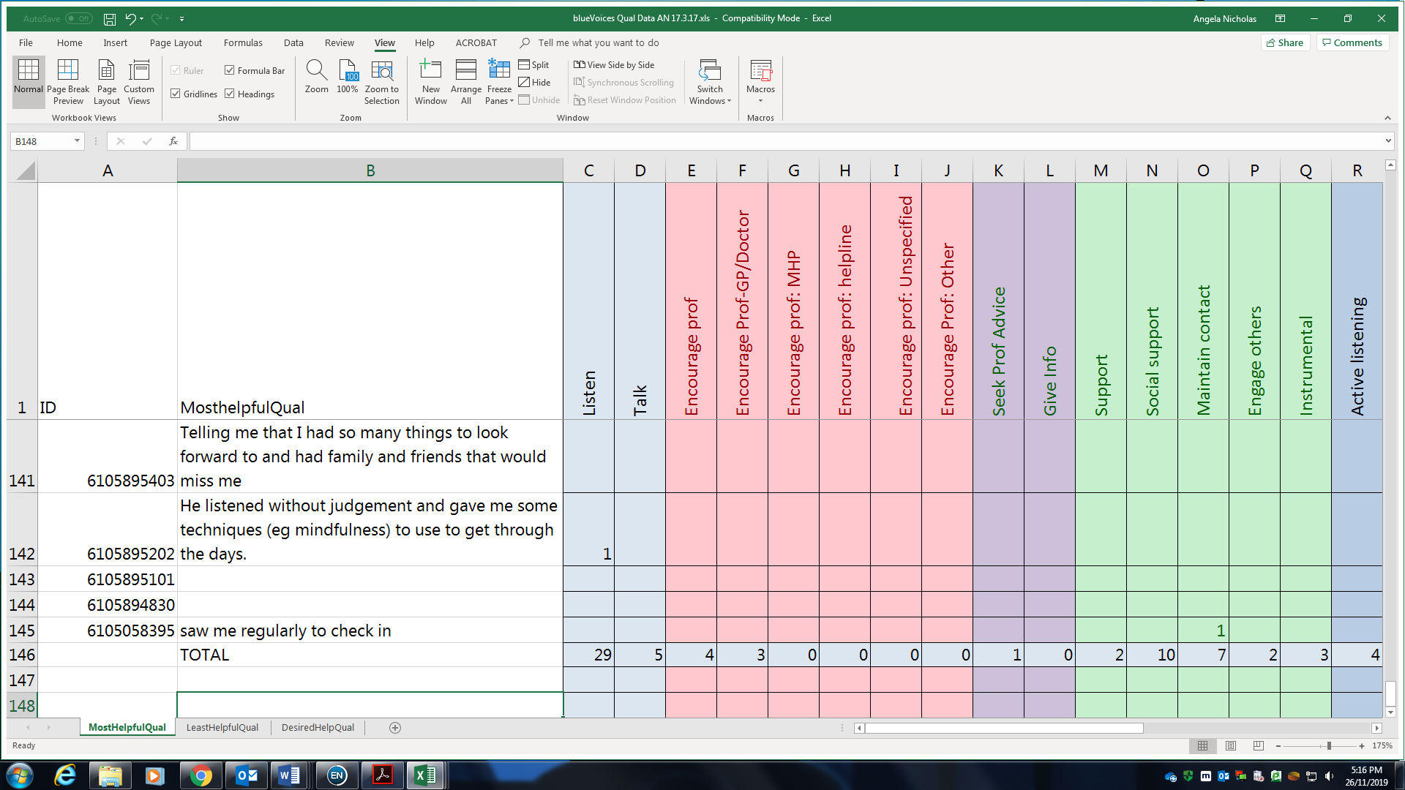
Figure 1. Coding of qualitative data

Nationally representative telephone survey (Studies 3 to 5)
An overview of Studies 3, 4 and 5 are provided in sections 3.1.3.3, 3.1.3.4, and 3.1.3.5, respectively. The full description of the studies in their format as accepted or published papers are included as Chapter 6, Chapter 7, and Chapter 8, respectively. The Theory of Planned Behaviour (see section 2.7.1) guided the choice of constructs measured in the national survey (Ajzen, 1985, 1991, 2011). The purpose of the nationally representative telephone survey was therefore to assess Australian adults’ current confidence, attitudes, intentions and behaviours toward suicide prevention when a person close to them is at risk of suicide. These constructs were assessed using a survey administered via a computer-assisted telephone interview (CATI) method.

Sample and recruitment
In order to administer the survey nationally, Roy Morgan Research Ltd was contracted to conduct a national telephone survey using a survey developed specifically for this purpose using a CATI method. Data was gathered from 3002 adults (further details of recruitment methods are provided in sections 6.3.1, 7.3.1, and 8.3.1).

Materials
The survey included nine sub-sections relevant to the studies reported in this thesis: (1) age and gender; (2) presentation of vignettes; (3) intentions and confidence to help the person in the vignette; (4) real-life helping behaviour toward someone in severe distress or at risk of suicide; (5) last 12-month history of suicide risk; (6) help given to the respondent when at risk of suicide; (7) attitudes to suicide; (8) formal training in suicide prevention; and (9) additional demographics (postcode, whether Aboriginal and/or Torres Strait Islander, languages spoken at home other than English, highest education level); (13) permission to re-contact and contact details; (14) contacts for distress (optional). The survey had both closed- and open-ended questions.
Most details of how and why the survey content was created is outlined in the published papers (sections 6.3.2, 7.3.2, and 8.3.2). More details on how the items chosen to measure history of suicide risk are provided in section 3.1.2.2.1. However, limited detail is provided on how the attitudes to suicide items were chosen for this survey, which is relevant to Study 5 (Chapter 8). Therefore, more detail is provided here.

Choice of attitudes to suicide items
A brief literature search was conducted using Medline and Psycinfo using terms such as ‘suicid*’ AND ‘attitude*’ OR ‘belief*’ in title or abstract. The search was limited to peer-reviewed papers published in English, with no date limits. Any measures of attitudes to suicide in the papers found through the literature search described in Section 3.1.1.2.2 were also included. From these searches, 15 scales measuring attitudes toward suicide were identified. There was substantial overlap between the content of items across the scales. Those attitudes items that were most commonly used across scales were chosen to include in the national survey. When there was overlap in content but variation in wording, the version was chosen that had the clearest and most succinct wording or a different version was created combining wording from different versions. Using this process, 12 attitudes items were included in the national survey.
However, for Study 5 (included as Chapter 8), the number of ‘attitudes’ items was reduced in order to focus on ‘suicide myths’. This focus was adopted because suicide myth ‘debunking’ is a common approach in suicide prevention education and frequently focuses on a small number of suicide myths. However, the empirical evidence for the effects of beliefs in suicide myths on helping intentions and actions is limited (see section 2.7.2). To identify those suicide myths that are most commonly believed, and those most commonly targeted in suicide myth debunking, Medline and Psycinfo were searched using terms such as ‘suicid*’ AND ‘myth*’. The literature identified through the literature search on ‘attitudes’ described above was also used. From the literature found through this search, seven myths were chosen to include in Study 5.

Procedures

Data collection
Survey questions were programmed into the CATI software. This software automatically dialled random telephone numbers as programmed, presenting the survey ‘script’ that interviewers were required to follow, allowed interviewers to directly input survey responses for collation in a real-time database, and performed ‘skip logic’ to ensure that the correct flow of questions was asked based on responses to previous questions (Weeks, 1992). The survey was read aloud by the interviewers and respondents answered questions verbally. Interviewers indicated respondents’ answers in an online form, and typed answers verbatim for open-ended questions. At the completion of data collection, Roy Morgan provided the weighted dataset to the candidate to complete data analyses.

Pilot testing
A pilot test of 100 completed surveys was undertaken from 14th to 16th February 2017. The candidate attended the call centre during the pilot phase to answer questions from the interviewers regarding the study, to troubleshoot any immediate problems arising, and to better understand the data collection process. In addition to providing a technical test and a usability test of the survey, the pilot also allowed calculation of how long completion of the survey would take. On average, survey completion took 22 minutes. No serious difficulties with the survey arose, so the 100 pilot surveys were retained in the final sample.

Data weighting
‘Raking’ is a type of data weighting that is used to reduce bias in survey data from ‘unit non-response’ i.e., to adjust for the fact that there are some population groups who have lower response rates and others who have higher response rates (Lumley, 2010). However, in order to provide population estimates (e.g., means, coefficients), it is necessary to estimate these from the study sample. Raking is one of several methods for weighting the sample according to observable characteristics so that they match the target population (Pew Reserach Center, 2019). This is the method that Roy Morgan Research used to weight the sample of 3002 to the target population of 18,871,042 Australian adults. Using data from the Australian Bureau of Statistics as the basis for matching (Australian Bureau of Statistics, 2016, 2017b), the sample was weighted using age, gender, location, education level and telephone status (ownership of mobile and/or landline telephones). In the survey data, weighting was required to adjust for over-representation of people with a university-level education and under-representation of men and older people.

Data analysis
Specific details of the data analyses conducted in Studies 3 to 5 are included in sections 6.3.2.1, 7.3.2.1 and 8.3.3. However, further details of the use of Stata survey commands are provided here.

Data analysis in Stata using survey commands
The statistical software Stata 15.0 was used for the analyses using the weighted survey data. To analyse the weighted data in Stata, the weights (as discussed in section 3.1.3.2.3) were first applied to the data using the command ‘svyset’. Once the weights were applied, survey commands (prefix ‘svy’) were then used in all analyses. Use of the svy command in Stata ensures the correct calculation of standard errors by considering the effect of weighting in these calculations (StataCorp, 2013). Failure to account for these can produce artificially small standard errors because, in effect, the entire target population is treated as the sample size, rather than the sample that was actually surveyed. This means that the wrong sample size values are used to calculate the standard errors, meaning confidence values are artificially too narrow and p-value too small. Details of the specific analyses carried out for Studies 3 to 5 are detailed in Chapters 6 to 8.

Summary
Table 2 provides a summary of the research questions addressed and the overall method used across the five studies.
Table 2. Research questions addressed in each of the five studies
 | Consensus study | Online survey | Nationally representative telephone survey
Research question | Study 1 | Study 2 | Study 3 | Study 4 | Study 5
1 | √
2 |  | √
3 |  |  | √
4 |  |  | √
5 |  |  | √
6 |  |  | √
7 |  |  | √
8 |  |  | √
9 | √
10 |  |  |  | √
11 |  |  |  | √
12 | √ |  |  | √
13 |  |  |  |  | √
14 |  |  |  |  | √
15 |  |  |  |  | √

Study 1. Importance of messages for a suicide prevention media campaign: An expert consensus study
Study 1 has been published in Crisis:
Nicholas A, Rossetto A, Jorm A, Pirkis J, Reavley N. (2018) Importance of messages for a suicide prevention media campaign: An expert consensus study. Crisis, 39(6), 438-450.

Abstract
Background: A suicide prevention media campaign aimed at family members and friends may be one useful population-level suicide prevention strategy for Australia. However, evidence for what messages would be acceptable and appropriate for inclusion is currently limited.
Aims: This expert consensus study aimed to identify messages that experts with lived experience of suicide risk and suicide prevention professionals believed were most important to include in such a suicide prevention campaign.
Method: Using an online survey method, 127 participants with lived experience (lived experience group) and 33 suicide prevention professionals (suicide prevention professionals group) rated 55 statements, drawn from an earlier Delphi study, from ‘very low priority’ to ‘very high priority’ for inclusion in a suicide prevention campaign.
Results: There was significant agreement within and between the two participant groups on the most highly rated messages for inclusion. The mostly highly rated messages were that family members or friends should ask directly about suicidal thoughts and intentions, listen to responses without judgement, and tell the person at risk that they care and want to help.
Conclusion: There is substantial agreement between professionals and people with lived experience on the most important messages to include in a suicide prevention campaign. These most highly rated messages could be adopted in a suicide prevention media campaign.

Background
In 2015, the standardised death rate in Australia was 12.6 deaths per 100,000 people (Australian Bureau of Statistics, 2018). Despite an increased policy focus on mental health in Australia (Department of Health, 2009), the suicide rate has increased steadily over the last decade (Australian Bureau of Statistics, 2018). This increase in suicide rates suggests the need for alternative approaches to suicide prevention, and one such population-level approach that has not yet been undertaken in Australia is the suicide prevention media campaign. While the international evidence for the effectiveness of such campaigns is mixed, there is some evidence that such campaigns can change attitudes, intentions and behaviours relating to suicide (Pirkis et al., 2019).

A significant proportion of people who die by suicide are not in contact with mental health or general health services (Hunt et al., 2006; Isometsä, 2001; Sveticic et al., 2012). Research evidence suggests that people at risk of suicide often communicate their suicidal thoughts and intentions to family members and friends before they make a suicide attempt (Houston, Hawton, & Shepperd, 2001; Isometsä, 2001; Owens et al., 2009; Rich, Fowler, Fogarty, & Young, 1988). There may therefore be an important role for family members and friends in identifying and intervening in response to suicide risk. However, because family members and friends are frequently uncertain about how best to interpret and respond to this communication, they may be unsure about whether, or how, to address this suicide risk, and their responses may be unintentionally unhelpful or dismissive (Owen et al., 2012; Owens et al., 2011; Owens et al., 2009). A media campaign aimed at promoting identification of people at risk of suicide and positive helping responses among family members and friends could therefore have significant positive effects for both those at risk and those wanting to offer support who are unclear about how to do so.

It is imperative that any suicide prevention campaign include acceptable and appropriate messaging that is evidence based and does no harm (Pirkis, Rossetto, Nicholas, & Ftanou, 2016). The evidence regarding the effective elements of suicide prevention media campaigns requires further development (Pirkis et al., 2019). The present expert consensus study aimed to identify messages that two groups of experts believe are most important to include in a suicide prevention media campaign aimed at increasing the likelihood that the general population, and particularly family members and friends, would appropriately identify and intervene with someone at risk of suicide. These two groups of experts were people with lived experience of suicide risk and suicide prevention professionals. Inclusion of those with lived experience of suicide risk is imperative to gaining the best understanding of this experience, and there are increasing calls for standard inclusion of the lived experience in all suicide prevention activities (Suicide Prevention Australia, 2015).

The online consensus method used in this study is based on the Delphi consensus method, which asks chosen experts to provide their opinions on a particular issue, usually by rating their agreement with statements presented in a questionnaire (Jones & Hunter, 1995). The purpose of such studies is to reach a consensus on the issue of interest, and to measure the level of agreement between experts. Allowing experts to provide their opinions anonymously and remotely avoids pitfalls common to decision making by committees meeting face to face, such as dominance by particular individuals (Jones & Hunter, 1995), and also requires significantly less resourcing than face-to-face meetings. Use of this consensus method for identifying media messages for a suicide prevention campaign is appropriate because there is not yet clear research evidence as to the components that make a suicide prevention campaign effective (Pirkis et al., 2019). To our knowledge, this had not been done before.

Method

Sample and recruitment

Sample
We invited two groups of experts to participate in our expert consensus study. The first group had lived experience of suicide risk (the lived experience group) and the second group had professional expertise in the suicide prevention field (suicide prevention professionals group). Inclusion criteria were that participants must be over 18 years of age; able to complete the study in English; have an understanding of suicide and its prevention, including the ‘signs and symptoms that someone is experiencing suicidal thoughts and how to respond upon recognition of these’; and either personal experience of suicide through past ideation or attempts, or through supporting someone personally who has had suicidal thoughts or attempts; or professional experience working in the area of suicide prevention.

Recruitment
To recruit participants with lived experience of suicide risk, Beyond Blue sent an email to its blueVoices reference group requesting expressions of interest for participation in the study. blueVoices is Beyond Blue’s reference group and online community for people with lived experience of depression and anxiety and those supporting them (https://www.beyondblue.org.au/get-involved/bluevoices) (see section 3.1.1.1 for additional details). Potential participants emailed a researcher with a short statement regarding their experiences with suicide risk and eligibility to participate was assessed based on the information provided. Lived-experience participants were deemed to meet the criteria ‘had an understanding of suicide and its prevention’ if they had first-hand experience of being at risk of suicide or had supported someone at risk of suicide. We received 165 expressions of interest.
We also invited to participate members of the International Association of Suicide Prevention (IASP) Media and Suicide Special Interest Group who also had expertise in media campaigns for suicide prevention, professionals who had participated in the MHFA guidelines re-development Delphi study (Ross et al., 2014), authors of multiple peer-reviewed suicide prevention journal articles and books, and other professionals known to our research team as meeting the criteria for participating in the suicide prevention professional participant group. We sent 111 suicide prevention professionals an email requesting expressions of interest for participation, and also used a ‘snowball technique’ whereby professionals could suggest other appropriate professionals to invite to participate. From this process, we received 50 expressions of interest.

Materials
Statements in our expert consensus study questionnaire were taken from an earlier Delphi expert consensus study aimed at re-developing the Mental Health First Aid (MHFA) Guidelines for Suicide Prevention (Ross et al., 2014) (See section 3.1.1.2.1 for additional details). In that three-round Delphi study, a group of consumer advocates and a group of professionals each rated the importance of a large number of statements for inclusion in the MHFA suicide prevention guidelines. Those statements that 95% or more of either the consumer advocate or professional expert groups rated as ‘important’ or ‘essential’ for inclusion in the guidelines at any of the three Delphi rounds were included in the current questionnaire. This resulted in the inclusion of 46 statements, to which we added nine statements identified through a review of the literature on suicide prevention interventions aimed at family members and peers of people at risk of suicide that were commonly included in these programs (see section 3.1.1.2.2 for additional details).
These 55 statements were divided into nine sections (see Table 3) based on the previous Delphi study from which the majority of items were drawn (Ross et al., 2014).
All participants were asked to rate each statement for ‘how high a priority it is (from ‘very low priority’ to ‘very high priority’) that each message be included in a national media campaign for suicide prevention’. Rankings were assigned a value from 1 = ‘very low priority’ to 5 = ‘very high priority’. (For additional details of the Delphi method and the single-round consensus method used here, see sections 3.1.1.3.1 and 3.1.1.3.2).
Participants were asked to complete a number of demographic questions before rating the statements for the expert consensus study. These questions related to age, gender, role related to suicide prevention, and experience with suicide risk. If participants indicated they were active in a professional or volunteer role, they were asked to specify their job title and indicate the number of years they had spent in that role.

Table 3. Items for the consensus study questionnaire
No. | Source | Item
Section 1. Approaching a suicidal person and asking about suicidal thoughts
1 | MHFA Delphi | You should be aware that if a person is suicidal, asking them about suicidal thoughts will allow them the chance to talk about their problems and show them that somebody cares.
2 | MHFA Delphi | You should act promptly if you think someone is considering suicide.
3 | MHFA Delphi | You should not assume that the person will seek help on their own.
4 | MHFA Delphi | If you think someone might be having suicidal thoughts and feel unable to ask them, you should find someone who is able to ask.
5 | MHFA Delphi | You should not ask about suicide in leading or judgemental ways e.g. 'You're not thinking of doing anything stupid, are you?'
6 | MHFA Delphi | You should know that it is more important to genuinely want to help than to be of the same age, gender or cultural background as the person.
Section 2. Reacting to expressions of suicidal thoughts
7 | MHFA Delphi | You should allow the suicidal person to discuss their feelings. A suicidal person may feel relief at being able to do so.
8 | MHFA Delphi | You should ask about issues that affect the immediate safety of the person who is suicidal.
9 | MHFA Delphi | You should react to expressions of suicidal thoughts with calmness and empathy.
10 | MHFA Delphi | You should avoid expressing negative reactions to suicidal thoughts, e.g. judgement, shock, panic, anger.
11 | MHFA Delphi | You should allow the suicidal person to express their feelings (e.g. allow them to cry, express anger or scream).
12 | MHFA Delphi | You should validate the suicidal person's thoughts and feelings and acknowledge that these may be hard to talk about.
Section 3. Assessing the seriousness of suicide risk
13 | MHFA Delphi | You should take expressions of suicidal thoughts seriously and act on these, not dismissing them as 'attention seeking' or a 'cry for help'.
14 | MHFA Delphi | You should ask the suicidal person if they have a plan for suicide.
15 | MHFA Delphi | You should take all thoughts of suicide seriously. The lack of a plan for suicide is not sufficient to ensure safety.
16 | MHFA Delphi | You should ask the suicidal person about current supports to help them.
17 | MHFA Delphi | You should ask the suicidal person how they are feeling right now.
18 | Literature | You should know the signs a person might be suicidal.
Section 4. Providing initial assistance
19 | MHFA Delphi | If you suspect there is an immediate risk of the person acting on suicidal thoughts, you should act quickly even if they are unsure.
20 | MHFA Delphi | You should keep in mind you may not be successful in preventing suicide.
21 | MHFA Delphi | You should exercise appropriate self-care after helping someone who is feeling suicidal.
22 | MHFA Delphi | If the person doesn't want to talk to someone face to face, you should encourage them to contact a suicide helpline.
23 | MHFA Delphi | You should not put yourself in any danger while offering support to the suicidal person
24 | Literature | For young people, you should make sure an adult close to them is aware of the situation.
25 | Literature | You should not leave someone who is feeling suicidal on their own.
26 | Literature | If someone has a specific plan for suicide, you should encourage the suicidal person to get appropriate professional help as soon as possible.
27 | Literature | If the suicidal person has a specific plan, you should call a mental health centre or crisis telephone line and ask for advice on the situation.
28 | Literature | If the person is suicidal, you should discuss with the suicidal person what actions they should take to get help.
Section 5. Talking with a suicidal person and letting them know you care
29 | MHFA Delphi | You should be supportive and understanding of the suicidal person.
30 | MHFA Delphi | You should listen to the suicidal person without expressing judgment.
31 | MHFA Delphi | You should be patient and calm while the suicidal person is talking about their feelings.
32 | MHFA Delphi | You should give the suicidal person their undivided attention.
33 | MHFA Delphi | You should be conscious of their body language, ensuring it doesn't communicate a lack of interest or negative attitude.
34 | MHFA Delphi | You should tell the suicidal person you care and want to help.
35 | MHFA Delphi | You should express empathy for the suicidal person.
36 | MHFA Delphi | You should ask what the suicidal person is thinking and feeling.
Section 6. Actively listening and offering assurance
37 | MHFA Delphi | You should ask the suicidal person how they would like to be supported and if there is anything they can do to help.
38 | MHFA Delphi | You should let the suicidal person know that it's okay to talk about things that might be painful.
39 | MHFA Delphi | You should focus on the things that will keep the suicidal person safe for now rather than the things that put the person at risk.
40 | MHFA Delphi | You should reassure the suicidal person that they are there for them and want to help.
41 | MHFA Delphi | You should reassure the suicidal person that there are solutions to problems or ways other than suicide for coping.
42 | MHFA Delphi | You should ask open questions to find out more about the suicidal thoughts and feelings and the problems behind these.
Section 7. What to avoid when talking to a suicidal person
43 | MHFA Delphi | You should not let the fear of saying the wrong words or of not saying the perfect words keep them from encouraging the suicidal person to talk.
44 | MHFA Delphi | You should not minimise the suicidal person's problems.
45 | MHFA Delphi | You should not give glib 'reassurance' such as 'don't worry', 'cheer up', 'you have everything going for you' or 'everything will be alright'.
46 | MHFA Delphi | You should not argue or debate with the person about their thoughts of suicide.
47 | MHFA Delphi | You should not take any hurtful actions or words of the suicidal person personally.
48 | Literature | You should not encourage a person who is suicidal to use drugs or alcohol.
Section 8. Making a safety plan and ensuring safety
49 | MHFA Delphi | You should engage the suicidal person to the fullest extent possible in decisions about a safety plan.
50 | Literature | The safety plan should be clear, outlining what will be done, who will be doing it, and when it will be carried out.
51 | Literature | You should try to remove the means of suicide available to the suicidal person if it is safe to do so.
Section 9. What else you should know when supporting a suicidal person
52 | MHFA Delphi | You should be aware of the local services that can assist in response to people at risk of suicide (i.e. hospitals, mental health clinics, mobile outreach crisis teams, suicide prevention helplines, local emergency services).
53 | MHFA Delphi | You should know that openly talking about suicidal thoughts and feelings can save a life.
54 | MHFA Delphi | You should be aware that even though you can offer support, you are not responsible for the actions or behaviour of someone else and cannot control what they might decide to do.
55 | MHFA Delphi | You should be aware that it is more important to be genuinely caring than to say 'all the right things'.
Note: MHFA Delphi = Delphi study for the re-development of the Australia Mental Health First Aid Guidelines on Suicide (Ross et al., 2014)

Procedures

Data collection
The questionnaire was presented within the online survey software SurveyMonkey. In June 2016, we sent an email containing a personalised link to the online survey to all people who had expressed interest in participating. There was also a paper-based option for those who preferred not to complete the online version. (For additional details see section 3.1.1.3.3).
Participants who did not complete the survey within one week were sent a reminder email stating they had one more week to complete the survey. Those who did not complete the survey within that week were followed up one more time within the following week, and the survey closed three weeks from the date the email was initially sent.

Data analysis
All statistical analyses were conducted in SPSS V22. We used descriptive statistics to summarise the demographic characteristics of the members of each participant group. Following a similar method to that used in the earlier Delphi consensus study conducted to re-develop the MHFA suicide prevention guidelines (Ross et al., 2014), we identified all messages that more than 80% of both groups indicated as ‘high’ or ‘very high priority’ for inclusion in the suicide prevention campaign. To determine the level of agreement between the two participant groups, we calculated a Pearson’s correlation coefficient between these percentage endorsement rates for ‘high’ and ‘very high’ ratings for the two groups across items. We then calculated an Intra-Class Coefficient (ICC: two-way, absolute value agreement, average measures, random effects) to assess the level of agreement on all ratings of all items within the members of each of the two participant groups. The ICC is frequently used to assess inter-rater reliability, where a number of raters provide ratings on a common phenomenon (Treventhan, 2017).
We then identified the 15 top-rated messages from each of the two participant groups, those with lived experience and suicide prevention professionals, and compared these to ascertain how many messages were common to both groups. Two members of our research team (AN and AR) independently conducted thematic analyses to identify the core messages of the highest-rated study items by both groups and each group separately. AN and AR each assessed the individual items for their core messages and compared these with other items to identify other messages with the same core message, but with different wording. They then discussed any discrepancies and reached a consensus on the results reported.

Ethical approval
This study was approved by the University of Melbourne Human Research Ethics Committee (No. 1646658.1). (Letter of Approval is included as Appendix C).

Results

Response rates
Figure 2 illustrates the number of responses received from participants with lived experience at each stage.

10 completed demographics but rated no statements
165 sent online questionnaire link
3 sent paper questionnaire by mail
2 opened but completed no questions
127 completed questionnaire
168 Blue Voices members responded to researchers with expressions of interest
Invitation to participate sent to Blue Voices members’ email addresses by Beyond Blue
3 completed and returned by mail
124 completed online questionnaire
Figure 2. Responses received from lived-experience participants throughout data collection
Of the 168 members of blueVoices who volunteered to participate in the study, 127 provided complete responses to the questionnaire. Three participants requested, and were sent, a paper copy of the survey, and the remaining 124 completed the questionnaire online.
Figure 3 illustrates the recruitment process for the professional participants.

Invitation to participate sent to 111 professionals email addresses by researchers
10 additional professionals invited on recommendation from original invited professionals (Snowball recruitment)
40 expressions of interest
50 sent online questionnaire link
33 completed online questionnaire
- 11 recipients not reached
- 8 incorrect emails
- 2 on leave until after study
- 1 mailbox full
- 4 declined
- 2 too busy
- 1 not his area of expertise
- 1 not interested
56 no reply

Figure 3. Responses received from professional participants throughout data collection
Fifty professionals agreed to participate in the study. Of these, 33 provided complete responses to the questionnaire.

Demographics
The mean age of participants with lived experience was 39.69 (n = 137, SD = 14.46), ranging from 18 to 74 years. The suicide prevention professionals had a mean age of 50.18 years (n = 33, SD = 12.31), ranging from 32 to 74 years. Responses to questions about role in relation to suicide prevention, and the type of experience with suicide risk are shown in Table 4. Overall, participants indicated a breadth of experience with suicide risk, with half of both the participants with lived experience and suicide prevention professionals having supported a person at risk of suicide, and almost 90% of the participants recruited for their lived experience having been at risk of suicide themselves.

Table 4. Characteristics of participants: Gender, role and experience with suicide risk
 | Lived experience  (n = 127) |  | Professionals  (n = 33)
Characteristic | No. | % | No. | %
Gender
Female | 85 | 66.9 | 19 | 57.6
Male | 41 | 32.3 | 14 | 42.4
Transgender (Male) | 1 | 0.8 | 0 | 0.0
Role
Suicide prevention researcher | 4 | 3.1 | 21 | 63.6
Lived experience of suicide risk | 121 | 95.3 | 7 | 21.2
Mental health service provider | 7 | 5.5 | 9 | 27.3
Other professional working for a mental health organisation | 4 | 3.1 | 11 | 33.3
Volunteer with a mental health organisation | 20 | 15.7 | 1 | 3.0
Other role | 4 | 3.1 | 5 | 15.2
Experience with suicide risk
Professional capacity | 13 | 10.2 | 32 | 97.0
At risk myself | 112 | 88.2 | 3 | 9.1
Provided support to another at risk | 63 | 49.6 | 17 | 51.5
Other | 14 | 11.0 | 4 | 12.1

Table 5 summarises the job titles of the participants who specified their job title. Twenty-four participants with lived experience were acting in a professional or volunteer role, and their mean number of years of experience in those roles was 8.13 (SD = 9.88; range: 1 month-35 years). The suicide prevention professionals’ mean number of years’ experience was 21.20 (n = 25, SD = 11.75, range: 3-49 years).

Table 5. Job titles for relevant professional or volunteer roles
Lived experience (n = 21) |  | Professionals (n = 30)
Title | No. | Title | No.
Support group leaders and members | 6 | Academic researchers and lecturers | 13
Allied health, medical and complementary medicine professionals | 5 | Senior management and staff | 9
Counsellors | 4 | Mental health clinicians | 8
Crisis support workers | 2
Online forum moderator | 2
Fundraiser for mental health organisation | 1
Mental health consumer consultant | 1

Ratings of the expert consensus study statements
The messages rated most highly by both groups are shown in Table 6.

Statements rated most highly by both groups
A number of the 15 statements rated most highly by both participants with lived experience and the suicide prevention professionals had a similar theme or core message expressed with different wording. These core messages related to taking expression of suicide seriously; allowing the person to talk openly while listening carefully and expressing a desire to help; encouraging them to call a helpline; calling a crisis service if the person has a specific suicide plan; and removing the means of suicide where necessary and safe.
The correlation between the lived experience and professional participants’ item ratings of high and very high priority illustrates a significant, moderate degree of agreement between the two participant groups (r = .58, P = <.001). While this correlation indicates moderate agreement, it does also illustrate that there are some differences between the two participant groups on the statements they valued as most important.
Table 6. Messages rated by 80% or more of both panels as ‘high’ or ‘very high’ priority
Highly rated messages common to both panels
Rated as ‘high priority’ or ‘very high priority’ by 90% or more of participants on both panels
You should take expressions of suicidal thoughts seriously and act on these, not dismissing them as 'attention seeking' or a 'cry for help'.
You should allow the suicidal person to discuss their feelings. A suicidal person may feel relief at being able to do so.
Rated as ‘high priority’ or ‘very high priority’ by 85% or more of participants on both panels
You should listen to the suicidal person without expressing judgment.
Rated as ‘high priority’ or ‘very high priority’ by 80% or more of participants on both panels
You should know that openly talking about suicidal thoughts and feelings can save a life.
If someone has a specific plan for suicide, you should encourage the suicidal person to get professional help as soon as possible.
You should be supportive and understanding of the suicidal person.
You should take all thoughts of suicide seriously. The lack of a plan for suicide is not sufficient to ensure safety.
You should tell the suicidal person that you care and want to help.
You should react to expressions of suicidal thoughts with calmness and empathy.
If the person doesn't want to talk to someone face to face, you should encourage them to contact a suicide helpline.
You should try to remove the means of suicide available to the suicidal person if it is safe to do so
You should not minimise the suicidal person's problems.
You should reassure the suicidal person that you are there for them and want to help.
You should not give glib 'reassurance' such as 'don't worry', 'cheer up', 'you have everything going for you' or 'everything will be alright'.
If the suicidal person has a specific plan, you should call a mental health centre or crisis telephone line an ask for advice on the situation

Most highly rated messages from each group
The 15 top-rated messages from each participant group are shown in Table 7.

Table 7. 15 top-rated messages from each panel in descending order of rated priority
Statement | % professionals indicated as ‘high’ or ‘very high’ priority | Statement | % lived experience participants indicated as ‘high’ or ‘very high’ priority
If a person is suicidal, asking them about suicidal thoughts will allow them the chance to talk about their problems and show them that somebody cares. | 100.00 | You should act promptly if you think someone is considering suicide. | 94.49
You should take expressions of suicidal thoughts seriously and act on these, not dismissing them as 'attention seeking' or a 'cry for help'. | 100.00 | You should take expressions of suicidal thoughts seriously and act on these, not dismissing them as 'attention seeking' or a 'cry for help'. | 93.70
You should allow the suicidal person to discuss their feelings. A suicidal person may feel relief at being able to do so. | 90.91 | You should listen to the suicidal person without expressing judgment. | 92.91
If someone has a specific plan for suicide, you should encourage the suicidal person to get professional help as soon as possible. | 90.91 | You should know that openly talking about suicidal thoughts and feelings can save a life. | 92.13
If the person is suicidal, you should discuss with them what actions they should take to get help. | 90.91 | If you suspect there is an immediate risk of the person acting on their suicidal thoughts, you should act quickly even if you are unsure. | 91.34
You should tell the suicidal person that you care and want to help. | 90.91 | You should allow the suicidal person to discuss their feelings. A suicidal person may feel relief at being able to do so. | 90.55
You should ask about issues that affect the immediate safety of the person who is suicidal. | 87.88 | You should react to expressions of suicidal thoughts with calmness and empathy. | 88.98
If the person doesn't want to talk to someone face to face, you should encourage them to contact a suicide helpline. | 87.88 | You should be supportive and understanding of the suicidal person. | 88.98
You should listen to the suicidal person without expressing judgment. | 87.88 | You should avoid expressing negative reactions to suicidal thoughts, e.g. judgement, shock, panic, anger. | 88.19
You should try to remove the means of suicide available to the suicidal person if it is safe to do so | 87.88 | You should be aware that it is more important to be genuinely caring than to say 'all the right things'. | 88.19
You should take all thoughts of suicide seriously. The lack of a plan for suicide is not sufficient to ensure safety. | 84.85 | You should allow the suicidal person to express their feelings (e.g. allow them to cry, express anger or scream). | 87.40
You should be supportive and understanding of the suicidal person. | 84.85 | You should take all thoughts of suicide seriously. The lack of a plan for suicide is not sufficient to ensure safety. | 87.40
You should reassure the suicidal person that you are there for them and want to help. | 84.85 | You should not minimise the suicidal person's problems. | 87.40
You should not let the fear of saying the wrong words or of not saying the perfect words keep you from encouraging the suicidal person to talk. | 84.85 | You should not assume that the person will seek help on their own. | 85.83
You should know that openly talking about suicidal thoughts and feelings can save a life. | 84.85 | You should not give glib 'reassurance' such as 'don't worry', 'cheer up', 'you have everything going for you' or 'everything will be alright'. | 85.04

Four statements appeared in the top 15 messages for both participant groups:
- You should take expressions of suicidal thoughts seriously and act on these, not dismissing them as 'attention seeking' or a 'cry for help'.
- You should allow the suicidal person to discuss their feelings. A suicidal person may feel relief at being able to do so.
- You should listen to the suicidal person without expressing judgment.
- You should take all thoughts of suicide seriously. The lack of a plan for suicide is not sufficient to ensure safety.

Table 8 shows the results of the thematic analysis of the top 15 items from each participant group, undertaken to identify whether the two groups chose items with different wording, but similar core messages, or whether they believed different core messages were most important to include in a suicide prevention media campaign aimed at family members and friends of a person at risk. Despite their differences, this analysis showed that both participant groups most frequently rated as high priority for inclusion in a suicide prevention campaign the core message that family members and friends should ask their loved one directly about suicide, listen carefully to the person at risk and show they care. They differed, however, in that the second most commonly rated core message for the professional group (six messages) related to taking action, while the lived experience group’s related to taking expressions of suicidal thoughts seriously.

Table 8. Core messages appearing in the top 15 statements rated by each panel
 | No. items in 15 top-rated messages
Core message | Professionals | Lived experience
Ask about suicide risk, listen and show you care | 7 | 8
Take talk of suicide seriously | 2 | 5
Take action | 6ª | 1^{b}
Act quickly | 0 | 2
ªget help, call a suicide helpline, address issues affecting safety, remove means
^{b}assist the person at risk to get help

Agreement within participant groups
In addition to assessing the level of agreement between the two participant groups, we also assessed the level of agreement within each group. The average measure ICC for the participant group with lived experience was .964 with a 95% confidence interval from .955 to .973 (F(125, 6750) = 29.916, P < .001). The average measure ICC for the suicide prevention professional group was .959 with a 95% confidence interval from .935 to .977 (F(31, 1674) = 28.285, P < .001). This indicates a strong and significant level of agreement within the members of each participant group on the ratings of the items.

Discussion
Research with people bereaved by suicide indicates that those who have died by suicide frequently communicate suicidal intentions or thoughts to family members and friends prior to their suicide, though often in indirect and ambiguous ways (Isometsä, 2001; Owen et al., 2012). Therefore, family members and friends of people at risk of suicide may be in a unique position to identify when their loved ones are at risk of suicide and to offer them appropriate support. This expert consensus study aimed to identify messages that participants with lived experience of suicide risk and suicide prevention professionals believe are most important to include in an Australian suicide prevention media campaign aimed at family members and friends of a person at risk of suicide. Such a campaign would aim to increase the likelihood that these family members and friends will recognise when their loved one is at risk of suicide and to then intervene in an appropriate way.

We were able to gain substantial input from both lived experience and suicide prevention professional groups. Participants recruited for their lived experience of suicide risk represented a range of experience, with close to 90% having been at risk themselves, and half having provided support to another person at risk of suicide. Combined with the research and clinical expertise of the professional participant group, who had on average 21 years of experience, this provides an excellent cross-section of experiences that are represented in the findings of this expert consensus study. There was significant consensus between professional and lived experience participants on the statements that should be included in a media campaign. Within each participant group, the level of consensus was even higher.

Both groups agreed on the central importance of the message that in supporting someone who might be at risk of suicide, the family member or friend should ask directly about suicidal thoughts and intentions, listen to responses without judgement, and tell the person at risk that they care and want to help. There was also substantial agreement as to the importance of the message that suicidal thoughts and intentions should always be taken seriously. These suicide prevention messages are consistent with those barriers to suicide prevention for family and friends proposed by Owens et al (2011) and Owen et al (2012), who conducted a series of in-depth interviews with family members and friends bereaved by suicide about expressions of suicidal intent by their loved ones and their own responses. These researchers propose a number of barriers to suicide prevention with loved ones that prevent open questioning and discussion about suicidal thoughts and plans, and which can lead to inaction or an ‘inadvertent closing down’ of the suicidal communication (Owen et al., 2012). These barriers include a fear of jeopardising the relationship by discussing suicide more openly; a willingness to be ‘relieved’ of their responsibility to intervene by the person at risk, and therefore to favour positive signs over signs of suicide risk; and the effect of enduring myths about ‘suicide talk’ that might create uncertainty about the need to intervene or the harmfulness of addressing the ‘taboo’ of suicide. A suicide prevention campaign aimed at family and friends that incorporates these ‘high priority’ messages, therefore, might usefully address some of these barriers.

Despite a high level of agreement between the participants with lived experience and the suicide prevention professionals, there were some differences in their ratings of the messages. The lived experience participants also rated as particularly important the message that family members and friends should take expressions of suicidal thoughts seriously, while suicide prevention professionals gave greater priority to the message that people lending support need to take action once they have confirmed that their loved one is at risk. Professional participants rated as high priority for inclusion in a suicide prevention campaign that family members and friends should either help the person at risk to get professional help, call a suicide hotline, ask about issues directly related to the safety of the person, and consider removing access to means of suicide.

This difference in prioritising of messages possibly arises due to the different learning experiences of the two expert groups. For suicide prevention professionals, initial interactions with people at risk of suicide are likely to focus on assessing suicide risk and ensuring the safety of the person before continuing work on more detailed assessment and addressing ongoing mental health difficulties. This approach is outlined in the Australian Psychological Society’s Ethical guidelines relating to clients at risk of suicide (‘promote the safety and support of clients, pending a more thorough assessment of their needs, the context, and the options for further assistance’) (Australian Psychological Society, 2014p. 175). We have recently conducted a study with people with a history of suicide risk asking them to describe helpful and unhelpful responses to communication of suicidal thoughts. Preliminary findings show that these participants frequently cite responses from people close to them that minimise their suicidal thoughts and feelings as the least helpful responses received in response to communications of their suicide risk (Nicholas, Pirkis, Rossetto, & Reavley, In press). Common experiences of such responses might partly explain the focus of people with personal experience of suicide risk on the importance of taking expressions of suicidal thoughts seriously.

Ftanou et al. (2017) have previously undertaken a qualitative analysis of the content of 35 suicide prevention public service announcements that had appeared on television across five countries, including Australia. That study identified that the content of these public service announcements primarily promoted talking about suicide and encouraged help-seeking through helplines, websites and other informal sources either directly by people at risk or via those offering them support. They noted, however, that these announcements rarely provided guidance on how to talk about suicide with someone who might be at risk, and few directly promoted seeking professional support, both of which, we suggested, could strengthen the effects of these campaigns .

The findings of this expert consensus study are in agreement with this suggestion on suicide prevention public service announcements. In suggesting that family members and friends who suspect a loved one is at risk of suicide should ask directly about their suicidal thoughts and intentions, listen to these responses, and tell them that they care and want to help, the study participants have provided direct guidance as to how to begin to talk about suicide. The professional participants also suggested the inclusion of statements that then tell supporters of a person at risk what they should do once they confirm that their loved one is at risk of suicide. They endorsed statements suggesting helping the person at risk to get access to professional help in person or by phone, and addressing issues of safety, including removing means of suicide where it is safe to do so.

Recommendations for a suicide prevention media campaign
The findings from this expert consensus study lead us to recommend that the following messages be considered for inclusion in a suicide prevention media campaign that aims to encourage members of the public, and in particular family members and friends, to identify when someone is at risk of suicide, and to intervene in an appropriate way. This list summarises the core messages of those items rated most highly by the participants of our expert consensus study:
- Take expressions of suicidal thoughts seriously. Do not dismiss them.
- Allow the person to talk openly about their suicidal thoughts and feelings. Listen with calmness and empathy and without judgement. Let them know you care and want to help.
- If the person doesn't want to talk face to face, encourage them to call a suicide helpline.
- If the person has a specific plan for suicide, call a mental health centre or crisis line, or get professional help as soon as possible.
- Try to remove the means of suicide available to the suicidal person if it is safe to do so.

Limitations
The questionnaire used in this study drew heavily on the results of a previous three-round Delphi consensus study. As the Delphi consensus method had already been used to establish the importance and acceptability of these messages, we used a single-round consensus method to identify those suicide prevention messages that participants rated most important for inclusion in a suicide prevention campaign. However, by restricting participants’ ratings to just one round, we may have limited the level of consensus achieved, and we most certainly limited participants’ ability to change their ratings in consideration of others’ ratings and rationales. There is some evidence that providing participants with an aggregate and the rationale for others’ ratings, or allowing group discussion between rounds in which participants can adjust their responses in further rounds can lead to more accurate decision-making and greater consensus than when participants work alone (Gürçay, Mellers, & Baron, 2015; Rowe & Wright, 1999). Furthermore, using a pre-defined set of suicide prevention messages arising from the previous Delphi study might have prevented us from identifying other important messages not included in the pre-defined list.
A purposive sampling method was used for recruitment of experts for this expert consensus study. Suicide prevention professionals were identified by members of the research team and through a snowballing technique and experts recruited for their lived experience were members of Beyond Blue’s reference group and online community, blueVoices. This sampling technique has the potential to bias the sample toward participants with particular points of view given their exposure to common sources of information related to suicide prevention. For example, participants recruited from blueVoices might have been exposed to similar suicide prevention messages through information and resources accessible through Beyond Blue, which could influence how they respond to the survey. This means that the messages identified as most important to those who participated might differ systematically from those not exposed to this same information.
We specifically asked participants to rate the importance of the statements for inclusion in ‘a national media campaign for suicide prevention’. We recognise that this is a general statement and the results might not generalise to a campaign aimed at particular audiences. For example, the messages recommended for inclusion in a campaign aimed at helping young people at risk of suicide might differ from those recommended in our study.

Conclusion
This study forms part of a larger body of research (Nicholas et al., 2020; Nicholas, Pirkis, Jorm, Spittal, & Reavley, 2019; Nicholas et al., EPub ahead of print July 24, 2019; Nicholas et al., In press) attempting to establish an evidence base for the development of key messages for a suicide prevention media campaign aimed at increasing the likelihood that the general population, and particularly family members and friends, would appropriately identify and intervene with someone at risk of suicide. The substantial agreement within and between the suicide prevention professionals and those with lived experience of suicide risk on their ratings of the proposed messages has allowed us to make specific recommendations about some of the key messages that might be included in this potential suicide prevention campaign. These messages relate to encouraging people to talk openly about their suicidal thoughts, taking expressions of suicidal thoughts seriously, showing that you want to help, getting professional assistance when needed, and removing means of suicide where appropriate and safe. Despite the high rate of agreement between suicide prevention professionals and those with lived experience of suicide risk, the differences in their ratings also highlight the importance of the inclusion of different types of expertise, including lived experience, to ensure the inclusion or wide-ranging points of view in the development of new suicide prevention approaches. Our findings showed nuanced differences between these groups that are likely to be important for the development of a suicide prevention campaign. The resulting recommendations propose the inclusion of key messages ranging from those encouraging empathetic and supportive responses to communications of suicide risk (e.g., listening and showing you want to help) to more direct actions aimed at ensuring the safety of the person at risk (e.g. seeking professional help and removing means).
Funding note: This study is funded by Beyond Blue (www.beyondblue.org.au), an Australian not-for-profit organisation that aims to provide information and support for those affected by depression and anxiety.

References
Australian Bureau of Statistics. (2016). 3303.0 Causes of death in Australia, 2015: Suicide in Australia. Retrieved from Canberra, Ausrtalia: http://www.abs.gov.au/ausstats/abs@.nsf/Lookup/by%20Subject/3303.0~2015~Main%20Features~Intentional%20self-harm:%20key%20characteristics~8
Australian Psychological Society. (2014). Ethical guidelines relatin to clients at risk of suicide. Retrieved from
Department of Health. (2009). Fourth National Mental Health Plan: An agenda for collaborative government action in mental health 2009-2014. Canberra, Australia: Commonwealth of Australia Retrieved from http://www.health.gov.au/internet/main/publishing.nsf/content/mental-pubs-f-plan09.
Ftanou, M., Cox, G., Nicholas, A., Spittal, M. J., Machlin, A., Robinson, J., & Pirkis, J. (2016). Suicide prevention public service announcements (PSAs): examples from around the world. Health Communication, 1-9. Retrieved from http://dx.doi.org/10.1080/10410236.2016.1140269 doi:10.1080/10410236.2016.1140269
Gürçay, B., Mellers, B., & Baron, J. (2015). The power of social influence on estimate accuracy. Journal of Behavioural Decision Making, 28, 250-261. doi:10.1002/bdm.1843
Houston, K., Hawton, K., & Shepperd, R. (2001). Suicide in young people aged 15–24: a psychological autopsy study. Journal of Affective Disorders, 63(1–3), 159-170. doi:10.1016/S0165-0327(00)00175-0
Hunt, I., Kapur, N., Robinson, J., Shaw, J., Flynn, S., Bailey, H., . . . Parson, R. (2006). Suicide within 12 months of mental health service contact in different age and diagnostic groups. National clinical survey, 188(2), 135-142. doi:10.1192/bjp.188.2.135
Isometsä, E. T. (2001). Psychological autopsy studies – a review. European Psychiatry, 16(7), 379-385. doi:10.1016/S0924-9338(01)00594-6
Jones, J., & Hunter, D. (1995). Consensus methods for medical and health services research. BMJ: British Medical Journal., 311(7001), 376-380.
Nicholas, A., Pirkis, J., Rossetto, A., & Reavley, N. (In preparation). Helpful and unhelpful responses to communications of suicide risk: An online questionnaire study.
Owen, G., Belam, J., Lambert, H., Donovan, J., Rapport, F., & Owens, C. (2012). Suicide communication events: Lay interpretation of the communication of suicidal ideation and intent. Social Science & Medicine, 75(2), 419-428. doi:10.1016/j.socscimed.2012.02.058
Owens, C., Owen, G., Belam, J., Lloyd, K., Rapport, F., Donovan, J., & Lambert, H. (2011). Recognising and responding to suicidal crisis within family and social networks: qualitative study. BMJ, 343(7828). doi:10.1136/bmj.d5801
Owens, C., Owen, G., Lambert, H., Donovan J, Belam, J., Rapport, F., & Lloyd, K. (2009). Public involvement in suicide prevention: understanding and strengthening lay responses to distress. BMC Public Health, (9), 308. Retrieved from http://bmcpublichealth.biomedcentral.com/articles/10.1186/1471-2458-9-308 doi:10.1186/1471-2458-9-308
Pirkis, J., Rossetto, A., Nicholas, A., & Ftanou, M. (2016). Editorial: Advancing knowledge about suicide prevention media campaigns. Crisis, 37(5), 319-322. doi:10.1027/0227-5910/a000441
Pirkis, J., Rossetto, A., Nicholas, A., Robinson, J., & Reavley, N. (Submitted). Suicide prevention media campaigns: a systematic literature review. Health Communication.
Rich, C., Fowler, R., Fogarty, L., & Young, F. (1988). San Diego suicide study III: Relationships between diagnoses and stressors. Archives of General Psychiatry, 45, 589–559. doi:10.1001/archpsyc.1988.01800300087012
Ross, A. M., Kelly, C. M., & Jorm, A. (2014). Re-development of mental health first aid guidelines for suicidal ideation and behaviour. BMC Psychiatry. Retrieved from http://bmcpsychiatry.biomedcentral.com/articles/10.1186/s12888-014-0241-8 doi:10.1186/s12888-014-0241-8
Rowe, G., & Wright, G. (1999). The Delphi technique as a forecasting tool: issues and analysis. International Journal of Forecasting, 15, 353-375. doi:10.1016/S0169-2070(99)00018-7
Suicide Prevention Australia. (2015). Transforming suicide prevention research: A national action plan. Retrieved from Sydney, Australia.: https://www.suicidepreventionaust.org/sites/default/files/resources/2016/SUPR9490_SPA_National%20Action%20Plan_V1_0.pdf
Sveticic, J., Milner, A., & De Leo, D. (2012). Contacts with mental health services before suicide: a comparison of Indigenous with non-Indigenous Australians. General hospital psychiatry, 34(2), 185. doi:10.1016/j.genhosppsych.2011.10.009
Treventhan, R. (2017). Intraclass correlation coefficients: clearing the air, extending some cautions, and making some requests. Health Services and Outcomes Research Methodology, 17(2), 127-143.

Study 2. What responses do people at risk of suicide find most helpful and unhelpful from professionals and non-professionals
Study 2 has been accepted for publication in the Journal of Mental Health:
Nicholas A, Pirkis J, Reavley N. What responses do people at risk of suicide find most helpful and unhelpful from professionals and non-professionals? Journal of Mental Health, (In Press, 31 July 2020).

Abstract
Background: People at risk of suicide frequently communicate suicidal thoughts to professionals and non-professionals. These groups therefore need to be aware of how best to respond.

Aims: We aimed to identify helpful and unhelpful responses to communications of suicide risk from the perspective of those at risk to inform suicide prevention messaging and education.

Method: We conducted an online survey (N = 141) of members of an online reference group for an Australian mental health organisation with a history of suicide risk.

Results: Most respondents had repeatedly considered and attempted suicide. Indirect suicide communications were more common than direct communications. Listening without judgement was the most common helpful response and ‘minimising’ responses to suicidal thoughts and feelings, the most common unhelpful responses.

Conclusion: We make recommendations for suicide prevention messages and professional education content based on these findings.

Background
The suicide rate in Australia has increased over the last decade from 10.9 deaths per 100 000 people in 2008 to 12.6 per 100 000 in 2017 (Australian Bureau of Statistics, 2018). A substantial proportion of people experiencing thoughts of suicide will communicate these thoughts to either professionals (Luoma, Martin, & Pearson, 2002; Sveticic et al., 2012) or non-professionals, such as close family and friends (Draper, Krysinska, Snowdon, & De Leo, 2017b; Isometsä, 2001; Paraschakis et al., 2015; SANE Australia and University of New England, 2015; Wasserman et al., 2008), before they make a suicide attempt. Approximately one third to one half of people who attempt suicide communicate their intentions to someone close to them prior to the attempt (Paraschakis et al., 2015; SANE Australia and University of New England, 2015; Wasserman et al., 2008; Wolk-Wasserman, 1986).

It is imperative that both professionals and non-professionals are aware of how best to respond to expressions of suicide risk for two primary reasons. First, communication of suicidal intent provides an opportunity to intervene to prevent a suicide attempt and promote help-seeking to reduce ongoing suicidal intentions (Owen et al., 2012; Player et al., 2015). Second, family and friends’ responses to disclosures of history of suicide attempt has been shown to have a significant effect on subsequent depression and other risk factors for further suicide attempt (Frey & Fulginiti, 2017; Frey et al., 2016). These reactions are also likely to affect the likelihood of future disclosures (Frey et al., 2016; Latakienė et al., 2015), and therefore future opportunities to intervene. These studies of the effects of reactions to suicide communications, however, relate primarily to disclosure of past suicide attempts, and those examining reactions to suicide communications that occurred before an attempt are limited (Latakienė et al., 2015; Owen et al., 2012; Player et al., 2015; Shand et al., 2015; Wolk-Wasserman, 1986).

Furthermore, while there is a significant body of literature that assesses the suicide risk responses of health and mental health professionals and their comfort with working with individuals at risk of suicide (Draper et al., 2017b; Jahn, Quinnett, & Ries, 2016; Rothes & Henriques, 2018; Roush et al., 2018), these studies are largely from the view of the professional. Few studies have assessed the actions taken and the helpfulness of these actions from the perspective of those individuals at risk (SANE Australia and University of New England, 2015). While professionals may believe they are capable of responding appropriately to suicide communications, the view of the person at risk may differ. Furthermore, those attempting to communicate their suicide risk will also be aware of suicide communications that may have been ‘missed’ or misinterpreted by the professional, while the professional remains unaware.

Support offered by informal networks to people experiencing mental health difficulties and suicide risk are often perceived as helpful (Reavley & Jorm, 2011; Riedel-Heller, Angermeyer, & Matschinger, 2001; SANE Australia and University of New England, 2015). However, family members and friends of people at risk of suicide can have trouble interpreting and responding to communications of suicidal thoughts or intentions from loved ones (Owen et al., 2012; Owens et al., 2009). While the suicide prevention gatekeeper literature includes some limited evidence for the effects of gatekeeper training on suicide prevention behaviours, this evidence again is largely collected through the gatekeeper (Mo, Ko, & Xin, 2018; Yonemoto et al., 2019; Zalsman et al., 2016). Research that identifies helping actions that people at risk of suicide found most and least helpful, retrospectively, is rare (Player et al., 2015; SANE Australia and University of New England, 2015; Shand et al., 2015). Furthermore, this gatekeeper literature assesses the behaviours of trained gatekeepers, while a significant number of people to whom those at risk of suicide communicate their suicidal thoughts will be untrained community members.

Helpful behaviours in response to suicide communications can serve a number of functions, including promotion of professional help-seeking, interruption of acute suicidal thoughts, and reducing feelings of isolation and worthlessness. The literature examining the responses of family and friends to suicide communications shows that helpful behaviours toward those at risk include family and friends expressing their concern, following up after the initial conversation, spending additional time with them, and providing them with hope and someone to talk to (Shand et al., 2015). Conversely, unhelpful behaviours fail to translate the suicide communication in into further support or action and serve to reinforce feelings of worthlessness and hopelessness. Such reactions include disregarding or shutting down the attempt at communication, disengagement from the person at risk, and even aggressive or goading responses (Latakienė et al., 2015; Owen et al., 2012; Wolk-Wasserman, 1986).

In this study, we aim to identify helpful and unhelpful responses from professionals and non-professionals to communications of suicide risk from the perspective of those who have been at risk. Our sample was drawn from an online lived experience reference group for an Australian not-for-profit mental health organisation. From these findings, we aim to make recommendations regarding the education of health and mental health professionals to assist them in responding to suicide risk and regarding the development of suicide prevention messages and resources for non-professionals to enhance their ability to identify and assist a person at risk.

Method

Sample and recruitment
The study sample was recruited from the blueVoices online reference group for Beyond Blue. Beyond Blue is an Australian not-for-profit organisation that aims to promote the mental health of the community by providing information and support (www.beyondblue.org.au). blueVoices is their online reference group, which is open to people over 16 years with experience of anxiety, depression or suicide risk, including caring experience (www.beyondblue.org.au/get-involved/bluevoices) (see section 3.1.1.1 for additional details).

In the information provided to potential respondents, we specified the following selection criteria. Respondents self-selected into the study on the basis of these criteria:
- be comfortable completing the questionnaire in English,
- be 18 years or over,
- have experienced persistent thoughts of suicide or attempted suicide,
- be comfortable anonymously sharing experiences of suicide risk, and
- not be at immediate risk of suicide.

Materials
We developed an online questionnaire using Survey Monkey (Appendix E). The questionnaire had six sections and we used skip logic throughout. All respondents were asked about: (1) their age and gender; and (2) their history of suicidal thoughts, plans and behaviours (Paykel et al., 1974), including the year of their most recent suicidal ideation. (For additional details on selection of items to assess history of suicide risk, see section 3.1.2.2.1.)

Those who indicated having been at risk of suicide at some time in their lives were asked (3) whether someone knew the last time they were at risk of suicide, and whether they had communicated their suicidality directly or indirectly to others (e.g., by saying it would be better if they just ‘disappeared’) (Wasserman, 2001).

If the respondent indicated that someone knew the last time they were at risk of suicide they were then asked: (4) who was the most helpful person (e.g., mental health professional, friend); to state, using free-text, what that person did or said that they found most helpful; and to state whether the most helpful person had carried out 15 specified actions. These 15 actions comprised ten actions rated in a previous study as most important for promotion in a suicide prevention campaign (Nicholas, Rossetto, Jorm, Pirkis, & Reavley, 2018), and five actions listed as unhelpful to a person at risk of suicide in the Mental Health First Aid Guidelines for Suicidal Thoughts and Behaviours (Mental Health First Aid Australia, 2014). These respondents were also asked: (5) who was the most unhelpful person; and to state, using free-text, what that person did that was most unhelpful; and (6) to state, using free-text, any desired responses to communications of suicide risk they never received.

Procedures

Data collection
On 2 March, 2017, Beyond Blue sent an email invitation containing a direct web-link to the questionnaire to all members of their blueVoices reference group. A reminder was sent one week later. In the Background information at the start of the survey, potential respondents were reminded that if they did feel upset by any of the survey content, they should connect with their usual supports, or with one of several helplines for which we provided details. They were also reminded they can discontinue their participation at any time.

To determine whether our sample was representative of the broader blueVoices group on age and gender, Beyond Blue provided us with retrospective de-identified member data collected at registration via online questionnaire.

Data analysis

Quantitative analysis
We used descriptive statistics to summarise demographic characteristics of respondents and questionnaire responses with categorical or scale data. We calculated time elapsed since the respondent had last experienced suicidal thoughts by subtracting the year stated from the current year (2017) and collapsing the resulting durations into several categories. All statistical analyses were conducted in SPSS V22.

To make comparisons with the blueVoices registration data, we excluded data from members not matching our inclusion criteria. We used a one sample t-test and a chi-square test of independence to test for significant differences on age and gender distribution, between the blueVoices group and our sample (p < 0.05).

Qualitative analysis
Two members of our team (AN and NR) conducted thematic analysis of free-text responses using a grounded theory approach (Strauss & Corbin, 1990) whereby we independently and iteratively generated a coding framework by identifying themes, creating codes that captured the themes, and wrote definitions and recorded examples for each theme. AN has a postgraduate degree in psychology. Both have extensive experience in mental health research, including in coding similar qualitative data. Using an Excel spreadsheet, we summed the number of times each theme was indicated and compared totals and the use of codes between coders. Discrepancies were resolved through discussion between the two coders and the coding framework revised accordingly. The revised framework was used to re-code the qualitative data. (See section 3.1.2.3.1 for additional details.)

Ethical approval
Ethical approval for this study was granted be the University of Melbourne Human Research Ethics Committee (No. 1648511). (The letter of ethics approval is included as Appendix D.)

Results

Respondents

Demographics
Respondent’s mean age was 37.0 years (N = 143; SD = 15.0; range, 17-85), with 53% between 17 and 35. Almost three-quarters of respondents were female (n = 105, 73.4%); three respondents specified their gender as ‘Other’. There was no difference in age or gender distribution between our sample and the blueVoices group (Age: blueVoices N = 7244, M = 38.22, SD = 13.97, range, 16-113; t(140) = -1.35, p = 0.181. Gender: blueVoices N = 5152, 70.3% female; X²(1) = 1.432, p = 0.231).

History of suicide risk
Figure 4 shows the number of respondents who answered each question about their history of suicide risk, and a summary of responses is provided in Table 9. Two respondents had no history of suicide risk and were excluded from further questions.
Within the last year, two thirds (66%) of respondents had considered suicide. Over three quarters had chronic suicidality (76%), with 41% having considered suicide five or more times during their lifetime, and one third (36%) having done so continuously for a long time. Almost 90% had ‘seriously’ considered suicide or made a suicide plan; three quarters (76%) of these had done so three or more times; and 42% had done so in the last year. Of those who had seriously considered suicide, 62% had made a suicide attempt; 42% had attempted suicide three or more times and 31% had attempted suicide within the last year.

17 had not seriously considered suicide
43 had not made a suicide attempt
21 skipped question about suicide attempts
4 skipped question about serious consideration of suicide
2 had never thought about suicide and were excluded from further questions
141 had thought about suicide, even if they wouldn’t really do it
120 had seriously considered suicide
143 blueVoices members responded to the questionnaire
Invitation to participate sent to blueVoices members’ email addresses by Beyond Blue
77 had made a suicide attempt
Figure 4. Progression through history of suicidal thoughts and attempts questions

Table 9. Respondents’ history of suicidal thoughts and suicide attempts
Suicidal thoughts and attempts questions | Frequency | %
Ever considered suicide (even if ‘wouldn’t really do it’) |  | N = 143
Yes | 141 | 98.6
No | 2 | 1.4
How many times considered suicide |  | n = 137
Once | 3 | 2.2
Twice | 5 | 3.6
3 or 4 times | 24 | 17.5
5 or more times | 56 | 40.9
Continuously for a long time | 49 | 35.8
Missing (Respondent skipped voluntarily) | 4 | 2.9
Last time considered suicide |  | n = 137
In the current year | 41 | 29.9
Last year | 50 | 36.5
2 to 5 years ago | 32 | 23.4
6 to 10 years ago | 7 | 5.1
More than 10 years ago | 7 | 5.1
Ever seriously considered suicide or made a plan |  | n = 137
Yes | 120 | 87.6
No | 17 | 12.4
Number of times seriously considered suicide or made a plan |  | n = 120
Once | 7 | 5.8
Twice | 22 | 18.3
3 or 4 times | 26 | 21.7
5 or more times | 47 | 39.2
Continuously for a long time | 18 | 15.0
Last time seriously considered suicide or made a plan |  | n = 120
In the current year | 22 | 15.4
Last year | 38 | 26.6
2 to 5 years ago | 39 | 27.3
6 to 10 years ago | 10 | 7.0
More than 10 years ago | 11 | 7.7
Ever attempted suicide |  | n = 120
Yes | 77 | 64.2
No | 43 | 35.8
Number of times attempted suicide |  | n = 77
Once | 24 | 31.2
Twice | 21 | 27.3
3 or 4 times | 15 | 19.5
5 or more times | 17 | 22.1
Year of last suicide attempt |  | n = 77
In the current year | 3 | 3.9
Last year | 21 | 27.3
2 to 5 years ago | 26 | 33.8
6 to 10 years ago | 12 | 15.6
More than 10 years ago | 15 | 19.5

Communications of suicide risk
Table 10 shows responses to questions about suicide communications and helping responses. One quarter of the 137 respondents who answered the questions about suicidal communications used neither direct nor indirect communications regarding their suicidal thoughts (27%). Indirect communications of suicidal thoughts were more common (64%) than direct communications (31%). About one quarter of respondents used both direct and indirect communication methods (28%); and almost one third used either a direct or indirect communication method (32%). More than half of respondents (56%) stated either that no-one else knew (40%), or that they weren’t sure if anyone else knew (16%), the last time they were suicidal. Respondents most commonly indicated that mental health professionals knew (53%), then friends (26%) and family members other than partners (25%).

Helping responses

Most helpful people
Of the 99 respondents who indicated someone knew the last time they were thinking about suicide, the majority (78%) could nominate the ‘most helpful’ person to them at that time. Respondents most commonly nominated mental health professionals (39%; 54% of respondents who said a mental health professional knew about their suicide risk). Of the non-professional groups, friends (15%) and romantic partners (13%) were most helpful (42% and 45% of those who stated these groups knew they were suicidal).

Most unhelpful people
Of the 85 respondents who indicated someone knew the last time they were thinking about suicide and who also answered this question, 89% could nominate the least helpful person to them at that time. Family members (22%) (62% of family members who knew of the suicide risk) were most commonly named as most unhelpful. Friends (17%) and mental health professionals (16%) were the next most common groups (21% of each group who knew about the suicide risk).

Table 10. Suicide communications and helping responses
Suicidal communications and helping responses | Frequency | %
Someone knew the last time respondent was thinking about suicide |  | n = 137
Yes | 60 | 43.8
No | 55 | 40.1
Not sure | 22 | 16.1
Respondent directly communicated suicidal thoughts to someone |  | n = 137
Yes | 42 | 30.7
No | 85 | 62.0
Not sure | 10 | 7.3
Respondent indirectly communicated suicidal thoughts to someone |  | n = 137
Yes | 87 | 63.5
No | 41 | 29.9
Not sure | 9 | 6.6
Person who knew last time respondent was thinking about suicide |  | n = 137
No-one knew | 38 | 27.7
Mental Health professional(s) | 72 | 52.6
Romantic partner | 29 | 21.2
Family members other than partner | 34 | 24.8
Work colleague(s) | 5 | 3.6
Friend(s) | 36 | 26.3
Other – online friends | 1 | 0.7
Most helpful person |  | n = 99
No-one did or said anything helpful | 21 | 21.0
Mental health professional(s) | 39 | 39.0
Romantic partner | 13 | 13.0
Family members other than partner | 8 | 8.0
Work colleague(s) | 0 | 0.0
Friend(s) | 15 | 15.0
Other: online friends, GP receptionist, Secondary school teacher | 3 | 3.0
Rating of helpfulness of most helpful person |  | n = 78
Not at all helpful | 0 | 0.0
Not helpful | 2 | 2.6
Neither helpful nor unhelpful | 8 | 10.3
Helpful | 44 | 56.4
Extremely helpful | 24 | 30.8
Most unhelpful person who knew respondent was thinking about suicide |  | n = 85
Everyone was helpful | 11 | 11.3
Mental health professional(s) | 15 | 15.5
Romantic partner | 13 | 13.4
Family members other than partner | 21 | 21.6
Work colleague(s) | 9 | 9.3
Friend(s) | 16 | 16.5
How helpful or unhelpful were they? |  | n = 85
Not at all helpful | 32 | 37.6
Not helpful | 28 | 32.9
Neither helpful nor unhelpful | 15 | 17.6
Helpful | 8 | 9.4
Extremely helpful | 2 | 2.4

Types of helping by the most helpful person
Table 11 shows the frequency of occurrence of the 15 specified helping actions offered by the ‘most helpful’ person, by ‘professional’ and ‘non-professional’ groups. Asking the respondent ‘how are you feeling?’ and listening without judgement were the most common actions. Small sample size prevented statistical comparisons, but there are some observable differences between professionals and non-professionals. Professionals more commonly asked direct questions about suicide (i.e., suicidal thoughts, plans and means), while non-professionals more commonly asked the respondent how they could help.

Free-text responses regarding the most helpful actions
The themes resulting from the coding of free-text relating to the ‘most helpful’ actions are outlined in Table 12. Some themes are the same as actions specified in Table 11, and some are new. Listening without judgement was the most common theme identified for most helpful actions from both professionals (n = 18, 46%) and non-professionals (n = 17, 44%). Developing strategies to facilitate coping (n = 9, 23%) was the second most common theme for most helpful actions by a professional (e.g., mindfulness techniques and self-care), and for non-professionals it was providing support (n = 12, 31%).

Free-text responses regarding the least helpful actions
When asked to describe the most unhelpful actions from others, 17 respondents provided a response related to a professional and 59 to a non-professional (Table 12). Minimising responses were the most commonly described unhelpful responses from professionals and non-professionals, although these varied somewhat between groups. Ten respondents described a minimising response or lack of action from a professional that made them feel the professional was not taking them seriously or that their suicidal intentions did not warrant an immediate response. Minimising responses from non-professionals included those that communicated a lack of understanding of mental illness as a real illness (n = 34, 58%), including indications that they could make themselves better by trying harder or changing their attitude.

Table 11. Frequency of specific types of helping actions
 | Overall (n = 78) |  | Professionals (n = 39) |  | Non-professionals (n = 35)
Helping action | Frequency | % | Frequency | % | Frequency | %
Recommended actions
Asked you about how you were feeling | 75 | 71.4 | 38 | 97.4 | 33 | 94.3
Listened to your problems without judgement | 72 | 68.6 | 37 | 94.9 | 32 | 91.4
Listened to why you wanted to die | 64 | 61.0 | 34 | 87.2 | 28 | 80.0
Asked you if you were thinking about killing yourself | 56 | 53.3 | 35 | 89.7 | 18 | 51.4
Asked how they could help | 51 | 48.6 | 22 | 56.4 | 25 | 71.4
Asked you if you had a plan for suicide | 41 | 39.0 | 31 | 79.5 | 9 | 25.7
Asked if you had a means to kill yourself | 40 | 38.1 | 30 | 76.9 | 10 | 28.6
Helped make an appointment with a health professional | 38 | 36.2 | 23 | 59.0 | 13 | 37.1
Went with you to an appointment with a professional | 14 | 13.3 | 5 | 12.8 | 9 | 25.7
Called a crisis line | 7 | 6.7 | 4 | 10.3 | 3 | 8.6
Non-recommended actions
Reminded you what you had going for you | 58 | 55.2 | 27 | 69.2 | 28 | 80.0
Told you how much it would hurt your family and friends if you killed yourself | 37 | 35.2 | 17 | 43.6 | 18 | 51.4
Reassured you they knew exactly how badly you were feeling | 35 | 33.3 | 18 | 46.2 | 15 | 42.9
Tried to solve your problems | 31 | 29.5 | 12 | 30.8 | 17 | 48.6
Tried to convince you that suicide is wrong | 24 | 22.9 | 10 | 25.6 | 12 | 34.3

Table 12. Most helpful and unhelpful strategies from professionals (n = 39, n = 17) and non-professionals (n = 39, n = 59)
 | Professionals |  | Non-professionals
Theme | n | % | n | % | Description
Most helpful strategies
Listening without judgement | 18 | 46.2 | 17 | 43.6 | Listening without judgement and without trying to solve problems, asking how they are feeling, providing understanding and empathy, or simply ‘talking’ or similar.
Providing support | - | - | 12 | 30.8 | Being supportive, providing assurances they will ‘be there’, company/social outings, instrumental support (e.g., cooking), regular contact, asking how they can help.
Developing coping strategies | 9 | 23.1 | 3 | 7.7 | Helping develop ways to cope, reminding them of strategies they’d used in the past, or encouraging self-help through healthy lifestyle or enjoyable activities
Loving and caring | - | - | 9 | 23.1 | Verbal and physical affection and caring, assurances like you are ‘important’, ‘loved’, would be ‘missed’.
Remind of effect on others | 3 | 7.7 | 8 | 20.5 | The person made them see the effect their suicide would have on others, like their children or partner.
Availability | 7 | 17.9 | - | - | Professional available for regular contact by phone or frequent appointments
Encouraging professional help | 2 | 5.1 | 6 | 15.4 | Encouraged to seek professional help: suggesting getting help; making or going to an appointment; calling for professional advice. Professionals encouraged additional help.
Providing perspective | 5 | 12.8 | 9 | 23.1 | Responses relating to gaining new perspective, such as assurances that these feelings won’t last or that thoughts and beliefs the respondent holds might not be true.
Acute care | 3 | 7.7 | - | - | Arranging for the respondent to receive acute mental health care
Taking seriously | 3 | 7.7 | - | - | Professional taking the respondent’s feelings and concerns seriously
Assessing safety | - |  | 3 | 7.7 | Including by asking about safety and removal of means.
Most unhelpful strategies
Minimising responses | 10 | 58.8 | 34 | 57.6 | Reactions minimise experiences, feelings, or intentions. Lack of reaction or action. Non-Professionals: Responses show a lack of understanding of mental illness (e.g., being ‘silly’).
Blaming | 3 | 17.6 | 19 | 32.2 | Blame the respondent for the way they were feeling, expressing negativity or anger in response to their feelings e.g., telling them they are selfish or attention-seeking.
Withdrawal | - | - | 11 | 18.6 | The other person withdrew from the respondent or threatened to; e.g., by no longer speaking to the respondent or not responding to expressions of suicidal thoughts.
Positivity |  |  | 6 | 10.2 | Should be more ‘positive’; talking about getting ‘through’ or getting ‘better’ soon.
Effect on others | 4 | 23.5 | 1 | 1.7 | The person made them see the effect their suicide would have on others, like their children
Acute care | 2 | 11.8 | - | - | Reference to acute care resulting in the respondent feeling afraid of being sent into acute care

Desired helping actions that were not received
All but nine of the 141 respondents (i.e., 94%) indicated some type of helping action they would have liked in response to communications of their suicidal thoughts but that they never received. Most of these themes have been described in previous sections. Nine respondents (6.4%) said that nothing that others could have done would have helped them. Listening without judgement and providing support (n = 35, 24.6%) were the two themes that recurred most frequently and equally. Being loving and caring (n = 15, 10.6%) was the third most common theme. Other themes (n = 52, 36.6%) were coded for less than 10% (n = 14) of responses: someone acknowledging or recognising their difficulties (n = 13); encouraging professional help (n = 11); responding with positivity, indicating they would get better (n = 9); taking them seriously (n = 7); asking or talking directly about suicide (n = 7); arranging for them to enter acute care (n = 4); or developing strategies to facilitate coping (n = 3).

Discussion
We used an online questionnaire to gain the views of people with a history of suicide risk regarding helpfulness of actions taken by professionals and non-professionals in response to suicide risk. In our study, it was far more common for respondents to indicate either that they had not communicated their suicide risk or had communicated it in a non-direct way than it was to have directly told others about their suicidal thoughts. Respondents were most likely to have disclosed their suicidal thoughts to a mental health professional. Listening without judgement was most frequently nominated as the most helpful action from both professionals and non-professionals. Providing support was the second most common for non-professionals. These two actions were also the most frequently indicated helping actions that were desired but never received. Conversely, responses that minimised the suicidal thoughts and feelings of the person at risk were the most commonly indicated ‘most unhelpful’ actions.

Communication of suicide risk
Forty percent of respondents stated the last time they considered suicide, no-one else knew. It is possible that family members or friends were aware of the risk when the respondents believed they weren’t. However, Shand et al (2015) similarly found that 35% of participating family/friends of men with a recent suicide attempt said they ‘didn’t know how bad things were’, suggesting these perceptions may be accurate. Indirect means of communicating risk, such as respondents telling someone they couldn’t see a way out of their problems, were far more common than direct communications. Isometsä (2001) and Owen et al (2012) found similar proportions of direct and indirect communications of suicidal thoughts in psychological autopsy studies and reviews of coroners’ cases following deaths by suicide. Shand et al (2015) also identified a similar proportion of participants who had directly told someone about their suicidal feelings. Indirect communications of suicidal thoughts can be difficult to interpret, particularly for family and friends (Owen et al., 2012; Owens et al., 2011), and may lead to inadvertent ‘missing’ or dismissal of these attempts to communicate suicidal thoughts. The Mental Health First Aid Guidelines for Suicidal Thoughts and Behaviours (Mental Health First Aid Australia, 2014) list a number of non-verbal signs of suicide risk, including acting recklessly or engaging in risky behaviours; increasing alcohol and drug use; and withdrawing from friends, family or society. Educating both professionals and non-professionals in these and other non-verbal signs of suicide may assist in better identifying those at risk so that appropriate helping actions can be taken.

Most helpful and unhelpful responses
Listening without judgement was by far the most commonly identified ‘helpful’ action from professionals and non-professionals, followed by non-professionals providing support. Listening without judgement included asking open-ended questions; allowing the person time to speak; expressing empathy and compassion; and allowing them to discuss everything they needed to talk about, including thoughts of suicide. Providing support included providing company, reassurance, social inclusion, regular contact and instrumental support. Population studies of Rossetto, Jorm, and Reavley (2014b), and Jorm, Blewitt, Griffiths, Kitchener and Parslow (2005b) similarly found listening non-judgementally to a person with a mental illness in distress was one of the most commonly reported helping behaviours.
While the most common of helping actions, listening without judgement and providing support were also the actions that respondents most frequently wanted that they did not receive. There is still a common fear among Australian adults that trying to assist someone thinking about suicide or asking about suicide can make the situation worse (Nicholas et al., 2020). That respondents identified listening and providing support as their most helpful, and most wanted, response suggests that these relatively basic responses can have a significant positive effect on those at risk. Communicating the message to family and friends that listening without trying to solve the person’s problems and offering general support are often the most helpful responses for someone at risk may help to alleviate some of this fear that trying to help can make things worse. This in turn may help to reduce dismissive or minimising responses which may, in some cases, arise from common anxieties around discussions about suicide risk (Mental Health First Aid Australia, 2014; Owen et al., 2012).
Indeed, ‘minimising’ responses that indicated that respondent’s thoughts were not being taken seriously were most commonly identified as the most unhelpful actions from both professionals and non-professionals. For professionals, this also included a lack of action, such as not providing a referral or service. For non-professionals, as well as ignoring suicide communications or trying to distract the respondent, minimising responses were also those that indicated the person did not consider respondents’ mental health problems to be ‘real’. For example, telling the respondent they were ‘being silly’ or ‘dramatic’. These reactions may occur in response to feelings of panic or anxiety in response to expressions of suicide risk (Owen et al., 2012; Wolk-Wasserman, 1986), as discussed, but it is also important to note that our sample mostly comprised people with recurrent or chronic thoughts of suicide. Repetitive expressions of suicidal thoughts might lead to communications of suicidal thoughts being taken less seriously or ‘closed down’ by family and friends, and this may be the result of ‘fatigue’ that results from caring for someone with repeated suicide risk. As stated in the 1986 study of Wolk-Wasserman in regard to a group of ‘significant others’ of people with repeated suicide attempts, ‘[they]… often perceived the patients’… support needs to be limitless. They felt bitter when they were accused of failing in their attempts to care for them, and they were deeply disappointed that the support… they gave… proved to be fruitless’(Wolk-Wasserman, 1986, p. 496). While there is no simple solution to this complex dynamic, it is important that those to whom suicidal thoughts are being expressed are made aware that it is important to take each communication of suicidal thoughts seriously. Professionals may be better trained to work collaboratively with those at risk to determine a mutually agreeable course of action following expressions of suicide risk, which may include encouraging access to other services.

Non-recommended actions
Although non-professionals had frequently offered very helpful support to respondents at risk of suicide, non-recommended actions were extremely common, and actions taken to directly identify suicide risk were relatively uncommon. For example, telling respondents their suicide would hurt their friends and family (not recommended) was as common as asking them if they had been thinking about killing themselves (recommended) and more common than asking about a plan or means for suicide, making or going to an appointment with a health professional, or calling a crisis line (all recommended). Inclusion of messages regarding ‘what not to do’ when someone is at risk of suicide, including dismissive reactions or reminding the person ‘what they have going for them’, might also be a useful inclusion for suicide prevention messaging aimed at family and friends. While promoting general caring and non-judgemental responses is important, it is also currently best practice in suicide prevention to ask direct questions about suicide risk in response to informed suspicions that a person might be suicidal (Mental Health First Aid Australia, 2014). Therefore, trying to reduce stigma around talking directly about suicide, and educating Australian adults about how to ask direct questions about suicide risk (i.e., about thoughts, plans and means) and the appropriate follow-up steps is indicated.

Limitations
Our sample was not representative of the broader population (the majority of respondents were aged under 35 and female), though they were representative in terms of age and gender of the blueVoices reference group. Our sample had largely experienced recurrent suicidal thoughts and showed a far higher prevalence of suicidal ideation, and having made a suicide plan and a suicide attempt, than has been observed in the Australian population (Slade et al., 2009). It was also common for them to have seen a mental health professional. This is to be expected, given they were a convenience sample drawn from a reference group for people who had experienced depression or anxiety, which are both associated with higher rates of suicidality (Slade et al., 2009). However, the conclusions drawn from this study must therefore be considered mostly relevant to people with recurrent suicide risk and to a group who are highly engaged with services.
Therefore, our respondents’ experiences of suicidal communications and help from others might differ from those from different sociodemographic groups and with a less chronic course. Notwithstanding, our findings are consistent with previous research involving large samples of Australian adults representative of the Australian population (Jorm et al., 2005b; Rossetto et al., 2014a), as well as smaller qualitative studies (Owen et al., 2012; Owens et al., 2009; Shand et al., 2015), and with our own previous research (Nicholas et al., 2019).
This online questionnaire methodology only allowed us to ask broad questions about helping and suicide communications and was not able to fully capture the complexity of the respondents’ experience. Our small sample size and the characteristics of our sample prevented us from further disaggregating responses. That is, we were unable to determine whether different sub-groups (e.g., age, gender, type of communication) had preferences for, or received, certain helping actions compared with other sub-groups.

Conclusion
In line with previous research, our findings indicate that indirect communications of suicide risk are more common than direct communications, suggesting that increasing the ability of non-professionals and professionals to recognise these indirect signs of suicide risk will be important for enhancing the helping responses of these groups.
The findings that general supportive responses to communications of suicide risk are considered most helpful to those at risk suggests that providing appropriate and useful support to those at risk is within the capabilities of most Australian adults. Our findings suggest that having someone listen with patience and without judgement; being allowed time to discuss their thoughts and feelings; knowing that someone is there when they are needed; and being provided with social support are most highly valued by people at risk of suicide. Our findings also indicate that the majority of the ‘most helpful’ people responding to suicide risk did not ask directly about suicidal thoughts, plans or means nor directly encouraged seeking professional help. In addition, non-recommended actions, like telling the person at risk ‘what they’ve got going for them’ were as common or more common than asking questions about suicide planning and means, suggesting that those who are most helpful still undertake non-recommended actions in relation to suicide risk. Therefore, education regarding both what to do when supporting someone at risk, but also what not to do, may be useful. Respondents indicated they sometimes received ‘dismissive’ responses from professionals following communications of suicide risk. Health and mental health professionals might benefit from greater education in how to negotiate with those at risk of suicide to decide on a mutually agreed course of action following expressions of suicide risk.
To further elucidate what helping actions are most valued by people at risk, future research could attempt to determine whether preferences for helping actions vary systematically between sub-groups. It would be useful to determine whether people with certain demographic characteristics or who communicate their suicide risk in different ways might be more likely to elicit differing helping responses. For example, disclosure of a higher level of detail regarding a previous suicide attempt (e.g., the reasons why they attempted suicide) elicits more positive responses from family and friends than lower levels of disclosure (Frey & Fulginiti, 2017; Frey et al., 2016), and it is likely there are myriad other factors that mediate this response. Highlighting these biases in responding would also be useful in providing more targeted guidance for helping people at risk.

References
Australian Bureau of Statistics. (2018). 3303.0 Causes of death, Australia 2017: Intentional self-harm, key characteristics. Canberra, Australia: http://www.abs.gov.au/ausstats/abs@.nsf/Lookup/by%20Subject/3303.0~2017~Main%20Features~Intentional%20self-harm,%20key%20characteristics~3
Draper, B., Krysinska, K., Snowdon, J., & De Leo, D. (2017). Awareness of suicide risk and communication between health care professionals and next-of-kin of suicides in the month before suicide. Suicide and Life-Threatening Behavior, 48(4), pp. 449-458. doi:10.1111/sltb.12365
Frey, L. M., & Fulginiti, A. (2017). Talking about suicide may not be enough: family reaction as a mediator between disclosure and interpersonal needs. Journal of Mental Health, 26(4), pp. 366-372. doi:10.1080/09638237.2017.1340592 Retrieved from https://ezp.lib.unimelb.edu.au/login?url=https://search.ebscohost.com/login.aspx?direct=true&db=ccm&AN=124481524&site=eds-live&scope=site
Frey, L. M., Hans, J. D., & Cerel, J. (2016). Suicide Disclosure in Suicide Attempt Survivors: Does Family Reaction Moderate or Mediate Disclosure's Effect on Depression? Suicide & Life-Threatening Behavior, 46(1), pp. 96-105. doi:10.1111/sltb.12175 Retrieved from https://ezp.lib.unimelb.edu.au/login?url=https://search.ebscohost.com/login.aspx?direct=true&db=mnh&AN=26120914&site=eds-live&scope=site
Isometsä, E. T. (2001). Psychological autopsy studies – a review. European Psychiatry, 16(7), pp. 379-385. doi:10.1016/S0924-9338(01)00594-6 Retrieved from http://dx.doi.org/
Jahn, D., Quinnett, P., & Ries, R. (2016). The influence of training and experience on mental hea;th practitioners' comfort working with suicidal individuals. Professional Psychology: Researchand Practice, 47(2), pp. 130-138. doi:10.1037/pro0000070
Jorm, A. F., Blewitt, K. A., Griffiths, K. M., Kitchener, B. A., & Parslow, R. A. (2005). Mental health first aid responses of the public: results from an Australian national survey. [journal article]. BMC Psychiatry, 5(1), p 9. doi:10.1186/1471-244x-5-9 Retrieved from http://dx.doi.org/10.1186/1471-244X-5-9
Latakienė, J., Skruibis, P., Dadašev, S., Grižas, A., Dapševičiūtė, I., & Gailienė, D. (2015). “They Don’t Take It Seriously”: Perceived Reactions of Surrounding People to Suicide Communication. Illness, Crisis & Loss, 24(3), pp. 123-136. doi:10.1177/1054137315589691 Retrieved from https://doi.org/10.1177/1054137315589691
Luoma, J., Martin, C., & Pearson, J. (2002). Contact with mental health and primary care providers before suicide: A review of the evidence. Americal Journal of Psychiatry, 159, pp. 909-916.
Mental Health First Aid Australia. (2014). Suicidal thoughts and behaviours: First Aid Guidelines (Revised 2014 ed.) Melbourne, Australia: Mental Health First Aid Australia.
Mo, P. K. H., Ko, T. T., & Xin, M. Q. (2018). School-based gatekeeper training programmes in enhancing gatekeepers' cognitions and behaviours for adolescent suicide prevention: a systematic review. Child Adolesc Psychiatry Ment Health, 12, p 29. doi:10.1186/s13034-018-0233-4
Nicholas, A., Rossetto, A., Jorm, A., Pirkis, J., & Reavley, N. (2018). Importance of messages for a suicide prevention media campaign: An expert consensus study. Crisis, EPub ahead of print (April 5, 2018)doi:10.1027/0227-5910/a000517
Owen, G., Belam, J., Lambert, H., Donovan, J., Rapport, F., & Owens, C. (2012). Suicide communication events: Lay interpretation of the communication of suicidal ideation and intent. Social Science & Medicine, 75(2), pp. 419-428. doi:10.1016/j.socscimed.2012.02.058 Retrieved from http://dx.doi.org/10.1016/j.socscimed.2012.02.058
Owens, C., Owen, G., Belam, J., Lloyd, K., Rapport, F., Donovan, J., & Lambert, H. (2011). Recognising and responding to suicidal crisis within family and social networks: qualitative study. BMJ, 343(7828)doi:10.1136/bmj.d5801
Owens, C., Owen, G., Lambert, H., Donovan J, Belam, J., Rapport, F., & Lloyd, K. (2009). Public involvement in suicide prevention: understanding and strengthening lay responses to distress. BMC Public Health(9), p 308. doi:10.1186/1471-2458-9-308 Retrieved from http://bmcpublichealth.biomedcentral.com/articles/10.1186/1471-2458-9-308
Paraschakis, A., Michopoulos, I., Christodoulou, C., Koutsaftis, F., & Douzenis, A. (2015). Characteristics of suicide victims who had verbally communicated suicidal feelings to their family members. Psychiatr Danub, 27(3), pp. 230-235.
Paykel, E. S., Myers, J. K., Lindenthal, J. J., & Tanner, J. (1974). Suicidal feelings in the general population: A prevalence study. British Journal of Psychiatry(124), pp. 460-469.
Player, M. J., Proudfoot, J., Fogarty, A., Whittle, E., Spurrier, M., Shand, F. L., . . . Wilhelm, K. (2015). What interrupts suicide attempts in men: A qualitative study. PLOS ONE, 10(6)doi:10.1371/journal.pone.0128180
Reavley, N., & Jorm, A. (2011). Recognition of mental disorders and beliefs about treatment and outcome: findings from an Australian survey of mental health literacy and stigma. Australian and New Zealand Journal of Psychiatry, 45, pp. 947-956. doi:10.3109/00048674.2011.621060
Riedel-Heller, S., Angermeyer, M., & Matschinger, H. (2001). What to do about mental disorder help-seeking recommendations of the lay public. Acta Psychiatrica Scandinavia, 103, pp. 220-225.
Rossetto, A., Jorm, A., & Reavley, N. (2014). Examining predictors of help giving toward people with a mental illness: results from a national survey of Australian adults. SAGE Open, April-June 2014, pp. 1-11. doi:10.1177/2158244014537502
Rossetto, A., Jorm, A. F., & Reavley, N. J. (2014). Quality of helping behaviours of members of the public towards a person with a mental illness: a descriptive analysis of data from an Australian national survey. [Article]. Annals of General Psychiatry, 13(1), pp. 1-21. doi:10.1186/1744-859X-13-2 Retrieved from https://search.ebscohost.com/login.aspx?direct=true&db=a9h&AN=94458032&site=ehost-live
Rothes, I., & Henriques, M. (2018). Health professionals facing suicidal patients: What are their clinical practices? International Journal Of Environmental Research And Public Health, 15(6), p 1210. doi:10.3390/ijerph15061210 Retrieved from https://www.ncbi.nlm.nih.gov/pmc/articles/PMC6024946/
Roush, J., Brown, B., Jahn, D., Mitchell, S., Taylor, N., Quinnett, P., & Ries, R. (2018). Mental health professionals' suicide risk assessment and management practices: The impact of fear of suicide-related outcomes and comfort working with suicidal individuals. Crisis, 39(1), pp. 55-64. doi:10.1027/0227-5910/a000478
SANE Australia and University of New England. (2015). Lesssons for life: The experiences of people who attempt suicide: A qualitative research report. Retrieved Date from https://www.sane.org/images/PDFs/lessons-for-life.pdf.
Shand, F. L., Proudfoot, J., Player, M. J., Fogarty, A., Whittle, E., Wilhelm, K., . . . Christensen, H. (2015). What might interrupt men's suicide? Results from an online survey of men. BMJ Open, 5(10)doi:10.1136/bmjopen-2015-008172
Slade, T., Johnston, A., Teesson, M., Whiteford, H., Burgess, P., Pirkis, J., & Saw, S. (2009). The mental health of Australians 2: report on the 2007 national survey of mental health and wellbeing. Canberra, Australia: http://www.health.gov.au/internet/main/publishing.nsf/content/A24556C814804A99CA257BF0001CAC45/$File/mhaust2.pdf
Strauss, A., & Corbin, J. (1990). Basics of Qualitative Research: Grounded Theory Procedures and Techniques B Newbury Park, CA: Sage Publications, .
Sveticic, J., Milner, A., & De Leo, D. (2012). Contacts with mental health services before suicide: a comparison of Indigenous with non-Indigenous Australians. General hospital psychiatry, 34(2), p 185. doi:10.1016/j.genhosppsych.2011.10.009
Wasserman, D. (2001). A stress-vulnerability model and the development of the suicidal process. In D. Wasserman (Ed.), Suicide: An unnecessary death. London: Martin Dunitz.
Wasserman, D., Tran Thi Thanh, H., Pham Thi Minh, D. U. C., Goldstein, M. A. X., NordenskiÖLd, A. N. A., & Wasserman, C. (2008). Suicidal process, suicidal communication and psychosocial situation of young suicide attempters in a rural Vietnamese community. World Psychiatry, 7(1), pp. 47-53. Retrieved from http://www.ncbi.nlm.nih.gov/pmc/articles/PMC2359725/
Wolk-Wasserman, D. (1986). Suicidal communication of persons attempting suicide and responses of significant others. Acta Psychiatrica Scandinavia, 73, pp. 481-499.
Yonemoto, N., Kawashima, Y., Endo, K., & Yamada, M. (2019). Gatekeeper training for suicidal behaviors: A systematic review. J Affect Disord, 246, pp. 506-514. doi:10.1016/j.jad.2018.12.052
Zalsman, G., Hawton, K., Wasserman, D., van Heeringen, K., Arensman, E., Sarchiapone, M., . . . Zohar, J. (2016). Suicide prevention strategies revisited: 10-year systematic review. Lancet Psychiatry, 3(7), pp. 646-659. doi:10.1016/s2215-0366(16)30030-x

Study 3. Confidence and intentions to help a person at risk of suicide
Study 3 has been published in Suicide and Life-Threatening Behavior:
Nicholas A. Pirkis J, Rosetto A, Jorm A, Spittal MJ, Reavley N. (2019) Confidence and intentions to help a person at risk of suicide: A nationally representative telephone survey. Suicide and Life-Threatening Behavior, Epub ahead of print, July 2019.

Abstract
Objective: We aimed to identify Australian adults’ current level of confidence and
intentions to help a person close to them in distress or at risk of suicide to inform
the content and targeting of suicide prevention messages aimed at family and
friends of those at risk.

Methods: We conducted a nationally representative computer-assisted telephone
survey of confidence and intentions to help someone in distress or at risk of suicide
(N = 3,002). We used logistic regression to determine whether sociodemographic
and exposure variables predicted confidence and intentions to help.

Results: Confidence to help was high. About half of the respondents had intentions
inconsistent with best practice. Listening and talking, and encouraging the person
to seek professional help were the most common types of intended helping actions.
Intentions to ask suicide risk assessment questions were least common. Men were
more likely than women to have intentions to carry out non-recommended actions,
and less likely to have intentions to carry out recommended actions.

Conclusions: Suicide prevention messaging aimed at family and friends could
encourage them to ask direct questions about suicide risk and could include
messages about “what not to do”. Suicide prevention messages aimed specifically at
men are indicated.

Background
In 2016, the suicide rate among Australians was 11.7 deaths per 100,000 (Australian Bureau of Statistics, 2017a). Many people who die by suicide are not in contact with health services prior to their death (Hunt et al., 2009; Isometsä, 2001; Sveticic et al., 2012). Therefore, family members and friends of people at risk of suicide have an important role in identifying risk, offering support, ensuring safety and encouraging professional help. Between 58% and 85% of Australians know someone who has died by suicide, and about one third of these had a close relationship with that person (Maple et al., 2016; Nicholas, Pirkis, & Reavley, 2017a). Between one third and one half of people who die by suicide (Isometsä, 2001), and a similar proportion who attempt suicide, communicate their suicidal intentions to loved ones (Paraschakis et al., 2015; SANE Australia and University of New England, 2015; Wasserman et al., 2008; Wolk-Wasserman, 1986). However, family members and friends can find it difficult to recognise suicide risk or may not know how to respond when a person close to them expresses their suicidal thoughts (Owen et al., 2012; Owens et al., 2011; Owens et al., 2009).
Wolk-Wasserman (1986) characterises verbal communications of suicidal intentions as either direct or indirect. Direct communications are ‘clearly expressed suicidal intentions’ (p. 485). Indirect communications express a more general sense of hopelessness and meaninglessness. Because indirect suicide communications can be difficult to recognise, family members and friends may not respond appropriately to those at risk (Owen et al., 2012; Owens et al., 2011). This is especially problematic as indirect suicide communications are far more common than direct communications of suicide risk (Shand et al., 2015; Wasserman et al., 2008; Wolk-Wasserman, 1986).
There are relatively few studies assessing Australians’ abilities to appropriately identify and assist those at risk of suicide (Jorm et al., 2005b; Rossetto et al., 2016; Rossetto et al., 2014b). No studies have assessed whether community members intend to respond differently to indirect communications of suicide risk. In existing studies, confidence to help the person at risk was high (Rossetto et al., 2016), though the quality of intended actions was poor (Rossetto et al., 2014b). Intentions to listen to the person, offer them support and encourage them to get professional help were relatively common (Jorm et al., 2005b; Rossetto et al., 2014b), although men were less likely to intend to encourage professional help-seeking than women (Jorm et al., 2005b). Intentions to ask questions about suicide risk were uncommon (Jorm et al., 2005b; Rossetto et al., 2014b) and most uncommon among those over 60 years of age (Jorm et al., 2005b).
Measuring confidence and intentions to help those at risk could be a useful indicator of future action. The Theory of Planned Behaviour proposes that behaviour can be determined, in part, by a person’s intentions and their belief in their ability to undertake intended actions (Ajzen, 1985). Consistent with this theory, Rossetto et al (2016) showed that intentions and confidence to help a person at risk of suicide were significant predictors of future real-life helping behaviour.
Identifying deficits in community members’ ability to recognise suicide risk and in their intended behaviours could therefore assist in developing targeted community suicide prevention messaging. Identifying sub-groups of people who lack confidence or skills to help a person at risk could also allow specific targeting of such messages. Such messaging would aim to better prepare Australian adults to identify a loved one at risk of suicide, to offer appropriate support, help them to stay safe and get the help they need.
The aim of the current study is to identify Australian adults’ confidence and intentions to help a person in distress or at risk of suicide. We also aim to determine if confidence and intentions vary depending on whether the person requiring help show signs of significant distress without any communication of suicide risk, indirect verbal communication of suicide risk or direct verbal communications of suicide risk. These findings will be used to make recommendations regarding the content and target audiences for an Australian suicide prevention campaign. We seek to answer the following four research questions:
- How confident are Australian adults to help a person in distress or at risk of suicide?
- How do Australian adults intend to help a person in distress or at risk of suicide?
- Do confidence and intentions to help vary according to communication of suicide risk?
- What sociodemographic and exposure variables predict confidence and intentions?

Methods
Between February 14 and 29 March 2017, we conducted a computer-assisted telephone interview (CATI) of Australian adults. The complete survey aimed to identify Australian community members’ confidence, attitudes, intentions and behaviours related to helping someone in severe distress or at risk of suicide. We report here on a subset of findings from the survey regarding confidence and intentions to help a person presented in a vignette. Findings related to other topic areas of the survey have been, or will be, reported elsewhere (Maple et al., 2019; Nicholas et al., 2020; Nicholas et al., 2019; Nicholas et al., EPub ahead of print July 24, 2019). Two of these papers focus on the effects of suicide prevention training on confidence, intentions and actions to assist someone in severe distress or at risk of suicide and conclude that such training has significant positive effects (Jorm et al., 2018a; Jorm, Nicholas, Pirkis, Rossetto, & Reavely, 2018b).

Sampling and recruitment
We commissioned Roy Morgan Research Ltd to random-digit-dial mobile telephone numbers and landline numbers from all states and territories with the aim of sampling 3000 Australian adults. They made up to six attempts at contact for each telephone number. Interviewers asked to survey one person in each household, selected on the basis of their being over 18 and having had the last birthday in that household.

Materials and procedures
A copy of the survey is included as Appendix G. See section 3.1.3.2.1 for additional details on use of the CATI to collect the survey data.
To measure confidence and intentions to help a person in severe distress or at risk of suicide, we randomly presented respondents with one of six vignettes. The person described in the vignettes varied by gender (John/Jenny) and directness of their suicide communication (distressing life events only, indirect verbal communication of suicide risk, direct verbal communication of suicide risk). These vignettes were based on a vignette describing a person showing signs of depressed mood, reduced functioning in daily life, and direct communications of suicidal thoughts used in a previous study by Jorm et al (2005a). For all vignettes used in the current study, we added that the person in the vignette (John/Jenny) had experienced some stressful life events (separation and financial strain) (Blasco-Fontecilla et al., 2012; Holmes & Rahe, 1967). In the ‘distressing life events only’ vignette, no signs of suicide risk are detailed. For the ‘indirect’ and ‘direct’ verbal suicide communications vignettes, in addition to experiencing distressing life events, the person shows varying signs of suicide risk (Mental Health First Aid Australia, 2014).
The ‘distressing life events only’ vignette was as follows:
‘Imagine (John/Jenny) is someone you know well. You have noticed that (he/she) has been looking unusually sad and miserable for the last few weeks. (He/She) looks tired all the time, and (he/she) tells you (he/she) has been having trouble sleeping nearly every night. (He/She) is also very withdrawn, talking very little at work and avoiding social situations. When you ask (him/her) about what is going on, (John/Jenny) tells you that (he/she) and (his/her) partner have separated, and (he/she) is having financial problems.’
The ‘indirect verbal suicide communication’ vignette was the same as the ‘distressing life events only’ vignette, with the following addition:
‘(John/Jenny) says (he/she) feels (he/she) will never be happy again and believes (his/her) family would be better off without (him/her).’
The ‘direct verbal suicide communication’ vignette was the same as the ‘life events only’ vignette, with the following addition:
‘(John/Jenny) says (he/she) feels (he/she) will never be happy again and believes (his/her) family would be better off without (him/her). You run into a friend of (John’s/Jenny’s). He says that (John/Jenny) told him (he/she) feels desperate and has been thinking of ways to end (his/her) life.’
Respondents were asked to rate how confident they would feel supporting the person in the vignette (1. not at all confident to 5. extremely confident). In a previous study, the two-month test-retest reliability of this single-item measure of confidence to assist a person shown in a vignette showing signs of major depression was 0.64 (0.48-0.76) (Reavley et al., 2018).
Respondents were asked to indicate their likelihood of undertaking 13 helping actions (1. very unlikely to 5. very likely). These actions comprise nine recommended actions identified in an earlier expert consensus study (Nicholas et al., 2018) and four non-recommended actions drawn from the ‘what not to do’ section of Mental Health First Aid guidelines for Suicidal Thoughts and Behaviours (Mental Health First Aid Australia, 2014). The recommended actions were rated by participants with lived experience of suicide risk and suicide prevention professionals as most important for inclusion in a suicide prevention media campaign. We created four subscales for this 13-item helping intentions scale representing four types of helping behaviours. We named these subscales talking and listening, encouraging professional help, risk assessment, and non-recommended actions. We use these subscales in our analyses.
The three items on the talking and listening subscale relate to asking John/Jenny how they are feeling, listening to their problems without judgement, and asking them how you can help. The professional help subscale items relate to helping John/Jenny to make an appointment with a professional, going to the appointment with them, and calling a crisis line. The three risk assessment subscale items relate to asking John/Jenny if they have been thinking about killing themselves, asking if they have a means to kill themselves*, and asking if they have a plan for suicide*. The non-recommended intentions subscale items relate to trying to solve John’s/Jenny’s problems, reassuring them you know exactly how they feel, trying to make them understand that suicide is wrong*, and telling them how much it would hurt their friends and family if they were to kill themselves*. The four items indicated with an asterisk are only relevant if John/Jenny has communicated that they are considering suicide. Therefore, when asking respondents how likely they were to undertake these actions, we began each item with ‘If John/Jenny told he/she was thinking about killing him/herself…’. Therefore, the directness of suicide communication condition does not apply to these actions.
Respondents were asked if any of their family members or close friends had experienced a similar level of distress to John/Jenny in the last 12 months. Respondents were then asked if they had thought of taking their own life in the last 12 months (Paykel et al., 1974); if they had ever had a job that involved providing treatment or services to a person experiencing distress like John’s/Jenny’s; and if that had ever completed any training or course in how to help someone who is suicidal. Respondents also provided information on their age, gender, marital status, language spoken at home, country of birth, identification as Aboriginal or Torres Strait Islander, highest level of education, and location.

Data analysis
We used the statistical software R version 3.5.2 to calculate omega values with 95% confidence intervals to assess internal consistency of the intentions subscales. All other data analysis was carried out in STATA 15.0, using weighted data. (See section 3.1.3.3.1 for additional details on data analysis conducted in STATA). We used ‘raking’ to weight our sample to represent the Australian adult population (Lumley, 2010). (See section 3.1.3.2.3 for additional details regarding data weighting). We present all descriptive data as percentages with 95% confidence intervals. Helping intentions subscale scores were calculated by summing item scores (1 to 5) such that minimum and maximum scores were 3 and 15 for the talking and listening, encouraging professional help, and risk assessment subscales, and 4 and 20 for non-recommended intentions. In addition to omega values, we also calculated Cronbach’s alpha values to assess the internal consistency of these subscales. We conducted a correlation analysis, using unweighted data, to determine the correlation between confidence and intentions to help.
We conducted logistic regressions to determine if certain sociodemographic and exposure variables were associated with confidence and intentions to help the person in the vignette. For these analyses, we collapsed level of confidence and helping intentions into binary outcome variables: ‘confident’ (confident/very confident) vs ‘not confident’ (neither confident nor not confident/not confident/not at all confident); and ‘likely’ (likely/very likely) vs ‘unlikely’ (neither likely nor unlikely/unlikely/very unlikely). To be classified into the ‘likely’ category for the four helping intentions subscales, responses to each item in the subscale had to be ‘likely’ or ‘very likely’. We established this high cut-off to only include respondents who consistently intended to undertake particular types of actions. All predictors were entered simultaneously, and we used a significance level of p < 0.01 for all regression analyses.

Ethical approval
The study was approved by the University of Melbourne Human Research Ethics Committee (Ethics ID: 1648060). (The letter of ethics approval is included as Appendix F.)

Results
There were 3002 completed surveys. The response rate was 12.2%, calculated as the number of completed surveys (3002) as a proportion of households where the call was answered and there was an eligible person within that household (i.e., 18 years or over) (23,366).

Sociodemographic and exposure characteristics
Applied data weights adjusted for under-representation of men and older respondents, and over-representation of people with university-level education. The resulting dataset is representative of the Australian adult population in relation to gender, age and region (Australian Bureau of Statistics, 2017b), level of education (Australian Bureau of Statistics, 2016), and telephone status. The sociodemographic and exposure characteristics of the study population are shown in Table 13.

Level of confidence
Seventy four percent of respondents indicated being ‘confident’ or ‘very confident’ to help John/Jenny, irrespective of the vignette presented (Table 14).

Predictors of confidence
Preliminary logistic regression analyses showed that exposure to male or female vignettes (John/Jenny) had no effect on confidence to help (p > 0.01). Therefore, gender of the person in the vignette was not included in regression analysis predicting confidence. Significant predictors of being confident were having known a person in the last 12 months with a level of distress or suicide risk similar to the person in the vignette (OR = 1.67, 95%CI 1.32-2.12, p = .000), and training in suicide prevention (OR = 4.97, 95%CI 1.61-15.40, p = .005). There was no difference in level of confidence to help based on exposure to the life events, indirect or direct verbal communication vignettes.

Helping intentions
Internal consistency for each of the four subscales was as follows: Talking and listening (α = 0.64; Ω = 0.64 [95% CI, 0.62-0.66]); encouraging professional help (α = 0.68; Ω = 0.68 [95% CI, 0.66-0.70]); risk assessment: (α = 0.79; Ω = 0.79 [95% CI, 0.78-0.81]); non-recommended actions: (α = 0.65; Ω = 0.65 [95% CI, 0.64-0.68]).

Table 13. Sociodemographic and exposure characteristics of the population
Characteristics | % | 95% CI
Gender
Male | 49.1 | 46.8, 51.4
Female | 50.9 | 48.6, 53.2
Age group
18-30 | 23.8 | 21.5, 26.2
31-44 | 24.5 | 22.5, 26.7
45-59 | 24.6 | 22.9, 26.4
60+ | 27.1 | 25.3, 28.9
Marital status
Never married | 24.6 | 22.5, 6.9
Married or de facto | 62.0 | 59.7, 64.3
Separated, widowed or divorced | 13.1 | 11.8, 14.5
Language spoken at home
English | 91.0 | 89.5, 92.3
Language other than English | 9.0 | 7.7, 10.5
Country of birth
Australia | 78.8 | 77.2, 80.6
Other | 20.9 | 19.2, 22.8
Aboriginal and/or Torres Strait Islander
No | 97.5 | 96.7, 98.1
Yes | 2.3 | 1.8, 3.1
Level of education
Below Bachelor degree | 74.6 | 72.8, 76.8
Bachelor degree or above | 24.6 | 22.9, 26.4
Location
Major city | 60.2 | 57.9, 62.4
Regional, rural or remote | 39.8 | 37.6, 42.1
Exposure to distress/suicide risk of others
No | 60.9 | 58.6, 63.1
Yes | 39.1 | 36.9, 41.4
Suicidal ideation
No | 84.0 | 82.2, 85.7
Yes | 16.0 | 14.3, 17.8
Professional experience in suicide prevention
No | 80.1 | 78.3, 81.8
Yes | 19.9 | 18.2, 21.7

Table 14. Confidence to assist the person in the vignette by vignette, percent (95% CI)
Level of confidence | Life Events (Male) | Life Events (Female) | Life events (Both) | Indirect (Male) | Indirect (Female) | Indirect (Both) | Direct  (Male) | Direct (Female) | Indirect (Both)
Extremely confident | 18.0  (14.1, 22.7) | 19.1  (15.1, 23.8) | 18.5  (15.7, 21.8) | 20.7  (16.0, 26.3) | 22.9  (18.0, 28.5) | 21.7  (18.3, 25.6) | 16.3  (12.7, 20.6) | 21.4  (17.3, 26.3) | 18.9  (16.0, 22.1)
Confident | 57.1  (51.4, 62.6) | 54.5  (49.0, 59.8) | 55.7  (51.8, 59.6) | 56.1  (50.2, 61.8) | 53.4  (47.4, 59.3) | 54.8  (50.6, 58.9) | 55.2  (49.6, 60.7) | 54.2  (48.6, 59.6) | 54.7  (50.7, 58.6)
Neither | 15.5  (11.7, 20.3) | 16.6  (13.0, 21.0) | 16.1  (13.4, 19.2) | 13.7  (10.4, 17.8) | 15.0  (11.6, 19.2) | 14.3  (11.9, 17.2) | 16.9  (13.2, 21.4) | 14.5  (11.2, 18.6) | 15.7  (13.2, 18.7)
Not confident | 8.1  (5.7, 11.4) | 8.9  (6.1, 12.9) | 8.5  (6.6, 11.0) | 7.9  (5.7, 10.8) | 7.6  (4.9, 11.7) | 7.8  (5.9, 10.1) | 9.4  (6.5, 13.4) | 8.9  (6.2, 12.7) | 9.2  (7.1, 11.8)
Not at all confident | 1.3  (0.6, 3.0) | 0.9  (0.3, 2.5) | 1.1  (0.6, 2.1) | 1.6  (0.6, 3.8) | 1.1  (0.3, 3.9) | 1.3  (0.6, 2.8) | 2.2  (1.2, 4.1) | 0.9  (0.2, 3.5) | 1.6  (0.9, 2.8)

Figure 5 shows the percentage of the population who indicated they were ‘likely’ or ‘very likely’ to carry out all of the specified helping actions within each helping intentions subscale. Talking and listening subscale actions were most frequently intended, with more than 90% of respondents indicating they were ‘likely’ or ‘very likely’ to carry out these actions, regardless of the vignette. Risk assessment subscale actions were least likely, with about 40% of respondents being ‘likely’ or ‘very likely’ to ask these questions.
There was a significant (p < 0.01) but weak association between confidence to help and all helping intentions subscales: talking and listening (r = 0.31), encourage professional help (r = 0.21), risk assessment (r = 0.24), and non-recommended actions (r = 0.14).

Figure 5. Percentage of the population likely or very likely to carry out specified helping actions

Predictors of helping intentions
Preliminary logistic regression analyses showed that exposure to male or female vignettes (John/Jenny) had no effect on helping intentions (p > 0.01), so we excluded gender of the person in the vignette from further analysis. Table 15 shows results of the logistic regression analyses predicting helping intentions, with significant results shown in bold type.
Being female was associated with greater odds of intending to carry out all recommended actions, and negatively associated with intending to take non-recommended actions. Those aged 60 years or older had lower odds than those 18 to 30 to intend to ask risk assessment questions, but also had lower odds of non-recommended intentions. Those who spoke a language other than English at home had lower odds than those who spoke English at home to intend to talk and listen to people in distress or at risk of suicide. Those with a higher level of education had lower odds than those with less education to intend to encourage professional help and undertake risk assessment, but also to have non-recommended intentions. Those living in regional, rural or remote locations had higher odds of intending to ask risk assessment questions than those living in major cities. Intention to carry out risk assessment was associated with having been exposed to a person with a similar level of distress or risk of suicide to the person in the vignette in the last 12 months, having suicidal ideation in the last 12 months, having professional experience in suicide prevention and having had suicide prevention training. Of these exposure variables, only having professional experience in suicide prevention was associated with reduced odds of having non-recommended intentions. The percentages (and 95% CIs) of respondents who indicated they were likely or very likely to ask the person if they were thinking about suicide were 46.4% (42.5, 50.3) for the life events only vignette, 54.5% (50.3, 58.6) for the indirect verbal communication of suicide risk vignette, and 60.0% (56.1, 63.7) for the direct verbal communication of suicide risk vignette.
Logistic regression analyses predicting the likelihood of asking the person in the vignette if they were thinking about killing themselves produced similar findings as for the other risk assessment actions. The exception was that, in comparison to the distressing life events only vignette, the likelihood of asking about suicidal thoughts increased when the vignette included indirect verbal communication of suicide risk (OR = 1.44, 95%CI 1.13, 1.85, p = 0.00), or direct verbal communication of suicide risk (OR = 1.86, 95%CI 1.47, 2.35, p = 0.00).
Table 15. Logistic regression analysis predicting likelihood of helping intentions
 | Talking and listening |  |  | Professional help |  |  | Risk assessment |  |  | Non-recommended intentions
Predictor (Comparator) | OR | 95% CI | P | OR | 95% CI | P | OR | 95% CI | P | OR | 95% CI | P
Gender (Male)
Female | 2.72 | 1.70, 4.33 | <0.01 | 2.04 | 1.67, 2.49 | <0.01 | 1.44 | 1.17, 1.77 | <0.01 | 0.70 | 0.58, 0.85 | <0.01
Age, years (18-30)
31-44 | 1.39 | 0.61, 3.16 | 0.44 | 1.01 | 0.72, 1.42 | 0.95 | 0.72 | 0.52, 1.02 | 0.06 | 0.73 | 0.53, 1.02 | 0.07
45-59 | 1.10 | 0.31, 1.10 | 0.77 | 0.88 | 0.64, 1.20 | 0.41 | 0.68 | 0.50, 0.93 | 0.02 | 0.77 | 0.57, 1.04 | 0.08
60+ | 0.59 | 0.31, 1.10 | 0.10 | 1.01 | 0.73, 1.38 | 0.97 | 0.55 | 0.40, 0.75 | <0.01 | 0.58 | 0.43, 0.78 | <0.01
Speak a language other than English at home (No)
Yes | 0.41 | 0.21, 0.79 | 0.01 | 1.18 | 0.80, 1.74 | 0.41 | 1.25 | 0.85, 1.8.3 | 0.25 | 1.65 | 0.10, 2.50 | 0.02
Highest Education (Below Bachelor degree)
Bachelor degree or higher | 1.92 | 1.13, 3.24 | 0.02 | 0.53 | 0.43, 0.66 | <0.01 | 0.57 | 0.46, 0.71 | <0.01 | 0.48 | 0.39, 0.59 | <0.01
Geographic location (Major city)
Regional, rural or remote | 0.80 | 0.52, 1.25 | 0.34 | 1.19 | 0.97, 1.46 | 0.10 | 1.44 | 1.17, 1.78 | <0.01 | 1.22 | 1.00, 1.49 | 0.05
Vignette (Life events only)
Indirect communication of suicide risk | 0.77 | 0.46, 1.30 | 0.33 | 1.37 | 1.08, 1.74 | 0.01 | 1.35 | 1.05, 1.74 | 0.02 | 0.89 | 0.70, 1.33 | 0.35
Direct communication of suicide risk | 0.72 | 0.43, 1.23 | 0.23 | 2.27 | 1.78, 2.90 | <0.01 | 1.32 | 1.03, 1.69 | 0.03 | 0.89 | 0.71, 1.12 | 0.33
Exposure to distress/suicide in others (No)
Yes | 1.30 | 0.80, 2.12 | 0.28 | 1.10 | 0.89, 1.36 | 0.40 | 1.43 | 1.15, 1.77 | <0.01 | 1.13 | 0.92, 1.39 | 0.23
Own suicidal ideation (No)
Yes | 0.90 | 0.48, 1.66 | 0.73 | 1.03 | 0.77, 1.38 | 0.85 | 1.71 | 1.28, 2.29 | <0.01 | 0.92 | 0.69, 1.21 | 0.55
Professional experience (No)
Yes | 1.25 | 0.69, 2.24 | 0.46 | 1.13 | 0.88, 1.46 | 0.34 | 1.53 | 1.19,1.96 | <0.01 | 0.68 | 0.53, 0.86 | <0.01
Suicide prevention training (No)$
Yes | - | - | - | 1.60 | 0.83, 3.08 | 0.16 | 10.05 | 4.53, 22.30 | <0.01 | 0.76 | 0.37, 1.58 | 0.47
Note: significant predictors are shown in bold type.
$Suicide prevention training was excluded as a predictor from the ‘Talking and listening’ subscale regression as there were no cases where an individual coded as ‘unlikely’ to talk and listen had received suicide prevention training.

Discussion
Our findings suggest that Australian adult community members have a high level of confidence to assist a person in distress or at risk of suicide. There was a significant, weak correlation between confidence and all helping intentions. A substantial proportion of the population also show some appropriate intentions to assist someone they know in distress or at risk of suicide by talking and listening, and by encouraging them to get professional help. They also exhibit some appropriate modification of their intentions according to apparent suicide risk. However, a significant proportion of the population do not intend to take steps to get the person in the vignette professional help, nor to ask specific suicide risk assessment questions (thoughts, means and plans for suicide), even when it is specified that the person is thinking about suicide. Older people are less likely than younger people to ask risk assessment questions. Non-recommended intentions, such as trying to make the person at risk understand that suicide is wrong and telling them that their suicide would hurt their friends and family, are common. Overall, men show more intentions to carry out non-recommended actions and fewer intentions to carry out recommended actions than women.

Intentions and type of suicide communication
Although some previous studies have asked about respondents’ intentions to assist a person at risk of suicide, this risk has always been overtly expressed, despite most suicide communications being indirect (Shand et al., 2015; Wasserman et al., 2008; Wolk-Wasserman, 1986). Given the high number of community members exposed to close family members or friends at risk of suicide (Cerel et al., 2016; Maple et al., 2016), it is imperative to understand whether community members can recognise indirect signs of suicide risk and respond accordingly. Our findings show that both indirect and direct verbal suicide communications increase the likelihood of community members intending to assist the person at risk in getting professional help, and asking about suicidal thoughts, suggesting some recognition of indirect verbal suicide communications. However, less than half the population intend to ask about suicidal thoughts, and plans and means for suicide, regardless of the type of suicide communication. Therefore, there is a broad need to encourage community members to ask about suicide in response to any expression of suicide risk.
This low level of intentions to ask about suicide risk suggests a need to target these behaviours in population-level suicide prevention messaging. Naturally, any encouragement to ask questions about suicide risk also needs to include messaging regarding appropriate actions to take if risk is indicated. Those who have undertaken suicide prevention training are far more likely to carry out risk assessment, suggesting that these might be a good basis for some suicide prevention messaging. This effect of suicide prevention training has been previously reported (Cimini et al., 2014; Clark, Matthieu, Ross, & Knox, 2010; Cross, Matthieu, Lezine, & Knox, 2010; Jones, Walker, Miles, De Silva, & Zimitat, 2015; Mitchell, Kader, Darrow, Haggerty, & Keating, 2013; Pasco et al., 2012; Tompkins & Witt, 2009; Wyman et al., 2008).

Intentions to carry out non-recommended actions
As far as we are aware, this is also the first population-based study to assess community members’ intentions to undertake specified non-recommended actions in response to someone at risk of suicide. This is important because, while confidence to help is high, undertaking non-recommended actions in the belief that they will be helpful could increase risk of harm. Almost half of the population intended to undertake all four of the non-recommended actions we specified. This seems a clear target for suicide prevention messaging, which, in addition to encouraging community members to take positive steps to assist those in distress, might also discourage use of these unhelpful behaviours.

Men and suicide prevention
Our findings also suggest that men, in particular, could be targeted in a suicide prevention media campaign. Men showed a consistently lower likelihood of intending to carry out recommended actions and a higher likelihood of intending to carry out non-recommended actions when helping a person in distress or at risk of suicide. Previous research has suggested that these gender differences might result from men having more negative attitudes toward suicide prevention (Schwartz, Pyle, Dowd, & Sheehan, 2010), a reduced ability to recognise the warning signs of suicide (Burns & Rapee, 2006; Marshall & Dunstan, 2013), reduced perceptions that a person at risk of suicide needs assistance (Reavley, Morgan, & Jorm, 2014; Sweeney, Owens, & Malone, 2015), greater reluctance to discuss emotional difficulties, and greater stigma toward suicidal ideation (Sweeney et al., 2015). Suicide prevention campaigns might, therefore, need to focus on some of these antecedents to affect helping intentions and behaviours. Indeed, one Australian documentary series (Man Up), aimed at suicide prevention among men (by men for men) has shown some success in shifting both masculine norms and help-seeking behaviour (King, Schlichthorst, Spittal, Phelps, & Pirkis, 2018).

Limitations and future research
This study focused on confidence and intentions to help a person in a vignette who is in severe distress and showing signs of suicide risk. This methodology allowed us to include all willing respondents in the survey, regardless of their real-life exposure to suicide risk. However, the association between confidence and intentions to help with future actions is relatively weak (Rossetto et al., 2016; Rossetto et al., 2014b), meaning that we cannot assume all positive intentions will result in appropriate action when needed. Sampling of real-life helping behaviour would provide a more accurate understanding of Australians’ approaches to suicide prevention. In other sections of this survey we have asked respondents about real-life helping behaviour, both given and received, in response to distress and suicide risk, and the findings are published elsewhere (Nicholas et al., 2020; Nicholas et al., 2019).
We included indirect and direct suicide verbal communications in our vignettes to assess if Australian adults would recognise indirect verbal signs of suicide risk and alter their helping intentions. However, we used only indirect verbal suicide communications, when previous research suggest that suicide communications can also be non-verbal (Shand et al., 2015; Wasserman, 2001; Wolk-Wasserman, 1986), including actions such as withdrawal and severing ties from family members and friends (Wasserman et al., 2008). Future research could assess community members’ abilities to recognise non-verbal signs of suicide risk to inform further suicide prevention messaging.
The problem of low response rates to population surveys, including telephone surveys, in recent years has been noted (Hu, Balluz, Battaglia, & Frankel, 2011; Wallander, Tikkanen, Mannheimer, Östergren, & Plantin, 2015). The response rate to our survey was no exception. Although we weighted the sample to be representative of the Australian population on several sociodemographic variables, it may be that we over-sampled Australian adults who had a particular interest or experience with the survey topic (‘helping people in severe distress’), higher mental health literacy and confidence to help than the general population. However, the validity of our findings is supported by replication of a number of previous research findings in regard to intentions to help (Jorm et al., 2005b; Rossetto et al., 2016; Rossetto et al., 2014b).
The internal consistency of some of the intentions subscales fell below the generally recommended standard of 0.7. However, it must be considered that these are largely 3- and 4-item scales, and alpha tends to increase with the number of items (e.g., Abdelmoula, Chakroun, & Akrout, 2015). Furthermore, it is generally accepted that a lower alpha value will tend to under- rather than over-estimate associations with the dependent variables.

Conclusion
This nationally representative telephone survey of Australian adults provides an understanding of current confidence and intentions to assist a person in severe distress or at risk of suicide. Our findings suggest that suicide prevention campaign messages that encourage appropriate risk assessment and follow-up actions, that provide advice on how to assist a person who is resistant to receiving support, and that discourage commonly intended actions that are contrary to current best practice could be well-targeted areas of focus for community-wide suicide prevention campaigns. Campaigns that specifically target men are also needed.

References
Abdelmoula, M., Chakroun, W., & Akrout, F. (2015). The effects of sample size and the number of items on reliability coefficients: Alpha and Rho: A meta-analysis. International Journal of Numerical Methods and Applications, 13(1), 1-20. doi:10.17654/IJNMAMar2015_001_020
Ajzen, I. (1985). From Intentions to Actions: A Theory of Planned Behavior. In J. Kuhl & J. Beckmann (Eds.), Action Control: From Cognition to Behavior. Heidelberg: Springer.
Australian Bureau of Statistics. (2016). Education and Work. http://www.abs.gov.au/AUSSTATS/abs@.nsf/DetailsPage/6227.0May%202016?OpenDocument (accessed 24 May)
Australian Bureau of Statistics. (2017a). Causes of death, Australia, 2016. http://www.abs.gov.au/ausstats/abs@.nsf/Lookup/by%20Subject/3303.0~2016~Main%20Features~Intentional%20self-harm:%20key%20characteristics~7 (accessed 17 July)
Australian Bureau of Statistics. (2017b). Labour Force, Australia, February 2017. http://www.abs.gov.au/AUSSTATS/abs@.nsf/Lookup/6202.0Explanatory%20Notes1Feb%202017?OpenDocument (accessed 24 May)
Blasco-Fontecilla, H., Delgado-Gomez, D., Legido-Gil, T., de Leon, J., Mercedes Perez-Rodriguez, M., & Baca-Garcia, E. (2012). Can the Holmes-Rahe Social Readjustment Rating Scale (SRRS) be used as a suicide risk scale? An exploratory study. Archives of Suicide Research, 16, 13-28. doi:10.1080/13811118.2012.640616
Burns, J. R., & Rapee, R. M. (2006). Adolescent mental health literacy: Young people's knowledge of depression and help seeking. Journal of Adolescence, 29, 225-239. doi:10.1016/j.adolescence.2005.05.004
Cerel, J., Maple, M., van de Venne, J., Moore, M., Flaherty, C., & Brown, M. (2016). Exposure to suicide in the community: prevalence and correlates in one US state. Public Health Reports, 131(1), 100-107.
Cimini, M. D., Rivero, E. M., Bernier, J. E., Stanley, J. A., Murray, A. D., Anderson, D. A., . . . Bapat, M. (2014). Implementing an audience-specific small-group gatekeeper training program to respond to suicide risk among college students: A case study. Journal of American College Health, 62(2), 92-100. doi:10.1080/07448481.2013.849709
Clark, T. R., Matthieu, M. M., Ross, A., & Knox, K. L. (2010). Training outcomes from Samaritans of New York Suicide Awareness and Prevention Programme among community- and school-based staff. British Journal of Social Work, 40(7), 2223-2238. doi:http://dx.doi.org/10.1093/bjsw/bcq016
Cross, W., Matthieu, M. M., Lezine, D., & Knox, K. L. (2010). Does a brief suicide prevention gatekeeper training program enhance observed skills? Crisis, 31(3), 149-159.
Holmes, T. H., & Rahe, R. H. (1967). The Social Readjustment Rating Scale. Journal of Psychosomatic Research, 11(2), 213-218.
Hu, S. S., Balluz, L., Battaglia, M. P., & Frankel, M. R. (2011). Improving Public Health Surveillance Using a Dual-Frame Survey of Landline and Cell Phone Numbers. American Journal of Epidemiology, 173(6), 703-711. doi:10.1093/aje/kwq442
Hunt, I., Kapur, N., Webb, R., Robinson, J., Burns, J., Shaw, J., & Appleby, L. (2009). Suicide in recently discharged psychiatric patients: A case-control study. Psychological Medicine, 39(3), 443-449.
Isometsä, E. T. (2001). Psychological autopsy studies – a review. European Psychiatry, 16(7), 379-385. doi:10.1016/S0924-9338(01)00594-6
Jones, S., Walker, C., Miles, A. C. J., De Silva, E., & Zimitat, C. (2015). A rural, community-based suicide awareness and intervention program. Rural And Remote Health, 15(1), 2972-2972.
Jorm, A., Nakane, Y., Christensen, H., Yoshioka, K., Griffiths, K. M., & Wata, Y. (2005a). Public beliefs about treatment and outcome of mental disorders: a comparison of Australia and Japan. BMC Medicine, 3(12). doi:10.1186/1741-7015-3-12
Jorm, A., Nicholas, A., Pirkis, J., Rosetto, A., Fischer, J.-A., & Reavely, N. (2018a). Quality of assistance provided by members of the Australian public to a person at risk of suicide: associations with training experiences and sociodemographic factors in a national survey. BMC Psychiatry, 19, 68. doi:https://www.ncbi.nlm.nih.gov/pmc/articles/PMC6371420/
Jorm, A., Nicholas, A., Pirkis, J., Rossetto, A., & Reavely, N. (2018b). Associations of training to assist a suicidal person with subsequent quality of support: results from a national survey of the Australian public. BMC Psychiatry, 18(132). Retrieved from doi:https://doi.org/10.1186/s12888-018-1722-y
Jorm, A. F., Blewitt, K. A., Griffiths, K. M., Kitchener, B. A., & Parslow, R. A. (2005b). Mental health first aid responses of the public: results from an Australian national survey. BMC Psychiatry, 5(1), 9. doi:10.1186/1471-244x-5-9
King, K. E., Schlichthorst, M., Spittal, M. J., Phelps, A., & Pirkis, J. (2018). Can a documentary increase help-seeking intentions in men? A randomised controlled trial. Journal of Epidemiology and Community Health, 72(1), 92-98. doi:10.1136/jech-2017-209502
Lumley, T. (2010). Post-stratification, raking and calibration. In M. Couper, G. Kalton, J. Rao, N. Scwarz, & S. C. (Eds.), Complex Surveys: A Guide to Analysis using R (pp. 135-154). Hoboken, New Jersey: John Wiley and Sons.
Maple, M., Kwan, M., Borrowdale, K., Riley, J., Murray, S., & Sanford, R. (2016). The Ripple Effect: Understanding The Exposure and Impact of Suicide in Australia. Sydney, Australia
Marshall, J. M., & Dunstan, D. A. (2013). Mental health literacy of Australian rural adolescents: An analysis using vignettes and short films. Australian Psychologist, 48(2), 119-127. doi:http://dx.doi.org/10.1111/j.1742-9544.2011.00048.x
Mental Health First Aid Australia. (2014). Suicidal thoughts and behaviours: First Aid Guidelines (Revised 2014 ed.). Melbourne, Australia: Mental Health First Aid Australia.
Mitchell, S. L., Kader, M., Darrow, S. A., Haggerty, M. Z., & Keating, N. L. (2013). Evaluating Question, Persuade, Refer (QPR) Suicide Prevention Training in a College Setting. Journal of College Student Psychotherapy, 27(2), 138-148.
Nicholas, A., Pirkis, J., & Reavley, N. (2017). Help provided to blueVoices members when at risk of suicide: An online questionnaire study. Centre for Mental Health, Melbourne School of Population and Global Health, The University of Melbourne
Nicholas, A., Rossetto, A., Jorm, A., Pirkis, J., & Reavley, N. (2018). Importance of messages for a suicide prevention media campaign: An expert consensus study. Crisis, EPub ahead of print (April 5, 2018). doi:10.1027/0227-5910/a000517
Owen, G., Belam, J., Lambert, H., Donovan, J., Rapport, F., & Owens, C. (2012). Suicide communication events: Lay interpretation of the communication of suicidal ideation and intent. Social Science & Medicine, 75(2), 419-428. doi:10.1016/j.socscimed.2012.02.058
Owens, C., Owen, G., Belam, J., Lloyd, K., Rapport, F., Donovan, J., & Lambert, H. (2011). Recognising and responding to suicidal crisis within family and social networks: qualitative study. BMJ, 343(7828). doi:10.1136/bmj.d5801
Owens, C., Owen, G., Lambert, H., Donovan J, Belam, J., Rapport, F., & Lloyd, K. (2009). Public involvement in suicide prevention: understanding and strengthening lay responses to distress. BMC Public Health(9), 308. doi:10.1186/1471-2458-9-308
Paraschakis, A., Michopoulos, I., Christodoulou, C., Koutsaftis, F., & Douzenis, A. (2015). Characteristics of suicide victims who had verbally communicated suicidal feelings to their family members. Psychiatria Danubia, 27(3), 230-235.
Pasco, S., Wallack, C., Sartin, R. M., & Dayton, R. (2012). The impact of experiential exercises on communication and relational skills in a suicide prevention gatekeeper training program for college resident advisors. Journal of American College Health, 60(2), 134-140. doi:10.1080/07448481.2011.623489
Paykel, E. S., Myers, J. K., Lindenthal, J. J., & Tanner, J. (1974). Suicidal feelings in the general population: A prevalence study. British Journal of Psychiatry, 124, 460-469.
Reavley, N., Morgan, A., Fischer, J.-A., Kitchener, B. A., Bovopoulos, N., & Jorm, A. (2018). Effectiveness of eLearning and blended modes of delivery of Mental Health First Aid training in the workplace: randomised controlled trial. BMC Psychiatry, 18, 312. doi:10.1186/s12888-018-1888-3
Reavley, N., Morgan, A., & Jorm, A. (2014). Development of scales to assess mental health literacy relating to recognition of and interventions for depression , anxiety disorders and schizophrenia/psychosis. Australian and New Zealand Journal of Psychiatry, 48(1), 61-69.
Rossetto, A., Jorm, A., & Reavley, N. (2016). Predictors of adults' helping intentions and behaviours towards a person with a mental illness: A six-month follow-up study. Psychiatry Research, 240, 170-176. doi:http://dx.doi.org/10.1016/j.psychres.2016.04.037
Rossetto, A., Jorm, A. F., & Reavley, N. J. (2014). Quality of helping behaviours of members of the public towards a person with a mental illness: a descriptive analysis of data from an Australian national survey. Annals of General Psychiatry, 13(1), 1-21. doi:10.1186/1744-859X-13-2
SANE Australia and University of New England. (2015). Lesssons for life: The experiences of people who attempt suicide: A qualitative research report. https://www.sane.org/images/PDFs/lessons-for-life.pdf (accessed May 29, 2018)
Schwartz, K. A., Pyle, S. A., Dowd, M. D., & Sheehan, K. (2010). Attitudes and beliefs of adolescents and parents regarding adolescent suicide. Pediatrics, 125(2), 221-227. doi:http://dx.doi.org/10.1542/peds.2008-2248
Shand, F. L., Proudfoot, J., Player, M. J., Fogarty, A., Whittle, E., Wilhelm, K., . . . Christensen, H. (2015). What might interrupt men's suicide? Results from an online survey of men. BMJ Open, 5(10). doi:10.1136/bmjopen-2015-008172
Sveticic, J., Milner, A., & De Leo, D. (2012). Contacts with mental health services before suicide: a comparison of Indigenous with non-Indigenous Australians. General hospital psychiatry, 34(2), 185. doi:10.1016/j.genhosppsych.2011.10.009
Sweeney, L., Owens, C., & Malone, K. (2015). Communication and interpretation of emotional distress within the friendships of young Irish men prior to suicide: A qualitative study. Health & Social Care in the Community, 23(2), 150-158. doi:http://dx.doi.org/10.1111/hsc.12124
Tompkins, T., & Witt, J. (2009). The short-term effectivness of a suicide prevention gatekeeper training program in a college setting with residence life advisers. Journal of Primary Prevention, 30, 131-149.
Wallander, L., Tikkanen, R. H., Mannheimer, L. N., Östergren, P.-O., & Plantin, L. (2015). The problem of non-response in population surveys on the topic of HIV and sexuality: a comparative study. European Journal of Public Health, 25(1), 172-177. doi:10.1093/eurpub/cku154
Wasserman, D. (2001). A Stress-Vulnerability Model and the Development of the Suicidal Process. In D. Wasserman (Ed.), Suicide: An unnecessary death. London: Martin Dunitz.
Wasserman, D., Tran Thi Thanh, H., Pham Thi Minh, D. U. C., Goldstein, M. A. X., NordenskiÖLd, A. N. A., & Wasserman, C. (2008). Suicidal process, suicidal communication and psychosocial situation of young suicide attempters in a rural Vietnamese community. World Psychiatry, 7(1), 47-53.
Wolk-Wasserman, D. (1986). Suicidal communication of persons attempting suicide and responses of significant others. Acta Psychiatrica Scandinavia, 73, 481-499.
Wyman, P. A., Brown, C. H., Inman, J., Cross, W., Schmeelk-Cone, K., Guo, J., & Pena, J. B. (2008). Randomized trial of a gatekeeper program for suicide prevention: 1-year impact on secondary school staff. Journal of Consulting and Clinical Psychology, 76(1), 104-115. doi:10.1037/0022-006x.76.1.104

Study 4. Helping actions given and received in response to suicide risk: Findings from an Australian national survey
Study 4 has been published in Social Science and Medicine: Population Health:
Nicholas A, Pirkis J, Jorm A, Spittal MJ, Reavley N. (2019) Helping actions given and received in response to suicide risk: Findings from an Australian national survey. SSM – Population Health, 9. 100483.

Abstract
We conducted a nationally representative telephone survey of 3000 Australian adults. We assessed helping responses toward people in severe distress and experiencing suicidal thoughts by asking whether respondents had undertaken 15 specified helping actions (10 recommended and 5 non-recommended actions) to support such a person. We also asked respondents who had experienced suicidal ideation in the last 12 months whether the most helpful person at that time had undertaken the 15 specified helping actions. We weighted the data to represent the Australian adult population, calculated percentage frequencies for the helping actions and used logistic regression to analyse whether sociodemographic and exposure variables related to helping actions taken. Supportive actions consistent with best practice were most commonly undertaken (e.g., listened to their problems without judgement: 96.5%, 95% CI 94.6-97.7); however, some non-recommended actions (e.g., reminded the person what they have they going for them: 91.6%, 95% CI 89.1-93.5) were also very common. Suicide risk assessment actions such as asking if they had a plan for suicide (39.8%; 95% CI 35.0-44.9), and encouraging professional help (e.g., helped make an appointment with a health professional: 61.3%, 95% CI 57.4-65.2) were relatively uncommon. Age, gender, level of education, language spoken at home, own suicidal ideation and suicide prevention training were shown to affect the odds of carrying out various helping actions. Australian adults need to be educated to ask direct questions about suicide risk and to encourage others in distress to seek professional help. There may also be a place for discouraging certain behaviours that oppose best practice in suicide prevention. While most previous studies have assessed intentions to help a person at risk of suicide, this study makes a unique contribution to the literature by assessing ‘real-world’ helping behaviour, including the occurrence of helping actions undertaken that oppose best practice in suicide prevention.

Background
Australia’s suicide rate is currently 11.7 per 100 000 people (Australian Bureau of Statistics, 2018). More than half of the Australian adult population know someone who has died by suicide, and one third of these had a close relationship with that person (Maple et al., 2016). Up to half of people who attempt, or die by, suicide express their suicidal thoughts or intentions close family and friends (Isometsä, 2001; Paraschakis et al., 2015; SANE Australia and University of New England, 2015; Wasserman et al., 2008; Wolk-Wasserman, 1986). However, family and friends can find expressions of suicidal thoughts difficult to interpret and can be unsure how best to respond (Owen et al., 2012; Owens et al., 2011; Owens et al., 2009).
Studies of what people have done to help those at risk of suicide are rare (Rossetto et al., 2016), and studies that examine what help is received are even rarer (Shand et al., 2015). Relevant studies published in the last decade have used largely qualitative methods to ask Australian adults how they have assisted a person close to them at risk of suicide. One Australian national survey study asked 548 people who had assisted a person experiencing depression with suicidal thoughts an open-ended question regarding how they had helped the person at risk of suicide (Rossetto et al., 2016). The other study involved interviews and focus group with 35 Australian men who had attempted suicide and 47 family members and friends (Shand et al., 2015). The former study focused purely on the actions recalled by the helper. In both studies, the open-ended data collection techniques used relied on participants to recall and state what their helping actions had been, increasing the likelihood of recall and social desirability biases.
To minimise these biases in the current study, we conducted a survey in which we asked Australian adults to indicate whether they had undertaken a series of specified helping actions. Some of these actions were consistent with best practice and some contrary to best practice. By doing this, we hoped to capture whether respondents had undertaken a variety of specific behaviours, rather than relying on recall of their dominant helping actions more broadly. We also wanted to assess whether they had undertaken actions that oppose best practice, but which may appear, to many, to be helpful. Such actions include trying to convince the person that suicide is wrong and telling them how much it would hurt their friends and family if they were to kill themselves. We also asked respondents who had been at risk of suicide to indicate the actions taken by the person who had been most helpful. We are not aware of any similar large-scale study that has assessed the viewpoint of people who has received assistance from others when experiencing suicidal thoughts. Understanding how Australian adults respond to those close to them who are at risk of suicide could help to identify behaviours and population sub-groups for targeted community suicide prevention campaigns and education.
We undertook a computer-assisted telephone survey of Australian adults to identify Australian community members’ confidence, attitudes, intentions and behaviours toward helping someone in severe distress or at risk of suicide (see Appendix G for survey). We report here on results from those sections of the survey that included questions about the actions taken by respondents to help a person in severe distress or at risk of suicide, and the help received if the respondent had themselves been at risk of suicide. Findings from other sections of the survey are reported elsewhere (Jorm et al., 2018a; Jorm et al., 2018b; Nicholas et al., 2020; Nicholas et al., EPub ahead of print July 24, 2019). This paper reports on the real-life helping actions taken in response to suicide risk by Australian community members. Our previous papers relating to this survey relate to confidence and intentions to help a person at risk (Nicholas et al., EPub ahead of print July 24, 2019), and the effects of suicide prevention training on helping intentions and behaviors (Jorm et al., 2018a; Jorm et al., 2018b). Further papers report on survey findings regarding the effects of exposure to suicide on own suicidal thoughts (Maple et al., 2019), and the relationships between believing in common suicide myths and helping intentions and behaviours (Nicholas et al., 2020).

Method

Sample and recruitment
To sample 3000 Australian adults, we used a dual frame (mobile and landline) random digit-dial method. Landline numbers were from all states and territories of Australia. Six contact attempts were made per telephone number and for landlines, interviewers asked to speak to the person associated with each number who was 18 years or over and had the last birthday. We commissioned Roy Morgan Research Ltd to conduct the survey.

Materials and procedures
A copy of the survey is provided as Appendix G. See section 3.1.3.2.1 for additional details on use of CATI to collect the survey data.
To provide context for the survey questions, we randomly presented respondents with one of six vignettes. These vignettes described a person in severe distress following a series of stressful life events and were based on a vignette used by Jorm et al in a study of intended mental health first aid behaviours of Australian adults (2005b). All vignettes provided a description of a person showing signs of depression and impaired daily functioning. The six versions of the vignette varied by gender (John/Jenny) and directness of communication of suicide risk (distressing life events only, indirect verbal communication of suicide risk, direct verbal communication of suicide risk). The vignettes have been published in full elsewhere (Nicholas et al., EPub ahead of print July 24, 2019). (See section 6.3.2 for the full vignettes.)
Following presentation of the vignette, interviewers asked respondents if someone in their family or close circle of friends had experienced distress like John’s/Jenny’s in the last 12 months. If the respondent answered ‘yes’, they were asked if they did anything to support that person. If they had, the interviewer asked if the respondent had performed the following 10 general helping actions for the person in distress (yes/no): (1) asked about how they are feeling; (2) listened to their problems without judgement; (3) asked how you could help; (4) helped make an appointment with a professional - for example, a GP [General Practitioner]; (5) went to an appointment with a professional with them – for example, a GP; (6) called a crisis line – for example, Lifeline; (7) asked if they had been thinking about killing themselves; (8) tried to solve their problems; (9) reminded them what they have going for them; and (10) reassured them you know exactly how badly they feel. Actions 1 to 7 are consistent with current best practice guidelines for assisting a person at risk of suicide and therefore recommended. These actions are recommended in the Australian Mental Health First Aid Guidelines for suicidal thoughts and behaviours and identified in our own previous expert consensus study (Mental Health First Aid Australia, 2014; Nicholas et al., 2018). Actions 8 to 10 are non-recommended actions, as stipulated in the Australian Mental Health First Aid Guidelines for suicidal thoughts and behaviours (Mental Health First Aid Australia, 2014). Respondents were then asked if, during the time they were supporting the person in distress, they found out or suspected the person was thinking about suicide. Those who said ‘yes’ where then asked if they performed the following five suicide-specific actions (yes/no): (1) asked if they had a plan for suicide – for example, a date or how they will die; (2) asked if they had a means to kill themselves – for example, pills or a weapon; (3) listened to why they wanted to die; (4) tell them how much is would hurt their friends and family if they were to kill themselves; and (5) tried to make them understand that suicide is wrong. Actions 1 to 3 are recommended, and actions 4 and 5 are non-recommended actions (Mental Health First Aid Australia, 2014; Nicholas et al., 2018). The order of presentation of the actions was randomised.
All respondents were asked if, in the last 12 months, they had considered taking their own life (Paykel et al., 1974). Those who had were asked if they had seriously considered suicide or made a plan for suicide (Paykel et al., 1974). If they said ‘yes’, they were then asked if they made a suicide attempt (Paykel et al., 1974). Any respondent who had thought about suicide in the last 12 months was asked if they had received either professional or non-professional help for their suicidal thoughts. Those who had received help from a non-professional were asked if that person had carried out the 15 helping actions described above. Respondents then rated the overall degree of helpfulness of the actions taken (1 = not at all helpful to 5 = extremely helpful).
All respondents were asked if they had ever had a job that involved providing treatment or services to a person ‘experiencing distress like John’s/Jenny’s?’ (yes/no), and if they had completed any suicide prevention training (yes/no). Respondents also answered sociodemographic questions relating to age, gender, marital status, language spoken at home, country of birth, identification as Aboriginal or Torres Strait Islander, highest level of education, and location of residence.

Data analysis
We conducted descriptive analyses and present the results as percentages with 95% confidence intervals. We conducted logistic regressions to determine if sociodemographic and exposure variables were associated with helping a person in distress and the types of actions taken. All predictors were entered simultaneously, and a significance level of p < 0.01 was used as the threshold to indicate evidence of association. All results were calculated using sample weights to account for non-response. Weights were calculated using gender, age, region, level of education and telephone status using raking (Lumley, 2010) and are described more fully elsewhere (Nicholas et al., EPub ahead of print July 24, 2019). (See section 3.1.3.2.3 for additional details regarding data weighting). These weights adjusted for under-sampling of men and older people and for over-sampling of respondents with an education of Bachelor degree or above. All analyses were carried out using STATA 15.0. (See section 3.1.3.3.1 for additional details on data analysis conducted in STATA).

Ethical approval
The study was approved by the University of Melbourne Human Research Ethics Committee (Ethics ID: 1648060). Data collection took place from February 14 to March 29, 2017. (The ethics approval letter is included as Appendix F.)

Results

Helping actions undertaken by respondents to support others
Figure 6 shows the flow of participants through the survey questions related to helping a person close to them in distress. Each percentage is a proportion of the number of respondents who answered ‘yes’ to the previous question. The percentage of respondents who had known someone in the last 12 months experiencing a level of distress similar to the person in the vignette was not different across vignettes (directness of suicidal communication: p = 0.29; gender: p = 0.52). The majority of respondents who knew someone in distress in the last 12 months offered them support (87.6%, 95% CI 84.8-89.9). Sociodemographic and exposure characteristics of those who did and did not support the person in distress are shown in Table 16. Logistic regression (Table 17) showed that those who had been at risk of suicide in the last 12 months, compared with those who had not, had higher odds of having offered support to a person in distress (OR = 2.8; 95% CI, 1.3-5.9, p < 0.001).

General helping actions
Helping actions in decreasing order of frequency were as follows (non-recommended actions are marked with an asterisk*): listened to their problems without judgement (96.5%, 95% CI 94.6-97.7); asked about how they were feeling (95.3%, 95% CI 93.5-96.6); asked how you could help (91.6%, 95% CI 89.3-93.5); reminded them what they have going for them* (91.6%, 95% CI 89.1-93.5); helped make an appointment with a health professional (61.3% , 95% CI 57.4-65.2); reassured them you know exactly how they feel* (56.2%, 95% CI 52.2-60.1); asked if they had been thinking about killing themselves (48.5%, 95% CI 44.4-52.6); tried to solve their problems* (44.2%, 95% CI 40.3-48.3); went to an appointment with a professional with them (39.0%, 95% CI 35.1-43.0); and called a crisis line (19.2%, 95% CI 16.3-22.6).
In last 12 months, have any of your family or close friends experienced a level of distress similar to John/Jenny?

No
60.4 (95% CI 58.1-62.6)

Yes
38.8% (95% CI 36.6-41.1)

Did you do something to support this person?

No
10.7% (95% CI 8.5-13.3)

Yes
87.6% (95% CI, 84.8-89.9)

When you were supporting that person, did you ever find out or suspect they might be thinking about suicide?

No
35.0% (95% CI 31.3-39.0)

Yes
63.4% (95% CI 59.4-67.1)

Figure 6. Flow of respondents through questions relating to supporting someone experiencing distress similar to the person in the vignette
Note: We have not reported the small proportions of respondents who answered ‘don’t know’ or who refused to answer the question, so the totals for each question do not add to 100%; percentages are a proportion of the number of people who answered ‘yes’ to the previous question.

Table 16. Sociodemographic and exposure characteristics of population who knew someone in distress in the last 12 months and who did and did not offer them support
Characteristics | Offered support (%) | Did not offer support (%)
Gender
Male | 39.1 | 48.6
Female | 60.9 | 51.4
Age group
18-30 | 25.9 | 28.8
31-44 | 29.8 | 21.5
45-59 | 26.3 | 22.4
60+ | 17.9 | 27.4
Marital status
Never married | 28.8 | 27.6
Married/de facto | 56.2 | 62.4
Separated/widowed/divorced | 14.9 | 8.6
Language spoken at home
English | 92.9 | 95.0
Language other than English | 7.1 | 5.0
Country of Birth
Australia | 82.4 | 82.5
Other | 17.6 | 17.5
Aboriginal and/or Torres Strait Islander
No | 95.3 | 95.5
Yes | 4.6 | 4.5
Level of education
Below Bachelor degree | 77.9 | 81.2
Bachelor degree or above | 22.1 | 18.8
Location
Major city | 56.8 | 53.1
Regional, rural or remote | 43.2 | 46.9
Suicidal ideation
No | 73.7 | 88.6
Yes | 26.3 | 11.4
Professional experience in suicide prevention
No | 76.5 | 79.7
Yes | 23.5 | 20.3
Note. Weighted data are used. Percentage who refused to provide these details are not included, so totals across groups may not equal 100%
Table 17. Logistic regression using sociodemographic and exposure characteristics to predict likelihood of having offered assistance to a family member or close friend like the person in the vignette
Predictor (Reference) | OR | 95% CI (lb) | 95% CI (ub) | p
Gender (Male)
Female | 1.57 | 0.92 | 2.71 | 0.100
Age, years (18-30)
31-44 | 1.50 | 0.66 | 3.39 | 0.330
45-59 | 1.55 | 0.74 | 3.25 | 0.243
60+ | 0.84 | 0.41 | 1.71 | 0.630
Speak a language other than English at home (No)
Yes | 1.32 | 0.44 | 3.92 | 0.617
Highest Education (Below Bachelor degree)
Bachelor degree or higher | 1.12 | 0.64 | 1.96 | 0.689
Geographic location (Major city)
Regional, rural or remote | 0.92 | 0.53 | 1.57 | 0.747
Vignette (Life events only)
Indirect communication of suicide risk | 0.91 | 0.47 | 1.77 | 0.787
Direct communication of suicide risk | 0.50 | 0.28 | 0.88 | 0.017
Gender of the person in the vignette (Male)
Female | 0.82 | 0.48 | 1.39 | 0.456
Own suicidal ideation (No)
Yes | 2.82 | 1.34 | 5.96 | 0.006
Professional experience (No)
Yes | 1.04 | 0.60 | 1.81 | 0.904
Suicide prevention training (No)
Yes | 2.23 | 0.41 | 12.08 | 0.352
Note: Significant predictors are shown in bold type.

Table 18 shows results of logistic regression analyses using sociodemographic and exposure variables to predict whether respondents had undertaken each of these 10 general helping actions. Those aged 60+, compared with those aged 18 to 30, had lower odds of having asked how you could help (OR = 0.32; 95% CI, 0.14-0.76; p = 0.009) and to have asked if they had been thinking about killing themselves (OR = 0.40; 95% CI, 0.24-0.67; p = 0.001). Female respondents had greater odds than male respondents of having helped make an appointment with a health professional (OR = 1.74; 95% CI, 1.23-2.48, p = 0.002). Those with a Bachelor degree or higher had lower odds than those with a lower level of education to having went to an appointment with a professional with them (OR = 0.60; 95% CI, 0.42-0.87; p = 0.002) and to have reassured them you know exactly how badly they feel (OR = 0.52; 95% CI, 0.37-0.75; p = 0.000). Those respondents who had experienced suicidal thoughts in the last 12 months, compared with those who had not, had higher odds of having told the person in distress ‘I know exactly how you feel’ (OR = 2.15; 95% CI, 1.40-3.28; p < 0.001).

Table 18. Results of logistic regression analysis using sociodemographic and exposure characteristics to predict whether respondents carried out specified actions
 | Ask how are feeling |  | Listened |  | Asked how they can help |  | Helped make an appointment |  | Went to an appointment
Predictor (Comparator) | OR | 95% CI | OR | 95% CI | OR | 95% CI | OR | 95% CI | OR | 95% CI
Gender (Male)
Female | 1.64 | 0.81, 3.32 | 1.14 | 0.46, 2.83 | 1.26 | 0.70, 2.27 | 1.74 | 1.23, 2.48 | 1.41 | 0.98, 2.03
Age, years (18-30)
31-44 | 0.45 | 0.12, 1.74 | 1.76 | 0.41, 7.50 | 0.86 | 0.32, 2.29 | 1.18 | 0.70, 1.98 | 1.31 | 0.77, 2.25
45-59 | 0.51 | 0.15, 1.69 | 1.30 | 0.30, 5.70 | 0.98 | 0.40, 2.37 | 1.04 | 0.63, 1.71 | 1.40 | 0.83, 2.36
60+ | 0.25 | 0.08, 0.76 | 0.94 | 0.23, 3.83 | 0.32 | 0.14, 0.76 | 0.97 | 0.58, 1.62 | 1.45 | 0.85, 2.47
Speak language other than English at home (No)
Yes | 0.86 | 0.12, 6.02 | 3.91 | 0.47, 32.52 | 0.54 | 0.19, 1.54 | 1.38 | 0.65, 2.93 | 1.34 | 0.65, 2.74
Highest Education (Below Bachelor degree)
Bachelor degree or higher | 0.67 | 0.28, 1.57 | 0.93 | 0.36, 2.41 | 0.80 | 0.45, 1.42 | 0.87 | 0.60, 1.27 | 0.60 | 0.42, 0.87
Geographic location (Major city)
Regional, rural or remote | 0.79 | 0.39, 1.60 | 0.60 | 0.25, 1.44 | 1.12 | 0.64, 1.97 | 1.30 | 0.92, 1.84 | 1.31 | 0.92, 1.86
Own suicidal ideation (No)
Yes | 1.08 | 0.44, 2.67 | 2.06 | 0.60, 7.04 | 0.91 | 0.46, 1.82 | 0.99 | 0.66, 1.49 | 1.33 | 0.89, 2.00
Professional experience (No)
Yes | 1.14 | 0.47, 2.80 | 2.42 | 0.84, 6.95 | 1.09 | 0.55, 2.14 | 1.39 | 0.92, 2.10 | 1.03 | 0.68, 1.55
Suicide prevention training (No)ª
Yes | 2.48 | 0.47, 12.95 | -ª | -ª | 2.64 | 0.51, 13.50 | 2.44 | 0.93, 6.41 | 1.09 | 0.47, 2.52
Note: significant predictors are shown in bold type: p < 0.01 ªThese cells are empty as no respondent with suicide prevention training answered ‘no’.

Table 18 continued. Results of logistic regression analysis using sociodemographic and exposure characteristics to predict whether respondents carried out specified actions
 | Called a crisis line |  | Reminded them what have going for them |  | Tried to solve their problems |  | Told them you know exactly how they feel |  | Asked if they had been thinking about suicide
Predictor (Comparator) | OR | 95% CI | OR | 95% CI | OR | 95% CI | OR | 95% CI | OR | 95% CI
Gender (Male)
Female | 1.50 | 0.95, 2.38 | 1.71 | 0.95, 3.06 | 1.07 | 0.75, 1.53 | 0.92 | 0.64, 1.33 | 1.00 | 0.71, 1.42
Age, years (18-30)
31-44 | 1.56 | 0.77, 3.18 | 0.68 | 0.25, 1.83 | 0.73 | 0.44, 1.22 | 1.10 | 0.65, 1.87 | 0.68 | 0.41, 1.13
45-59 | 1.71 | 0.85, 3.44 | 0.83 | 0.31, 2.22 | 0.54 | 0.33, 0.88 | 1.61 | 0.98, 2.66 | 0.84 | 0.52, 1.38
60+ | 1.39 | 0.67, 2.87 | 0.40 | 0.16, 1.03 | 0.55 | 0.33, 0.92 | 1.54 | 0.92, 2.58 | 0.40 | 0.24, 0.67
Speak language other than English at home (No)
Yes | 0.68 | 0.26, 1.79 | 0.56 | 0.19, 1.59 | 2.33 | 1.09, 4.99 | 2.06 | 0.95, 4.45 | 0.99 | 0.48, 2.02
Highest Education (Below Bachelor degree)
Bachelor degree or higher | 0.57 | 0.36, 0.92 | 0.87 | 0.46, 1.67 | 0.85 | 0.58, 1.23 | 0.52 | 0.37, 0.75 | 0.71 | 0.49, 1.02
Geographic location (Major city)
Regional, rural or remote | 0.93 | 0.60, 1.45 | 2.21 | 1.19, 4.09 | 1.48 | 1.05, 2.09 | 1.11 | 0.79, 1.58 | 1.06 | 0.75, 1.51
Own suicidal ideation (No)
Yes | 1.04 | 0.62, 1.74 | 1.64 | 0.76, 3.57 | 1.03 | 0.69, 1.54 | 2.14 | 1.40, 3.28 | 1.56 | 1.05, 2.34
Professional experience (No)
Yes | 1.34 | 0.79, 2.26 | 1.37 | 0.70, 2.67 | 0.69 | 0.46, 1.04 | 0.66 | 0.44, 0.99 | 1.38 | 0.92, 2.08
Suicide prevention training (No)ª
Yes | 0.92 | 0.37, 2.27 | 6.38 | 0.78, 52.23 | 0.94 | 0.35, 2.48 | 0.92 | 0.38, 2.20 | 2.68 | 1.09, 6.62
Note: significant predictors are shown in bold type: P<0.01

Suicide-specific actions
Respondents who found out or suspected that the person they were supporting was thinking about suicide (63.4%, 95%CI 59.4-67.1) were asked to indicate of they had undertaken five suicide-specific helping actions. The frequency of these actions in decreasing order was as follows (non-recommended actions are marked with an asterisk*): listened to why they wanted to die (91.8%; 95% CI 89.1-93.9); told them how much it would hurt their family and friends if they were to kill themselves* (78.0%, 95% CI 73.7-81.8); tried to make them understand that suicide is wrong* (70.4%, 95% CI 65.9-74.5); asked if they had a means to kill themselves (43.0%; 95% CI 38.0-48.1); and asked if they had a plan for suicide (39.8%; 95% CI 35.0-44.9).
Table 19 shows the results of logistic regression analyses using sociodemographic and exposure variables to predict whether respondents had undertaken five suicide-specific actions. Those with a Bachelor degree or higher, compared with those with a lower level of education, had lower odds of having asked if they had a plan for suicide (OR = 0.48, 95% CI 0.29-0.78; p = 0.003); having told them how much it would hurt their family and friends if they were to kill themselves (OR = 0.35; 95% CI 0.21-0.59; p = 0.000); and having tried to make them understand that suicide is wrong (OR = 0.31; 95% CI 0.19-0.50; p = 0.004). Having undertaken suicide prevention training was associated with higher odds of having asked if they had a plan for suicide (OR = 13.44; 95% CI 4.23-42.72, p = 0.000) and if they had a means to kill themselves (OR = 7.39; 95% CI, 2.34-22.27, p = 0.001). Those aged 60+ had higher odds than those aged 18 to 30 of having listened to why they wanted to die (OR = 0.22; 95% CI 0.08-0.62; p = 0.000) and of having tried to make them understand that suicide is wrong (OR = 0.30; 95% CI 0.14-0.64; p = 0.002). Those aged 45 to 59 had lower odds than those aged 18 to 30 of having tried to make them understand that suicide is wrong (OR = 0.38; 95% CI 0.19-0.75; p = 0.000). Those who spoke a language other than English at home had higher odds then those who spoke English at home of having tried to make them understand that suicide is wrong (OR = 5.22; 95% CI 0.19-0.50; p = 0.003).
Table 19. Results of logistic regression analysis using sociodemographic and exposure characteristics to predict whether respondents carried out suicide-specified actions when the person in distress had been thinking about suicide
 | Asked about a plan |  | Asked about means |  | Listened to why want to die |  | Tell them it would hurt their friends and family |  | Try to convince them suicide is wrong
Predictor (Comparator) | OR | 95% CI | OR | 95% CI | OR | 95% CI | OR | 95% CI | OR | 95% CI
Gender (Male)
Female | 1.81 | 1.12, 2.89 | 1.55 | 0.97, 2.47 | 1.38 | 0.65, 2.90 | 1.14 | 0.67, 1.92 | 0.69 | 0.43, 1.11
Age, years (18-30)
31-44 | 0.81 | 0.43, 1.55 | 0.57 | 0.30, 1.11 | 0.55 | 0.14, 1.99 | 0.54 | 0.25, 1.18 | 0.40 | 0.19, 0.85
45-59 | 0.79 | 0.41, 1.51 | 0.85 | 0.44, 1.62 | 0.49 | 0.18, 1.54 | 0.54 | 0.26, 1.13 | 0.38 | 0.19, 0.75
60+ | 0.55 | 0.28, 1.08 | 0.53 | 0.26, 1.05 | 0.22 | 0.08, 0.62 | 0.40 | 0.19, 0.83 | 0.30 | 0.14, 0.64
Speak language other than English at home (No)
Yes | 2.32 | 0.95, 5.68 | 3.27 | 1.28, 8.35 | 2.28 | 0.51, 10.22 | 1.45 | 0.40, 5.19 | 5.22 | 1.72, 15.87
Highest Education (Below Bachelor degree)
Bachelor degree or higher | 0.48 | 0.29, 0.78 | 0.59 | 0.37, 0.95 | 0.39 | 0.18, 0.82 | 0.35 | 0.21, 0.59 | 0.31 | 0.19, 0.50
Geographic location (Major city)
Regional, rural or remote | 0.98 | 0.62, 1.54 | 1.17 | 0.74, 1.83 | 1.52 | 0.77, 3.00 | 1.40 | 0.84, 2.32 | 1.39 | 0.91, 2.14
Own suicidal ideation (No)
Yes | 1.53 | 0.92, 2.54 | 1.80 | 1.09, 2.96 | 0.97 | 0.41, 2.28 | 0.55 | 0.33, 0.94 | 0.95 | 0.55, 1.62
Professional experience (No)
Yes | 1.16 | 0.69, 1.97 | 1.22 | 0.73, 2.05 | 1.01 | 0.47, 2.19 | 0.85 | 0.49, 1.47 | 1.14 | 0.67, 1.95
Suicide prevention training (No)ª
Yes | 13.44 | 4.23, 42.72 | 7.39 | 2.34, 22.27 | 7.64 | 0.91, 63.84 | 1.68 | 0.59, 4.75 | 0.46 | 0.16, 1.38
Note: significant predictors are shown in bold type: P <0.01.

Helping actions respondents received from a non-professional when at risk of suicide

Sources of help
Figure 7 shows the flow of respondents through the survey questions about receiving help when at risk of suicide. Percentages are a proportion of the entire population, drawn from the total weighted sample. Of those who had experienced suicidal thoughts in the last 12 months (15.9%, 95% CI 14.2-17.7), more than half (56.4%, 95% CI 50.5-62.2) had received help from a non-professional for their suicidal thoughts.

Helping actions received from a non-professional
Figure 8 shows the percentage of people who had received the 15 specified helping actions from a non-professional. Non-recommended actions are shown with an asterisk*. The most commonly received helping actions were that the helper asked about how they are feeling (96.8%; 95% CI, 92.7-98.7), listened to their problems without judgement (94.5%; 95% CI, 89.3-97.2), reminded them what they have going for them* (92.4%, 95% CI, 86.8-95.7), and asked how [they] could help (91.9%, 95% CI, 86.1-95.3). The least common action was that the helper called a crisis line (12.3%, 95% CI, 95% CI 7.7-19.2), followed by having the helper ask if they had a plan for suicide (28.4%; 95% CI, 21.4-36.6), and having asked if they had a means to kill themselves (32.1%, 95% CI, 24.7-40.6).

Similarities and differences between helping actions undertaken to support another person at risk of suicide and helping actions received when at risk of suicide
The proportion of respondents who reported having both given support to someone in severe distress and having received support for their suicidal thoughts from a non-professional was 56.0% (95% CI, 50.1-61.8; see Figure 7). For the whole sample, the proportion of respondents reporting having received each helping action were similar to those reported as having been undertaken by respondents who had helped another person. The greatest discrepancies were for the suicide-specific actions tried to make them understand that suicide is wrong (helped another = 70.4% vs helped me = 44.0%), tell them it would hurt their friends and family if they were to kill themselves (helped another = 78.0% vs helped me = 59.9%), and listened to why they wanted to die (helped another = 91.9% vs helped me = 75.4%).
Has there been a time in the last 12 months that you thought of taking your own life, even if you would not really do it?
Yes
15.9% (95% CI, 14.2-17.7)
No
83.6% (95% CI 81.8-85.3)
Has there been a time in the last 12 months when you reached the point where you seriously considered taking your own life, or perhaps made plans how you would go about doing it?

No
9.6% (95% CI 8.3-11.0)
Not asked
84.1%
(95% CI 82.3-85.8)
Yes
6.1% (95% CI, 5.0-7.4)

In the last 12 months, have you made an attempt to take your own life?
No
9.6% (95% CI 8.3-11.0)
Not asked
93.9%
(95% CI 92.6-95.0)
Yes
1.1% (95% CI, 0.6-1.8)

Did you receive help from a professional for your suicidal thoughts?
No
47.7% (95% CI 41.7-53.7)
Yes
52.3% (95% CI, 46.3-58.3)

Did anyone, other than a professional, try to help you when you were having suicidal thoughts?
Yes
56.4% (95% CI 50.5-62.2)
No
42.3% (95% CI 36.6-48.1)
Received help from a professional and a non-professional
36.9% (95% CI, 31.3-42.8)
Received help from neither a professional nor a non-professional
27.0% (95% CI, 22.3-32.3)

Figure 7. Flow of respondents through questions relating to receiving help for suicidal thoughts
Note: We have not reported the small proportions of respondents who answered ‘don’t know’ or who refused to answer the question, so the totals for each question do not add to 100%.
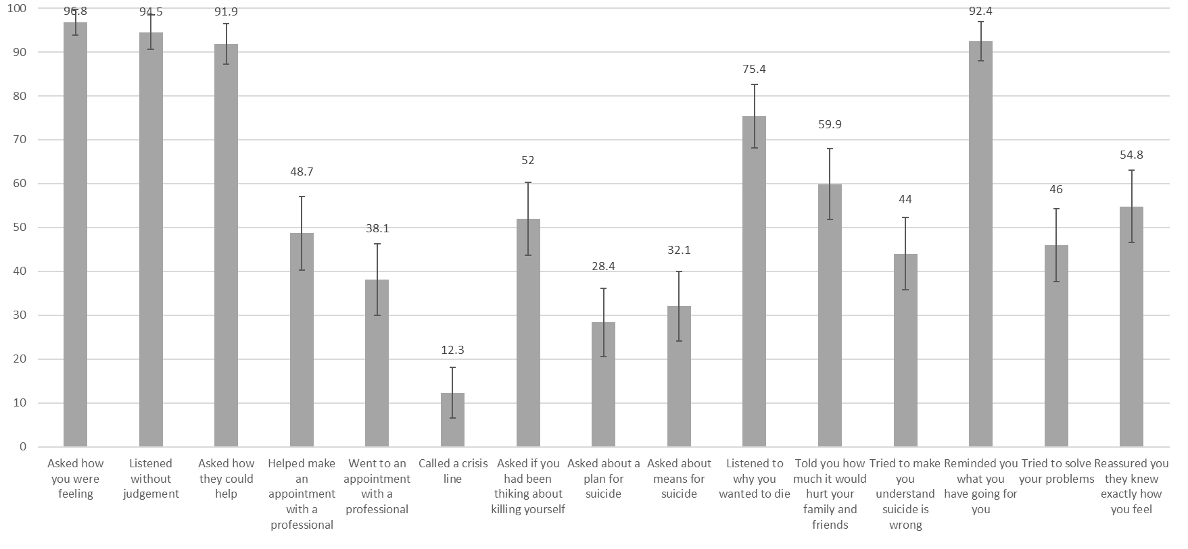
Figure 8. Percentage (95% CI) of population who had experienced suicidal thoughts in the last 12 months who received 15 specified types of helping action from a non-professional

Helpfulness of actions by a non-professional
Almost 90% of respondents indicated they found the actions taken by a non-professional when they were considering suicide helpful (34.4%, 95% CI 26.9-42.5) or extremely helpful (55.3%, 46.9-63.5). The remaining 10% found the help provided neither helpful nor unhelpful (7.4%, 95% CI 3.9-13.7), not helpful (1.5%, 95% CI 0.4-5.9), or not at all helpful (1.5%, 95% CI, 0.4-6.0).

Discussion
Our telephone survey of 3000 Australian adults showed that nearly 40% of people had known someone close to them experiencing severe distress in the last 12 months. Almost 90% did something to support that person. Supportive actions consistent with best practice were most commonly undertaken (e.g., listened to their problems without judgement), although some non-recommended actions (e.g., reminded the person what they have they going for them) were very common. Of those who had assisted a person in distress, 63.4% found out or suspected that person was thinking about suicide. The most common suicide-specific action was listening to why the person wanted to die and the least common were asking about plans and means for suicide. Those who had undertaken suicide prevention training had had far greater odds of asking about a plan and means for suicide. Sixteen percent of respondents had thought about suicide themselves in the last 12 months, 6% had seriously considered suicide, and 1% had attempted suicide. Of those who had thought about suicide, half received help from a health professional and 56% from a non-professional. Responses regarding types of helping actions received from a non-professional were very similar to those actions reported by those who had helped others, and the actions from a non-professional were rated as being helpful.
The relatively high rate of suicidal thoughts among the population and the high rate of help-seeking from informal sources emphasise the likelihood of Australians having someone close to them being at risk of suicide at some time in their lives. The finding that informal supports were used as commonly as formal supports echoes previous research (Houston et al., 2001; Rich et al., 1988). It is therefore imperative that community members know how to identify suicide risk and to take appropriate actions to keep the person at risk safe, and to encourage them to seek professional help.
This study was unique in including the perspective of both those who had supported others at risk of suicide and those who had received support from others. Helping behaviours reported by these two groups were very similar, providing evidence for the validity of the self-report methodology. There was also significant overlap between those who had supported others and those who had received support (more than half reported both), and the similarities between helping behaviours given and received also suggests that this group may undertake actions when supporting others that they have found helpful themselves. Our findings are also in line with previous studies of intended and actual helping behaviour in demonstrating that Australian adults are most likely to carry out general supportive behaviours like asking how they can help, listening and asking how the person is feeling (Jorm et al., 2005b; Rossetto et al., 2016; Rossetto et al., 2014b). These actions are consistent with current best practice guidelines for assisting a person at risk of suicide (Mental Health First Aid Australia, 2014). In addition, most respondents who received support from a non-professional for suicidal thoughts rated it as helpful. There is also previous research to suggest that help provided by family and friends can indeed be helpful to many people when experiencing mental health difficulties (Reavley, Morgan, & Jorm, 2017; Riedel-Heller et al., 2001).
The findings of our study are positive in that Australian adults were largely willing to help others at risk of suicide, and often undertook appropriate helping actions. However, we also found that a significant proportion of Australian adults took no steps to ensure that the person in distress got professional help (Jorm et al., 2005b; Rossetto et al., 2014b). They were also unlikely to ask about plans and means for suicide, even when they were aware the person was experiencing suicidal thoughts (Jorm et al., 2005b; Rossetto et al., 2014b). Encouraging professional help, risk assessment, and the appropriate follow-up steps, are central to best practice in suicide prevention (Mental Health First Aid Australia, 2014). These actions therefore need to be further encouraged. Conversely, several behaviours outlined in the ‘what not to do’ section of the Mental Health First Aid Guidelines for Suicidal Thoughts and Behaviours (Mental Health First Aid Australia, 2014) were commonly reported by respondents to our study. Reminding the person ‘what they’ve got going for them’ was reported by more than 90% of respondent groups as an action both undertaken and received. Telling the person that their suicide would hurt their friends and family, and trying to convince them that suicide is wrong were also common. These actions need to be discouraged.

Implications for practice
Our findings, and those of others, show that gatekeeper suicide prevention training, such as Mental Health First Aid, has a significant effect on the likelihood of asking questions to assess suicide risk (Cimini et al., 2014; Jones et al., 2015; Tompkins & Witt, 2009). Such training could therefore be encouraged among more Australian community members, and particularly among those who might be natural ‘gatekeepers’. Such gatekeepers include community members who are not health or mental health professionals but who hold some position of authority who are likely to observe or be sought out by people in extreme distress. These gatekeepers could include teachers, coaches, managers, human resources professionals, volunteers and others.
In addition to specific training of targeted groups, our study findings indicate there is potential to improve the skills of Australian adults in general to take appropriate suicide prevention actions towards their family members and friends. In particular, community members need to be educated to ask direct questions about suicide risk and to encourage others in distress to seek professional help. There may also be a place for discouraging certain behaviours that oppose best practice in suicide prevention. There is substantial evidence in other areas of public health, such as road safety, to suggest that media-based public education campaigns can modify behaviour in desirable ways at a population level (Wakefield, Loken, & Hornik, 2010); it is therefore reasonable to propose that a media campaign aimed at improving suicide prevention behaviours among Australian adults might have similar success. Based on this premise, the findings of our research have been used to develop an Australian public education campaign aimed at increasing the likelihood that Australian adults will identify when family members and friends are at risk of suicide and to improve their skills in providing them with appropriate support. The #YouCanTalk campaign (https://www.lifeinmindaustralia.com.au/youcantalk/) was launched in 2018 through a collaboration between several of Australia’s major not-for-profit mental health organisations (Beyond Blue, Black Dog Institute, Everymind, headspace, Lifeline, ReachOut and R U OK?). Each partner organisation uses its social media presence to promote resources on their websites that provide information about what to do and what not to do to support someone close to them who they think might be considering suicide, in line with our research findings.

Limitations
It is possible that we oversampled people with a specific interest in the survey topic, which we introduced as ‘helping people in severe distress’. Respondents’ interest could have arisen from personal experience as someone who had helped another in distress or because they had received help from others at a time when they were particularly distressed themselves. Therefore, our results may overestimate the proportion of the population who had recognised a family member or friend in distress in the last 12 months and who had offered them support. Our results might also overestimate the rate of suicidal ideation among the general population. The proportion of the population in our study who had seriously considered suicide (6%) is substantially higher than in a previous Australian population study (Slade et al., 2009). There are some differences in the wording of the suicidal ideation questions asked that might account for this variation. But it also cannot be ruled out that the rate of suicidal ideation among Australian adults has actually increased, in line with the increased suicide rate (Australian Bureau of Statistics, 2018).
We also had a relatively low response rate (12%). Low response rates to telephone surveys are now commonly reported (Hu et al., 2011; Wallander et al., 2015), but could also increase the likelihood of sampling bias. However, our use of weighted data in our sample corrected some sampling biases in that we ensured that the data was representative of the population in terms of age, gender, level of education, geographic location and telephone status.
We relied on self-report of helping behaviours undertaken and received, and therefore the responses are prone to recall and social desirability biases. However, we attempted to minimise these biases by asking respondents if they had undertaken or received 15 specific helping actions, rather than relying on purely open-ended responses, as in previous studies (Rossetto et al., 2016; Shand et al., 2015). To counter social desirability biases, we also asked if respondents had undertaken or received five non-recommended actions, and a number of these were commonly indicated. This suggests that social desirability bias was minimised, in part because some of these actions that are not recommended may seem to many to be helpful (e.g., trying to convince the person that suicide is wrong). Asking respondents to answer ‘yes or no’ to whether they undertook the 15 helping actions has the potential to elicit a higher number of ‘yes’ responses. However, before asking respondents to respond to these yes/no questions, we asked them an open-ended question ‘what did you do [to support the person at risk]?’. The results from this open-ended question closely replicate the findings from the ‘yes/no’ responses to the 15 helping actions (unpublished report available from the authors upon request).

Conclusion
A third of Australians will have someone close to them die by suicide (Maple et al., 2016). Those people at risk who receive support for their suicidal thoughts are most likely to receive that support from a non-professional. Many will not receive any professional support (Houston et al., 2001; Rich et al., 1988). Therefore, it is a national imperative that Australians develop the skills to know when a family member or friend might be at risk of suicide and to take action to ensure that person stays safe and gets the professional support they need. While Australians report being confident and willing to help a person close to them at risk of suicide (Nicholas et al., EPub ahead of print July 24, 2019), this study identified two significant deficits in the helping behaviours of Australian adults when compared with current suicide prevention best practice.(Mental Health First Aid Australia, 2014). First, assisting the person to get professional help and asking questions to assess suicide risk were relatively uncommon. Second, some non-recommended actions, such as telling the person at risk ‘what they have going for them’ were very common. There is evidence to suggest that existing gatekeeper training, such as Mental Health First Aid, can have significant positive effects on such behaviours (Cimini et al., 2014; Jones et al., 2015; Tompkins & Witt, 2009; Wakefield et al., 2010). These behavioural deficits also provide specific targets for community-level suicide prevention education and public health campaign messages. Equipping Australian community members to intervene with family members and friends at risk of suicide is a crucial component of our national suite of suicide prevention strategies.

References
Australian Bureau of Statistics. (2018). 3303.0 Causes of death, Australia 2017: Intentional self-harm, key characteristics. Canberra, Australia
Cimini, M. D., Rivero, E. M., Bernier, J. E., Stanley, J. A., Murray, A. D., Anderson, D. A., . . . Bapat, M. (2014). Implementing an audience-specific small-group gatekeeper training program to respond to suicide risk among college students: A case study. Journal of American College Health, 62(2), 92-100. doi:10.1080/07448481.2013.849709
Houston, K., Hawton, K., & Shepperd, R. (2001). Suicide in young people aged 15–24: a psychological autopsy study. Journal of Affective Disorders, 63(1–3), 159-170. doi:10.1016/S0165-0327(00)00175-0
Hu, S. S., Balluz, L., Battaglia, M. P., & Frankel, M. R. (2011). Improving Public Health Surveillance Using a Dual-Frame Survey of Landline and Cell Phone Numbers. American Journal of Epidemiology, 173(6), 703-711. doi:10.1093/aje/kwq442
Isometsä, E. T. (2001). Psychological autopsy studies – a review. European Psychiatry, 16(7), 379-385. doi:10.1016/S0924-9338(01)00594-6
Jones, S., Walker, C., Miles, A. C. J., De Silva, E., & Zimitat, C. (2015). A rural, community-based suicide awareness and intervention program. Rural And Remote Health, 15(1), 2972-2972.
Jorm, A., Nicholas, A., Pirkis, J., Rosetto, A., Fischer, J.-A., & Reavely, N. (2018a). Quality of assistance provided by members of the Australian public to a person at risk of suicide: associations with training experiences and sociodemographic factors in a national survey. BMC Psychiatry, 19, 68. doi:https://www.ncbi.nlm.nih.gov/pmc/articles/PMC6371420/
Jorm, A., Nicholas, A., Pirkis, J., Rossetto, A., & Reavely, N. (2018b). Associations of training to assist a suicidal person with subsequent quality of support: results from a national survey of the Australian public. BMC Psychiatry, 18(132). Retrieved from doi:https://doi.org/10.1186/s12888-018-1722-y
Jorm, A. F., Blewitt, K. A., Griffiths, K. M., Kitchener, B. A., & Parslow, R. A. (2005). Mental health first aid responses of the public: results from an Australian national survey. BMC Psychiatry, 5(1), 9. doi:10.1186/1471-244x-5-9
Lumley, T. (2010). Post-stratification, raking and calibration. In M. Couper, G. Kalton, J. Rao, N. Scwarz, & S. C. (Eds.), Complex Surveys: A Guide to Analysis using R (pp. 135-154). Hoboken, New Jersey: John Wiley and Sons.
Maple, M., Kwan, M., Borrowdale, K., Riley, J., Murray, S., & Sanford, R. (2016). The Ripple Effect: Understanding The Exposure and Impact of Suicide in Australia. Sydney, Australia
Mental Health First Aid Australia. (2014). Suicidal thoughts and behaviours: First Aid Guidelines (Revised 2014 ed.). Melbourne, Australia: Mental Health First Aid Australia.
Nicholas, A., Pirkis, J., Rosetto, A., Jorm, A., Spittal, M., & Reavley, N. (EPub ahead of print July 24, 2019). Australians’ confidence and intentions to help a person at risk of suicide: A nationally representative telephone survey. Suicide and Life-Threatening Behavior. doi:10.1111/sltb.12575
Nicholas, A., Rossetto, A., Jorm, A., Pirkis, J., & Reavley, N. (2018). Importance of messages for a suicide prevention media campaign: An expert consensus study. Crisis, EPub ahead of print (April 5, 2018). doi:10.1027/0227-5910/a000517
Owen, G., Belam, J., Lambert, H., Donovan, J., Rapport, F., & Owens, C. (2012). Suicide communication events: Lay interpretation of the communication of suicidal ideation and intent. Social Science & Medicine, 75(2), 419-428. doi:10.1016/j.socscimed.2012.02.058
Owens, C., Owen, G., Belam, J., Lloyd, K., Rapport, F., Donovan, J., & Lambert, H. (2011). Recognising and responding to suicidal crisis within family and social networks: qualitative study. BMJ, 343(7828). doi:10.1136/bmj.d5801
Owens, C., Owen, G., Lambert, H., Donovan J, Belam, J., Rapport, F., & Lloyd, K. (2009). Public involvement in suicide prevention: understanding and strengthening lay responses to distress. BMC Public Health(9), 308. doi:10.1186/1471-2458-9-308
Paraschakis, A., Michopoulos, I., Christodoulou, C., Koutsaftis, F., & Douzenis, A. (2015). Characteristics of suicide victims who had verbally communicated suicidal feelings to their family members. Psychiatria Danubia, 27(3), 230-235.
Paykel, E. S., Myers, J. K., Lindenthal, J. J., & Tanner, J. (1974). Suicidal feelings in the general population: A prevalence study. British Journal of Psychiatry, 124, 460-469.
Reavley, N., Morgan, A., & Jorm, A. (2017). Predictors of experiences of discrimination and positive treatment in people with mental health problems: findings from an Australian national survey. Soc. Psychiatry Psychiatr Epidemiol, 52, 269-277.
Rich, C., Fowler, R., Fogarty, L., & Young, F. (1988). San Diego suicide study III: Relationships between diagnoses and stressors. Archives of General Psychiatry, 45, 589–559. doi:10.1001/archpsyc.1988.01800300087012
Riedel-Heller, S., Angermeyer, M., & Matschinger, H. (2001). What to do about mental disorder help-seeking recommendations of the lay public. Acta Psychiatrica Scandinavia, 103, 220-225.
Rossetto, A., Jorm, A., & Reavley, N. (2016). Predictors of adults' helping intentions and behaviours towards a person with a mental illness: A six-month follow-up study. Psychiatry Research, 240, 170-176. doi:http://dx.doi.org/10.1016/j.psychres.2016.04.037
Rossetto, A., Jorm, A. F., & Reavley, N. J. (2014). Quality of helping behaviours of members of the public towards a person with a mental illness: a descriptive analysis of data from an Australian national survey. Annals of General Psychiatry, 13(1), 1-21. doi:10.1186/1744-859X-13-2
SANE Australia and University of New England. (2015). Lesssons for life: The experiences of people who attempt suicide: A qualitative research report. https://www.sane.org/images/PDFs/lessons-for-life.pdf (accessed May 29, 2018)
Shand, F. L., Proudfoot, J., Player, M. J., Fogarty, A., Whittle, E., Wilhelm, K., . . . Christensen, H. (2015). What might interrupt men's suicide? Results from an online survey of men. BMJ Open, 5(10). doi:10.1136/bmjopen-2015-008172
Slade, T., Johnston, A., Teesson, M., Whiteford, H., Burgess, P., Pirkis, J., & Saw, S. (2009). The mental health of Australians 2: report on the 2007 national survey of mental health and wellbeing. Canberra, Australia
Tompkins, T., & Witt, J. (2009). The short-term effectivness of a suicide prevention gatekeeper training program in a college setting with residence life advisers. Journal of Primary Prevention, 30, 131-149.
Wakefield, M., Loken, B., & Hornik, R. (2010). Use of mass media campaigns to change health behaviour. The Lancet, 376(9748), 1261-1271. doi:https://doi.org/10.1016/S0140-6736(10)60809-4
Wallander, L., Tikkanen, R. H., Mannheimer, L. N., Östergren, P.-O., & Plantin, L. (2015). The problem of non-response in population surveys on the topic of HIV and sexuality: a comparative study. European Journal of Public Health, 25(1), 172-177. doi:10.1093/eurpub/cku154
Wasserman, D., Tran Thi Thanh, H., Pham Thi Minh, D. U. C., Goldstein, M. A. X., NordenskiÖLd, A. N. A., & Wasserman, C. (2008). Suicidal process, suicidal communication and psychosocial situation of young suicide attempters in a rural Vietnamese community. World Psychiatry, 7(1), 47-53.
Wolk-Wasserman, D. (1986). Suicidal communication of persons attempting suicide and responses of significant others. Acta Psychiatrica Scandinavia, 73, 481-499.

Study 5. Belief in suicide prevention myths and its effect on helping: A nationally representative survey of Australian adults
Study 5 has been published in BMC Psychiatry:
Nicholas A, Niederkrotenthaler T, Reavley N, Pirkis J, Jorm A, Spittal MJ. (2020) Belief in suicide prevention myths and its effect on helping: A nationally representative survey of Australian adults. BMC Psychiatry, 20(303).

Abstract
Background: Debunking suicide myths, such as ‘asking someone about suicide could make them start thinking about it’ is a common strategy in suicide prevention education. However, there has been little research investigating the relationship between suicide myths and helping behaviour toward people at risk of suicide. We aimed to identify sociodemographic characteristics associated with belief in seven common suicide myths and the associations between beliefs in these myths and helping intentions and behaviours toward a family member or friend in severe distress or at risk of suicide.
Methods: We conducted a random digit dial (mobile and landline) survey of 3002 Australian adults. We asked respondents about their beliefs in suicide myths, intentions to help a person in severe distress or at risk of suicide presented in a vignette, and helping actions taken toward such a person in the last 12 months. We weighted this data to be representative of the Australian population. Regression analyses were undertaken to determine associations between sociodemographic and exposure characteristics and beliefs in suicide myths, and between beliefs in myths and helping intentions and behaviours.
Results: Being male, speaking a language other than English at home and being over 60 years were associated with the strongest beliefs in suicide myths. The strongest and most consistent associations were found between belief in the myth ‘asking someone about suicide could make them start thinking about it’, risk assessment intentions and behaviours and intentions to undertaken actions not recommended for suicide prevention.
Conclusions: Identifying those sociodemographic groups most likely to believe in suicide myths allows targeted intervention for suicide prevention education ‘debunking’ suicide myths. By isolating those myths that are most commonly believed, and their specific effects on helping intentions and behaviours, suicide prevention educators can target these specific myths to have the most effect on helping behaviour. Our findings suggest that targeting the myth ‘asking someone about suicide could make them start thinking about it’ may have the greatest effects on helping behaviour, and that men, those aged over 60 years and those speaking a language other than English at home could most benefit from myth ‘debunking’.

Background
In 2017, Australia’s suicide rate was 12.6 per 100 000 persons. This rate has increased from 10.9 suicide deaths per 100 000 persons in 2008 (Australian Bureau of Statistics, 2018). Although Australian mental health services are currently undergoing significant reforms that may address this issue (Commonwealth of Australia, 2015), a high proportion of those who attempt suicide never attend mental health services (Hunt et al., 2006; Isometsä, 2001; Sveticic et al., 2012). It is relatively common, however, for them to express their suicidal thoughts in some manner to close family members or friends (Houston et al., 2001; Isometsä, 2001; Owens et al., 2009; Rich et al., 1988). It is therefore a national imperative that Australians can identify expressions of suicide risk by those close to them and be willing and able to respond in an appropriate way.
‘Debunking’ suicide myths through education is a common strategy adopted in suicide prevention education aimed at increasing the intentions of community members to assist a person at risk of suicide (Aseltine, James, Schilling, & Glanovsky, 2007; Schurtz et al., 2010; Strunk et al., 2014). Adoption of this strategy is based on the assumption that belief in suicide ‘myths’ can have a negative effect on suicide prevention intentions and behaviours (Schurtz et al., 2010; Segal, 2001). Examples of suicide myths shown to be relatively common among community samples include the belief that people who attempt suicide don’t talk about it (Hjelmeland & Knizek, 2004; Till et al., 2018); that suicide happens without warning (Arendt et al., 2018; Marzano et al., 2016; Renberg & Jacobsson, 2003); that asking someone about suicide could make them start thinking about it (Cwik et al., 2016; Hjelmeland & Knizek, 2004; Renberg & Jacobsson, 2003); and that once a person has made up his or her mind about suicide, no one can stop him or her (Hjelmeland & Knizek, 2004; Renberg & Jacobsson, 2003). Such views of suicide may reduce the likelihood of community members intervening with someone who may be at risk because they believe they might make the situation worse or that suicide is not preventable. Beliefs in suicide myths have been shown to be especially common among men (Renberg & Jacobsson, 2003; Voracek, Tran, & Sonneck, 2008) and older people (Till et al., 2018), and to vary widely between cultural groups (Thimmaiah, Poreddi, Ramu, Selvi, & Math, 2016).
Despite the logical assumption that belief in suicide myths affects helping intentions and behaviour, empirical testing of this relationship is rare. Evaluation of some gatekeeper training programs for suicide prevention shows that training can reduce belief in suicide myths, while increasing intentions to help or helping behaviour, though these evaluations fall short of assessing the link between these constructs (Aseltine et al., 2007; Litteken & Sale, 2018; Strunk et al., 2014). Arendt, Scherr, Niederkrotenthaler, Krallman and Till (2018) conducted a randomised controlled trial assessing the effects of exposure to awareness material specifically aimed at debunking suicide myths. This exposure was effective in reducing beliefs in myths and this in turn had a positive effect on participants’ intentions to provide adequate help to individuals at risk of suicide. This finding is, however, restricted purely to helping intentions, and not helping behaviour.
We conducted a national survey of Australian adults to assess their confidence, intentions, behaviours and attitudes toward assisting a person they know well who is in severe distress or considering suicide. Findings of this and other studies in our research program (Nicholas et al., 2019; Nicholas et al., EPub ahead of print July 24, 2019) were conducted to inform suicide prevention messages for a national suicide prevention campaign aimed at family members and friends of people at risk of suicide (https://www.lifeinmindaustralia.com.au/youcantalk).
In this survey, we assessed respondents’ beliefs in a number of suicide myths, their intentions to help someone in distress or at risk of suicide (presented in a vignette) and their helping actions toward someone at risk of suicide who they had assisted in their own life.
Our analyses aimed to answer three primary research questions:
- Which sociodemographic characteristics are associated with belief in suicide myths?
- Is there an association between endorsement of suicide myths and intentions to help a person in severe distress or at risk of suicide?
- Is there an association between endorsement of suicide myths and types of actions taken to help a person in severe distress or at risk of suicide?

Methods
We conducted a computer-assisted telephone survey of Australian adults to identify Australian community members’ confidence, attitudes, intentions and behaviours toward helping someone in severe distress or at risk of suicide. We report here on results from those sections of the survey that included questions about attitudes to suicide prevention (belief in ‘suicide prevention myths’), intentions to help a person at risk in severe distress or at risk of suicide and actions taken to help a person in severe distress or at risk of suicide. Findings from other sections of the survey are reported elsewhere (Nicholas et al., 2019; Nicholas et al., EPub ahead of print July 24, 2019). The study was approved by the University of Melbourne Human Research Ethics Committee (Ethics ID: 1648060). (The ethics approval letter is included as Appendix F.) Data collection took place from February 14 to March 29, 2017.

Sample and recruitment
To sample 3000 Australian adults, we used a dual frame (mobile and landline) random digit-dial telephone survey method. Landline numbers were from all states and territories of Australia. Six contact attempts were made per telephone number. For landline numbers, interviewers asked to speak to the person associated with each number who satisfied the criteria of being 18 years or over and having the last birthday. The interviewers asked to speak to the person in the household who had the most recent birthday, rather than the person who answered the call, to reduce sampling bias occurring because some members of the household may be more likely than others to answer the landline phone. For mobile phones, interviewers just asked those who answered whether they were 18 years or over. There were 3002 completed surveys. The response rate was 12.2%. This was calculated as the number of completed surveys (n = 3002) as a proportion of households where the call was answered and there was an eligible person within that household (i.e., 18 years or over) (n = 23, 366). We commissioned Roy Morgan Research Ltd to conduct the survey. More detail about the sampling method can be found in other publications from our research program (Nicholas et al., 2019; Nicholas et al., EPub ahead of print July 24, 2019).

Materials and procedure
(A copy of the survey is included as Appendix G. See section 3.1.3.2.1 for additional details on use of the CATI to collect the survey data.)

Suicide myths
We searched the literature to identify existing measures of attitudes to suicide and its prevention and for papers relating to suicide prevention ‘myths’. No measure was found that suited the aims of this study. Rather, we identified several myths commonly believed by lay people (Aldrich, 2015, 2017; Arendt et al., 2018; Cwik et al., 2016; Domino, 1990; Hjelmeland & Knizek, 2004; Neuringer, 1987; Renberg & Jacobsson, 2003; Schurtz et al., 2010; Till et al., 2018) and included seven items in the survey representing these myths: (1) ‘There is a risk that asking someone about suicide will make them start thinking about it’ (Cwik et al., 2016; Hjelmeland & Knizek, 2004; Renberg & Jacobsson, 2003); (2) ‘There is a risk of making the situation worse if I try to help someone who is thinking about suicide’ (Cwik et al., 2016); (3) ‘Suicide happens without warning’ (Arendt et al., 2018; Marzano et al., 2016; Renberg & Jacobsson, 2003); (4) ‘Most suicides occur without any sign’ (Nakayma & Amagasa, 2004); (5) ‘People who make suicidal threats rarely kill themselves’ (Hjelmeland & Knizek, 2004; Renberg & Jacobsson, 2003); (6) ‘If a person wants to kill themselves, we should not interfere’ (Renberg & Jacobsson, 2003); and (7) ‘Once a person has made up his or her mind about suicide, no one can stop him or her’ (Hjelmeland & Knizek, 2004; Renberg & Jacobsson, 2003). Respondents indicated their agreement with these items on a five-point scale (1. strongly agree to 5. strongly disagree). (See section 3.1.3.1.1 for additional details on selection of these ‘myths’ items.)

Helping intentions
To provide context for the survey questions about intentions to help, we randomly presented respondents with one of six vignettes. These vignettes described a person in severe distress following a series of stressful life events and were based on a vignette used by Jorm et al in a study of intended mental health first aid behaviours of Australian adults (2005b). All vignettes provided a description of a person showing signs of depression and impaired daily functioning. The six versions of the vignette varied by gender (John/Jenny) and directness of communication of suicide risk (distressing life events only, indirect verbal communication of suicide risk, direct verbal communication of suicide risk). The vignettes have been published in full elsewhere (Nicholas et al., EPub ahead of print July 24, 2019). (See section 6.3.2 for the full vignettes.)
Following presentation of their given vignette, respondents were asked to indicate their likelihood (1. very unlikely to 5. very likely) of undertaking 13 helping actions. We allocated these helping actions to four subscales: talking and listening, encouraging professional help, risk assessment, and non-recommended actions. The non-recommended actions oppose current best practice in suicide prevention (Mental Health First Aid Australia, 2014; Nicholas et al., 2018). More detail regarding the selection of the 13 actions, allocation to subscales, and psychometric properties is provided elsewhere (Nicholas et al., EPub ahead of print July 24, 2019). The three items on the talking and listening subscale relate to asking the person in distress how they are feeling, listening to their problems without judgement, and asking them ‘how you can help’. The professional help subscale items relate to helping the person in distress to make an appointment with a professional, going to the appointment with them, and calling a crisis line. The three risk assessment subscale items relate to asking the person in distress if they have been thinking about killing themselves, asking if they have a means to kill themselves*, and asking if they have a plan for suicide*. The non-recommended actions subscale items relate to trying to solve the problems of the person in distress, reassuring them you know exactly how they feel, trying to make them understand that suicide is wrong*, and telling them how much it would hurt their friends and family if they were to kill themselves*. The four items indicated with an asterisk are only relevant if John/Jenny has communicated that they are considering suicide. Therefore, when asking respondents how likely they were to undertake these actions, interviewers began each item with ‘If John/Jenny told he/she was thinking about killing him/herself…’. Therefore, the directness of suicide communication condition does not apply to these actions.

Helping behavior
Interviewers then asked respondents if someone in their family or close circle of friends had experienced distress like John’s/Jenny’s in the last 12 months. If the respondent answered ‘yes’, they were asked if they did anything to support that person. If they did, the interviewer asked if the they had performed the actions included in the talking and listening and encouraging professional help subscales, the item from the risk assessment subscale relating to asking the person in distress if they have been thinking about killing themselves, and the non-recommended item related to reassuring the person in distress ‘you know exactly how they feel’ (Yes/No). Interviewers then asked if, during the time respondents were supporting the person in distress, they found out or suspected the person in distress was thinking about suicide. Those who said ‘yes’ were then asked if they performed the remaining actions in the risk assessment subscale and the two non-recommended items, ‘tell them how much it would hurt their friends and family if they were to kill themselves’; and ‘tried to make them understand that suicide is wrong’.
All respondents were asked if, in the last 12 months, they had considered taking their own life (Yes/No) (Paykel et al., 1974). All respondents were asked if they had ever had a job that involved providing treatment or services to a person ‘experiencing distress like John’s/Jenny’s?’ (Yes/No), and if they had completed any suicide prevention training (Yes/No). Respondents also answered sociodemographic questions relating to age, gender, language spoken at home, highest level of education, and location of residence.

Data analysis

Data preparation
To determine the frequency of beliefs in suicide myths, we re-coded endorsement of each myth (from strongly agree to strongly disagree) into agree, or do not agree or no view: agree = agree and strongly agree; do not agree or no view = neither agree nor disagree, disagree and strongly disagree.
Helping intentions subscale scores were calculated by summing item scores (1 to 5) such that minimum and maximum scores were 3 and 15 for the talking and listening, encouraging professional help, and risk assessment subscales, and 4 and 20 for non-recommended actions. Internal consistency for each of the four intentions subscales is as follows: talking and listening (α = 0.64, 3 items); encouraging professional help (α = 0.68, 3 items); risk assessment (α = 0.60, 3 items); and non-recommended actions (α = 0.58, 5 items).
Helping behaviours items were also summed to make a score on each of the subscales. The possible range for the talking and listening, professional help, and risk assessment subscales is therefore 0 to 3, and for the non-recommended actions subscale is 0 to 5. Internal consistency for each of the four helping actions subscales was as follows: talking and listening (α = 0.53, 3 items); encouraging professional help (α = 0.64, 3 items); risk assessment (α = 0.59, 3 items); and non-recommended actions (α = 0.58, 5 items).

Analysis
We generated survey weights and applied these to our sample so that it was representative of the Australian adult population in relation to age, gender, region, and education. Weights were calculated using raking methods (Lumley, 2010) (See section 3.1.3.2.3 for additional details regarding data weighting). To describe the sample, we first calculated percentages with 95% confidence intervals. To determine if sociodemographic and exposure variables were associated with belief in the suicide prevention myths, we conducted logistic regression analysis. We then used linear regression analysis to assess whether belief in suicide prevention myths was associated with helping intentions and behaviours. All logistic and linear regression analyses were adjusted for the following sociodemographic and exposure variables: gender, age, education level, speaking a language other than English at home (LOTE), location, having a family member or friend in distress in the last 12 months, own suicidal ideation in last 12 months, professional experience in suicide prevention, suicide prevention training, and the vignette to which they were exposed. Note that gender of the person in the vignette was shown to have no significant associations with variables of interest, and not included in subsequent analyses.
All data analyses were carried out in STATA 15.0. (See section 3.1.3.3.1 for additional details on data analysis conducted in STATA).

Ethical approval
The study was approved by the University of Melbourne Human Research Ethics Committee (Ethics ID: 1648060). (The ethics approval letter is included as Appendix F.)

Results
Table 20 shows the sociodemographic and exposure characteristics of respondents (using weighted data). A substantial minority (39.1%, 95% CI 36.9-41.4) stated that a close family member or friend had experienced distress like the person in the vignette, and 84% (95% CI 82.2-9.9) said they had offered that person support. Sixteen percent stated they had considered suicide in the last 12 months (95% CI, 14.3-17.8), and more than half of these received help from a non-professional (52.3%, 95% CI 46.3-58.3).

Table 20. Descriptive statistics for sociodemographic and exposure characteristics
Characteristic | % | 95%CI
Gender
Female | 50.9 | 48.6, 53.2
Male | 49.1 | 46.8, 51.4
Age, years
18-30 | 23.8 | 21.5, 26.2
31-44 | 24.5 | 22.5, 26.7
45-59 | 24.6 | 22.9, 26.4
60+ | 27.1 | 25.3, 28.9
Speak language other than English at home
No | 91.0 | 89.5, 92.3
Yes | 9.0 | 7.7, 10.5
Highest Education
Below Bachelor degree | 75.5 | 73.4, 76.9
Bachelor degree or higher | 24.8 | 23.1, 26.6
Geographic location
Major city | 60.2 | 57.9, 62.4
Regional, rural or remote | 39.8 | 37.6, 42.1
Vignette
Life events | 34.8 | 32.6, 37.0
Indirect | 31.2 | 29.1, 33.4
Direct | 34.0 | 31.8, 36.2
Family/friend in distress last 12 months
Yes | 39.1 | 36.9, 41.4
No | 60.9 | 58.6, 63.1
Offered support to the family member or friend in distress
Yes | 87.6 | 84.8, 89.9
No | 10.7 | 8.5, 13.3
Own suicidal ideation in last 12 months
Yes | 16.0 | 14.3, 17.8
No | 84.0 | 82.2, 85.37
Received help from a non-professional when having suicidal thoughts
Yes | 52.3 | 46.3-58.3
No | 47.7 | 41.7-53.7
Professional experience in suicide prevention
Yes | 19.9 | 18.2, 21.7
No | 80.1 | 78.3, 81.8
Suicide prevention training
Yes | 15.9 | 14.3, 17.6
No | 84.1 | 82.4, 85.7

Endorsement of suicide prevention myths
The most commonly endorsed myths, each endorsed by more than one quarter of respondents, were ‘suicide happens without warning’ (41.5%, 95% CI 39.2-43.8); ‘there is a risk that asking someone about suicide will make them start thinking about it’ (30.5%, 28.4-32.6); ‘there is a risk of making the situation worse if I try to help someone who is thinking about suicide’ (29.4%, 27.3-31.5); and ‘most suicides occur without any sign’ (26.7%, 24.7-28.8) (Table 21).
Table 21. Percentage frequencies of those who did and did not agree with the suicide prevention myths
 | Agree |  | Do not agree/no view
Suicide myth | % | 95% CI | % | 95% CI
Suicide happens without warning. | 41.5 | 39.2, 43.8 | 58.5 | 56.2, 60.8
There is a risk that asking someone about suicide will make them start thinking about it. | 30.5 | 28.4, 32.6 | 69.5 | 67.4, 71.6
There is a risk of making the situation worse if I try to help someone who is thinking about suicide. | 29.4 | 27.3, 31.5 | 70.6 | 68.5, 72.7
Most suicides occur without any sign. | 26.7 | 24.7, 28.8 | 73.3 | 71.2, 75.3
People who make suicidal threats rarely kill themselves. | 23.6 | 21.8, 25.6 | 76.4 | 74.4, 78.2
Once a person has made up his or her mind about suicide, no one can stop him or her. | 11.5 | 10.2, 12.9 | 88.5 | 87.1, 89.8
If someone wants to kill themselves, it is his or her own business and we should not interfere | 3.5 | 2.7, 4.4 | 96.5 | 95.6, 97.3

Associations between sociodemographic and exposure variables and endorsement of myths
Being male, aged over 60 years, or speaking a language other than English at home were each associated with increased odds of endorsing four suicide prevention myths, including that ‘suicide occurs without any sign’ and ‘people who make suicidal threats rarely kill themselves’ (Table 22). Having experienced suicidal thoughts in the last 12 months was strongly associated with endorsement of the myth, ‘If a person wants to kill themselves, we should not interfere’ (OR = 2.80, 95% CI 1.34-4.80). Males, compared with females, had lower odds of endorsing the myth ‘suicide happens without any sign’ (OR = 0.72, 95% CI 0.58-0.89). Those who had a Bachelor degree (compared to those with a lower education) and those with suicide prevention training (compared with no training) had lower odds of endorsing the myths that suicide happens without warning or sign. Those with a Bachelor degree also had lower odds of endorsing the myth that once the person has ‘made up their mind, no one can stop him or her’ (OR = 0.36, 95% CI, 0.24-0.53).
Significant associations identified in these logistic regression analyses are summarised in Figure 9.
Table 22. Multiple logistic regression analysis using sociodemographic and exposure characteristics to predict endorsement of myths
 | Asking about suicide might start them thinking about it |  | Risk making the situation worse if I try to help |  | Suicide happens without warning |  | Suicide occurs without any sign
Predictor | OR | 95% CI | OR | 95% CI | OR | 95% CI | OR | 95% CI
Gender
Female | 1.0 | - | 1.0 | - | 1.0 | - | 1.0 | -
Male | 1.53 | 1.24, 1.89 | 1.37 | 1.11, 1.69 | 0.89 | 0.73, 1.08 | 0.72 | 0.58, 0.89
Age, years
18-30 | 1.0 | - | 1.0 | - | 1.0 | - | 1.0 | -
31-44 | 0.66 | 0.46, 0.96 | 0.92 | 0.64, 1.31 | 1.04 | 0.74, 1.46 | 0.90 | 0.61, 1.32
45-59 | 0.84 | 0.61, 1.17 | 0.99 | 0.71, 1.37 | 1.24 | 0.91, 1.69 | 1.17 | 0.83, 1.64
60+ | 1.23 | 0.89, 1.69 | 1.42 | 1.03, 1.96 | 1.83 | 1.35, 2.48 | 1.60 | 1.14, 2.24
Speak language other than English at home
No | 1.0 | - | 1.0 | - | 1.0 | - | 1.0 | -
Yes | 1.74 | 1.20, 2.52 | 0.98 | 0.66, 1.46 | 1.46 | 1.00, 2.12 | 1.83 | 1.23, 2.73
Highest Education
Below Bachelor degree | 1.0 | - | 1.0 | - | 1.0 | - | 1.0 | -
Bachelor degree or higher | 0.81 | 0.65, 1.01 | 0.97 | 0.78, 1.22 | 0.62 | 0.51, 0.77 | 0.51 | 0.40, 0.65
Geographic location
Major city | 1.0 | - | 1.0 | - | 1.0 | - | 1.0 | -
Regional, rural or remote | 0.92 | 0.74, 1.14 | 1.00 | 0.81, 1.23 | 1.19 | 0.98, 1.46 | 1.18 | 0.95, 1.47
Vignette
Indirect | 1.0 | - | 1.0 | - | 1.0 | - | 1.0 | -
Direct | 1.06 | 0.83, 1.37 | 1.32 | 1.03, 1.69 | 1.05 | 0.83, 1.33 | 1.06 | 0.82, 1.37
Family/friend in distress last 12 months
No | 1.0 | - | 1.0 | - | 1.0 | - | 1.0 | -
Yes | 0.95 | 0.76, 1.19 | 1.02 | 0.81, 1.28 | 1.02 | 0.83, 1.26 | 1.15 | 0.92, 1.45
Own suicidal ideation
No | 1.0 | - | 1.0 | - | 1.0 | - | 1.0 | -
Yes | 0.97 | 0.71, 1.32 | 1.34 | 0.99, 1.80 | 1.23 | 0.93, 1.62 | 1.14 | 0.83, 1.56
Professional experience
No | 1.0 | - | 1.0 | - | 1.0 | - | 1.0 | -
Yes | 1.00 | 0.74, 1.34 | 0.97 | 0.73, 1.30 | 0.92 | 0.71, 1.20 | 0.89 | 0.66, 1.19
Suicide prevention training
No | 1.0 | - | 1.0 | - | 1.0 | - | 1.0 | -
Yes | 0.67 | 0.47, 0.94 | 0.65 | 0.47, 0.91 | 0.76 | 0.56, 1.01 | 0.84 | 0.60, 1.17
Table 22... Multiple logistic regression analysis using sociodemographic and exposure characteristics to predict endorsement of myths
 | If want to kill themselves, we should not interfere |  | Once made up mind, no one can stop him or her |  | People who make suicidal threats rarely kill themselves
Predictor | OR | 95% CI | OR | 95% CI | OR | 95% CI
Gender
Female | 1.0 | - | 1.0 | - | 1.0 | -
Male | 1.67 | 0.71, 1.90 | 0.75 | 0.56, 1.01 | 1.53** | 1.23, 1.91
Age, years
18-30 | 1.0 | - | 1.0 | - | 1.0 | -
31-44 | 0.84 | 0.30, 2.31 | 1.02 | 0.55, 1.89 | 1.18 | 0.78, 1.78
45-59 | 0.98 | 0.44, 2.18 | 1.85 | 1.10, 3.11 | 1.38 | 0.96, 1.99
60+ | 1.99 | 0.96, 4.16 | 2.46** | 1.51, 4.01 | 2.08** | 1.45, 2.98
Speak language other than English at home
No | 1.0 | - | 1.0 | - | 1.0 | -
Yes | 2.80* | 1.27, 6.15 | 1.51 | 0.83, 2.77 | 1.91* | 1.26, 2.89
Highest Education
Below Bachelor degree | 1.0 | - | 1.0 | - | 1.0 | -
Bachelor degree or higher | 0.74 | 0.40, 1.37 | 0.36** | 0.24, 0.53 | 0.73 | 0.57, 0.94
Geographic location
Major city | 1.0 | - | 1.0 | - | 1.0 | -
Regional, rural or remote | 1.03 | 0.63, 1.70 | 1.29 | 0.97, 1.72 | 1.44* | 1.14, 1.81
Vignette
Indirect | 1.0 | - | 1.0 | - | 1.0 | -
Direct | 1.16 | 0.61, 2.21 | 0.94 | 0.66, 1.34 | 1.00 | 0.76, 1.31
Family/friend in distress last 12 month
No | 1.0 | - | 1.0 | - | 1.0 | -
Yes | 0.69 | 0.39, 1.21 | 1.16 | 0.86, 1.57 | 0.93 | 0.73, 1.18
Own suicidal ideation
No | 1.0 | - | 1.0 | - | 1.0 | -
Yes | 2.54* | 1.34, 4.80 | 1.23 | 0.80, 1.89 | 1.07 | 0.78, 1.49
Professional experience
No | 1.0 | - | 1.0 | - | 1.0 | -
Yes | 0.80 | 0.40, 1.58 | 1.31 | 0.88, 1.95 | 0.90 | 0.78, 1.49
Suicide prevention training
No | 1.0 | - | 1.0 | - | 1.0 | -
Yes | 1.28 | 0.61, 2.67 | 0.75 | 0.48, 1.16 | 0.77 | 0.54, 1.08
Note: Significant associations are indicated in bold type. *p < 0.05, **p <.001

Sociodemographic or exposure characteristic | Asking about suicide might start them thinking about it | Risk making the situation worse if I try to help | Suicide happens without warning | Suicide occurs without any sign | If wants to kill themselves, we should not interfere | Once a person has made up mind, no one can stop him/her | People who make suicidal threats rarely kill themselves
Male | ↑ | ↑ |  | ↓ |  |  | ↑
Aged 60+ |  |  | ↑ | ↑ |  | ↑ | ↑
Speaks language other than English at home | ↑ |  |  | ↑ | ↑ |  | ↑
Bachelor degree or higher |  |  | ↓ | ↓ |  | ↓
Regional, rural or remote location |  |  |  |  |  |  | ↑
Own suicidal ideation |  |  |  |  | ↑
Suicide prevention training | ↓ | ↓
Figure 9. Sociodemographic and exposure variables predicting beliefs in suicide myths (↓ = lower odds, ↑ higher odds)

Associations between endorsement of suicide prevention myths and helping intentions and behaviours
Table 23 shows the results of linear regression analyses of the associations between suicide prevention myths and helping intentions and behaviours. Endorsement of the myth, ‘If a person wants to kill themselves, we should not interfere’ had the strongest associations with helping intentions, showing a negative association with both talking and listening (coef. = -1.13, 95% CI -1.83, -0.44, p < 0.001) and non-recommended intentions (coef. = -1.51, 95% CI -2.40, -0.61, p < 0.001). It also had a weaker negative association with talking and listening behaviour (coef. = - 0.37, 95% CI -0.72, -0.01, p < 0.05). Endorsement of the myth, ‘asking about suicide might start them thinking about it’ had negative associations with risk assessment intentions (coef. = -1.30, 95% CI -1.64, -0.94, p < 0.001), risk assessment behaviours (coef. = -0.47, 95% CI -0.77, -0.17, p < 0.05); and talking and listening intentions (coef. = -0.18, 95% CI -0.35, -0.01, p < 0.05). ‘Suicide happens without warning’ had a positive association with non-recommended intentions (coef. = 0.52, 95% CI 0.21, 0.82, p < 0.001) and behaviours (coef. = 0.48, 95% CI, 0.24-0.73, p < 0.001). ‘Suicide happens without any sign’ had a positive association with risk assessment intentions (coef. = 0.47, 95% CI, 0.07-0.86, p < 0.001).
Figure 10 illustrates the significant relationships identified in regression analyses using endorsement of suicide myths as predictors of helping intentions and behaviours.
Table 23. Linear regression analyses of the associations between belief in suicide myths and helping intentions, and between belief in suicide myths and helping behaviours, adjusted for sociodemographic characteristics
 | Talk and listen |  | Professional help |  | Risk assessment |  | Non-recommended actions
Myth | Coefficient | 95%CI | Coefficient | 95%CI | Coefficient | 95%CI | Coefficient | 95%CI
Helping intentions
Asking about suicide might start them thinking about it | -0.18* | -0.35, -0.01 | -0.06 | -0.34, 0.21 | -1.30** | -1.64, -0.94 | 0.19 | -0.10, 0.49
Risk making the situation worse if I try to help | -0.17* | -0.33, -0.02 | -0.17 | -0.44, 0.11 | -0.00 | -0.35, 0.35 | -0.65** | -0.96, -0.34
Suicide happens without warning | -0.06 | -0.20, 0.09 | 0.04 | -0.23, 0.30 | 0.06 | -0.28, 0.41 | 0.52** | 0.21, 0.82
Suicide occurs without any sign | 0.02 | -0.14, 0.18 | 0.05 | -0.26, 0.35 | 0.47* | 0.07, 0.86 | 0.54** | 0.22, 0.87
If wants to kill themselves, we should not interfere | -1.13** | -1.83, -0.44 | -0.83 | -1.74, 0.08 | -0.86 | -1.89, 0.17 | -1.51** | -2.40, -0.61
Once a person has made up mind, no one can stop him/her | 0.06 | -0.17, 0.29 | -0.12 | -0.50, 0.26 | 0.09 | -0.39, 0.58 | 0.26 | -0.18, 0.70
People who make suicidal threats rarely kill themselves | -0.13 | -0.31, 0.05 | -0.28 | -0.57, 0.02 | -0.13 | -0.51, 0.25 | 0.32 | 0.01, 0.63
Helping behaviours
 | Coefficient | 95%CI | Coefficient | 95%CI | Coefficient | 95%CI | Coefficient | 95%CI
Asking about suicide might start them thinking about it | -0.05 | -0.13, 0.04 | 0.04 | -0.16, 0.24 | -0.47* | -0.77, -0.17 | -0.05 | -0.29, 0.20
Risk of making the situation worse if I try to help | 0.01 | -0.07, 0.08 | 0.07 | -0.13, 0.27 | -0.17 | -0.47, 0.13 | -0.04 | -0.30, 0.22
Suicide happens without warning | 0.05 | -0.01, 0.12 | 0.17 | -0.04, 0.38 | 0.11 | -0.17, 0.39 | 0.48** | 0.24, 0.73
Suicide occurs without any sign | 0.04 | -0.03, 0.11 | 0.06 | -0.15, 0.27 | 0.12 | -0.18, 0.42 | 0.08 | -0.18, 0.34
If wants to kill themselves, we should not interfere | -0.37* | -0.72, -0.01 | -0.27 | -0.73, 0.20 | -0.13 | -0.70, 0.44 | -0.07 | -0.82, 0.69
Once a person has made up mind, no one can stop him/her | -0.16 | -0.12, 0.09 | -0.11 | -0.41, 0.18 | -0.23 | -0.65, 0.20 | -0.01 | -0.41, 0.38
People who make suicidal threats rarely kill themselves | -0.12* | -0.22, -0.01 | -0.00 | -0.22, 0.21 | -0.06 | -0.35, 0.24 | -0.10 | -0.38, 0.19
Note: Significant associations are indicated in bold type. *p < 0.05, **p <.001. All analyses adjusted for gender, age, education level, speaking a language other than English at home (LOTE), location, own suicidal ideation in last 12 months, professional experience in suicide prevention, suicide prevention training, and the vignette to which they were exposed. Intentions analyses were also adjusted for having a family member or friend in distress in the last 12 months.

 | Talk and listen |  | Professional help |  | Risk assessment |  | Non-recommended behaviours
Myth | Intention | Behaviour | Intention | Behaviour | Intention | Behaviour | Intention | Behaviour
Asking about suicide might start them thinking about it | ↓ |  |  |  | ↓ | ↓
Risk of making the situation worse if I try to help | ↓ |  |  |  |  |  | ↓
Suicide happens without warning |  |  |  |  |  |  | ↑ | ↑
Suicide occurs without any sign |  |  |  |  | ↑ |  | ↑
If wants to kill themselves, we should not interfere | ↓ | ↓ |  |  |  |  | ↓
Once a person has made up mind, no one can stop him/her |  | ↓
People who make suicidal threats rarely kill themselves |  | ↓
Figure 10. Significant relationships between belief in suicide prevention ‘myths’ and helping intentions and behaviours (↓ = lower odds, ↑ higher odds)

Discussion
We conducted a nationally representative survey of Australian adults to determine the answers to three primary research questions: (1) which sociodemographic characteristics are associated with belief in suicide myths; (2) are beliefs in suicide myths related to people’s intentions to carry out recommended and non-recommended helping actions; and (3) are beliefs in suicide myths associated with actions taken to help someone in severe distress or at risk of suicide.
The most commonly endorsed myths were those that suicide occurs without warning (41.5%) or sign (26.7%); and those related to fears of making the situation worse by asking about suicide (30.5%) and trying to help (29.4%). Being male, aged 60+ and speaking a language other than English at home had the most consistent associations with endorsement of suicide prevention myths. These groups had elevated odds of believing four of the seven myths, including ‘people who make suicidal threats rarely kill themselves’ and ‘suicide occurs without any sign’. Having undertaken suicide prevention training demonstrated positive effects, being associated with reduced odds of believing the two myths about making the situation worse by asking about suicide and trying to help. The two suicide myths having the strongest and most diverse effects on intentions and behaviours were ‘asking about suicide might start them thinking about it’ and ‘if a person wants to kill themselves, we should not interfere’.

Belief in suicide prevention myths in Australia
Those suicide prevention myths most commonly endorsed by Australian adults in our study related to a fear of worsening the situation by asking the person at risk directly about suicide or by trying to help and to the unpredictability of suicide. The belief that people who make ‘threats’ about suicide don’t carry them out was also common. These myths persist in almost one quarter or more of the population. Similar levels of endorsement of these most common suicide prevention myths are reported by Hjelmeland and Knizek (2004) in a study with Norwegian adults and in the study of adults from the United States by Domino (1990). Given that these studies were conducted more than a decade ago, it would seem the suicide prevention literacy of Australians requires significant development.
This is particularly true of men, older people and those who speak a language other than English at home, who had the greatest odds of believing several suicide prevention myths. Swedish and Austrian studies have similarly found that men more commonly believe several suicide prevention myths regarding the predictability of suicide and that communication of suicidal thoughts means there is no real suicidal intent (Renberg & Jacobsson, 2003; Voracek et al., 2008). Till et al also recently reported that ‘older age consistently predicted the endorsement of suicide myths’ (p.4) (2018). In our study, the countries of origin of those respondents who spoke a language other than English at home were diverse (e.g., from Mediterranean, South Asian and South East Asian Countries), and we were therefore unable to conduct further evaluations of cultural sub-groups. However, previous research indicates vast cultural differences in beliefs about suicide prevention (Thimmaiah et al., 2016). It is possible that beliefs in suicide prevention myths reflect a broader lack of mental health literacy, consistent with the findings of a large-scale Australian study, which found that men, those aged over 60 years, and those with a lower level of education have lower levels of general mental health literacy (Reavley et al., 2014). It is notable that there are numerous suicide prevention programs targeting these population sub-groups (e.g., the Australian Mates in Construction and Mates in Mining programs aimed at men in male-dominated, high suicide risk professions) and that addressing suicide myths is a common inclusion in such programs. The findings of this study support this approach.

Effects of endorsement of myths on helping intentions and behaviours
Believing that ‘asking about suicide might start them thinking about it’ was associated with a reduction in both the intention to ask risk assessment questions and of having asked risk assessment questions when supporting a person at risk. This finding illustrates the importance of targeting this myth in suicide prevention education programs, particularly as it was endorsed by almost one-third of the population. In previous studies, we have also found risk assessment intentions and action to be relatively uncommon (Nicholas et al., 2019; Nicholas et al., EPub ahead of print July 24, 2019). Debunking this myth could help to reduce anxiety about causing harm by asking direct questions about suicide and enhance the likelihood of family and friends asking questions of those at risk about suicidal thoughts, plans and means. Debunking of this myth may be particularly important for men and those who speak a language other than English at home. Our findings also show that suicide prevention training is associated with a reduction in beliefs in this myth.
Believing ‘If a person wants to kill themselves, we should not interfere’ was associated with a reduction in talking and listening intentions and behaviour, but also with reduced intentions to undertake non-recommended behaviours. While no other associations between this myth and intentions and behaviours were significant, they were all negative, suggesting that people who believe this myth have reduced intentions to help overall, and therefore undertake fewer helping behaviours of any kind. Belief in this myth is relatively rare among Australian adults, though more likely among those who speak a language other than English at home. This may therefore be a useful target for ‘debunking’ among some culturally and linguistically diverse groups to increase feelings of responsibility for suicide prevention and therefore suicide prevention intentions and actions.
There were relatively few other strong associations between beliefs in suicide myths and intentions and behaviours. Contrary to expectation, endorsement of the myth, ‘suicide occurs without any sign’ was associated with increased intentions to ask risk assessment questions. It seems that those who do not expect to observe any overt warning signs of suicide risk are more likely to ask risk assessment questions to better understand the risk status of the person of concern. While community members should be encouraged to continue asking such questions, education regarding the warning signs of suicide risk and indirect forms of suicide communication is clearly needed for a substantial minority of the Australian population.

Limitations
Consistent with other population health surveys conducted in the recent past, including via telephone, our response rate was relatively low (Hu et al., 2011; Wallander et al., 2015). We took significant steps to reduce sampling bias, including by weighting our sample to represent the Australian population in terms of age, gender and location; and by making calls for the phone survey to landlines and mobiles and at various times of the day. However, we gained consent for participation by stating that we were conducting a survey regarding ‘helping people in severe distress’. Therefore, we may have oversampled those with higher mental health literacy or with experience of this type of helping, which may have biased our results toward reporting of more positive attitudes, intentions and behaviours. However, if this were the case, we would expect that our estimates of the proportion of Australians who believe in suicide prevention myths would be underestimates, rather than overestimates. Furthermore, in our previous studies, we also demonstrated that a substantial proportion of our sample intended to, or had undertaken, non-recommended actions toward a person at risk of suicide, while neglecting a number of recommended actions (Nicholas et al., 2019; Nicholas et al., EPub ahead of print July 24, 2019).
The internal consistency of some of the intentions and helping actions subscales fell below the broadly accepted minimum of α = 0.7. However, it must be considered that these are largely 3- and 4-item scales, and alpha tends to increase with the number of items. Furthermore, a lower alpha value is likely to lead to underestimating, rather than overestimating, associations.
We recognise that Indigenous Australians are at high risk of suicide. While we did collect data from some Indigenous Australians, this was a very small sample. Given this very small sample size, we excluded identification as Aboriginal and/or Torres Strait Islander as a predictor in these analyses. Investigation of the beliefs in suicide myths among Indigenous Australians would be a useful investigation, though different recruitment and data collection methods are likely to be required to be culturally appropriate.

Our study was also cross-sectional, with belief in suicide prevention myths, intentions and behaviours being assessed at one timepoint. This cross-sectional design limits our ability to state whether beliefs in suicide prevention myths and helping intentions prospectively predict helping behaviours.

Conclusions
Suicide prevention education frequently aims to reduce beliefs in suicide prevention myths, often with the intention of increasing the likelihood of participants assisting a person at risk of suicide in desirable ways (Aseltine et al., 2007; Schurtz et al., 2010; Strunk et al., 2014). However, the results of our study challenge some assumptions of this ‘debunking’ approach, suggesting that beliefs in individual suicide prevention myths may have differing effects on individual helping intentions and behaviours or no effect at all. The pattern of associations between beliefs in individual suicide prevention myths and helping intentions and behaviours was inconsistent, and sometimes counter-intuitive, such as the association between believing that suicide happens without sign and greater intentions to ask risk assessment questions.
Our findings suggest that targeting the myth ‘There is a risk that asking someone about suicide might make them starting thinking about it’, particularly among men and those who speak a language other than English at home, may have the greatest effects on helping intentions and behaviour. Reducing beliefs in this myth may increase the likelihood of undertaking risk assessment among a substantial minority of the population. The most appropriate study design to test the effects of debunking suicide myths on suicide prevention behaviours would be an intervention study. This would involve an education intervention aimed at correcting beliefs in the target myths and testing whether this had a subsequent effect on helping intentions and behaviours. This method is often undertaken in assessing the effects suicide prevention gatekeeper training; however, such a study would require a sufficient follow-up period to allow opportunity for real-life helping to have taken place, and this is relatively rare. Furthermore, we recommend testing the effects of reducing beliefs in specific myths on specific intentions and behaviours in order to enhance the evidence base in this area. Such debunking could also take place on a population level, through targeted suicide prevention campaigns. Though the effects of such interventions are more difficult to establish, assessing whether these types of campaigns can reduce beliefs in suicide myths, and the consequences for helping intentions and behaviours would also be invaluable.

Abbreviations
Coef. = Coefficient
95% CI = 95% Confidence Interval
OR = Odds Ratio

Declarations

Ethics approval and consent to participate
The study was approved by the University of Melbourne Human Research Ethics Committee (Ethics ID: 1648060). (The ethics approval letter is included as Appendix F.) Given that this was a telephone survey, participants were provided with verbal information about the study and provided verbal consent to participate. Participants were directed to more detailed written study information (plain language statement) where more detail was requested. Approval for respondents’ providing verbal consent was provided as part of the approval from the University of Melbourne Human Research Ethics Committee.

Consent for publication
Not applicable

Availability of data and materials
The datasets generated and/or analysed during the current study are not publicly available due limitations of ethical approval but are available from the corresponding author on reasonable request.

Competing interests
The authors declare that they have no competing interests

Funding
This research was funded by Beyond Blue, Australia. Beyond Blue had no role in the design of the study, or collection, analysis and interpretation of data, or in writing the manuscript.

Authors’ contributions
AN contributed to the overall design of the study, oversaw data collection, and had primary responsibility for analysing the data and writing the manuscript. JP, NR and AJ made major contributions to the design of the study and had significant input into revising the drafted manuscript. TN had significant input into revising the drafted manuscript. MS provided substantial advice on data analysis and interpretation of data. All authors approved the manuscript.

Acknowledgements
Not applicable.

References
Aldrich, R. (2015). Using the theory of planned behavior to predict college students' intention to intervenene with a suicidal individual. Crisis, 36(5), 332-337. doi:10.1027/0227-5910/a000330
Aldrich, R. (2017). Suicide prevention: Colleges students' intention to intervene. Archives of Suicide Research, 21(3), 403-412. doi:10.1080/13811118.2016.1211041
Arendt, F., Scherr, S., Niederkrotenthaler, T., Krallman, S., & Till, B. (2018). Effects of awarenss material on suicide-related knowledge and the intention to provide adequate help to suicidal individuals. Crisis, 39(1), 47-54. doi:10.1027/0227-5910/a000474
Aseltine, R. H., James, A., Schilling, E. A., & Glanovsky, J. (2007). Evaluating the SOS suicide prevention program: A replication and extension. BMC Public Health, 7(161), 161-167. doi:10.1186/1471-2458-7-161
Australian Bureau of Statistics. (2018). 3303.0 Causes of death, Australia 2017: Intentional self-harm, key characteristics. Canberra, Australia
Commonwealth of Australia. (2015). Australian Government Response to Contributing Lives, Thriving Communities - Review of Mental Health Programmes and Services. Canberra, Australia
Cwik, M. F., Tingey, L., Wilkinson, R., Goklish, N., Larzelere-Hinton, F., & Barlow, A. (2016). Suicide prevention gatekeeper training: Can they advance prevention in Indian country? Archives of Suicide Research, 20(3), 402-411. doi:10.1080/13811118.2015.1033122
Domino, G. (1990). Popular misconceptions about suicide: How popular are they? Omega, 21(3), 167-175.
Hjelmeland, H., & Knizek, B. (2004). The general public's views on suicide and suicide prevention, and their perception of participating in a study on attitudes to suicide. Archives of Suicide Research, 8(4), 345-359.
Houston, K., Hawton, K., & Shepperd, R. (2001). Suicide in young people aged 15–24: a psychological autopsy study. Journal of Affective Disorders, 63(1–3), 159-170. doi:10.1016/S0165-0327(00)00175-0
Hunt, I., Kapur, N., Robinson, J., Shaw, J., Flynn, S., Bailey, H., . . . Parson, R. (2006). Suicide within 12 months of mental health service contact in different age and diagnostic groups. National clinical survey, 188(2), 135-142. doi:10.1192/bjp.188.2.135
Isometsä, E. T. (2001). Psychological autopsy studies – a review. European Psychiatry, 16(7), 379-385. doi:10.1016/S0924-9338(01)00594-6
Jorm, A. F., Blewitt, K. A., Griffiths, K. M., Kitchener, B. A., & Parslow, R. A. (2005). Mental health first aid responses of the public: results from an Australian national survey. BMC Psychiatry, 5(1), 9. doi:10.1186/1471-244x-5-9
Litteken, C., & Sale, E. (2018). Long-term effectiveness of the Question, Persuade, Refer (QPR) suicide prevention gatekeeper training program: Lessons from Missouri. Community Mental Health Journal, 54(3), 282-292. doi:10.1007/s10597-017-0158-z
Lumley, T. (2010). Post-stratification, raking and calibration. In M. Couper, G. Kalton, J. Rao, N. Scwarz, & S. C. (Eds.), Complex Surveys: A Guide to Analysis using R (pp. 135-154). Hoboken, New Jersey: John Wiley and Sons.
Marzano, L., Smith, M., Long, M., Kisby, C., & Hawton, K. (2016). Police and suicide prevention: Evaluation of a training program. Crisis, 37(3), 194-204. doi:10.1027/0227-5910/a000381
Mental Health First Aid Australia. (2014). Suicidal thoughts and behaviours: First Aid Guidelines (Revised 2014 ed.). Melbourne, Australia: Mental Health First Aid Australia.
Nakayma, T., & Amagasa, T. (2004). Special reference to employee knowledge about depression and suicide: baseline results of a workplace-based mental health support program. Psychiatry and Clinical Neurosciences, 58(3), 280-284.
Neuringer, C. (1987). The meaning behind popular myths about suicide. Omega, 18(2), 1987-1988. doi:10.2190/RGHW-W8JT-8J6V-LQAJ
Nicholas, A., Pirkis, J., Rosetto, A., Jorm, A., Spittal, M., & Reavley, N. (EPub ahead of print July 24, 2019). Australians’ confidence and intentions to help a person at risk of suicide: A nationally representative telephone survey. Suicide and Life-Threatening Behavior. doi:10.1111/sltb.12575
Nicholas, A., Rossetto, A., Jorm, A., Pirkis, J., & Reavley, N. (2018). Importance of messages for a suicide prevention media campaign: An expert consensus study. Crisis, EPub ahead of print (April 5, 2018). doi:10.1027/0227-5910/a000517
Nicholas, A., Pirkis, J., Jorm, A., Spittal, M. J., & Reavley, N. (2019). Helping actions given and received in response to suicide risk: Findings from an Australian national survey. SSM-Population Health, 9, 100483. doi:10.1016/j.ssmph.2019.100483
Owens, C., Owen, G., Lambert, H., Donovan J, Belam, J., Rapport, F., & Lloyd, K. (2009). Public involvement in suicide prevention: understanding and strengthening lay responses to distress. BMC Public Health(9), 308. doi:10.1186/1471-2458-9-308
Paykel, E. S., Myers, J. K., Lindenthal, J. J., & Tanner, J. (1974). Suicidal feelings in the general population: A prevalence study. British Journal of Psychiatry, 124, 460-469.
Reavley, N., Morgan, A., & Jorm, A. (2014). Development of scales to assess mental health literacy relating to recognition of and interventions for depression , anxiety disorders and schizophrenia/psychosis. Australian and New Zealand Journal of Psychiatry, 48(1), 61-69.
Renberg, E. S., & Jacobsson, L. (2003). Development of a questionnaire on Attitudes Towards Suicide (ATTS) and its application in a Swedish population. Suicide and Life-Threatening Behavior, 33(1), 52-64. doi:10.1521/suli.33.1.52.22784
Rich, C., Fowler, R., Fogarty, L., & Young, F. (1988). San Diego suicide study III: Relationships between diagnoses and stressors. Archives of General Psychiatry, 45, 589–559. doi:10.1001/archpsyc.1988.01800300087012
Schurtz, D., Cerel, J., & Rodgers, B. (2010). Myths and facts about suicide from individuals involved in suicide prevention. Suicide and Life-Threatening Behavior, 40(4), 346-352.
Segal DL. (2001). Levels of kowledge about suicide facts and myths among younger and older adults. Clinical Gerontologist, 22(2), 71-80.
Strunk, C. M., King, K. A., Vidourek, R. A., & Sorter, M. T. (2014). Effectiveness of the Surviving the Teens® suicide prevention and depression awareness program: An impact evaluation utilizing a comparison group. Health Education & Behavior, 41(6), 605-613. doi:10.1177/1090198114531774
Sveticic, J., Milner, A., & De Leo, D. (2012). Contacts with mental health services before suicide: a comparison of Indigenous with non-Indigenous Australians. General hospital psychiatry, 34(2), 185. doi:10.1016/j.genhosppsych.2011.10.009
Thimmaiah, R., Poreddi, V., Ramu, R., Selvi, S., & Math, S. B. (2016). Influence of Religion on Attitude Towards Suicide: An Indian Perspective, 2039.
Till, B., Wild, T., Arendt, F., Scherr, S., & Niederkrotenthaler, T. (2018). Associations of tabloid newspaper use with endorsement of suicide myths, suicide-related knowledge, and stigmatizing attitudes toward suicidal individuals. Crisis, 39(6), 428-437. doi:10.1027/0227-5910/a000516
Voracek, M., Tran, U. S., & Sonneck, G. (2008). Psychometric Properties of the Revised Facts on Suicide Quiz in Austrian Medical and Psychology Undergraduates. Death Studies, 32(10), 937-950.

Discussion
This chapter integrates the findings of the five studies outlined in Chapters 4 to 8. It summarises the overall study findings and outlines their contribution to the development of a national family-focused suicide prevention campaign and to the international suicide prevention literature and to suicide prevention more broadly. Suggestions for future research are also made.

Overview of study findings related to the research questions
This section provides a summary of the findings of the five studies structured according to the research questions that were presented in section 3.1.2.

Prioritising suicide prevention messages
- What are the suicide prevention messages that experts believe are most important to include in a suicide prevention media campaign aimed at increasing the likelihood that the general population, and particularly family members and friends, would appropriately identify and intervene with someone at risk of suicide?

Summary of findings
The findings of Study 1 indicated that the following five messages should be given priority in a family and friends-focused suicide prevention campaign:
- Take expressions of suicidal thoughts seriously. Do not dismiss them.
- Allow the person to talk openly about their suicidal thoughts and feelings. Listen with calmness and empathy and without judgement. Let them know you care and want to help.
- If the person does not want to talk face to face, encourage them to call a suicide helpline.
- If the person has a specific plan for suicide, call a mental health centre or crisis line, or get professional help as soon as possible.
- Try to remove the means of suicide available to the suicidal person if it is safe to do so.
There was generally strong agreement within and between the lived experience and professional groups on their ratings of which messages were most important to include in such a suicide prevention campaign aimed at family and friends. However, the lived experience group gave higher ratings to messages communicating the importance of taking suicidal thoughts seriously, while professionals gave higher ratings to messages emphasising the need to take action, such as calling a crisis line or removing means for suicide.

Findings in context
Following a review of the content of 35 suicide prevention advertisements, Ftanou et al. (2017) noted that the suicide prevention messages had provided little direction on how to talk about suicide with a person at risk. The messages developed through the current study provide some clear guidance to family and friends who want to assist a person at risk. Two messages provide overarching principles applicable to all situations of suicidal communications (i, ii above), and the remaining three messages (iii to iv above) provide context-dependent advice. The overarching principles: that the person’s suicidal thoughts should she be taken seriously and not dismissed; and that they should be listened to with care and empathy, without judgement, and with the wish to help made clear, complement findings from the studies by Owen et al. (2012) and Owens et al. (2011). These authors identified that a range of barriers, such as a fear of jeopardising the relationship and that talking about suicide might be harmful, frequently led to family and friends dismissing suicidal thoughts or failing to take any follow-up action. The findings of the current study clearly illustrate that people experiencing suicidal thoughts prefer to be able to talk about them openly without fear of judgement or dismissal. This preference can be communicated in a suicide prevention campaign to overcome fears that talk of suicide will have harmful effects. Other barriers to engaging with loved ones about suicidal thoughts relate to ‘fatigue’ that family and friends can experience when suicide risk is protracted or recurrent; primarily, allowing signs that suicide risk has abated to take precedence over suicidal communications in a desire for the person to have ‘recovered’ from their suicidal thoughts. Promoting the importance of taking all instances of suicidal communications seriously is also important in this regard, though must be accompanied by support resources that can help to reduce feelings of fatigue among those family and friends supporting a person at risk of suicide.
The importance given to the suicide prevention messages that suicidal communications should be taken seriously and listened to without judgement and with a clear intent to help align with the Interpersonal Theory of Suicide (ITS) (Joiner, 2005; Van Orden et al., 2010). Open and non-judgemental responses to suicide risk where family and friends clearly express their desire to help may reduce feelings of thwarted belongingness and burdensomeness. Previous studies have shown that such positive reactions to suicidal communications can indeed reduce thwarted belongingness and burdensomeness (Frey & Fulginiti, 2017), as well as the severity of depression (Frey et al., 2016), which may in turn reduce suicidal thoughts. Such positive reactions also promote future disclosures should suicidal thoughts recur, allowing opportunities for further intervention by family and friends (Fulginiti et al., 2016).

Suicidal communications
- How do Australians at risk of suicide communicate their suicidal thoughts to those close to them?

Summary of findings
The findings of Study 2 provided support for the results of previous research related to direct and indirect suicidal communications. This research indicates that it is most common for people experiencing suicidal thoughts to communicate these to others using indirect verbal suicidal communications (e.g., talking about not being able to see any solution to their problems), rather than by direct verbal suicidal communications that articulate their suicidal thoughts. About one-quarter used both direct and indirect verbal communications. Approximately one quarter of respondents did not communicate their suicidal thoughts verbally at all, about one third used direct verbal suicidal communications to talk about their suicidal thoughts to another, and about two-thirds communicated their thought using indirect verbal communications.
A large proportion of the sample in this study had a recurrent history of suicide risk over a long duration, and a high likelihood of having planned a suicide and made a suicide attempt. Therefore, caution should be exercised in generalising these findings to people experiencing suicide risk that is less chronic. This study also only explored verbal communications of suicide risk, while suicidal communications can also be non-verbal, or behavioural, in nature.

Findings in context
These findings are consistent with those from previous studies of suicidal communications that indicate it is more common for people at risk of suicide to use indirect suicidal communications than direct communications (Latakienė et al., 2015; Owen et al., 2012; Shand et al., 2015; Wasserman et al., 2008; Wolk-Wasserman, 1986). Previous studies also illustrate that these indirect communications can be missed or misinterpreted, preventing opportunities for suicide prevention actions from family and friends (Owen et al., 2012; Owens et al., 2011). The predominance of indirect suicidal communications and the negative consequences of their misinterpretation highlight the importance of understanding how well family and friends can recognise these indirect communications as indicators of suicide risk, and suicide prevention messages that promote greater understanding of what indirect suicidal communications might look like.

Confidence to help someone at risk of suicide
- How confident are Australian adults to help a person in distress or at risk of suicide?
- Does confidence to help a person at risk of suicide vary depending on whether the person requiring help shows signs of significant distress without any communication of suicide risk, indirect verbal communication of suicide risk or direct verbal communications of suicide risk?
- What are the sociodemographic and exposure characteristics that are associated with confidence to help a person at risk of suicide?

Summary of findings:
Findings from Study 4 indicated that Australian adults were largely confident to help a person in severe distress or at risk of suicide. Specifically, three quarters of participating Australian adults indicated that they were ‘confident’ or very confident’ to provide help. Analyses also conducted in Study 4 showed that neither sociodemographic characteristics nor type of suicidal communication were associated with confidence to help a person in severe distress or at risk of suicide. However, having assisted someone experiencing severe distress or suicide risk in the last 12 months and having completed formal training in suicide prevention were both associated with a higher level of confidence to assist such a person.

Findings in context
The high level of confidence to assist a person at risk of suicide found in this study is higher than that reported in the study of Rossetto et al. (2016) (data collected 2013 and 2014), in which participants reported being ‘moderately’ confident to help a person at risk of suicide. This trend could reflect a general increase in the mental health and suicide prevention literacy of Australians over time. According to the Theory of Planned Behaviour (TPB, ‘perceived behavioural control, together with behavioural intention [discussed in the next section], can be used to directly predict behavioural achievement’ (Ajzen, 1991 p. 184). Perceived behavioural control reflects a person’s confidence to carry out desired actions within a certain situation, and therefore is akin to the ‘confidence’ construct measured in Study 4. Research assessing the effects of perceived behavioural control on intentions to carry out suicide prevention gatekeeper behaviours have shown a consistent positive relationship, and therefore, low confidence could provide a barrier to carrying out helping behaviours (Aldrich, Harrington, & Cerel, 2014; Kuhlman et al., 2017; Muehlenkamp & Hagan, 2019a). Confidence of Australians to support a person close to them at risk of suicide is high, however, and generally should not be a barrier to helping. Therefore, increasing confidence to support a person at risk of suicide need not be a primary focus of a family and friends-focused suicide prevention campaign.

Intentions to help someone at risk of suicide
- Do Australian adults intend to carry out specified recommended and non-recommended actions to assist a person in severe distress or at risk of suicide?
- Do intentions to help a person at risk of suicide vary depending on whether the person requiring help shows signs of significant distress without any communication of suicide risk, indirect verbal communication of suicide risk or direct verbal communications of suicide risk?
- What are the sociodemographic and exposure characteristics that are associated with intentions to help a person at risk of suicide?

Summary of findings
In regard to recommended actions toward a person in severe distress or at risk of suicide, results of Study 3 showed that more than 90% of participating Australian adults intended to support a person they know well who is in severe distress or at risk of suicide by talking to them, asking questions like ‘how can I help’, and listening to them without judgement. This did not change according to type of suicidal communication presented in the vignette. Between 50 and 70% of the sample intended to encourage the person in the vignette to seek professional help. This was the only type of helping action that differed significantly depending on the type of suicidal communication presented in the vignette. Presentation of a vignette depicting either indirect or direct suicidal communications, compared with the ‘life events only’ vignette was associated with a higher likelihood of encouraging professional help. Approximately 40% of participating Australian adults intended to ask suicide risk assessment questions about suicidal thoughts, plans or means, and this did not vary according to type of suicidal communication. About half intended to carry out all the specified non-recommended helping intentions. This did not vary according to type of suicidal communication.
Men, compared with women, had a lower likelihood of intending to undertake recommended actions and a higher likelihood of intending to take non-recommended actions. People aged 60 years and over, compared with those 18 to 30, had a lower likelihood of asking risk assessment questions. Those who speak a language other than English at home are less likely to talk and listen to people in distress or at risk of suicide compared with those who speak English. It is worth noting that having undertaken suicide prevention training, such as Mental Health First Aid, had a very strong association with asking risk assessment questions, supporting the effectiveness of this training in improving such intentions.

Findings in context
The TPB posits that behavioural intentions are a powerful predictor of behavioural acheivement (Ajzen, 1991); therefore, to increase appropriate helping actions toward people at risk of suicide, it is necessary to increase their intentions to undertake those actions. Consistent with this notion, Rossetto et al. (2016) found that intentions and confidence to carry out suicide prevention behaviours were predictive of having performed those behaviours six months later. Kuhlman et al. (2017) similarly found that behavioural intentions significantly predicted gatekeeper behaviours following gatekeeper training. Although intentions do not perfectly predict behaviours, increasing behavioural intention is a necessary pre-requisite to behavioural change, and therefore can be used as a useful construct for measuring the effectiveness of suicide prevention messages aimed at improving helping behaviour. Intentions act as a useful proxy for measuring how those people who have not yet been required to offer support to a loved one at suicide risk are likely to behave in that situation in the future.
In regard to helping intentions toward a person at risk of suicide, the findings from Study 4 are similar to those of the Australian studies by Jorm et al. (2005b) and Rossetto et al. (2014b). In these studies, as in Study 4, Australians commonly intended to listen, offer support and encourage professional help, though intentions to ask about suicide risk were rare. As in Study 4, older people and men had poorer helping intentions. In addition, in Study 4, those who speak a language other than English at home also had some poorer helping intentions. These findings show the importance of targeting risk assessment behaviours in a suicide prevention campaign, and the need, in particular, for targeted interventions for men, older people and culturally diverse groups to improve their helping intentions.
Unique to this study was the assessment of whether helping intentions changed according to variations in the types of suicidal communications presented; that is, having the person in need of support shown only as having experienced difficult life events, as expressing suicidal thoughts in an indirect but verbal manner, or in a direct manner. Although Australians modulated their behavioural intentions somewhat by showing increased intentions to encourage professional help upon presentation of either vignette including suicidal communications, this modulation did not extend to asking about suicidal thoughts, plans or means for suicide. These findings suggest, once again, that suicide risk assessment behaviours are a useful target for suicide prevention media messages aimed at family and friends. Participating Australians seemed to recognise the indirect suicidal communication in the vignette as an indicator of suicide risk (i.e., John/Jenny thinking that others would be better off without them); however, non-verbal suicidal communications and more subtle forms of indirect verbal communications were not assessed in Study 4, and therefore the ability of Australians to understand these more oblique forms of suicidal communications and to respond accordingly remains untested.

Helping actions undertaken to assist a person at risk of suicide
- What are the most helpful and unhelpful responses from professionals and non-professionals to communications of suicide risk from the perspective of those who have been at risk?
- What recommended and non-recommended actions have Australian adults undertaken to assist a person close to them at risk of suicide?
- What are the sociodemographic and exposure characteristics that are associated with carrying out recommended and non-recommended actions to help a person at risk of suicide?
- What recommended and non-recommended actions have Australians received from family and friends when they were at risk of suicide?

Summary of findings
Study 2 illustrated that when experiencing suicidal thoughts, having someone to listen without judgement and provide support (e.g., through social company and regular contact) were the most helpful actions that both professionals and non-professionals can undertake. Conversely, the most unhelpful actions that others could undertake in response to expressions of suicide risk were ‘minimising’ responses that suggest the suicidal communication is not being taken seriously.
Overall, the reported frequency of the 15 types of helping actions given and received when at risk of suicide were very similar. The most common general recommended actions both undertaken to support another person at risk and received by a person when at risk of suicide were talking and listening actions (i.e., listening, asking questions). Asking if the person was thinking about killing themselves was undertaken about half of the time. When suicide risk was present, the most common action was to listen why the person wanted to die. Asking about plans and means for suicide were relatively rare, being indicated a maximum of 43% of the time, despite suicide risk being present.
In relation to general non-recommended actions, reminding a person what they have going for them was indicated by more than 90% or more of respondents. This was followed by reassuring the person ‘I know exactly how you feel’ (about 50%). For suicide-specific non-recommended actions, the most common was telling the person how much it would hurt their family and friends if they were to kill themselves (60%).
There was no sociodemographic variable that was consistently associated with poorer helping actions toward people at risk of suicide. In fact, findings were quite mixed. For example, while being aged 60 or over was associated with lower odds of having undertaken the recommended actions asking how they can help, asking about suicidal thoughts, and listening why the person wants to die, it was also associated with lower odds of having undertaken the non-recommended action of trying to convince the person that suicide is wrong. There were, however, some particularly strong associations that are noteworthy. Those Australians who speak a language other than English at home were five times as likely than those who speak English at home to try to convince the person at risk that suicide is wrong. Those who have undertaken suicide prevention training, such as Mental Health First Aid, were 13 times as likely as untrained individuals to ask about a plan for suicide, and more than seven times as likely to ask about means for suicide, illustrating the effectiveness of this training in promoting suicide risk assessment actions.

Findings in context
The ITS helps to understand why those actions labelled in Study 2 as most helpful and unhelpful in response to suicidal communications might act to increase and decrease suicide risk. Having another person listen without judgement and offer support, including through greater social inclusion, might act to reduce feelings of burdensomeness and thwarted belongingness known to increase suicidal thoughts (Chu et al., 2017; Frey & Fulginiti, 2017). Conversely, negative responses to suicide communications, such as not taking thoughts of suicide seriously or acting in flippant or dismissive ways, might serve to reinforce the beliefs of the person at risk that those close to them find them a burden (burdensomeness) and so do not want to engage with them regarding their distress, and may also make the person at risk feel further marginalised, confirming beliefs that they don’t ‘belong’ within the family or social group (thwarted belongingness).
The findings of Study 4 regarding helping actions are consistent with those of the only other large-scale study of suicide prevention actions identified. This study, by Rossetto et al. (2016), similarly found that helping actions such as listening without judgement were relatively common, while asking questions about suicidal thoughts was uncommon. Study 4 differed from that of Rossetto et al in that is assessed the perspective of those who had received helping actions in response to their communications of suicide risk in addition to those who had given help. Despite this methodological difference, the outcomes are similar. These findings, similar to those of Study 3 assessing helping intentions, illustrate the importance of encouraging Australians to ask directly about suicide risk and to follow these responses with appropriate action. Findings of Study 4 show that suicide prevention training is particularly effective for encouraging risk assessment behaviours.
Study 4 was unique in its assessment of helping actions that are not recommended in suicide prevention best practice. This assessment showed that some of these non-recommended actions were very common. Including assessment of such behaviours in this study helped to identify helping responses that need to be discouraged, in addition to those that need to be encouraged, in a family and friends-focused suicide prevention campaign. Findings of Study 4 indicate that reminding a person what they have going for them, reassuring the person ‘I know exactly how you feel’, and telling the person how much it would hurt their family and friends if they were to kill themselves are the most commonly undertaken non-recommended actions, and therefore these may be targeted for discouragement in a suicide prevention campaign. The finding that those who speak a language other than English at home were five times as likely to try to convince the person at risk that suicide is wrong again indicates the culturally diverse groups may require targeted intervention.
It is notable that while men reported poorer helping intentions in Study 3, when actual helping behaviours were assessed, gender differences largely disappeared. This may be because those men who have offered support to a person at risk of suicide may have higher suicide prevention literacy than men who have not, and therefore the actions undertaken are of a higher quality than would be expected from men’s helping intentions, which were assessed for all men.

Beliefs in suicide myths
- Which sociodemographic characteristics are associated with belief in suicide myths?
- Is there an association between endorsement of suicide myths and intentions to help a person in severe distress or at risk of suicide?
- Is there an association between endorsement of suicide myths and types of actions taken to help a person in severe distress or at risk of suicide?

Summary of findings
Australian adults in Study 5 most commonly endorsed belief in myths regarding the unpredictability of suicide (e.g., ‘suicide happens without warning’, 42%) and fearing making the situation worse if they tried to help (e.g., ‘there is a risk that asking someone about suicide can make them start thinking about it’). Being male, aged 60 years or over, and speaking a language other than English at home were most consistently associated with beliefs in suicide myths. No consistent picture emerged in regard to belief in myths and negative (or positive) associations with helping intentions or behaviours. The strongest and most consistent effect observed was that belief in the myth ‘asking about suicide might make then start thinking about it’ was associated with reductions in both intentions and actions related to asking suicide risk assessment questions and intentions to talk and listen to a person at risk of suicide. Belief in the myth ‘if a person wants to kill themselves, it is their own business and we should not interfere’ was associated with a reduced likelihood of talking and listening, but also with intentions to undertake non-recommended actions. Other myths were associated inconsistently with intentions and behaviours. For example, believing that ‘people who make suicidal threats rarely kill themselves’ had a significant negative association with talking and listening behaviour, though not with intentions.

Findings in context
Although no previous studies were found of Australians’ beliefs in suicide myths, international studies suggest that beliefs in myths regarding the unpredictability of suicide and negative effects of talking about suicide are relatively common (Arendt et al., 2018; Cwik et al., 2016; Hjelmeland & Knizek, 2004; Marzano et al., 2016; Renberg & Jacobsson, 2003). Study 5 found this to also be the case within an Australian sample. Suicide myth ‘debunking’ is a common approach within suicide prevention education (Aseltine et al., 2007; Schurtz et al., 2010; Strunk et al., 2014), and the RCT of Arendt et al. (2018) illustrates that providing information that reduces beliefs in suicide myths can improve helping intentions. However, no previous studies have examined whether beliefs in specific myths are related to specific helping intentions, and no previous study has also included helping actions. In this regard, Study 5 also makes a unique contribution to the literature by assessing what effect beliefs in such myths have on helping intentions and actions.
The TPB proposes that attitudes toward a behaviour affect intentions to carry out that behaviour, which in turn has an effect on the likelihood of behaviourial achievement (Ajzen, 1991). That is, if a person believes that a particular behaviour will have a positive effect, then they are more likely to carry it out, and vice versa. This is in keeping with the strongest and most consistent finding from Study 5, that believing in the myth, ‘asking about suicide might make then start thinking about it’ was most strongly associated with reductions in both intentions and actions to ask about suicidal thoughts, plans and means. This was the only myth included in the study that specifically related to a suicide prevention action (i.e., asking about suicide) and its outcome (i.e., will make them start thinking about it), in contrast to the other assessed myths, which are more general in nature (e.g., suicide happens without warning). This finding, which is consistent with the TPB, can provide useful guidance as to which myths should be targeted in suicide prevention education or gatekeeper training and in a family and friends-focused suicide prevention campaign. That is, reducing belief in the myth that talking about suicide can induce suicidal thoughts may have positive effects on helping intentions and behaviours. Further investigation is required to determine whether myths regarding the effects of other helping behaviours have similar effects on related helping intentions and behaviours.

Recommendations for messages to include in an Australian suicide prevention campaign aimed at family members and friends
The overall aim of the research described in this thesis was to provide Beyond Blue with recommendations regarding what ‘evidence-informed and socially acceptable advice could be given to the Australian general public to increase the likelihood that they will ask about and support someone who may be at risk of suicide to stay safe and get the help they need’ (Nicholas et al., 2017b). There are consistencies across the findings from the five studies included in this thesis that point to the need for targeting certain intentions, behaviours and beliefs in suicide myths in a family and friends-focused suicide prevention campaign. Therefore, the following recommendations are made regarding messaging that might be included in Beyond Blue’s family and friends-targeted campaign, or indeed any such campaign undertaken in Australia in order to improve helping actions toward those at risk of suicide:
- Family and friends can be very helpful to those at risk of suicide.
- Gaining additional support from a professional is important, so help the person you are worried about get to an appointment with a professional, like their GP.
- Talking to someone about suicide if you think they might be at risk is more likely to be helpful than harmful.
- If you are concerned your family member or friend is thinking about suicide, ask them directly ‘have you been thinking about suicide’ or ‘do you ever think of harming yourself’, or in some other direct way you are comfortable with.
- Prepare yourself to take action if the person says ‘yes’, he or she has been thinking about suicide by accessing some resources or calling a helpline to ask what you can do (provide links to resources and/or a helpline number).
- All talk of suicide needs to be taken seriously and not dismissed as ‘attention seeking’ or ‘not real’, even if the person has talked about suicide before but not attempted.
- People can be at risk of suicide even if they don’t talk about it. Other signs of suicide risk are saying things like ‘you’d be better off without me’ or ‘I can’t see things will ever get better’; but can also be behaviours like social withdrawal, reckless behaviour, increased drug or alcohol use, agitation, insomnia, or dramatic changes in mood.

In addition, findings from this research suggest that groups who might benefit from particular targeting in such a campaign include men, those over 60 years and people who speak a language other than English at home. These groups may benefit from encouragement to ask direct questions about suicide risk and to take appropriate action to ensure the person’s safety.

Implications for suicide prevention

Methodological importance
As a whole, this program of research makes an important contribution to the suicide prevention literature. It provides a ‘model’ of how a local knowledge base can be developed in order to specifically tailor suicide prevention messages to the needs of the community to whom it is targeted. It also allows the identification of the needs of specific population sub-groups. To date, suicide prevention campaigns have been lacking such an evidence base (Dumesnil & Verger, 2009).
In addition to providing this overall model for establishing a local evidence base, one particularly important methodological inclusion was the use of vignettes that depicted no, indirect, and direct, verbal suicidal communications. This is the first population-based study that assessed community members’ confidence, intentions and actions toward a person at risk of suicide with variations in suicidal communications. Previous studies have used vignettes depicting direct suicidal communications (Jorm et al., 2005b; Rossetto et al., 2014a; Rossetto et al., 2016; Rossetto et al., 2014b). Since the findings from previous research and research presented here have consistently shown indirect suicidal communications to be most common (Latakienė et al., 2015; Owen et al., 2012; Shand et al., 2015; Wasserman et al., 2008; Wolk-Wasserman, 1986), assessing family and friends’ abilities to identify suicide risk from indirect communications and to act accordingly is imperative. Our research provides an example of how this type of research might be conducted and points to the importance of doing so.
Additionally, the use of an online survey method also provides a cheap and fast alternative to methods previously used to interrogate the experiences of those at risk of suicide, such as interview studies (e.g., Latakienė et al., 2015) or psychological autopsy (e.g., Isometsä, 2001). The consistency between the findings from Study 2, and from qualitative data gathered by telephone in the national telephone survey (not reported in this thesis) suggest that open-ended questions in an online survey are a valid way to collect such data. Similarly, the consistency in responses between those who had given and received help for suicide risk suggests that collecting data from either source is also valid.

Establishing best practice and comparison with current practice
At the outset of this research, there was no established ‘best practice’ for what suicide prevention messages should be included in a suicide prevention campaign aimed at family and friends. By conducting the expert consensus study (Study 1), this standard was established for Australia. The actions identified in the expert consensus study as best practice for assisting a family member or friend at risk of suicide were used as the criteria against which the current quality of Australian adults’ intentions and behaviours toward loved ones at risk was able to be measured. Points of difference provided opportunities for the development of even more targeted suicide prevention messages to improve the helping actions of Australian adults (detailed in section 9.2). The result, therefore, is a set of campaign messages specifically targeted toward the needs of the population in order to improve their current practice. While these targeted messages have been used by Beyond Blue to develop a family and friends-focused social media-based suicide prevention campaign (see section 9.4), the findings of these studies can be used by others wishing to develop similar education, gatekeeper training, resources, supports or campaigns. Of equal importance is the availability of the data gathered through this research program to provide a baseline for future evaluation of the effects of Beyond Blue’s, or any another, national suicide prevention campaign.

Belief in suicide prevention myths and effects on helping
Identifying specific associations between belief in individual suicide myths and helping intentions and actions toward people at risk of suicide has strong implications for international suicide prevention practice. Suicide myth ‘debunking’ is common practice in suicide prevention education and campaigns aimed at encouraging community members to support people at risk of suicide (Aseltine et al., 2007; Schurtz et al., 2010; Strunk et al., 2014). The findings from this research show that targeting the myths that suicide is unpredictable and that asking about suicide or trying to help someone at risk might make the situation are most likely to have effects on helping intentions and behaviours. Specifically, reduction in beliefs in these myths may help to increase risk assessment actions and to reduce non-recommended helping actions.

Implications for Beyond Blue: development of the #YouCanTalk campaign
Combined, the research findings outlined here were used to develop recommendations for Beyond Blue regarding the suicide prevention messages that should be included in their family and friends-focused suicide prevention campaign. Collaboration with a communications company, WhereTo, resulted in the development of a communications strategy for Beyond Blue’s campaign, based on the research findings outlined in this thesis. The outcome has been the development of the national social media suicide prevention campaign, #YouCanTalk. This campaign has used the recommended messages to provide immediate education to those exposed to the campaign and as a leader to encourage those who are concerned about a family member or friend to visit one of the partner organisations’ websites. Currently, there are ten partner organisations in the #YouCanTalk campaign: Beyond Blue, Black Dog Institute, The Centre of Best Practice in Aboriginal and Torres Strait Islander Suicide Prevention, Everymind, headspace, Lifeline, ReachOut, Roses in the Ocean, R U OK?, and Sane Australia. Appendix H includes some screenshots from this campaign as an illustration of how the findings and recommendations from the research included in this thesis have been implemented into the campaign. While #YouCanTalk is currently a social media campaign, it is possible that it will be further developed into a broader media campaign.

Future research
The five studies outlined here have made significant advances in the understanding of Australia adults’ beliefs, confidence, intentions and actions toward those close to them at risk of suicide. However, this research has raised a number of questions that warrant further investigation.

Evaluation of the #YouCanTalk campaign
While #YouCanTalk has achieved broad reach, its effects on belief in suicide myths, helping intentions and actions are yet to be evaluated. High quality evaluations of suicide prevention campaigns, and particularly those that elucidate the most effective or ‘active’ components, are rare (Dumesnil & Verger, 2009; Pirkis et al., 2019). In addition to assessing the effectiveness of the individual campaign to determine if it should be retained, modified or ceased, such an evaluation could inform others developing suicide prevention campaigns in order to achieve maximal effectiveness.

Reactions to indirect and non-verbal suicidal communications
Study 3 assessed how adults modify their helping intentions and actions toward a person in a vignette depending on the type of verbal suicidal communication they use. Because the research questions required assessment of actions toward a person at risk of suicide, even the indirect verbal communication vignette included relatively ‘strong’ indicators that the person was at risk of suicide (stating he/she ‘feels he/she will never be happy again and believes his/her family would be better off without him/her’). In reality, indirect communications of suicide risk may be far more subtle and therefore more difficult to interpret, and many suicidal communications are in fact non-verbal. However, reactions to more subtle verbal communications and to non-verbal suicidal communications were not assessed here. Future research could assess whether community members are able to identify suicide risk from more subtle indirect verbal suicidal communications and from indirect suicidal communications. Identifying common signs of suicide risk that community members are less able to identify could provide further direct targets for suicide prevention messaging. Methods for exploring these questions could also be further developed. It may be desirable to mimic real-life situations as closely as possible in order to improve validity of the research findings, so presentation of video-based vignettes could be a useful development of the verbal communication of vignettes most commonly used.

Investigating why people don’t help those at risk
Studies of helping actions taken toward those at risk of suicide are rare. However, studies of why people don’t help, even when they recognise that someone is at risk, are even rarer. While most respondents to the national telephone survey who had encountered a person at risk had offered them support, there was a minority who did not. Attempts were made to elucidate some sociodemographic and exposure factors associated with non-helping (Study 4); however, it is likely that in situ factors at the time of recognition of suicide risk affect the likelihood of undertaking helping actions, regardless of helping intentions. Indeed, the TPB labels factors affecting immediate ability to undertake intended actions, ‘behavioural control’, and some research using the TPB to predict helping actions toward people at risk of suicide has indicated that contextual factors at the time of suicidal communication do affect helping actions (Deane et al., 2006; Kuhlman et al., 2017). Greater understanding of common barriers to helping those at risk of suicide could further assist in developing suicide prevention messages and educational information aimed at empowering family and friends to overcome these barriers to assist loved ones at risk.

Helper sub-groups
The examination of associations between belief in suicide myths and helping intentions and actions (Study 5) revealed some inconsistent patterns. For example, belief in the myth ‘if a person wants to kill themselves, we should not interfere’ was negatively associated with both some recommended and some non-recommended behaviours. It is plausible that belief is such a myth could be indicative of a low level of ‘suicide literacy’ and this low level of literacy is associated with a reduced likelihood of undertaking any type of suicide prevention action, recommended or non-recommended. This observation raises the question of whether there are sub-groups within the population who are predisposed to respond to suicide risk in a ‘blanket’ way. Just as there may be sub-groups who undertake no helping actions, there may also be those who undertake all helping actions, both recommended and non-recommended. Identification of such sub-groups could also assist in targeting of tailored suicide prevention messages.

Responses to suicidal communications that occur online
Increasingly, suicidal communications are occurring online (Corbitt-Hall, Gauthier, & Troop-Gordon, 2019). There is a growing body of research into how people communicate their suicide risk online and how others respond (Barton, Hirsch, & Lovejoy, 2013; Corbitt-Hall et al., 2019; Fu, Cheng, Wong, & Yip, 2013). However, studies of suicidal communications and helping toward those at risk will need to develop rapidly to consider the online context. Unique interventions and suicide prevention campaigns will need to be developed in order to identify what helping actions are most appropriate online, and to encourage use of these helping actions. While some work has been done to develop guidelines for young people to communicate online regarding suicide (Robinson et al., 2018), similar work may be needed for adult populations.

Conclusion
The five studies comprising this thesis provide an evidence base for the development of specific and targeted messages for inclusion in an Australian suicide prevention campaign aimed at family members and friends of those at risk of suicide. These messages aim to increase the likelihood that family and friends will identify when a person close to them is at risk of suicide and take appropriate action to provide support, ensure their safety and encourage them to get professional help for their suicidal thoughts. This program of research also provides a precedent for how such a local evidence base can be developed.
The results of the consensus study prioritise suicide prevention actions to be taken towards people at risk of suicide, establishing best practice in suicide prevention by family and friends. These findings are supported by those from the online survey study (Study 2), which also provided some insight into unhelpful actions toward people at risk of suicide that should be avoided. Those best practice suicide prevention actions include taking suicidal communications seriously; listening to the person express their suicidal thoughts without judgement; communicating the desire to help; and assessing plans and means for suicide, then acting accordingly depending on the level of imminent risk by seeking professional help and removing means when safe to do so.
A comparison between best practice and current practice among Australian adults showed that Australians frequently intend to, and indeed do, undertake appropriate helping actions such as listening and talking to the person at risk regarding their distress and offering to help and encourage them to seek professional help. However, a significant proportion do not intend to, nor do, encourage professional help, and half or less ask direct questions about suicide risk. These actions therefore require encouragement among community members. Conversely, some actions that oppose best practice, such as reminding the person at risk ‘what they have going for them’ are common. Such actions require discouragement through suicide prevention messaging in a family and friends-focused suicide prevention campaign.
This research also identified that belief is some suicide prevention myths among Australian adults is common, particularly those relating to the unpredictability of suicide (e.g. ‘suicide happens without warning’) and to the potential harm to be done by trying to assist a person at risk (e.g., ‘there is a risk that asking someone about suicide will make them start thinking about it’). These myths are associated with poorer helping intentions and actions related to risk assessment and undertaking non-recommended helping actions. Identifying those myths with the strongest associations to intentions and actions allows more targeted suicide myth ‘debunking’ approaches to be undertaken, with a greater likelihood of affecting helping outcomes. Targeting the myth ‘There is a risk that asking someone about suicide might make them starting thinking about it’, particularly among men and those who speak a language other than English at home, is recommended as being the most likely myth to affect helping intentions and behaviour.
This research, while having broader implications for suicide prevention internationally, was developed primarily to inform the development of a suicide prevention campaign aimed at family and friends of people at risk led by Beyond Blue. Recommendations arising from this research regarding the most important suicide prevention messages to include in this campaign have led to the development of the national #YouCanTalk social media-based suicide prevention campaign. While the effectiveness of this campaign in promoting better identification of those at risk of suicide and appropriate helping actions toward the person at risk is yet to be established, the campaign has achieved significant reach.

References
Abdelmoula, M., Chakroun, W., & Akrout, F. (2015). The effects of sample size and the number of items on reliability coefficients: Alpha and Rho: A meta-analysis. International Journal of Numerical Methods and Applications, 13(1), 1-20. doi:10.17654/IJNMAMar2015_001_020
Ajzen, I. (1985). From Intentions to Actions: A Theory of Planned Behavior. In J. Kuhl & J. Beckmann (Eds.), Action Control: From Cognition to Behavior. Heidelberg: Springer.
Ajzen, I. (1991). The theory of planned behavior. Organizational behavior and human decision processes, 50(2), 179-211. doi:0749-5978/91
Ajzen, I. (2011). The theory of planned behaviour: Reactions and reflections. Psychol Health, 26(9), 1113-1127. doi:10.1080/08870446.2011.613995
Aldrich, R. (2015). Using the theory of planned behavior to predict college students' intention to intervenene with a suicidal individual. Crisis, 36(5), 332-337. doi:10.1027/0227-5910/a000330
Aldrich, R. (2017). Suicide prevention: Colleges students' intention to intervene. Archives of Suicide Research, 21(3), 403-412. doi:10.1080/13811118.2016.1211041
Aldrich, R. S., Harrington, N. G., & Cerel, J. (2014). The Willingness to Intervene Against Suicide Questionnaire. Death Studies, 38(1-5), 100-108. doi:10.1080/07481187.2012.738763
Andrew, B., Mullan, B., Wit, J., Monds, L., Todd, J., & Kothe, E. (2016). Does the Theory of Planned Behaviour Explain Condom Use Behaviour Among Men Who have Sex with Men? A Meta-analytic Review of the Literature. AIDS & Behavior, 20(12), 2834-2844. doi:10.1007/s10461-016-1314-0
Andriessen, K., Rahman, B., Draper, B., Dudley, M., & Mitchell, P. B. (2017). Prevalence of exposure to suicide: A meta-analysis of population-based studies. Journal of Psychiatric Research, 88, 113-120. doi:https://doi.org/10.1016/j.jpsychires.2017.01.017
Arendt, F., Scherr, S., Niederkrotenthaler, T., Krallman, S., & Till, B. (2018). Effects of awarenss material on suicide-related knowledge and the intention to provide adequate help to suicidal individuals. Crisis, 39(1), 47-54. doi:10.1027/0227-5910/a000474
Aseltine, R. H., James, A., Schilling, E. A., & Glanovsky, J. (2007). Evaluating the SOS suicide prevention program: A replication and extension. BMC Public Health, 7(161), 161-167. doi:10.1186/1471-2458-7-161
Australian Bureau of Statistics. (2016). Education and Work. http://www.abs.gov.au/AUSSTATS/abs@.nsf/DetailsPage/6227.0May%202016?OpenDocument (accessed 24 May 2017)
Australian Bureau of Statistics. (2017a). Causes of death, Australia, 2016. http://www.abs.gov.au/ausstats/abs@.nsf/Lookup/by%20Subject/3303.0~2016~Main%20Features~Intentional%20self-harm:%20key%20characteristics~7 (accessed 17 July)
Australian Bureau of Statistics. (2017b). Labour Force, Australia, February 2017. http://www.abs.gov.au/AUSSTATS/abs@.nsf/Lookup/6202.0Explanatory%20Notes1Feb%202017?OpenDocument (accessed 24 May)
Australian Bureau of Statistics. (2018). 3303.0 Causes of death, Australia 2017: Intentional self-harm, key characteristics. http://www.abs.gov.au/ausstats/abs@.nsf/Lookup/by%20Subject/3303.0~2017~Main%20Features~Intentional%20self-harm,%20key%20characteristics~3 (accessed 17 July 2019)
Australian Bureau of Statistics. (2019). 3303.0 Causes of death, Australia 2018. https://www.abs.gov.au/AUSSTATS/abs@.nsf/0/47E19CA15036B04BCA2577570014668B?Opendocument (accessed 18 December 2019)
Australian Psychological Society. (2014). Ethical guidelines relating to clients at risk of suicide. https://www.psychology.org.au/for-members/resource-finder/resources/ethics/Ethical-guidelines-clients-risk-of-suicide (accessed 29 July 2020)
Baber, K., & Bean, G. (2009). Frameworks: A community-based approach to preventing youth suicide. Journal of Community Psychology, 37(6), 684-696. doi:10.1002/jcop.20324
Barnes, L. S., Ikeda, R. M., & Kresnow, M. J. (2001). Help-seeking behavior prior to nearly lethal suicide attempts. Suicide and Life-Threatening Behavior, 32(1 Suppl), 68-75.
Barton, A. L., Hirsch, J. K., & Lovejoy, M. C. (2013). Peer response to messages of distress. Crisis, 34(3), 183-191. doi:10.1027/0227-5910/a000169
Bean, G., & Baber, K. M. (2011). Connect: An effective community-baesd youth suicide prevention program. Suicide and Life-Threatening Behavior, 41(1), 87-97. doi:10.1111/j.1943-278X.2010.00006.x
Bebbington, P. E., Minot, S., Cooper, C., Dennis, M., Meltzer, H., Jenkins, R., & Brugha, T. (2010). Suicidal ideation, self-harm and attempted suicide: Results from the British psychiatric morbidity survey 2000. European Psychiatry, 25(7), 427-431. doi:https://doi.org/10.1016/j.eurpsy.2009.12.004
Blasco-Fontecilla, H., Delgado-Gomez, D., Legido-Gil, T., de Leon, J., Mercedes Perez-Rodriguez, M., & Baca-Garcia, E. (2012). Can the Holmes-Rahe Social Readjustment Rating Scale (SRRS) be used as a suicide risk scale? An exploratory study. Archives of Suicide Research, 16, 13-28. doi:10.1080/13811118.2012.640616
Bossarte, R. M., Karras, E., Lu, N., Tu, X., Stephens, B., Draper, J., & Kemp, J. E. (2014). Associations between the Department of Veterans Affairs' Suicide Prevention Campaign and Calls to Related Crisis Lines. Public Health Reports, 129(6), 516-525. doi:10.1177/003335491412900610
Burns, J. R., & Rapee, R. M. (2006). Adolescent mental health literacy: Young people's knowledge of depression and help seeking. Journal of Adolescence, 29, 225-239. doi:10.1016/j.adolescence.2005.05.004
Capp, K., Deane, F. P., & Lambert, G. (2001). Suicide prevention in Aboriginal communities: Application of community gatekeeper training. Australian & New Zealand Journal of Public Health, 25(4), 315-321. doi:10.1111/j.1467-842X.2001.tb00586.x
Cerel, J., Maple, M., van de Venne, J., Moore, M., Flaherty, C., & Brown, M. (2016). Exposure to suicide in the community: prevalence and correlates in one US state. Public Health Reports, 131(1), 100-107. doi: 10.1177/003335491613100116
Chu, C., Buchman-Schmitt, J. M., Stanley, I. H., Hom, M. A., Tucker, R. P., Hagan, C. R., . . . Joiner, T. E. (2017). The interpersonal theory of suicide: A systematic review and meta-analysis of a decade of cross-national research. Psychol Bull, 143(12), 1313-1345. doi:10.1037/bul0000123
Cigularov, K., Chen, P., Thurber, B. W., & Stallones, L. (2008). Investigation of the effectiveness of a school-based suicide education program using three methodological approaches. Psychological Services, 5(3), 262-274. doi:10.1037/1541-1559.5.3.262
Cimini, M. D., Rivero, E. M., Bernier, J. E., Stanley, J. A., Murray, A. D., Anderson, D. A., . . . Bapat, M. (2014). Implementing an audience-specific small-group gatekeeper training program to respond to suicide risk among college students: A case study. Journal of American College Health, 62(2), 92-100. doi:10.1080/07448481.2013.849709
Clark, T. R., Matthieu, M. M., Ross, A., & Knox, K. L. (2010). Training outcomes from Samaritans of New York Suicide Awareness and Prevention Programme among community- and school-based staff. British Journal of Social Work, 40(7), 2223-2238. doi:http://dx.doi.org/10.1093/bjsw/bcq016
Commonwealth of Australia. (2015). Australian Government Response to Contributing Lives, Thriving Communities - Review of Mental Health Programmes and Services. Canberra, Australia
Corbitt-Hall, D. J., Gauthier, J. M., & Troop-Gordon, W. (2019). Suicidality disclosed online: Using a simulated Facebook task to identify predictors of support giving to friends at risk of self-harm. Suicide and Life-Threatening Behavior, 49(2), 598-613. doi:10.1111/sltb.12461
Cross, W., Matthieu, M. M., Lezine, D., & Knox, K. L. (2010). Does a brief suicide prevention gatekeeper training program enhance observed skills? Crisis, 31(3), 149-159. doi:10.1027/0227-5910/a000014
Cukrowicz, K. C., Duberstein, P. R., Vannoy, S. D., Lin, E. H., & Unutzer, J. (2014). What factors determine disclosure of suicide ideation in adults 60 and older to a treatment provider? Suicide and Life-Threatening Behavior, 44(3), 331-337. doi:10.1111/sltb.12075
Cusimano, M. D., & Sameem, M. (2011). The effectiveness of middle and high school-based suicide prevention programmes for adolescents: a systematic review. Injury Prevention, 17, 43-49. doi:10.1136/ip.2009.025502
Cwik, M. F., Tingey, L., Wilkinson, R., Goklish, N., Larzelere-Hinton, F., & Barlow, A. (2016). Suicide prevention gatekeeper training: Can they advance prevention in Indian country? Archives of Suicide Research, 20(3), 402-411. doi:10.1080/13811118.2015.1033122
Deane, F. P., Capp, K., Jones, C., de Ramirez, D., Lambert, G., Marlow, B., . . . Sullivan, E. (2006). Two-year follow-up of a community gatekeeper suicide prevention program in an Aboriginal community. Australian Journal of Rehabilitation Counselling, 12(1), 33-36.
Department of Health. (2009). Fourth National Mental Health Plan: An agenda for collaborative government action in mental health 2009-2014. Canberra, Australia: Commonwealth of Australia Retrieved from http://www.health.gov.au/internet/main/publishing.nsf/content/mental-pubs-f-plan09.
Dessart, G. (2013). Public service announcements. In H. Newcomb (Ed.), Encyclopedia of television/museum of broadcast television (2nd ed., pp. 1849–1851). Yarmouth, ME: Intercultural Press.
Domino, G. (1990). Popular misconceptions about suicide: How popular are they? Omega, 21(3), 167-175.
Domino, G. (1996). Test-retest reliability of the Suicide Opinion Questionnaire. Psychological Reports, 78(3), 1009-1010. doi:10.2466/pr0.1996.78.3.1009
Draper, B., Krysinska, K., Snowdon, J., & De Leo, D. (2017a). Awareness of suicide risk and communication between health care professionals and next-of-kin of suicides in the month before suicide. Suicide & Life - Threatening Behavior, 48(4), 449-458. doi:10.1111/sltb.12365
Draper, B., Krysinska, K., Snowdon, J., & De Leo, D. (2017b). Awareness of suicide risk and communication between health care professionals and next-of-kin of suicides in the month before suicide. Suicide and Life-Threatening Behavior, 48(4), 449-458. doi:10.1111/sltb.12365
du Roscoät, E., & Beck, F. (2013). Efficient interventions on suicide prevention: A literature review. Revue d'Épidémiologie et de Santé Publique, 61(4), 363-374. doi:https://doi.org/10.1016/j.respe.2013.01.099
Dumesnil, H., & Verger, P. (2009). Public awareness campaigns about depression and suicide: A review. Psychiatric Services, 60(9), 1203-1213. doi:10.1176/ps.2009.60.9.1203
Encrenaz, G., Kovess-Masfety, V., Gilbert, F., Galera, C., Lagarde, E., Mishara, B., & Messiah, A. (2012). Lifetime risk of suicidal behaviors and communication to a health professional about suicidal ideation. Results from a large survey of the French adult population. Crisis, 33(3), 127-136. doi:10.1027/0227-5910/a000113
Feigelman, W., Cerel, J., McIntosh, J. L., Brent, D., & Gutin, N. (2018). Suicide exposures and bereavement among American adults: Evidence from the 2016 General Social Survey. Journal of Affective Disorders, 227, 1-6. doi:https://doi.org/10.1016/j.jad.2017.09.056
Frey, L. M., & Fulginiti, A. (2017). Talking about suicide may not be enough: family reaction as a mediator between disclosure and interpersonal needs. Journal of Mental Health, 26(4), 366-372. doi:10.1080/09638237.2017.1340592
Frey, L. M., Hans, J. D., & Cerel, J. (2016). Suicide disclosure in suicide attempt survivors: Does family reaction moderate or mediate disclosure's effect on depression? Suicide and Life-Threatening Behavior, 46(1), 96-105. doi:10.1111/sltb.12175
Ftanou, M., Cox, G., Nicholas, A., Spittal, M. J., Machlin, A., Robinson, J., & Pirkis, J. (2017). Suicide prevention public service announcements (PSAs): Examples from around the world. Health Communication, 32(4), 493-501. doi:10.1080/10410236.2016.1140269
Fu, K. W., Cheng, Q., Wong, P. W., & Yip, P. S. (2013). Responses to a self-presented suicide attempt in social media: a social network analysis. Crisis, 34(6), 406-412. doi:10.1027/0227-5910/a000221
Fulginiti, A., Pahwa, R., Frey, L. M., Rice, E., & Brekke, J. S. (2016). What factors influence the decision to share suicidal thoughts? A multilevel social network analysis of disclosure among individuals with serious mental illness. Suicide and Life-Threatening Behavior, 46(4), 398-412. doi:10.1111/sltb.12224
Guest, G., MacQueen, K. M., & Namey, E. E. (2012). Introduction to Applied Thematic Analysis Applied Thematic Analysis (pp. 3-20). Thousand Oaks, California, US: SAGE.
Gürçay, B., Mellers, B., & Baron, J. (2015). The power of social influence on estimate accuracy. Journal of Behavioural Decision Making, 28, 250-261. doi:10.1002/bdm.1843
Hjelmeland, H., & Knizek, B. (2004). The general public's views on suicide and suicide prevention, and their perception of participating in a study on attitudes to suicide. Archives of Suicide Research, 8(4), 345-359. doi:10.1080/13811110490476725
Hjelmeland, H., & Loa Knizek, B. (2020). The emperor’s new clothes? A critical look at the interpersonal theory of suicide. Death Studies, 44(3), 168-178. doi:10.1080/07481187.2018.1527796
Holmes, G., Clacy, A., Hermens, D. F., & Lagopoulos, J. (2019). The long-term efficacy of suicide prevention gatekeeper training: A systematic review. Archives of Suicide Research, 1-31. doi:10.1080/13811118.2019.1690608
Holmes, T. H., & Rahe, R. H. (1967). The Social Readjustment Rating Scale. Journal of Psychosomatic Research, 11(2), 213-218.
Houston, K., Hawton, K., & Shepperd, R. (2001). Suicide in young people aged 15–24: a psychological autopsy study. Journal of Affective Disorders, 63(1–3), 159-170. doi:10.1016/S0165-0327(00)00175-0
Hu, S. S., Balluz, L., Battaglia, M. P., & Frankel, M. R. (2011). Improving Public Health Surveillance Using a Dual-Frame Survey of Landline and Cell Phone Numbers. American Journal of Epidemiology, 173(6), 703-711. doi:10.1093/aje/kwq442
Hunt, I., Kapur, N., Robinson, J., Shaw, J., Flynn, S., Bailey, H., . . . Parson, R. (2006). Suicide within 12 months of mental health service contact in different age and diagnostic groups. National clinical survey, 188(2), 135-142. doi:10.1192/bjp.188.2.135
Hunt, I., Kapur, N., Webb, R., Robinson, J., Burns, J., Shaw, J., & Appleby, L. (2009). Suicide in recently discharged psychiatric patients: A case-control study. Psychological Medicine, 39(3), 443-449.
Institute of Medicine Committee on Pathophysiology and Prevention of Adolescent and Adult Suicide. (2002). Programs for Suicide Prevention. In S. K. Goldsmith, T. C. Pellmar, A. M. Kleinman, & W. E. Bunney (Eds.), Reducing Suicide: A National Imperative. Washington (DC): National Academies Press (US).
Isometsä, E. T. (2001). Psychological autopsy studies – a review. European Psychiatry, 16(7), 379-385. doi:10.1016/S0924-9338(01)00594-6
Jahn, D., Quinnett, P., & Ries, R. (2016). The influence of training and experience on mental hea;th practitioners' comfort working with suicidal individuals. Professional Psychology: Researchand Practice, 47(2), 130-138. doi:10.1037/pro0000070
Jenner, E., Jenner, L. W., Matthews-Sterling, M., Butts, J. K., & Williams, T. E. (2010). Awareness Effects of a Youth Suicide Prevention Media Campaign in Louisiana. Suicide and Life-Threatening Behavior, 40(4), 394-406. doi:10.1521/suli.2010.40.4.394
Joiner, T. (2005). Why People Die By Suicide. Cambridge, MA: First Harvard University Press.
Jones, J., & Hunter, D. (1995). Consensus methods for medical and health services research. BMJ: British Medical Journal., 311(7001), 376-380. doi:10.1136/bmj.311.7001.376
Jones, S., Walker, C., Miles, A. C. J., De Silva, E., & Zimitat, C. (2015). A rural, community-based suicide awareness and intervention program. Rural And Remote Health, 15(1), 2972-2972.
Jorm, A., Nakane, Y., Christensen, H., Yoshioka, K., Griffiths, K. M., & Wata, Y. (2005a). Public beliefs about treatment and outcome of mental disorders: a comparison of Australia and Japan. BMC Medicine, 3(12). doi:10.1186/1741-7015-3-12
Jorm, A., Nicholas, A., Pirkis, J., Rosetto, A., Fischer, J.-A., & Reavely, N. (2018a). Quality of assistance provided by members of the Australian public to a person at risk of suicide: associations with training experiences and sociodemographic factors in a national survey. BMC Psychiatry, 19, 68. doi:https://www.ncbi.nlm.nih.gov/pmc/articles/PMC6371420/
Jorm, A., Nicholas, A., Pirkis, J., Rossetto, A., & Reavely, N. (2018b). Associations of training to assist a suicidal person with subsequent quality of support: results from a national survey of the Australian public. BMC Psychiatry, 18(132). doi:https://doi.org/10.1186/s12888-018-1722-y
Jorm, A. F. (2015). Using the Delphi expert consensus method in mental health research. Aust N Z J Psychiatry, 49(10), 887-897. doi:10.1177/0004867415600891
Jorm, A. F., Blewitt, K. A., Griffiths, K. M., Kitchener, B. A., & Parslow, R. A. (2005b). Mental health first aid responses of the public: results from an Australian national survey. BMC Psychiatry, 5(1), 9. doi:10.1186/1471-244x-5-9
Katz, C., Bolton, S., Katz, L. Y., Isaak, C., Tilston-Jones, T., Sareen, J., & Swampy Cree Suicide Prevention Team. (2013). A systematic review of school-based suicide prevention programs. Depression and Anxiety, 30(10), 1030-1045. doi:10.1002/da.22114
Kavalidou, K., McPhedran, S., & De Leo, D. (2015). Farmers' contact with health care services prior to suicide: evidence for the role of general practitioners as an intervention point. Aust J Prim Health, 21(1), 102-105. doi:10.1071/py13077
King, K. E., Schlichthorst, M., Spittal, M. J., Phelps, A., & Pirkis, J. (2018). Can a documentary increase help-seeking intentions in men? A randomised controlled trial. Journal of Epidemiology and Community Health, 72(1), 92-98. doi:10.1136/jech-2017-209502
Kitchener, B. A., & Jorm, A. F. (2002). Mental health first aid training for the public: evaluation of effects on knowledge, attitudes and helping behavior. BMC Psychiatry, 2. doi:10.1186/1471-244x-2-10
Klimes-Dougan, B., Klingbeil, D. A., & Meller, S. J. (2013). The impact of universal suicide-prevention programs on the help-seeking attitudes and behaviours of youths. Crisis, 34(2), 82-97. doi:10.1027/0227-5910/a000178
Kuhlman, S., Walch, S., Bauer, K., & Glenn, A. (2017). Intention to enact and enactment of gatekeeper behaviors for suicide prevention: an application of the Theory of Planned Behavior. Prevention Science, 18(18), 704-715. doi:10.1007/s11121-017-0786-0
Latakienė, J., Skruibis, P., Dadašev, S., Grižas, A., Dapševičiūtė, I., & Gailienė, D. (2015). “They don’t take it seriously”: Perceived reactions of surrounding people to suicide communication. Illness, Crisis and Loss, 24(3), 123-136. doi:10.1177/1054137315589691
Li, A. S. W., Figg, G., & Schuez, B. (2019). Socioeconomic status and the prediction of health promoting dietary behaviours: A systematic review and meta-analysis based on the theory of planned behaviour. Applied Psychology-Health And Well Being, 11(3), 382-406. doi:10.1111/aphw.12154
Litteken, C., & Sale, E. (2018). Long-term effectiveness of the Question, Persuade, Refer (QPR) suicide prevention gatekeeper training program: Lessons from Missouri. Community Mental Health Journal, 54(3), 282-292. doi:10.1007/s10597-017-0158-z
Lumley, T. (2010). Post-stratification, raking and calibration. In M. Couper, G. Kalton, J. Rao, N. Scwarz, & S. C. (Eds.), Complex Surveys: A Guide to Analysis using R (pp. 135-154). Hoboken, New Jersey: John Wiley and Sons.
Luoma, J., Martin, C., & Pearson, J. (2002). Contact with mental health and primary care providers before suicide: A review of the evidence. Americal Journal of Psychiatry, 159, 909-916. doi:10.1176/appi.ajp.159.6.909
Mann, J. J., Apter, A., Bertolate, J., Beautrais, A., Currier, D., Haas, A., . . . Hendin, H. (2005). Suicide prevention strategies: A systematic review. Journal Of The American Medical Association, 294(16), 2064-2074.
Maple, M., Kwan, M., Borrowdale, K., Riley, J., Murray, S., & Sanford, R. (2016). The Ripple Effect: Understanding The Exposure and Impact of Suicide in Australia. Sydney, Australia
Maple, M., Sanford, R., Pirkis, J., Reavley, N., & Nicholas, A. (2019). Exposure to suicide in Australia: A representative random digit dial study. Journal of Affective Disorders, 259, 221-227. doi:https://doi.org/10.1016/j.jad.2019.08.050
Marshall, J. M., & Dunstan, D. A. (2013). Mental health literacy of Australian rural adolescents: An analysis using vignettes and short films. Australian Psychologist, 48(2), 119-127. doi:http://dx.doi.org/10.1111/j.1742-9544.2011.00048.x
Marzano, L., Smith, M., Long, M., Kisby, C., & Hawton, K. (2016). Police and suicide prevention: Evaluation of a training program. Crisis, 37(3), 194-204. doi:10.1027/0227-5910/a000381
Matsubayashi, T., Ueda, M., & Sawada, Y. (2014). The effect of public awareness campaigns on suicides: Evidence from Nagoya, Japan. Journal of Affective Disorders, 152-154, 526-529. doi:https://doi.org/10.1016/j.jad.2013.09.007
McEachan, R. R., Conner, M., Taylor, N. J., & Lawton, R. J. (2011). Prospective prediction of health-related behaviours with the Theory of Planned Behaviour: a meta-analysis, 97.
Mental Health First Aid Australia. (2014). Suicidal thoughts and behaviours: First Aid Guidelines (Revised 2014 ed.). Melbourne, Australia: Mental Health First Aid Australia.
Mishara, B. L., & Martin, N. (2012). Effects of a Comprehensive Police Suicide Prevention Program. Crisis, 33(3), 162-168. doi:10.1027/0227-5910/a000125
Mitchell, S. L., Kader, M., Darrow, S. A., Haggerty, M. Z., & Keating, N. L. (2013). Evaluating Question, Persuade, Refer (QPR) Suicide Prevention Training in a College Setting. Journal of College Student Psychotherapy, 27(2), 138-148.
Mo, P. K. H., Ko, T. T., & Xin, M. Q. (2018). School-based gatekeeper training programmes in enhancing gatekeepers' cognitions and behaviours for adolescent suicide prevention: a systematic review. Child Adolesc Psychiatry Ment Health, 12, 29. doi:10.1186/s13034-018-0233-4
Muehlenkamp, J. J., & Hagan, C. R. (2019a). Factors predicting intent to intervene with a potentially suicidal peer. Archives of Suicide Research, Epub ahead of print, 1-15. doi:10.1080/13811118.2019.1635933
Muehlenkamp, J. J., & Hagan, C. R. (2019b). Factors predicting intent to intervene with a potentially suicidal peer. Archives of Suicide Research, EPub ahead of print(July 31), 1-15. doi:10.1080/13811118.2019.1635933
Nakayma, T., & Amagasa, T. (2004). Special reference to employee knowledge about depression and suicide: baseline results of a workplace-based mental health support program. Psychiatry and Clinical Neurosciences, 58(3), 280-284. doi:10.1111/j.1440-1819.2004.01232.x
Neuringer, C. (1987). The meaning behind popular myths about suicide. Omega, 18(2), 1987-1988. doi:10.2190/RGHW-W8JT-8J6V-LQAJ
Nicholas, A., Niederkrotenthaler, T., Reavley, N., Pirkis, J., Jorm, A., & Spittal, M. (2020). Belief in suicide prevention myths and its effect on helping: A nationally representative survey of Australian adults. BMC Psychiatry, 20(303).
Nicholas, A., Pirkis, J., Jorm, A., Spittal, M. J., & Reavley, N. (2019). Helping actions given and received in response to suicide risk: Findings from an Australian national survey. SSM-Population Health, 9, 100483. doi:10.1016/j.ssmph.2019.100483
Nicholas, A., Pirkis, J., & Reavley, N. (2017a). Help provided to blueVoices members when at risk of suicide: An online questionnaire study. Centre for Mental Health, Melbourne School of Population and Global Health, The University of Melbourne
Nicholas, A., Pirkis, J., Rosetto, A., Jorm, A., Spittal, M., & Reavley, N. (EPub ahead of print July 24, 2019). Confidence and intentions to help a person at risk of suicide: A nationally representative telephone survey. Suicide and Life-Threatening Behavior. doi:10.1111/sltb.12575
Nicholas, A., Pirkis, J., Rossetto, A., & Reavley, N. (In press). Helpful and unhelpful responses to communications of suicide risk: An online questionnaire study. Journal of Mental Health.
Nicholas, A., Rossetto, A., Jorm, A., Pirkis, J., & Reavley, N. (2018). Importance of messages for a suicide prevention media campaign: An expert consensus study. Crisis, 39(6), 438-450. doi:10.1027/0227-5910/a000517
Nicholas, A., Rossetto, A., Pirkis, J., Jorm, A., & Reavley, N. (2017b). What are Australian community members’ attitudes, intentions and behaviours toward helping some in severe distress or at risk of suicide: A nationally-representative telephone survey. Centre for Mental Health, Melbourne School of Population and Global Health, The University of Melbourne
Niederkrotenthaler, T., Reidenberg, D., Till, B., & Gould, M. (2014). Increasing help-seeking and referrals for individuals at risk for suicide by decreasing stigma: The role of mass media. American Journal of Preventive Medicine, 47(3S2), S235-S243.
Oliver, R. J., Spilsbury, J. C., Osiecki, S. S., Denihan, W. M., Zureick, J. L., & Friedman, S. (2008). Brief Report: Preliminary Results of a Suicide Awareness Mass Media Campaign in Cuyahoga County, Ohio. Suicide and Life-Threatening Behavior, 38(2), 245-249. doi:10.1521/suli.2008.38.2.245
Owen, G., Belam, J., Lambert, H., Donovan, J., Rapport, F., & Owens, C. (2012). Suicide communication events: Lay interpretation of the communication of suicidal ideation and intent. Social Science & Medicine, 75(2), 419-428. doi:10.1016/j.socscimed.2012.02.058
Owens, C., Owen, G., Belam, J., Lloyd, K., Rapport, F., Donovan, J., & Lambert, H. (2011). Recognising and responding to suicidal crisis within family and social networks: qualitative study. BMJ, 343(7828). doi:10.1136/bmj.d5801
Owens, C., Owen, G., Lambert, H., Donovan J, Belam, J., Rapport, F., & Lloyd, K. (2009). Public involvement in suicide prevention: understanding and strengthening lay responses to distress. BMC Public Health(9), 308. doi:10.1186/1471-2458-9-308
Paraschakis, A., Michopoulos, I., Christodoulou, C., Koutsaftis, F., & Douzenis, A. (2015). Characteristics of suicide victims who had verbally communicated suicidal feelings to their family members. Psychiatria Danubia, 27(3), 230-235.
Pasco, S., Wallack, C., Sartin, R. M., & Dayton, R. (2012). The impact of experiential exercises on communication and relational skills in a suicide prevention gatekeeper training program for college resident advisors. Journal of American College Health, 60(2), 134-140. doi:10.1080/07448481.2011.623489
Paykel, E. S., Myers, J. K., Lindenthal, J. J., & Tanner, J. (1974). Suicidal feelings in the general population: A prevalence study. British Journal of Psychiatry, 124, 460-469.
Pew Reserach Center. (2019). How different weighting methods work. https://www.pewresearch.org/methods/2018/01/26/how-different-weighting-methods-work/ (accessed 27 November)
Pirkis, J., Rossetto, A., Nicholas, A., & Ftanou, M. (2016). Editorial: Advancing knowledge about suicide prevention media campaigns. Crisis, 37(5), 319-322. doi:10.1027/0227-5910/a000441
Pirkis, J., Rossetto, A., Nicholas, A., Robinson, J., & Reavley, N. (2019). Suicide prevention media campaigns: A systematic literature review. Health Communication, 34(4), 402-414. doi:10.1080/10410236.2017.1405484
Player, M. J., Proudfoot, J., Fogarty, A., Whittle, E., Spurrier, M., Shand, F. L., . . . Wilhelm, K. (2015). What interrupts suicide attempts in men: A qualitative study. PLOS ONE, 10(6). doi:10.1371/journal.pone.0128180
Pompili, M., Belvederi Murri, M., Patti, S., Innamorati, M., Lester, D., Girardi, P., & Amore, M. (2016). The communication of suicidal intentions: a meta-analysis. Psychological Medicine, 46(11), 2239-2253. doi:10.1017/S0033291716000696
Reavley, N., & Jorm, A. (2011). Recognition of mental disorders and beliefs about treatment and outcome: findings from an Australian survey of mental health literacy and stigma. Australian and New Zealand Journal of Psychiatry, 45, 947-956. doi:10.3109/00048674.2011.621060
Reavley, N., Morgan, A., Fischer, J.-A., Kitchener, B. A., Bovopoulos, N., & Jorm, A. (2018). Effectiveness of eLearning and blended modes of delivery of Mental Health First Aid training in the workplace: randomised controlled trial. BMC Psychiatry, 18, 312. doi:10.1186/s12888-018-1888-3
Reavley, N., Morgan, A., & Jorm, A. (2014). Development of scales to assess mental health literacy relating to recognition of and interventions for depression , anxiety disorders and schizophrenia/psychosis. Australian and New Zealand Journal of Psychiatry, 48(1), 61-69. doi:10.1177/0004867413491157
Reavley, N., Morgan, A., & Jorm, A. (2017). Predictors of experiences of discrimination and positive treatment in people with mental health problems: findings from an Australian national survey. Social Psychiatry and Psychiatric Epidemiology, 52, 269-277. doi:10.1007/s00127-016-1301-9.
Renberg, E. S., & Jacobsson, L. (2003). Development of a questionnaire on Attitudes Towards Suicide (ATTS) and its application in a Swedish population. Suicide and Life-Threatening Behavior, 33(1), 52-64. doi:10.1521/suli.33.1.52.22784
Rich, C., Fowler, R., Fogarty, L., & Young, F. (1988). San Diego suicide study III: Relationships between diagnoses and stressors. Archives of General Psychiatry, 45, 589–559. doi:10.1001/archpsyc.1988.01800300087012
Riedel-Heller, S., Angermeyer, M., & Matschinger, H. (2001). What to do about mental disorder help-seeking recommendations of the lay public. Acta Psychiatrica Scandinavia, 103, 220-225. doi:10.1034/j.1600-0447.2001.103003220.x
Robinson, J., Cox, G., Malone, A., Williamson, M., Baldwin, G., Fletcher, K., & O'Brien, M. (2013). A systematic review of school-based interventions aimed at preventing, treating and responding to sucide-related behavior in young people. Crisis, 34(3), 164-182. doi:10.1027/0227-5910/a000168
Robinson, J., Hill, N. T. M., Thorn, P., Battersby, R., Teh, Z., Reavley, N. J., . . . Skehan, J. (2018). The #chatsafe project. Developing guidelines to help young people communicate safely about suicide on social media: A Delphi study. PLOS ONE, 13(11), e0206584. doi:10.1371/journal.pone.0206584
Ross, A. M., Kelly, C. M., & Jorm, A. (2014). Re-development of mental health first aid guidelines for suicidal ideation and behaviour. BMC Psychiatry, 14, 241. doi:10.1186/s12888-014-0241-8
Rossetto, A., Jorm, A., & Reavley, N. (2014a). Examining predictors of help giving toward people with a mental illness: results from a national survey of Australian adults. SAGE Open, April-June 2014, 1-11. doi:10.1177/2158244014537502
Rossetto, A., Jorm, A., & Reavley, N. (2016). Predictors of adults' helping intentions and behaviours towards a person with a mental illness: A six-month follow-up study. Psychiatry Research, 240, 170-176. doi:http://dx.doi.org/10.1016/j.psychres.2016.04.037
Rossetto, A., Jorm, A. F., & Reavley, N. J. (2014b). Quality of helping behaviours of members of the public towards a person with a mental illness: a descriptive analysis of data from an Australian national survey. Annals of General Psychiatry, 13(1), 1-21. doi:10.1186/1744-859X-13-2
Rothes, I., & Henriques, M. (2018). Health professionals facing suicidal patients: What are their clinical practices? International Journal Of Environmental Research And Public Health, 15(6), 1210. doi:10.3390/ijerph15061210
Roush, J., Brown, B., Jahn, D., Mitchell, S., Taylor, N., Quinnett, P., & Ries, R. (2018). Mental health professionals' suicide risk assessment and management practices: The impact of fear of suicide-related outcomes and comfort working with suicidal individuals. Crisis, 39(1), 55-64. doi:10.1027/0227-5910/a000478
Rowe, G., & Wright, G. (1999). The Delphi technique as a forecasting tool: issues and analysis. International Journal of Forecasting, 15, 353-375. doi:10.1016/S0169-2070(99)00018-7
SANE Australia and University of New England. (2015). Lesssons for life: The experiences of people who attempt suicide: A qualitative research report. https://www.sane.org/images/PDFs/lessons-for-life.pdf (accessed May 29, 2018)
Schurtz, D., Cerel, J., & Rodgers, B. (2010). Myths and facts about suicide from individuals involved in suicide prevention. Suicide and Life-Threatening Behavior, 40(4), 346-352. doi:10.1521/suli.2010.40.4.346
Schwartz, K. A., Pyle, S. A., Dowd, M. D., & Sheehan, K. (2010). Attitudes and beliefs of adolescents and parents regarding adolescent suicide. Pediatrics, 125(2), 221-227. doi:http://dx.doi.org/10.1542/peds.2008-2248
Segal, D. (2001). Levels of knowledge about suicide facts and myths among younger and older adults. Clinical Gerontologist, 22(2), 71-80. doi:10.1300/J018v22n02_06
Shand, F. L., Proudfoot, J., Player, M. J., Fogarty, A., Whittle, E., Wilhelm, K., . . . Christensen, H. (2015). What might interrupt men's suicide? Results from an online survey of men. BMJ Open, 5(10). doi:10.1136/bmjopen-2015-008172
Silverman, M. M., & Maris, R. W. (1995). The Prevention of Suicidal Behaviors: An Overview. Suicide and Life-Threatening Behavior, 25(1), 10.
Slade, T., Johnston, A., Teesson, M., Whiteford, H., Burgess, P., Pirkis, J., & Saw, S. (2009). The mental health of Australians 2: report on the 2007 national survey of mental health and wellbeing. Canberra, Australia
Starfelt Sutton, L. C., & White, K. M. (2016). Predicting sun-protective intentions and behaviours using the theory of planned behaviour: a systematic review and meta-analysis. Psychol Health, 31(11), 1272-1292.
StataCorp. (2013). Stata Survey Data Reference Manual: Release 13. https://www.stata.com/manuals13/svy.pdf (accessed 7 July)
Strauss, A., & Corbin, J. (1990). Basics of Qualitative Research: Grounded Theory Procedures and Techniques. B Newbury Park, CA: Sage Publications
Strunk, C. M., King, K. A., Vidourek, R. A., & Sorter, M. T. (2014). Effectiveness of the Surviving the Teens® suicide prevention and depression awareness program: An impact evaluation utilizing a comparison group. Health Education & Behavior, 41(6), 605-613. doi:10.1177/1090198114531774
Suicide Prevention Australia. (2015). Transforming suicide prevention research: A national action plan. Sydney, Australia.
Sveticic, J., Milner, A., & De Leo, D. (2012). Contacts with mental health services before suicide: a comparison of Indigenous with non-Indigenous Australians. General hospital psychiatry, 34(2), 185. doi:10.1016/j.genhosppsych.2011.10.009
Sweeney, L., Owens, C., & Malone, K. (2015). Communication and interpretation of emotional distress within the friendships of young Irish men prior to suicide: A qualitative study. Health & Social Care in the Community, 23(2), 150-158. doi:http://dx.doi.org/10.1111/hsc.12124
Thimmaiah, R., Poreddi, V., Ramu, R., Selvi, S., & Math, S. B. (2016). Influence of religion on attitude towards suicide: an Indian perspective, 2039.
Till, B., Wild, T., Arendt, F., Scherr, S., & Niederkrotenthaler, T. (2018). Associations of tabloid newspaper use with endorsement of suicide myths, suicide-related knowledge, and stigmatizing attitudes toward suicidal individuals. Crisis, 39(6), 428-437. doi:10.1027/0227-5910/a000516
Tompkins, T., & Witt, J. (2009). The short-term effectivness of a suicide prevention gatekeeper training program in a college setting with residence life advisers. Journal of Primary Prevention, 30, 131-149. doi:10.1007/s10935-009-0171-2
Torok, M., Calear, A., Shand, F., & Christensen, H. (2017). A Systematic Review of Mass Media Campaigns for Suicide Prevention: Understanding Their Efficacy and the Mechanisms Needed for Successful Behavioral and Literacy Change. Suicide Life Threat Behav, 47(6), 672-687. doi:10.1111/sltb.12324
Treventhan, R. (2017). Intraclass correlation coefficients: clearing the air, extending some cautions, and making some requests. Health Services and Outcomes Research Methodology, 17(2), 127-143.
Van Orden, K. A., Witte, T. K., Cukrowicz, K. C., Braithwaite, S. R., Selby, E. A., & Joiner, T. E., Jr. (2010). The interpersonal theory of suicide. Psychological review, 117(2), 575-600. doi:10.1037/a0018697
Voracek, M., Tran, U. S., & Sonneck, G. (2008). Psychometric properties of the Revised Facts on Suicide Quiz in Austrian medical and psychology undergraduates. Death Studies, 32(10), 937-950.
Wakefield, M., Loken, B., & Hornik, R. (2010). Use of mass media campaigns to change health behaviour. The Lancet, 376(9748), 1261-1271. doi:https://doi.org/10.1016/S0140-6736(10)60809-4
Wallander, L., Tikkanen, R. H., Mannheimer, L. N., Östergren, P.-O., & Plantin, L. (2015). The problem of non-response in population surveys on the topic of HIV and sexuality: a comparative study. European Journal of Public Health, 25(1), 172-177. doi:10.1093/eurpub/cku154
Wasserman, D. (2001). A Stress-Vulnerability Model and the Development of the Suicidal Process. In D. Wasserman (Ed.), Suicide: An Unnecessary Death. London: Martin Dunitz.
Wasserman, D., Tran Thi Thanh, H., Pham Thi Minh, D. U. C., Goldstein, M. A. X., Nordenskiöld, A. N. A., & Wasserman, C. (2008). Suicidal process, suicidal communication and psychosocial situation of young suicide attempters in a rural Vietnamese community. World Psychiatry, 7(1), 47-53.
Weeks, M. (1992). Computer-assisted survey information collection: A review of CASIC methods and their implications for survey operations. Journal of Official Statistics, 8(4), 445-465.
Wilcox, H. C., & Wyman, P. A. (2016). Suicide prevention strategies for improving population health. Child & Adolescent Psychiatric Clinics of North America, 25(2), 219-233. doi:10.1016/j.chc.2015.12.003
Wolitzky-Taylor, K., LeBeau, R. T., Perez, M., Gong-Guy, E., & Fong, T. (2019). Suicide prevention on college campuses: What works and what are the existing gaps? A systematic review and meta-analysis. Journal of American College Health, Epub ahead of print, 1-11. doi:10.1080/07448481.2019.1577861
Wolk-Wasserman, D. (1986). Suicidal communication of persons attempting suicide and responses of significant others. Acta Psychiatrica Scandinavia, 73, 481-499.
World Health Organisation. (2012). For which strategies of suicide prevention is there evidence of effectiveness? Copenhagen, Denmark
World Health Organisation. (2016). Disease Burden and Mortality Estimates: Cause-Specific Mortality, 2010-2016. https://www.who.int/healthinfo/global_burden_disease/estimates/en/ (accessed 20 December)
Wyman, P. A., Brown, C. H., Inman, J., Cross, W., Schmeelk-Cone, K., Guo, J., & Pena, J. B. (2008). Randomized trial of a gatekeeper program for suicide prevention: 1-year impact on secondary school staff. Journal of Consulting and Clinical Psychology, 76(1), 104-115. doi:10.1037/0022-006x.76.1.104
Wyman, P. A., Brown, C. H., LoMurray, M., Schmeelk-Cone, K., Petrova, M., Yu, Q., . . . Wang, W. (2010). An outcome evaluation of the Sources of Strength suicide prevention program delivered by adolescent peer leaders in high schools. American Journal of Public Health, 100(9), 1653-1661 1659p. doi:10.2105/AJPH.2009.19002
Yonemoto, N., Kawashima, Y., Endo, K., & Yamada, M. (2019). Gatekeeper training for suicidal behaviors: A systematic review. Journal of Affective Disorders, 246, 506-514. doi:10.1016/j.jad.2018.12.052
Zalsman, G., Hawton, K., Wasserman, D., van Heeringen, K., Arensman, E., Sarchiapone, M., . . . Zohar, J. (2016). Suicide prevention strategies revisited: 10-year systematic review. Lancet Psychiatry, 3(7), 646-659. doi:10.1016/s2215-0366(16)30030-x

Appendix A. Consensus study questionnaire
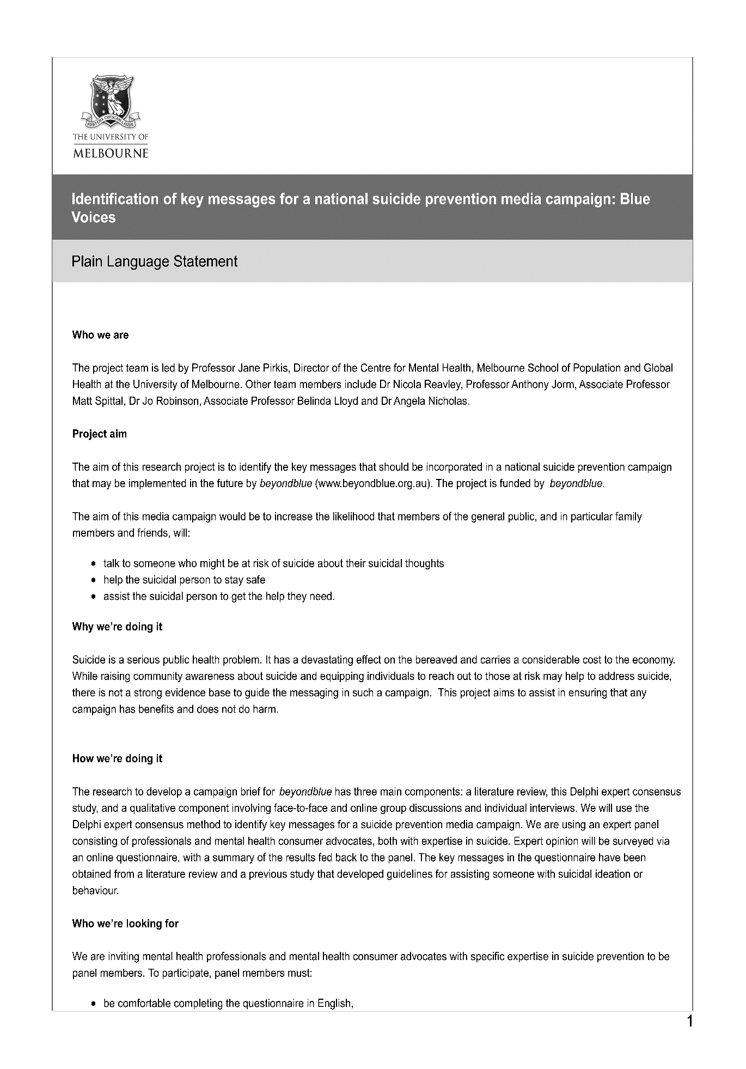
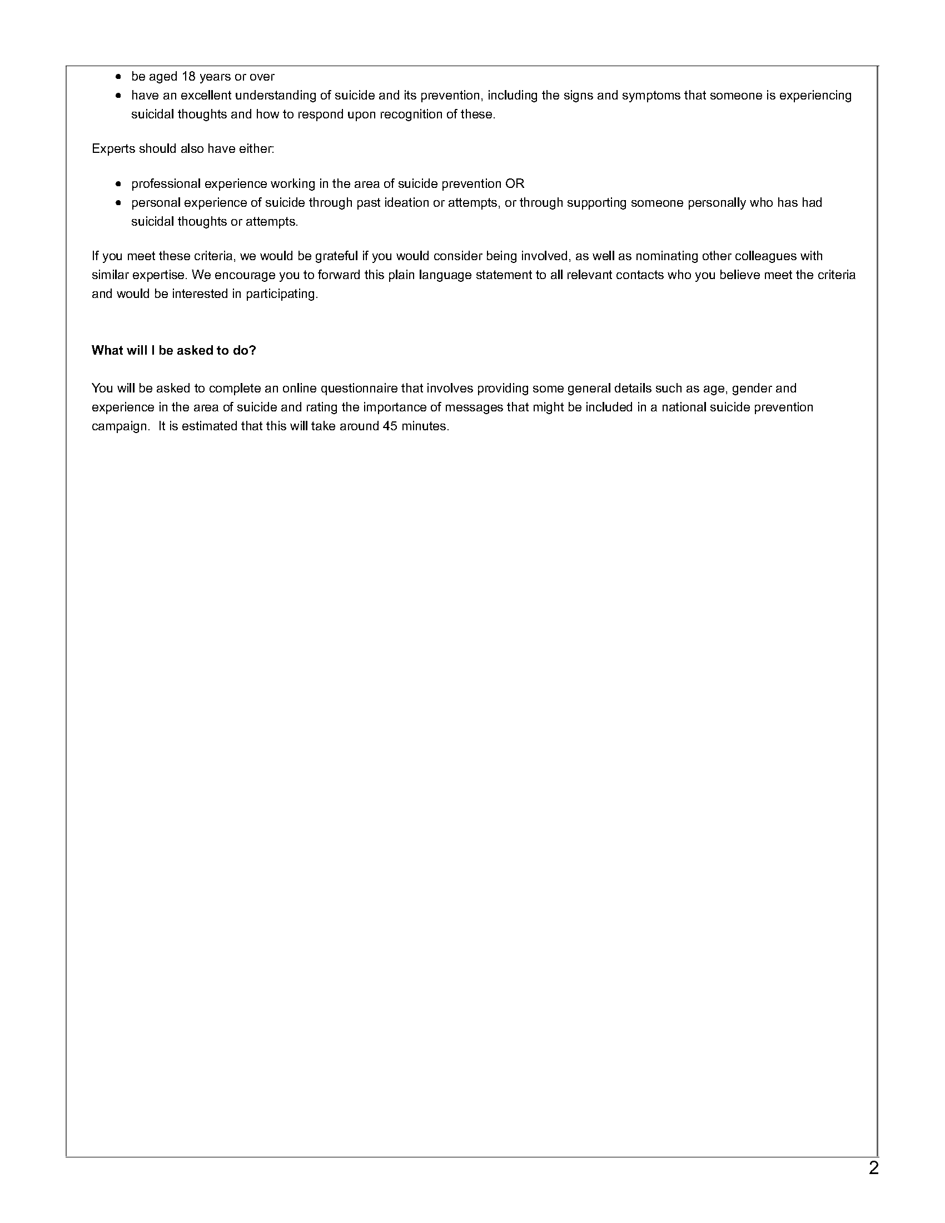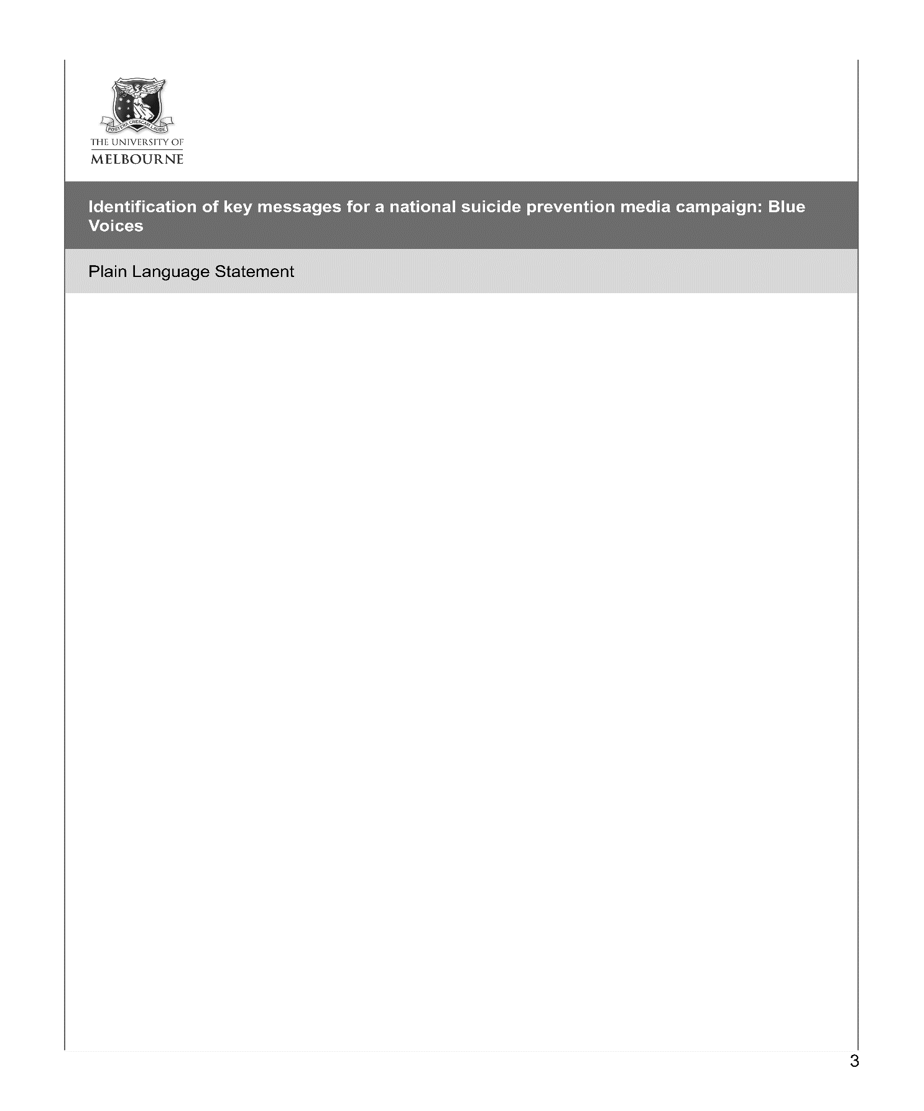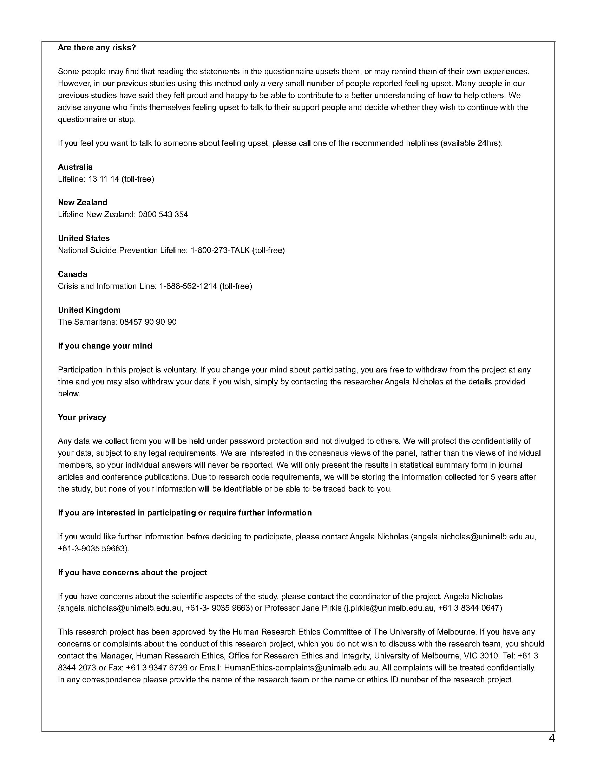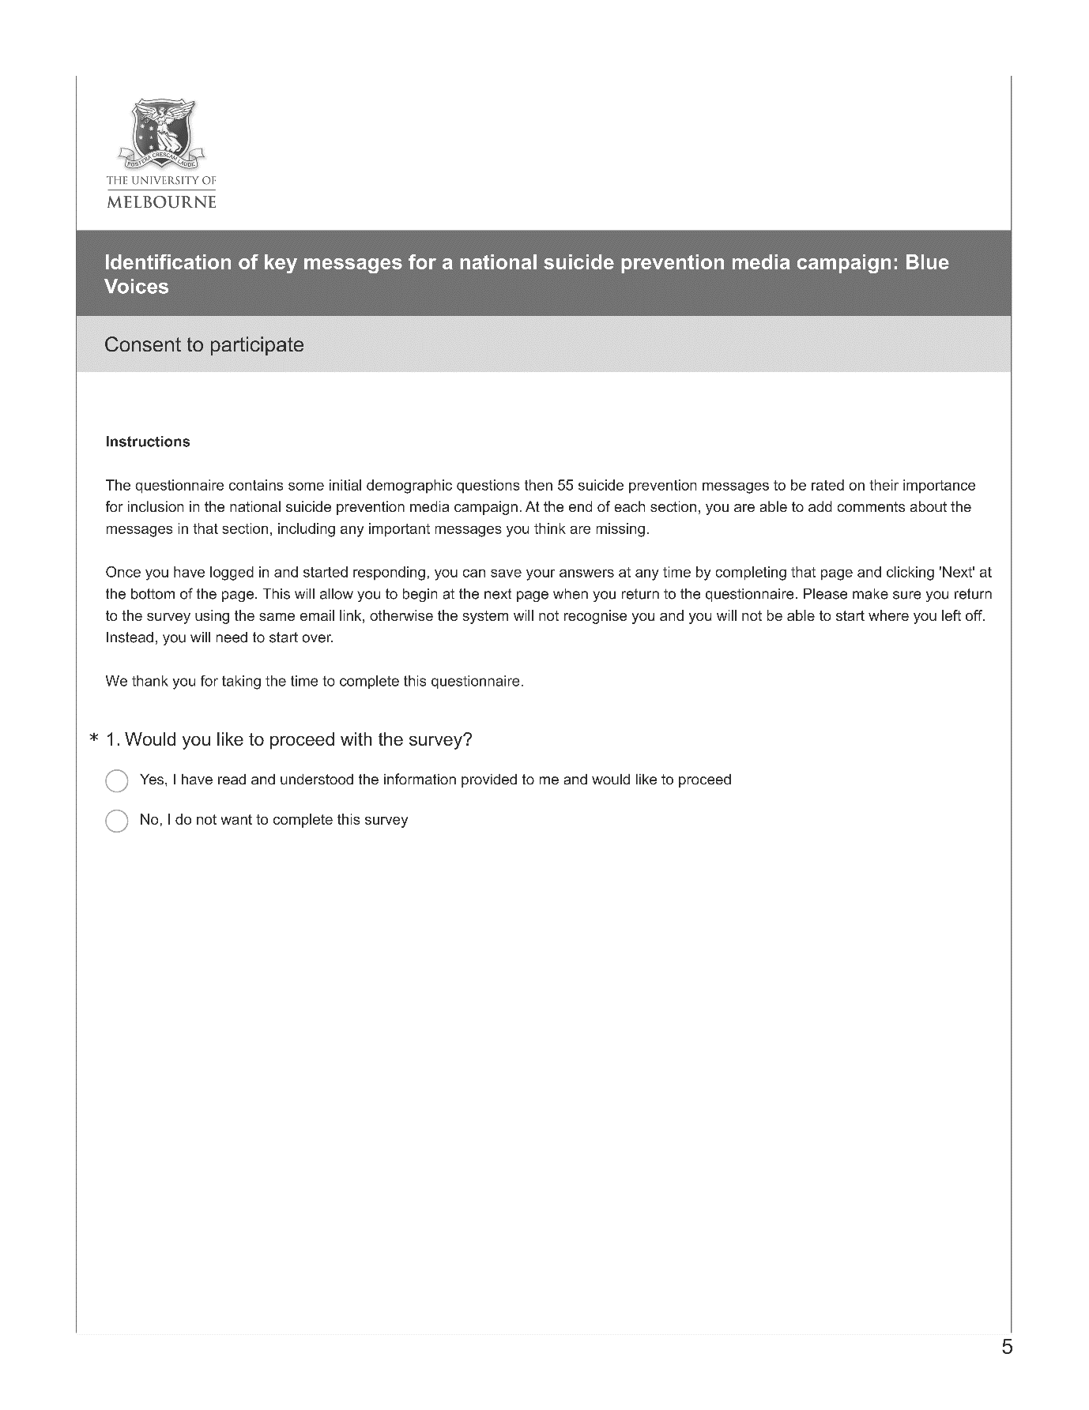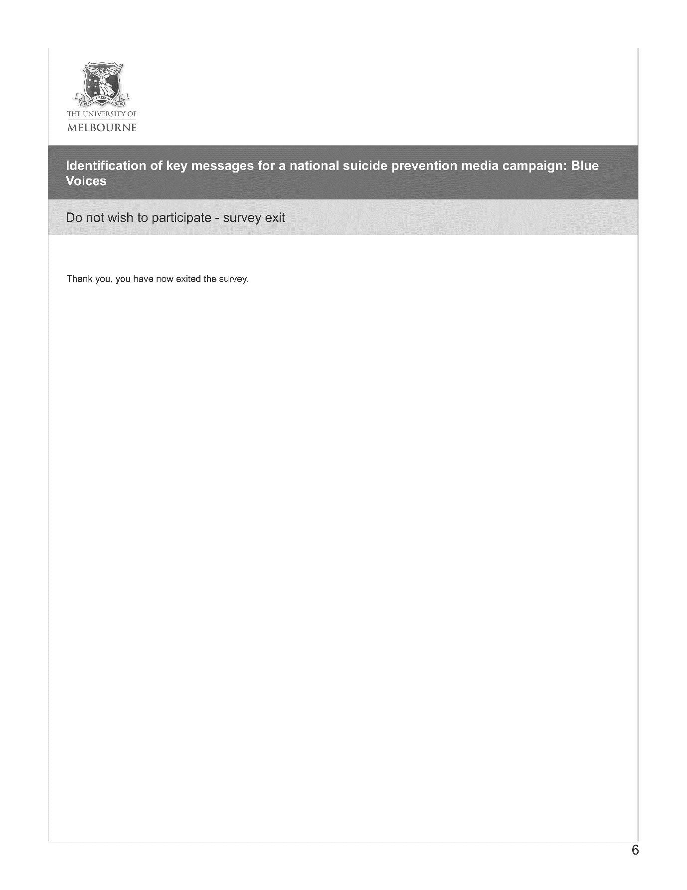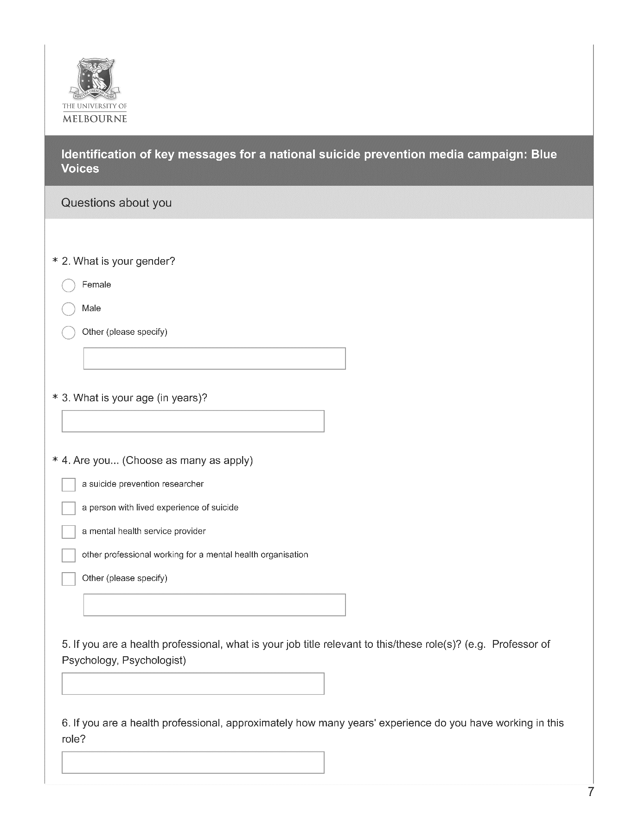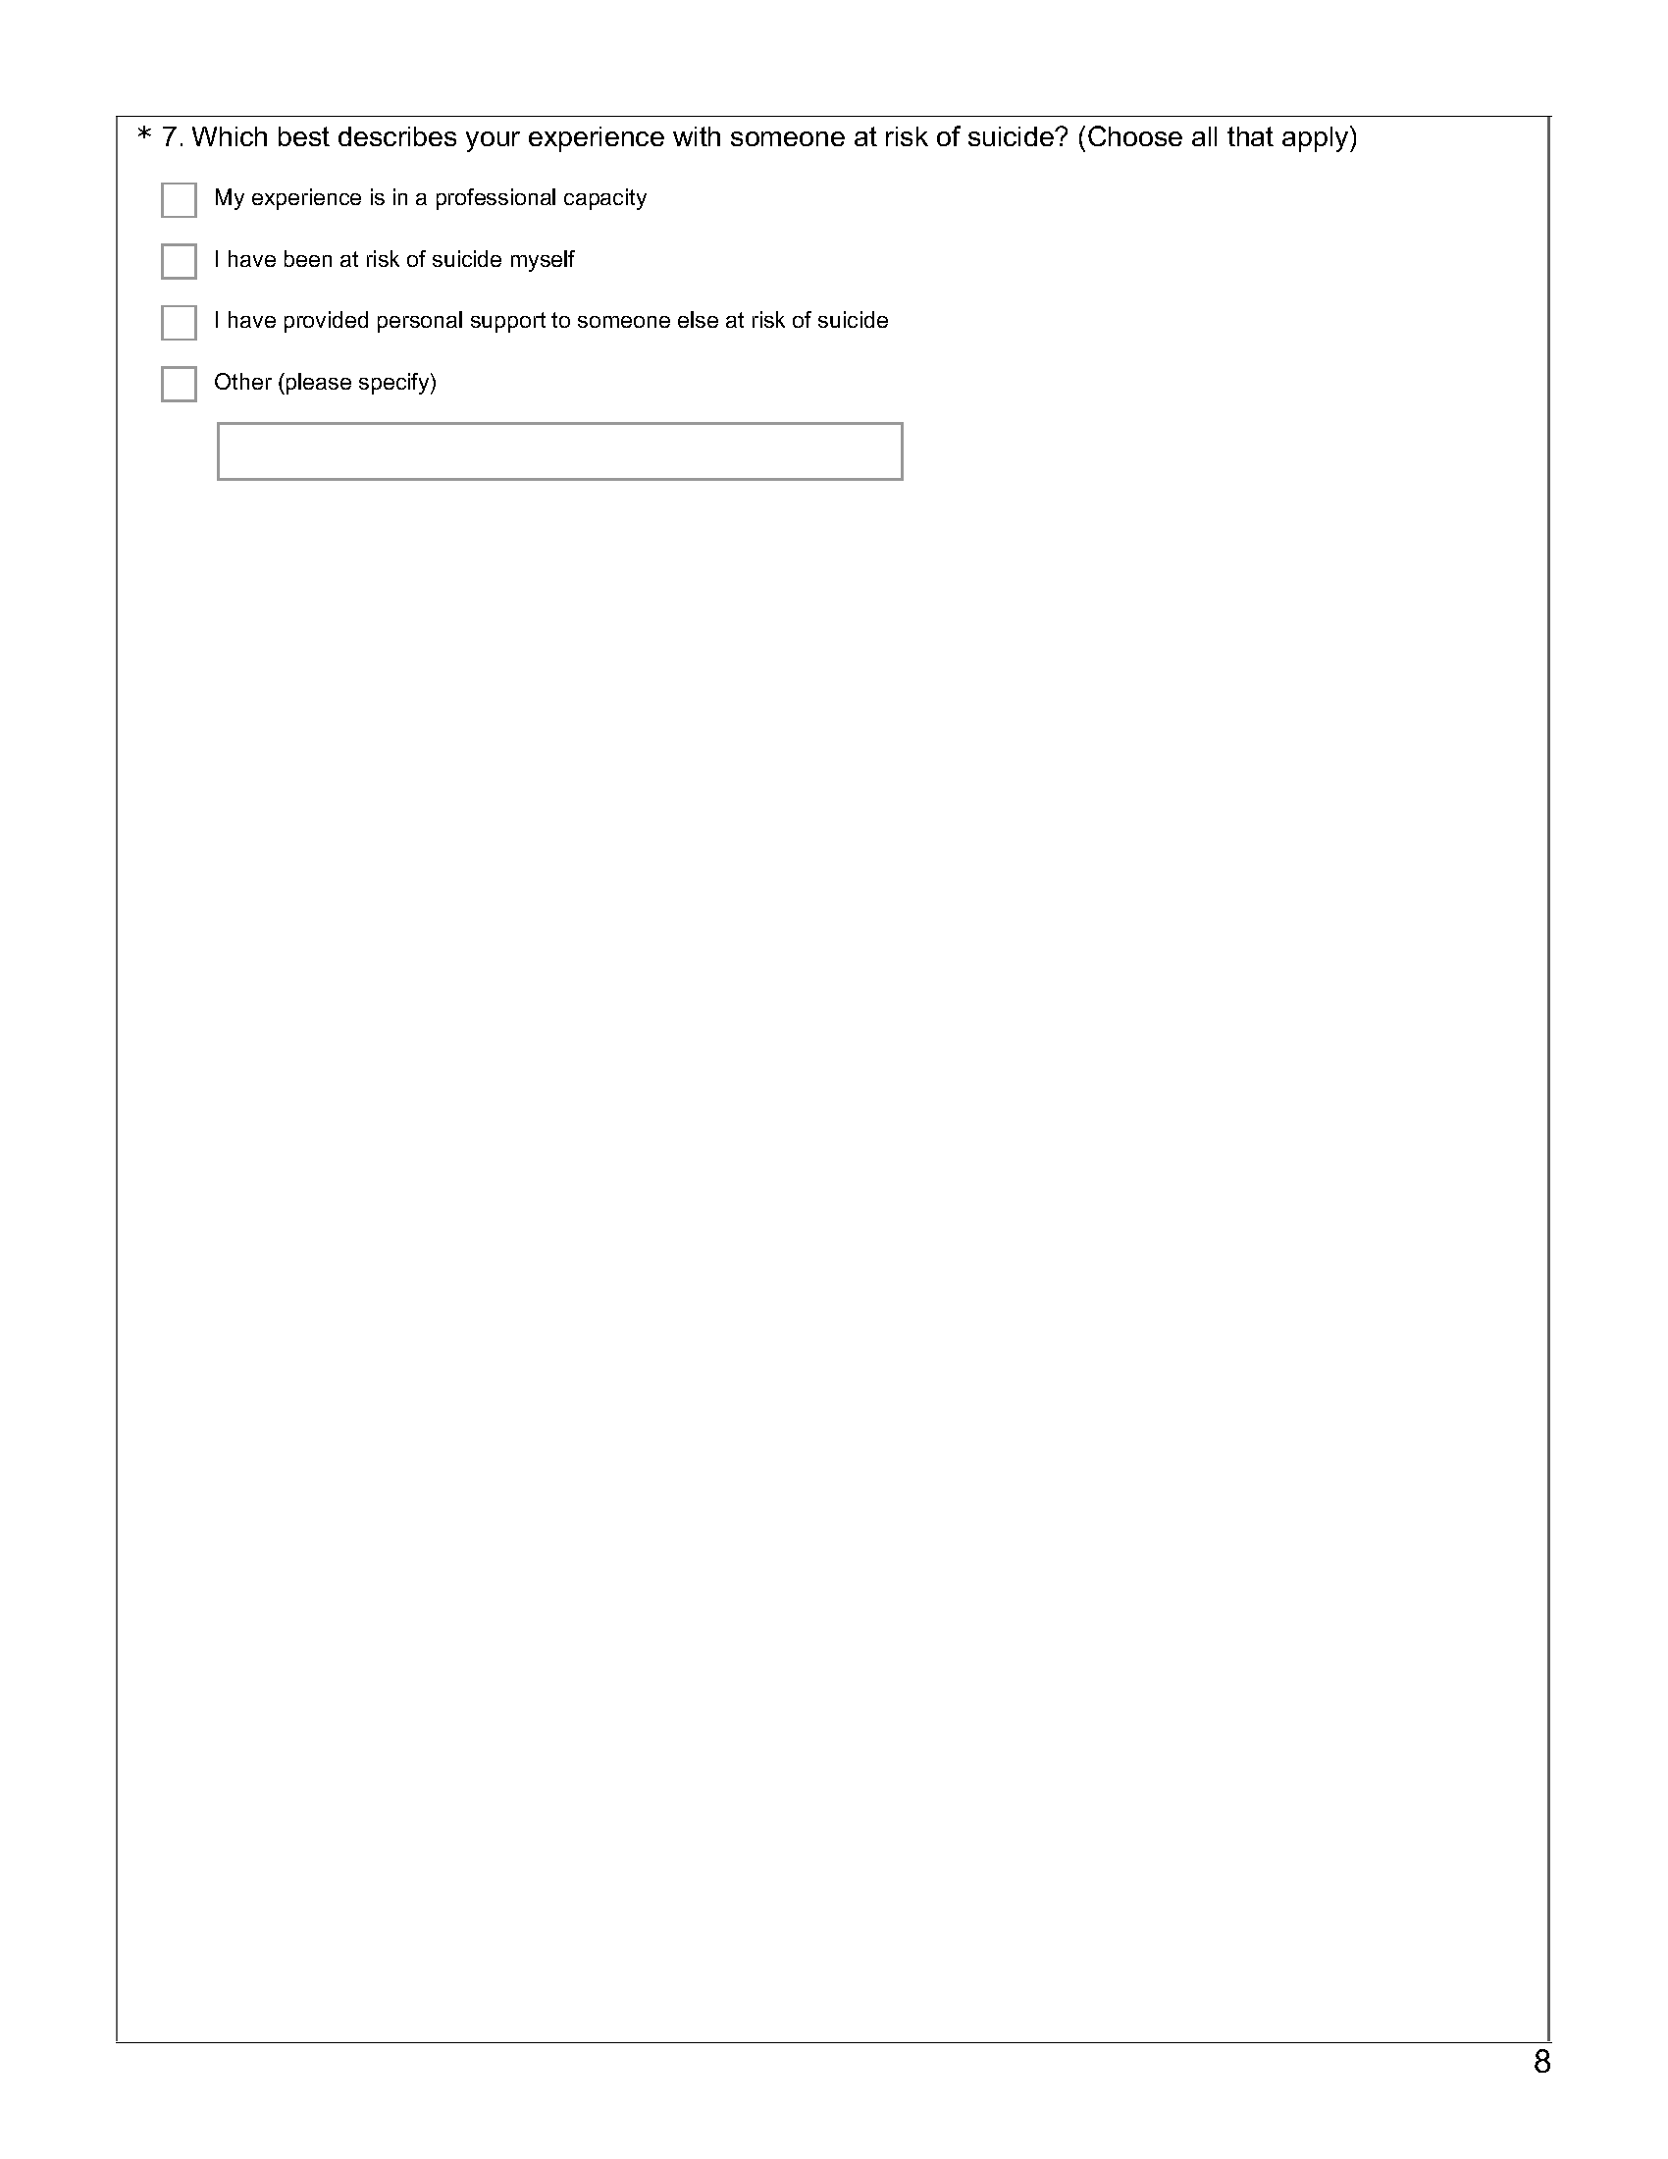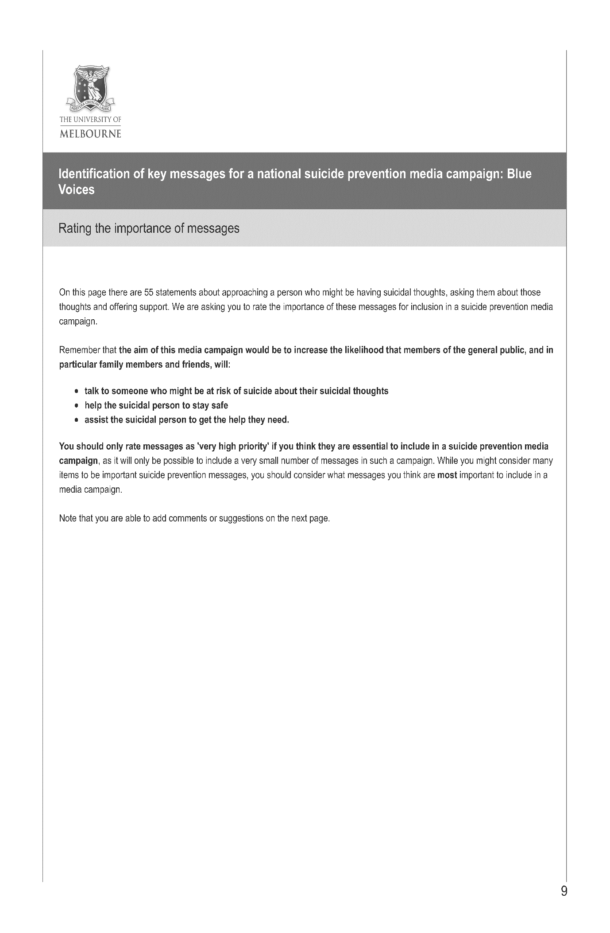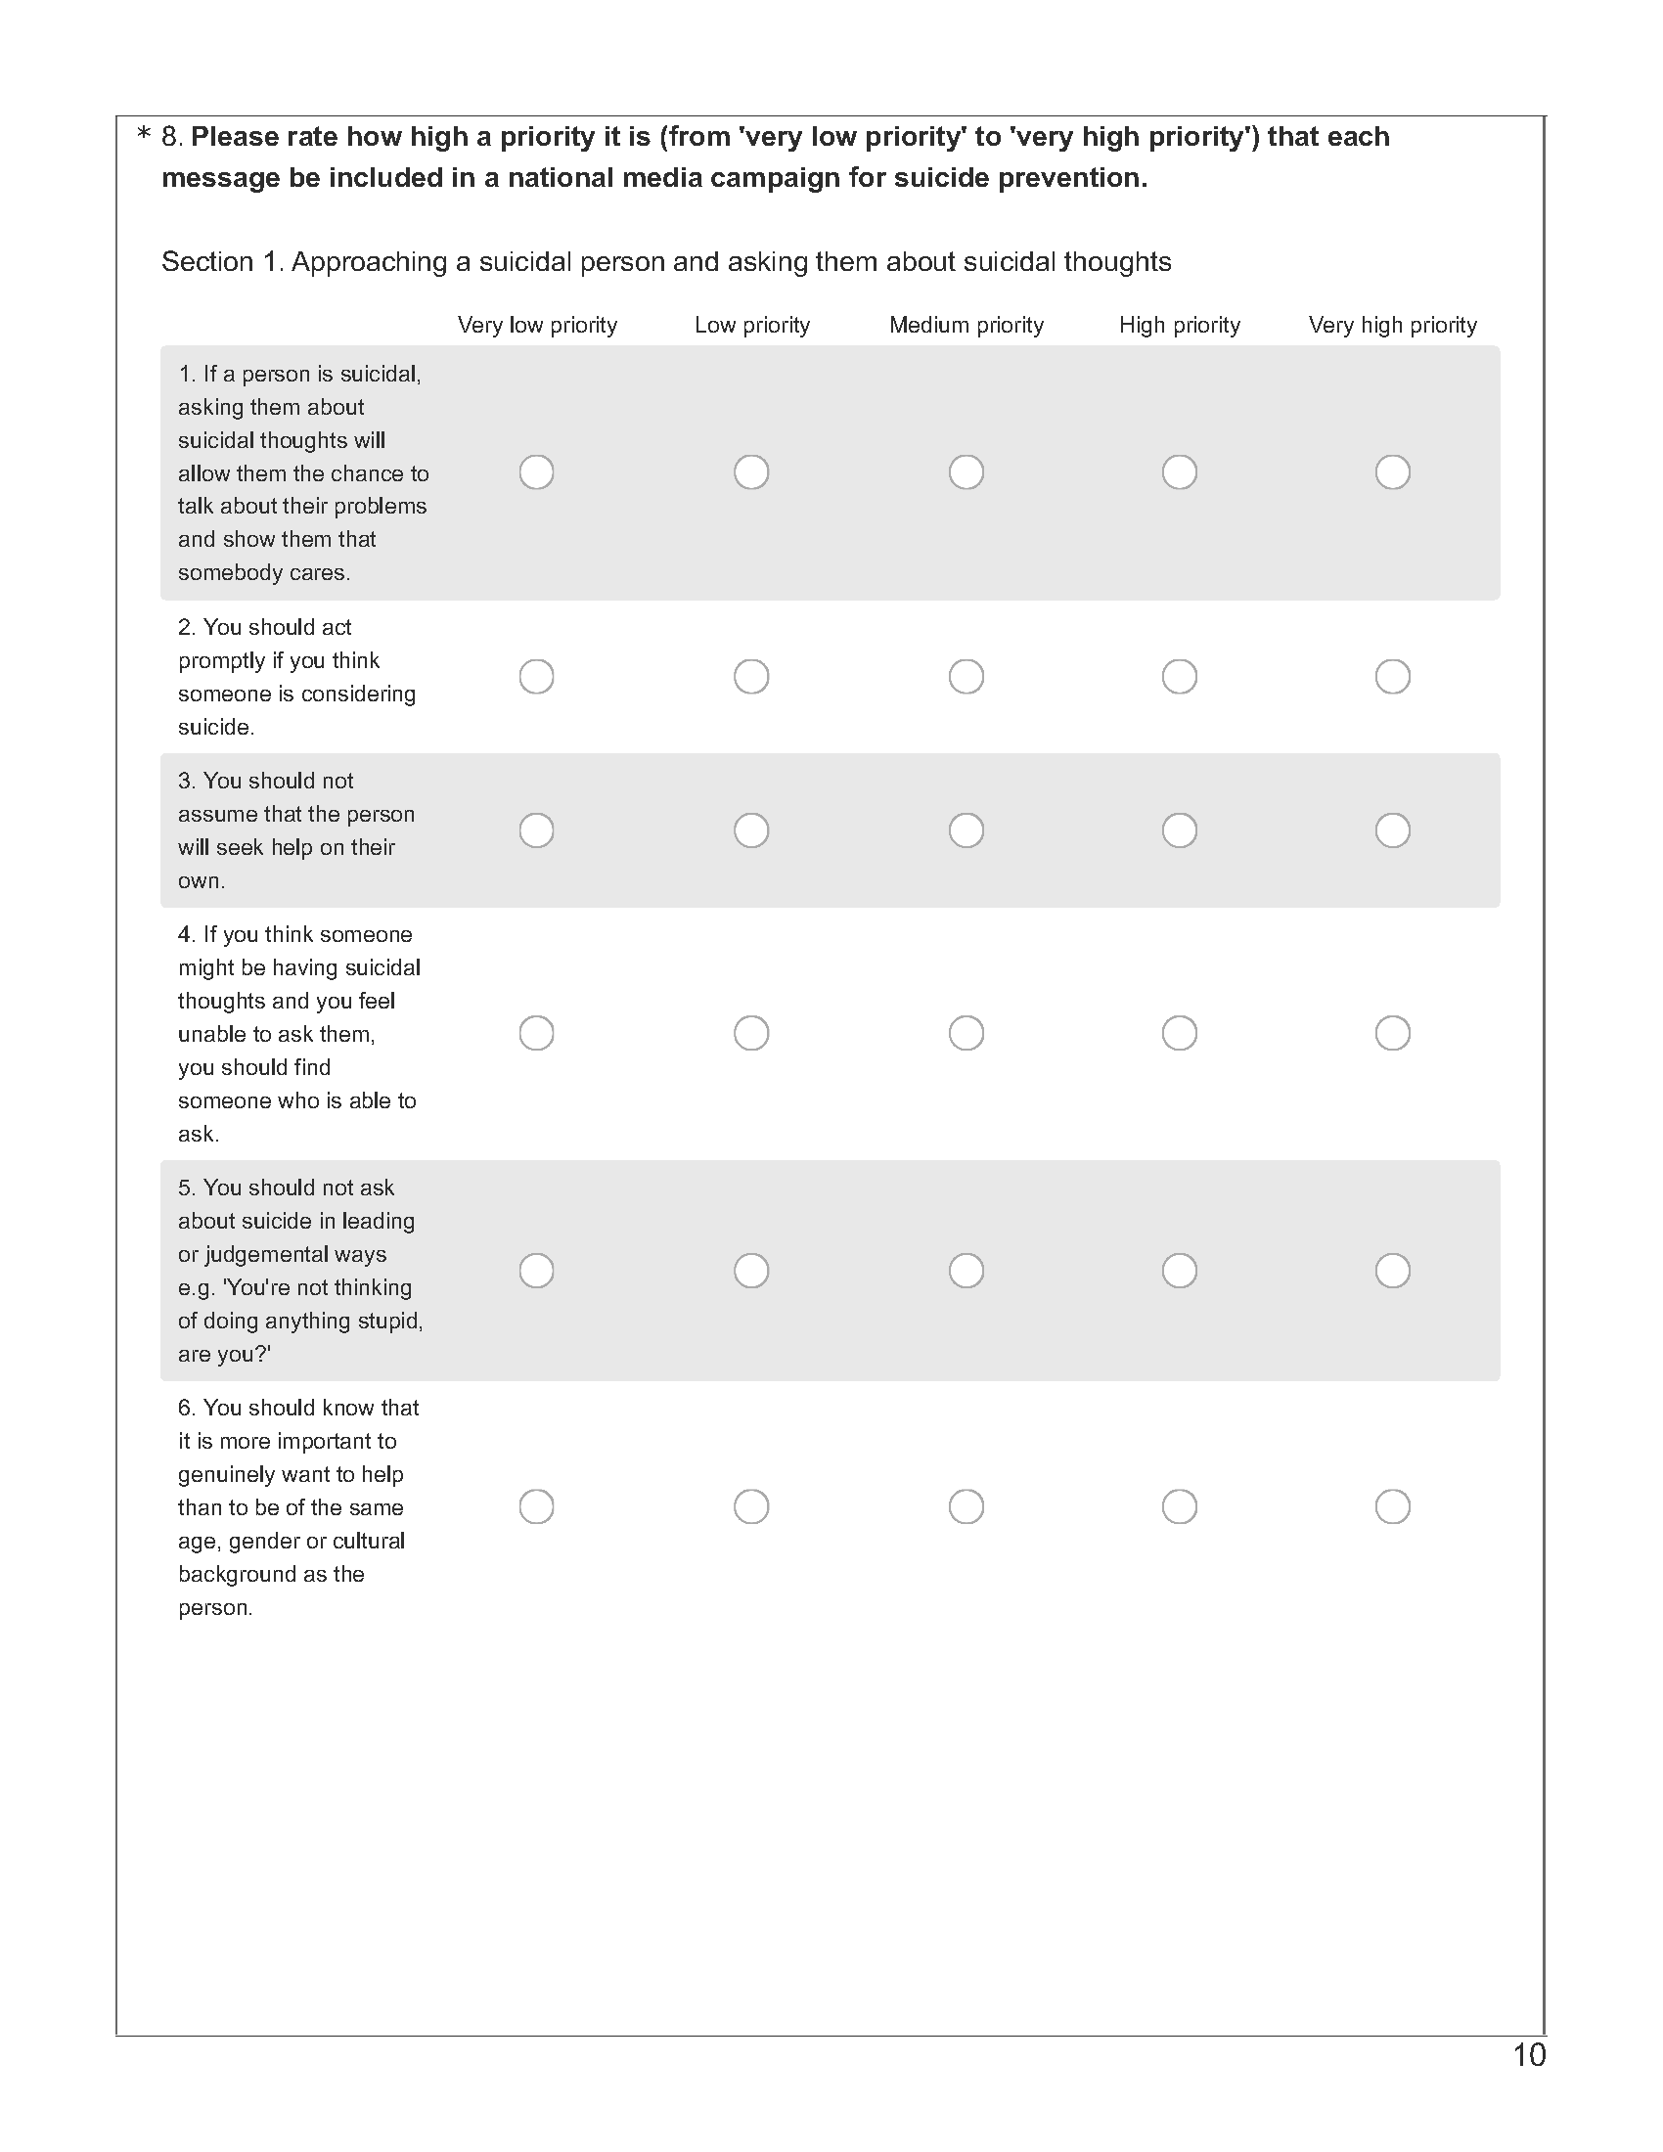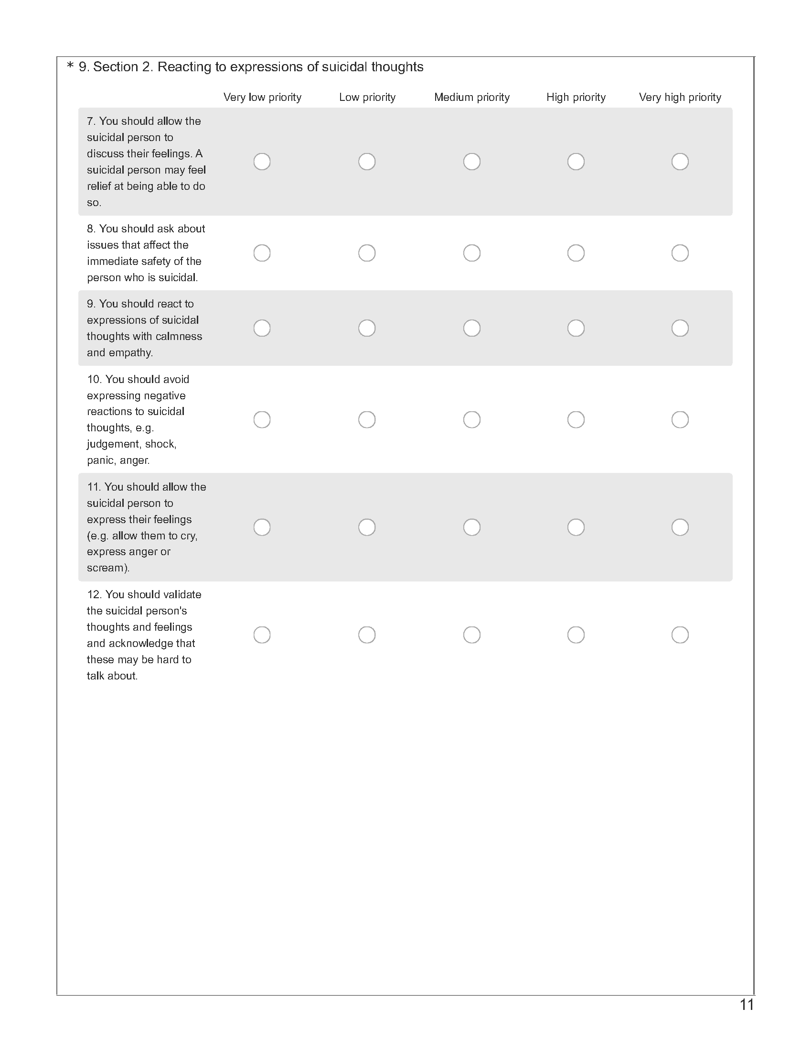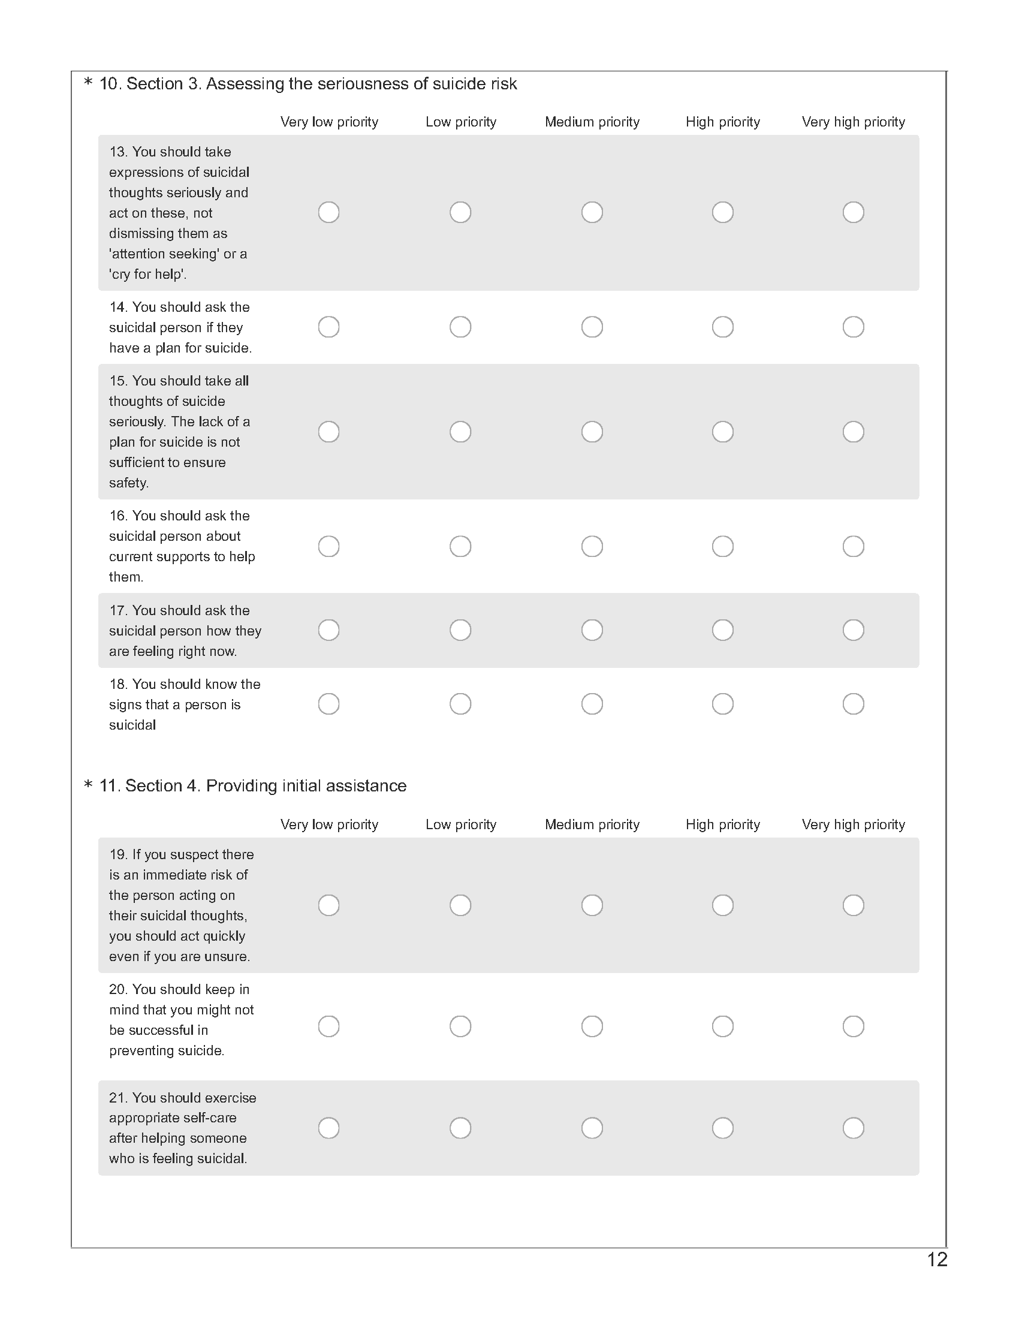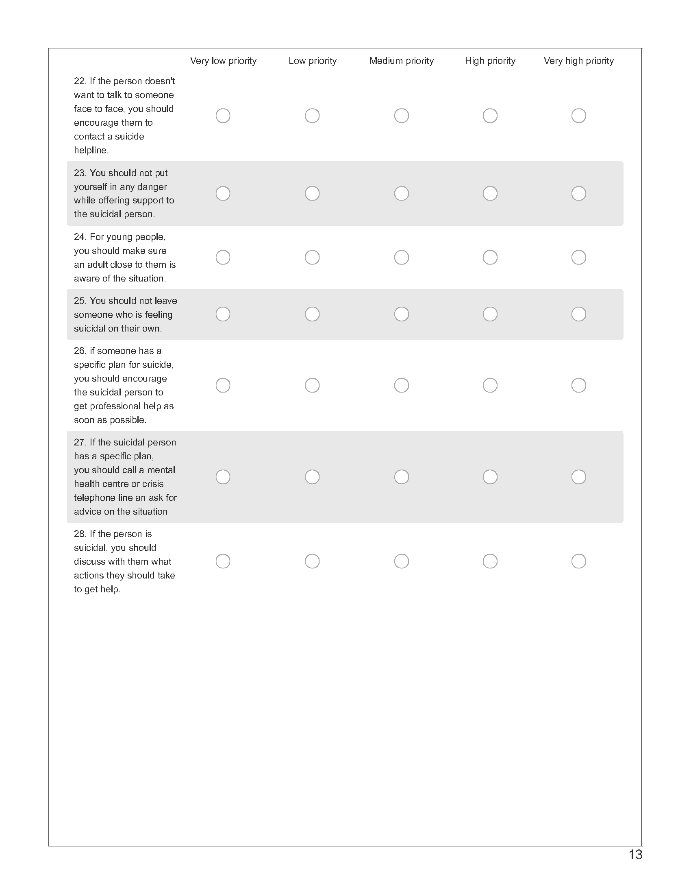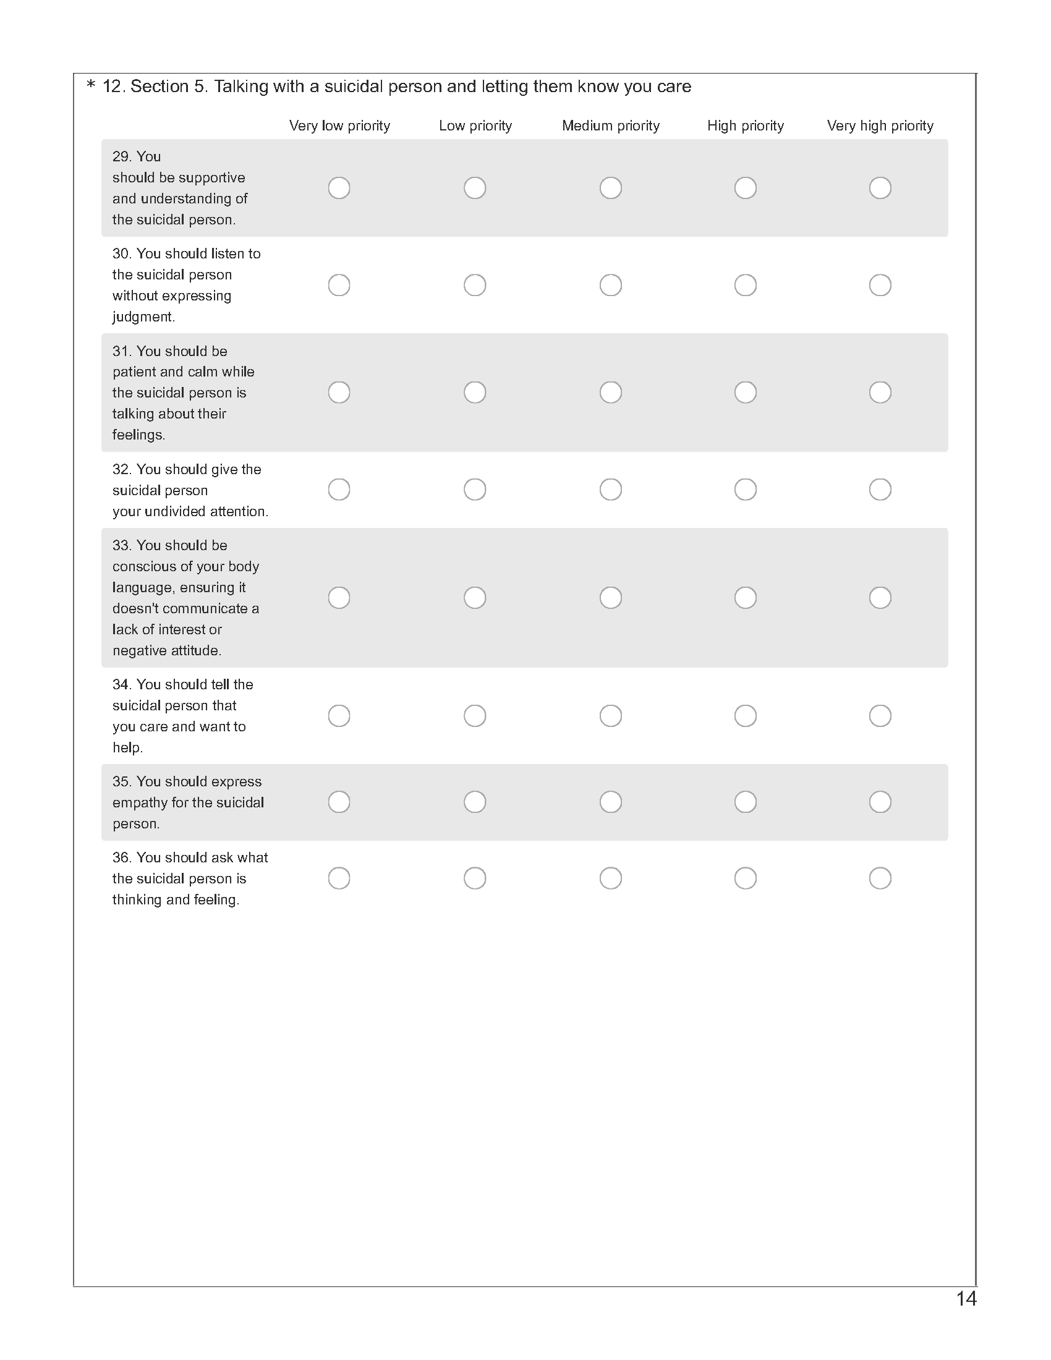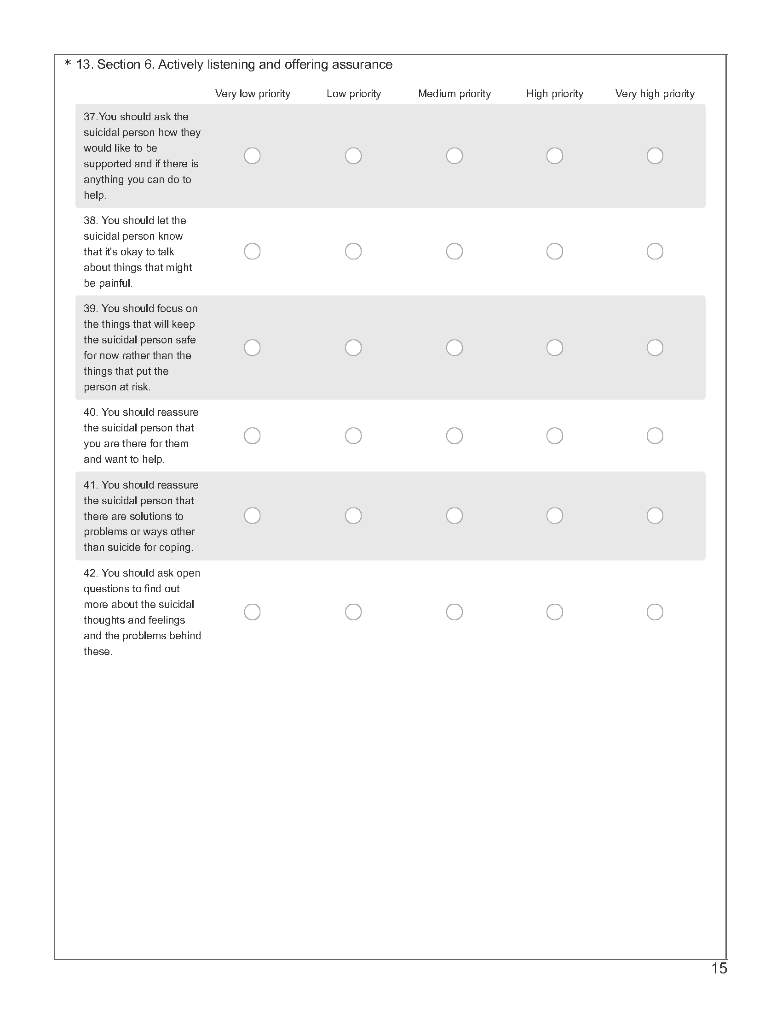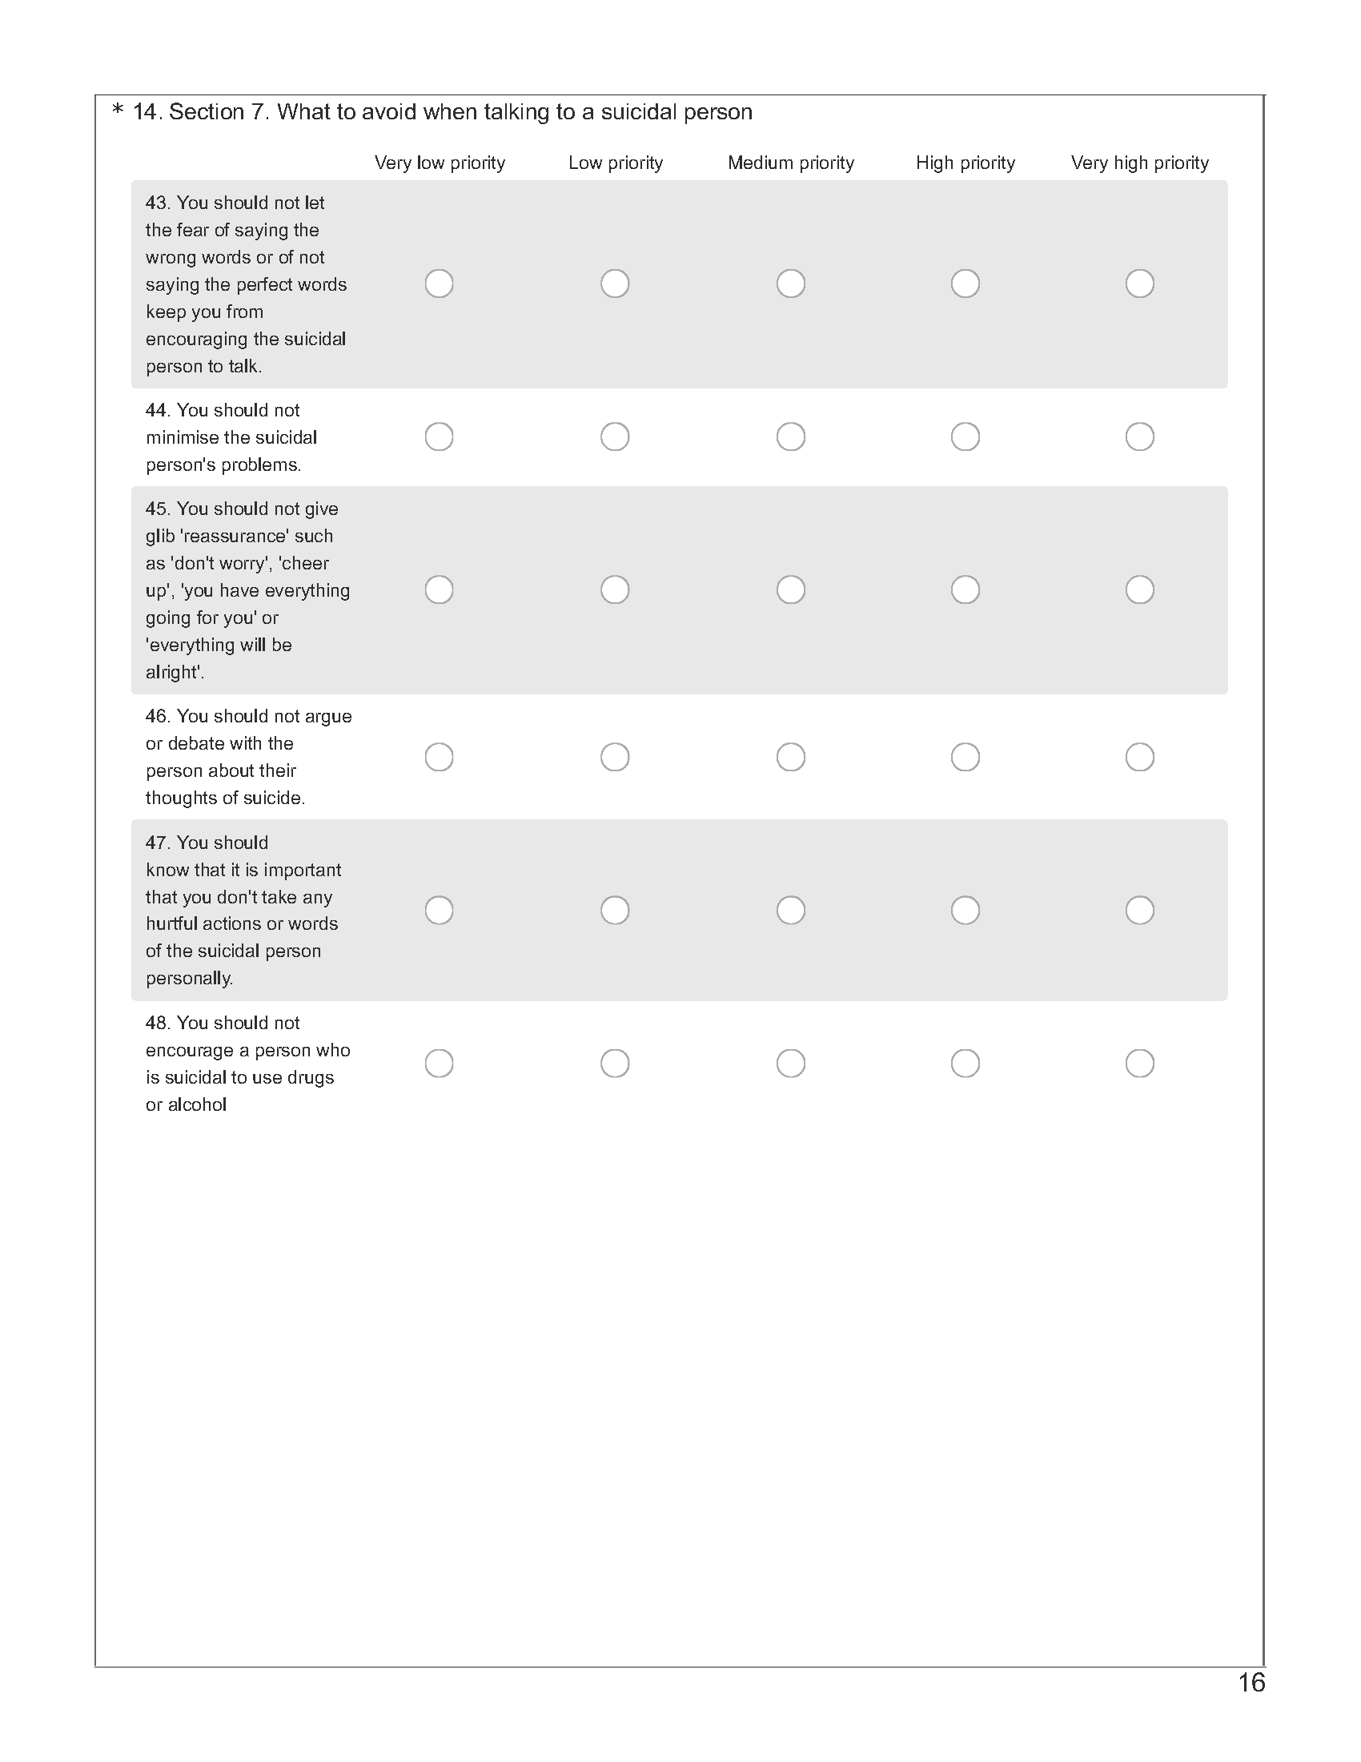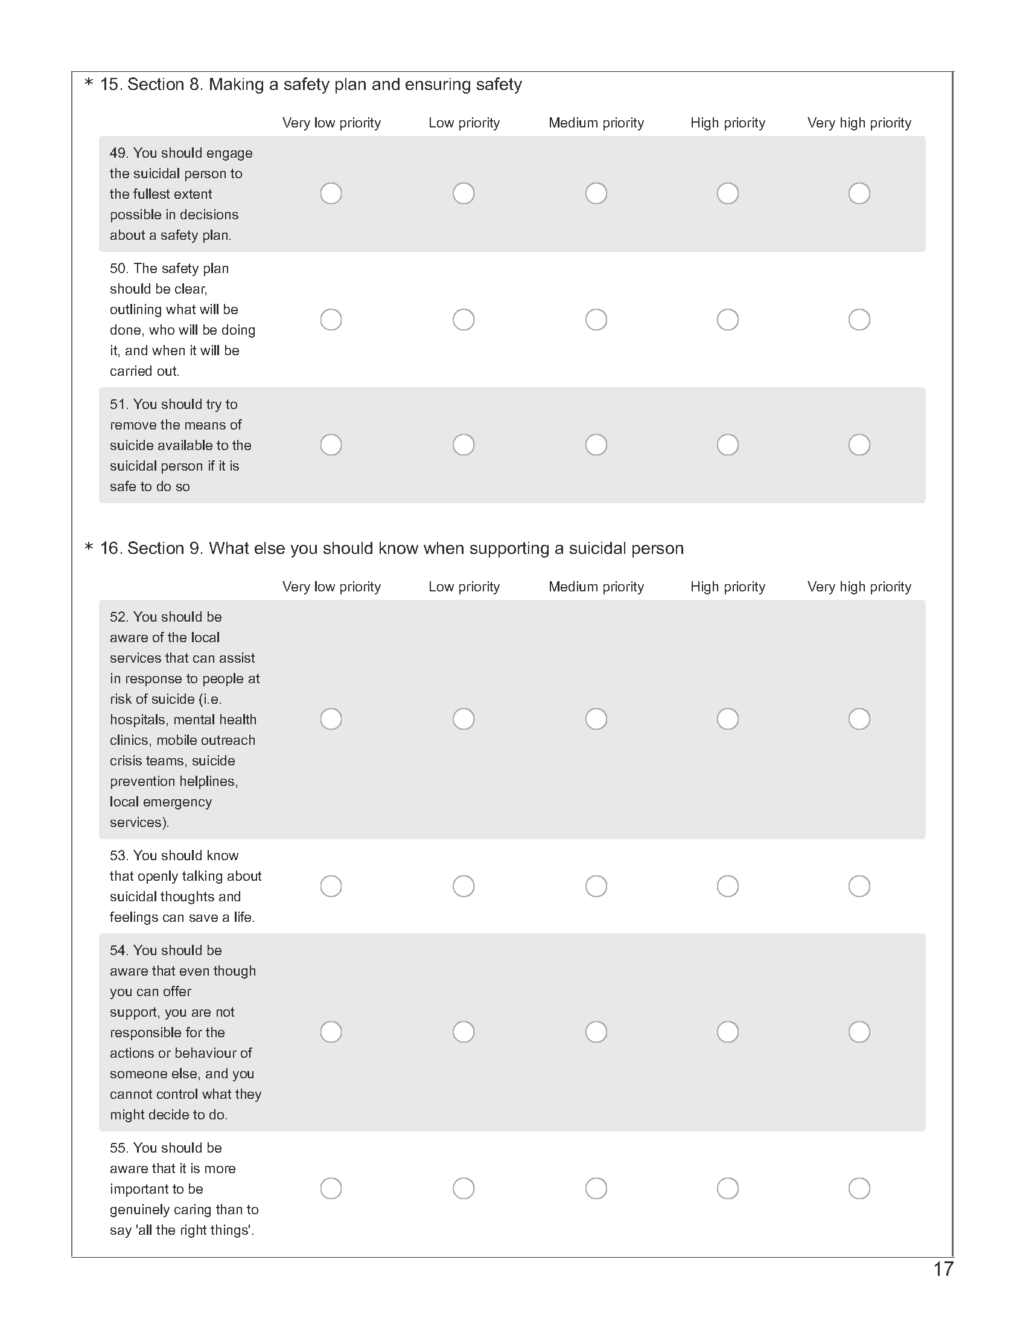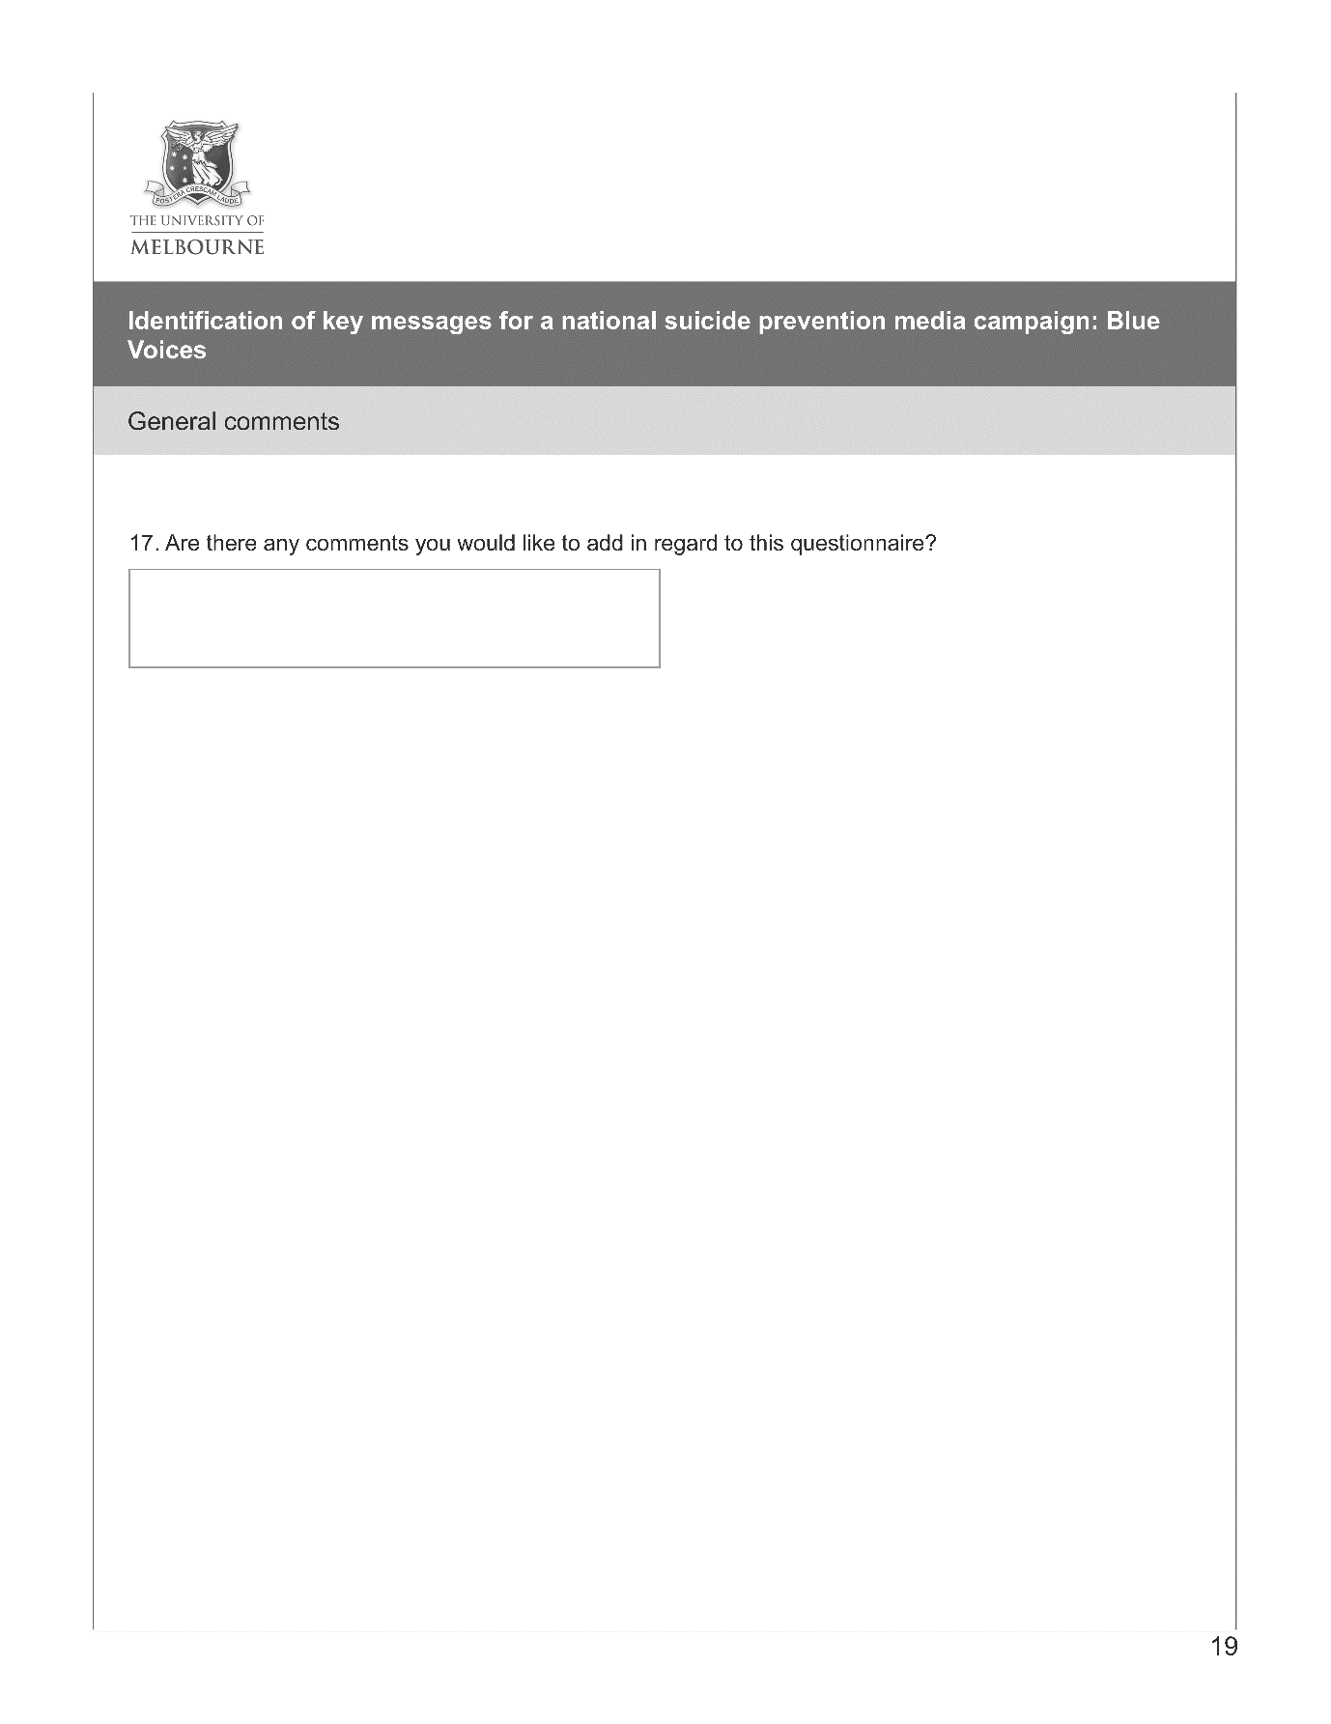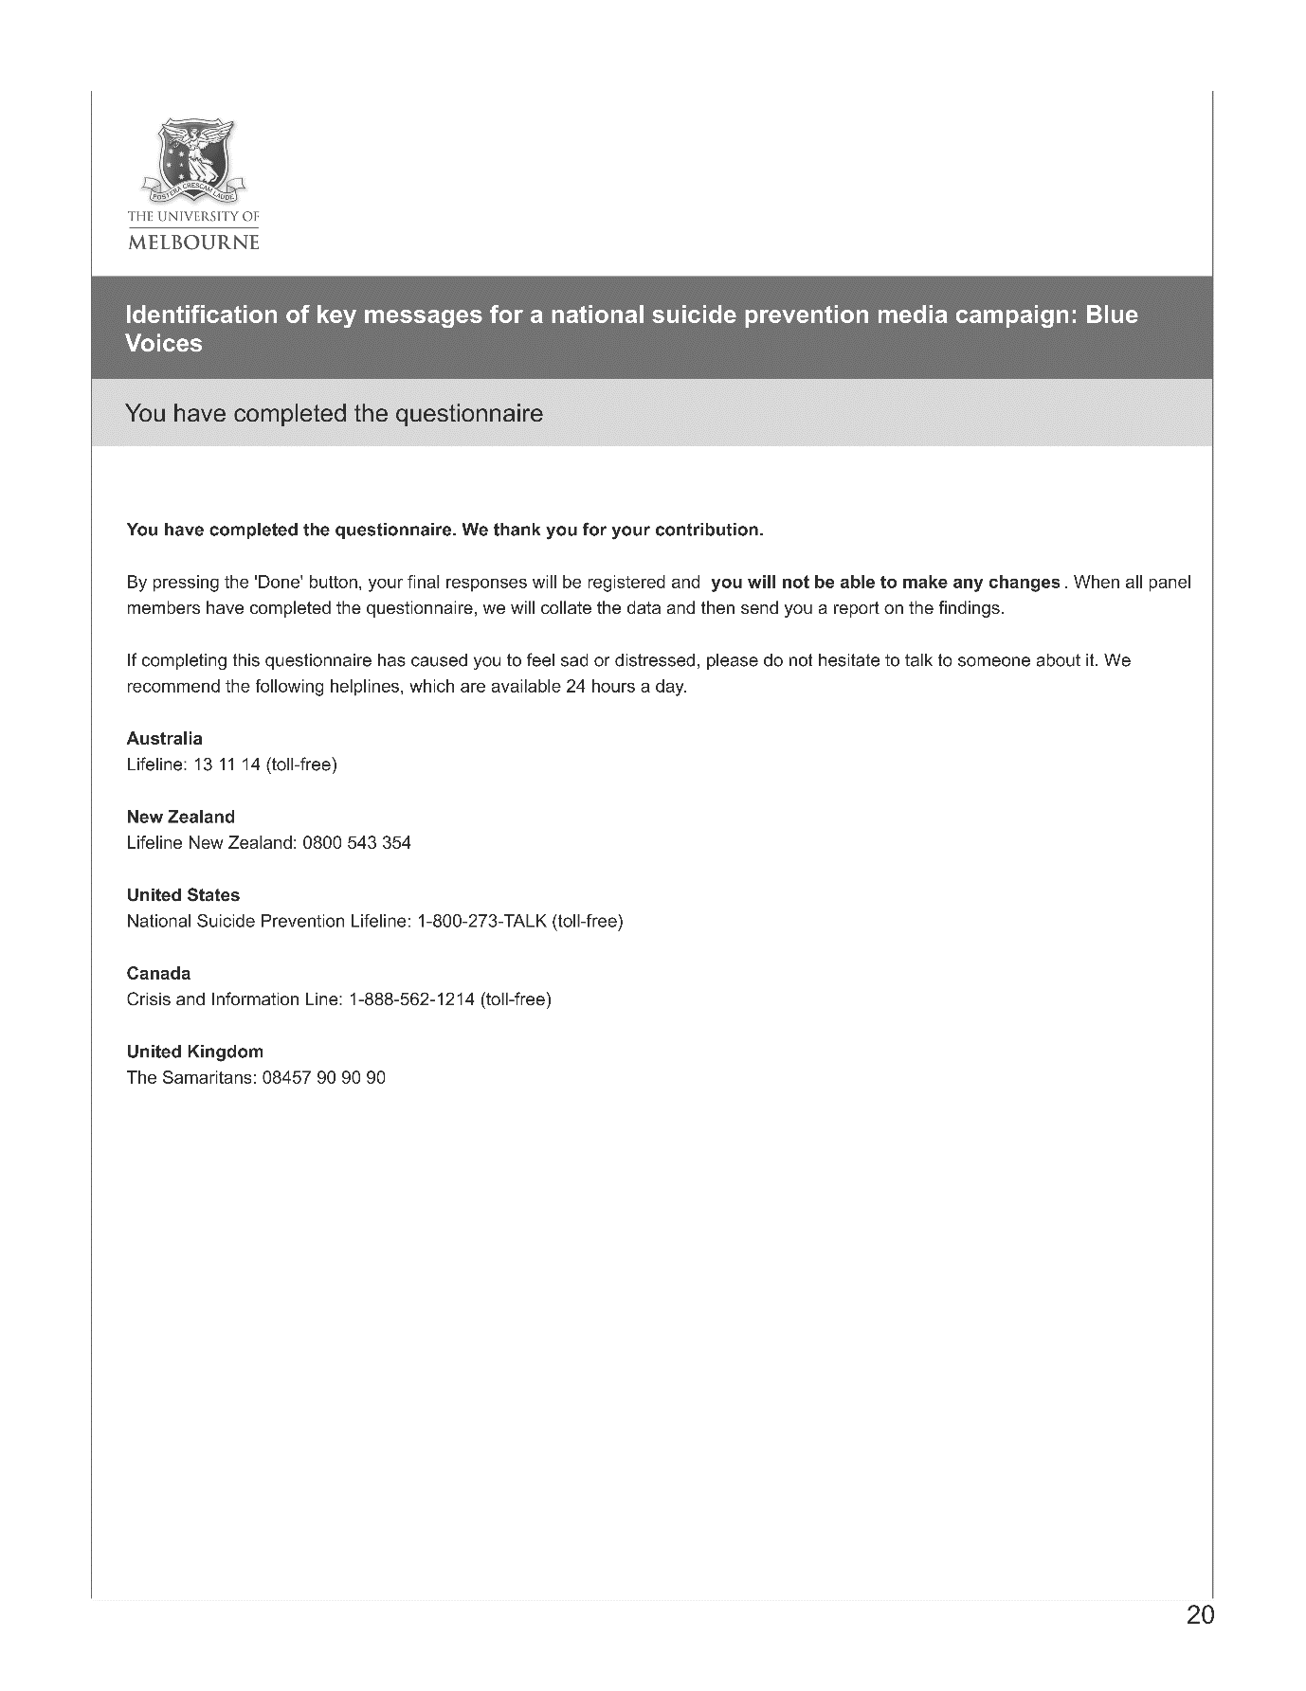

Appendix B. Study 2 qualitative data coding framework
MOST HELPFUL RESPONSES: Non-professional
Code | Description | Examples/Code if… | Do not code if…
Listen | ‘Listening’, including listening without judgement and without trying to solve problems. Also references to asking how they are feeling, providing understanding and empathy, talking. | ‘He listened without judgement’  ‘They were happy for me to discuss…’
Encourage prof | Encourage J to seek professional help of any kind, including by suggesting getting help, but also by making an appointment or going to an appointment with the respondent, calling the professional for advice | ‘Let’s get you some help’  ‘They picked me up and forced me to go to the doctor’  ‘Encouraged me to see my GP’
Support | Support includes all references to being supportive, but also to providing company, taking the respondent out socially, instrumental support like cooking, maintaining regular contact, asking how they can help the respondent | ‘They came to stay’  ‘Assured me he’d always be there’ | Not ‘tell me I am worthwhile’, ‘hug me’ etc which are ‘loving’
Safety | Support person directly addressed issues of safety, including by asking about safety and removal of means | ‘Was I safe? Was there someone he could call?’  ‘He put sharps and medication away where I could not access them.’
Loving | Loving includes references to verbal and physical shows of affection and caring | ‘Comforting’ ‘They told me they loved me’ ‘Gave me a hug every morning’
Strategies | ‘Strategies’ includes developing ways to cope with the respondent, reminding them of strategies they’d used in the past, or encouraging self-help through healthy lifestyle or doing enjoyable activities | ‘Made me get healthy’  ‘I can speak up and talk at anytime’
Perspective | Responses relating to gaining new perspective | ‘That everyone is going through something, and I’m not alone’  ‘It is a time-limited problem and it will end soon’  ‘treating the same feeling in a different way’
Effect on others | The person made them see the effect their suicide would have on others, like their children | e.g. ‘He reminded me about the lasting impact my actions would have on my children.’
Unable to code | The response does not make sense within the context of the question, the respondent refused to answer the question, or the response cannot be coded without making some strong assumptions about the respondent’s meaning
MOST HELPFUL RESPONSES: Professional
Code | Description | Examples/Code if… | Do not code if…
Listen | ‘Listening’, including listening without judgement and without trying to solve problems. Also references to asking how they are feeling, providing understanding and empathy, talking. | ‘He listened without judgement’  ‘They were happy for me to discuss…’
Availability | The professional made themselves available for regular contact, either by taking calls or be making frequent appointments | ‘Kept in contact everyday’  ‘I would go to an appointment every day for a month’
Seriously | The professional took the respondent seriously when they raised their distress or concerns, or made the respondent feel that their concerns were valid | ‘They made me feel validated’  ‘Took my feelings seriously’
Encourage prof | Encouraged respondent to seek professional help from another professional, or liaised with another professional | ‘Lifeline counsellors… encouraged me to see my GP’
Strategies | ‘Strategies’ includes developing ways to cope with the respondent, reminding them of strategies they’d used in the past, or encouraging self-help through healthy lifestyle or doing enjoyable activities | ‘Gave me some techniques (e.g. mindfulness’) to get through the day’  ‘trying to stop my agoraphobia’
Perspective | Responses relating to gaining new perspective | ‘Things that I had clouded judgement on and things in my life I had made assumptions about that were not grounded by evidence’  ‘Reworded the thoughts’
Acute | The professional took steps to get the respondent to receive acute care, such as making an admission to an inpatient facility, or calling triage or emergency | ‘the most helpful thing was to call police/ambulance’  ‘Admitted me to hospital’
Effect on others | The person made them see the effect their suicide would have on others, like their children | ‘Reminded me of the pain it would cause my son’
Unable to code | The response does not make sense within the context of the question, the respondent refused to answer the question, or the response cannot be coded without making some strong assumptions about the respondent’s meaning

LEAST HELPFUL: NON-PROFESSIONALS
Code | Description | Examples/Code if… | Do not code if…
Minimising | Reactions of the other person that minimises the respondent’s experience or feelings, intentions. This includes by responses that indicate a lack of understanding of mental illness, statements like ‘you’re just being silly’ or ‘lots of people are worse off than you’, or a lack of reaction or action when the respondent confided their feelings | ‘Pull your socks up’  ‘Not taking my seriously’  ‘Tried to just distract me’  ‘Told me to get over it’  ‘Tried to push me through the episode as fast as possible’
Blaming | The response of the other person was to blame the respondent for the way they were feeling, or expressing negativity or anger in response to their feelings | ‘Depression is self-inflicted’  ‘That I was over-dramatic and attention seeking’  ‘Told me how selfish I was being’
Withdrawal | The other person withdrew from the respondent or threatened to | ‘he withdrew himself even more from me’  ‘They didn’t speak to me’  ‘said nothing at all’
Positivity | The other persons response relays the message that the respondent should be more positive | ‘Just the usual positive speak’  ‘It will get better’  ‘You’ll get through it; you always do’
Effect on others | The person made them see the effect their suicide would have on others, like their children | ‘Think of being here for your kids’

LEAST HELPFUL: PROFESSIONALS
Code | Description | Examples/Code if… | Do not code if…
Minimising | Reactions of the other person that minimises the respondent’s experience or feelings, intentions. This includes by responses that indicate a lack of understanding of mental illness, statements like ‘you’re just being silly’ or ‘lots of people are worse off than you’, or a lack of reaction or action when the respondent confided their feelings | ‘The triage nurse said “we can’t help you”’  ‘I felt I wasn’t taken seriously and there was no real urgency’
Blaming | The response of the other person was to blame the respondent for the way they were feeling, or expressing negativity or anger in response to their feelings | ‘CATT team: being dismissed as attention-seeking’  ‘Told me suicide is selfish and hurts everyone’
Acute | Response makes reference to acute care | ‘Talking to the CAAT team, I felt too scared to tell the truth because I didn't want to be "sectioned".’  ‘Said they would send me to hospital’
Effect on others | The person made them see the effect their suicide would have on others, like their children | ‘Being told how devastated the family would be.’

DESIRED HELP: ALL
Code | Description | Examples/Code if… | Do not code if…
Listen | ‘Listening’, including listening without judgement and without trying to solve problems. Also references to asking how they are feeling, providing understanding and empathy, talking. | ‘be empathetic’  ‘just have the ears to listen’
Encourage prof | Encourage the respondent to seek professional help of any kind, including by suggesting getting help, but also by making an appointment or going to an appointment with the respondent, calling the professional for advice | ‘Wish someone made me call Lifeline’  ‘I wish someone advised me to seek medical assistance sooner’
Support | Support includes all references to being supportive, but also to providing company, taking the respondent out socially, instrumental support like cooking, maintaining regular contact, asking how they can help the respondent | ‘I wish someone had just really been there for me and kept me company during the most difficult times and known to just stay.’  ‘I needed people to sit with me and listen to my problems without giving me advice or solutions. I just wanted to feel less alone.’ | Not ‘tell me I am worthwhile’, ‘hug me’ etc which are ‘loving’
Suicide | Respondent makes reference to wanting others to address suicide directly and openly | ‘At the time I attempted suicide I wish someone had asked if I was suicidal.’  ‘"Are you thinking/planning to take your life?", "Do you have a planned method?", "What do I need to remove to keep you safe?"’
Loving | Loving includes references to verbal and physical shows of affection and caring, including being told they are important or meaningful | ‘I wish my husband had taken the time to tell me how important I am to him and the kids’ ‘I would have like someone to hug me’
Strategies | ‘Strategies’ includes developing ways to cope with the respondent, reminding them of strategies they’d used in the past, or encouraging self-help through healthy lifestyle or doing enjoyable activities | ‘I wish there would be some action taken to solve the problem… to actually say that they will help me get to the solution is a really big thing’ ‘Encouraged me to use techniques from my psychologist/psychiatrist sessions in a non-demeaning way.’
Positive | Respondent would have liked someone to tell them something positive, like that there is a way out or that things will get better | ‘If you are unhappy about the way your life is right now, you can change it. It will even just change by itself. This might be the very worst time in your life, or one of the worst times.’  ‘I wanted someone to explain to me that life could get better.’
Seriously | The respondent wants to be taken seriously when they raise their distress or concerns | ‘I wish people took me seriously when I said I was struggling’ ‘I wish someone had considered my feelings within situations where only people with obvious emotional stress were focused on’
Acknowledge/  recognise | The respondent wanted someone to recognise that they were suffering or to acknowledge their depression or suffering | ‘I wish someone had just noticed that I was suffering.’  ‘I wish my family understood mental health is an actual illness’
Acute | Respondent expressed a desire for access to acute care or more immediate access to acute care | ‘I wish I could have been admitted to hospital/ somewhere where I could just shut my brain off and give it a rest without constant stress and worry.’  ‘I'm going to ring (triage/psychiatrist)’
Fatalistic | The respondent states that when they were suicidal, no response would have made a difference, or that they still want to die. | ‘No, I thought my children would be better without me. I didn’t want help.’ ‘I wish someone would just give me the Nembutal and I am not being sarcastic.’

Appendix C. Study 1 ethics approval letter
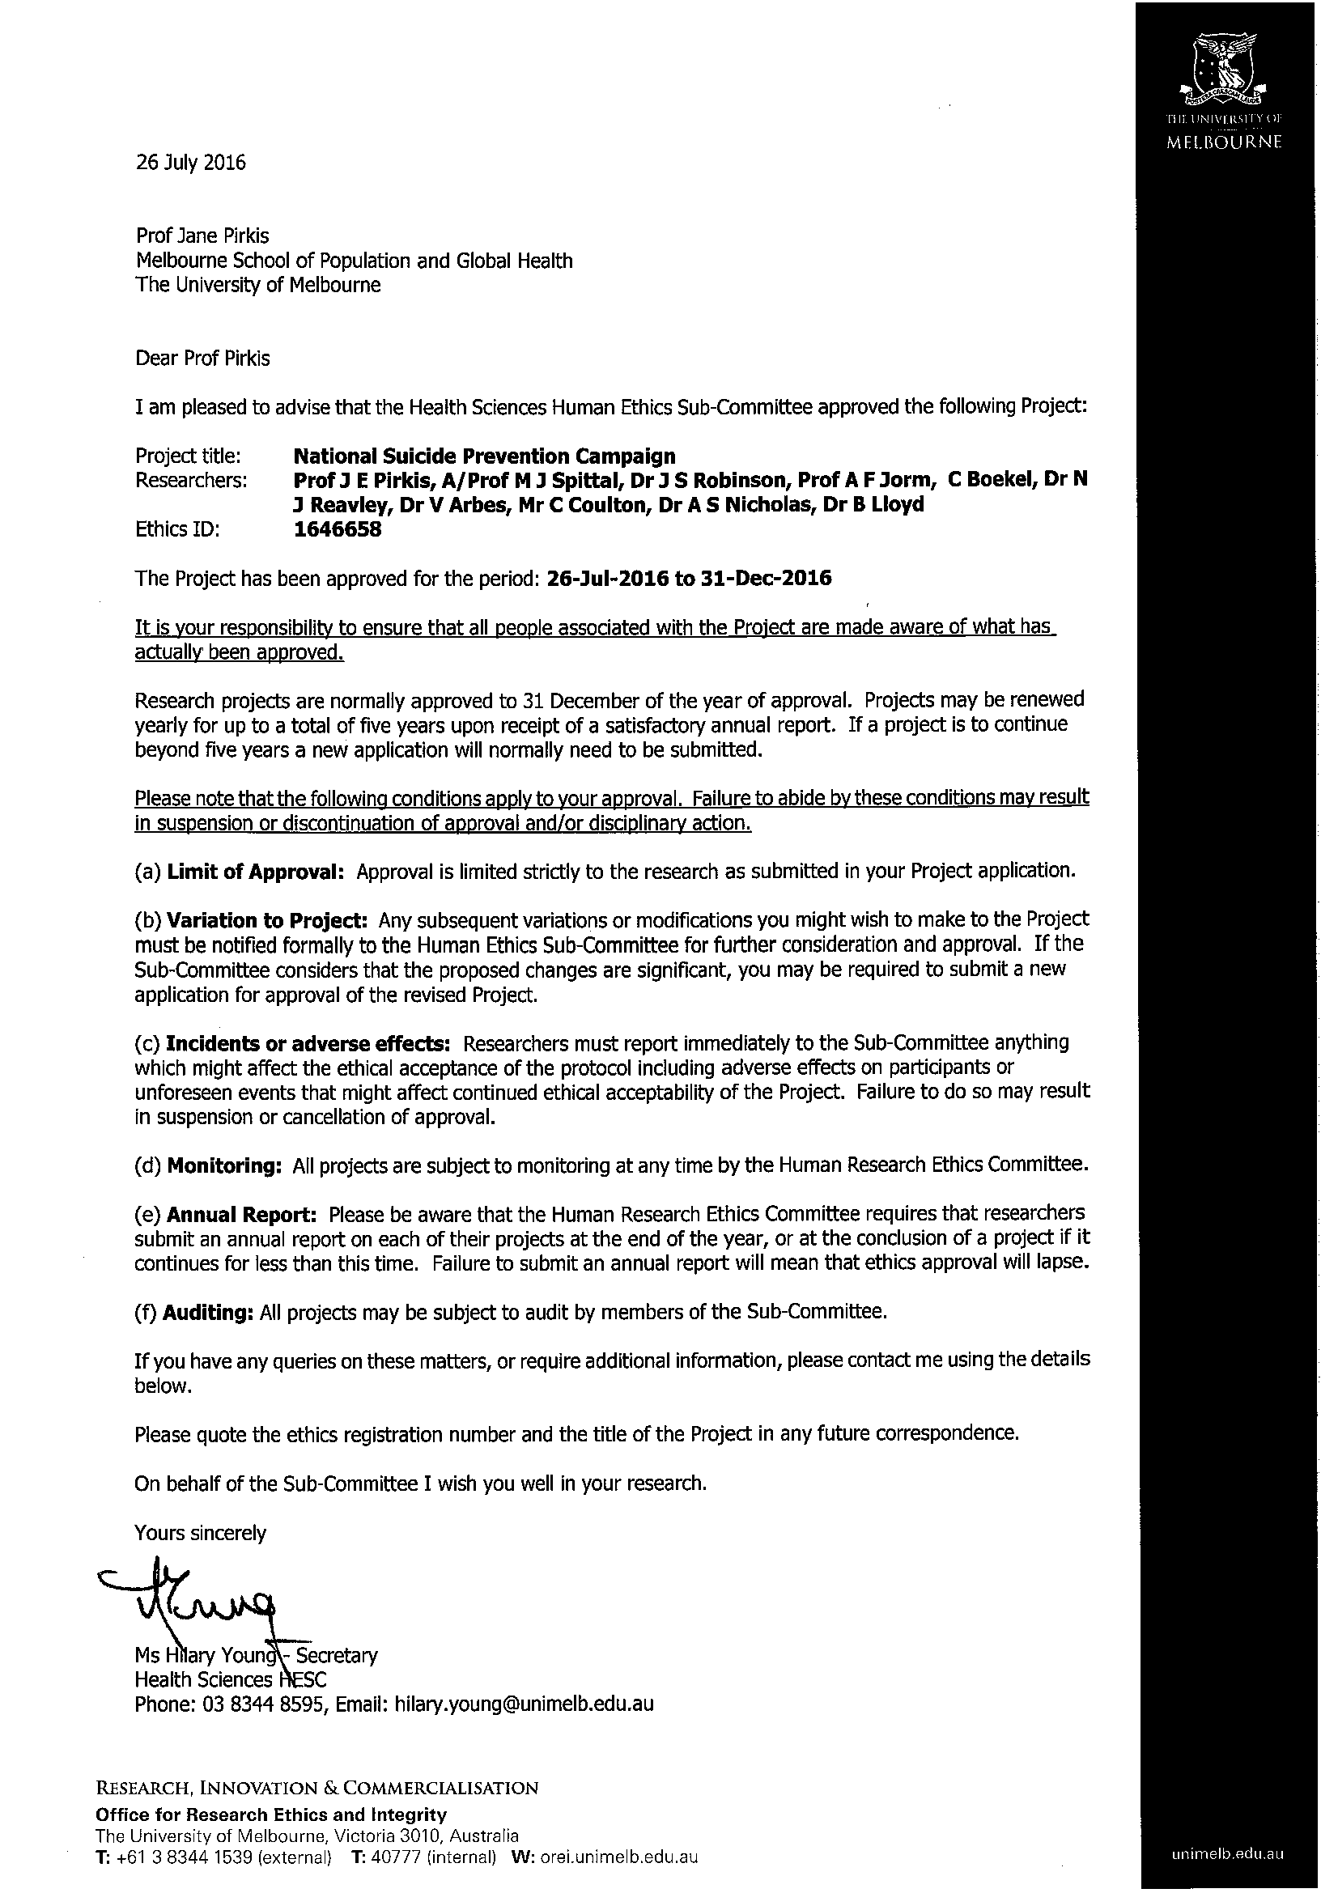
Appendix D. Study 2 ethics approval letter
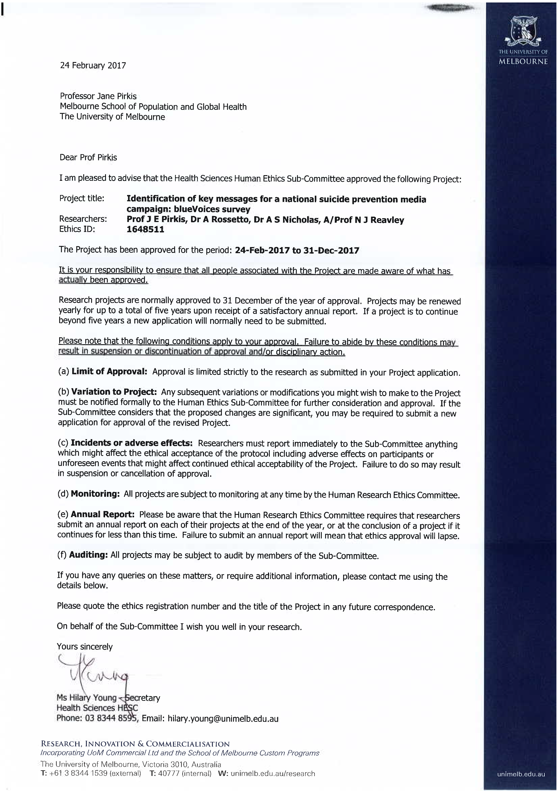
Appendix E. Study 2 online survey
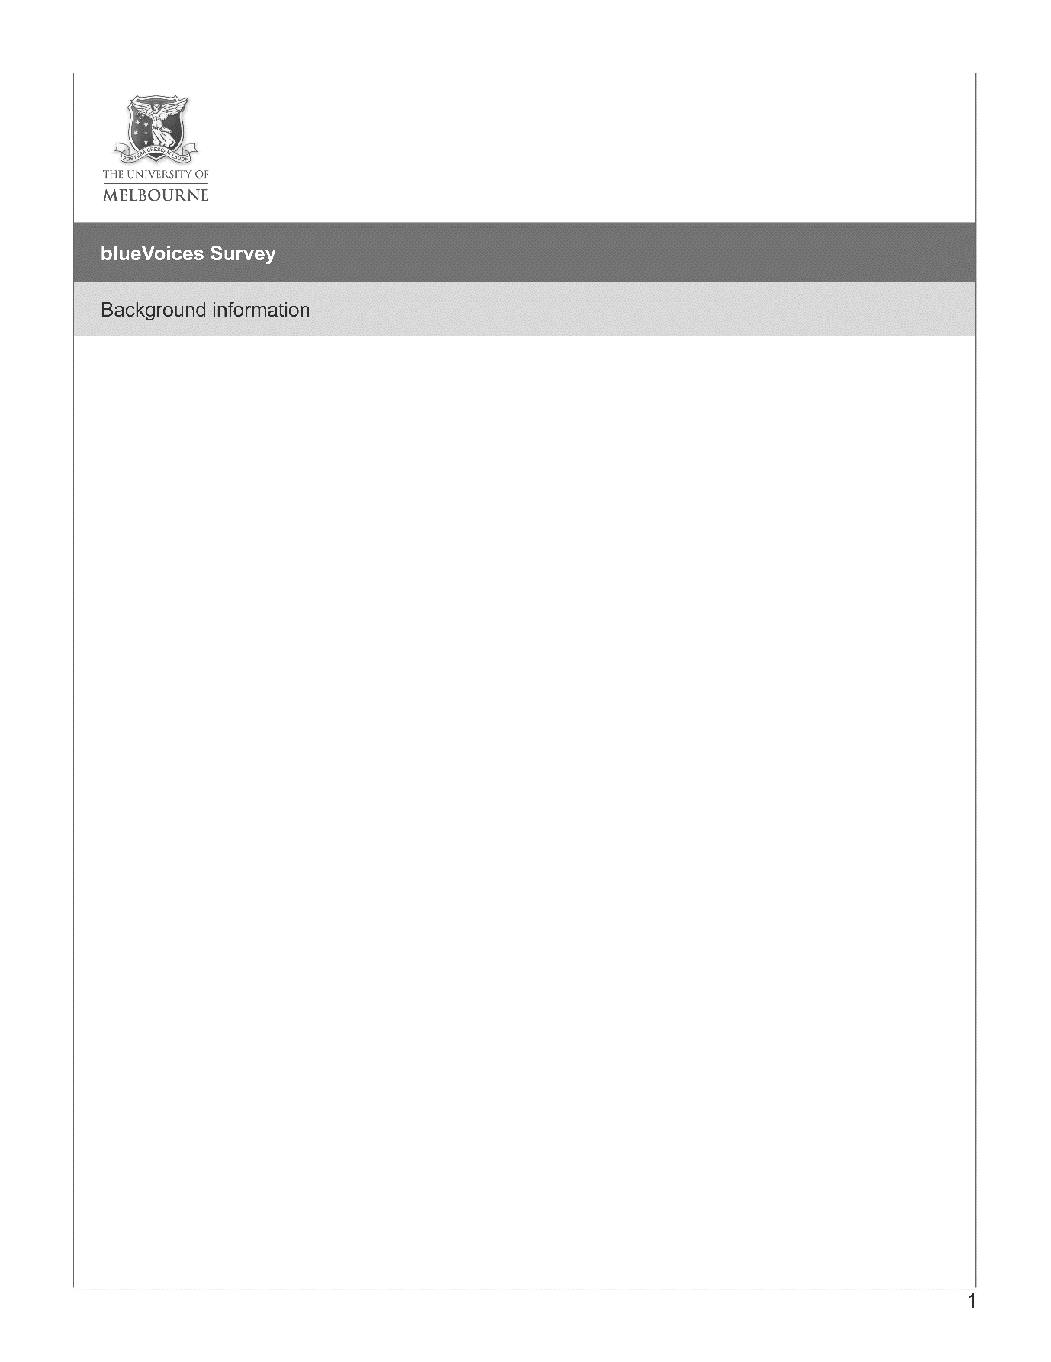
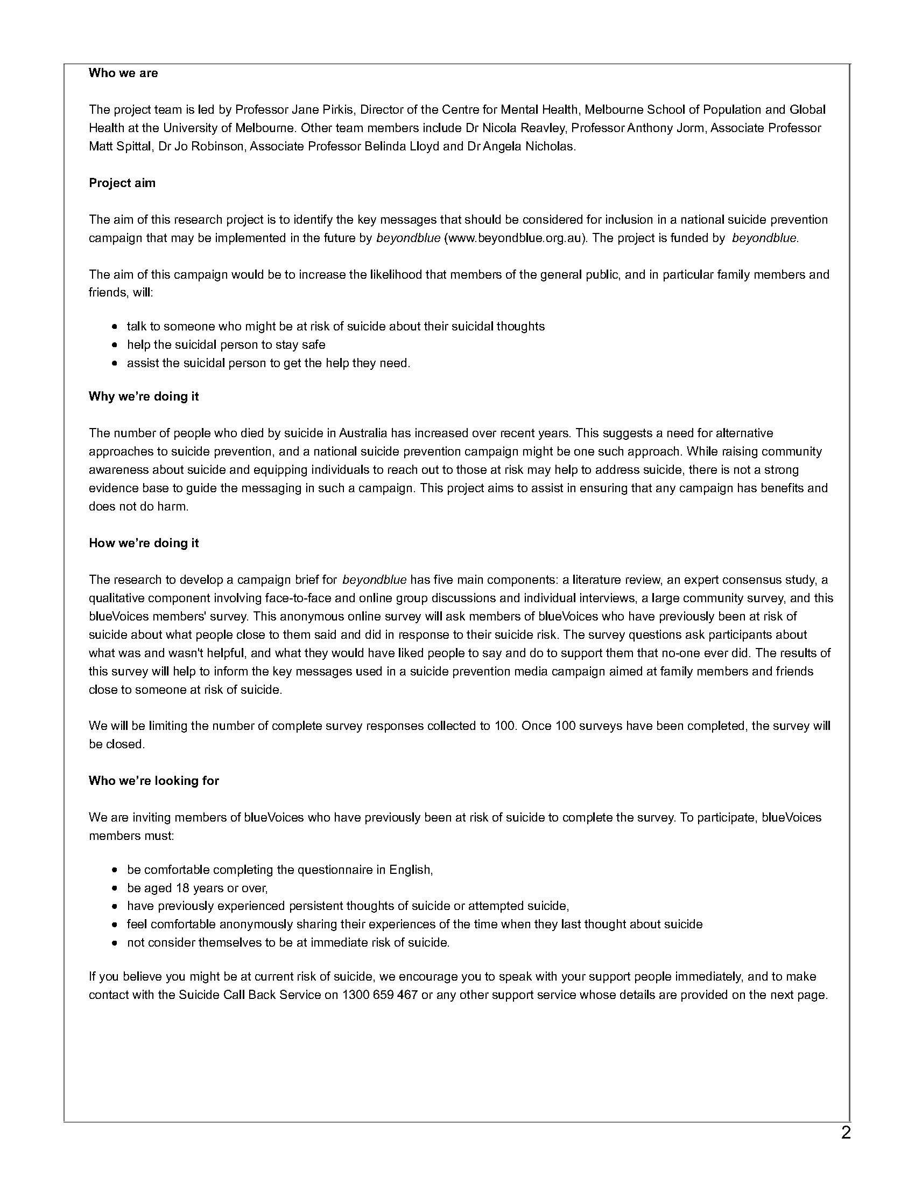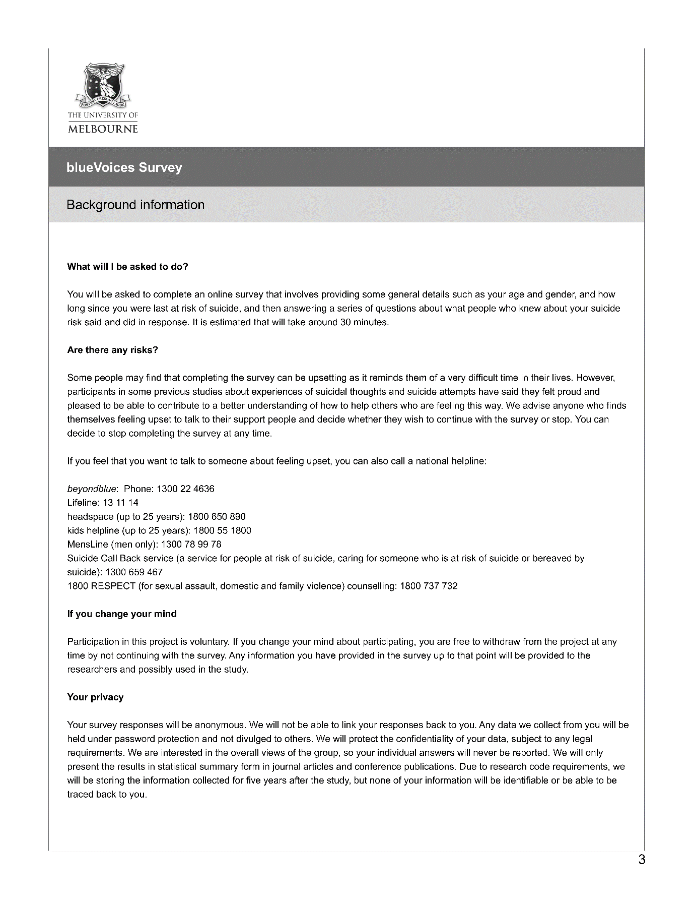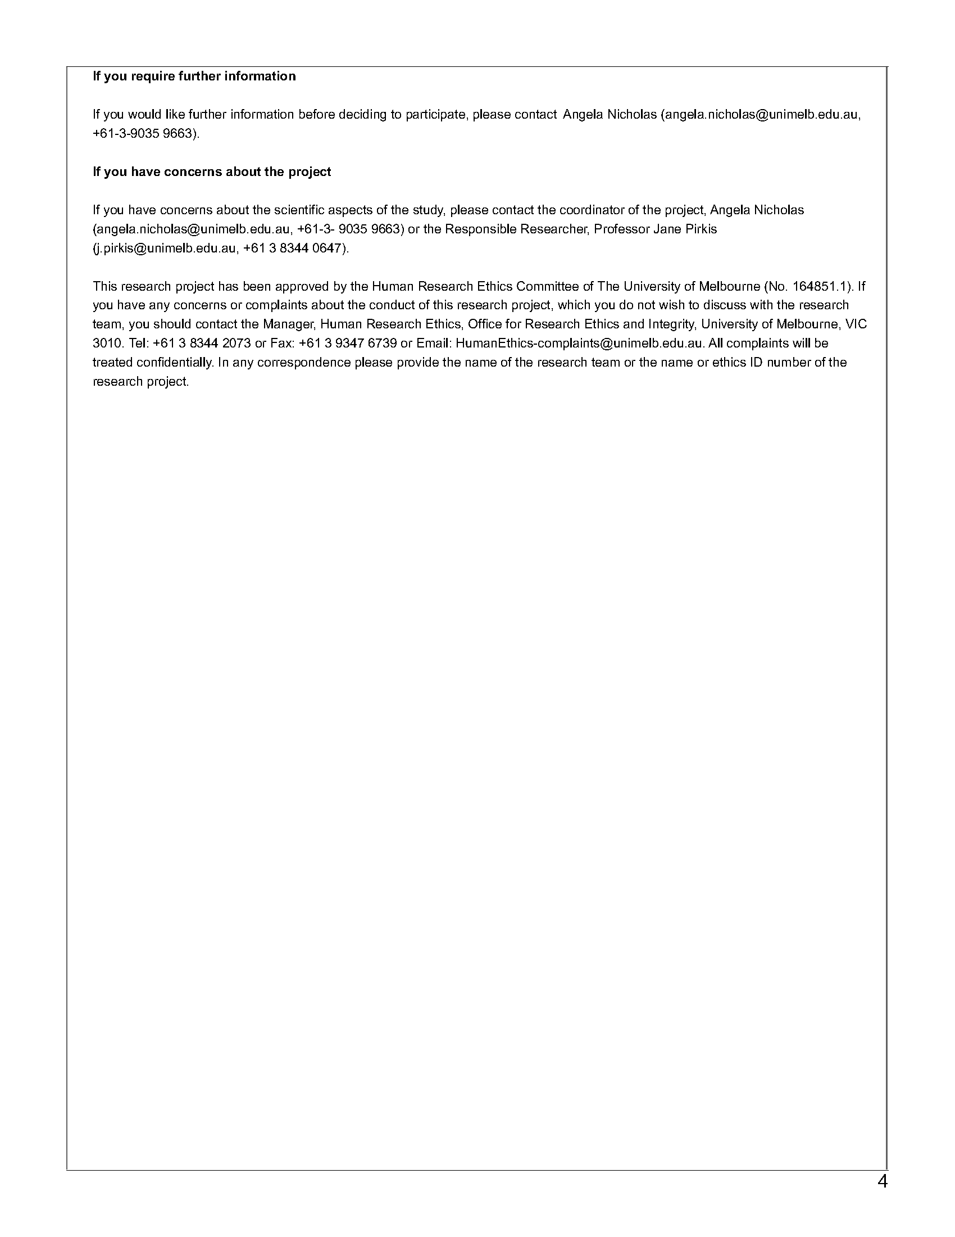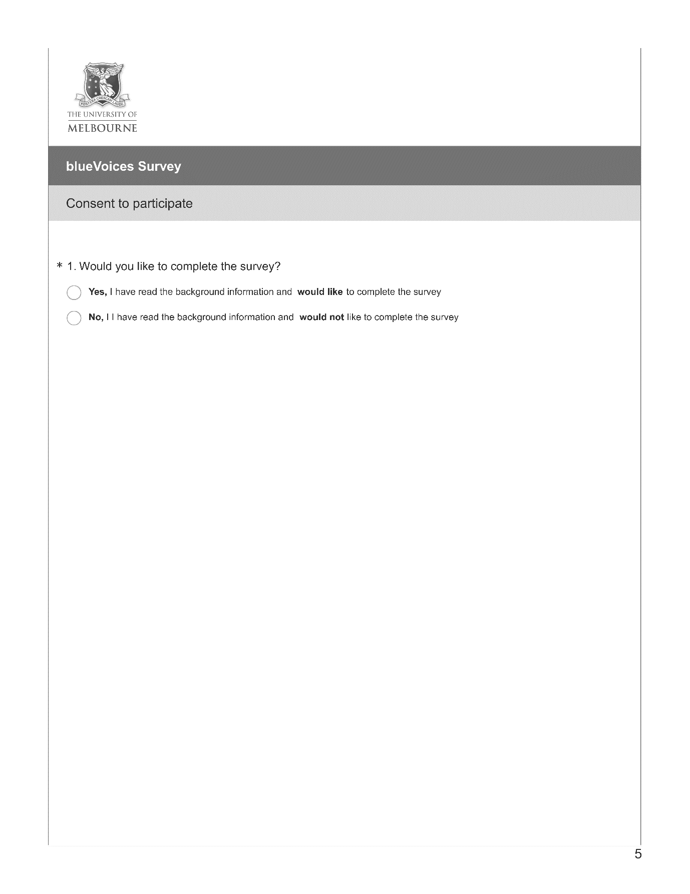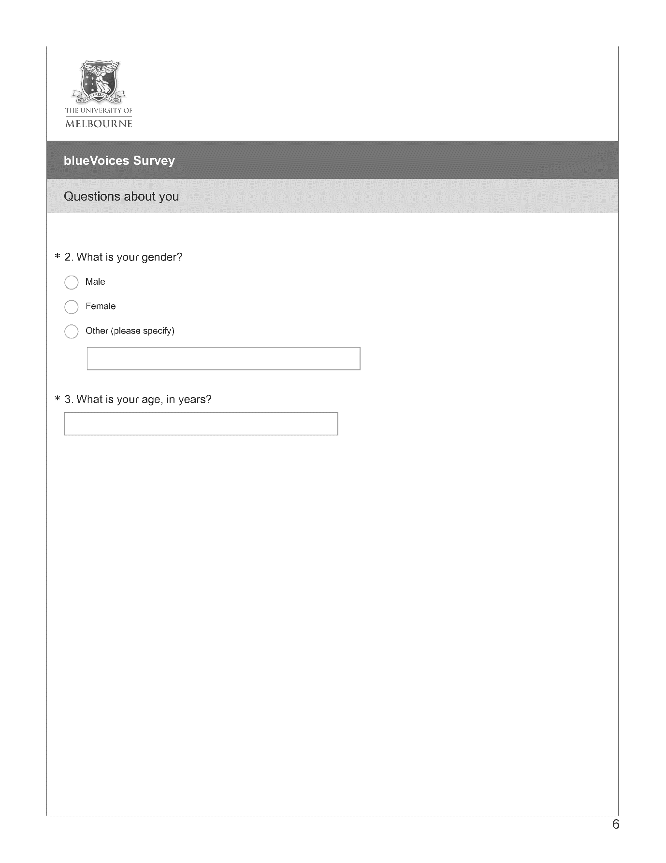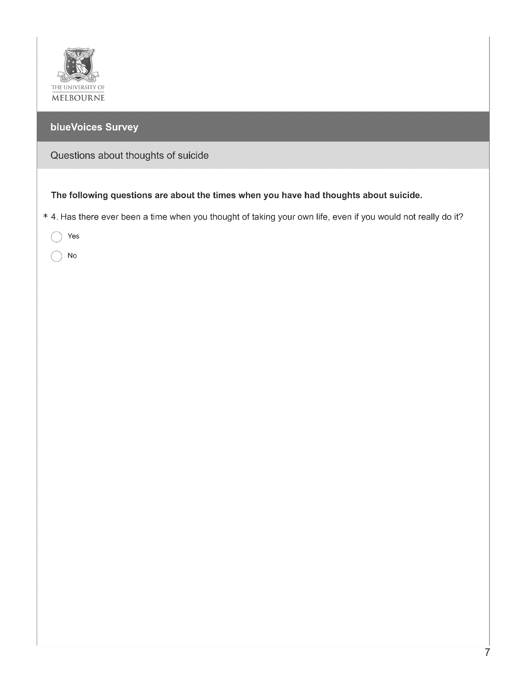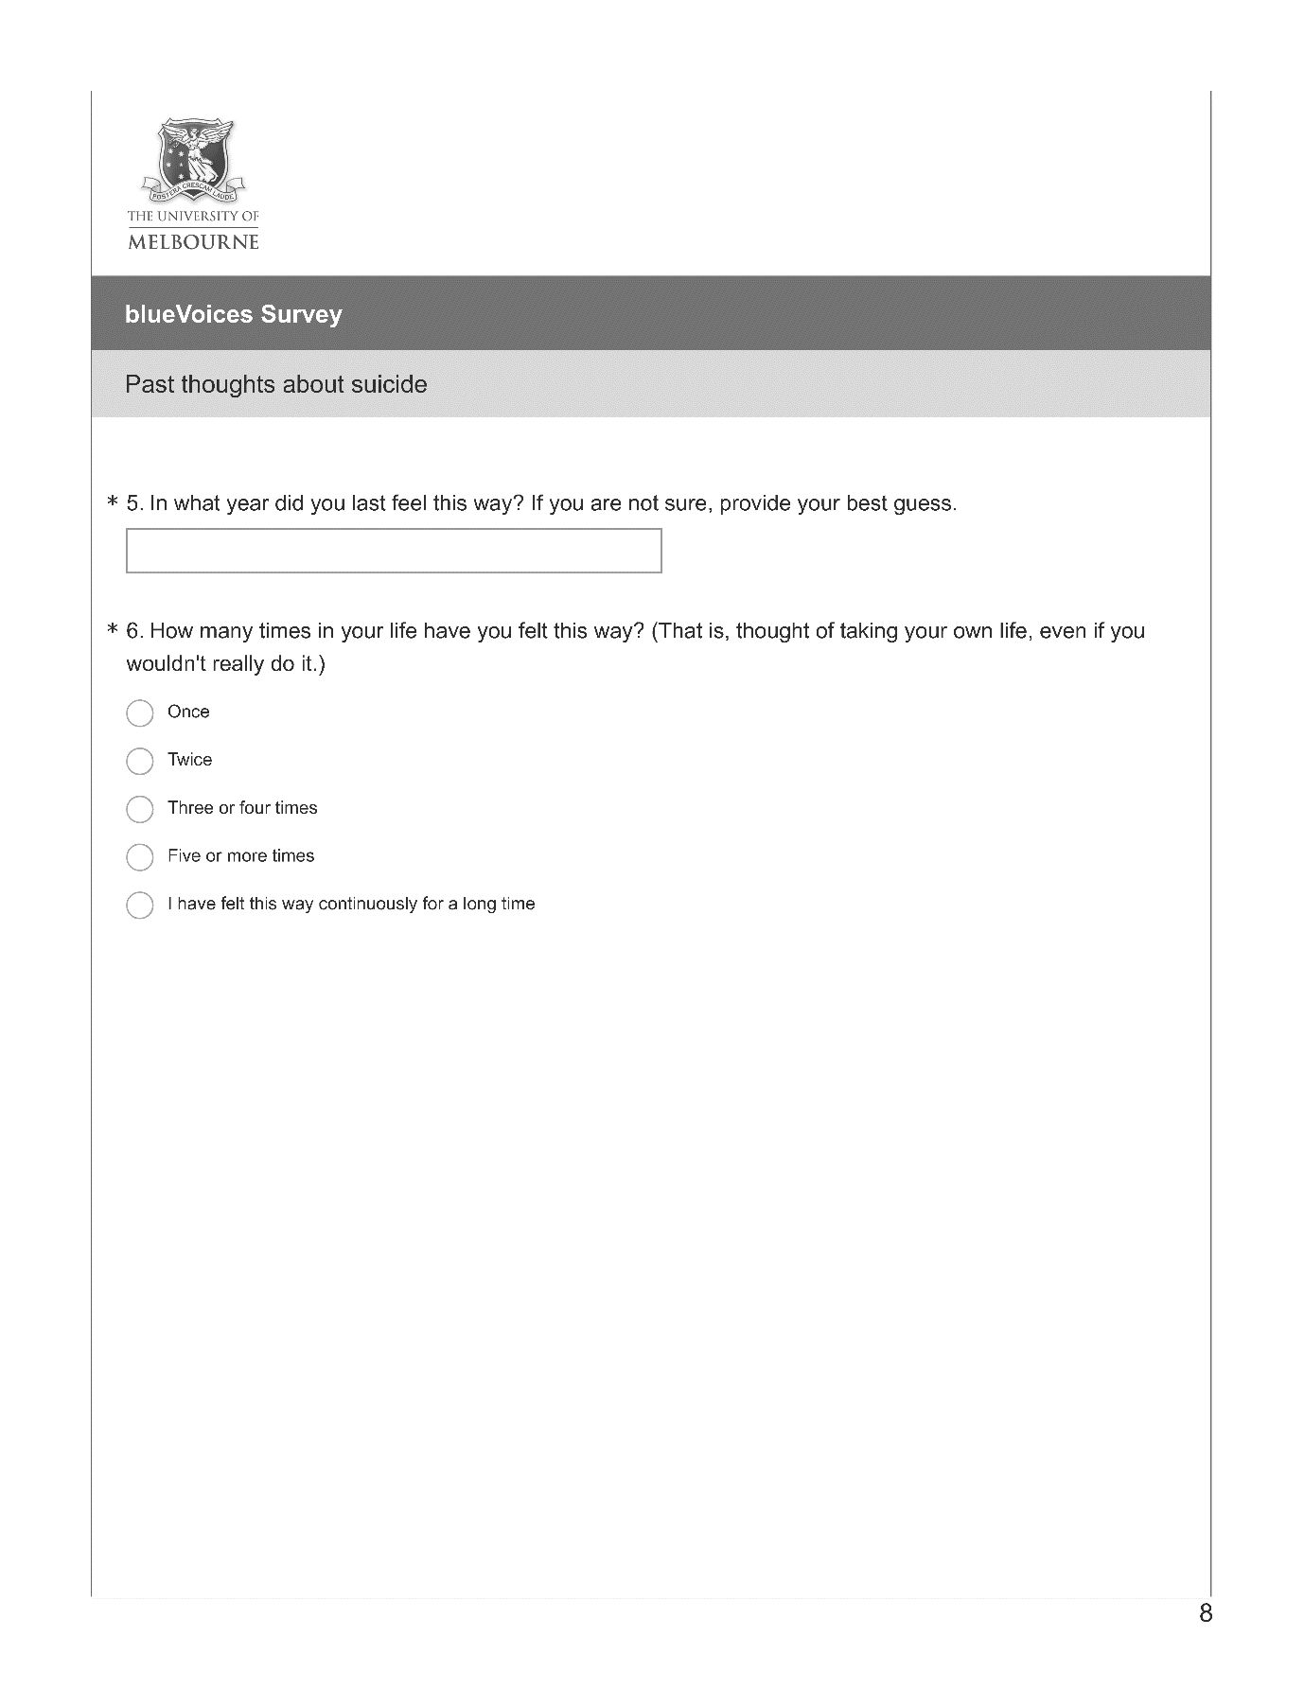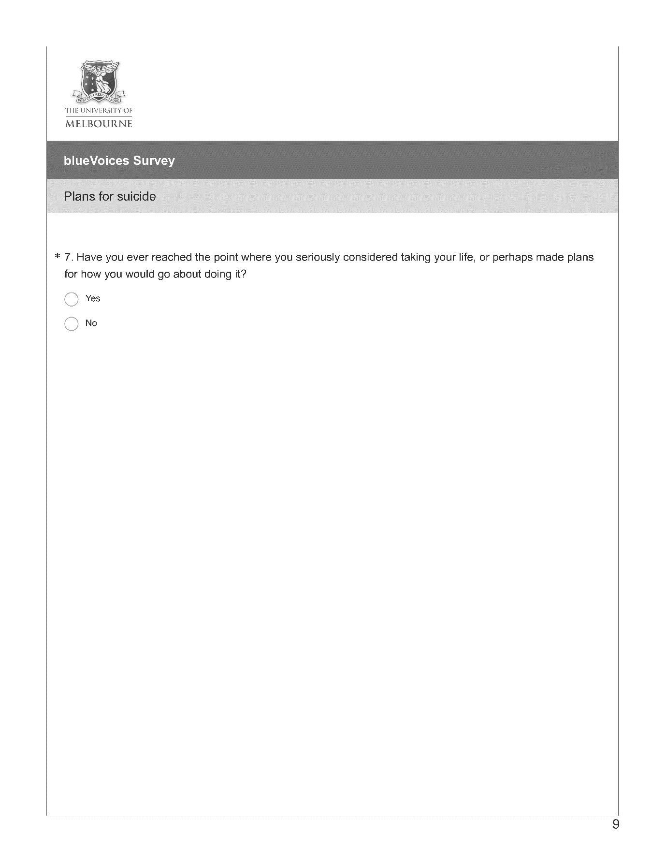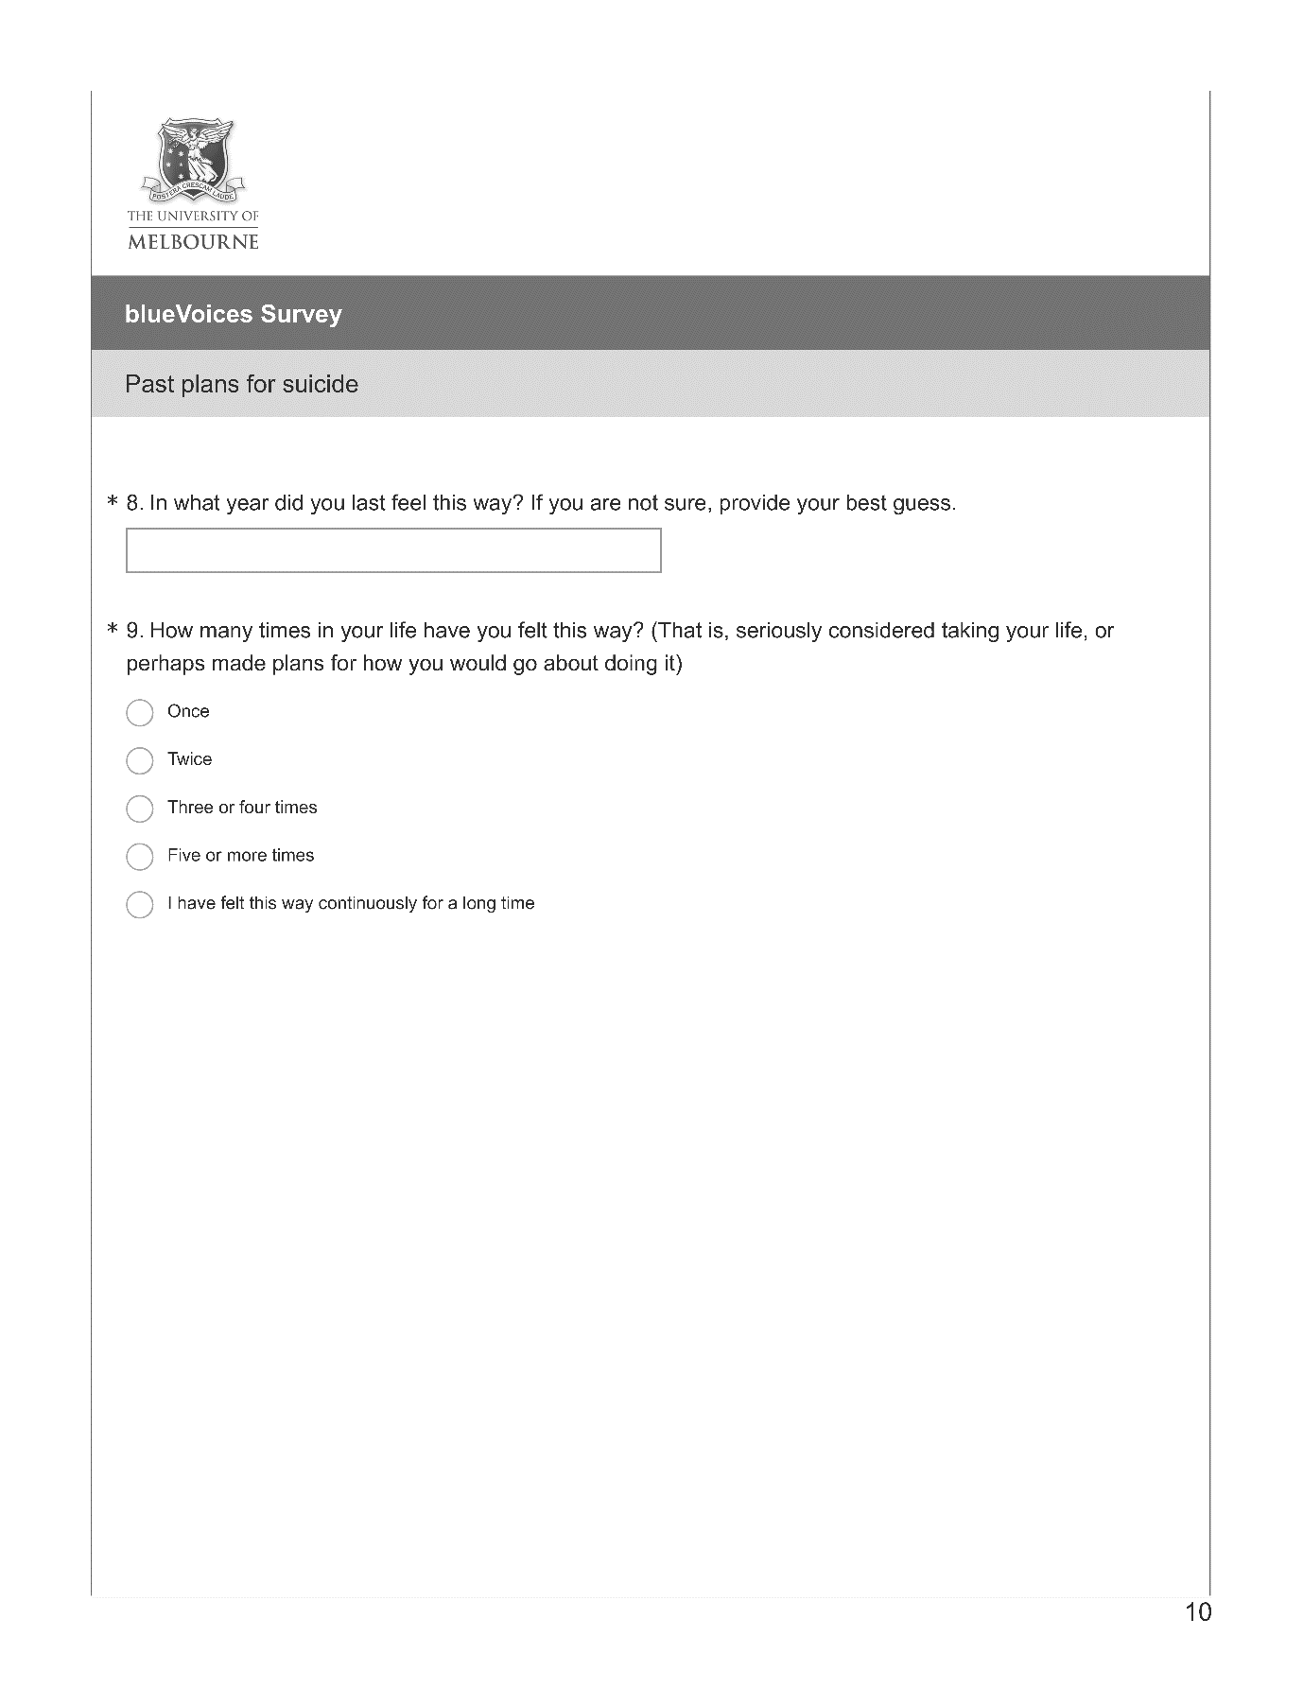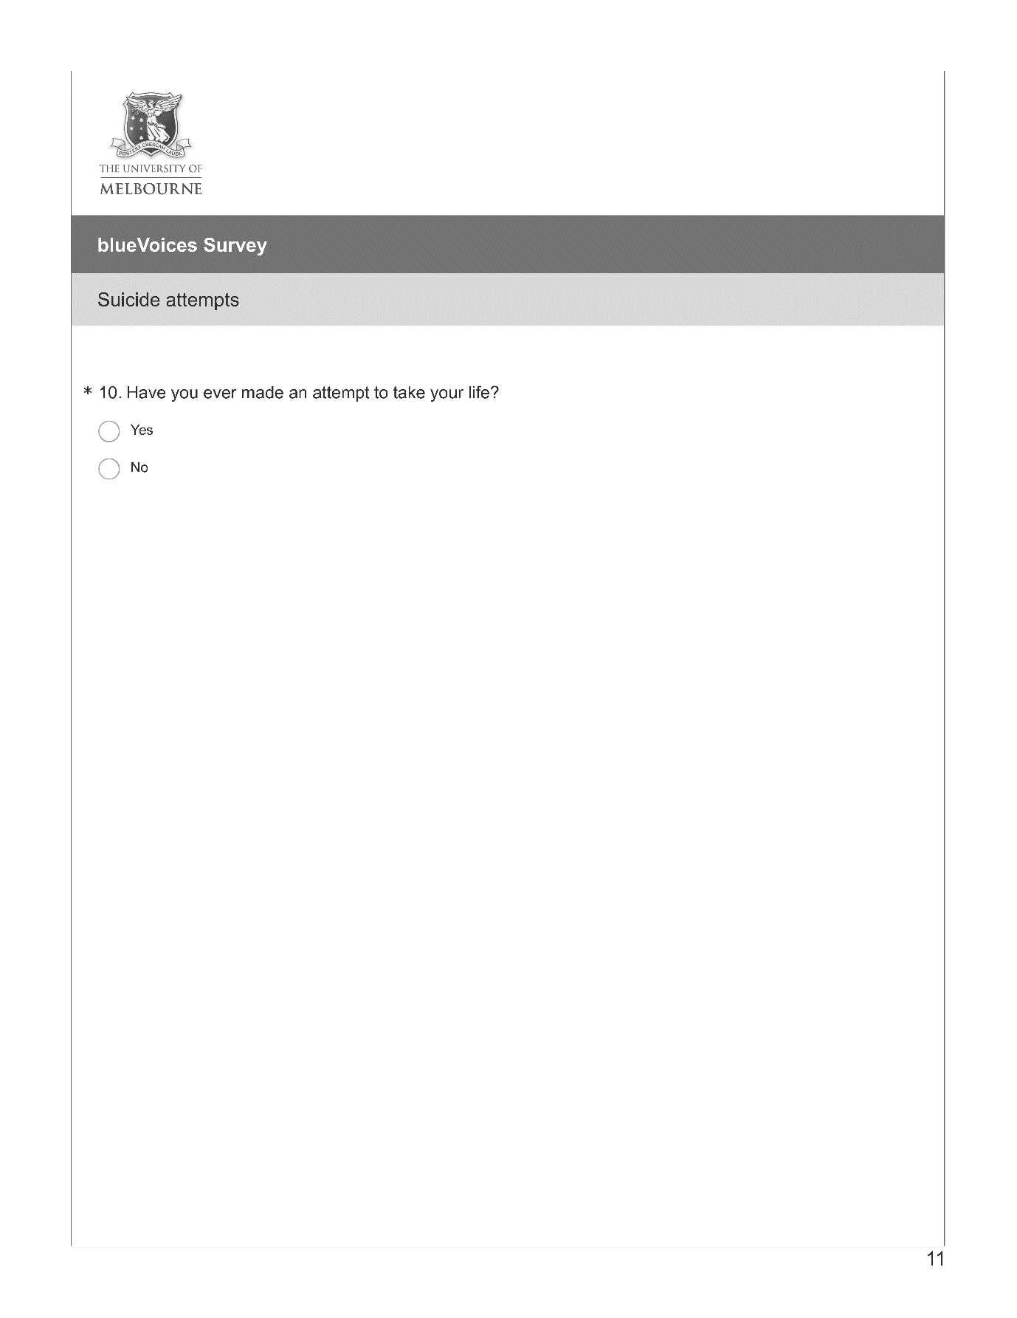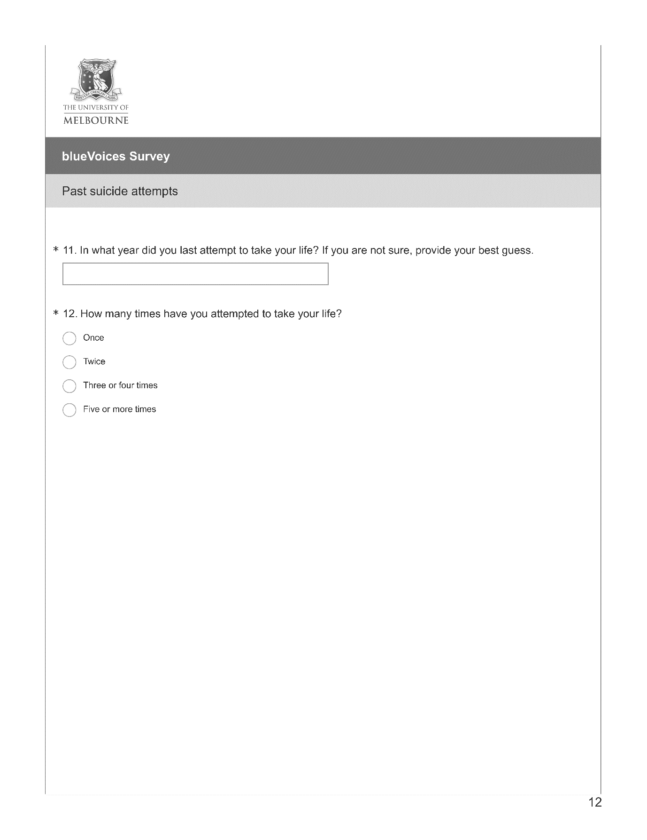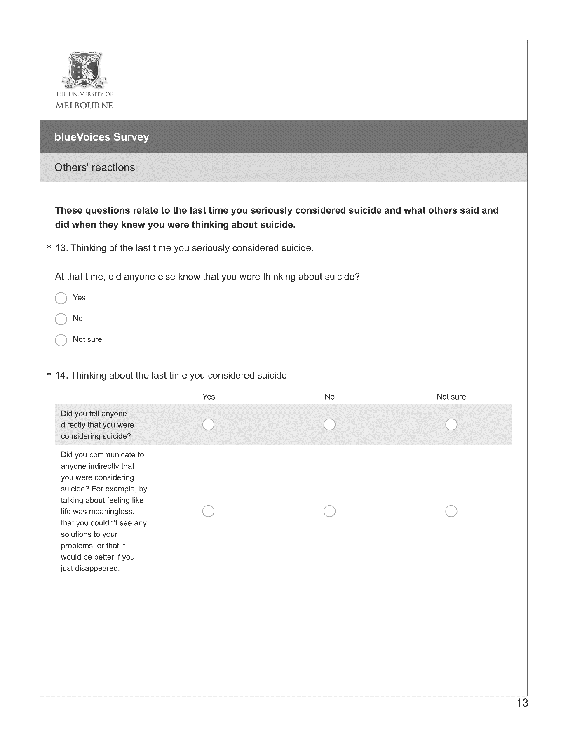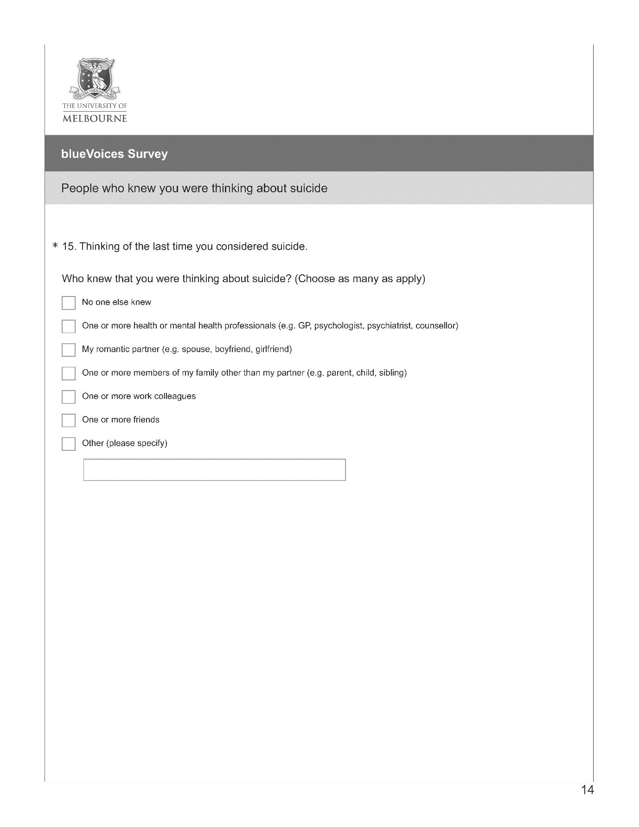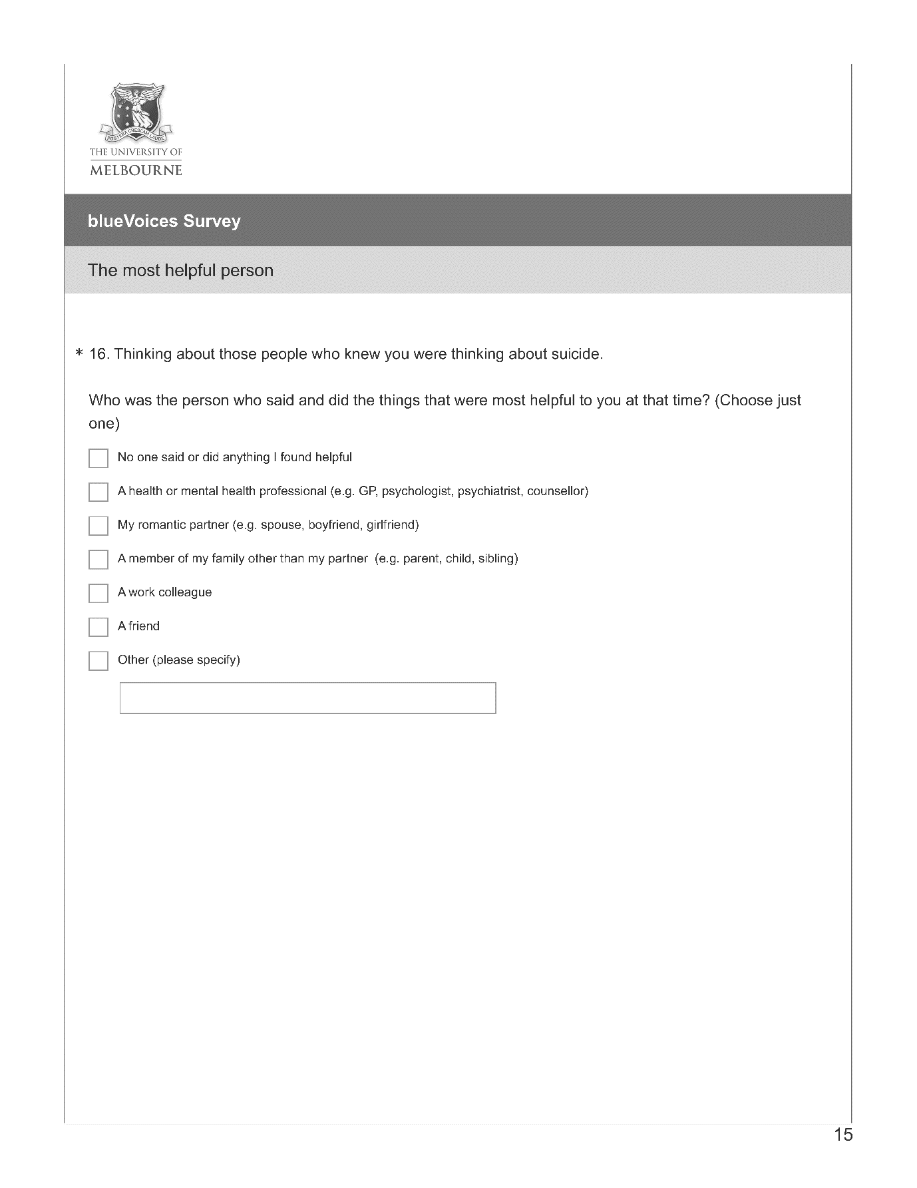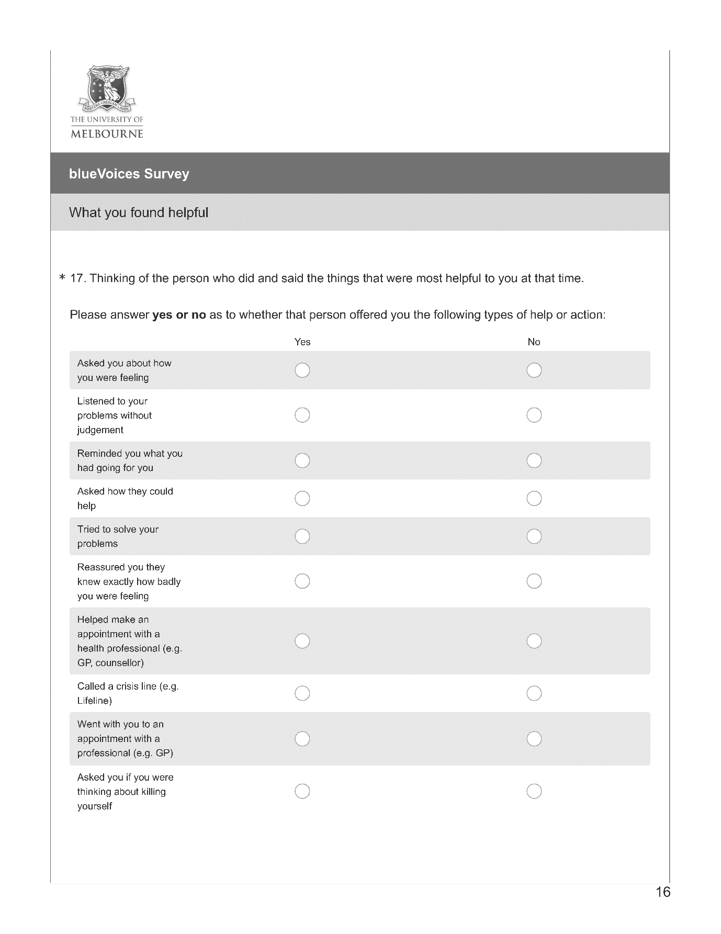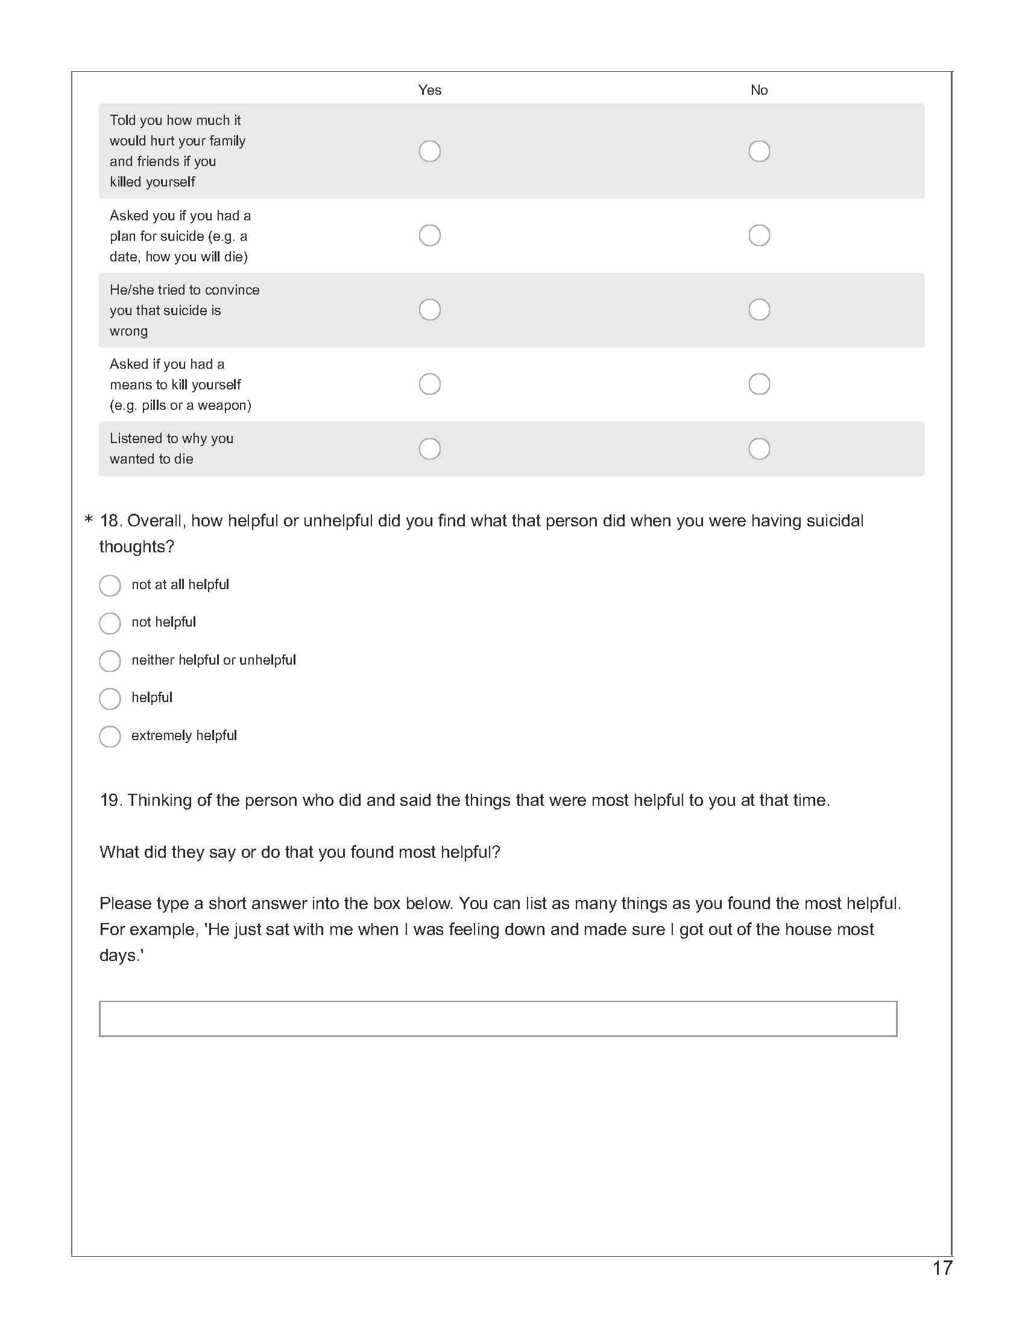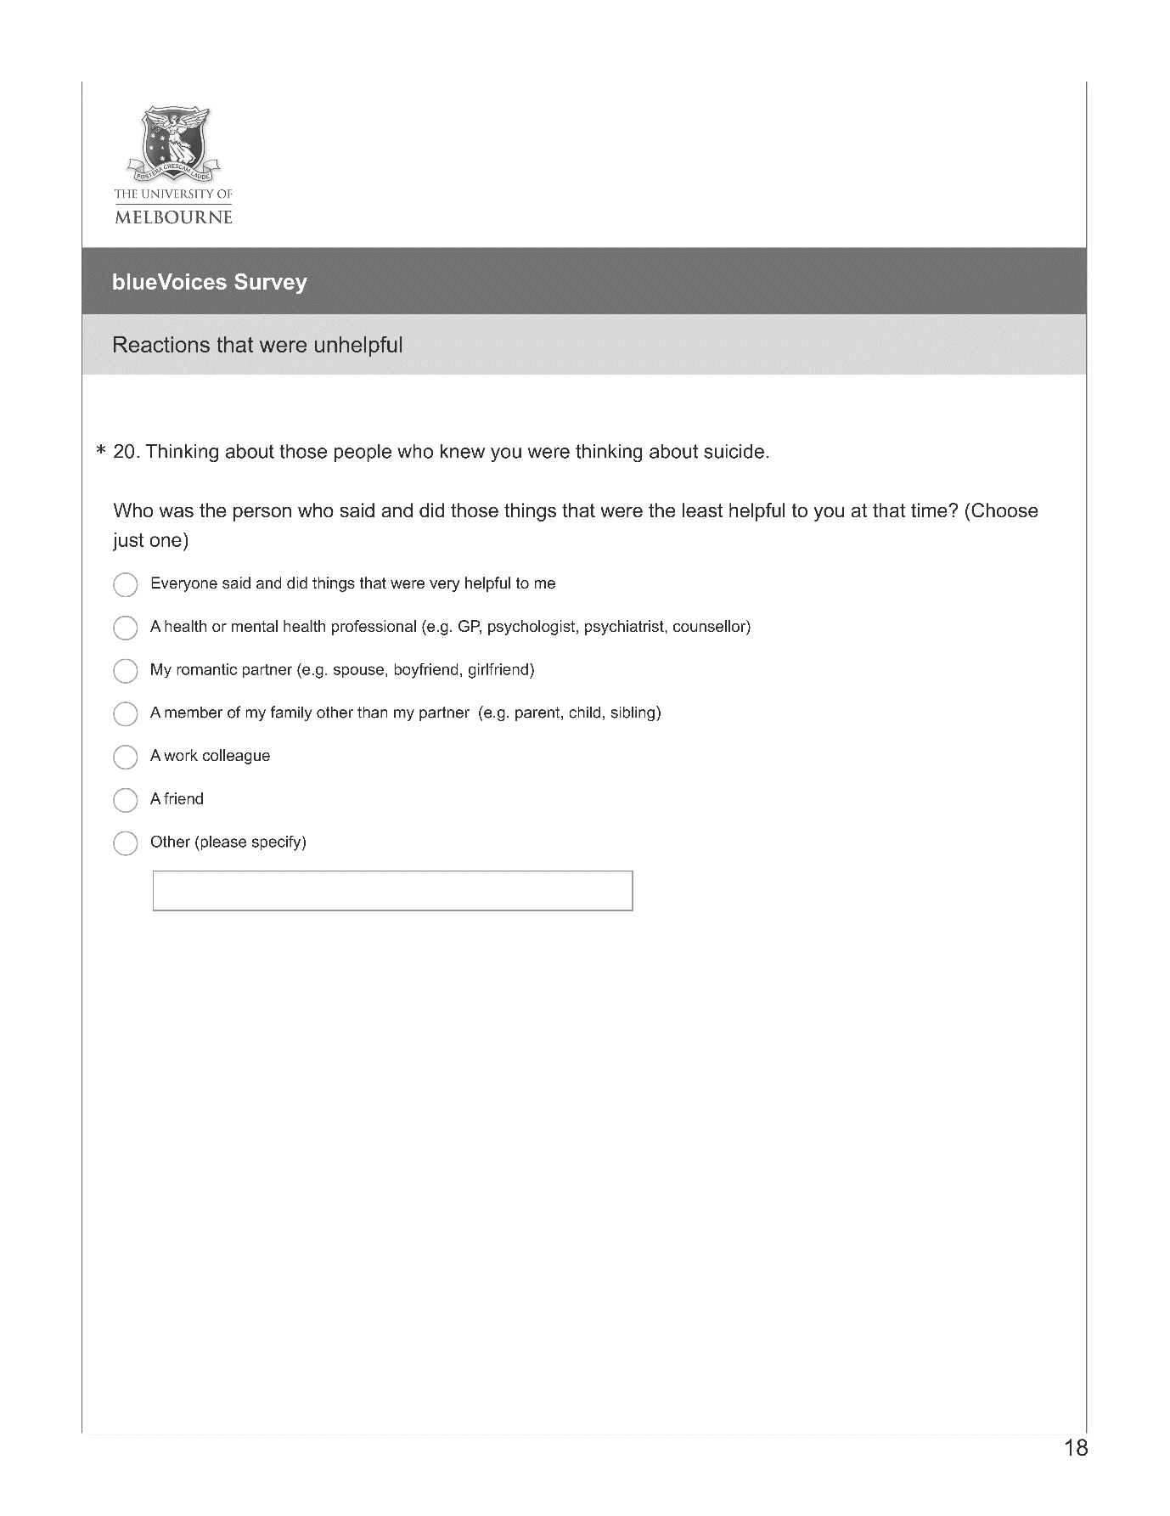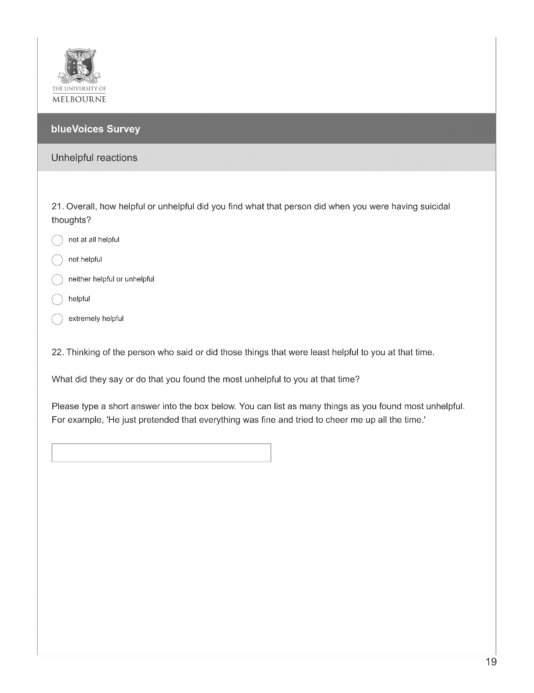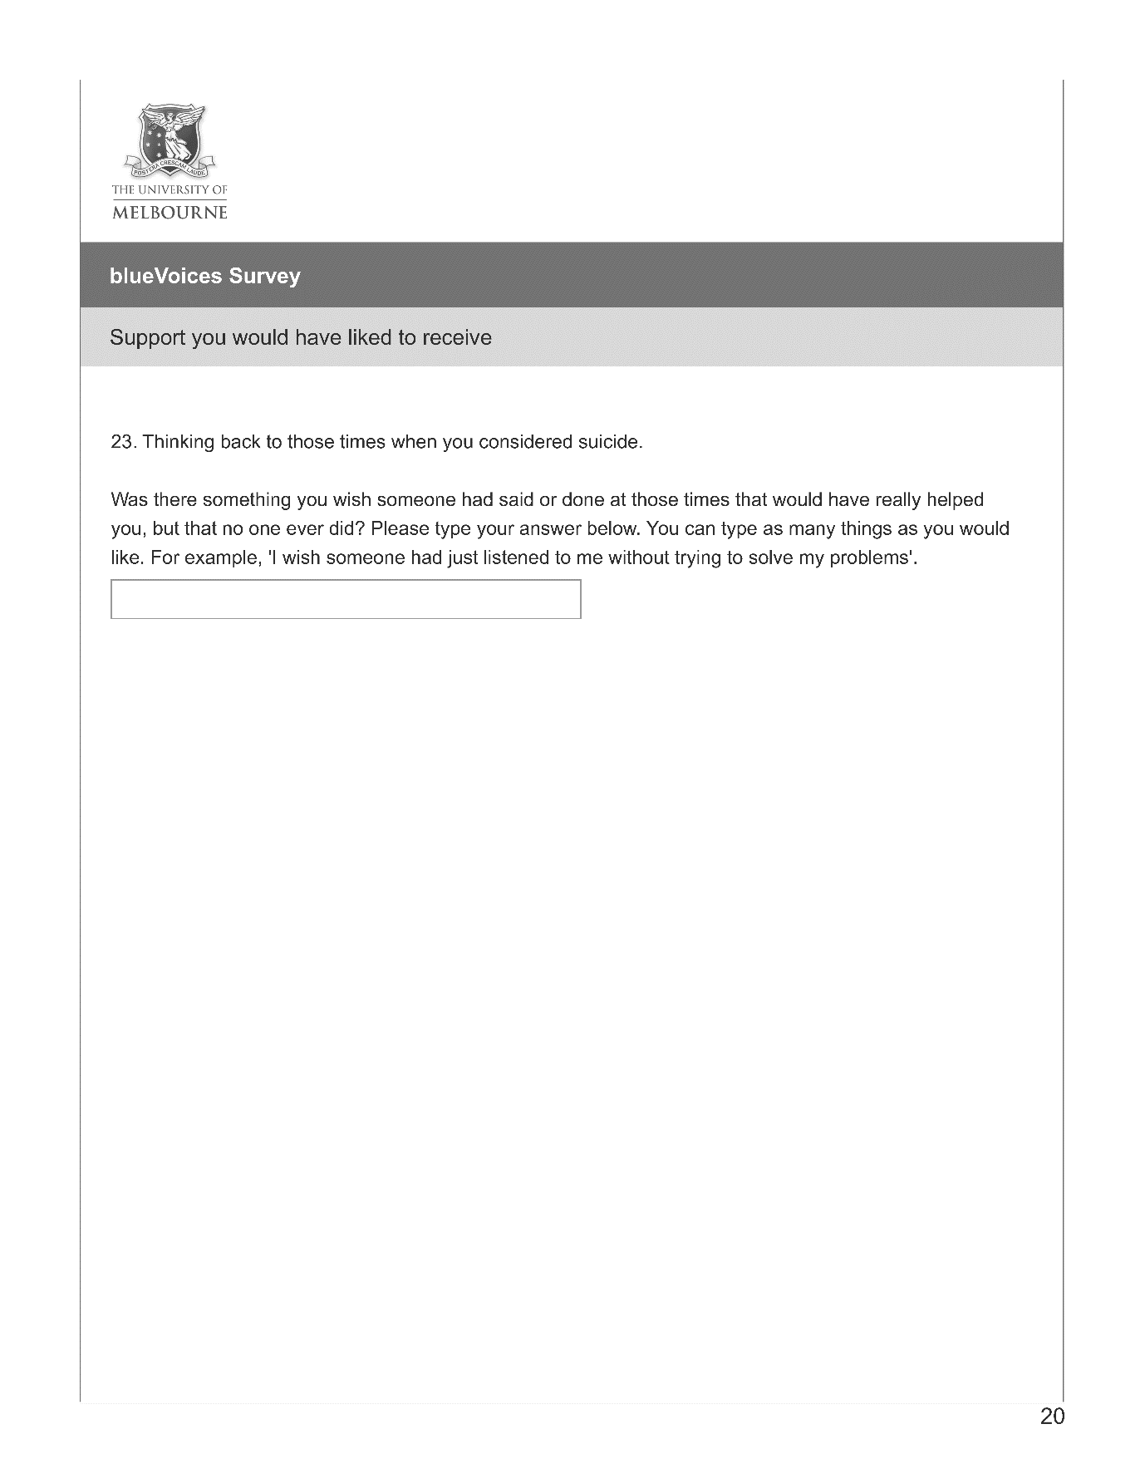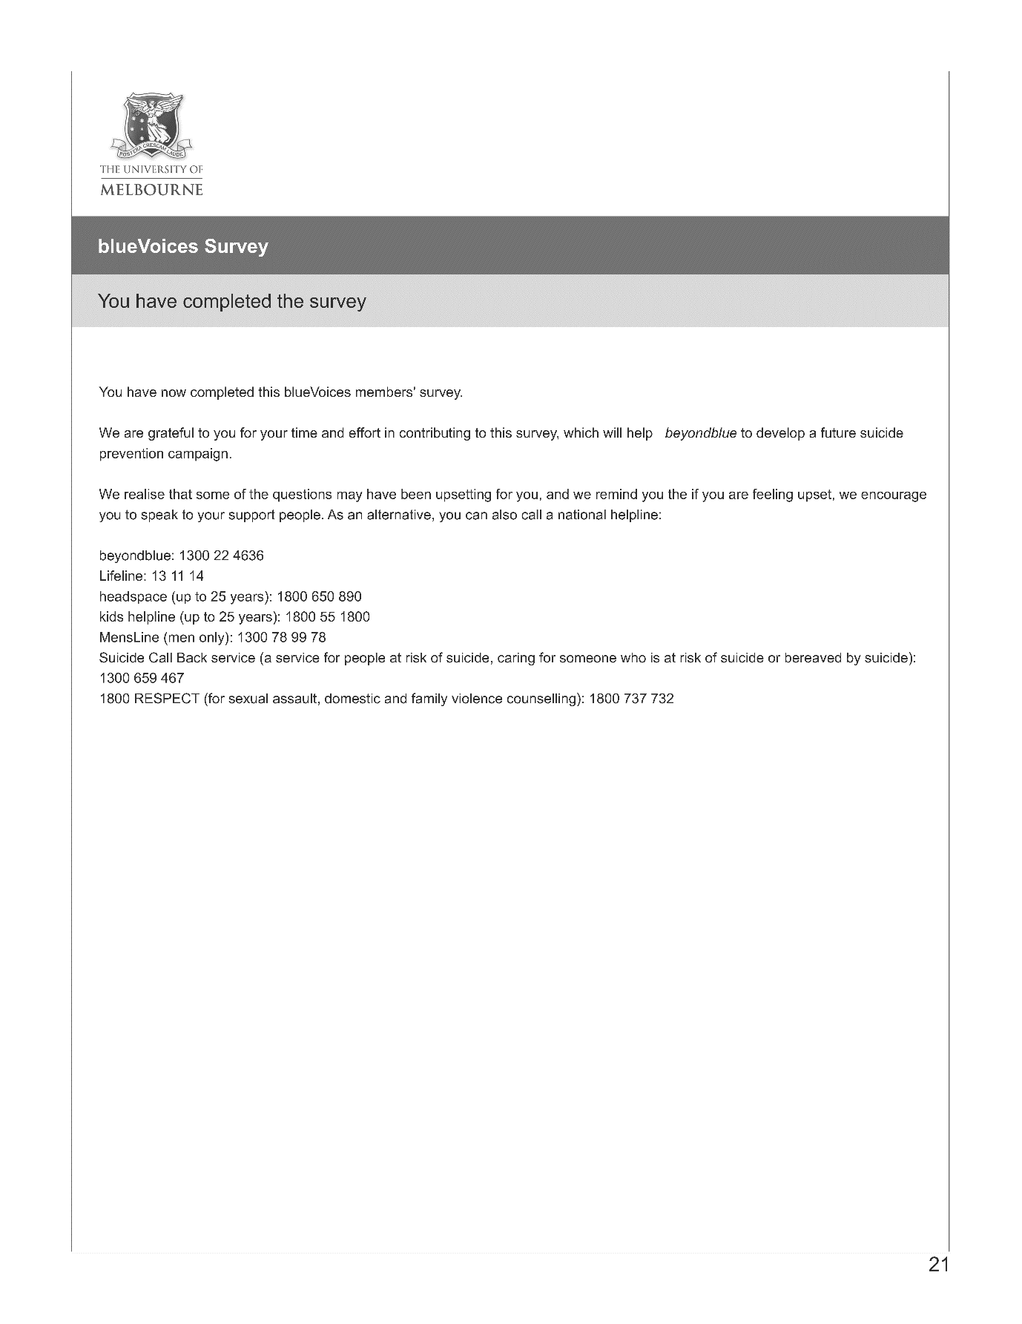

Appendix F. Studies 3, 4 and 5 ethics approval letter
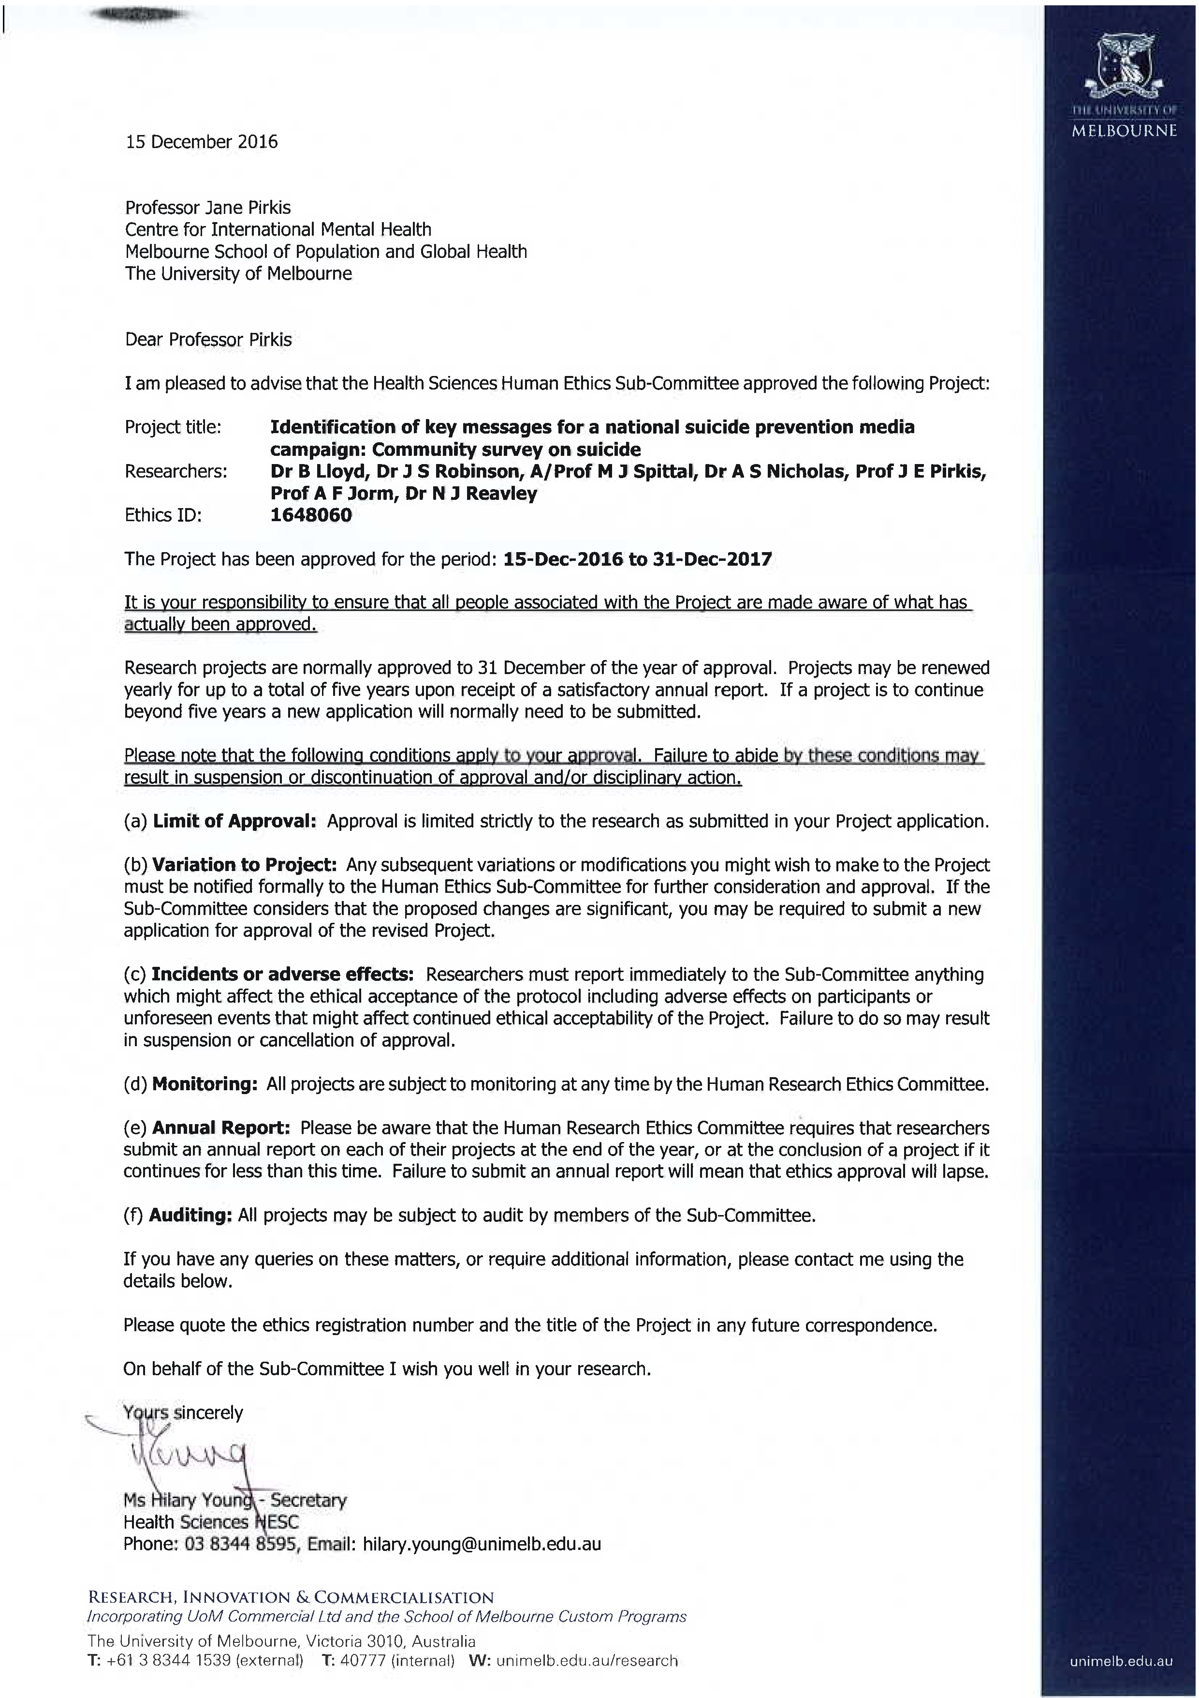
Appendix G. Study 3, 4 and 5 national telephone survey
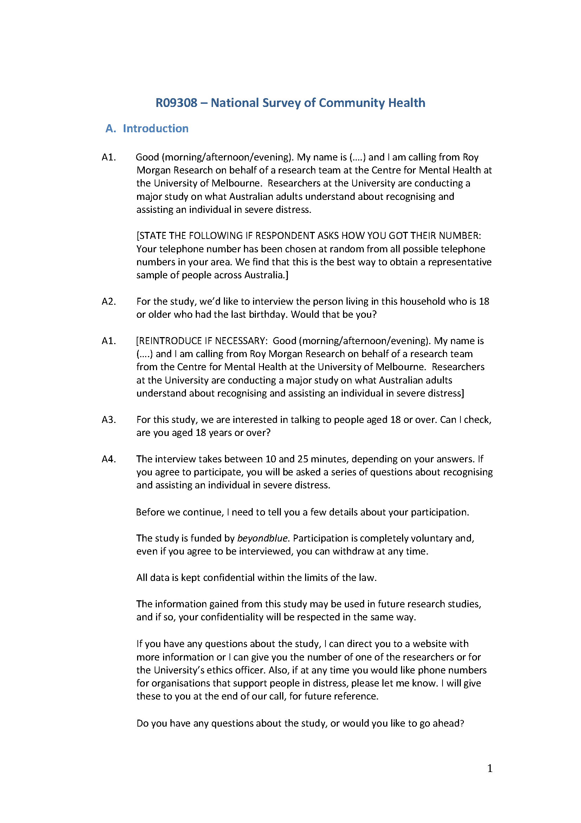
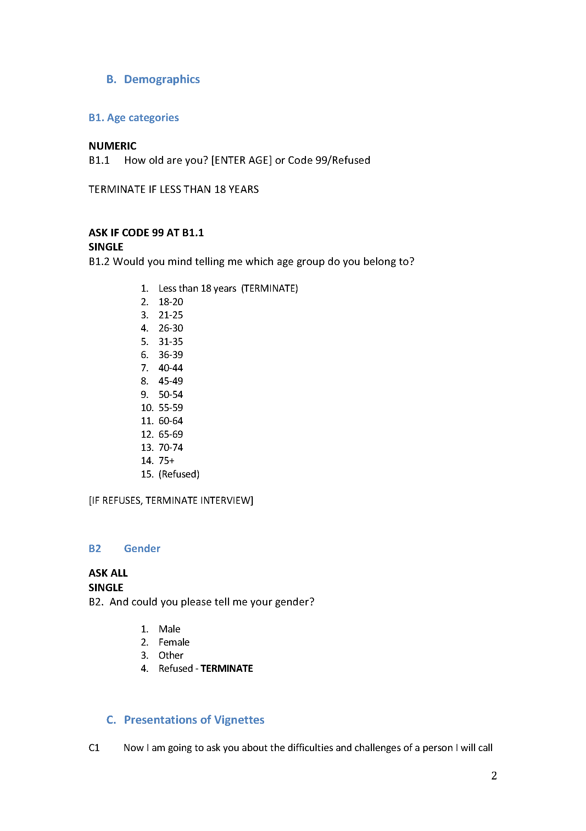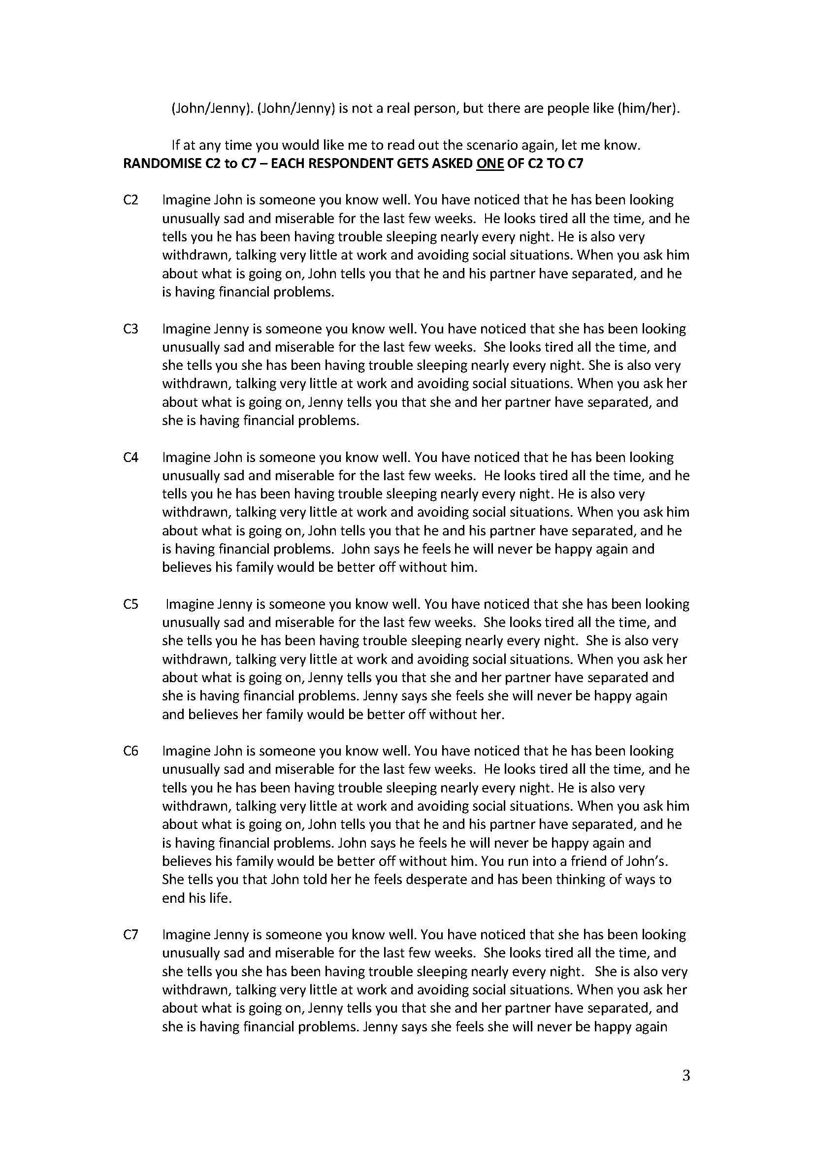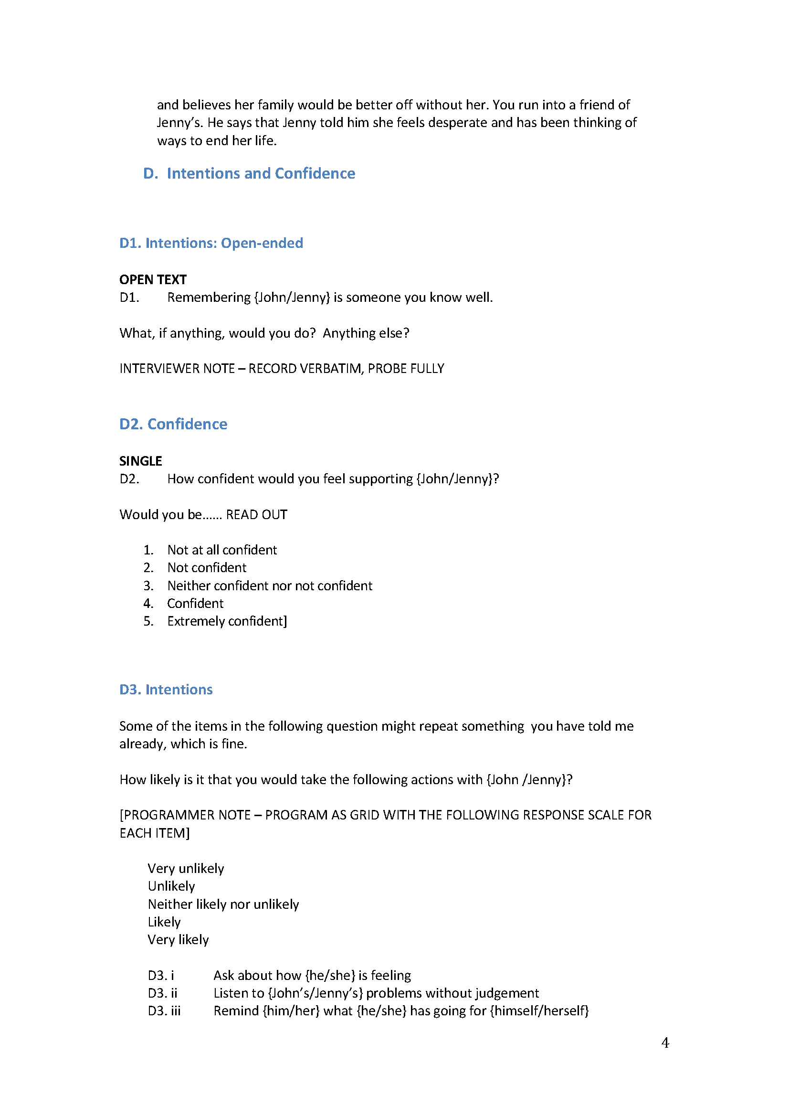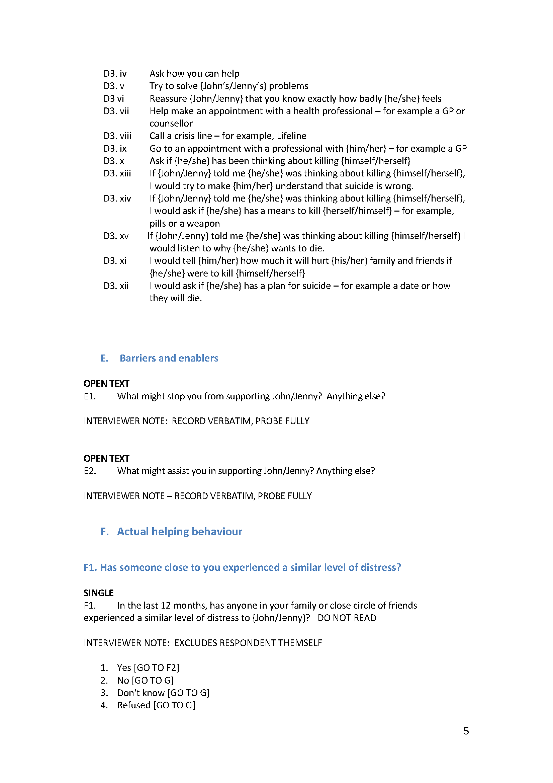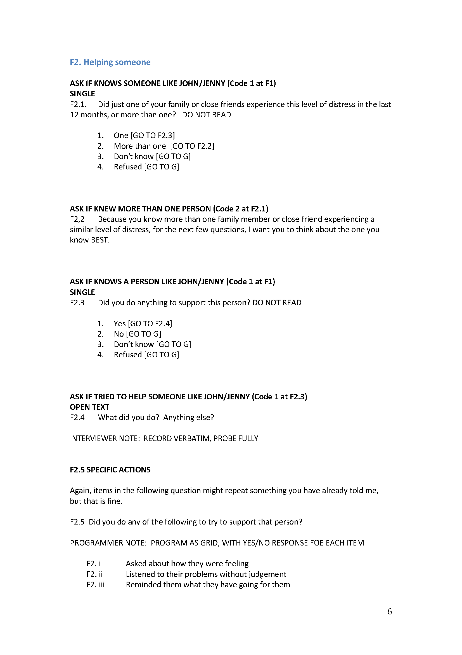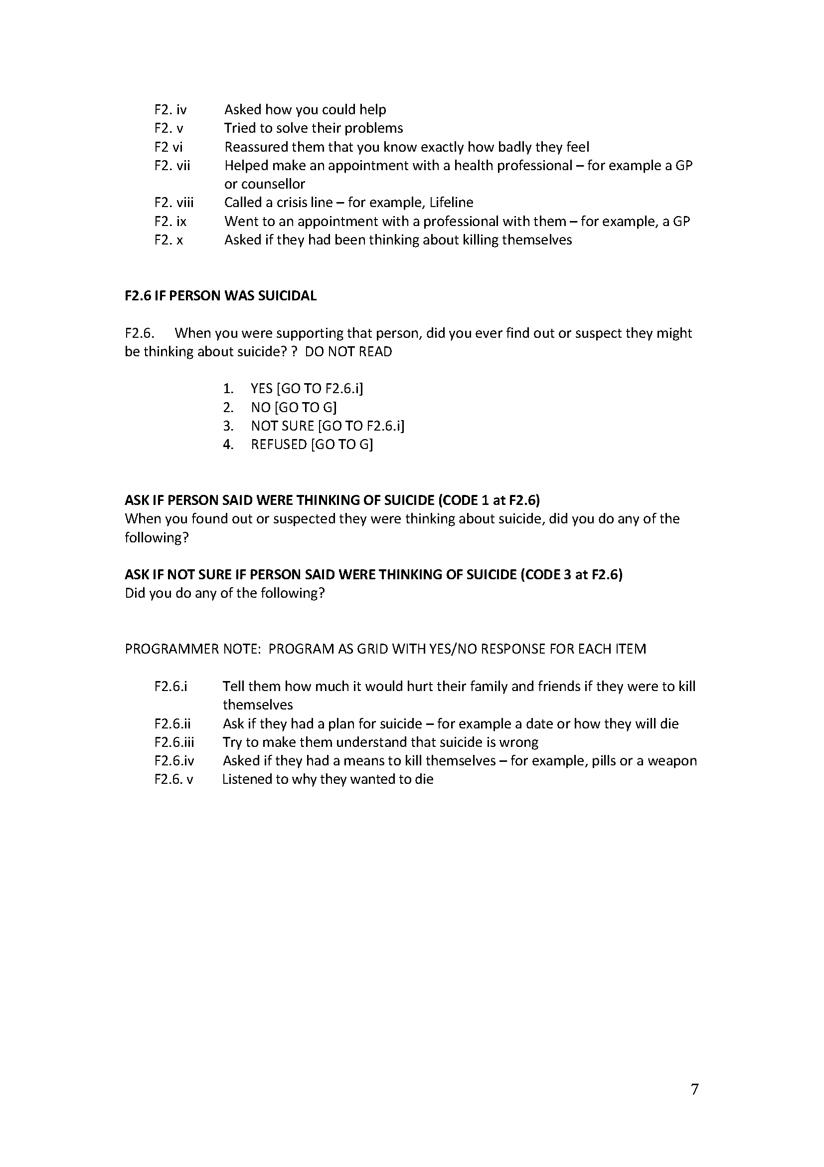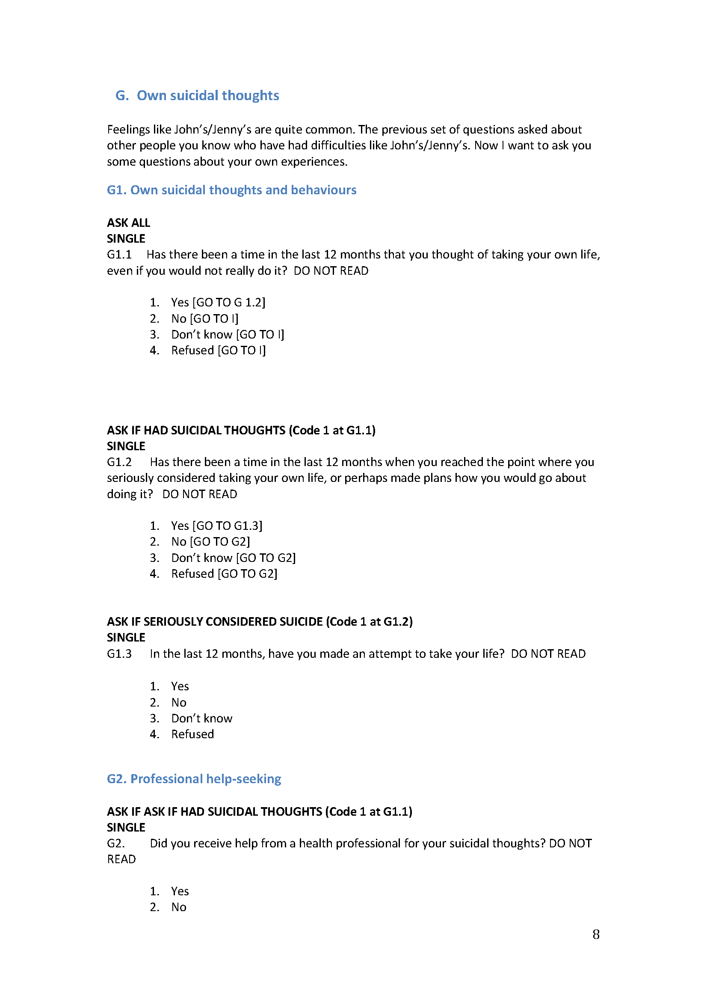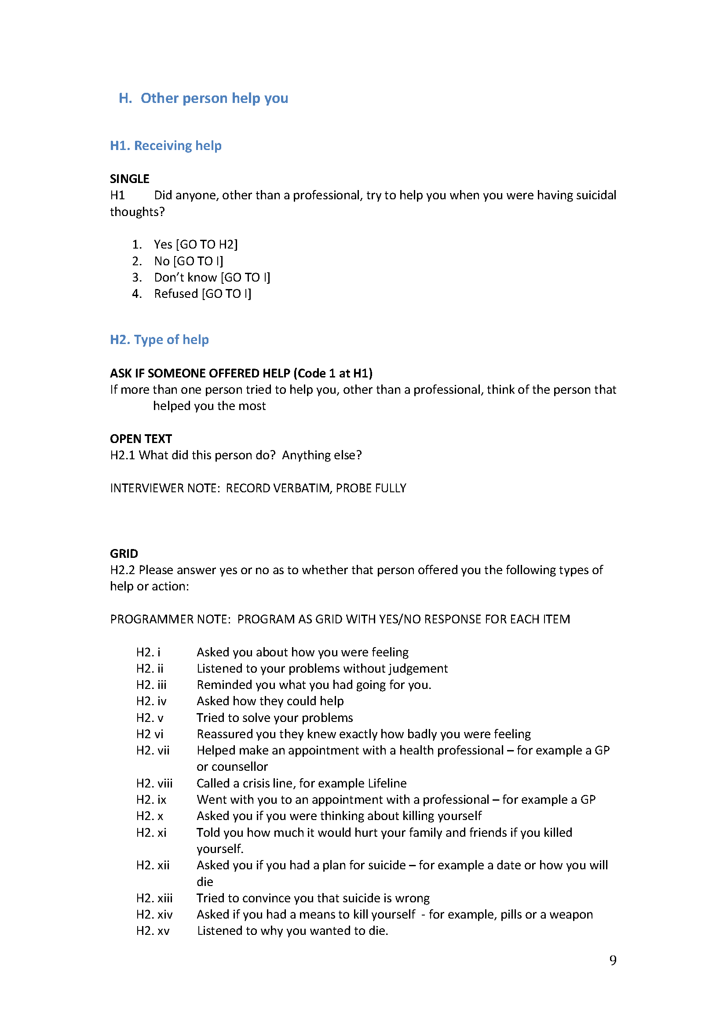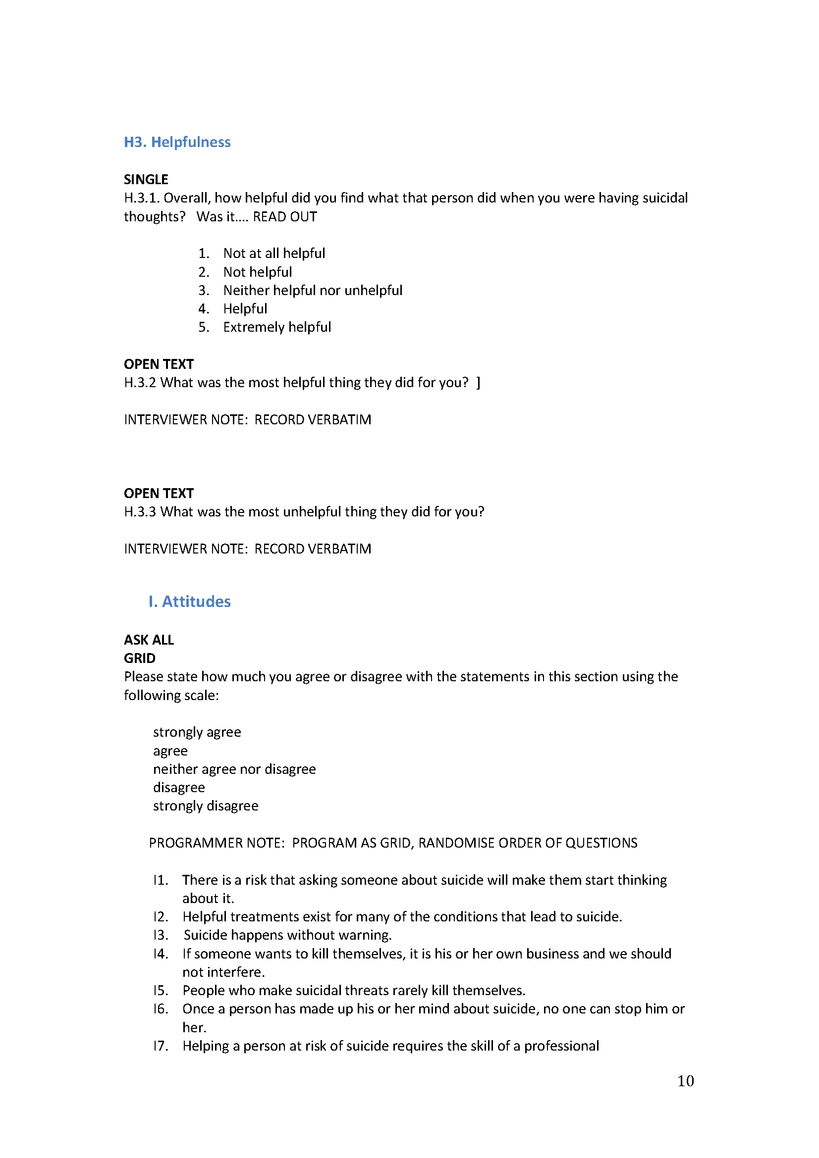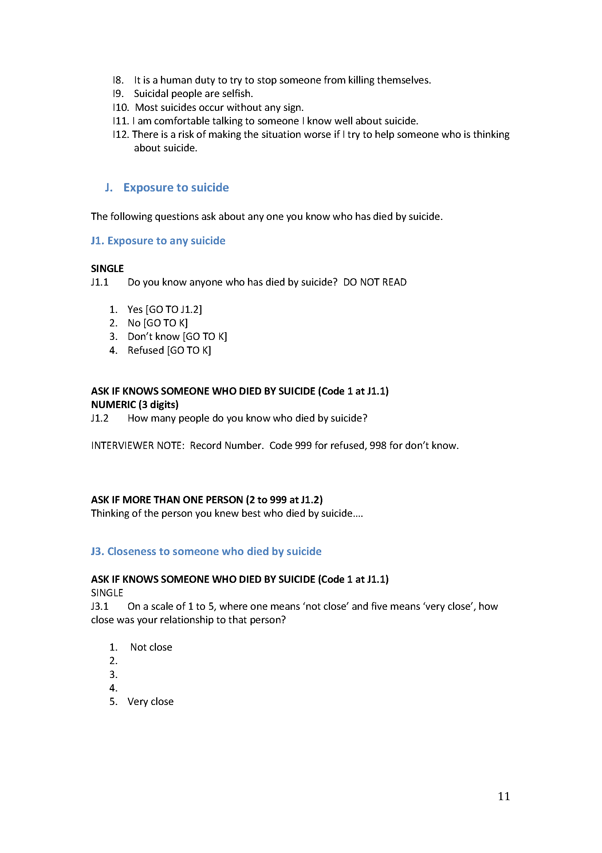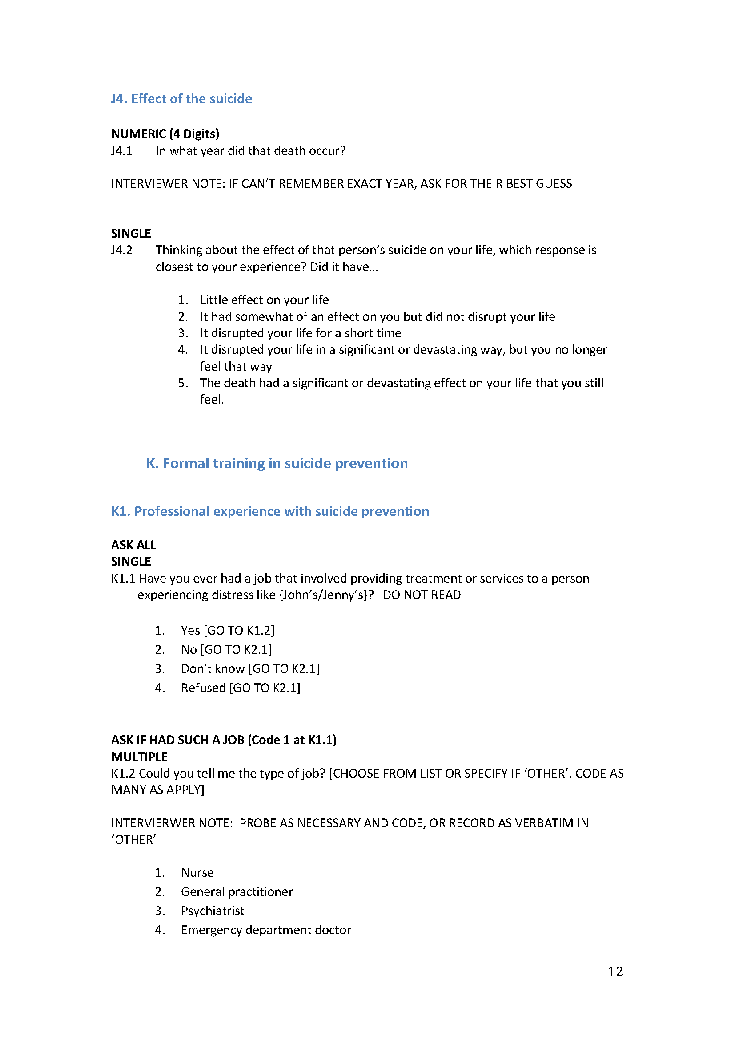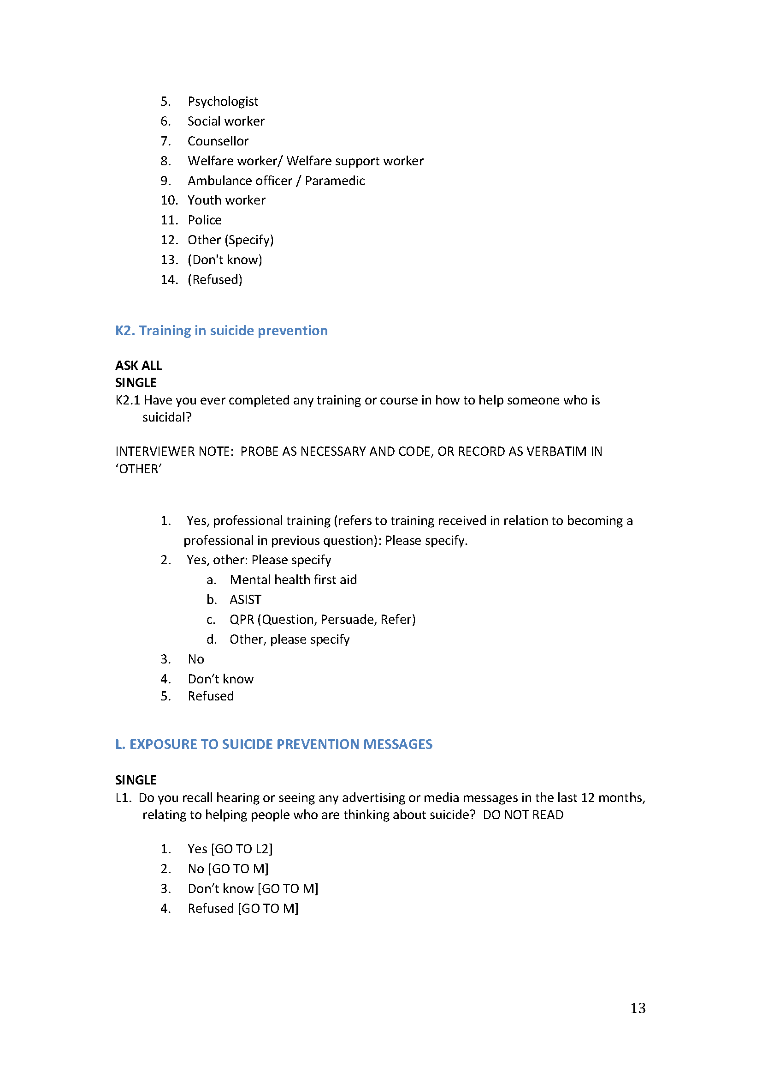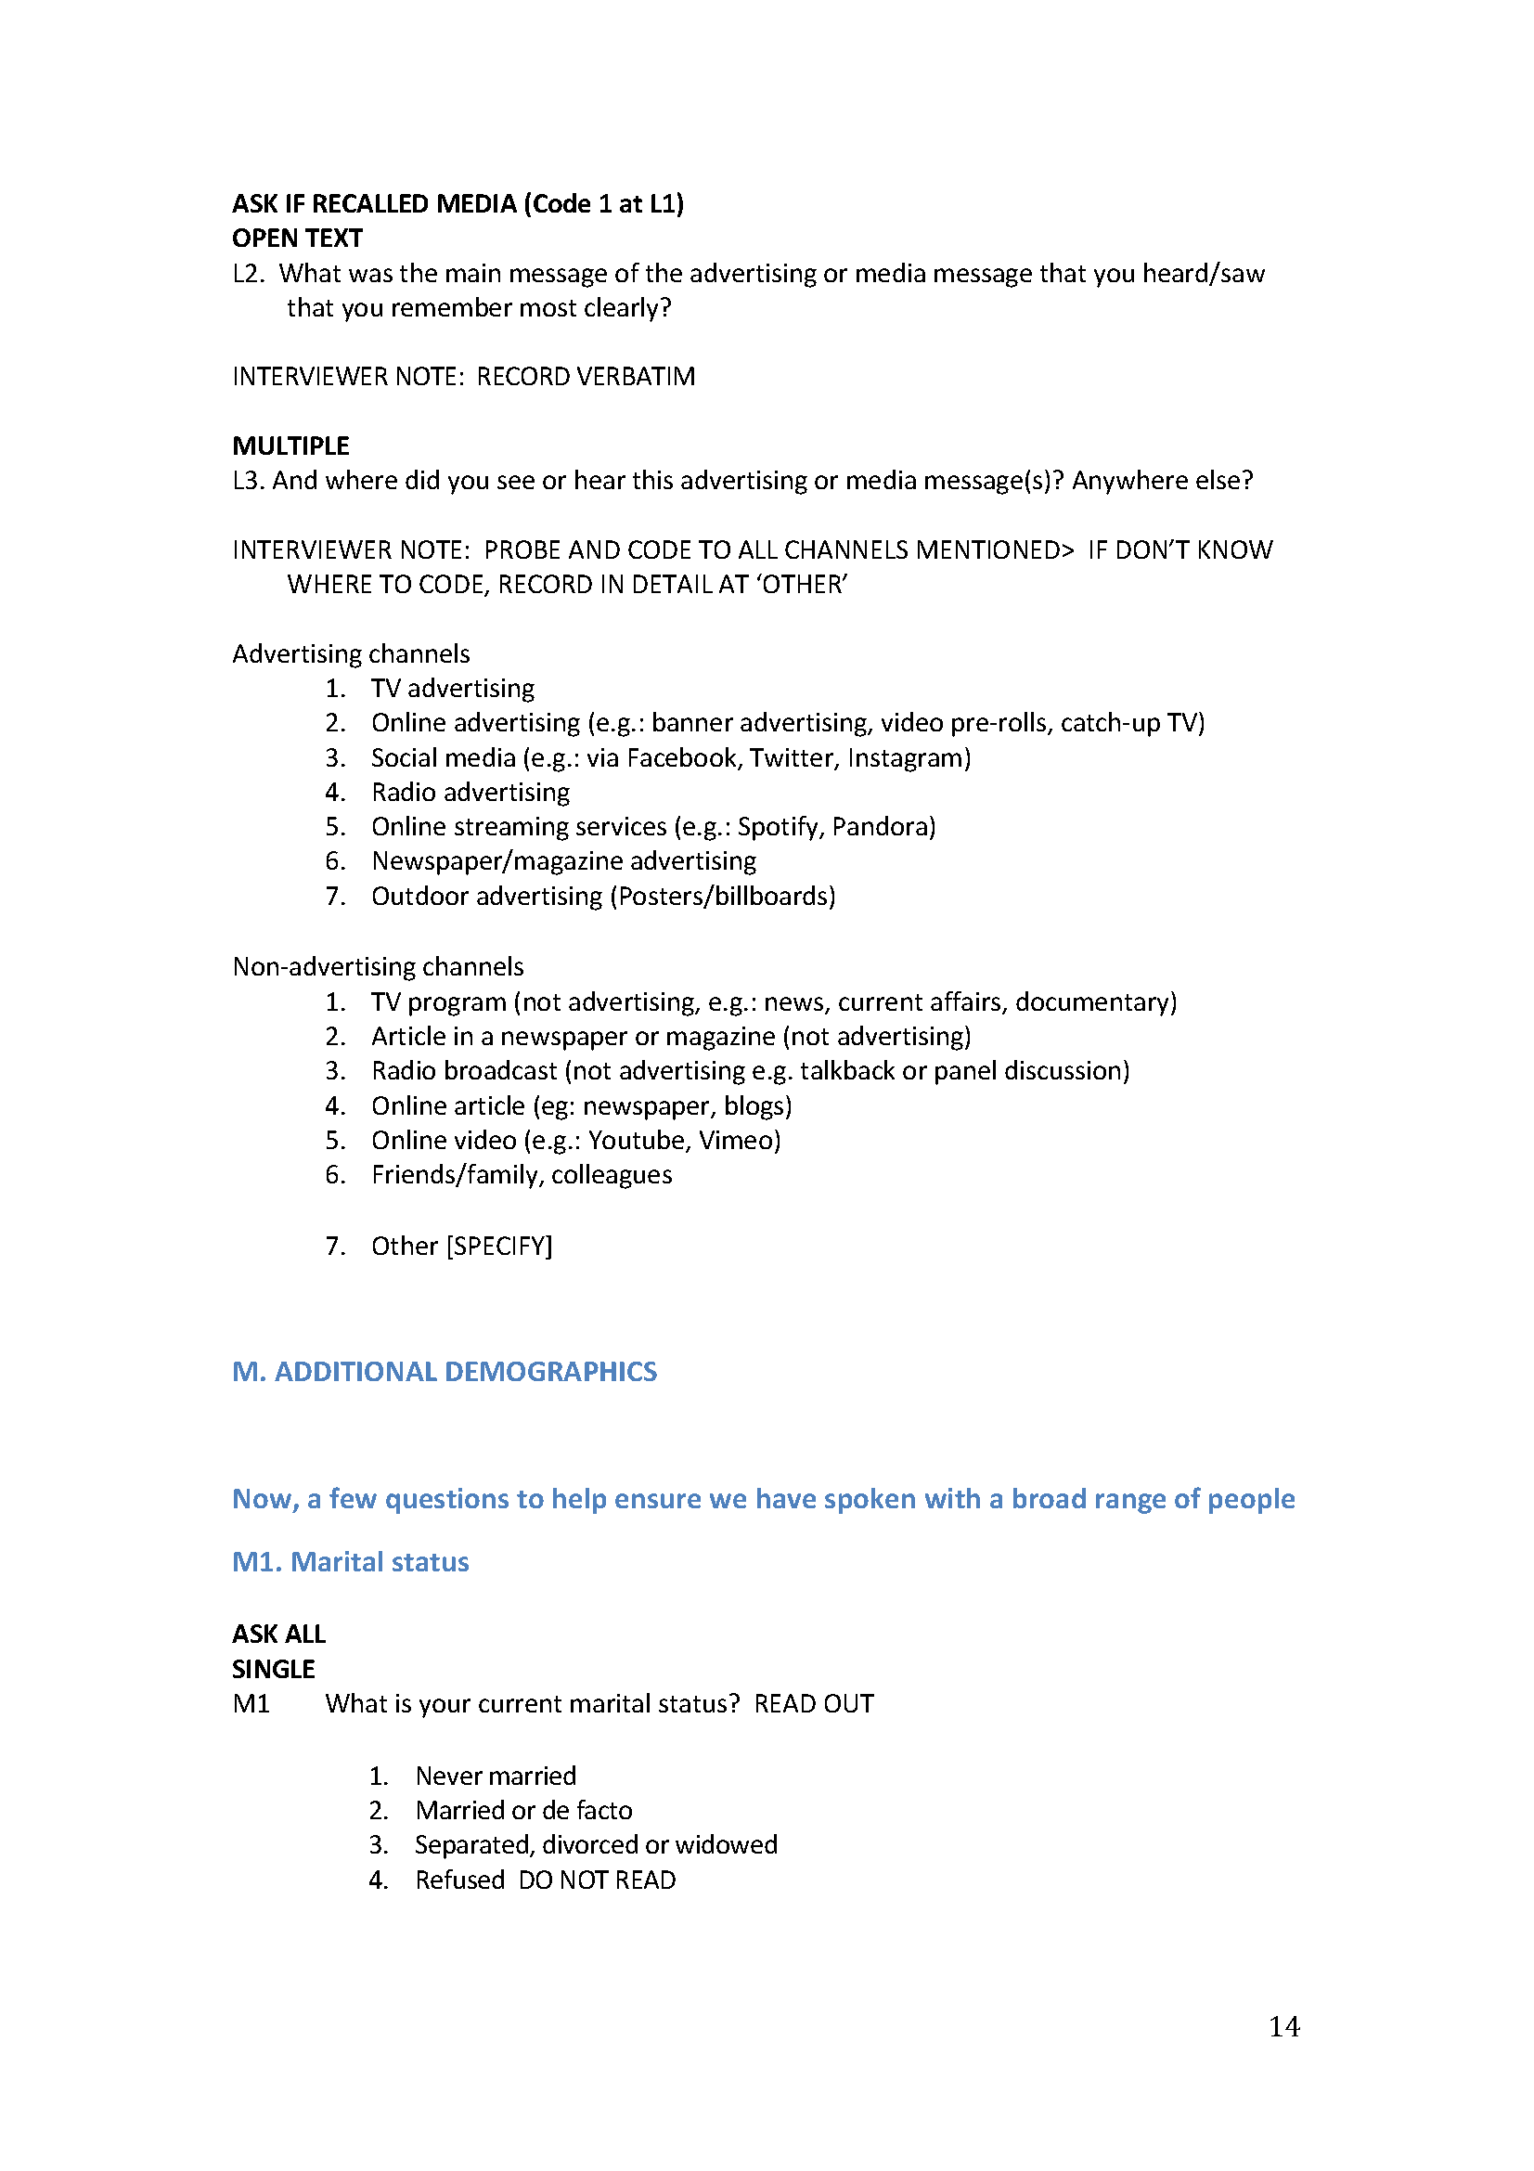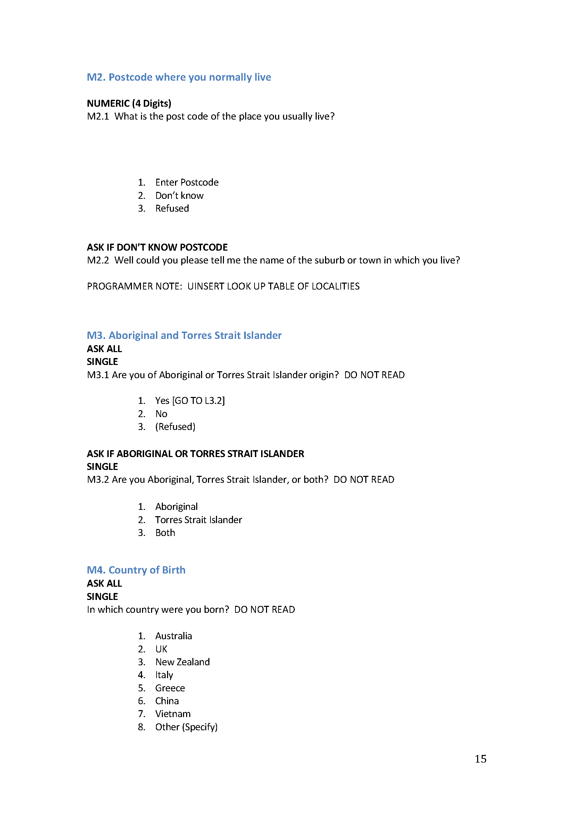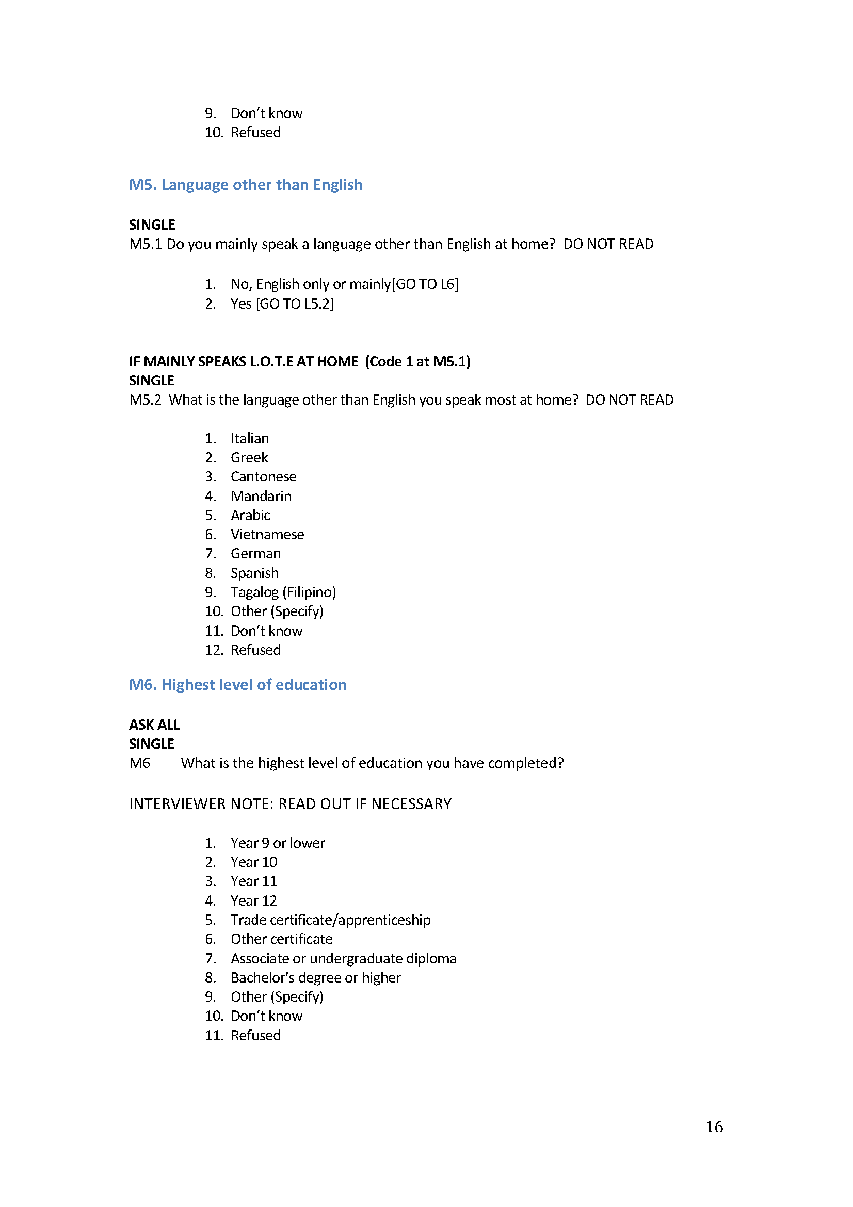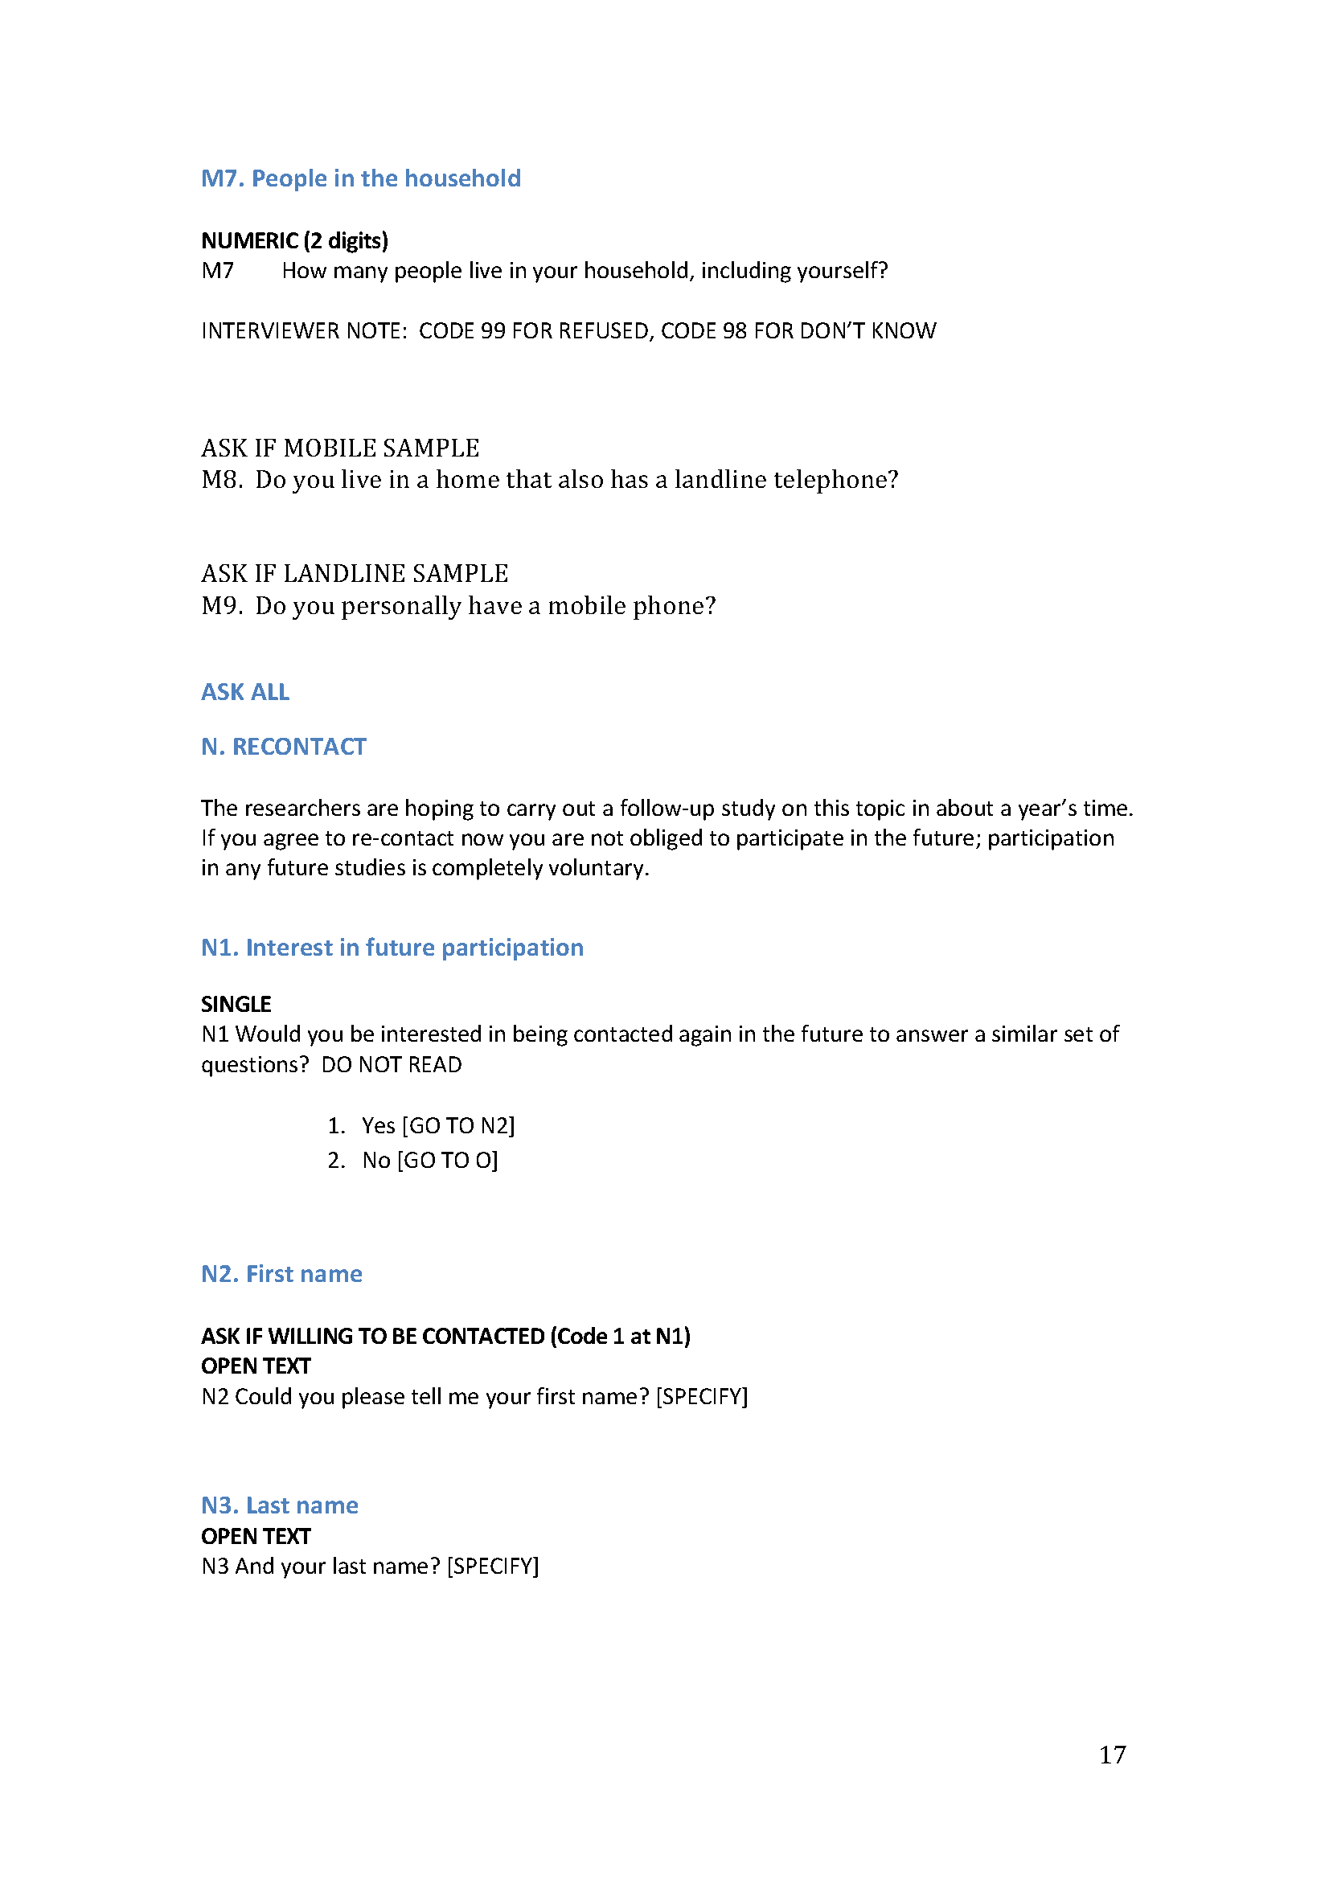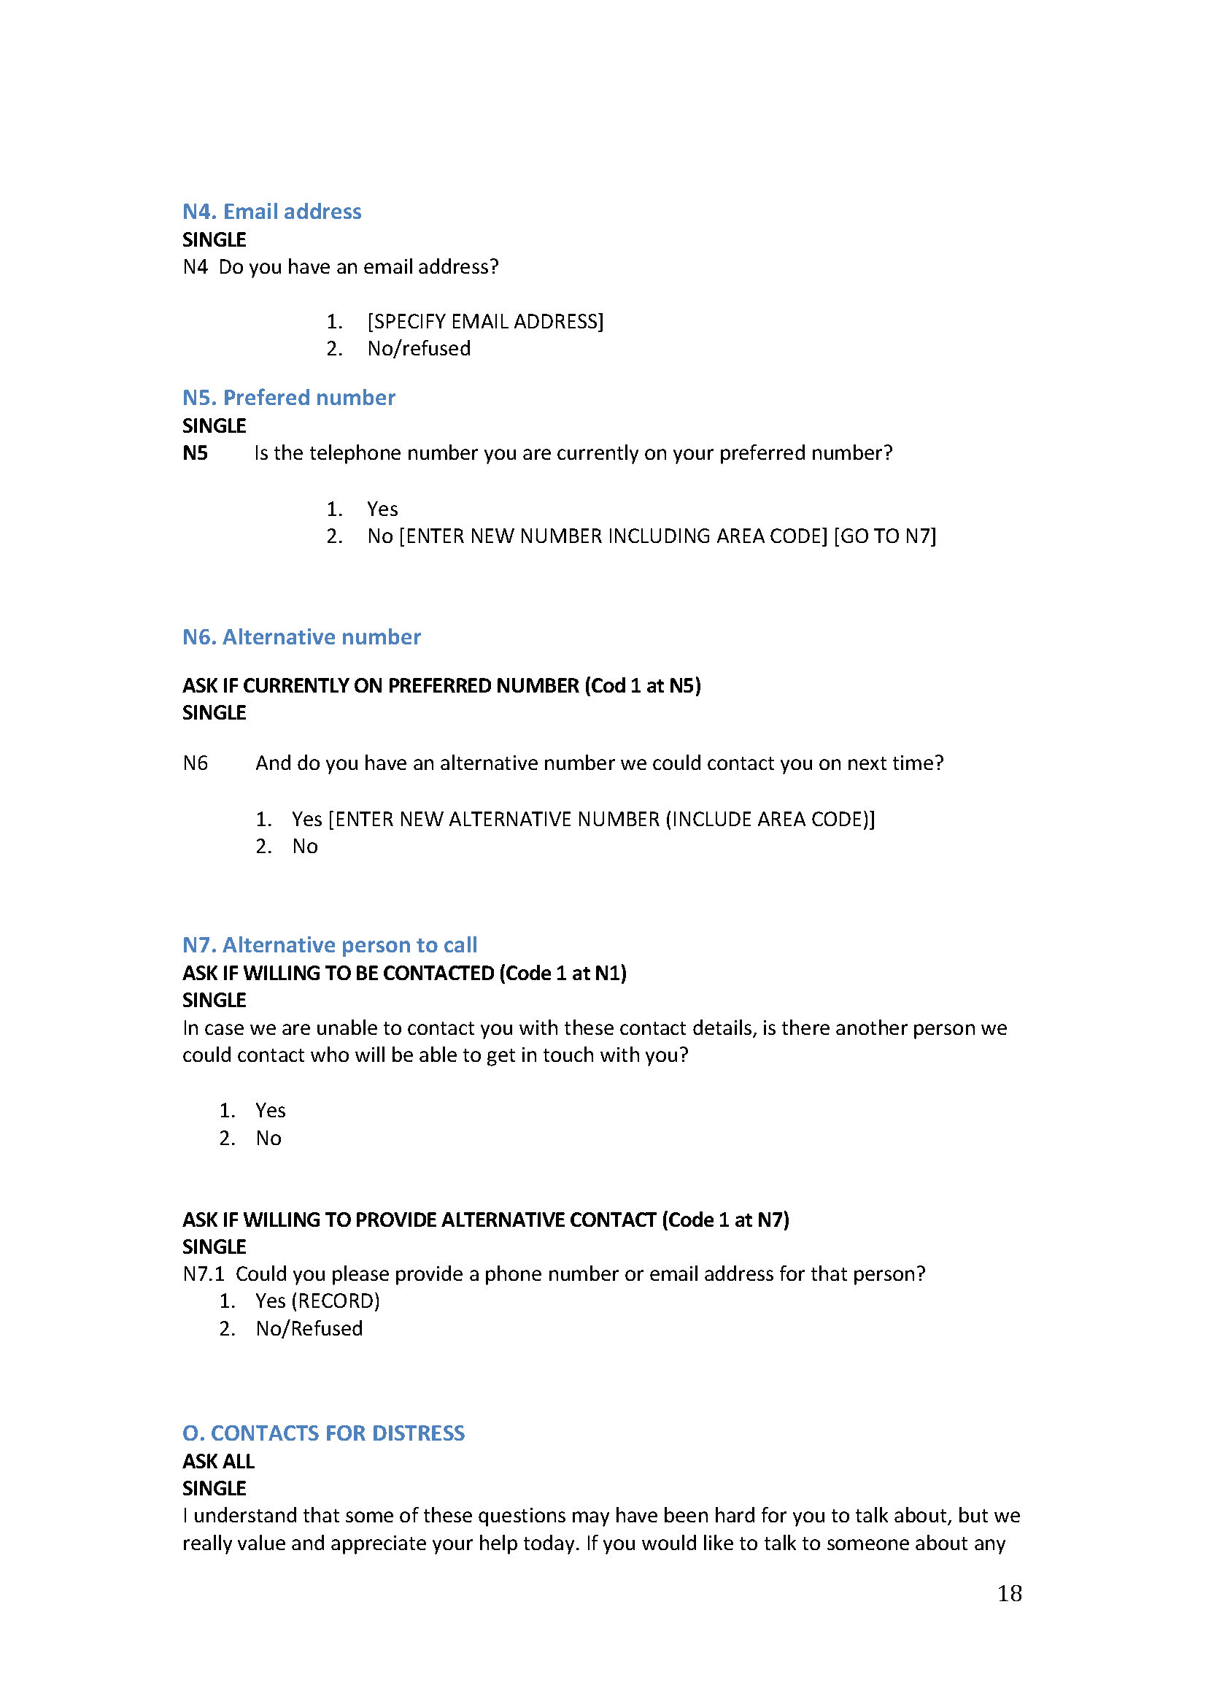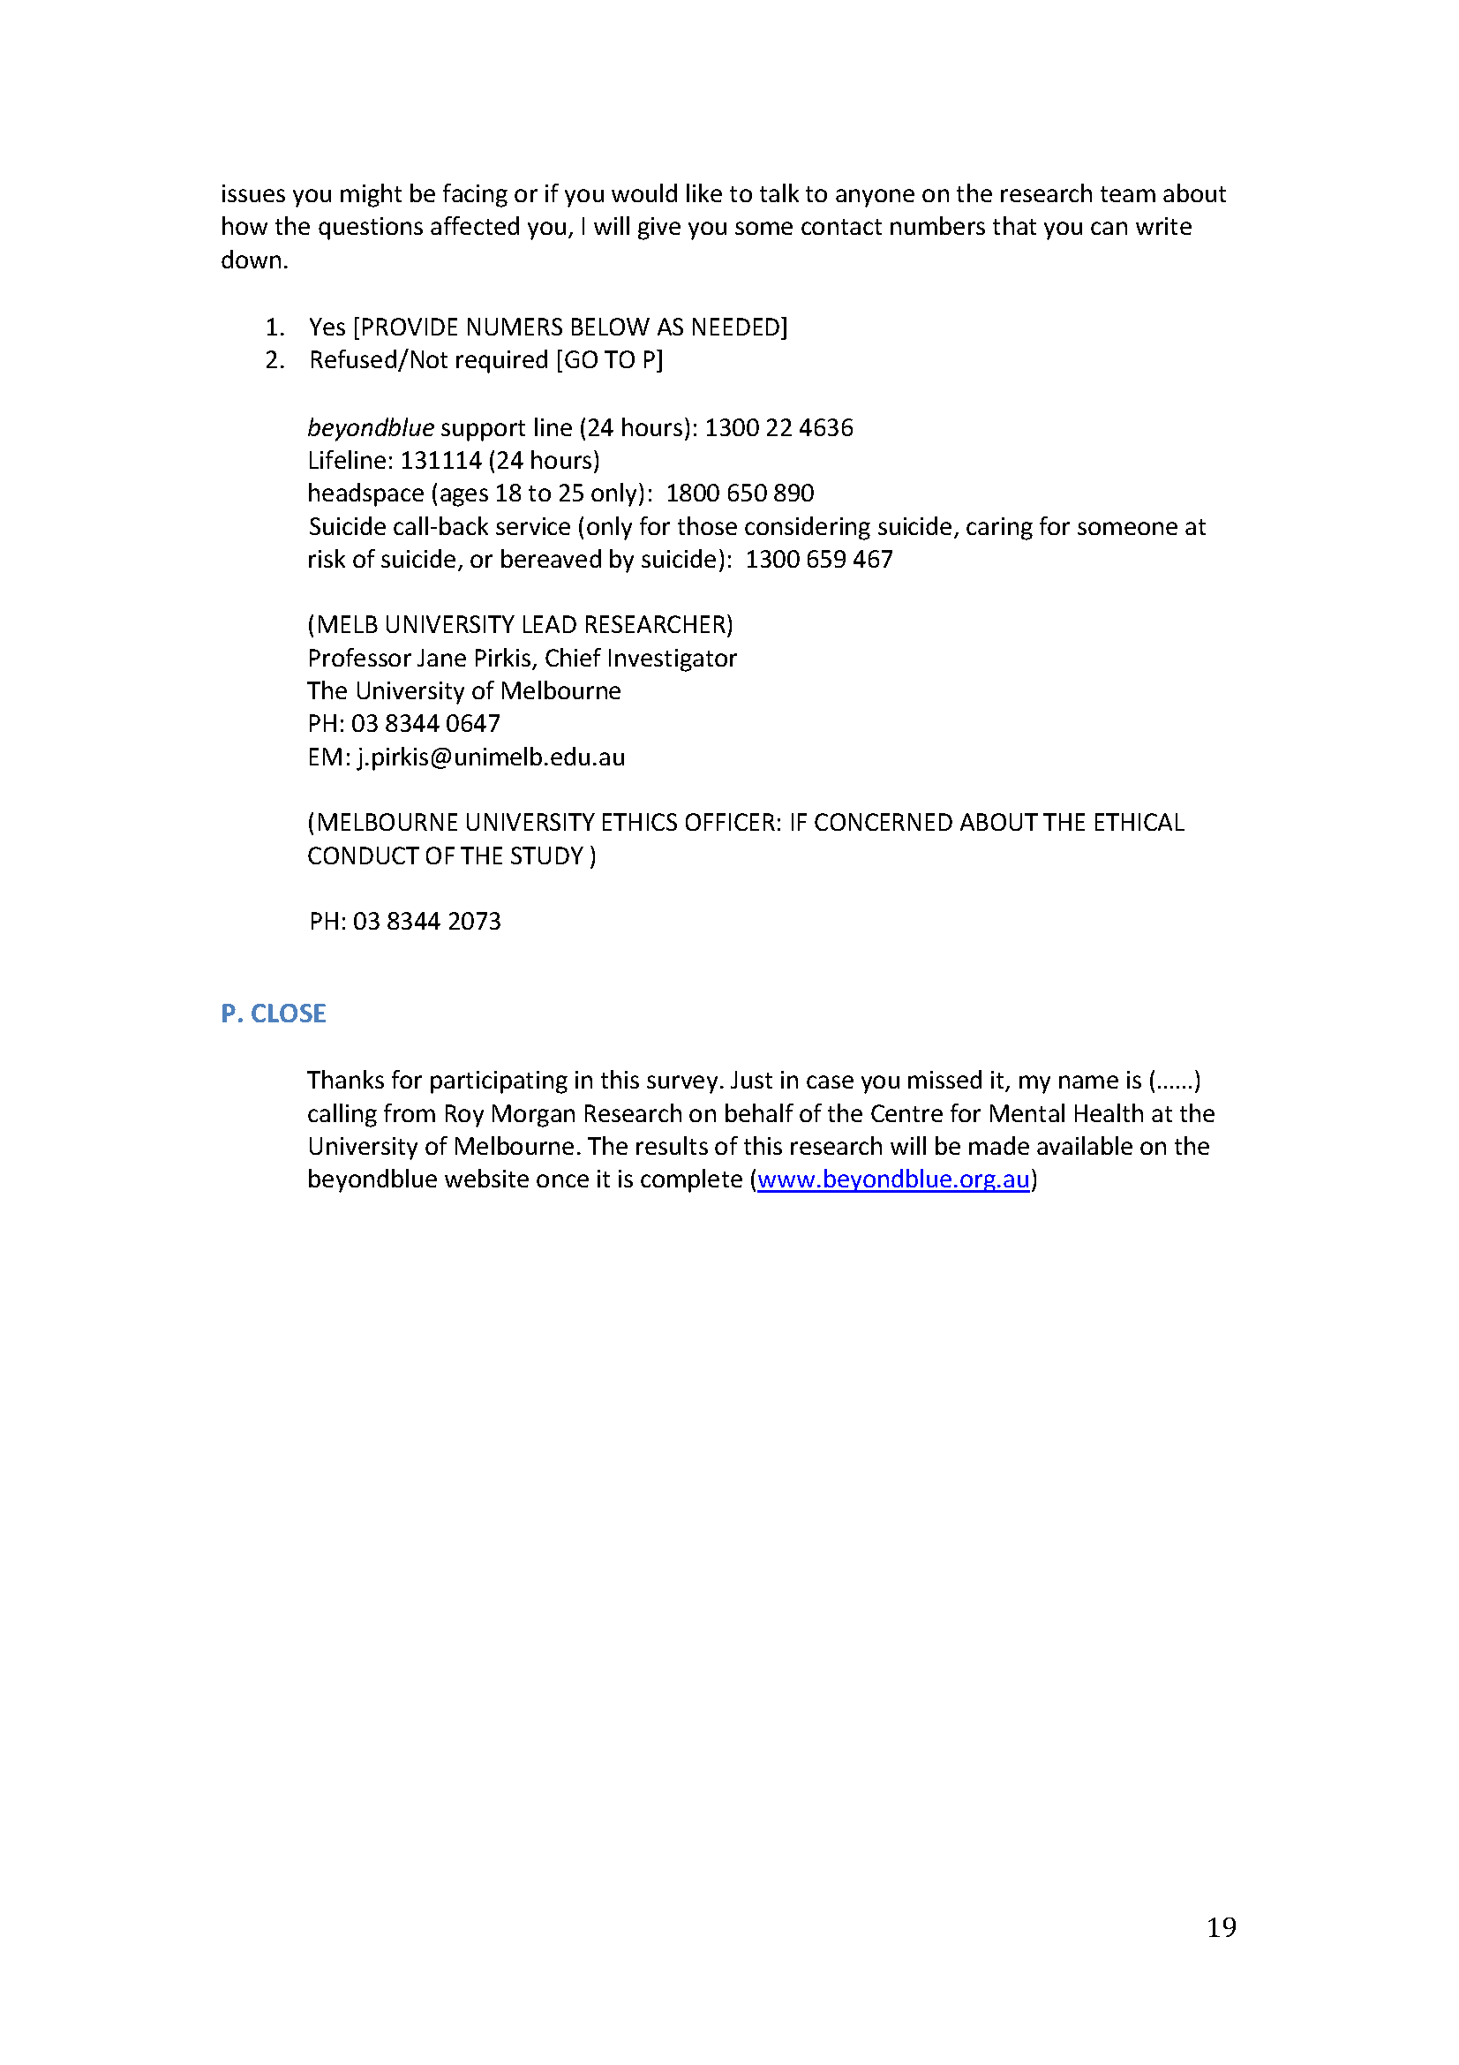

Appendix H. Screenshots from the #YouCanTalk campaign
