Tuning light-matter interactions with mid-infrared plasmonic coaxial apertures

Goekalp Engin Akinoglu¹ and James Andell Hutchison¹
¹ARC Centre of Excellence in Exciton Science, School of Chemistry, University of Melbourne, Parkville, VIC 3010, Australia
E-mail engina@zedat.fu-berlin.de, james.hutchison@unimelb.edu.au

Keywords: Plasmon, Extraordinary Transmission, Whispering gallery mode, Surface Enhanced Infrared Absorption, Fano Distortion, Vibrational Strong Coupling, Rabi Splitting

Abstract
Thin plasmonic coaxial apertures have unique optical properties, including extraordinary light transmission and confinement, that can enhance light-matter interactions and be applied for sensing applications. Here, we use finite difference time domain simulations to investigate the mid-infrared optical response of coaxial aperture arrays, consisting of a combination of disk arrays and perforated films of periodically-arranged holes. We find that the plasmon response of these arrays is governed by the disk size with little influence from the hole size, with surface plasmon excitation around the circumference of the disks mediating extraordinary optical transmission and strong near-field enhancements. The simulations also predict that light-matter coupling with the vibrational modes of a poly(methyl methacrylate) film placed inside the coaxial apertures can be tuned from weak to strong by adjusting the thickness of the coaxial aperture array’s metal film. Such open structures that can promote tailored light-matter interactions are therefore attractive target platforms for plasmon-enhanced sensing and polaritonic chemistry.

Introduction
Thin plasmonic coaxial aperture array templates that are resonant in the mid-infrared have attracted strong interest for their ability to modulate and enhance light-matter interactions. In the weak light-matter coupling regime, coaxial apertures have been used for surface-enhanced infrared absorption spectroscopy¹, which is a versatile tool for the detection of a small number of analytes, including biomolecules such as proteins². However, it was also recently shown that coaxial apertures can generate strong light-matter coupling with a proximal material absorber in the infrared, specifically phonon modes in silica ³. Strong light-matter interactions have been shown to modify the energy landscape of molecules and materials in recent years, with consequences for chemical reactivity and many other molecular properties, arousing much interest ^{4, 5}.
Tuning the light-matter interaction regime between these two extremes requires a precise overlap of the plasmonic resonance with the material vibrational excitation and subsequent fine adjusting of the coaxial plasmonic response, which is the focus of this work.
The optical properties of coaxial apertures are governed by extraordinary optical transmission (EOT)⁶⁻¹⁰. In contrast to the traditional EOT effect, which is based on propagating surface plasmon polaritons that require a grating coupling¹¹, the plasmonic response of coaxial apertures is highly localized and the EOT exists independent of the pitch or the arrangement of the coaxial apertures¹²⁻¹⁴. Generally, circular coaxial apertures are used, but anisotropic and polarization-dependent coaxial apertures were also investigated^{13, 14}. Earlier studies suggest that the EOT transmission scales with the aperture size and occurs close to the cut-off frequency, which is proportional to the average circumference of the coaxial apertures^{12, 15, 16}.
Here, we deepen these studies, decomposing the coaxial aperture templates into disk arrays and hole arrays and investigating their respective roles in the overall design of coaxial apertures (see Scheme 1). Furthermore, we investigate the electric near-field properties of coaxial apertures, and light-matter interactions between the coaxial aperture plasmons and the vibrational modes of a poly(methyl methacrylate) (PMMA) film placed inside the apertures. Depending on the coaxial aperture geometry, and particularly the thickness of the gold film, light-matter coupling strength can be tuned. For the weak coupling regime, the simulations predict Fano distortion of the PMMA absorptions, which is a typical observation for surface enhance infrared spectroscopy. The strong coupling regime can also be achieved however, suggesting that these coaxial apertures can be relevant for the strong coupling of organic molecular vibrations, which have much weaker oscillator strength than the Fuchs-Kliewer phonon modes of SiO₂ investigated to date ³.

Scheme 1. A coaxial plasmonic template as the combination of a hole array and a disk array.

Plasmon excitation energy
In Fig. 1 we show the simulated transmission spectra of hexagonally-arranged coaxial apertures with a fixed, 50 nm gap size between the holes of the perforated gold film and the gold disks on silicon substrates. The optical properties are governed by EOT, which redshifts with increasing size of the coaxial apertures. This is in line with previous studies that suggest that the plasmon excitation is close to the cut-off frequency of a T₁₁-like mode and that the EOT can be understood as the excitation of the zeroth order Fabry–Pérot mode^{12, 15, 16}. The cut-off frequency/wavelength ($λ_{max}$) is defined as the whispering gallery mode that goes around the average circumference of the cavity inside the coaxial apertures:
$λ_{max}≈λ_{pl}=π\sqrt{ε}\left(dhole+ddisk\right)/2$ (1)
where $ε$ is the effective dielectric function of the surrounding medium and inside the cavity of the coaxial apertures. Indeed, we observe a linear relationship between the plasmon excitation energy and the size of the coaxial apertures. However, the numerical results have a mismatch to the cut-off frequency (see inset in Fig. 1A). The coaxial apertures also show a smaller transmission peak around 2500 nm. Though, higher modes are greatly supressed, the mode is governed by grating coupling as its position is depending on the pitch (see figure S1)¹⁷.
Next, we decompose the same coaxial apertures and consider only the respective disks without the surrounding perforated film in their optical behaviour (Fig. 1B). The transmission spectra show a large dip around 2900 nm, which is associated with the plasmon lattice resonance, and which increases in amplitude with larger diameters and whose resonance can be tuned by the pitch (see figure S2)¹⁸. Additionally, many higher modes appear for larger energies. In Fig. 1C the transmission spectra of the hole array of the respective coaxial apertures are plotted without the disks. The spectra show a remarkable complementarity to the disk arrays: Instead of a dip, the hole arrays feature a transmission peak around the same plasmonic excitation energy and the EOT amplitude increases with larger $dhole$. We attribute this behaviour to Babinet’s 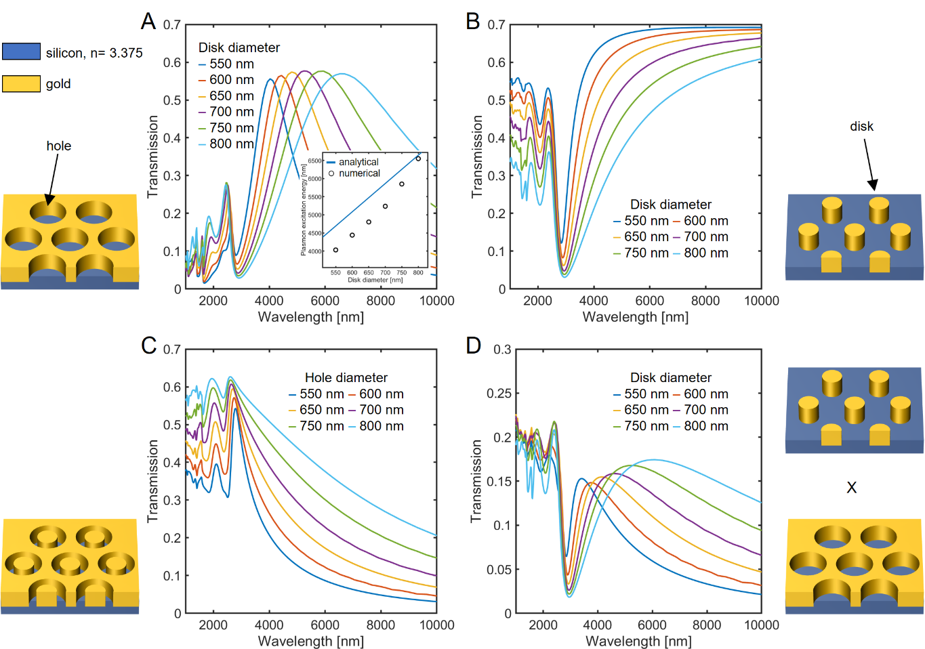
principle, which states that the transmission of complementary arrays reads^{19, 20}:
Figure 1. FDTD transmission spectra with fixed d_{hole}- d_{disk} =100 nm. (A) Coaxial apertures, (B) disk arrays and (C) hole arrays. (D) Multiplication of the respective spectra of the disk and hole arrays. Both the hole array and the coaxial apertures exhibit extraordinary transmission at the plasmon excitation. The inset in figure (A) shows the missmatch between the numerical plasmon resonance and the analytical cut-off frequency, the average circumference of the cavity of the coaxial apertures.
$T_{disks,λ} + T_{holes,λ} = 1$ (2)
The principle suggests that the plasmonic excitation energy of the disk and hole arrays should be similar but also assumes no absorption loss and exact complementarity between the disk and the hole templates. This is strictly not the case because the gold metal films are not perfect conductors and because the disks are smaller than the holes in our coaxial apertures. Nevertheless, the results show a good quasi-Babinet complementarity²⁰⁻²².
Next, we consider that the total transmission is a combination of the transmission of the disks and holes, expressing the transmission of the coaxial apertures as the product:
$T_{coaxial}=T_{disks}T_{holes}$(3)
Here, any interactions between the disks and holes of the perforated film are neglected. In Fig. 1(D) we have multiplied the respective disk and hole array spectra from Fig. 1(B) and 1(C). The multiplied spectra show an EOT resonance, which redshifts with increasing diameter size. The absolute shift and transmission maxima differ from the simulated coaxial apertures of Fig. 1(A), but an overall qualitative agreement can be observed. Following the argumentation of Ref. ²⁰, we insert eq. (2) into eq. (3):
$T_{coaxial}=T_{disks}T_{holes}=T_{disks}\left(1-T_{disks}\right)=T_{disks}-{\left(T_{disks}\right)}^{2}$ (4)
In the case when $T_{disks}$ is small, the transmission of the coaxial apertures can be approximated as ${ T}_{coaxial}≈T_{disks}.$Consequently, the optical behavior of the coaxial apertures is governed by the properties of the disks. To test this hypothesis, we ran two series of simulations. In the first series we varied $d_{disks}$ and kept $d_{holes}$fixed for the coaxial apertures (Fig. 2(A)). The plasmonic EOT peaks clearly scale with disk diameter, similar to the simulations in Fig. 1(A) for a constant gap between the disks and holes. In the second series, we varied $d_{holes}$and kept $d_{disks}$ fixed. The EOT amplitude increased with larger $d_{holes}$ because the overall gold coverage of the film decreases. However, plasmonic excitation energy does not scale with $d_{holes}$. Note, that the gap size between the disks and holes is kept large enough to reduce plasmonic hybridization in these simulations ²³.
Figure 2. FDTD transmission spectra of coaxial apertures. (A) With fixed d_{hole} =700 nm and (B) with fixed d_{disk} =300 nm. Variations of the hole diameter do not affect the plasmon excitation energy.
Therefore, the estimation of the plasmon excitation energy with the help of the cut-off frequency is insufficient because the plasmon excitation energy is primary determined by the disk diameter. Instead we propose a different equation to determine the EOT resonance of coaxial apertures in the mid-infrared spectral region, where the surface plasmons are retarded and the plasmon dispersion follows the light line²⁴. The excited plasmons at the EOT resonance can be understood as whispering gallery modes that travel around the circumference of the disks:
$λ_{max}≈λ_{pl}=πd_{disks}\sqrt{ε}$ (3)
where $λ_{pl}$ is the plasmon excitation. The dielectric background function is estimated as an average of the air and the silicon substrate with $ε≈\left(1+ε_{Si}\right)/2$. The analytical expression agrees very well with the computational results in Fig. 3. However, we neglect any plasmonic hybridization between the disks and holes that can occur for very small gaps below 10 nm, which generally results in a red shift of the EOT peak^{13, 16, 23}.
Figure 3. Comparison of analytical and computational estimations of plasmon energy in coaxial apertures. Blue line: Linear relationship estimated from Equation 3; circles: simulated data with constant gap size from Figure 1A; and crosses: constant hole diameter with data taken from Figure 2A.

Near field enhancement and light-matter coupling
Plasmonic templates confine light and strongly enhance the electric near-field enhancement at their surfaces²⁵. The electric near-field enhancement is an important parameter for amplification in surface-enhanced spectroscopy. The near-field enhancement is generally strongest for small junctions and gaps between plasmonic arrays when the plasmonic modes hybridize. In figure 4(A-C) we can see a birds-eye view of the electric near-field enhancement for coaxial apertures with 10 nm (4A), 25 nm (4B), and 50 nm (4C) gaps between the disks and hole arrays. The near-field enhancement is strongest for the coaxial apertures with 10 nm gaps and the enhancement is distributed along almost the entire circumference of the coaxial apertures. For 50 nm gaps there is weaker enhancement which has a more distinctly bi-lobal distribution.
Furthermore, we have simulated the near-field enhancement as a function of wavelength for different disk diameters for each gap size in Figure 4 (D-E). The voids were filled with a dispersionless medium (n=1.5, typical of soft matter). For these structures, the plasmon excitation energy lies within the fingerprint region of vibrational modes of organic molecules that provide valuable structural and conformational information in sensing contexts. Again, the electric field enhancement is strongest for the 10 nm gaps for all disk diameters. For larger gaps, we observe a decrease in electric near-field enhancement and a blue shift of the plasmon resonance. However, this does not mean that smaller gaps are always better plasmonic templates for sensing. Depending on the application, the number of molecules that can be trapped inside the gaps, and their size, also need to be considered. For example, for a very low number of small-sized analytes, a small gap gives the highest enhancement, however small gaps may not be suited for the sensing of macromolecules which might not fit into the gaps.
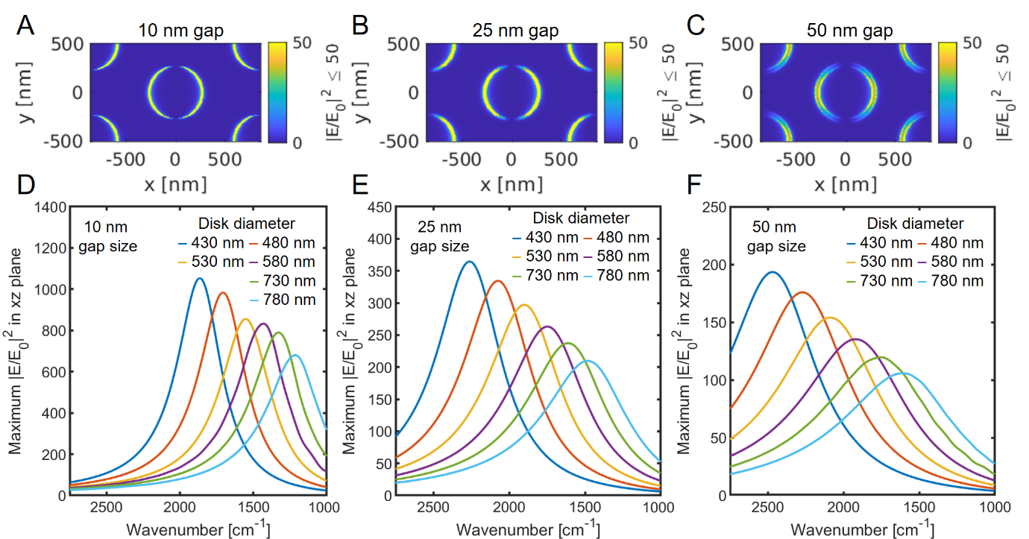
Figure 4. Electric near-field enhancement of coaxial apertures. The voids are filled with a dispersionsless medium with a refractive index of 1.5. (A-C) xy cross section with 530 nm disk diameters at the plasmon excitation energy. (A) 10 nm gap, (B) 25 nm gap and (C) 50 nm gap. (D-F) Electric near-field enhancement as a function of wavelength for different diameters. (D) 10 nm gap, (E) 25 nm gap and (F) 50 nm gaps.

Next we simulated filling the coaxial apertures with PMMA and monitored the infrared response of the coaxial apertures. A Lorentz-Drude function of the dielectric properties of PMMA was obtained from Ref. ²⁶ and implemented in our computational code. The transmission results are plotted for different disk diameters and 10 nm gaps (Fig. 5(A)), 25 nm gaps (Fig. 5(B)), and 50 nm gaps (Fig. 5(C)), all for a gold film thickness of 50 nm on silicon. The plasmon resonance appears as a broad background that is modulated by the vibrational mode absorptions of the PMMA. The PMMA signals are strongest when they overlap with the plasmon excitation energy. We observe that the light-matter coupling is in the weak coupling regime where the vibrational modes are Fano-distorted²⁷⁻²⁹. The Fano-distortion depends on the linewidth of the vibrational modes and the plasmonic excitation, and their spectral tuning with respect to each other. When the aperture resonance energy is far away from the vibrational absorption, the latter takes a Lorentzian from, which becomes increasingly Fano-distorted as resonance with the plasmon excitation energy improves. At exact resonance, it appears as an anti-Lorentzian, an effect which is known in the Fano picture as electromagnetic induced transparency, with the three relevant states in that context being the ground state, bright state (plasmon), and dark state (molecule). The effect can be seen for the C=O stretch vibration at 1730 cm⁻¹ for 580 nm disk diameters and 10 nm gaps.
In Figure 5(D-F) we have plotted the corresponding absorption spectra. Note that the Fano distortion discussed above is less visible in this case. This is because scattering effects contribute to the total line shape and are captured in our simulated transmission, but not in our simulated absorption²⁸. Nevertheless, in typical experiments, only the direct transmission is detected and the collection of diffuse transmission or reflection is lower. An exception are measurements with IR microscopes, which collect light from a broader angular range². The best enhancement of the extinction signal is achieved when the system’s intrinsic losses and radiative losses are equivalent, as shown by temporarily coupled mode theory or Fano ab initio theory²⁷⁻²⁹.
The Fano-distortion also causes a shift of the excitation energy which complicates the already complex interpretation of the vibrational signatures ^{30, 31}. The shift correlates with the coupling efficiencies between the plasmonic mode and the vibrational mode. In the case of the C=O stretch vibration and 10 nm gaps, the absorption modes lie between 1741 cm⁻¹ to 1715 cm⁻¹. On the other hand, for the 25 nm gaps the energy range is reduced to 1734 cm⁻¹ to 1726 cm⁻¹. Therefore, it might be more practical to use larger gaps that fit more molecules and have less distortion of the absorption bands due to the smaller coupling strength.

Next, we investigated if the coaxial apertures can be used for vibrational strong coupling. In the strong coupling regime, the hybridization of the optical mode and the vibrational excitation leads to a visible splitting of the modes and the formation of higher and lower polaritons. The energy difference between the new modes is called the Rabi splitting, $ℏΩ_{Rabi}$. The Rabi splitting is proportional to the coupling strength g and depends on the number of oscillators N inside the optical cavity, the vacuum electric field vector $E_{vac}$ inside the optical cavity, and the transition dipole moment of the oscillators µ, and reads:
$$ℏΩ_{Rabi}=2ℏg= 2μ \sqrt{N} E_{Vac} =2μ \sqrt{\frac{N}{V}\frac{ℏω_{0}}{2ε}}$$
where $ℏ$ is the reduced Planck’s constant, $ε$ is the permittivity of medium inside the cavity and V is the effective mode volume, the spatial extend of the electric field. The effective mode volume for open resonators, like in the case for plasmonic cavities, is difficult to determine, due to their highly dispersive nature. It is important to note that in our simulations the incoming light is not inducing the coupling between the molecular vibration and the plasmonic cavity but only probing the interaction governed by the vacuum electric fields.³²
The transition dipole moments for molecular vibrational transitions in the IR are significantly lower than, for example, electronic
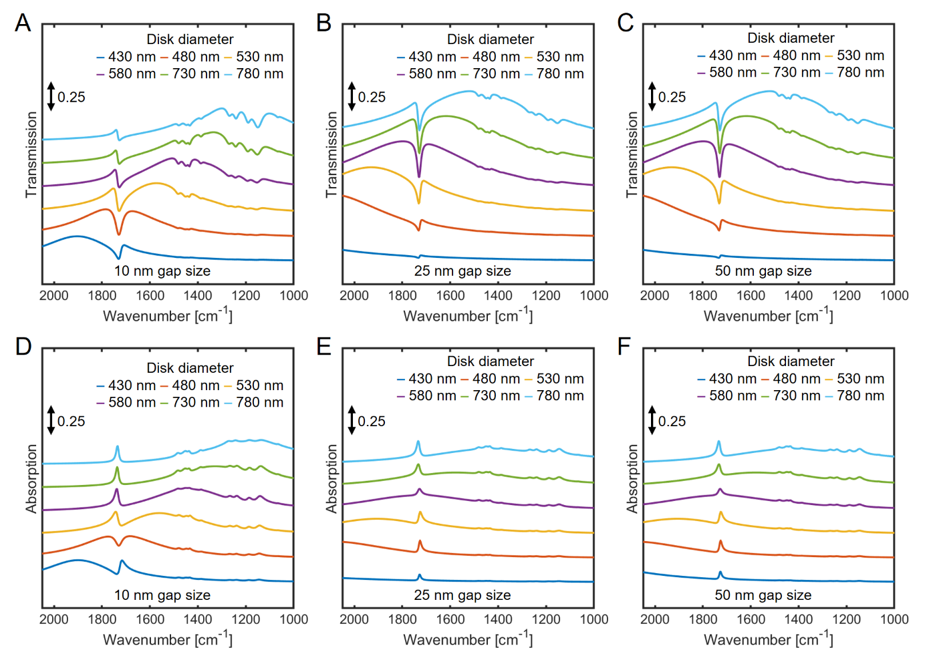
Figure 5. Coaxial apertures filled with PMMA. Transmission spectra with (A) a 10 nm gap, (B) 25 nm gap and (C) 50 nm gap. Absorption spectra with (D) a 10 nm gap, (E) 25 nm gap and (F) 50 nm gap. The spectra show a typical Fano distortion of the vibrational modes, typical for weak coupling.
excitations in the visible, which makes vibrational strong coupling challenging. For PMMA, the strongest absorber is the C=O stretch vibration. For strong coupling, the Rabi oscillations should be faster than the dissipation rates of the system. This is determined in experiments when the Rabi splitting is larger than the average full width half maximum (FWHM) of the plasmonic and vibrational modes involved and is driven by maximising $\sqrt{N}∙µ$ .
In our simulations, for coaxial apertures with a 10 nm gap, 480 nm disk diameter, and 50 nm Au film thickness, we observe only weak coupling and electromagnetic induced transparency in the absorption (Fig. 6A, see also investigations above summarized in Fig. 5). However, the situation changes for different Au film thicknesses (as film thickness is increased, the circular channel depth in the coaxial apertures gets deeper, however we simulate the PMMA film completely filling the channel in each case, so there is no change in the concentration of vibrational oscillators in the channel). For thicker Au films, we observe a clear Rabi splitting that is slightly larger than the average FWHMs of the plasmon excitation and the C=O stretch vibrational. The splitting increases from 90 cm⁻¹ for a 50 nm thick Au film to 138 cm⁻¹ for a 400 nm thick Au film, where the effect begins to saturate (Fig. 6(B)). Simultaneously, we observe a drastic decrease of the FWHM of the plasmonic mode for thicker films. In figure

This result could be explained by the transmission spectra (Fig. 6(C)) and electric near-field spectra (Fig. 6(D)) of these structures. We observe a large decrease in the electric near-field amplitude as film thickness increases, and subsequent lowered transmission for larger film thickness, which we attribute to reduced coupling of the whispering gallery modes from one side through the other³³. At the same time however, and as already mentioned, the PMMA fills the channel completely as the film is made thicker, thus more PMMA may interact with bound plasmonic fields which would decay evanescently into the dielectric medium over 100s of nm. Balancing these effects may explain the only mild increase in Rabi frequency with Au film thickness. Nevertheless, the highest observed Rabi splitting of ~130 cm⁻¹ should be sufficiently large to modify the energy landscape of molecules inside the cavity and influence reaction kinetics in the context of polaritonic chemistry ^{4, 5}.

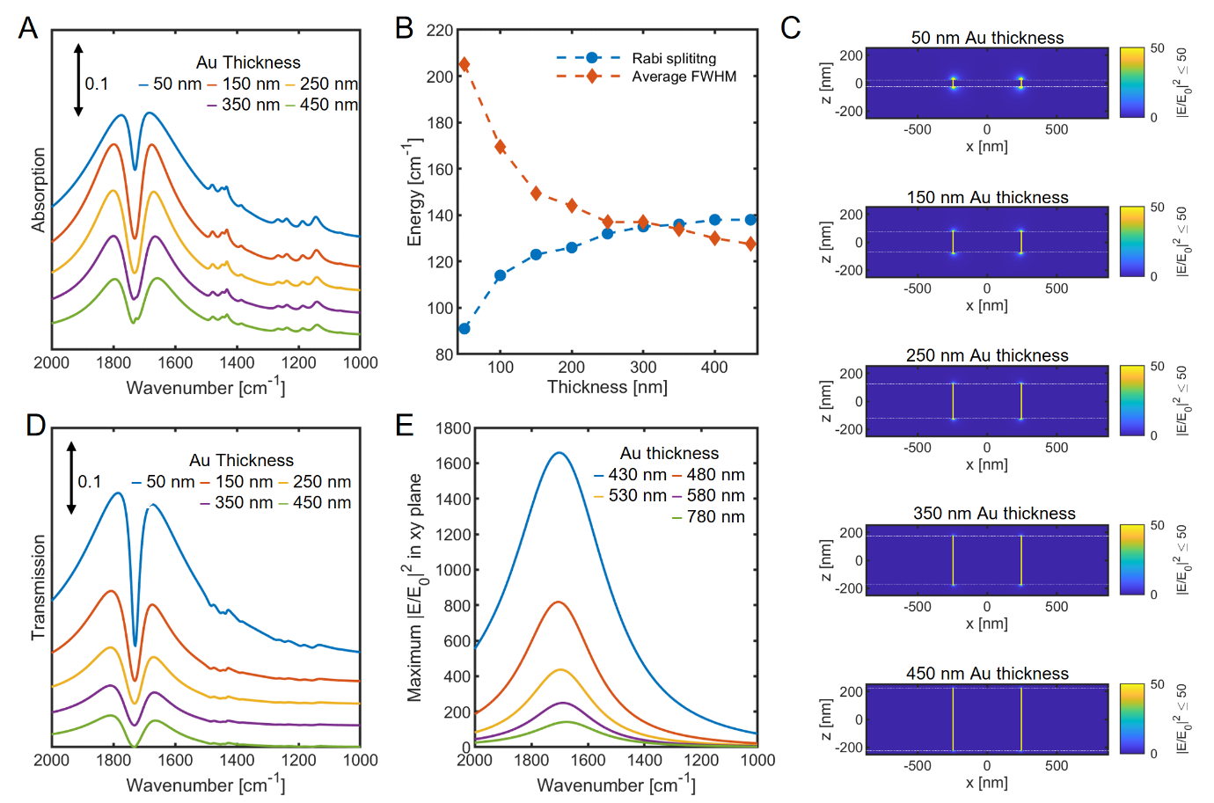
Figure 6 Coaxial apertures with filled with PMMA for different Au film thicknesses. The disk diameters are 480 nm and the hole diameters are 500 nm. (A) Absorption spectra (B) Rabi splitting and mean FWHM of the plasmonic and vibrational as a function of film thickness, (C) electric near-field cross section for different thicknesses, (D) Transmission spectra and (E) Electric near-field as a function of wavelength.
Conclusion
The influence of both the holes of the perforated gold film, and the gold disks, on the optical properties of coaxial apertures has been investigated. It has been observed that the disks and holes of the coaxial apertures are quasi-Babinet complementary and that the optical properties of the coaxial apertures can be roughly determined by the behaviour of the disks. The EOT resonance of the coaxial apertures can be expressed as surface plasmons that propagate around the circumference of the disks, and an analytical expression for the plasmonic energy based on this assumption agrees well with the computational results. We find that the coaxial apertures can strongly confine light inside the cavities and enhance the absorption of vibrational modes (the C=O stretching vibration of PMMA) coupled to the plasmonic modes with Fano-distortions typical for weak light-matter coupling. For sufficiently deep apertures we observe a transition from the weak coupling to the strong coupling regime with Rabi splittings of the order of 138 cm⁻¹. These results suggest the great promise that open plasmonic templates could be used to modify chemical reactions via molecular polariton-induced changes in chemical energy landscapes, which to date have been restricted in the mid-infrared to Fabry–Pérot cavity structures^{4, 5}.

Computation details
Transmission spectra were simulated at normal incidence with the software package MEEP³⁴. The plasmonic arrays were hexagonally arranged with a fixed pitch equal to 1000 nm and the fixed gold thickness of the plasmonic structures equals 50 nm. The dielectric function of gold was described with a Lorentz-Drude model with experimental data obtained from Rakić et. al ³⁵. The dielectric function of silicon was set dispersionless with $ε_{Si}=11.39$. A periodic boundary condition was used in all directions with an artificial absorber layer at the end of the computational cell that is perpendicular to the incidence of the light and that blocks unwanted back reflection.

Funding
The authors thank the Australian Government for funding through the Australian Research Council Future Fellowship scheme (FT180100295), the Centre of Excellence in Exciton Science (CE170100026) and an Australian Government Research Training Program (RTP) Scholarship.

References
1. Yoo, D.; Mohr, D. A.; Vidal-Codina, F.; John-Herpin, A.; Jo, M.; Kim, S.; Matson, J.; Caldwell, J. D.; Jeon, H.; Nguyen, N.-C.; Martin-Moreno, L.; Peraire, J.; Altug, H.; Oh, S.-H., High-Contrast Infrared Absorption Spectroscopy via Mass-Produced Coaxial Zero-Mode Resonators with Sub-10 nm Gaps. Nano Letters 2018, 18 (3), 1930-1936.
2. Pfitzner, E.; Seki, H.; Schlesinger, R.; Ataka, K.; Heberle, J., Disc Antenna Enhanced Infrared Spectroscopy: From Self-Assembled Monolayers to Membrane Proteins. ACS Sensors 2018, 3 (5), 984-991.
3. Yoo, D.; de León-Pérez, F.; Pelton, M.; Lee, I.-H.; Mohr, D. A.; Raschke, M. B.; Caldwell, J. D.; Martín-Moreno, L.; Oh, S.-H., Ultrastrong plasmon–phonon coupling via epsilon-near-zero nanocavities. Nature Photonics 2021, 15 (2), 125-130.
4. Hutchison, J. A.; Schwartz, T.; Genet, C.; Devaux, E.; Ebbesen, T. W., Modifying Chemical Landscapes by Coupling to Vacuum Fields. Angewandte Chemie International Edition 2012, 51 (7), 1592-1596.
5. Hirai, K.; Hutchison, J. A.; Uji-i, H., Recent Progress in Vibropolaritonic Chemistry. ChemPlusChem 2020, 85 (9), 1981-1988.
6. Fan, W.; Zhang, S.; Minhas, B.; Malloy, K. J.; Brueck, S. R. J., Enhanced Infrared Transmission through Subwavelength Coaxial Metallic Arrays. Physical Review Letters 2005, 94 (3), 033902.
7. Fan, W.; Zhang, S.; Malloy, K.; Brueck, S., Enhanced mid-infrared transmission through nanoscale metallic coaxial-aperture arrays. Optics express 2005, 13, 4406-13.
8. Lee, J.; Yang, S.; Lee, J.; Choi, J.-H.; Lee, Y.-H.; Shin, J. H.; Seo, M.-K., Extraordinary optical transmission and second harmonic generation in sub–10-nm plasmonic coaxial aperture. Nanophotonics 2020, 9 (10), 3295-3302.
9. Saleh, A. A. E.; Dionne, J. A., Toward Efficient Optical Trapping of Sub-10-nm Particles with Coaxial Plasmonic Apertures. Nano Letters 2012, 12 (11), 5581-5586.
10. Lu, B.-R.; Xu, C.; Liao, J.; Liu, J.; Chen, Y., High-resolution plasmonic structural colors from nanohole arrays with bottom metal disks. Opt. Lett. 2016, 41 (7), 1400-1403.
11. Ebbesen, T. W.; Lezec, H. J.; Ghaemi, H. F.; Thio, T.; Wolff, P. A., Extraordinary optical transmission through sub-wavelength hole arrays. Nature 1998, 391, 667.
12. Yoo, D.; Nguyen, N.-C.; Martin-Moreno, L.; Mohr, D. A.; Carretero-Palacios, S.; Shaver, J.; Peraire, J.; Ebbesen, T. W.; Oh, S.-H., High-throughput fabrication of resonant metamaterials with ultrasmall coaxial apertures via atomic layer lithography. Nano letters 2016, 16 (3), 2040-2046.
13. Yanik, A.; Adato, R.; Erramilli, S.; Altug, H., Plasmon hybridization in nanoapertures for development of an efficient nanoantenna array. Proc SPIE 2009, 7394.
14. Yanik, A. A.; Wang, X.; Erramilli, S.; Hong, M. K.; Altug, H., Extraordinary midinfrared transmission of rectangular coaxial nanoaperture arrays. Applied Physics Letters 2008, 93 (8), 081104.
15. Baida, F. I.; Belkhir, A.; Van Labeke, D.; Lamrous, O., Subwavelength metallic coaxial waveguides in the optical range: Role of the plasmonic modes. Physical Review B 2006, 74 (20), 205419.
16. Yoo, D.; Vidal-Codina, F.; Ciracì, C.; Nguyen, N.-C.; Smith, D. R.; Peraire, J.; Oh, S.-H., Modeling and observation of mid-infrared nonlocality in effective epsilon-near-zero ultranarrow coaxial apertures. Nature Communications 2019, 10 (1), 4476.
17. Ctistis, G.; Patoka, P.; Wang, X.; Kempa, K.; Giersig, M., Optical Transmission through Hexagonal Arrays of Subwavelength Holes in Thin Metal Films. Nano Letters 2007, 7 (9), 2926-2930.
18. Utyushev, A. D.; Zakomirnyi, V. I.; Rasskazov, I. L., Collective lattice resonances: Plasmonics and beyond. Reviews in Physics 2021, 6, 100051.
19. Wang, Y.; Plummer, E.; Kempa, K., Foundations of plasmonics. Advances in Physics 2011, 60 (5), 799-898.
20. Akinoglu, G. E.; Akinoglu, E. M.; Kempa, K.; Giersig, M., Plasmon resonances in coupled Babinet complementary arrays in the mid-infrared range. Opt. Express 2019, 27 (16), 22939-22950.
21. Akinoglu, E. M.; Luo, L.; Dodge, T.; Guo, L.; Akinoglu, G. E.; Wang, X.; Shui, L.; Zhou, G.; Naughton, M. J.; Kempa, K.; Giersig, M., Extraordinary optical transmission in nano-bridged plasmonic arrays mimicking a stable weakly-connected percolation threshold. Optics express 2020, 28 (21), 31425-31435.
22. Akinoglu, G. E.; Mir, S. H.; Gatensby, R.; Rydzek, G.; Mokarian-Tabari, P., Block Copolymer Derived Vertically Coupled Plasmonic Arrays for Surface-Enhanced Raman Spectroscopy. ACS Applied Materials & Interfaces 2020, 12 (20), 23410-23416.
23. Nordlander, P.; Oubre, C.; Prodan, E.; Li, K.; Stockman, M., Plasmon hybridization in nanoparticle dimers. Nano letters 2004, 4 (5), 899-903.
24. Wang, Y.; Plummer, E. W.; Kempa, K., Foundations of Plasmonics. Advances in Physics 2011, 60 (5), 799-898.
25. Akinoglu, G. E.; Akinoglu, E. M.; Kempa, K.; Hutchison, J. A., Materials design of vertically coupled plasmonic arrays. Nanoscale Advances 2021, 3 (24), 6925-6933.
26. Tsuda, S.; Yamaguchi, S.; Kanamori, Y.; Yugami, H., Spectral and angular shaping of infrared radiation in a polymer resonator with molecular vibrational modes. Opt. Express 2018, 26 (6), 6899-6915.
27. Adato, R.; Artar, A.; Erramilli, S.; Altug, H., Engineered Absorption Enhancement and Induced Transparency in Coupled Molecular and Plasmonic Resonator Systems. Nano Letters 2013, 13 (6), 2584-2591.
28. Neuman, T.; Huck, C.; Vogt, J.; Neubrech, F.; Hillenbrand, R.; Aizpurua, J.; Pucci, A., Importance of Plasmonic Scattering for an Optimal Enhancement of Vibrational Absorption in SEIRA with Linear Metallic Antennas. The Journal of Physical Chemistry C 2015, 119 (47), 26652-26662.
29. Giannini, V.; Francescato, Y.; Amrania, H.; Phillips, C. C.; Maier, S. A., Fano Resonances in Nanoscale Plasmonic Systems: A Parameter-Free Modeling Approach. Nano Letters 2011, 11 (7), 2835-2840.
30. Fano, U., Effects of Configuration Interaction on Intensities and Phase Shifts. Physical Review 1961, 124 (6), 1866-1878.
31. Gallinet, B.; Martin, O. J., Ab initio theory of Fano resonances in plasmonic nanostructures and metamaterials. Physical Review B 2011, 83 (23), 235427.
32. Damari, R.; Weinberg, O.; Krotkov, D.; Demina, N.; Akulov, K.; Golombek, A.; Schwartz, T.; Fleischer, S., Strong coupling of collective intermolecular vibrations in organic materials at terahertz frequencies. Nature Communications 2019, 10 (1), 3248.
33. Kim, D.; Jeong, J.; Choi, G.; Bahk, Y.-M.; Kang, T.; Lee, D.; Thusa, B.; Kim, D.-S., Giant Field Enhancements in Ultrathin Nanoslots above 1 Terahertz. ACS Photonics 2018, 5 (5), 1885-1890.
34. Oskooi, A. F.; Roundy, D.; Ibanescu, M.; Bermel, P.; Joannopoulos, J. D.; Johnson, S. G., MEEP: A flexible free-software package for electromagnetic simulations by the FDTD method. Computer Physics Communications 2010, 181 (3), 687-702.
35. Rakić, A. D.; Djurišić, A. B.; Elazar, J. M.; Majewski, M. L., Optical properties of metallic films for vertical-cavity optoelectronic devices. Appl. Opt. 1998, 37 (22), 5271-5283.

