Tuning the Properties of Polymer Capsules for Cellular Interactions
Huanli Sun,†,§ Jiwei Cui,†,¶ Yi Ju,† Xi Chen,† Edgar H. H. Wong,‡ Jenny Tran,† Greg G. Qiao,‡,* and Frank Caruso†,*
†ARC Centre of Excellence in Convergent Bio-Nano Science and Technology, and the Department of Chemical and Biomolecular Engineering, The University of Melbourne, Parkville, Victoria 3010, Australia.
‡Department of Chemical and Biomolecular Engineering, The University of Melbourne, Parkville, Victoria 3010, Australia.

ABSTRACT: Particle-cell interactions are governed by, among other factors, the composition and surface properties of the particles. Herein, we report the preparation of various polymer capsules with different compositions and properties via atom transfer radical polymerization-mediated continuous assembly of polymers (CAP_{ATRP}), where the cellular interactions of these capsules, in particular fouling and specific targeting, are examined by flow cytometry and deconvolution microscopy. Acrylated 8-arm poly(ethylene glycol) (8-PEG) and poly(N-(2-hydroxypropyl)-methacrylamide) (PHPMA), as well as methacrylated hyaluronic acid (HA), poly(glutamic acid) (PGA) and poly(methacrylic acid) (PMA) are used as macrocrosslinkers to obtain a range of polymer capsules with different compositions (PEG, PHPMA, HA, PGA, PMA). Capsules composed of low fouling polymers PEG and PHPMA show negligible association with macrophage Raw 264.7, monocyte THP-1, and HeLa cells. HA capsules, although moderately low fouling (<22%) to HeLa, BT474, Raw 264.7 and THP-1 cells, exhibit high targeting specificity to CD44 overexpressing MDA-MB-231 cells. In contrast, PGA and PMA capsules show high cellular association toward phagocytic Raw 264.7 and THP-1 cells. These findings demonstrate the capability of the CAP_{ATRP} technique to prepare polymer capsules with specific cellular interactions.
INTRODUCTION
Over the last decade, engineered polymer particles have been of widespread interest, in large part because of their potential interest in biomedical applications.¹⁻⁴ Particles for such applications are generally designed to: (i) exhibit “stealth” properties, which can be achieved by introducing low fouling polymers, for instance, poly(ethylene glycol) (PEG) and poly[N-(2-hydroxypropyl) methacrylamide] (PHPMA), to prevent non-specific binding and reduce phagocytic clearance, thus prolonging in vivo circulation time;⁵⁻⁷ (ii) display active targeting, through targeting ligands, for example, folic acid, monoclonal antibodies, peptides, aptamers, or hyaluronic acid (HA),^{8,9} to allow specific binding to cancer cells thus leading to enhanced tumor accumulation and therapeutic efficacy;¹⁰ and (iii) exhibit high biocompatibility and biodegradability, often addressed by using bio-related polymers (polyester, polycarbonate, polysaccharide, etc.), which can be degraded into non-toxic products for further excretion or absorption by the body.¹¹⁻¹³ Constructing polymer particles with tailored compositions, low fouling and targeting properties, and that display high biocompatibility and/or biodegradability for studying fundamental cellular interactions is of key importance toward developing particles that are aimed at biomedicine.
Polymer particles (which include capsules) prepared via templating approaches¹⁴⁻¹⁶ are of particular interest because they can be assembled with various compositions and specific physicochemical properties (e.g., size, shape, stiffness, surface chemistry, biodegradability).¹⁷ For example, dextran sulfate/poly-L-arginine,¹⁸ poly(allylamine hydrochloride)/poly(sodium 4-styrenesulfonate),¹⁹ poly(methacrylic acid) (PMA),²⁰ and poly(vinylpyrrolidone)²¹ capsules have been prepared through layer-by-layer (LbL) assembly using complementary polymers followed by the removal of sacrificial templates (e.g., silica particles). In an alternative approach, termed the continuous assembly of polymers (CAP), polymer capsules can be prepared via the one-step polymerization of macrocrosslinkers (pre-functionalized polymers) on initiator-anchored particulate substrates.²²⁻²⁴ The CAP technique is applicable to a wide range of macrocrosslinkers containing polymerizable vinyl groups, and allows for tailoring of the capsule composition, wall thickness and surface chemistry. Capsule formation using the CAP approach has been demonstrated using poly(meth)acrylate polymers, including poly(2-hydroxyethyl methacrylate),²² poly(2-hydroxyethyl acrylate),^{23,24} and poly(methyl methacrylate).²⁴ However, these polymers are not biodegradable or biocompatible, and lack low fouling and active targeting abilities. Addressing some of these aspects, we recently reported the use of the natural polymer hyaluronic acid (HA) in combination with a polymethacrylate-based macroinitiator to prepare capsules that showed excellent biocompatibility and efficient cellular interaction with HeLa cells.^{25,26} However, to advance the biological applications of CAP-based polymer capsules, it is desirable to develop polymer capsules with a range of properties (e.g., biodegradability, biocompatibility, fouling, and/or targeting) and to examine their fundamental interactions with cells.
Herein, we demonstrate the versatility of the CAP approach to tune the composition of polymer capsules for cellular interactions. The low fouling polymers PEG and PHPMA, high fouling polymer PMA, active-targeting natural polysaccharide HA, and synthetic biodegradable polypeptide poly(glutamic acid) (PGA), are used to construct capsules with various compositions and properties. Specifically, capsules with varying composition are constructed via atom transfer radical polymerization-mediated CAP (CAP_{ATRP}) of (meth)acrylate-functionalized PEG, PHPMA, PMA, PGA, and HA on initiator-functionalized sacrificial silica particles (Scheme 1). The capsule morphology is examined using fluorescence microscopy, transmission electron microscopy (TEM), and atomic force microscopy (AFM). The cellular association of polymer capsules composed of different compositions and the targeting ability of HA_{289k} capsules with CD44 overexpressing cells are examined by flow cytometry and deconvolution microscopy. Overall, this study demonstrates the feasibility of the CAP approach to prepare various (bio)polymer capsules with defined compositions and properties (low fouling, targeting etc.), and provides an alternative approach to tune capsules for cellular interactions.
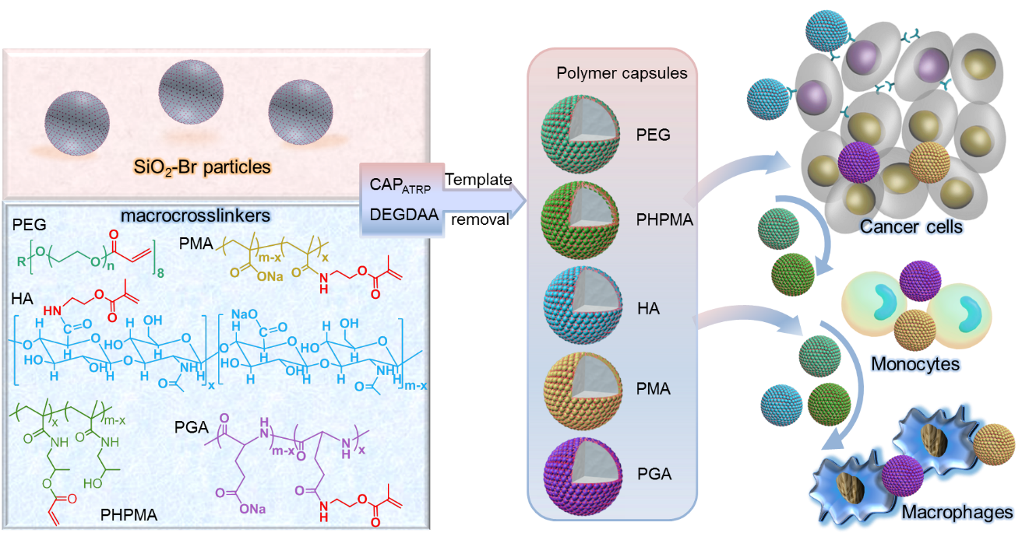
Scheme 1. Schematic illustration of CAP_{ATRP}-mediated formation of various polymer capsules with different compositions and their cellular interaction with (non)targeting cancer cells, phagocytic monocytes, and macrophage cells. DEGDAA, diethylene glycol diacrylate.

RESULTS AND DISCUSSION
Macrocrosslinker Synthesis. Various macrocrosslinkers with different properties, including acrylated 8-arm-PEG (8-PEG-A), PHPMA (PHPMA-A) and methacrylated HA (HA_{47k}-AEMA, HA_{289k}-AEMA), PGA (PGA-AEMA) and PMA (PMA-AEMA) were obtained by introducing (meth)acrylate groups at the periphery or side chain of the corresponding polymers (Scheme S1-S3). For instance, PHPMA-A was synthesized by partially converting hydroxyl groups into polymerizable acrylate groups (10 mol% with respect to the hydroxyl groups)²⁷ (Figure S1) using acryloyl chloride. Meanwhile, HA_{47k}-AEMA, HA_{289k}-AEMA, PGA-AEMA, and PMA-AEMA were obtained via partial conversion of carboxylic groups into methacrylate groups through reaction with 2-aminoethyl methacrylate (AEMA), for which the number of methacrylate groups relative to the carboxylic groups were 16, 7, 25, and 13 mol%, respectively, as analyzed by ¹H NMR (Scheme 1c, Schemes S2 and S3, and Figures S2-S4).
CAP_{ATRP} Capsule Formation. Using the macrocrosslinkers, polymer capsules with various compositions were prepared via the CAP_{ATRP} technique. Firstly, nonporous aminated silica (SiO₂-NH₂, 2.1 µm in diameter, NH₂: >30 µmol g⁻¹) particles were reacted with α-bromoisobutyryl bromide to prepare ATRP initiator-functionalized silica particles (SiO₂-Br) through amide bond formation. Various polymer capsules with similar size were prepared via CAP_{ATRP} of a series of macrocrosslinkers in the presence of DEGDAA on sacrificial SiO₂-Br particles and following template removal. The macrocrosslinker was varied from low fouling polymers 8-PEG-A and PHPMA-A, to negatively charged fouling PGA-AEMA and PMA-AEMA, and to targeting HA_{47k}-AEMA and HA_{289k}-AEMA (to the CD44 receptor), thus generating various polymer capsules (PEG, PHPMA, PGA, PMA, HA_{47k} and HA_{289k}, respectively) with different compositions and surface chemistries. The obtained capsules were further labeled with Alexa Fluor 633 (AF633) dyes to enable fluorescence imaging. Subsequently, the capsules were imaged with differential interference contrast (DIC) and fluorescence microscopy (Figure 1). All of the polymer capsules were well dispersed in aqueous solution and had a similar size of ca. 2 µm. To further characterize the obtained capsules, TEM and AFM were used to observe the capsules in the air-dried state. The polymer capsules exhibited the typical collapsed structure with folds and creases^{28,29} (Figure 2). This validates the versatility of the CAP_{ATRP} approach to prepare synthetic and natural polymer capsules with different compositions.
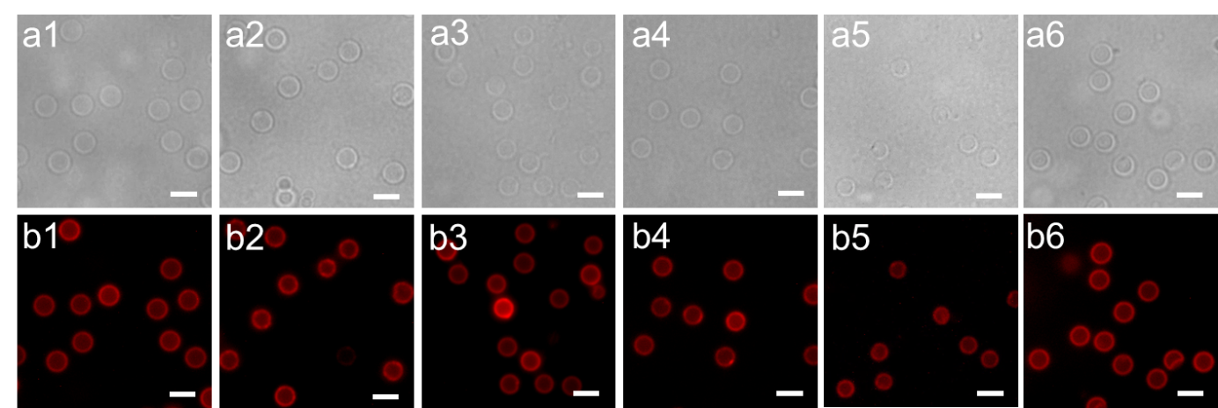
Figure 1. DIC microscopy (a1–a6) and fluorescence microscopy (b1–b6) images of PEG, PHPMA, HA_{47k}, HA_{289k}, PGA and PMA capsules, respectively. Scale bars represent 3 μm.
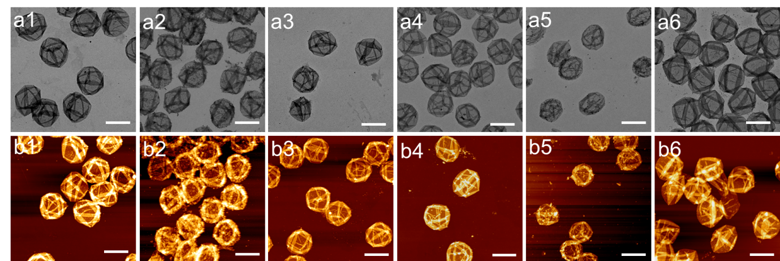
Figure 2. TEM (a1–a6) and AFM (b1–b6) images of PEG, PHPMA, HA_{47k}, HA_{289k}, PGA and PMA capsules, respectively. Scale bars are 2 μm.
The composition of the polymer capsules was varied from (near) neutrally charged PEG and PHPMA to negatively charged HA_{47k}, HA_{289k}, PGA and PMA. The surface properties of the resulting capsules were examined using a Zetasizer Nano-ZS. As shown in Figure 3, PEG capsules had a slightly negative charge at pH 7.4, reflecting the near-neutral surface of PEG capsules. PHPMA capsules exhibited a ζ-potential of -15 mV as a result of the hydroxyl groups, which can be deprotonated. Capsules made from HA, PGA and PMA exhibited higher negative ζ-potentials, ranging from -27 mV to -38 mV, because of the pendent carboxylic groups. The observed results are consistent with previous findings,^{30,31} and demonstrate that the surface properties of polymer capsules can be tuned by changing the type of macrocrosslinker.
Figure 3. ζ-potential of various polymer capsules in phosphate buffer (PB, 5 mM, pH 7.4), as examined using a Zetasizer Nano-ZS.
Polymer Capsule-Cell Interactions. Previous studies have reported that particle surface properties influence cellular processing.^{32,33} Hence, we investigated the role of capsule composition and surface properties on cellular association. We examined the interaction between the various polymer capsules with model cervical cancer HeLa, macrophage Raw 264.7, and monocyte THP-1 cell lines at 37 °C via flow cytometry. The cytotoxicity of all polymer capsules was found to be negligible at the capsule-to-cell ratio of 100:1, according to XTT assays (Figure S5). The cell association for the three types of cells was monitored at different time intervals (1, 2, 4, 8 and 24 h) by incubation with AF633-labeled polymer capsules with differing compositions and surface properties (PEG, PHPMA, HA_{47k}, HA_{289k}, PGA, PMA) at a capsule-to-cell ratio of 100:1. As expected, PEG and PHPMA capsules were low fouling toward HeLa cells, with an association degree of less than 2% at 24 h (Figure 4a). It is known that macrophage and monocyte cells are mainly responsible for the phagocytosis of particles in vivo that leads to short circulation time. However, in our case with the macrophage Raw 264.7 and monocyte THP-1 cells, the cell association of PEG and PHPMA capsules was still below 10% after 24 h incubation (Figure 4b,c). On the contrary, the negatively charged PMA capsules exhibited much higher cellular association efficiency in three types of cells with ca. 80-95% of cells associated with capsules after 8 h incubation (Figure 4). This is in line with previously reported cell interaction studies with PMA capsules, which have generally displayed high fouling behavior.³⁴⁻³⁶ Interestingly, polypeptide PGA capsules bearing similar ζ-potentials to PMA capsules revealed lower cell association (< 20% at 24 h) with HeLa cells (Figure 4a) likely due to its certain stealth property, ³⁷ whereas increased cell association (75-85%) was observed in phagocytic Raw 264.7 and THP-1 cells (Figure 4b,c). In regards to the natural polysaccharide HA capsules, the percentage of cells associated with capsules was consistently low regardless of cell type, in particular for HA_{289k} capsules (< 22% in 24 h) (Figure 4). This low-fouling feature, combined with its inherent active targeting ability, makes HA capsules attractive for drug delivery systems.
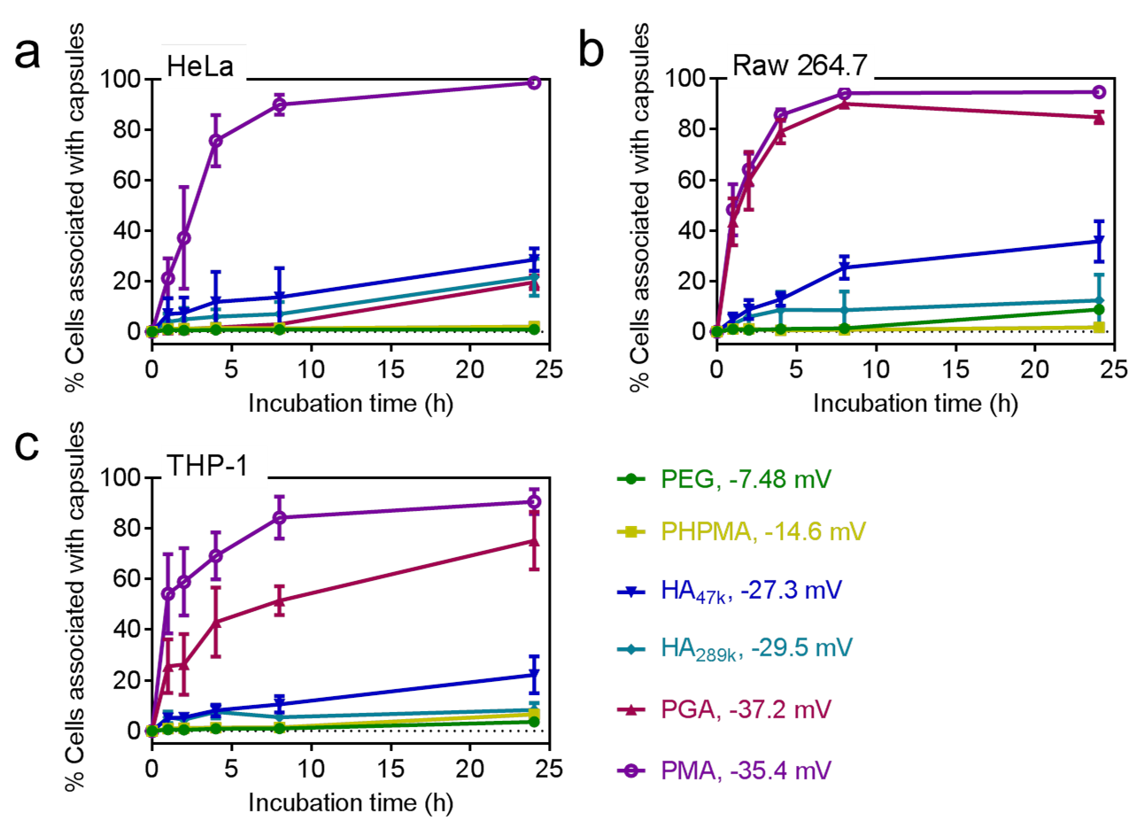
Figure 4. Cellular association of AF633-labeled polymer capsules of different composition with a) HeLa, b) Raw 264.7, and c) THP-1 cell lines (capsule-to-cell ratio: 100:1), as quantified using flow cytometry. Data represent mean ± standard deviation, n = 3. Zeta potential values of each type of capsules were shown next to the capsule name.
The cellular association behavior of the polymer capsules with HeLa and phagocytic cells was further investigated via deconvolution microscopy. Due to the similar association profiles in phagocytic Raw 264.7 and THP-1 cells, adherent Raw 264.7 cells were used for further studies. The cells were incubated with polymer capsules for 24 h. Consistent results with flow cytometry were observed from the microscopy images, where low fouling PEG and PHPMA capsules had negligible cell association with either HeLa or Raw 264.7 cells. HA_{47k} and HA_{289k} capsules also showed low association with HeLa and Raw 264.7 cells. PGA capsules exhibited low cell association with HeLa cells, but higher cell association with phagocytic Raw 264.7 cells. PMA capsules were confirmed to be high fouling, as shown by the high association and internalization in the two cell lines (Figure 5). Overall, our data show that tuning the capsule composition during the CAP_{ATRP} process yields polymer capsules with significantly different cell interaction behavior.
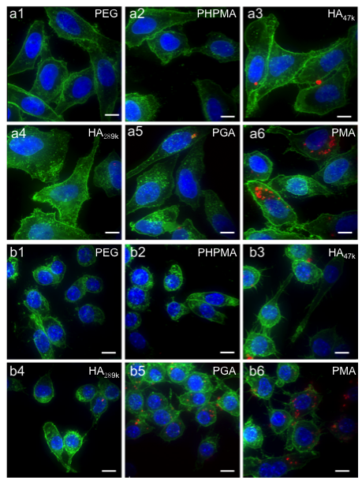
Figure 5. Maximum projection deconvolution fluorescence microscopy images showing the cellular interaction of AF633-labeled polymer capsules with varying compositions (PEG, PHPMA, HA_{47k}, HA_{289k}, PGA, PMA) in HeLa cells (a1-a6) and Raw 264.7 cells (b1-b6), respectively. After 24 h incubation at 37 °C, cell membranes and nuclei were stained with AF488-Wheat Germ Agglutinin (AF488-WGA, green) and Hoechst 33342 (blue), respectively. Scale bars represent 10 μm.
Targeting Specificity of HA Capsules. HA is a highly biocompatible and biodegradable natural polysaccharide, which has been found to specifically and efficiently bind to the CD44 receptor that is overexpressed on many cancerous cells, including human lung cancer cells (e.g., A549) and breast cancer cells (e.g., MDA-MB-231).³⁸⁻⁴³ To explore the targeting ability of CAP_{ATRP}-produced HA capsules to the CD44 receptor, the cell association of HA_{289k} capsules with CD44 overexpressed MDA-MB-231 cells was investigated using flow cytometry and deconvolution microscopy. CD44 negative human breast cancer cell BT474, Raw 264.7, THP-1 and HeLa cells were used as controls. The level of CD44 expression on MDA-MB-231 cells was first investigated by incubating cells with fluorescein (FITC)-labeled anti-CD44 antibody. After 30 min incubation on ice, almost all of MDA-MB-231 cells exhibited strong fluorescence (compared to untreated cells), demonstrating the expression of CD44 (Figure S6). In contrast, less than 30% BT474 cells have an increase of fluorescence (Figure S6), which is probably caused by non-specific protein adsorption. After 8 h incubation at 37 °C, the percentage of MDA-MB-231 cells associated with HA_{289k} capsules was ca. 51%, which is ~ 9, 5, 9, and 6-fold higher than the control groups BT474 (5%), Raw 264.7 (8%), THP-1 (5%), and HeLa (7%), respectively (Figure 6a). With the incubation time prolonged to 24 h, non-specific interactions between HA_{289k} capsules and CD44 negative control cells increased ~ 1 to 3-fold. It should be noted, however, that the cell association of CD44 positive MDA-MB-231 with HA_{289k} capsules was still significantly higher than the CD44 negative cells, specifically, 8-fold higher compared to BT474, where only ca. 6% of cells had associated capsules. The deconvolution microscopy images acquired from MDA-MB-231 and BT474 cells after 24 h incubation with HA_{289k} capsules also confirmed the flow cytometry data (Figure 6b,c). Some HA_{289k} capsules deformed and were internalized into MDA-MB-231 cells, while few capsules were associated with BT474 cells (Figure 6b,c). These results clearly revealed the specific targeting ability of CAP_{ATRP} based HA_{289k} capsules to CD44 overexpressed MDA-MB-231 cells, while having very low non-specific interaction with CD44 negative cells. Our previous work has shown that smaller capsules (35 to 585 nm) can be prepared using similar templating strategies as those used in the current study⁴⁴ – smaller capsules will be the subject of future studies.
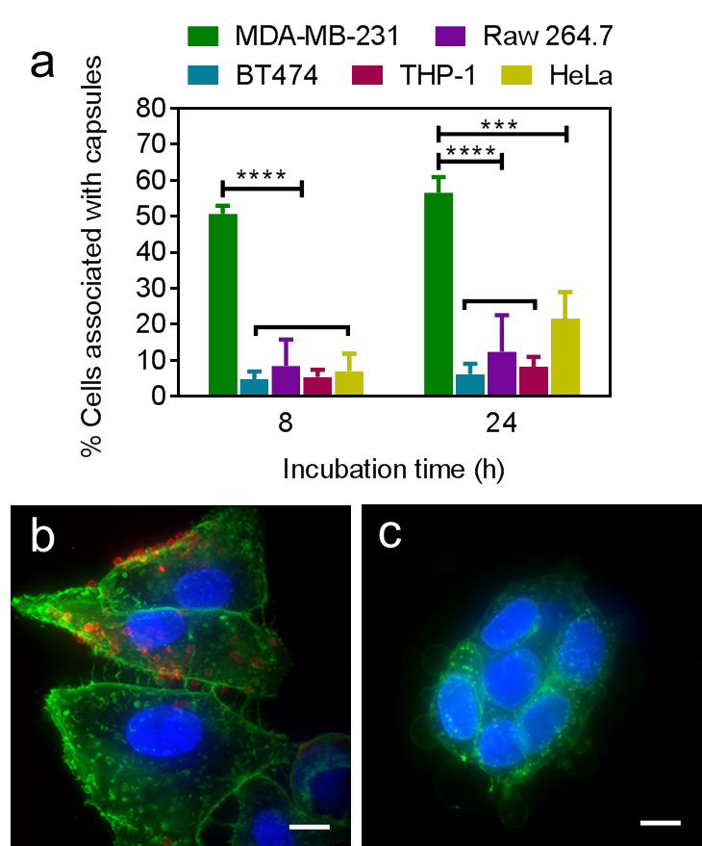
Figure 6. a) Targeting ability of HA_{289k} capsules to CD44 overexpressed MDA-MB-231 cells after 8 and 24 h incubation, respectively, as examined using flow cytometry. CD44 negative cell lines (BT474, Raw 264.7, THP-1 and HeLa) were used as controls. Cellular interaction of HA_{289k} capsules with b) MDA-MB-231 and c) BT474 cells after 24 h incubation at a capsule-to-cell ratio of 100:1. Cell membranes and nuclei were stained with AF488-WGA (green) and Hoechst 33342 (blue), respectively. Scale bars are 10 μm.
CONCLUSIONS
This study demonstrates the capability of CAP_{ATRP} to engineer polymer capsules with controllable composition and hence tunable cellular interactions. PEG, PHPMA, PGA, PMA and HA capsules with similar sizes and morphologies were prepared via CAP_{ATRP}-mediated assembly of corresponding (meth)acrylate functionalized polymers on particulate silica templates. Different capsule properties were imparted via judicious selection of polymers, from neutrally charged to negatively charged, from low fouling to active targeting, and from natural to synthetic. Additionally, the cellular association of various polymer capsules with different cell types was studied using flow cytometry and deconvolution microscopy. The results validated that PEG and PHPMA capsules were low fouling to cancerous cells as well as phagocytic macrophage and monocyte cells. HA capsules, which displayed low fouling behavior to CD44 negative cells (BT474, HeLa, Raw 264.7, THP-1), showed specific targeting to CD44 overexpressed MDA-MB-231 cells. Overall, this work demonstrates the potential of the CAP_{ATRP} technique to fabricate polymer capsules with defined compositions and properties for specific cellular interactions. These results can therefore facilitate the rational design of capsule systems with tunable properties and controlled bio-nano interactions (e.g., targeting and low fouling), which is important for advancing the use of engineered capsules in targeted therapeutic delivery.

EXPERIMENTAL PROCEDURES
ATRP Initiator Functionalization of SiO₂. The ATRP initiator was attached onto the surface of SiO₂-NH₂ particles via reaction with α-bromoisobutyryl bromide through amide bond formation. Briefly, 1 mL of a SiO₂-NH₂ particle suspension (2.1 µm, 50 mg mL⁻¹) was spun down (1000 g, 1 min), washed three times with Milli-Q water (3 × 1 mL), three times with pyridine (3 × 0.8 mL), and finally dispersed in 1 mL of anhydrous pyridine, followed by addition of 200 µL of α-bromoisobutyryl bromide. After constant shaking overnight at 25 °C, the particles were sequentially washed with ethanol and Milli-Q water to obtain the ATRP initiator functionalized SiO₂ particles (SiO₂-Br), which were finally dispersed in ethanol to yield a particle concentration of ca. 50 mg mL⁻¹, and stored in the fridge before use.
Synthesis of Macrocrosslinker. PHPMA-A (M_{w} 31.5 kDa) with an acrylate functionality of ca. 10 mol% and HA_{47k}-AEMA (M_{w} of HA 47 kDa) with a methacrylate functionality of ca. 16 mol% were synthesized, as reported previously^{26,27} (Scheme S1b,c). HA_{289k}-AEMA, PGA-AEMA and PMA-AEMA were synthesized using a similar procedure with HA_{47k}-AEMA with slight modifications (Schemes S2, S3). Briefly, 4-(4,6-dimethoxy-1,3,5-triazin-2-yl)-4-methylmorpholinium chloride (DMTMM, 94 mg, 0.34 mmol) and AEMA (28 mg, 0.17 mmol) were added to a HA (113 mg, 0.28 mmol -COOH) solution in PB (50 mM, pH 7.2, 12 mL) and stirred for 4 days at 37 °C. Afterward, the reaction solution was thoroughly dialyzed against water and lyophilized for 2 days to obtain HA_{289k}-AEMA (107 mg, yield: 93%, methacrylate functionality: 7 mol%). PGA-AEMA (108 mg, yield: 79%, methacrylate functionality: 25 mol%) was obtained via reaction of PGA (121 mg, 0.80 mmol -COOH) with AEMA (32 mg, 0.19 mmol) under catalysis of DMTMM (107 mg, 0.39 mmol) in PB (50 mM, pH 7.2) for 24 h at 25 °C, followed by dialysis in water and freeze-drying. For the PMA-AEMA synthesis, to a 15 mL solution of PMA (500 mg, 4.63 mmol -COOH) in PB (50 mM, pH 7.2) was added DMTMM (469 mg, 1.70 mmol) and AEMA (153 mg, 0.92 mmol). The mixture was reacted for 24 h at 25 °C, followed by dialysis in water and freeze-drying for 2 days (485 mg, yield: 88%, methacrylate functionality: 13 mol%).
Capsule Formation. Firstly, 200 µL of a SiO₂-Br particle suspension (~ 50 mg mL⁻¹) was spun down (1000 g, 1 min) to remove the ethanol supernatant. The particles were then incubated in 900 μL of a water/DMSO (3:1 v/v for HA and otherwise 1:1 v/v) stock solution containing macrocrosslinker (10.0 mM vinyl), DEGDAA (50.0 mM), N,N,N′,N′,N′′-pentamethyldiethylenetriamine (3.1 mM), copper(II) bromide (1.0 mM), and sodium ascorbate (20.5 mM) with agitation overnight at 25 °C. Following this, the particles were washed three times using water (1000 g, 1 min).
The aforementioned CAP_{ATRP}-assembled polymer particles were spun down, then HA_{47k} and HA_{289k} particles were resuspended in 1 mL of PBS (10 mM, 150 mM NaCl, pH 7.4), and PHPMA particles were redispersed in 1 mL of PB (10 mM, pH 7.4). Following this, AF633-NHS solution in DMSO (6 µL, 1 mg mL⁻¹) was added to the above particle suspensions. PEG particles were suspended in 1 mL of PB (10 mM, pH 8.5), and PMA and PGA particles were suspended in 1 mL of water with 4 mg mL⁻¹ of DMTMM. Then 6 µL of AF633-hydrazide was added to the above particle suspensions. All of the particle suspensions were shaken under dark for 24 h at 25 °C. AF633-labeled polymer particles were finally suspended into water (200 µL) after three washings with water.
Polymer capsules were obtained after mixing the particle suspension (200 µL in water) with 1.0 mL of ammonium fluoride (13.3 M) buffered hydrofluoric acid (HF, 5.0 M) at a volumetric ratio of 2:1 to remove the SiO₂ templates. [Caution! HF solution is highly toxic. Extreme care should be taken when handling HF solution and only small quantities should be prepared.] The capsules were then spun down (4000 g, 5 min) and washed thoroughly with water (3 × 1 mL).
Capsule-Cell Interaction Analysis by Flow Cytometry. In all of the cell experiments, the capsule-to-cell ratio was set at 100:1. HeLa, Raw 264.7 and THP-1 cell lines were plated into 24-well plates at a density of 6 × 10⁴ cells per well, for which HeLa and Raw 264.7 cells were allowed to adhere overnight at 37 °C with 5% CO₂. Following this, AF633-labeled polymer capsules were added and incubated for different time intervals (1, 2, 4, 8 and 24 h). After incubation, HeLa and Raw 264.7 cells were washed three times with DPBS and harvested by trypsinization, followed by centrifugation at 400 g for 5 min. THP-1 cells were harvested by centrifugation and further washed three times with DPBS (400 g, 5 min). The cell pellet was resuspended in DPBS and analyzed using flow cytometry (Apogee Flow). Cells were identified according to their scattering characteristics, and the percentage of cells associated with capsules was determined by acquisition of AF633 (FL5).
Capsule Targeting Analysis by Flow Cytometry. MDA-MB-231 and BT474 cells were seeded into 24-well plates with 6 × 10⁴ cells per well and allowed to adhere overnight and ~ 36 h, respectively. Then, AF633-labeled HA_{289k} capsules were added and incubated for 8 h and 24 h at 37 °C. After incubation, cells were gently washed three times with DPBS and harvested by trypsinization, followed by centrifugation at 400 g for 5 min. The cell pellet was suspended in DPBS and analyzed using flow cytometry (Apogee Flow). At least 1 × 10⁴ cells were counted and samples were prepared in triplicates.
Cell Imaging by Fluorescence Deconvolution Microscopy. HeLa and Raw 264.7 cells were seeded at 3 × 10⁴ cells per well into 8-well Lab-Tek I chambered coverglass slides (Thermo Fisher Scientific, Rochester, NY, USA) and allowed to adhere overnight. AF633-labeled polymer capsules were added into the corresponding well and incubated for 24 h at 37 ºC. Subsequently, cells were washed three times with DPBS and fixed with 4% paraformaldehyde for 15 min at 25 °C followed by three washings with DPBS.
For targeting studies, MDA-MB-231 and BT474 cells were seeded into 8-well Lab-Tek I chambered coverglass slides at a density of 3 × 10⁴ cells per well. AF633-labeled HA_{289k} capsules were then incubated with cells for 24 h at 37 ºC. Following this, cells were gently washed three times with DPBS and fixed with 4% paraformaldehyde for 15 min at room temperature (i.e., 25 °C) followed by three washings with DPBS.
Cell membranes were stained via incubation with AF488-WGA (1 μg mL⁻¹) on ice for 20 min, followed by washing with DPBS. Cell nuclei were counterstained using Hoechst 33342 (2.5 μg mL⁻¹) for 15 min at 25 °C. Following this, cells were washed three times with DPBS and immersed in 200 μL DPBS for microscopy observation. Fluorescence images were collected using a fluorescence deconvolution microscope (DeltaVision, Applied Precision) equipped with a 60× 1.42 NA oil objective and a standard DAPI/FITC/CY₅ filter set. Images were processed with Imaris 6.3.1 (Bitplane) using the maximum intensity projection.

ASSOCIATED CONTENT
Supporting Information
The Supporting Information is available free of charge on the ACS Publications website.
Materials, characterization methods, cell cultures, cell viability analysis, chemical structure (Scheme S1), synthetic pathway (Schemes S2, S3), ¹H NMR spectra (Figures S1-S4), cytotoxicity data (Figure S5), and CD44 expression study (Figure S6).

AUTHOR INFORMATION
Corresponding Author
* Email: gregghq@unimelb.edu.au (G.G.Q.)
* Email: fcaruso@unimelb.edu.au. (F.C.)
Present Addresses
§H. Sun: Biomedical Polymers Laboratory, and Jiangsu Key Laboratory of Advanced Functional Polymer Design and Application, College of Chemistry, Chemical Engineering and Materials Science, Soochow University, Suzhou 215123, China
¶J. Cui: Key Laboratory of Colloid and Interface Chemistry of Ministry of Education, and the School of Chemistry and Chemical Engineering, Shandong University, Jinan 250100, China
Notes
The authors declare no competing financial interest.
ACKNOWLEDGMENTS
This research was supported by the Australian Research Council (ARC) Centre of Excellence in Convergent Bio-Nano Science and Technology (CE140100036), and the ARC under the Australian Laureate Fellowship (FL120100030, F.C.), Future Fellowship (FT110100411, G.G.Q.), Discovery Project (DP1094147 and DP130101846, F.C., G.G.Q.), and Super Science Fellowship (FS110200025, F.C. and G.G.Q.) schemes. This work was performed in part at the Materials Characterisation and Fabrication Platform (MCFP) at the University of Melbourne and the Victorian Node of the Australian National Fabrication Facility (ANFF). We acknowledge Dr. Biao Kong, Dr. Christina Cortez-Jugo, Dr. Junling Guo and Tomoya Suma (the University of Melbourne) for helpful discussions.
ABBREVIATIONS
CAP_{ATRP}, atom transfer radical polymerization-mediated continuous assembly of polymers; PEG, poly(ethylene glycol); PHPMA, poly(N-(2-hydroxypropyl)-methacrylamide); HA, hyaluronic acid; PGA, poly(glutamic acid); PMA, poly(methacrylic acid); LbL, layer-by-layer; AEMA, 2-aminoethyl methacrylate; DMTMM, 4-(4,6-dimethoxy-1,3,5-triazin-2-yl)-4-methylmorpholinium chloride; DEGDAA, diethylene glycol diacrylate; HF, hydrofluoric acid; AF, Alexa Fluor; WGA, wheat germ agglutinin; SiO₂-NH₂, aminated silica; TEM, transmission electron microscopy; AFM, atomic force microscopy; DIC, differential interference contrast.
REFERENCES
(1) Elsabahy, M., and Wooley, K. L. (2012) Design of polymeric nanoparticles for biomedical delivery applications. Chem. Soc. Rev. 41, 2545-2561.
(2) Bao, G., Mitragotri, S., and Tong, S. (2013) Multifunctional nanoparticles for drug delivery and molecular imaging. Annu. Rev. Biomed. Eng. 15, 253-282.
(3) Nicolas, J., Mura, S., Brambilla, D., Mackiewicz, N., and Couvreur, P. (2013) Design, functionalization strategies and biomedical applications of targeted biodegradable/biocompatible polymer-based nanocarriers for drug delivery. Chem. Soc. Rev. 42, 1147–1235.
(4) Liu, X. Q., and Picart, C. (2016) Layer-by-layer assemblies for cancer treatment and diagnosis. Adv. Mater. 28, 1295-1301.
(5) Cui, J., De Rose, R., Alt, K., Alcantara, S., Paterson, B. M., Liang, K., Hu, M., Richardson, J. J., Yan, Y., Jeffery, C. M., et al. (2015) Engineering poly(ethylene glycol) particles for improved biodistribution. ACS Nano 9, 1571-1580.
(6) Lowe, S., O'Brien-Simpson, N. M., and Connal, L. A. (2015) Antibiofouling polymer interfaces: poly(ethylene glycol) and other promising candidates. Polym. Chem. 6, 198-212.
(7) Otsuka, H., Nagasaki, Y., and Kataoka, K. (2012) PEGylated nanoparticles for biological and pharmaceutical applications. Adv. Drug Deliv. Rev. 64, 246-255.
(8) Dosio, F., Arpicco, S., Stella, B., and Fattal, E. (2016) Hyaluronic acid for anticancer drug and nucleic acid delivery. Adv. Drug Deliv. Rev. 97, 204-236.
(9) Rao, N. V., Yoon, H. Y., Han, H. S., Ko, H., Son, S., Lee, M., Lee, H., Jo, D.-G., Kang, Y. M., and Park, J. H. (2016) Recent developments in hyaluronic acid-based nanomedicine for targeted cancer treatment. Expert Opin. Drug Deliv. 13, 239-252.
(10) Kamaly, N., Xiao, Z., Valencia, P. M., Radovic-Moreno, A. F., and Farokhzad, O. C. (2012) Targeted polymeric therapeutic nanoparticles: design, development and clinical translation. Chem. Soc. Rev. 41, 2971-3010.
(11) Tian, H., Tang, Z., Zhuang, X., Chen, X., and Jing, X. (2012) Biodegradable synthetic polymers: Preparation, functionalization and biomedical application. Prog. Polym. Sci. 37, 237-280.
(12) Danhier, F., Ansorena, E., Silva, J. M., Coco, R., Le Breton, A., and Préat, V. (2012) PLGA-based nanoparticles: An overview of biomedical applications. J. Control. Release 161, 505-522.
(13) Delplace, V., and Nicolas, J. (2015) Degradable vinyl polymers for biomedical applications. Nat. Chem. 7, 771-784.
(14) Cui, J., van Koeverden, M. P., Müllner, M., Kempe, K., and Caruso, F. (2014) Emerging methods for the fabrication of polymer capsules. Adv. Colloid Interface Sci. 207, 14-31.
(15) Richardson, J. J., Bjornmalm, M., and Caruso, F. (2015) Technology-driven layer-by-layer assembly of nanofilms. Science 348, aaa2491.
(16) Gaitzsch, J., Huang, X., and Voit, B. (2016) Engineering functional polymer capsules toward smart nanoreactors. Chem. Rev. 116, 1053-1093.
(17) Cui, J., Richardson, J. J., Björnmalm, M., Faria, M., and Caruso, F. (2016) Nanoengineered templated polymer particles: Navigating the biological realm. Acc. Chem. Res. 138, 13449-13456.
(18) De Koker, S., De Geest, B. G., Cuvelier, C., Ferdinande, L., Deckers, W., Hennink, W. E., De Smedt, S. C., and Mertens, N. (2007) In vivo cellular uptake, degradation, and biocompatibility of polyelectrolyte microcapsules. Adv. Funct. Mater. 17, 3754-3763.
(19) Hartmann, R., Weidenbach, M., Neubauer, M., Fery, A., and Parak, W. J. (2015) Stiffness-dependent in vitro uptake and lysosomal acidification of colloidal particles. Angew. Chem. Int. Ed. 54, 1365-1368.
(20) Zelikin, A. N., Li, Q., and Caruso, F. (2008) Disulfide-stabilized poly(methacrylic acid) capsules: Formation, cross-linking, and degradation behavior. Chem. Mater. 20, 2655-2661.
(21) Kinnane, C. R., Such, G. K., Antequera-García, G., Yan, Y., Dodds, S. J., Liz-Marzan, L. M., and Caruso, F. (2009) Low-fouling poly(N-vinyl pyrrolidone) capsules with engineered degradable properties. Biomacromolecules 10, 2839-2846.
(22) Wong, E. H. H., Guntari, S. N., Blencowe, A., van Koeverden, M. P., Caruso, F., and Qiao, G. G. (2012) Phototriggered, metal-free continuous assembly of polymers for the fabrication of ultrathin films. ACS Macro Lett. 1, 1020-1023.
(23) Mertz, D., Ochs, C. J., Zhu, Z., Lee, L., Guntari, S. N., Such, G. K., Goh, T. K., Connal, L. A., Blencowe, A., Qiao, G. G., et al. (2011) ATRP-mediated continuous assembly of polymers for the preparation of nanoscale films. Chem. Commun. 47, 12601-12603.
(24) Goh, T. K., Guntari, S. N., Ochs, C. J., Blencowe, A., Mertz, D., Connal, L. A., Such, G. K., Qiao, G. G., and Caruso, F. (2011) Nanoengineered films via surface-confined continuous assembly of polymers. Small 7, 2863-2867.
(25) Sun, H., Björnmalm, M., Cui, J., Wong, E. H. H., Dai, Y., Dai, Q., Qiao, G. G., and Caruso, F. (2015) Structure governs the deformability of polymer particles in a microfluidic blood capillary model. ACS Macro Lett. 4, 1205-1209.
(26) Sun, H., Wong, E. H. H., Yan, Y., Cui, J., Dai, Q., Guo, J., Qiao, G. G., and Caruso, F. (2015) The role of capsule stiffness on cellular processing. Chem. Sci. 6, 3505-3514.
(27) Wong, E. H. H., van Koeverden, M. P., Nam, E., Guntari, S. N., Wibowo, S. H., Blencowe, A., Caruso, F., and Qiao, G. G. (2013) Assembly of nanostructured films with hydrophobic subcompartments via continuous assembly of polymers. Macromolecules 46, 7789-7796.
(28) Ejima, H., Richardson, J. J., Liang, K., Best, J. P., van Koeverden, M. P., Such, G. K., Cui, J., and Caruso, F. (2013) One-step assembly of coordination complexes for versatile film and particle engineering. Science 341, 154-157.
(29) Shchepelina, O., Drachuk, I., Gupta, M. K., Lin, J., and Tsukruk, V. V. (2011) Silk-on-silk layer-by-layer microcapsules. Adv. Mater. 23, 4655-4660.
(30) Huang, J., Zhang, H., Yu, Y., Chen, Y., Wang, D., Zhang, G., Zhou, G., Liu, J., Sun, Z., Sun, D., et al. (2014) Biodegradable self-assembled nanoparticles of poly (d,l-lactide-co-glycolide)/hyaluronic acid block copolymers for target delivery of docetaxel to breast cancer. Biomaterials 35, 550-566.
(31) Gonzalo, T., Lollo, G., Garcia-Fuentes, M., Torres, D., Correa, J., Riguera, R., Fernandez-Megia, E., Calvo, P., Avilés, P., Guillén, M. J., et al. (2013) A new potential nano-oncological therapy based on polyamino acid nanocapsules. J. Control. Release 169, 10-16.
(32) Verma, A., and Stellacci, F. (2010) Effect of surface properties on nanoparticle–cell interactions. Small 6, 12-21.
(33) Albanese, A., Tang, P. S., and Chan, W. C. W. (2012) The effect of nanoparticle size, shape, and surface chemistry on biological systems. Annu. Rev. Biomed. Eng. 14, 1-16.
(34) Yan, Y., Johnston, A. P. R., Dodds, S. J., Kamphuis, M. M. J., Ferguson, C., Parton, R. G., Nice, E. C., Heath, J. K., and Caruso, F. (2010) Uptake and intracellular fate of disulfide-bonded polymer hydrogel capsules for doxorubicin delivery to colorectal cancer cells. ACS Nano 4, 2928-2936.
(35) Zelikin, A. N., Breheney, K., Robert, R., Tjipto, E., and Wark, K. (2010) Cytotoxicity and internalization of polymer hydrogel capsules by mammalian cells. Biomacromolecules 11, 2123-2129.
(36) Chen, X., Cui, J., Sun, H., Müllner, M., Yan, Y., Noi, K. F., Ping, Y., and Caruso, F. (2016) Analysing intracellular deformation of polymer capsules using structured illumination microscopy. Nanoscale 8, 11924-11931.
(37) Hu, C.-M. J., Fang, R. H., Luk, B. T., and Zhang, L. (2014) Polymeric nanotherapeutics: clinical development and advances in stealth functionalization strategies. Nanoscale 6, 65-75.
(38) Ganesh, S., Iyer, A. K., Morrissey, D. V., and Amiji, M. M. (2013) Hyaluronic acid based self-assembling nanosystems for CD44 target mediated siRNA delivery to solid tumors. Biomaterials 34, 3489-3502.
(39) Deng, X., Cao, M., Zhang, J., Hu, K., Yin, Z., Zhou, Z., Xiao, X., Yang, Y., Sheng, W., Wu, Y., et al. (2014) Hyaluronic acid-chitosan nanoparticles for co-delivery of MiR-34a and doxorubicin in therapy against triple negative breast cancer. Biomaterials 35, 4333-4344.
(40) Ju, Y., Cui, J., Sun, H., Müllner, M., Dai, Y., Guo, J., Bertleff-Zieschang, N., Suma, T., Richardson, J. J., and Caruso, F. (2016) Engineered metal-phenolic capsules show tunable targeted delivery to cancer cells. Biomacromolecules 17, 2268-2276.
(41) Ju, Y., Dai, Q., Cui, J., Dai, Y., Suma, T., Richardson, J. J., and Caruso, F. (2016) Improving targeting of metal–phenolic capsules by the presence of protein coronas. ACS Appl. Mater. Interfaces 8, 22914-22922.
(42) Draffin, J. E., McFarlane, S., Hill, A., Johnston, P. G., and Waugh, D. J. J. (2004) CD44 potentiates the adherence of metastatic prostate and breast cancer cells to bone marrow endothelial cells. Cancer Res. 64, 5702-5711.
(43) Wei, X., Senanayake, T. H., Warren, G., and Vinogradov, S. V. (2013) Hyaluronic acid-based nanogel–drug conjugates with enhanced anticancer activity designed for the targeting of CD44-positive and drug-resistant tumors. Bioconjug. Chem. 24, 658-668.
(44) Richardson, J. J., Ejima, H., Lörcher, S. L., Liang, K., Senn, P., Cui, J., and Caruso, F. (2013) Preparation of Nano- and Microcapsules by Electrophoretic Polymer Assembly. Angew. Chem. Int. Ed. 52, 6455-6458.

Table of Contents graphic

